

Module: Strategic Management
Module code: LCMB7003
Assignment Title: Individual report on Heineken
Student Name: Chandru subbaiah
Student ID: 2507406
Lecturer name: Hoang Dang Nguyen
Term : 02
Table of Contents
Section 1 4
1. Organisational Context and Overview 4
1.1 Summary of the chosen organisation 4
1.2 Discussion of the industry 6
2. External and Internal Environment Analysis 7
2.1 External Environment: PESTLE Analysis 7
2.2 Critical Success Factors and Strategic Challenges from the External Environment 9
2.2.1 Critical Success Factors 9
2.2.2 Strategic Challenges 10
2.3 Internal Environment: VRIO Analysis 11
2.4 Heineken's Internal Strengths Contribution to its Competitive Advantage 13
3. CSR and Sustainability Objectives 13
3.1 Company's CSR Strategy and its Alignment with Business Objectives 13
4.1 The Balanced Scorecard 14
4.2 Analysis of Objectives, Key Performance Indicators (KPIs), Targets, and Initiatives 16
5. Strategic Choices and Implementation 16
5.1 Evaluation of the Strategic Choices at the Business Level and Corporate Level, and the Justification of the Selection 16
5.2 Change Management and its Impact on Strategic Implementation 17
6. Strategic Evaluation and Recommendations 18
6.1 Current Strategy 18
6.2 Recommendations for Improving Strategy and Boosting Competitive Advantage 19
6.3 Justification of Recommendations 19
Section 2 20
Gibbs Reflective Cycle 20
References 23

Section 1

1. Organisational Context and Overview

1.1 Summary of the chosen organisation
Heineken N.V. is a Dutch multinational brewery that was created in 1864 by Gerard Adriaan Heineken in Amsterdam. Its historical growth is marked by the internationalisation strategy, the combination of the acquisition and the domestic production. This has allowed it to be on the global stage of the 70 countries' presence, 300 brands in the portfolio (Heineken, 2025). The company has a mission of brewing the happiness of real togetherness in order to create a better world, which shows that the company has changed from product-oriented brewing to experience-based branding and sustainability positioning. The vision is congruent with premiumisation and responsible consumption, especially with low and no-alcohol products like Heineken 0.0. This has demonstrated a growth into the double digits in terms of growth and strategic significance of the product in diversifying the demand.
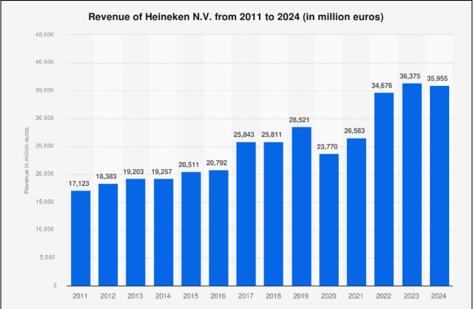
Figure 1: Revenue of Heineken
(Source: Statista, 2024)
Figure 1 shows the revenue of Heineken over the years; in 2024, the company generated 36 billion Euros, which is slightly less than the previous year's revenue.
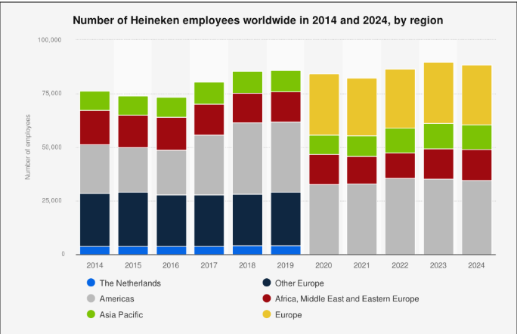
Figure 2: Number of employees of Heineken
(Source: Statista, 2024a)
Figure 2 shows the number of employees of Heineken in the different regions they operate. The firm has the largest number of employees in America, and it employs more than 28,000 people globally.
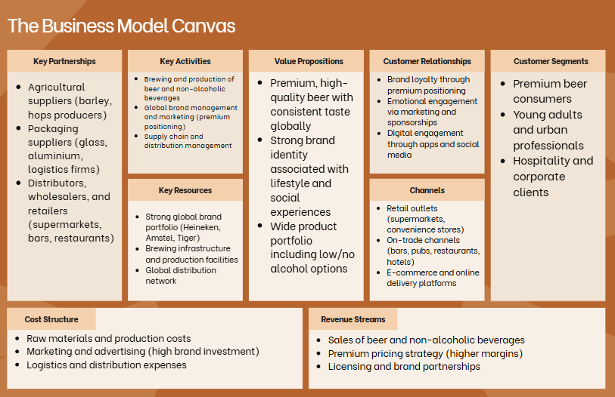
Figure 3: Business model canvas
(Source: Self-developed)
Value creation relies on the premium beer positioning, a good network of distribution and collaborating with the retail and other hospitality industries. A multi-brand portfolio of premium, mainstream and non-alcoholic lines of revenue drives the company (Heineken, 2025a). Cost structure is intensive in the capital-based structure as it relates to brewing infrastructure and supply chain investment.

1.2 Discussion of the industry
Heineken has been in the international alcoholic beverage market, where beer is the dominant market segment, consuming a large portion of the alcohol consumption expenditure. Europe and North America are experiencing structural deterioration, whereas emerging markets like India, Brazil and Vietnam have been enjoying rising demands. Figure 4 shows Heineken is the second-largest brewer globally with a market share of about 11% and follows behind Anheuser-Busch InBev, but surpasses Carlsberg and Molson Coors. This ranking represents a great international presence but also shows a scale drawback when compared to AB InBev, which makes approximately twice the volume and is more profitable.
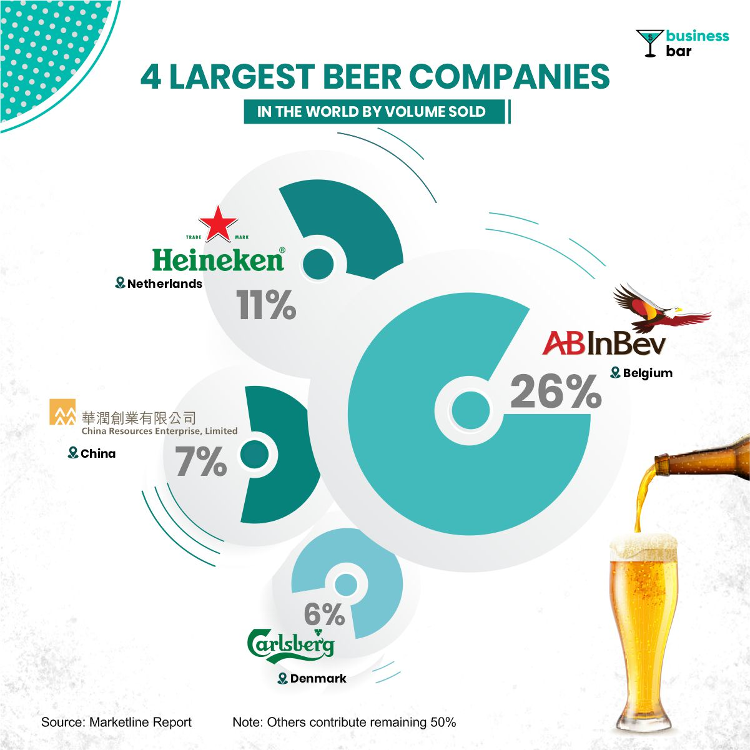
Figure 4: Largest Beer Companies Globally
(Source: Businessbar, 2021)
Other competitors like Carlsberg are diversifying into non-beer beverages, thus enhancing their resilience and margins, and craft breweries and local brands are taking away market share by targeting niche and premium segments (Erl and Kiesel, 2021). The competitive strength of Heineken is the premium products positioning and geographic diversification.

2. External and Internal Environment Analysis

2.1 External Environment: PESTLE Analysis
Factors | Description | Impact
Political | The political stability index of the Netherlands is 0.43 in 2024, which is down from 0.61 in the previous year (The Global Economy, 2024).  Trade policies and taxation have less uncertainty in terms of cross-border distribution. | High
Economical | The GDP of the country is more than 1200 billion USD, which has improved from last year (Trading Economics, 2024).  The inflation rate of the Netherlands is about 2.4%, which forces consumer prices up to 1% (Trading Economics, 2024b).  Unemployment rate has increased from 4% to 4.1%, though the labour market stays relatively strong (Trading Economics, 2024c). | High
Social | The demand is being restructured in a more structural way due to social factors.  The growing ageing population and the rise in health awareness in the Netherlands and Europe at large lower the per capita consumption of alcohol (Listabarth et al., 2022). | Low
Technological | Efficiency and competitive differentiation are aided by technological change.  Use of digital marketing and use of data-driven distribution enhances targeting and customer interaction.  Heineken has made more investments in marketing and digital, which means that the company relies on technology to maintain brand equity and channel optimisation (Oliveira, 2024). | Moderate
Environmental | The Netherlands has stringent rules regarding sustainability in emissions, use of water and circular packaging.  These drive the costs of operations up, yet encourage Heineken to become more innovative in renewable energy and sustainable brewing (Serviss et al., 2025). | Moderate
Legal | Promotional flexibility is restricted by strict advertising limits, minimum drinking age legislation, and labelling requirements.  These costs of compliance rise, and more importantly, limit expansion strategies in the market, especially in Europe, where regulation is becoming stricter. | Low to moderate
Table 1: PESTEL analysis
(Source: Self-developed)

2.2 Critical Success Factors and Strategic Challenges from the External Environment

2.2.1 Critical Success Factors
Premiumisation and brand equity
The capacity of Heineken to maintain a premium positioning is the key to profitability. The volumes of premium beer increased by approximately 5% in 2024, which is much higher than the total portfolio growth of 1.6%, with the flagship brand growing by nearly 9% (Arthur, 2025). Premium product earns a gross profit per hectolitre that is more than 50% higher than mainstream beer, and this means that the protection of margin requires further consumer willingness to purchase. The duty levels in the EU markets are still increasing, which has a direct impact on the pricing tactics, limiting them and compelling Heineken to focus more on premiumisation instead of volume growth. Success in any strategy is therefore dependent on brand equity being high through investing in marketing and global uniformity.
Low and no-alcohol segment leadership
Structural growth opportunities develop in the way consumption is shifting to moderation. Heineken 0.0 witnessed over 53% volume growth in 2020-24 and has a presence in more than 100 markets (Heineken International B.V, 2025). The non-alcoholic beer market in the world is estimated to be 13.7 billion dollars and is growing at a rate higher than the traditional beer markets. This segment already comprises more than 4% of the Heineken portfolio, so diversification into health-oriented products is an important capability, and not an extension of the niche.
Geographical diversification and development of new markets
The emerging economies like India, Vietnam, Brazil, and Nigeria, where the consumption of beer is on the increase, are causing growth. Heineken is distributed in more than 70 countries and will enable risk spread over the decreasing European demand and the growth regions (Euro Next, 2025). This geographical distribution assists in the strength of revenues and allows volume to grow in areas with more significant demographic expansion and urbanisation. The increasing input prices, especially on barley and packaging, squeeze margins, and it becomes impossible to compete with the cheaper brands.
Cost management and efficiency
Necessary constant efficiency improvements are necessitated by growing production costs and inflation. Heineken saved more than 0.6 billion euros in 2024, which helped to maintain the margins in a stable situation despite the poor growth of volumes (Heineken, 2025a). The implementation of the strategic planning requires striking a balance between cost-saving and long-term investment in marketing and innovation.
Integrating sustainability into strategy
Sustainability is a competitive requirement due to environmental regulations and pressure on stakeholders. Heineken boasts of a huge carbon emission cut and incorporates ESG targets into capital allocation decisions. This enhances the legitimacy in the long term and capital access and meets the regulatory requirements in European markets.

2.2.2 Strategic Challenges
Falling consumption of beer in established markets
The decline in structural demand is experienced in European markets because of the ageing population and healthy habits. The total beer volumes have been increasing slowly at 1.6%, which implies a lack of growth in core categories (Heineken, 2024). This restrains economies of scale and compels dependency on the price and premium segment, exposing it to the risks of elastic demand.
Brutal competition and saturation of the market
Differentiation goes down due to competition between international brewers and new craft producers. Competitors like AB InBev are also spending heavily on the same premium and non-alcoholic segments, which are increasing competition (Dunne et al., 2023). The rise of Corona Cero and other such products indicates convergence in the strategic direction, making Heineken less superior in terms of first movers.
Inflation in costs and pressure on margins
Unpredictability of raw materials, energy and logistics costs limits profitability. Although a rise in prices will enhance revenue growth, it may decrease its demand in price-sensitive markets (Gielens et al., 2021). This leads to a strategic conflict on the maintenance of margins and volumes, especially in emerging economies, where affordability is a crucial factor.
Taxation and regulatory limitations
Taxation and a ban on advertisements of alcohol will directly restrict growth potential. The high excise rates in most of the markets make retail prices higher and lower competitiveness compared to the non-alcoholic options. Strictening of the regulations also limits the freedom of promotions, reducing the brand communication strategy.
Substitution risk and changing consumer preferences
The change in lifestyle to healthier living minimises the frequency of alcohol intake. Even though the non-alcoholic segment provides growth, it is still a minor part of the total volume in the world, being less than 2%, which means that the substitution is not completely compensating for the decreasing traditional beer demand (Heineken International B.V, 2025a). This poses a structural issue in the long term, in that portfolio transformation will have to be quicker than category decay.

2.3 Internal Environment: VRIO Analysis
Capabilities | Valuable | Rare | Inimitable | Organised | Competitive advantage | Outcomes
Brand portfolio | Yes | Yes | Yes | Yes | Sustainable | Growth supports margin expansion and resilience against demand decline.
Leadership in low and no-alcohol innovation | Yes | Yes | No | Yes | Temporary | Heineken 0.0 focuses on double-digit growth, but it has higher competitor entry chances, which reduces the rarity of the product.
Global distribution network | Yes | No | No | Yes | Temporary | Differentiation is limited due to the similar market access of its competitors.
Cost management and operations efficiency | Yes | No | No | Yes | Competitive parity | Improved profit margin during inflation, but efficiency practices can be replicated.
Table 2: VRIO analysis
(Source: Self-developed)

2.4 Heineken's Internal Strengths Contribution to its Competitive Advantage
The position of brand-led premiumisation is a core value of the competitive advantage of Heineken because it meets all the conditions of the VRIO and provides long-term value capture. Even with an overall beer volume growth in 2024 that is relatively weak, premium brands generated solid growth, thus showing that value creation is becoming decoupled with volume expansion (Scheel and Aguiñaga, 2025). This is an indication of a high brand equity, which is not easily nipped because of a long period of marketing investment and uniformity across the world. It is not possible to copy the accumulated symbolic value in the Heineken brand, as competitors are able to imitate the features of the product. The company is also organised in a way that allows it to harness this capability by having high marketing expenditure and global-local brand management systems.
Low and no-alcohol beer innovation serves to enhance this strength and draw boundaries in rarity. Heineken 0.0 has recorded over 10% growth, and it is sold in over 100 countries, which puts the company ahead of changes in demand that are associated with healthy consumption (Heineken International B.V, 2025a). This is an asset which is highly prized and at first only available to a few competitors, but imitation is gaining pace as rivals upscale comparable products. The benefit then changes back to product innovation, to the quickness of product penetration and brand trust, and the sustainability of differentiation becomes less.
The global distribution capability allows access to the market and scale economies, which strengthen revenue stability in the various regions. Efficiency that applies in the operations assists in margin protection during inflationary pressure (Bouis et al., 2025). This is a useful ability, but replicable, which means that its strategic effect is constrained. Long-term benefit relies therefore on brand equity in conjunction with selective innovation, whilst other capabilities are the conditions of necessity but a state of insufficiency for brand differentiation.

3. CSR and Sustainability Objectives

3.1 Company's CSR Strategy and its Alignment with Business Objectives
The CSR strategy of Heineken is incorporated in its Brew a Better World 2030 framework that incorporates goals of environmentally and socially responsible consumption into its business, but does not consider them as side issues. This is seen through the focus on carbon cut, resource optimisation, and transformation of the portfolio that directly contribute to cost management, reduction of risk and income increase. As of 2022, Heineken has been decreasing Scope 1 and 2 emissions by 34% and Scope 3 emissions by 14% since then, and raising the renewable electricity consumption to 84% in 2024 (Heineken, 2024b). These measures lower the future energy expenses and risks of having to pay taxes on carbon, which implies that ecological responsibilities make financial sense and are not ethical in nature. The 2030 net-zero operations and the 2040 net-zero value chain target further ensure that the company complies with the regulations in the EU sustainability frameworks, which enhances strategic resiliency (Heineken, 2024). Cost and supply chain stability are also in line with circular packaging and water effectiveness objectives.
Approximately 39% of volume is sold in reusable packaging, and 98 percent of packaging is designed to be recycled. These actions lower the expenses of materials and reliance on unstable raw materials. Brewing is subject to a critical production constraint as its water efficiency goals of 2.6 per hl in the world and water-stressed areas have higher targets (Heineken, 2025d). This portrays a positive association between CSR and the continuity of operations. The social pillar is directly related to expanding the market and positioning the brand. Responsible consumption campaigns and low and no-alcohol growth targets are in line with the changing consumer interests. This will not only reduce the risk in regulation, but will also help to diversify revenues amidst a shrinking alcohol consumption climate.4. Comprehensive and holistic view of the organisation

4.1 The Balanced Scorecard
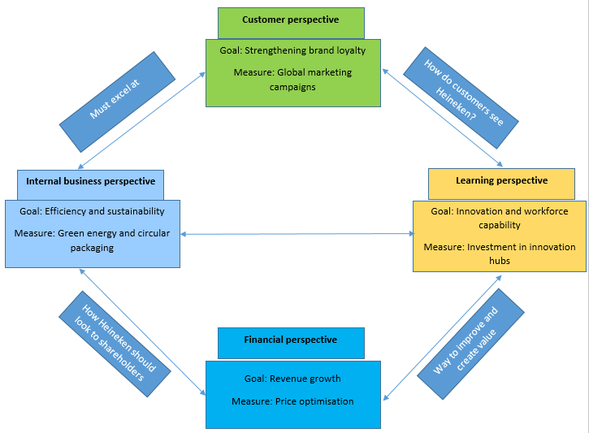
Figure 5: Balance Scorecard of Heineken
(Source: Self-developed)
Financial perspective
The financial lens indicates a strategic change towards growing in volume to growing in value. The net revenue growth of Heineken stood at approximately 5% in 2024, even though the volume growth was poor, meaning that it has to rely on pricing and premiumisation to maintain margins. This is in line with the expectations of shareholders, but it exposes the company to the risks of demand elasticity in an inflationary environment (Ropele, Gorodnichenko and Coibion, 2022). Pricing power and affordability have to be balanced to make profits, especially in emerging markets where income sensitivity is more pronounced.
Customer perspective
Customer attitude focuses on brand equity and the shifting consumption behaviour. Health-conscious consumers and the younger generation are important to the relevance of the premium brands and Heineken 0.0. The low and no-alcohol market is responsive to the changes in moderation, but consumer loyalty is becoming more divided with the help of craft substitutes and changed preferences (Anderson, 2023). Brand investment is also needed, but the differentiation is decreasing since the competitors are doing the same.
Internal business perspective
Internal business processes pay attention to the operational efficiency and supply chain resilience. Inflationary pressure has shown good performance in terms of cost savings of more than 0.6 billion euros in 2024. The improvement of efficiencies helps in maintaining the stability of the margin; however, they do not contribute towards long-term benefit, as the competitors also employ the same cost optimisation approaches.
Learning perspective
Digital capabilities and innovation are the focus of learning and development. Portfolio transformation is supported with investment in product innovation, especially in the non-alcoholic drink category. Customer targeting and distribution are improved through digital marketing and data analytics (Theodorakopoulos and Theodoropoulou, 2024). Technological capabilities are highly ubiquitous throughout the industry, and therefore, they are restrained in their capabilities of creating long-term differentiation.

4.2 Analysis of Objectives, Key Performance Indicators (KPIs), Targets, and Initiatives
Financial goals give a focus on revenue increase by premiumisation and cost effectiveness. The key performance indicators are the net revenue growth, operating profit margin and savings of costs. Targets look into the increased growth in the middle of the single digits of revenue and the expansion of the margins (Hayden and Dasilva, 2022). Strategy initiatives comprise price optimisation, portfolio premiumisation and continuous cost reduction programmes. This is a change in scale to profitability, though it makes it more susceptible to consumer price resistance.
The objective of customers is to leverage brand commitment and penetration of health-conscious segments. KPIs entail brand market share, growth of the premium segment and the sales of non-alcoholic products (Kamińska, Dmowsk, and Marjańska, 2024). Goals include sustained growth in Heineken 0.0 in the doubles and a greater share in the premiums. Some of the initiatives are global marketing campaigns, sponsorships, and the growth of alcohol-free products.
Internal process goals look at efficiency, sustainability and resiliency of the supply chain. Some of the KPIs are the cost per hectolitre of production, carbon emissions, water use, and the rate of packaging recyclability. Targets are net-zero operations by 2030 and more use of renewable energy. The efforts include green energy investment, circular packaging, and logistics optimisation. These are less risky in terms of regulations and operating expenses; however, they involve huge capital expenditure.
Educational and development goals give more focus to innovation and labour ability. KPIs are investment in research and development, rates of product innovation, and productivity of the employees (Kwee, Yaghmaei and Flipse, 2021). The targets will be the development of the low and no-alcohol range and increasing the digital experience. The programs involve investing in innovation centres, online marketing, and training of employees.

5. Strategic Choices and Implementation

5.1 Evaluation of the Strategic Choices at the Business Level and Corporate Level, and the Justification of the Selection
Business level
Cost leadership can be structurally challenged at the business level. Brewing is a business that has high fixed costs and is susceptible to unpredictable input prices, including barley and energy. Heineken does not have the scale advantage of Anheuser-Busch InBev, which manufactures larger volumes and greater cost efficiencies (Voltz, 2023). Price competition would reduce the margins without volume increases, especially in the mature European markets where demand is plateauing.
Premiumisation will enable Heineken to enjoy superior margins and less sensitivity to falling consumption. The strategy is supported by the development of high-quality brands and non-alcoholic products. Differentiation is, however, getting smaller with competitors copying premium positioning as well as growing alcohol-free portfolios (Furlan and Ren, 2025). It could be argued that this strategy can be sustained through constant brand investment and innovation, and not the uniqueness of the product alone. The business-level strategy that is recommended is the differentiation of premium branding in health-oriented innovation.
Corporate level
International expansion and diversification at the corporate level have different trade-offs. The move to have non-alcoholic drinks and other related line-ups would minimise reliance on the waning beer sales. The world non-alcoholic market is growing more rapidly than conventional beer and has the potential to grow in the long term. Non-beverage diversification, however, is a threat to watering down the brand and focus of operation.
Justification of choice
Related diversification into low and no-alcohol products, thus, makes more sense than unrelated diversification. International expansion is always necessary but not exclusive. The emerging markets like India, Vietnam, and Brazil are focused on the growth opportunities where demographic trends are in favour of increasing consumption (Mahmood et al., 2023). The proposed corporate approach includes geographic growth in the high-growth markets and associated diversification in the low and non-alcohol segments. This is the tradeoff between growth and managing risks, and is consistent with the current capabilities.

5.2 Change Management and its Impact on Strategic Implementation
Heineken has shown partial success in handling strategic change, especially changing its volume-based growth strategy to value-based strategies. Profitability has been stabilised through the shift to premiumisation and cost discipline, even in the face of inflationary pressure (Sanjeev and Yadav, 2026). The growth of Heineken 0.0 and wider alcohol-free products is a proactive measure to the falling alcohol demand. The company has scaled its products to over 100 markets, which means that the organisation is capable of doing innovation at scale and facilitates flexibility and responsiveness of strategy.
Weaknesses arise in the pace and regularity of effecting changes. Volume stagnation clarifies the point that it is in the mature markets that premiumisation is not entirely compensating for dying demand. The other competitors, like Carlsberg Group, are also diversifying vigorously in related drinks segments, whilst Molson Coors Beverage Company has restructured itself beyond beer into an extensive drinks base. The comparatively smaller diversification of Heineken decreases exposure to new areas of growth and can limit the resilience in the long term (Korálová and Procházková, 2025). External dependencies are also a challenge to change management. Suppliers are a key element of transformation on sustainability, and a significant percentage of emissions exists in Scope 3. This restricts the control and reduces the implementation speed.
Cost control and a portfolio focus have helped in enhancing organisational synchronisation, but strategic execution is not uniform across regions. The new markets bring the growth, and Europe still suffers a structural decline (Diemer et al., 2022). This deviation needs increased regional diversification, but not global strategies. Heineken has been able to handle change well within the context of operational efficiency and incremental innovation, and poorly within the context of structural transformation.

6. Strategic Evaluation and Recommendations

6.1 Current Strategy
Application of BCG Matrix
The portfolio of Heineken indicates the absence of consistency in value creation in the opinion of the BCG Matrix. The core Heineken brand is a "Star" in the high-end segment with robust growth and relative market share. In 2024, high-end beer volumes grew at a higher rate than the total portfolio, which underlines the fact that it is the main contributor to profitability (Fernando et al., 2023). On the contrary, mainstream lager brands are Cash Cows as they are able to produce stable cash flows but suffer structural deterioration in mature European markets where per capita consumption of alcohol is still decreasing.
The low and non-alcoholic portfolio of Heineken 0.0 is a Question Mark. The segment is expanding at a very fast rate and is more than 13 billion dollars in the world, but the market share is a point of contention, as other competitors are ramping up similar products. Its long-term strategy requires long-term investment and brand differentiation (Farida and Setiawan, 2022). Some of the regional or heritage brands will run the risk of being dogs, especially in saturated markets where there is little growth and high competitive intensity. Holding these assets is a waste of capital with no major strategic payback.

6.2 Recommendations for Improving Strategy and Boosting Competitive Advantage
Re 1: Invest in the low or no-alcohol market
This strategy will involve diversifying the product beyond beer to functional and flavoured beverages. The strategy followed by the Carlsberg Group, which ventured into soft drinks. The energy drinks market in Asia can illustrate the capacity of the related category expansion in enhancing resiliency in the face of falling beer demand (Rostami et al., 2024). There is a need to rationalise the portfolio to deal with Dog brands that are not performing well. Liquidating or rebranding of non-growing assets would free up capital to grow areas. This is in line with the principle of resource allocation, where high returns are considered.
Re 2: Penetration in emerging markets by using local products
India and Vietnam demand is developing and requires affordability and premium positioning, which implies a dual approach of affordable and premium Indian products, as well as the local brands. The digital transformation must be focused not on marketing support, but value creation by direct-to-consumer channels and data-driven pricing. This would help decrease the middleman dependence and increase margin capture.

6.3 Justification of Recommendations
The recommendations are consistent with the Resource-Based View, which focuses on the redeployment of valuable and non-common capabilities to growth markets. The brand equity and distribution network of Heineken can be used to provide beyond the conventional beer to other related categories, where it yields more returns on the available resources (Martins, 2021). A good example comes in PepsiCo, in which the diversification of the beverages and snacks segments stabilises income streams and eliminates category-related risk. Ansoff Matrix justifies associated diversification in non-alcoholic drinks as a strategy of product development in the given markets. This minimises risk as opposed to unrelated diversification and meets the new demand. This can be justified by the fact that evidence indicates that the non-alcoholic segment is expanding more than the traditional beer segment. The BCG Matrix also lays more stress on capital diversion between the Cash Cows and the expansion segments. Unilever has already used this reasoning by selling low-growth brands and investing in health and sustainability-oriented products to enhance long-term growth opportunities (Modreanu et al., 2022). Premium positioning is being copied by competitors, and uniqueness is being diminished.

Section 2

Gibbs Reflective Cycle
Description
My research is designed with a solid purpose to critically analyse the strategy of Heineken based on integrated rather than individual tools. I start with locating reputable academic materials through databases like ScienceDirect and Emerald, and company reports and presentations to investors. Industry reports, company annual reports and CSR reports are other materials that I have used to understand the current strategies of the firm. Use of methodological rigour and direct relevance to strategy filters to eliminate sources that are general commentary on the industry (Annamalah et al., 2025). The application of PESTEL has determined external forces, including regulatory restrictions and changing consumer behaviour. I then use VRIO to evaluate the responsiveness of internal capabilities to these pressures. I employ the Balanced Scorecard to relate strategy with quantifiable results and the BCG Matrix to identify balance in the portfolio.
Feeling
I usually feel confused in the initial stage because of the amount of available information and the ability to maintain a critical focus. I am personally getting involved in overdoing the descriptive bits, thus reducing the analytical value. This is frustrating since the arguments are not precise and clear. The narrower I make my search to the good sources, the more confident I become. The combination of frameworks provides me with a better sense of direction, and I start to perceive how various tools of analysis are related to each other. I am conscious of constraints during the process. I doubt the accuracy of the information announced by the company, and I understand that it may be biased. This puts me on high alert for interpreting evidence. This warning proves beneficial with time because it improves my critical assessment instead of restraining it.
Evaluation
It is an effective process in the production of a structured and evidence-based analysis. The application of various frameworks can enable me to view the organisation from various perspectives, which enhances the level of evaluation. I have been able to associate external forces and inner abilities, and this makes the overall argument stronger. One of the strengths is to concentrate on the latest and most believable evidence (Holt‐Lunstad, 2024). This also makes sure that the analysis is based on the existing industry dynamics, including premiumisation and the development of non-alcoholic beverages. It increases the applicability and validity of my conclusions. Some of the sections are limited in depth as I depend on secondary data, hence limiting my capacity to record real-time strategic decisions. There are frameworks that reduce the complex realities, with the BCG Matrix being one of them, which involves assumptions on market growth and share (García-Vidal et al., 2023). I also realise that I am prone to focusing on evidence that confirms my stand and not venturing into opposing views. There is also a time factor that affects the degree of critical engagement. I am centred on accomplishing all the parts, but this limits the chances of delving deeper into other strategic choices.

Analysis
I realise that the success of my work is determined by the ability to incorporate frames rather than the number of applied frameworks. PESTEL identifies the external limitations, such as regulation and shifting consumer behaviour. VRIO then evaluates whether the capabilities of Heineken have a long-term response. This shows that brand equity is long-term beneficial, and operational efficiency is not, and this congruency enhances the level of analysis (Winit and Kantabutra, 2022). The Balanced Scorecard assists in linking strategy to performance indicators. I can see that pricing and not volume lead to financial growth, which is an indication that the strategy has changed. This knowledge only comes when I critically analyse information and do not perceive it at face value.
BCG Matrix gives a portfolio view, which reveals premium brand concentration risk. This is a reason why I recommend diversification. Simultaneously, I recognise the drawbacks of the framework. It makes the strategy less complicated and does not entirely reflect the dynamic market conditions. Becoming aware of these limitations will help me not to over-emphasise one model. My more critical attitude towards evidence has also developed. I do not make revenue growth a positive result on its own. I comparatively analyse it with weak volume growth, which means dependence on pricing strategies. This strategy enables the finding of deep-rooted strategic tensions and the integration of educational ideology and actual evidence. The source materials produced by academics give conceptual clarity, whereas the company reports present up-to-date information.
Conclusion
I conclude that my strength is that of integration, selectivity and critical interpretation. The numerous frameworks used give a complete picture of the organisation, but it is the relationship that is valuable. The analytical relevance is enhanced by the fact that I focus on the new and authoritative evidence. I see weaknesses in the critique level and the use of secondary data. I also realise how I should become more active in challenging my own assumptions. The plan enhances my skill in using theoretical knowledge in practice and my capability to get out of descriptive writing.

Action plan
- I intend to enforce my reliance on academic literature by getting more involved in peer-reviewed journals. This will enhance the theoretical basis and minimise the use of data reported by companies.
- I will utilise fewer frameworks but critically put them into practice. This will bring about clarity and enable one to analyse more than just go through the surface.
- The second area I will work on is time management, where I will set designated periods of research, analysis and revision. This will provide more room for critical reflection and analysis of other views.
- I will also be vigorous in finding compelling evidence to refute my points. This will minimise prejudice and enhance the strength of my findings.
- I will look forward to avenues of using primary data or case-based information to increase the knowledge on strategic decision-making.
- I will also keep enhancing my writing skills, and one way of doing it is to be precise and critical in depth with each point, adding value to the argument.

References
Anderson, K. (2023) ‘The emergence of lower-alcohol beverages: The case of beer’, Journal of Wine Economics, 18(1), pp. 66–86. Available at: https://doi.org/10.1017/jwe.2023.8.
Annamalah, S., Aravindan, K.L., Ahmed, S. and Sentosa, I. (2025) ‘Exploring the relevance and rigour of case study research in business: A contemporary perspective’, Journal of Sustainability Research, 7(2). Available at: https://doi.org/10.20900/jsr20250032.
Arthur, R. (2025). Premium brands continue to shine for Heineken, BeverageDaily.com. Available at: https://www.beveragedaily.com/Article/2025/02/13/premium-brands-continue-to-shine-for-heineken/ (Accessed: 16 March 2026).
Bouis, R., Capelle, D., Dell' Ariccia, G., Erceg, C., Martinez, M., Sy, M., Teoh, K. and Vandenbussche, J. (2025) SUERF Policy Brief Navigating Trade-Offs between Price and Financial Stability in Times of High Inflation Navigating Trade-Offs between Price and Financial Stability in Times of High Inflation. Available at: https://www.suerf.org/wp-content/uploads/2025/06/SUERF-Policy-Brief-1196_Bouis_Capelle-et-al.pdf (Accessed: 14 March 2026).
Businessbar (2021) What’s brewing in the Beer business? | BusinessBar, BusinessBar | Find stories where business meets casual and numbers meet narratives! Available at: https://businessbar.net/all/whats-brewing-in-the-beer-business/ (Accessed: 21 March 2026).
Diemer, A., Iammarino, S., Rodríguez-Pose, A. and Storper, M. (2022) ‘The Regional Development Trap in Europe’, Economic Geography, 98(5), pp. 1–23. Available at: https://doi.org/10.1080/00130095.2022.2080655.
Dunne, A., Malec, P., Shank, A., Foral, E. and Rethmeier, H. (2023) A strategic audit of a company in the alcoholic beverages A strategic audit of a company in the alcoholic beverages industry: Anheuser-Busch inbev industry: Anheuser-Busch inbev part of the strategic management policy commons. Available at: https://digitalcommons.unl.edu/cgi/viewcontent.cgi?article=1643&context=honorstheses (Accessed: 16 March 2026).
Erl , L. and Kiesel, F. (2021) Divestiture and Its Market Reaction in a Consolidating Industry: The Global Brewing Industry. Available at: https://bia.unibz.it/esploro/fulltext/journalArticle/Divestiture-and-Its-Market-Reaction-in/991006568798701241?repId=12300128870001241&mId=13300108770001241&institution=39UBZ_INST (Accessed: 20 March 2026).
Euro Next (2025) Heineken Holding N.V. reports 2024 full year results, Euronext.com. Available at: https://live.euronext.com/en/products/equities/company-news/2025-02-12-heineken-holding-nv-reports-2024-full-year-results (Accessed: 18 March 2026).
Farida, I. and Setiawan, D. (2022) ‘Business Strategies and Competitive advantage: the Role of Performance and Innovation’, Journal of Open Innovation: Technology, Market, and Complexity, 8(3), p. 163. Available at: https://doi.org/10.3390/joitmc8030163.
Fernando, J., De, A., Marques, Q., Ribeiro and Gomes, E. (2023) INTERNATIONALIZATION PROJECT OF COCKTAIL TEAM. AN IN-DEPTH ANALYSIS OF THE UK AND LITERATURE REVIEW ON ENTRY MODES OF SMALL AND MEDIUM ENTERPRISES Work project carried out under the supervision of. Available at: https://run.unl.pt/bitstream/10362/171148/1/Internationalization_project_Cocktail_team_Fall_FernandoRibeiro.pdf (Accessed: 21 March 2026).
Furlan, P. and Ren, A. (2025) ‘RAISING THE BAR, LOWERING THE ABV: Strategic Future Planning for the Spirit-Free Industry - Open Research Repository’, Ocadu.ca [Preprint]. Available at: https://openresearch.ocadu.ca/id/eprint/4669/1/Furlan_Paige_Ren_Allison_2025_MDES_SFI_MRP_.pdf.
García-Vidal, G., Sánchez-Rodríguez, A., Pérez-Campdesuñer, R. and Martínez-Vivar, R. (2023) ‘Contribution margin and quantity matrix to analyze the product portfolio in the context of SMEs. Criticism of the BCG matrix and its alternatives’, Cogent Business & Management, 10(3). Available at: https://doi.org/10.1080/23311975.2023.2233272.
Gielens, K., Ma, Y., Namin, A., Sethuraman, R., Smith, R.J., Bachtel, R.C. and Jervis, S. (2021) ‘The Future of Private Labels: Towards a Smart Private Label Strategy’, Journal of Retailing, 97(1), pp. 99–115. Available at: https://doi.org/10.1016/j.jretai.2020.10.007.
Hayden, A. and Dasilva, C. (2022) ‘The wellbeing economy: Possibilities and limits in bringing sufficiency from the margins into the mainstream’, Frontiers in Sustainability, 3. Available at: https://doi.org/10.3389/frsus.2022.966876.
Heineken (2024a) 2030 Strategy Booklet, The HEINEKEN Company. Available at: https://www.theheinekencompany.com/sites/heineken-corp/files/2024-06/BABW%202030%20Strategy%20Booklet%20-%20June%202024.pdf (Accessed: 18 March 2026).
Heineken (2024b) Report of the Executive Board. Available at: https://www.theheinekencompany.com/sites/heineken-corp/files/2025-02/heineken_n_v_annual_report_2024_final_20feb2025.pdf (Accessed: 24 March 2026).
Heineken (2025a) Heineken Media release, Otcmarkets.com. Available at: https://www.otcmarkets.com/file/company/financial-report/421740/content (Accessed: 24 March 2026).
Heineken (2025b) Heineken N. V. Investor Presentation. Available at: https://www.theheinekencompany.com/sites/heineken-corp/files/heineken-corp/investors/results-reports-webcasts-presentations/2025/heineken-investor-presentation-may-2025.pdf (Accessed: 15 March 2026).
Heineken (2025c) Heineken N.V. Annual Report 2025. Available at: https://www.theheinekencompany.com/sites/heineken-corp/files/2026-02/2025_Heineken_NV_Annual_Report_Interactive_100226_FINAL.pdf (Accessed: 16 March 2026).
Heineken (2025d) Heineken simplifies sustainability goals, Foodservice Footprint. Available at: https://foodservicefootprint.com/heineken-simplifies-sustainability-goals/ (Accessed: 24 March 2026).
Heineken International B.V (2025a) 2025 OUTLOOK FOR 0.0 CATEGORY LOOKS POSITIVE, BUT STILL SOME SOCIAL BARRIERS TO OVERCOME, 2025 OUTLOOK FOR 0.0 CATEGORY LOOKS POSITIVE, BUT STILL SOME SOCIAL BARRIERS TO OVERCOME. Heineken International B.V. Available at: https://www.theheinekencompany.com/newsroom/2025-outlook-for-00-category-looks-positive-but-still-some-social-barriers-to-overcome/ (Accessed: 23 March 2026).
Heineken International B.V (2025b) Festive freedom: Why saying ‘no thanks’ to alcohol is the new normal, Festive freedom: Why saying ‘no thanks’ to alcohol is the new normal . Heineken International B.V. Available at: https://www.theheinekencompany.com/newsroom/festive-freedom-why-saying-no-thanks-to-alcohol-is-the-new-normal (Accessed: 24 March 2026).
Holt‐Lunstad, J. (2024) ‘Social connection as a critical factor for mental and physical health: evidence, trends, challenges, and future implications’, World Psychiatry, 23(3), pp. 312–332. Available at: https://doi.org/10.1002/wps.21224.
KAMIŃSKA, A., DMOWSK, P. and MARJAŃSKA, E. (2024) ‘Availability conditions as a critical factor in product category management in shaping the offer of non-alcoholic equivalents of alcoholic beverages’, Scientific Papers of Silesian University of Technology Organization and Management Series, 2024(207). Available at: https://doi.org/10.29119/1641-3466.2024.207.12.
Korálová, E. and Procházková, P.T. (2025) ‘Sustainable Finance and Carbon Neutrality in the Brewery Industry: Challenges and Opportunities’, ACC JOURNAL, 31(2), pp. 43–58. Available at: https://doi.org/10.2478/acc-2025-0009.
Kwee, Z., Yaghmaei, E. and Flipse, S. (2021) ‘Responsible research and innovation in practice an exploratory assessment of Key Performance Indicators (KPIs) in a Nanomedicine Project’, Journal of Responsible Technology, 5, p. 100008. Available at: https://doi.org/10.1016/j.jrt.2021.100008.
Listabarth, S., Grömer, M., Waldhoer, T., Vyssoki, B., Pruckner, N., Vyssoki, S., Glahn, A., Deirdre Maria König-Castillo and König, D. (2022) ‘Cognitive decline and alcohol consumption in the aging population—A longitudinal analysis of the Survey of Health, Ageing and Retirement in Europe’, European Psychiatry, 65(1). Available at: https://doi.org/10.1192/j.eurpsy.2022.2344.
Mahmood, A., Farooq, A., Akbar, H., Ghani, H.U. and Gheewala, S.H. (2023) ‘An Integrated Approach to Analyze the Progress of Developing Economies in Asia toward the Sustainable Development Goals’, Sustainability, 15(18), p. 13645. Available at: https://doi.org/10.3390/su151813645.
Martins, F. (2021) EQUITY RESEARCH HEINEKEN N.V. BREWING FOR THE FUTURE! Available at: https://run.unl.pt/bitstream/10362/144700/1/27608_gon_alo_miguel_martins_duarte_dos_santos_2020-21_fall_44039_goncalo_santos_211803_679711189-1.pdf (Accessed: 24 March 2026).
Modreanu, A., Andrișan, G.N., Sârbu, A.-M. and Grădinaru, C. (2022) ‘Corporate Social Responsibility, a Strategic Tool for Sustainable Value Creation: a Case Study of Unilever’s Sustainable Living Plan’, New Trends in Sustainable Business and Consumption [Preprint]. Available at: https://www.academia.edu/download/118779697/076.pdf (Accessed: 19 March 2026).
Oliveira, L. (2024) The World Connected Brewer Equity Research in the beer IndustryHeineken N.V. Available at: https://run.unl.pt/bitstreams/fbf30c76-c61d-424b-92c7-6b2cafd45ef8/download (Accessed: 17 March 2026).
Ropele, T., Gorodnichenko, Y. and Coibion, O. (2022) ‘Inflation Expectations and Corporate Borrowing Decisions: New Causal Evidence’, SSRN Electronic Journal [Preprint]. Available at: https://doi.org/10.2139/ssrn.4241593.
Rostami, M., Babashahi, M., Ramezani, S. and Hadis Dastgerdizad (2024) ‘A scoping review of policies related to reducing energy drink consumption in children’, BMC Public Health, 24(1). Available at: https://doi.org/10.1186/s12889-024-19724-y.
Sanjeev, K. and Yadav (2026) The Effect of Inflation and Interest Rate Changes on Corporate Financial Performance. Available at: https://www.a-fl-insight.com/vol-15/91.pdf (Accessed: 22 March 2026).
Scheel, C. and Aguiñaga, E. (2025) ‘A Systems View of Circular Economy’, Sustainability, 17(3), p. 1268. Available at: https://doi.org/10.3390/su17031268.
Serviss, M.T., Hout, D.V., Britton, S.J. and MacIntosh, A.J. (2025) ‘Brewing for the Future: Balancing Tradition and Sustainability’, Journal of the American Society of Brewing Chemists, pp. 1–19. Available at: https://doi.org/10.1080/03610470.2025.2509059.
Statista (2024a) Employees of Heineken by region 2024| Statista, Statista. Available at: https://www.statista.com/statistics/269136/employees-of-the-heineken-group-by-region/?srsltid=AfmBOopD8z77sVpq5uORpI-tKGdOHznovjEiisUwbjDd34EFaqs8W5h_ (Accessed: 16 March 2026).
Statista (2024b) Heineken N.V. revenue 2024| Statista, Statista. Available at: https://www.statista.com/statistics/516457/heineken-revenue-worldwide/?srsltid=AfmBOopewMLOtM7egmDZtyRsudX8UYUYt6smoue0tSiwEwgaxMSGBA0W (Accessed: 18 March 2026).
The Global Economy (2024) Netherlands Political stability - data, chart, TheGlobalEconomy.com. Available at: https://www.theglobaleconomy.com/Netherlands/wb_political_stability/ (Accessed: 14 March 2026).
Theodorakopoulos, L. and Theodoropoulou, A. (2024) ‘Leveraging Big Data Analytics for Understanding Consumer Behavior in Digital Marketing: a Systematic Review’, Human Behavior and Emerging Technologies, 2024(1), pp. 1–21. Available at: https://onlinelibrary.wiley.com/doi/full/10.1155/2024/3641502?msockid=2a94fca733156bef1b09e8bc32696a91 (Accessed: 19 March 2026).
Trading Economics (2024a) Netherlands GDP, Tradingeconomics.com. TRADING ECONOMICS. Available at: https://tradingeconomics.com/netherlands/gdp (Accessed: 20 March 2026).
Trading Economics (2024b) Netherlands Inflation Rate, Tradingeconomics.com. TRADING ECONOMICS. Available at: https://tradingeconomics.com/netherlands/inflation-cpi (Accessed: 18 March 2026).
Trading Economics (2024c) Netherlands unemployment rate, Tradingeconomics.com. TRADING ECONOMICS. Available at: https://tradingeconomics.com/netherlands/unemployment-rate (Accessed: 18 March 2026).
Voltz, L. (2023) Equity research on AB InBev – context and overview of the global beer industry. Available at: https://run.unl.pt/bitstreams/8f3107c3-d171-4f31-99f4-8461143724d9/download (Accessed: 24 March 2026).
Winit, W. and Kantabutra, S. (2022) ‘Enhancing the Prospect of Corporate Sustainability via Brand Equity: A Stakeholder Model’, Sustainability, 14(9), p. 4998. Available at: https://doi.org/10.3390/su14094998.

