University of Wales Trinity Saint David

Wales Institute of Science & Art



Research Proposal and Presentation
Research Methods (ACHA_7027)

Benjamin Ellis-Jones
2204298
(04/2026)
Contents
Title 2
Introduction 2
Background information / context 2
Research Problem 2
Variables / Focus of Study 3
Methodology 3
Scope of the study 5
Literature review 5
Brief History of aerodynamics in motorsport 5
Aerodynamic testing equipment 6
Wind tunnel 6
CFD 7
Track testing 8
Open wheel and single seater vehicle design 9
Gnatt chart 11
References 11

Figure 1- Open Loop Wind tunnel design (Senft & Gillian, 2019) 6
Figure 2 - Closed Loop wind tunnel design (Senft & Gillian, 2019) 7
Figure 3 - Navier-Stokes equations (Tim Tudor, Lecture notes) 8

Title
The title of this project is:
Aerodynamic adaptation of the Mygale M21-F4 for chapter 14 of the FIA National Competition Rules.

Introduction

Background information / context
Vehicle design focus in motorsport has evolved significantly, from reliance on mechanical grip to the aerodynamic focused designs that we see today. As Katz observes, in motorsports, vehicle aerodynamics has gained increased attention in recent years, primarily due to the utilisation of negative lift or downforce. While drag reduction and fuel efficiency remain important considerations, it is the generation of downforce that provides the most significant competitive advantage. (Katz, 2006)

Research Problem
In junior categories such as Formula 4 (F4), restrictions from aerodynamic regulations are deliberate and significant. The category operates as a spec series, where chassis, engine, and aerodynamic specifications are tightly controlled to ensure a competitive field and limit costs. Downforce is such a powerful performance variable that its generation is expressly restricted or forbidden in several junior formula series so that drivers learn to manage it progressively as they advance through the ranks (Katz, 2006) (McBeath, 2011).
The Mygale M21-F4 was introduced in 2021 as a next generation F4 chassis. It features a carbon fibre monocoque, halo safety feature and adjustable front and rear wings. (FFSA Academy, n.d.)
A clear research opportunity arises as the M21-F4 will be raced in the HAS Sprint Championship, which operates under the UK National Competition Rules (NCR), Chapter 14. These rules impose considerably more relaxed aerodynamic restrictions than the FIA F4 regulations. McBeath identifies that when regulations permit greater geometric freedom significant improvements in downforce generation and aerodynamic balance become achievable through an iterative development process. (McBeath, 2011)
This study will investigate the extent to which the aerodynamic performance of the Mygale M21-F4 can be improved through design modifications permitted under NCR Chapter 14 but not under the FIA F4 regulations.
Aims:
- Shift the aerodynamic balance of the vehicle forwards
- Increase overall downforce generation
- Improve aerodynamic efficiency

Variables / Focus of Study
This study focuses on evaluating how changes in vehicle design influence aerodynamic performance. The independent variable is the modifications to vehicle geometry, and the dependent variables are the resulting aerodynamic forces and coefficients. The control variable is the testing methodology.

Methodology
This study adopts a combined computational and experimental approach to evaluate the aerodynamic performance of the vehicle under a baseline configuration and with a series of design modifications.

CFD
Computational Fluid Dynamics (CFD) simulations will be conducted using ANSYS Fluent. A CAD model of the vehicle will be placed within a computational domain with boundary conditions applied to replicate on track operating conditions. The domain will be discretised into a finite mesh, with Bodies of Influence (BOI) regions used to ensure adequate mesh refinement in aerodynamically critical areas such as the front wing, rear wing, and underbody. A mesh independence study will be conducted to confirm that the solution is not sensitive to mesh resolution, following best practices established in the literature.
The turbulence model will be selected following a comparative evaluation during the validation phase. The k-ω SST model is identified in the literature as the most widely used and reliable model for race car aerodynamic simulations due to its superior near-wall treatment and ability to predict flow separation (MENDONÇA DE FREITAS, et al., 2025) (Joslin & Brinklow, 2025) (Lanfrit, 2005).

Validation
Validation will be conducted by comparing CFD results against on-track data obtained through pressure taps mounted on the vehicle surface. The CFD methodology will be developed with the aim of representing track conditions as accurately as possible, and results will be assessed based on the agreement between simulated and measured pressure distributions.

Iterative design process
This study will follow an iterative design process. The baseline vehicle in its current configuration will be simulated first to establish reference aerodynamic performance data. Based on analysis of the baseline results, a modified geometry will be designed incorporating changes permitted under NCR Chapter 14. This modified configuration will then be tested with CFD and the results analysed, informing the next design iteration. This process will repeat, targeting approximately three design iterations, though this is subject to change due to the potential for meshing errors.

Post processing
Post-processing of both simulation and experimental data will include the generation of aerodynamic maps (aero maps), surface pressure distribution plots and front-to-rear aerodynamic balance data.. CFD will be used to produce surface plots as well as flow visualisation images including streamlines and vorticity contours. The key output metrics will be the coefficients of lift and drag and the front-to-rear downforce balance, which directly affects vehicle handling characteristics.
Given the inherent limitations of CFD simulations, the analysis will focus on the relative magnitude of changes between configurations rather than absolute predicted values.

Limitations
CFD simulations are subject to inherent limitations including turbulence modelling assumptions, simplified geometry representation, and idealised boundary conditions that do not fully replicate real-world on-track variability.
Track testing is subject to environmental variability and uncontrollable external conditions. These limitations will be acknowledged throughout the analysis and results interpreted accordingly.

Scope of the study
The scope of this study is limited to aerodynamic analysis and does not extend to suspension, powertrain, or structural considerations. Results are subject to the inherent limitations of CFD simulation, including turbulence modelling assumptions, simplified geometry, and idealised boundary conditions.

Literature review

Brief History of aerodynamics in motorsport
The introduction of aerodynamics into racing, particularly in Formula One, initially focused on drag reduction to improve straight-line speed. It was slowly adopted and saw some initial criticism most notably from Enzo Ferrari who famously said “aerodynamics are for people who can’t build engines” in 1960. The exact phrasing of the quote is contested but, in all variations, it reflects the initial resistance to aerodynamic innovations in motorsport. (Ulrich, 2024)
A major shift occurred in 1968, when Formula One teams began introducing aerodynamic wings as performance devices. The first wings appeared at the Monaco Grand Prix on the Lotus 49B (Lotus cars, n.d.). Shortly after, at the Belgian Grand Prix, teams including Ferrari and Brabham introduced more developed rear wings. To maximise their effectiveness, these wings were mounted high in relatively undisturbed airflow. However, these early designs were structurally fragile, and several failures during the 1969 season led to high-mounted and movable wings getting banned (Broderick, 2023). Despite these issues, the introduction of aerofoils marked a fundamental transformation in race car design, shifting the focus from purely mechanical grip to aerodynamic load generation. This innovation established aerodynamics as a dominant factor in motorsport performance. (Fagnan, 2018)
The 1970s saw one of the most significant innovations in the sport's history: ground effect aerodynamics. In 1977, team lotus produced the Lotus 78 which was the first successful example of ground affect in formula one using shaped sidepods to create low-pressure regions beneath the car, effectively “sucking” it to the track. This concept was further refined in the Lotus 79 the following year, which demonstrated the competitive advantage of ground effect vehicles by dominating the world championship that year. (Total Motorsport, 2025)
In modern Motorsport, design focus has shifted from isolated aerodynamic components to holistic airflow management, where the entire vehicles geometry contributes to overall performance.

Aerodynamic testing equipment
The three main aerodynamic testing methods include CFD, wind tunnel and track testing. Each method offers distinct advantages and limitations, and current research highlights that the most reliable aerodynamic development is achieved through strong correlation between all three approaches (Senft & Gillan, 2019).

Wind tunnel
Wind tunnel testing recreates on-track aerodynamic conditions by passing airflow over a vehicle or scale model at controlled speeds. Test facilities are categorised as either open or closed loop designs.
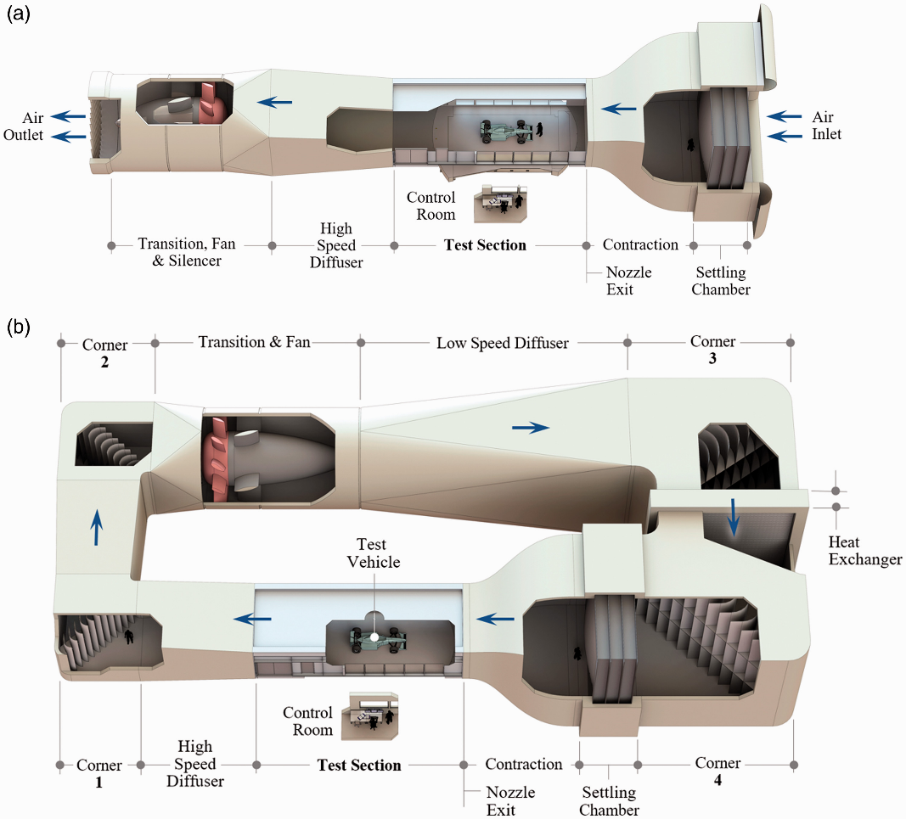
Figure 1- Open Loop Wind tunnel design (Senft & Gillian, 2019)

An open loop wind tunnel draws air from the surrounding environment, accelerates it through a contraction, and passes it over the test model before exhausting it back to the atmosphere as seen in Figure 1. The Advantages of an open loop design include lower construction and operational costs, as well as reduced thermal build-up due to continuous intake of ambient air. However, flow quality is inherently less controlled, with increased turbulence intensity and sensitivity to external environmental conditions such as temperature and pressure.

Figure 2 - Closed Loop wind tunnel design (Senft & Gillian, 2019)

Figure 2 shows a closed loop wind tunnel design where the air is recycled in the tunnel instead of released after it passes through the test section.
After passing through the test section, the airflow is diffused, redirected through turning vanes, cooled, and straitened before re-entering the contraction. This design provides better control of the test environment allowing for improved flow quality and more consistent testing conditions. However, these systems are more complex and expensive to design and operate and require additional cooling systems to manage heat build-up within the circuit.
State of the art wind tunnels are typically closed loop systems and include features such as moving ground planes, rolling road systems, and boundary layer controls to better replicate real world conditions and improve correlation with track data . (Senft & Gillan, 2019)

CFD
CFD is a numerical approach used to predict fluid flow by solving the governing Navier-Stokes equations, which describe the conservation of mass, momentum, and energy within a fluid (ANSYS, n.d.).
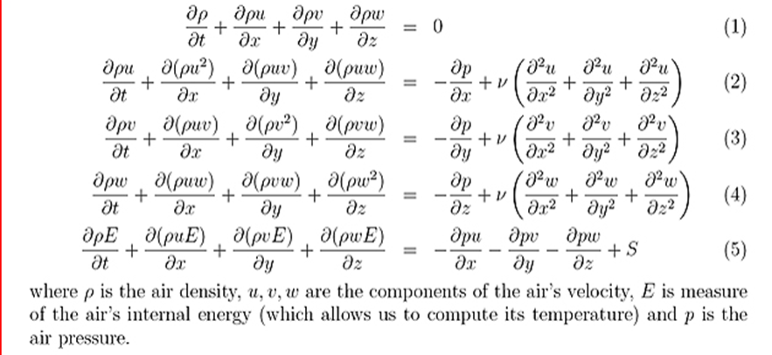
Figure 3 - Navier-Stokes equations (Tim Tudor, Lecture notes)

A CAD model of the vehicle is placed within a computational domain, where boundary conditions are applied to replicate the operating environment of the test subject. The domain is discretised into a finite mesh, and the governing equations are solved at the nodes of every element to determine the pressure and velocity field around the geometry (the Mygale M21-F4).
CFD enables detailed analysis of complex flow structures and allows rapid evaluation of design changes without the need for physical prototypes. Furthermore, optimisation techniques, such as adjoint-based method, allow efficient evaluation of large numbers of design variables (Martinelli, et al., 1998) (Martins, 2022). However, CFD is limited by assumptions in turbulence modelling and is reliant on mesh quality and the applied boundary conditions. These limitations affect CFDs ability to accurately represent real-world conditions which is the most significant limitations in aerodynamic optimisation whilst using CFD (Martins, 2022).

Track testing
Track testing is the most representative data as it is collected during the vehicles operation is it allows engineers to know exactly what is happening when the car is out on track. However, it is less controlled than wind tunnel or CFD testing and is subject to uncontrollable variables.
Pressure taps are commonly used to measure local static pressure across vehicle surfaces, providing data for pressure distribution and aerodynamic loading (Katz, 2006).
Air flow characteristics can be assessed using aero rakes, consisting of pitot tube arrays that measure airflow velocity and direction typically placed within the wake and near body regions, providing insight into flow structures and component performance (McBeath, 2011).
Flow visualisation techniques including flow-vis paint, are widely used to identify flow separation and surface flow patterns (Katz, 2006).
Indirect aerodynamic measurements are obtained through ride height sensors and load measurement systems, which allow estimation of downforce and aerodynamic balance. Despite its limitations, track testing remains essential for validation, and literature emphasises that accurate aerodynamic development depends on effective correlation between experimental and computational methods (Senft & Gillan, 2019) (Katz, 2006).

Open wheel and single seater vehicle design
Open wheel single seater race cars like the Mygale M21-F4 are designed under strict regulations. Other open wheel single seaters such as F1 cars which have more aerodynamic design freedom are designed with a primary focus on maximising aerodynamic performance.
Unlike closed-body vehicles, the exposed wheels introduce a significant aerodynamic problem of complex wake regions generated by rotating wheels which have a negative impact on the aerodynamic performance of any components down stream. This makes airflow management a central design challenge when developing an open wheeled car (Katz, 2006) .
In high-level motorsport, aerodynamic design is treated as an integrated system in which each component contributes to the overall flow field. The front wing is the first component to interact with undisturbed free-stream airflow, conditioning flow for all downstream elements while contributing approximately 25–35% of total vehicle downforce (MENDONÇA DE FREITAS, et al., 2025). The underfloor and diffuser generate the largest proportion of total downforce through ground effect, and their performance is heavily influenced by the rear wing. Brinklow and Joslin demonstrate that the longitudinal position of the rear wing has the greatest influence on underbody performance with a shift of just 100 mm increased the underbody downforce coefficient from 1.55 to 2.00 reinforcing that components must be optimised as a system rather than in isolation. (Joslin & Brinklow, 2025)
Key geometric parameters that affect wing performance include angle of attack, camber, chord length, and element spacing. Downforce generation is significantly influenced by ground proximity, as the pressure differential across an inverted wing is amplified by the ground effect (MENDONÇA DE FREITAS, et al., 2025). Small geometric additions can also yield disproportionate gains. Gurney flaps are a great example of this, despite their simple geometry, they have been shown to downforce by up to 28.19% at a cost of only a 5% reduction in aerodynamic efficiency (MENDONÇA DE FREITAS, et al., 2025).
More recently, flexible wing structures so called flexi-wings have attracted attention as a means of passively adapting aerodynamic geometry under load, offering a potential route to optimising the downforce to drag trade-off across varying speed conditions without active mechanical systems (Mishra, et al., 2022).
Drag management is equally important, as aerodynamic devices that generate downforce inevitably incur a drag penalty. Lui notes that balance between maximising downforce and minimising drag remains a defining challenge in motorsport aerodynamic design and development. Managing the trade off between drag and downforce is essential for all race car design and the optimal balance changes with the race track. For the Mygale M21-F4 operating under the NCR Chapter 14 framework in HAS Sprint competition, the short and technically demanding nature of sprint circuits suggests that a high downforce, drag tolerant aerodynamic configuration will be most appropriate, as cornering performance and mechanical grip are likely to be more influential than top-speed. This context will be a consideration for all proposed design changes. (Liu, n.d.)

Gnatt chart
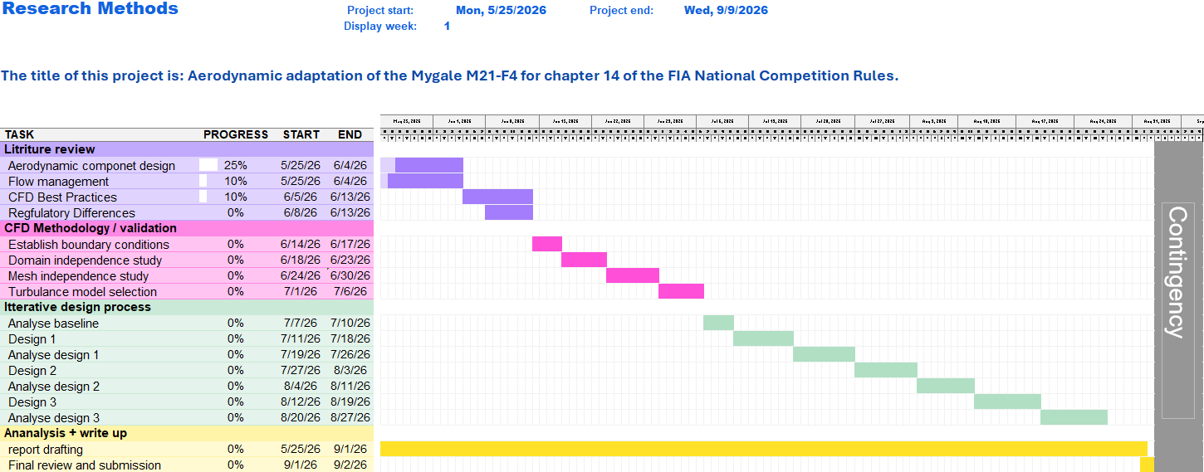

References
Agathangelou, B. & Gascoyne, M., 1998. Aerodynamic Design Considerations of a Formula 1 Racing Car. Detroit, Michigan, United States of America, SAE International.
ANSYS, n.d. 23.5.1. Governing Equations in Vector Form. [Online]
Available at: https://ansyshelp.ansys.com/public/account/secured?returnurl=/Views/Secured/corp/v242/en/flu_th/flu_th_sec_solver_db_eq_vect.html
[Accessed 19 04 2026].
ANSYS, n.d. What is Computational Fluid Dynamics (CFD)?. [Online]
Available at: https://www.ansys.com/simulation-topics/what-is-computational-fluid-dynamics
[Accessed 19 04 2026].
Broderick, S., 2023. The Rise And Fall Of F1's High Wings. [Online]
Available at: https://onmotorsport.substack.com/p/the-rise-and-fall-of-f1s-high-wings
[Accessed 19 04 2026].
Fagnan, R., 2018. The first appearance of wings on Formula 1 cars. [Online]
Available at: https://au.motorsport.com/f1/news/1968-first-wings-f1-1000902/1389077/
[Accessed 19 04 2026].
FFSA Academy, n.d. THE F4 FIA MYGALE. [Online]
Available at: https://www.ffsaacademy.org/championnat-de-france-f4/f4-mygale/?lang=en
[Accessed 19 04 2026].
Hammond, A. R. & Flay, R. G., 2008. AERODYNAMIC DESIGN OF A FORMULA SAE RACE CAR, Auckland: BBAA VI International Colloquium on Bluff Bodies Aerodynamics and Applications.
Joslin, R. & Brinklow, G., 2025. Open wheel competition car rear wing placement and underbody aerodynamic interactions: Aerodynamic design for a competitive advantage in motorsports. Institute of mechanical engineers.
Katz, J., 2006. Race Car Aerodynamics. s.l.:Bentley Publishers.
Lanfrit, M., 2005. Best practice guidelines for handling , Darmstadt, Germany: Fluent Deutschland GmbH.
Liu, Y., n.d. Race Car aerodynamics——Key Roles and Future Trends, Qingdao, China: s.n.
Lotus cars, n.d. Lotus Type 49: Revolutionising F1 with the Cosworth DFV. [Online]
Available at: https://www.lotuscars.com/en-US/lotus-story/race-cars/type-49
[Accessed 19 04 2026].
Martinelli, L., Jamerson, A. & Pierce, N. A., 1998. Optimum Aerodynamic Design Using the Navier–Stokes Equations. Theoretical and computational fluid dynamics, pp. 213-237.
Martins, J. R., 2022. Aerodynamic design optimization: Challenges and perspectives. Computers & Fluids.
McBeath, S., 2011. Competition Car Aerodynamics: A Practical Handbook. 3ed ed. Dorchester, United Kingdom: Veloce Publishing.
MENDONÇA DE FREITAS, C., TELLI, G. D. & ROSA, J. S., 2025. Aerodynamic Influence of Front Wing Geometry on Formula One Car Performance: A Computational Fluid Dynamics Review. SAO Paulo, Brazil, SAE International.
Mishra, S., Singh, S., Sharma, S. & Bhardwaj, D. M., 2022. Flexi wings: An innovative approach for the. International Journal of Mechanical Engineering.
Senft, V. & Gillan, M., 2019. Recent advances and test processes in automotive and motorsports aerodynamic development. Instutution of mechanical engineers.
Total Motorsport, 2025. What is Ground Effect in F1? Formula 1 Ground Effect Explained. [Online]
Available at: https://www.total-motorsport.com/ground-effect-f1-explained/
[Accessed 19 04 2026].
Ulrich, T., 2024. Racing History: The Slippery Tale of Aerodynamics, In the October Issue. [Online]
Available at: https://www.roadracingworld.com/news/racing-history-the-slippery-tale-of-aerodynamics-in-the-october-issue/
[Accessed 19 04 2026].

