Digital Skills and Research Methods

By
Shakhawat Hossain
Student ID: 2030416

Contents
Introduction 3
Objectives 3
Literature Review 3
Research Methodology 4
Sampling Model: 4
Primary Data: 5
Secondary Data: 5
Ethical Consideration: 5
Primary Data Analysis 5
Secondary Data Analysis 9
Recommendation 10
Conclusion 10
Reference 11
Appendix 12

Introduction
Research skill is one of the beneficial skills that, gathered during learning or doing research, enables them to think critically and descriptively about any aspect. Specially this skill helps them when they analyze or evaluate any project or topic. This research report will produce a report on e impact of Virtual Learning Environment (VLE) which is based on the experiences of student’s use of Moodle for their online classes during this neo-normal situation of Covid-19 pandemic. The research report will include objectives of the research and a brief literature review of this topic. The report also contains Research Methodology, mode of data collection and sources; primary and secondary data source of this research. Finally, the report also provides some recommendation based on the research on effects of Virtual Learning Environment (VLE) on students of the university.

Objectives
The research is conducted to achieve some goals and objectives particularly which are important to elaborate. The objectives of this research are–
- The first objective of this research is to assess the impact and influences of Moodle method used by student. More broadly, examining the influences of virtual learning on students.
- Assessing the effectiveness of Moodle as an online learning management system is another objective of this research.
- Evaluating the consequences of using Moodle is another objective. The impact is assessed based on the student’s data.
- Find out the problems of the platform as well as the online learning process.

Literature Review
Virtual Learning Environment is becoming an important topic to discuss because of increasing importance of Online learning process. More specially, the during covid-19 pandemic, this appeal has been increased mostly as it allows learners and teachers to engage with each other maintain social distance; they can be connected from their residence. Moreover, the technological advanced society promotes the use of Virtual Learning Environment through different methods like Moodle. University of Wales Trinity Saint David London conducted research to evaluate and assess the outcomes and limitations of Moodle and the virtual learning environment overall (Rajagukguk, 2020).
Though the University of Wales Trinity Saint David London conducted research on this topic, there are some previous work that demonstrate the impact of online learning methods as well as the outcomes of using Moodle for learning on students. The previous study suggests that, these kinds of online learning benefit students more because they get access to the huge resources quickly. Teachers and students can do real-time communication from their home. At the same time this facilitate learners through providing various problems and keep them safe from dangers like covid-19 (Dhawan, 2020). According to Hawkins, it is a very good system of; earning that facilitate learners and teachers to get together and access various facilities. There are many online learning platform or virtual learning environment that can be used. Moodle is a world-famous learning tool for facilitating Virtual Learning Environment effectively (Stiles, 2000).
Another study suggests that, online learning programs have many positive impacts on student and on the system of learning. As per this research, the VLE method is more comfortable and quick accessing way of learning. Though the author suggested some recommendations for the Virtual Leaning Environment based on his study, he concluded a positive result for virtual learning for students. University of the Wales Trinity Saint David London also used Moodle to facilitate Virtual Learning Environment the institution. Now, it is also one of the most used online learning system platforms in United Kingdom (Estrada, 2021).

Research Methodology
This research has used both primary and secondary data through survey. Students o University of Wales Trinity Saint David London are the survey population in this research to assess the objectives. This research collect data from students of University of Wales Trinity Saint David London to gather primary data based on predetermined questionnaire. It also used different sources to collect data for this research such as books, journal, research paper, previous surveys, and other online sources (Nayak & Singh, 2021).
Sampling Model: Among different sampling method, random sampling model will used in this research. To accomplish the task, I will provide research questionnaire to 100 randomly selected students of University of Wales Trinity Saint David London Campus. Some other respondents also can participate in this research from different universities.
Primary Data: Students of universities are the main source of data in this research. More specially, students of University of Wales Trinity Saint David London Campus are the key respondents of this research. The research will collect primary data through some questionnaire. Randomly selected student will respond to these questions. 10 questions are prepared to ask them about the impact and effectiveness of Moodle usage as a virtual learning environment platform. The response of these questions are the primary data of this research (Chivanga & Monyai, 2021).
Secondary Data: Secondary data are the secondhanded data which is also important in research. This research will collect secondary data about the topic from books, journals, websites, previous research papers. These data will help me to conduct the research and engage the discussion appropriately. Some previous survey data of online learning facilities are also be used to the research.
Ethical Consideration: To be precise and authentic, considering ethical consideration is important. So, this research will conduct the survey without harming privacy of respondents. This study will not publish respondent’s identity and it will not ask any kind of personal question. Other ethical issues of research are also maintained strictly in this research.

Primary Data Analysis
After collecting primary data through questionnaire, it is important to analyze those data to make conclusion about the issues. First question is about the population distribution; male and female. Among 100 respondents 58% are male and 42% are female respondents.

Age distribution of this research questionnaire suggests that, there were 72% of respondents from 18-24 age group, 20% were participated from the age group of 25-29 while others are above 30.

However, a significant number of respondents have experienced virtual learning environment in their academic practice. Among the total respondent, 60% are from 18-24 aged students.
Next question was about their thinking of Moodle using; whether it is effective for them or not to learn. According to the survey response, most of the students have a good thinking toward Moodle for learning. According to 80% of respondents, Moodle is effective for them to learn online while 20% of them do not think so.

Respondents also asked about the contribution of Moodle in their learning improvement. In this case, 75% of them think that their learning has been improved using Virtual Learning Environment by the help of Moodle platform.
Next question was about VLE’s effectivity on new learners. They have been asked whether the process is helpful for new learners or not. 63% of them responded ‘Yes” while other think that this is not good for new learners. Similarly, their opinion has shown a positive view on Moodle’s operation; whether it is easy and comfortable for learning through Virtual Learning Environment.
This research question tried to measure influence or encouragement to learning. There were asked about the level of the VLE encourage learners to learn about new things. 40 of them strongly agree with the statement and another group of 36 are agreed with that statement. The question also inspects the level of comfortable with the learning through VLE. Response of this question is also positive because most of the user of this learning platform are comfortable with this whereas some of the do not agree with this statement. Most of the learners who experienced virtual Learning method have high level of satisfaction.

After theses previous question, the research questionnaire asked respondent about their satisfaction of using this process of online learning. According to their response, most of the students are satisfied with the process of online learning. They are satisfied with the overall services and facilities of Moodle which is a virtual learning environment (Cysouw, 2021).

Finally, they have ben asked about the growth of the number of users Moodle as virtual learning environment. Most of the answered that, the number of users is increasing in learning by VLE for Moodle. In this question remained silent to provide comment about the fact.

Secondary Data Analysis
Wit the development of technologies and continuous globalization process, online learning is increasing swiftly. More recently, the covid-19 pandemic has boosted the increasement rate of online learning process. Because it helps people to maintain social distance and work from home. Another important thing is that, online learning enables learners to learn quickly and help them getting quick access to learning materials. The virtual learning environment boost up the improvement of learning through quick access (Boellaard, 2021). This system of learning access real-time communication from distance. Some scholars explored that, the online learning process is quicker than n the offline learning though he argued the it can b vary based on the culture and technological acceptability of the learners. Nowadays, all kinds of learning materials are available on internet with open access. The VLE and Moodle enable student to get access these materials quickly though the criticism of Moodle said that, the technological competence of learners is not enough to maintain VLE smoothly (Gold, J.A., 2021).

Recommendation
This research report analyzed and illustrated the impacts of Moodle on learners. Primary data has been collected thorough survey questionnaire which explores the real scenario that is existed. However, this report also demands some recommendation based on its findings and observation (Marzano, et l., 2021).
Learners sometimes face problems using the Moodle, so university authority should provide training or video tutorial to make learners skilled to use the system.
Moodle need to adopt more easy and comprehensive operation system for new learners.
Required learning materials of the courses can be added to the Moodle according to suggestion of course teachers. It will be easy for learners.
Moodle VLE can conduct survey on the total process of Moodle to get feedback from learner and update their features accordingly.

Conclusion
Since the whole world is advancing to the online learning process, University of Wales Trinity Saint David London Campus should adopt the VLE through Moodle to facilitate its students. University of Wales Trinity Saint David London Campus also need to know the barriers and problems faced by learners to upgrade the system and facilitate the appropriately. At the same time, it will increase the effectiveness of learners and teachers as well.

Reference

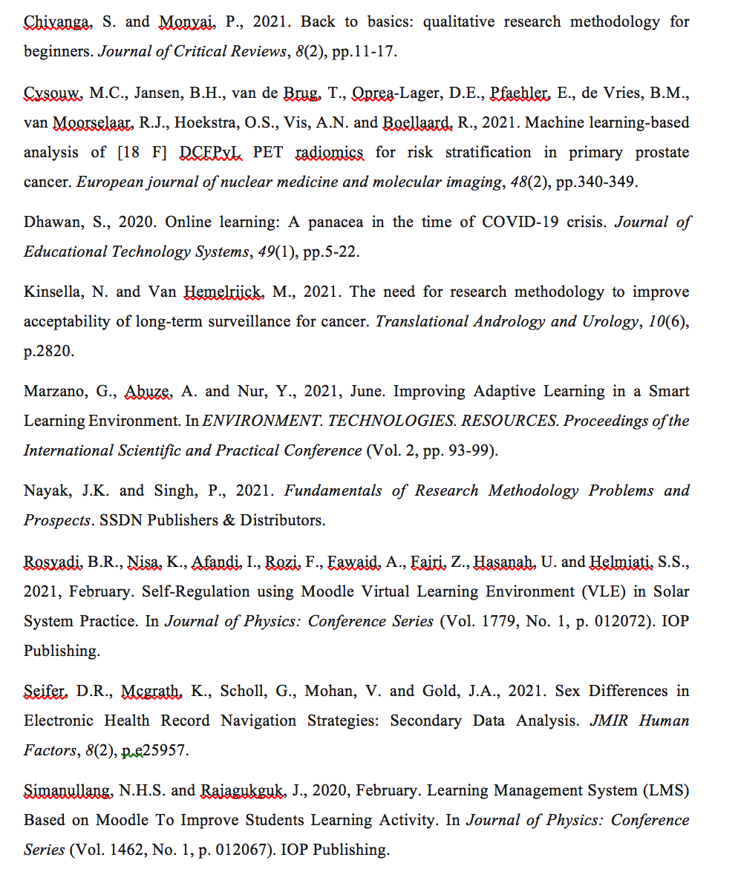

Appendix
Research Questionnaire:
- Gender:
- Male
- Female
- Age
- 18-24
- 25-29
- 30-39
- 40 and above
- Have you experience of using online learning process (Moodle)?
- Yes
- No
- Do you feel: VLE Moodle is effective for learning?
- Strongly agree
- Agree
- Not agree
- Strongly disagree
- Is there impact of VLE on your learning development?
- Yes
- No
- Is VLE an effective platform for new learner?
- Yes
- No
- Neutral
- Do you think: Moodle is easy and comfortable for learning through VLE?
- Strongly agree
- Agree
- Disagree
- Strongly disagree
- Do you think: the VLE encourage learners to learn about new things?
- Strongly agree
- Strongly
- Disagree
- Strongly disagree
- Are you happy and satisfied with Moodle using?
- Yes
- No
- Do you think: the number of users is increasing in learning by VLE for Moodle?
- Yes
- No

