

BSc Level 5 in Health and Social Care
Introduction to Physiology
(BMHP5003_LON.)
Term 2

.

Assignment 2 Report.

Normal and abnormal elements of physiology:
A lifestyle of a Cardiovascular Patient/ Individual

Elizabeth Owusu
Student Number: 1917244
Module: Introduction to Physiology
Code: BMHP_5003_LON.
Lecturer: Eleni Koutsogeorgou.
Date: 20/ 08/ 2021

Table of Contents. Page
Introduction……………………………………………………………………………2
Case Study………………….…………………………………………………………………3
Health assessment……………………………………………………………………………..4
Recommendation………………………………………………………………………………..5
Conclusion…………………………………………………………………………………………..6
References………………………………………………………………………………………….A
Appendix………………………………………………………………………………………………B

Introduction
Cardiovascular disease continues to be a primary source of morbidity and mortality in the Western world and the world as whole, despite several advances in acute and chronic care, as well as the health risks associated with certain lifestyle choices. (Bonnet, 2005).
This report is to analyse the risk factors of patient A lifestyle, the help and advise she can have, prevention and intervention matters measures, Activities, and dietary requirements. The study also assesses the physical, physiological and biological aspect of cardiovascular disease, a risk factor to patient A.

Physiology
The study of how a live organism or physiological portion functions is referred to as physiology. Medical physiology is the problems and disorders. Individuals and care providers are affected by changes in physiological condition.
Macroscopic gross anatomy is the study of big body structures or organ, such as the heart, lungs, kidneys, and bones, while anatomy is the study of body parts and their relationships. This is further divided into religion, anatomy, which includes all parts within a specific region, and Systematic anatomy which includes system by system, such as the circulatory and respiratory systems. The superficial anatomy, or landmarks on the surface that corresponds to deeper tissues.
Microscopic Anatomy is the study of microscopic features that are invisible to naked eye. The study of body cells is cytology, while the study of body tissues is histology

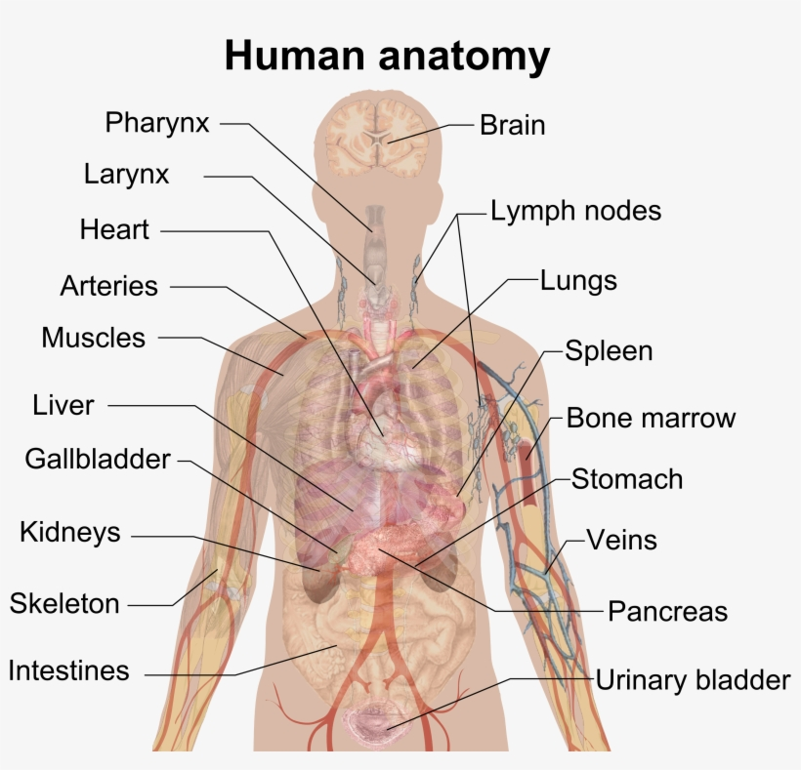
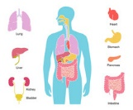220_F_269943088_CocgJj7qxNrLejMGLzS2IthByAbylRyn.jpg (220×181) (ftcdn.net).

There are various organizational levels, The oxygen, carbon, and nitrogen atoms are the smallest units of pure substance. Water is formed when hydrogen and oxygen combine to form a compound. The cell is the tiniest self-contained unit of living organism. A tissue is a collection of cells that collaborate to fulfil a certain task. The organ is made up of two or more tissues, and the physiology of the system is complex.

Levels of organization

Organelle

Organ system
Compound

The ten major system in physiology.

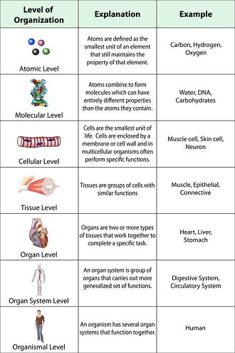

Organization.JPG (330×495) (scioly.org)

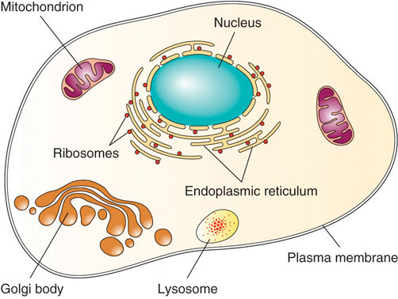
image26.jpg (502×378) (hawaii.edu).

Functions of the skin.
Microorganisms, dehydration, ultraviolet light, and mechanical damage are all protected by the body’s processes. It detects pain, temperature, touch, and deep pressure, as well as to move freely. The body moves as muscles flex. Excretion, (vitamin D), immunity, and temperature regulation are controlled by the skin.

The ten major system in physiology.
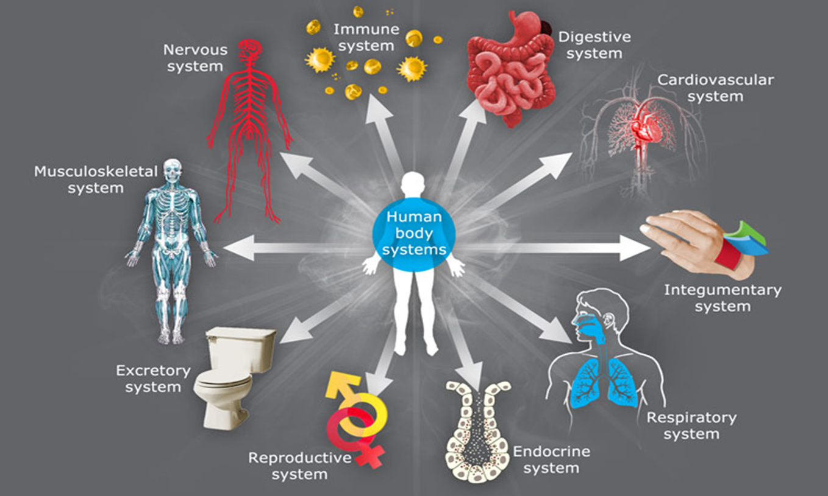
https://courses.lumenlearning.com
.

Case Study.
The Case of Patient A.
.
Patient A might be at risk for a heart attack, a stroke, or Diabetes. Due to the amount of alcohol, she consumes on regular basis (3-6 units each day), and the sort of food she eats daily. Lack of exercise and family history of health problems, the father suffered a heart attack at the age of 68, and his sister had cholesterol problems. Patient A has a blood pressure of 180/ 95, which is higher than the normal blood pressure of 120/80.

Patient A is 165 centimetres tall and weighs 86 kilograms. Patient A can be classified as obese according to the NHS BMI calculation, as her BMI is 31. Her BMI which is calculated by comparing her height and weight, should be between 18.5- 25, with anything above 30 being a risk factor. Patient A should strive to lose 5% of her body weight.

The Cardiovascular system.
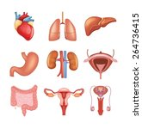
The cardiovascular system

The double pump system
Systematic
Pulmonary

Systemic transport oxygenated blood throughout the body for use and returns deoxygenated blood to the heart
The pulmonary system transports
Deoxygenated, before returning to the heart.

By providing oxygen and glucose to the central nervous system, the brain, and the spinal cord on a continuous basis, the cardiovascular system aids in maintaining homeostatic balance. Without oxygen for even one minute, brain cells begin to die. The process of homeostasis is when the body is in a state of equilibrium.

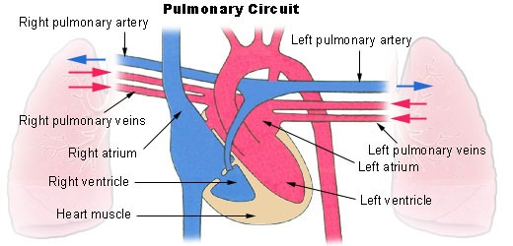illu-pulmonary-circuit.jpeg (520×250)


There are three parts to the cardiovascular system, the heart, blood arteries, and blood are all parts of the human body. Plasma, red blood cells, white blood cells, and platelets are the four basic components of blood, which serve a variety of activities, including carrying oxygen and nutrients to the lungs and tissues.
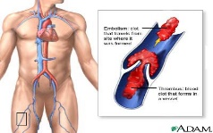

The heart
Blood vessels Blood
Organic substances.
Carbohydrates are made up of hydrogen and oxygen and provide energy for biological processes. Monosaccharide, or (simple sugars), are from carbohydrates. Two monosaccharides are linked together to form a disaccharide, starch, and other complex carbohydrates. Polysaccharides are made to up of several sugars.
Phospholipids are significant in cell architecture because they include glycerol, two fatty acids, and a phosphate group. Steroids are ring-shaped molecules that incorporate cholesterol, which is utilized to have sex hormones.
COH and nitrogen atoms are found in proteins. Some of them also have sulphur in them. The amino acids, which have a carboxyl group, an amino group, and a side chain known as the R group, are the building blocks of protein.

The lymphatic system and the immune system.
The lymphatic system is important for the immune system, fluid balance, and fat and fat-soluble nutrition absorption. Foreign elements can be transferred to lymph nodes for evaluation by immune system cells because lymph veins drain fluid from human tissues.
The lymphatic system fights infection by activating lymphocytes, which then produce antibodies and begin to defend the body, if they have already encountered the disease, they can also create antibodies from memory.
Receptors and Effectors.

The Homeostasis
The Homeostasis mechanism keeps the internal environment constant by maintaining a dynamic equilibrium with minimal variations over a narrow range of conditions.
Support internal environment constantly.

Water
Salt
Temperature
Glucose

Blood pressure
Carbon dioxide

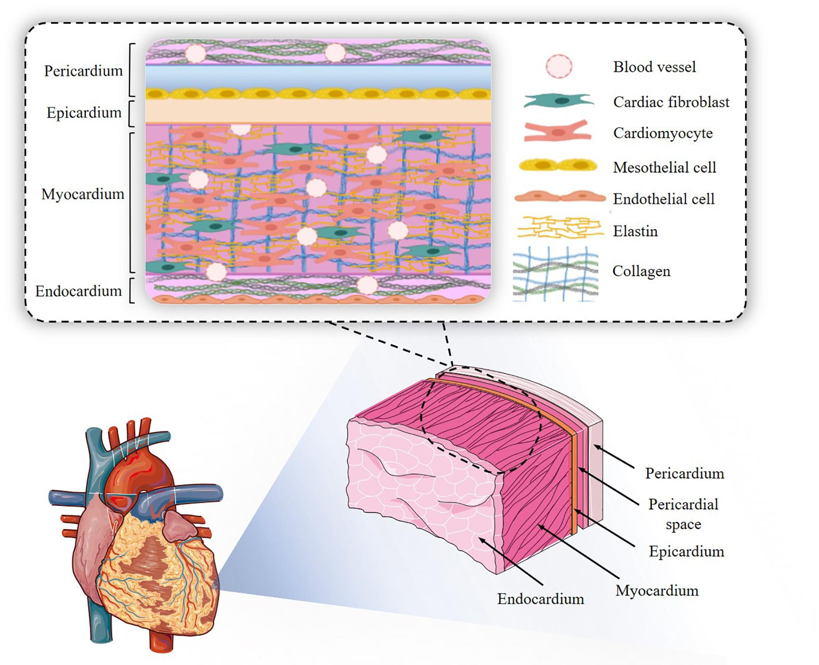.
fbioe-08-00955-g002.jpg (1850×1505) (frontiersin.org).

Cardiovascular Disease.
When the cardiovascular system fails.
When the circulatory system fails, blood flow stops, and muscles are deprived of the oxygen and nutrients they require. Blood provides oxygen and glucose to the cells, allowing them to convert food into energy for survival. If the cells do not receive blood, they will die, killing the organism.
Coronary artery disease occurs when the arteries construct and contract, preventing oxygen and nutrients from reaching the heart. High blood pressure, often known as hypertension, narrows the arteries and makes it difficult for blood to flow through the veins. Another disorder is stroke, which occurs when the arteries that supply the brain with blood and oxygen get blocked, causing the brain to die. The risk of vascular dementia is further increased by stroke and heart disease.

Lifestyle of a cardiovascular disease patient.
Cardiovascular system function is maintained by lifestyle decisions. Exercising and maintaining a healthy weight can help to lower your risk of heart disease. Smoking should be avoided because it harms your compounds and causes heart problems.

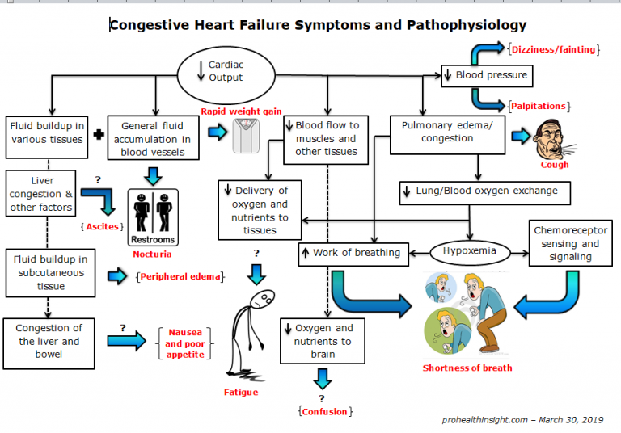
Congestive-Heart-Failure-Symptoms-and-Pathophysiology-768x536.png (768×536) (prohealthinsight.com)
.
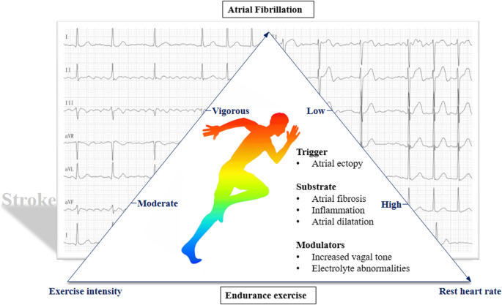
https://media.springernature.com/lw685/springer-static/image/art:10.1186%2Fs12872-019-1150-z/MediaObjects/12872_2019_1150_Fig2_HT
Psychosocial stressors have been linked to an increased risk of coronary artery disease. Depression, chronic work stress, a lack of control, and financial stress all increase the risk of heart disease. (Hagstrom, 2018)

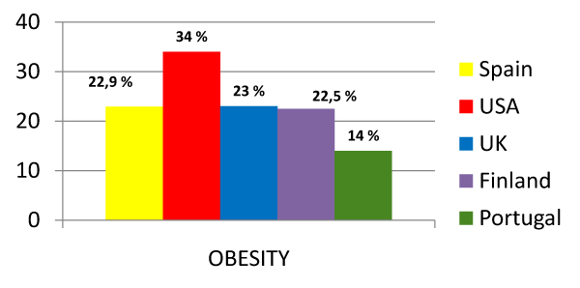
http://www.symbiosisonlinepublishing.com/obesity-control-therapies/images/obesity-control-therapies05-g001.gi

Factors that cam contribute to a person’s weight.
Maintaining a healthy weight and eating a nutritious diet with a 500-calorie reduction in daily intake. Limiting your time spent sedentary and staying physically active. Weight gain may be influenced by environment, family history, and genetics. Metabolism, referring to the process by which the body converts food and oxygen into energy, as well as habit or behaviour. (DHH, 2020).
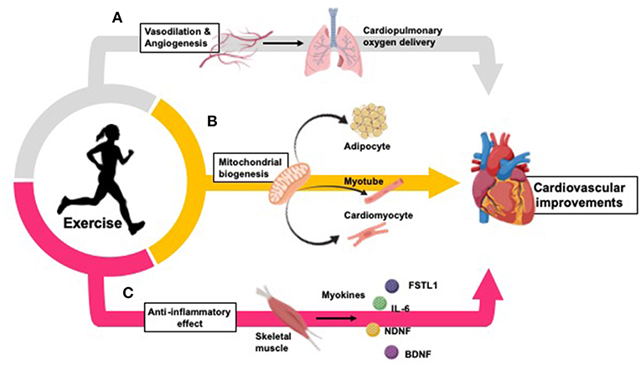

Health Profile.

Alcohol counselling is available for all care and parental care visits, so Patient A. can benefit from that. Cancer screening is available for people aged 50 to 75. The liver is known as the ‘’energy factory’’ of the human body. It transforms glucose to glycogen and store it, and then coverts glycogen back to glucose as needed. It processes nutrients in the body and clear out toxins and waste, an individual cannot live without a liver and drinking alcohol harms the liver.

Health Assessment
According to the widely referenced Global Burden of Disease (GBD) study, environmental pollution is directly responsible for roughly 9.0 million deaths with 4.2 million deaths due to ambient air pollution and 2.9 million deaths due to household air pollution. (Rajagopalan, 2018).
Reduced physical activity can have a negative impact on ones’ mental health, manifesting as unpleasant feelings such as melancholy, anger, annoyance, and aggravation. Physical inactivity was linked to 24% increased risk of coronary artery disease. (Lippi G, 2020).
Dietary variables are the most important of the four CVD behaviour factors, accounting for most of the CVD mortality in population. Western Europe has a male-to-female mortality rate percent of 447 percent and 38 percent, respectively, Diet, alcohol consumption, excessive cholesterol, and smoking are all factors that might affect one’s health. (Wilkins, 2017)

Prevention.
WHO suggested physical activity levels was linked to a 17 percent lower risk of cardiovascular events, Relative risk? 0.83 which is 95%, confidence intervals: 0.77, which is 89% and 23 % lower risk of cardiovascular mortality. According to data from 4004,840 people in observational cohort studies, there was a relative risk of 0.77, 95%, 0.71- 0.844 and 26 % lower incidence of type 2 diabetes, according to the data (Lippi G, 2020).

PREVAILANCE
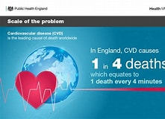
The national Public Health England has provided an overview of data on heart disease, stroke, diabetes, and renal disease, as well as other cardiovascular and cardiovascular -related illness. They are designed to assist commissioners and health professionals in assessing the impact of cardiovascular disease, making decisions, and improving patients’ outcomes. (England, 2020). HYP, percentage of patients aged 79 years who have hypertension measured within the last 12 months in the GP’s hypertension register is 140/ 90 or less and the percentage of patients aged 80 years or more who have hypertension measured within the last 12 months in the GPS hypertension measured within the last 12 months is 150/ 90mmhg or less. (England, 2020). (Wilkins, 2017). European statistic report.

Hhhhhhhhhhhhhhhhhhhhhhhhhhhhhhhhhhhhhhhhhhhhhhhhhhhhhhh

Legislation. Gov.uk

Health and Social Care ACT. 2012

Vvbbbbbbbbbbbbbbbbbbbbbbbbbbbbbbbbbbbbbbbbbbbbbbbbbbbb

Healthy Diet

.

Intervention
Public Health England’s goal by 2029 is the hypertension treatment program to treat 80% of people diagnosed with hypertension according to NICE standards. (Norberg, 2021).
Nurse- led intervention have been shown to reduce cardiovascular risk estimates (Marco Aurelio Lumertz Saffi, 2014). Changes in behaviour have been shown to be both and effective. Patients with coronary artery disease and heart failure have been shown benefits from interventions such as education, behavioural counselling, and support. Attempting to excuse lifestyle changes, on the other hand, is tough and time consuming. (Marco Aurelio Lumertz Saffi, 2014).
This Nurse-led intervention was used in this trial which involved deducting face to face sessions and phone contact over the course of one year, beginning three months after release from the hospital, with activity and food target. 1.7- point reduction in cardiovascular risk score was observed during a ten-year period. 14 percent reduction in blood pressure control.

Recommendations.

As a result, in both clinical management and future clinical studies, secondary prevention of CHD should focus on psychological concerns. (Hagstrom, 2018).Regardless of context, lifestyle counselling should be incorporated into clinical nursing practice. New research should be conducted to see how much risk reduction affects endpoints like myocardial infarction and death. (Marco Aurelio Lumertz Saffi, 2014).

.

References

Appendix

