Module: Marketing Essentials
Module code: BMIH4005

Table of Contents
1 Introduction 3
2 Main Body 3
3 Conclusion 7
4 References 8
5 Appendices 9
5.1 Appendix 1: Geographic 9
5.2 Appendix 2: Social Traffic. 9
5.3 Appendix 3: Target Audience 9
5.4 Appendix 4: Perceptual Mapping 10

Introduction
There is growing competition in the hospitality industry, making the sector dynamic, where firms are competing to secure an adequate market share. However, the essay is also focused on the comparison of two such brands, namely, Six Senses and Holiday Inn. The hotel's marketing strategies are evaluated by analysing the brands through the use of situational analysis tools and through the elements of the marketing mix. This will help in highlighting the similarities and differences between the marketing method of the two brands. In addition to this, the use of STP will be made to highlight the communication practices. Six Senses is a luxury hotel with a global presence that focuses on wellness and sustainability (Six Senses, 2023). In contrast, Holiday Inn is a recognisable brand of IHG which serves as a mid-scale hotel with a focus on comfortable and affordable accommodation services (IHG 2023). It has been predicted that the marketing efforts of Six Senses are more adequate compared to the Holiday Inn as it focuses on providing a unique experience to the customers. By comparing the two brands, exploring a range of generational and strategic approaches to marketing will be achieved, including the use of social media and digital marketing compared to traditional advertising and marketing techniques.

Main Body
Before beginning with the identification of the marketing strategies of the two hotels, an insight into the internal and external environment is important. Gepner et al. (2022) provided that situational analysis is the process that is crucial for a business as it helps highlight the opportunities as well as challenges regarding the internal and external environment of the business. For conducting the internal analysis, a SWOT analysis will be used for both brands.
Six Senses
Strengths  -Maintenance of a strong brand image in the luxury hospitality industry.  -The brand has maintained a global presence.  -It focuses on a personalised approach to allow customers to experience unique travelling (Zhang et al., 2020) | Weakness  -The brand maintains a high pricing strategy.  -Its dependency on high-end consumers is more.  -The services offered are limited.
Opportunity  -Consumers are becoming more responsible and spend a premium on sustainable choices (Karatepe et al., 2021).  -Expanding its geographical presence by entering new markets.  -Leverage the use of technology to provide exceptional consumer experience. | Threats  -Uncertain political and economic conditions (Al Mamun et al., 2020).  -Shifts in market trends and changes in consumer demands.  -Intense competition in the market.

Holiday Inn
Strengths  -Recognisable brand under the portfolio of IHG (Tošić et al., 2021).  - Affordable pricing strategy targeting budget-conscious customers.  -Standardised approach to delivering quality services. | Weakness  -There is limited differentiation from other mid-scale hotels.  -Dependence on the IHG brand portfolio for brand recognition.  - Perception of lower-quality services
Opportunity  -Growing demand for affordability and budget-friendly hotels.  -To further reach out to new destinations. | Threats  -Fierce competition in the industry.  -Inflation leading to decreased travel demands.  -Shifting the needs and wants of travellers.

In addition to this, for conducting the external analysis, PESTLE Framework will be used. This would help evaluate what the world looks like for the two brands and where the brands differ in terms of challenges and possibilities.
Political factors can have a significant influence on the operations and functionality of the two brands in the hospitality industry. Gursoy and Chi (2020) provided that Brexit has caused a change in immigration policies, and there is also an influence on the availability of workers. In addition, Gursoy and Chi (2020) provided that the pandemic has led to the implementation of policies regarding travel restrictions, which caused a decrease in the demand for hospitality services. Considering the economic factors, the inflation rate of the country, as per BBC (2023), is stated to be 10.1% based on the soaring cost of energy and the Ukraine war, which further put pressure on the prices. The hospitality industry is sensitive to fluctuations, which causes a decline in demand for hospitality services. In terms of sociocultural factors, the changes in preferences and societal trends can influence the hospitality industry, and the focus on sustainable accommodation is increasing. This is a beneficial move for Six Senses based on the organisation's growing concern about sustainable approaches. The technological factors are necessary for the hospitality sector as it helps streamline processes and improves customer experience (Mercan et al., 2021). Online booking and contactless services can also be incurred. The industry in which the two brands operates is also regulated heavily, and compliance with rules and regulations is necessary. Garcés-Ayerbe et al. (2019) provided that environmental concerns also need to be adapted gradually by the brands. However, both brands have been affected by societal trends and the pandemic and are therefore working to align themselves to capture consumer attention. However, a focus on marketing is done to overcome the pressure from external sources and indulge consumers in unique experiences.
In order to provide a detailed picture of the two brand and their brand strategies, the use of a marketing mix is appropriate. For the six senses, the hotel offers spa treatment, luxurious accommodations, gourmet dining experiences, wellness programs and much more. The brand is known for its commitment to sustainable approaches and offers eco-friendly services. They offer individual styles and experiences (Chen et al., 2022). Holiday Inn, on the other hand, provides reasonably priced lodging services with an emphasis on convenience and comfort. The hotels offer a variety of rooms with contemporary amenities, including Wi-Fi, television, and a comfy bed. In terms of pricing, Six Senses commands high pricing being a luxury brand for both its lodging and services. The brand bases its pricing approach on the value it offers, with a focus on the distinctiveness of the experience. Holiday Inn has a more reasonable pricing policy that emphasises value for money. Considering the place element, numerous sites, including seaside resorts, big cities, and isolated areas, are home to Six Senses facilities (Liu et al., 2020). Holiday Inn, on the other hand, takes a more uniform approach to location and property design. Hotels are frequently found in busy commercial areas, close to major thoroughfares or airports, or in well-known tourist locations. The major traffic for Holiday Inn comes from US and UK, whereas for Six Senses, it comes from Australia and France (refer to Appendix 1). For the promotional element, Six Senses places a lot of emphasis on digital marketing, which includes influencer marketing, email marketing, and social media. Additionally, the company runs loyalty programmes and forms strategic alliances with other luxury brands. Contrary to this, Holiday Inn concentrates on more conventional marketing strategies, such as print and television ads, email marketing, and loyalty programmes. The company participates in strategic collaborations with airlines and other travel businesses and has a significant online presence on travel booking portals (refer to Appendix 2). Considering the people aspect, Six Senses takes great satisfaction in giving visitors a highly personalised and unforgettable experience. The hotel frequently hires workers that are specialists in wellness and sustainability. Holiday Inn, in contrast, concentrates on giving visitors a dependable and consistent experience. The brand's employees are taught to be personable and polite. For the process aspect, Six Senses provides visitors with a distinctive and engaging experience. With a variety of activities and programmes that address various wellness demands. Holiday Inn, in contrast, focuses on giving customers a convenient and comfortable stay with more standardised services. The brand's check-in and check-out procedures are streamlined. The last element is physical evidence, where Six Senses focuses on creating an immersive environment and luxury experience for guests with unique property design, eco-friendly amenities, and wellness facilities. On the other hand, Holiday Inn's properties have a more standardised look and feel.
In addition to this, the marketing mix elements of both brands are focused on targeting a specific group of travellers. According to Similar Web (2023), the target audience for Six Senses includes 49% males and 50% females. These belong mainly to the age category of 25-34 years, suggesting that the target audience of Six Senses is young individuals. Contrary to this, the target audience for Holiday Inn comprises 46% males and 53% females, focusing on the age category 35 and above (refer to Appendix 3). It can be said that Six Senses being a luxury brand, targets young consumers, whereas the Holiday Inn's target audience is mainly adults who prefer budgeting and affordability. Therefore, the brand targeting strategies also differs as Six Senses focuses mainly on digital and social media advertising tactics, whereas Holiday Inn emphasises traditional modes of marketing. In terms of positioning, Six Senses position itself as a luxury brand offering premium services, whereas the Holiday Inn is positioned as an affordable brand with quality services that appeal to budget-conscious travellers (refer to Appendix 4).

Conclusion
From the overall analysis of the two hotel brands, it can be said that when comparing the marketing methods of the two hotels, Six Senses leads the game. This is because of the organisation's approach to offering premium services and the visibility of sustainable and eco-friendly approaches. Additionally, Holiday Inn being a budget-friendly hotel, is more focused on traditional marketing strategies and therefore lags behind the competing game. However, the essay provides a thorough insight into the two hotels.

References
Al Mamun, M., Uddin, G.S., Suleman, M.T. and Kang, S.H., 2020. Geopolitical risk, uncertainty and Bitcoin investment. Physica A: Statistical Mechanics and Its Applications, 540, p.123107.
BBC 2023. What is the UK inflation rate, and why is the cost of living rising? [Online] Available at https://www.bbc.com/news/business-12196322 [Accessed on 9 May 2023].
Chen, C.C., Han, J. and Wang, Y.C., 2022. A hotel stay for a respite from work? Examining recovery experience, rumination and well-being among hotel and bed-and-breakfast guests. International Journal of Contemporary Hospitality Management, 34(4), pp.1270-1289.
Garcés-Ayerbe, C., Rivera-Torres, P., Suárez-Perales, I. and Leyva-de la Hiz, D.I., 2019. Is it possible to change from a linear to a circular economy? An overview of opportunities and barriers for European small and medium-sized enterprise companies. International Journal of environmental research and public health, 16(5), p.851.
Gepner, P., Tien, N.H., Dao, M.T.H. and Minh, D.T., 2022. Analysis of business strategy of leading Vietnamese real estate developers using SWOT matrix. International journal of multidisciplinary research and growth evaluation, 3(1), pp.181-187.
Gursoy, D. and Chi, C.G., 2020. Effects of COVID-19 pandemic on hospitality industry: a review of the current situations and a research agenda. Journal of Hospitality Marketing & Management, 29(5), pp.527-529.
Gursoy, D. and Chi, C.G., 2020. Effects of COVID-19 pandemic on hospitality industry: a review of the current situations and a research agenda. Journal of Hospitality Marketing & Management, 29(5), pp.527-529.
IHG Hotel 2023. Holiday Inn. [Online] Available at https://www.ihg.com/holidayinn/hotels/us/en/reservation [Accessed on 9 May 2023].
Karatepe, O.M., Rezapouraghdam, H. and Hassannia, R., 2021. Sense of calling, emotional exhaustion and their effects on hotel employees’ green and non-green work outcomes. International Journal of Contemporary Hospitality Management, 33(10), pp.3705-3728.
Liu, Y., Kou, Y., Guan, Z., Hu, J. and Pu, B., 2020. Exploring hotel brand attachment: The mediating role of sentimental value. Journal of Retailing and Consumer Services, 55, p.102143.
Mercan, S., Cain, L., Akkaya, K., Cebe, M., Uluagac, S., Alonso, M. and Cobanoglu, C., 2021. Improving the service industry with hyper-connectivity: IoT in hospitality. International Journal of Contemporary Hospitality Management, 33(1), pp.243-262.
Similar Web 2023. Audience Interest. [Online] Available at https://pro.similarweb.com/#/digitalsuite/websiteanalysis/audience-interests/*/999/3m?webSource=Total&key=holidayinn.com,sixsenses.com [Accessed on 9 May 2023].
Six Senses 2023. About Us. [Online] Available at https://www.sixsenses.com/en/about-us [Accessed on 9 May 2023].
Tošić, V., Tucović, M. and Tošić, T., 2021. Loyalty programs in hospitality on the example of hotel Holiday Inn Suschevsky. Turističko poslovanje, (28), pp.39-46.
Zhang, Y., Xiong, Y. and Lee, T.J., 2020. A culture-oriented model of consumers’ hedonic experiences in luxury hotels. Journal of Hospitality and Tourism Management, 45, pp.399-409.

Appendices

Appendix 1: Geographic
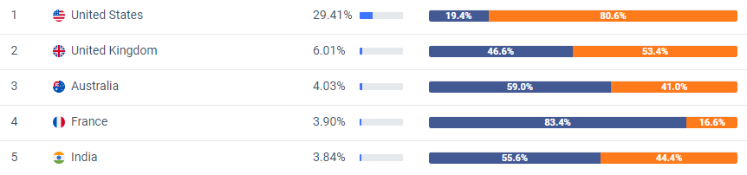

Appendix 2: Social Traffic.
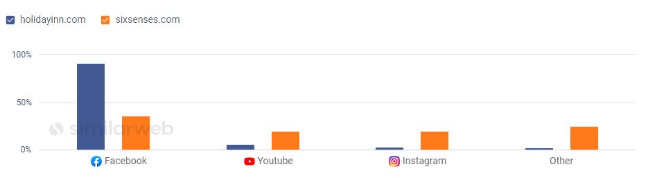

Appendix 3: Target Audience
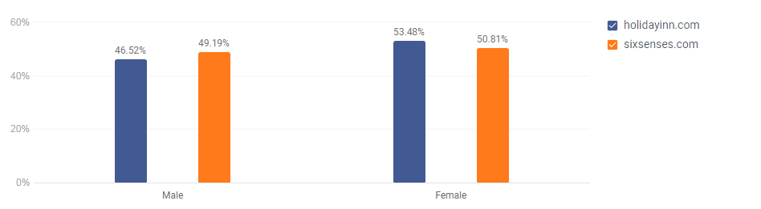
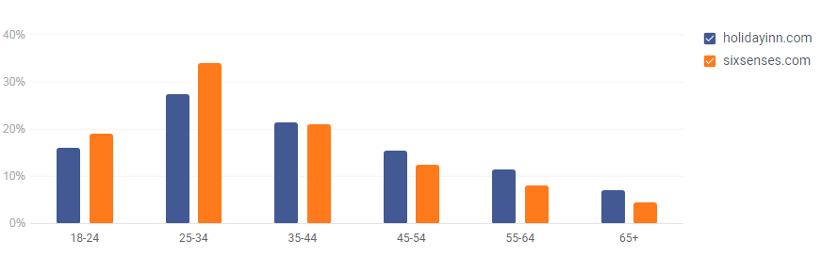

Appendix 4: Perceptual mapping


