
Skills for the Workplace
Module Assignment Submission
Student Name: | Yasmin Khalid
Student Number: | 1902962
Module No: | BMSK4002
Module Title: | Effective Team Working and Communication

Statement of Confirmation of Authenticity
By the act of making this submission, the student declares that this is the work of the student named above. The work has not, in whole or in part, been knowingly presented elsewhere for assessment, or where assessment has been built on a previous assessment, this has been identified. Where materials have been used from other sources it has been properly acknowledged. If this statement is untrue, the student acknowledges that an assessment offence has been committed.
Attention is drawn to the plagiarism and unfair practice policies of both the University and of ILM.
Permission for ILM to use this script
ILM uses learners’ submissions – on an anonymous basis – for assessment standardisation. By submitting, both the centre and the learner agree that ILM may use this script on condition that identifying information is removed. However, if you are unwilling to allow ILM use this script, please refuse by ticking the box: □

Table of Contents
Introduction 3
Section 1 – What is Communication? 3
1.0 Types of communication 3
1.1 Communication styles 4
1.2 Communication barriers 5
1.3 Conclusion 6
Section 2 – Personal Reflection on communication 6
2.1 Description 7
2.5 Conclusion 7
References 9
Appendix 1 10
Appendix 2 11

Introduction

This report will be investigating Communication, its importance and the different styles and the barriers that may affect it. Communication is very important, thus learning to communicate effectively can be a challenge which means that this report will express what communication is. Due to there being many different types of communication styles and theories about how to communicate, there can sometimes be various obstacles that can impact communication.

Section 1 – What is Communication?

According to the Oxford dictionary, the definition of communication is “the imparting or exchanging of information by speaking, writing, or using some other medium”. This means that at least one entity has to be the transmitter of the message, meanwhile the other the receiver of it, vice versa. A model designed by Shannon – Weaver in 1949 which was developed to help portray how the source of the information is like the sender, and the encoder channel being representative of the transmitter, usually through the medium of sound. Alternatively, the decoder is the reception and the destination of the information is portrayed by the receiver. In the first place, the message starts with the sender which would be the person who wants to communicate the message. Next, the encoder would be the sound waves, with the channel being a telephone. The next step is the decoder which is the person receiving the messages and finally, the destination would be the person understanding the message who would then usually give feedback which would be a response to the message (Communication Theory, 2021). In 1960 David Berlo expanded on the Shannon – Weaver model as it focuses on the encoding and decoding of the message, which can be a more efficient communication as it identifies factors that affect the source. The model includes four components that describe the communication process which are as follows: sender, message, channel and receiver. Issues that may affect the sender are communication skills such as reading, listening and speaking, someone’s attitude can change the meaning of the message, but if you have knowledge about the subject this will make the subject more interesting and a persons’ way of life can influence how the sender communicates the message as all people interpret messages differently. Things that can affect the message may be the body language and which method in which the message is sent. The way a message is conducted (channel), whether it is by hearing, seeing, touching, smelling and tasting, can stop the message being understood. Matters that affect the receiver might be when a message has been sent by lots of different people and then the original message has been lost in communication (Janse, 2018).

Types of communication

There are three different types of communication:
- Verbal
- Non-verbal
- Visual

Verbal communication is the most used form of communication with many people using it daily to hold conversations, provide each other with information or to make decisions, whether this is done face-to-face or by telephone. In many circumstances face-to-face conversations are not possible, so the use of phone and written forms as alternatives such as letters or skype are used. Face-to-face communication allows for a relationship to form and to increase trust, it has proven effective as it allows the person who is speaking to monitor the other persons reactions to the message being relayed so there is less of a chance of misunderstanding between the two of them. This oral method of communicating is used in interviews, meetings, giving instructions and giving sensitive information. Communication by telephone has proven effective to communicate as a way of communicating verbally with someone who is not present, communicating by telephone may be used urgently if an answer is required immediately. Non-verbal communication such as body language, shows others if someone understands what is being said to them. It will help the individual recognise if the person is taking in the information by watching their facial expressions, posture and eye contact, for example if someone was speaking and the other person was not paying attention by looking elsewhere and not directly at the speaker, it would seem as if they were not listening to the information. On the other hand, if they gave good eye contact to the person speaking and possibly agreeing to what was being said then that could illustrate that they are listening, understanding and interested. Video calls are a good innovation, giving some of the benefits of face to face however there are some drawbacks, such as not being able to look around the room to connect with people the way we can if we were in a conference room. Examples of visual communication is pictures, charts and graphs (Bright Hub PM, 2010). Communication done well makes the cogs in any business run smoothly, and investment in training and technology can facilitate this, helping to avoid potential problems caused by poor communication.
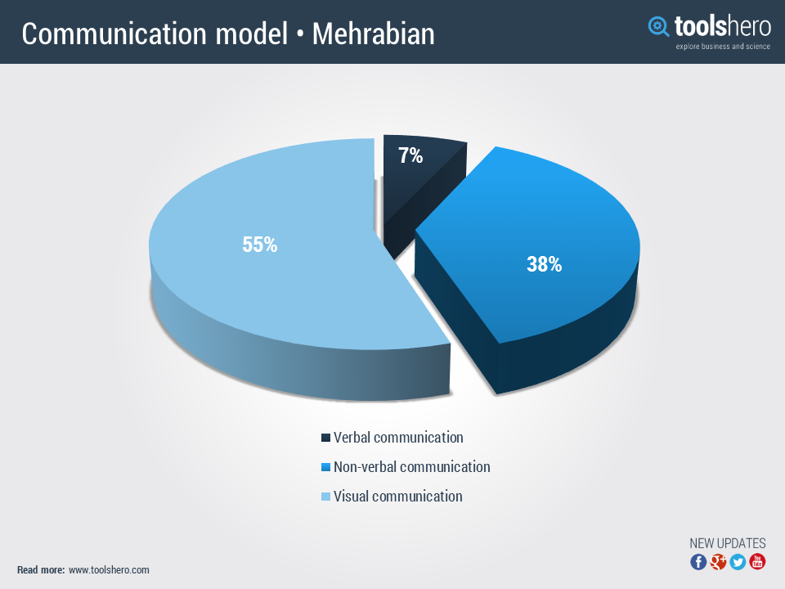

1.1 Communication styles

There are four types of communication styles and each person has a unique style, these styles are passive, aggressive, passive-aggressive and assertive. Passive communicators usually fail to express their feelings or needs but allow others to express themselves, they can lead to misunderstandings or resentment due to their lack of outward communication. Aggressive communicators usually issue commands they usually speak in a loud demanding tone and control others by intimidating, blaming and criticising. They usually fail to listen to others but can be considered as leaders and command respect from people around them. Passive-aggressive communicators seem passive on the surface but build up resentment inside leading to them acting out in a subtle and indirect ways. They will usually mutter to themselves than confront an issue or person. Assertive communicators are thought to be the most effective form of communicators they express their own needs, ideas and feelings whilst also considering the needs of others (Alvernia University, 2018).

1.2 Communication barriers

Skills You Need (2021), states that there are many different barriers that can affect communication which are listed below:

- Lack of attention
- Language differences
- Psychological Barriers
- Physical Barriers
- Difference in perception
- Cultural Barriers
- Attitude Barriers

The student will seek feedback after communicating to the team to make sure that they understood the message, so that there is no confusion or misunderstanding. When communicating at any level it is crucial that the correct tone is used as a persons’ message can be taken the wrong way and this may cause issues with the person communicating and the person receiving the message. When communicating to either one person or a multitude of people then it is necessary to speak clearly and at the right volume because if the person cannot hear the message then mistakes will happen, even depending on where an individual lives, sometimes the message can be misinterpreted because of different accents, this may be the case people visit different cities even though the language is the same, because of the dialect then the message can be misunderstood. If the audience you are communicating to have a speech impediment then it is wise to speak slowly and confirm regularly if the message has been understood, ask if there are any questions. Sometimes there may be noise around the area which the communication is taking place which may hinder the message being relayed and the person may not have heard the message correctly. Another thing to consider is when communicating to others that the correct body language is used as this may confuse the message being given at that time. It is good to remember not to stereotype anybody when communicating as this can cause upset with the other person receiving the message.

1.3 Listening

According to Leaders Who Learn (2021) ‘Listening is an important part of communicating with Steven R. Covey identifying that there are five listening levels: 1-5

Empathic - 5
Attentive - 4
Selective - 3
Pretending - 2
Ignoring - 1

The first four levels the listener hears with their own assumptions in mind whereas level 5 is when real communication happens, the listener attempts to see things from the other persons point of view and not through their own thoughts.

Level 1: Ignoring – No attention is being paid to the communicator.
Level 2: Pretending – Not really listening to what is being said, the person gives a false impression by giving small gestures to the communicator.
Level 3: Selective – This person only listens to what they want to hear, so only a small part of the message is heard.
Level 4: Attentive – People will give attention to what is being said, however they will make up their own assumptions and may not see eye to eye on all matters.
Level 5: Empathic – Makes an emotional connection and finds similarities between their own lives and the speaker so that their response is heartfelt.

There are 5 key techniques that can be used to develop active listening skills.

- Pay attention
- Show that you are listening
- Provide feedback
- Defer judgment
- Respond appropriately

1.3 Conclusion

After completing my assignment I now know that there are many styles of communication and various methods of communication. I have learned about the different stages and elements of listening, which has made me realise about how I will communicate more effectively in the future. After completing the self-assessment communication questionnaire, I found out that my communication style is assertive which I am in agreement with.

Section 2 – Personal Reflection on communication

Depending on your position within a company will determine the level of formality in management communication between your manager and a colleagues, using the correct tone and language will depend on who we are communicating with. For instance if the company employs a new person into the company then a formal approach will be used to tell them what is required of them, but with people who know what they are doing a less formal approach will be used. The type of emails or verbal communication that we have with a manager compared to a colleague will be different in language and tone, giving your manager a level of respect and professionalism in communicating but with colleagues who are on the same pay level this may well be a bit more of a relaxed communication.
Example:

Manager – Dear Mr Smith, your wife rang today at 3pm and would like you to give her a call back at home. Kind regards, Yasmin
Colleague – Hi Hun, did you manage to pick up some coffee on your way into work today?
An email sent to HR will be different to an email sent to your boss or to an external supplier who you order goods from, so customers are internal and external. Internal customers are people within your company who rely on you for something and external customers are suppliers, auditors and creditors, basically the whole supply chain outside of the company. Within my workplace I communicate in various ways towards the guests who are planning to visit the hotel and also who are staying within the hotel, this is mainly verbal communication face-to-face but also by email and telephone, however I communicate with my colleagues verbally, texting and the telephone. We use a notice board to see how well the hotel is performing, but really nobody pays much attention to the notice board.

2.1 Description

People who I appreciate as good communicators would be someone like Oprah Winfrey or Barrack Obama, this is because they are both confident and enthusiastic in communicating with people, which makes their tone clear and they sound passionate about what they are talking about, they also have good eye contact and they engage with their audience. They have a warm tone which makes you want to listen to them and what they talk about is interesting. They have good body language which draws you in to them, they are friendly and they smile a lot.

Objectives | Tasks | Success Criteria | Time Frame | Resources
List your Goals | What do you need to do to achieve these goals? | How will you identify your success? | When do they need to be done by? | Who or what do you need to help you?
Not to be frightened to say no | Strength | Colleagues will recognise my authority | 07/21 | More assertiveness
Stop doubting myself | Confidence | People will listen to me | 08/21 | Recognition of good work
Take opportunities to develop | Believe in myself | Take advantage of promotion | 08/21 | Support from managers

2.5 Conclusion

From researching and completing my assignment I have found out that there are many different communication styles and my methods of communication and I have found out about the different stages of listening and the elements of listening. It has made me think more about how I communicate and the methods I use, also how to become more efficient at communicating.

References

Alvernia University. (2018) ‘4 Types of Communication Styles’ [online] Available at: https://online.alvernia.edu/articles/4-types-communication-styles/ [Accessed May 2021]
Bright Hub PM. (2010) ‘Three different types of communication: verbal, nonverbal & visual’ [online] Available at: https://www.brighthubpm.com/methods-strategies/79297-comparing-various-forms-of-communication/#:~:text=Three%20Different%20Types%20of%20Communication%3A%20Verbal%2C%20Nonverbal%20%26,...%204%20Paralanguage.%20...%205%20Visual%20Communication.%20 [Accessed May 2021]
Communication Theory. (2021) ‘Communication Theory’ [online] Available at: https://www.communicationtheory.org/shannon-and-weaver-model-of-communication/ [Accessed May 2021]

Janse, B. (2018) ‘Berlo’s SMCR Model of Communication’ [online] Available at: Http://www.toolshero.com/communication-skills/berlos-smcr-model-of-communication/ [Accessed May 2021]

Leader who leads. (2021) ‘Levels of Listening’ [online] Available at: www.leaderwholeads.com/levels-of-listening.html [Accessed May 2021]
Skills You Need. (2021) ‘Barriers to Effective Communication’ [online] Available at: https://www.skillsyouneed.com/ips/barriers-communication.html [Accessed May 2021]

Appendix 1

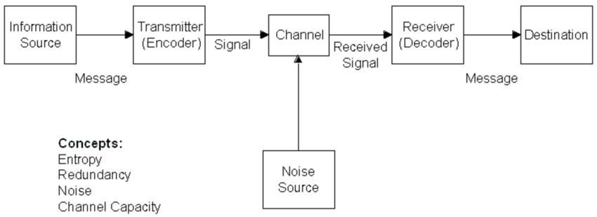
SHANNON-WEAVER’S MODEL OF COMMUNICATION

The Shannon-Weaver Mathematical Model, (1949)

Appendix 2



