
The City Book Store
Shaun Davies (1903572)


Contents
1. Abstract 2
2. Requirements 3
3. Entity Relationship Diagram 3
4. Creating the Database 5
5. Forms and Reports 7
6. Conclusion 9
Appendix A. 10

Abstract

The author was approached by The City Book Store to create a user-friendly database. This was due to their expanding client base and stock collection. The author has compiled the following report to explain their procedure in implementing this.

Requirements

The City Book store are a book company that specialise in the trading of collectable first edition books and new bestsellers. They have a solid customer base in their local area of Swansea as well as a wider online community throughout the United Kingdom. They currently hold minimal records of their customers which includes names, addresses and this is held on a word document which is not regularly updated. The store cannot continue to function efficiently without a database in place which should give them the ability to manage their stock, customer orders and their 3-monthly newsletter.

Entity Relationship Diagram

The author began their research into the needs of the bookstore by designing an Entity Relationship Diagram (ERD). This helped the author to set out what the database would require and begin to define relationships between tables and set primary keys. The ERD can be seen on page 4.
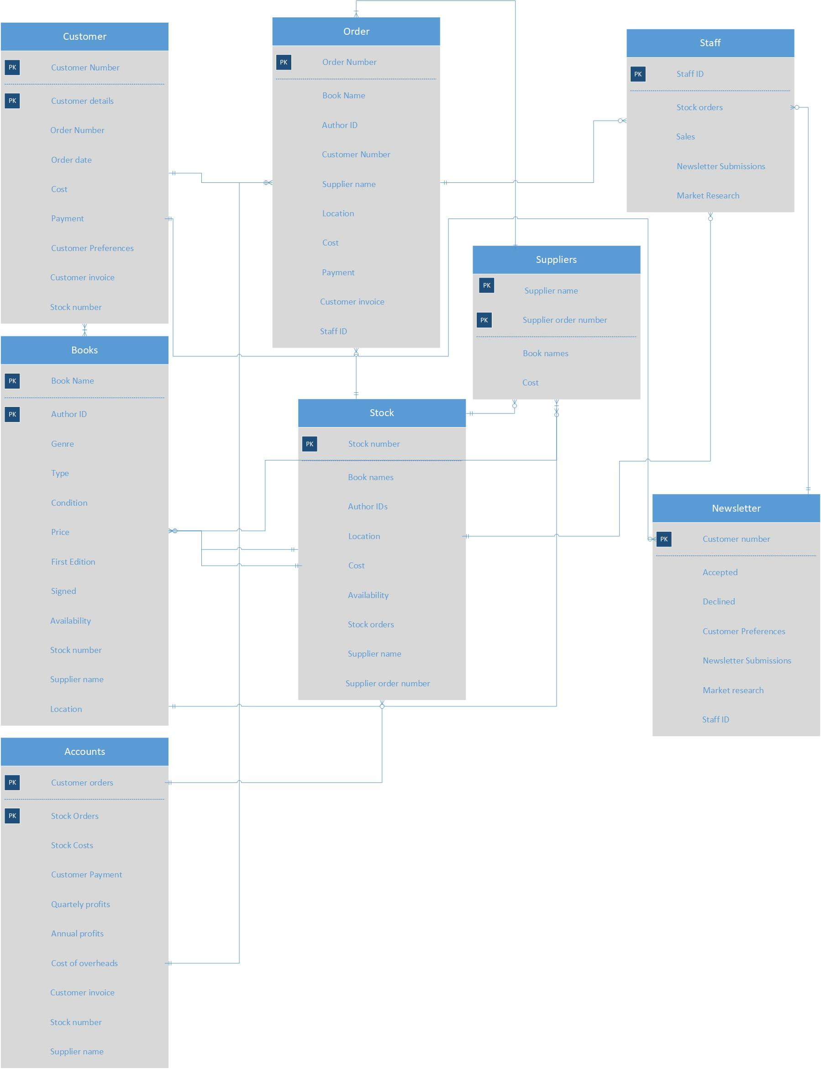

Creating the Database

From the ERD the author could then start to build the tables within Microsoft© access. The author did this by creating the table and entering the requirements themselves without the use of SQL (structured query language). See below for the books table. The author found this the most efficient way of entering the field names, data types (input masks) and descriptions. This was repeated for all tables. Input masks helped to maintain what data was input to the tables.
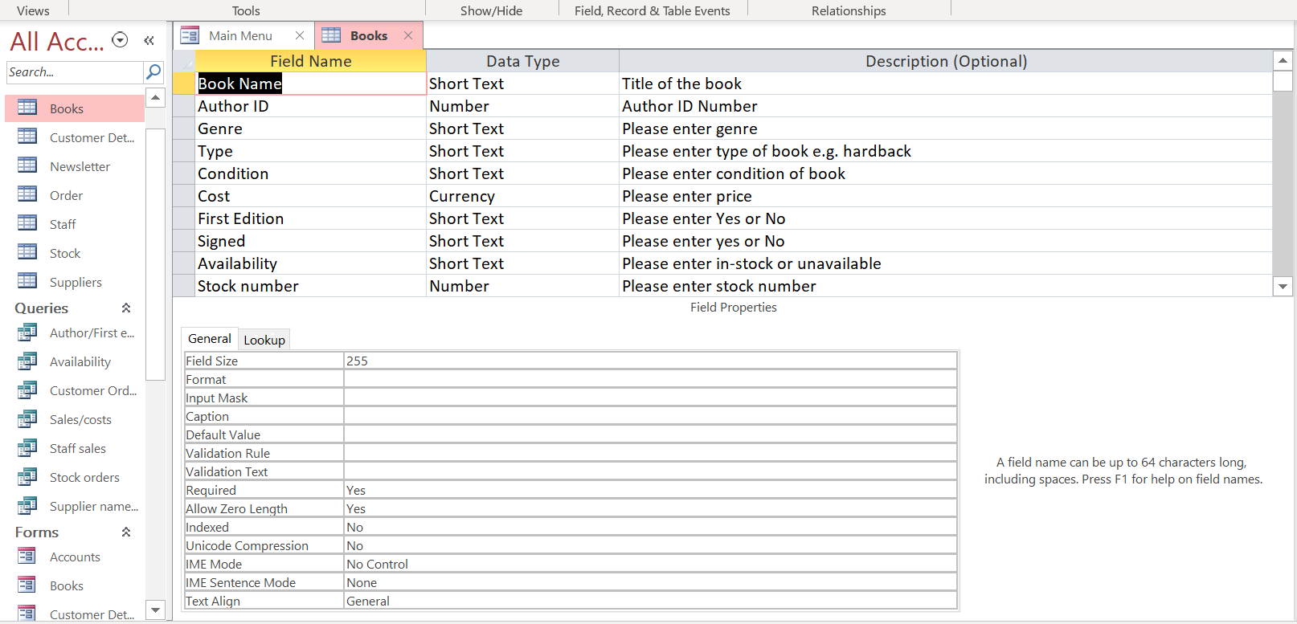

The author decided to input the test data set themselves manually, this was for the same reasons as the table as SQL was no more efficient. This was a personal choice for the author, using SQL you would define what tables you wished the data to be inserted by stating “INSERT INTO (Author_ID)” and then set the data by stating “VALUE (J.K.Rowling);”. The author saw this as no more efficient than typing in the data directly. The data set for the books table can be seen below.

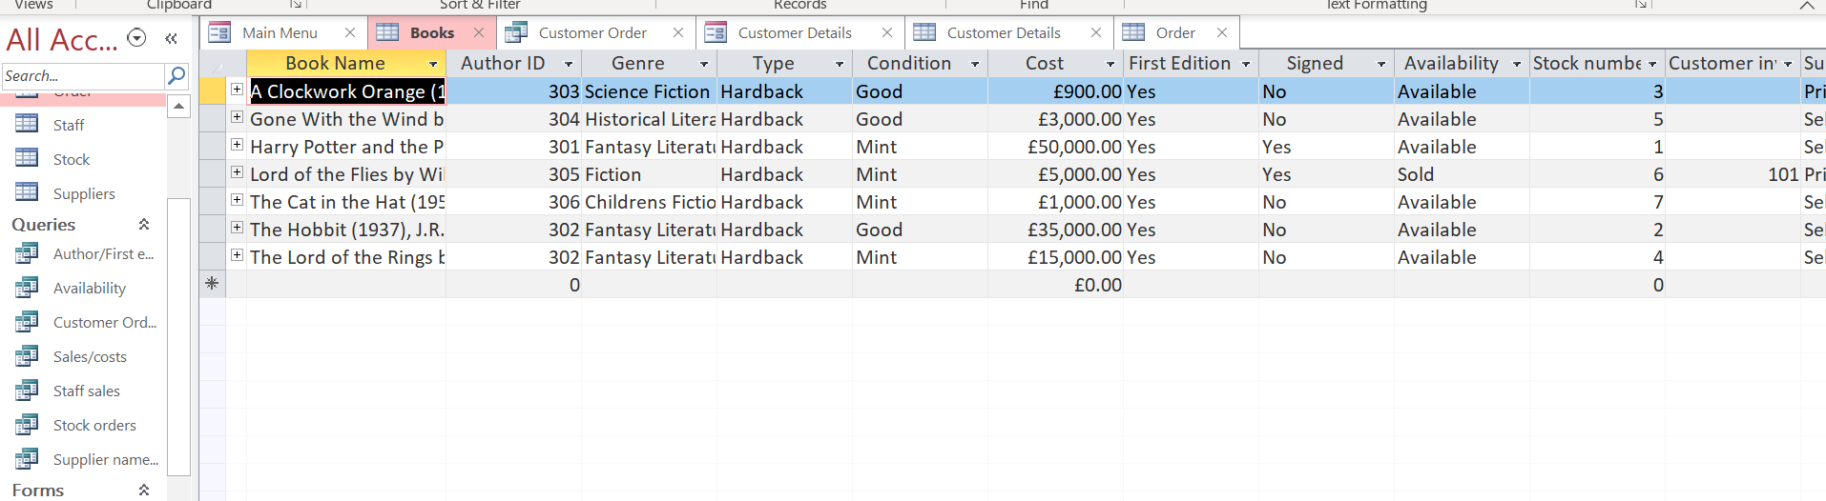

Queries were then created not only between differing tables but within a table. These were created utilising the query design and implementing relevant SQL to execute the query. The Author and first edition query can be seen in the below images. This query relates to the books table and shows what first editions are available, the author ID and if they are signed.
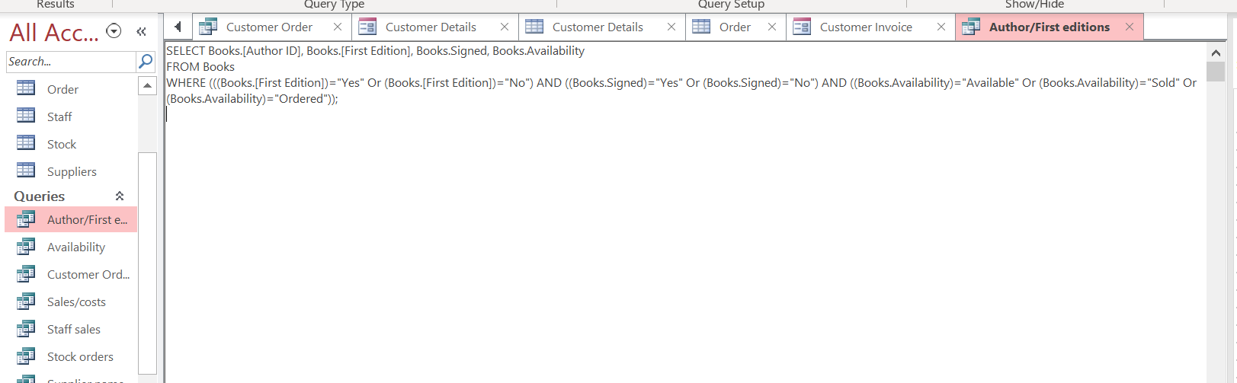
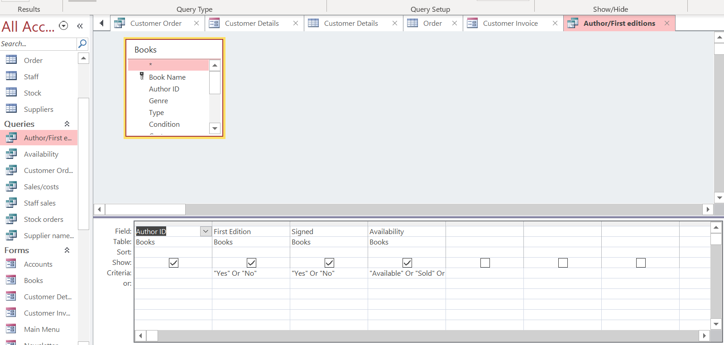
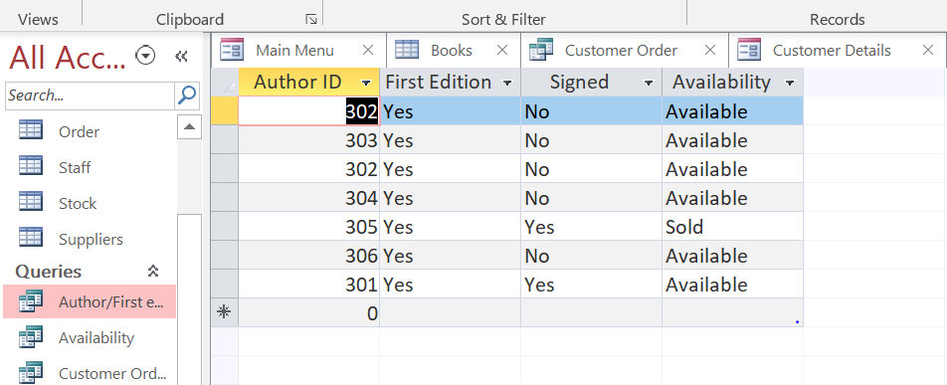

The author was able to identify various other queries by identifying the relationships between the tables prior to doing so. The relationships can be seen below.
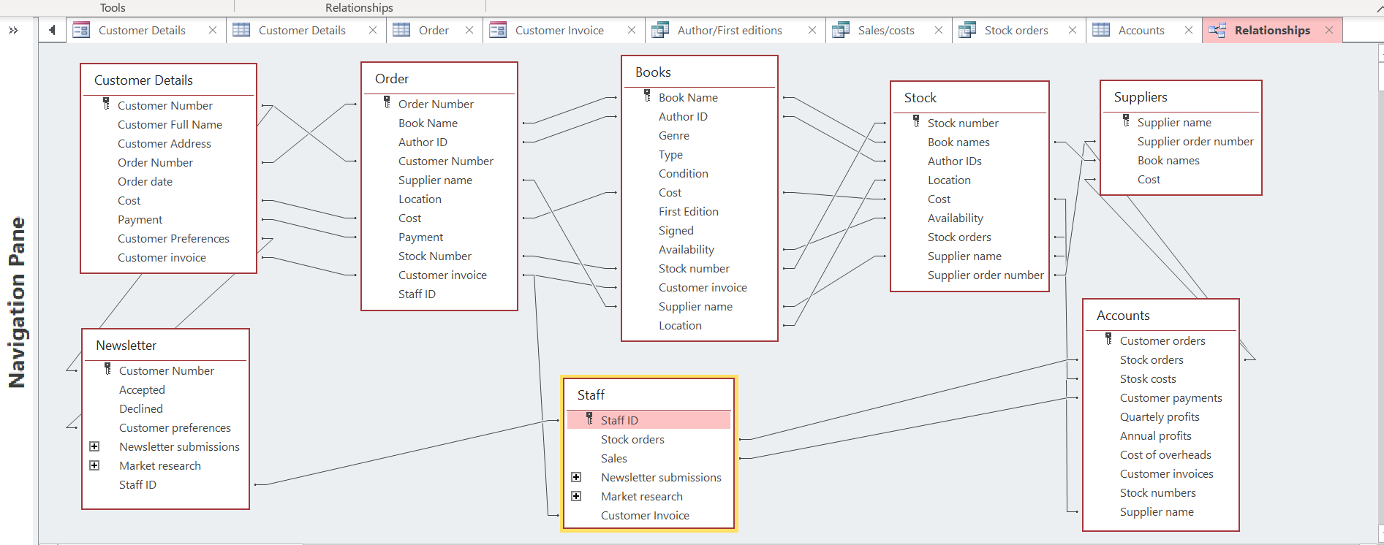

The queries created will allow the database user to search the database tables for information relating to stock, sales, customer orders, availability and suppliers.
When opening the database, the Main Menu will be the first thing to open as this was set within the database options and can be changed.

Forms and Reports

Forms were created in order that the data could be viewed in a better format and was able to be added to and/or deleted at the users will. All the forms created have a “Main Menu” button which allows the user to return to the main menu and navigate the rest of the database. There are also navigation buttons which allow the user to navigate through the records and labelled buttons which indicate to the user how they add, save and delete a record. The below is one of the said forms.
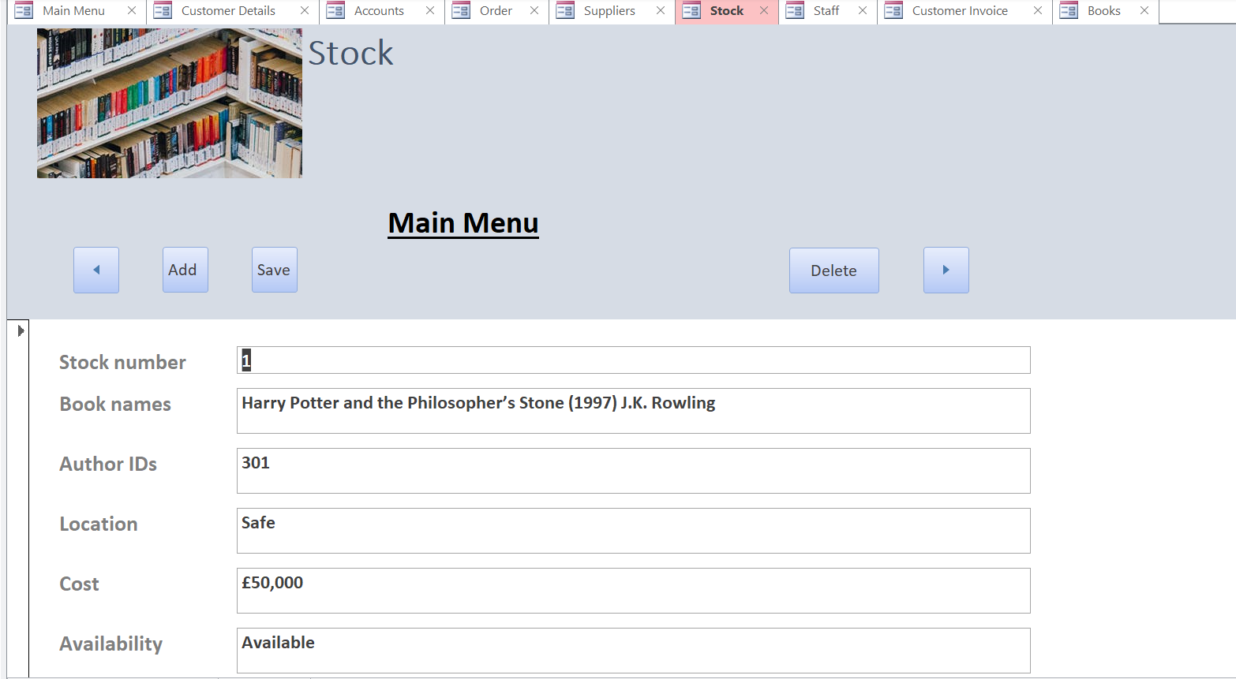
Reports were made by referring to the queries created within the tables of the database. These reports allow for data to be placed together for the user. They can also then be printed if necessary as can be seen below. The author created a macro for the customer invoice which was applied to the printer button on the report form.
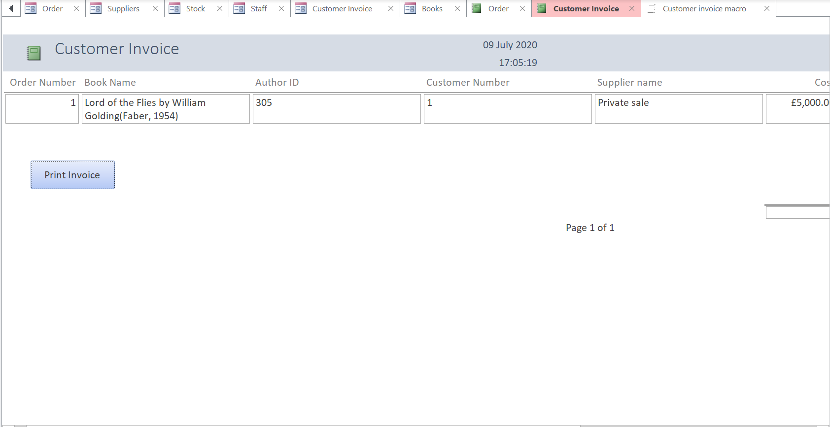
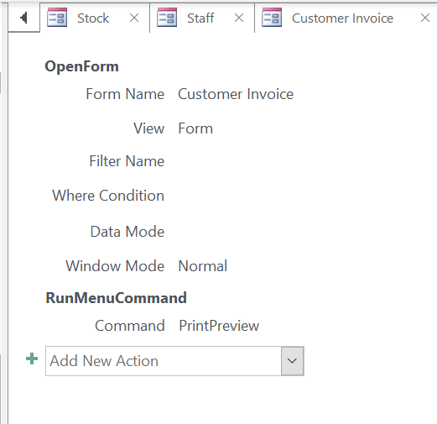

The Author has provided a basic user guide for the City Book Store database and can be seen in Appendix A.

Conclusion
In conclusion the author has created a user-friendly database whereby data can be stored, edited and retained at will by the user. The database is a simple design and provide the necessary functions required by the CITY Book Store

Appendix A.

The City Book Store Database user guide.
The main menu is a simple design with hyperlinks which direct the user to the required form.



The user in this case has selected books which can be seen below. From here the user can view the books and their availability. The user can add and delete a book from the records. There is also a search facility.

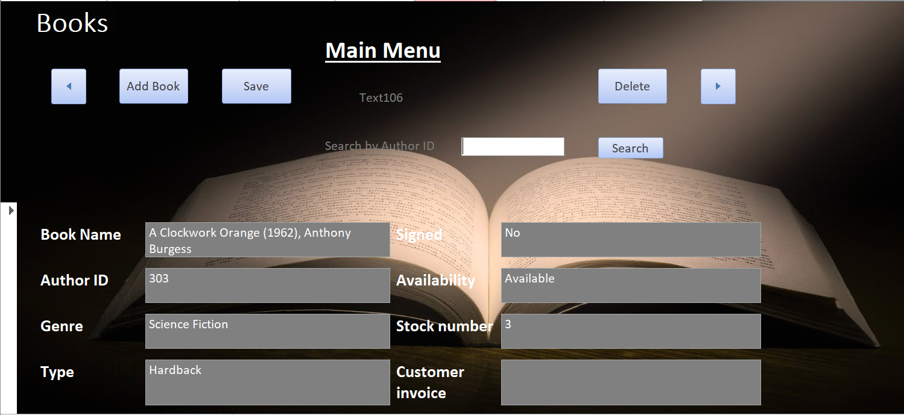

Customer details page, this allows the user to record customer details and edit those already held.
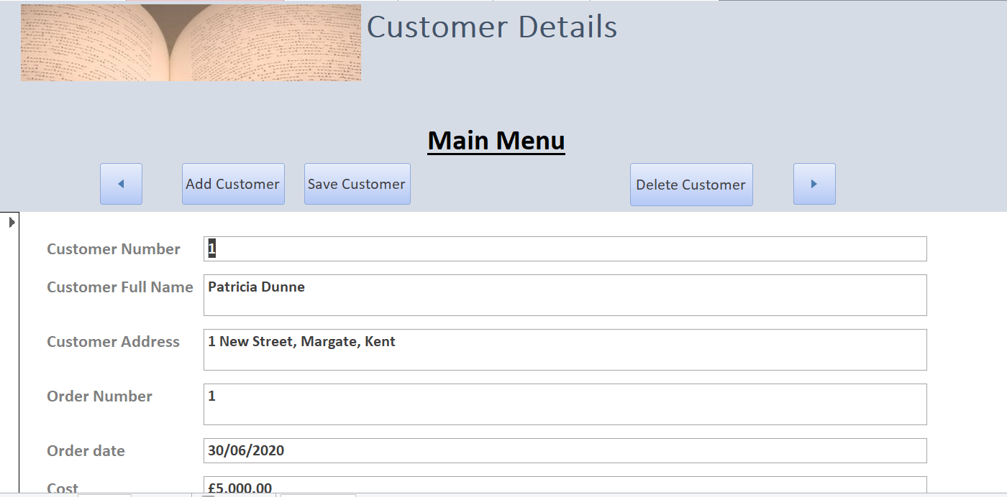
The same design is kept for the following forms.
Order form.
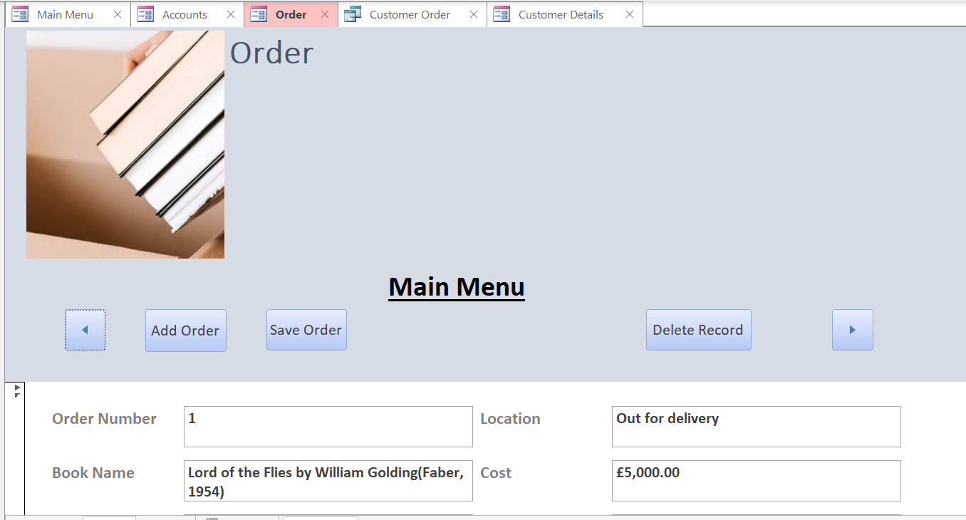

Staff Form which includes Newsletter/market research submission attachments.
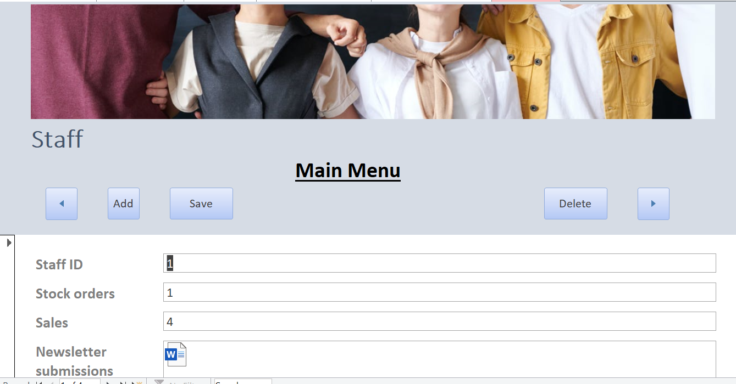

The remaining forms used within the database use the same format and navigation controls which are self-explanatory.

