Title: Business Report – Comparison of Corinthia Hotels and Ibis Hotels.
Name: A K M Amdadul Hoque
ID:2107424
Module Name: Financial Management for the hotel industry.
Module Code: BMIH 5007
Course Teacher Name: Tristan Hawkins

Table of Contents
Executive Summary 3
Introduction 4
Analysing and comparing the total revenue obtained by each organisation 5
The sources of revenue 5
Revenue trends 5
The factors driving revenue growth 6
Assessing the market positioning of the hotel groups 6
Evaluating the growth potentiality of the firms 7
Expansion strategies 7
Market opportunities 7
Potential barriers to growth 8
Financial Commitment to CSR 8
Financial commitment to CSR initiatives of Corinthia Hotels 8
Financial commitment to CSR initiatives of Ibis Hotels 8
Recommendations 9
Recommendations for Corinthia Hotels 9
Recommendations for Ibis Hotels 9
Conclusion 10
References 11
Appendix 13
Income statements of Cornithia Hotels 13
Income statements of Ibis Hotels (AccorHotels Group) 15

Executive Summary
This report will bring information about the revenue generation of Corinthia Hotels and Ibis Hotels. This will offer information regarding the sources of revenue, revenue trends of the firms and reasons for revenue growth. Further, this report will also show necessary information about market positioning through market share and brand perception. Here, the growth potentiality of both firms will be also discussed. In this segment, expansion strategies of the firms, available market opportunities and potential barriers that can hamper the growth will be also added. Further, the financial commitment to CSR by Corinthia Hotels and Ibis Hotels will be also provided. At last, necessary recommendations for both firms will be also included considering the analysis of this report.

Introduction
The hospitality sector has been developing over the years and the organisations engaged in the service offerings in the sector are also focusing on different strategies to grab a higher market share. To ensure revenue generation the organisations are hoping to improve the services offered by them. This report will contain information based on two hotel groups named Corinthia Hotels and Ibis Hotels. Here, Corinthia Hotels focuses on a luxurious hotel experience and ensures a unique service for the guests. This is a small player in the global luxury hotel sector (Harif, and Hameed, 2022). The target audience of this firm is affluent travellers. On the other hand, Ibis Hotels, a part of AccorHotels is a major player in global budget-friendly hospitality destinations. This organisation holds a large share in the global market and the target audience of this firm is budget-conscious visitors.

Analysing and comparing the total revenue obtained by each organisation

The sources of revenue
Here, the major source of revenue generation for Corinthia Hotels is room revenue. This organisation has been offering luxurious hotel rooms for visitors. It targets mainly leisure travellers. Further, food and beverage are another major source of revenue as Corinthia focuses on a unique culinary service for the visitors (Seo, 2021). Spa and wellbeing treatments are also considered as the major source of revenue for the firm. Since the organisation provides luxurious services to the visitors, obtaining revenue from the spa is an additional income. On the other hand, Ibis hotels focus on budget-friendly room revenue. It offers room services for travellers who focus on budget-friendly accommodations. The ancillary revenue of the firm is the second-highest source of revenue. Here, food and beverage and other necessary services contribute a significant amount to the total revenue. However, considering Corinthia Hotels, the revenue from food and revenue is insignificant for Ibis Hotels. Here, group booking is a large source of revenue for Ibis Hotels (Kahveci, 2023). Sometimes, large groups from different corporate offices and travel agencies come to take the group booking due to the budget-friendly offerings of the firm.

Revenue trends
In following the revenue trends of Corinthia Hotels and Ibis Hotels have been provided-

Figure 1: Revenue trends of Corinthia Hotels and Ibis Hotels
Source: Self-made (Using the annual reports)
From the revenue trends of both firms, it can be seen that the firms are achieving an increasing revenue over the years. Though the revenue of Ibis Hotels is showing too high than the revenue of Corinthia Hotels, it is happening because the revenue of AccorHotels Group is showing here. The financial statements of this group do not show separate revenue for Ibis Hotels. However, the Ibis Hotels are simultaneously contributing to the revenue generation of the group (Legrand and Laeis, 2022). After the downfall in revenue generation during COVID, both firms have reached a growth phase in the last two years.

The factors driving revenue growth
After recovering from COVID, Corinthia Hotels has achieved a 95% increase in revenue in the last year compared to 2021. This has been ensured due to the market expansion of the firm in Africa and Southeast Asia. Further, the revenue management of the firm has also contributed to the revenue growth. This organisation has ensured a high occupancy rate by considering the service pricing. Furthermore, focusing on key markets has also ensured revenue growth for the firm. Here, this organisation has focused on London, St Peterburg, and Malta mostly and obtained a high revenue. On the other hand, Ibis hotels have achieved revenue growth due to the resilient demand. This organisation has obtained a high revenue from European and Latin American markets (Karatepe and Okumus, 2021). Cost optimisation has also contributed to the revenue generation of the firm. Considering the revenue, this organisation has spent a lower operating cost in 2022 than in 2021. Furthermore, expanding business in Asia and Africa has also contributed to revenue growth.

Assessing the market positioning of the hotel groups
It is necessary to measure the market share, customer demographics, and brand perception to assess the market positioning of Corinthia Hotels and Ibis Hotels. In following those factors have been analysed-
Factors | Corinthia Hotels | Ibis Hotels
Market share | Corinthia Hotels holds a small market share considering the global luxury hotel giants. It is considered a niche player in this segment. Here, some of the giant hotel groups such as Hilton and Marriott are holding the major market share. However, Corinthia Hotels are holding a major portion of Malta. | Considering the budget-friendly, hotel accommodations, Ibis Hotels are holding a significant market share. This hotel is a major player in this segment and due to the global network of AccorHotels, Ibis Hotels always gets the preference of budget-friendly visitors (Çop and Alola, 2021).
Customer demographics | Corinthia Hotels mainly focuses on affluent travellers. This hotel offers services to the visitors who seek a high-end hotel experience. It offers an exceptional service to leisure travellers and business executives (Aboramadan and Karatepe, 2021). Travellers having high disposable incomes are the target of Corinthia Hotels. | Budget-conscious visitors are the major target of Ibis Hotels. They focus on several visitors rather than charging a particular visitor with a high amount. They focus on solo travellers, students, budget-focused professionals and families. They consider the young travellers mostly.
Brand perception | Corinthia Hotels are highly considered for their presence in the luxury hotel segment. They offer personalised services and unique cultural experiences (Mehta and Ramkumar, 2023). Due to providing an exceptional service, they also charge a premium price from the visitors. | Ibis hotels are considered for budget-friendly and affordable services. Their services have a comfortable touch with cleanliness and reliability. They do not focus on personalisation or unique service experience. Therefore, they offer services at a competitive price.

Evaluating the growth potentiality of the firms

Expansion strategies
Corinthia Hotels are considering the geographical expansion of their services. They are trying to capture some of the Southeast Asian nations and Africa. They will focus on the luxury tourism of these areas. Again, this organisation is also considering strategic partnerships. Here, Corinthia Hotels is ensuring necessary collaboration with airlines, loyalty programs and travel agencies. On the other hand, Ibis Hotels are focusing on continued internationalisation. This organisation is focusing on the emerging markets of Asia to grab the budget-conscious tourism destination (Meira and Hancer, 2021). Further, the digitalisation of the services is another major expansion strategy of this firm. It is focusing on online bookings, mobile applications and other digitalisations.

Market opportunities
Rising affluence in the global boundaries is increasing the opportunities for Corinthia Hotels as these hotels are offering luxurious services to the customers. It focuses on luxury travel experiences too. Further, the increasing blend of leisure and business travel is also increasing the opportunity for Corinthia Hotels. On the other hand, increasing urbanisation opens the doors for Ibis Hotels to get growth opportunities in budget-friendly areas. Here, people have been focusing more on budget travel in recent days (Djajasinga and Rihardi, 2021). Here, the popularity of budget travel has opened a new expansion channel for Ibis Hotels. Therefore, both firms are enjoying market opportunities.

Potential barriers to growth
The high investment cost is one of the major barriers for Corinthia Hotels to obtain growth opportunities. Renovating the hotels in London, St Peterburg and Malta requires a high investment cost. Further, intensifying competition among luxury hotels is also hampering the growth potentiality of Corinthia Hotels. On the other hand, rising operational expense is mentioned as the major barrier for Ibis Hotels to obtain growth opportunities (Hendriyatmoko and Poernomo, 2023). Here, this has been impacting the profit generation of the firm. Further, maintaining brand differentiation has become difficult for the firm. Despite focusing only on budget-friendly travel, consumer expectations of luxurious service are hampering this attention.

Financial Commitment to CSR

Financial commitment to CSR initiatives of Corinthia Hotels
Corinthia Hotels have allocated €5 million in 2022 as corporate responsibility which represents almost 1.2% of the operating revenue. This investment in CSR has been distributed in some of the major areas. This organisation has contributed €1.5 million in energy efficiency activities in that year. This contribution has reduced the energy consumption by 10% which is a major resource saving for the firm. Again, the investment of €0.75 million for the community engagement activities is another major task ensured by the firm (Bagdadi, 2023). This has contributed to education, local communities and other cultural initiatives. Furthermore, the investment in sustainable sourcing of €0.5 million has also ensured the growth of the local community by 15% which is a major contribution by this firm in CSR.

Financial commitment to CSR initiatives of Ibis Hotels
From the analysis of AccorHotels Group, the parent group of Ibis Hotels, a proper idea regarding the financial contribution of the firm can be achieved. Here, this group has contributed €212 million to CSR activities (Varga and Cobanoglu, 2021). This investment has been made for a CSR program of this firm named Planet21 Program. This contribution has been made by all the brands of AccorHotels Group. Moreover, a sustainable practice is considered by Ibis Hotels to ensure the cost-saving practice within the organisation. Since the firm has been considering budget-friendly accommodations for visitors, it is trying to ensure cost-saving practices within the organisation. A major focus on environmental sustainability has been also achieved by Ibis Hotels which ensures sustainable energy use and responsible material sourcing.

Recommendations

Recommendations for Corinthia Hotels
Expanding collaboration with strategic partnerships.
Justifications: Corinthia Hotels have been focusing on luxurious travel experiences. In this case, this firm should ensure a strategic partnership with travel agencies to get the visitors who want this type of service (Karina, 2022). Further, partnering with airlines can also ensure providing exceptional service to the visitors of Corinthia Hotels. From the analysis of the annual reports of 2022 this firm, the partnership with Air Malta has been contributing to the revenue generation of the firm. In this case, the firm should focus on partnering in some other areas too. Here are some more recommendations-
- Exploring the boutique hotel area can be a major way to obtain a specific number of customers (Ben Issa, 2021).
- Focusing more on personalised experience can ensure a greater customer experience which can lead to deeper customer satisfaction and ensure customer relationships.
- Ensuring sustainability to reduce operational costs will be an effective move for the firm.

Recommendations for Ibis Hotels
Investing in technology and focusing on digital marketing.
Justification: Competition has been increasing in the budget-friendly travel sector. In this case, focusing on technology and digitalisation of the services can grab the attention of the customers. In this case, offering online bookings will increase the number of visitors to the firm. Moreover, focusing on digital marketing can also grab the attention of customers from different areas where the firm is thinking of expanding its business. In this case, the firm should focus on some other areas too. Here are those-
- Partnering with local communities can offer firm-specific service opportunities.
Offering eco-friendly services can grab the attention of visitors to new markets (Hyppönen and Petrelius, 2022).
- Ensuring flexible work facilities can ensure customer engagement and improve service offerings.

Conclusion
Hospitality organisations need to focus on market expansion. Considering the similar location to offer services can hamper the growth opportunities. Moreover, this can also hamper the revenue generation of the firm if new firms arrive to offer services in a similar area. In this case, focusing on national and global expansion is necessary. Here, the firms should consider different factors while focusing on business expansion. In this case, considering market factors, target audience, and organisation-specific strengths and weaknesses is necessary (Dressler and Paunovíc, 2021). This can offer the firms a proper guideline on the ways to develop business activities and grab the attention of the customers in the national and global boundaries. In this case, the firms also need to focus on the barriers so that they can avoid them to obtain the growth opportunities.

References
Aboramadan, M. and Karatepe, O.M., 2021. Green human resource management, perceived green organizational support and their effects on hotel employees’ behavioral outcomes. International Journal of Contemporary Hospitality Management, 33(10), pp.3199-3222.
Bagdadi, A., 2023. Corporate social responsibility practices within the scope of sustainable tourism: A research at Accor Hotels. Prosperitas, 10(1).
Ben Issa, F.R., 2021. Obstacles to Foreign Direct Investment in the Libyan Hotel Sector: A Case Study of the Corinthia Company (Doctoral dissertation, University of Gloucestershire).
Çop, S. and Alola, U.V., 2021. Achieving environmental sustainability through green transformational leadership policy: Can green team resilience help?. Business Strategy and the Environment, 30(1), pp.671-682.
Djajasinga, N.D. and Rihardi, E.L., 2021, June. Practices in Human Resources and Employee Turnover in the Hospitality Industry. In 2nd Annual Conference on blended learning, educational technology and Innovation (ACBLETI 2020) (pp. 113-117). Atlantis Press.
Dressler, M. and Paunovíc, I., 2021. Business model innovation: strategic expansion of German small and medium wineries into hospitality and tourism. Administrative Sciences, 11(4), p.146.
Harif, M.A.A.M. and Hameed, W.U., 2022. The role of open innovation, hotel service quality and marketing strategy in hotel business performance. Heliyon.
Hendriyatmoko, D. and Poernomo, M.I., 2023. Communication Of The Crisis Of Hotel Ibis Budget Daan Mogot Jakarta In Facing The Covid-19 Pandemic. International Journal Of Humanities Education and Social Sciences, 3(2).
Hyppönen, P. and Petrelius, J., 2022. Improving profitability of the royal spa: development plan for the Royal Spa Department-Corinthia Grand Hotel Royal.
Kahveci, E., 2023. Business strategies for small-and medium-sized tourism enterprises during COVID-19: a developing country case. Journal of Hospitality and Tourism Insights, 6(4), pp.1569-1593.
Karatepe, O.M. and Okumus, F., 2021. COVID-19, mental health problems, and their detrimental effects on hotel employees’ propensity to be late for work, absenteeism, and life satisfaction. Current Issues in Tourism, 24(7), pp.934-951.
Karina, L., 2022. Communication promotion of Corinthia Hotel St. Petersburg in an increasingly competitive environment.
Legrand, W. and Laeis, G.C., 2022. Sustainability in the hospitality industry: Principles of sustainable operations. Taylor & Francis.
Mehta, M.P. and Ramkumar, M., 2023. Customer expectations in the hotel industry during the COVID-19 pandemic: a global perspective using sentiment analysis. Tourism Recreation Research, 48(1), pp.110-127.
Meira, J.V.D.S. and Hancer, M., 2021. Using the social exchange theory to explore the employee-organization relationship in the hospitality industry. International Journal of Contemporary Hospitality Management, 33(2), pp.670-692.
Seo, K., 2021. Asset-light business model: strategies for hotels during the pandemic. Accounting & Finance.
Varga, S. and Cobanoglu, C., 2021. Employee perceptions of wellness programs in the hospitality industry. International Journal of Contemporary Hospitality Management, 33(10), pp.3331-3354.

Appendix

Income statements of Cornithia Hotels
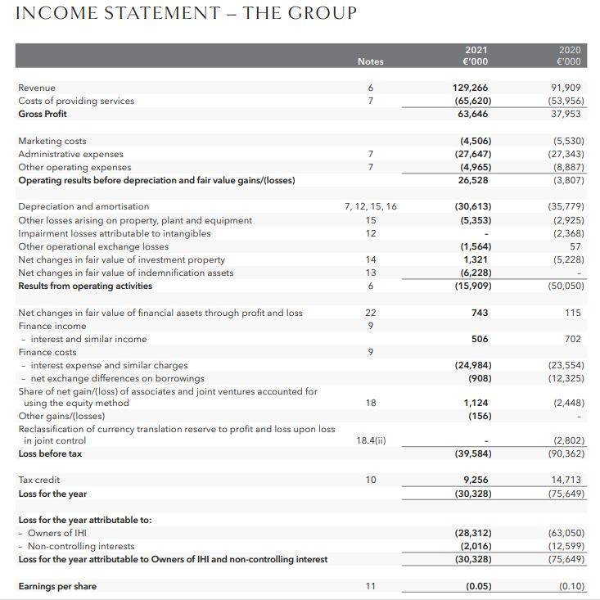
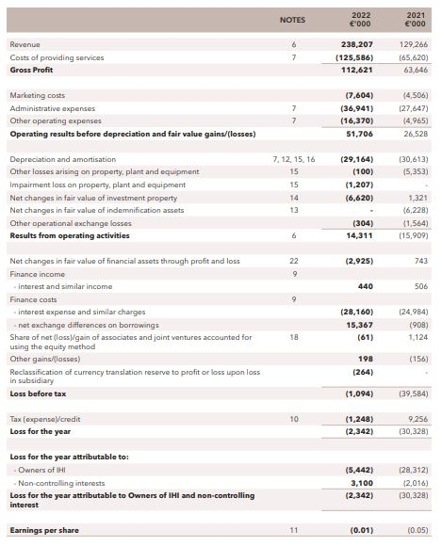

Income statements of Ibis Hotels (AccorHotels Group)


