
Supervisor: Jordan Jenkins
By
NF3 Reduction study in the application of thin film Chemical Vapour Deposition

Anneliese Edwards

BEng (Hons) Material Science
Project Submitted as part of the requirements for the award of

May 2026

Word Count = 9644
‘This thesis is the result of the author’s original research. It has been composed by the author and has not been previously submitted for examination which has led to the award of a degree.’
Signed: A. Edwards Date: 09/04/2026

Declaration
I, Anneliese Edwards declare that I am the sole author of this project, that all references cited have been consulted, that I have conducted all work of which this is a record and that the finished work lies within the prescribed word limits.
Form of consent
I, Anneliese Edwards hereby do not consent that my Project, submitted in candidature for the B.Eng. (Hons) Material Science degree, if successful, may be made available for inter-library loan or photocopying (subject to the law of copyright), and that the title and abstract may be made available to outside organisations. The justification of restricting access to this project is due to the potential loss of confidential information.

Abstract
This report outlines the design, development and implementation of a NF3 reduction study in the application of thin film Chemical Vapour Deposition, using a KLA CVD Delta deposition module at a customer production site in Italy. The project was proposed in order to reduce the NF3 consumption of the production site.
The primary objective of the project was to reduce the overall NF3 consumption by 10%, the quantitive reduction in NF3 usage was determined by two factors, a minimum reduction requested by the customer, as well as by determining what was deemed to be a reasonable expectation based on similar projects. The solution must also not have a negative effect on the on-wafer results. There was no strict budget set for the project as minimal resources will be required, as well as the fact the reduction in usage was of high priority for the customer. The project must be completed by May 2026.
The project revolved around the design of experiments as well as implementation testing and finally collation and comparison of results to identify the reduction in NF3 usage. The implementation required on site testing, including, pre-implementation testing, recipe adjustment, deposition tests and metrology measurement. The analysis of the results identified the reduction in NF3 usage, by calculating the total volume gas usage during the process. This was identified using the total gas flow and the total clean time via end point detection.
The project was overall a success, achieving the minimum of 10% reduction in NF3 consumption, with minimal challenges encountered throughout the project. Due to its success, there are recommendations for future iterations, including implementing this solution for alternative deposition recipes used on site, including but not limited to, aSi, SiO and TEOS films.

Acknowledgements
I would like to express my gratitude to my project supervisor, Jordan Jenkins, for their guidance and support throughout this project. Without their expertise and feedback the successful completion of this project would not have been possible.
I also extend my appreciation for my manager at KLA, Jafar Alkuzee, who has given me the time and support needed to complete my degree, they have also taught me key skills, needed to work as an applications engineer over the almost 6 years of employment at KLA.
Finally, I would like to extend my gratitude to my family and friends for their encouragement and support throughout this project. This support has been fundamental in keeping me motivated and focused despite the challenges I encountered outside the scope of this project.

Contents
1.0 List of content 7
1.1 List of figures 7
1.2 List of tables 8
1.3 List of equations 8
2.0 Introduction 9
2.1 Project Context 9
2.2 Problem Statement and Rationale 9
2.3 Aims and Objectives 10
2.4 Report Structure 10
3.0 Literature Review 11
3.1 Introduction 11
3.2 KLA Tencor 11
3.3 Nitrogen Tetrafluoride 12
3.4 Environmental impacts 12
3.5 Economic considerations 13
3.6 Metrology tools 14
3.7 Relevance to the project 18
3.8 Existing clean recipe 18
3.9 Silicon Wafers 20
3.10 Ethical and environmental considerations 20
3.11 Legal considerations 21
3.12 Conclusion 22
4.0 Project Design 22
4.1 Project Design Introduction 22
4.2 Tools and software 22
4.3 Tool Baseline Testing 23
4.4 NF3 reduction via reduced clean frequency 24
4.5 NF3 reduction via reduced gas flow 24
4.6 NF3 reduction via change in clean chemistry 24
4.7 Implementation Spreadsheet 25
4.8 Proposed Plan 25
4.9 Design of Experiments 26
4.10 Recipe creation and simulation 26
5.0 Pre-Implementation testing 28
5.1 Introduction 28
5.2 Metrology Baselining 28
5.3 Process Baselining 29
6.0 Implementation 29
6.1 Introduction 29
6.1 Results - Increased Number of Wafers between cleans 30
6.3 Endpoint maps – Increased number of wafers between cleans 31
6.4 Results – Reduction in NF3 flow rate 34
6.5 Endpoint maps – Reduction in NF3 Flow rate 35
7.0 Discussion and conclusion 37
7.1 Increased number of wafers between cleans 37
7.2 Decreased NF3 Flow rate 39
7.3 Conclusion 40
8.0 Recommended further work 40
9.0 References 41

List of content

1.1 List of figures
Figure 1 - Image of TOHO Flexus metrology tool 15
Figure 2 - Image depicting the measurement mechanism of the TOHO Flexus metrology tool 15
Figure 3 - Image of ResMap metrology tool 16
Figure 4 - Image of resultant stress map from ResMap metrology tool 17
Figure 5 - Post wafer clean recipe used in CVD module 18
Figure 6 - Example quote for high quality 200mm Silicon wafers 20
Figure 7 - Image depicting the recipe changes for DOE 1 27
Figure 8 - Image depicting the recipe changes for DOE 2 28
Figure 9 - Endpoint trace for 5WBC – Post wafer clean (left) and Post cassette clean (right) 32
Figure 10 - Endpoint trace for 6WBC – Post wafer clean (left) and Post cassette clean (right) 33
Figure 11 - Endpoint trace for 7WBC – Post wafer clean (left) and Post cassette clean (right) 34
Figure 12 - Endpoint trace for 8WBC – Post wafer clean (left) and Post cassette clean (right) 34
Figure 13 - Endpoint trace for 5000sccm NF3 – Post wafer clean (left) and Post cassette clean (right) 36
Figure 14 - Endpoint trace for 4000sccm NF3 – Post wafer clean (left) and Post cassette clean (right) 37

1.2 List of tables
Table 1 – Table containing the planned project tasks and estimated wafer usage 25
Table 2 – Table depicting the Baseline CapOx results compared to the specification 29
Table 3 – Table depicting the baseline SiN results compared to the specification 29
Table 4 – Table depicting the SiN recipe parameters 31
Table 5 – Table depicting the results for the increase number of wafer between cleans test 31
Table 6 – Table containing SiN Specification 31
Table 7 – Table depicting the SiN recipe parameters 35
Table 8 - table depicting the results for the reduced NF3 flow rate tests 35
Table 9 - Table depicting the calculated NF3 consumption for the increased number of wafer between clean tests 37
Table 10 - Table depicting the calculated NF3 consumption during the decreased NF3 flow tests 39

1.3 List of equations
Equation 1 – Film Stress Calculation 13
Equation 2 – Film thickness calculation 14

2.0 Introduction

2.1 Project Context
Nitrogen Tetrafluoride (NF3) is critical in Chemical Vapor Deposition (CVD) cleaning applications. It is the preferred cleaning chemistry for CVD deposition due to its high fluorine atom production and higher etch rate and cleaning efficiency compared to other cleaning methods, such as Octafluropropane (C3F8), which is used in older model machines. This project aims to explore the methods that can be used to reduce the NF3 usage during CVD processing and the resultant effects on the on-wafer results. This is essential to reduce production costs and wasted resources.
The project is focused on the efforts to reduce the overall NF3 usage in the module during the post wafer cleaning of the chamber. The focus is towards the rate of flow of gas, the rate of cleaning and the potential use of other cleaning chemistries.

2.2 Problem Statement and Rationale
SPTS is a manufacturing company based in Newport, UK, which specialises in the development and manufacture of semiconductor equipment. SPTS specialises in Plasma Vapor Deposition (PVD), Chemical Vapor Deposition (CVD), Molecular Vapor Deposition (MVD) and etch equipment, providing advanced wafer processing technologies and solutions for the semiconductor and microelectronics industry (KLA, n.d.). CVD Is a thin film deposition method which is used by SPTS APM tools, it is used to create thin films or coatings by depositing a solid material onto a substrate via chemical reactions of a gaseous precursor. SPTS tools use Plasma enhanced deposition which allow us to deposit films at lower temperatures, common films include, Silicon Oxide (SiO), Silicon Nitride (SiN), Amorphous Silicon (aSi) and Tetraethyl orthosilicate (TEOS). (Sigma Aldrich, n.d.)
After deposition, it is imperative that the chamber walls and other components are left completely clean to prevent particle contamination of the film. To achieve this, a clean step is required, this involves using a NF3 gas and plasma to etch away the deposition from the chamber. The SPTS process uses a high flow of NF3 to achieve this, leading to high usage and high gas usage costs. At the customer site in Italy, only (1) NF3 bottle can be stored on site due to gas storage regulations, and the lead time of a new bottle is approximately 12 weeks, therefore, accurate usage tracking and also limiting its usage will be of great benefit to the customer.

2.3 Aims and Objectives
NF3 gas, is the clean chemistry used in a large majority of CVD process modules, this is due to the improved etch rate achieved with this chemistry compared to older methods such as using C3F8. Although, this is the best method in terms of etch rate, the gas itself, is costly and poses an environmental risk. With an average cost of $90 per Kg for high purity gas and an global warming potential of ~172000 times that of Co2. Therefore, it is the best interest of the end user to minimise the amount of NF3 used in the process.
The primary aim of the project is to minimise the amount of NF3 used in the post wafer clean during CVD processing, in order to make it most cost effective. The aim is to achieve this by minimising NF3 usage, by the method of, reduced gas flow, reduced clean frequency or potential change in clean chemistry.
The key business metric for this project is cost so the aim is to reduce the NF3 Usage by at least 10%, to reduce the overall cost of the process. The quantitive reduction in NF3 usage was determined by two factors, a minimum reduction requested by the customer, as well as by determining what was deemed to be a reasonable expectation based on similar projects. For the project to be considered successful the following criteria must be met:
- Time Constraints - The project must be completed by May 2026
- Success Criteria - The NF3 Usage must be reduced by a minimum of 10% overall.
- Process Impacts - The new process should not negatively impact the on-wafer results currently being achieved.
- Change Implementation - The final recipe should be explained fully to the customer to ensure the new process is implemented effectively.
- Tool Availability Constraints - Tests must be completed around production to prevent any down time on the tool.

2.4 Report Structure
This report is structured into multiple chapters to provide a cohesive flow of the project. This includes an introduction into the project; the literature review, containing existing literatures on similar topics, including metrology, NF3 usage and safety considerations; the design and implementation of the project, which discusses the hardware, software and processes to be used during the project, as well as the planned tests to be completed; the testing and evaluation of the results compared to the expected results; finally, the conclusion and recommendations, which will aim to summarize the results found during the project and make recommendations or potential improvements that can be made to the current CVD process.
The timeline of the project aims to begin the project implementation by January 2026 for completion by May 2026. Several weeks were initially allocated for the implementation to allow for any unforeseen issues and lack of access to the tool due to production schedules.

3.0 Literature Review

3.1 Introduction
The literature review chapter contains a comprehensive review of literature available surrounding NF3 usage and the relevant metrology, as well as economic and safety factors. Relevant environmental considerations include, internal environmental conditions such as airborne particles and contamination control, controlled by the cleanroom regulations, ISO14644. As well as external environmental considerations, including energy consumption and greenhouse gas production, NF3 has a green house gas potential ~17200 times that of Co2, makings its environmental Impact significant. The chapter is organised into separate chapters relating to each topic to allow a comprehensive review on each. By looking at existing literature surrounding the topic of NF3 usage in the semiconductor industry it provides a background for the project and provides insight for the context for completing the project. The literature review guided the methodological approach of the project by identifying similar projects that have been completed, such as the research completed by Lam, which revolved around minimising gas usage by reducing the gas flow rate.

3.2 KLA Tencor
SPTS, now known as a KLA company, works within the Semiconductor industry, producing the world’s leading Semiconductor and microelectronic devices. SPTS has worked for 40 years to produce the industry’s leading Silicon etch, Dielectric Etch, Dry release Etch, PVD, PECVD and MVD solutions. As well as supplying our customers with the best semiconductor solutions, SPTS also offers a dedicated customer support network. ‘Demos’ are used in order to demonstrate the capabilities of SPTS’s semiconductors tools as well as to solve issues currently being observed by customers.
KLA operates a significant facility in Newport, South Wales, currently encompassing, 2 manufacturing and production sites as well as significant office space. These facilities specialise in the manufacture and development of silicon etch and deposition modules, while also housing the required, human resources, customer service and sales departments at KLA.
The operations of KLA Newport, play a crucial role in the company’s presence in both the UK as well as throughout Europe and worldwide as they supply both tools and customer support to customers worldwide.

3.3 Nitrogen Tetrafluoride
Nitrogen Tetrafluoride or NF3, is a colourless, toxic gas, made up of a single nitrogen atom and three fluorine atoms. Often associated with Plasma Enhanced Chemical Vapour Deposition (PECVD) processes for chamber cleaning and conditioning due to it being non-corrosive and non-reactive (Martin-Torres, 2020).
Plasma enhanced chemical vapour deposition modules uses NF3 with remote plasma applications to clean thin film deposition, a plasma is struck in a remote plasma source, and the deposition is cleaned via Ion bombardment. (Kim, 2021). SPTS deposition modules, such as the Delta APM, use a high flow of NF3 as standard, at 5000sccm. This results in a high gas usage on the module leading to financial, environmental and practical concerns.
Despite its issues, NF3 continues to be used due to its high cleaning efficiency and lower direct emissions compared to perfluorocarbons, however, the emissions are still high, with a global warming potential of ~17,200 CO2e, making it 17,200 times more powerful than carbon dioxide in trapping atmospheric heat (Russel, 2013), making its reduction critical for sustainability and climate target compliance. Another driving factor for reducing NF3 in industry is cost. Purchasing NF3 is expensive, with high purity gas costing around $90 per Kg, with a large bottle containing 47Kg, totalling 4230 per bottle, making it a leading manufacturing costs in the semiconductor industry. Based on these factors, the points driving NF3 reduction during thin film reduction are mainly cost, health and safety and environmental factors.

3.4 Environmental impacts
According to (Byeon, 2025) NF3 gas, is the optimal choice for etching silane-based films, such as amorphous silicon (aSi) which is a common PECVD deposition, as it doesn’t produce foreign species contaminants, such as carbon or sulphur, which could contaminate the film, or lead to particle contamination in the chamber. They conclude that, after reacting with the Silane based deposition, a byproduct of the etch process is SiF4, or Silicon Tetrafluoride. Silicon Tetrafluoride is a colourless, corrosive toxic gas with a pungent odour, it reacts with both air and water and is toxic when inhaled. (EFC Gases, n/a). Due to the toxicity of the byproduct, this is the main environmental concern surrounding the use of NF3 gas, as even post abatement system, some elements will still remain and be released into the atmosphere.
(Zhou, 2024)discussed the environmental impacts of fluorinated compounds, including Nitrogen Trifluoride, stating that during semiconductor manufacturing, significant greenhouse gases are emitted which all have a high global warming potential. This is a major environmental concern relating to semiconductor processes, as the byproduct creates a risk to both the environment and to health, if people are situated near the exhaust point of the abatement system. Zhou concludes that to reduce the environmental impact of manufacturing, the byproducts being released needs to be drastically reduced. This is also supported by (Kim, 2021) who also stated that NF3 is a greenhouse gas, with high global warming potential, expanding on the risk by detailing the lifespan of the gas, which is 500 years, cementing the seriousness of the issue. Kim explores the theory or replacing the use of NF3 entirely with different chemistries to limit the environmental impact of the process.
Lam 2025, states that NF3 ranks second in global warming potential of all greenhouse gases, identifying that it has a great impact on the environment. Lam investigated alternative methods of reducing NF3 consumption in order to reduce the environmental impact. They conducted an experiment on reducing the flow rate of the gas; to reduce overall usage, this identified an average of a 32% reduction in Co2 emissions after abatement.
Lam research worked with a well-known semiconductor company, ST Electronics to complete the research study, providing industry expertise and providing transparent results, making them a decent and reliable source of information, it is possible any opinions throughout the document could be biased as the companies work in the semiconductor industry and results will benefit them, however, the quantitive data from testing is also provided, making the results more reliable and trustworthy. Both Zhou, and Byeon were both research papers published in legitimate and trustworthy journals, they were also recently published, in 2024 and 2025 respectively. They are also well referenced, quoting from multiple sources, supporting their information and conclusions. Therefore, these can both be considered accurate and reliable sources of information.

3.5 Economic considerations
As well as environmental considerations, NF3 is also problematic due to its high cost. The upfront costs of purchasing high purity NF3 cylinders which are required for PECVD processing is in the thousands, with the price varying based on quantity and purity of gas. Other related costs include, storage of the gas, which in many countries is only allowed to be stored 1 bottle at a time due to gas storage restrictions, as well as the cost of the abatement system required to burn off the byproducts of the manufacturing and conditioning processes. (Seyun, 2023)identified the associated costs with NF3 usage as well as the exacerbated increase in cost caused by advanced manufacturing devices due to the increased consumption of NF3 due to the requirement for high cleaning rates and thorough cleaning. This is the case for SPTS / KLA devices, due to particle requirements, the machine must be thoroughly cleaned, required long clean times with a high flow of NF3 at ~5000sccm.
PW Consulting, 2025 discusses operational costs due to NF3 infrastructure, they identified the additional costs required to meet compliance with environmental regulations, including emissions controls and strict rules for abatement systems. If these requirements are not met, this can lead to penalties for leaks or to the plant being shut down until conditions are met. PW consulting stated from in 2025, NF3 related costs have increased by 15% compared with figures from 2019. This is supported by the data provided by (Pulidini, 2023) who stated that the NF3 market in 2023 had reached $1.68 Billion, with it estimated to grow by approximately 11.7% CAGR by 2032 due to the increasing rising demand and increasing costs associated with environmental compliance.

3.6 Metrology tools
In the application of semiconductor deposition, several metrology measurement tools are used in order to determine the quality, stress, thickness and electrical properties of the film. In order to determine these figures, pre and post measurements must be completed on the silicon wafer. For the proposed testing, 2 measurement tools are required, thin film thickness measurement and film stress.
TOHO FLX Thin Film Stress Measurement tool
The TOHO FLX is used to premeasure the stress of Si wafers, then used to measure the wafers post deposition process. By comparing these 2 measurements it allows the tool to create a ‘stress map’ in order to show how the stress is distributed across the surface of the metal film. These maps show a pictorial representation of the film stress as well as giving the figures for the minimum stress, maximum stress, and the average stress. From this the stress range can be calculated as well as showing if the film stress is compressive or Tensile. (TOHO Technology, n.d.)
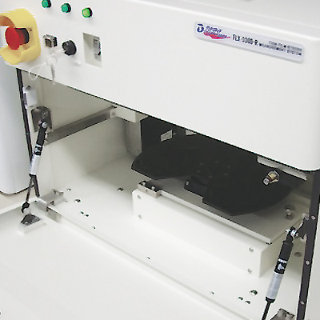

Figure 1 Image of TOHO Flexus metrology tool

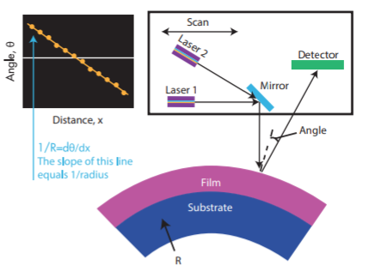
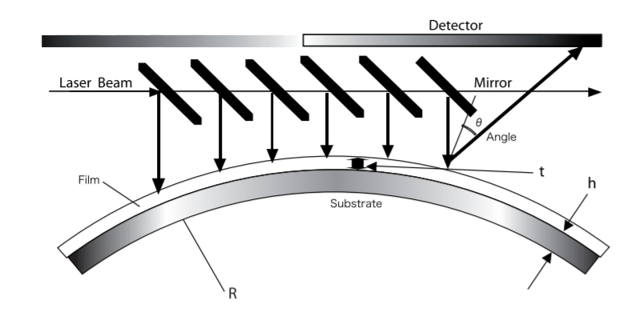
A laser beam is shone onto a mirror surface this is shone onto the surface of the wafer and deflected onto a detector. The angle in which the laser beam reflects off of the surface of the wafer is Theta(Ɵ), this is used to calculate the film stress.
Figure 2 Image depicting the measurement mechanism of the TOHO Flexus metrology tool

The film stress is calculated using the equations.

$\frac{1}{R}=ⅆθ∕ⅆx$ $S=\frac{Eh^{2}}{\left(1-v\right)6Rt}$
Equation 1 – Film Stress Calculation
(Quantum Design, n.d.)

Where
S = Stress
E = Youngs modulus
h = thickness
v = Poissons ratio of the material
r = radius
t = time

CDE ResMap

The CDE ResMap Model 273 – for up to twelve” Wafers, is used to measure the electrical resistance of Silicon wafer films. This is done using a 4-point probe which measures the Rs directly and with a 0.5% accuracy. (CDE, n.d.)
The varying resistance across the wafer film can then be used to calculate the thickness of the film on top of the wafer’s surface. This is beneficial as film thickness cannot be measured optically as the film is not transparent to light. (Creative design engineering, 2002)
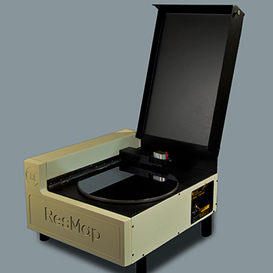

(CDE, n.d.)
Figure 3 Image of ResMap metrology tool

In the event that we assume the resistivity of the film will not be consistent throughout the entire surface of the film, the film thickness can be calculated using the equation.

$$W={\tilde{n}}^{'}Rs^{\hat{a}}$$
Equation 2 – Film thickness calculation
Where $\tilde{n}$ = Bulk sensitivity

Where $\hat{a}$ = Armstrong

ResMap will also produce a map showing each point value as well as a contour map showing the distribution of thickness across the surface of the wafer. From these values you can determine if the wafer is centralised when it is being processed as well as see if the magnetron speed will need to be changed. For example, if there are high points towards the center of the wafer, if the magnetron speed is increased, these high spots will be pushed out towards the edge of the wafer.
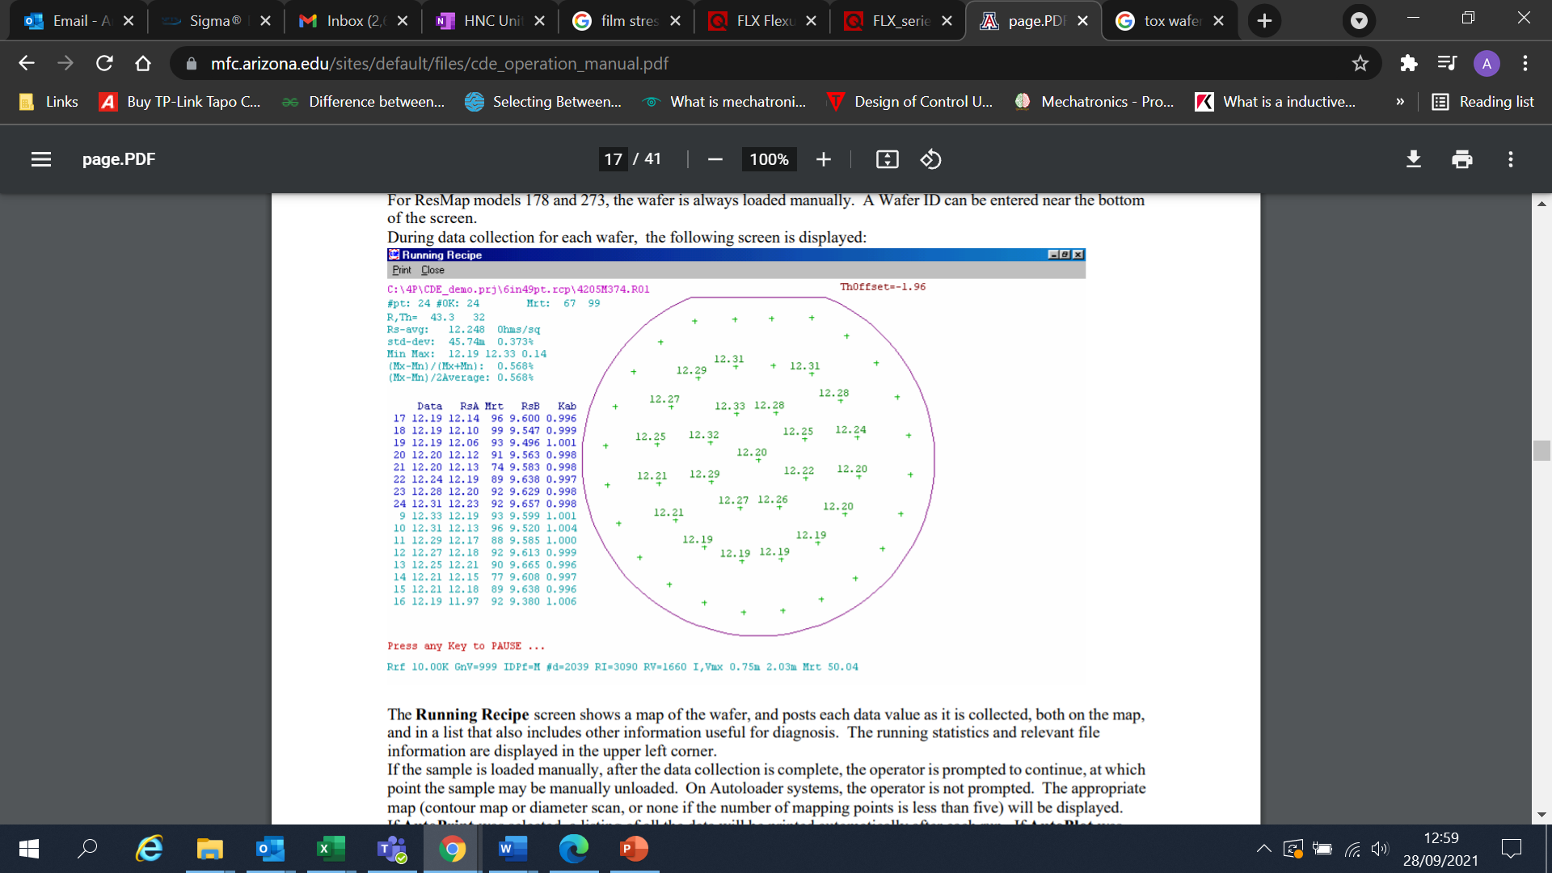
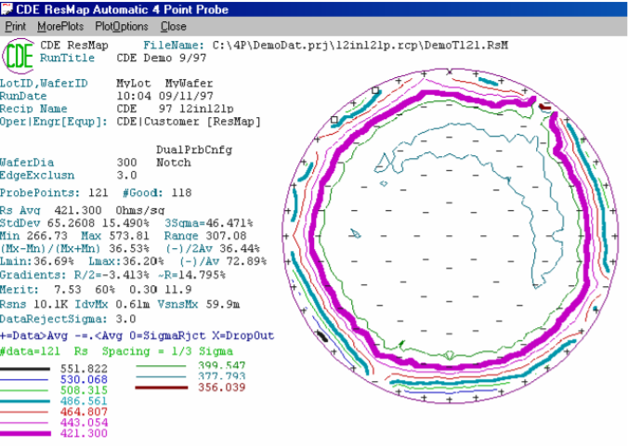
ResMap Examples
Figure 4 Image of resultant stress map from ResMap metrology tool
(Creative design engineering, 2002)

3.7 Relevance to the project
Within Chemical Vapour Deposition Tools, NF3 gas is used in the typical etch chemistry used for chamber cleaning. Kim and Torres detail the importance of the etch chemistry in relation to cleaning rates, with NF3 improving the throughput of the tool, while also being unreactive and lower direct emissions compared to perfluorocarbons. This is important in semiconductor deposition due to the myriads of other gases being used within the chamber, therefore, the reactivity of the cleaning chemistry is very important.
The research by Zhou and Russel presents the environmental impacts of using NF3 gas – with its global warming potential being high at ~ 17200. As well as the distinct environmental impact of the Gas. This research supports the idea that reducing the NF3 consumption of module would be critical for sustainability and climate target compliance. Another factor for reducing the NF3 consumption in the current application is the potential health and safety concerns associated with the gas. EFC gases discuss the concerns of using NF3, including the toxicity of the gas, which reacts in air, and even post abatement system, some elements may remain and be released in the atmosphere. This again supports the idea that reducing the usage of the gas will be beneficial for safety reasons.

3.8 Existing clean recipe
As discussed previously, KLA semiconductor processing tools use a Nitrogen tetrafluoride based clean chemistry to clean the chamber post chemical vapour deposition. KLA uses a standard ‘BKM’ or best-known method recipe for this process, which is optimised to work for all deposition processes on the module. These BKM recipes are used for all tool installations to ensure consistency and are also used in order to ensure the tool is operating correctly as extensive data is available. Below is the standard BKM post wafer clean recipe used in the CVD modules.
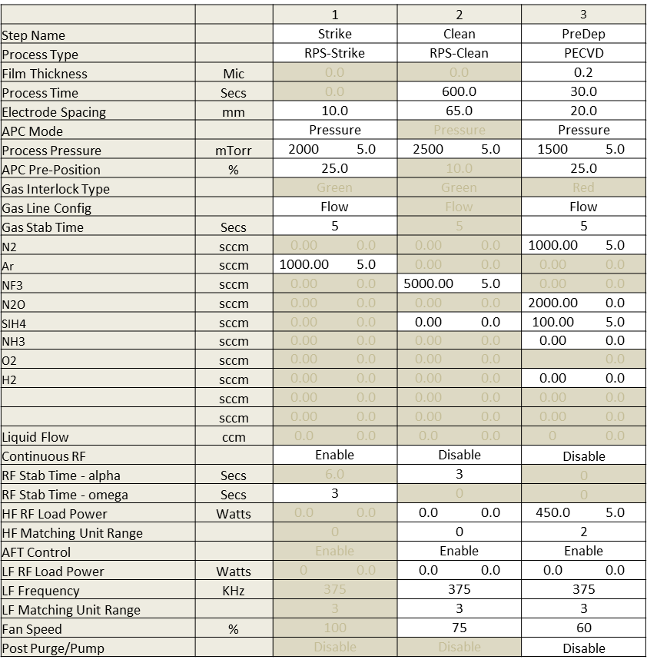

Figure 5 Post wafer clean recipe used in CVD module

A post wafer clean refers to the recipe run after a wafer is deposited, this is the second clean ran in the chamber. An initial AR or at ready clean is run before a wafer enters the chamber, this is completed to ensure each wafers see the exact same chamber conditions; therefore, they are deposited after the chamber has undergone a clean and a pre deposition step.
The post wafer clean consists of 3 stages, a strike, a clean and a pre deposition step. In the first step, a plasma is struck in the remote plasma source, while flowing 1000sccm of argon gas into the chamber under a pressure of 2000mTorr.
In the clean step, the plasma remains on in the RPS module, while flowing 5000sccm of NF3 gas into the chamber to clean the deposition via ion bombardment, the debris from this process is them pumped away using a roughing pump or cryogenic pump.
Finally, the pre deposition step, involves, depositing a thin layer of baseline oxide onto the walls of the chamber to prepare for the next wafer. 200nm of Oxide film is deposited during this step, which coats all of the hardware within the process module.

3.9 Silicon Wafers
In Chemical Vapour Deposition processing – typically bare silicon wafers are used for research and development; patterned wafers are typically reserved for final testing and manufacturing in order to save on costs. However, even when completing tests for development the bare silicon wafers have to have high purity substrates as it is required for the post measurement processes. High purity wafers are required for extreme flatness, low defects and high-quality surface finishes. Silicon wafers come in a plastic cassette of 25 wafers as standard. The price can be dependent on the size of the wafers and also if it contains any dopants – for this application, 200mm wafers with no dopants will be used for research and development purposes. The wafers required for the project will be available from stores at the customer’s site, therefore, they will not be ordered by the project manager, however, similar standard
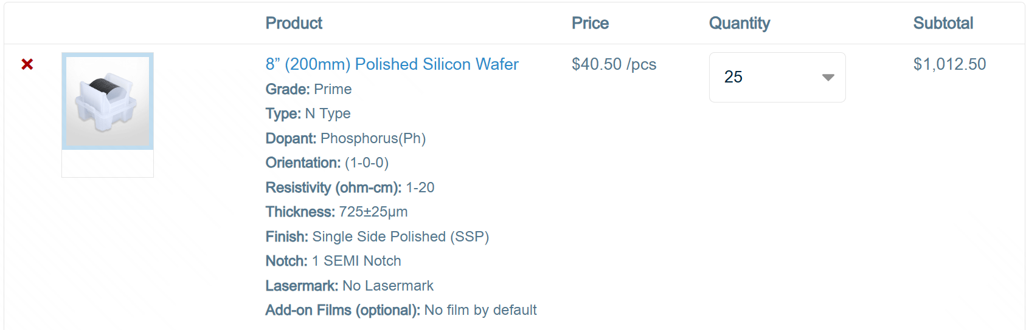
wafers can be obtained for approximately ~$1012 per box, or approximately ~$40.50 per wafer from wafer pro as can be seen below. (Wafer Pro , n.d.)
Figure 6 Example quote for high quality 200mm Silicon wafers

3.10 Ethical and environmental considerations
During the design and manufacture of KLA tools, all materials and components were sourced ethically, ensuring all components are obtained from sources which adhere to the responsible business alliance (RBA) code of conduct, prohibiting child labour, ensuring safe working conditions and promotes environmental stewardship across the entire supply chain. All materials and components must adhere to strict supply chain accountability, to ensure all materials are sources responsibly and all members in the supply chain adhere to strict human rights policies. (KLA, 2026)
KLA has a comprehensive ethics program, focusing on reducing their carbon footprint and conducting the business with honesty and integrity.
All aspects of the project have adhered to all legal standards and relevant site procedures. The design of experiments was constructed using best known practices. The required duty and care were taken while completing all tasks to ensure the safety of the project manager as well as all other subsequent users of the tool.
The Delta APM module will be housed inside the cleanroom, which requires key card access, this will prevent any unauthorised access to the module, minimising the health and safety risk as well as the potential risk of data breaches and loss of information. No access logs are kept so there is no concern regarding loss of personal information. The module itself requires a login in with a user and password, this information is only shared with relevant personnel to prevent loss of confidential information and for health and safety purposes, to ensure than only those trained to use the module can access it.
As there were no human participants involved in the projects scope, no thought had to be given to the protection of personal data as well as ethical storage and deletion of said data. The only data collected during the scope of the project was wafer measurements, relating to the thickness, RI, Stress and non-uniformity of the deposited films. This data was collected using bare silicon wafers, no confidential customer patterned wafers were used, so any data or images that may be taken can be collected without any risk of breach of confidentiality.

3.11 Legal considerations
Clean room registration (ISO 14644-1 and GMP) dictates the strict environmental controls, including particulate limits, HEPA filtration, temperature and pressure requirements required in clean room environments to prevent contamination. (ISO, 2015)
Other considerations including the Health and Safety at work act (1974) and Control of substances Hazardous to health regulations (COSHH). All recommended PPE must be worn in accordance with the HSWA, in a cleanroom environment this typically includes, but is not limited to, full cleanroom suit, including hood, overalls, shoe covers, Gloves, hairnet and steel toe cap clean room shoes. This is required for health and safety purposes, to reduce the introduction of particulates into the cleanroom and also to dissipate static electricity. The guideline for cleanroom garments can be found in standard IEST-RP-CC003. (Health and safety executive , n.d.) (IEST , 2023)
Customer information, including the name, and other personal information cannot be shared with external entities due to potential NDA limitations.

3.12 Conclusion
The literature review has considered several aspects of semiconductor processing, including the gases used, the use of metrology measurement tools for post process measurement, the environmental impacts of NF3 and also the economic considerations. The findings of the study concluded that it would be beneficial to reduce the NF3 consumption of the process by considering multiple angles, including, benefiting the financial aspects of the business, reducing the environmental impact of the tool, due to the high global warming potential of the gas itself and also reduce health and safety risks associated with the gas as it is highly toxic. The insights from other research relating to these topics demonstrate the relevance of completing the project and also its importance in improving the environmental impact and economics of the process. The research by Lam, also supports the methodology suggested with their research in reducing gas usage by reducing gas flow being successful in reducing overall consumption.

4.0 Project Design

4.1 Project Design Introduction
The design of the project consisted of 3 stages, firstly identifying the scope of the clean frequency changes, secondly the scope of the reduced clean frequency and finally the potential for a change in clean chemistry from NF3 to another chemistry such as C3F8. This stage was limited to planning the implementation of the NF3 reduction study, identifying what could be done in each stage to successfully reduce the NF3 consumption of the module. This detailed planning was essential to ensuring the successful completion of the implementation stage.

4.2 Tools and software
In the planning stages of the project, the hardware and software that were intended to be used were identified, no additional hardware or software were needed to be added during the implementation of the project as there were no unforeseen problems during the duration of the project.
SPTS Delta APM module including mimic software; this is the chemical vapour deposition module used for deposition testing in the implementation of the project. It is a plasma enhanced module manufactured by SPTS, recently purchased by KLA, it is a system used in advanced semiconductor packaging, photonics, and MEMS manufacturing. This will be used for the DOE testing for the NF3 reduction study. The mimic software is built into the module and can be used to operate the tool. (KLA, 2022)
TOHO FLX Thin Film Stress Measurement tool is used to premeasure the stress of Si wafers as well as post measure to calculate the resultant stress and bow of the thin film. By comparing these two measurements it allows the tool to create a ‘stress map’ to show how the stress is distributed across the surface of the film. These maps show a pictorial representation of the film’s stress as well as giving the figures for the minimum stress, maximum stress, and the average stress. From this the stress range can be calculated as well as showing if the film stress is compressive or Tensile. (TOHO Technology, n.d.)

CDE ResMap - The CDE ResMap Model 273 – for up to 12” Wafers, is used to measure the electrical resistance of Silicon wafer films. This is done using a 4-point probe which measures the Rs directly and with a 0.5% accuracy. (CDE, n.d.) The varying resistance across the wafer film can then be used to calculate the thickness of the film on top of the wafer’s surface. This is beneficial as film thickness cannot be measured optically as the film is not transparent to light. (Creative design engineering, 2002)

A range of Microsoft software will be used including Word, Excel and PowerPoint, used to collate data and for presenting the project upon completion. Excel is a spreadsheet editor that features calculation and computation capabilities as well as graphing tools. This will be used to input and organise the DOE data from the NF3 reduction study, it can also be used to plot graphs for data comparison. Microsoft Word is a word processing program which is used to create documents, this will be used for the write up of the project. Microsoft PowerPoint is a presentation program which can be used to create presentation slides, this will be used during the final viva to present the outcome of the NF3 reduction project. (Microsoft, 2026)

4.3 Tool Baseline Testing
Prior to running any new tests on a module, it must first be baselined. This involves running a BKM Oxide recipe in order to ensure the module is operating as expected and is achieving the on-wafer results, we are expecting. Typically, this would involve running several dummy wafers, followed by a minimum of 2 premeasured wafers to calculate the resultant stress, Non-uniformity, Refractive index and thickness, to compare against prior data to ensure there hasn’t been a process shift in the module. The clean traces on the machine can also be compared against previous results to ensure there hasn’t been any shift in behaviour. Only after it is ensured the tool is working correctly will any additional tests be completed.

4.4 NF3 reduction via reduced clean frequency
The first stage of the implementation will be a reduction in NF3 usage via reduced clean frequency. This will involve increasing the number of wafers between cleans until either the on-wafer results are negatively affected, or, until the maximum deposition chamber has been reached. In deposition chambers there is a maximum thickness that can be deposited between cleans before there will be a risk of flaking of deposition and particulates in the chamber. For Silicon Nitride deposition the general maximum thickness is less than 4um, this is based on particle issues as well as changing the dielectric properties in the chamber which can lead to plasma striking issues, however, dependant on the chemistry of the nitride film, there could be some leeway dependant on the plasma behaviour and resultant on wafer results.
The current recipe implements a post wafer clean after every 5 wafers processed in the module. Each deposition step will deposit 500nm of SiN film within the chamber, therefore, initially up to 8 wafers between cleans will be tested, totalling 4um. However, it is possible this could be exceeded dependant on the plasma behaviour and on wafer results. This process currently uses a total of 4066cm3 of NF3 per wafer, therefore in order to meet the success criteria of the project, this must be reduced to 3659.4cm3 in order to meet the minimum 10% reduction of NF3 usage.

4.5 NF3 reduction via reduced gas flow
The next stage of the implementation will be a reduction in NF3 usage via reduced NF3 gas flow. This will involve reducing the flow rate of the gas from the current 5000sccm being used. Potential issues related to this stage is that a reduction in flow will result in an increase in clean time, which may negate the reduction in flow and also will have a negative impact on the throughput of the tool, which is a very important metric in production settings. Also, very little data is available regarding a reduced NF3 flow rate, due to the fact the standard for all BKM recipes uses the current flow of 5000scccm, as this recipe is optimised for the hardware used in SPTS / KLA deposition modules. The plan for the implementation is to reduce the flow from 5000 to 4000sccm and identify any benefits and any potential issues, the figure could be reduced further if there are no issues in the initial tests.

4.6 NF3 reduction via change in clean chemistry
The third stage of the implementation is to reduce the NF3 usage via a change in clean chemistry. This would involve removing the use of NF3 altogether. This could be achieved by replacing it with alternative clean gases. This could be achieved by using a direct clean using C3F8 gas. This involves striking a plasma directly in the chamber, rather than in the remote plasma source, then using C3F8 as the clean chemistry instead of NF3. This stage will be entirely dependent on the gases available on the customer site. Other limitations include, being able to make changes to the gas box to facilitate the C3F8 gases.

4.7 Implementation Spreadsheet
In order to keep track of the critical data throughout the project, a spreadsheet was created in excel, with sections for recipe details, results and notes. By tracking the critical data this allows for the data to be compared easily, as well as allows for visualisation in the form of graphs to be created for better comparison.

4.8 Proposed Plan
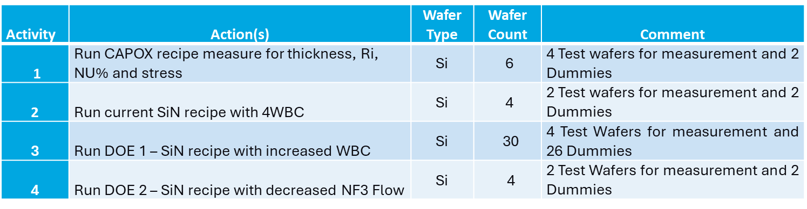
The proposed plan for project including the required materials is the following.
Table 1 – Table containing the planned project tasks and estimated wafer usage

Although using C3F8 as an alternative clean chemistry was identified as a possible solution in the early stages of the project, it was identified that it would not be a plausible solution in the current application. This is due to the fact that C3F8 was not available on the module and it would be impractical to supply it as this would require installing additional gas lines at the cost of the customer, as well as purchasing the gas itself. Therefore, it was deemed it was not a financially viable option at this time.
The total number of wafers required for the project include 32 Dummy silicon wafers, this will not be premeasured, each cassette contains 25 wafers, therefore, 2 cassettes will be required for the project allowing for 18 spare dummy wafers to account for any additional testing that may be required, or for breakages. There will be 12 premeasured, high quality silicon wafers required for testing, each cassette contains 25 wafers, therefore, 1 cassette will be required for the project, while allowing for 13 spare wafers to account for any additional testing that may be required or for breakages.

4.9 Design of Experiments
The method used in order to plan and analyse the data found in the implementation is factorial design of experiments. This method is used to systematically study the effects of changing a control variable by measuring response variables. In the application of the project, the control variable is either the NF3 flow, or the wafers between cleans and the response variable are the on wafer results and the end point traces. This method of experimentation is efficient as it provides information on several factors and how they interact with each other simultaneously. (Yang, 2023)

4.10 Recipe creation and simulation
After the planned DOEs were constructed, the required recipes then must be created on the mimic software of the APM module. This involves creating the required, wafer, module and cassette recipes. The wafer recipe determines what happens the wafer inside the module, detailing the relevant deposition or clean recipe. The module recipe is used to allocate a module to the wafer recipe being run. Finally, the cassette recipe determines what module recipe is run for each slot in the cassette, therefore, it is possible to run a different recipe for every single wafer in the cassette.
For DOE 1, the testing involving increased clean frequency, the same deposition recipe could be used for all testing, including the wafer, module and cassette recipe the only changes required were to the Cassette conditioning recipe, where the frequency of the recipe must be changed. A recipe must be made for all iterations, from 4WBC to 8WBC.
For DOE 2, the testing involving reduced NF3 gas flow, , the same deposition recipe could be used for all testing, including the wafer, module and cassette recipe the only changes required were to the wafer conditioning recipe, where the gas flows of the recipe must be changed, a recipe must be made for all iterations, including 4000sccm NF3 flow and 5000sccm NF3 flow.
In typical running operations, the APM module is run in automatic, in this mode a recipe is selected and each stage in the recipe runs consecutively without any user input. However, when creating any new recipe, it is advised to run It in the module manually to ensure no errors were made during the recipe creation. This is most important for changes to the deposition recipe, as this can lead to damage to the hardware, however, it is imperative to also test the gas flows to ensure the module can tolerate the lower flow rates. Therefore, prior to running DOE 2, the recipe will be tested manually to ensure correct operation prior to running the official testing. This minimises the risk of damaging hardware as well as reduces potential wafer wastage if the module were to abort during processing.
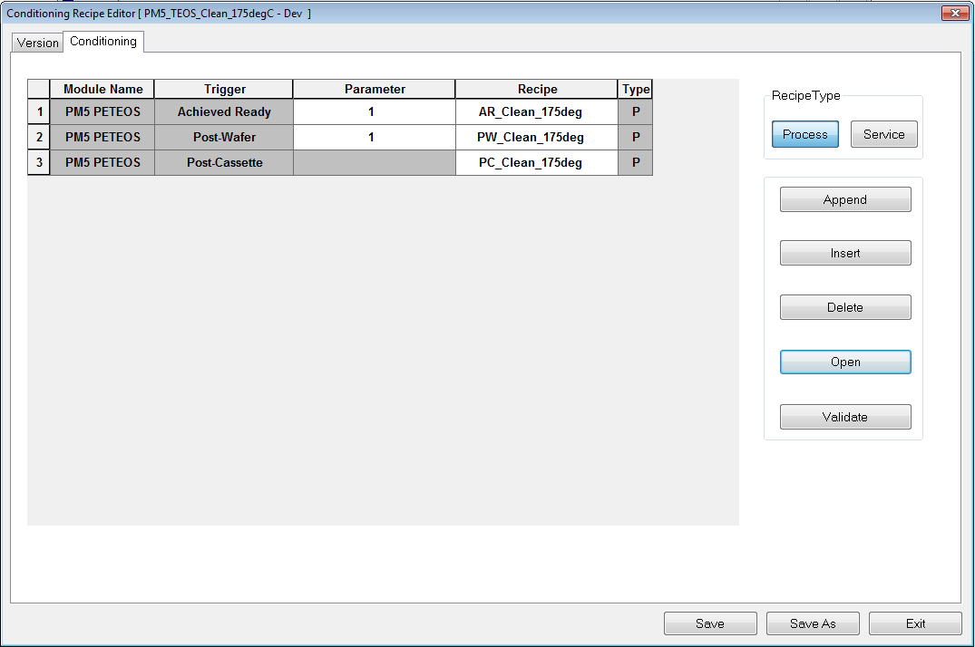
DOE 1 recipe changes
The post Wafer parameter needs to be changed to increase wafers between clean. The parameter refers to the number of wafers in the chamber before the post wafer clean is triggered, therefore, by increasing this parameter the number of wafers between cleans will increase. A recipe will need to be saved for each iteration.

Figure 7 - Image depicting the recipe changes for DOE 1

DOE 2 Recipe changes
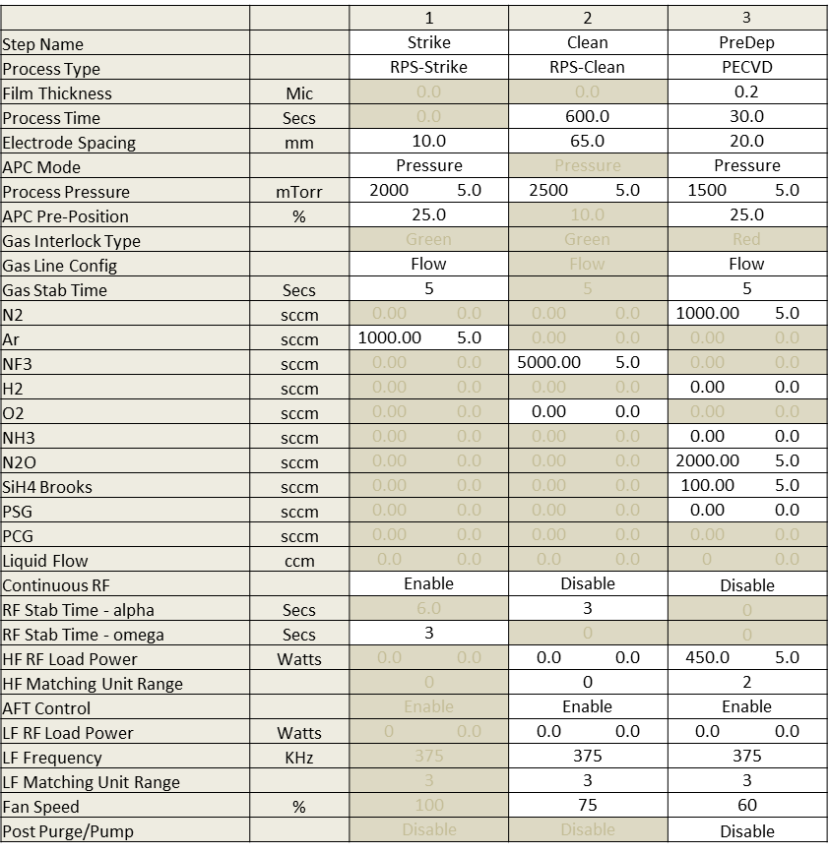
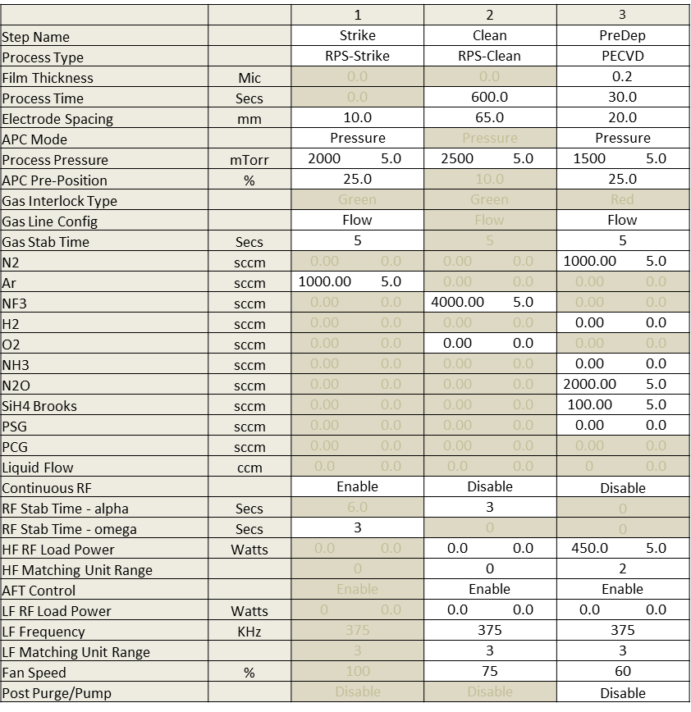
Figure 8 – Image depicting the recipe changes for DOE 2

5.0 Pre-Implementation testing

5.1 Introduction
The implementation of the project was conducted in two stages to ensure the module is performing as expected and there are no hardware or process concerns before the implementation was completed. The first stage consisted of pre-implementation testing. This involves checking the module is physically operational, as well as confirming its current operation to previous results to ensure there has been no process drift.

5.2 Metrology Baselining
Baselining the metrology tools involves checking the measurement against a known variable to ensure the results are accurate and repeatable. At the beginning of each workday – each of the metrology tools undergoes calibration. This involves using a known wafer to baseline the tool. In regard to the filmetrics – this involves checking the reflectivity of a bare silicon wafer to calibrate the tool. This reflectivity is then used as a reference point to all wafers measured thereafter. This is completed at minimum once a day to ensure the measurement is accurate. A warning message is displayed on the metrology tool if this task has not been completed in the last 12 hours.

5.3 Process Baselining
Baselining the APM module involves checking the results of a well known BKM recipe to ensure the on-wafer results as well as the operation of the module is as expected. For this stage, 2 dummy wafers and 2 premeasured wafers were run in the module to check its operation, the on-wafer results were checked to ensure they were as expected, as well as observing the operation of the module, checking the chamber pressure, reflected power and the endpoint of the clean. All of these factors were normal, aligning with the expected results, therefore, it was acceptable to continue on with the implementation testing.
 | Thickness(nm) | Uniformity (%) | Stress (Mpa) | RI | Dep Rate(nm/min)
CapOx | 1014 | 2.1% | -137 | 1.45 | 353
Specification | 1000 | <2.5% | -140 | 1.45 | 350
Table 2 – Table depicting the Baseline CapOx results compared to the specification

The next pre-implementation test involves testing the SiN recipe to be used in the implementation – this will involve running 2 premeasured wafers and 2 dummys to check the on-wafer results and compare them to the specification to ensure the module in spec. The module was operating as expected and all wafer parameters were within spec, therefore it was acceptable to continue with the implementation testing,
 | Thickness(nm) | Uniformity (%) | Stress (Mpa) | RI | Dep Rate(nm/min)
SiN 5WBC | 5000 | 0.5 | -105 | 2.04 | 81
Specification | 5000 | <3% | -110 | 2.03 | 85
Table 3 – Table depicting the baseline SiN results compared to the specification

6.0 Implementation

6.1 Introduction
The implementation of the project took place at a customer site in Italy, a large semiconductor production site, the customer’s name and other specific details cannot be discussed due to potential breach of the customer NDA. The system in question was installed in 2024, this process was executed by myself, therefore, access to prior work and previous results for comparison are available.
The implementation was completed on a 200mm Delta APM module ran at 350 degrees Celsius, with the following configuration: V2 showerhead, 200mm one piece platen and RPS bypass clean configuration. This module was previously signed off and handed over to the customer in 2024, therefore, the customers standard operating procedures must be followed, including strict gowning procedures to prevent film contamination.
No additional work permits or health and safety risk assessments were required, as the tasks to be completed were within the realm of standard operating procedures and testing, which are covered by the customers risk assessment.
For the purpose of testing, access was available to all required metrology without the requirement for supervision, therefore, all testing was completed independently without any external support.
The proposed testing was sent to the customer prior to the planned implementation, including estimated wafer usage, so all materials were prepared in advance to prevent delays during the implementation. All testing had prior approval to minimise the total installation time, during this approval it was identified that testing of an alternative chemistry would not be possible due to the gas available on the module. The alternative clean chemistry was not available, therefore, for this test to be completed, it would require the purchase of C3F8, the install of an additional gas line, and government approval for the new gas usage, therefore, it was not a plausible solution.
Once the testing was approved, the implementation was scheduled, this was completed earlier than scheduled, completing all the scheduled testing in January, rather than the march deadline. The original schedule allowed extra time as a contingency for potential issues during the implementation, such as hardware issues, or lack of access to the module. Later on, it can be seen that this was not required as no major delays were observed during the implementation process, therefore, the implementation was completed ahead of schedule.

6.1 Results - Increased Number of Wafers between cleans
Once the baselining tests had been completed, the implementation tests were completed. Firstly, the testing relating to the increased number of wafers between cleans was completed. The SiN Recipe parameters used during the testing is as follows.
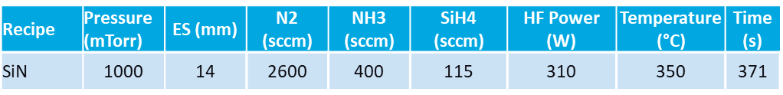
Table 4 – Table depicting the SiN recipe parameters
During the testing 28 wafers were used, consisting of 24 dummy wafers and 4 premeasured high quality silicon wafers for measurement.
In the 5WBC test, it consisted of 4 dummy wafers and 1 premeasured wafer, the premeasured wafer was in slot 5, the last wafer run in the chamber. By measuring the last wafer, this would present the worst-case scenario in terms of on wafer results, therefore, if this wafer was within specification, all the wafers processed before that would also be acceptable.
Similarly for the other 3 tests, in the 6WBC test, 5 dummy wafers were run, followed by 1 premeasured wafer. For the 7WBC, 6 dummy wafers were run, followed by 1 premeasured wafer. Then finally for the 8WBC test, 7 dummy wafers were run, followed by 1 premeasured wafer.
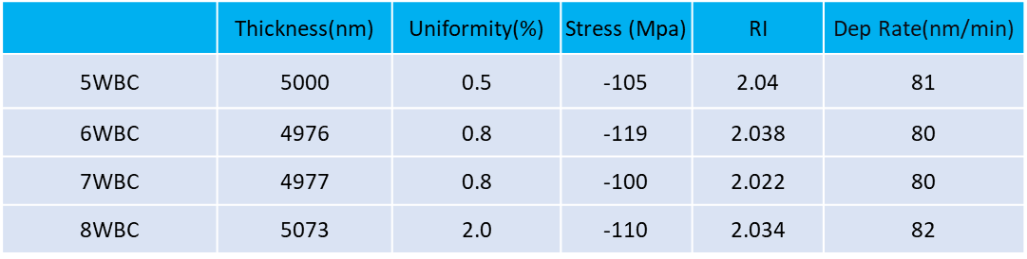
Table 5 – Table depicting the results for the increase number of wafer between cleans test
Throughout the testing there was minimal shift in the stress, with all results staying within a maximum deviation of 15MPa, all staying within the range of the specification. Similarly for the refractive index, the maximum deviation was 0.018, a minimal change, staying within the range of the specification. The most significant change seen throughout the testing was the non-uniformity of the film. As the wafers between cleans increased, there is an obvious upwards trend, with 5WBC achieving 0.5% non-uniformity, while the final test, 8WBC, achieved 2%, a significant increase, however, the specification allows for <2.5%, therefore, this result was still acceptable. The maximum thickness allowed in the chamber between cleans limited the range of the testing, therefore, the customer cannot exceed 8WBC.
Table 6 – Table containing SiN Specification

6.3 Endpoint maps – Increased number of wafers between cleans
5 Wafers between cleans
The end points below in figure 14 depicts the clean traces for the post wafer and post cassette clean processed after the 5 wafers between cleans test, showing the clean traces after 5 accumulative depositions. The post wafer clean end pointed at approximately 150 seconds and the post cassette endpoints at approximately 40 seconds. The clean trace continues for the post wafer as the end point detection had not been adjusted for the additional wafers. However, the end point time is determined by the point the peak drops to 0.05, therefore the time is still accurate. Once the end point is reached, the process then completes an over etch step, this is to ensure that the chamber has no residual deposition. The over etch time is typically determined by the thickness of the deposition processed in the chamber. Therefore, due to the high number of wafers between cleans, the over etch time was increased from the standard 30s to 60 seconds. The over etch time is triggered at a drop of 90% from the peak intensity of the end point, therefore it triggers prior to the end point signal bottoming out at 0.05. With the additional over etch time, the total clean time across the post wafer and post cassette clean was approximately 300 seconds.
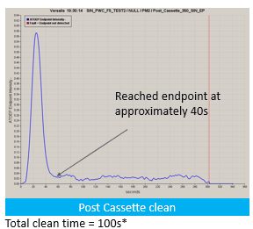
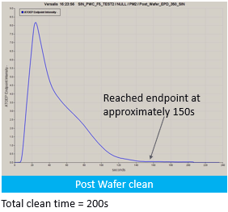
Figure 9 – Endpoint trace for 5WBC – Post wafer clean (left) and Post cassette clean (right)
6 Wafers between cleans
The end points below in figure 15 depicts the clean traces for the post wafer and post cassette clean processed after the 6 wafers between cleans test, showing the clean traces after 6 accumulative depositions. The post wafer clean end pointed at approximately 160 seconds and the post cassette endpoints at approximately 40 seconds. The end point detection was adjusted in order to account for the additional deposition thickness, therefore, there is no significant tail on the post cassette clean of this test and those going forward. While accounting for the additional over etch time, the total clean time was approximately 340 seconds, an increase of 40 seconds compared to the 5WBC test.
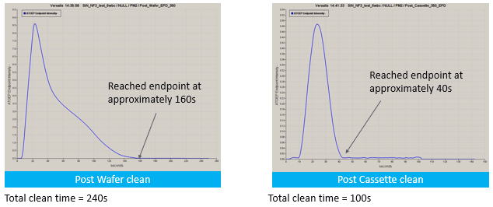
Figure 10 - Endpoint trace for 6WBC – Post wafer clean (left) and Post cassette clean (right)
7 Wafers between cleans
The end points below in figure 16 depicts the clean traces for the post wafer and post cassette clean processed after the 7 wafers between clean test, showing the clean traces after 7 accumulative depositions. The post wafer clean end pointed at approximately 170 seconds and the post cassette endpoints at approximately 45 seconds. While accounting for the additional over etch time, the total clean time was approximately 365 seconds, an increase of 25 seconds compared to the 6WBC test, and an increase of 65 seconds compared to the 5WBC test.

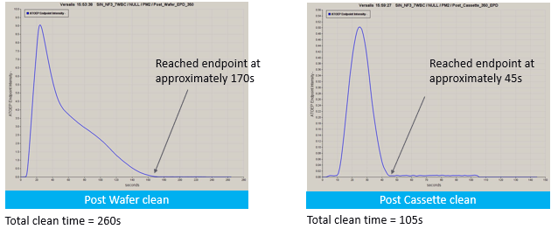
Figure 11 - Endpoint trace for 7WBC – Post wafer clean (left) and Post cassette clean (right)

8 Wafers between cleans
The end points below in figure 17 depicts the clean traces for the post wafer and post cassette clean processed after the 8 wafers between clean test, showing the clean traces after 8 accumulative depositions. The post wafer clean end pointed at approximately 190 seconds and the post cassette endpoints at approximately 45 seconds. While accounting for the additional over etch time, the total clean time was approximately 390 seconds, an increase of 30 seconds compared to the 7WBC test, an increase of 50 seconds compared to the 6WBC test, and an increase of 90 seconds compared to the 5WBC test.
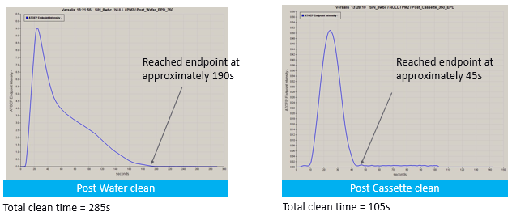
Figure 12 -Endpoint trace for 8WBC – Post wafer clean (left) and Post cassette clean (right)

6.4 Results – Reduction in NF3 flow rate
Prior to running the decreased NF3 flow rate tests, the baseline SiN recipe was run again to ensure there was no shift in chamber conditions after the testing surrounding the increased number of wafers between cleans. These tests showed no shift in chamber behaviour. The SiN Recipe parameters used during the testing is as follows.
Table 7 – Table depicting the SiN recipe parameters
During the testing 6 wafers were used, consisting of 4 dummy wafers and 2 premeasured high quality silicon wafers for measurement.
In the 5000sccm NF3 flow test, it consisted of 2 dummy wafers and 1 premeasured wafer, the premeasured wafer was in slot 3, the last wafer run in the chamber. By measuring the last wafer, this would allow the conditions in the chamber to stabilize, ensuring we were not observing the first wafer effect in terms of on wafer results.
Similarly for the other test, in the 4000sccm NF3 flow test, 2 dummy wafers were run, followed by 1 premeasured wafer.

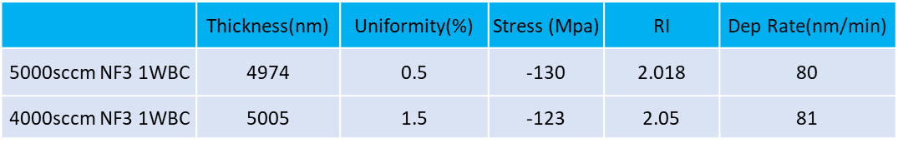
Table 8 – table depicting the results for the reduced NF3 flow rate tests

With the reduction in NF3 flow rate from 5000sccm to 4000sccm, there was a minimal shift in both deposition rate and stress, with a very minimal 7Mpa shift. However, there is a large shift in refractive index, totalling 0.32, which is a larger change than the customer is willing to accept. It also produced a large shift in non-uniformity, at a 1% increase, although still remaining within specification. Due the high refractive index observed this would not be a plausible solution to be implemented into the customers production processes.

6.5 Endpoint maps – Reduction in NF3 Flow rate
5000sccm flow
The end points below in figure 19 depicts the clean traces for the post wafer and post cassette clean processed after the 5000sccm NF3 flow tests, showing the clean traces after 1 accumulative deposition, using 5000sccm NF3 flow during the post wafer clean. The post wafer clean end pointed at approximately 60 seconds and the post cassette endpoints at approximately 40 seconds. While accounting for the additional over etch time, the total clean time was approximately 210 seconds.
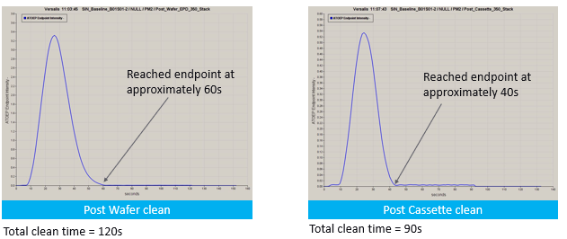
Figure 13 - Endpoint trace for 5000sccm NF3 – Post wafer clean (left) and Post cassette clean (right)

4000sccm flow
The end points below in figure 20 depicts the clean traces for the post wafer and post cassette clean processed after the 4000sccm NF3 flow tests, showing the clean traces after 1 accumulative deposition, using 4000sccm NF3 flow during the post wafer clean. The post wafer clean end pointed at approximately 60 seconds and the post cassette endpoints at approximately 40 seconds. While accounting for the additional over etch time, the total clean time was approximately 250 seconds. An increase of 40 seconds compared to the 5000sccm testing.
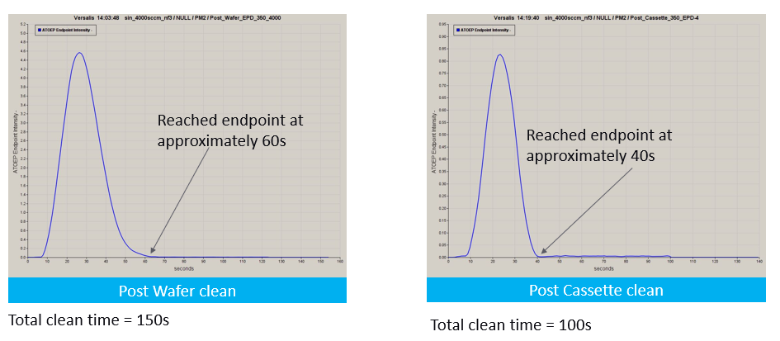
Figure 14 - Endpoint trace for 4000sccm NF3 – Post wafer clean (left) and Post cassette clean (right)

7.0 Discussion and conclusion

7.1 Increased number of wafers between cleans
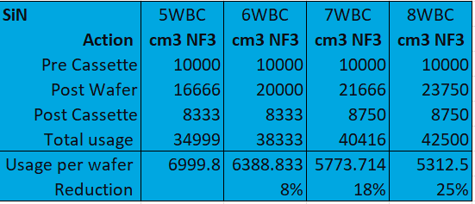
Using the total clean time and the NF3 gas flow of 5000sccm, it was possible to calculate the total volume of gas used during each of the processes. The table below details the volume of gas consumed during the pre-cassette, post wafer and post cassette cleans for each of the tests completed in the trials relating to the increased number of wafers between cleans. The pre-cassette clean for each test consumed the same amount of gas as an identical standard clean was used for all four tests.

Table 9- Table depicting the calculated NF3 consumption for the increased number of wafer between clean tests

The current clean recipe with a frequency of five wafers per clean currently uses a total of 34999cmᶟ of NF3, with 10000cm3 attributed to the pre cassette clean, 16666cm3 attributed to the post wafer and finally 8333cm3 attributed to the post cassette clean. This works out to approximately 6999cm3 NF3 usage per wafer. The throughput for five wafers between clean test is approximately 6.55 wafers per hour.
If the clean frequency were to be increased to six wafers per clean, the NF3 consumption would be decreased by 8%, using a total of 38333cm3 of NF3, with 10000cm3 attributed to the pre cassette clean, 20000cm3 attributed to the post wafer and finally 8333cm3 attributed to the post cassette clean. This works out to approximately 6388cm3 NF3 usage per wafer. The throughput for six wafers between clean test is approximately 6.57wafers per hour.
If the clean frequency were to be increased to seven wafers per clean, the NF3 consumption would be reduced by 18%, using a total of 40416cm3 of NF3, with 10000cm3 attributed to the pre cassette clean, 21666cm3 attributed to the post wafer and finally 8750cm3 attributed to the post cassette clean. This works out to approximately 5773cm3 NF3 usage per wafer. The throughput for seven wafers between clean test is approximately 6.66wafers per hour.
If the clean frequency were to be increased to eight wafers per clean, the NF3 consumption would be reduced by 25%, using a total of 42500cm3 of NF3, with 10000cm3 attributed to the pre cassette clean, 23750cm3 attributed to the post wafer and finally 8750cm3 attributed to the post cassette clean. This works out to approximately 5312cm3 NF3 usage per wafer. The throughput for eight wafers between clean test is approximately 6.8wafers per hour.
Therefore, taking into account the success criteria of a minimum NF3 usage reduction of 10%, the only feasible parameters are seven or eight wafers between cleans, which achieved a usage reduction of 18% and 25% respectively, while increasing the throughput from the current 6.55 wafers per hour to 6.66 and 6.8 wafers per hour respectively. While improving the throughput and gas consumption, this trial also provided good on wafer results, producing minimal changes to stress and non-uniformity compared to the current recipe parameters. The uniformity increased from 0.5% to 2% in the worst-case scenario with 8WBC, with a specification of <2.5, therefore this is well within acceptable ranges. The stress also decreased minimally from -100 to -110, a negligible amount, well within acceptable ranges.

7.2 Decreased NF3 Flow rate
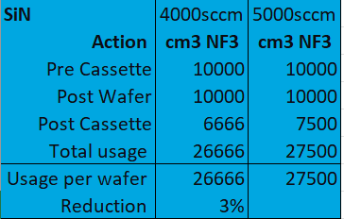
Using the total clean time and the NF3 gas flow of 5000sccm and 4000sccm, it was possible to calculate the total volume of gas used during each of the processes. The table below details the volume of gas consumed during the pre-cassette, post wafer and post cassette cleans for each of the tests completed in the trials relating to the reduced NF3 flow during cleans. The pre-cassette clean for each test consumed the same amount of gas as an identical standard clean was used for both tests.

Table 10 – Table depicting the calculated NF3 consumption during the decreased NF3 flow tests
The current clean recipe with an NF3 flow rate of 5000sccm currently uses a total of 27500cmᶟ of NF3, with 10000cm3 attributed to the pre cassette clean, 10000cm3 attributed to the post wafer and finally 7500cm3 attributed to the post cassette clean. This works out to approximately 27500cm3 NF3 usage per wafer as during these tests only one wafer was run between cleans.
If the NF3 flow rate were to be decreased to 4000sccm, the NF3 consumption would be decreased by approximately 3%, using a total of 26666cm3 of NF3, with 10000cm3 attributed to the pre cassette clean, 10000cm3 attributed to the post wafer and finally 6666cm3 attributed to the post cassette clean. This works out to approximately 26666cm3 NF3 usage per wafer as during these tests only one wafer was run between cleans.
The decrease in NF3 flow rate rresults in a minimal reduction in NF3 usage per wafer of approximately 3%. However, it negatively impacted on the on-wafer results of the film, resulting in higher non-uniformity. Due to the increased clean time with the lower NF3 flow the savings are negligible. As the NF3 flow had a negative effect on the on-wafer results, it would not be viable to further decrease the NF3 flow.

7.3 Conclusion
In conclusion, the results of the testing identified that the use of a reduction in NF3 flow in order to reduce gas consumption was not successful, as this method only resulted in a consumption saving of 3%, while also negatively affecting the on-wafer results, resulting in higher non-uniformity, outside the range in the specification, meaning that the success criteria for the project were not met. Therefore, for both reasons it was identified that this was not a feasible solution to reduce the NF3 consumption on site.
The use of increased wafers between cleans to reduce gas consumption was identified to be successful, reducing gas consumption by up to 25% with eight wafers between cleans, while also maintaining acceptable on-wafer results, including, non-uniformity of less than or equal to 2%. This method also positively benefited the throughput of the process. Increasing productivity from 6.55 wafers per hour to 6.8 wafers per hour. This was not a success criterion of the project; however, it is a beneficial secondary effect of the changes to the process. Therefore, as this solution was able to meet the success criteria of the project, including a necessary gas consumption reduction of a minimum of 10% while maintaining acceptable on-wafer results, as well being completed within the set deadline of May 2026, the project was deemed a success.
The full project was demonstrated and presented to the customer in late January, including the chosen solution of eight wafers between cleans, which was identified to be the most appropriate solution, resulting in the highest financial saving. It was therefore proposed for the customer to implement the identified changes in their production going forward.

8.0 Recommended further work
Due to the success of the project in application of the SiN process, in order to further reduce the NF3 usage at the customer site, it is a possibility to also implement the solution to the other processes on site. This currently includes a SiO, aSi and TEOS film, however, would also be applicable to other future processes that may be implemented on the tool.
In the immediate future, the plan is to implement the same process for the TEOS film first, as this was identified to be the second highest NF3 usage due to the current thickness of the film. The plan for the work is to only implement the increased number of wafers between cleans as the usage of reduced NF3 flow was identified to not be an effective method.
It could also be beneficial to implement the solution into other customer sites in order to reduce their overall NF3 consumption and to minimise process cost. Due to the range of applications the project would be beneficial to, it could be implemented across a wide range of thin film applications and customer sites.

9.0 References
Byeon, M., 2025. Decarbonization Strategies in Semiconductor Manufacturing: Reducing Greenhouse Gas Emission and Energy Consumption in the CVD Process. International Journal of Precision Engineering and Manufacturing-Green Technology.
CDE, n.d. s.l.: s.n.
CDE, n.d. Resmap 273. [Online]
Available at: https://cde-resmap.com/up-to-12-resmap-273/
[Accessed 17 05 2024].
Creative design engineering, 2002. ResMap four point probe user manual , s.l.: s.n.
EFC Gases, n/a. Silicon Tetrafluoride, s.l.: s.n.
Health and safety executive , n.d. Health and safety at work etc Act 1974. [Online]
Available at: https://www.hse.gov.uk/legislation/hswa.htm
IEST , 2023. IEST-RP-CC0003. [Online]
Available at: https://www.iest.org/Standards-RPs/Recommended-Practices/IEST-RP-CC003
[Accessed 03 2026].
ISO, 2015. Cleanrooms and associated controlled environments : part 1, s.l.: ISO.
Kim, W.-J., 2021. Silicon Oxide Etching Process of NF3 and F3NO Plasmas with a Residual Gas Analyzer. Materials , 21 06.
KLA, 2022. SPTS Etch and Deposition Processes. [Online]
Available at: https://www.kla.com/wp-content/uploads/KLA-SPTS-Processes-for-Advanced-Packaging.pdf
[Accessed 03 2026].
KLA, 2026. Standards of Business Conduct. [Online]
Available at: https://www.kla.com/sobc
[Accessed 03 2026].
KLA, n.d. Deposition. [Online]
Available at: https://www.kla.com/products/chip-manufacturing/deposition
[Accessed 09 2025].
Martin-Torres, P. F., 2020. What is Nitrogen trifluoride (NF3)?, s.l.: s.n.
Microsoft, 2026. Powerpoint. [Online]
Available at: https://www.microsoft.com/en-gb/microsoft-365/powerpoint
[Accessed 03 2026].
Quantum Design, n.d. Thin Film Stress measument tool. [Online]
Available at: https://qd-europe.com/fileadmin/Mediapool/products/Toho/pdf/FLX_series.pdf
[Accessed 17 05 2024].
Russel, S., 2013. Nitrogen Trifluoride Now Required in GHG Protocol Greenhouse Gas Emissions Inventories, s.l.: s.n.
Seyun, J., 2023. Research Progress on NF₃ Substitute Gas of PECVD Chamber Cleaning Process for Carbon Neutrality. Journal of the Semiconductor & Display Technology, pp. 72-75.
Sigma Aldrich, n.d. Chemical Vapor Deposition. [Online]
Available at: https://www.sigmaaldrich.com/GB/en/applications/materials-science-and-engineering/chemical-vapor-deposition?utm_source=chatgpt.com
[Accessed 09 2025].
TOHO Technology, n.d. FLX Series. [Online]
Available at: https://tohotechnology.com/industries/metrology/flx-series/
[Accessed 17 05 2024].
Wafer Pro , n.d. 8" Wafers. [Online]
Available at: https://waferpro.com/product-category/wafer-size/8-inch-200mm-wafer/
[Accessed 03 2026].
Yang, L., 2023. Ordering factorial experiments. Series B: Statistical Methodology, pp. 869-885.
Zhou, Y., 2024. Advancements in greenhouse gas emission reduction methodology for fluorinated compounds and N2O in the semiconductor industry via abatement systems. Process and Energy Systems Engineering.

