Module Name: Changemakers: Creativity and Value Creation
Module Code: ACCA5033
Student Name: Elena Alexandra Mihail
Student ID: 2437664
Group: 1
Lecturer’s Name: Fahad Ahmed
  Exploration-Based Narrative Puzzle Game with Educational Elements  Assignment Project 2: Project Management & Innovation | University of Wales Trinity Saint David  London campus

Table of Contents
Introduction 2
Task 1: Project Management 3
Task 1.1: Project Management & Planning 3
Task 1.2: Project Design Artefacts 5
Task 2: Enterprise & Innovation 8
Task 2.1: Strategic Analysis (PEST & SWOT) 8
Task 2.2: Tech Start-up Proposal 10
Task 3: Critical Reflection 11
Task 3.1: Skill Development & Personal Growth 11
Task 3.2: Societal Impact & Value Creation 12
Task 3.3: Risk Management & Challenge Mitigation 13
Conclusion 14
References 14

Introduction
This report presents a comprehensive project management, enterprise, and innovation framework for the conceptual development of an exploration-based narrative puzzle game with educational elements, building directly upon the foundational research established in Assignment 1. In the contemporary digital landscape, interactive entertainment serves as a powerful medium for cognitive development and informal.
The objective of this document is threefold: firstly, to define the technical project scope, development lifecycle, and design architecture using industry-standard engineering tools; secondly, to evaluate the strategic market positioning (PEST and SWOT analyses) and commercialization model for a potential tech start-up; and thirdly, to critically reflect on the broader societal impact, risk mitigation strategies, and personal skill acquisition inherent in this venture.

Task 1: Project Management

Task 1.1: Project Management & Planning
Scope of the project and proposed solution
The proposed solution is an interactive 3D narrative puzzle and exploration game designed to systematically integrate historical and cultural knowledge into basic game loops. The scope of the project covers the complete pre-production and primary production phases of a single-player desktop application.
The elements in the field include:
Development of basic 3D space exploration mechanics and environmental interaction systems.
Design and programming of puzzle mechanics based on logic directly linked to historical narrative data.
Creation of a responsive user interface (UI) and Head-Up Display (HUD) for player navigation, inventory and historical records.
Implementation of a local database system to track the player's progress, the status of completion of the puzzle and educational achievements.
Out of reach items include:
Online multiplayer or cooperative game modes, maintaining a strict focus on single-player narrative immersion.
Multiplatform console port during the initial launch phase (focussing exclusively on PC/Desktop).
Real-time microtransactions or live service cloud backend infrastructure.
Technologies and resources required
To successfully execute the project within the set deadline, a specialised stack of hardware and software is required:
Game Engine: Unity (C#) or Unreal Engine (C++) for graphics rendering, physical calculation and scene management.
3D modelling and asset creation: Blender and Substance Painter for modelling 3D environments, character assets and texturing.
UI/UX Design & Wireframing: Figma to design interactive HUD interfaces, menus and user travel flows.
Version control and repository: GitHub/GitLab for code version control, branch management and technical documentation.
Project management tools: Jira / Trello for task tracking and agile Sprint management.
Hardware resources: Dedicated development workstations equipped with high-performance GPUs for real-time rendering and optimisation testing.
Project schedule, schedule and restrictions
The project life cycle is planned over a 12-week development period, structured in different sequential phases: requirements analysis, game design, asset creation, basic programming, user interface integration and quality assurance [1].
Key operational limitations include:
Time constraints: a strict presentation period of 12 weeks that requires precise adherence to milestones.
Resource Restrictions: Limited equipment size (independent development model), which restricts the total volume of 3D assets that can be produced manually.
Technical constraints: Objective the optimisation of hardware performance to ensure stable frame rates throughout the standard PC hardware.
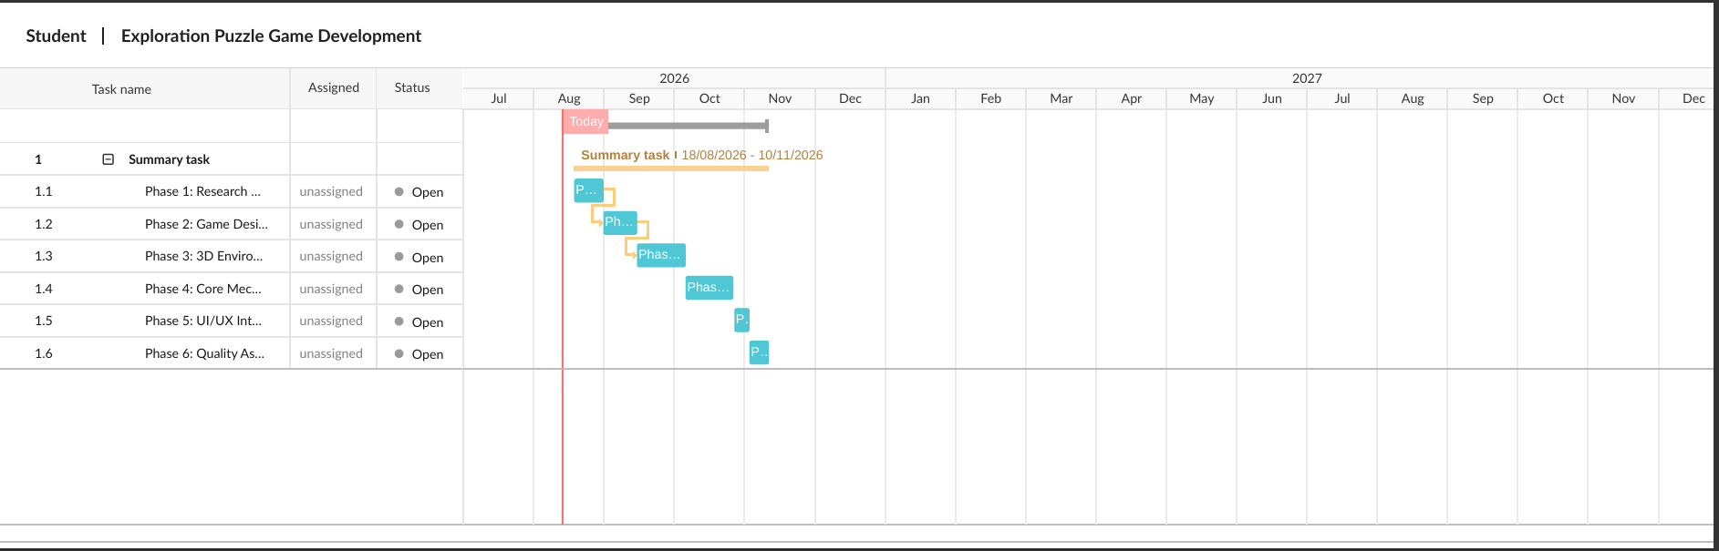
Figure 1: Gantt chart for the development of an exploration and puzzle game (12-week project)
Task allocation and schedule summary
Phase 1: Research and requirements specification (Weeks 1–2): Initial literature review, establishment of educational objectives, and drafting of technical software requirements.
Phase 2: Game design and narrative prototyping (Weeks 3–4): Level design, writing narrative-based puzzles, and creating UI/UX wireframes.
Phase 3: 3D environment and asset creation (Weeks 5–7): Modeling 3D assets, texturing environmental objects, and configuring lighting in Unreal Engine/Unity.
Phase 4: Core mechanics and puzzle programming (Weeks 8–10): Programming player interactions, collision triggers, the inventory system, and puzzle logic.
Phase 5: UI/UX integration and audio design (Week 11): Integrating sound effects and ambient music, and connecting the main menu with interface elements (HUD).
Phase 6: Quality assurance and bug fixing (Week 12): Comprehensive playtesting, fixing visual or logic errors, and compiling the final executable version.
Development methodology (Agile/Scrum framework)
To effectively manage the software development lifecycle, an Agile framework based on the Scrum methodology has been selected. Video game development is an inherently iterative and dynamic process in which user experience (UX), mechanics, and narrative integration must be continuously refined based on feedback obtained during playtesting. Traditional predictive models, such as the Waterfall methodology, are unsuitable for creative computing projects due to their rigid linear progression and inability to adapt to design changes that arise during the process.
Using Scrum, development is structured into two-week operational *Sprints*. Each *Sprint* focuses on delivering a functional increment of the Minimum Viable Product (MVP), such as prototyping a specific puzzle mechanic or designing environmental assets. Key Scrum events include daily meetings (*daily stand-ups*) to identify development bottlenecks, *Sprint Reviews* to evaluate playable versions, and *Sprint Retrospectives* to continuously optimize workflow efficiency. This iterative approach directly mitigates project risks by ensuring early validation of core game mechanics and educational alignment prior to large-scale deployment [2].

Task 1.2: Project Design Artefacts
Artefact 1: Wireframe and storyboard for the interactive puzzle interface
To establish clear functional requirements and ensure an intuitive user experience (UX), a high-fidelity wireframe of the interactive puzzle interface was created. Game accessibility and non-intrusive learning are fundamental to user retention in educational software [3].
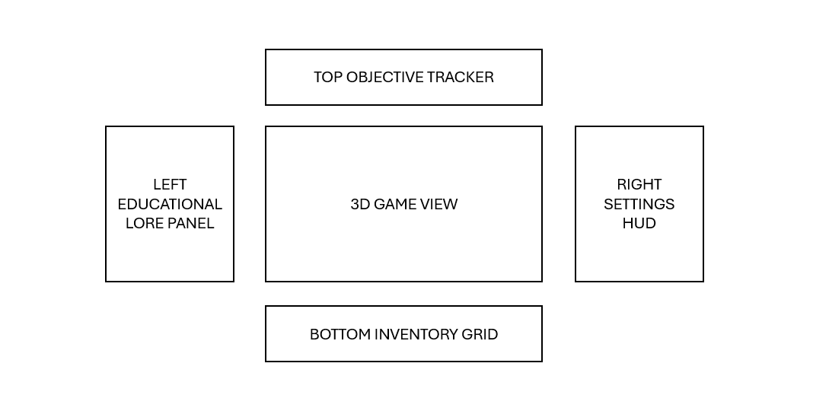
Figure 2: Schematic breakdown (wireframe) of the interactive puzzle user interface.

Key interface elements and their rationale:
Educational context panel: Displays historical information and hints clearly in the left third of the screen, without obstructing gameplay mechanics.
Interactive objective tracking: Monitors active puzzle sub-tasks to guide player progress and reduce cognitive load.
Minimalist HUD and navigation bar: Ensure maximum visual immersion in the 3D environment while offering immediate access to inventory items.
Artifact 2: UML flowchart of core game logic
To structure the underlying technical logic of the game's main interactive mechanic, a UML activity diagram (flowchart) was created. This diagram models the conditional logical branches that occur when a player interacts with an environment-integrated puzzle [4].

Figure 3: UML conditional flowchart of the main puzzle mechanic
Technical flow rationale:
Event activation: The player initiates an interaction within a designated 3D collision zone.
Validation and branching logic: The engine verifies whether required conditions regarding inventory or prior knowledge are met.
Feedback loop: If the action is correct, the system updates the player progress database, triggers a visual or auditory response, and unlocks the next narrative area. If incorrect, dynamic contextual hints are displayed to assist the player [5].

Task 2: Enterprise & Innovation

Task 2.1: Strategic Analysis (PEST & SWOT)
PEST Analysis
To evaluate the external macro-environment of the proposed exploration-based narrative educational game, a PEST analysis framework was applied to the video game and educational technology (EdTech) sectors:
Political: The UK government actively supports video game development through cultural tax incentives—such as Video Games Tax Relief (VGTR) or the Video Games Expenditure Credit (VGEC)—and innovation grants like the UK Games Fund, thereby fostering the creation of local independent studios [6].
Economic: The global market for serious games and educational technology (EdTech) is experiencing rapid expansion, driven by institutional demand for interactive learning tools. However, high inflation and the cost of living are putting pressure on consumer discretionary spending on independent titles [7].
Social: Growing consumer demand for gamified learning and immersive storytelling has positioned educational puzzle games as valuable tools for remote and self-directed learning.
Technological: Advances in game engines (e.g., Unity and Unreal Engine), combined with the widespread adoption of digital distribution platforms, have lowered barriers to entry for independent developers, enabling the distribution of high-quality products at reduced operating costs.
STENGHTS | WEAKNESSES
• Unique integration of narrative and backstory  • Low hardware requirements (broad access)  • High engagement through interactive puzzles | • Limited initial marketing budget  • Limited capacity of an independent team  • Dependence on specific distribution platforms
OPPORTUNITIES | THREATS
• Expansion into educational institutions  • Seeking support from the UK Games Fund  • Adaptation for mobile/tablet educational markets | • High market saturation on Steam/Itch.io  • Rapid changes in player preferences  • Potential intellectual property infringements

Legal and ethical considerations
Project development and commercialization require strict adherence to legal and ethical frameworks:
Intellectual property (IP) and copyright: All artistic assets, code, audio, and narrative scripts will be original creations or licensed through appropriate commercial agreements (e.g., Creative Commons or asset purchase licenses) to avoid copyright infringement [5].
User data privacy: Compliance with the UK General Data Protection Regulation (UK GDPR) and the Data Protection Act 2018 is imperative—especially if telemetry data or player metrics are collected—ensuring user consent and data minimization [8].
Software licensing: End-User License Agreements (EULAs) will be drafted to govern the legitimate use of the game software and protect proprietary assets.

Task 2.2: Tech Start-up Proposal
Brand Identity
Studio Name: Aetheria Interactive Studio Ltd.
Concept: An independent video game studio based in the UK, specializing in the development of 3D narrative puzzle and exploration games that integrate rich historical and educational elements into engaging gameplay mechanics.
Figure 4: Brand identity and logo concept for Aetheria Interactive Studio Ltd.

Legal Classification
The company will be officially incorporated as a Private Limited Company (Ltd) in the UK. This corporate structure offers limited liability protection to the founders, separating personal assets from company obligations. Furthermore, the limited company structure enhances credibility when negotiating licensing agreements with educational institutions, securing intellectual property rights, and applying for government innovation funding.
Business and Commercialization Strategy
Digital Distribution Channels: The primary commercial rollout will target major digital storefronts for PC. Steam will serve as the main sales channel due to its massive global user base, robust community features, and integrated telemetry tools. Additionally, Itch.io will be used during the early access and playtesting phases to engage with the indie gaming community and gather rapid user feedback.
Marketing Strategy: A digital-focused promotional campaign will aim to build an active player community. Key tactics include regular developer updates ("devlogs") on YouTube, short teaser videos on TikTok and X (Twitter), a dedicated Discord server for community interaction, and direct outreach to streamers and influencers in the educational technology sector. Funding Initiatives
To support the development lifecycle and subsequent commercial launch, a dual funding mechanism will be implemented:
1. Public innovation grants (UK Games Fund): The studio will apply for early-stage prototype grants offered by the UK Games Fund to cover essential software licenses, asset acquisition, and core development costs.
2. Kickstarter crowdfunding campaign: A dedicated Kickstarter campaign will be launched during Phase 2 of development. This initiative aims to secure community-backed funding, validate market demand, and build an initial fan base through exclusive digital rewards and early-access keys.

Task 3: Critical Reflection

Task 3.1: Skill Development & Personal Growth
Participating in the comprehensive conceptualization and holistic management of this exploration-based narrative puzzle game offered a key opportunity to bridge high-level theoretical concepts with the practical realities of creative computing and modern software engineering. During the initial stages of the development lifecycle, technical competencies were significantly strengthened through the structured evaluation of system architectures. This required a rigorous analysis of performance trade-offs between major game engines, specifically comparing Unity’s object-oriented structure (C#) with Unreal Engine’s high-fidelity rendering pipeline and visual programming capabilities (C++). Concurrently, operational design skills were deepened through the management of asset creation workflows in Blender and Substance Painter, balancing optimization techniques—such as LOD (Level of Detail) configuration, texture packing, and polygon count reduction—with aesthetic and narrative requirements.
From a process management perspective, implementing an Agile framework centered on two-week Scrum sprints transformed abstract schedule planning into an active operational routine. Participation in core Scrum ceremonies—including sprint planning, backlog refinement, daily stand-ups, and retrospectives—fostered a disciplined approach to milestone tracking and feature prioritization. Managing an iterative development model provided invaluable hands-on experience regarding how early playtesting feedback directly influences UX/UI refinements and core mechanic design, reinforcing the importance of adaptability over rigid, linear planning.
Beyond specific technical capabilities, the project served as a catalyst for developing broader, transferable leadership and entrepreneurial competencies. Conducting macro-environmental assessments using strategic analytical frameworks (PEST and SWOT) required a critical understanding of market positioning within the rapidly expanding sectors of educational technology (EdTech) and serious games. Formulating the business proposal for Aetheria Interactive Studio Ltd. enhanced strategic vision, intellectual property awareness, and financial planning—particularly regarding UK public funding structures for innovation (such as the UK Games Fund and VGEC tax incentives) and community-backed crowdfunding strategies. Looking ahead, refining quantitative user analysis, telemetry data interpretation, and playtesting methodologies will be essential for leading complex, user-centric digital projects within professional computing environments.

Task 3.2: Societal Impact & Value Creation
Interactive media and video games hold immense potential for generating positive social impact by transforming passive consumption into active cognitive engagement. By integrating historical narratives with intuitive puzzle-solving mechanics, the project addresses the growing demand for engaging, informal educational tools. It creates public value by facilitating accessible, self-directed learning experiences for diverse demographics, thereby promoting cultural heritage preservation and historical literacy through immersive digital environments. From a broader value-creation perspective, the initiative demonstrates how creative technology can contribute to the "common good" by fostering critical thinking and problem-solving skills among players. Within an educational ecosystem increasingly embracing gamification, this project offers a scalable model for integrating curriculum-aligned learning objectives into the design of mainstream indie games without compromising entertainment value [9].

Task 3.3: Risk Management & Challenge Mitigation
Executing an independent interactive software project entails managing a complex matrix of technical, operational, regulatory, and market-related uncertainties. To maintain structural control, avoid delivery delays, and safeguard the project's overall viability, a formal risk assessment matrix was established to identify potential threats, evaluate their severity, and implement specific mitigation strategies.
Risk Category | Identified Threat | Impact & Probability | Mitigation & Action Plan
Operational | Scope Creep & Schedule Slippage: Uncontrolled feature accumulation during active production leading to missed delivery deadlines. | High Impact / High Probability | Strict enforcement of a Minimum Viable Product (MVP) model through two-week Scrum sprints. Non-essential features are pushed to post-launch patches to guarantee core puzzle stability within 12 weeks [10].
Technical | Resource & Capacity Constraints: Workload bottlenecks caused by small team sizes and limited hours for manual 3D asset generation. | Medium Impact / High Probability | Adoption of modular 3D modeling pipelines in Blender, pre-configured shader graphs, and commercially licensed open-source assets to reduce overhead while maintaining quality.
Commercial | Market Saturation & Low Visibility: Severe discoverability challenges on crowded digital PC distribution platforms (Steam / Itch.io). | High Impact / Medium Probability | Execution of early community engagement via public developer logs (devlogs), active social media channels (Discord/X), and a Kickstarter campaign to validate market demand prior to launch.
Legal & Ethical | Regulatory Non-Compliance: Unintentional breaches of user data privacy laws when collecting telemetry or player analytics. | High Impact / Low Probability | Implementation of strict privacy-by-design principles adhering to the UK GDPR and Data Protection Act 2018, using data minimization and explicit user consent mechanisms.

Conclusion
This report has successfully established a comprehensive project, business, and innovation management framework for an exploration-based narrative puzzle game. Through structured agile planning, strategic market analysis (PEST/SWOT), a clear tech startup proposal (Aetheria Interactive Studio Ltd.), and critical reflection on social value and risk mitigation, the project demonstrates how creative computing can generate both commercial viability and significant educational impact.

References
[1] K. Claypool and M. Claypool, "Teaching software engineering through game design," in Proceedings of the 36th SIGCSE Technical Symposium on Computer Science Education, 2005, pp. 123–127.
[2] K. Schwaber and J. Sutherland, "The Scrum Guide: The Definitive Guide to Scrum: The Rules of the Game," Scrum.org, 2020.
[3] J. Jesse, "A UX framework for video game design," in Proceedings of the International Conference on Game Jams, Hackathons, and Game Creation Events, 2018, pp. 1–8.
[4] M. Fowler, UML Distilled: A Brief Guide to the Standard Object Modeling Language, 3rd ed. Boston, MA: Addison-Wesley, 2004.
[5] E. Adams, Fundamentals of Game Design, 3rd ed. Berkeley, CA: New Riders, 2014.
[6] UK Interactive Entertainment (Ukie), "The UK Games Industry Fact Sheet," Ukie Trade Association Report, 2023.
[7] T. Connolly, E. A. Boyle, E. MacArthur, T. Hainey, and J. M. Boyle, "A systematic literature review of empirical evidence on computer games and serious games," Computers & Education, vol. 59, no. 2, pp. 661–686, 2012.
[8] Information Commissioner's Office (ICO), "Guide to the UK General Data Protection Regulation (UK GDPR)," ICO Statutory Guidance, 2021.
[9] J. McGonigal, Reality Is Broken: Why Games Make Us Better and How They Can Change the World. New York: Penguin Press, 2011.
[10] D. Djaouti, J. Alvarez, and J. P. Jessel, "Classifying serious games: the G/P/S model," Handbook of Research on Improving Learning and Motivation through Educational Games, pp. 118–136, 2011.

