Critical Reflections on Landscape Sites Glyncorrwg and Dinefwr
It is important to understand the concept of landscape before describing and defining what may perhaps be understood to be within a landscape. To begin with we should remind ourselves that a landscape is something we construct in our minds, however real or physical, the components and milieu of a landscape are, and it will always holistically exist whether we as humans define it with words or not (Larsen, 1992).
The mode of locomotion for surveying the two sites, Glyncorrwg and Dinefwr was walking. Using this method to survey a landscape allows the surveyor to really take in one’s environment, the autonomy of ones control over travel and movement allows for a natural and wholly felt experience (Jacks, 2007). The quote below really epitomises this for me:
‘The practices of walking, in particular sighting, measuring, merging, and reading each define a particular way through which we come to know and understand landscapes; walking takes us beyond intellectual ideas and concepts to embodied knowledge’ (Jacks, 2007, p. 270).
In any case though, understanding a landscape isn’t just limited to what we see in front of us or what is felt underfoot. An interesting point as Barbanti (2018) emphasises, landscapes are also understood by the sounds emitted from them, each landscape having a unique acoustic range due to its topographical features.
So then, it becomes clear that there must be characteristics and criteria that make a landscape aesthetically appealing to an individual or group of individuals. According to Berque’s (2013, p. 3) notion of landscape theory, to be able to psychologically construct thoughts towards a landscape, one must be able to conceptualise the landscape first by means of description through language.
Landscape Evolution
Depicting the height and relief of the land can tell us a lot about the geology of the landscape before us. The landscape character is influenced by environmental effects such as weathering, an example of this could be erosion and abrasive actions caused by wind, rain and even tectonic movement. Alternatively, landsides and melting glaciers can also act to deposit sediment and other debris from one location to another.
Another key aspect of landscape evolution is animal influences, including human beings. Usually as a result of an environments settings and natural formations, animals tend to habitat areas based on how bountiful the area is, essentially what it can afford the inhabitant. Cultural landscapes can be represented as;
“the evolution of human society and settlement over time, under the influence of the physical constraints and/or opportunities presented by their natural environment and of successive social, economic and cultural forces, both external and internal.” (UNESCO, 2020, para. 3).
The Physical and Cultural Influences of Glyncorrwg
Glyncorrwg is located within the Upper Afan Valley area in the county of Neath Port Talbot, West Glamorgan, South Wales. In 2001 the recorded population was set at just over five thousand people (Davies, 2008). According to Glyncorrwg Ponds Visitor Centre (2015) website, the area was once an important coal mining centre during the industrial revolution in Wales. However due to parliamentary legislation many mines were closed down in Wales including mines within the Afan Valley area leading to unemployment and neglect to the South Wales coal towns and villages, many areas could be perceived as being almost abandoned in terms of industry and commerce (Llewellyn, 2019). Officially the majority of land is privately owned by sheep farmers in the local area, access is fairly limited with only the public rights of ways, including walking paths, cycling trails and small areas around the ponds. The Glyncorrwg area, along with other similar Valleys’ villages can be seen as part of the cultural landscape that was designed and formed around the mining industry (Thomas, W.G. & National Museum of Wales, 1976). As partly seen from Appendix A, the area is fairly easy accessed via car and bike, however, public transport due to its isolated location is rather lacking. The area is signposted with the brown tourist signage from the southern road towards Glyncorrwg.
The bedrock geology specifically for the Glyncorrwg area previewed at a scale of 1:625,000 is recorded as, the South Wales Upper Coal Measures, consisting of Mudstone, Siltstone, Sandstone, Coal, Ironstone and Ferricrete (British Geological Survey, 2017). This type of bedrock was estimated to have formed approximately 307 to 310 million years ago during the Carboniferous period, a period rich and diverse in flora (British Geological Survey, 2017). A deeper geological review of the specific area we visited starting from the base of the Valley at Glyncorrwg Ponds and visitor centre includes, superficial deposits of Alluvium clay and salt approximately 11.8 thousand years old, heading south following the Afon Corrwg, Till Devensian – Diamicton 116 to 11.8 thousand years old. This fresher deposit most likely would have been conveyed down the valley from melting glacier waters around the time of the last ice age (British Geological Survey, 2017). The neighbouring hills composition of bedrock to the east and west from the visitor centre are mainly composed of Rhondda member sandstone and Brithdir member sandstone, approximately 315.2 to 308 million years old (British Geological Survey, 2017). As for the tops of those neighbouring hills superficially, extents of Peat sedimentary deposit can be found approximately 2.588 million years old from the Quaternary period (British Geological Survey, 2017).
The topography of the land depicts a typical south Wales valley, the hills are gracefully rounded to give a rolling impression when stood upon the tops of them. Primarily the hill slops are covered with Larix decidua, the European Larch tree. However due to an outbreak of Phytophthora Ramorum many of the trees have been felled to stop further spread of the fungal disease, the majority of lost trees have been replaced with native Broadleaf tree (BBC, 2015). On examination of appendix A, we can see that the area is fairly quiet with no motorways or A roads for at least over a kilometre radius from the three ponds. The wildlife in the local area according to the Glyncorrwg Ponds Visitor Centre (2015) consists of ‘Kites, Buzzards, Heron, Pied Flycatchers, Sandpipers, Dragonfly, Primroses, Flag Iris, Purple Loosestrife and Meadow Sweet’.
Generally, the landscape character perception of Glyncorrwg is of a natural green environment. Having said this, it does have a sense of a former Welsh coal mining town with an almost nostalgic feel, the majority of people who worked at the visitor centre as far as I could tell were from the local area, giving the whole environment a real sense of place for Welsh culture. I would certainly say the place has a stiff yet charming feeling to it, this is evident from the older generation of local Welsh males. Yet, there was definitely also need for some regeneration into the local area, in the bottom right of the photo appendix C we can see litter and debris within the pond. Again, in appendix D we see a bridge crossing the River Corrwg desperately in need of repair. A report by Neath Port Talbot Council (2009) really sets the tone and scene for the problems faced within the Afan Valley local area. It is no surprise that areas such as Glyncorrwg are suffering economic issues and commercial growth problems.
The potential for areas such as Glyncorrwg can be fruitful if appropriate funding from private enterprises and governmental initiatives succeeds in the area (Neath Port Talbot Council, 2009). Its current recreational uses, according to Glyncorrwg Ponds Visitor Centre (2015) include; Mountain biking, Walking, Fishing, Caravanning and Camping, Wildlife spotting and Canoeing. Particularly Mountain biking including cycling seems to be the most predominant activity in the area. The visitor centre seems to be conducive towards cyclists of all kind, the rustic and authentic sign appendix E shows a vibrant map of trail routes for cyclists.
According to Davies (2008) The South Wales valleys’ area was almost untouched before the industrial revolution began, which resulted in an economic boom essentially creating the villages and towns found throughout the valleys today. As represented by Llewellyn (2019) the landscape and subsequent coal mining industry formed the cultural identities of people living near and working in the coal mines. Still today the typical South Wales valley terraced house stands as a reminder of the cultural history and lives of those that worked in the local areas, the Valleys’ could be perceived as a place of tough and injurious work (Thomas, W.G. & National Museum of Wales, (1976). Though today as Llewellyn (2019, p. 5) points out much has changed, there appears to be a disconnect with the landscape, this resulting in anti-social behaviour and perhaps a lack of respect for the land. This disconnect was again evident in appendix C from the illegal deposits of waste discarded at the ponds edge. Despite this, community groups and local initiatives are helping to develop the area by investing in it, some sectors recently developed include, renewable energy and tourism sectors. A European company, Siemens Gamesa Renewable Energy S.A. has influenced the area as a result of a contract for the construction of wind turbines to produce renewable energy. the company has also created a local community benefit fund which according to Llynfi Afan Renewable Energy Park (2017) funds a local project or community group the sum of £96,000.
Neath Port Talbot Council (2009, p. 9) reported that, “Much of the valley area should be declared as an area of outstanding natural beauty”. Although the area currently has no such designation, the Glyncorrwg area is community leased regeneration land and the mountain bike trails are managed by Natural Resources Wales. It would be effective if private businesses were to set up mountain biking facilities such as new trails, bike shops and repairs, in the area to support local jobs for the community. The designation of the Afan Valley as an Area of Outstanding Natural Beauty would definitely increase the profile of the area, potentially increasing visitor numbers, while also giving the landscape the suiting protection and preservation needed.
An interesting focus by Ramos, et al, (2016) is the notion of understanding landscape identity to better influence policy making and planning. According to Ramos, et al, (2016, p. 41) better policies can provide local citizens with a more positive identity therefore strengthening the citizens relationship with their landscape. It is now thought that visitors commonly prefer an authentic experience of a tourist location, essentially people are looking for diverse culture to be ticked off on their bucket list (Ramos, et al., 2016). So, for future developments in the Glyncorrwg area, it should be suggested that authenticity be one of the main focuses for any type of development. An excellent way of doing this could be to use disused buildings such as the old mine near the visitor centre, Neath Port Talbot Council (2009) reported that they would prefer making use of existing buildings and extending them rather than building new structures. An idea to turn a section of the central pond area into an inland wave machine for surfing enthusiasts was anticipated by the local visitor centre and government. This could be beneficial for the local economy as it would attract visitors from a wider area by also tapping into a different consumer market.
However, as mountain biking and cycling is probably the biggest influencer for tourism in the area, typically during the summer months, a set of strategies should be developed to encourage more tourists to come and use the routes. A connection to Swansea was suggested via a non-vehicle thoroughfare being made, as parts of this thoroughfare are already in place at either end it would only require the joining of the two Neath Port Talbot Council (2009). The developing of renewable energy sites such as the already built wind farm and proposed hydroelectricity site which would utilise the Afon Corrwg could create sustainable jobs for the local economy and would also perhaps attract others in to live in the Upper Afan Valley area. A draw back of this would be the environmental effects of the renewable energy sites, in particular if the hydroelectricity project went ahead. A study by Bakken, T. H. et al. (2012) found that small scale hydroelectricity damns have more of a tendency to cause more environmental damage to life that relies of the river. Norway shares similar landscape character, hydrology, flora and fauna with Wales and therefore means that there would likely be adverse effects to the flora and fauna in the Upper Afan Valley area.
The Physical and Cultural Influences of Dinefwr
Dinefwr estate is an 800-acre site which is owned and maintained by the National Trust, the full site encompasses Newton House which was built in 1660, accompanied by the walled gardens, a medieval deer park and a lake that supports birdlife such as Herons (National Trust 2020). The grade II listed house (Appendix F) really is the centre piece to the estate, its emitting history can really be seen through its transitions from a medieval to Venetian Gothic style mansion (Greeves, 2008). One can really get a sense of how old the site is when reminded that some of the Oak trees on the site are over 400 years old (Appendix G), some of the oldest in Britain (National Trust, 2020). The area has two notable designations including much of the estate and lower southern river area (see appendix B) being a Site of Special Scientific Interest and also the site being the first parkland National Nature Reserve in Wales (National Trust, 2020). As seen from Appendix H, the area has slight and soft hills and an open feel landscape, still very much giving that timeless impression of British Style country estate property. As seen from Appendix B, this site is easily accessible via the A483 through Llandeilo, as the site is a National Trust property it is well established and brown signposted from the A road. Public transport is reasonably good, however there is no direct route from Llandeilo other than to walk to cycle to Dinefwr. The estate are including the house has good facilities for disabled users.
The bedrock geology specifically for the Dinefwr area previewed at a scale of 1:625,000 is recorded as Llanvirin rocks, a type of Sandstone approximately 464 to 467 million years old (British Geological Survey, 2017). Under closer review the house and walled garden area sits on a bedrock of Llandeilo Flags formation consisting of Sandstone, Limestone and argillaceous rocks, these are estimated to be between 465.5 to 449 million years old (British Geological Survey, 2017). Further north by approximately 800 metres lies a bedrock formation of Hendre Shales Mustone, just south of the house and gardens the River Towy flows south westerly through the area, the superficial geology of the river bed shows a composition of Alluvial deposit consisting of Clay, Silt and Sand sediment approximately 11.8 thousand years old. Again, very much like the Afon Corrwg this would likely have come from glacial melt waters flowing down from the higher mid Wales region. This can be seen in the local area’s topography in appendix B, the shaping of the river area reflects the geological history making it relatable to the current landform.
The landscape has sustained much history, ultimately it has been shaped by many influences, the remains of Dinefwr castle in the south of appendix B, mark the local areas strategic high point. This is understandable as many different generations have erected strongholds in this area, some of these include Neolithic, Roman and Middle Ages (Greeves, 2008; Dyfed Archaeology, No Date). Through a historic perspective lens of Newton House, it is outright obvious that the house and surrounding estate area was owned by affluent families over the centuries, from the time of its construction, the site has hosted cultural events such as ball room dances and art work showcases (National Trust, 2020).
The landscape around the house is characteristically rich in culture and heritage, like the majority of National Trust properties it is very well maintained. However, there are some issues with certain features of the site such as the water fountain, that require forthcoming funding for the preservation of the site (National Trust, 2020). The house is currently open to visitors for a fee, this includes access to the surrounding woodland and deer park area, the house is also being used to facilitate an art programme, some of the artwork is available to view inside the house’s internal gallery called the Black Raven Gallery (National Trust, 2020).
As appendix B shows, there are three main A-roads to the north, east and south of the Dinefwr area, it was evident as traffic could be heard from nearly every location on the site. Barbanti (2018) believes that humans have been effectively disturbed by the invention of the engine resulting in the increase in noise pollution from traffic. Along with the water fountain, the lake and its surrounding area looked equally in despair, the raised wooden footpath that handrails the lake had sustained damage and was not open to public visitors. There are several individual small holdings on the sight, one of these still privately owned (National Trust, 2020).
According to Zee, (1990) when planning to build or introducing effects on an environment three aspects need to be considered in the suitability assessment for recreation, these are accessibility, scenic quality and physical suitability. These aspects can be quite problematic dependant on the environment’s characteristics and its prerequisite for human desire and utilisation. An obvious example could be the summit of Mount Everest, a highly desirable place to be as a human but also extremely inaccessible and also physically demanding to get there. The Dinefwr landscape could be used for outdoor and environmental education as the culture and history is rich in the area, this can be utilised as a site to facilitate the relationships between student and their environment (Stewart, 2008). Using the landscape to inform the student with a sense of place approach by using outdoor activities such as bush craft or volunteering conservation work, can help the student to connect to the environment and culture.

Appendixes
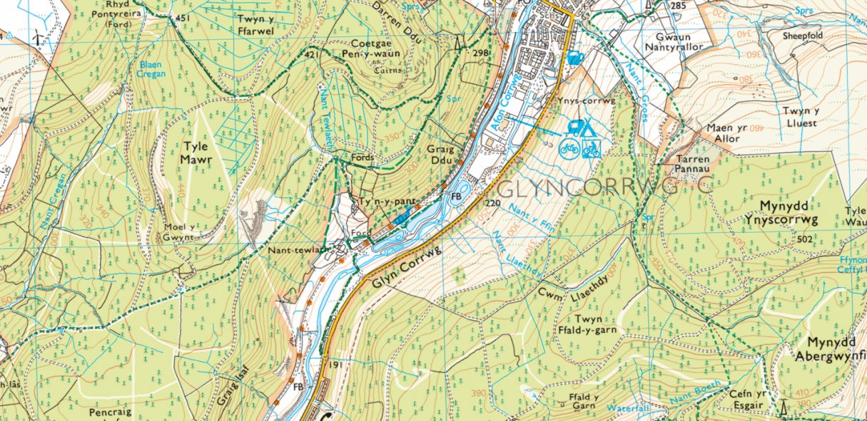
Appendix A
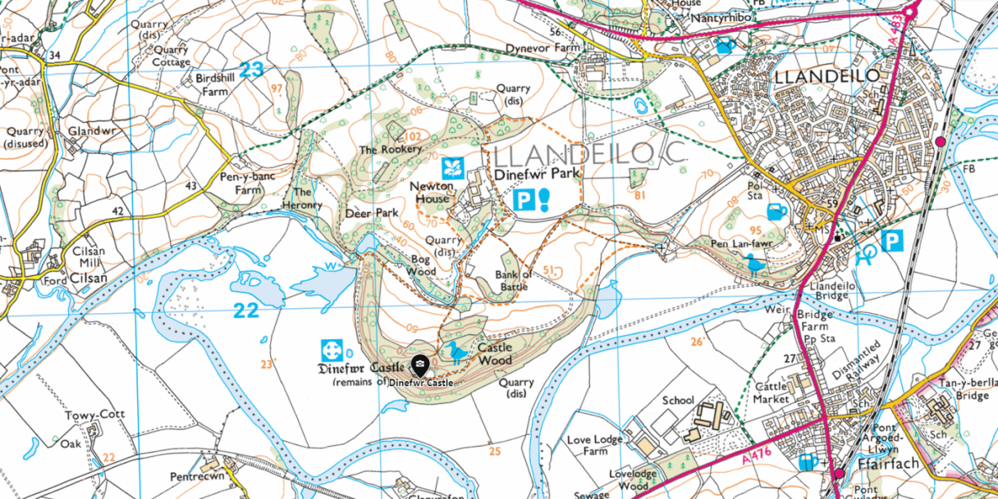
Appendix B

Appendix C
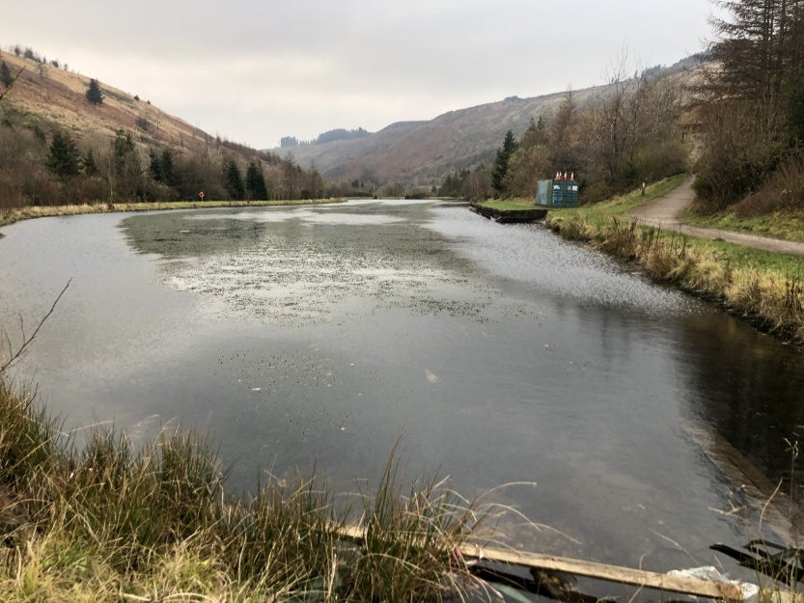

(The Second Glyncorrwg Pond, Debris and litter in the water)

Appendix D
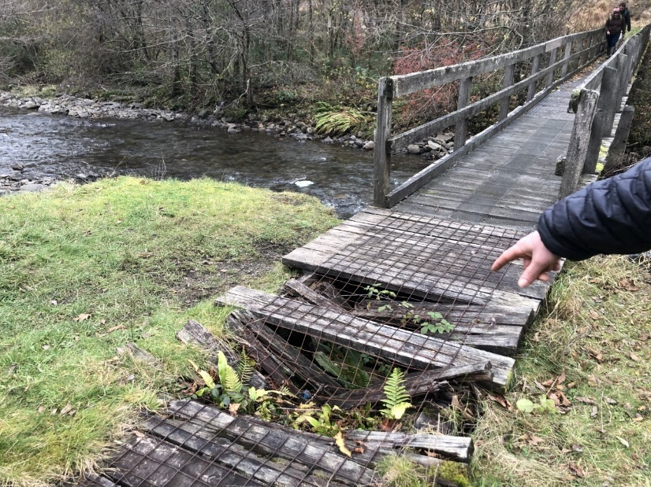

(Bridge Crossing the Afon Corrwg in need of repair)

Appendix E
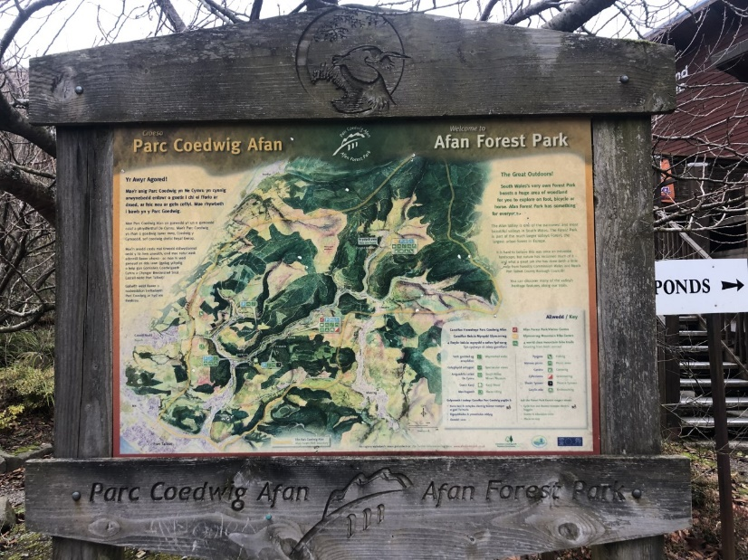

(An overview map of Afan Forest Park)

Appendix F
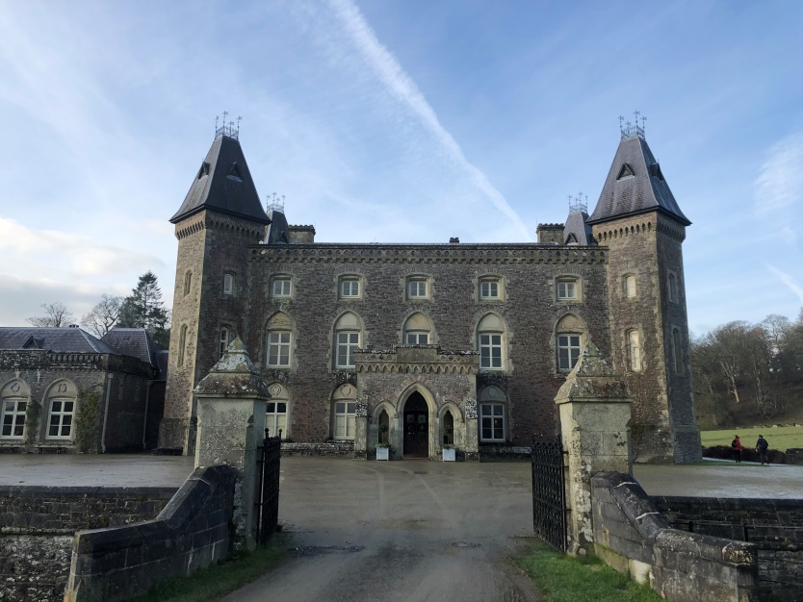

Newton House, built in 1660.

Appendix G

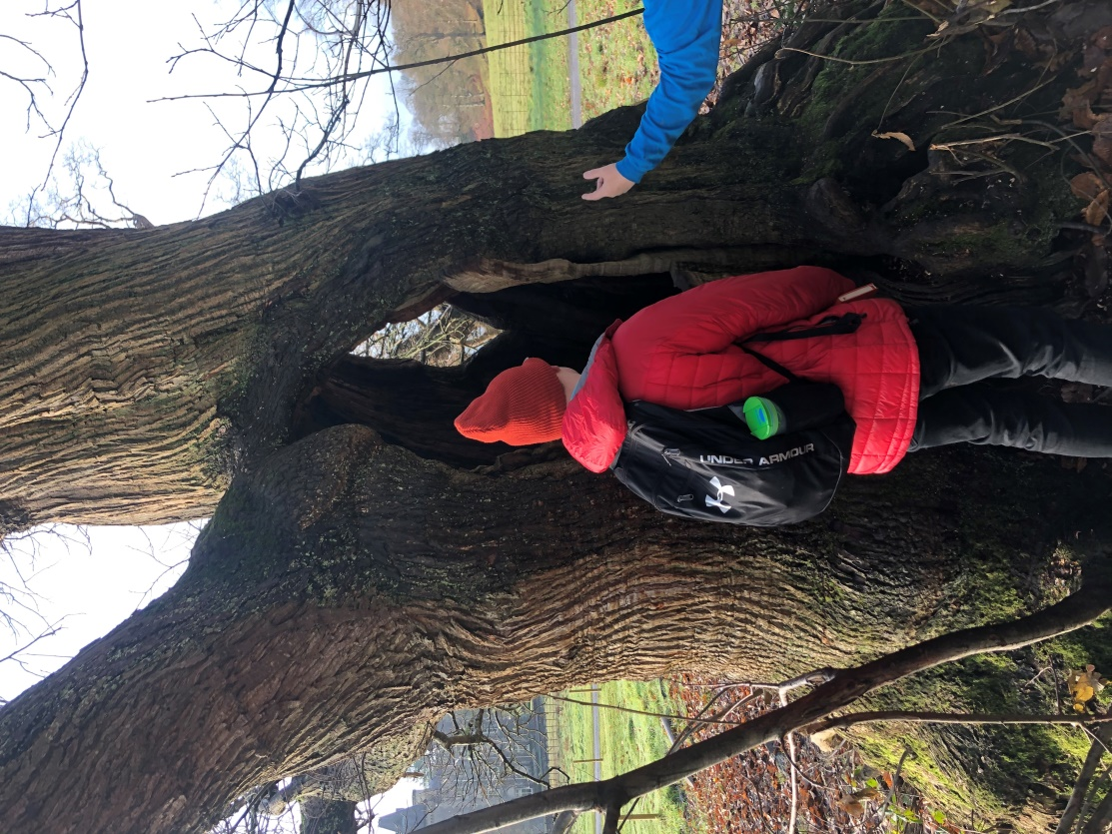

One of the Oak trees found on the site, over 400 years old.

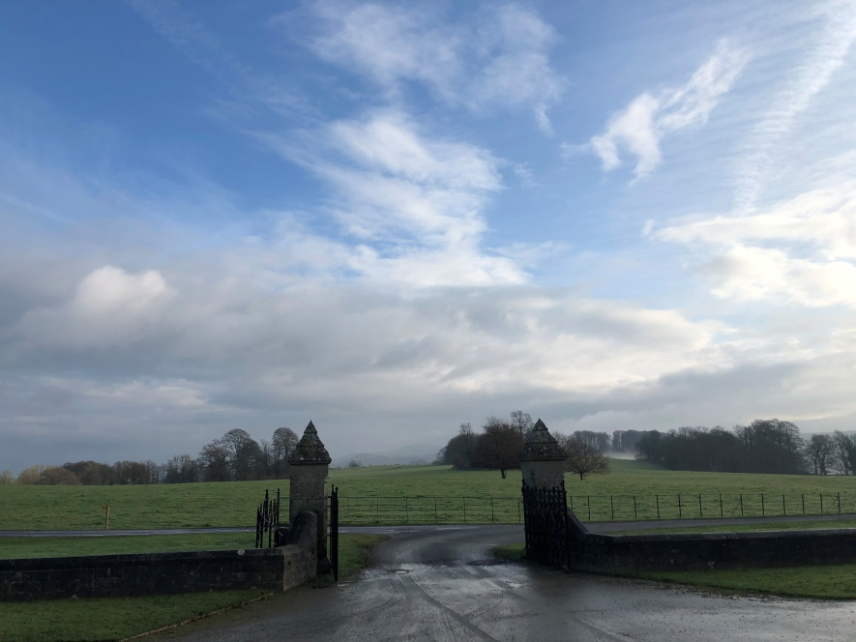
Appendix H

The soft hills of the Dinefwr estate (A typical British country view)

Bibliography

Bakken, T. H. et al. (2012) ‘Development of Small Versus Large Hydropower in Norway– Comparison of Environmental Impacts’. Energy Procedia, 20(C), pp. 185–199.
Barbanti, R. (2018) ‘Listening to the Landscape for an Ecosophic Aesthetic’. Paragraph, 41(1), pp. 62–79.
BBC (2015) Thousands of Afan Forest trees planted after infected larch. Available at: https://www.bbc.co.uk/news/uk-wales-south-west-wales-31559342 (Accessed: 16th January 2020).
Berque, A. (2013) Thinking through landscape. 2nd ed. Oxon: Routledge.
British Geological Survey. (2017) South Wales (Glyncorrwg Ponds and Dinefwr, Llandeilo) (1:625,000). United Kingdom: Ordnance Survey; Garmin; Esri (Geological Survey of Great Britain [England and Wales]). Available at: http://mapapps.bgs.ac.uk/geologyofbritain3d/ (accessed: 14th January 2020).
Davies, J. (2008) The Welsh Academy encyclopaedia of Wales. Cardiff, Wales: University of Wales Press.
Dyfed Archaeology (No Date) Tywi Time Line. Available at: http://www.dyfedarchaeology.org.uk/tywi/tywitimeline.pdf (Accessed on: 22nd January 2020)
Glyncorrwg Ponds Visitor Centre (2015) About us. Available at: https://glyncorrwgpondsvisitorcentre.co.uk/about-us.html (Accessed: 15th January 2020).
Greeves, L. (2008) Houses of the National Trust. London: National Trust Books.
Jacks, B. (2007) ‘Walking and Reading in Landscape’. Landscape Journal, 26(2), pp. 270–287.
Larsen, S. E. (1992) ‘Is nature really natural?’ Landscape Research, 17(3), pp. 116-122.
Llewellyn, D. H. (2019) ‘Transforming Landscapes and Identities in the South Wales Valleys’. Landscape Research, 44(7), pp. 804–822.
Llynfi Afan Renewable Energy Park (2017) Community Benefit Fund. Available at: http://llynfiafanrep.com/index.html (Accessed: 18th January 2020).
National Trust (2020) Dinefwr Park Land and Newton House. Available at: https://www.nationaltrust.org.uk/dinefwr (Accessed: 19th January 2020)
Neath Port Talbot Council (2009) Afan Valley Issues and Alternatives. Available at: https://neath-porttalbot.objective.co.uk/events/4524/703226_accessible.pdf (Accessed: 16th January 2020).
Ramos, I.L. et al. (2016) ‘Landscape identity: Implications for policy making’. Land Use Policy, 53, pp. 36–43.
Stewart, A. (2008) ‘Whose place, whose history? Outdoor environmental education pedagogy as 'reading' the landscape.’ Journal of Adventure Education & Outdoor Learning, 8(2), pp.79–99.
Thomas, W.G. & National Museum of Wales (1976) Welsh coal mines, Cardiff: National Museum of Wales.
UNESCO (2020) Cultural Landscapes. Available at: https://whc.unesco.org/en/culturallandscape/#1 (accessed: 14th January 2020).
Zee, D. V. (1990) ‘The complex relationship between landscape and recreation’. Landscape Ecology, 4 (4). pp. 225-236.

