Strategic Management
Case Study: Akamai's Localization Challenge
Student’s name: Iva Pavlova-Minkova
Student’s ID: 1919329
Table of Contents
Introduction 3
Company Background 3
Industry Analysis 4
Success Factors 5
External Analysis 7
Industry Life Cycle 7
Porter’s Five Forces Analysis 8
PESTEL Analysis 10
Internal Analysis 12
SWOT Analysis for Akamai Technologies 12
VRIO Framework for Akamai Technologies 14
Growth Strategies for Akamai Technologies 15
Conclusion and Recommendations 17
References 18

Introduction
The Strategic Management can be illustrated as the part of the management of the organisation resources for achieving its overall goals as well as objectives and is further engrossed in the process of setting the objectives along with analysing the competitive environment as well as analysing the internal situation of the organisation and establishing strategies across the organisational mainframe that can help the firm in enhancing a strategic as well as a competitive advantage as a whole (Ansoff, et al., 2018). The strategic management involves the process of formulation as well as the implementation of the major goals and targets of the film that are undertaken by the organisations top manager as a whole.
The importance of strategic management can be listed from the fact that it allows the firm to anticipate the changing conditions in the external environment. Strategic management allows the firm to innovate as well as implement changes in time in order to take advantage of the new opportunities in the environment in which they operate and ensure that they can exploit the opportunities that present themselves (Trigeorgis & Reuer, 2017). The strategic management further provides the employees with clear objectives as well as direction for employees, it provides a strong incentive as well as directing the employees and the management for achieving the goals and targets of the company.
A content delivery network system or content distribution network can be illustrated as a network of distributed proxy servers as well as data centres which are located sparsely across a certain geographical location for providing high availability as well as performance through distributing the service spatially relative to the end-users. The Global Content Delivery Network system and their market value as of the fiscal year of 2019 was estimated to be around $11.85 billion as of 2019 and is anticipated to grow to over $24.70 billion by the end of 2025 (Manca, et al., 2021).

Company Background
Akamai Technologies is one of the largest global Content Delivery Network as well as cybersecurity and cloud service company that provides internet security Services as well as web services which are aimed at providing distributed computing platforms. The company of bridge intelligent edge platforms which are amongst the world’s largest distributed computing platforms and operate a range of services across the world and runs out its capacity on the service to the customers for providing them with better as well as the faster distribution of content from locations that are near the user as a whole (akamai.com, 2020).
The company is headquartered in Cambridge, Massachusetts, and was established in 1998, and is traded in NASDAQ as a listed company, and was founded by Daniel Lewin, F. Thomson Leighton, Randall Kaplan and Jonathan Seelig after being selected as one of the finalists in the 1998 MIT $50K competition. The company had is revenue generation capability of over 2.894 billion dollars as of the face value of 2019 with an operating income of 549 million dollars and net income of 478 billion dollars as a whole, the company had total equity of 3.6 billion dollars and total assets valuing of over 7 billion dollars as of the physically of 2019 and employed 7650 skilled and capable individuals as of the fiscal year of 2019 (akamai.com, 2020).

Industry Analysis
The industry analysis can be illustrated as the study and analysis often attractive as well as the dynamics of a special market within the special industry analysis and is considered as one of the primary tools that are utilised by the analysts and businesses for understanding and establishing the competitive dynamics of a particular industry as a whole. Thereafter the industry analysis further removes any significant risk of failure and loss of capital through helping the organisations to identify and eliminate any risks that are involved in the industry which could result in the loss of trust in the industry. In the global mainframe, the Content Delivery Network market as of the fiscal year of 2020 was established and ascertained to be at around $11.85 billion, and is expected to grow at a CAGR rate of 13% from 2020 to 2025 and is expected to reach the values of over $24.70 billion as a whole (Coote, 2021).
The consumption of the internet over the past few years have been on the rise and the penetration of the internet in all the verticals of the industry along with the ever-increasing demand for the content delivery systems over the years primarily due to the fact that the delivery handling of the platforms is increasing in addition to the reduction in latency as well as the increase in the efficiency of the data handling as a whole. The United States of America, hold a significant share of consumption of the CDS networks, as it is estimated that around 38% of the global CDS is consumed and utilised in the Americas alone, as of 2019 and is forecasted to reach heights of $9.18 billion by the year of 2025 with a Compounded Annual Growth Rate of 13.2% between 2020 and 2025 alone. Thereafter, the media delivery segment in the global market held a share of 34% in the global Content Delivery Network market as a whole which is attributed to the ever-increasing population of internet users as well as the COVID pandemic where the majority of the populace in the global mainframe is confined to their houses which leads to higher consumption of media and thus drives the market growth of the Content Delivery Network in a global mainframe (globaldots.com, 2020).
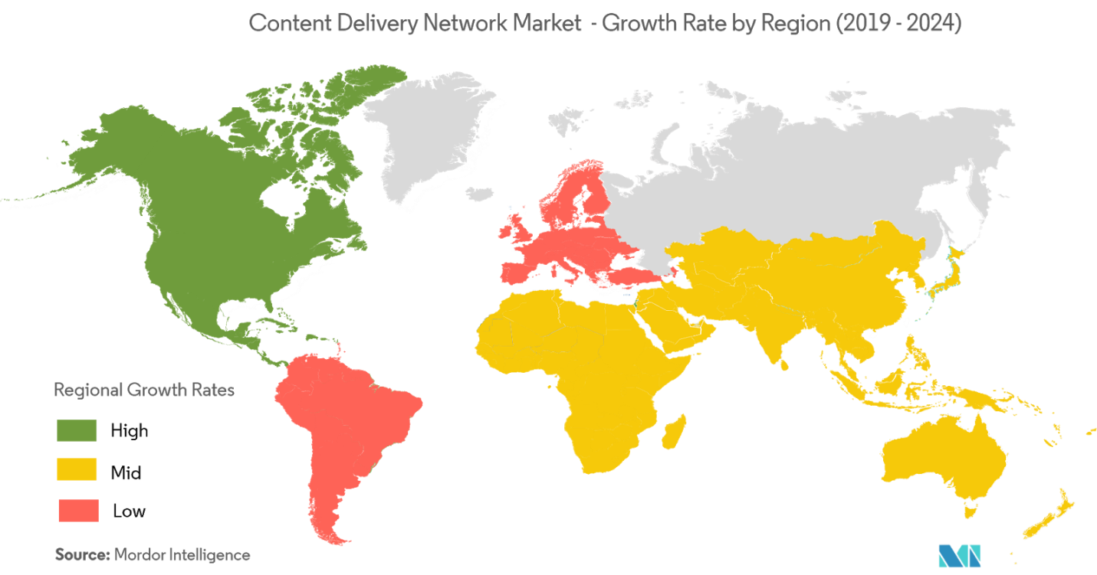

Success Factors
Akamai is one of the largest content delivery network on a global mainframe currently operates for a range of megacorporations like Apple, Amazon, Netflix, Microsoft to name a few and provides them with content delivery as well as infrastructure services as a whole for improving and accelerating the applications over the internet and improving the delivery of content. The company provides a range of services which further includes the delivery of live as well as on-demand video streaming capabilities as well as dynamic and static website content, along with tools that can help the people for conducting their business and reach out to their current as well as new customers as a whole. As of the fiscal year of 2011, the company operated over 100,000 localised servers in 1976 networks that were spread across 78 countries, and was responsible for moving over 30% of all the internet traffic as a whole and in addition to that over 75% of all the individuals who viewed something on the internet had come across Akamai everyday technologies and the company had a market share of over 60% with $1.6 billion in revenues (reuters.com, 2020).
The company during its first five years of operations and its very existence had been the CDS industry in its entirety, and the company post-2011 had been facing threats as well as opposition from the local vendors as well as providers along with the mega-corporation that were setting up their data farm across the globe eliminating the need for the services that were provided by the company. The telecom companies as well as other marge organisations that were once relied on the services of Akamai technologies had been setting up their farms and thus rendering the company unwanted (bamsec.com, 2020).
The company came across the challenges and had thus diversified and restructured their operations wherein previously where all the global operations and decisions which were centralised and were taken at the global headquarters, were further segmented and spared across the localised units, and the functions and operations of the country were divided into three geographical areas as a whole. These included the Americas, the EMEA or the European Market and the APJ or the Asian markets, where each of these markets were considered as theatres under the theatre model and were responsible for their sales, marketing efforts as well as providing services and the global support for the services were congregated into one major centre. Thereafter, each of these theatres further provided a range of services which were previously segmented into two which were product management and engineering was segmented into web security, Media and Enterprise based on the users. These subdivisions based on the users had their own department for the management of the product as well as engineering in order to enhance the level of efficiency and effectiveness of the human resources of the company and enhancing the capability of the company to take on the local and global competitors like the Amazon Content Delivery systems, the Microsoft farms etc (bamsec.com, 2020).

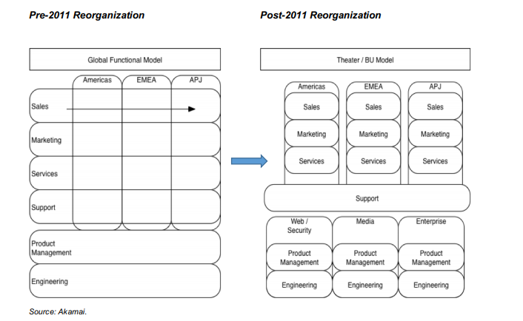

External Analysis
The External environment analysis can be illustrated as the study of the macro-environmental forces as well as factors that include the analysis of the industry as for getting a purview of the growth of an organisation and contains the broader dimensions that have an impact on the broader society (economicsdiscussion.net, 2020). Therein for understanding and establishing the impact of the external environment of Akamai, Porter's Five forces analysis, along with the Industry Life cycle and PESTLE analysis has been utilised for gaining a profound understanding of the business environment.

Industry Life Cycle
The industry life cycle can be illustrated as a process of the evolution of an industry of business through different faces which are characterized by common features which are displayed during each phase. There are four phases in the industry life cycle which are in the form of introduction, growth, maturity as well as decline, wherein the first phase is known as din production where industries born and new products are developed in the market and are characterized by uncertainty regarding the size of the market as well as product specifications along with main competitors. This is followed by the growth phase where the demand grows rapidly and the consumers of the new industry understand the value of the products that are being offered as a handful of important players emerge in the market becomes apparent and establish a share of the new market as a whole. The growth phases followed by maturity face which begins with the shakeout period during which the growth slows down and the focus of the company is shifted towards the reduction of expense as consolidation occurs in the market where a few companies are able to achieve economies of scale which hampers the overall sustainability of smaller competitors. Thus lastly, comes the Decline phase, where the industry cannot support any growth any longer and the product that we hosted by the industry becomes obsolete which negatively impacts the demand and leads to decline in revenues and increases margin pressure which forces the weaker competitors out of the industry (inc.com, 2020).
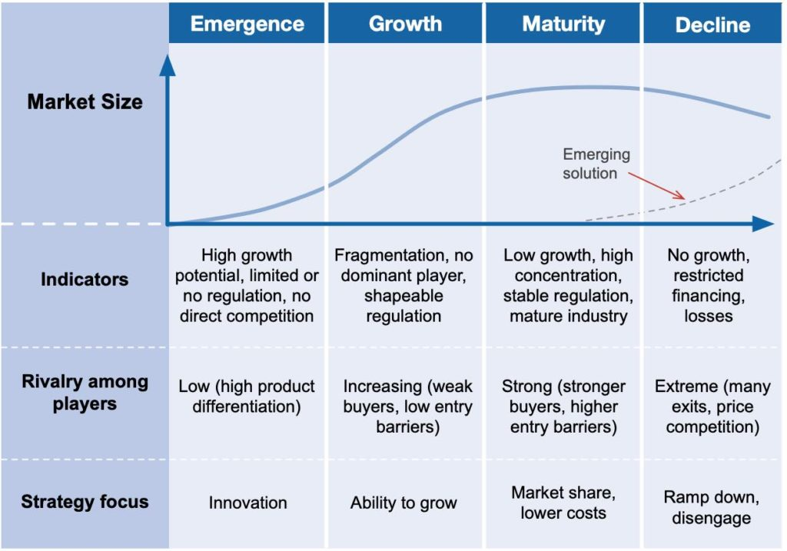
The current phase of the content delivery system is the growth phase where II a few important players are becoming apparent like Amazon global content delivery system and other localised competition since the customers understand the value of the new offering and the overall demand of the industry is booming.

Porter’s Five Forces Analysis
The porter's five forces framework can be listed as a method that is used for analysing competition that business faces and grows from the industrial organisation economics in order to derive the five forces which help in determine the competitive intensity as well as the attractiveness of industry through analysing the profitability (businessnewsdaily.com, 2020).
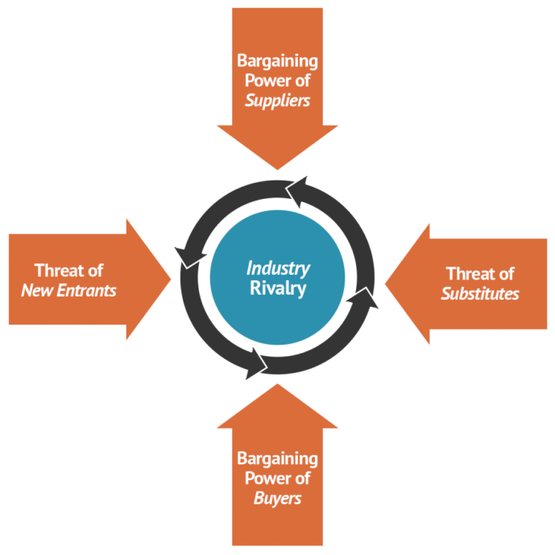
Threats of New Entrants: The threat of new entrants that the company faces is relatively high since new entrants in the industry could bring about innovation as well as new ways in which the content delivery systems can be revitalized as well as provided to the end-users which guide result in the description of the industry as a whole. Barriers to entry in the market are low and the threat that the new entrants pose to the company is high as Mega corporations like Microsoft have been setting up their own data form for indirectly competing with the services of Akamai rendering them unwanted.
Bargaining Power of Suppliers: The bargaining power of the suppliers is relatively low since the company is one of the largest providers of content delivery systems, and has it localised nodes as well as servers present in over 136 countries along with no unique suppliers since the services do not require any localised services or raw materials to provide the services as a whole.
Bargaining Power of Buyers: The bargaining power of the buyers is relatively moderate since the number of customers in the organisational main frame of akamai technologies is relatively congested and limited to large corporations as well as companies that require the services of the company. Thereafter the size of the orders, in general, are large and are of routine nature due to the nature of the product. In addition to that, the competitors are also limited and are localised or have proprietary ownership over them which gives them a competitive advantage over their peers and the rest of industry, thus the bargaining power of the buyers is moderate.
Threats of Substitute Products or Services: The threats of the substitute products and services are largely localised since Akamai technologies in the initial phases of its existence was the CDS industry in its entirety and over 75% of the individuals who access the internet come in contact with the services provided by the company on a daily basis. Thereafter, the competitors are largely localised in different areas which are countered by the subdivision of the services through re-organising the services of the company into theatres and the competitors use their Specialised networks for their competitive advantage, and thus the threat of substitution is moderate.
Industry Rivalry: The competitive Rivalry that exists in the mainframe of the Content Delivery Systems Network is intense and characterized by cut-throat Competition at local levels since the services of the company are spread across 136 countries and all the continents in the global mainframe. Thereafter the industry as a whole is in the phase of growth where there are a few major competitors in the market and has a compounded average growth rate of over 13.2%, where the services of the company are diversified in the global mainframe and their competitors localised, and thus the industry rivalry amongst the competitors are relatively high.

PESTEL Analysis
The PESTLE analysis can be illustrated as a Framework that is used for analysing the external environmental factors which can influence the organisation from the outside and have an impact on its day-to-day decision-making as well as functional capability as a whole (pestleanalysis.com, 2020).
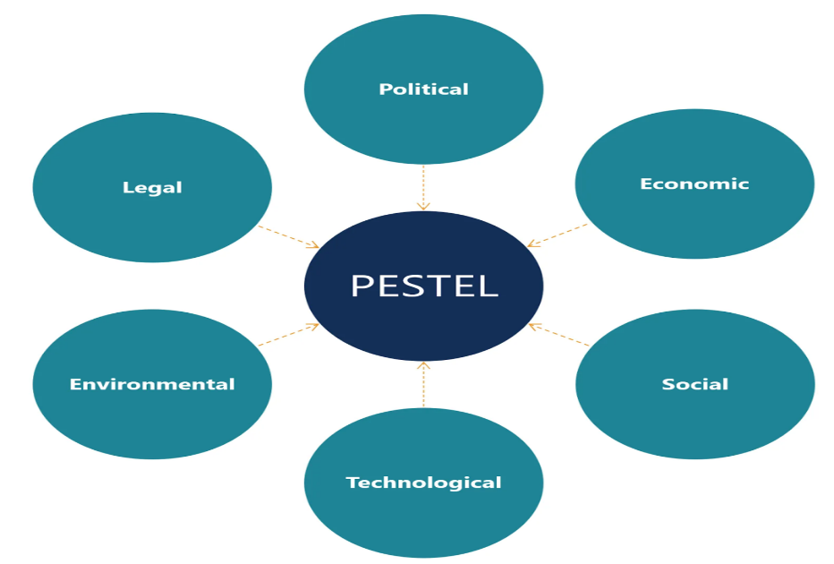
Political: The political factors of the country have a significant impact on the profitability as well as the chances of survival of the company since sudden changes in the existing political regimes, civil unrest and major decisions taken by the government can have an impact on the very existence of the company. The political stability, as well as the importance of internet information providers in the economy of the country, have a relatively large impact on the existence of the company and in addition to that, the provisions for the intellectual property protection as well as trade regulations and tariffs that are related to technology have an impact on the day to day functions of the company.
Economic: The factors of economic environment like the rate of inflation, interest rate foreign exchange rate as well as economic cycle have an impact on determining the aggregate investment as well as demand in the economy in the terms of the internet. The type of economic system, as well as government intervention in the free market that is related to technology along with the exchange rate as well as stability of host country currency, have an impact on the day-to-day decisions as well as functions of Akamai Technology.
Sociocultural: The socio-cultural factors include the behavioural assessment of the individuals within the country that have an impact on their decision making as well as being part of the culture as well as shared beliefs and attitudes of the general population as a whole. demographics, as well as a level of scale of the populace as well as the power structure the hierarchy in the class structure of the society along with their relevance of the use of internet and attitudes, impacts the day-to-day functions and decision making of the company since a society with high internet usage would require a higher quality of services by the company and vice versa.
Technological: The technological factors can rapidly dismantle the structure of the price as well as the competitive landscape of the industry in a very short amount of time and thus it becomes extremely important for constantly and consistently to innovate for prevention of obsolescence in the future along with maximizing profits as well as becoming the market leader. the rate of diffusion of Technology, as well as the impact of value chain structure in the technologies sector as well as the cost structure of the internet information provider industry, have an impact on the day-to-day functions and operations of akamai Technology.
Environmental: The environmental factors consist of the market known as well as legislation that is implemented within the organisation in the mainframe of a particular market in order to protect the general environment as well as the flora and fauna of the country. As some European Markets provide tax breaks as well as other range of benefits and amenities for green initiatives. The water and air pollution regulations and the mainframe of the internet information provider industry, as well as waste management in the technological sectors along with their overall attitudes towards ecological products and green products, have an impact on the functions and operations of the company.
Legal: The legal mainframe is constituted of the government institutions as well as frameworks within the country and the legislative as well as regulative mainframe which are implemented for the protection of the society and the business mainframe as a whole. The Intellectual Property law as well as copyrights and patents protection of the country, along with the Anti-trust law implemented by the country for the Internet Information Providers industry, along with the health and safety regulations and the employee regulations have an impact on the day-to-day functions and operations of the company (Perera, 2017).

Internal Analysis
The aspect of internal analysis mainly examines the internal environment of the business for assessing the available resources, competitive advantage and also competencies of the company (Palepu, et al., 2020). The performance of internal analysis on Akamai Technologies shall help in identifying the strengths and weaknesses of the business by using the SWOT Analysis strategy and understand factors that can be used for overcoming the challenges for the business to localise.

SWOT Analysis for Akamai Technologies
The aspect of SWOT analysis is mainly understood to be the planning methodology which helps a business for building a strategic plan for meeting the company goals, improving the business operations and also keeping the requirements of the business-relevant by analysing the internal environment of the company which includes its strengths, weakness, opportunities and threats (Sarsby, 2016). Following is the SWOT analysis for Akamai Technologies to understand the challenges of the company’s localisation aspect.
Strengths | The overall base of customers for Akamai Technologies is strong which is one of the biggest strengths of the company as well as helps the company to achieve steady revenues. Also, the product portfolio of the business being diversified allows the company to serve different types of market. Moreover, the R&D department is strong due to the robust financial structure of the company along with the competitive edge of Akamai being its strength by the help of robust network capabilities (MBA Skool Team, 2020). The other strengths of Akamai which shall help the business to overcome the challenge of getting localised are that their customers include Bing, Apple, Facebook, Twitter, which are big names in this part of the market.
Weaknesses | One of the biggest weaknesses of Akamai Technologies is that the revenue of the business majorly depends on the US market. This makes the business to focus only in certain areas which lead to the business getting locked behind in terms of revenue generation. Moreover, the short terms concern the business regarding its liquidity also stands to be a significant weakness for the business.
Opportunities | There are various opportunities associated with Akamai Technologies in terms of localising and making the business stable appropriately. The increase in the aspect of bandwidth tends to demand the force of using the cloud computing process which shall make the work of the company easier (Attaran, 2017). Also, there are opportunities for the business to grow with the help of different mergers along with the cyber-security aspect getting increasingly known for this sector of the business.
Threats | The biggest threat of Akamai Technologies is the intense level of competition which it faces from both the existing as well as the new companies within the industry, for instance, Level 3 Communications Inc., Amazon Web Services, etc. Moreover, the regulations being strict ever in terms of data privacy is becoming a threat for Akamai as well as the rapid technological inventions being used in this industry.

VRIO Framework for Akamai Technologies
To further analyse the capability of Akamai Technologies towards localising its business and the challenges it is facing, the VRIO structure will be applied. "VRIO structure is the device used to examine the association's inward assets and capacities to see whether they can be a wellspring of the supported upper hand." This device is utilized to investigate the association's inner assets and was initially evolved by Barney, J. B. in 1991. The VRIO structure can be utilized to test Akamai Technologies' assets and capacities for making the upper hand (Ariyani & Daryanto, 2018).
Valuable: Akamai Technology's monetary assets are profoundly basic and important, helping Akamai Technologies in putting resources into R&D openings that emerge. Research and development ability at Akamai Technologies are significant as they help in picking up an upper hand over opponents. These additionally help Akamai Technologies in fighting outside dangers. The organization's items are a significant asset as they yearly dispatch new medications available (Waschke, 2017). This makes the apparent incentive for these by clients high. Human resources (primarily is another important asset for Akamai Technologies. An enormous segment of the labour force is profoundly prepared, particularly in medication improvements and deals, and this prompts a more beneficial yield for the association. The representatives are additionally steadfast, and maintenance levels for the association are high. Additionally, Akamai Technologies' appropriation network is an important capacity. The conveyance network helps in arriving at more clients and furthermore assists with the advancement exercises turning out to be dealt as the items are made accessible without any problem.
Rare: Akamai Technologies' all around created R&D associations are uncommon as a couple of drug firms have R&D capacities in this scale in the business. Licenses are the most significant and uncommon assets yet will decrease in an incentive as they will terminate. Licenses of Akamai Technologies are progressively significant as the organization was the first to produce some specific medications. Licenses, licenses, expertise and advertising rights are significant and uncommon assets for producing an upper hand and financial execution in Akamai Technologies (Edward, 2018). Their items through their brands' name are likewise uncommon. In any case, contenders can give less expensive and comparative items; thus, their items bring about serious equality. The human resources of Akamai Technologies are one of a kind asset as they are profoundly prepared and gifted. The better compensation, pay, and workplace guarantee that these significant assets don't leave for different associations.
Inimitable: The human asset abilities, cutting edge innovations, and R&D capacities of Akamai Technologies are not imitable (or difficult to mirror) as the organization has gained them through delayed benefits throughout the long term. New contestants and a few contenders would require comparable benefits for a significant stretch of time to collect these measures of monetary assets. The dissemination organization of Akamai Technologies is additionally expensive to mirror by rivalry as recognized by the VRIO Analysis. This has been created throughout the years slowly by Akamai Technologies. Contenders should contribute a huge sum in the event that they are to mimic a comparable dissemination framework (Attaran, 2017). A portion of their items, for example, medical care items are not that expensive to emulate as contenders can deliver comparable items on the lookout. These additionally don't need years-long insight. Thus, their items furnish it with an impermanent upper hand that contenders can procure over the long haul. Licenses can be here and there imitable and exorbitant as different contenders may acquire licenses for a comparative item with an alternate name.
Organising: The achievement of Akamai Technologies has been very relying upon misusing its significant, uncommon and incomparable asset. The gathering's monetary assets are deliberately coordinated and figured out how to catch esteem. They deliberately put resources into the correct spots and items, utilizing possible chances and combatting dangers. Henceforth, monetary assets end up being an essential wellspring of supported upper hand for Akamai Technologies (Byrne, 2018). The organization's conveyance network is efficient, and Akamai Technologies utilizes this organization to connect with its clients by guaranteeing that items are accessible overall notwithstanding where they are created, thus ending up being a wellspring of the supported upper hand. Akamai Technologies utilizes a successful capital assignment system to utilize existing assets and capacities to make esteem and produce an upper hand.

Growth Strategies for Akamai Technologies
Akamai Technologies is observed to have achieved leadership in the market in terms of delivery of content and also the acceleration of the application services by mainly pursuing the aggressive rate of growth of the company. Akamai Technologies is observed to have advised their market for a growth up to $5 Billion by the year 2020 which is only achievable after exploiting all the opportunities which are related with the key market of the business (Galloway, et al., 2017). Nonetheless, the internal aspect related to the legacy of Akamai’s business practices which are observed to be incapable of scaling the overall market growth rate. What Akamai requires to do for executing on their goals or revenue and also how Akamai would be able to maintain their overall position of leadership within the rapid and dynamic expansion of the market?
Recently one of the biggest strategies for growth which was observed to be taken by Akamai Technologies is that “the industry leader to drive growth and innovation in the Asia Pacific and Japan Region'' (Akamai Technologies, Inc., 2020). Hence for understanding the growth strategies useful for Akamai revolving around the recent scenarios as well as the business localising can be understood from the following discussion of growth strategies with the help of Ansoff’s Growth Matrix framework.
Ansoff Matrix is understood to be such a tool which can be used by an organisation for analysing as well as planning the growth strategies of the business. There are mainly four aspects of this growth framework, which are-
- Market Penetration: Here, the focus mainly remains towards increasing the overall sales of existing products and services by the business in their existing market.
- Market Development: In this strategy, the company focuses on entering an entirely new market by using its existing services and products.
- Product Development: In this case, the focus is mainly given towards introducing an entirely new line of products or services within the existing market (corporatefinanceinstitute, 2020).
- Diversification: Lately, as per this strategy, the focus is given to an entirely new product or service to be launched in a new market.
The intention of Akamai Technologies as per the case study is to localise their business but facing several challenges. In such a scenario, the best growth strategy that shall be appropriate for Akamai Technologies to use is the Market Development strategy. This is mainly because the main aim of Akamai Technologies is to help the local web-based organizations to give a platform to perform the required tasks but localisation being not so an easy process is facing a lot of issues and challenges regarding the business processes (Umbach, 2017). Hence in such a scenario, it becomes important for Akamai Technologies to use their knowledge how to capture the market since they already have captured the high-end web-based market and they have knowledge how to attract customers and local business towards the prospects of the company. Hence, entering the new market form requires to use the strategy which was used earlier with their existing products and services and thus market development is the appropriate strategy for the application.

Conclusion and Recommendations
Hence from the above discussion, it can be concluded by saying that Akamai Technologies is required to focus more on the requirements of the local businesses with which it intends to associate with so that the challenges which it is facing could be overcome. Moreover, the aspect of strategic management has helped to analyse that it is very significant for every business to focus on the strategies that shall be useful for solving short term challenges as well as the long terms ones also.
There are certain recommendations which can be provided to Akamai Technologies for overcoming the challenges of business localisation and application of the appropriate business strategies. Some of them are-
- Firstly, it is recommended to Akamai Technologies to have extensive research about its competitor who has already achieved the aspect of business localisation so that it can analyse what strategies the rival company has used to make their strategies work.
- It is very important for Akamai Technologies to have better communication with the localised associate if it wants to remove barriers to these prospects. Having proper communication regarding the goals and aims of Akamai Technologies towards the local businesses and why they should be helping them must be conveyed appropriately.
- The requirements for the local web-based service providers must be considered if Akamai Technologies want to resolve the challenges it is facing.

References
Akamai Technologies, Inc., 2020. Akamai Taps Industry Leader to Drive Growth and Innovation in Asia Pacific and Japan Region. [Online]
Available at: https://www.prnewswire.com/news-releases/akamai-taps-industry-leader-to-drive-growth-and-innovation-in-asia-pacific-and-japan-region-301147077.html
[Accessed 2020].
akamai.com, 2020. About us. [Online]
Available at: https://www.akamai.com/us/en/about/
[Accessed 2020].
akamai.com, 2020. Company history. [Online]
Available at: https://www.akamai.com/uk/en/about/company-history.jsp
[Accessed 2020].
Ansoff, H. et al., 2018. Implanting strategic management.. s.l.:Springer.
Ariyani, W. & Daryanto, A., 2018. Operationalization of Internal Analysis Using the VRIO Framework: Development of Scale for Resource and Capabilities Organization. Asian Business Research Journal, Volume 3, pp. 9-14.
Attaran, M., 2017. The internet of things: Limitless opportunities for business and society. Journal of Strategic Innovation and Sustainability , 12(1), p. 11.
bamsec.com, 2020. plans-of-reorg. [Online]
Available at: https://www.bamsec.com/companies/1086222/akamai-technologies-inc/plans-of-reorg
[Accessed 2020].
businessnewsdaily.com, 2020. porters-five-forces. [Online]
Available at: https://www.businessnewsdaily.com/5446-porters-five-forces.html
[Accessed 2020].
Byrne, T., 2018. Analysis Of Akamai Technologies Inc. [Online]
Available at: https://www.essay48.com/value-chain-analysis/5534-Akamai-Technologies-Inc-Value-Chain-Analysis
[Accessed 2020].
Coote, A., 2021. Universal basic services and sustainable consumption.. Sustainability: Science, Practice and Policy, 17(1), pp. 32-46.
corporatefinanceinstitute, 2020. What is the Ansoff Matrix?. [Online]
Available at: https://corporatefinanceinstitute.com/resources/knowledge/strategy/ansoff-matrix/#:~:text=The%20four%20strategies%20of%20the,new%20market%20using%20existing%20products.
[Accessed 2021].
economicsdiscussion.net, 2020. business-environment-types-external-micro-and-external-macro. [Online]
Available at: http://www.economicsdiscussion.net/business-environment/business-environment-types-external-micro-and-external-macro/10095
[Accessed 2020].
Edward, Z., 2018. VRIO Analysis of Akamai Technologies Inc. [Online]
Available at: https://www.case48.com/vrio-analysis/5534-Akamai-Technologies-Inc
[Accessed 2020].
Galloway, T., Miller, D., Sahaym, A. & Arthurs, J., 2017. Exploring the innovation strategies of young firms: Corporate venture capital and venture capital impact on alliance innovation strategy. Journal of Business Research, Volume 71, pp. 55-65.
globaldots.com, 2020. content-delivery-network-explained. [Online]
Available at: https://www.globaldots.com/content-delivery-network-explained
[Accessed 2020].
inc.com, 2020. industry-life-cycle. [Online]
Available at: https://www.inc.com/encyclopedia/industry-life-cycle.html
[Accessed 2020].
Manca, S., Bocconi, S. & Gleason, B. .., 2021. “Think globally, act locally”: A glocal approach to the development of social media literacy.. Computers & Education, Volume 160, p. 104025.
MBA Skool Team, 2020. AKAMAI Technologies SWOT Analysis, Competitors, Segmentation, Target Market, Positioning & USP. [Online]
Available at: https://www.mbaskool.com/brandguide/it-technology/13081-akamai-technologies.html
[Accessed 2020].
Palepu, K. et al., 2020. Business analysis and valuation: Using financial statements. s.l.:Cengage AU.
Perera, R. .., 2017. The PESTLE analysis.. s.l.:Nerdynaut.
pestleanalysis.com, 2020. what-is-pestle-analysis. [Online]
Available at: https://pestleanalysis.com/what-is-pestle-analysis/
[Accessed 2020].
reuters.com, 2020. Akamai technologies limited. [Online]
Available at: https://uk.reuters.com/companies/AKAM.O
[Accessed 2020].
Sarsby, A., 2016. SWOT analysis. s.l.:Lulu. com.
Trigeorgis, L. & Reuer, J., 2017. Real options theory in strategic management.. Strategic Management Journal, 38(1), pp. 42-63.
Umbach, C., 2017. Management and governance of external developer platforms-at the example of Akamai, Inc. and Uber Technologies, Inc.. Doctoral dissertation, Massachusetts Institute of Technology.
Waschke, M., 2017. Personal cybersecurity: how to avoid and recover from cybercrime. s.l.:Apress.

