
International Marketing
SIEMENS REFRIGERATOR

Name : Desai Vikaskumar H
Student ID : 1706369
Subject : International Marketing
Subject Code : SBMA7108_LON
Tutor Name : Richard Small

Table of Contents
Introduction 2
Identification of Target Markets 2
Comparison of the Marketing Strategies in respect to the markets of India and United Kingdom (UK) 3
Marketing Goals and Objectives 3
Market Research and Analysis 4
Segmentation Targeting and Positioning (STP) 7
Brand Awareness 14
Analysis of the Ethical and Environmental Issues 17
Conclusion and Recommendations 17
References 19

Introduction
The following report will focus upon analysis and identification of the overall similarities and differences concerning the marketing strategy of an organization for promotion of their services and products across different international markets. In this specific assignment, the organization of Siemens have been selected and the product specified is refrigerators. Siemens is a Germany based organization that is considered to be among the biggest industrial manufacturing organization across the globe. The product chosen for this specific assignment is the refrigerators designed and sold by the organization of Siemens. Siemens effectively specializes in manufacturing and delivering of premium and high end refrigerators to the customers and buyers across global markets offering of super specifications and features at high or premium pricing (Wilson, 2012). The chosen markets for this assignment is India and United Kingdom (UK). The chosen markets of India and UK are seen to be showcasing higher growth in respect to the consumer electronic home appliances that in turn offers the organization of Siemens with the advantage of obtaining higher sales and revenues by successful marketing of their products of high end refrigerators. The following report will conduct a detailed evaluation and analysis of the selected markets along with suggesting the similarities and differences that exists in the overall marketing approaches implemented by the organization in both the targeted markets of United Kingdom (UK) and India.

Identification of Target Markets
While developing and implementation of marketing strategies it is necessary for the organization of Siemens to have a detailed understanding and knowledge that the selected markets of India and United Kingdom (UK), are quite different from one other in the context of the marketing environment, the socio cultural factors and other specific parameters.
Now considering the suitability of the market environment, the political stability in India as well as UK offers better growth and development opportunities for Siemens for effective promotion and marketing of their products and services. The overall relaxation in the context of the government regulations and protocols successfully enable Siemens to conduct their marketing activities and operations without any disruptions or hindrances. However there exist a higher difference in the socio cultural and the economic perspectives. The UK market has a better economic presence compared to the Indian market and the spending power of the UK customers is also high. Thereby considering the products of premium quality and high priced refrigerators, the organization of Siemens must target a narrow customer segment in India which will only comprise of the niche customers belonging to the higher income classes of the society. Both the markets of India and UK have the required technology and resources to support Siemens in their marketing and promotional methods or approaches. Therefore both the markets can be said to be having higher potential in respect to offering better growth and success opportunities for the organization of Siemens.

Comparison of the Marketing Strategies in respect to the markets of India and United Kingdom (UK)
In relation to the marketing of their product of refrigerators, there is need for the organization of Siemens to be focused upon implementation of proper marketing strategies, which can help in better promotion of their products and services among the consumer segments, in different markets. When considering the marketing of the products in the markets of India and UK, there is a high need for the organization to have a proper understanding of the differences in cultural values and preferences of the markets which is different in respect to India and United Kingdom (UK). This section of the report will focus upon conducting a detailed analysis and evaluation of the overall marketing strategies and approaches that the organization of Siemen’s must implement for successful marketing and promotion of their products and services in the UK and Indian market so that better growth and business profitability is achieved (Kotler, 2015). The overall comparison and analysis of the marketing strategies employed by the organization in respect to the identified markets have been discussed in details under the following sections of the report;

Marketing Goals and Objectives
To successfully market their products and services, in the markets of United Kingdom (UK) and India, there is a high need for the organization of Siemen’s to focus upon development and implementation of SMART objectives and goals. This effectively specifies that the marketing objectives and goals are high specific, realistic, measurable and time bound so that they can be fulfilled within the context of a stipulated frame of time.
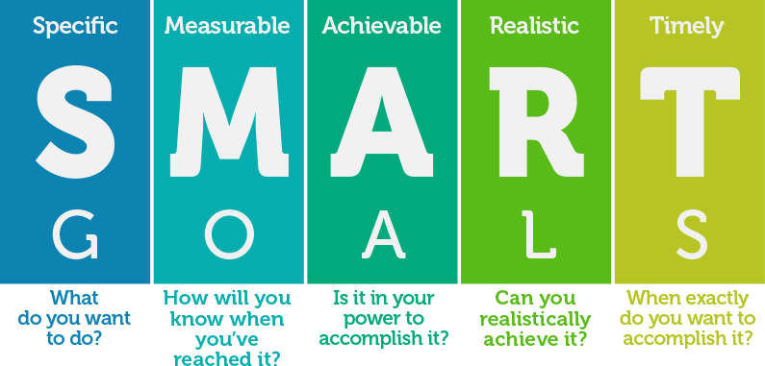
Fig: SMART Goals and Objectives (source: self)
Now considering the two different and diverse markets of India and United Kingdom (UK), the marketing goals and objectives can be different in two respects. Thus the marketing goals and objectives of Siemen’s in context of the UK market can be explained in details as below;
- To enhance the overall sales and profitability by nearly 5 to 7 percent within six months of launching the products of refrigerators in the UK electronic home appliances industry market.
- To substantially improve the overall market presence and competitiveness and achieve steady market growth of nearly 2 to 4.5 percent.
- To attract more customers and buyers and developing or strengthening the customer base in the UK market.
On the other hand, while considering the marketing of the products in the Indian market, the marketing objectives of Siemens must effectively comprise of the following;
- To generate a better customer research and convey the products and services benefits to the targeted customer or the buyer segments in the Indian market.
- To achieve a better and improved brand awareness and brand image in respect to the consumer home appliances industry in India.
- To effectively differentiate their products and services from that of the core competitors in the Indian market, that includes the organizations of Samsung, LG, Whirlpool, Videocon and others (Meissner, 2012).
- To achieve a sales growth of nearly 2 to 3.5 percent within 3 months of launching the new refrigerator products in the Indian market.

Market Research and Analysis
In relation to the business operations and activities in international markets, the overall marketing strategy of the organization of Siemens, can be seen to be effectively characterized by the overall and in depth market knowledge which can be achieved through a detailed analysis of the targeted markets. In this context, the detailed market analysis and research, will help the organization of Siemens, in understanding of the market dynamics, which can help in implementation of proficient and well planned marketing strategies and initiatives to achieve successful product promotions and marketing in the targeted markets of India and United Kingdom (UK).
Analysis of UK market
Concerning the United Kingdom (UK), the consumer electronics market is seen to exhibit a higher sales and growth prospects, which offers the respective organization of Siemens with high market growth and development opportunities. As per the statistics, it is evident that the overall value of the consumer electronics market in UK has witnessed a specific rate of increase which proves to the beneficial for the organization of Siemens in achieving better marketing and sales opportunities in terms of their products of high end refrigerators for the consumers (Hartmann, 2018). In addition the overall preferences of consumers have shifted towards technologically upgraded services and products, which can also add to the success of Siemens in terms of marketing and promotions.
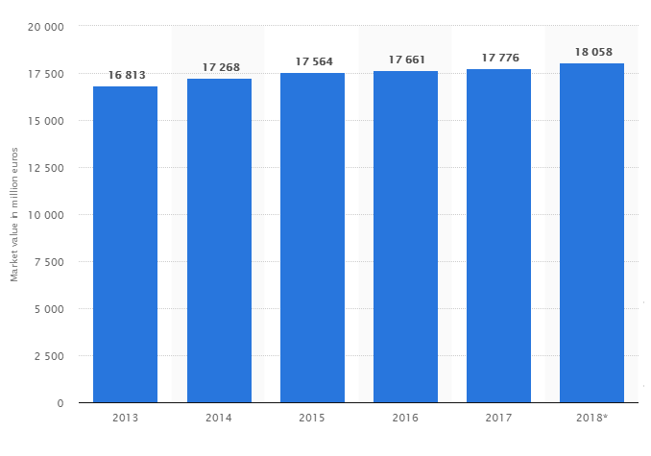
Fig: Consumer Electronics Market Value in UK (2013-2018) (source: statistica.com)
Now considering the different environmental factors, the overall political stability of UK government and relaxed business regulations offers Siemens with a better and improved opportunity of marketing their products and services. In addition the stable economy of UK also refers to the higher spending capability of the consumers, which offers Siemens with higher sales opportunities by launching of their products of high end refrigerators in the UK market. In addition considering the customer segments, in the consumer electronics appliance market of UK, the changes and preferences of the consumers are seen to be on technologically advanced products and services which can offer Siemens with an added advantage in achievement of higher marketing and sales success in the targeted UK market. In addition, the availability of technology and other resources also offers Siemen’s with a higher growth in terms of marketing and sales of their high end refrigerator products in the UK market.
Analysis of the India market
In context of the targeted market of India, the consumer electronic home appliances have been achieving a steady growth and development which offers the organization of Siemen’s with a high success in effective marketing and promotions of their products and services in the Indian market. As per the statistics it is evident that, at present the overall market value considering the consumer electronic home appliances is nearly at 1.3 billion USD. This market value is said to have the potential of achieving a further growth of nearly 10 percent by the year of 2022. In addition considering the sale of electronic home appliances products and services, refrigerators are among one of the highest selling products in the Indian, market. This in turn can be said to be offering the organization of Siemen’s with higher growth and success in the UK market amidst the high competition from core rivals that include LG, Samsung, Videocon and others (Ghosh, 2017).
Now considering the different environmental factors, the stability of the Indian political system, offers Siemens with all the needed opportunities for marketing and promotions of their products in the Indian market. In addition, the Indian government also facilitates 100 percent foreign direct investment (FDI), in respect to consumer electronics which can lead to successful marketing and sales of the Siemen’s refrigerators in the concerned industry market. However, the organization must effectively note that the preferences of the consumers or buyers in the Indian market is majorly focused upon adapting of advanced and smart features in context of home appliances. Thus the customer focus is upon deriving of better convenience from the products and services. The high economic growth and development of the Indian market, also offers Siemen’s in enjoying better sales of their high end refrigerators. However, in this specific context, there is a requirement for the organization to analyse and identify that although the spending power of customer’s have increased, the general consumer segments tend to prefer competitively priced products and services. Thus the product and services marketing are required to be concentrated upon attracting the niche customer segments, who are expected to make purchases of the high end products offered by Siemens. There is also a widespread availability of technology in the Indian market, which in turn offers the business organization of Siemens in context of achievement of better success in regards to the sales and marketing of their services and products in the Indian consumer electronic home appliances industry market. Therefore there is requirement for the organization to use the availability of the technology and resources so that better success can be achieved in the context of product promotion and sales in the respective Indian market.

Segmentation Targeting and Positioning (STP)
The successful marketing of the products and services in a market is largely dependent upon the implementation of proper and well-structured segmentation, targeting and positioning (STP) process. The implementation of an effective STP strategy is therefore essential for the organization of Siemens to realize higher growth and development in the markets of India and United Kingdom (UK). This specific strategy can help Siemens in effective segmentation and targeting of the concerned customer segments in the targeted markets of India and UK. In addition proper strategies can also be implemented so that the respective services and products can be effectively positioned in the customer or buyer mind sets so that better sales and revenues can be achieved or obtained in the market (Janiszewska and Insch, 2012). The overall segmentation, targeting and positioning strategies of Siemens in the market of India and UK can be explained in details, under the following sections;
Segmentation
Segmentation can significantly help business organizations such as Siemen’s to identify and detect the potential customer groups who are likely to make repeat purchases from the organization. This can help the organization in focusing upon development and implementation of proper strategies so that such customer or buyer segments can be effectively targeted with the product of high end refrigerators. Considering the both markets of India and UK, the segmentation of the consumer electronics home appliances market can be segmented by considering the following mentioned factors or parameters;
Demographics: Considering the aspect of the demographic factors, Siemens needs to segment the consumers or buyers in the UK and India market, by analysis the dimensions of income level, age, gender and others. Now considering the overall demographic profile differences in the UK and India market, the choices of the customer segments can be different. To exemplify in details; the customers or buyers in UK market will generally comprise of people belonging to the middle and high income groups or classes of the society who can have the preference and spending power to purchase the high end products offered by the organization of Siemens. On the other hand, while considering the market of India, the people belonging to the high income groups of the society are likely to be the potential buyers for Siemen’s high end refrigerators.
Psychographics: This factor mainly comprises of the attitudes and lifestyles of the customers. For example; the customers in the UK market, tend to have a more lavish lifestyle than their Indian counterparts. Therefore in context of the UK market, Siemens can enjoy a wider customer base for their high end products. However, considering the Indian market, the customer base for the products and services delivered by Siemens is concentrated to the customer or buyer segments who have the economic capability and higher economic status to live lavish lifestyles.
Behavioural: In context of the behavioural factors, Siemens must effectively focus upon segmenting the targeted market based upon the factors of sure status, preference of the brand image and identity along with the benefits sought from the products and services. Thus considering the targeted market of India, the potential customers for Siemens are seen to be concentrated to the higher income classes of the society who tend to prefer high end products and services (Wilson, 2012). While the general consumer masses tend to prefer highly valued and competitive products and services. In respect to the UK market, the customers have a higher preference to the high end products and services, which can offer Siemen’s with the opportunity of targeting more customer segments with their products of high ended refrigerators that usually comes with a higher price point.
Geographic:In respect to the geographic factors or parameters, it is necessary for the organization of Siemens, that the demand for the products and services are concentrated only among the customers or consumers based in the urban and metropolitan areas. This situation is relevant for both the concerned markets of India as well as UK. The customers or consumer belonging to the urban and metropolitan areas are seen to having the capability and purchasing power to purchase the high end products delivered by the organization of Samsung. Therefore the marketing strategies needs to be highly concentrated on attracting the attention of the urban consumers or customers in both the targeted markets of India as well as United Kingdom (UK).
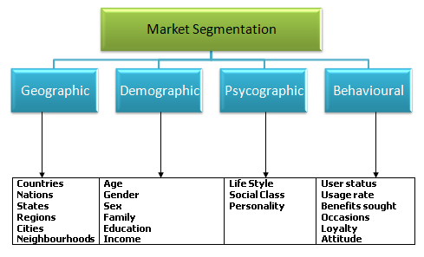
Fig: Market segmentation (source: mindtools.com)
Targeting
As per the analysis of the segmentation, it is evident that the organization of Siemens need to target different customer segments when considering their marketing and promotional activities in the markets of India and UK which can be said to be culturally different from one another.
While considering the market of UK, Siemens has a wider customer segments or groups to target. In this context, the potential segments for the organization of Siemens to target in the UK market signficiantly involves the customers or buyers belonging to the middle as well as higher income groups or classes of the society who are seen to be preferring the high end electronic appliances to serve their needs and purposes (Hassan, 2012). Thus the targeting strategy must be focused upon differentiated targeting. This can help the respective organization, in effectively targeting multiple customers segments or groups in the UK market having diverse range of needs and demands. This can help the organization in deciding upon the services that can be delivered to the different customer segments so that higher success can be achieved in terms of marketing, promotion and sales of their high end refrigerator products and services among the buyers or customers.
On the contrary, the market in India, the core customer groups for the organization of Siemens have been identified to be the customers or buyers belonging to the higher income groups or classes of the society, who have the purchasing power or potential to avail the high end products and services delivered by the organization of Siemens. In this specific regards, the organization must effectively focus upon implementation of concentrated marketing and targeting strategy. This specific strategy can be said to be of higher importance for Siemens, as it can help the organization in concentrating their marketing activities and operations upon the niche segments of customers who are the potential customers or buyers in the Indian market. This can help the organization in designing and implementation of exclusive product, services and marketing strategies so as to generate higher appeal to the niche customer segments for successful promotion, marketing and sales of their services and products.

Fig: Targeting Strategy of Siemens for UK and India Market (source: self)
Positioning
Once the markets have been selected and targeted, Siemens need to focus upon implementation of proper marketing mix, so that the products and services can be effectively positioned in customer mind-sets. This can lead to successful promotion and branding of the products in the UK and India markets, resulting in better and improved sales and profitability for the organization. In this specific regards, the use and implementation of the 7 Ps of marketing can be suggested. The different elements in the context of the 7 Ps of marketing along with their use in appealing to the identified customer or buyer segments have been discussed in details as below;
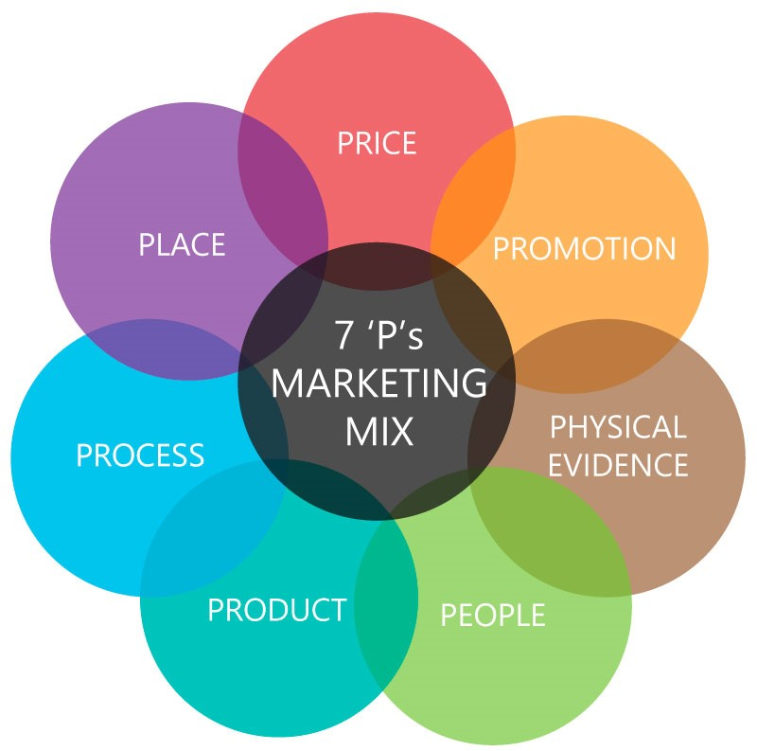
Fig: 7 Ps of marketing (source: mindtools.com)
As identified from the above figure the use of marketing mix for effective products and service positioning in the UK and India markets have been discussed in details as below;
Product:
There is a need for the organization to be focused upon developing and offering of products and services that are wanted or demanded by the customer segments in the targeted markets. The product which the organization wishes to market and promote in India and UK are high end and advanced refrigerators. Considering the dynamics of the India and UK consumer electronic appliances, the modern day customers or buyers tend to prefer technologically advanced and upgraded services and products that can offer high value for money. In addition they also demand the products and services to be highly convenient for use and applications. Thus considering the demands of the customers as mentioned above, the high end refrigerators delivered by the organization of Siemens, can be said to be having a higher capability of appealing to the targeted sets of customers or buyers in the UK and the Indian market (Papadopoulos, 2014). This can make the overall promotion and marketing of the services and products. In addition, the products offered by Siemens also offers a higher differentiation and value which can also help the organization in achievement of a higher competitive edge or advantage in the concerned industry markets resulting in successful promotion, marketing and sales.

Price:
Considering the perspective of pricing, Siemens is seen to be implementing higher or premium pricing for their products and services. This overall premium pricing can be considered to be highly justified in respect to the quality of products and services delivered. The refrigerators manufactured by organization of Siemens, are of high quality, with advanced and premium features that offers a higher differentiation than other competitors operating in the markets of India and UK (Terpstra,2012). Therefore the pricing is justified and it will also deliver better product values to the customers or buyers in the markets of India and UK. The overall pricing of the high end products can be said to help the organization of Siemens in having a higher appeal to the identified customer segments in the UK and India market. This can lead to better success in the context of marketing, promotions and sales of the services and products, by better positioning of the products and services among the targeted segments of customers in the UK and India market effectively.
Place:
In the context of place, there is a need for the organization of Siemens, to be focused upon making their products and services properly available in the targeted markets of India and United Kingdom (UK). The availability of the products must be done in such a manner, that the customers or buyers can be provided with higher convenience. Considering the perspective of the UK consumer electronic appliances market, Siemens can make their products and services directly available to their customers through their own retail stores or through the third part retailers. The products can also be marketed and sold through different e commerce platforms for better customer convenience. On the other hand, considering the concentrated customer segments in the market of India, direct selling of the products and services through own retail stores or outlets may not prove to be fruitful or beneficial for the organization of Siemens. Therefore the organization must focus upon selling and marketing their products and services through extensive use of the e commerce platforms. In addition, the products and services can also be sold by the different third party sellers or retailers having stores at convenient locations across different metropolitan or urban cities and areas. In regards to both the markets of UK and India, there is a need for Siemens to proper manage and develop their distribution channels which is necessary for making their products widely available in the market for consumer purchases.

Promotion:
In context of both the markets of UK and India, the promotion of the products and services is considered to be necessary for the organization of Siemens for the purpose of facilitating the better product sales and revenues. Therefore for successful promotion of the services and products can be done by the organization of Siemens through consideration of both traditional and digital promotional and marketing approaches. In this specific context, the use and implementation of proper media channels is necessary in the organisational context. Some of the key media channels that can be utilized by the organization of Siemens for successful marketing and promotion of their high end refrigerators have been discussed in details as below;
- Print Media: The organization of Siemens can utilize the print media for successful promotion and marketing of their products and services in India and UK. This effectively includes the use of advertisements in newspapers, consumer magazines and others for reaching out to the targeted sets of customers or buyers in both the markets.
- Television Media: The use of television channels can be effectively done by the organization of Siemens for successful marketing of the products and services which can aired on television. This can help the organization in reaching out to the targeted customer segments in the UK and India markets.
- Visual Media: In context of visuals media, the promotion of the products and services can be effectively done by the use of advertisements in banners, billboards, hoardings and others.
- Social Media and Internet: In the current age of digital technology, the use of the social media platforms offers the organization of Siemens with an innovative platform for marketing, which can be widely used both in the context of the India and UK market (Berthon, 2012). The use of social media platforms such as Twitter, Facebook, Instagram and other can be used for effectively communicating and promoting the products and services among the targeted customer segments at much lower cost and better efficiency. This can help Siemens in creation of a high product appeal which can motivate the targeted customer or buyer segments from purchasing the products delivered by the organization. In addition the use of social media platforms will also offer Siemens with the advantage of having an improved customer communication along with betterment of customer support and services. This can help in better and efficient product promotion and branding in the India and UK markets.
Process:
For successful positioning and branding of the products and services in both the UK and India markets, there is a need for organization of Siemens to focus upon developing and improving their business processes, so that better values can be offered to the customers. To exemplify; the betterment of the customer support and services can encourage the potential customers or buyers in the India and UK market to buy from the products delivered by Siemens.
People:
For successful positioning of the services and products in the markets of UK and India, there is a need for the organization of Siemens to have well trained and qualified sales and support staffs. In this context the sales and support staff of the organization must have the competence and knowledge to offer the desired level of support and services for better convenience and satisfaction of the targeted customer or consumer groups in the market. This can help in better promotion and marketing of the high end refrigerators in India and UK along with leveraging the overall organisational sales and productivity (Paliwoda and Thomas, 2013).
Physical Evidence:
This basically depicts the overall intangible services delivered to the customers or buyers. Thus considering the promotion of products in the markets of India and United Kingdom (UK), the business organization of organization of Siemens must effectively focus upon offering their customers with certain intangible elements that includes highly maintained customer care which offers the demanded after sales and support services to the customers and buyers in the markets of India and UK effectively.

Brand Awareness
The overall success of the marketing activities and operations of the organization of Siemens is seen to be largely dependent upon the brand awareness in both the markets of India and United Kingdom (UK). Therefore, there is a need for the respective organization to have a better and improved focus on developing of effective brand awareness among the customers or buyers in the UK and Indian markets. This can also help the organization of Siemens in achievement of a better and improved return on investments (ROI), which can lead to better organizational growth and stability in the respective markets.
While considering their business activities in the UK market, there is a need for Siemens to generate better awareness and reputation of the brand among the buyers belonging to the middle and upper classes or income groups of the society. Thus the organization effectively needs to be focused upon implementation of better and improved brand experiences for the potential customers in the UK market. This can majorly include enhancing and improvement of the customer services and support, enhanced customer communications and interactions. For this purpose, there is a need for the respective organization to be focused upon maintaining a specific consistency across the different marketing elements. This can include the development and delivery of consistent quality of products and services, delivering of higher customer values in addition to appealing to the overall social nature of the UK customers (Tanner, 2015). Considering their delivery of the high quality products across the middle and higher income groups of the society, the organization of Siemens requires to be properly defining their brand to the customers. This includes the delivery of proper marketing and brand messages so that the consumers or customers can identify the differentiated products and services offered by the organization. For example; while branding the product of refrigerators, the organization of Siemens must effectively communicate with the customers in the UK market regarding the benefits that they will receive from the products when considered to that of products offered by other competitors in the market. The overall brand image and awareness of Siemens in the consumer electronics appliances industry market is much more developed when compared to the overall scenario in the targeted market of India. Therefore the branding strategies and initiatives of the organization must be effectively focused upon retargeting of the individual potential customers who have a preliminary awareness regarding the Siemens brand of refrigerators. In addition, the organization must also track and target the users searching their products by name so that a better customer base can be generated or developed. There is also a high need for the organization of Siemens to be focused upon personalization and improvements in the targeting marketing campaigns and messages so that the brand awareness can be leveraged across the targeted customer segments in the market of United Kingdom (UK). In addition, the organization must also focus upon correct utilization of the social media platforms for the purpose of enhancing the customer levels of engagements, in addition to offering the customers with a better and improved brand experience. This can help the organization in leveraging the overall awareness of the brand of refrigerators in the United Kingdom (UK) market, thereby facilitating the turning of respective leads into highly profitable sales and productivity.
On the other hand, considering the brand awareness in the market of India, the organization of Siemens must focus upon branding their products among the narrow or concentrated customer segments unlike that in the UK market. Considering the premium price of the products, it is evident that the products will only appeal to the niche segments of customers in the market that is the high income groups or classes of the society. IN this specific context, there is a need for the organization of Siemens to concentrate or segments their branding activities and efforts, that can help in targeting specific audience groups in the market of India (Huang, 2014). Thus the branding awareness activities must be focused or concentrated to the identified or targeted groups of customers. This can help the organization, to enhance their overall brand awareness among a more qualified and esteemed audiences or consumers who are likely to purchase the premium branded refrigerators delivered by the organization. Thus to generate a better or leveraged brand awareness among the targeted customer segments, the organization of Siemens is required to have a specific social media focus. There is a need to communicate and engage the potential customer or buyer groups across different social media levels. Regular product updates and feedbacks, must be delivered to the targeted customer groups so that the brand messages are properly delivered. Now considering the Indian market, in respect to premium refrigerators the organization of Siemens is seen to be facing a stiff competition from rivals such as Samsung and LG who have a higher popularity and awareness among the niche customer segments. Therefore, Siemens needs to be focused upon their branding messages delivered to the targeted consumers or buyers. The branding messages must clearly define the product specifications and added differentiation that the brand offers when compared to the other premium priced products available in the market. The overall brand awareness initiatives must also focus upon increasing the loyalty of the customers towards the brand. To exemplify; Siemens must create and adhere to their brand promise which can offer the customers or buyers with a high level of differentiation in the market. However this brand promise just be real, achievable and deliverable. Therefore there is a high need for the organization to be focused upon maintain the product and service quality along with brand values constantly. Exclusive services and support can also be arranged for the customers who have previously purchased from the brand. This can help the organization in achievement of higher brand loyalty which can lead to the sustainability and growth of the brand image and awareness in the targeted market of India. In addition, the organization also needs to be highly focused upon enhancing and leveraging their overall public relations (PR) to develop a better communication with the customers and buyers that can lead to the development of a high and sustainable brand image in the market of India.

Analysis of the Ethical and Environmental Issues
In respect to marketing the services and products in India and United Kingdom (UK), the overall marketing strategies and approaches of Siemens in respect to marketing of the product of high quality and premium priced refrigerators is largely dependent upon certain specific ethical as well as environmental issue and concerns. The environmental laws and regulations in the UK market is much more stringent than compared to the targeted market of India. Thus there is a need for the organization to be focused upon fulfilling the environmental rules and regulations while implementation of their marketing and promotional activities. Failing to do so can result in the organization facing legal disputes and issues, which can lower their reputation and image in both the markets. In addition to the overall environmental issues, during promotion of the products and services, the organization of Siemens must also fulfil some ethical norms and obligations. In this context, it can be said that the organization of Siemens by no means can harm ort tamper the brand reputation or image of any other business organization or competitor operating in the same industry market. Additionally, when operating in India, the organization must also ensure that their advertisements and campaigns don’t hurt the sentiments and beliefs of the religion and minority communities (Guillén, 2012). The organization must also refrain from any sort of illegal and unfair practices in both the markets of India and United Kingdom (UK) by maintaining the different employment and labour standards in both the markets of India and United Kingdom (UK).

Conclusion and Recommendations
The report has been successful in making a detailed comparison of the marketing strategies and the factors or parameters influencing the overall marketing strategies of the organization of Siemens for successful marketing of the product in the targeted markets of India and United Kingdom (UK). In addition a detailed comparison of the marketing strategies employed or implemented by the organization within the perspectives of the markets of India and United Kingdom (UK), have also been discussed and analysed in details in the report. From the overall report analysis, it can be recommended that the organization of Siemens must effectively focus upon monitoring of their marketing planning and activities considering the international markets of India and United Kingdom (UK). This can ensure better branding and marketing success in the targeted markets (Sheth, 2015). The organization must also ensure that the marketing approaches have a better appeal to the concerned customer groups that can lead to successful marketing and sales of the products and services in the market of India and United Kingdom (UK). In addition the overall marketing activities must also be properly reviewed so that any specific issues or concerns can be properly mitigated or minimized to achieve higher marketing success.

References
Akaka, M.A., Vargo, S.L. and Lusch, R.F., 2013. The complexity of context: A service ecosystems approach for international marketing. Journal of Marketing Research, 21(4), pp.1-20.
arreda, A.A., Bilgihan, A., Nusair, K. and Okumus, F., 2015. Generating brand awareness in online social networks. Computers in human behavior, 50, pp.600-609.
Balta-Ozkan, N., Davidson, R., Bicket, M. and Whitmarsh, L., 2013. The development of smart homes market in the UK. Energy, 60, pp.361-372.
Berthon, P.R., Pitt, L.F., Plangger, K. and Shapiro, D., 2012. Marketing meets Web 2.0, social media, and creative consumers: Implications for international marketing strategy. Business horizons, 55(3), pp.261-271.
Chattopadhyay, A., Batra, R. and Ozsomer, A., 2012. The new emerging market multinationals: Four strategies for disrupting markets and building brands. McGraw Hill Professional.
Czinkota, M.R. and Ronkainen, I.A., 2013. International marketing. Cengage Learning.
Ghosh, C., 2017. A Study on-Evaluating Marketing Strategies Adopted by Home Appliance for Economic Development in India. International Journal of Social Sciences and Humanities (IJSSH), 1(1), pp.9-15.
Guillén, M.F. and García-Canal, E., 2012. Emerging markets rule: Growth strategies of the new global giants. McGraw Hill Professional.
Hartmann, H., Trew, T. and Bosch, J., 2018. The changing industry structure of software development for consumer electronics and its consequences for software architectures. Journal of Systems and Software, 85(1), pp.178-192.
Hassan, S.S. and Craft, S., 2012. Examining world market segmentation and brand positioning strategies. Journal of Consumer marketing, 29(5), pp.344-356.
Huang, R. and Sarigöllü, E., 2014. How brand awareness relates to market outcome, brand equity, and the marketing mix. In Fashion Branding and Consumer Behaviors (pp. 113-132). Springer, New York, NY.
Janiszewska, K. and Insch, A., 2012. The strategic importance of brand positioning in the place brand concept: elements, structure and application capabilities. Journal of International Studies, 5(1).
Kotler, P., 2012. Marketing Management, millenium edition: Custom Edition for University of Phoenix.
Kotler, P., 2015. Framework for marketing management. Pearson Education India.
Kumar, V., Rahman, Z., Kazmi, A.A. and Goyal, P., 2012. Evolution of sustainability as marketing strategy: Beginning of new era. Procedia-Social and Behavioral Sciences, 37, pp.482-489.
Meissner, H.G., 2012. Strategic international marketing. Springer Science & Business Media.
Mullins, J., Walker, O.C. and Boyd Jr, H.W., 2012. Marketing management: A strategic decision-making approach. McGraw-Hill Higher Education.
Paliwoda, S. and Thomas, M., 2013. International marketing. Routledge.
Papadopoulos, N. and Heslop, L.A., 2014. Product-country images: Impact and role in international marketing. Routledge.
Sheth, J.N. and Sisodia, R.S., 2015. Does marketing need reform?: Fresh perspectives on the future. Routledge.
Tanner, J. and Raymond, M., 2015. Principles of marketing. University of Minnesota Libraries Publishing.
Terpstra, V., Foley, J. and Sarathy, R., 2012. International marketing. Naper Press.
Weinstein, A., 2013. Handbook of market segmentation: Strategic targeting for business and technology firms. Routledge.
Wilson, R.M. and Gilligan, C., 2012. Strategic marketing management. Routledge.

