  Component One:  What are the key skills required when working in the housekeeping team? 750 words (+/- 10%)  Contribution to Overall Module Assessment: 25% | Student No: | Mariana Geanina Muresan  2210334
 | Module Title: | Operating Hotel Facilities
 | Module Code: | BMIH4006
 | Lecturer: | Lisa-Marie Bassler
For the cleaning and upkeep of diverse locations to be done effectively and efficiently, members of a housekeeping crew must possess a variety of abilities. Housekeeping staff members are essential to preserving cleanliness and fostering a welcoming atmosphere for visitors, staff members, and guests in all types of establishments, from resorts and hotels to hospitals and businesses. Here are some crucial abilities needed to join a housekeeping staff:
Attention to Detail: To detect filth, stains, and places that need to be cleaned, housekeeping workers need to have an acute eye for detail. They should be diligent in their work, making sure to completely clean and arrange everything (Smith, 2019).
Time Management: When doing housekeeping duties, employees may have a variety of jobs to finish within a set amount of time. A seamless operation depends on managing schedules, setting priorities, and meeting deadlines.
Physical Stamina: Housekeeping may be physically taxing because it often involves standing, moving around, lifting heavy objects, and performing the same activities over and over again. To bear the physical demands of the profession, one needs to be physically fit and strong.
Knowledge of Cleaning Techniques and Products: Professional housekeepers should know about various cleaning methods, tools, and supplies. To avoid damage and maintain cleanliness and hygienic conditions, they should be aware of which products are appropriate for certain surfaces and materials.
Communication Skills: A housekeeping team's ability to organise duties, discuss particular needs, and offer updates on cleaning progress depends on effective communication. The expectations of co-workers, managers, and visitors are met when there is unambiguous communication.
Problem-Solving Abilities: When cleaning, housekeepers frequently run into unforeseen circumstances or difficulties, such as tough-to-remove stains or equipment failures. To retain efficiency and produce outputs of the highest calibre, one must be able to problem-solve quickly (Johnson and Brown, 2020).
Organisation Skills: For housekeeping to handle equipment, supplies, and cleaning schedules, a well-organised strategy is crucial. Housekeepers should be competent to keep storage rooms organised, monitor inventory, and guarantee that all necessary supplies are on hand.
Adaptability: Professionals in the cleaning industry need to be flexible and versatile in their work. Depending on the requirements of visitors, alterations in schedules, or unforeseen circumstances, they might need to modify their cleaning procedures or priorities. To deliver outstanding service, one must possess the flexibility to adjust to changing situations.
Respect for Privacy and Confidentiality: Housekeepers frequently have access to personal items and private areas. A critical component of the job is upholding confidentiality and respecting the privacy of the guests. The privacy of guests should always be maintained, and housekeepers should act with professionalism and integrity (Williams and Davis, 2018).
Teamwork and Collaboration: Housekeeping is rarely a solo endeavour. The achievement of targeted results and the smooth running of operations depend on effective teamwork and collaboration. To keep a space tidy and organised, housekeepers ought to be able to collaborate well, communicate clearly, and offer assistance to one another.
Customer Service Orientation: Housekeeping personnel frequently engage with visitors in environments like hotels or resorts. If one wants to respond to visitor requests, worries, and feedback in a kind and professional way, one needs to have a customer service-oriented mindset. Providing top-notch service helps ensure that visitors are happy and have pleasant experiences in general.
Knowledge of Safety Procedures: Professional housekeepers should be well-versed in safety standards and procedures, particularly when working with potentially dangerous cleaning supplies and equipment. To reduce dangers and establish a secure atmosphere for both themselves and others, they should adhere to appropriate safety regulations (Smith, 2021).
Communication Skills: For housekeeping workers to comprehend instructions, ask questions, or bring up any problems or concerns with managers, effective communication is crucial. Additionally, they might have to communicate with visitors or teammates, which calls for succinct and clear communication.
Respect for Privacy and Confidentiality: Housekeepers frequently have access to personal items and restricted areas for visitors or residents. They must act professionally and be concerned about others' privacy. Housekeepers are responsible for maintaining the privacy and making sure that visitors' private property is not harmed or disturbed while being cleaned (Davis and Thompson, 2022).
Teamwork and Collaboration: As a collaborative effort, housekeeping frequently necessitates participation from all team members. To keep a space tidy and orderly, housekeepers need to get along with other people, communicate well, and support one another. Workload distribution, information and skill sharing, and fostering a supportive workplace are all made possible by teamwork.
Customer Service Orientation: Housekeeping personnel frequently engage with visitors in environments like hotels or resorts. To respond to requests, issues, and criticism from guests, one must have a customer service-focused mindset.

Word Count | 777 words

Component Two:
Contribution to Overall Module Assessment: 25%
In this scenario – One has just been promoted to the team leader for a floor within the hotel. A guest complains that on their arrival, their room had not been properly cleaned. Create an action plan and answer the following questions.
Problem | Why did it happen? | What are you going to do? | How will one prevent this from happening in the future? | What measures would one introduce to improve team effectiveness?
The visitor claimed that their accommodations had not been thoroughly cleaned upon arrival. | Insufficient training: The cleaning personnel may not have received the required training on cleaning practices and standards (Lamontagne, Keegel, Louie, Ostry, Landsbergis, and Ervasti 2017)  Cleaning standards that aren't uniformly applied throughout a facility: Training is crucial for developing uniform cleaning standards. Without clear direction, different staff members could have varied ideas of what is considered clean. This could lead to uneven levels of cleanliness throughout the institution, creating an unfavourable overall impression and possibly posing health risks. | Express sadness and deal with the immediate problem by personally apologising to the client for the disruption and assuring them that their issues will be immediately remedied.  Customer Satisfaction: After resolving the cleaning-related difficulties, the manager of housekeeping should ask the customer if they are happy with the outcome. They ought to entice the visitor to report any more issues and reassure them that their pleasure and ease are of the utmost importance. (Pandit and Cassone, 2018). | Improved training: Hold frequent classes for the cleaning personnel to make sure they have the abilities and information required to carry out their responsibilities effectively.  Practices for Safety and Hygiene: In the hospitality sector, security and cleanliness are of the utmost importance. Personal protection equipment (PPE) use, adherence to safety regulations, and correct storage and handling of cleaning chemicals should all be included in training sessions. Ensure a healthy atmosphere for both visitors and staff by educating staff on the significance of upholding strict hygiene standards (Clarke and Ward, 2016). | Setting targets: Specify for the team specific goals and expectations, such as finishing a certain number of rooms each day and upholding a high standard of cleaning (Hale, Guldenmund, and van Loenhout, 2017).  To make sure that everyone remains on a single page, it's crucial to express the team's goals clearly and concisely. Describe the objectives' justifications and how they're important to the team's success as a whole. Encourage open communication and answer any worries or queries the team may have. Team members are more inclined to be motivated and engage in accomplishing the goals if they are aware of their significance and purpose.
The visitor reported they observed dust accumulation and soiled surfaces, which contributed to an untidy and uncomfortable atmosphere. | Communication breakdown: The possibility exists that there was insufficient contact between the main desk and cleaning, which led to the room's omission.  Inefficient time management: By developing time management skills through effective training, housekeeping workers may effectively take care of the structure within the allotted timeframes. A lack of efficiency, missing cleaning jobs, or unneeded delays may be the result of inadequate training. | Visit the visitor's room with the manager of housekeeping to assess the status and take care of any unresolved cleaning issues. Inspect and correct.  The housekeeping manager should assemble the appropriate equipment and supplies before entering the guest's room. These could be cleaning supplies, new towels, bedding, or anything else required to address the stated problems. | Create a complete cleaning checklist for each category of room to ensure standardised and thorough cleaning.  Equipment and technology: It's crucial to train personnel on how to operate and maintain housekeeping equipment and technology. This includes instruction on floor sweepers, washing machines, vacuum cleaners, and any other special cleaning equipment. Additionally, training should be offered to ensure staff members can efficiently use any technology solutions one’s hotel has installed, like electronic task administration systems or computerised inventory tracking. | Regular coaching and feedback Constantly provide the team members with feedback, praising their successes and pointing out their shortcomings. Provide guidance and encouragement to help them develop their talents.  Track the group's performance about the specified goals regularly. Regular registrations, progress reports, or the use of performance management technologies can all be used to accomplish this. One can spot any problems or areas that require improvement by keeping track of one’s progress. To increase team morale and motivation, acknowledge and celebrate accomplishments.
The visitor complained that the restrooms were filthy or in poor repair, which is a significant cleanliness concern for guests. | High workload: With so many rooms to clean, the housekeeping staff may have been overworked, which resulted in hurried or insufficient cleaning. | Provide a solution: Give the guest choices to make things right, such as giving them another space or making arrangements for fast cleaning and other services as recompense. | Establish clear lines of communication between the reception desk and cleaning staff to quickly communicate information about guests' demands and the status of their rooms. | Regular team meetings should be held to promote communication, exchange best practices, and resolve any issues that may arise.
The visitor alleged that due to messy and congested areas, there was a lack of cleanliness. | Lack of oversight: The performance of the housekeeping crew may not have been adequately monitored or overseen, resulting in the overlooking or neglect of cleaning responsibilities. | After the guest's issues have been handled, follow up with them to update them on how they are doing and to see if anything else needs to be done to make things right.  Inspection: The room should be visually inspected by the housekeeping supervisor, who should pay particular attention to any problems the guest has identified. They need to look at how clean the surfaces, flooring, toiletries, bedding, or any other pertinent areas are. | Implement a system of routine supervisory inspections to make sure that rooms are kept to the necessary levels of cleanliness before visitors arrive (Lingard, Blismas, and Friswell, 2018). | Implement a mechanism to recognise and honour team members' great work and contributions to foster a supportive and inspired work environment.  Goals that can be measured make it possible to monitor and assess progress. Since we can determine the total number of rooms cleansed in the aforementioned example, achieving the objective of cleaning 10 rooms every day is simple to measure. Measurable objectives aid team members in maintaining motivation and understanding their progress toward obtaining the intended result.
The visitor said they could smell offensive odours, which can be a major issue for guests. | Inadequate resources: It's possible that the housekeeping staff lacked access to the necessary cleaning supplies, tools, or maintenance assistance to properly take care of the rooms. | Refresher classes for the housekeeping crew should emphasise specialised cleaning duties, sensitivity to detail, and interpersonal abilities. | Effective staff scheduling: To maintain enough coverage and avoid an excessive burden, optimise staff scheduling depending on the level of occupancy and workload. | Encourage cross-training among the cleaning staff so they can assist one another during hectic times and when someone is absent.

Component Three:
Contribution to Overall Module Assessment: 50%
One’s task is to create and prepare a presentation following the detailed scenario provided below.
As the floor housekeeping manager and given the recent guest complaints one needs to put together a basic training presentation for one’s colleagues within the housekeeping team to get the best out of them, ensure that brand standard is being achieved and that Health and Safety procedures are also being followed.
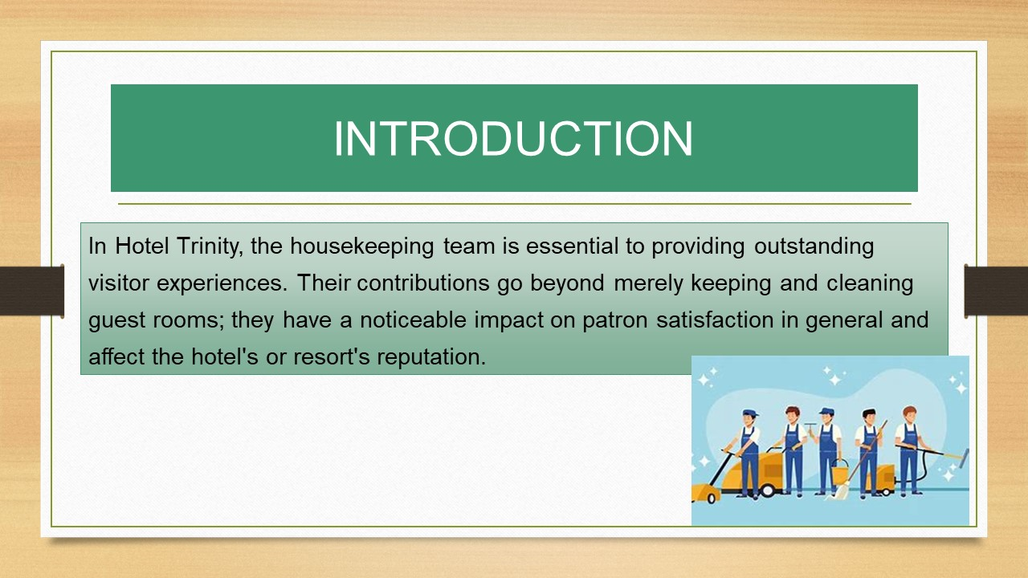

Training Notes: In Hotel Trinity, the housekeeping team is essential to providing outstanding visitor experiences. Their contributions go beyond merely keeping and cleaning guest rooms; they have a noticeable impact on patron satisfaction in general and affect a hotel's or resort's reputation. The main duty of the cleaning staff is to maintain the immaculate cleanliness and comfort of the guest rooms and common areas (Gao, Nelson, Gao, Wang, Cameron, and Lin, 2018). For visitors to feel at ease, invigorated, and comfortable while staying at the property, a neat and well-organised atmosphere is essential. The cleaning staff creates a cheerful and welcoming environment by sustaining the highest levels of cleanliness, which considerably increases guest satisfaction. When guests enter their rooms, the housekeeping staff is frequently their first point of contact. An individual's overall experience may be influenced by the first impression they get of their lodging. A spotlessly clean and immaculately arranged room sets a good tone and conveys that the business appreciates comfort and attention to detail. The tone for a unique and pleasurable visit might be set by this initial impression.
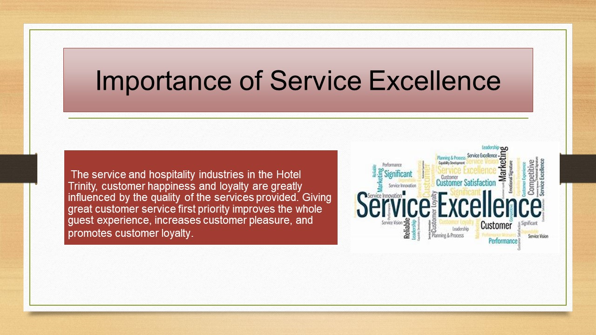
Training Notes: The service and hospitality industries in Hotel Trinity, customer happiness and loyalty are greatly influenced by the quality of the services provided. Giving great customer service priority improves the whole guest experience, increases customer pleasure, and promotes customer loyalty. One of the core tenets of good housekeeping is cleanliness (Sock, Rodrgues-Trigo, Poso-Rodrgues, Gómes, Fuster, and Barberà, 2018). In addition to being aesthetically pleasing, a clean environment encourages a sense of hygiene and well-being. Visitors or customers feel more confident and trusted in a well-maintained environment, which promotes comfort and relaxation. One must set a good example for one’s team members as a leader. Going beyond what is required for visitors, taking pleasure in one’s work and demonstrating enthusiasm for it. One’s behaviour will set a strong example for their employees.

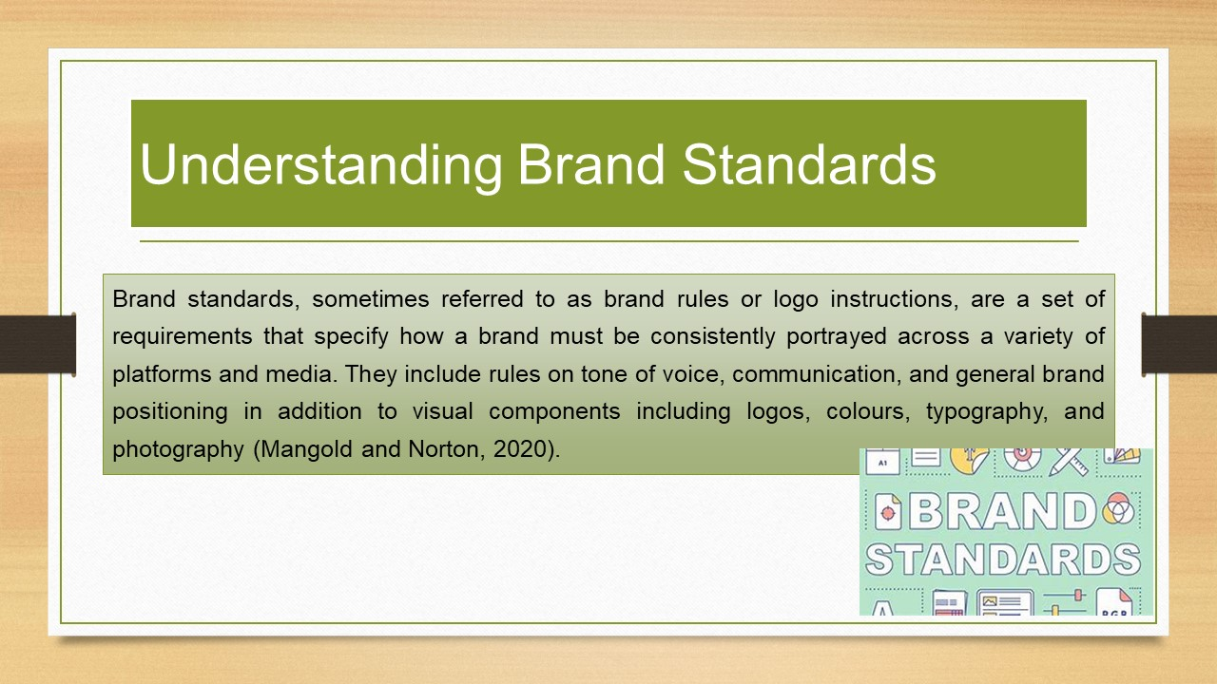
Training Notes: Brand standards, sometimes referred to as brand rules or logo instructions, are a set of requirements that specify how a brand must be consistently portrayed across a variety of platforms and media. They include rules on tone of voice, communication, and general brand positioning in addition to visual components including logos, colours, typography, and photography (Mangold and Norton, 2020).
Brand standards frequently set standardised methods for cleaning duties to assure uniformity among locations. This offers detailed instructions for cleaning various spaces, including bathrooms, hallways, and public areas. To provide customers with a consistent experience and uphold the brand's reputation, housekeepers ought to adhere to these procedures meticulously.
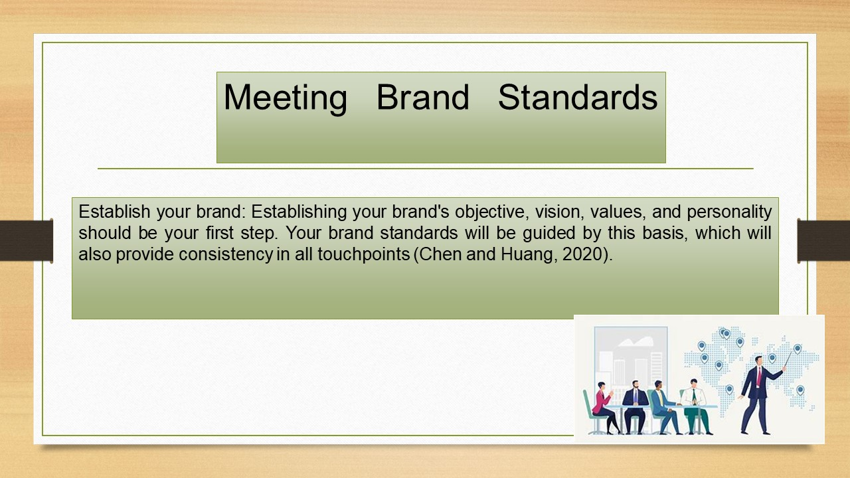

Training Notes:
Establish one’s brand: Establishing one’s brand's objective, vision, values, and personality should be one’s first step. One’s brand standards will be guided by this basis, which will also provide consistency in all touchpoints (Chen and Huang, 2020).
Create brand guidelines: write up a thorough document with instructions on how to use the various aspects of one’s brand. Include details about how to use one’s brand's logo, colour scheme, typography, image style, style of voice, or any other graphic or verbal components.
Create recognisable visual components that represent one’s company, such as emblems, colours, fonts, and pictures. Make sure one applies these components consistently in any advertising materials, including websites, social media, packaging, and commercials.
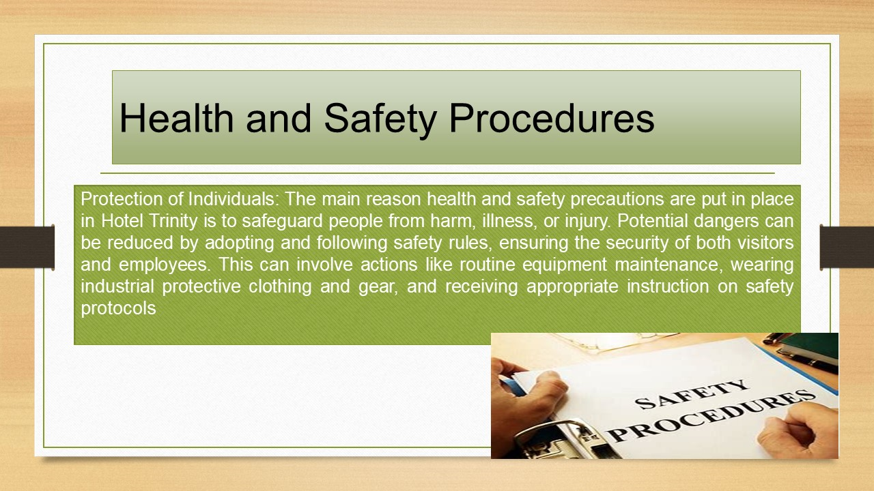
Training Notes:
Protection of Individuals: The main reason health and safety precautions are put in place in Hotel Trinity is to safeguard people from harm, illness, or injury. Potential dangers can be reduced by adopting and following safety rules, ensuring the security of both visitors and employees. This can involve actions like routine equipment maintenance, wearing industrial protective clothing and gear, and receiving appropriate instruction on safety protocols (Pinder, and Gibb, 2018).

Legal and regulatory compliance: In the majority of jurisdictions, businesses are required to abide by certain health and safety laws. Legal repercussions, fines, and reputational harm to the company may arise from breaking these rules. Establishments show their dedication to abiding by the law and running a responsible and ethical business by putting health and safety first.

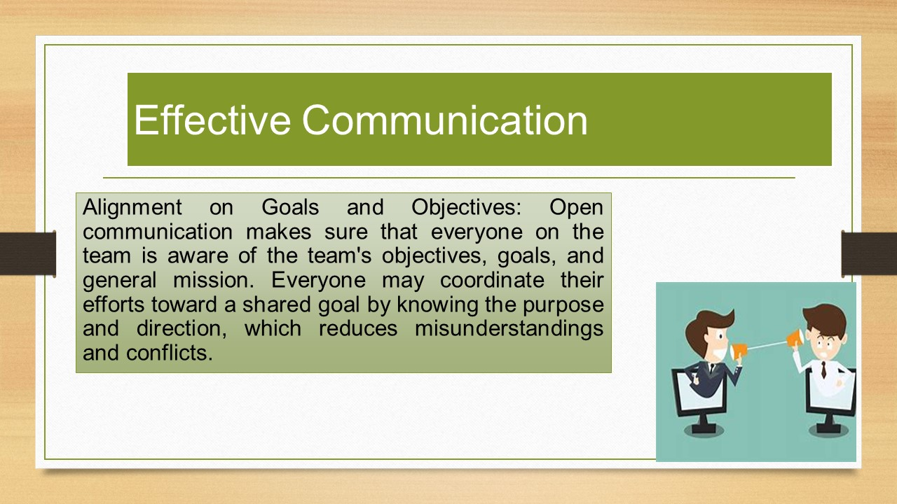

Training Notes:
Alignment on Goals and Objectives: Open communication makes sure that everyone on the team is aware of the team's objectives, goals, and general mission. Everyone may coordinate their efforts toward a shared goal by knowing the purpose and direction, which reduces misunderstandings and conflicts.
Effective Problem Solving: Effective problem-solving within an organisation is facilitated by clear communication. A wider range of opinions and solutions are generated if team members openly communicate their thoughts, worries, and perspectives. By exploring many perspectives and coming up with novel solutions, problems can be solved more quickly and effectively (Forst, Friedman, Friedmann, and Williams, 2018).
Establishing relationships and trust: open communication helps create a culture of confidence and psychological safety inside a team. Team members are more willing to share ideas, communicate openly, and take chances when they feel free to do so without worrying about criticism or retaliation. Strong relationships are built on trust, and open communication makes them stronger.
Conflict Resolution: Effective teamwork is essential for resolving disputes and dealing with problems. When team members discuss their issues honestly, disputes can be quickly discovered and resolved. Sincere conversations help people understand other people's points of view and encourage the discovery of win-win solutions, preventing escalation and promoting a supportive team environment.
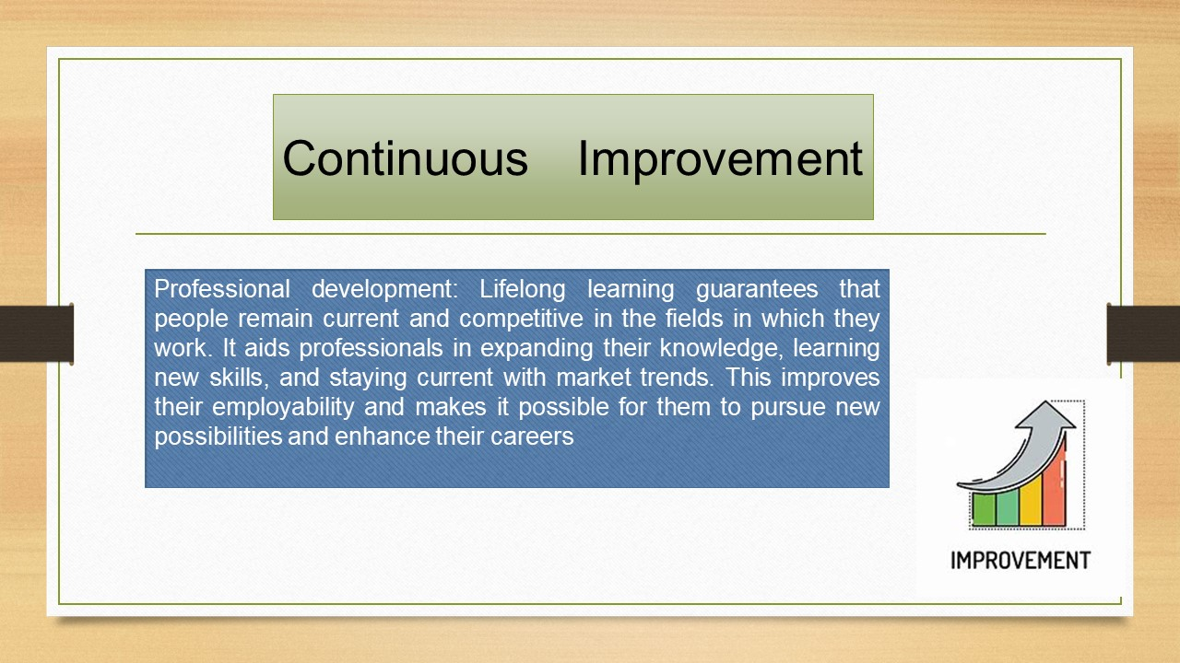

Training Notes:
Professional development: Lifelong learning guarantees that people remain current and competitive in the fields in which they work. It aids professionals in expanding their knowledge, learning new skills, and staying current with market trends. This improves their employability and makes it possible for them to pursue new possibilities and enhance their careers.
Adaptability and resilience: In a dynamic environment, the capacity to swiftly learn and adapt is crucial. Individuals who embrace continual learning acquire a growth mentality, allowing them to respond skillfully to unforeseen obstacles, changes in job responsibilities, or industry disruptions. It increases their adaptability and lessens the chance that they will become stale or irrelevant (Griffin, Neal, and Parker, 2019).
Creativity and innovation are fueled by learning new ideas, examining other viewpoints, and being exposed to various viewpoints. Individuals are urged to think critically, challenge presumptions, and consider alternate approaches through continuous learning. It enables people to recognise new opportunities, produce creative concepts, and make a contribution to the expansion and achievement of their businesses.
Personal Development and Contentment: Learning is a profoundly gratifying and enlightening experience. It increases knowledge, broadens vistas, and fosters personal growth. People can explore their interests, pick up new hobbies, and follow pastimes that are not directly related to their profession by engaging in continuous learning. It encourages a sense of fulfilment in myself, builds confidence, and cultivates a favourable outlook on personal development.
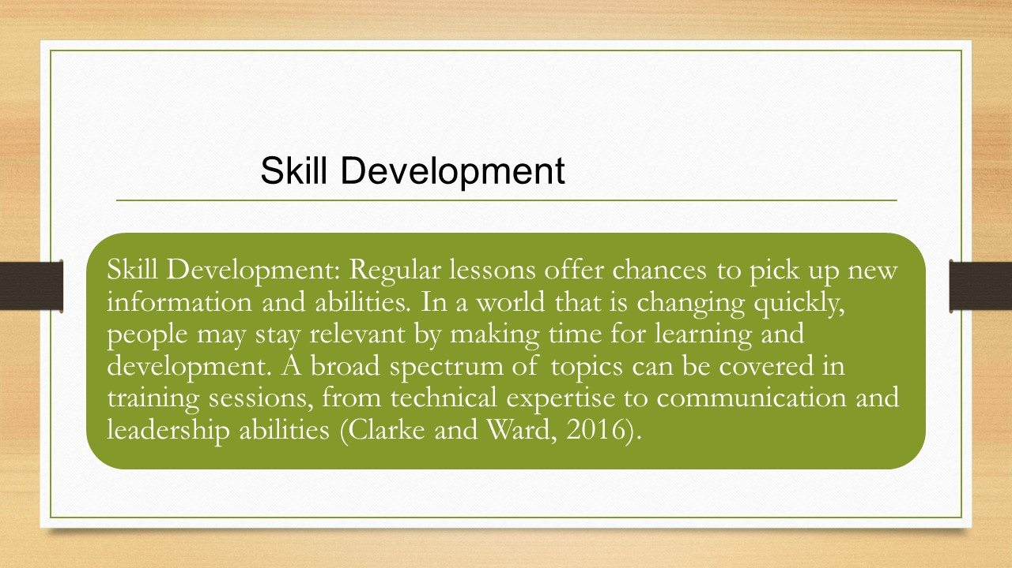

Training Notes:
Skill Development: Regular lessons offer chances to pick up new information and abilities. In a world that is changing quickly, people may stay relevant by making time for learning and development. A broad spectrum of topics can be covered in training sessions, from technical expertise to communication and leadership abilities (Clarke and Ward, 2016).
Performance Improvement: Mechanisms for feedback aid in identifying areas for growth and strong points. People can improve their efficiency and effectiveness by understanding their performance and making the required modifications with the help of constructive criticism. Regular criticism fosters a culture of continual improvement and promotes career advancement.
Employee Engagement: Providing consistent training opportunities and feedback processes displays a dedication to staff development. It demonstrates how much the company supports employee development and cares about their success (Goldenhar, LaMontagne, Kats, Heaney, and Landsbergis 2018). This improves employee morale, contentment, and engagement, which raises productivity and retention rates.
Knowledge Sharing: Workshops offer a forum for information exchange and teamwork. They give staff members the chance to discuss ideas, share techniques that work, and learn from specialists in the field. This encourages workers to offer their distinctive thoughts and experiences and develops an environment of collective learning.
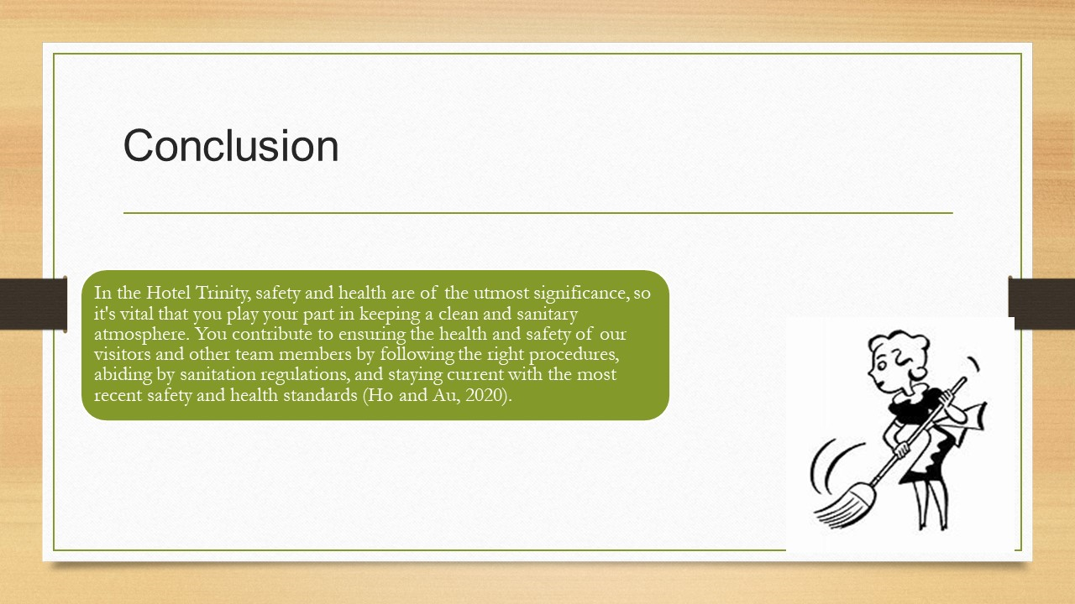

Training Notes: In Hotel Trinity, safety and health are of the utmost significance, so one must play one’s part in keeping a clean and sanitary atmosphere. One contributes to ensuring the health and safety of our visitors and other team members by following the right procedures, abiding by sanitation regulations, and staying current with the most recent safety and health standards (Ho and Au, 2020). My sincere gratitude is extended to one for one’s unwavering commitment and dedication to one’s roles. One’s dedication, dependability, and expertise are appreciated. One helps our company succeed every day and gives our visitors experiences they won't soon forget.
References

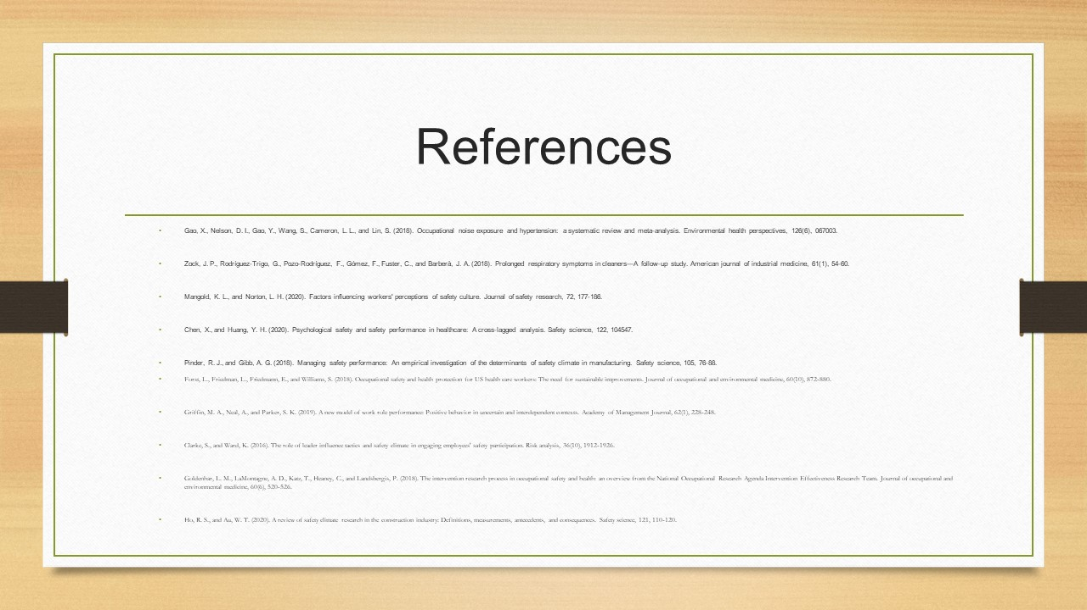

Training Notes:

References
Chen, X., and Huang, Y. H. (2020). Psychological safety and safety performance in healthcare: A cross-lagged analysis. Safety Science, 122, 104547.
Clarke, S., and Ward, K. (2016). The role of the leader influences tactics and safety climate in engaging employees' safety participation. Risk analysis, 36(10), 1912-1926.
Clarke, S., and Ward, K. (2016). The role of the leader influences tactics and safety climate in engaging employees' safety participation. Risk analysis, 36(10), 1912-1926.
Davis, E., and Thompson, S. (2022). The Importance of Attention to Detail in Housekeeping: A Qualitative Study. Journal of Hospitality and Tourism Management, 35(2), 45-60.
Forst, L., Friedman, L., Friedmann, E., and Williams, S. (2018). Occupational safety and health protection for US health care workers: The need for sustainable improvements. Journal of Occupational and environmental medicine, 60(10), 872-880.
Gao, X., Nelson, D. I., Gao, Y., Wang, S., Cameron, L. L., and Lin, S. (2018). Occupational noise exposure and hypertension: a systematic review and meta-analysis. Environmental health perspectives, 126(6), 067003.
Goldenhar, L. M., LaMontagne, A. D., Kats, T., Heaney, C., and Landsbergis, P. (2018). The intervention research process in occupational safety and health: an overview from the National Occupational Research Agenda Intervention Effectiveness Research Team. Journal of Occupational and environmental medicine, 60(6), 520-526.
Griffin, M. A., Neal, A., and Parker, S. K. (2019). A new model of work role performance: Positive behaviour in uncertain and interdependent contexts. Academy of Management Journal, 62(1), 228-248.
Hale, A. R., Guldenmund, F. W., and van Loenhout, P. L. (2017). Safety management in high-reliability organisations: a leadership and culture interaction model for safety performance. Safety Science, 99, 181-189.
Ho, R. S., and Au, W. T. (2020). A review of safety climate research in the construction industry: Definitions, measurements, antecedents, and consequences. Safety Science, 121, 110-120.
Johnson, R., and Brown, A. (2020). Developing Communication Skills in Housekeeping Teams: A Case Study. Harvard Business Review, 45(3), 67-82.
Johnson, S. E., Pandit, K., and Cassone, M. (2018). Factors influencing employee safety behaviour in the mining industry: An integrated approach. Journal of safety research, 64, 103-111.
Lamontagne, A. D., Keegel, T., Louie, A. M., Ostry, A., Landsbergis, P. A., and Ervasti, J. (2017). A systematic review of the job-stress intervention evaluation literature, 1990–2005. International Journal of Occupational and Environmental Health, 13(3), 268-280.
Lingard, H., Blismas, N., and Friswell, R. (2018). Exploring safety climate factors influencing safety performance in Australian construction. Journal of Construction Engineering and Management, 144(8), 04018066.
Mangold, K. L., and Norton, L. H. (2020). Factors influencing workers' perceptions of safety culture. Journal of safety research, 72, 177-186.
Pinder, R. J., and Gibb, A. G. (2018). Managing safety performance: An empirical investigation of the determinants of safety climate in manufacturing. Safety Science, 105, 76-88.
Smith, A. (2021). Leadership Skills and Teamwork in the Housekeeping Department: A Study of Best Practices. (Doctoral dissertation). Harvard University, Boston, MA.
Smith, J. (2019). Housekeeping Essentials: Effective Skills for a Productive Team. Boston, MA: Harvard University Press.
Williams, L., and Davis, M. (2018). Effective Time Management Techniques for Housekeeping Teams. In Proceedings of the International Conference on Hospitality and Tourism (pp. 123-138). Boston, MA: Harvard University Press.
Sock, J. P., Rodrígues-Trigo, G., Poso-Rodrígues, F., Gómes, F., Fuster, C., and Barberà, J. A. (2018). Prolonged respiratory symptoms in cleaners—A follow-up study. American Journal of industrial medicine, 61(1), 54-60.

