

Name: Ahir Jinalben Dilipbhai
Student ID: 2535262
Module name: Cloud Engineering Principles and Practice
Program: MSc cyber security and digital forensics.
Module code: ACCA7027
Lecture's name: Renuga Jayakumar
Word count: 5000

Abstract
Cloud computing has revolutionized the way applications are deployed today offering scalable, flexible and cost-effective computing resources. This report explores some of the principles of virtualisation and containerisation, as well as the impact of Docker on helping to deploy cloud-native applications more efficiently. A web app implementation was performed, it was packaged and run in Docker containers, deployed using a Nginx web server and published to Docker Hub. The implementation also illustrated how to create images using Docker, to run them with Docker as containers, use Docker volumes for persistent storage, and communicate securely with Docker networking. Furthermore, the report discusses AWS implementation of load balancing, scalability and application gateways, and how these technologies enhance application availability, performance and reliability. The report also explores the major factors accelerating the adoption of cloud computing as well as the difference between containerisation vs. serverless environments (such as AWS Lambda). The result shows that Docker has the characteristics of being lightweight, portable and scaleable, and it is a technology that is indispensable for modern cloud-native application development and enterprise cloud computing.
Table of Contents
1. Introduction 4
2. Principles of Virtualisation 4
3. Principles and Benefits of Containerisation 6
4. Docker Images and Dockerfile 8
5. Docker Containers 9
6. Docker Volumes 10
7. Docker Networking 12
8. Docker Hub Publishing 13
9. Overall Docker Demonstration 13
10. Load Balancing, Scalability and Application Gateway 14
11. Drivers for Cloud Computing 16
12. Serverless Computing 16
13. Containerisation vs Serverless 18
14. Practical Video 18
15. Discussion 19
16. Conclusion 19
References 21

1. Introduction
Cloud computing has revolutionised the development, deployment and management of applications in organisations by offering access to computing services online as required. Cloud Systems provide services such as computing, storage, networking, and software provisioning that can be dynamically scaled when needed in order to improve business operational efficiency and lower infrastructure costs, rather than relying on traditional on-premises infrastructure [3]. Cloud native architecture has grown in popularity, and the uptake of such systems has accelerated the use of technologies like containerisation through the use of Docker that offer lightweight, portable and consistent application deployment across computing environments [1].
Cloud Computing has been based on virtualisation since the beginning, offering multiple VMs running on the same physical machines with the help of a hypervisor. But the problem with the deployment of modern applications is that containerisation has become more efficient due to its ability to run applications with different operating system environments, while sharing the same operating system kernel. This helps save resources, increases the portability of applications and makes the deployment of software easier in continuous integration (CI) and continuous deployment (CD) frameworks [4] and [9].

2. Principles of Virtualisation
Virtualisation is one of the basic technologies that allows several operating systems and applications to run on the same physical machine with the help of a software layer called a hypervisor. Virtualisation takes the raw resources of a machine - such as processor, memory, storage and networking resources and divides them into several separate partitions, each creating an independent computing environment ‘virtual machines' or ‘VMs' [16]. In fact, virtualisation is one of the most important technologies that underpins the modern cloud computing platforms, a layer that helps better utilise hardware, lowers infrastructure costs and makes cloud computing feasible.
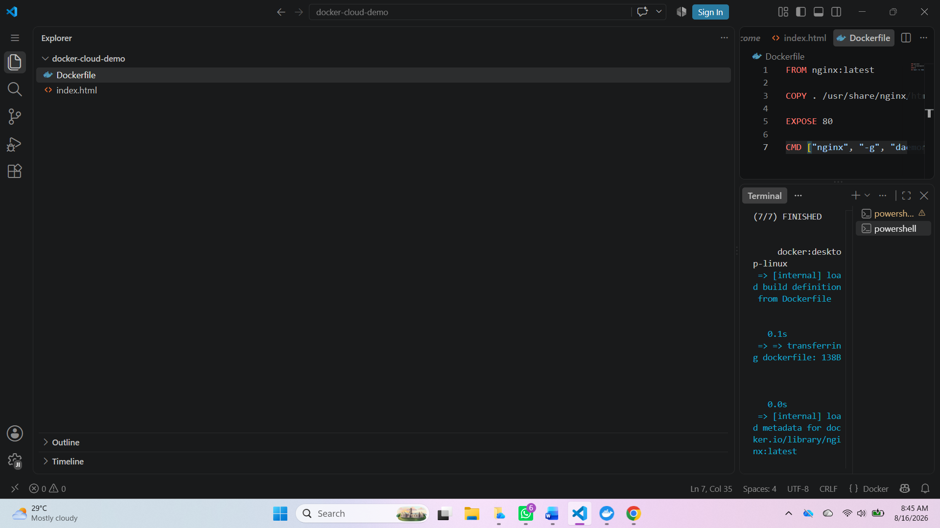

Figure 1: Docker YML
(Source: Developed by the learner)
Virtualisation implementers use two types of hypervisors. Type 1 (bare metal) hypervisors like VMware ESXi and Microsoft Hyper-V run directly on the physical machines and offer better performance, security and efficiency for enterprises running their cloud infrastructure. Type 2 (hosted) hypervisors such as VMware Workstation and Oracle VirtualBox run on top of an existing operating system, and are usually utilised for software development, testing and educational use [5]. VMware Workstation was used to set up virtual machines that were isolated and could be used for deployment of Docker containers that would not impact the host operating system during the practical lab session.
The underlying structure of virtualisation is physical hardware, followed by the hypervisor, which assigns the computing power to various operating systems known as guest operating systems. Each virtual machine has a separate operating system, applications, libraries and virtual hardware, which provides full isolation of workloads. This isolation is beneficial for securing one environment from another and for providing the possibility to host several services on fewer physical machines, decreasing acquisition, maintenance and energy costs of physical machines [13].
Virtualisation is of great significance in cloud computing in a number of ways. Some of the benefits include efficient use of hardware (e.g. sharing it among multiple virtual machines), fast deployment of new virtual machines, disaster recovery (e.g. virtual machine snapshots and backups), and easier migration of workloads between physical machines [14]. But virtualisation also has some restrictions, however. With virtual machines, one needs to install a full guest OS, which means that they use more RAM, boot slower and have higher storage needs than container-based technologies. Such constraints have helped the prevailing trend of containerisation, which eliminates software context and maintains isolated runtime environments, thereby giving a lighter and more efficient deployment model for cloud-native applications [8].

3. Principles and Benefits of Containerisation
Containerisation is a virtualisation technique for running software, which bundles it along with its runtime, system libraries, dependencies and configuration into a portable, lightweight unit called a container. Containers share the host OS kernel and have isolated execution environments as opposed to a full-fledged OS in traditional virtual machine environments. This architectural paradigm cuts down the resource usage and enhances deployment efficiency, serving as an integral part of cloud-native application development today [4].
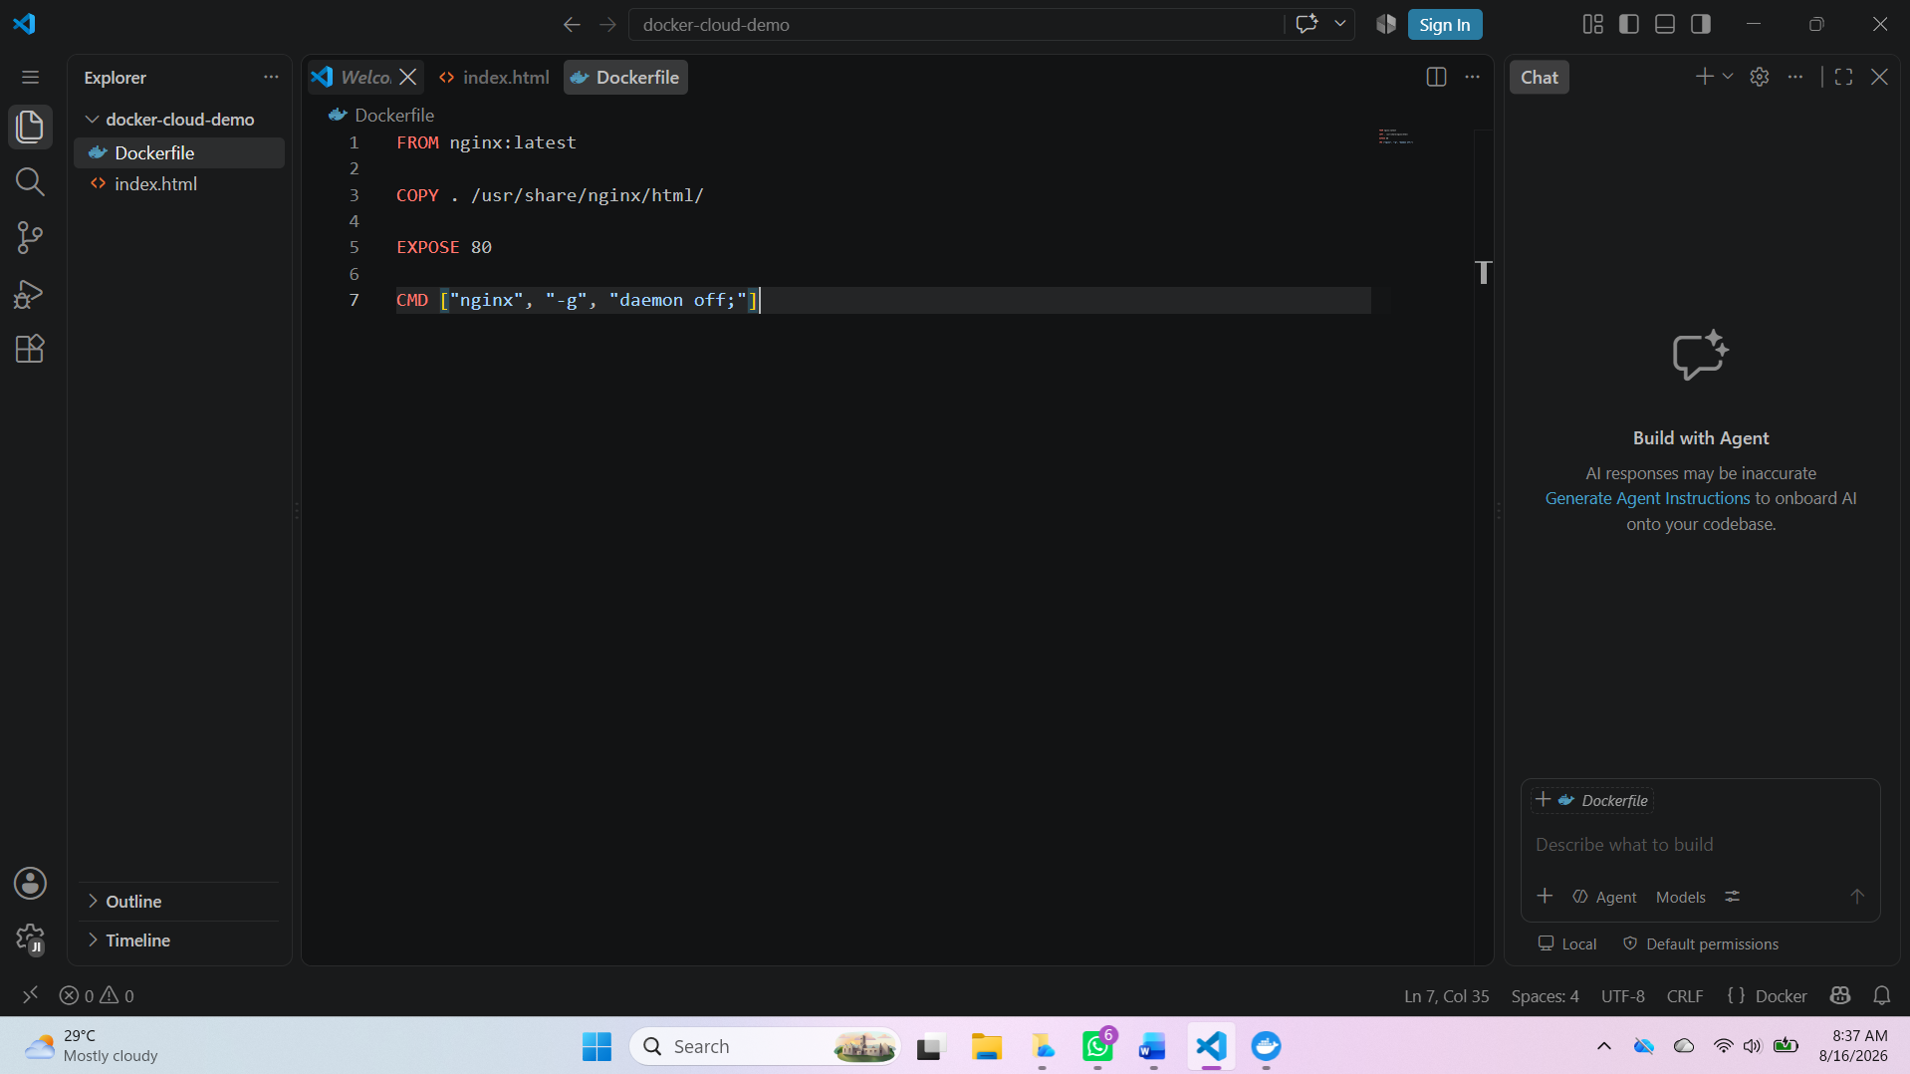
Figure 2: Docker file
(Source: Developed by the learner)
Docker is the most popular platform for containerization, and has become an industry standard for creating, publishing and running applications in containers. Docker makes it easier to deploy software so that applications run reliably on every platform. Once built, the application can be packaged into a Docker image and deployed without modification to development, test, staging and production environments. This helps solve the "it works on my machine" problem [2].
The architecture of Docker is built up by various integrated components. The core of it is the Docker Engine, an application that controls how the containers are run. Docker developers write a set of instructions in a Dockerfile to build a container image. The images reside locally or are published to image repositories like Docker Hub and then are run as containers. Other services available by Docker include Docker volumes for persistent storage and Docker networking for secure application communications between containers, which are independent of the containers' lifecycle [7].
An illustration of the Docker architecture, containing Docker Client, Docker Engine, Images, Containers, Docker Volumes, Docker Networks, and the Docker Hub repository.
Lightweight virtualisation is one of the main benefits of containerisation. Containers have much lower resource requirements than virtual machines because the host operating system kernel is shared. While a virtual machine comes with full guest operating systems and applications and their libraries, containers have only the application and its libraries. As a result, containers are more compact, less disk-intensive, and quick to start up, making them ideal for use in a cloud, where fast provisioning is a critical concern [20].
Containerisation also offers increased scalability. Cloud providers can quickly deploy more container instances as necessary demand grows and scale them back when they need them. This elasticity allows companies to ensure application performance and manage and optimise their resources during peak traffic. For larger cloud-native applications, their deployment, scaling, load balancing, and service discovery are also automated, thanks to container orchestration platforms like Kubernetes [17].
Another key benefit of containerisation is security. Applications run without affecting each other, running in separate environments created by Linux namespaces and Linux control groups (cgroups). Docker uses several security features to reduce its overall exposure: image verification, access controls, user namespaces, and resource limits. Advanced trust evaluation models and security assessment frameworks have also recently been proposed to enhance trust in Docker deployment in enterprise cloud settings in [15].
Containerisation has been tightly linked with DevOps methodologies and Continuous Integration/Continuous Deployment (CI/CD) pipelines. Build Docker images, run automated tests, and deploy new Docker containers with minimal downtime at a given interval. This automation minimises deployment errors, speeds up software delivery and helps to follow agile software development approaches [13].
The containerization of a static web application built with HTML, CSS, and JavaScript is implemented in this project using Docker. A Dockerfile was developed for packaging the application in a Nginx web server. The Docker image was then created with docker build, and the app was launched in a Docker container with docker run. Persistent storage was enabled with Docker volumes, and communication between multiple containers was enabled with Docker networking. Finally, the full Docker image was published at Docker Hub, showcasing the end-to-end process of containerisation from dev to cloud.

4. Docker Images and Dockerfile
Docker images are the backbone of Docker-based application deployments. A Docker image is a lightweight, read-only archive of an application, its runtime environment, operating system libraries and utilities, its program dependencies, and its configuration files. Images can be used to build Docker containers and will be identical in all containers instantiated from it, even across different deployment environments [17].
A Dockerfile is a series of layered instructions which are used to build a Docker image. Each instruction generates another immutable layer that is stored within the Docker Engine and can be reused with further image builds, thereby reducing image build times. This layered approach also reduces storage space since the same layers can be used in several images [21].
When implementing this project practically, a Dockerfile was prepared for packaging an HTML-based web application using the official web server image of the Nginx software. The FROM instruction specifies an image from which the application is created. The official nginx: latest image was used because it is a lightweight, reliable, and production-ready web server. The COPY command copies HTML, CSS, JavaScript, and application-required files to the default web directory of Nginx (/usr/share/nginx/html/). The application will be listening for connections on TCP port 80, and CMD will execute the “nginx” service and run it in the foreground process so that the container will keep running during its execution [11].
After having the Dockerfile written, the Docker image was constructed by:
docker build -t docker-cloud-demo.
The image is called docker-cloud-demo. Docker built the required base image for Nginx, ran each line of the Dockerfile one after the other, and created its final image using layered caching. The final image was then locally kept inside the Docker image repository.
The produced image was checked with:
docker images
which prints out the repository name, image ID, creation time and size of the image. Because Docker images are immutable, any changes to an application will need to rebuild the image to contain the new application files. This immutability increases the reliability of deployment as all deployed containers run the same application version [25].
Images are shareable via image registries, such as Docker Hub, which is the famous public image registry. The locally built image was then tagged with a repository name and version, and published with:
docker tag docker-cloud-demo username/docker-cloud-demo: v1
docker push username/docker-cloud-demo: v1
Running images on Docker Hub allows application versions to be pulled by other developers and cloud platforms, enabling collaborative software development, automatic CI/CD pipelines, and cloud-native deployment workflows [19].
Docker images thus ensure the portability, consistency and reproducibility that are indispensable for modern cloud computing. They fit around entire application environments in reusable templates, making software distribution and deployment easier, more complex, and more similar during development, testing, and production.

5. Docker Containers
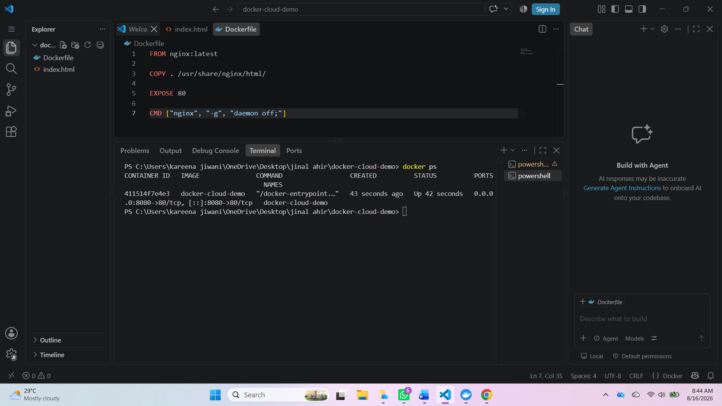
Figure 3: Docker containers
(Source: Developed by the learner)
Docker Containers: These are runnable instances of Docker images, where every application is executed in its own isolated container. A Docker image is a read-only template of the application, and a container is an actual runtime environment where the application runs. Each container has the application, required libraries, configuration files, and dependencies, and uses the same host operating system kernel. This lightweight architecture allows faster app deployment, consuming much fewer resources compared to traditional virtual machines [23].
Docker container life cycle – create, run, monitor, stop, delete. The Docker run command is used to create containers based on pre-existing Docker images. The Docker image with the HTML/CSS/JS web application was deployed as a container via the following command: docker run -d -p 8080:80 --name docker-cloud-demo
The command started the application running in detached mode, named it docker-cloud-demo, and bound port 8080 of the host machine to port 80 inside the container. Its website was exposed to a web browser at "localhost:8080", and it showed that it can be executed in a container.
The following commands were used in the running container:
docker ps
docker stop docker-cloud-demo
docker start docker-cloud-demo
The output of docker ps included the container ID, image name, running status, ports and container name, which were used to verify the application is running properly. The terminal output displays the running Docker container.

6. Docker Volumes
Docker volumes allow for persistent data with a lifespan that is independent of the Docker container's lifespan. Data created in a Docker container will be deleted if the container is removed. In contrast, Docker volumes [10] offer a fix to this limitation, allowing data associated with applications to be stored outside of the container's writable layer so that information is preserved when containers are stopped, recreated, and upgraded.
Named volumes, bind mounts, and anonymous volumes are among the several ways in which Docker can be implemented through a storage mechanism. Named volumes are managed directly by Docker and are the preferred choice for persistent application data, as it is easier to manage storage and ensures portability across deployment environments. Bind mounts assign host directories to the container that can be used by the developer for manipulating their contents while the container is executing. Anonymous volumes are not given names and are usually used for the temporary requirements for storage [5].
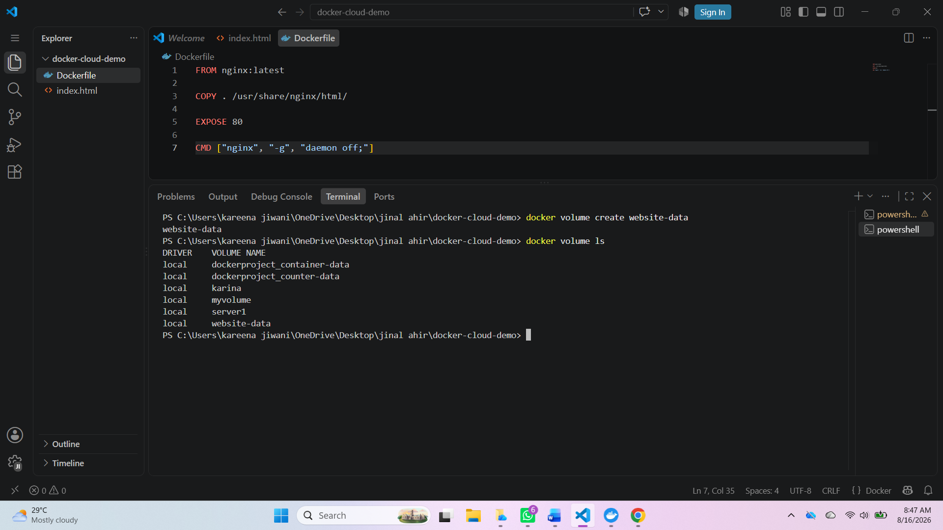
Figure 4: Docker volumes
(Source: Developed by the learner)
In this project, a named Docker volume was created using the following command to show the use of persistent storage during the actual implementation:
docker volume create website-data
Using -v during container creation, the volume was then added to the running web application container, so that application files and generated data remain intact outside of the container. The following Docker volumes were checked for:
docker volume ls
Detailed configuration info was displayed using:
docker volume inspect website-data
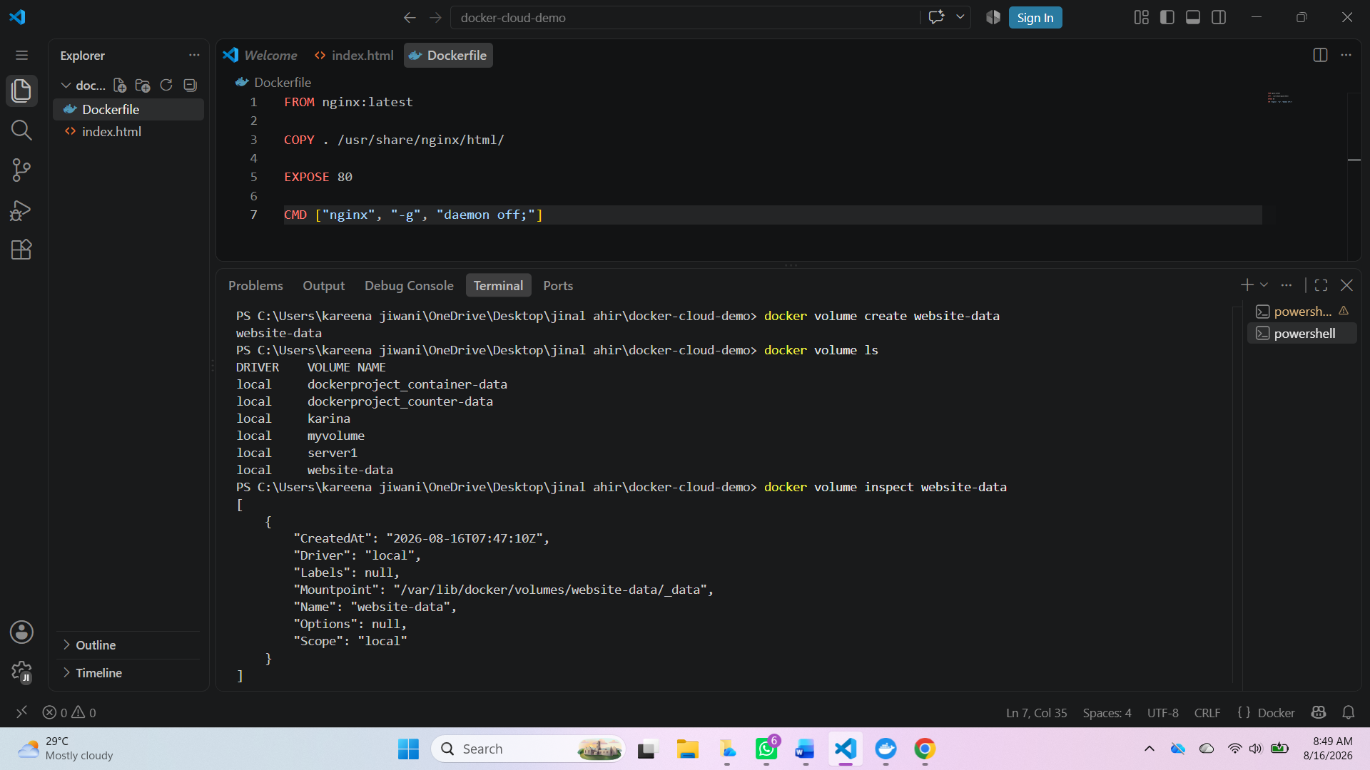
Figure 5: Volume inspects
(Source: Developed by the learner)
There are several benefits to using Docker volumes with cloud-native applications. They maintain application data across container removals, enable sharing of data within multiple containers, make backup and recovery easier and promote application portability across cloud environments. Volumes play a crucial role in stateful applications like databases, content management systems, and enterprise web apps, where one need to retain data across service restarts. Therefore, Docker volumes are of paramount importance in containerised solutions, standing on top for data persistence layer separation and for secure deployments in the cloud [11].

7. Docker Networking
Docker networking allows containers to communicate with each other, but without touching other external systems. Docker enables software-defined networks, which lets different containers share data securely without having to open their internal services to the host network. This is of critical importance when network applications run in the cloud: web servers, application servers, etc. are run as separate web services in containers, and need to be able to communicate with others efficiently between the containers [15].
Docker offers several networking modes, such as: Bridge, Host, Overlay, and Macvlan. The default choice is the “Bridge” network, which is typically utilised for talking between containers on the same Docker host. Host networking is used to share the host network stack, and Overlay networking is used to enable communication among containers spread across several Docker hosts in clustered environments [20].
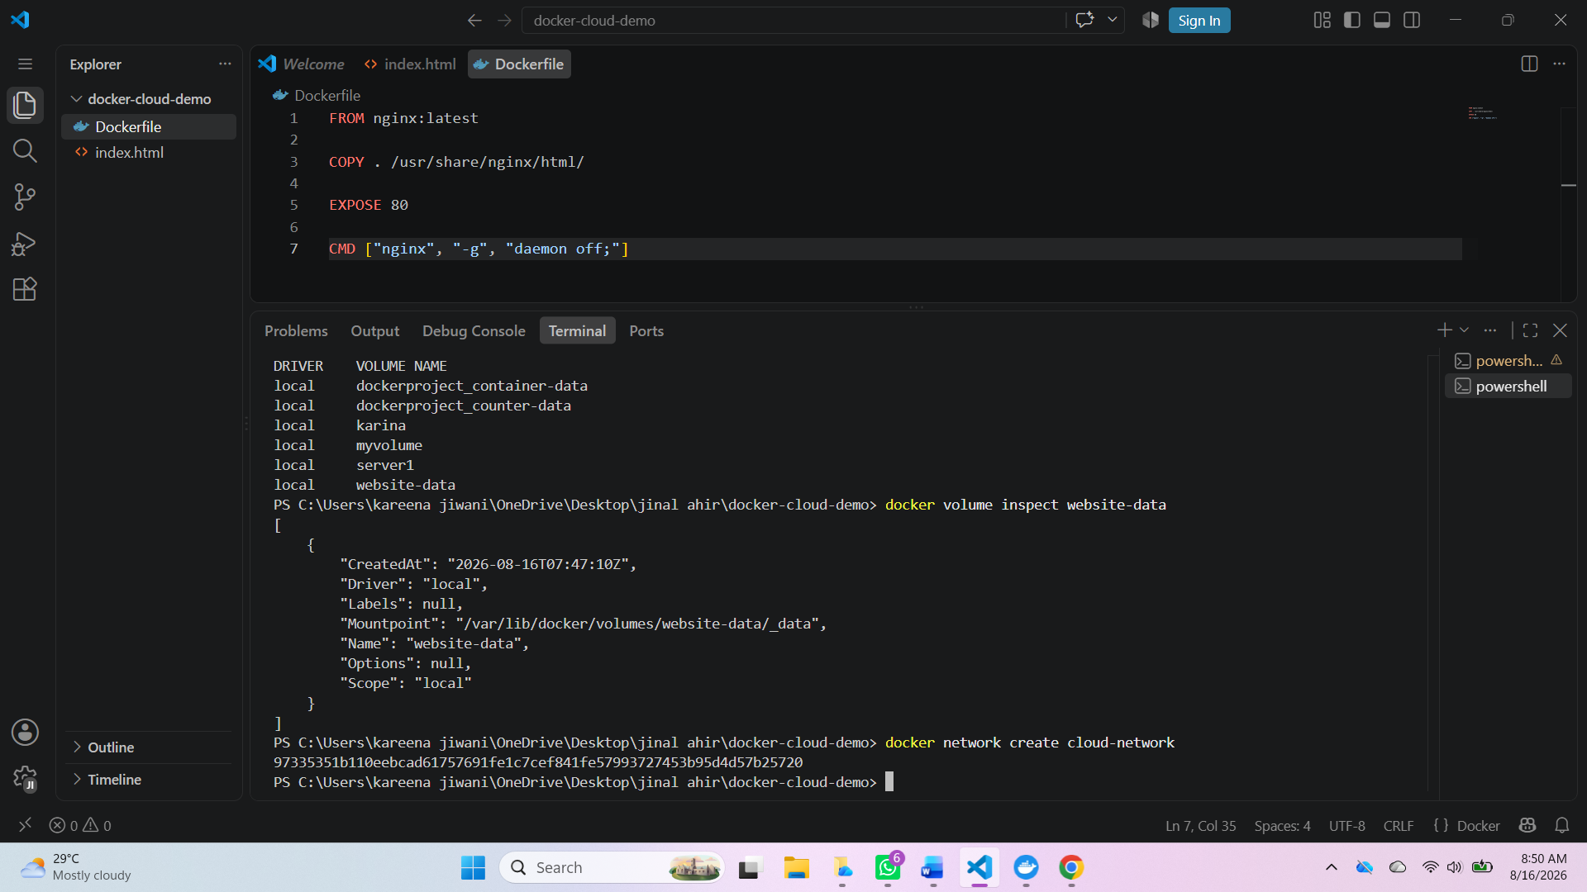
Figure 6: Creating network
(Source: Developed by the learner)
A custom bridge network was constructed with the following command for the practical implementation:
docker network create cloud-network
When the web app was deployed, it was then linked to this network to allow it to communicate securely with other containers added to the deployment. To check available Docker Networks used:
docker network ls
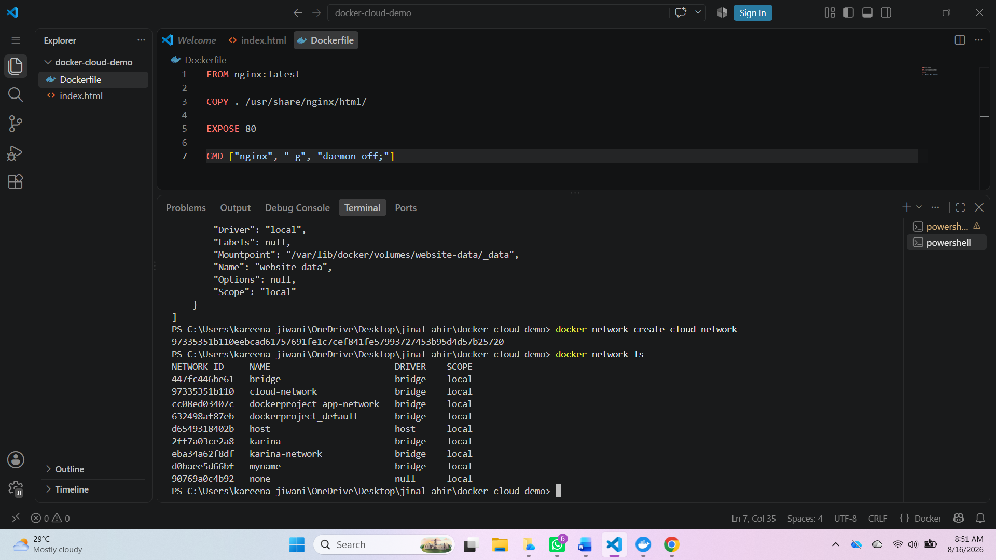
Figure 7: Network list
(Source: Developed by the learner)
The custom Docker network configuration during the practical is shown in Figure 7. In modern container-based systems, Docker networking is crucial for enabling secure service communication, isolation of networks, easy application deployment, and adaptable cloud-native architectures [1];[5].

8. Docker Hub Publishing
Docker Hub is a cloud-based container registry that enables developers to store, control, and share Docker images. It offers public and private repositories, enabling different development teams and deployment environments within an organisation to share containerised applications. When images are published to Docker Hub, software is easily distributed such that the same version is downloaded and run in the same predictable manner across different systems [18].
After the Docker image was successfully deployed, the application evolved from this work was ready for publication in Docker Hub, with the correct Repository name.
docker login
docker tag docker-cloud-demo docker-cloud-demo:v1
docker push username/docker-cloud-demo:v1

9. Overall Docker Demonstration
In this project, the entire process of creating, packaging, launching, and sharing a web app with Docker was demonstrated through a hands-on approach. For the age of concepts, containerisation and cloud-native deployment, a simple web app that is developed in HTML, CSS and JavaScript is the demonstration platform.
The first step was setting up the application source code and defining the Dockerfile using the official Nginx image. The Dockerfile included the base image, copied the application files into the Nginx web directory, opened port 80 and set the container start command. After writing the Dockerfile, the Docker image was created by running the Docker build command and verified locally using the Docker versions command.
The generated image was then run as a Docker container with port mapping, running the app on the user's machine locally through a browser at: http://localhost:8080. This was done by checking the docker ps command, which returns the running container along with the associated configuration. The steps were to create a named Docker volume and attach it to the container to provide persistent data storage beyond the scope of the container's lifetime. A custom Docker bridge network was also developed to show secure communication between containers and to show what Docker bridges can do.
The last step was pushing the finished/orchested Docker image to Docker Hub. The image was authenticated, named with the name of the repository that contained it and the version and then pushed to Docker Hub with docker push. With this, it became possible to pull from the cloud with the command docker pull, which made the application accessible and deployable in a consistent manner across various cloud computing environments.

10. Load Balancing, Scalability and Application Gateway
The modern cloud computing platforms are intended to offer highly available, scalable and reliable services to users all over the world. Load balancing, scalability, and application gateways are three basic technologies that allow these capabilities. Cloud-based processing technology, together with these technologies, can efficiently handle user requests, provide service continuity, and automatically adjust to changing workloads. Amazon Web Services (AWS) offers a full range of managed services that exemplify these concepts, so AWS is a suitable platform for which their implementation can have some real-world examples [25].
Load Balancing: Distributing incoming client requests over several computational resources to avoid having any one bottlenecked. AWS calls this feature Application Load Balancer (ALB), which sits on OSI layer 7. The Application Load Balancer intelligently distributes the flow of HTTP and HTTPS traffic based on one or more attributes that are specified for the request, such as its URLs, host names and application paths. It regularly monitors registered application instances for health and reroutes traffic away from unhealthy instances to achieve continuous service availability [23].
A typical request lifecycle involves the user going to a web application via the Internet. The request is first sent to the Application Load Balancer, which assesses each registered EC2 instance for health and availability and sends the request to the healthiest and most available instance. The result is that individual servers don't need to become overwhelmed, and application performance, fault tolerance and response are enhanced. The architecture of an AWS Application Load Balancer is shown, where the traffic varies across multiple EC2 instances that are running the containerised web application.
Scalability means the ability of cloud infrastructure to both scale up and scale down resources based on the needs of the application. AWS does so with Auto Scaling Groups (ASGs) that continually track the performance metrics of the applications, including CPU utilisation, memory usage and network traffic. Auto Scaling automatically scales up during busy periods by creating additional EC2 instances and scales down during slack periods using predefined scaling policies.
There are two types of Auto Scaling: horizontal and vertical auto scaling. Vertical scaling means upgrading the computing resources of instances, while horizontal scaling means scaling out by adding more EC2 instances to increase application capacity. For Cloud Native architecture, it is typically preferred to perform horizontal scaling in order to achieve high-availability applications, ease of maintenance and fault-tolerance. The Application Load Balancer scales out by automatically adding more container hosts to the Autoscaling Group during peak traffic times. The Application Gateway is another critical part of the cloud service; it's the security gateway that receives requests from the client with security. For API based applications, this capability is offered by AWS as an API Gateway, while for web applications, it's integrated with Application Load Balancer (ALB). Before requests eventuate on the application servers, the gateway takes charge of several important functions. They include SSL/TLS termination, URL-based routing, authentication, request filtering, and even integration with AWS Web Application Firewall (AWS WAF) to safeguard applications from malicious traffic.
Load balancing and scalability are thus complementary technologies, addressing separate issues of application performance. Load balancing is about how the existing requests are met; scalability is about the number of resources to process these requests. Without load balancing, new servers would see very little traffic; without scalability, when there is a heavy load on the system, the load balancer's ability to scale would be depleted.

11. Drivers for Cloud Computing
The growth and penetration of Cloud have been due to the rising need for cost-effective, flexible and scalable computing solutions that provide scalable support for modern digital services. Reducing costs is one of the main motivations since cloud providers sell a pay-as-you-go fee that saves organisations from large investments in physical servers, networking devices and data centres. The OPEX model allows businesses to optimise infrastructure expenses without paying for idle computing resources that are just sitting there [20].
Another factor is flexibility, enabling organisations to launch applications quickly and to gain access to computing from almost anywhere. Cloud platforms allow multiple OS, programming languages, and cloud deployment models, making it easier to develop and deploy applications. Further developments of these technologies, such as containerisation, microservices and DevOps practices, have further streamlined software deployments and enhanced application portability across environments, leading to the acceleration of cloud migration [13].
Cloud computing also offers resources that can be dynamically scaled up or down, known as elastic scalability. This allows for uniform application performance and decreases the waste of resources during periods of low demand. They also feature security, monitoring, high availability, server backup and disaster recovery services with the capability to mitigate business downtime while reducing the management of complex infrastructure with cloud services [25]. The glue is offered by these mixed benefits, making cloud computing the training ground for building and deploying the latest enterprise applications.

12. Serverless Computing
With serverless computing, cloud providers take care of the underlying infrastructure needed to run the code in application systems. Developers upload functions, instead of provisioning and maintaining virtual machines or containers, that are executed when events of interest occur. Popular serverless platform offerings include AWS Lambda, Microsoft Azure Functions, and Google Cloud Functions that dynamically provision resources, scale to demand and maintain servers themselves.
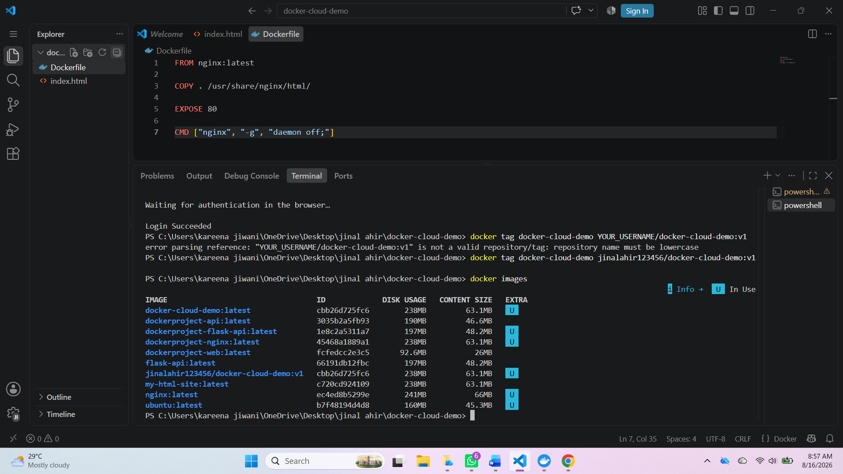
Figure 8: Pushing images
(Source: Developed by the learner)
Serverless computing is great because of its event-driven model. Functions are only called when they're needed, e.g. to process an HTTP request, upload a file, or respond to a database update. Resources are allocated dynamically, meaning organisations only pay for the runtime of the function, not for the continued running of infrastructure. It can substantially lower the operating costs of applications with irregular and non-uniform workloads [20].
Serverless platforms also offer auto-scaling, which means there are thousands of instances of functions that can all run without being manually set up. This eases up the administration of the infrastructure and lets developers concentrate only on the application logic – not on server administration. Serverless computing has some drawbacks, however, such as vendor lock-in, limited run-time customisation, cold-starts, and time limits. Event-driven applications, Application Programming Interfaces, data processing tasks, and automation workflows often take advantage of serverless architectures and architectures based on molecules for long-running applications and complex services that still have additional advantages [13].

13. Containerisation vs Serverless
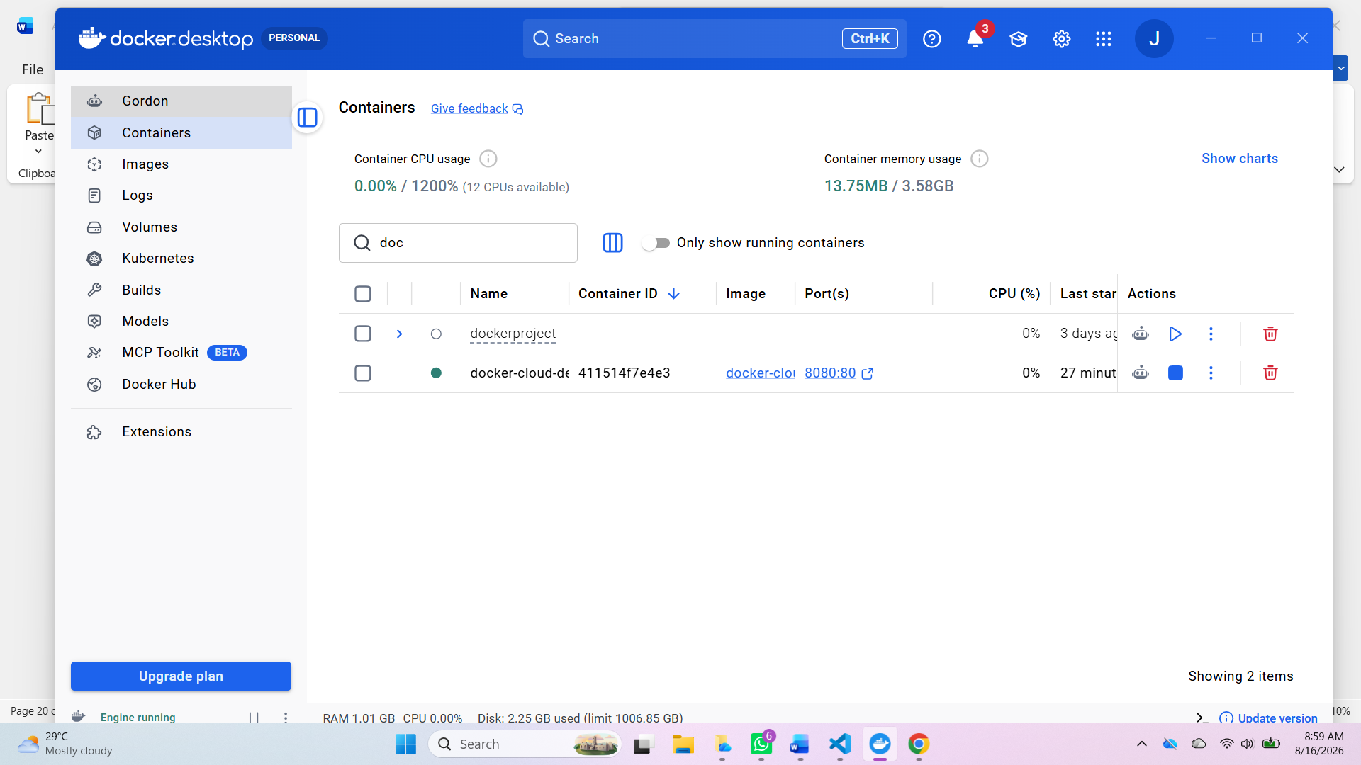
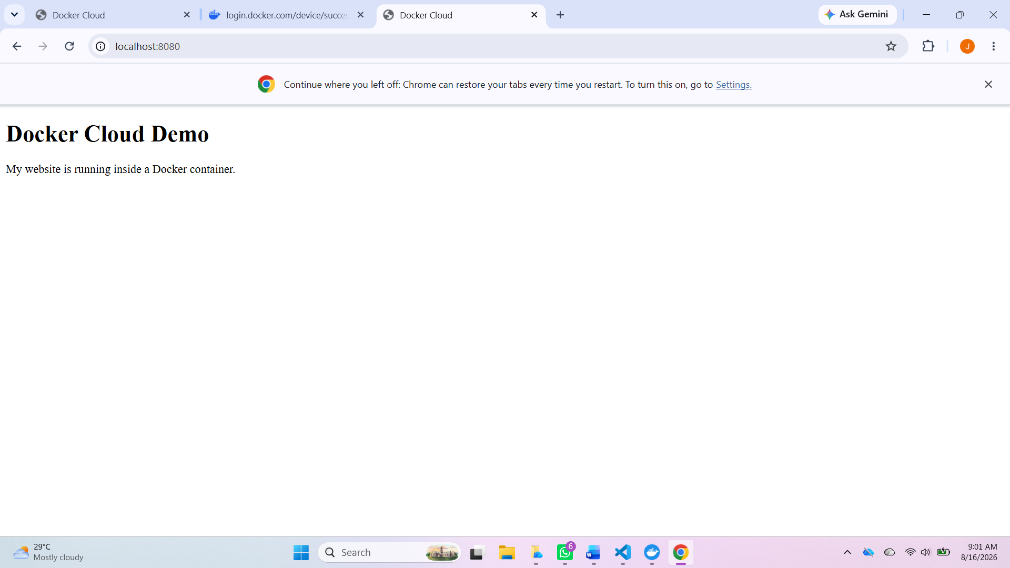
Figure 9: Docker dashboard
(Source: Developed by the learner)

Although both are vital for cloud-native app development, they are suited towards different deployment needs. Containerisation groups applications and their requirements into portable containers that give the developer control over the runtime settings and are appropriate for extensive enterprise systems, microservices, and long-running applications [14]. Contrastingly, functions in serverless applications run when triggered by an event, automatically scaling resources and billed only for the duration of function execution [23]. Serverless has the advantage of being easier to use and processes fewer resources, but containers give better flexibility, the ability to tweak the runtime, and offer wider support for variations in application workloads, complementing each other within modern cloud systems.
14. Docker-Cloud-Demo – Practical Video
Link https://youtu.be/pPMSR7aJs80

15. Discussion
This project highlights the implementation of Docker, which facilitates cloud-native application development and deployment by using lightweight containers. Docker containers are more lightweight and resource-constrained compared to VMs, allowing apps to be run in a consistent manner in development, test and production environments. Combined, the creation of a Dockerfile, the building of an image, deploying a container, Docker volumes and networking, and finally publishing the image to Docker Hub, demonstrate the full Docker workflow and its importance in the modern cloud era [24].
The Application Gateway, Auto Scaling, and Load Balancer attributes are another high point in the discussion of cloud architecture in achieving high availability, performance, and reliability. The Application Gateway is responsible for secure routing and traffic management. The Load Balancer distributes requests to multiple application instances, and Auto Scaling dynamically increases or decreases computing resources as needed based on the demands of the load. These technologies are working together in tandem to form resilient cloud infrastructures that still guarantee service quality for varying traffic conditions [23].
Moreover, the container challenge with serverless demonstrates that both deployment modes have their own pros and cons. In the end, while containerisation provides flexibility and runtime control, serverless simplifies managing infrastructure with automatic resource provisioning. Therefore, the key question is which is the right deployment for what application needs and what scalability goal and how the application needs to be operated. In general, Docker continues to be an essential technology for cloud-native application development, DevOps and enterprise digital transformation [18].

16. Conclusion
By presenting theory along with practical applications, this report has amply shown the significance of Docker and containerization as it exists in the current cloud computing world. The project itself was an effective demonstration of the concept of virtualisation, creation of Docker images, deployment of containers, persistent storage using Docker volumes, Docker networking, and Docker Hub publishing. It also explored how to keep cloud services reliable by using load balancing, scalability, application gateways or serverless computing. Through the practical demonstration, it was verified that Docker is a lightweight, portable, and scalable deployment technology that has become a must-have technology for enterprise architectures in the modern era of cloud-native app development [24].

References
[1] Raftopoulos, C., 2025. Cloud security with Docker and Kubernetes (Master's thesis, Πανεπιστήμιο Πειραιώς).
[2] Thiyagarajan, G. and Nayak, P., 2025. Docker under siege: Securing containers in the modern era. arXiv preprint arXiv:2506.02043.
[3] Kader, M.A. and Ahmed, R., 2025. Modern Cloud-Native Architectures: A Review of Full-Stack Design Patterns and AWS Best Practices. Scientia. Technology, Science and Society, 2(11), pp.283-290.
[4] Ogungbola, A., 2025. Scalability and Stability in Cloud-Native Applications: Lessons from Docker and Kubernetes Deployments. In Knowledge Production and Management in Africa: Exploring Socioeconomics, Indigenous Knowledge, and Technological Integration Across a Continent (pp. 33-53). Cham: Springer Nature Switzerland.
[5] Manavadariya, B. and MANGUKIYA, D., 2025. Cloud-Native System Administration: Principles, Practices, Challenges. Practices, Challenges (January 26, 2025).
[6] Sousa, T.B., Ferreira, H.S. and Correia, F.F., 2025. A pattern language for engineering software for the cloud. In Transactions on Pattern Languages of Programming V (pp. 1-66). Berlin, Heidelberg: Springer Berlin Heidelberg.
[7] Pavedemukala, S.L.D., 2025. Enhancing Docker Security on Azure Cloud: A Comprehensive Analysis and Mitigation Strategy (Doctoral dissertation, Dublin, National College of Ireland).
[8] Gajula, S., 2025. A decade of cloud-native technologies: Multi-cloud strategies, Docker, and ci/cd pipelines. International Journal of Advanced Computer Science and Applications (IJACSA), 16(4), pp.75-81.
[9] Temgire, D., Thorat, V., Raut, V., Babar, A. and Yadav, S., 2025. Cloud-Based Solution Architecture for Placement Cell Web-Based Application. IJSAT-International Journal on Science and Technology, 16(2).
[10] More, S.A., Polineni, U.K. and Sudhakaran, S., 2026. Advancing cybersecurity competency through structured Docker-based laboratories in locally hosted student settings. In INTED2026 Proceedings (p. 1260). IATED.
[11] Li, T. and Zhang, Y., 2025. Adaptive trust evaluation model based on container security analysis in the Docker platform. International Journal of Information Security, 24(5), p.190.
[12] Manor, D., Rod, D., Fang, H. and Watkins, J., 2025. Containerization in cloud computing: A review.
[13] Saleh, S.M., Madhavji, N. and Steinbacher, J., 2025. A systematic literature review on continuous integration and deployment (CI/CD) for secure cloud computing. arXiv preprint arXiv:2506.08055.
[14] Edgar, T., James, P. and John, S., 2025. Security Challenges and Best Practices in Docker and Kubernetes Environments.
[15] Mendonsa, A.N., 2025. Longitudinal risk-based security assessment of Docker software container images (Doctoral dissertation, Dublin, National College of Ireland).
[16] Jackson, L., Teymourlouei, H., Stone, D., Latson, V. and Cobbs, M., 2025, April. Activity in a Docker-Based Multitenant to Verify. In Software Engineering Research and Practice and e-Learning, e-Business, Enterprise Information Systems, and e-Government: 22nd International Conference, SERP 2024, and 23rd International Conference, EEE 2024, Held as Part of the World Congress in Computer Science, Computer Engineering and Applied Computing, CSCE 2024, Las Vegas, NV, USA, July 22–25, 2024, Revised Selected Papers (Vol. 2263, p. 52). Springer Nature.
[17] Kacem, O.B., Mansour, A., Eddermoug, N., Kassouh, F., Tazili, S. and Ettalibi, A., 2026. Migrating from a Docker Compose–based Microservice to a Kubernetes-Orchestrated Architecture: A Practical Case Study. In The 4th International Workshop on Human-Centric Innovation and Computational Intelligence.
[18] Ajasa, A.D., Chizari, H. and Alam, A., 2025. Database Security and Performance: A Case of SQL Injection Attacks Using Docker-Based Virtualisation and Its Effect on Performance. Future Internet, 17(4), p.156.
[19] Dehury, C.K. and Srirama, S.N., 2026. Mastering DevOps: A Cloud Engineering and Data Science Perspective. Morgan Kaufmann.
[20] Bayya, A.K., 2025. Leveraging advanced cloud computing paradigms to revolutionise enterprise application infrastructure. Asian Journal of Mathematics and Computer Research, 32(1), pp.133-154.
[21] Ajasa, A., Chizari, H. and Alam, A., 2025. A Case Study of Docker-Based Databases and Why They Should Become an Alternative to Centralised Databases.
[22] Khaldi, A., 2025, August. Revolutionising University IT Labs: A Docker-Based Approach for Next-Generation Learning Environments. In 2025 International Conference on Artificial Intelligence, Computer, Data Sciences and Applications (ACDSA) (pp. 1-6). IEEE.
[23] Yin, Y., Yang, Y. and Zhao, L., 2025, May. Research and practice on software componentization development model based on container technology. In Fourth International Conference on Electronic Information Engineering and Data Processing (EIEDP 2025) (Vol. 13574, pp. 663-669). SPIE.
[24] Khan, S., 2025. A Comprehensive Framework for Docker Container Security: Design, Implementation, and Community Validation. Authorea Preprints.
[25] Tamilmani, V., Maniar, V., Singh, A.A.S., Kothamaram, R.R., Rajendran, D. and Namburi, V.D., 2025. Automated Cloud Migration Pipelines: Trends, Tools, and Best Practices–A Survey. Journal of Computer Science and Technology Studies, 7(11), pp.121-134.

