Data manipulation
Farley staines
2204098

Contents
Task 1 2
Flow diagram 2
Initial setup 2
Generate numbers 2
Creating the data frame 2
Testing 3
Task 2 4
Flow diagram 4
Initial setup 4
Generate numbers 4
Adding to the data frame 4
Testing 4
Task 3 5
Flow diagram 5
Initial setup 5
Generate numbers 5
Adding to the data frame 5
Simplified method 5
Testing 6
Task 4 7
Flow diagram 7
Initial setup 7
Generate numbers 7
Adding to the data frame 7
Testing 8
Reflection 8

Task 1

Flow diagram
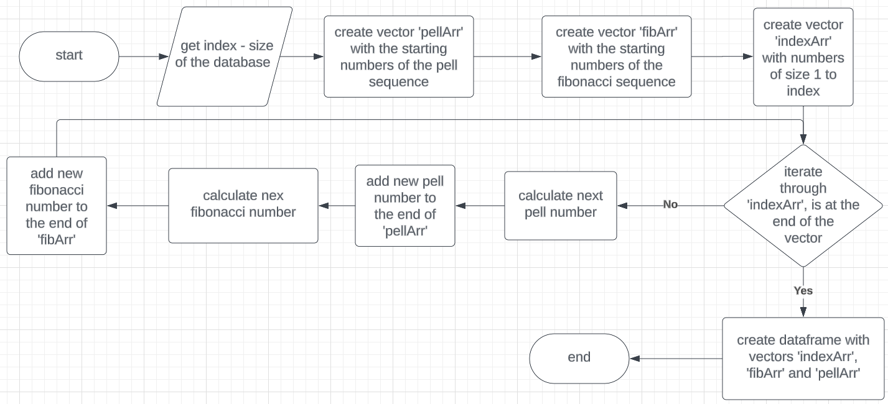

Initial setup
- The variable ‘index’ is created and is used to define the size of the data frame.
- The vector ‘pellArr’ is created and contains the starting numbers for the Pell sequence.
- The vector ‘fibArr’ is created and contains the starting numbers for the Fibonacci numbers.
- The vector 'indexArr’ is created and contains the numbers from 1 to the value of ‘index’.

Generate numbers
- A loop is created and iterates from 1 to ‘index’ amounts of times, with ‘i’ being the current iteration (steps 2-5). This is to calculate the Pell and Fibonacci numbers.
- It creates the next Pell number with the formula
$$(2*pellArr[i]) + pellArr[i-1]$$and stores the result in ‘pellNum’.
- ‘pellNum’ is then added to the end of the vector ‘pellArr’.
- It creates the next Fibonacci number with the formula
$$fibArr[i] + fibArr[i+1]$$and stores the result in ‘fibNum’.
- ‘fibNum’ is then added to the end of the vector ‘fibArr’.

Creating the data frame
- After the loop has been completed it creates a dataframe called ‘pellData’ with the following vectors.
- ‘indexArr’ is added and is unchanged. Column name is called ‘Index’.
- ‘pellArr’ is added and is sliced to the value of ‘index’ to ensure the vectors are all the same size. Column name is called ‘Pell’.
- ‘fibArr’ is added and is sliced to the value of ‘index’ to ensure the vectors are all the same size. Column name is called ‘Fibonacci.

Testing
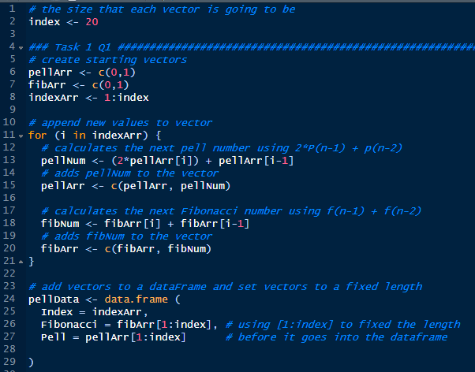
For testing if the values of Pell and Fibonacci were correct, I generated the first 10 values then checked the results against what was said on Wikipedia. If the values were wrong, I would have adjusted what value of ‘I’ would have been used.
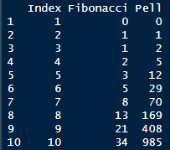

Task 2

Flow diagram
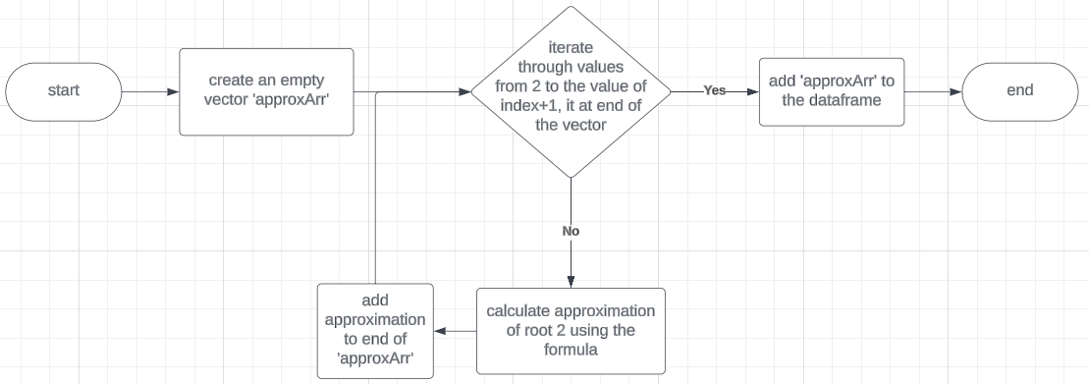

Initial setup
- The vector ‘approxArr’ is created and is set as NULL as there are no starting values.

Generate numbers
- A loop is created and iterates from 2 to ‘index’ +1 amounts of times, with ‘i’ being the current iteration (steps 2-3). This is to calculate the estimated value of square root of 2 using Pell numbers. If it starts at 1 the formula will return ‘NA’.
- It creates an estimate of root 2 with the formula
$$\frac{pellArr[i] + pellArr[i-1]}{pellArr[i]}$$and stores the result in ‘approxNum’.
- ‘approxNum’ is then added to the end of the vector ‘pellArr’.

Adding to the data frame
- After the loop has been completed it adds ‘approxArr’ to the existing data frame ‘pellData’ as ‘Approximation’.

Testing
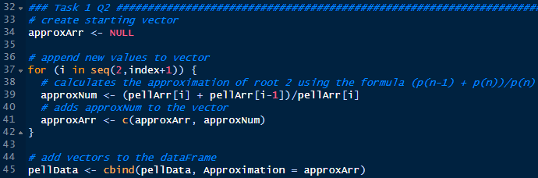
For testing if the approximation was correct, I would calculate what the actual number should be then compared it to what the code is giving me. Then checked if it is the formula or the value of ‘I’ that needs to be changed
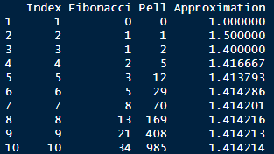

Task 3

Flow diagram
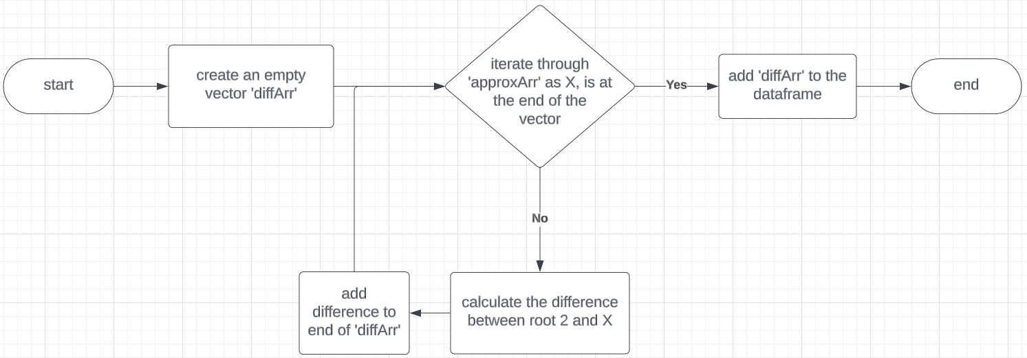

Initial setup
- The vector ‘diffArr’ is created and is set as NULL as there are no starting values.

Generate numbers
- A loop is created and iterates through the column ‘Approximation’ with in the dataframe, with ‘i’ being the current iteration (steps 2-4). This is to calculate the difference between the approximate value of root 2 and the actual value of square root of 2.
- It calculates the difference and stores the result in ‘approxNum’.
- It will then round ‘approxNum’ to 5 decimal places then restore it in ‘approxNum’.
- ‘approxNum’ is then added to the end of the vector ‘diffArr’.

Adding to the data frame
- After the loop has been completed it adds ‘diffArr’ to the existing data frame ‘pellData’ as ‘Difference’ and slices the vector to ‘index’.

Simplified method
The above steps can be merge and simplified into a single line.
$$pellData <-$$
$$cbind(pellData, Difference = round(sqrt(2)-pellData\$Approximation,5))$$

Testing
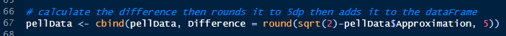
To check if the values were wrong, I would calculate what the actual answer was meant to be then change the part that was causing the issue, if that still didn’t fix the issue I would break it down, so it is easier to see what each line is doing, fix the problem then build it back up.
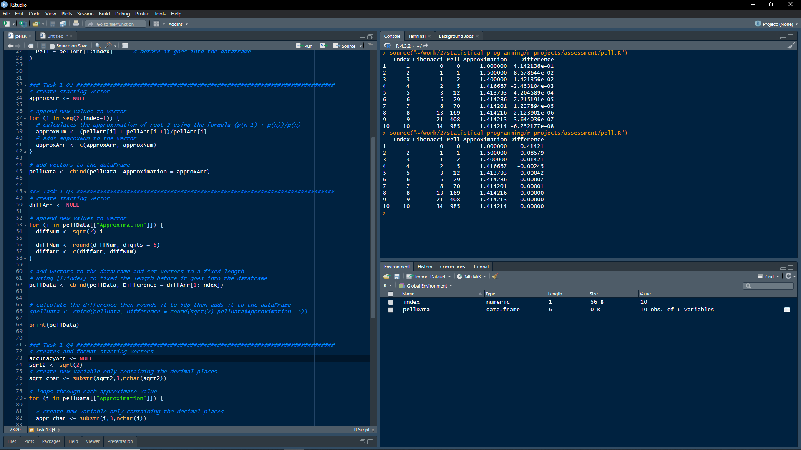

Task 4

Flow diagram
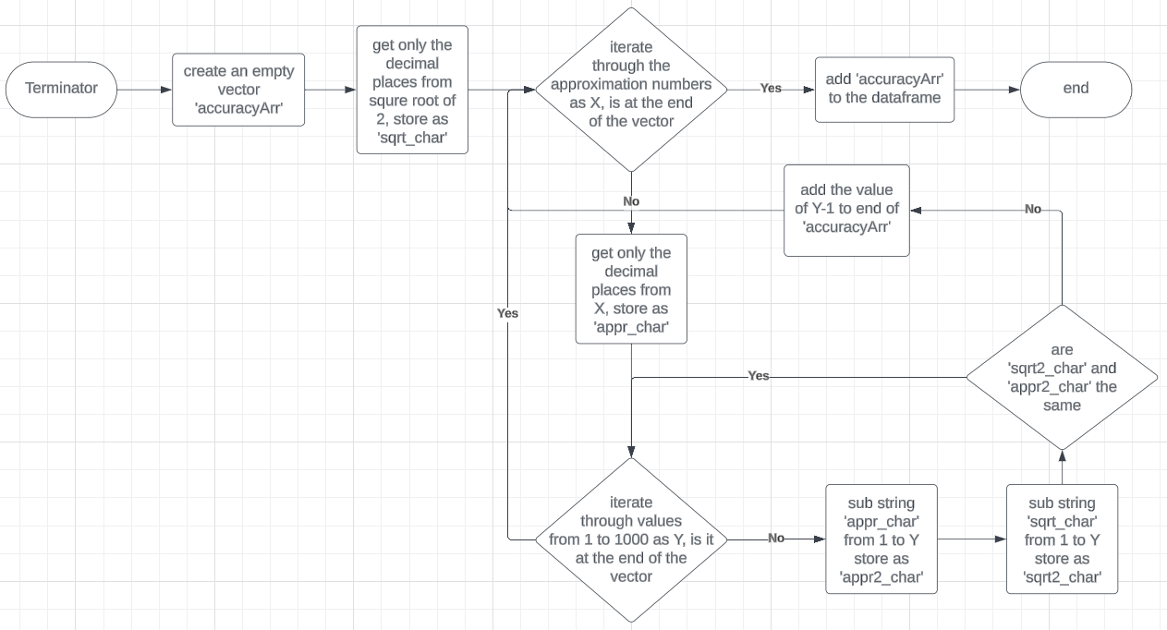

Initial setup
- The vector ‘accuracyArr’ is created and is set as NULL as there are no starting values.
- The vector 'sqrt2’ is created and is set to the answer of square root of 2.
- The vector 'sqrt_char’ is created and is set to ‘sqrt2’ without the first 2 characters (so all is left are the decimals places) and is stored as a character.

Generate numbers
- A loop is created and iterates through all values in ‘approxArr’, with ‘i’ being the current iteration (steps 2-6). This will check how many decimal points the approximation is accurate to.
- The vector 'appr_char’ is created and is set to ‘i’ without the first 2 characters (so all is left are the decimals places) and is stored as a character.
- Another loop is created and iterates from 1 to 1000 and stores it in ‘y’ (steps 4-6). This loop will compare 2 values then break out the first occurrence the values aren’t the same.
- The vector 'sqrt2_char’ is created and is set to the first ‘y’ number of characters of ‘sqrt_char’.
- The vector 'appr2_char’ is created and is set to the first ‘y’ number of characters of ‘appr_char’.
- If ‘sqrt2_char’ and ‘appr2_char’ are not the same, it will add ‘y-1’ to the end of ‘accuracyArr’ then break out of the loop.

Adding to the data frame
- After the loop has been completed it will add ‘accuracyArr’ to the existing data frame ‘pellData’ as ‘Accuracy’ and slices the vector to ‘index’.

Testing
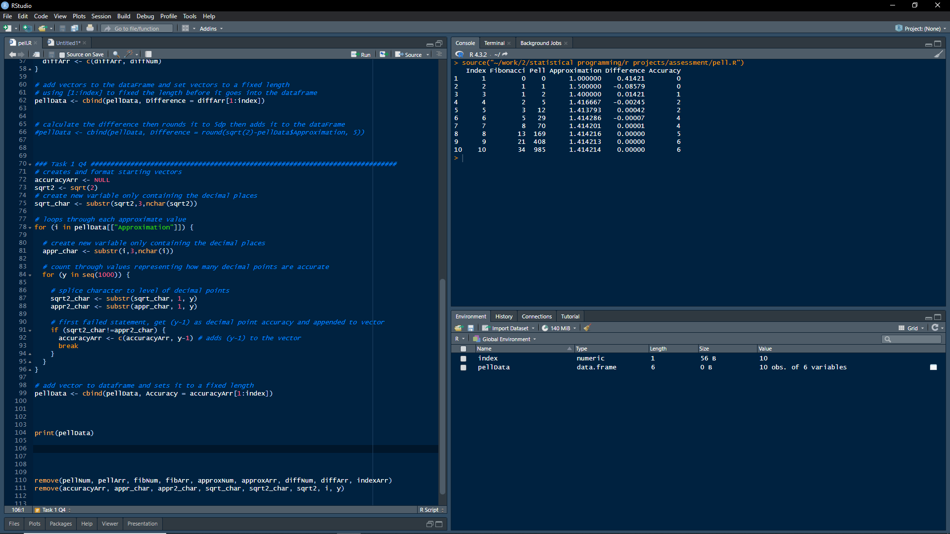
To check if it was giving me the correct answer, I would print out what the 2 values being compared are then count how many similar decimals places there are then compare that to what it gave me. When it gave the wrong answer, I would place a few print statements in and check if the values displayed are what they should be.

Reflection
Overall, I didn’t find any of the questions to challenging besides question 4 which I struggled mainly on what it was asking for, but after I understood what it was asking for, I then wasn’t sure how I was going to answer it. So, I asked ChatGPT for some code on how to answer the question. I didn’t really know what the code was doing, but I could see that the result it was providing was wrong compared to what it should be. I went through 2 iterations of code to get the right answer, the first iteration didn’t work at all, but the second iteration did and is the one that I used. Looking back at the solution ChatGPT gave I ended up with a similar method.

