University of Wales Trinity Saint David

- Course: Skills for the Workplace
- Teacher: Timothy Hopkins
- Class: Academic and Employability Skills (ACE)
- Name: Osvaldo Francisco
- Number: 1913130

Table of Contents
- Abstract…………………………………………………………3page
- Introduction .................................................................................4page
- Skills.............................................................................................5page
- Employability……………………………………………….......6page
- Hard skills…………………………………………………….....6page
- Soft skills………………………………………………………..7page
- Teamwork…………………………………………….…………8page
- Fundamental Skills for Teamwork……..….…………………….9page
- Communication………………………………….………………10page
- Time Management………………………………………………11page
- Team Management…………………………………………...…11page
- Swot Analysis.................................................................................12page
- Internal Environment......................................................................13page
- External Environment….................................................................13page
- Research and Note – Taking………………………………….14/15page
- Conclusions ..................................................................................16page
- Reference ...................................................................................17page.

Abstract
the purpose of this report is of fundamental importance because it aims to develop general knowledge and provide an important understanding of today's academic ability and employability.
through the knowledge I gained during these three months of class and through my skills; they will be analysed using all the knowledge and analysis I obtained on skills and communication. Assessing the relevance of swot and personal development.
Considering what was observed, however, it is necessary to remember about advantages and disadvantages and how these skills are learned and how they can come to shape an individual, including in his personal and academic growth and professional

Introduction
This research has the focus to analyse how employability skills have been carried out and elaborates the following questions. employability skills and there developed in society.
society is developing rapidly and competition between different companies is also increasing today.
Nowadays employers are not only waiting for students to focus on their diploma but also paying more attention to their employability skills.
However, they believe that in order to defeat their competitors in the fierce competition of the market, employers want graduates with a wide range of intellectual skills who can get out of the box, innovative people capable of thinking fast and who have the ability to create new things in a work environment. and require employees with different skills to perform multiple functions. Anyway. However, this aims to become more competitive in the job market in the future.

skills
The concept of skill refers to the quality of a skilful person. related to the ability to perform a specific task with a certain level of dexterity. ability to solve solutions to a specific problem. to be more than capable, more than instructed, because even if there is one, reading or witnessing a certain subject, he may not be able to reproduce the action that was successfully practised.
Skill consists of movements performed by a person who performs with precision and talent. That has the power to calculate, read, observe and interpret. The person's ability to mobilize their skills, knowledge and attitudes, to solve a certain problem situation.

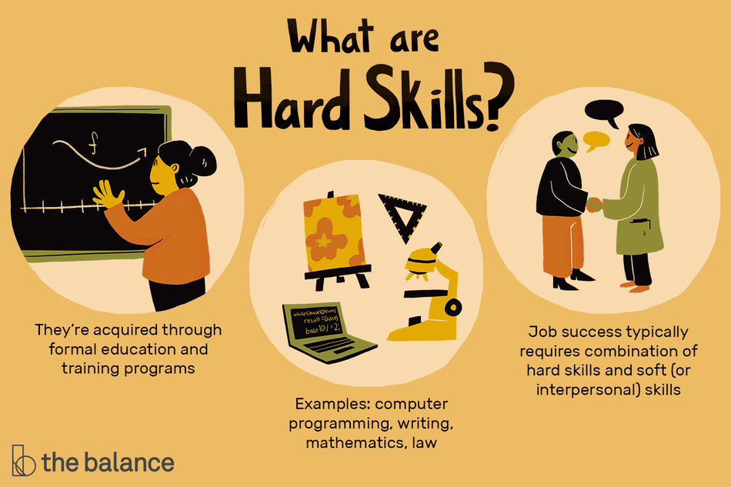
“*Image by Emilie Dunphy © The Balance 2019*”

employability skills
Employability skills are defined as skills to mobilize knowledge, skills and values ​​to act effectively in a set of necessary situations. not only to get a job but also to progress within a company, to reach someone's potential and successfully contribute to the company's strategic directions.
Nowadays companies are not only employing people with degrees but are also looking for and searching for efficient workers, individuals who can mobilize their knowledge, experiences and knowledge in any professional situation.
Knowing is essential and accumulating knowledge and knowledge is very important. accumulation of those same pieces of knowledge and experiences is to know how to act, apply and use what has been achieved throughout school life and professional work, it is through this accumulation that the individual transfers his skills from organization to organization, always remaining active in the market of work.

hard skills
Hard skills can be defined as specific knowledge and skills learned through education or training. As in schools and universities, through books or other training materials or at work. as many industries and professions have a specific list of skills needed to perform the job properly, they can also be considered job-specific skills.
They are teachable, which means that you can develop them through dedicated training. And, for some careers, certain hard skills will be considered prerequisites.
- Proficiency in a foreign language
- A diploma (or other academic qualification)
- Typing speed
- Encoding capability
- Microsoft Office Suite
- Social media
- SEO Marketing
- Machine operation
- Computer programming

Soft skills
Social skills are habits and attributes of personal characteristics that shape how you work, on your own and with others. Effective communication is included with self-development, which are not specific to a specific function.
they are usually accompanied by their life and work experiences, on the other hand, they are subjective skills that are much more difficult to quantify. Also known as "personal skills" or "interpersonal skills and social skills are related to the way we relate and interact with other people, which means that no training is necessary to build them.
Social skills are essential for career and job search. While the skills needed to successfully perform technical tasks in a job, skills are needed to create a positive and functional work environment.
For this reason, social groups, such as business and school groups, generally look for people who have social skills instead of physical skills, as social skills are sometimes more difficult to develop.
- Integrity
- Reliability
- Effective communication
- Open mind
- Creativity
- Problems solution
- Interpersonal skills
- Leadership
- Project management
- A good work ethic
- Teamwork
- Adaptability
- Perseverance

Teamwork Skills
Teamwork skill is one of the most sought after and valued professional characteristics in the job market, developing it is essential to increase the chances of being hired or promoted by a company. Although all professionals have their skills, it is only when their knowledge, ideas and experiences come together equally, that the groups become stronger and more prepared,
However, forming a team is a challenge. On top of that, it forms a compatible team.
The team's interaction also favours the ability to provide and add value and generate trust, providing a healthy and positive environment, increases motivation. With this motivation, employees feel more motivated and prepared for the company's opportunities. It is not just about working together, but knowing how to share, divide and add. To build a successful career and contribute to the growth of the company, it is necessary to be aware that nobody does anything alone and the value of each member's contribution.
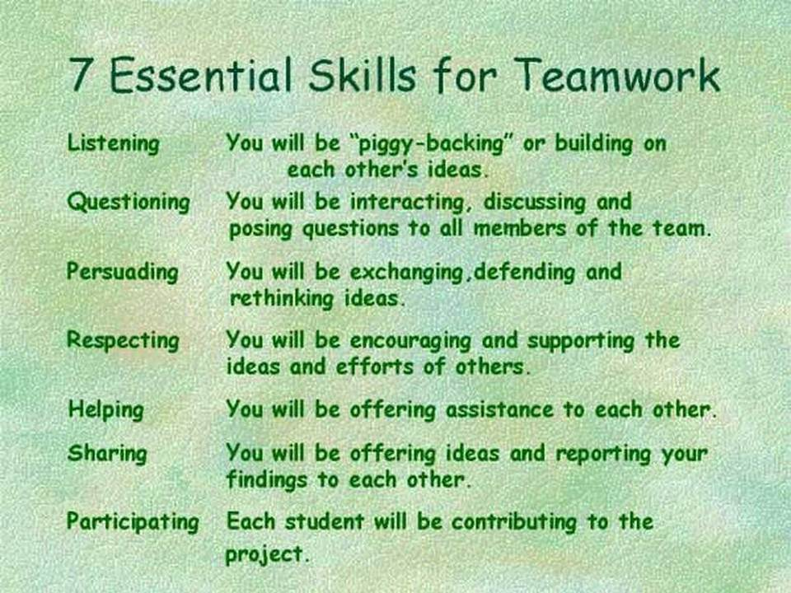
“*Get 2GB Free Storage Now. Office365 and D2L Combatible*”

Fundamental skills for teamwork
It is a great challenge for companies to be able to align the different interests of their employees. However, this is an essential task, as the job market requires flexible professionals, able to adapt, willing to learn from each other and who know how to take advantage of the opportunities that arise.
Teamwork is not just working together, it is sharing. However, this is an essential task, as the job market requires professionals capable of adapting in various areas and obtaining results, the results are never achieved by just one person so it is necessary to share with the other to reach the final goal.
knowing how to work together is a skill that cannot be neglected. Each employee has a specific competence and, when they share their knowledge, the group becomes stronger and more competitive
- Communication.
- proactivity and commitment.
- conflict management.
- confidence.
- common goals.
- empathy.
- flexibility.
- self-knowledge and emotional intelligence.

Communication skills
communication skill is a powerful tool for the career and essential to master it. it is necessary for everyone, especially in society, communication is necessary for the following professional areas, whether during a job interview, everyday work, or when it is necessary to make a presentation, during networking moments.
Speaking well will never be a wasted skill. Even because how it is expressed is an indispensable part of interpersonal communication, the exchange of information between two or more people that takes place through verbal or non-verbal signals.
The ability to communicate effectively with any staff is essential, regardless of the social level or sector in which you work. Communication and knowing how to transmit and receive messages in person, as well as by phone, email and social media. Finally, communication is verbal and not verbal.
Because having good communication means saying enough, don't say too little or talk too much. Try to get your message across with as few words as possible. Say what you want clearly and directly, whether you're talking to someone in person, over the phone or via email. If you have fun, your listener will adjust it or they won't know exactly what you want. Think about what you want to say before saying it; this will help you to avoid talking excessively or confusing your audience.
- Listen
- Clarity and Conciseness
- Sympathy
- Confidence
- Empathy
- Open mind.
- Respect
- Feedback
- Always ask
- Be positive
- Focus on the results of the conversation

time management
Good time management makes you work more efficiently, completing your activities in a short time, even if your time seems short or tight and you suffer from high pressures. The lack of time management impairs its efficiency and causes stress.
So, the best entrepreneurs are those who manage to do good time management and enjoy every minute of the 24 hours. When using management techniques. You improve your professional capacity, even if you are tight with so much work and still gain quality of life

team management
Having good team management is one of the great challenges for companies today. is that this is not just a task in the area of human resources.
It is the leaders of each sector who need to know how to transmit what they want to achieve and understand what needs to be developed in their team.
A good team leader must meet everyone's expectations and knows how to manage the most varied adversities that arise daily.
To be a successful leader in team management, you need to show that you don't take it personally when employees fail.
One of the most important tips for managing a team is good communication. It is essential in any company. It is necessary to know how to communicate clearly, directly and precisely. So that All employees need to understand what is happening to them, thus avoiding problems and even misunderstandings.

Swot analysis
Swot is an analysis of the most well-known matrices on the market, an existing strategic planning tool. with a global and business assessment of the four aspects of the business. strengths, weaknesses, opportunities and threats are called a SWOT analysis.
However, this is a very rare matrix or tool for finding a professional who has not even heard of the concept of SWOT and its famous analysis of the internal and external environment. You can use SWOT analysis to make the most of what you have, to the best advantage of your organization. And you can reduce the chances of failure by understanding what is missing and eliminating the risks that would otherwise take you by surprise.
Better yet, you can start to devise a strategy that can give your competitors the advantage and thus compete successfully in your market. and to arrive at the appropriate result of this analysis using the SWOT tool, it is necessary to divide the environment in which the company is in two spheres: External Environment, Internal Environment.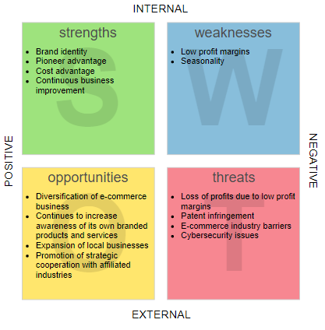
“*Strategic Planning to Actionable Items: From SWOT to TOWS Analysis *“

internal environment
The company's internal environment is formed by the set of humans, financial, physical resources, among others, over which it is possible to exercise greater control, as they are the result of strategies defined by management. it is in this domain that you will find the strengths and weaknesses of your company.
- Marketing.
- Financial.
- Production.
- Management.

external environment
The external environment is composed of factors that exist outside the organization's limits, and that in some way, influence it.
- Competitors
- Customers
- Distributors
- Suppliers, among others
- Policy
- Economy
- Technological
- Cultural, among others

Research and Note – Taking
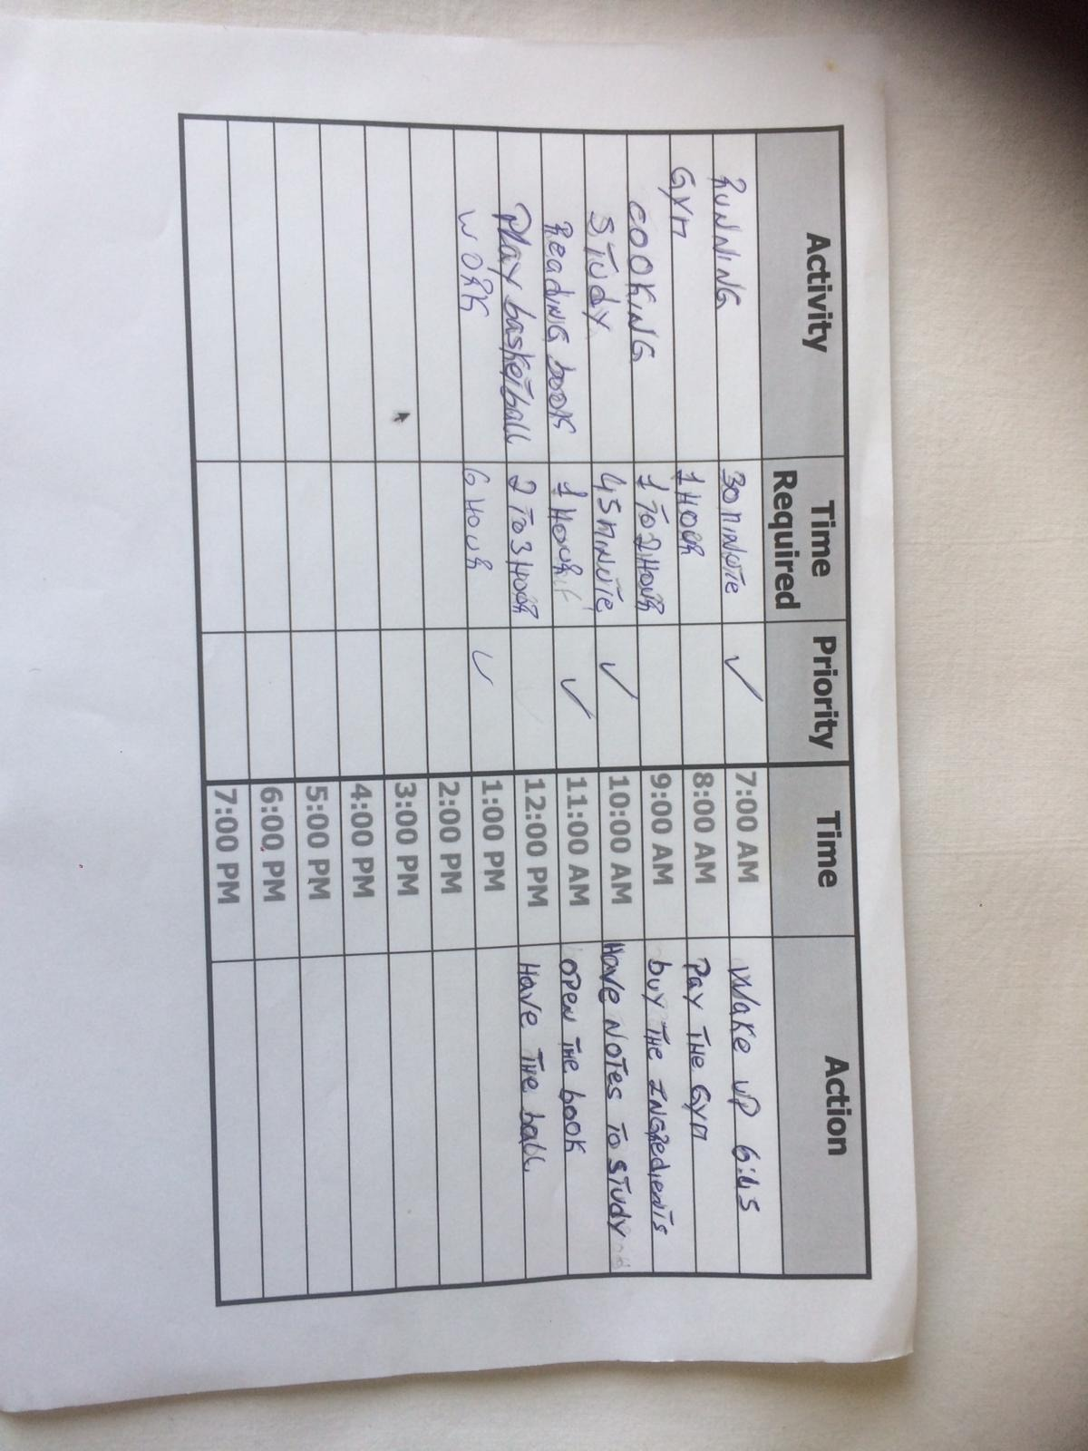

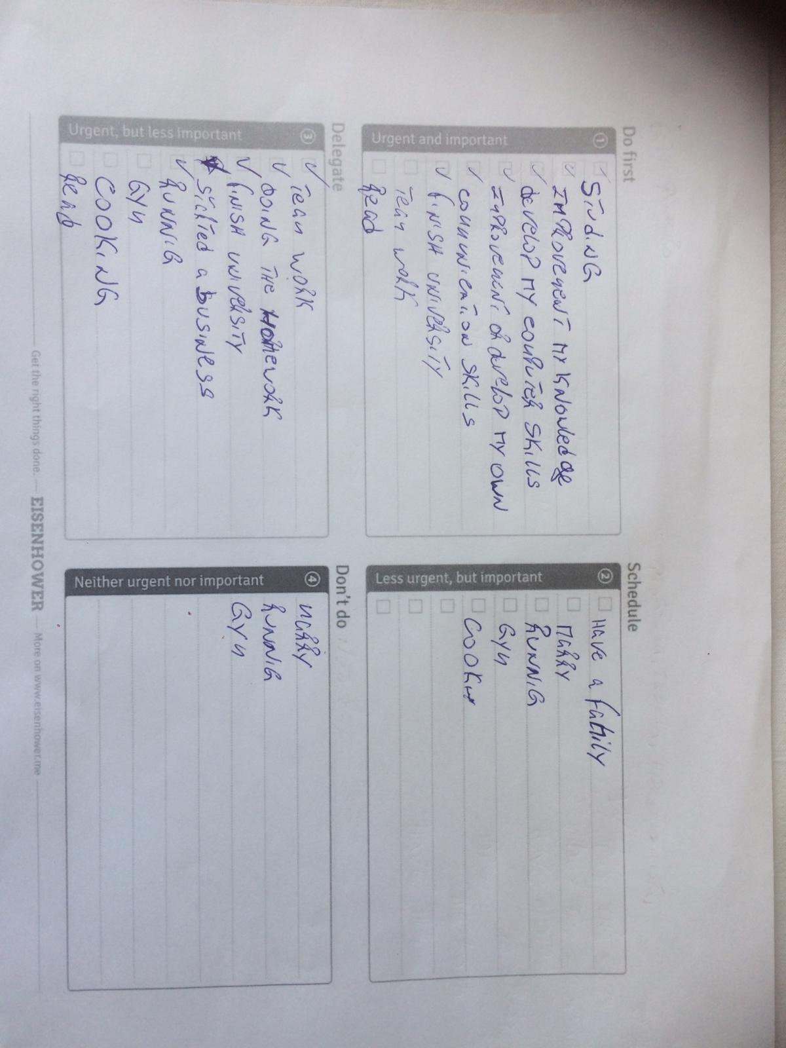

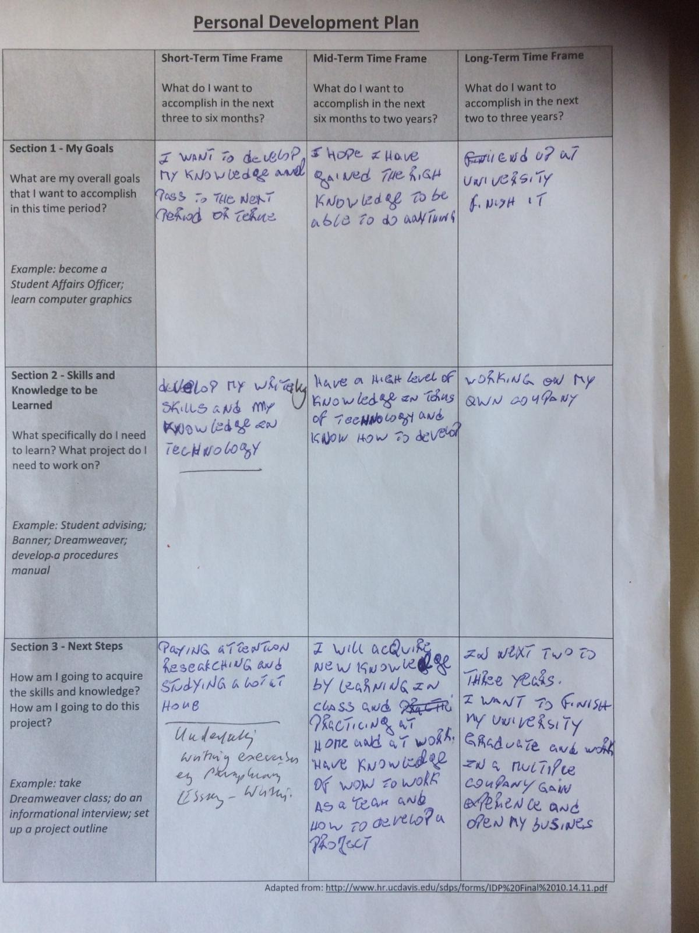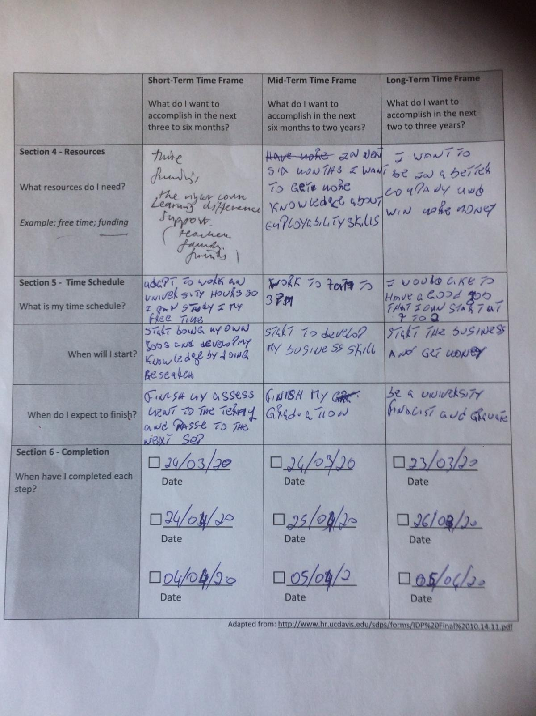

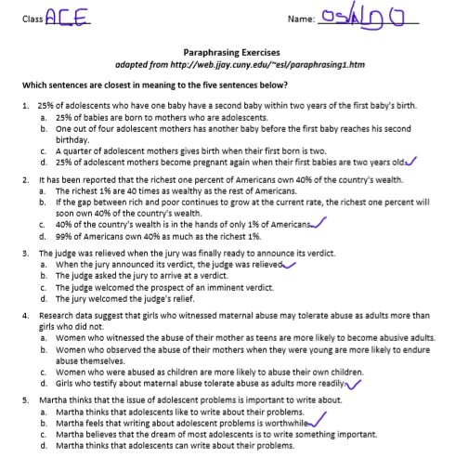
Conclusion

As we can see in the above theme that experience in the market is essential but not only it but also being graduated is important. however, a diploma alone is not enough, employers want a lot more from their senior employees, they want employees to bring benefits to the company and leave the company in an invincible position in the face of competition.
Through research, I summarized and concluded that Investing and strengthening more in education is relevant. We must develop experience in practice and not just in theory. so that we can gain and develop knowledge to help economies and achieve dynamic growth with quality jobs, it should be a pressing priority worldwide.

Reference
“Strategic Planning to Actionable Items: From SWOT to TOWS Analysis”
https://medium.com/@warren2lynch/from-swot-to-tows-analysis-55ac394064b7
“development of society, the competitions between companies are also increasing”
https://www.ukessays.com/essays/business/employability-skills-personal-swot-analysis-and-an-action-plan-business-essay.php

https://www.thebalancecareers.com/what-are-hard-skills-2060829

https://www.thebalancecareers.com/hard-skills-vs-soft-skills-2063780

https://www.indeed.com/career-advice/resumes-cover-letters/hard-skills-vs-soft-skills

https://www.reed.co.uk/career-advice/hard-skills-vs-soft-skills/

https://learnaliving.co.uk/employability-course/?gclid=EAIaIQobChMIlJKUh8SV6QIVA-vtCh1kHACOEAAYAiAAEgJVgvD_BwE

https://www.wikijob.co.uk/content/interview-advice/competencies/communication

https://www.skillsyouneed.com/ips/communication-skills.html
https://www.mindtools.com/pages/article/newTMC_05.htm
https://medium.com/@warren2lynch/from-swot-to-tows-analysis-55ac394064b7

https://www.wordstream.com/blog/ws/2017/12/20/swot-analysis

