University of Wales Trinity Saint David
Module: LCHS4003 - Introduction to Health and Social Care
Assignment: Component 1 Portfolio (Poster and Essay)
Student Name: Justyna Szweda
Student ID: 2435764
Lecturer: Aishat Bakre
Submission Date: 20 October 2025
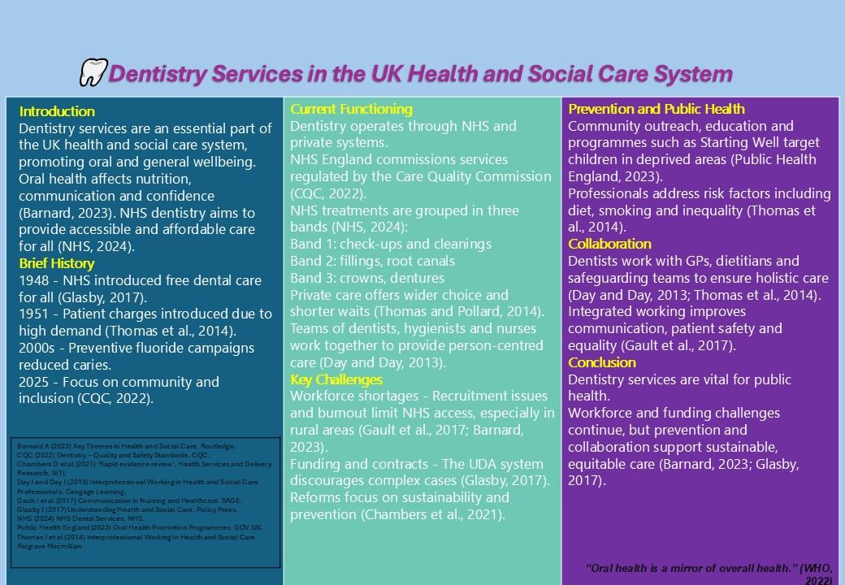

Task 2 – Essay: The Origins and Structure of the NHS

Introduction

The National Health Service (NHS) is one of the UK’s most important public institutions, founded to provide free, universal healthcare accessible to all citizens (Glasby, 2017). Since 1948 it has adapted to changing health needs while retaining its core values of equity and quality (Barnard, 2023).

Origins and Principles

Following the Beveridge Report (1942) and the National Health Service Act (1946), Aneurin Bevan launched the NHS in 1948 to offer care that was free at the point of delivery, available to all and funded through taxation (NHS, 2024). It replaced fragmented charitable and insurance schemes with a state-funded model symbolising social equality (Barnard, 2023).

Current Structure of the NHS

The NHS operates across England, Scotland, Wales and Northern Ireland with devolved responsibilities. In England, the Department of Health and Social Care provides strategy while NHS England commissions services through Integrated Care Boards (ICBs). Since 2022 Integrated Care Systems (ICSs) have strengthened co-operation between health and social care (CQC, 2022). NHS Trusts deliver hospital, community and mental health services regulated by the CQC (Thomas and Pollard, 2014).

Challenges and Evaluation

Funding pressures, workforce shortages and an ageing population have stretched capacity (Barnard, 2023). Rising chronic disease rates and technology demands add further strain (Gault et al., 2017). The COVID-19 pandemic exposed weaknesses but also demonstrated resilience through teamwork (Chambers et al., 2021). Reforms now focus on sustainability, digitalisation and prevention (NHS, 2024).

Conclusion

The NHS has transformed population health and remains a global example of universal care. Maintaining its founding principles while adapting to modern pressures is essential for its future success (Barnard, 2023).

References:

Barnard, A. (2023) Key Themes in Health and Social Care. 2nd ed. Abingdon: Routledge.
Care Quality Commission (CQC) (2022) The State of Health and Adult Social Care in England. Available at: https://www.cqc.org.uk/ (Accessed 15 Oct 2025).
Chambers, D., Cantrell, A. and Booth, A. (2021) ‘Rapid evidence review: digital and data-driven technologies in health and social care’, Health Services and Delivery Research, 9(1).
Day, J. and Day, J. (2013) Interprofessional Working: An Essential Guide for Health and Social Care Professionals. 2nd ed. Andover: Cengage Learning.
Gault, I., Shapcott, J. and Luthi, A. (2017) Communication in Nursing and Healthcare: A Guide for Compassionate Practice. London: SAGE.
Glasby, J. (2017) Understanding Health and Social Care. 3rd ed. Bristol: Policy Press. The National Health Service (2024) About the NHS: Principles and Structure. Available at: https://www.nhs.uk/ (Accessed 15 Oct 2025).
Public Health England (2023) Oral Health Promotion Programmes. Available at: https://www.gov.uk/ (Accessed 15 Oct 2025).
Thomas, J., Pollard, K. and Sellman, D. (2014) Interprofessional Working in Health and Social Care: Professional Perspectives. 2nd ed. London: Palgrave Macmillan. World Health Organization (WHO) (2022) Oral Health: Key Facts. Geneva: WHO. Available at: https://www.who.int/news-room/fact-sheets/detail/oral-health (Accessed: 15 October 2025).

