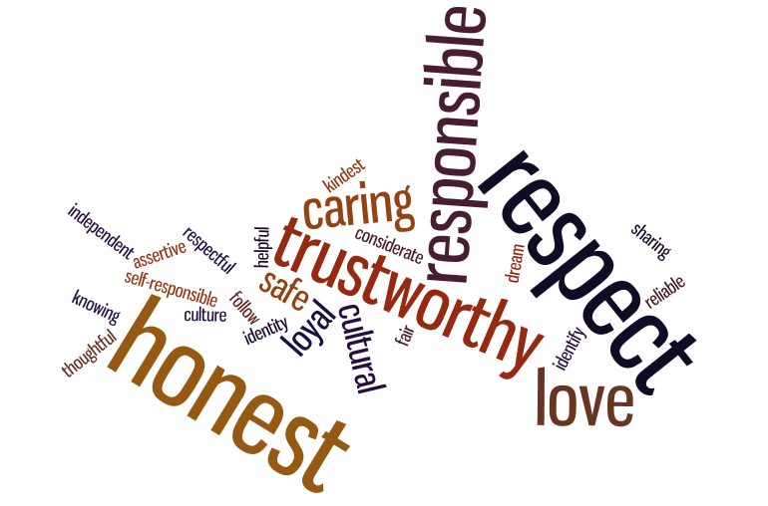

How Individuals’ Beliefs, Attitudes and Values Impact on Workplace Behaviour
Module: Developing workplace critical thinking
Module code: BMSW5101
Student name: Corina Berco
Student ID: 1918420
Lecturer’s name: Obinna Nkwocha

Table of Contents

Introduction 3
Question I: An analysis of the impact of individual beliefs and values on workplace behaviour.
1. Values in the workplace 4
2. Believes and their origins 4
2.1. Quality and Customer Commitment 6
2.2. Accountability and Leadership 6
2.3. Integrity and Data Democracy 7
2.4. Teamwork and Sincerity 8
3. Recommendations on how to reduce the negative impact of beliefs in the workplace 8
Conclusion 9
References 10
Question II: A reflection on how my critical thinking skills have developed based on my learning on the module.
Introduction 11
1. The learning that took place on this module 11
1.1. Concrete Experience 11
1.2. Reflective Observation 13
1.3. Abstract Conceptualisation 13
1.4. Active Experimentation 13
2. Various topics that have shaped my critical thinking abilities 13
3. How I intend to use critical thinking skills gained in this module to inform future engagement 14
References 15

Question I: An analysis of the impact of individual beliefs and values on workplace behaviour.
Introduction.
The report reflects the beliefs and values of an enterprise, which dictate the way ethical behaviour, professional work activities, and other aspects are conducted. It is essential to understand beliefs and values as it can help in elevating the individualistic performance of each subordinate within an organisation (Shealy, 2016).
Being able to develop workplace believes is important as they help in making sure that ethics are being followed and a higher level of connectivity is being established. It is important to understand how different types of believes government values and ethical directions of a business. Throughout this research, a wide variety of individual beliefs will be presented for the singular employees operating within an organisation. Emphasis will be given upon understanding how focus can be funnelled towards how their beliefs are impacting the workplace scenario. In addition, several examples of American Express, Google, and other companies will be highlighted here in this research.

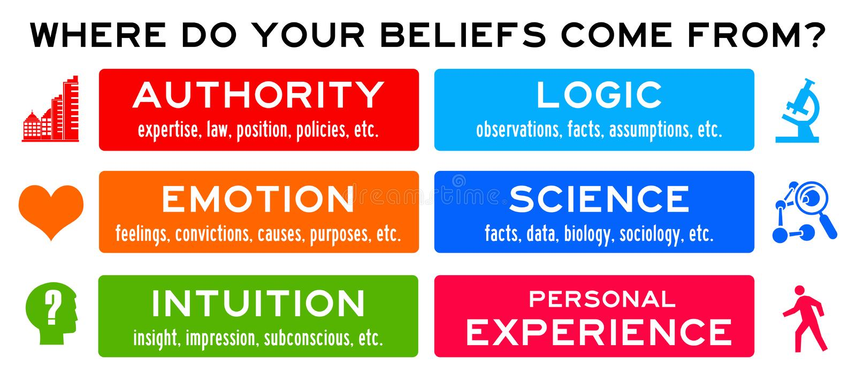

Source: beliefs-where-personal-come-authority-science-experience-83373841.jpg (1600×700) (dreamstime.com)


1. Values in the workplace.
Several different types of values such as honesty, hard work, and discipline are various facets that have helped major corporations such as Microsoft, Amazon, Facebook, and others. Through the guidance of Bill Gates, Jeff Bezos, Mark Zuckerberg, these aspects, and values have facilitated inefficiency to be created. Moreover, honesty has facilitated better relations with consumers. Source: Jaiz-core-values.png (2000×2000) (jaizbankplc.com)
Similarly, in the case of Facebook, the organisation had been initiated by a single individual, which was Mark Zuckerberg. He had been able to initiate the website, create entrepreneurial activities, and facilitate holding endeavours for other employees and had initiated a large corporation that could sustain it. Through the interest of others, he was able to create a work atmosphere on Facebook whereby which, individuals could operate on their own and create influence on the workplace. Since Facebook was primarily created as an individual attempt, most of the work that is performed through coding and other online activities is focused on individualistic work however focused on a team endeavour (Best, 2016).
Another example that can be taken into consideration is of event and how Jeff Bezos had been able to initiate a small book enterprise that led to becoming Amazon Inc. Some of the different types of aspects and values on which the enterprise focuses upon encompasses customer loyalty, frugality, a bias for action, and other aspects be even important. All these areas are essential as they have helped Amazon to be able to create a network through which a variety of sellers can provide their commodities to consumers for effective sales. The belief of creating a continuous connection with consumers is an effective measure that has enabled the prospect of efficiency to be raised.

2. Believes and their origins.
There are different scientist that explains beliefs in various ways, as thoughts and supposition that a person or a group of people beliefs to be true. These different definitions describe beliefs as thoughts that a person believes to be true with a level of trust that can change from poor to strong (Emmanuel and Delaney, 2014).
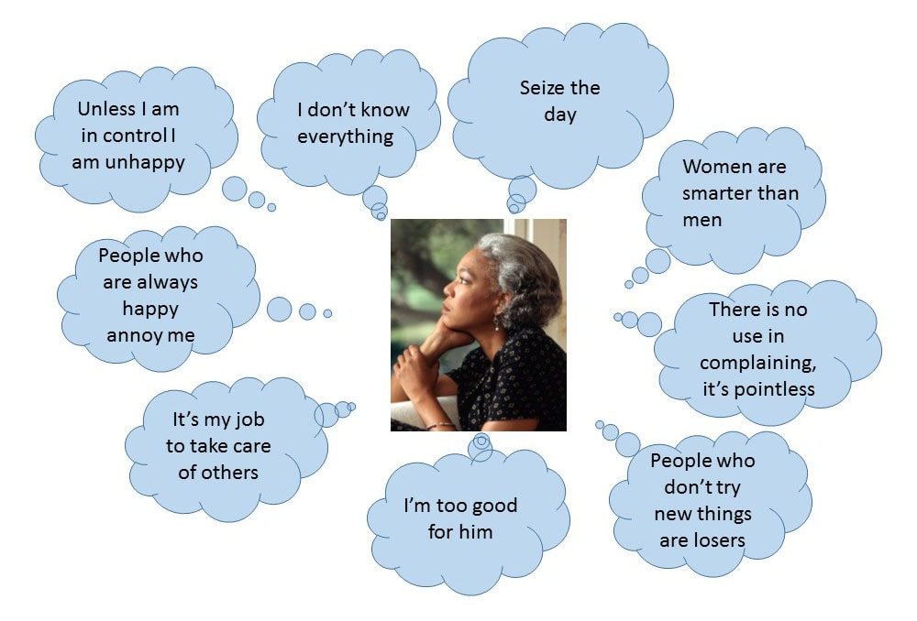
Beliefs can be defined as the internal formulation of feelings that are true by an individual. Zhanga (2020) pointed that believes can be irrational, unproven, or any form of psychological mindset through which someone believes something to be true. Values play an integral part in setting up beliefs as values can be illustrated as the ethics, rights, and mannerisms that an individual or organisation believes that it possesses. It can be highlighted that the beliefs and values of an organisation or individual origins from a wide variety of factors.
Source: beliefs-graphic-bh.jpg (1000×678) (elsevier.com)
Some of these different types of factors might include religion, social influential factors, workplace influence, cultural influence, family values, historical events, and others. By the locality, a country that an individual or business is performing in, the influence of religion and community values changes (John, 2016). For instance, in the United Kingdom and the United States, most of the population falls under the Roman Catholic or protestant religion of Christianity. Through conservative thinking, having faith towards family values, helping others, the community of interpersonal support is created. Moreover, some of the other origins aspects from their beliefs that can be contracted might include the corporate culture that is prevailing in the United Kingdom. This culture focuses upon monetary gain, providing services and products that are of high utility to consumers. This type of culture facilitates in creating a job environment in which emphasis is given upon exploiting all the gaps in the market and coming up with products that can facilitate optimised performance to be reached.
Some other places of origin for specific values and beliefs might be family traditions and how behaviour, interpersonal values, and other aspects are exchanged. These help in making sure that a particular set of worldview approaches are created for each employee and managerial head in the organisation (Reiter, 2019).
Different types of companies have different types of values and beliefs. To illustrate the beliefs and values that can emerge within the organisation, the example of Apple Inc can be taken into consideration. For instance, Steve Jobs had the reputation of creating a work-driven enterprise in which innovation, customisation, simplicity, and other beliefs were valued to deliver a high margin of utility to consumers. The origin of this set of beliefs within an organisation can be attributed to the work ethics and business culture that had been created through Steve Jobs and his personal life's influence (Moritz, 2016).

2.1. Quality and Customer Commitment.
In American Express the belief that is present is focused on commitment. This specific belief towards creating integrity and respect for people focuses on providing quick and effective services that can be relied upon by consumers. This helps the business to gain a higher margin of capital and reserves that can be valued for a longer period and period (American express, 2021).
Through the utilisation of a quality-oriented and customer commitment belief, the workplace is directly impacted with a focus on consumer security. Since American Express is focused on dealing with monetary exchange and value for consumers, these beliefs must be upheld. To do this, continuous emphasis upon reassurance, security checks, and other measures are required to be implemented.
In different types of organizations, individual employees and their personal beliefs impact the organisation in a wide variety of manner. This is directly connected to the overall workplace behaviour. For instance, in the case of American Express, the individual employees are extroverted and highly active. Their beliefs are rooted in being able to move effectively and connect with consumers at a high capacity. This directly impacts workplace behaviour as better logical processes, movement of goods, and other activities are undertaken (Estigoy et al., 2020).

2.2. Accountability and Leadership.
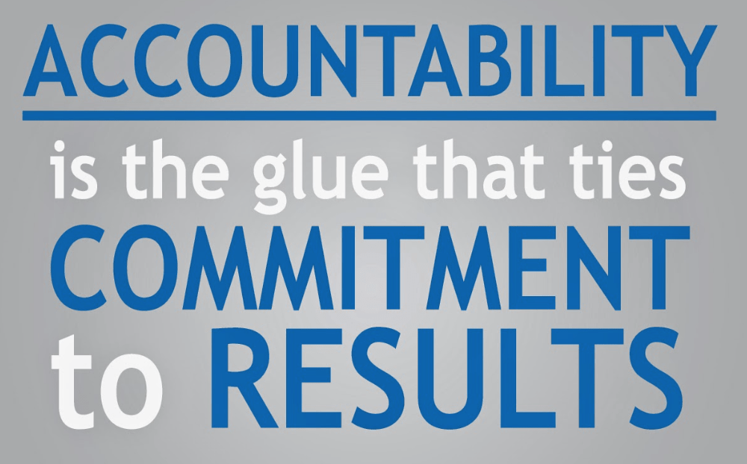
Coca-Cola is a beverage organisation that provides carbonated drinks. This is an enterprise that is well known in the beverage industry for being able to create an innovative carbonated drink through which a high margin of passion, delivery of quality, and uniformity in each product, are all being provided.
Source: Accountabilty-1.png (1000×622) (wp.com)

Through this type of leadership, Coca-Cola can operate in multiple different countries and provide a higher scale of sustainability through which growth is attained (Coca-cola company, 2021).
The impact of leadership and accountability for Coca-Cola directly facilitates in creating pressure for employees in the production line. This helps incorrect measurements, adequate quantity, and other aspects to be attained. As a result of this, being able to connect with consumers at a deeper capacity is initiated.
Similarly, it can also be highlighted that in the case of Coca-Cola, individual employees are much more focused on having an introverted outlook on various aspects of the business since they operate in a factory and closed environment. As a result of this, accountability for each other's works and having a personal belief of taking one's responsibility is an important facet in the business. This enables the prospect of impacting the workplace as a whole and enhancing behaviourism in the enterprise.

2.3. Integrity and Data Democracy.

Google is a major corporation that operates all around the globe and is relied upon by consumers irrespective of the country to obtain information that is valuable to them. This major tool and website, not only value and impacting lists is provided but also case studies, examples, images, news, and other facilities as well. Through all of this, democracy is created through equality read data and the opportunity to learn is being facilitated to everyone at a grander scale (firstmonday.org, 2021).
Source: 4715411-Zig-Ziglar-Quote-Integrity-gives-you-real-freedom-because-you-have.jpg (3840×2160) (quotefancy.com)
In the case of Google, having integrity directly impacts the workplace because of this is that people are coming to the search engine to get reliable data that facilitate better knowledge to develop for an enterprise and individuals.
In the case of Google, individual employees dictate how integrity, data democracy, and other aspects operate. As a result of this, it can be understood that their values are focused upon having a high margin and value of self. This helps in achieving self-actualisation at a higher capacity which directly impacts workplace behaviour and makes sure that a higher standard of work is being attained.

2.4. Teamwork and Sincerity.
Whole Foods is an organisation that is focused on consumer satisfaction and delight. Owing to the nature of the business to provide good quality food items to consumers, quick delivery, and sincerity towards providing high-quality commodities must be essential. This helps in making sure that community development through which good cuisine and food items in the form of raw materials are being provided to customers (Fastcompany, 2021).
Teamwork and sincerity in Whole Foods play an important role as this can help in making sure that good quality raw materials are being accumulated and a higher margin of focus is being given upon delivery. As a result of this, the margin of support being created in the market elevates. Moreover, loyalty in consumers through good food items can be elevated over a long period as well.
In the cases of whole foods, the employees are focused on communicating and connecting with employees effectively. Their beliefs are rooted in being able to communicate effectively since they are operating at a lower employee scale. This helps them to connect with subordinates as well as other customers and provide services that are beneficial for the community and the business (Estigoy et al., 2020).
3. Recommendations on how to reduce the negative impact of beliefs in the workplace.
Several recommendations can be made which can facilitate in understanding how better beliefs can be attained to improve the workplace environment and mitigate negative beliefs.
- Uniformity is a strategy through which the negative impact of diversity and democracy can be minimised. It can be highlighted that while providing everyone the opportunity to speak and express their opinion is an equality-driven endeavour, it can create an immense level of contract. However, this can be mitigated through emphasis upon creating pre-determined decisions and strategies that can be followed in every department.
- For there to be the empowerment of subordinates and ideas being created within an organisation, support must be created. This form of support can be driven forward towards an emphasis upon better operation management strategies to be implemented, interpersonal belief and teamwork to be created. As a result of this, efficiency can be raised overall. For there to be involvement being created, it is important to implement specific laws such as the competition act, health and safety act, and others. These are all important as they can help in making sure that empowerment towards safety and optimisation and other aspects are being drawn into the enterprise.
- Anti-discriminate policies and measures can be implemented in larger corporations. These revelatory and prejudice-based comments are a negative facet within an organisation that can take place through a wide variety of beliefs. For there to be such policies created integration of a governance professional in the organisation to help implement company laws, equality act, and others require guidance for the executive heads at a higher margin.
- Continuous training and development programs are effective methods through which effective values and beliefs can be established within the organisation. This will directly help in creating a much more reliable business framework for progress.
Conclusion.
Utilising this entire research for beliefs and values in various workplace situations, multiple businesses have been taken here in this research. Some of the different types of companies that have been included here in this analysis encompass Google, American Express, Coca-Cola, and others. Following all the detailed enterprises, specific suggestions have been made on how these businesses have the chance of increasing efficiency through various recommendations. Some of the recommendations focus upon anti-discrimination aspects, uniformity being created, and other strategies being implemented as well. Moreover, the origin and basis of various types of values and beliefs have been underpinned here in this research as well.

Reference.
1. Accountability [illus.] (ND) Available at: Accountabilty-1.png (1000×622) (wp.com) (Accessed: 24 July 2021).
2. Americanexpress (2021) The American Express commitment to supplier diversity, equity, and inclusion. Available at: The American Express Commitment to Supplier Diversity, Equity, and Inclusion (Accessed: 12 July 2021).
3. Best, M.L. (2016) The internet that Facebook built. Communications of the ACM, 57(12), pp. 21-23.
4. Coca-cola company (2021) Leadership - The Coca-Cola Company. Available at: Leadership | The Coca-Cola Company (Accessed: 12 July 2021).
5. Core values [illus.] (ND) Available at: Jaiz-core-values.png (2000×2000) (jaizbankplc.com) (Accessed: 15 July 2021).
6. Emmanuel, G. and Delaney, H. (2014) ‘Professors' influence on students' beliefs, values and attitudes in the classroom’, Journal of College and Character, 15(4), pp. 245-258.
7. Estigoy, E., Sulasula, J. and Guodu, X.A. (2020) ‘Factors affecting employee commitment in the workplace: an analysis’, Journal of Education and Practice, 11(27), pp.160-171.
8. Fastcompany.com, (2021) Whole Foods Is All Teams. Available at: Whole Foods Is All Teams (fastcompany.com) (Accessed: 12 July 2021).
9. First Monday (2021) View of in Google we trust: Information integrity in the digital age: First Monday. Available at: View of In Google we trust: Information integrity in the digital age | First Monday (Accessed: 12 July 2021).
10. Integrity [illus.] (ND) Available at: 4715411-Zig-Ziglar-Quote-Integrity-gives-you-real-freedom-because-you-have.jpg (3840×2160) (quotefancy.com) (Accessed: 20 July 2021).
11. John, N.J. (2014) Understanding different sets of beliefs. MIT Press.
12. Moritz, M. (2016) Steve Jobs & Apple. Alba Editorial.
13. Reiter, D. (2019) Crucible of beliefs. Cornell University Press.
14. Shealy, C.N. (2016) Making sense of beliefs and values: Theory, research, and practice. Springer Publishing Company.
15. Zhanga, T., Grunertb, K. G. and Zhou, Y. (2020) A values–beliefs–attitude model of local food consumption: An empirical study in China and Denmark. https://doi.org/10.1016/j.foodqual.2020.103916.
Question II: A reflection on how my critical thinking skills have developed based on my learning on the module.
Introduction.
It is essential to engage in a reflective activity as it can help in improving employees, work operations process, and other activities as well. Throughout this research, Kolb's reflective framework will be implemented that can help in improving the ways through which better personal development can be attained over a long course of time, and to evaluate own performance to understand personal feedback and the level of their performance and how they can improve it (Brown, 2021).
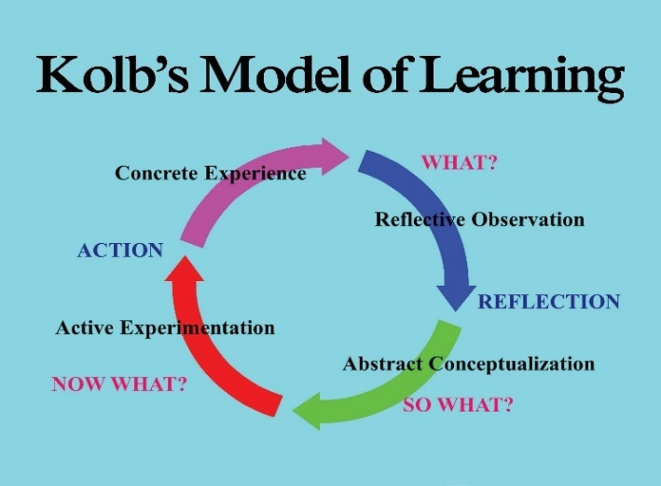
Reflective learning over the learning on this module shall be highlighted here in this research as well, as various subjects were taught and discussed to understand what critical thinking is and how it can help us in the future.
Source: 8cb072e6-f543-46d5-ab41-e9e48b3d7953.jpg (3300×2550) (pfw.edu)
1. The learning that took place on this module.
To develop a review of the different types of skills that have been learned, Kolb's Reflection Model shall be taken into consideration here in this assessment (Morris, 2020). Some of the various types of scales that have been presented and practically implemented to practice in this entire module encompass research skills, writing skills, critical thinking skills, time management, and others. All of these have been important as they have facilitated better university-level performance to be leased and much more learning to be enabled at a higher efficiency.

1.1. Concrete Experience.
Week 3. Beliefs, Values, and Attitudes.
The lesson that was taught in week 3 was that much of interest and importance, as we should write about the topic in the assignment. The lesson started with the What is Belief question, where students answered differently to it, as – Belief is something you agree with, regardless of whatever is true or not (Andrea), - Beliefs are just faith and confidence in someone or something (Oliver). The same question was What are values. Students shared their thoughts – Value is a thing of importance, like for example family (Abdul). – Appreciating someone or something (Roxana). We had class activities as well - Do you agree or disagree with various statements about the value that has been given to the class. Attitudes as well were discussed. Students were involved in a discussion, where everyone had to choose from a list of values, the most important and least important.

1.2. Reflective Observation.
Week 6. Validating evidence.
In week 6 we have learned how to validate evidence, which is a huge part of critical thinking. Several class activities were given, where students had to reflect on several resources and think about whether information coming from these sources can be categorised to be good sources or bad ones. Examples were given as well to understand better the proposed sources. Our lecturer shared with the class some of the tools that we can use to examine qualities of good evidence and sources, focusing more on the explication of the C.R.A.A.P. test. We have discussed the critical thinking models as Pearson's RED and Six Types of Socratic Questions. From which it is evident that every organization has its internal problems, no matter of the appeared circumstances (as COVID-19).
Various types of companies such as Coca-Cola, Google, were all examples of using leadership, teamwork, and other aspects that have facilitated me to have my own understanding of where I excel in having these beliefs. These have facilitated me to understand the strategies that can be implemented to create unity within an organisation and make sure that progress is being attained (Cottrell, 2017).

1.3. Abstract Conceptualisation.
Week 2. Logical reasoning.
Definition of Logic and Reasoning and the difference between valid and invalid reasoning was given by our lecturer supporting it with examples. Students were involved in an activity to say if the given situations are valid or invalid. Necessary and Sufficient Conditions were explained, as well supported with examples for a better understanding of the subject.
Two types of valid and invalid reasoning were discussed as well as Sound and unsound arguments, followed by two class exercises. Although I did not involve in answering, I benefited by listening to other points of view, and I understand how to apply the above-mentioned concepts, which was of value for part A assignment (Multiple choice question).
1.4. Active Experimentation.
Week 7. Causal reasoning.
The causal claim was explained, as well as the importance of causal reasoning, and students had the chance to fully engage in a class activity implementing what we have learned by reflecting on whether we agree or disagree with the causal claims found in a text we had to read. Group activity where students were to identify any error in causal reasoning if any.
Throughout this entire research for different values and beliefs, I have been able to plan my next effective step for growth. I have realised that being able to work in multiple types of circumstances and environments can help diversify my thinking. Moreover, effectively working with a wide range of clients through these types of company heads can also facilitate me to develop as a researcher and develop multiple points of view on how to conduct work for different products and services (Burns and Danyluk, 2017).

2. Various topics that have shaped my critical thinking abilities.
After learning in this module, a wide variety of factors shaped my critical thinking abilities. Throughout this entire research for beliefs and values, I have been able to undergo these types of factors to help improve my ability to actively think about a wide variety of topics. Firstly, I have become much more curious through research on how to have a variety of mindsets when focusing upon leadership, integrity, customer obsession, and other values. Helping have curiosity has facilitated me to be able to engage with a wide variety of circumstances and develop consistently. Moreover, I have been able to create an effective confident persona through which it is much easier for me to be able to engage with a wide variety of research content. As a result of this, I can evaluate false data and focused on authentic information that helps me to make better inferences about what type of deductions someone must make (McPeck, 2016).
I have been able to learn immensely from this experience on how to be ethical. For there to be good relationships being created with the consumers, it is essential to put a high level of emphasis upon good values being exchanged through effective communication, high standards of value proposition, and other aspects are being met effectively by the business. As a result of this, having the chance to effectively develop is attained.
Perseverance has also been a major factor that has allowed me to expand my thinking process and become much more agile in taking quick critical thinking decisions. The effective study has facilitated me to be able to think widely about when to not give up and keep digging for more data. This has facilitated me to be able to prevent myself from extensively just researching on a single company and move on to other topics as well that could enrich the study.

3. How I intend to use critical thinking skills gained in this module to inform future engagement.
To gain future engagement, it is immensely essential for emphasis to be given upon making specific decisions that can facilitate in choosing better subjects, working with much more educated tutors, and other choices. Being able to engage with peers’ members that are focused upon academic and personal growth is essential. Moreover, it is also important in the educational facility to have critical thinking to solve problems in a teamwork-based dynamic. As a result of this, unless teamwork is present, it is not possible for there to be teamwork oriented presentations, research, and other aspects to be created. Having believes such as these facilitate in an effective development mindset to be created for the growth (McPeck, 2016).
Reference.
1. Brown, N. (2021) Reflective model according to Kolb. Available at: www.nicole-brown.co.uk/reflective-model-according-to-kolb/ (Accessed: 12 July 2021).
2. Burns, A. and Danyluk, P. (2017) ‘Applying Kolb’s model to a non-traditional preservice teaching practicum’ Journal of Experiential Education, 40(3), pp.249-263.
3. Cottrell, S. (2017) Critical thinking skills: Effective analysis, argument, and reflection. Macmillan International Higher Education.
4. Kolb’s model of learning [illus.] (ND) Available at: 8cb072e6-f543-46d5-ab41-e9e48b3d7953.jpg (3300×2550) (pfw.edu) (Accessed: 15 July 2021).
5. McPeck, J.E. (2016) Critical thinking and education. Routledge.
6. Morris, T.H. (2020) ‘Experiential learning–a systematic review and revision of Kolb’s model’ Interactive Learning Environments, 28(8), pp.1064-1077.

