

Analysis vision, mission and values of Zara and evaluate its business strategies

By Chung Chung Pong James (Student ID:2123147)

HKBM 7013 Strategic Management
Lecturer: Dr. Terence Li
University of Wales Trinity Saint David

Table of Contents
 |  |  |  | Page
1 | Introduction |  |  | 1
2 | Background of Zara |  |  | 1
 | 2.1 | The ‘Strategic Direction’ and ‘Vision, Mission and Values (VMV) of Zara |  | 2
3 | Analysis on Hong Kong casual wear industry |  |  | 4
 | 3.1 | Threat and opportunities of the causal wear industry in Hong Kong |  | 5
4 | Value chain of Giordano in the post pandemic environment |  |  | 7
 | 4.1 | Product’s research and development |  | 7
 | 4.2 | Technology and system development |  | 8
 | 4.3 | Human resource management and general administration |  | 8
5 | Business strategies of Giordano |  |  | 8
 | 5.1 Low cost strategies |  |  | 9
 | 5.2 | Best-cost provider strategies |  | 9
6 | Corporate strategy of Giordano |  |  | 10
7 | Balanced scorecard |  |  | 11
8 | Recommendations |  |  | 12
9 | Work plan schedule |  |  | 13
10 | Conclusion |  |  | 13
 | Academic References |  |  | 15
 | Bibliography |  |  | 17

- Introduction

The report would focus on analyzing Zara which is an international clothing retail chain owned by the Inditex group in Spain. It is the market leader in fast fashion segment with wide range of products including clothing, shoes, accessories, beauty, perfumes and housewares (Zara Home). With 2,489 stores (Inditex, 2021) in the global market, Zara was among the global fashion retailers was impacted heavily by the outbreak of COVID-19 pandemic crisis in 2019. The Hong Kong market is no exception due to the global travel restriction and social distance measures that brought tremendous impact to the retail industry. The retail sales in Hong Kong dropped 42% in March 2020 compared with the same period in 2019. After taken a hit in 2020, the revenue of ZARA has been back to the level before the pandemic according to the earnings result in 2021. This report will study the vision, mission and value of Zara, assess how Zara set the strategic direction by these, analyse the corporate and business strategies proposed by Zara and, base on the findings of the analysis, propose recommendation for the strategies.

- Background of Zara

As a group, Inditex (parent company of Zara) is the biggest clothing retailer in the world in 2021 (Statista, 2022). In 1975, the first store of Zara (was called Zorba initially) was opened by the founder Mr. Amancio Ortega in Galicia, Spain. At the beginning, Zara sold high-end clothing fashion alike products at low price and with few stores in Spain only. In 1980s, Zara introduced a revolutionary way to change the whole process from design, manufacturing to distribution of its products so it could capture the new trends and deliver to the customers swiftly. Zara started to expand to outside Spain in 1988 (Inditex, 2022) that Porto, New York and Paris were the stepping stone. The expansion accelerated in early 2000s that the footprint of Zara reached South America (Mexico, Brazil, Venezuela e.t.c), Asia (Japan, Singapore, China and Philippines) and Africa. Although hundred of stores were closed globally during the COVID-19 pandemic, there are 2,489 Zara (including Zara Home) stores all over the world in 2021. It’s parent company, Inditex, which Zara contributes over 70% of Sales revenue (Inditex, 2021), went public on the Madrid Stock Exchange in 2000 and the current market capitalization is USD73 Billion as of Oct 2022 (Bloomberg, 2022). In 2003, Zara Home was introduced to the label which enabled Zara to reach a new market segment of housewares. As a retailer giant that brick-and-mortar stores is the majority of its revenue, 2010 was the milestone for Zara to launch its online e-commerce platform in Jordan firstly then extended to different countries.

2.1 The threat and opportunities of causal wear industry in Hong Kong

In the

- Analysis of causal wear industry in Hong Kong

COVID-19 pandemic brought a big hit to the causal wear retail industry in Hong Kong. It also changed the industry in many aspects. The drop of sales at stores due to a series of strict social distant measures by Hong Kong Government forced retailers to shut down under-performing stores especially those in tourist regions. Retailers shifted much more resources to the online platform and logistics in order to compensate the drop of revenue from physical stores. Over 40% of those fashion retailers without e-commerce platform have plans to develop the platform in coming 2 years, raise dramatically from the same survey conducted by HKTDC in 2019. The skyrocketing shipping costs due to bottlenecks in global logistics hubs is another major challenge for clothing especially low-priced causal wear retailers. The slow turnover of inventory due to pandemic and highly uncertain of global shipping cost and lead time made the inventory control is very challenging for clothing retailers. The new product lines in clothing industry is influenced by the COVID-19 pandemic as well. The work-from-home arrangements across different industries and enterprises changed the clothing appetite of customers. The demand for formal, well-designed and tailor-made clothing dropped almost overnight when people stay home most of time even during working hours. In opposite, the demand for causal wear which is low-priced, washable and less-durable was raised by the trend of work-from-home and health-aware “new-normal” lifestyle. The causal and sporty wear captured a great part of the clothing market as there is lack of occasion (intention) for customers to spend high cost on high fashion which would become outdated after one season. And for hygiene reason aroused by the concern of the COVID-19 pandemic, people would wash the outfit everyday if they have to leave home. For most high fashion items, it is not for daily washing or even dry clean only. Though fast causal fashion is relatively less design and made by cheaper material and parts, it is more suitable and affordable for those prefer to wash the outfit everyday. Those factors boost the market of causal wear in Hong Kong as previously it was labeled for those low income and budget customers only, the target group expanded to those higher income earner who would rather spend on other categories than fashion or designer clothing.

Fundamental, Hong Kong is an attractive market for global fashion brands due to no consumption tax and well-developed regulations to protect authentic branding products. Although the scale of domestic market is small in Hong Kong, the high turnover of tourist and business travelers from all over the world would attract global brands. The figure 1 shows the global clothing brands such as Zara, H&M and Uniqlo had much bigger market share than local brand such as Giordano in 2020.
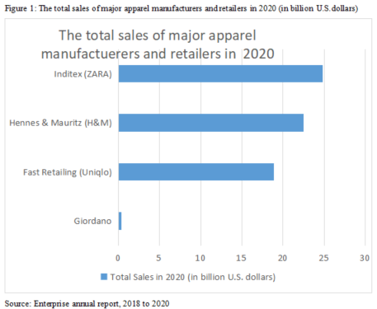

3.1 The threat and opportunities of causal wear industry in Hong Kong

In the past few years, the pandemic crisis was inevitably the biggest uncertainty and challenge to the causal wear industry in Hong Kong. As the short term effect due to the suspension of global travelling, the social distancing measures, the work-from-home arrangement in wide range of industries and lack of consumption intention, many causal wear brands had to shut down their stores temporarily or permanently and took a big hit on the sales revenue. Many brands were forced to implement very strict cost control by cutting number of stores and staffs to survive from the prolonged pandemic period. Some apparel brands needed to file bankruptcy if they did not have enough cash flow to survive or the plans to open new revenue sources were not successful. Even for those are surviving, the COVID-19 pandemic brought many changes to the whole operation process from the logistic cost and turnover time control, the forecasting and budget planning under lot of uncertainties to the daily operation to protect the safety of customers and staffs. Without any similar reference from the past, it is very challenging for all participators in the causal wear industry no matter from the local or international as wrong decision and direction may cause a heavy damage to the brand.

In medium and long term, the causal wear industry has to deal with the change of customer’s purchase behavior which probably be permanently. Even before the COVID-19 pandemic, the brick-and-mortar retail was declining for years due to the speedy development of online e-commerce. In Figure 2, Taobao, the e-commerce platform under the Alibaba Group and one of the biggest in the world, had double its gross sales volume in 5 years and reach CNY 3,387 billion in 2020. The surge of Taobao forced many retailers in Hong Kong and China, especially those small to medium scale, out of the market. For those big or international labels, they have to play catch up game to develop their own e-commerce platform in order to maintain the market share. The outbreak of pandemic further stimulated the trend. People stays home for safety would shop online for actual needs or the desire of shopping. The online e-commerce platform of most fashion brands need to be well-developed that customers could visualize how they look when putting the clothing items on and know what color and size would fit. The biggest obstacle of online shopping versus retail store experience is the delivery time. Many customer’s purchase decision is coming from impulsion which is irreplaceable experience of retail shopping. While the fashion retailers are eager to share the e-retailing market by setting up the e-platform, logistic is another major challenge to minimize the waiting time of the customers. The anxiety of waiting for delivery is the biggest challenge for e-commerce business. With the strong logistic and store network, Zara offers the in-store pick up is a relative advantage over other fast fashion brands which is one of key factor why Zara could recover the sales faster from the pandemic impact. Therefore, the development of e-commerce exponentially in last few years could be a threat but also an opportunity for causal wear industry.

Figure 2 : The gross sales volume of Taobao from financial year 2015 to 2020
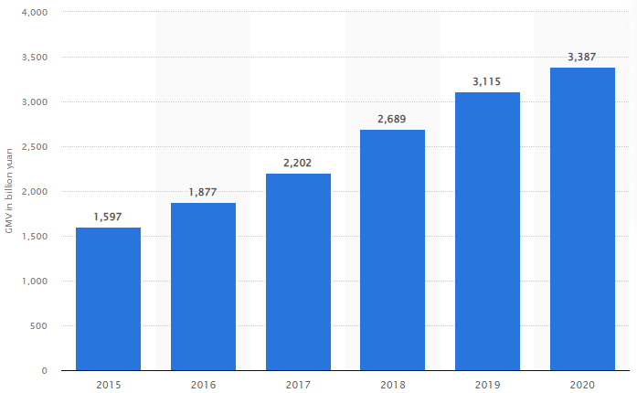
Source: Statista 2022

Another change of customer behavior could also be the opportunity for causal wear industry. As mentioned in the analysis of the Hong Kong causal wear industry, the work-from-home and health-aware new living style allows causal wear brands to reach some new customer segment. Especially if those brands could provide causal fashion items with modest design or high-end fashion design alike in cheaper material and lower price, that would capture those customers used to spend a lot on high-end or designer clothing. Lack of formal occasion and demand for daily wash let some fast fashion brands like Zara be the ideal substitution of high-end fashion clothing.

Although there are many uncertainties and unexpected cost due to the global knock down that jet up the global shipping and energy cost, the drop of rental cost is one of major positive effect from the pandemic. Rental cost is always the major cost factor for retailers in Hong Kong. Since the outbreak of pandemic in early 2020 that landlords in Hong Kong stood strong on the rent as people took the situation of SARS in 2002-2004 as reference that market rebounded sharply after several months of crisis. But with the pandemic prolong for years after waives of outbreak, the market of commercial property is declining from the peak in 2019. The retailers have more bargaining power and landlords cut the rents up to 50% in order to keep the property occupied. With a lower rental cost, casual wear brands could reposition their allocation of stores from focusing on tourism areas previously to more domestic areas to recoup the sales before the tourist from mainland China and overseas are coming back.

To have a through analysis of those threats and opportunities of the causal wear industry is important for the retailers to build the strategic planning for the post-pandemic situation. Introduced by Michael E. Porter in 1979, the Porter’s Five Forces analysis is a framework to analyse the five major forces which could be applied on all industries to determine the weakness and strength of an industry (Dobbs, 2014). This framework could find out why an industry could sustain and with varies profitability level.

Figure 3 demonstrated the Porter’s Five Force analysis of the causal wear industry in Hong Kong. Firstly, the threat from substitute products or service is stronger among the five forces. The causal wear industry in Hong Kong is an open market with high competition. With relative lower brand recognition and loyalty with high-end fashion brands, there are lots of similar substitute products in the market. The switching cost is low for customers and product differentiation is low among different brands. Except Zara, there are other international brands such as H&M, Uniqlo or GU providing fast, causal fashion items at similar price. Those competitors have strengths and weaknesses in different categories. For example, Uniqlo has a better Research and Development of material like “HEATTECH” so Uniqlo is strong at producing some cloths are very thin and light, breathable but still able to keep warm. Zara, on the other hand, do not have any self-develop high technology and functional material but offer some more fashionable items for different occasion from causal, smart causal to formal. Zara is also well-known by some products which are controversial by mocking some designs of high fashion brands. It could be a selling points for those customers desire fashionable items at low price.

The impact from the rest of the four forces is low relatively. The bargaining power of suppliers is low in the causal wear industry especially for an international brand as Zara. Zara even has its own factories to manufacturing some core products to reduce the dependency of suppliers. The volume is so big which give Zara dominant power on negotiation with suppliers. The bargaining power of customer is low as individual however, it would be stronger as a segment. With the competition from other retailers in the same market segment, Zara needs to be caution with its pricing strategy as there are many options for its target customers not only from the local market but also, with powerful online shopping platform and logistics infrastructure in Hong Kong, from overseas as well. Even though the high competition in the causal wear industry in Hong Kong, the rivalry among the competitors is not very high. Different brands have their own market positioning and product differentiation. And the number of competitors is big that no particular rival to target on. At the end, the threat from new entrants is low for Zara as well. The capital investment is substantial for any new entrants could threaten Zara’s market share, especially when the global economy is declining. After analyzed the status of causal wear industry in Hong Kong with the Porter’s Five Force model, the threat from substitute is obviously the strongest factor to consider for any business strategic planning.
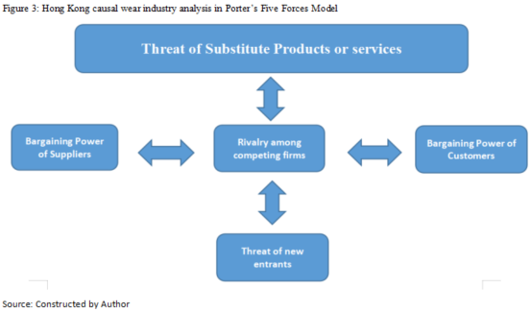

- Value chain of Zara in the post-pandemic environment

A value chain is the process flow of the creation of finished product, from the design stage to the delivery of the products to customers. The chain divided the process into different steps which value was added including the procurement, manufacturing, supply chain management and marketing. By evaluate the value chain, a company could zoom in to every steps to maximize the creation of value at the lowest possible cost and maintain the efficiency of the whole process. It would enable a company a competitive advantage when it could scratch the most productivity from every dollar it spent which is the key to survive and success in the post-pandemic environment. The report will focus on the primary activities in the value chain of Zara which enable it with some competitive advantages.

  - Inbound Logistics

It is the movement of raw material for manufacturing, distribution of finished products, inventory control of raw material and supplies for production and stock in stores. Zara processes the control of supply chain as almost 60% of products are manufactured in Spain and the rest is in overseas. Zara set up the manufacturing centers with high interchangeability so it could adjust the production force to response to the market changes swiftly with minimal transition time and cost. It enables Zara the ability to maximize the revenue from best sales products instead of inflexible and unreliable pre-season market prediction.

  - Operations

Zara consolidates the design departments at its headquarters in Spain with the procurement sector that it could response to any changes of direction quickly. It separates the production of the three main lines: Men, Women and juvenile as independent decision making and operations so they could react to the changes of the particular market.

  - Outbound logistics

Basically Zara’s distribution of finished products according to the each fashion seasons. Forecast of order quantity is highly replied on big data predictions. Since 2014 (Bjork, 2016), Zara introduced the RFID technology to stores which allowed Zara could possess the real time monitoring and control of its inventory level globally. Zara also changed the traditional approach of shipping that items are with prices and tags and on hangers already so they are ready to the point of sales once delivered.

  - Marketing and Sales

The marketing strategy of Zara does not reply on promotion offer and advertising. While most of the brands are spending around 3.5% of sales on advertising, Zara spends only about 0.3%. Instead, Zara is focusing on collecting first hand comments (good or bad) on its product and service then the report will be channeled back to the headquarters directly. The ideas would be emerged in the incoming designs which allows Zara could truly follow the trend closely. The brand loyalty could be established and enforced as customers feel they are participating in the process of design.

The selection of store locations is another key element of Zara’s marketing strategy. Usually it would pick the heart area of a downtown city not only for the footfall but also being together with those high-end fashion brands. During the pandemic period, the demand for high-end fashion dropped for a series of reason mentioned above, Zara is an ideal substitute with premium looking products at affordable price. Therefore, when studying the marketing spending of Zara, investing on more efficient areas instead of traditional advertising channels is a smart strategy for a well-established brand like Zara.

  - Service

Be responsive is the core of Zara’s strategy on service. They would avoid a long period of waiting at their stores. Ensure staffs will reach out for those customers need help or in rush and any complaints or inquiries would be handled and responded quickly.

In the post-pandemic environment, the control of each links of the value chain is the key for Zara to sustain and out-performing other fast fashion brands. It could maintain the strategy to deliver most trendy fashion items from design, manufacturing to deliver the end products to customer at the shortest lead time. It enables Zara to stay at the first choice of customers when considering low priced fashion items with the most trendy and exclusive designs.

Bloomberg https://www.bloomberg.com/quote/ITX:SM
https://www.bloomberg.com/news/articles/2022-04-20/hong-kong-landlords-brace-for-even-deeper-cuts-to-retail-rents?leadSource=uverify%20wall
- Bjork, Christopher (16 September 2014). "Zara Builds Its Business Around RFID". The Wall Street Journal. Retrieved 29 April 2016.

Dobbs, M. E. (2014) ‘Guidelines for applying Porter's five forces framework: a set of industry analysis templates’, Competitiveness Review, 24(3), pp. 32-45. DOI: 10.1108/CR-06-2013-0059.

HKTDC https://research.hktdc.com/en/article/MzEzOTM4MzY2

Inditex https://static.inditex.com/annual_report_2021/en/documents/consolidated-annual-accounts-2021.pdf
JLL https://www.jll.com.hk/en/trends-and-insights/cities/how-covid-19-is-changing-the-fashion-world

New York times https://www.nytimes.com/2012/11/11/magazine/how-zara-grew-into-the-worlds-largest-fashion-retailer.html?pagewanted=1&_r=2&ref=magazine&adxnnlx=1352725405-jSS0/SqaGslCt/4JfgJjeg&
Modern retail https://www.modernretail.co/retailers/how-fast-fashion-retailer-zara-recovered-to-surpass-pre-pandemic-sales/
- Michael E. Porter, "How Competitive Forces Shape Strategy", Harvard Business Review, May 1979 (Vol. 57, No. 2), pp. 137–145.

Statista https://www.statista.com/statistics/242114/sales-of-the-leading-10-apparel-retailers-worldwide/
The telegraph https://www.telegraph.co.uk/finance/newsbysector/retailandconsumer/11172562/How-Inditex-became-the-worlds-biggest-fashion-retailer.html

