Self-Evaluation of Welsh Lesson

Feelings
I feel that this welsh activity went well, as I was able to work with a small group of mixed abilities. I have taught these children for the previous five weeks, so I was aware of most the needs and abilities of these children. I was able to be confident in teaching these children and I was able to mostly take control of the activity. I believe I was competent in teaching this level of Welsh Language skills especially with the correct pronunciation and correct language sentences. I also believe I was able to use the correct incidental welsh such as ‘dim siarad’ and ‘eisteddwch’.

Evidence of learning (including attitude to learning over time) - Pupils
During this lesson, I was evaluating a small group of children with their Welsh language skills. The evaluation of the children during this session was completed using the oracy skills stickers that were provided by the school. These stickers are used by highlighting the skills that the child was capable of during this session. The children were able to use language to extend their sentences such as ‘achos’ and ‘gyda’. They were able to use sentence patterns such as ‘Mae hi’n wisgo …’ , ‘Mae hi’n hoffi ….. gyda… achos….’ And ‘Mae hi’n ddim yn hoffi achos…’. This language the year two children were learning was the same language my year four class was learning. The year two class were better at using this language and remembering it as I was able to introduce them to this type of language and sentence patterns earlier than the year fours and therefore learnt it quicker.

Next Steps for Progress
The children within this group who are currently lower attaining (LA) will be a key focus for the next sessions in Welsh language development. These children will benefit from working with a more knowledgeable other (MKO) whether that be a teacher, teaching assistant (TA) or one of the currently higher attaining (HA) children. Having the currently HA children work with the currently LA children will benefit from educating another child. The currently HA children will have support and will develop more skills for these children. The children’s assessments will further their learning as now the teachers can tailor the lessons and activities to the children learning. The MKO will provide the scaffolding which is needed for all children to develop. The support from the MKO needs to be slowly withdrawn along with the interaction between the MKO and the child (Pound, 2014). This diagram shows how the children will be in the purple with scaffolding and the MKO as part of the zone of proximal development (ZPD). The difference between the green section is where the child is able to do things independently without help, the next section (purple) is where scaffolding is used and an MKO to help students do what they can be stretched to do and the last section (blue) is where the challenges are too hard for the child where it is impossible for them to complete the task (McLeod, 2019).
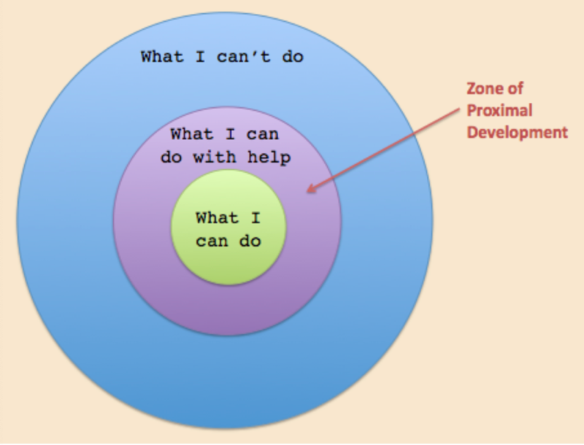(McLeod, 2019)

Evidence of my effective practice
I was able to have control over the children in the group I had. The children were able to use their own methods they have learnt the previous weeks from the ‘slot drillio’ sessions. I believe the children gained sound knowledge and understanding throughout the welsh ‘slot drillios’ throughout the week leading up to this session where they were able to make this knowledge and understanding concrete. The repetitiveness of the welsh session during slot drillio every morning with the children is where the children have been able to learn new language or sentence patterns. This welsh session is where the children were asked to remember these sentences patterns and language. The reason they could remember this new information and understanding is due to the repetitiveness. Atkinson and Shiffrin explored a theory that information in the short-term memory such as the slot drillio sessions will only turn into long term memory for which they can use throughout their future if it is rehearsed and repeated (McLeod, 2017).

Remember and understand
The aspects of the lesson that went well were that all the children were able to participate in the activity and that all the children enjoyed doing this activity with me. The children were very happy doing this task and thoroughly enjoyed that I was completing the task with them. The higher ability children were able to complete the task set with little help, the MA children were able to complete the task with help and the LA children were able to complete the task with help from an MKO. An aspect of the task that I found disappointing was the concentration of the children. An example of effective teaching and learning during this session was the children were able to activate prior knowledge by using a song they use on a daily basis for the daily tasks. The children’s motivation was very high throughout the session. The learning would have been more effective if my class management skills were more developed. The class management techniques that were used to grab the children’s attention was if I clapped a pattern and the children copied it back. I felt my class management skills could have been improved for a mixed ability group. This will develop more through research and working more and more with these types of groups. An aspect of my teaching that could be developed is my ability to manage mixed ability groups as I have experience of working with whole classes or ability groups but little experience of small mixed ability groups. This will be a personal target for the future. My class management skills for a small group need to be developed as the skills used for a whole class situation differs to the classroom management skills used in a small mixed ability group. Giving the children rules before setting them off to a task is one way to develop this area (Education Support, 2020).

Evaluate and analyse
I think that this activity was successful as the children had learnt to use skills, they have learnt in the previous weeks during slot drillio sessions. I believe that the children moved forward in their learning in welsh in this lesson as they had clear guidance and instructions, so they knew how to successfully complete the task. The difficulty that I encountered with the children included that when the currently LA were having their turn of independently completing the task, the more able were not concentrating and were distracting all the children around them including the currently LA child that was being assessed. The link between the behaviour of the children and their learning was how their level of learning depended on the concentration levels of the children. The more the children were distracted the less they were able to do independently. Therefore, my classroom management skills are what need to be explored and developed.

Conclusions and actions
The expectations of the current lower abilities compared to the expectation of the currently HA will be different. To move the children forward would be to make the answers of higher quality so that the currently LA are more on the level of the current MA and the currently LA are more on the level of the HA. The currently HA need to be pushed with more difficult tasks. I believe the task should have slightly more differentiation for the currently LA children. After conducting this session, I feel that the children who are currently LA would benefit more from having less to talk about so they could perhaps extend their sentences.
The most important aspect of this session was that the children has learnt a welsh pattern to use for conversations in the future. To move all the children forward, I would plan another session on third person in Welsh to develop their use of their knowledge with adaptations such as less to talk about but concentrating on the extension of one or two sentences instead and for the currently MA and HA to help them to remember these sentence patterns off the top of their heads. The currently HA need to be pushed with more difficult tasks. I could reward the children in the future that fully engage with the activities in the session by giving them Dojo’s. The Dojo’s as a reward will motivate the children. The children will be motivated by the reward as the children will perceive that this reward will outweigh the negative consequences (McLeod, 2016).

Word Count - 1446/1500

Reference List
Pound, L. (2014) How children learn. London: Practical Pre-School Books.

McLeod, S. (2019) The Zone of Proximal Development and Scaffolding. [Online]
Available at: https://www.simplypsychology.org/Zone-of-Proximal-Development.html
[Accessed 21 April 2020].

McLeod, S (2016) Bandura – Social Learning Theory [Online]
Available at https://www.simplypsychology.org/bandura.html
[Accessed 21 April 2020].

Education Support (2020) Managing pupil behaviour [Online]
Available at: https://www.educationsupport.org.uk/resources/life-guides/managing-pupil-behaviour?gclid=EAIaIQobChMIqsrgjtf56AIVn4BQBh3NzwwMEAAYASAAEgII6vD_BwE
[Accessed 21 April 2020].

McLeod, S. A. (2017) Multi store model of memory [Online]
Available at: https://www.simplypsychology.org/multi-store.html
[Accessed 21 April 2020].

