
COMPONENT 2: HTML & CSS Web Development
Introduction to Web and Database Concepts - ACCA4023

Lecturer: SADHANA JHA

Assignment Topic: Design, Implementation and Evaluation of a Responsive Healthcare Website

Student: Assadullah Gulamhussein (2509693)

Word Count: 2,259
(Excluding title page, content list, list of figures, list of tables, references, appendices)

UNIVERSITY OF WALES TRINITY SAINT DAVID

Table of Contents
1. Introduction 4
2. Requirements 4
2.1. Purpose 4
2.2. Subject Matter 4
2.3. Intended Audience 5
3. Implementation 5
3.1. Completed Web Pages 5
3.2. HTML validation 8
3.3. CSS Validation 9
4. Evaluation 10
4.1. Usability, Accessibility and SEO 10
4.1.1. Usability 10
4.1.2. Accessibility 10
4.1.3. Search Engine Optimisation 11
4.2. Evaluation of the Healthio Medicare Website 11
4.2.1 Utility, Usability and Content 11
4.2.2. Search Engine Optimisation 12
4.2.3. Accessibility (WCAG 2.1) 12
5. Comparison of website 13
5.1. Usability 13
5.2. Accessibility 14
5.3. Search engine optimisation 15
5.4. Mobile Friendliness 16
5.5. Overall Judgement 17

List of Figures

Figure 1: Home page of website 5
Figure 2: About page of website 6
Figure 3: Doctors page of website 6
Figure 4: Services page of website 7
Figure 5: Contact page of website 7
Figure 6: Home page on a mobile device with the menu open 8
Figure 7: Validation of HTML using W3C 9
Figure 8: Validation of CSS using W3C 9
Figure 9: WAVE accessibility report of Healthio Medicare 11
Figure 10: WAVE accessibility result for Midland Health 13
Figure 11: WAVE accessibility result for Private Medical Clinic 13
Figure 12: Mobile view of Midland Health 15
Figure 13: Mobile view of Private Medical Clinic 16

List of Tables

Table 1: Healthio Medicare against WCAG principles 12
Table 2: Error related to WCAG 2.1 principles 13
Table 3: Comparison of two similar websites 14

1. Introduction
The current report is for a fictitious private healthcare clinic named “Healthio Medicare”, in which an elaboration is made on website design, implementation, and its evaluation. In the building process, the website was structured using hand-coded HTML5 and CSS3, and no website builder or code generator was used for this purpose. It is a fully responsive website with five pages, which mean its adjusts its layout according to the suitability of desktop computers, tablets, and mobile devices. The report initially shows its purpose, subject matter, and intended audience; later, it presents the completed pages together with the results of W3C validation testing. In the main body of this report, the three most important areas of modern web development are discussed, including usability, accessibility, and engine optimisation. Then, the complete website is evaluated against these three areas as per the guidelines of Web Content Accessibility. The final stage of the website shows a comparison with two live websites related to the same purpose and recommendations for improvement.

2. Requirements

2.1. Purpose
The purpose of the Healthio Medicare website is to give a small private clinic a professional presence on the internet. Many patients now look for healthcare information online before they telephone or visit a clinic. The website therefore allows visitors to learn about the clinic, view the services it offers, read about its specialist doctors, and find the information they need to make contact.

2.2. Subject Matter
There are 5 linked pages on the site. A welcoming home page with a description of the clinic and its values. The clinic's mission and approach to caring is explained in the about page. The doctors page displays six specialist doctor pages for the neurology, paediatrics, cardiology, dermatology, orthopedics and gynaecology departments, each of which contains an appointment request form. The services page outlines what services are provided at the clinic, including general consultation, health checks, vaccinations, diagnostic imaging and emergency care.

2.3. Intended Audience
The website focuses on visitors who are either prospective or existing patients of the local area and families seeking a trustworthy clinic. The audience may include older people and individuals with visual, physical and/or cognitive disabilities, given that they are all accessing healthcare services.

3. Implementation
This section shows the finished website and the outcomes of the validation testing. A screenshot of each completed page is provided below, followed by the W3C HTML and CSS validators.

3.1. Completed Web Pages
The five completed pages are displayed in a web browser in Figures 1–5.

Figure 1: Home page of website
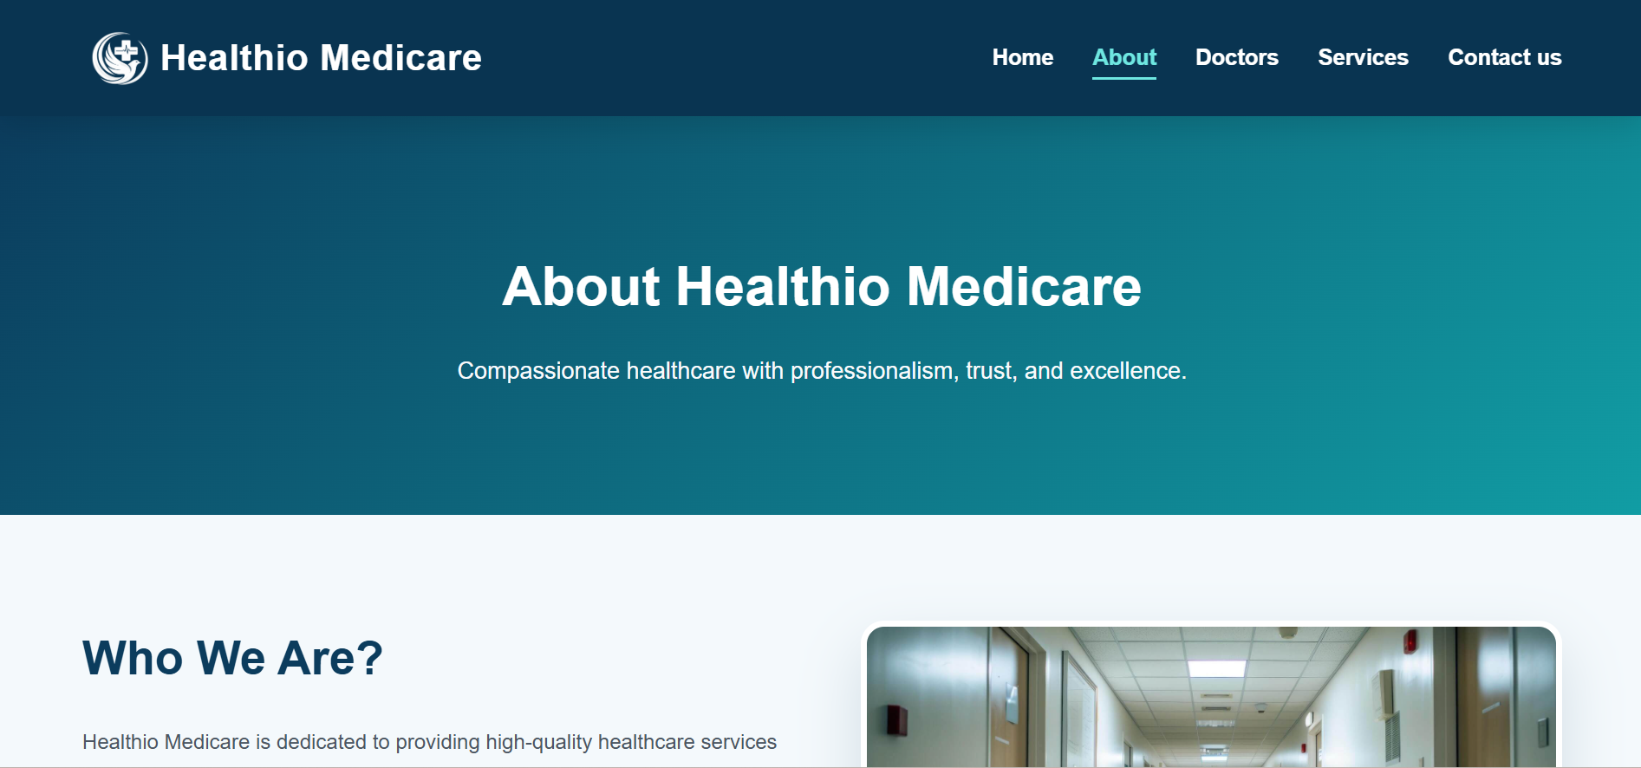
Figure 2: About page of website
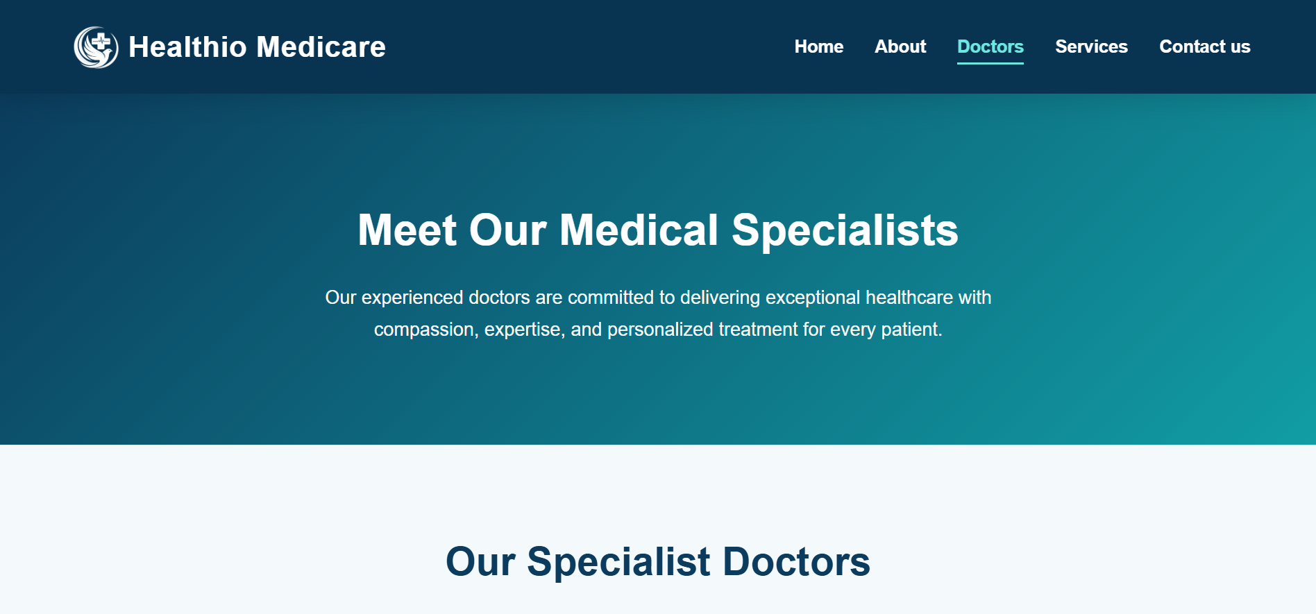
Figure 3: Doctors page of website

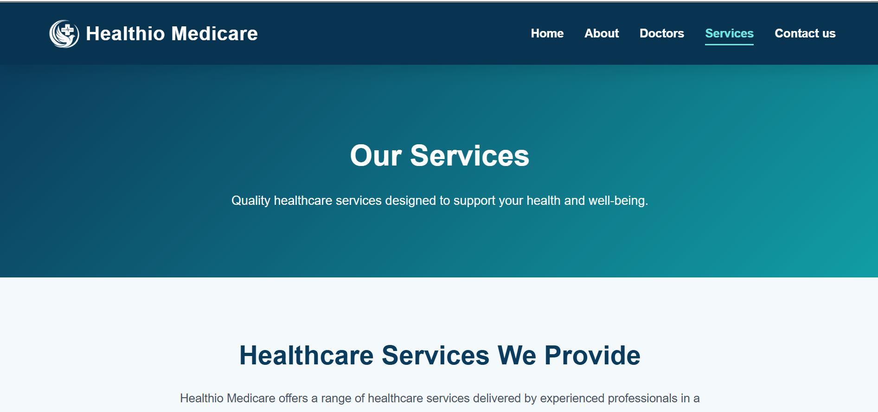
Figure 4: Services page of website
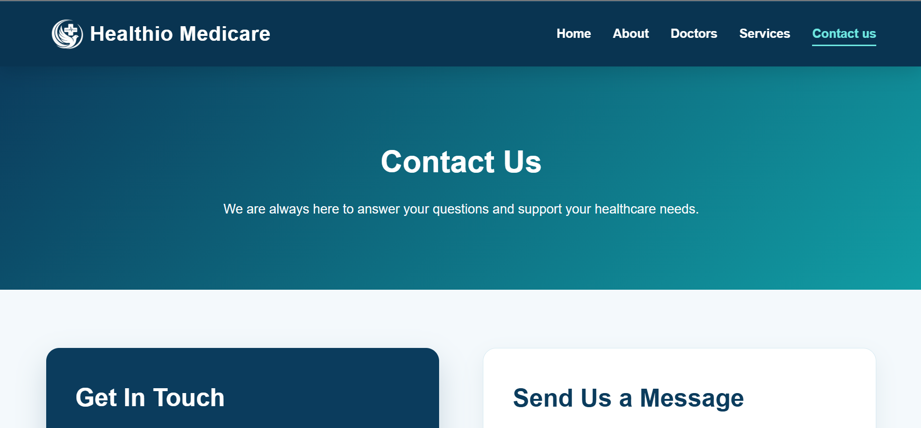
Figure 5: Contact page of website
The website is responsive which can be seen in Figure 6. The below figure shows the home page as it appears on a mobile phone, where the navigation menu collapses into a single menu button.

Figure 6: Home page on a mobile device with the menu open

3.2. HTML validation
The W3C Markup Validator was used for each page to verify the HTML. A few early errors were found and remediated, such as a missing alternative text attribute on one image and a missing heading tag on the home page. Next, 5 pages were passed without errors/warnings. The outcome of this for the home page is demonstrated in Figure 7. Passing the validation means that the HTML is properly formatted and adheres to web standards, meaning it will render similarly in various browsers.
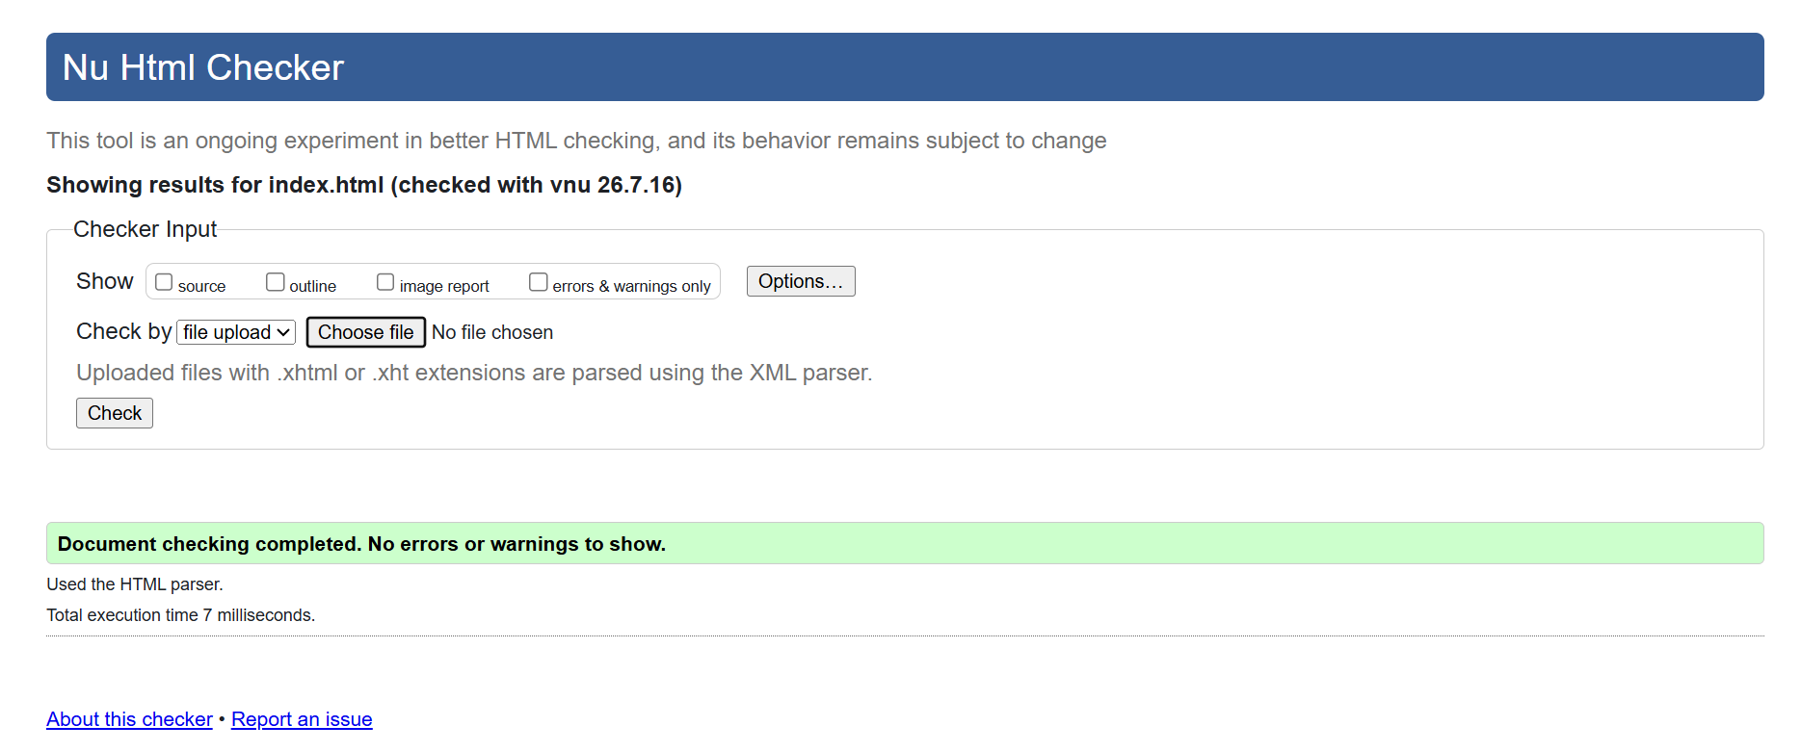
Figure 7: Validation of HTML using W3C

3.3. CSS Validation
The main stylesheet was validated using the W3C CSS Validation Service, and the result is displayed in Figure 8. The validator reported two items about properties inset and backdrop-filter. These are both valid, modern CSS properties supported by all current browsers and applied to the appointment pop-up windows. These are not faults in the stylesheet but limitations in the validator system that limit it to an earlier version of the CSS specification that doesn't contain them. However, the properties were not removed because their presence would make the design less interesting, but does not make it less practical to use in the real world.
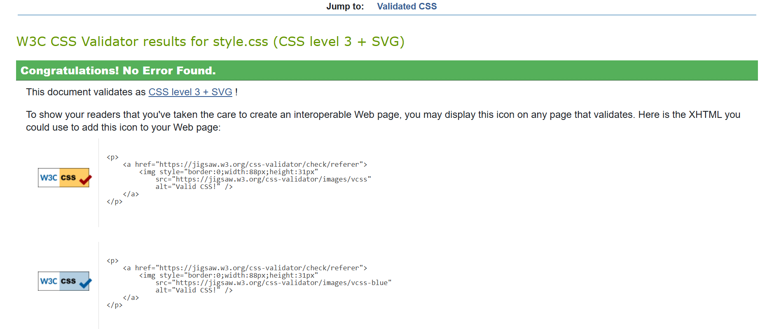
Figure 8: Validation of CSS using W3C

4. Evaluation

4.1. Usability, Accessibility and SEO
In this section, three important zones of web development have been explained for usability, accessibility and search engine optimisation.

4.1.1. Usability
Usability refers to how easily a visitor can use a website to accomplish their objective [1]. Usability is important because if a visitor cannot find what he or she is looking for, then he or she will eventually be frustrated and leave, and for the clinic, that would be the loss of a patient. Gale et al. [2] conducted a study of the usability of academic medical centre websites in the U.S. They determined, by a structured scoring method, the extent to which each website enabled patients to complete typical tasks, including making contact with information and contact details. They determined that many health sites were poor on basic measures of usability and that there were definite directions that could be taken to make the sites better, and that these directions could be measured and shown to be effective. This discovery is directly applicable to Healthio Medicare, where clear navigation and a consistent layout were allotted priority levels.

4.1.2. Accessibility
Accessibility means designing a website so that people with disabilities can use it successfully including visual, physical, hearing and cognitive disabilities [3]. It is guided by the Web Content Accessibility Guidelines (WCAG), which are organised around four principles: content must be perceivable, operable, understandable and robust [4]. Accessibility matters for ethical, legal and commercial reasons, and it also improves the experience for all users. The scale of the problem is shown by the annual WebAIM Million study [5], which used automated testing to examine the home pages of the top one million websites. The study found that 95.9% of these home pages had detectable WCAG failures, with an average of 56 errors per page. The most common problems were low-contrast text, found on 79.1% of pages, missing alternative text for images on 55.5% of pages, and form fields without labels on 48.2% of pages. These three issues are exactly the kind of barriers that were considered and addressed during the development of Healthio Medicare, as discussed in the next section.

4.1.3. Search Engine Optimisation
Search engine optimisation (SEO) is the practice of building a website so that search engines can find, understand and rank it well [6]. Because most visits to a website begin with a search, a page that does not appear near the top of the results may never be seen. On-page SEO includes writing clear title tags and meta descriptions, using a logical heading structure, adding descriptive alternative text to images, and keeping pages fast to load. Ziakis et al. [7] investigated which factors most affect a website’s position in Google search results. They examined the first fifteen Google results for several search terms and used a statistical method, the Spearman correlation, to measure how strongly each factor related to ranking. They found that factors such as the presence of a keyword in the page address, the amount of text on the page, and the use of a secure connection were among those linked to higher rankings. Their work confirms that careful on-page structure has a measurable effect on visibility, which supports the SEO techniques applied to Healthio Medicare

4.2. Evaluation of the Healthio Medicare Website

4.2.1 Utility, Usability and Content
The utility of a website is the ability to do what the website can do, the features and functions that it offers. The Healthio Medicare website performs its functions effectively. It has 5 linked pages, a functional navigation bar, a contact form, and 6 forms to request appointments, all created with only CSS. The two combined provide visitors with the tools to find out more about the clinic and make contact. Usability is a measure of how easy it is for visitors to use those functions. Two families of methods for usability assessment exist: empirical methods such as testing on actual users; and analytical methods based on expert examination against a set of rules [8]. Because of its limited scope, real-user testing was not conducted; thus, an analytical method (heuristic evaluation) was used based on Jakob Nielsen's Ten Usability Heuristics [9].
In these respects, the site does a good job when compared to these heuristics. It's based on consistency and standards, as the navigation, footer and headers are the same on each page. It helps with recognition, not recall, since the current page's menu is highlighted, allowing visitors to not have to remember where they are. It utilizes error prevention, as the forms utilize required fields and marking that enable guests to not send away unfilled details. Last but not least, it is aesthetically pleasing and in a minimalist style, utilising a clean layout of navy and white, without clutter. The website content is relevant and understandable, providing information about the doctors' qualifications and experience and explaining the services they offer. A more thorough review would include an empirical assessment, such as having user-test subjects who would respond to the System Usability Scale (SUS) [10], to provide feedback based on their computer usage.

4.2.2. Search Engine Optimisation
Several on-page SEO techniques were used (see Appendix A). The title tag and meta description are unique on each page; the home page might have “Healthio Medicare | Home” and a description that includes local trusted healthcare. There is also one main heading for each page, followed by a logical series of sub-headings to break down each page. Descriptive alternative text for all images (to enable search engines to understand the images). All links have relative links which connect the pages, and meaningful header, nav, main, section and footer HTML elements. Finally, the images were compressed to reduce their file size and help the pages load more quickly, which benefits both search ranking and the user experience.

4.2.3. Accessibility (WCAG 2.1)
The website was assessed against the four principles of WCAG 2.1. The results of an automated accessibility check (WAVE) are shown in Figure 9.
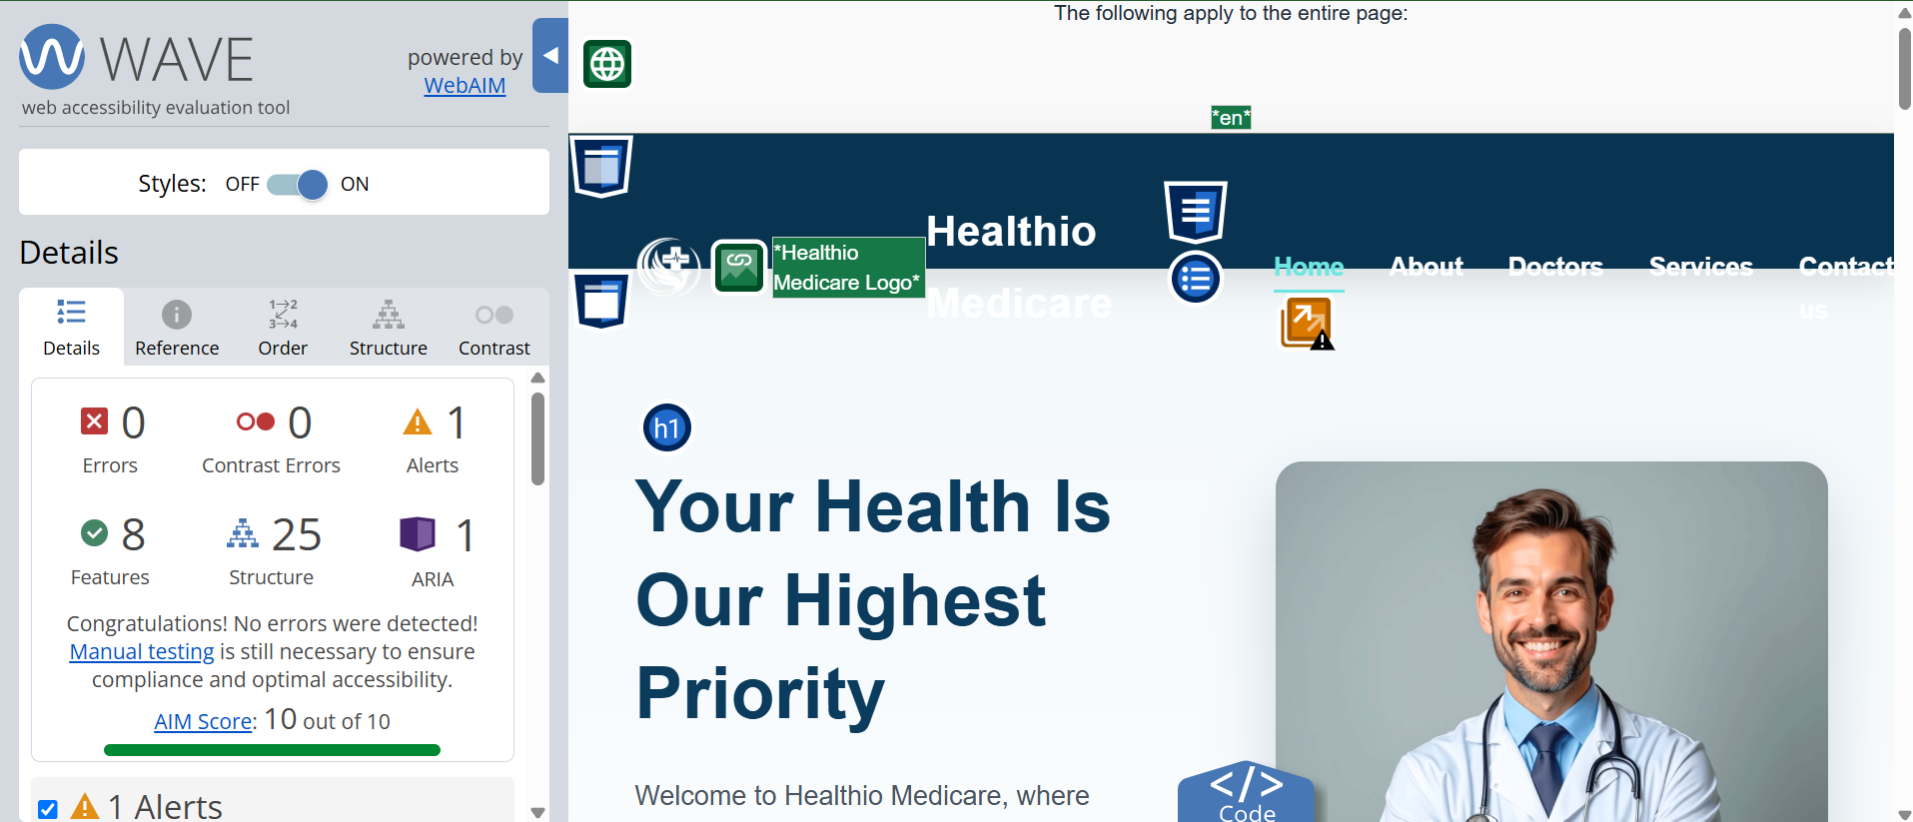
Figure 9: WAVE accessibility report of Healthio Medicare
Table 1: Healthio Medicare against WCAG principles
WCAG principle | How it was addressed in Healthio Medicare
Perceivable | All images have descriptive alternative text; text colour was adjusted to meet the required contrast ratio; a hidden heading was added so that every section has a title for screen-reader users.
Operable | The navigation can be used with a keyboard alone. The mobile menu button was made reachable by keyboard, and closed pop-up forms are kept out of the keyboard order until opened.
Understandable | The page language is declared, the navigation is identical on every page, and every form field has a matching label so its purpose is clear.
Robust | All five pages pass W3C validation with no errors, and the site uses standard, semantic HTML that works reliably with assistive technologies.

5. Comparison of website
In this report, two websites named Midland Health (midlandhealth.co.uk), and Private Medical Clinic Birmingham (privatemedicalclinic.com) are compared against their usability, accessibility, search engine optimisation, and mobile friendliness, and finally the concluding remarks are given.

5.1. Usability
Midland Health has a professional and detailed website layout. The depth of information it provides is one of its main strengths, with a vast array of services provided on the site spanning from GP consultations to specialist clinics. But this is also the primary point of weakness where it falls short in terms of usability. The navigation menu is very extensive, and many sublevels have dozens of links. This is where it can become difficult to find a single service for a first-time visitor, and it can be overwhelming the first time. The Private Medical Clinic site is simple and cohesive in layout. It has a simpler navigation system, with fewer, well-focused headings to scan. The key actions, such as “Book Online” and the clinic's phone number, are prominent at the top of the page for a visitor to easily complete the primary action of making an appointment. t has clearly defined sections with short text blocks, and the pricing is mentioned upfront, enhancing user experience.

5.2. Accessibility
Accessibility was tested using the WAVE tool extension (wave.webaim.org). The same tool was applied to both websites, and the results were related to the four principles of WCAG 2.1: Perceivable, Operable, Understandable and Robust.
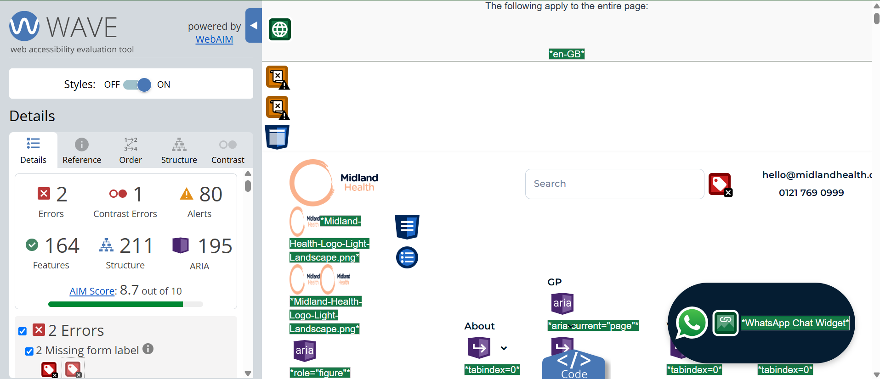
Figure 10: WAVE accessibility result for Midland Health
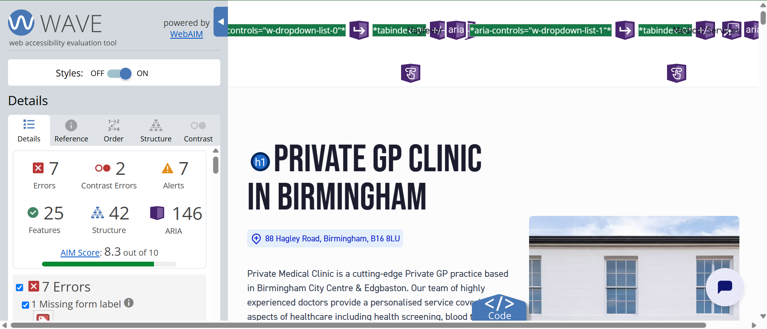
Figure 11: WAVE accessibility result for Private Medical Clinic
Midland Health returned 2 errors and 1 contrast error, with an AIM score of 8.7 out of 10. Private Medical Clinic returned 7 errors and 2 contrast errors, with an AIM score of 8.3 out of 10. On this measure, Midland Health is the more accessible of the two websites, as it has fewer errors and a higher overall score.
Table 2: Error related to WCAG 2.1 principles
Issue found by WAVE | WCAG 2.1 principle affected
Missing form label (both sites) | Understandable
Low-contrast text (both sites) | Perceivable
Alerts, e.g. possible heading or link issues (mainly Midland Health) | Operable / Robust (to review)

5.3. Search engine optimisation
The on-page SEO of each website was examined by viewing its page source and checking four features: the title tag, the meta description, the alternative text on images, and the heading structure.
Table 3: Comparison of two similar websites
SEO feature | Midland Health | Private Medical Clinic
Title tag | Present and descriptive: “Private GP Services Birmingham | Private Medical Centre Edgbaston” | Present and descriptive: “Private GP Birmingham | Same Day Appointments from £49”
Meta description | Present, clearly summarising the service | Present, including price and location keywords
Alt text on images | Present on many images, though some images use empty alt text | Present on key images with descriptive text
Heading structure | One main H1 heading followed by H2 and H3 sub-headings in order | One main H1 heading followed by H2 and H3 sub-headings in order
Extra SEO features | Open Graph and Twitter tags, canonical link, structured menu | Open Graph and Twitter tags, canonical link, local area links
Both websites apply strong on-page SEO. Each has a clear, keyword-rich title tag and a meta description, both of which help the site appear well in search results. Both use a single main heading followed by ordered sub-headings, and both include social-media (Open Graph) tags that control how the page looks when shared.

5.4. Mobile Friendliness
The browser developer tools (F12) were used to check mobile display as they will provide a display of each page on a phone-sized screen.

Figure 12: Mobile view of Midland Health

Figure 13: Mobile view of Private Medical Clinic
Both mobile views are demonstrated via a screenshot. Both websites are responsive and adjust to a mobile screen. Main navigation menu collapses into a single menu button; text is legible without zooming; images resize to fit the narrow screen. They have a viewport element in their coding, and that's the one that will be used for most phones to automatically scale the page to fit their screen. A minor difference is that Midland Health has such a large menu that the mobile menu has a very long list of links that may take a length of time to scroll through.

5.5. Overall Judgement
Both websites are properly professional and effective, though one is more so than the other. Private Medical Clinic was easier to use, with clearer navigation and booking options displayed, whilst Midland Health was more accessible, as it had fewer WAVE errors (2 compared with 7) and higher AIM scores (8.7 compared with 8.3). Their performance is comparable with respect to SEO and mobile-friendliness. Overall, Private Medical Clinic is a better site for a typical clinic visitor, as ease of use is the most critical factor for bookings, while Midland Health would be better for someone who prefers use of depth of information for bookings.

6. References
[1] R. Garett, J. Chiu, L. Zhang, and S. D. Young, “A Literature Review: Website Design and User Engagement,” Online J Commun Media Technol, vol. 6, no. 3, pp. 1–14, Jul. 2016.
[2] J. J. Gale et al., “An Analysis of US Academic Medical Center Websites: Usability Study,” Journal of Medical Internet Research, vol. 23, no. 12, p. e27750, Dec. 2021, doi: 10.2196/27750.
[3] S. Gartland et al., “The State of Web Accessibility for People with Cognitive Disabilities: A Rapid Evidence Assessment,” Behav Sci (Basel), vol. 12, no. 2, p. 26, Jan. 2022, doi: 10.3390/bs12020026.
[4] W3C, “Web Content Accessibility Guidelines (WCAG) 2.1.” Accessed: Jul. 22, 2026. [Online]. Available: https://www.w3.org/TR/WCAG21/
[5] WebAIM, “WebAIM: The WebAIM Million - The 2026 report on the accessibility of the top 1,000,000 home pages.” Accessed: Jul. 22, 2026. [Online]. Available: https://webaim.org/projects/million/
[6] U. F. Ahmad, J. Mahdee, and N. Abu Bakar, “Search engine optimisation (SEO) strategy as determinants to enhance the online brand positioning,” F1000Res, vol. 11, p. 714, Feb. 2024, doi: 10.12688/f1000research.73382.2.
[7] C. Ziakis, M. Vlachopoulou, T. Kyrkoudis, and M. Karagkiozidou, “Important Factors for Improving Google Search Rank,” Future Internet, vol. 11, no. 2, p. 32, Feb. 2019, doi: 10.3390/fi11020032.
[8] N. S. Aziz, N. S. Sulaiman, W. N. I. T. M. Hassan, N. L. Zakaria, and A. Yaacob, “A Review of Website Measurement for Website Usability Evaluation,” J. Phys.: Conf. Ser., vol. 1874, no. 1, p. 012045, May 2021, doi: 10.1088/1742-6596/1874/1/012045.
[9] T. P. Thyvalikakath, V. Monaco, H. Thambuganipalle, and T. Schleyer, “Comparative study of heuristic evaluation and usability testing methods,” Stud Health Technol Inform, vol. 143, pp. 322–327, 2009.
[10] J. Lorincz, K. Barišić, and V. Vlahović, “Usability Testing and the System Usability Scale Effectiveness Assessment on Different Sensing Devices of Prototype and Live Web System Counterpart,” Sensors (Basel), vol. 26, no. 2, p. 679, Jan. 2026, doi: 10.3390/s26020679.

7. Appendices
Appendix A (SEO screenshot)
(About Page)



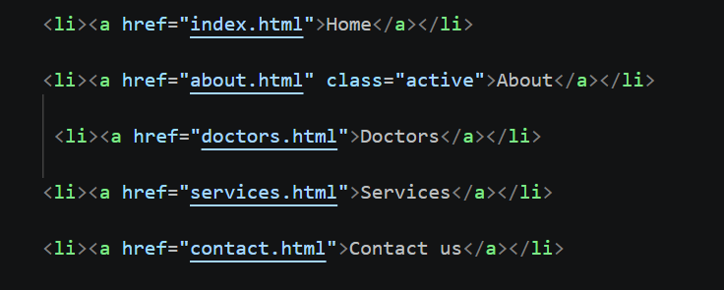

(Home page)


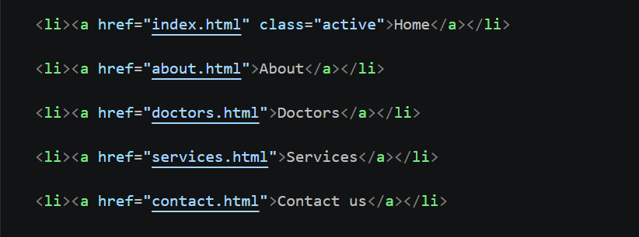

(Doctors page)




.

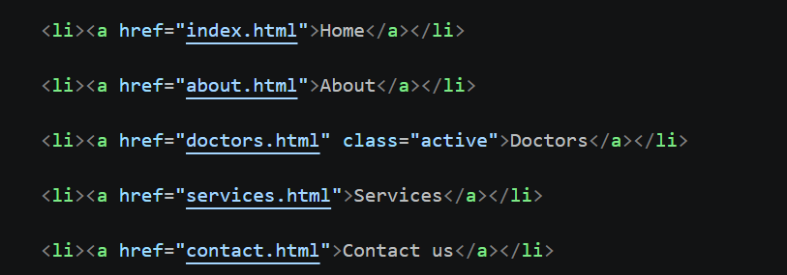

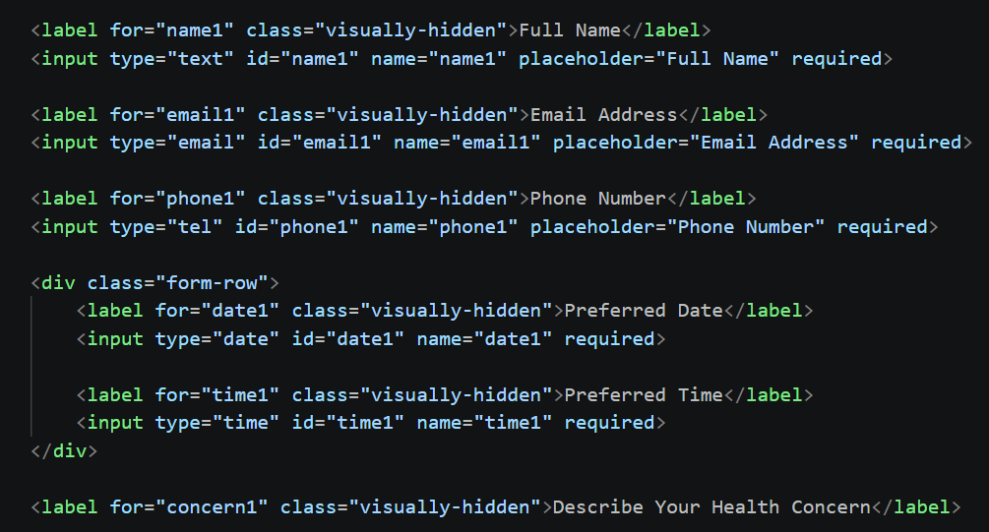



(Services Page)



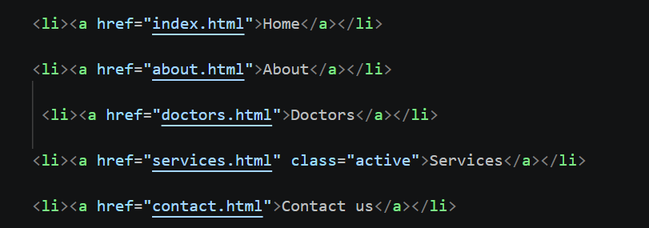


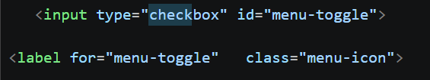

(Contact Page)







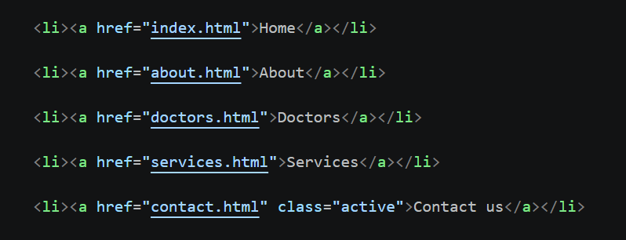

Appendix B (Copy and paste HTML & CSS Code)

Index.html code
<!DOCTYPE html>
<html lang="en">

<head>
<meta charset="UTF-8">
<meta name="viewport" content="width=device-width, initial-scale=1.0">
<title>Healthio Medicare | Home</title>
<meta name="description" content="Healthio Medicare
provides trusted GP consultations, health checkups
and family healthcare in Edgbaston, Birmingham.">

<link rel="stylesheet" href="css/style.css">
</head>

<body>

<!-- HEADER -->

<header>

<div class="container">

<div class="logo">

<a href="index.html">

<img src="images/logo.png" alt="Healthio Medicare Logo">

<span class="logo-text">Healthio Medicare</span>

</a>

</div>
<input type="checkbox" id="menu-toggle">

<label for="menu-toggle" class="menu-icon">
<span class="visually-hidden">Menu</span>
<span aria-hidden="true">&#9776;</span>
</label>

<nav>

<ul>

<li><a href="index.html" class="active">Home</a></li>

<li><a href="about.html">About</a></li>

<li><a href="doctors.html">Doctors</a></li>

<li><a href="services.html">Services</a></li>

<li><a href="contact.html">Contact us</a></li>

</ul>

</nav>

</div>

</header>

<!-- HERO SECTION -->
<main>
<section class="hero">

<div class="container hero-content">

<div class="hero-text">

<h1>Your Health Is Our Highest Priority</h1>

<p>

Welcome to Healthio Medicare, where compassionate care
meets professional medical excellence. We are committed
to providing trusted healthcare services in a safe,
welcoming, and comfortable environment for every patient.

</p>

<a href="services.html" class="btn">
Explore Services
</a>

</div>

<div class="hero-image">

<img src="images/hero.png" alt="Doctor at Healthio Medicare">

</div>

</div>

</section>

<!-- INTRO SECTION -->

<section class="intro">

<div class="container">

<div class="section-title">

<h2>Welcome to Healthio Medicare</h2>

<p>

We believe quality healthcare should be accessible,
reliable, and patient-centered. Our clinic provides
modern medical care with experienced professionals
who genuinely care about your health.

</p>

</div>

</div>

</section>

<section class="clinic-banner">
<h2 class="visually-hidden">Our Clinic</h2>

<img src="images/clinic-banner.png" alt="The Healthio Medicare clinic
reception area with waiting chairs and a welcome desk">

</section>

<!-- WHY CHOOSE US -->

<section class="features">

<div class="container">

<div class="section-title">

<h2>Why Choose Us</h2>

<p>

We focus on delivering trusted healthcare services
while ensuring every patient feels respected,
valued, and cared for.

</p>

</div>

<div class="feature-grid">

<div class="feature-card">
<img src="images/doctor-team.jpg" class="card-image" alt="Four
doctors in white coats reviewing a patient chart together">

<h3>Experienced Medical Team</h3>

<p>

Our healthcare professionals are committed to delivering
compassionate and reliable medical care using modern
practices.

</p>

</div>

<div class="feature-card">
<img src="images/patient-care.png" class="card-image" alt="A
doctor listening to a patient during a consultation">

<h3>Patient-Centered Care</h3>

<p>

Every patient receives personalized attention with treatment
plans designed according to individual healthcare needs.

</p>

</div>

<div class="feature-card">
<img src="images/clinic-room.jpeg" class="card-image" alt="A clean,
modern consultation room with an examination bed">

<h3>Comfortable Environment</h3>

<p>

We maintain a clean, welcoming, and friendly atmosphere
where patients feel safe and supported.

</p>

</div>

</div>

</div>

</section>

<!-- SERVICES PREVIEW -->

<section class="home-services">

<div class="container">

<div class="section-title">

<h2>Our Core Services</h2>

<p>

Healthio Medicare offers essential healthcare services
with a commitment to quality, professionalism,
and patient satisfaction.

</p>

</div>

<div class="service-grid">

<div class="service-card">

<h3>General Consultation</h3>

<p>

Professional health consultations for routine checkups,
illness diagnosis, and preventive healthcare.

</p>

</div>

<div class="service-card">

<h3>Preventive Care</h3>

<p>

Regular health assessments that help detect health
concerns early and promote long-term wellness.

</p>

</div>

<div class="service-card">

<h3>Family Healthcare</h3>

<p>

Comprehensive healthcare services for individuals and
families of all age groups.

</p>

</div>

</div>

</div>

</section>
<!-- OUR VALUES -->

<section class="values">

<div class="container">

<div class="section-title">

<h2>Our Commitment</h2>

<p>

At Healthio Medicare, we strive to build long-lasting
relationships with our patients through trust, respect,
and quality healthcare.

</p>

</div>

<div class="value-grid">

<div class="value-card">

<h3>Compassion</h3>

<p>

We treat every patient with kindness, empathy, and
respect, ensuring they receive the attention they
deserve.
</p>

</div>

<div class="value-card">

<h3>Integrity</h3>

<p>

We maintain honesty, transparency, and professionalism in
every healthcare service we provide.

</p>

</div>

<div class="value-card">

<h3>Excellence</h3>

<p>

Our team continuously works to deliver healthcare
services that meet the highest standards of quality.

</p>

</div>

</div>

</div>

</section>

<!-- CALL TO ACTION -->

<section class="cta">

<div class="container">

<h2>Your Health Deserves Professional Care</h2>

<p>

Learn more about our healthcare services and discover how
Healthio Medicare is committed to supporting your well-being.

</p>

<a href="contact.html" class="btn">
Contact Us
</a>

</div>

</section>
</main>

<!-- FOOTER -->

<footer>

<div class="container footer-container">

<div class="footer-box">

<h3>Healthio Medicare</h3>

<p>

Providing trusted healthcare services with compassion,
professionalism, and excellence.

</p>

</div>

<div class="footer-box">
<h3>Quick Links</h3>

<ul>
<li><a href="index.html">Home</a></li>
<li><a href="about.html">About</a></li>
<li><a href="doctors.html">Doctors</a></li>
<li><a href="services.html">Services</a></li>
<li><a href="contact.html">Contact us</a></li>
</ul>
</div>

<div class="footer-box">

<h3>Contact Information</h3>

<p>Email: info@healthiomedicare.com</p>

<p>Phone: +44 7700 900123</p>

<p>Address: House No. 27, Willow Court, 84 Bristol Road,
Edgbaston, Birmingham, West Midlands, B5 7XH,
United Kingdom</p>

</div>

</div>

<div class="footer-bottom">

<p>

&copy; 2026 Healthio Medicare. All Rights Reserved.

</p>

</div>

</footer>
</body>

</html>

About.html code
<!DOCTYPE html>
<html lang="en">

<head>

<meta charset="UTF-8">

<meta name="viewport" content="width=device-width, initial-scale=1.0">

<title>Healthio Medicare | About</title>
<meta name="description" content="Learn about Healthio Medicare, our mission, vision and values, and our commitment to compassionate patient-centred healthcare in Birmingham.">

<link rel="stylesheet" href="css/style.css">

</head>

<body>

<header>

<div class="container">

<div class="logo">

<a href="index.html">

<img src="images/logo.png" alt="Healthio Medicare Logo">

<span class="logo-text">Healthio Medicare</span>

</a>

</div>
<input type="checkbox" id="menu-toggle">

<label for="menu-toggle" class="menu-icon">
<span class="visually-hidden">Menu</span>
<span aria-hidden="true">&#9776;</span>
</label>

<nav>

<ul>

<li><a href="index.html">Home</a></li>

<li><a href="about.html" class="active">About</a></li>

<li><a href="doctors.html">Doctors</a></li>

<li><a href="services.html">Services</a></li>

<li><a href="contact.html">Contact us</a></li>

</ul>

</nav>

</div>

</header>
<main>

<section class="page-banner">

<div class="container">

<h1>About Healthio Medicare</h1>

<p>
Compassionate healthcare with professionalism, trust, and excellence.
</p>

</div>

</section>

<section class="about-section">

<div class="container about-content">

<div class="about-text">

<h2>Who We Are?</h2>

<p>

Healthio Medicare is dedicated to providing high-quality healthcare
services in a welcoming and patient-friendly environment. Our
experienced medical professionals focus on delivering reliable,
ethical, and compassionate care for individuals and families.

</p>

<p>

We believe that every patient deserves respect, personal attention,
and professional treatment. Our goal is to support healthier lives
by offering trusted healthcare services with modern medical
standards.

</p>

</div>

<div class="about-image">

<img src="images/about.jpg" alt="Healthio Medicare">

</div>

</div>

</section>

<section class="mission">

<div class="container">

<div class="section-title">

<h2>Our Mission, Vision & Values</h2>

<p>

We are committed to delivering quality healthcare while maintaining
trust, integrity, and compassion in everything we do.

</p>

</div>

<div class="mission-grid">

<div class="mission-card">

<h3>Our Mission</h3>

<p>

To provide accessible, patient-centered healthcare through
professional medical services and compassionate care.

</p>

</div>

<div class="mission-card">

<h3>Our Vision</h3>

<p>

To become a trusted healthcare provider recognized for
excellence, innovation, and patient satisfaction.

</p>

</div>

<div class="mission-card">

<h3>Our Values</h3>

<p>

Integrity, respect, teamwork, professionalism, and continuous
improvement guide every service we provide.

</p>

</div>

</div>

</div>

</section>
<section class="features">

<div class="container">

<div class="section-title">

<h2>Why Choose Healthio Medicare?</h2>

<p>

We are committed to providing dependable healthcare services with
professionalism, compassion, and respect for every patient.

</p>

</div>

<div class="feature-grid">

<div class="feature-card">

<h3>Qualified Healthcare Professionals</h3>

<p>

Our experienced medical team is dedicated to providing quality
healthcare services using modern medical practices.

</p>

</div>

<div class="feature-card">

<h3>Patient-Focused Care</h3>

<p>

We listen carefully to every patient and provide personalized
healthcare solutions based on individual needs.

</p>

</div>

<div class="feature-card">

<h3>Safe & Comfortable Environment</h3>

<p>

Our clinic offers a clean, welcoming, and comfortable
environment where patients feel valued and cared for.

</p>

</div>

</div>

</div>

</section>

<section class="cta">

<div class="container">

<h2>Your Well-Being Is Our Priority</h2>

<p>

Learn more about our healthcare services or contact our team for
further information.

</p>

<a href="contact.html" class="btn">Contact Us</a>

</div>

</section>
</main>

<!-- footer -->

<footer>

<div class="container footer-container">

<div class="footer-box">

<h3>Healthio Medicare</h3>

<p>

Delivering trusted healthcare services with compassion,
professionalism, and excellence.

</p>

</div>

<div class="footer-box">
<h3>Quick Links</h3>

<ul>
<li><a href="index.html">Home</a></li>
<li><a href="about.html">About</a></li>
<li><a href="doctors.html">Doctors</a></li>
<li><a href="services.html">Services</a></li>
<li><a href="contact.html">Contact us</a></li>
</ul>
</div>

<div class="footer-box">

<h3>Contact Information</h3>

<p>Email: info@healthiomedicare.com</p>

<p>Phone: +44 7700 900123</p>

<p>Address: House No. 27, Willow Court, 84 Bristol Road, Edgbaston,
Birmingham, West Midlands, B5 7XH, United Kingdom</p>

</div>

</div>

<div class="footer-bottom">

<p>&copy; 2026 Healthio Medicare. All Rights Reserved.</p>

</div>

</footer>

</body>

</html>

Doctors.html code

<!DOCTYPE html>
<html lang="en">

<head>

<meta charset="UTF-8">

<meta name="viewport" content="width=device-width, initial-scale=1.0">

<title>Healthio Medicare | Doctors</title>
<meta name="description" content="Meet the specialist doctors at Healthio Medicare, including neurology, cardiology, paediatrics, dermatology, orthopaedics and gynaecology.">

<link rel="stylesheet" href="css/style.css">

</head>

<body>

<!-- HEADER -->

<header>

<div class="container">

<div class="logo">

<a href="index.html">

<img src="images/logo.png" alt="Healthio Medicare Logo">

<span class="logo-text">Healthio Medicare</span>

</a>

</div>
<input type="checkbox" id="menu-toggle">

<label for="menu-toggle" class="menu-icon">
<span class="visually-hidden">Menu</span>
<span aria-hidden="true">&#9776;</span>
</label>

<nav>

<ul>

<li><a href="index.html">Home</a></li>

<li><a href="about.html">About</a></li>

<li><a href="doctors.html" class="active">Doctors</a></li>

<li><a href="services.html">Services</a></li>

<li><a href="contact.html">Contact us</a></li>

</ul>

</nav>

</div>

</header>

<!-- PAGE BANNER -->
<main>

<section class="page-banner">

<div class="container">

<h1>Meet Our Medical Specialists</h1>

<p>

Our experienced doctors are committed to delivering exceptional
healthcare with compassion, expertise, and personalized treatment
for every patient.

</p>

</div>

</section>

<!-- DOCTORS -->

<section class="doctors-section">

<div class="container">

<div class="section-title">

<h2>Our Specialist Doctors</h2>

<p>

Our highly qualified medical professionals provide trusted,
modern, and patient-focused healthcare using the latest
medical practices and technology.

</p>

</div>

<div class="doctor-grid">

<!-- Doctor 1 -->

<div class="doctor-card">

<img src="images/doctor1.png" alt="Dr. Ahmed Khan, Neurologist">

<h3>Dr. Ahmed Khan</h3>

<h4>Neurologist</h4>

<p><strong>Experience:</strong> 12 Years</p>

<p><strong>Qualification:</strong> MBBS, FCPS (Neurology)</p>

<p>

Dr. Ahmed Khan specializes in diagnosing and treating
disorders of the brain, spinal cord, and nervous system.
He is committed to providing compassionate care and
accurate treatment plans for every patient.

</p>

<a href="#appointment1" class="appointment-btn">

Book Appointment

</a>

</div>

<!-- Doctor 2 -->

<div class="doctor-card">

<img src="images/doctor2.png" alt="Dr. Amelia Turner, Pediatric Specialist">

<h3>Dr. Amelia Turner</h3>

<h4>Pediatric Specialist</h4>

<p><strong>Experience:</strong> 9 Years</p>

<p><strong>Qualification:</strong> MBBS, DCH</p>

<p>

Dr. Amelia Turner provides comprehensive healthcare for
infants, children, and adolescents while focusing on
preventive care and healthy development.

</p>

<a href="#appointment2" class="appointment-btn">

Book Appointment

</a>

</div>
<!-- Doctor 3 -->

<div class="doctor-card">

<img src="images/doctor3.png" alt="Dr. James Thompson, Cardiology Consultant">

<h3>Dr. James Thompson</h3>

<h4>Cardiology Consultant</h4>

<p><strong>Experience:</strong> 15 Years</p>

<p><strong>Qualification:</strong> MBBS, FCPS (Cardiology)</p>

<p>

Dr. James Thompson is an experienced cardiologist dedicated to
diagnosing and treating heart diseases using advanced
medical technology and patient-centered care.

</p>

<a href="#appointment3" class="appointment-btn">

Book Appointment

</a>

</div>

<!-- Doctor 4 -->

<div class="doctor-card">

<img src="images/doctor4.png" alt="Dr. Sarah Noor, Dermatologist">

<h3>Dr. Sarah Noor</h3>

<h4>Dermatologist</h4>

<p><strong>Experience:</strong> 10 Years</p>

<p><strong>Qualification:</strong> MBBS, MCPS (Dermatology)</p>

<p>

Dr. Sarah Noor specializes in skin, hair, and nail care,
providing modern dermatological treatments with a focus
on healthy and confident living.

</p>

<a href="#appointment4" class="appointment-btn">

Book Appointment

</a>

</div>
<!-- Doctor 5 -->

<div class="doctor-card">

<img src="images/doctor5.png" alt="Dr. James Wilson, Orthopedic Surgeon">

<h3>Dr. James Wilson</h3>

<h4>Orthopedic Surgeon</h4>

<p><strong>Experience:</strong> 13 Years</p>

<p><strong>Qualification:</strong> MBBS, MS (Orthopedics)</p>

<p>

Dr. James Wilson specializes in treating bone, joint, muscle, and sports injuries using advanced orthopedic care.

</p>

<a href="#appointment5" class="appointment-btn">

Book Appointment

</a>

</div>
<!-- Doctor 6 -->

<div class="doctor-card">

<img src="images/doctor6.png" alt="Dr. Olivia Smith, Gynecologist">

<h3>Dr. Olivia Smith</h3>

<h4>Gynecologist</h4>

<p><strong>Experience:</strong> 11 Years</p>

<p><strong>Qualification:</strong> MBBS, FCPS (Gynecology)</p>

<p>

Dr. Olivia Smith provides expert healthcare for women, including maternity care, reproductive health, and preventive treatment.

</p>

<a href="#appointment6" class="appointment-btn">

Book Appointment

</a>

</div>

</div>

</div>

</section>

<!-- CALL TO ACTION -->

<section class="cta">

<div class="container">

<h2>Your Health Deserves the Best Care</h2>

<p>

Our experienced specialists are committed to delivering
compassionate, reliable, and high-quality healthcare for
patients of every age.

</p>

<a href="contact.html" class="btn">

Contact Our Clinic

</a>

</div>

</section>

<!-- Doctor 1 Popup -->

<div id="appointment1" class="popup">

<div class="popup-content">

<a href="#" class="close">&times;</a>

<h2>Book Appointment</h2>

<p class="popup-subtitle">
Appointment with <strong>Dr. Ahmed Khan</strong><br>
<span>Neurologist</span>
</p>

<form>
<label for="name1" class="visually-hidden">Full Name</label>
<input type="text" id="name1" name="name1" placeholder="Full Name" required>

<label for="email1" class="visually-hidden">Email Address</label>
<input type="email" id="email1" name="email1" placeholder="Email Address" required>

<label for="phone1" class="visually-hidden">Phone Number</label>
<input type="tel" id="phone1" name="phone1" placeholder="Phone Number" required>

<div class="form-row">
<label for="date1" class="visually-hidden">Preferred Date</label>
<input type="date" id="date1" name="date1" required>

<label for="time1" class="visually-hidden">Preferred Time</label>
<input type="time" id="time1" name="time1" required>
</div>

<label for="concern1" class="visually-hidden">Describe Your Health Concern</label>
<textarea id="concern1" name="concern1" placeholder="Describe Your Health Concern" rows="4"></textarea>
<button type="submit" class="popup-btn">

Confirm Appointment

</button>

</form>

</div>

</div>

<!-- Doctor 2 Popup -->

<div id="appointment2" class="popup">

<div class="popup-content">

<a href="#" class="close">&times;</a>

<h2>Book Appointment</h2>

<p class="popup-subtitle">
Appointment with <strong>Dr. Amelia Turner</strong><br>
<span>Pediatric Specialist</span>
</p>

<form>
<label for="name2" class="visually-hidden">Full Name</label>
<input type="text" id="name2" name="name2" placeholder="Full Name" required>

<label for="email2" class="visually-hidden">Email Address</label>
<input type="email" id="email2" name="email2" placeholder="Email Address" required>

<label for="phone2" class="visually-hidden">Phone Number</label>
<input type="tel" id="phone2" name="phone2" placeholder="Phone Number" required>

<div class="form-row">
<label for="date2" class="visually-hidden">Preferred Date</label>
<input type="date" id="date2" name="date2" required>

<label for="time2" class="visually-hidden">Preferred Time</label>
<input type="time" id="time2" name="time2" required>
</div>

<label for="concern2" class="visually-hidden">Describe Your Health Concern</label>
<textarea id="concern2" name="concern2" placeholder="Describe Your Health Concern" rows="4"></textarea>
<button type="submit" class="popup-btn">

Confirm Appointment

</button>

</form>

</div>

</div>
<!-- Doctor 3 Popup -->

<div id="appointment3" class="popup">

<div class="popup-content">

<a href="#" class="close">&times;</a>

<h2>Book Appointment</h2>

<p class="popup-subtitle">

Appointment with <strong>Dr. James Thompson</strong><br>

<span>Cardiology Consultant</span>

</p>

<form>
<label for="name3" class="visually-hidden">Full Name</label>
<input type="text" id="name3" name="name3" placeholder="Full Name" required>

<label for="email3" class="visually-hidden">Email Address</label>
<input type="email" id="email3" name="email3" placeholder="Email Address" required>

<label for="phone3" class="visually-hidden">Phone Number</label>
<input type="tel" id="phone3" name="phone3" placeholder="Phone Number" required>

<div class="form-row">
<label for="date3" class="visually-hidden">Preferred Date</label>
<input type="date" id="date3" name="date3" required>

<label for="time3" class="visually-hidden">Preferred Time</label>
<input type="time" id="time3" name="time3" required>
</div>

<label for="concern3" class="visually-hidden">Describe Your Health Concern</label>
<textarea id="concern3" name="concern3" placeholder="Describe Your Health Concern" rows="4"></textarea>
<button type="submit" class="popup-btn">

Confirm Appointment

</button>

</form>

</div>

</div>

<!-- Doctor 4 Popup -->

<div id="appointment4" class="popup">

<div class="popup-content">

<a href="#" class="close">&times;</a>

<h2>Book Appointment</h2>

<p class="popup-subtitle">

Appointment with <strong>Dr. Sarah Noor</strong><br>

<span>Dermatologist</span>

</p>

<form>
<label for="name4" class="visually-hidden">Full Name</label>
<input type="text" id="name4" name="name4" placeholder="Full Name" required>

<label for="email4" class="visually-hidden">Email Address</label>
<input type="email" id="email4" name="email4" placeholder="Email Address" required>

<label for="phone4" class="visually-hidden">Phone Number</label>
<input type="tel" id="phone4" name="phone4" placeholder="Phone Number" required>

<div class="form-row">
<label for="date4" class="visually-hidden">Preferred Date</label>
<input type="date" id="date4" name="date4" required>

<label for="time4" class="visually-hidden">Preferred Time</label>
<input type="time" id="time4" name="time4" required>
</div>

<label for="concern4" class="visually-hidden">Describe Your Health Concern</label>
<textarea id="concern4" name="concern4" placeholder="Describe Your Health Concern" rows="4"></textarea>
<button type="submit" class="popup-btn">

Confirm Appointment

</button>

</form>

</div>

</div>
<!-- Doctor 5 popoup -->
<div id="appointment5" class="popup">

<div class="popup-content">

<a href="#" class="close">&times;</a>

<h2>Book Appointment</h2>

<p class="popup-subtitle">

Appointment with <strong>Dr. James Wilson</strong><br>

<span>Orthopedic Surgeon</span>

</p>

<form>
<label for="name5" class="visually-hidden">Full Name</label>
<input type="text" id="name5" name="name5" placeholder="Full Name" required>

<label for="email5" class="visually-hidden">Email Address</label>
<input type="email" id="email5" name="email5" placeholder="Email Address" required>

<label for="phone5" class="visually-hidden">Phone Number</label>
<input type="tel" id="phone5" name="phone5" placeholder="Phone Number" required>

<div class="form-row">
<label for="date5" class="visually-hidden">Preferred Date</label>
<input type="date" id="date5" name="date5" required>

<label for="time5" class="visually-hidden">Preferred Time</label>
<input type="time" id="time5" name="time5" required>
</div>

<label for="concern5" class="visually-hidden">Describe Your Health Concern</label>
<textarea id="concern5" name="concern5" placeholder="Describe Your Health Concern" rows="4"></textarea>
<button type="submit" class="popup-btn">

Confirm Appointment

</button>

</form>

</div>

</div>
<!-- Doctor 6 popup -->
<div id="appointment6" class="popup">

<div class="popup-content">

<a href="#" class="close">&times;</a>

<h2>Book Appointment</h2>

<p class="popup-subtitle">

Appointment with <strong>Dr. Olivia Smith</strong><br>

<span>Gynecologist</span>

</p>

<form>
<label for="name6" class="visually-hidden">Full Name</label>
<input type="text" id="name6" name="name6" placeholder="Full Name" required>

<label for="email6" class="visually-hidden">Email Address</label>
<input type="email" id="email6" name="email6" placeholder="Email Address" required>

<label for="phone6" class="visually-hidden">Phone Number</label>
<input type="tel" id="phone6" name="phone6" placeholder="Phone Number" required>

<div class="form-row">
<label for="date6" class="visually-hidden">Preferred Date</label>
<input type="date" id="date6" name="date6" required>

<label for="time6" class="visually-hidden">Preferred Time</label>
<input type="time" id="time6" name="time6" required>
</div>

<label for="concern6" class="visually-hidden">Describe Your Health Concern</label>
<textarea id="concern6" name="concern6" placeholder="Describe Your Health Concern" rows="4"></textarea>
<button type="submit" class="popup-btn">

Confirm Appointment

</button>

</form>

</div>

</div>
</main>
<!-- FOOTER -->

<footer>

<div class="container footer-container">

<div class="footer-box">

<h3>Healthio Medicare</h3>

<p>

Delivering trusted healthcare services with compassion,
professionalism, and excellence.

</p>

</div>

<div class="footer-box">
<h3>Quick Links</h3>

<ul>
<li><a href="index.html">Home</a></li>
<li><a href="about.html">About</a></li>
<li><a href="doctors.html">Doctors</a></li>
<li><a href="services.html">Services</a></li>
<li><a href="contact.html">Contact us</a></li>
</ul>
</div>

<div class="footer-box">

<h3>Contact Information</h3>

<p>Email: info@healthiomedicare.com</p>

<p>Phone: +44 7700 900123</p>

<p>Address: House No. 27, Willow Court, 84 Bristol Road, Edgbaston,
Birmingham, West Midlands, B5 7XH, United Kingdom</p>

</div>

</div>

<div class="footer-bottom">

<p>&copy; 2026 Healthio Medicare. All Rights Reserved.</p>

</div>

</footer>

</body>

</html>

Services.html code
<!DOCTYPE html>
<html lang="en">

<head>

<meta charset="UTF-8">

<meta name="viewport" content="width=device-width, initial-scale=1.0">

<title>Healthio Medicare | Services</title>
<meta name="description" content="Healthio Medicare offers general consultations, health checkups, vaccinations, diagnostic imaging, laboratory and emergency care services.">

<link rel="stylesheet" href="css/style.css">

</head>

<body>

<header>

<div class="container">

<div class="logo">

<a href="index.html">

<img src="images/logo.png" alt="Healthio Medicare Logo">

<span class="logo-text">Healthio Medicare</span>

</a>

</div>
<input type="checkbox" id="menu-toggle">

<label for="menu-toggle" class="menu-icon">
<span class="visually-hidden">Menu</span>
<span aria-hidden="true">&#9776;</span>
</label>

<nav>

<ul>

<li><a href="index.html">Home</a></li>

<li><a href="about.html">About</a></li>

<li><a href="doctors.html">Doctors</a></li>

<li><a href="services.html" class="active">Services</a></li>

<li><a href="contact.html">Contact us</a></li>

</ul>

</nav>

</div>

</header>
<main>

<section class="page-banner">

<div class="container">

<h1>Our Services</h1>

<p>

Quality healthcare services designed to support your health and well-being.

</p>

</div>

</section>

<section class="services-section">

<div class="container">

<div class="section-title">

<h2>Healthcare Services We Provide</h2>

<p>

Healthio Medicare offers a range of healthcare services delivered by
experienced professionals in a safe and welcoming environment.

</p>

</div>

<div class="service-grid">

<div class="service-card">

<h3>General Consultation</h3>

<p>

Comprehensive medical consultations for routine health concerns,
diagnosis, and treatment guidance.

</p>

</div>

<div class="service-card">

<h3>Health Checkups</h3>

<p>

Regular health examinations that help monitor your overall
health and detect potential medical conditions early.

</p>

</div>

<div class="service-card">

<h3>Preventive Care</h3>

<p>

Preventive healthcare services that encourage healthy living
and reduce future health risks.

</p>

</div>

<div class="service-card">

<h3>Family Healthcare</h3>

<p>

Healthcare services for children, adults, and senior family
members under one trusted clinic.

</p>

</div>

<div class="service-card">

<h3>Vaccination Services</h3>

<p>

Safe vaccination services that support disease prevention
and long-term community health.

</p>

</div>

<div class="service-card">

<h3>Diagnostic Imaging</h3>

<p>

Modern imaging services, including X-rays and ultrasound
scans, for accurate diagnosis and patient care.

</p>

</div>
<div class="service-card">

<h3>Laboratory Services</h3>

<p>

We provide reliable blood tests, urine tests, and other laboratory investigations with accurate and timely results.

</p>

</div>
<div class="service-card">

<h3>Emergency Care</h3>

<p>

Our emergency care team is available to provide immediate medical attention for urgent health conditions and injuries.

</p>

</div>
<div class="service-card">

<h3>Pharmacy Services</h3>

<p>

Our in-house pharmacy provides prescribed medicines and healthcare products with professional guidance for safe use.

</p>

</div>

</div>

</div>

</section>
<section class="values">

<div class="container">

<div class="section-title">

<h2>Why Choose Our Services?</h2>

<p>

We are committed to providing reliable healthcare services that
focus on patient safety, quality treatment, and compassionate care.

</p>

</div>

<div class="value-grid">

<div class="value-card">

<h3>Professional Care</h3>

<p>

We provide expert medical care with professionalism and compassion.
Your health, comfort, and well-being are our top priorities.

</p>

</div>

<div class="value-card">

<h3>Modern Healthcare</h3>

<p>

We follow modern healthcare practices include advanced diagnostic technology, digital
patient records, preventive care methods, and evidence-based treatments.

</p>

</div>

<div class="value-card">

<h3>Patient Satisfaction</h3>

<p>

We strive to ensure every patient feels comfortable,
informed, and confident throughout their visit.

</p>

</div>

</div>

</div>

</section>

<section class="cta">

<div class="container">

<h2>We're Here to Support Your Health</h2>

<p>

Whether you need a routine consultation or preventive healthcare,
our team is ready to assist you with professional medical services.

</p>

<a href="contact.html" class="btn">Contact Us</a>

</div>

</section>
</main>
<!-- footer -->

<footer>

<div class="container footer-container">

<div class="footer-box">

<h3>Healthio Medicare</h3>

<p>

Providing trusted healthcare services with compassion,
professionalism, and excellence.

</p>

</div>

<div class="footer-box">
<h3>Quick Links</h3>

<ul>
<li><a href="index.html">Home</a></li>
<li><a href="about.html">About</a></li>
<li><a href="doctors.html">Doctors</a></li>
<li><a href="services.html">Services</a></li>
<li><a href="contact.html">Contact us</a></li>
</ul>
</div>

<div class="footer-box">

<h3>Contact Information</h3>

<p>Email: info@healthiomedicare.com</p>

<p>Phone: +44 7700 900123</p>

<p>Address: House No. 27, Willow Court, 84 Bristol Road, Edgbaston,
Birmingham, West Midlands, B5 7XH, United Kingdom</p>

</div>

</div>

<div class="footer-bottom">

<p>&copy; 2026 Healthio Medicare. All Rights Reserved.</p>

</div>

</footer>

</body>

</html>

Contact.html code
<!DOCTYPE html>
<html lang="en">

<head>

<meta charset="UTF-8">

<meta name="viewport" content="width=device-width, initial-scale=1.0">

<title>Healthio Medicare | Contact</title>
<meta name="description" content="Contact Healthio Medicare in Edgbaston, Birmingham. Find our phone number, email address and clinic opening hours for appointments.">

<link rel="stylesheet" href="css/style.css">

</head>

<body>

<header>

<div class="container">

<div class="logo">

<a href="index.html">

<img src="images/logo.png" alt="Healthio Medicare Logo">

<span class="logo-text">Healthio Medicare</span>

</a>

</div>
<input type="checkbox" id="menu-toggle">

<label for="menu-toggle" class="menu-icon">
<span class="visually-hidden">Menu</span>
<span aria-hidden="true">&#9776;</span>
</label>

<nav>

<ul>

<li><a href="index.html">Home</a></li>

<li><a href="about.html">About</a></li>

<li><a href="doctors.html">Doctors</a></li>

<li><a href="services.html">Services</a></li>

<li><a href="contact.html" class="active">Contact us</a></li>

</ul>

</nav>

</div>

</header>
<main>

<section class="page-banner">

<div class="container">

<h1>Contact Us</h1>

<p>

We are always here to answer your questions and support your healthcare needs.

</p>

</div>

</section>

<section class="contact-section">

<div class="container contact-container">

<div class="contact-info">

<h2>Get In Touch</h2>

<p>

If you have any questions regarding our healthcare services,
feel free to contact us. Our team will be happy to assist you.

</p>

<p><strong>Address:</strong><br>
House No. 27, Willow Court, 84 Bristol Road, Edgbaston,
Birmingham, West Midlands, B5 7XH, United Kingdom</p>

<p><strong>Phone:</strong><br>
+44 7700 900123</p>

<p><strong>Email:</strong><br>
info@healthiomedicare.com</p>

<p><strong>Working Hours:</strong><br>
Monday – Saturday<br>
9:00 AM – 6:00 PM</p>

</div>

<div class="contact-form">

<h2>Send Us a Message</h2>

<form action="#">

<label for="fullname" class="visually-hidden">Full Name</label>
<input
type="text"
id="fullname"
name="fullname"
placeholder="Full Name"
required>

<label for="email" class="visually-hidden">Email Address</label>
<input
type="email"
id="email"
name="email"
placeholder="Email Address"
required>

<label for="phone" class="visually-hidden">Phone Number</label>
<input
type="tel"
id="phone"
name="phone"
placeholder="Phone Number"
required>

<label for="subject" class="visually-hidden">Subject</label>
<input
type="text"
id="subject"
name="subject"
placeholder="Subject"
required>

<label for="message" class="visually-hidden">Your Message</label>
<textarea
id="message"
name="message"
placeholder="Write your message here..."
required></textarea>

<button type="submit" class="btn">

Send Message

</button>

</form>

</div>

</div>

</section>
<section class="cta">

<div class="container">

<h2>Your Health Matters to Us</h2>

<p>

We are committed to providing quality healthcare services with
professionalism, compassion, and patient-centered care. Feel free
to contact us for any questions or assistance.

</p>

<a href="services.html" class="btn">Explore Our Services</a>

</div>

</section>
</main>

<!-- footer -->

<footer>

<div class="container footer-container">

<div class="footer-box">

<h3>Healthio Medicare</h3>

<p>

Delivering trusted healthcare services with compassion,
professionalism, and excellence.

</p>

</div>

<div class="footer-box">

<h3>Quick Links</h3>

<div class="quick-links">

<ul>
<li><a href="index.html">Home</a></li>
<li><a href="about.html">About</a></li>
<li><a href="doctors.html">Doctors</a></li>
</ul>

<ul>
<li><a href="services.html">Services</a></li>
<li><a href="contact.html">Contact us</a></li>
</ul>

</div>

</div>

<div class="footer-box">

<h3>Contact Information</h3>

<p>Email: info@healthiomedicare.com</p>

<p>Phone: +44 7700 900123</p>

<p>Address: House No. 27, Willow Court, 84 Bristol Road, Edgbaston,
Birmingham, West Midlands, B5 7XH, United Kingdom</p>

</div>

</div>

<div class="footer-bottom">

<p>&copy; 2026 Healthio Medicare. All Rights Reserved.</p>

</div>

</footer>

</body>

</html>

Style.css code
/* Reset */

*{
margin:0;
padding:0;
box-sizing:border-box;
}

html{
scroll-behavior:smooth;
}

body{
font-family:Arial, Helvetica, sans-serif;
background:#F4F9FC;
color:#1F2937;
line-height:1.7;
}

.container{
width:90%;
max-width:1200px;
margin:auto;
}

a{
text-decoration:none;
color:inherit;
}

img{
display:block;
max-width:100%;
}

/* Header */

header{
background:#093451;
position:sticky;
top:0;
z-index:1000;
box-shadow:0 8px 25px rgba(0,0,0,.12);
height: 90px;

}

header .container{
display:flex;
justify-content:space-between;
align-items:center;
padding:18px 0;
height: 100%;
}

.logo a{
display:flex;
align-items:center;
justify-content: center;
gap:0%;

}

.logo img{
object-fit:contain;
width: 60px;
height: 60px;
vertical-align: middle;
position: relative;
}

.logo .logo-text{
color:#FFFFFF;
font-size:28px;
font-weight:700;
letter-spacing:.5px;

}

nav ul{
display:flex;
list-style:none;
gap:30px;
}

nav ul li a{
color:#FFFFFF;
font-size:17px;
font-weight:600;
padding-bottom:6px;
transition:.35s;
border-bottom:2px solid transparent;
}

nav ul li a:hover,
nav ul li a.active{
color:#6EE7E1;
border-bottom:2px solid #6EE7E1;
}

/* Common */

section{
padding:80px 0;
}

.page-banner{
background:linear-gradient(135deg,#0B3C5D,#119DA4);
color:#FFFFFF;
text-align:center;
padding:95px 20px;
}

.page-banner h1{
font-size:42px;
margin-bottom:15px;
}

.page-banner p{
max-width:720px;
margin:auto;
font-size:18px;
color:#F8FAFC;
}

.section-title{
text-align:center;
margin-bottom:55px;
padding-bottom: 15px;
}

.section-title h2{
font-size:38px;
color:#0B3C5D;
margin-bottom:15px;
}

.section-title p{
max-width:760px;
margin:auto;
color:#4B5563;
font-size:17px;
}

/* Hero */

.hero{
background:linear-gradient(to bottom,#F4F9FC,#FFFFFF);
padding: 40px 0 80px;

}

.hero-content{
display:grid;
grid-template-columns:repeat(2,1fr);
gap:60px;
align-items:center;
}

.hero-text h1{
color:#0B3C5D;
font-size:48px;
line-height:1.3;
margin-bottom:22px;
}

.hero-text p{
color:#4B5563;
font-size:18px;
margin-bottom:35px;
}

.hero-image img{
border-radius:18px;
box-shadow:0 18px 45px rgba(11,60,93,.18);
}

/* Buttons */

.btn{
display:inline-block;
background:#0e4e79;
color:#FFFFFF;
padding:15px 34px;
border-radius:10px;
font-weight:bold;
transition:.35s;
box-shadow:0 8px 20px rgba(17,157,164,.25);
}

.btn:hover{
background:#0B3C5D;
transform:translateY(-3px);
box-shadow:0 12px 28px rgba(11,60,93,.25);
}
/* Intro */

.intro{
padding-top:30px;
padding-bottom: 10px;
}

/* Cards */

.feature-grid,
.service-grid,
.value-grid,
.mission-grid{
display:grid;
grid-template-columns:repeat(3,1fr);
gap:30px;
}

.feature-card,
.service-card,
.value-card,
.mission-card{
background:#FFFFFF;
padding:35px;
border-radius:18px;
text-align:center;
border:1px solid #d7e7f2;
box-shadow:0 10px 25px rgba(11,60,93,.08);
transition:.35s;
overflow:hidden;
position:relative;
}

.feature-card::before,
.service-card::before,
.value-card::before,
.mission-card::before{
content:"";
position:absolute;
top:0;
left:0;
width:100%;
height:5px;
background:linear-gradient(90deg,#119DA4,#0B3C5D);
}

.feature-card:hover,
.service-card:hover,
.value-card:hover,
.mission-card:hover,
.doctor-card:hover{

background:#EDFDFC;
transform:translateY(-10px);
box-shadow:0 18px 40px rgba(17,157,164,.18);

}

.feature-card h3,
.service-card h3,
.value-card h3,
.mission-card h3{

color:#0B3C5D;
margin-bottom:15px;
font-size:24px;
margin-top: 35px;
}

.feature-card p,
.vice-card p,
.value-card p,
.mission-card p{

color:#4B5563;

}

/* About */

.about{
background:#F9FCFD;
}

.about-content{

display:grid;
grid-template-columns:repeat(2,1fr);
gap:60px;
align-items:center;

}

.about-text h2{

color:#0B3C5D;
font-size:36px;
margin-bottom:20px;

}

.about-text p{

color:#4B5563;
margin-bottom:18px;

}

.about-image img{

border-radius:18px;
border:5px solid #FFFFFF;
box-shadow:0 20px 45px rgba(11,60,93,.15);

}

/* Services */

.services{

background:#FFFFFF;

}

.service-card{

cursor:pointer;

}

.service-card:hover{

background:#EDFDFC;

}

/* Values */

.values{

background:#F5FBFC;
padding: 20px 0;

}

/* Mission */

.mission{

background:#FFFFFF;

}
/* Doctors */

.doctors-section{
background:#F4F9FC;
}

.doctor-grid{
display:grid;
grid-template-columns:repeat(2,1fr);
gap:35px;
}

.doctor-card{
background:#FFFFFF;
padding:35px;
border-radius:18px;
text-align:center;
border:1px solid #D7EAF2;
box-shadow:0 12px 28px rgba(11,60,93,.08);
transition:.35s;
position:relative;
overflow:hidden;
}

.doctor-card::before{
content:"";
position:absolute;
top:0;
left:0;
width:100%;
height:6px;
background:linear-gradient(90deg,#119DA4,#0B3C5D);
}

.doctor-card:hover{
background:#F2FCFC;
transform:translateY(-10px);
box-shadow:0 20px 45px rgba(17,157,164,.18);
}

.doctor-card img{
width:180px;
height:180px;
object-fit:cover;
border-radius:50%;
margin:0 auto 20px;
border:3px solid #119DA4;
transition:.35s;
}

.doctor-card:hover img{
border-color:#0B3C5D;
transform:scale(1.05);
}

.doctor-card h3{
color:#0B3C5D;
margin-bottom:8px;
font-size:24px;
}

.doctor-card h4{
color:#0E7F86;
margin-bottom:15px;
font-size:17px;
font-weight:600;
}

.doctor-card p{
color:#4B5563;
margin-bottom:10px;
line-height:1.7;
}

/* Contact */

.contact{
background:#FFFFFF;
}

.contact-container{
display:grid;
grid-template-columns:repeat(2,1fr);
gap:60px;
align-items:start;
}

.contact-info{
background:#0B3C5D;
color:#FFFFFF;
padding:40px;
border-radius:18px;
box-shadow:0 18px 40px rgba(11,60,93,.18);
}

.contact-info h2{
margin-bottom:20px;
font-size:34px;
}

.contact-info p{
margin-bottom:18px;
color:#E5F4F6;
}

.contact-info strong{
color:#6EE7E1;
}

.contact-form{
background:#FFFFFF;
padding:40px;
border-radius:18px;
border:1px solid #D7EAF2;
box-shadow:0 12px 30px rgba(11,60,93,.08);
}

.contact-form h2{
color:#0B3C5D;
margin-bottom:25px;
font-size:34px;
}

.contact-form form{
display:flex;
flex-direction:column;
gap:18px;
}

.contact-form input,
.contact-form textarea{
width:100%;
padding:15px;
border:1px solid #C7DCE5;
border-radius:10px;
outline:none;
font-size:16px;
background:#FAFCFD;
transition:.3s;
}

.contact-form input:focus,
.contact-form textarea:focus{
border-color:#119DA4;
background:#FFFFFF;
box-shadow:0 0 12px rgba(17,157,164,.20);
}

.contact-form textarea{
min-height:170px;
resize:vertical;
}

.contact-form button{
border:none;
cursor:pointer;
}
/* CTA */

.cta{
background:linear-gradient(135deg,#0B3C5D,#119DA4);
color:#FFFFFF;
text-align:center;
padding:90px 20px;
}

.cta h2{
font-size:42px;
margin-bottom:20px;
font-weight:700;
}

.cta p{
max-width:700px;
margin:0 auto 35px;
font-size:18px;
color:#EAF8FA;
}

.cta .btn{
background:#FFFFFF;
color:#0B3C5D;
border:2px solid #FFFFFF;
box-shadow:0 12px 25px rgba(255,255,255,.20);
}

.cta .btn:hover{
background:#6EE7E1;
color:#0B3C5D;
border-color:#63e6df;
}

/* Footer */

footer{
background:#083552;
color:#FFFFFF;
padding-top:70px;
}

.footer-container{
display:grid;
grid-template-columns: 1.2fr 0.9fr 1.2fr;
gap:30px;

}

.footer-box{
padding:5px;
}

.footer-box h3{
color:#6EE7E1;
margin-bottom:22px;
font-size:24px;
position:relative;
display:inline-block;

}

.footer-box h3::after{
content:"";

position:absolute;

left:0;

bottom:-10px;

width:100%;

height:4px;

background:#63E6E2;

border-radius:5px;
}

.footer-box p{
color:#D8E8ED;
margin-bottom:14px;
line-height:1.8;
}

.footer-box ul{
list-style:none;
}

.footer-box ul li{
margin-bottom:14px;
}

.footer-box ul li a{
color:#EAF8FA;
transition:.3s;
}

.footer-box ul li a:hover{
color:#6EE7E1;
padding-left:8px;
}

.footer-box i{
color:#6EE7E1;
margin-right:8px;
}

.footer-bottom{
margin-top:55px;
border-top:1px solid rgba(255, 255, 255, 0.12);
padding:22px 0;
text-align:center;
}

.footer-bottom p{
color:#C8DCE3;
font-size:15px;
letter-spacing:.3px;

}

.clinic-banner{
padding:10px 0 30px;

}

.clinic-banner img{
width:70%;
max-width:1200px;
height:auto;
display:block;
margin:auto;
object-fit:cover;
border-radius:20px;
box-shadow:0 10px 30px rgba(0,0,0,0.15);

}
.feature-card{
position:relative;
overflow:visible;
transition:0.4s;
}

.card-image{

width:110px;
height:110px;

border-radius:50%;

object-fit:cover;

position:absolute;

top:-60px;
left:50%;

transform:translateX(-50%) scale(.5);

opacity:0;

border:2px solid #239092;

box-shadow:0 15px 35px rgba(0,0,0,.25);

transition:.5s;
}

.feature-card:hover{

transform:translateY(-12px);

background:#0B3C5D;

color:white;

}

.feature-card:hover h3,
.feature-card:hover p{

color:white;

}

.feature-card:hover .card-image{

opacity:1;

transform:translateX(-50%) scale(1);

}
/* Appointment Button */

.appointment-btn{

display:inline-block;

margin-top:20px;

padding:12px 24px;

background:#0B3C5D;

color:#fff;

text-decoration:none;

border-radius:8px;

font-weight:600;

transition:.4s;

}

.appointment-btn:hover{

background:#119DA4;

transform:translateY(-3px);

}

/* Popup Box */

.popup-content{

width:500px;

background:#fff;

padding:35px;

border-radius:18px;

position:relative;

animation:popup .4s ease;

}

/* Animation */

@keyframes popup{

from{

transform:scale(.8);

opacity:0;

}

to{

transform:scale(1);

opacity:1;

}

}

/* Close Button */

.close{

position:absolute;

top:15px;

right:20px;

font-size:30px;

text-decoration:none;

color:#444;

}

.close:hover{

color:red;

}

/* Heading */

.popup-content h2{

color:#0B3C5D;

margin-bottom:8px;

}

.popup-content h3{

margin-bottom:25px;

color:#0E7F86;

}

/* Form Inputs */

.popup-content input,

.popup-content textarea{

width:100%;

padding:12px;

margin-bottom:15px;

border:1px solid #ccc;

border-radius:8px;

font-size:15px;

outline:none;

}

.popup-content textarea{

height:100px;

resize:none;

}

.popup-content button{

width:100%;

padding:14px;

background:#0B3C5D;

color:white;

border:none;

border-radius:8px;

cursor:pointer;

font-size:16px;

font-weight:bold;

transition:.4s;

}

.popup-content button:hover{

background:#119DA4;

}

/* POPUP */

.popup{

position:fixed;

inset:0;

display:flex;

justify-content:center;

align-items:center;

background:rgba(0,0,0,.45);

backdrop-filter:blur(8px);

opacity:0;

visibility:hidden;

transition:.35s;

z-index:9999;

}

.popup:target{

opacity:1;

visibility:visible;

}

/* POPUP BOX */

.popup-content{

width:85%;

max-width:460px;

max-height:80vh;

overflow-y:auto;

background:#fff;

border-radius:18px;

padding:25px;

position:relative;

animation:popup .35s ease;

box-shadow:0 20px 50px rgba(0,0,0,.25);

}

@keyframes popup{

from{

transform:translateY(25px);

opacity:0;

}

to{

transform:translateY(0);

opacity:1;

}

}

/* CLOSE BUTTON */

.close{

position:absolute;

top:15px;

right:20px;

font-size:30px;

text-decoration:none;

color:#555;

font-weight:bold;

}

.close:hover{

color:#0B3C5D;

}

/* POPUP HEADING */

.popup-content h2{

color:#0B3C5D;

margin-bottom:8px;

}

.popup-subtitle{

margin-bottom:25px;

color:#555;

line-height:1.6;

}

.popup-subtitle span{

color:#0E7F86;

font-weight:600;

}

/* FORM */

.popup-content form{

display:flex;

flex-direction:column;

gap:15px;

}

.popup-content input,

.popup-content textarea{

width:100%;

padding:13px 15px;

border:1px solid #d8d8d8;

border-radius:8px;

font-size:15px;

outline:none;

transition:.3s;

font-family:inherit;

}

.popup-content input:focus,

.popup-content textarea:focus{

border-color:#119DA4;

box-shadow:0 0 8px rgba(17,157,164,.2);

}

.form-row{

display:grid;

grid-template-columns:1fr 1fr;

gap:15px;

}

.popup-content textarea{

resize:none;

}

/* BUTTON */

.popup-btn{

border:none;

padding:14px;

border-radius:8px;

background:#0B3C5D;

color:#fff;

font-size:16px;

font-weight:600;

cursor:pointer;

transition:.35s;

}

.popup-btn:hover{

background:#119DA4;

}
.visually-hidden {
position: absolute;
width: 1px;
height: 1px;
padding: 0;
margin: -1px;
overflow: hidden;
clip-path: inset(50%);
white-space: nowrap;
border: 0;
}
#menu-toggle{
display:none;
}

.menu-icon{
display:none;
font-size:30px;
color:#fff;
cursor:pointer;
}

/* ================= Responsive ================= */

@media (max-width:992px){

.hero-content,
.about-content,
.contact-container{
grid-template-columns:1fr;
gap:40px;
text-align:center;
}

.feature-grid,
.service-grid,
.value-grid,
.mission-grid,
.footer-container{
grid-template-columns:repeat(2,1fr);
}

.doctor-grid{
grid-template-columns:repeat(2,1fr);
}

.hero-text h1{
font-size:40px;
}

.page-banner h1{
font-size:36px;
}

.section-title h2{
font-size:34px;
}

.contact-form button{
width:100%;
}

.features{
padding:30px 0;
}

.home-services{
padding:40px 0;
}

}

@media (max-width:768px){

header{
height:auto;
}

header .container{
padding:15px 20px;
display:flex;
justify-content:space-between;
align-items:center;
flex-wrap:wrap;
}

.logo a{
justify-content:center;
}

.logo img{
width:50px;
height:50px;
}

.logo-text{
font-size:22px;
}

.menu-icon{
display:block;
}
#menu-toggle{
display:block;
position:absolute;
opacity:0;
width:1px;
height:1px;
}
#menu-toggle:focus ~ .menu-icon{
outline:2px solid #FFFFFF;
outline-offset:3px;
}

nav{
display:none;
width:100%;
margin-top:15px;
}

#menu-toggle:checked ~ nav{
display:block;
}

nav ul{
display:flex;
flex-direction:column;
width:100%;
gap:0;
padding:0;
margin:0;
}

nav ul li{
width:100%;
text-align:center;
border-top:1px solid rgba(255,255,255,.15);
}

nav ul li a{
display:block;
padding:15px;
font-size:16px;
}

section{
padding:60px 0;
}

.hero{
padding:70px 0;
}

.hero-text h1{
font-size:34px;
}

.hero-text p,
.section-title p,
.cta p{
font-size:16px;
}

.page-banner{
padding:70px 20px;
}

.page-banner h1{
font-size:32px;
}

.about-text h2,
.contact-info h2,
.contact-form h2{
font-size:30px;
}

.cta h2{
font-size:32px;
}

.feature-grid,
.service-grid,
.value-grid,
.mission-grid,
.doctor-grid,
.footer-container{
grid-template-columns:1fr;
}

.form-row{
grid-template-columns:1fr;
}

.popup-content{
width:90%;
max-width:500px;
padding:25px;
}

.features{
padding:25px 0;
}

.home-services{
padding:30px 0;
}

.clinic-banner img{
width:90%;
}

}

@media (max-width:576px){

.popup-content{
width:95%;
padding:20px;
}

.features{
padding:20px 0;
}

.home-services{
padding:25px 0;
}

.clinic-banner img{
width:95%;
}

}

@media (max-width:480px){

.container{
width:92%;
}

.logo img{
width:45px;
height:45px;
}

.logo-text{
font-size:22px;
}

.hero{
padding:50px 0;
}

.hero-text h1{
font-size:28px;
}

.hero-text p{
font-size:15px;
}

.section-title h2{
font-size:28px;
}

.section-title p{
font-size:15px;
}

.feature-card,
.service-card,
.value-card,
.mission-card,
.doctor-card,
.contact-info,
.contact-form{
padding:25px;
}

.btn{
width:100%;
text-align:center;
padding:14px;
}

.footer-container{
gap:30px;
}

.footer-bottom{
padding:18px 0;
}

}

@media (max-width:400px){

.popup-content{
width:96%;
padding:18px;
}

.features{
padding:15px 0;
}

.home-services{
padding:20px 0;
}

}

