

Applied Leadership and Management in the Workplace
Module Assignment Submission
Student Name: | KIM BOUKERAS
Student Number: | 2226794
Module No: | BMSK 5013
Module Title: | Knowledge and Information Management Skills for the Workplace

Statement of Confirmation of Authenticity
By the act of making this submission, the student declares that this is the work of the student named above. The work has not, in whole or in part, been knowingly presented elsewhere for assessment, or where assessment has been built on a previous assessment, this has been identified. Where materials have been used from other sources it has been properly acknowledged. If this statement is untrue, the student acknowledges that an assessment offence has been committed. Attention is drawn to the plagiarism and unfair practice policies of both the University and of ILM.
TABLE OF CONTENTS
Contents
REPORT 3
1.1. INTRODUCTION 3
1.2. EXECUTIVE SUMMARY 3
2.1. Evaluating the concept of K.I.M. 3
(The concept and importance of knowledge management in the context of an organisation’s knowledge assets). 3
WHAT WE KNOW AND NEED TO KNOW 4
TACIT AND EXPLICIT KNOWLEDGE 5
VM (Visual Merchandising) 6
Tommy Clubs 7
2.2. Understanding K.I.M processes 7
(Important knowledge management processes in the context of organisational development). 7
2.3. Providing a framework for a K.I.M. culture. 9
2.3.1. The contribution of knowledge assets to an organisation: knowledge assets and intellectual property 9
I.P. (Intellectual Property) 9
GDPR (General Data Protection Regulation), 2016 9
FOIA (Freedom of Information Act) 10
Patents and Copyright 10
Social Media 10
2.3.2. Making better use of knowledge assets: establishing a K.I.M. culture 11
TRUST PYRAMID 11
INFORMATION CULTURE 11
3. CONCLUSIONS 13
4. REFERENCES 14

REPORT

FROM: KIM BOUKERAS
TO: COLLEAGUES AT TOMMY HILFIGER, BRIDGEND
SUBJECT: KNOWLEDGE AND INFORMATION MANAGEMENT (K.I.M.)

1.1. INTRODUCTION
I am an experienced sales associate at a branch of Tommy Hilfiger (TH) and the longest serving employee of this branch. TH is a very well-known international clothing brand. The store where I work is located in the McArthur Glen Designer Outlet in Bridgend. McArthur Glen Bridgend advertises itself as the largest designer outlet centre in the UK. Visitors to the centre are shopping in a highly regulated environment, where there are high profile stores along with cafés, restaurants, a play area and a cinema. For many people, shopping at the Designer Outlet is much more than a shopping trip, it is a day out, almost a type of tourism rather than just “shopping”, and people come from a very wide distance, often in organised groups.

1.2. EXECUTIVE SUMMARY
I have been asked to explain the concept of Knowledge and Information Management (K.I.M.) to see if there any lessons we could use in the workplace.
My findings are organised below under three main headings:

- Evaluating the concept of K.I.M.;
- Understanding K.I.M. processes;
- Providing a framework for a K.I.M. culture.

2.1. Evaluating the concept of K.I.M.

(The concept and importance of knowledge management in the context of an organisation’s knowledge assets).

In a recent class, we were asked: What are the relationships between data, information, and knowledge? And is there anything that I’ve learned in the last 12 months that can help me answer this question?

The first relevant idea that came into my mind from the last 12 months was Kolb’s Learning Cycle. Kolb’s theory explains that concrete experience, reflective observation, thinking about ideas or concepts, using your brain to try things out (active experimentation) gives a four-stage process or learning cycle which helps in transforming information into effective learning and effective action. (Kolb, 1984). Applying this theory has benefits to students, teachers and also to business organisations, where employers need to gather and process information every day. In the most effective organisations Kolb is also used for the benefit of employees. Businesses that process information effectively and reflect on experience to improve in the future are sometimes called “learning organisations” (Senge, 1990)

Reflection is very important if we want to turn data into useful information. I won’t repeat the Kolb Learning Cycle diagram here, however, later in this report I refer to something similar, a cycle diagram showing how information can be shared.
Here are some reflections of my own concerning information at my place of work, the Tommy Hilfiger store at the McArthur Glen Designer Outlet, Bridgend.

WHAT WE KNOW AND NEED TO KNOW
In class our lecturer showed us a design thinking model of four classes of knowledge and a very interesting diagram which shows two scales. One scale from left to right: the things we don’t know now and the things we know now. Another scale from top to bottom: things we will need to know and things we will not need to know.
This gives us 4 cells:
(1) Need to know, don’t know now. Example: at TH we need to constantly update through staff training so that we reduce waste control costs and become more efficient.
(2) Need to know, know now. Example: through our loyalty programme, we have information on our customers (see below).
(3) Don’t need to know, know now. Example: in the fashion trade old products are discarded. So we could throw this information away. However we could also keep this information and store it just in case it is needed again, as fashion often repeats itself. So, suppose there was a new interest in 1960s clothing, having an archive would give our company an advantage.
(4) Don’t need to know, don’t know now. I myself would say that it is impossible to know what we will need or not need in the future. There will be unpredicted changes for which we need to adapt rapidly, and we might need to bring in new skills and new knowledge and information from outside.
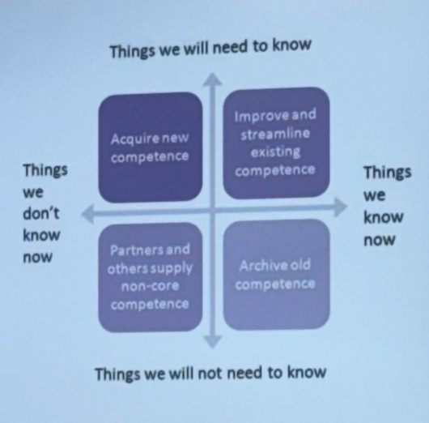
Something we know and also need to know is that in Bridgend Tommy Hilfiger is a part of the McArthur Glen outlet and this environment is always changing, for example due to shops closing and others opening. At the moment I think TH and other stores are going to feel an impact on sales because the food court is being refurbished and it will not re- open for a few months.

The store needs to track changes as there is information we definitely need to know going forward. This information is very important because Tommy Hilfiger has a high turnover and when customers come to McArthur Glen, they bring their children, and they make it a full day. It is not yet clear what the new food offer will be. This information will be important as it could affect visitor numbers and also the types of visitors, for example whether they will be individuals or couples or family groups.

The model reminds me of something said by Donald Rumsfeld, who was the United States Secretary of Defence in 2002 when the US and its partners were invading Iraq and he spoke about known unknowns and unknown unknowns. Many people laughed, but what he said was true. In life and business we have to expect the unexpected. Example: the way that Covid affected businesses. (Uncertainty project, n.d)

TACIT AND EXPLICIT KNOWLEDGE
I think the following model (Nonaka and Takeuchi, 1995) helps to understand the difference between tacit and explicit knowledge. This is another model with four “cells” but this one is dynamic not static. It moves in a cycle, similar in some ways to Kolb’s Learning Cycle which I mentioned earlier.

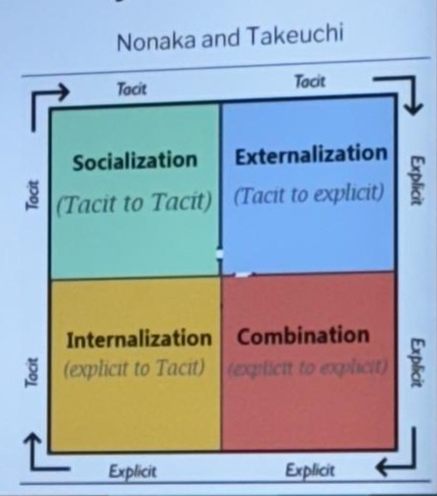

A manual can teach you how to use the gears and brakes and other controls on a car. This is explicit knowledge which exists out there for everyone who wants to use it. Tacit knowledge is my ability to use the controls and it comes from my own experience. To me tacit knowledge is what I know in my brain.

When a new starter begins work at TH they do have induction training but it is very basic, a health and safety video. For further training we log on to an app and do it ourselves. In the past newcomers were guided through a much more structured training. Nowadays newcomers are starting with very little explicit knowledge, and TH is relying on the tacit knowledge of experienced staff to be shared.

In many companies nowadays they talk of an “onboarding” process where newcomers are shown the existing explicit knowledge that they need. I would say that TH has gone backwards, considering they are a high-end brand. As an experienced sales associate and also the longest serving employee in my branch, I earn the same as a new 16 year old sales associate and I sometimes feel that I am being used as an unpaid staff trainer, as the store is relying on me to make my tacit knowledge explicit.

Tacit knowledge is useful to myself but only useful to others if I am willing to share it. An employer should not take this for granted. A company that recognises the importance of sharing tacit knowledge and builds this in properly to their training model and pay scales will do better in the long run, even though the short-term costs might look higher than relying on the good will of more experienced employees taking on an informational role.

Henry Mintzberg listed informational roles as one of three groups of roles which make a good leader (Mintzberg, 1997), the other roles being interpersonal and decisional roles. Within informational roles he listed three types of leaders: (1) a monitor, who collects data and keeps up to date; (2) a disseminator, who communicates with staff and shares information; (3) a spokesperson, who communicates with groups of stakeholders, and talks to the media and the outside world. In my present informal role I am a disseminator, but with training I think I have the capacity be a spokesperson, certainly when it comes to recruiting, onboarding, welcoming new people into the company, and getting them properly trained.

Two examples of my knowledge and information over several years working at TH are: Visual Merchandising and Tommy Clubs.

VM (Visual Merchandising)
This is largely to do with the presentation of stock. The data in this case would be a long list of stock available for the shop to sell. The information would be this list processed so that different items of stock are grouped into different categories. The tacit knowledge that I would contribute to make it explicit would be how to put these items into place to make that stock look how it is supposed to, and to catch the eye of the customer. This would include decisions on where to place items of different colours. Management has ideas about colour schemes that reflect the TH brand, and they change through the year and over the years. Clothes must be folded in a certain way, so they sit on the shelves and the presentation must be of an exceptional standard. Only two people in the store have the authority to do the folding and presenting. I was never actually trained, I am self-trained, but I trained the other person, who is the assistant manager. If a customer leaves a jumble of clothing in the fitting room another store member might be asked to sort it out, but my colleague or I will check the work to make sure the presentation is to the standard required.

Twice a year the head of VM will visit the store to share the latest information and ideas on how to make the clothes sell by “flipping” the shop. Flipping means that items are re-arranged, sections are redesigned so that if a customer comes into the store again in sixth months’ time everything will look presented in a fresh and interesting way. The basic image of TH is still there, but always looks fresh and updated.

Some failures in retailing, such as Marks and Spencer and Debenhams, might be partly due to a lack of updating in this way. While these shops built up an image of quality, they also had an image of being tired and outdated.

This VN concept is even more important because we are an outlet, which means that our clothes are a year behind the updated fashion found in the high street full price stores. If people know this, which I might actually tell customers, they accept it because they want the discounted price, but they also need to think they are still in fashion. So careful use of VM gives customers the feeling they are cutting edge, and that the brand name is something they value.

The other extreme would be “pile it high and sell it cheap”. TH will only do this on occasions of a one-off sale to clear surplus stock. This needs to be carefully controlled and it depends on keeping close track of what is in the storeroom and in the “cage” that we rent from McArthur Glen that contains stock. If the manager forgets what is held there, then that causes financial problems to the business as items that could have gone at full now end up at 90% off. Information gaps cost money.

Tommy Clubs
Like many other companies TH has a “loyalty programme” which offers customers incentives so that they share personal information which is very useful to the company. (Tommy Hilfiger Club, n.d.)

When a customer approaches the till with their items which they wish to purchase I will ask them if they would like to join the Tommy Club. If so, they will get 10% off their items. Most people do join the Tommy Club, but there are some who do not. The information that is needed to join is full name, date of birth and email address. That information that is stored means that TH can see how many customers come into the store, when they come, and what types of items they prefer. Going forward TH will send emails about new stock tailored to their choices, and discount vouchers, especially on their birthday. As this information is gathered TH can see how much money the store is making, and can also assess how different offers increase revenues, what marketing works and what does not including, discounts, sales and promotions. This is very valuable information if it is used intelligently.

2.2. Understanding K.I.M processes

(Important knowledge management processes in the context of organisational development).

I have gathered some information about Tommy Hilfiger and the information that I’ve found is that Tommy himself was a co-founder of The People’s Place store in New York in the 1970s, then he began to design their male clothing in the 1980s. In 1992 he began his women’s wear and perfume lines. He sold his company in 2006 for 1.2 billion dollars.

The general public probably think that the company is still owned by Tommy Hilfiger, his personal name is also a brand name, and it is a brand that is known all over the world. Until I did this research, I had not found out that Tommy Hilfiger did not own the brand anymore, and it is actually owned by a company called PVH. (PVH Corp., n.d.)

PVH claims to be one of the highest performing brand groups in the world. It owns a few brands some of which are better known in the USA than Europe, but which include Calvin Klein. (Company Histories.com, n.d.)

At Bridgend Designer Outlet, the Calvin Klein store is two doors down from TH. There is nothing there to suggest that the two brands are in any way related. The staff know because we work to the same wage rates and most customers probably have no idea they are both owned by PHV. The word “PHV” means little or nothing to them, what is important is the branding. The brand “Tommy Hilfiger” means something to them, it gives them an image. I would say that everyone, male or female love Tommy Hilfiger’s brand.

For about eight years Bridgend used to sell a Kids’ range, they used to sell really well, then the company decided in 2019 not to sell kid’s clothing at Bridgend, due to lack of space, and they said due to lack of demand, but people still come in everyday asking for kids’ clothing, and it is sold by TH at Mcarthur Glen outlets at Bicester, Cheshire Oaks, Swindon, and in Scotland and Northern Ireland. Bridgend is the only McArthur Glen in Wales, so I don’t understand why they don’t have the kid’s clothing range. I would risk trying a pop-up store for a trial period of say six months, and then full term if it does really well. This is the sort of information that should be shared between branches.

TH is a company of departments that are not always sharing information with each other. PVH as a company doesn’t seem always to run properly as each department has a job to do. For example the buying team does not always buy enough stock to share for each store and so does not have enough to do a run of new clothing. Then clothes end up not going on the shop floor, and in months to come they go into a sale. Therefore the company has lost money.

Payroll as a department hardly ever gets salary right as they underpay or overpay, especially when there is a bank holiday and you get owed time and a half, and this is a problem if they pay it in the next pay period and you end up getting taxed more for that month. Budgeting is important for staff because it is not a very well-paid job and even being over paid is a problem. It is very bad for staff morale. In my workplace people are not happy because the pay grade is very low. People on the outside might love to work for Tommy Hilfiger but when they do work for the company, they realise that it is not that great.

Nevertheless, people need to work so they get on and do their job. Having said that, the reviews online about TH Bridgend are usually very positive about the staff, describing a positive shopping experience with “kind, polite helpful staff”, which suggests that PVH should value their workforce more.

The facts and figures I have collected show a very complicated structure for the group. At one time it was owned by an equity group, which meant that it had no shareholders. These groups do not have to publish as much information as companies listed on the stock exchange. PVH shares are now sold on the USA stock exchange, which means that the public can have much more information about the company, its profits, and the property it owns. However, one thing is never mentioned in the accounts, and that is the value of the Tommy Hilfiger Brand. (Tommy.com, 2017)

The company knows how important the brand name is, and that is why Tommy Hilfiger himself still has a role in the group even though he no longer owns it. The brand name’s reputation is maintained by the front-line workers in the retail outlets who deal with customers and are the public face of the company. If better information sharing and better decisions based on this information, including decisions on staff working conditions and pay rates, supports the brand image of Tommy Hilfiger, then everyone wins, not just the top managers and shareholders.

2.3. Providing a framework for a K.I.M. culture.

2.3.1. The contribution of knowledge assets to an organisation: knowledge assets and intellectual property

I.P. (Intellectual Property)
Professor Michael Porter says that companies have to compete with each other, but they also have to cooperate, but without colluding. (Porter 1985). This means that sometimes they have to keep information to themselves, but some information needs be shared. However shared information should be in the public interest, so companies should not “collude” which means companies putting their heads together in order to fix prices and reduce competition so that the public are paying higher prices than they need. There are British and European laws against price fixing, so companies have to be careful about sharing this type of information (Griffiths and Wall, 2008).
An example of a previous lack of cooperation was the case of mobile phone chargers, with every company having its own design, which meant that consumers had to pay high prices for their cable due to one large company having a monopoly. The European Union passed a law saying that all companies should use a standard cable. (Gerken, Oct. 2022)
In retailing, an example of what would be very useful shared information would be better standardisation of sizes, so that size XL for example would be the same in every shop.
Company information nowadays is regulated by laws that have been passed by governments. Here are some examples.

GDPR (General Data Protection Regulation), 2016
This is to do with protecting people’s privacy, it sets guidelines for collecting and processing personal information. It was EU law, but Britain still uses it even though outside the EU. Any company dealing with European residents must obey these laws. (European Union, 2016)

FOIA (Freedom of Information Act)
The UK government also passed a Freedom of Information Act 2000. This law affects public bodies, rather than companies like Tommy Hilfiger, unless they have government contracts. However the holding company PVH is listed on the U.S. stock exchange and that means it has to share a certain amount of information by law. (UK government, 2000)

Patents and Copyright
Patents are usually for machines and inventions whose design can be registered so that other companies can only use them under licence paid to the inventor. In the clothing industry these would include manufacturing processes, and man-made materials, like polyester, which were developed by chemical industries.
Copyright laws cover the printed word, designs trademarks and logos. I would say that these are the most important Intellectual Property Rights (IPRs) for TH, as the company has spent millions of pounds and dollars over the years building up a brand name and any company trying to use a false logo to pass itself off as a TH brand is likely to find TH lawyers acting very quickly. (UK Copyright Service, n.d.)
In Britain, county councils have Trading Standards Officers who are on the lookout for counterfeiting activity. Internet trading is causing many problems with some companies based in China in particular being accused of counterfeiting. TEMU is a huge and fast growing company which has been accused of cutting prices by using forced labour and selling counterfeits. It is known to be a Chinese company, but the information it gives out seems to say it is headquartered in Boston, USA. (Paszkiewicz, Apr. 2024). Another counterfeiting problem was reported recently about false Royal Mail postage stamps, printed in China, being sold in corner shops. (Royal Mail, 2024)

Social Media
A lot of businesses use social media such Whatsapp or Messenger for sharing information, and Indeed is an app used for recruitment and head hunting. Instagram is used for social interaction as well as work. We had an “Influencer” in the store the other day taking pictures of a bag and cardigan. We were informed by the centre that she was on her way. McArthur Glen have previously been slow on the take-up of social media, but obviously now they are working with influencers and networkers.
Our management use Whatsapp every day for such things as visual merchandising and day to day correspondence with staff, and passing messages along the hierarchy.
In government and politics we have seen politicians get into big trouble by governing through Whatsapp, and perhaps companies should learn some lessons and be a bit cautious. The UK Government officially describes Government Knowledge and Informational Management (GKIM) as one of the “professions” that civil servants use so that the government runs the country effectively. I think the idea to have “joined up” thinking across departments is a good one. (Gov.UK)

2.3.2. Making better use of knowledge assets: establishing a K.I.M. culture

TRUST PYRAMID
The Trust Pyramid by Patrick Lencioni gives a framework for better ways of sharing knowledge assets in an organisation like TH, where teamwork is very important, and where people need to be trusted with information. He names five dysfunctions of a team which are obstacles to trust and five methods of overcoming them to create five desirable outcomes. (Lencioni, 2002)
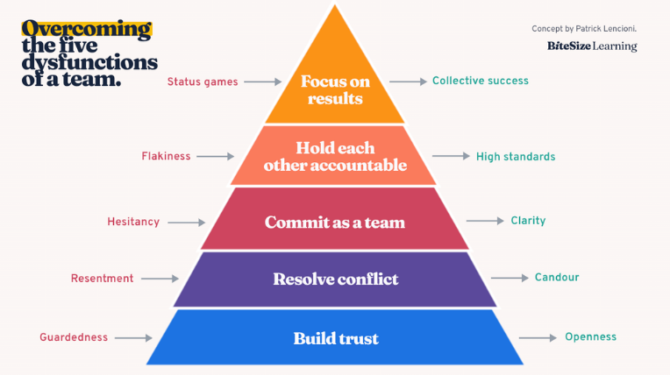

Everyone should feel important and equally valued. You want your team to come and talk to you without hesitancy, because a lot of people lack confidence and are afraid to speak. Those people have often got good ideas, but never get recognised because they are afraid, they won’t be listened to, or afraid their ideas will be dismissed as silly or rubbish. Often, it’s the quiet ones who have good ideas or useful information.

It is important that information should be shared. It is unhealthy to have one or two people in a team putting their heads together and sharing information that the rest of the team are excluded from. This undermines trust.

INFORMATION CULTURE
Du Plessis (2006) uses a diagram to say that a successful organisation needs to encourage staff to work effectively to come together to collaborate and share information.

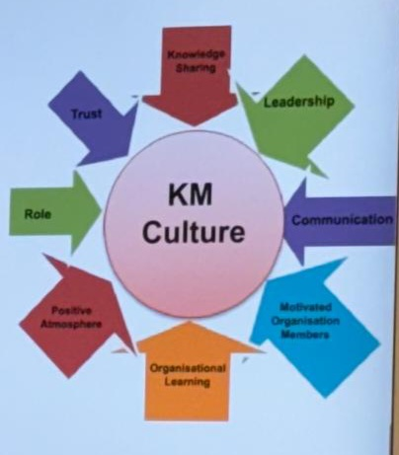

Knowledge sharing should be the normal way of doing things. It is wrong for certain people to “hoard” and hold bits of knowledge and keep it to themselves. I understand that sometimes people keep knowledge that they have acquired by hard work rather just give it away, but based on trust people will realise that there is give and take and sharing knowledge benefits everyone. Good leadership is given by someone very organised, so they know what information is needed where and when to get a job done. Communication is key, if information is not effectively communicated, nothing gets done. From my own experience in my workplace, motivation is very important and if a manager does not feel motivated it is demotivating for others, if they deliberately or unthinkingly communicate their own lack of motivation. For example I have worked with a manager who every day would say “I hate this place, I don’t want to be here”, and this is obviously very draining and puts myself and other team members into a negative frame of mind. So I would then take it on myself to create a lighter atmosphere to motivate colleagues to get us through the day. Even just a thank you goes a long way, a good boss knows that. Learning is to do with turning tacit knowledge into explicit knowledge. This needs to start at the top of the hierarchy. I would never criticise front line staff, if they don’t deal with the public properly, the fault lies with managers, a lack of leadership, training, knowledge sharing and communication. A positive atmosphere is closely related to motivation, a positive atmosphere shows respect to the work force. A workplace where people are ridiculed or made to feel small or where there is a blame culture is not only negative but demotivating and bad for business. It is important that people know their own roles, and also know what roles others have. Trust organisations are important because trust is one of the main things you should have in a workplace. Without this, things can deteriorate quickly. Symptoms of a lack of trust are things like strict clocking on and off, employees being on CCTV, strict timings for toilet breaks, etc. Positive ways of building trust include being consistent, showing appreciation, saying please and thank you, empowering team members with responsibilities, encouraging coaching (Information sharing) and giving feedback. (Achievers, Sept. 2023)

3. CONCLUSIONS

There is an old saying “Knowledge is power”. Everyone today has instant knowledge and can see huge amounts of information thanks to the internet and smartphones. But not all of that information is useful, and a lot of it is false. This is related to our previous module on “Critical Thinking”. Producers need reliable information so as to survive, and consumers need information so they can trust the companies and their products. In the retail trade where I work, it is the employees who link producers with consumers, and retail companies are more likely to succeed if they trust their employees with up to date and accurate information about what they are selling to the public.

4. REFERENCES

All internet sources accessed April 2024.

Achievers (Sept. 2023) 9 tips for building trust in the workplace, https://www.achievers.com/blog/building-trust-workplace/#:~:text=How%20to%20build%20trust%20in%20the%20workplace%201,8.%20Create%20an%20inclusive%20culture%20...%20More%20items

Company Histories.com (n.d.), Calvin Klein Inc. https://www.company-histories.com/Calvin-Klein-Inc-Company-History.html

Du Plessis (2006) The impact of organisational culture on knowledge management, Researchgate, https://www.researchgate.net/publication/286734489_The_Impact_of_Organisational_Culture_on_Knowledge_Management

European Union (2016) GDPR https://commission.europa.eu/law/law-topic/data-protection/data-protection-eu_en

Gerken, Thomas (4 October 2022) EU Parliament approves common charging cable from 2024 - BBC News

Gov.UK (n.d.) About us - Government Knowledge & Information Management Profession - GOV.UK (www.gov.uk)

Griffiths, A. and Wall, S. (2008), Economics for Business and Management, Prentice Hall

Kolb, David (1984), Experiential learning, Pearson

Lencioni, 2002, The Five dysfunctions of a team, quoted in Bite Size Learning https://www.bitesizelearning.co.uk/resources/five-dysfunctions-of-a-team-summary-pyramid

Mintzberg, H. (1997) The nature of managerial work, Pearson

Nonakua,I. and Takeuchi, H.(1995) The knowledge creating company: how Japanese companies create the dynamics of innovation, Oxford University Press.

Pakzkiewicz, Julian (April 2024) Kent illustrator's shock at finding design copies on Temu - BBC News

Porter, M. (1985) The competitive advantage of nations, Simon & Schuster

PVH Corp (n.d.) Company information https://pvh.com/

Royal Mail (2024) Stamp fraud - How can you spot counterfeit stamps? | Royal Mail Group Ltd

Rumsfeld Matrix, Uncertainty Project https://www.theuncertaintyproject.org/tools/rumsfeld-matrix

Senge, P. (1990), The Fifth Discipline, quoted in https://infed.org/mobi/peter-senge-and-the-learning-organization/

Tommy Hilfiger (n.d.) TH | Tommy Together | Tommy Hilfiger®️ UK

Tommy.com (2007) Biography and brand name https://newsroom.tommy.com/rockcircus-tommynow-2017-02-designer-bio/

UK Copyright Service (n.d), Copyrights, Trademarks and Logos, https://copyrightservice.co.uk/protect/logo_copyright

UK Government (2000) Freedom of Information, https://www.gov.uk/make-a-freedom-of-information-request

