
Identification of a Poka-Yoke System to Detect Incorrectly Seated Fuel Injector Connectors

Gareth John Hopkins (P144085)

University of Wales Trinity Saint David

School of Engineering

BENG Manufacturing Systems Engineering

2018

Declaration of Authenticity

This thesis is the result of the author’s original research. It has been composed by the author and has not been previously submitted for examination, which has led to the award of a degree.
Signed: Gareth Hopkins Date: 24th April 2018

Abstract

Incorrectly seated fuel injector connectors are the highest occurring warranty claim being made against the sigma production line at Ford Bridgend Engine Plant (BEP).To aid the project, literature relevant to Ford and their manufacturing operations was reviewed.
In this paper, the author aimed to further understand the financial and reputational impact this issue was having on BEP. Furthermore, using recognised problem solving methodology, namely DMAIC, verification of the root causes of this issue was sought and gained.
The primary objective of this paper was to investigate a suitable poka-yoke system that could prevent this issue from occurring. Using tools and analysis methods reviewed in the literature, the author developed specific criteria that such a poka-yoke system needed to meet. This enabled the author to compare suitable systems that were identified and further investigate only the ones that could achieve the projects objective.
Two poka-yoke systems were identified as being able to prevent this issue occurring. A click-hunter system, which detects the sound made by an OK connection and a vision system with the introduction of a connector position assurance (CPA) device.
Further investigation found both systems potentially deliver high accuracy although the click-hunter system was found to have a critical flaw if it was to be used on this process, its need for regular recalibration.
Based on the investigation, the author would recommend the use of a vision system with the introduction of a CPA device to the connector based on the high accuracy it offers for this process. This would prevent the issue occurring.
Acknowledgements are made to the potential a click-hunter system offers as a poka-yoke system, highlighting scenarios where it would be more suitable than a vision system. Recommendations are then made for scenarios more suitable for its use.

Table of Contents

Abstract III
Table of Contents IV
Table of Figures IX
1. Introduction 1
1.1. Company History 1
1.2. Background of the Project 2
1.3. Reason for Project 2
1.4. Aims and Objectives 2
1.5. Benefits 3
2. Literature Review 4
2.1. Introduction 4
2.2. Quality 4
2.2.1. Cost of Quality 5
2.2.1.1. Prevention, Appraisal and Failure Model 6
2.2.1.2. Opportunity Cost Models 6
2.2.2. Cost of Poor Quality 6
2.3. Six-Sigma 7
2.3.1. Define-Measure-Analyse-Improve-Control 8
2.3.1.1. Project Charter 8
2.3.1.2. Gantt Chart 9
2.3.1.3. Process Map 9
2.3.1.4. Supplier-Input-Process-Output-Customers Diagram 9
2.3.1.5. Voice of Customer 9
2.3.1.6. Cost and Benefit Analysis 9
2.3.1.7. Data Collection 10
2.3.1.8. Failure Modes and Effects Analysis 10
2.3.1.9. Payoff Matrix/Criteria Matrix 10
2.3.1.10. Cause and Effect Diagram 11
2.3.1.11. 5 Whys 11
2.4. Lean Manufacturing 11
2.4.1. Poka-yoke 11
2.5. Electronic Fuel Injection 12
2.6. Wiring harness Connectors 14
2.7. Conclusion 14
3. Define 15
3.1. Introduction 15
3.2. Project Charter 15
3.2.1. Problem Statement 15
3.2.2. Business Case 15
3.2.3. Project Goals 16
3.2.4. Project Constraints 16
3.2.5. Project Team 16
3.2.6. Project Timeline 17
3.3. Mapping the Process 19
3.3.1. Supplier-Input-Process-Output-Customer Diagram 19
3.3.2. Process Map 19
3.4. Identify Customers 21
3.4.1. Voice of Customer 21
3.4.2. Critical to Quality (CTQ) 22
3.5. Conclusion 23
4. Measure 24
4.1. Introduction 24
4.2. Identify Sources of Variation 24
4.3. Data Collection Plan 25
4.3.1. Quality Leadership System – Component Manufacturing 25
4.4. Failure Modes and Effects Analysis 25
4.5. Data Collected 27
4.6. Conclusion 28
5. Analyse 29
5.1. Introduction 29
5.2. Analysis Methods and Tools 29
5.3. Analysis of Warranty Data 29
5.3.1. Analysis of Harness Connector Warranty Claims 29
5.3.1.1. Defects per Million Opportunities 30
5.3.2. Analysis of Shift Producing Failed Engines 31
5.3.3. Mileage at Time of Failure 35
5.3.4. Findings 39
5.4. Root Cause Identification and Verification 39
5.4.1. Cause and Effect Diagram 39
5.4.2. 5 Whys Method 40
5.4.3. Root Cause 41
5.5. Impact on Customer 41
5.5.1. Repair Time 41
5.5.2. Effect on Customer 42
5.5.3. Effect on Dealership 43
5.6. Cost of Quality 43
5.6.1. Prevention 44
5.6.1.1. Quality planning costs 44
5.6.1.2. Quality Process System 45
5.6.1.3. Visual Aids 45
5.6.1.4. Operator Training 46
5.6.1.5. Maintenance 46
5.6.2. Appraisal 46
5.6.2.1. Hot Test 47
5.6.3. Failure – internal 47
5.6.3.1. Warranty Claim Processing 47
5.6.3.2. General Quality Meeting 48
5.6.3.3. Interim Containment Actions and Permanent Corrective Actions Meeting 49
5.6.3.4. Operator Stand Down 49
5.6.3.5. Single Point Lesson 49
5.6.4. Failure – External 50
5.6.4.1. Warranty costs 50
5.6.5. Total Measurable Cost of Quality 50
5.6.6. Unmeasurable Costs/Missed Opportunities 50
5.7. Conclusion 51
6. Improve 52
6.1. Introduction 52
6.2. Criteria for Improvement 52
6.2.1. Essential Criteria 52
6.2.2. Desirable Criteria 52
6.3. Brainstorming for Improvement Alternatives 53
6.4. Further Details of Improvement Alternative 54
6.4.1. Operator Traceability 54
6.4.1.1. Radio-Frequency Identification 54
6.4.2. Over-check 55
6.4.3. Alternative Connector 57
6.4.4. Click-hunter 58
6.4.5. Connector Position Assurance Device 60
6.4.6. Vision System 62
6.5. Payoff 64
6.5.1. Payoff Matrix 65
6.5.2. Further Evaluation of High Payoff Improvements 66
6.6. Further Investigation into Highest Scoring Improvements 68
6.6.1. Injector Harness with CPA Device 68
6.6.1.1. Ergonomic and Timing Evaluation 69
6.6.2. Vision Systems Currently in Use 70
6.6.3. Implementing this Improvement 73
6.6.3.1. Hardware and Software Requirements 73
6.6.3.2. Process for a Proposed Vision System 74
6.6.3.3. Operation 75
6.6.4. Failure Modes and Effects Analysis 77
6.7. Click-hunter System 79
6.7.1. Connector Compatibility with Click-Hunter System 79
6.7.1.1. Ergonomic and Timing Analysis 80
6.7.2. Use of Click-Hunter System at Other Plant 80
6.7.3. Implementing this Improvement 83
6.7.3.1. Hardware and Software Requirements 83
6.7.3.2. Process for Proposed Click-Hunter System 83
6.7.3.3. Operation 84
6.7.4. Failure Modes and Effects Analysis 85
6.8. Cost/Benefit Analysis for Alternative Improvements 86
6.8.1. Vision System and CPA Device 86
6.8.1.1. Costs 87
6.8.1.2. Benefits 88
6.8.2. Click-Hunter System 88
6.8.2.1. Costs 88
6.8.2.2. Benefits 89
6.8.3. Cost/Benefit Analysis Findings 90
6.9. Conclusion 90
7. Conclusion and Recommendations 91
7.1. Introduction 91
7.2. Conclusion 91
7.2.1. Define 91
7.2.2. Measure 91
7.2.3. Analyse 92
7.2.4. Improve 92
7.3. Conclusion 92
7.4. Recommendations 93
8. Reference List 94
9. Bibliography 100

Table of Figures

Figure 1 Bridgend Engine Plant 1
Figure 2 Electronic Fuel Injector 12
Figure 3 Fuel Injector Rail and Injector Harness Sub-Assembly/ Mated Fuel Injector Rail Connector and Injector Harness Connector 13
Figure 4 Block Diagram of a Typical Control System for an Electronic Fuel Injection System 13
Figure 5 Engine Management Light Displayed on Vehicle Dashboard 14
Figure 6 Project Team Hierarchy 17
Figure 7 Gantt Chart Timeline for Project 18
Figure 8 SIPOC Diagram for Fuel Injector Rail and Injector Harness Assembly and Fit 19
Figure 9 Process Map for Fuel Injector Rail Sub-Assembly and Fit 20
Figure 10 Identification of Customers of the Operation 21
Figure 11 Failure Modes and Effects Analysis for Current Process 26
Figure 12 Warranty Data for Failed Wiring Harness Connections 28
Figure 13 Analysis of Warranty Claims for Each Connector 30
Figure 14 Number of Failed Engines Created on Each Shift With or Without Absence Team 32
Figure 15 Number of Shifts Worked with Absence Team Compared to Number of Failed Engines Produced with Absence Team Present. 33
Figure 16 Number of Shifts Worked with Only Experienced Operators Compared to Failed Engines Produced with Only Experienced Operators Present. 34
Figure 17 Breakdown of Mileage at which Each Repair was Carried Out 35
Figure 18 Further Analysis of Mile Range 1-500 at which Repair was Completed. 36
Figure 19 Breakdown of Failure Concern for Repairs Carried Out Between 1-100 Miles. 37
Figure 20 Breakdown of Failure Concern for Repairs Carried Out Between 1-10 Miles. 38
Figure 21 Analysis of Failure Concern for All Repairs. 38
Figure 22 Cause and Effect Diagram for Loose Fuel Injector Connections 40
Figure 23 Analysis of Repair Time for Each Engine. 42
Figure 24 Retrieval and Processing of a Warranty Claim 48
Figure 25 Result from Brainstorming Session 53
Figure 26 Hooking Tool to Grab the Injector Connector Wire 56
Figure 27 Hooking Tool (highlighted) Gently Pulling Injector Connector Wire 56
Figure 28 Sound Waveform Diagram 58
Figure 29 Images of Click-hunter Microphone Positioned on Production Line at another Ford Plant 60
Figure 30 Airbag Connector with CPA Added 61
Figure 31 Ignition Coil Connector with CPA in Pre-Locked Position/Locked Position 61
Figure 32 Line Pairs are Used as a Measurement of the Required Distance Necessary Between Pixels For an Image to be Resolved 63
Figure 33 Difference in Distance From Bottom of Injector Harness Connector to Base of Fuel Injector Rail Connector for an OK Connection and NOK Connection 64
Figure 34 Criteria Payoff 65
Figure 35 Payoff Matrix 66
Figure 36 Criteria Matrix 67
Figure 37 Injector Harness with CPA Device on Lineside Jig 68
Figure 38 MODAPTS Analysis 70
Figure 39 Ignition Coil Connector with CPA Device Pre-lock and Locked Position 71
Figure 40 End-of-Line Camera Image from Computer 72
Figure 41 Data for Vision System Checking Ignition Coil Connectors over 6 Month Period 73
Figure 43 Potential Process for Proposed Vision System 75
Figure 44 Injector Harness CPA Device with Area of Interest Highlighted 75
Figure 45 Proposed Injector Rail Jig for New Process 76
Figure 46 Overhead Structure of Assembly Line 77
Figure 47 FMEA – Vision System + CPA Improvement 78
Figure 48 Results from Analysis of Fuel Rail and Injector Harness Connectors 79
Figure 49 Knock Sensor Connector and Main Harness Connector 80
Figure 50 Securely Connected Knock Sensor and Main Harness Connector 81
Figure 51 Click-Hunter System and VDA Application in Operation 82
Figure 52 Monthly Rejects of Knock Sensors Identified in Dock Audit before and after Click-Hunter System was Implemented 82
Figure 54 Process for Proposed Click-Hunter System 84
Figure 55 Current Lineside Jig 84
Figure 56 FMEA for Implementing a Click-hunter System 86

Introduction

Company History

Henry Ford, founder of Ford Motor Company, is regarded as one of the greatest industrialists in the world. His first moving assembly line, in 1913, transformed mass production methods.
Over the following decades, the company expanded out of America and became one of the largest multinational automotive companies in the world.
In 1980, Bridgend Engine Plant (BEP) in the UK, the setting for this project, started manufacturing engines and went on to play a vital part in the company’s global distribution of petrol engines.
The plant currently has two production lines, producing the sigma family of engines and the AJ133/AJ126 family of engines. Current output is around 2400 engines per day. An additional production line is also being installed to produce the new dragon family of engines, with production set to start at the end of 2018.
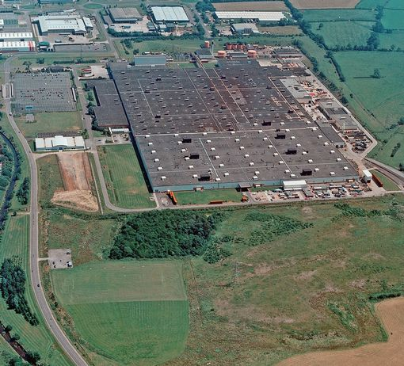
Figure 1 Bridgend Engine Plant

Background of the Project

Advances in technology, paired with the demand for reliable and efficient vehicles, has driven the introduction of huge electrical circuits, controlled by an Electronic Control Unit, into vehicles and engines. Whilst the primary operation of the engine remains mechanical, a number of electronic components and sensors ensure the engine achieves optimum performance. It is now common for a vehicle to have hundreds of electrical connections, with an average of 20 connections found on the engines wiring harness alone.
Ensuring that these electrical connections are secure during the manufacturing process has proven difficult for automotive companies. As a result, customers are regularly returning their vehicles to dealerships, leading to a warranty claim against the manufacturing plant responsible.

Reason for Project

Over a twelve-month period, BEP received 78 warranty claims related to unsecured wiring harness connectors, including 57 Fuel Injector connectors, which are currently the highest occurring warranty claim on the sigma production line. This issue is having a severe impact on the plants reputation and goal for delivering engines to our customers on time, with high quality, around the world. BEP aims to do this by using the Ford Production System (FPS), a company standard manufacturing system that is used in all plants around the world. FPS sets a target of zero defects, a target this issue is preventing BEP meeting.
Over recent years, Ford Motor Company has started manufacturing in countries with far lower labour costs. BEP relies on its reputation for delivering high quality engines especially when seeking future investment. With this in mind, resolving this issue is a high priority.

Aims and Objectives

In this paper, the author will aim to identify the root cause of this failure and investigate potential poka-yoke systems with the objective of preventing the failure occurring. The project will follow the six-sigma DMAIC roadmap, using recognised tools as a means of realising the aims and objectives, though the project will not exceed the Improve stage. Recommendations based on the findings of the project will provide the company with imperative information they will have the option of using it if they were to implement.

Benefits

The benefits of carrying out this project reach far beyond preventing the financial penalties arising from these warranty claims. Eliminating this failure mode will contribute to upholding the reputation of this plant, ensuring it remains an attractive option for future investment and potentially securing key employment in the area for years to come. It will also enhance customer satisfaction, one of the key driving forces of FPS and the success of the company.

Literature Review

Introduction

To assist the author in the completion of this project, research into literature deemed relevant to the manufacturing operations of Ford Motor Company and the issue under investigation was completed. This will provide the foundation of the project and offer guidance throughout.

Quality

In today’s society, many industries that previously had little competition are flooded due to globalization and the development of economies that previously offered little competition. To differentiate, organizations have turned to quality, identifying it as a critical success factor and a way to make them become more competitive.
Delivering good quality products to customers is a fundamental requirement in today’s automotive industry. Stylidis et al., (2017) acknowledges this as one of the biggest challenges faced by automotive companies and that it is essential to ensure the success of a product on the global market. A common theme throughout the literature reviewed is that an organization’s quality strategy and standards are some of the most important contributions to gaining a competitive advantage (Fraser et al., 2013; Kušar et al., 2014; Narasimhan and Schoenherr, 2012 and Su et al., 2014).
Organizations also look beyond delivering a high level of quality performance and now strive to deliver a high consistency of quality performance. Achieving high quality and consistently delivering high quality can be the defining difference between two organizations. Su et al., (2014) acknowledges that even the biggest names in the automotive industry face difficulties consistently delivering high quality. Evidence of this lies in product recalls that have occured over recent years. In 2017, Mercedes-Benz recalled 400,000 vehicles in the UK alone due to an airbag fault (Chapman, 2017). Toyota, once a leader in quality standards, made one of the biggest product recalls ever in 2009, recalling an estimated 4 million vehicles due to faulty pedals, costing billions of dollars (Vlasik and Bunkley, 2009).
Quality standards are extremely important to Ford and their global customer base. Customers are confident that the products they buy will meet the expectations they have, as a minimum. The loose fuel injector connections have affected too many customers and this is something they will interpret as poor quality, which is having a detrimental effect on the business.
Kučerová and Fidlerová, (2014) state that,
“The impulse for improvement can be when the values for an important performance indicator defined by the customer are not achieved.”
Previously, it was a widespread perception that producing high quality products was expensive and unproductive. Japanese industry changed this perception alongside works such as W.E. Deming’s “Out of the Crisis” (1986). He claimed that improving quality sparked a chain reaction leading to lower costs, increased productivity, increased market share and more jobs.
Deming, (1986) further explains that this is down to the reduction in expensive re-work and less need to replace products. In turn, workers and machines concentrate on tasks that add value to the business while delays and scrap decreases. Customer satisfaction will also increase so they are more likely to be a returning customer and will often make positive recommendations to other consumers, potentially increasing market share

Cost of Quality

The cost of quality (CoQ) is a measurement tool used by organizations to help understand the total cost of quality, usually made up of costs expended by the prevention of poor quality and the resultant cost of poor quality (unmeasurable). There is no standard way to calculate the CoQ, so calculations may differ between organizations. However, using this tool should deliver increased quality and lower costs. Harry and Schroeder (2000) claimed the cost of quality for most companies, is normally between 15 and 25 percent of total sales if evaluated correctly. Accurately calculating the CoQ is essential for an organization to identify the best improvement actions needed and to understand the success of the quality system in place. Inaccurate information can quite easily lead to unnecessary costs related to unnecessary or incorrect actions taken.
There are a number of different models available although Schiffauerova and Thomson (2006) claim the most common one is the Prevention, Appraisal and Failure model (PAF).

Prevention, Appraisal and Failure Model

In the Prevention, Appraisal and Failure (PAF) model, quality costs are categorized between prevention, appraisal and failure with the latter split between internal and external. Sower and Sower, (2015) identify typical costs attached to each category such as:
- Prevention costs – these may arise from quality planning, product/process design, maintenance of equipment, training/development and implementation.
- Appraisal costs – these may arise from quality check/inspection, product testing during production and after production and audits.
- Failure costs (internal) – these may arise from reworking, downtime, scrap, re-testing.
- Failure costs (external) – these may arise from warranty claims, customer returns, remedial work.

Opportunity Cost Models

Opportunity cost models are an alternative that take into consideration the cost of missed opportunities, though the principles of the PAF model still stand. In the event of missed opportunities occurring; a process is not achieving a perfect state and there is room for improvement and increased profits. A study carried out by Sandoval-Chavez and Beruvides (1998) at a manufacturing company in the U.S. found that opportunity costs accounted for 83% of CoQ in this study and therefore may be far more important than first realised.
A missed opportunity can be described as the opposite to the benefits achieved by producing good quality, such as lower costs, increased productivity, increased market share and more jobs. These can also arise from late delivery of products, underutilization of facilities or even inefficient handling of materials; all an attribute of poor quality.

Cost of Poor Quality

Poor quality can tarnish an organizations reputation, taking years to overcome. Eventually, poor quality will cost more than good quality. Firstly, poor quality products require replacement or re-working, often incurring additional logistical costs. Secondly, there is the loss of man/machine/equipment hours required to carry out re-work and the expense of extra materials and utilities used.
“The highest cost to a company is not producing high quality products or services; it is producing lower quality products and services”
Aras and Ozcam, (2016)
Customer dissatisfaction is another high cost of poor quality. This is difficult to measure as it can potentially lead to a loss of future sales, influencing profit margins and leaving the organization with a lower market share.
The Ford Production System incorporates aspects of industry recognised manufacturing systems to prevent poor quality being produced and save money.

Six-Sigma

Six-sigma, a quality focused manufacturing system, is a data driven and results based approach to build and sustain process excellence. Introduced by an engineer at Motorola in the 1980’s, it reportedly went on to save them billions of dollars over the following years (Madu, 2006). Following this, a number of large companies adopted the six-sigma approach with huge success (Box, 2017; Marzagao and Carvalho, 2016). Campos (2013) identifies the core principle of six-sigma is the continuous reduction in variation of a process as a way of eliminating the defects.
Successfully adopting a six-sigma approach leads to increased quality, reduced costs and increased customer satisfaction (Madu, 2006; Malik and Blumenfeld, 2012; Box, 2017). Yet with all the praise directed at six-sigma and the success it brings, some consider it as just an enhanced form of Total Quality Management (TQM) (Kaynak, 2003). Furthermore, Malik and Blumenfeld, (2012) identify a number of similar contents between a six-sigma approach and TQM approach.
Fundamentally, the focus of six-sigma is on the satisfaction of the customer and consumer. According to Kučerová and Fidlerová, (2014) to achieve this, the strategy seeks to:-
- identify and eliminate cause of defects
- reduce cycle times and the cost of operations
- enhance productivity and improve asset utilization
One of the key ways in which six-sigma aims to achieve this is through its structured problem solving methodology, namely Define-Measure-Analyse-Improve-Control (DMAIC).

Define-Measure-Analyse-Improve-Control

DMAIC is an acronym for Define-Measure-Analyse-Improve-Control. This structured problem solving method aims to find permanent solutions to difficult problems. The methodology is data driven and focuses on the requirements and expectations of the customer. According to George, (2005) each stage builds on the last and each section aims to do the following:
- Define Opportunity – identifies the problem and the customers, identifying what is important to them whist also detailing the business case for carrying out the project.
- Measure Performance – measures the current performance and identifies sources of variation in the process.
- Analyse Opportunity – all data collected from the measure stage is analysed.
- Improve Performance – based on the findings in the analysis, improvement strategies are investigated and implemented.
- Control Performance – performance of the improved process is controlled.
To achieve this, recognised tools and analysis are used at each stage, with some being used at a number of stages.

Project Charter

George, (2005) claims a project charter is the starting point of any DMAIC project. Typically, the project charter will include:
- a statement for the problem being addressed
- the business case for carrying out the project
- project goals and constraints
- project team
- an anticipated timeline

Gantt Chart

A Gantt chart is a common type of bar chart used to represent a DMAIC projects timeline (Pyzdek and Keller, 2014). A typical Gantt chart will show different stages of the project on the vertical axis with different width bars on the horizontal axis to represent the beginning and end of the stage.

Process Map

Process mapping involves the breakdown of a process into individual steps, helping to gain a clearer understanding of the process as a whole. This effective tool helps identify steps that add no value to a process (Conger, 2015).

Supplier-Input-Process-Output-Customers Diagram

A Supplier-Input-Process-Output-Customers (SIPOC) diagram is often used in conjunction with a process map. As well as breaking down individual steps of a process, it includes the suppliers, inputs, outputs and customers to a process (Savca, 2017).

Voice of Customer

The voice of the customer is an important aspect of defining the overall objectives of a project. Deming, (1986) maintained that the customer is the most important part of the production line, therefore understanding their needs and expectations is paramount. This is achieved through numerous means such as questionnaires, interviews, feedback or focus groups. Through this, the critical to quality (CTQ’s) are defined.

Cost and Benefit Analysis

A cost and benefit analysis is an important part of a DMAIC project as it compares the costs of carrying out a project to the potential benefits that can be gained. McCarty, (2005) claims it is common for this analysis to be carried out at various phases of a DMAIC project because costs that are more accurate are obtained as the project progresses and potential benefits become clearer.

Data Collection

Data collection has an important influence over the duration of a project. Different projects require different amounts and types of data be collected and at different intervals. It is important that the team be involved in the data collection to ensure it is accurate and that problems are recorded and understood (McCarty, 2005).

Failure Modes and Effects Analysis

An FMEA is an effective tool for estimating the effects of a potential failure mode. Initially, all potential failure modes need listing before all possible effects of this failure mode are considered. Scores of 1-10 are assigned to each failure mode and possible effect based on 3 categories. These are:
- Severity – How severe the effects of the failure could be. 10 being most severe.
- Occurrence – How often the failure mode is likely to occur. 10 being most frequent.
- Detection – How likely the failure mode is to be detected. 1 being most likely.
These scores are multiplied to give a Risk Priority Number (RPN) (Peeters, Basten and Tinga, 2018). The author found no industry recognised threshold for an RPN value.

Payoff Matrix/Criteria Matrix

These matrixes are used to compare alternative improvements. A payoff matrix will compare improvements in terms of the effort required to implement them against the potential benefit. A criteria matrix will compare improvements based on certain desirable criteria they can meet. The desirable criteria is specified at an earlier stage and is then assigned a score of 1-10 based on importance, 10 being most important (Thorne, 2017).

Cause and Effect Diagram

Park, Nam and Choi, (2011) describe a Cause and Effect diagram as a useful tool for displaying relationships between a given effect and its potential causes. Major causes of the effect are categorised with smaller sub-categories, typically aspects of the major cause, branching off each one.

5 Whys

The 5 Whys model is a way of identifying a root cause of a problem, often used in conjunction with a cause and effect diagram. The concept is that if you ask “Why” to a problem up to 5 times, you should eventually answer with a root cause, something that is actionable (McCarty, 2005).

Lean Manufacturing

Lean manufacturing is another widespread quality manufacturing system adopted by a number of major organisations as a way of achieving a competitive advantage, partly due to the impressive results experienced by the likes of Toyota (Alhuraish, Robledo and Kobi, 2017). The primary objective of lean manufacturing is the reduction of waste, with the aim of making operations more efficient. Emphasis is placed on the continuous improvement of processes rather than settling for a process as it is, which in turn continually enhances the quality of products and services. Successful implementation of lean manufacturing methodologies lead to lower costs, which in turn, increases productivity and will help enhance customer satisfaction.

Poka-yoke

Womack and Jones, (2003) describe poka-yoke as a technique critical to ensuring a process is lean. Poka-yoke is a Japanese term for mistake proofing. It has become widespread in manufacturing as a way of ensuring a process reaches specific quality standards. There are different levels of poka-yoke systems, some prevent mistakes at the source while others detect them at a later stage, yet they all strive to deliver the same goal of reducing waste and ensuring quality (Zhang, 2014).

Electronic Fuel Injection

The fuel injection system makes a critical contribution to an engine and vehicles performance (Monteiro Tavares and Szpytko, 2017). Most vehicles now have electronic fuel injection systems, which have widely replaced mechanical systems due to the greater accuracy and efficiency they offer. A vehicle Electronic Control Unit (ECU) controls these electronic systems.
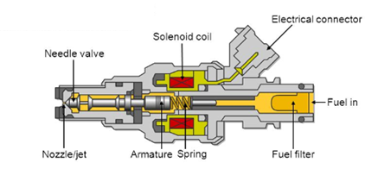
Figure 2 Electronic Fuel Injector
(Slideplayer.com, 2018)
Figure 2 shows the main features of a typical electronic fuel injector. The ECU controls the solenoid coil through the electrical connection. When instructed by the ECU, the solenoid coils pulls the armature away from the nozzle, giving way to pressurized fuel into the combustion cylinder. An injector is dedicated to delivering fuel to an individual cylinder and is connected to a high-pressure rail that delivers the fuel to the injector. The fuel rail has a wiring harness assembled to it (Figure 3) with an electrical connector for each injector. This enables it to receive its own signal from the ECU, enabling injection to each cylinder at alternating yet precise times. The injector has the ability to vary the amount of fuel released into the combustion chamber in one go, dependent on the signal received from the ECU. The ECU receives information from a number of sensors (Figure 4), located around the engine influencing the decision on timing and volume of fuel to inject (Tan and Xu, 2014).

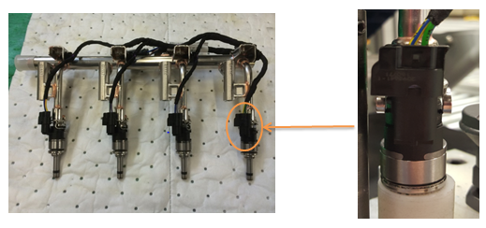
Figure 3 Fuel Injector Rail and Injector Harness Sub-Assembly/ Mated Fuel Injector Rail Connector and Injector Harness Connector
(Authors Pictures, 2018)
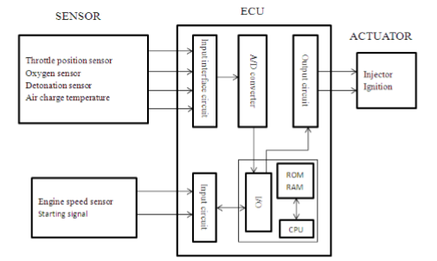
Figure 4 Block Diagram of a Typical Control System for an Electronic Fuel Injection System
(Liao, Sun and Zhou, 2014)
Primary factors defining the volume and timing of the injection include throttle position, engine temperature/speed oxygen and air at the intake (Liao, Sun and Zhou, 2014)
In the event of a failed electrical connection or an intermittent electrical connection, the coil will not pull the armature away from the nozzle, preventing fuel from passing through and starving the cylinder of essential fuel. Fuel is one of the key ingredients for combustion to occur therefore without it, the cylinder will be inactive. As a result, the engine will deliver poor performance, possibly even misfiring and the engine management light will illuminate (Figure 5). Ahma et al., (2014) identifies incorrect installation during manufacture as a common cause of failure or an intermittent fault with an electrical circuit.

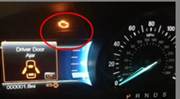
Figure 5 Engine Management Light Displayed on Vehicle Dashboard

Wiring harness Connectors

Due to recent advances in engine technology and the increasing demand for reliability, it is likely that a new car has hundreds of electrical connections (Swingler, 2009). Specification of a connector depends on the type and speed of the signal passing through, though designers must also be mindful of the operating environment (Morissette, 2016). A vehicles operating environment offers extreme conditions, with temperature change in excess of 120 ̊ C and vibration levels over 3G (Swingler, 2009). Ensuring a correct and secure connection can be difficult in these conditions. Once a connector is disconnected, the electrical connection terminates and any power or signal can no longer pass through.

Conclusion

From the findings of the literature reviewed, the author decided to adopt the DMAIC methodology using any tools and analysis methods required, for the completion of this project. Quality standards will remain at the forefront throughout every stage.

Define

Introduction

In this chapter, the author will define the problem and the business case for undertaking the project, following the guidance of George, (2005). Customers of the process will be identified enabling the author to establish the critical to quality requirements for the project.

Project Charter

As discussed in the literature review, a project charter is the starting point for a DMAIC project.

Problem Statement

“Injector harness connectors are not being securely mated with the fuel rail connector, prior to installation to the engine, resulting in disconnection in the field. Currently this is the highest occurring warranty claim on the Sigma assembly line, with 57 claims made against Ford Bridgend Engine Plant between October 2016 and October 2017. This is seen as a failure in terms of customer’s quality expectations being met.”

Business Case

In terms of occurrence, loose injector connectors are causing the highest number of warranty claims on the Sigma production line. A warranty claim, occurring this often, has far-reaching consequences for the reputation of this plant. The failure mode has not been a problem at other Ford plants, therefore raising questions about the plants ability to deliver high quality products and the consistency of the workforce. These are key factors that can influence the organisations decisions when considering future investment plans.
This poor quality is leading to customer dissatisfaction; therefore, rectifying it is a high priority to ensure this plant, as well as the organisation as a whole remains competitive and customers do not purchase from a competitor instead. Whilst the direct warranty costs are available, the true cost of this failure is far greater and the impact it is having on the organisation is unmeasurable in terms of loss of market share. Previous preventative measures are inadequate and further containment actions have failed to eliminate the issue; therefor the completion of this project is now a high priority. If the issue is not rectified then customers will continue to be dissatisfied and the failure to meet quality targets will be viewed negatively throughout the organisation. The organisation has specific expectations of its plants in regards to quality and delivery and due to this recurring issue, the organisations goal of delivering high quality products with zero defects is failing.

Project Goals

The project goals are:
- Collect data relating to issue
- Analyse data
- Identify the root cause
- Investigate preventative measures that ensure this issue no longer occurs
- Offer recommendations to company based on findings

Project Constraints

The assembly line runs continuously from 6am Monday to 6am Saturday. Management have been clear that production is not to be effected by the project therefore any potentially disruptive, investigative work must be carried out at weekends.

Project Team

Figure 6 depicts the hierarchy of the project team. The project team all have their day jobs and are completing this project in addition to them.

Figure 6 Project Team Hierarchy

Project Timeline

A Gantt chart will show the key activities and stages of the project (Figure 7). The anticipated duration of each stage will be represented in a format similar to that suggested by Pyzdek and Keller, (2014).

Figure 7 Gantt Chart Timeline for Project

Mapping the Process

Mapping the process is key to gaining a better understanding the process and the individual steps.

Supplier-Input-Process-Output-Customer Diagram

The Supplier-Input-Process-Output-Customer (SIPOC) diagram in Figure 8 identifies key inputs and suppliers to the process, including what outputs these are transformed into. As well as this, customers of the process are defined.

Figure 8 SIPOC Diagram for Fuel Injector Rail and Injector Harness Assembly and Fit

Process Map

Mapping the process enables the author to break down the process into individual steps (Figure 9). This is used in conjunction with the SIPOC diagram to gain a clearer understanding of the process as a whole (Savca, 2017). Total process time 24.36 seconds.

Figure 9 Process Map for Fuel Injector Rail Sub-Assembly and Fit

Identify Customers

The customers of this process were identified in the SIPOC diagram and can be categorised as internal or external (Figure 10). Internal customers are customers within BEP while external customers consist of customers within the company and end users.

Figure 10 Identification of Customers of the Operation

Voice of Customer

Customer satisfaction is imperative for any organisation to remain profitable in today’s manufacturing industry. The automotive industry is ever more competitive and customers’ expectations have risen in line with the choice of vehicles on the market. The customers identified above all expect high standards. The customers most impacted by this issue are the commercial/private customers and their first point of contact, the dealership network.
The following questions were asked to these most affected customers, and answers given to define the CTQ’s (Critical to Quality):
Vehicle Dealership – “What impact does a warranty claim against a vehicle sold by you have?”
Elliot Farmer (Farmer, 2017) – (Sales Executive, Fordthorne) “Warranty claims can put a big strain on my relationship with a customer. I am the first port of call for them and therefore must accept responsibility and try to maintain the positive relationship we have. With the boom in hire purchase sales over recent years, I build a relationship with customers who return to me every time they change car, thus the importance of maintaining a good relationship. Having to return a vehicle is inconvenient for them and raises questions on the quality of our vehicles.”
Private Customer – “What does a warranty claim on your new vehicle mean to you?”
Sarah Evans (Evans, 2017) – (Regular customer) “One of my previous vehicles had to return to the garage as the engine management light was showing. I had to make a time consuming trip to the dealer to find out I would have to take a courtesy car home and return a few days later. This was very inconvenient as I have a very busy family life. I expect a new car, which I pay a lot of money for, to work properly from the moment I pick it up.”

Critical to Quality (CTQ)

Based on the response of the customers, it is clear that quality is important and that they have certain, reasonable expectations. Therefore, CTQ’s can be determined as:-
- Prevent defective engines reaching customers
- Ensure customers are satisfied and expectations are met if not exceeded
To achieve the CTQ’s, it is imperative that operators do not complete the process of fitting the fuel injector rail unless all injector harness connections are securely connected.

Conclusion

With a sound understanding of the reasons and the requirements of the project, alongside the establishment of the CTQ’s and expectations of the customer, the aims and objectives of the Define phase are complete. The author will build on this knowledge to progress to the Measure phase of the project.

Measure

Introduction

The measure phase will focus on how the current process is performing. Mapping the process provided the author with a clearer understanding of the process, which has enabled sources of variation to be identified. The problem statement will support in the development of this data collection plan.

Identify Sources of Variation

Whilst standardisation has become commonplace in manufacturing it is very difficult to eliminate all sources of variation. Little variation can be identified from mapping the process although it does not detail the hourly rotation in place between the operators.
Job rotation is encouraged to reduce the risk of repetitive strain injury meaning six different operators carry out this process over a shift. There are three shifts on the production line. There are also five people on an absence team on each shift covering sickness and annual leave. Altogether, thirty-three people can potentially carry out this process. Every person has a different level of experience and concentration affecting his or her ability and accuracy, leaving this process prone to human error.
There is also variation in the pressure applied by the operator when connecting the harness connector to the fuel rail connector, resulting in some securely fitted and some not.
Dimensions of the connector housings may also vary in size. It is difficult to obtain precise measurements during manufacture therefore; tolerances are set offering a specific target range that a dimension has to meet. If connectors are manufactured at opposite ends of the tolerance limit then it could potentially make the connector slightly more difficult to use compared to if the tolerances are at the centre of the range.

Data Collection Plan

McCarty, (2005) maintained the importance of the project team gathering the required data to ensure accuracy. No new data is being generated for this project, the data being collected is from the previous 12 months, hence the short duration of this phase.
Existing data is available relating to the issue in the form of warranty data, relating to each individual warranty claim. This information will contain the individual engine numbers for each claim, which can provide traceability data from the manufacturing process.
All data relating to warranty claims will be collected from the Quality department within plant.
Shift operating reports are created for every shift though due to the sensitive information detailed on these reports, management are reluctant to disclose them. Any information required will be requested from Ryan Hopkin, Production Team Manager. This will help identify if the regular operators were working on any given day a failed engine passed through the process.

Quality Leadership System – Component Manufacturing

Ford have developed their own traceability system which stores all data generated from the manufacturing process at every manufacturing plant around the world, known as Quality Leadership System – Component Manufacturing (QLSCM). By entering an engine number to the system, a birth report is generated, detailing everything about it and its components manufacturing process that has been recorded. This can include individual processes on the production lines, including time and date of when it passed through any given process.
The time and date when every engine passed through the process in question will be collected from each birth report.

Failure Modes and Effects Analysis

A Failure Modes and Effects Analysis (FMEA), shown in Figure 11 is an effective tool to measure the process, this will be undertaken based on the method reviewed in the literature by Peeters, Basten and Tinga, (2018). Current process of connecting injector harness to injector rail has an RPN of 160.
Figure 11 Failure Modes and Effects Analysis for Current Process

Data Collected

Warranty data collected from the quality department, detailing all warranty claims for failed wiring harness connections, is shown in Figure 12.
Figure 12 Warranty Data for Failed Wiring Harness Connections

Conclusion

The performance of the current process has been measured and will offer a benchmark for comparison. With all relevant data collected, the project will now progress to the Analyse phase.

Analyse

Introduction

During this analyse phase the author will aim to identify the following:
- Root cause of the failure and the impact it is having on the customer
- Cost of Quality to the company and the true cost of this failure to the plant
Analysis will be carried out on the data collected in the measure phase.

Analysis Methods and Tools

To identify the root cause of the issue a range of graphical analysis tools will be used to interpret the data that has been collected. These include pareto charts, a type of bar chart that incorporates a line graph to represent the cumulative frequency as well as standard bar charts.
Further to this, a cause and effect diagram will be used to display potential root causes of the issue, as recommended by Park, Nam and Choi, (2011) in the literature review.
The cost of quality will be analysed using the PAF model, reviewed in the literature review. Consideration of the missed opportunities arising from the issue, due to the importance emphasised on this by Sandoval-Chavez and Beruvides (1998) based on their study, will be given.

Analysis of Warranty Data

Analysis of the data collected will be completed in this section.

Analysis of Harness Connector Warranty Claims

Injector harness connectors make up 73% of all warranty claims, relating to faulty harness connections. This is far greater than the next most common faulty harness connection, which makes up just 5.1% of all warranty claims, which is visualised clearly in Figure 13. Aside from injector harness connectors, there are 15 other harness connections made during production, 6 of which have no warranty claims made against them. This includes the EVRV connector, which is the same as the injector harness connector. The volume of these warranty claims in comparison to other harness connectors emphasises the importance of rectifying this issue, which is undoubtedly isolated to this operation.

Figure 13 Analysis of Warranty Claims for Each Connector

Defects per Million Opportunities

Defects per Million Opportunities (DPMO) are a way of calculating the performance of a process based on an average production run. An opportunity is classed as every time a defect could be produced against every defect that was produced, normalized to one million.
Approximately 500,000 1.5GTDI engines were produced in the timescale between the first failure and the last. Each engine offers 4 opportunities for a faulty fuel injector connection as there are 4 connectors and 15 opportunities for alternative faulty harness connections.
Fuel injector connectors offered 500,000 x 4 = 2,000,000 opportunities and made 57 defects.
Therefore 2,000,000/2 = 1,000,000 and 57/2 =28.5
Fuel injector connectors = 28.5 DPMO
All other connectors offered 500,000 x 15 = 7,500,000 opportunities and made 21 defects.
Therefore 7,500,000/7.5 = 1,000,000 and 21/7.5 = 2.8
All other connectors = 2.8 DPMO
All wiring harness processes have a manual quality check defined in the Quality Process System sheet. This consists of performing a push-click-push sequence, to ensure a connection is secure. Though this manual check is defined, there is nothing in place to ensure it is completed.

Analysis of Shift Producing Failed Engines

An engines birth report, generated in QLSCM provides the time and date, which an engine passed through the process. By cross-referencing this with shift calendars and shift manning reports it is possible to identify which shift was working and if the regular team was working and no members of the absence team were present. There is an absence team on every shift, which covers sickness and annual leave. Their trained on every process on the production line yet due to their need to change roles regularly they do not have the specialist knowledge and experience that a regular team member has.
These findings are presented in Figure 14 overleaf.

Figure 14 Number of Failed Engines Created on Each Shift With or Without Absence Team

Analysis of the data shows there not to be a conclusive link between an individual shift in which failed engines were produced or shifts in which members of the absence team were present.
Percentage of shifts where absence team were present and a failure was created
- A shift had absence team present on 48% of their 23 failures
- B shift had absence team present on 74% of their 19 failures
- C shift had absence team present on 40% of their 15 failures
Though there is no conclusive link, there are a high number of shifts with a member of the absence team on producing these failed engines. Further analysis will find the failure rate when the absence team is present and the failure rate when they are not (Figure 15 overleaf).

Figure 15 Number of Shifts Worked with Absence Team Compared to Number of Failed Engines Produced with Absence Team Present.
The failure rate for the absence team being present is as follows:-
- A shift have a failure rate of 61%
- B shift have a failure rate of 93%
- C shift have a failure rate of 21%
A and B shift have considerably higher failure rates than C shift. Though this analysis does not offer evidence that a member of the absence team is producing the failed engines, it suggests a high possibility that they are producing these failed engines when they are present on A and B shift.
Further analysis can find the failure rate for shifts when the absence team were not present. Between the date of the first failed engine and the date of the most recent, each shift will have worked 242 shifts. By deducting the number of shifts worked with absence team present it is possible to calculate the number of shifts which only regular team members were present. These findings are represented in Figure 16.

Figure 16 Number of Shifts Worked with Only Experienced Operators Compared to Failed Engines Produced with Only Experienced Operators Present.

From the information in Figure 16 the failure rates for only regular team members being present can be calculated:-
- A shift have a failure rate of 5%
- B shift have a failure rate of 2%
- C shift have a failure rate of 4%
The failure rates while the absence team are present are considerably higher in comparison to when they are not.
This analysis proves that this failure is not isolated to when the absence team is present though it is difficult to ignore the increase in failure rate when they are.
Nearly half of these failures, 46%, happened when no absence team were present. In addition, there is no guarantee that the absence team produced failures when they were present. With this in mind, it is possible the number of failed engines produced by regular, experienced team members could be higher than 46%.
Another important consideration is that a member of the absence team does not always cover sickness and annual leave. Operators have opportunities to work overtime though this is restricted to their own team. With this in mind, it is entirely possible that a single operator has produced all these failed engines. To eliminate this possibility, overtime rotas will identify relevant shifts in which operators worked overtime. Of the three shifts:-
- A shift had 10 failed engines produced with no operator working overtime
- B shift had 5 failed engines produced with no operator working overtime
- C shift had 8 failed engines produced with no operator working overtime
This is conclusive evidence that at least one person off the original team off each shift has produced a failed engine, proving that this issue is not isolated to inexperienced operators and is quite likely the work of an experienced operator.

Mileage at Time of Failure

The mileage at which each engine was repaired varies considerably throughout the data. Analysis of this is shown in Figure 17.

Figure 17 Breakdown of Mileage at which Each Repair was Carried Out

Figure 17 shows that the majority of repairs were carried out in the vehicles first 500 miles, 63% of repairs in total, with the remaining 37% happening between 501 and 7561 miles. Repairs within the mile range 1-500 will be analysed further as it represents such a high percentage of the repairs.

Figure 18 Further Analysis of Mile Range 1-500 at which Repair was Completed.

Figure 18 shows that 26 repairs were carried out within the first 100 miles of driving, totalling 46% of all repairs. Though this mile range represents a significant portion of all the warranty claims, there appears to be no clear pattern throughout the data, highlighted by the fact that 25% of all repairs were carried out beyond 1000 miles.
Elliot Farmer, (2017), sales executive at a local dealership that assisted in developing the VOC, claims that a vehicle normally has around 10 miles on its clock once handed over to the customer. Therefore, a repair carried out on a vehicle in its first ten miles would be repaired before being delivered to the customer, most likely at the dealership. Considering this, 50% of repairs within 0-100 miles would have been repaired before getting into the hands of the customer, also equating to nearly 25% of all repairs. Further analysis of the low mileage repairs will potentially identify whether these early repairs are influenced by a certain failure concern.
Each warranty claim has a different failure concern attached to it. The concerns are categorised as follow:-
- Disconnected – the connector on the injector harness is completely detached from the connector on the fuel injector rail.
- Loose – the connector on the injector harness and the fuel injector rail are still loosely connected.
- Not seated – the injector harness connector appears to be connected to the fuel injector rail though the connection is insecure. This has resulted in an intermittent fault.

Figure 19 Breakdown of Failure Concern for Repairs Carried Out Between 1-100 Miles.

Of the 26 repairs represented in Figure 19, 73% were a result of disconnection between the injector harness and the fuel injector rail. This is a significant majority though, considering 73% of all repairs were a result of disconnection, it is expected. These low mileage repairs are not isolated to a single failure concern, in fact they are of a similar proportion to the analysis of all repairs represented in Figure 21 (overleaf). Figure 20 (overleaf) further analyses the 13 repairs assumed to have been carried out at the dealership, finding that 85% were a result of disconnection while 15% were a result of a loose connection between the injector harness and the fuel injector rail.

Figure 20 Breakdown of Failure Concern for Repairs Carried Out Between 1-10 Miles.

Figure 21 Analysis of Failure Concern for All Repairs.

Findings

This analysis has found that, whilst a majority of these failed engines have been repaired within the first 100 miles of driving, it is quite likely for an engine to fail well beyond this. The mileage, at which this issue has occurred for these engines, appears to have no pattern. Further analysis has found no relationship between the failure concern and the mileage at which it happened. On the other hand, this analysis has found that experienced operators are producing failed engines across all three shifts, eliminating any lack of training or inexperience as the root cause. Additionally, this operation is creating far more DPMO than other harness dress operations; even though all harness dress operations have the same manual quality checks instructed in the Quality Process System sheet. Whilst theses quality checks are in place, there is nothing in place to ensure an operator performs them.

Root Cause Identification and Verification

The findings from the analysis will aid in the identification and verification of root causes in this section.

Cause and Effect Diagram

A cause and effect diagram will be used to display the potential major causes of this issue and to identify aspects of these major causes that could be contributing to the issue. This can be seen in Figure 22 (overleaf).

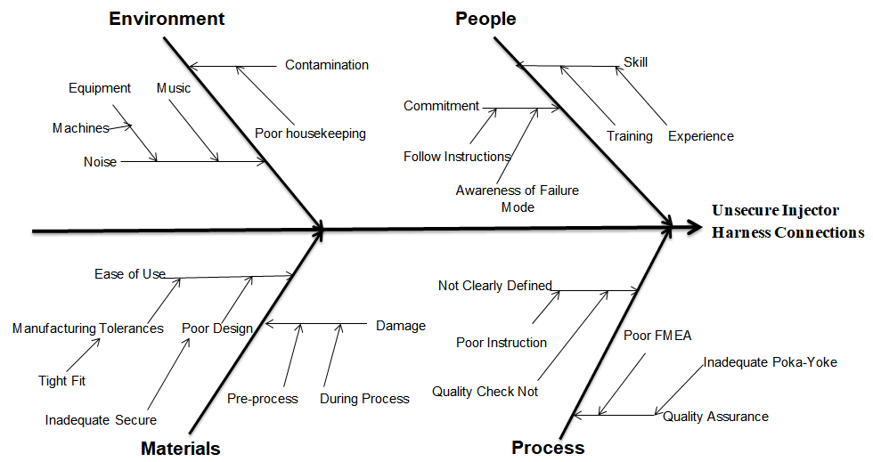
Figure 22 Cause and Effect Diagram for Loose Fuel Injector Connections

5 Whys Method

Potential root causes are displayed in Figure 22. The 5 whys methodology will be used in conjunction with this to reduce it to realistic, actionable root causes as recommended by McCarty, (2005).
The author carried out the 5 whys methodology on the production line, while an operator was working on the process:
- Why are injector harness connectors disconnecting in the field?
They are not securely connected at point-of-fit.
- Why are they not securely connected at point-of-fit?
Operator not completing the process correctly.
- Why are the operators not completing the process correctly?
Cannot hear the “click” sound made by an OK connection due to the machine in operation next to them.

Root Cause

Based on the findings of the analysis and the root cause identification and verification the author believes the following root causes are causing this issue:
- Environmental conditions – the surrounding noise from machinery is preventing the operator hearing the “click” sound made by an OK connection.
- Manual quality checks – there is no system in place to ensure operators are completing manual quality checks, therefore the process is prone to human error.

Impact on Customer

This issue will be having a significant impact on the customer and their confidence in the quality of their new vehicles. This section aims to portray the effects this can have on them as well as on the wider business.

Repair Time

Figure 23 analyses the amount of time spent repairing each engine, finding the most common repair time is 4.6 hours.

Figure 23 Analysis of Repair Time for Each Engine.

From this analysis the mean time in which it takes to carry out a repair can be calculated.
Mean Time to Repair (MTTR) = $\frac{Total Hours Spent Repairing }{Total Number of Repair Jobs}$
=$\frac{259.4 }{57}$
Mean Time to Repair = 4.6 hours

Effect on Customer

As well as having a negative view on the quality of their new vehicle, this issue will undoubtedly incur them some inconveniences such as:
- Time taken to return vehicle to dealer and wait for repair, possibly losing time in work and even losing money
- Costs of making the journey such as fuel
- Time without their new vehicle if they are unavailable to immediately return to the dealership.
- Due to the high mileage of some repairs it is possible that a customer could be far from home. This could result in a long wait for roadside recovery or a long journey home with the knowledge something is not as it should be with the vehicle.
- Insurance companies may void the insurance in the event of an accident.
Each of these problems a customer should not have to encounter.
.

Effect on Dealership

This issue will impact the dealership and the relationship they have with the customer. Word of mouth and social media play a powerful role in promoting and tarnishing the reputation of a business in today’s society therefore, it would be easy for knowledge of this issue to spread amongst the public. Dealerships rely on positive experiences to gain return customers and this issue is giving them the opposite.

Cost of Quality

The cost of quality to the company will be considered as well as the true cost of this issue to BEP. These will be categorised between prevention costs, appraisal costs and failure costs. Information obtained from the organisation gives an hourly cost of the following operators and engineers to the company on an hourly basis. This includes all insurances, pension contributions, utilities in plant and other costs attached to each individual employee. All are worked as an average throughout the plant as different workers have different costs attached to them such as different contracts, pension contributions, holiday entitlements etc.
Assembly operator on 3 shift pattern - £37/hour
Maintenance technician on 4 shift pattern - £43/hour
Engineer - £48/hour
Production team manager - £66/hour
The author will consider the cost of quality to the company as a whole whilst also considering more direct quality costs relating to the failure.

Prevention

The following costs may arise from preventing poor quality.

Quality planning costs

Quality planning costs for this are difficult to quantify as quality planning is part of the design of individual components as well as the overall design of the engine. Engineers will spend time on this alongside other aspects of the design, so calculating costs attached directly to this issue is difficult.
For example, in 2010, Ford invested $15,000,000 dollars into the development of advanced Gasoline Turbocharged Direct Injection technology, citing it as the future of petrol engine technology (Corey, 2014). Every stage of this development, quality would have been one of the key influencing factors. This technology then went on to influence the design of a new family of engines.
Ford has a technical design centre in Dunton, London, one of three globally, employing over 3000 engineers and hundreds more operators. This technical centre has been involved in the development of some of the companies most successful vehicles and engines. Quality will play a vital role in every stage of their development, from drawing board to prototyping and right through to production. The cost of this technical centre in salaries alone will cost the company hundreds of millions of dollars every year, without the cost of resources and utilities. This is without considering the cost of all the manufacturing facilities globally.
Quality is at the forefront of everything that is done at this manufacturing plant. Hundreds of maintenance technicians are employed alongside engineers to ensure that equipment and machinery deliver the high quality products expected. This is without the technology in place, the traceability systems, the poka-yoke systems, quality assurance operations and the vast amounts of training provided to workers.
Fords global sales exceeded $150 billion in 2017 (Ford, 2018). Considering this and the claim made by Harry and Schroeder (2000) in the literature review, that the cost of quality for most companies, is normally between 15 and 25 percent of total sales, it is a fair assumption that the cost of quality to Ford is billions of dollars every year.
Quality planning for the operation under investigation on the production line is difficult to quantify. For example, a PFMEA will not be created individually for the operation. Three PFMEA’s will be created for the complete engine build, one for short block, one for long block and one for engine dress. Line trials will be carried out that will include this operation as well as other operations.
“Quality planning costs for this engine, design and build, will run into the hundreds of millions of pounds. Quantifying an individual operation would prove extremely difficult and possibly inaccurate, though, it is likely to cost hundreds of thousands pounds, possibly in excess of a million”
Dean Matthews, Senior Launch Engineer, Ford, (2018)
(Matthews, 2017)
Aside from this, a new Maintenance Operating Strategy is being developed, with the aim of aligning all plants globally in terms of maintenance and ensuring best practices are followed which in turn increases productivity. Good quality is a vital part of a productive operation. The cost of development of this strategy alone is likely to be in the millions, without implementation.
After consideration of all these costs, measurable costs, related to this issue are as follows.

Quality Process System

Created by an engineer to assist an operator, this takes approximately 4 hours.
4 (hours) x £48 (Engineer cost per hour) = £192

Visual Aids

Created by an engineer to assist an operator, this can take around 6 hours.
6 (hours) x £48 (Engineer cost per hour) = £222

Operator Training

Each operator undergoes a week of training, which requires an operator be committed solely to training. 33 operators are currently fully trained on this operation and 4 operators have moved on.
Cost of training one operator = £37 (operator cost per hour) x 37.5 (hours) = £1387.50
Cost of training 37 operators = 37 x £1387.50 = £51,337.50

Maintenance

Maintenance logs show that a total of 11 hours of maintenance have been carried out on this operation, some as a result of a breakdown and some as a result of planned work.
Maintenance technician costs = 11 (hours) x £43 (Maintenance technician per hour) = £473

Appraisal

Quantifying these costs to the organisation as a whole can be difficult. Quality control and assurance is a vital part of manufacturing, every vehicle and engine must go through stringent testing at all plants around the world. This is a crucial part of the manufacturing process.
Consider that every engine goes through a hot test inspection, a process that checks for specific failure modes or quality concerns. This test costs BEP £1.68 (breakdown to follow) per engine. Vehicles sales exceeded 6,000,000 in 2017 (Ford, 2018), therefore just carrying out a hot test inspection on every vehicle last year cost in excess of £10,000,000, without all other quality assurance operations that are carried out.
After consideration of all these costs, measurable costs, directly related to this issue are as follows.

Hot Test

Each engine completes a petrol hot test (pht) before being bought off the production line. Alongside this hot test, a continuity test is carried out to check for any loose electrical connections, therefore this quality assurance check is directly related to this failure mode. Total cost of an engine pht is made up of operator costs, fuel, coolant, utilities and equipment. The figure used by the company to define this process is £1.68 per engine.
This cost will contributed in the form of an annual cost as it is a critical quality assurance process meant to detect this issue.
Total Cost of Hot Test each engine = 500,000 (annual production volume) x £1.68 = £840,000

Failure – internal

Numerous people within BEP are employed directly to address quality issues, mostly in the quality department. However, every engineer and operator is expected to identify or address quality concerns at some point too.
As this issue is not being detected in BEP there are no reworking, downtime or other productivity costs to be considered. On the other hand there are specific processes carried out in relation to this issue occurring such as warranty claim processing and meetings held as a means of identifying solutions.

Warranty Claim Processing

Every warranty claim goes through a process from the point it reaches plant. This following process takes 1.5 hours and is carried out by an engineer in the quality department, for every warranty claim (Figure 24).

Figure 24 Retrieval and Processing of a Warranty Claim

Cost per warranty claim = £48 (Engineer cost per hour) x 1.5 (hours) = £72
Total cost = £72 x 57 (number of warranty claims) = £4,104

General Quality Meeting

A general quality meeting is held every morning; in attendance are one operator, 5 engineers and the production team manager. Each warranty claim is discussed with approximately 5 minutes spent on each warranty claim.
Each warranty claim costs approximately:
Operator - £37 (Operator cost per hour) / 12 (Time spent in meeting) = £3.08
Engineer - £48 (Engineer cost per hour) / 12 (Time spent in meeting) = £4 x 5(Number of Engineers) = £20
Production Team Manager (PTM) - £66 (PTM per hour) / 12 (Time spent in meeting) = £5.50
Total cost of 1 meeting = £3.08 + £20 + £5.50 = £28.58
Total cost = £28.58 x 57 (Number of warranty claims) = £1,653

Interim Containment Actions and Permanent Corrective Actions Meeting

Interim Containment Actions (ICA) are actions in place temporarily to address an issue until a permanent solution is found. Permanent Corrective Actions (PCA) are actions put in place to permanently address an issue.
Throughout the time this issue has been ongoing, 6 meetings have been held between the production team manager and 3 engineers to discuss ICA’s & PCA’s, each lasting approximately 1 hour each.
Cost of meeting = 3 x £48 (Engineer cost per hour) = £144 + £66 (PTM cost per hour) = £210
Total cost of meetings = 6 x £210 = £1,260

Operator Stand Down

Operator stand down is a process of informing operators of ongoing quality concerns, potential ICA’s & PCA’s and advising extra vigilance. This information is cascaded by the production team manager and an engineer to every operator that carries out the operation, 33 in this instance. Operator stand down lasts approximately 15 minutes and 8 of these have been carried out on each shift.
Cost of operator stand down per shift = 11 x £9.25 (Operator cost for 15 minutes) = £101.75 + £16.50 (PTM cost for 15 minutes) +£12 (Engineer cost for 15 minutes) = £130.25
Cost of operator stand down for every operator across 3 shifts = 3 (Number of shifts) x £130.25 = £390.75
Total cost of operator stand down = 8 (Number of operator stand down) x £390.75 = £3,126

Single Point Lesson

A single point lesson (SPL) is an A4 document created and positioned at the operation to advise operators of the quality concern.
SPL’s are created by an engineer and take approximately 1 hour to create. 10 have been created.
Total cost of SPL = £48 (Engineer cost per hour) x 10 = £480

Failure – External

External failure costs come in the form of warranty claims although there is no record of other potential costs such as recovery cost, courtesy car costs or even compensation, which the company have incurred. It is possible these have been paid and have been absorbed into another cost

Warranty costs

Total cost of warranty claims to date = £25,960

Total Measurable Cost of Quality

Total measurable cost of quality, directly relating to this failure mode is £928,807.50. CoQ for the company as a whole must be given considerable acknowledgement, likely exceeding billions of pounds every year.

Unmeasurable Costs/Missed Opportunities

A missed opportunity can be defined as the opposite of what is achieved when an opportunity is grasped, such as an opportunity to provide a customer with a brand new vehicle on time, budget and with zero defects.
Grasping this opportunity brings customer satisfaction, which comes in hand with positive recommendations to friends and family, returning customers and an increase in market share.
Missing this opportunity potentially delivers the opposite, namely, customer dissatisfaction, negative feedback to friends and family, customers leave for a competitor and a loss of market share.
The negative effects of a missed opportunity are unmeasurable although there is enough evidence available to suggest that this poor quality is likely to contribute to it (Deming, 1986; Aras and Ozcam, 2016)
Not only does this provide the customer an opportunity to discuss this poor quality but it also provides the technicians fixing the problem an opportunity to discuss it. If they find themselves fixing this issue regularly, they may start to treat it as a “common fault” with these vehicles.

Conclusion

Detailed analysis in this chapter has eliminated numerous anticipated causes of this issue and uncovered potential root causes, which will be addressed in the Improve phase. The cost of quality to the company has been analysed and supports the claim made by the company that high quality and customer satisfaction are 2 of their driving factors. This information will support the progression of the Improve phase of the project.

Improve

Introduction

As discussed in the literature review, this chapter will use the findings from the Analyse phase to investigate potential improvement strategies. The aim is to identify a suitable Poka-yoke system, keeping in mind the different levels suggested by Zhang, (2014) in the literature review, such as preventing the issue at the source or detecting it at a later stage

Criteria for Improvement

The criteria for improvement will be developed as a means of comparing different improvements, ensuring that the issue, described in the problem statement, no longer occurs and that the CTQ’s for this operation are met. Categorization will be between essential criteria and desirable criteria.

Essential Criteria

The essential criteria are:
- Ensure fuel injector connectors are fully secure at point of fit.

Desirable Criteria

The desirable criteria are:
- Quality is imperative for this operation, minimum accuracy of 98%.
- Not to require global design change.
- An electronic system is desirable so that data can be stored in QLSCM for future reference.
- Design and installation achievable within 3 months.
- Not to require additional labour.
- Investment of less than £150,000.
- Not to increase Cost per Unit, one off investment preferred.
- No alteration to assembly line layout.

Brainstorming for Improvement Alternatives

A brainstorming session was held on December 15th. The project team attended. The aim of the session was to identify suitable improvement alternatives. The results from the session are shown in Figure 25.

Figure 25 Result from Brainstorming Session

Further Details of Improvement Alternative

Each improvement alternative will now be explored further to identify the most suitable Poka-yoke system.

Operator Traceability

By introducing an operator traceability system, engineers will be able to identify which operator was working when the process was completed. Vast amounts of data is already available from the manufacturing process, by means of a similar system, ranging from in-process testing, torque values of fixings and other error proofing systems that are in place. Every component in the machining process is traceable, primarily by marking each component with a 2D matrix that stores relevant data to individual processes. Prosser, (2015) claims that the automotive industry generates over 1 trillion pieces of traceability data annually and that traceability is an important part of a six-sigma program.

Radio-Frequency Identification

Radio-frequency identification (RFID) technology is becoming more mainstream in manufacturing and offers a suitable method of achieving operator traceability. This involves embedding a chip or tag in a plastic card with electronic product codes (EPC) programmed into it. EPC can be unique to a single card or multiple cards can be programmed the same (Jeong and Choi, 2012).The tags have radio transceivers, which they use to transmit the EPC’s. When the card is placed over an RFID reader, it receives the EPC and the data that is programmed and shares it with the relevant computer and data systems
RFID currently provides traceability in the form of a clock-in system for employees, allowing the organisation to monitor exactly what time they start and finish work. Each worker is issued with a card, unique to them, which they use every day. When the RFID reader receives the information, it shares it with the relevant department such as payroll and HR. If this system was to be used, in the event of an operator forgetting their card, they would not work on the process that day.
As an operator uses their card to clock-in to work every day, their card would also be available to use as a source of traceability within this process. By attaching an RFID reader to the operation and programming the process, it is possible not to allow completion until a card is scanned. This data could then be stored within an engines birth history, alongside other traceable data in QLSCM.
In the event of a failed engine, engineers would be able to check the birth history of the engine and identify which operator completed the process. This would likely encourage operators to be more vigilant and ensure they carry out manual quality checks on every process, holding them accountable if they do not. The current process has no way of identifying the responsible operator, resulting in a lack of responsibility and commitment.
A lot of the software and technology is in use on this production line and installing a system such as this would be relatively straightforward. The only new hardware that would need to be installed is the reader for the operators clock-in card as computer systems and a Programmable Logic Controller (PLC) are in place that this could be linked to. A PLC is an industrial digital computer, used on a production line as a means of controlling manufacturing processes.
Estimated costs for installation and development, provided by Phil Moreton are - £18,000, with a timeframe of approximately 12 weeks.
Though this system will identify the operator, it still does not meet the essential criteria of ensuring the connector is secure at point-of-fit. With this in mind, the accuracy of the system is low.

Over-check

An over-check would require another operator or third party contractor to check the operator initially completing the process has completed the process correctly, therefore validating his or her work. This would require additional labour to complete a quality check, either as soon as the operator assembles the injector harness to the fuel injector rail or after the sub-assembly is fitted to the engine. Either way, this would be difficult to carry out.
To complete an over-check before the sub-assembly is fitted; another operator would need to stand at the process and make a mark on each connector to confirm they are carrying out the quality check. A very limited amount of space is available at the workstation that could make this difficult. The sub-assembly could be assembled at this workstation then fitted and over-checked at another station though this could require a number of other operations being moved to create the space.
Alternatively, the over-check could be completed once an engine has been bought off the assembly line. A special tool (Figure 26) can be used to reach the injector connector wire (Figure 27) within the engine and by giving it a gentle pull, confirmation of an OK connector can be gained. This method would mean engines not being ready for shipping when they come off the production line, therefore, approval for this method being difficult to obtain.
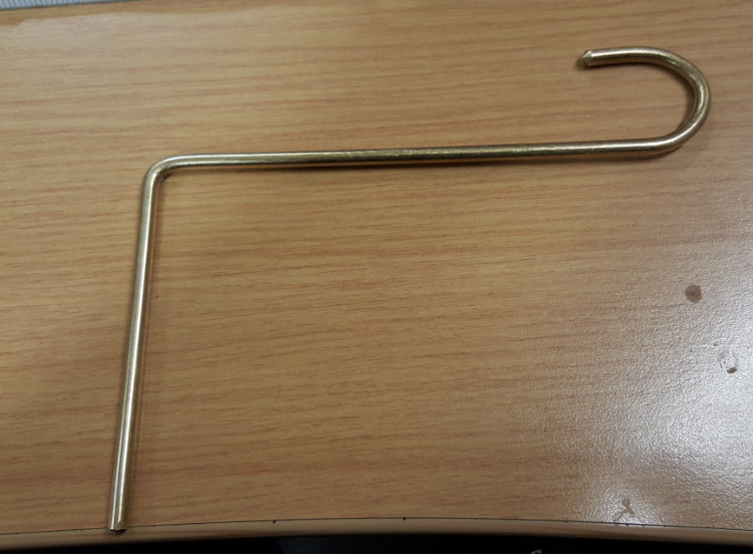
Figure 26 Hooking Tool to Grab the Injector Connector Wire

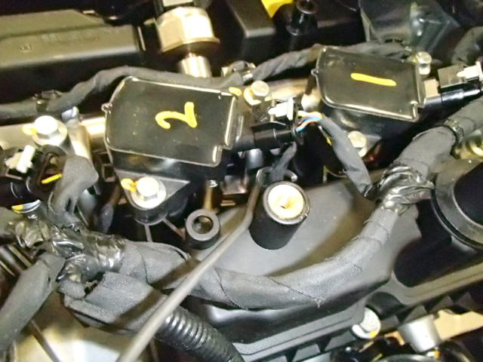
Figure 27 Hooking Tool (highlighted) Gently Pulling Injector Connector Wire

Estimated costs provided by Phil Moreton – using another operator for each shift is £210,000 a year whereas a third party contractor would cost £150,000 a year. This would increase the CPU of an engine as it is an ongoing cost. Other costs to consider are the time required to complete the check between buy-off and shipping the engine and the additional space that would be required.
Dependant on method, this improvement could be implemented in just a few weeks unless any alterations to the line layout are required.

Alternative Connector

In simplest terms, a connector consists of an enclosed, insulated housing that contains a conductive piece of metal, which, once mated with another connector creates an electrical connection that can carry both power and signal. A connector is specified based on the type and speed of the signal being sent, though consideration must be given to durability when being used inside an engine. There are various different types of connectors available, though the specific role and requirements will reduce the suitability of many. Ergonomics are also a crucial consideration as an assembly operator may assemble thousands of connectors per day. A connector must be easy to use with minimal insertion force required to mate the connectors.
Size also plays a crucial role in the selection of this connector, as it is located within the engine, meaning space is limited.
This would require a global design change, with support of the product design team. Obtaining this support can be difficult if this issue is isolated to this plant and there is no guarantee that it will prevent it.
Accurate costs for this improvement are difficult to obtain as development work and testing would need to be done. Phil Moreton suggests timeframe of at least 26 weeks is expected, potentially far more.

Click-hunter

This new technology was developed at another Ford plant as a joint venture between a third party contractor, Nutai, and Ford engineers. It involves analysing the sound heard when two connectors are mated.
The movement of air surrounding a vibrating object creates sound. As an object vibrates, the air around it compresses and rarefies, in a similar way to the object moving back and forth (Rumsey and Mccormick, 2009).
A representation of this can be seen in Figure 28.

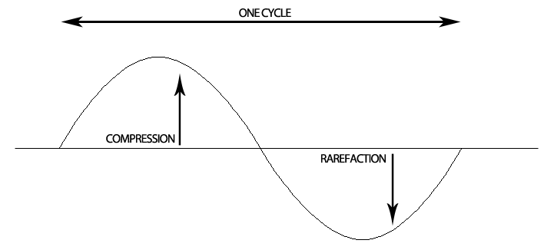
Figure 28 Sound Waveform Diagram

A correctly seated harness connection produces a characteristic “click” sound, similar to that of a pen top click, generated when the latch of the connector reaches the secure area. As the latch deforms to go over the mating connector it vibrates as it regains its original shape, causing the surrounding air to compress and rarefy in motion with the vibration of the connector
This is what creates the click sound, that can be heard when an OK connection is made. With the use of ultrasonic microphones (Figure 29), this click is detected, though having thousands of variables the ones that are used to uniquely identify the click are:
- Frequency – the rate at which a wave completes a full cycle of compression and rarefaction, per unit of time.
- Amplitude – the amount of compression/rarefaction of the air surrounding the vibration, represented by the peak displacement from the equilibrium. The more compression/rarefaction, the louder the sound is perceived.
- Temporal evolution of the main harmonics – the duration of the sound is also a key factor, helping to differentiate from surrounding machines and equipment.
Due to the industrial activity surrounding the operation, engineers used an Artificial Neural Network (ANN) to filter sounds. An ANN is a mathematical algorithm which imitates the structure and the operation of the human brain used to categorise a set of data into classes, in this case the click sound of the connectors versus the different noise signals derived from the industrial activity. The ANN has the ability to evaluate all characteristics at the same time, so even though there may be variation in the sound samples, the correct classification is assured with a very high probability. The system also has a trigger level, a minimum amplitude a soundwave must reach to be analysed by the system, helping reduce the amount of sounds being analysed by the system. If the trigger is too low, too many sounds will pass the filter and some may be taken as false OKs, bringing in errors. If the trigger is too high, none of the sounds will pass the filter, so there will be no sounds to analyse. Analysis of the captured sound is achieved using LabVIEW software. This technology has found to have an accuracy of 99.97% when used as a poka-yoke system, with the aim of preventing insecurely mated wiring harness connections, while also offering electronic traceability. It uses a Visual Dynamic Aid application, which acts as an electronic process display on a computer screen, advising the operator how many connections are required and will show when an OK/NotOK (NOK) connection has been made.
Phil Moreton estimates costs for purchase are £80,000. Installation and Development of the software are estimated at £65,000 and will take approximately 18 – 26 weeks.
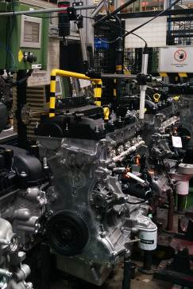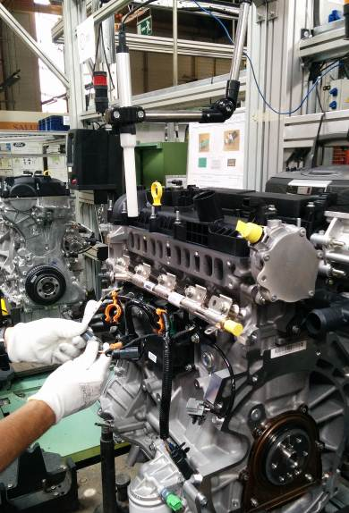

Figure 29 Images of Click-hunter Microphone Positioned on Production Line at another Ford Plant

Connector Position Assurance Device

Many newer connectors feature a secondary locking device to aid in the prevention of unintended disconnection, known as a Connector Position Assurance (CPA) device. Delphi Technologies Incorporated, (2017) acknowledge that unintended disconnection is a common problem between male and female connectors and that including a CPA provides added security to the connection. These devices are designed to withstand pressures and heavy vibration, making it a suitable alternative to the current connectors being used.
A CPA device has two positions, the pre-lock position and the locked position. Before connection, the device is secure in the pre-lock position. It is designed only to allow the CPA to move into the locked position once the male and female connectors are connected. Once this connection is secure and the device moves into the locked position, it prevents the connectors disconnecting. The CPA device therefore provides a means of guaranteeing and maintaining a secure connection.
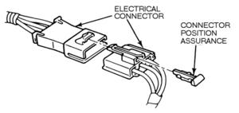
Figure 30 Airbag Connector with CPA Added
(Airbagcrash.com, 2018)
Airbag connectors commonly use a CPA device for extra security. Figure 30 shows how a CPA is added to an existing connector as a means of securely holding the two connectors in place. Upgrading the fuel injector connector is possible without the need for any product design changes.
CPA devices are used on ignition coil connectors, as an added feature to guarantee security. Figure 31 shows these connectors with the CPA device in the pre-locked position and the locked position.
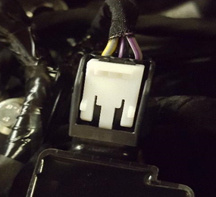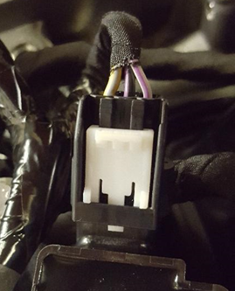
Figure 31 Ignition Coil Connector with CPA in Pre-Locked Position/Locked Position

Estimated costs for an upgraded injector harness are approximately 60p per unit.
Shipping could start with a weeks’ notice and they could be in use within 6 weeks. In terms of accuracy, while this upgraded connector offers more security, it is still prone to human error. There is no guarantee that the operator will close the CPA device.

Vision System

A vision system is simply a computer-based system that performs tasks that traditionally would have been carried out by a human. They have the ability to differentiate between objects and perform quality assurance checks for a number of industrial purposes. Advances in technology have led to the development of more accurate vision systems. These systems are becoming more common in manufacturing and are used at different areas of the manufacturing process in BEP. Li and Han, (2013) maintain that these systems are advantageous due to their reasonable cost, simple hardware and flexible measurement, identification and verification methods. Vision systems consist of a specialised camera, set at a specific distance from the object. This takes an image of a product once it is in place, normally triggered by a sensor and processes it based on defined parameters. The processor then sends the data to the PLC advising of an OK or NOK image (Maves, 2011).The accuracy and potential of the system is largely dependent on the pixel size and resolution of the camera.
A pixel (picture element) is the unit of an image and can vary in size dependant of the quality of the vision system. A single pixel is the smallest piece of information from an image that it can analyse. For instance, if a camera represents an image with a pixel range of 12x12 then the image will be visualised like a grid of 144 smaller square sections. Advanced cameras commonly have millions of pixels measured in units of microns due to their small size, with each pixel having their own unique binary code. The resolution of a system is a measurement of how accurately it can reproduce the detail of an image.
To enable the system to work a light shines on the target object; it is whilst this light shines that the image is captured.
The system identifies a colour by the light reflected off it when it captures an image. An individual pixel will be predefined to have a particular wavelength and intensity in the light spectrum; therefore, if an image is found to be different the system will alert the user.
The system interprets an image based on its colours in three ways. A binary image consisting of black and white, grey coloured images consisting of different shades and colour images with a base of red, green and blue (Brighthub Engineering, 2018).
For a system to differentiate between two similar objects, a gap of at least one pixel is required between them. Figure 32 explains how a line pair, a pattern of pixel-on, pixel-off, pixel-on (b), is necessary or the vision system will interpret it as one object (a).

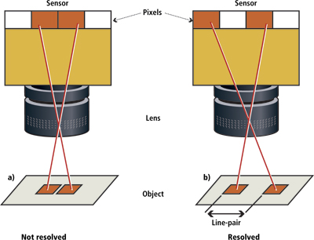
Figure 32 Line Pairs are Used as a Measurement of the Required Distance Necessary Between Pixels For an Image to be Resolved
(Vision-systems.com, 2018)

Figure 33 shows the difference between an OK and NOK injector harness/rail connection. There is a clear difference in distance between them, but, taking into consideration the principal of the line pair, the vision system would not accurately be able to differentiate between the connectors. This is because they are the same colour and there is no pixel between them enabling the vision system to differentiate between them.
This issue can be resolved by using alternating colour connectors or by the introduction of a different colour CPA device. A vision system is used on the black ignition coil connectors (Figure 31) and a CPA device.

Not OK Connection OK Connection
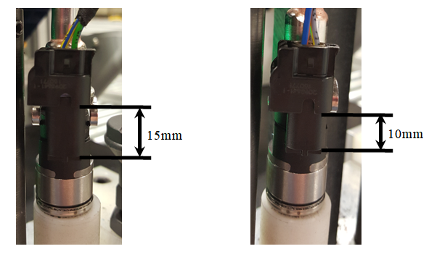
Figure 33 Difference in Distance From Bottom of Injector Harness Connector to Base of Fuel Injector Rail Connector for an OK Connection and NOK Connection

Estimated costs for vision system from Phil Moreton are - £25,000, whereas installation and development is around £80,000. Approximate timeframe 12-18 weeks dependant on application.
For this to work accurately it would need to be used with a CPA connector which would cost approximately 60p per unit.
If used in conjunction with a CPA device this system offers a near perfect accuracy, with electronic traceability.

Payoff

Each improvement will be considered based on the criteria, defined in section 6.2, that they meet. These are set out in figure 34. This table shows that only three improvements, Over-check, Click-hunter and a vision system with a CPA meet the essential criteria.

Criteria for Improvement | Improvement Alternative
Criteria for Improvement | Traceability | Over-check | Alternative  Connector | Click-hunter | CPA | Vision System+ CPA
Ensure connectors are fully secure at point of fit. |  | 
Minimum accuracy of 98%.
Not to require global design change.
Electronic system so that data can be stored for future reference.
Design and installation achievable within 3 months.
Not to require additional labour. |  |  | 
Investment of less than £150,000.
Not to increase Cost per Unit.
No alteration to assembly line layout.

Figure 34 Criteria Payoff

Payoff Matrix

Each improvement will be presented in a payoff matrix to differentiate between those offering a high/low benefit and those requiring a high/low effort for implementation. This can be seen in Figure 35.

LOW EFFORT HIGH EFFORT
LOW BENEFIT HIGH BENEFIT

Figure 35 Payoff Matrix

The payoff matrix shows that there are only three improvements offering a high benefit, each also requiring a high effort. Therefore, over-check, click-hunter and a vision system with a CPA device will be investigated further.

Further Evaluation of High Payoff Improvements

As all three improvements meet the essential criteria, they will now be compared regarding how they meet the desirable criteria, defined in section 6.2. This will be done with the use of a criteria matrix (Figure 36). Each desirable criteria is assigned a score between 1-10, 10 being most important. The highest scoring criteria will act as the benchmark to the others.

Desirable Criteria | Importance  (Weights) | Improvement Alternative
Desirable Criteria | Importance  (Weights) | Over-check |  | Click-hunter |  | Vision System +CPA
Desirable Criteria | Importance  (Weights) | Score | Weighted Score | Score | Weighted Score | Score | Weighted Score
Minimum accuracy of 98%. | 10 | 6 | 60 | 10 | 100 | 10 | 100
Not to require global design change. | 9 | 10 | 90 | 10 | 90 | 10 | 90
Electronic system so that data can be stored for future reference. | 8 | 0 | 0 | 10 | 80 | 10 | 80
Design and installation achievable within 3 months. | 8 | 10 | 80 | 9 | 72 | 7 | 56
Not to require additional labour. | 8 | 0 | 0 | 10 | 80 | 10 | 80
Investment of less than £150,000. | 7 | 10 | 70 | 8 | 56 | 6 | 42
Not to increase Cost per Unit. | 6 | 6 | 36 | 10 | 60 | 6 | 36
No alteration to assembly line layout | 5 | 7 | 35 | 10 | 50 | 10 | 50
 | Total |  | 371 |  | 588 |  | 534

Figure 36 Criteria Matrix

The results from the criteria matrix can be seen in Figure 36. Click-hunter and a vision system with a CPA device score considerably higher, therefore these improvements will be investigated further.

Further Investigation into Highest Scoring Improvements

Further investigation into the highest scoring improvements will now be carried out, including:
- An upgraded injector harness with CPA device has been requested from supplier to investigate process further.
- An injector harness with fuel injector rail is being trialled at another plant to check compatibility with a click-hunter system.
- Investigation into the current use of click-hunter and vision systems will be carried out.

Injector Harness with CPA Device

The current lineside jig is not compatible with the new injector harness. Figure 37 shows that the CPA device is not accessible for the operator; therefore, they will not be able to secure it in this operation. Alternative jigs need to be identified or designed for this new injector harness to be used.
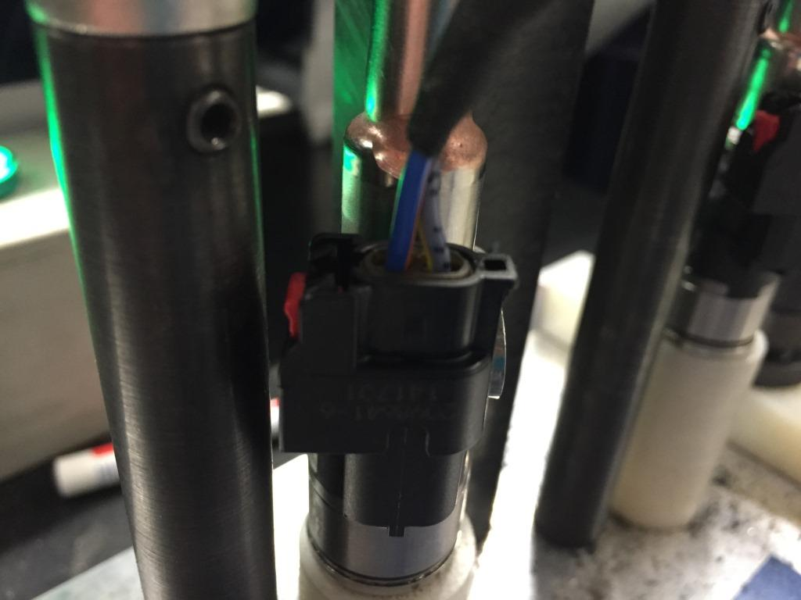
Figure 37 Injector Harness with CPA Device on Lineside Jig

Ergonomic and Timing Evaluation

An ergonomic and timing evaluation is required, most importantly to ensure the CPA connector is safe to use but also to obtain accurate timings for the additional work being carried out.
Ergonomic considerations include:-
- Which finger will be used to press the connector
- Angle at which the connector will be pressed
- Force required to secure CPA device
- Number of connections to be made by an operator
- Access to the CPA device
- Ease of disconnecting the CPA device
To time the new process, a modular arrangements of predetermined time standards (MODAPTS) analysis will be completed. This methodology is used to determine the time in which individual steps of a process are completed. This takes into consideration two main factors, the body part to be used and the level of effort required of the operator.
In relation to the body part being used, consideration is given to the actual body part and the actions they make when grasping and placing an object, as well as any other movements such as walking or bending. These are measured in MODs.
The level of effort required is calculated in MODs, with 1 MOD = 0.129 seconds. The total number of MODs are added together to calculate the total time for a process.
Ergonomic evaluation and MODAPTS analysis (figure 38) completed by Mike Pearce – no ergonomic constraints identified.
MODAPTS analysis found only 4.49 seconds of cycle time remaining after rest of process is complete, meaning the vision system will have little time to compete its’s part of the operation.
Figure 38 MODAPTS Analysis
(Pearce, 2018)

Vision Systems Currently in Use

A vision system is currently in place at the end of the assembly line, checking for numerous things, including ignition coil connectors and that their CPA device is locked.
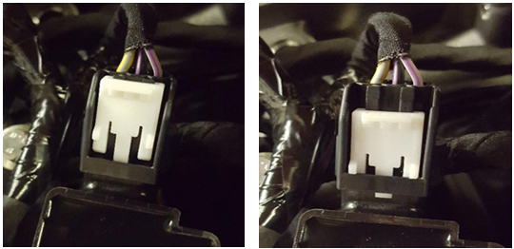

Figure 39 Ignition Coil Connector with CPA Device Pre-lock and Locked Position

Highlighted in red in figure 30 is the area of which the vision system concentrates on. There are thousands of pixels in this area alone and the vision system has a pre-determined wavelength and intensity programmed into it, which it expects to identify in this area. Other key features include:
- System is automated, triggered by a sensor
- Can analyse a number of features from one image, using binary code of pixels.
- Uses part of the engine as a focal point due to potential differences in platens. This guarantees the correct pixels are analysed.
- Has feedback system so confirmation of OK image is displayed on VDA unit.
- Has repair bay so any NOK images feedback to the PLC, which sends the engine to the repair bay.
Figure 40 shows an image taken by this vision system, as it is displayed on the VDA application on the computer screen, with a feature number attached to every feature the system is analysing. In this image the 4 ignition coil connectors are highlighted. In the event of a NOK image, the VDA application will highlight the feature to be investigated.

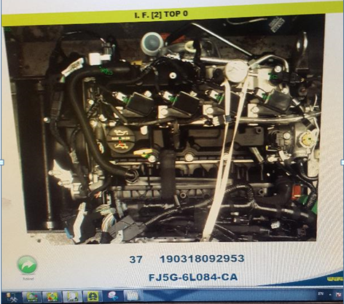
Figure 40 End-of-Line Camera Image from Computer

Figure 41 shows the number of NOK ignition coil connectors identified by the system for the first 6 months of 2017, an average of 34 per week. A NOK connector would not affect an engines performance therefore it would not cause a warranty claim although it would result in a Vehicle Operations (VO) alert from the vehicle assembly plant if found there. Before this system was in place, VO alerts were received on a weekly basis relating to open CPA devices. Zero VO alerts have been received since the introduction of the vision system.
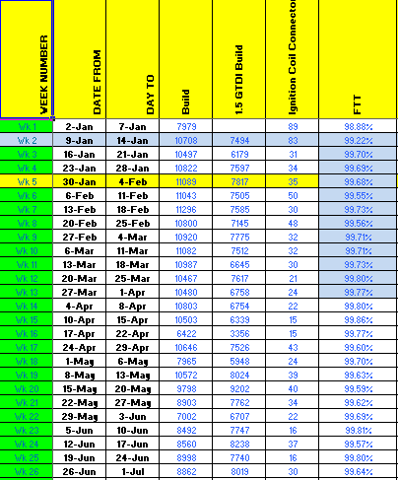
Figure 41 Data for Vision System Checking Ignition Coil Connectors over 6 Month Period

Implementing this Improvement

To implement this improvement will require the following.

Hardware and Software Requirements

Keyence, (2018) a leading supplier that have previously supplied Ford with Vision systems, has recommended the following vision system:
- Keyence X-GX Vision System - Offering 21 million pixels, this camera is suitable for the high accuracy and high resolution required for this process. Offers high-speed inspection through parallel processing. Compatible with USB 3.0 hard disks, allowing a memory capacity of 2 TB (Keyence.co.uk, 2018)
- Keyence XG-X VisionEditor – Where information and commands are input and enables engineers to program the system, define parameters, save images and keep a log of them linked to their engine number. This system has various programs, enabling engineers to define different parameters for different derivative of engine (Keyence.co.uk, 2018)

The following hardware and software, commonly used at BEP, are required to support the vision system and the manufacturing process. Keyence have confirmed that all are compatible with the above system:

- Dell Optiplex 9030 AIO PC – Intel quad core i5-4590s processor, Windows 7 professional 64 bit. 16 GB RAM, 8 USB ports (1 of which USB 3.0)
- Visual Dynaic Aids application, providing a display for the operator, showing pass/fail images.
- Data Acquisition Device – This is used to read inputs to the system and activate outputs that are triggered by sensors.
- HDD Intenso 3TB – Offers sufficient memory for images to be stored for later analysis or reference if needed.
- Programmable Logic Controller (PLC) – A PLC is used to control manufacturing processes
- Manual Trigger – Required to instruct the camera
- LED Lighting – To ensure critical areas are thoroughly illuminated, suitable lighting, such as LED bulbs, need to be positioned correctly above the injector rail.

Process for a Proposed Vision System

The author has developed a potential process of how the proposed vision system may operate. This can be seen in Figure 43.

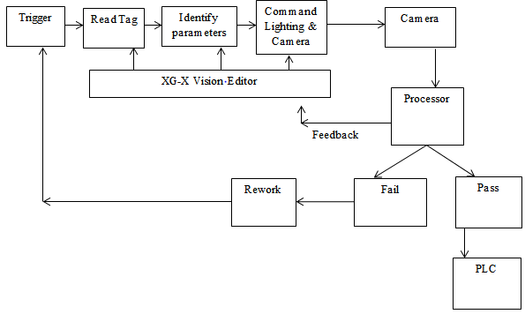
Figure 42 Potential Process for Proposed Vision System

Operation

This system would be required to analyse four features, one of which is shown in Figure 44, for each image taken.
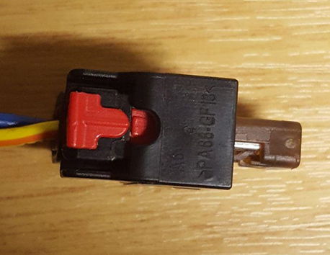

Figure 43 Injector Harness CPA Device with Area of Interest Highlighted
Figure 44 highlights the area in which the vision system will analyse to ensure the CPA device is locked. When the device is locked, this area will be black, if it is in pre-lock position it will be red. Other considerations for the operation of this vision system include:
- A suitable focal point would be on the fuel injector rail to avoid errors arising from the movement of the jig.
- A new lineside jig would be required so access to CPA device can be achieved. Figure 45 shows a new jig that has been developed and is being trialled.
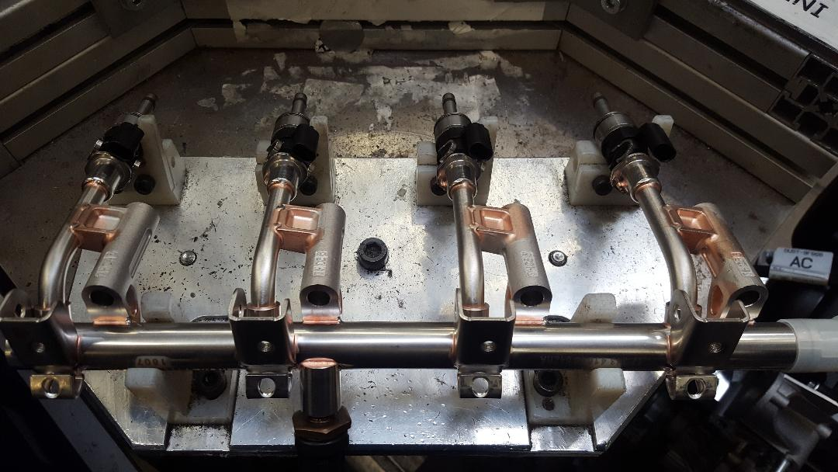
Figure 44 Proposed Injector Rail Jig for New Process

- MODAPTS analysis found only 4.49 seconds cycle time remaining after manual tasks performed. This is enough time to capture image but not to process. As a result image processing will have to be done between this process and the next on the production line.
- There is a repair bay at Opx290 which could be used in the event of a NOK image.
- A two-handed hold trigger is recommended to reduce chances of operators hands interfering with vision system and to ensure they are still to reduce chances of movement. Movement of the system can lead to NOK images.
- A rigid structure would need to be in place, above the operator and away from anything that can influence movement, to fix the camera to. This would ensure accuracy. Figure 46 shows an existing overhead structure at the operation that can be modified or extended.
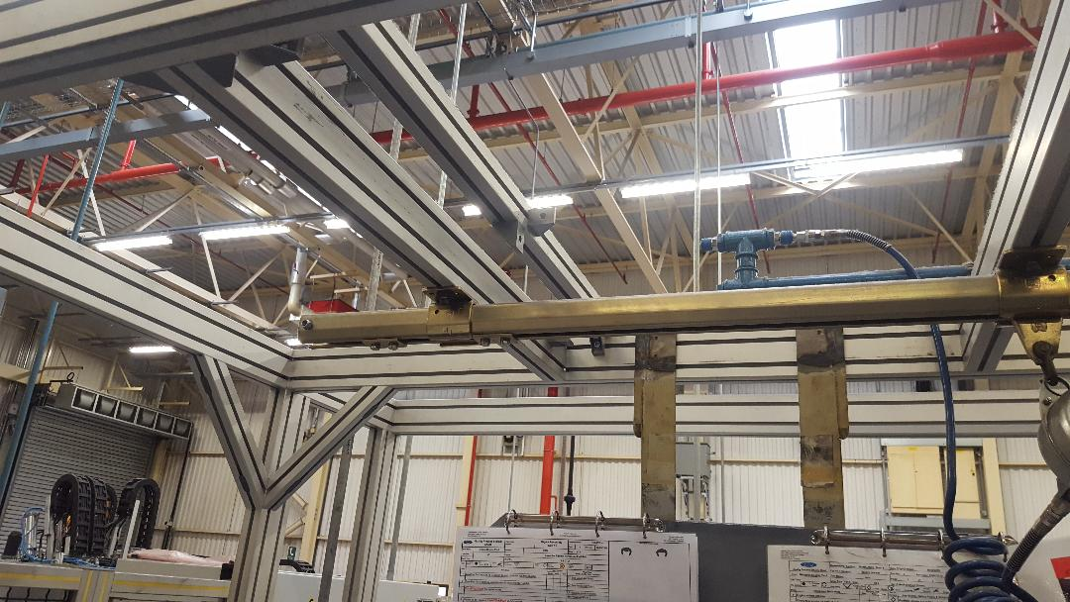
Figure 45 Overhead Structure of Assembly Line

Failure Modes and Effects Analysis

An FMEA of the proposed improvement will be completed, keeping in mind that the current process has an RPN of 160. Figure 47 shows the result of the FMEA and that introducing a vision system and a CPA device would reduce the RPN to 40, a significant reduction.

Figure 46 FMEA – Vision System + CPA Improvement

Click-hunter System

Connector Compatibility with Click-Hunter System

Results from the fuel rail trial found that the click-hunter system detected the click created by the connection, as can be seen in Figure 48. The image shows two graphs, top one displaying the frequency versus time and the bottom displays the amplitude versus time.
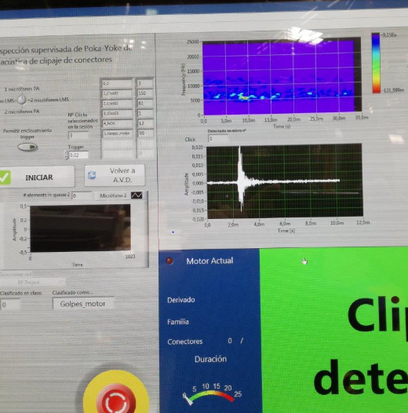
Figure 47 Results from Analysis of Fuel Rail and Injector Harness Connectors
(Carsi, 2018)

Ergonomic and Timing Analysis

An ergonomic evaluation is not required as the manual work for the operator is not changing. A timing analysis will not be required as the click-hunter system works simultaneously to the operator and removal of manual quality check will offset any unlikely additional time.

Use of Click-Hunter System at Other Plant

A click-hunter system is used to detect if knock sensors are securely connected or not at another Ford plant. With the use of a VDA unit, the operator can see exactly what connections need making at the operation and once an ok connection is identified, the unit updates.
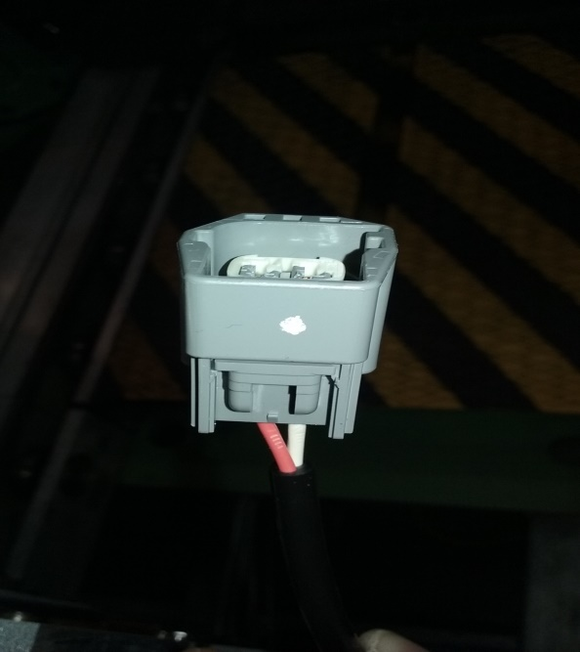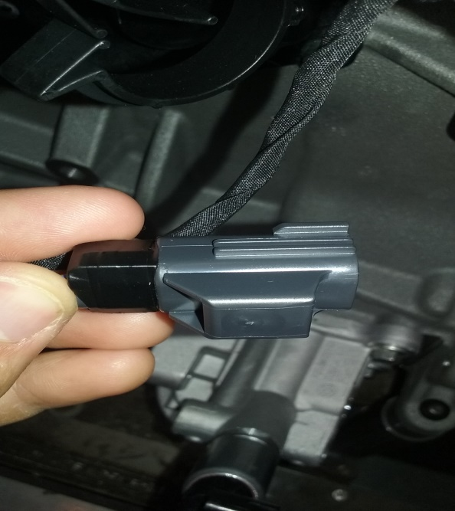
Figure 48 Knock Sensor Connector and Main Harness Connector

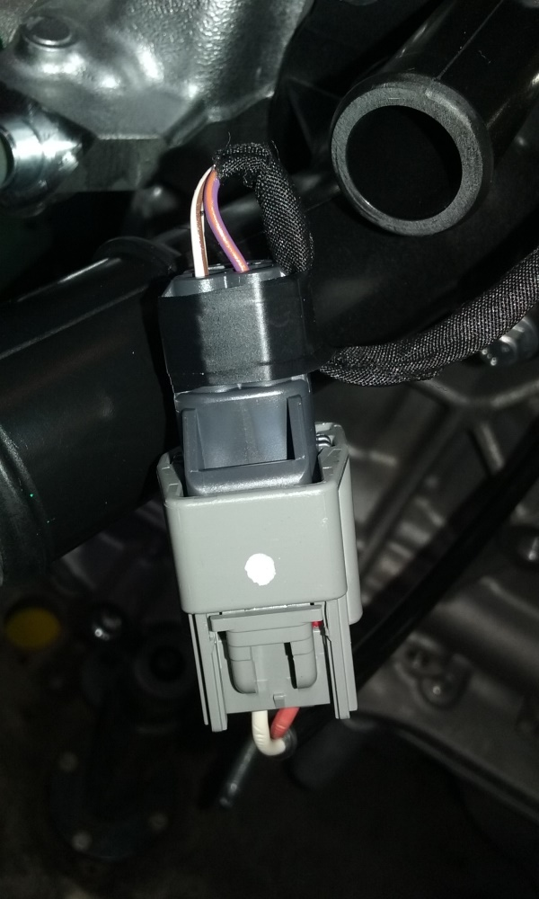
Figure 49 Securely Connected Knock Sensor and Main Harness Connector

Key features of this application include:
- The system is programmed to detect two clicks.
- Can be programmed to detect a number of different clicks, carried out in a specific order, dependant on engine derivative.
- Has feedback system so confirmation of OK image is displayed on VDA unit (Figure 51)
- Filtering of the sounds is done with the use of an ANN so that the system only analyses sounds within the target range.
- Has a manual override in the event of no detection, placing responsibility with the operator to ensure an OK connection.
- In the event that the system does not detect the connection and the operator must override it, the system beeps to check the correct position of the microphone. If this happens on three consecutive processes then the system will require recalibration. This normally happens two/three times a week and takes approximately two hours.

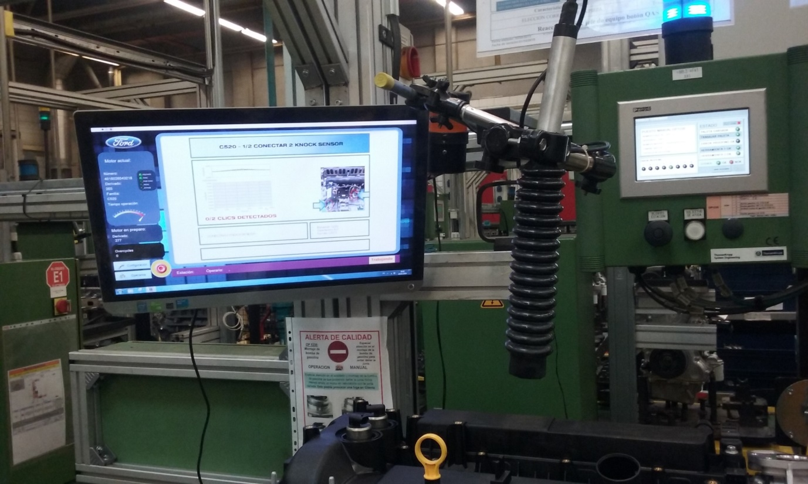
Figure 50 Click-Hunter System and VDA Application in Operation

Figure 54 shows that before installation of the click-hunter system, the plant was finding an average of 12,000 reject knock sensors per million opportunities. Only 4 were found in the 7 months following its introduction, a significant reduction.

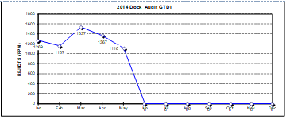
Figure 51 Monthly Rejects of Knock Sensors Identified in Dock Audit before and after Click-Hunter System was Implemented
(Carsi, 2018)

Implementing this Improvement

To implement this improvement will require the following.

Hardware and Software Requirements

Nutai, the third party contractor that assisted Ford engineers with the development of the System, provided the following hardware and software requirements:
- Dodotronic Ultramic 250k (Figure 57) – required to detect ultra-high frequencies of the clicks, up to 250KHz
- Nutai Click-hunter program – The program required to operate click-hunter.
- LabVIEW NI-DAQmx 14.0 (or next versions) – Free license
- NI LabVIEW Run-Time Engine 2011 – Required license
The following hardware and software are required to support the Click-hunter system. Nutai confirmed all are compatible with the click-hunter system.
- Dell Optiplex 9030 AIO PC – Intel quad core i5-4590s processor, Windows 7 professional 64 bit. 16 GB RAM, 8 USB ports (1 of which USB 3.0)
- Visual Dynaic Aids application, providing a display for the operator, showing OK/NOK sounds have been identified.
- Data Acquisition Device – This is used to read inputs to the system and activate outputs that are triggered by sensors.
- Programmable Logic Controller (PLC) – A PLC is used to control manufacturing processes
- HDD Intenso 3TB – Offers sufficient memory for sounds to be stored for later analysis or reference if needed.

Process for Proposed Click-Hunter System

The author has developed a potential process of how the proposed click-hunter system may operate. This is shown in Figure 54.

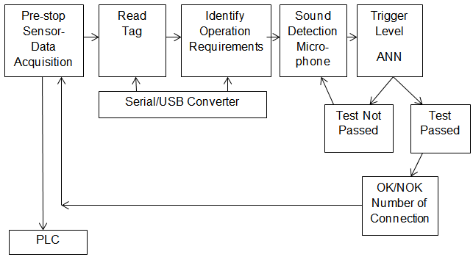
Figure 52 Process for Proposed Click-Hunter System

Operation

The current lineside jig is compatible with a click-hunter system. Alterations can be made so microphone sits beneath connectors, highlighted in Figure 55, reducing the risk of interference by operator. It may be necessary to have two microphones to get as close to the sound as possible.
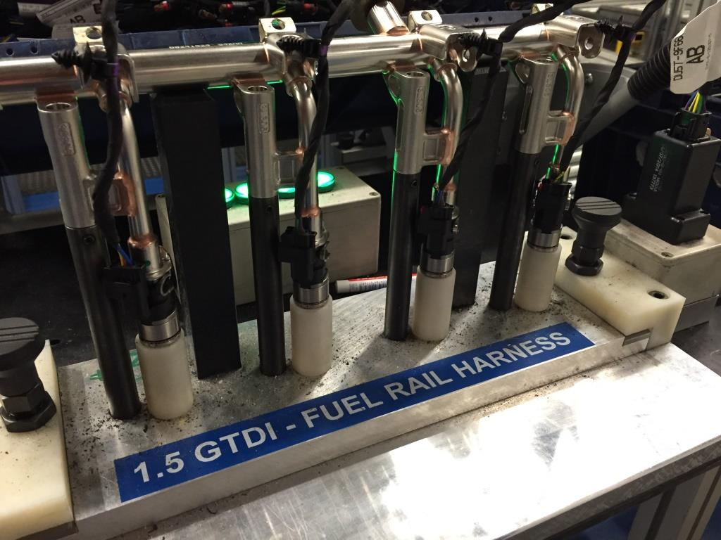
Figure 53 Current Lineside Jig
Other considerations for the operation of this system include:
- System will be required to listen for four connections.
- Computer with VDA application display needs to be visible and accessible for the operator.
- There is a lot of machinery and industrial activity occurring in close proximity to the operation so the trigger level will need to be as close to the sound of the connection as possible, reducing the amount of sounds passing through the filter.
- The click-hunter system needs to undergo supervised training in-house. This application allows the manual classification of the different sounds identified by the microphone, a requirement for training the artificial neural network. During this process, when a sound is registered, it is then classified. The more classified sounds generated during the supervised training, the more accurate the system will be (Nutai, 2018)
- Successful training of the ANN requires around 150 recorded sounds for each classification generated in the supervised training. The supervised training process is very time consuming and requires specific expertise and resources (Nutai, 2018).
- Once complete and the system is ready to use, resources must be available for the regular recalibration of the neural network that is required. Due to the assembly line running a three-shift pattern, recalibration during production time will leave the process vulnerable to NOK connections.

Failure Modes and Effects Analysis

An FMEA will be completed for the proposed click-hunter system, keeping in mind, the current process has an RPN of 160 and the proposed vision system has an RPN of 40. The result of the FMEA is displayed in Figure 56. Click-hunter system has an RPN of 128, due to the time in which it requires recalibration the process will be vulnerable. Whilst this is lower than the current process of 160 it is significantly higher than the proposed vision system and CPA.

Figure 54 FMEA for Implementing a Click-hunter System

Cost/Benefit Analysis for Alternative Improvements

A cost/benefit analysis will calculate the costs attached to implementing each improvement and compare these to the benefits each can potentially deliver.

Vision System and CPA Device

The costs and benefit of a vision system and CPA device will be considered in this section.

Costs

Costs for the Keyence vision system have been obtained directly from the company whereas costs for supporting hardware and software have been provided by the Production Team Manager.
Purchasing Keyence X-GX Vision System and Keyence X-GX Vision Editor -£18,800.
Dell Optiplex 9030 AIO PC – Intel quad core i5-4590s processor, Windows 7 professional 64 bit. 16 GB RAM, 8 USB ports - £1000
Data Acquisition Device from National Instruments - £3200
Designing and installing a rigid structure for the camera will cost £2500.
Installation of the vision system, including supply of any other hardware and software and development will cost £68,000.
Any disruptive work will take place at weekends, requiring an engineer to be present, resulting in overtime. During installation, operators may be required to do trial runs and offer assistance, also resulting in overtime. Total expected cost based on requirements of installation contractor £18,500.
Engineers will need to create new QPS sheets, taking approximately 4 hours, costing £192.
Each operator will require basic training, taking approximately 30 minutes. 33 operators to be trained plus a trainer for each one adds up to 33 hours, costing £1221.
Total cost = £113,413
All these costs are one off payments and do not include future maintenance and breakdown whereas upgrading the injector harness will make the engines more expensive to manufacture, increasing the cost per unit.
Cost of current injector harness = £3.60
Cost of upgrading the injector harness has been provided by Delphi Technologies, supplier of the injector harness.
Cost of injector harness with CPA = £4.10
Over a year, with a build schedule of approximately 500,000 engines, this costs £250,000.
Total cost for implementing this improvement is £363,413 (based on one year increase on price of injector harness).

Benefits

Keyence claim their vision system can deliver accuracy as high as 99.6%. The accuracy of the vision system currently used in BEP, detailed in this chapter, supports this claim; almost certainly preventing the failure mode from occurring.
The FMEA suggests that this system will significantly reduce the risk of this issue occurring.
Target of zero defects for this operation is nearly achievable.
Customer satisfaction will improve alongside the plants reputation for delivering high quality engines.

Click-Hunter System

The cost and benefit of a click-hunter system will be considered in this section.

Costs

Costs for the click-hunter system have been obtained directly from Nutai. The Production Team Manager has provided costs for the supporting hardware and software.
Purchase of click-hunter program with LabVIEW licence from Nutai £32,000.
Installation and mounting structure by Nutai £49,000.
Dodotronic Ultramic 250k - £2800
Dell Optiplex 9030 AIO PC – Intel quad core i5-4590s processor, Windows 7 professional 64 bit. 16 GB RAM, 8 USB ports - £1000
Data Acquisition Device from National Instruments - £3200
Any disruptive work will take place at weekends, requiring an engineer to be present, resulting in overtime. During installation, operators may be required to do trial runs and offer assistance, also resulting in overtime. Total expected cost based on requirements of installation contractor £14,000.
System set-up and training will require approximately 24 hours for 1 engineer costing £1,152.
Engineers will need to create new QPS sheets, taking approximately 4 hours, costing £192.
Each operator will require basic training, taking approximately 30 minutes. 33 operators to be trained plus a trainer for each one adds up to 33 hours, costing £1221.
Total cost = £104,565
These are one off payments that do not cover ongoing maintenance.
Recalibration of the system will be done three times a week, taking an engineer two hours at a time costing £288 per week. Over a year this will cost £13,536.
Total cost for implementing this improvement will cost £118,101 (based on one year of recalibration).

Benefits

Nutai claim the click-hunter system can deliver accuracy of 99.7% and the use of the system at another Ford plant, detailed in this chapter, supports this claim; almost certainly preventing the failure mode occurring.
Recalibration is to be done three times a week, ideally once on a weekend although this cannot always be guaranteed. With this in mind, the system will potentially be out of use six hours a week. Based on current production volume of half a million engines per year, approximately one hundred per hour, this leaves six hundred engines per week vulnerable.
47 weeks of production per year x 600 engines = 28,200 engines vulnerable
This totals 5.64% of annual production volume, therefore the accuracy in this scenario is more likely 94.06%.
The FMEA suggests this proposed system still poses a risk to the issue occurring.
Target of zero defects for this operation is not guaranteed, though a significant reduction would be likely.
Customer satisfaction and the reputation of the plant will improve if the failure mode becomes uncommon.

Cost/Benefit Analysis Findings

The cost/benefit analysis has shown significant differences between the alternative improvements. While a vision system with CPA offers far greater accuracy than a click-hunter system, a click-hunter system requires only a third of the investment.
While a significantly lower price, the issue could potentially occur as much as it previously has, eliminating any return on the investment (ROI).
An investment of £363,413 for a vision system to be used with a CPA device offers a more desirable ROI. When considering the COQ analysis in chapter 5, Ford spend billions of pounds every year ensuring their products set a benchmark for quality, a benchmark not being reached with this issue occurring. This issue has also been a financial drain on BEP directly.
The ROI for the vision system and CPA can be defined as the elimination of financial penalties arising from the failure and the justification of the billions of pounds spent setting the benchmark for quality, which can be realised with the use of this system.

Conclusion

This Improve phase of the project has identified a variety of different poka-yoke systems that could potentially prevent this issue occurring. With the aid of recognised tools and analysis methods, reviewed in the literature, the author has been able to compare these different systems. This comparison has led to the identification of a most suitable poka-yoke system for Ford to use in order to prevent this issue.

Conclusion and Recommendations

Introduction

This project aimed to identify a suitable poka-yoke system to aid in the prevention of NOK fuel injector connections. This chapter will present the findings of the project. Recommendations, based on the findings of the project will be made to Ford as well as alternative uses for the poka-yoke systems.

Conclusion

Overall, the author feels the project has been a success. The aims and objectives have been met. The literature review provided the author with sound a understanding of the importance of Quality in the manufacturing industry and provided guidance throughout.

Define

The define phase of this project provided the author with a solid foundation, capturing key information about the importance of the project and the impact the issue is having on the reputation of the plant. Understanding this and the significant threat the issue poses to BEP securing future investment from Ford helped drive the project team as well as the knowledge that customer satisfaction is a key focus of the business. Not resolving the issue would have meant more dissatisfied customers.

Measure

The data collection within this phase of the project was deemed a success as it provided enough data to be analysed and support in the identification of root causes. The FMEA also provided a benchmark for comparison when investigating potential improvements.

Analyse

The detailed analysis in this phase found the warranty costs for this issue are just a fraction of the true cost to BEP and the company as a whole. Also the billions of dollars they spend ensuring their products meet high quality standards is failing to do just that. The failure rate on the process under investigation was exposed as being significantly higher than other wiring harness processes. Root causes were identified as:
- the process is prone to human error, with manual quality checks potentially not being carried out
- the environmental conditions surrounding the operation could potentially prevent the operator hearing the click of the connection
These were influential factors during the Improve phase.

Improve

The findings from the previous phases enabled the project team to identify a number of potential poka-yoke systems. Viable systems were compared and some were found to be unsuitable while two systems proved to have a lot of potential. Further investigation enabled the author to discover a critical flaw in the click-hunter system which would leave the process vulnerable in a way that a vision system would not.

Conclusion

In conclusion, the project has identified several recommendations, which will be addressed in the next section.

Recommendations

Following on from the findings of this project, the author investigated a number of potential poka-yoke systems that could either prevent this issue occurring or detect it. Two suitable poka-yoke systems were investigated further, click-hunter and a vision system with a CPA device. Both can offer a high level of accuracy on this process.
The author would recommend to Ford the implementation of a vision system with a CPA device added to the connector.
Though this system is considerably more expensive, it offers far greater accuracy due to click-hunters need for recalibration. During the time spent recalibrating the click-hunter system an estimated 28,200 engines will pass through undetected. This leaves the process vulnerable to failures.
The primary influence of this project is quality therefore to ensure the highest level of quality a vision system with a CPA device will eliminate this issue.
The author would recommend the use of a click-hunter system on a production line which works less than a three-shift pattern. A low volume production line, only working a day shift or two-shift pattern would provide time during the week for recalibration, without interfering with production.
The click-hunter system could potentially be useful in processes where a vision system would not work. Vision systems focus on a fixed point yet with wiring harnesses, some connections are not in a fixed position, therefore a vision system would not work.
Click-hunter clearly offers a highly accurate, cost effective, poka-yoke system to detect OK wiring harness connections but in this scenario its inability to continuously work in a way that a vision system can makes it unsuitable.

Reference List

Ahma, W., Perinpanayagamb, S., Jennions, I. and Kahn, S. (2014). Study on Intermittent Faults and Electrical Continuity. In: 3rd International Conference on Through-life Engineering Services. [online] Londo: Elsevier, pp.71-75. Available at: https://ac.els-cdn.com/S2212827114008282/1-s2.0-S2212827114008282-main.pdf?_tid=27781012-ace9-11e7-ae12-00000aab0f6c&acdnat=1507550485_538297f884b4ca194e64e7b4d22eee1a [Accessed 9 Oct. 2017].
Airbagcrash.com. (2018). GM, Saturn, Airbag, Air Bag, Black Box, EDR, Event Data Recorder, SDM, Deployment Accident, SDM Technical Information, GM Airbag SDM Locations By Year and Model, GM Air Bag SDM Crash Data Recovery Using The Bosch CDR Tool. [online] Available at: http://www.airbagcrash.com/sdmairbagtechinfo.html [Accessed 29 Mar. 2018].
Alhuraish, I., Robledo, C. and Kobi, A. (2017). A comparative exploration of lean manufacturing and six sigma in terms of their critical success factors. Journal of Cleaner Production, [online] 164, pp.325-337. Available at: https://www-sciencedirect-com.ezproxy.uwtsd.ac.uk/science/article/pii/S095965261731315X [Accessed 12 Mar. 2018].
Aras, O. and Ozcam, B. (2016). Cost of Poor Quality in Energy Sector. International Journal of Commerce and Finance, [online] 2(1), p.27. Available at: https://search-proquest-com.ezproxy.uwtsd.ac.uk/docview/1811314069/fulltextPDF/EAA37D050A874655PQ/1?accountid=130472 [Accessed 21 Apr. 2018].
Breyfogle, F. (2003). Implementing six sigma. Hoboken, NJ: Wiley.
Brighthub Engineering. (2018). How Vision System in Robots WOrk? Process of Image Generation in Robots. [online] Available at: https://www.brighthubengineering.com/robotics/54373-vision-system-in-robots/ [Accessed 6 Apr. 2018].
Box, T. (2017). Six Sigma Quality: Experiential Learning. S.A.M.Advanced Management Journal, [online] 71(1), pp.20-23. Available at: https://search-proquest-com.ezproxy.uwtsd.ac.uk/docview/231244113?accountid=130472&rfr_id=info%3Axri%2Fsid%3Aprimo [Accessed 12 Oct. 2017].
Carsi, P. (2018). Click-hunter trial. [email].
Chapman, B. (2017). Mercedes-Benz recalls 400,000 cars over airbag fault. Independant. [online] Available at: http://www.independent.co.uk/news/business/news/mercedes-benz-recall-car-airbag-fault-a-class-b-c-e-cla-models-built-year-a8003291.html [Accessed 17 Oct. 2017].
Conger, S. (2015). Process mapping and management. [Place of publication not identified]: Business Expert Press.
Corey, W. (2014). Advanced Gasoline Turbocharged Direct Injection Development. [ebook] Ford, p.2. Available at: https://www.energy.gov/sites/prod/files/2014/07/f17/ace065_weaver_2014_o.pdf [Accessed 12 Apr. 2018].
Delphi Technologies Incorporated (2018), Quotation for Upgraded Injector Harness.
Evans, S. (2017). Voice of Customer.
Farmer, E. (2017). Voice of Customer.
Fraser, K., Watanabe, C. and Hvolby, H. (2013). COMMITMENT TO SERVICE QUALITY IN AUTOMOTIVE DEALERSHIPS: RESULTS FROM AN AUSTRALIAN PILOT STUDY.
Ford Motor Company, (2018). Financial Results for Employees.
George, M. (2005). The lean Six Sigma pocket toolbook. New York: McGraw-Hill.
Journal of Services Research, [online] 13(1), pp.7-29. Available at: https://search-proquest-com.ezproxy.uwtsd.ac.uk/docview/1355247798?accountid=130472&rfr_id=info%3Axri%2Fsid%3Aprimo [Accessed 12 Sep. 2017].
Mikel, M. and Schroeder, R. (2000). Six Sigma: The Breakthrough Management Strategy Revolutionizing the Worlds Top Corporations. 1st ed. New York: Doubleday, Random House.
Jeong, H. and Choi, H. (2012). A Quality Attribute for RFID Manufacturing System. Applied Mechanics and Materials, [online] 224, pp.43-46. Available at: https://search-proquest-com.ezproxy.uwtsd.ac.uk/docview/1430305753?accountid=130472&rfr_id=info%3Axri%2Fsid%3Aprimo [Accessed 18 Apr. 2018].
Kaynak, H. (2003). The relationship between total quality management practices and their effects on firm performance. Journal of Operations Management, [online] 21(4), pp.405-435. Available at: http://www.sciencedirect.com.ezproxy.uwtsd.ac.uk/science/article/pii/S0272696303000044 [Accessed 12 Oct. 2017].
Keyence.co.uk. (2018). Vision Systems | KEYENCE UK & Ireland. [online] Available at: https://www.keyence.co.uk/products/vision/vision-sys/index.jsp [Accessed 3 Apr. 2018].
Keyence (2018), Quotation for Vision System.
Kučerová, M. and Fidlerová, H. (2014). Improving the Quality of Manufacturing Process through Six Sigma Application in the Automotive Industry. Applied Mechanics and Materials, [online] 693, pp.147-152. Available at: https://search-proquest-com.ezproxy.uwtsd.ac.uk/docview/1631224113/fulltextPDF/9B63F0C5F25E4B0APQ/1?accountid=130472 [Accessed 19 Sep. 2017].
Kušar, J., Rihar, L., Duhovnik, J. and Starbek, M. (2014). Concurrent realisation and quality assurance of products in the automotive industry. Concurrent Engineering, [online] 22(2), pp.162-171. Available at: http://journals.sagepub.com.ezproxy.uwtsd.ac.uk/doi/pdf/10.1177/1063293X13520315 [Accessed 10 Oct. 2017].
Lear Corporation (2014). Connector position assurance device for a connector assembly. 8,926,355.
Liao, H., Sun, Y. and Zhou, P. (2014). Design and Research of Engine Electronic Fuel Injection Simulation Experimental Platform. Applied Mechanics and Materials, [online] 494-495, pp.184-187. Available at: https://search-proquest-com.ezproxy.uwtsd.ac.uk/docview/1826244887/fulltextPDF/BBFA7C8112D4401CPQ/1?accountid=130472 [Accessed 2 Apr. 2018].
Li, Z. and Han, Z. (2013). Research and Development of Vision Measurement System with Marked Targets. Applied Mechanics and Materials, [online] 336-338, pp.2003-2007. Available at: https://search-proquest-com.ezproxy.uwtsd.ac.uk/docview/1442309224/fulltextPDF/ABBD0C2555E9406DPQ/1?accountid=130472 [Accessed 3 Dec. 2017].
Madu, C. (2006). THE ROLE OF SIX-SIGMA IN ACHIEVING COMPETITIVENESS. i-managers journal on management, [online] 1(1), pp.1-8. Available at: https://search-proquest-com.ezproxy.uwtsd.ac.uk/docview/1473905041/fulltextPDF/1D936B77E29B46C6PQ/1?accountid=130472 [Accessed 12 Oct. 2017].
Malik, A. and Blumenfeld, S. (2012). Six Sigma, quality management systems and the development of organisational learning capability. International Journal of Quality & Reliability Management, [online] 29(1), pp.71-91. Available at: https://search-proquest-com.ezproxy.uwtsd.ac.uk/docview/912506941/fulltext/20FCD68EFC0A4CC4PQ/1?accountid=130472 [Accessed 12 Oct. 2017].
Marzagao, D. and Carvalho, M. (2016). international journal of project management, [online] 34(8), pp.1505-1518. Available at: http://www.sciencedirect.com.ezproxy.uwtsd.ac.uk/science/article/pii/S0263786316300667 [Accessed 12 Oct. 2017].
Matthews, D. (2017). Cost of Quality to Ford.
Maves, S. (2011). Vision systems increase productivity. InTech, [online] 58(2), pp.20-22,24. Available at: https://search-proquest-com.ezproxy.uwtsd.ac.uk/docview/862094127?accountid=130472&rfr_id=info%3Axri%2Fsid%3Aprimo [Accessed 29 Mar. 2018].
McCarty, T. (2005). The Six Sigma black belt handbook. New York: McGraw-Hill, pp.404,440.
Monteiro Tavares, C. and Szpytko, J. (2017). Maintenance strategy for vehicle with electronic fuel injection system. Journal of KONBiN, [online] 42(1). Available at: https://search-proquest-com.ezproxy.uwtsd.ac.uk/docview/1982843694/fulltextPDF/417B2517A1D6474CPQ/1?accountid=130472 [Accessed 2 Apr. 2018].
Morissette, B. (2016). CHOOSE THE BEST PARTS FOR YOUR WIRE HARNESS. Assembly, [online] 59(7), pp.10-13. Available at: https://search-proquest-com.ezproxy.uwtsd.ac.uk/docview/1800778796?accountid=130472&rfr_id=info%3Axri%2Fsid%3Aprimo [Accessed 1 Oct. 2017].
Muda, W. (2017). car electric harness connector - Bing images. [online] Bing.com. Available at: https://www.bing.com/images/search?view=detailV2&ccid=rT%2FZjSRO&id=2F69C311811414E761975FDEA8077BD074442D40&thid=OIP.rT_ZjSROOpP3wVzu28siuAEsDf&q=car+electric+harness+connector&simid=607991702433369768&selectedindex=41&ajaxhist=0&first=1 [Accessed 3 Oct. 2017].
M.S. Campos, L. (2013). Lean manufacturing and Six Sigma based on Brazilian model “PNQ”. International Journal of Lean Six Sigma, [online] 4(4), pp.355-369. Available at: https://search-proquest-com.ezproxy.uwtsd.ac.uk/docview/1445033748/fulltextPDF/9FF0EBB05C0F4CF1PQ/1?accountid=130472 [Accessed 19 Sep. 2017].
Narasimhan, R. and Schoenherr, T. (2012). The effects of integrated supply management practices and environmental management practices on relative competitive quality advantage. International Journal of Production Research, [online] 50(4), pp.1185-1201. Available at: http://web.a.ebscohost.com.ezproxy.uwtsd.ac.uk/ehost/pdfviewer/pdfviewer?vid=1&sid=1e5cd5e3-14fa-47da-8e0e-88562a14af6d%40sessionmgr4008 [Accessed 10 Oct. 2017].
Nutai (2015), Click-hunter Instruction Manual.
Nutai (2018), Quotation For Click-hunter System.
Park, J., Nam, G. and Choi, J. (2011). Parameters in cause and effect diagram for uncertainty evaluation. Accreditation and Quality Assurance, [online] 16(6), pp.325-326. Available at: https://link-springer-com.ezproxy.uwtsd.ac.uk/article/10.1007/s00769-011-0763-4 [Accessed 21 Apr. 2018].
Pearce, M. (2018). MODAPTS analysis.
Peeters, J., Basten, R. and Tinga, T. (2018). Improving failure analysis efficiency by combining FTA and FMEA in a recursive manner. Reliability Engineering & System Safety, [online] 172, pp.36-44. Available at: https://www-sciencedirect-com.ezproxy.uwtsd.ac.uk/science/article/pii/S0951832017304192#sec0012 [Accessed 21 Apr. 2018].
Prosser, R. (2015). Ensuring Traceability in Electronics Assembly. Assembly, [online] 58(9), pp.40-45. Available at: https://search-proquest-com.ezproxy.uwtsd.ac.uk/docview/1705964349?accountid=130472&rfr_id=info%3Axri%2Fsid%3Aprimo [Accessed 31 Mar. 2018].
Pyzdek, T. and Keller, P. (2014). The six sigma handbook. 4th ed. New York: McGraw-Hill Education.
Rumsey, F. and Mccormick, T. (2009). Sound and Recording. Burlington: Elsevier.
Sandoval-Chavez, D. and Beruvides, M. (1998). Using Opportunity Costs to Determine the Cost of Quality: A Case Study in a Continuous-Process Industry. The Engineering Economist, [online] 43(2), pp.107-124. Available at: https://search-proquest-com.ezproxy.uwtsd.ac.uk/docview/206751678?accountid=130472&rfr_id=info%3Axri%2Fsid%3Aprimo [Accessed 9 Dec. 2017].
Savca, T. (2017). Dynamics of the planning process in the local public administration (SIPOC diagram and PM). Public Administration, [online] 2(94), pp.31-41. Available at: http://librarycatalogue.uwtsd.ac.uk/primo_library/libweb/action/display.do?tabs=detailsTab&ct=display&fn=search&doc=TN_doaj_soai_doaj_org_article_78f91cfc5d29448faf52b87354d77965&indx=4&recIds=TN_doaj_soai_doaj_org_article_78f91cfc5d29448faf52b87354d77965&recIdxs=3&elementId=3&renderMode=poppedOut&displayMode=full&frbrVersion=&frbg=&&dscnt=0&scp.scps=scope%3A%2844WHELF_UWTSD%29%2C44WHELF_UWTSD_Ebsco%2Cprimo_central_multiple_fe&tb=t&mode=Basic&vid=44WHELF_UWTSD_VU1&srt=rank&tab=tab1&dum=true&vl(freeText0)=sipoc&dstmp=1524318143735 [Accessed 21 Apr. 2018].
Schiffauerova, A. and Thomson, V. (2006). A review of research on cost of quality models and best practices. International Journal of Quality & Reliability Management, [online] 23(6), pp.647-669. Available at: https://search-proquest-com.ezproxy.uwtsd.ac.uk/docview/1771400702?accountid=130472&rfr_id=info%3Axri%2Fsid%3Aprimo [Accessed 9 Nov. 2017].
Slideplayer.com. (2018). SlidePlayer - Upload and Share your PowerPoint presentations. [online] Available at: http://slideplayer.com/slide/3920570/13/images/29/Electronic+Fuel+Injector+Operation.jpg [Accessed 2 Apr. 2018].
Sower, V. and Sower, C. (2015). Better Business Decisions Using Cost Modeling. 2nd ed. Business Expert Press, pp.55-56.
Stylidis, K., Madrid, J., Wickman, C. and Soderberg, R. (2017). Towards overcoming the boundaries between manufacturing and perceived quality: an example of automotive industry. In: The 50th CIRP Conference on Manufacturing Systems. [online] Goteborg: Elsevier B.V., pp.733 – 738. Available at: http://ac.els-cdn.com.ezproxy.uwtsd.ac.uk/S2212827117302378/1-s2.0-S2212827117302378-main.pdf?_tid=f9e2a974-979d-11e7-a03f-00000aacb360&acdnat=1505209221_a6df9e2dfd16f2110e393aaf6d412f02 [Accessed 12 Sep. 2017].
Su, H., Linderman, K., Schroeder, R. and Van de Ven, A. (2014). A comparative case study of sustaining quality as a competitive advantage. Journal of Operations Management, [online] 32(7-8), pp.429-445. Available at: http://www.sciencedirect.com.ezproxy.uwtsd.ac.uk/science/article/pii/S027269631400062X [Accessed 10 Oct. 2017].
Swingler, J. (2009). Enhancing connector reliability by using conducting polymer materials to minimise contact fretting. Materials & Design, [online] 30(10), pp.3935-3942. Available at: http://www.sciencedirect.com.ezproxy.uwtsd.ac.uk/science/article/pii/S0261306909002799 [Accessed 1 Oct. 2017].
Tan, K. and Xu, G. (2014). Development and Optimization System of Vehicle Electronic Fuel Injection. Applied Mechanics and Materials, [online] 602-605, pp.1512-1517. Available at: https://search-proquest-com.ezproxy.uwtsd.ac.uk/docview/1826043927/fulltextPDF/13C4453BD6294C22PQ/1?accountid=130472 [Accessed 21 Apr. 2018].
Thorne, A. (2017). Six Sigma Improve Phase.
Thakore, R., Dave, R., Parsana, T. and Solank, A. (2014). A Review: Six Sigma Implementation Practice in Manufacturing Industries. International Journal of Engineering Research and Applications, [online] 4(11), pp.63-69. Available at: http://librarycatalogue.uwtsd.ac.uk/primo_library/libweb/action/display.do?tabs=detailsTab&ct=display&fn=search&doc=TN_doaj_soai_doaj_org_article_1bbbfbc0ea334ba0a28d7b11a1e7135e&indx=7&recIds=TN_doaj_soai_doaj_org_article_1bbbfbc0ea334ba0a28d7b11a1e7135e&recIdxs=6&elementId=6&renderMode=poppedOut&displayMode=full&frbrVersion=&frbg=&&dscnt=0&scp.scps=scope%3A%2844WHELF_UWTSD%29%2C44WHELF_UWTSD_Ebsco%2Cprimo_central_multiple_fe&tb=t&mode=Basic&vid=44WHELF_UWTSD_VU1&srt=rank&tab=tab1&dum=true&vl(freeText0)=six%20sigma%20manufacturing&dstmp=1505425869528 [Accessed 14 Sep. 2017].
Vision-systems.com. (2018). Fundamentals of machine vision lenses. [online] Available at: https://www.vision-systems.com/articles/print/volume-19/issue-11/features/fundamentals-of-machine-vision-lenses.html [Accessed 29 Mar. 2018].
Vlasik, B. and Bunkley, N. (2009). Toyota Will Fix or Replace 4 Million Gas Pedals. New York Times. [online] Available at: http://www.nytimes.com/2009/11/26/business/26toyota.html [Accessed 17 Oct. 2017].
Zhang, J. (2014). Development of an in-process Pokayoke system utilizing accelerometer and logistic regression modeling for monitoring injection molding flash. The International Journal of Advanced Manufacturing Technology, [online] 71(9-12), pp.1793-1800. Available at: https://web-b-ebscohost-com.ezproxy.uwtsd.ac.uk/ehost/pdfviewer/pdfviewer?vid=1&sid=42863ebc-3cbf-45f1-99f6-61066f3c52ad%40sessionmgr101 [Accessed 21 Apr. 2018].

Bibliography

Deming, W. (1986). Out of the crisis. Cambridge, Mass.: Massachusetts Institute of Technology, Center for Advanced Engineering Study.
George, M. (2005). The lean Six Sigma pocket toolbook. New York: McGraw-Hill.
Womack, J. and Jones, D. (2003). Lean thinking. New York: Free Press.
McCarty, T. (2005). The Six Sigma black belt handbook. New York: McGraw-Hill, pp.404,440.
Nutai (2015), Click-hunter Instruction Manual.

