

AI POWERED CHATBOT IN CUSTOMER SUPPORT USING TRANSFORMER MODELS & SENTIMENT ANALISYS

Athish Thomas Paul
Supervisor Dr. Nathan Morgan

Project submitted as part of the requirements for the award of MSc Software Engineering and Artificial Intelligence

September 2025

Declaration of Originality

I, Athish Thomas Paul declare that I am the sole author of this Project; that all references cited have been consulted; that I have conducted all work of which this is a record, and that the finished work lies within the prescribed word limits.

This work has not previously been accepted as part of any other degree submission.

Signed : ............. ............

Date : ........10../..09..2025..........

FORM OF CONSENT

I, Athish Thomas Paul, hereby consent that my Project, submitted in candidature for the MSc Software Engineering and Artificial Intelligence, if successful, may be made available for inter-library loan or photocopying (subject to the law of copyright), and that the title and abstract may be made available to outside organisations.

Signed : ............. .................

Date : ........10../..09..2025..........

Copyright Acknowledgement
I acknowledge that the copyright of this project report, and any product developed as part of the project, belong to University of Wales Trinity Saint David, Swansea.

ABSTRACT

Chatbots have become a widely adopted solution for organizations seeking to provide scalable and cost-effective customer support. They enable real-time interaction, reduce the workload of human agents, and improve service availability. However, conventional chatbots are limited in their ability to interpret user emotions, often generating responses that, while syntactically correct, fail to demonstrate empathy. This lack of emotional intelligence can diminish user satisfaction and undermine trust.
Sentiment analysis, a branch of Natural Language Processing (NLP), provides a means of addressing this limitation by enabling chatbots to detect and respond to the emotional tone of user messages. Recent advances in Transformer-based models, particularly lightweight architectures such as DistilBERT, have improved the accuracy and efficiency of sentiment classification. DistilBERT offers near-BERT performance while being significantly smaller and faster, making it suitable for real-time applications where latency and scalability are critical.
This dissertation presents the design, implementation, and evaluation of a sentiment-aware chatbot for customer support. The chatbot was built using DistilBERT, fine-tuned on the Stanford Sentiment Treebank (SST-5) dataset through the Hugging Face ecosystem, and deployed in a Streamlit interface. The system was evaluated using standard metrics, including accuracy, precision, recall, F1-score, and confusion matrix, as well as qualitative testing through user interactions.
The results demonstrate that the chatbot can successfully classify fine-grained sentiment categories and provide empathetic, sentiment-driven responses. Although challenges remain in accurately detecting neutral and ambiguous sentiments, the prototype illustrates the feasibility of deploying lightweight Transformer models for real-time customer support. The study concludes with recommendations for future research, including multilingual sentiment analysis, sarcasm detection, domain-specific fine-tuning, and enterprise-scale deployment.

Table of Contents

ABSTRACT 3
CHAPTER 1 – INTRODUCTION 7
1.1 INTRODUCTION 7
1.2 JUSTIFICATION / RATIONALE FOR THE RESEARCH 7
1.3 RESEARCH AIM 8
1.4 RESEARCH OBJECT 8
1.5 STRUCTURE OF THE DISSERTATION 8
CHAPTER 2 – REVIEW OF LITERATURE 9
2.1 INTRODUCTION 9
2.2 EVOLUTION OF NLP AND SENTIMENT ANALYSIS 10
2.3 TRANSFORMER ARCHITECTURES IN NLP 13
2.4 SENTIMENT ANALYSIS WITH TRANSFORMERS 16
2.5 CHATBOTS AND CUSTOMER SUPPORT 19
2.6 DEPLOYMENT, SCALABILITY, AND CLOUD AI 22
2.7 ETHICS, SECURITY, AND DATA QUALITY 24
2.8 RESEARCH GAPS AND FUTURE DIRECTIONS 26
2.9 CONCLUSION 29
CHAPTER 3 – RESEARCH METHODOLOGY 30
3.1 Introduction 30
3.2 Research Design 30
3.3 Dataset 31
3.4 Tools and Frameworks 32
3.5 Model Architecture 33
3.6 Training Setup 34
3.7 Deployment Process 34
3.8 Evaluation Metrics 36
3.9 Ethical Considerations 36
3.10 Limitations 37
3.11 Summary 37
CHAPTER 4 – EXPERIMENTS AND RESULTS ANALYSIS 37
4.1 Introduction 37
4.2 Quantitative Results 37
4.3 Qualitative Results 41
4.4 Performance and Efficiency 44
4.5 Summary 44
CHAPTER 5 – DISCUSSION 44
5.1 Introduction 44
5.2 Interpretation of Results 45
5.3 Comparison with Literature 45
5.4 Deployment Trade-offs 45
5.5 Strengths and Contributions 46
5.6 Limitations 46
5.7 Practical and Ethical Implications 47
5.8 Summary 47
CHAPTER 6 – CONCLUSION AND RECOMMENDATIONS 47
6.1 Introduction 47
6.2 Summary of Research 47
6.3 Key Findings 48
6.4 Contributions of the Study 49
6.5 Limitations 49
6.6 Recommendations for Future Work 50
6.7 Conclusion 50
REFERENCES 51
PROJECT MANAGEMENT 55

List Of Figures
Figure 1:The Transformer- model architecture [1] 14
Figure 2:diagram of text-to-text framework [6] 16
Figure 3:Research Design 31
Figure 4: model Architecture 34
Figure 5: performance of SST-5 39
Figure 6: Class Distribution 40
Figure 7: Classification Report for DistilBERT on SST-5 40
Figure 8: Confusion Matrix Counts 41
Figure 9:Normalized Confusion Matrix 42
Figure 10: Text & True vs predicted labels 42
Figure 11: Interface of VS code 43
Figure 12: successful development of the application 44
Figure 13: App interface 44
Figure 14: testing 45
Figure 15: Planned Gantt Chart 56
Figure 16: Actual Gantt Chart 57

ACKNOWLEDGEMENTS
I, Athish Thomas Paul, express my sincere gratitude to my supervisor Dr. Nathan Morgan of Trinity Saint David University of Wales for his invaluable support and guidance throughout the project. His expert advice on academic writing, critical thinking and research methodology significantly helped me with this study. His continuous feedback and encouragement were essential for me to refine my ideas and complete this complex study, especially in developing the model and analyzing the results.

My sincere thanks also go to the University of Wales Trinity Saint David for granting me access to its online library, which making a solid theoretical foundation for my subsequent research.

CHAPTER 1 – INTRODUCTION

INTRODUCTION

Artificial Intelligence (AI) has become a central feature of digital transformation across industries, enabling automation and personalization at scale. Within AI, Natural Language Processing (NLP) has facilitated the development of chatbots that serve as the first point of contact for many customers. These systems improve efficiency and reduce operational costs by handling routine queries, yet they often lack the ability to recognize or respond to user emotions. This shortcoming diminishes customer satisfaction and highlights the need for chatbots with enhanced emotional intelligence.
Sentiment analysis has emerged as a key technique for bridging this gap. By classifying customer messages into categories such as very positive, positive, very negative, negative, and neutral, sentiment-aware chatbots can adjust their responses accordingly, offering empathy when users are dissatisfied and reinforcement when users are positive. Advances in Transformer models, such as BERT [2], RoBERTa [4], and DeBERTa [5], have significantly improved sentiment classification. However, their large size and high computational requirements limit their applicability in real-time customer support.
DistilBERT, a lightweight variant of BERT, provides a practical solution by retaining most of BERT’s accuracy while being faster and more efficient [7]. Combined with the Hugging Face ecosystem, which streamlines training and deployment, and Streamlit, which enables rapid prototyping of web-based applications, DistilBERT offers a feasible architecture for building sentiment-aware chatbots.

JUSTIFICATION / RATIONALE FOR THE RESEARCH

Customer experience is increasingly shaped by the quality of digital interactions. While conventional chatbots provide efficiency, they often fail to connect with users on an emotional level, which can reduce trust and loyalty [23], [24]. Sentiment-aware chatbots address this by offering contextually sensitive responses that acknowledge the user’s emotional state.
From a technical standpoint, Transformers have proven to be the most effective models for sentiment analysis tasks [1], [2]. DistilBERT was chosen for this research because it balances accuracy with efficiency, enabling real-time deployment without requiring high-end infrastructure [7]. The Hugging Face library supports reproducible experimentation and provides access to pre-trained models and datasets, while Streamlit allows for lightweight deployment of prototypes that can be easily demonstrated and tested [31], [63].
This combination makes the project academically significant and practically relevant. Academically, it contributes to research on lightweight Transformer deployment in real-world NLP applications. Practically, it provides a roadmap for SMEs to adopt empathetic chatbot systems without prohibitive computational costs.

RESEARCH AIM

To design, implement, and evaluate a sentiment-aware chatbot for customer support using Transformer models and sentiment analysis.

RESEARCH OBJECT

To review the evolution of sentiment analysis techniques, from rule-based approaches to Transformer-based architectures.

- To fine-tune DistilBERT using the Hugging Face ecosystem on the SST-5 dataset for multi-class sentiment classification.
- To deploy the sentiment-aware chatbot in real time using Streamlit, enabling interaction with end users.
- To evaluate the chatbot using standard metrics (accuracy, precision, recall, F1-score, and confusion matrix).
- To assess the comparative benefits of deployment frameworks (Streamlit vs Flask/Django) for academic and lightweight applications.
- To identify ethical and practical challenges such as bias, privacy, and model limitations, and suggest mitigation strategies.

STRUCTURE OF THE DISSERTATION

The remainder of this dissertation is organized as follows:
- Chapter 2: Literature Review – Reviews prior work on sentiment analysis methods, Transformer architectures, chatbots, deployment frameworks, and ethical concerns.
- Chapter 3: Methodology – Describes the research onion, dataset selection, model architecture, fine-tuning process, deployment strategy, and evaluation methods.
- Chapter 4: Results – Presents both quantitative results (metrics, confusion matrices, training curves) and qualitative chatbot outputs.
- Chapter 5: Discussion – Interprets findings, compares them with literature, evaluates deployment trade-offs, and identifies limitations.
- Chapter 6: Conclusion and Recommendations – Summarizes the study’s contributions, acknowledges limitations, and proposes directions for future work.

CHAPTER 2 – REVIEW OF LITERATURE

2.1 INTRODUCTION

Artificial Intelligence (AI) has become deeply embedded in modern digital infrastructures, with Natural Language Processing (NLP) serving as a critical enabler for human–computer interaction. Among the most visible NLP applications are chatbots, which provide automated responses in domains such as healthcare, education, finance, and customer service. Over the past decade, businesses have increasingly deployed chatbots as frontline agents to handle routine queries, reduce operational costs, and provide round-the-clock support [23]. Despite their widespread adoption, one of the most persistent criticisms of chatbots is their inability to demonstrate empathy. Conventional chatbots often respond in ways that are syntactically correct but emotionally tone-deaf, which can frustrate customers rather than reassure them [24].
The lack of emotional intelligence in chatbots highlights the importance of sentiment analysis as an augmentation strategy. Sentiment analysis involves detecting the polarity (positive, negative, or neutral) or even more granular emotional states (anger, joy, sadness) from user text. When integrated into chatbot systems, sentiment analysis can enable contextually and emotionally aligned responses, improving user satisfaction and fostering trust. Studies have shown that customer service systems augmented with sentiment detection increase perceived quality of service and reduce escalation to human agents [23].
Recent advancements in machine learning, particularly the development of Transformer architectures, have revolutionized sentiment analysis and NLP at large. Traditional machine learning models such as Naïve Bayes and Support Vector Machines (SVM) relied on shallow features like n-grams and term frequency–inverse document frequency (TF-IDF) scores [2]. While effective in some domains, they were brittle and struggled to model contextual meaning. Deep learning improved on these limitations with distributed representations, including Word2Vec [3] and GloVe [4], and architectures such as Convolutional Neural Networks (CNNs) and Recurrent Neural Networks (RNNs). However, these methods still faced challenges in modeling long-range dependencies in text [5].
The Transformer model introduced by Vaswani et al. [1] marked a turning point, replacing recurrence with self-attention mechanisms capable of capturing dependencies across an entire sequence in parallel. Building on this foundation, BERT (Bidirectional Encoder Representations from Transformers) [2] achieved groundbreaking performance across multiple NLP tasks by leveraging bidirectional training. Its efficiency-focused variant, DistilBERT, retained nearly 97% of BERT’s accuracy while reducing model size by 40% and inference time by 60% [7], making it highly suitable for real-time chatbot deployment where low latency is critical.
Empirical evidence further supports this transition. For instance, Azam et al. [30] successfully applied BERT to classify emotional states in app reviews, achieving accuracy rates above 90%. Similarly, Srivastava et al. [27] demonstrated that sentiment-guided response generation in mental health chatbots significantly improved empathy and user satisfaction. These findings confirm that Transformer-based sentiment models not only enhance classification accuracy but also deliver tangible improvements in user experience when integrated into conversational systems.
This dissertation focuses on the design and evaluation of a sentiment-aware chatbot leveraging DistilBERT as the sentiment classification backbone, integrated into a lightweight Streamlit interface for real-time interaction. The aim is to combine academic rigor with practical feasibility, showing how cutting-edge NLP research can be applied in a customer support context. The following sections review the evolution of NLP and sentiment analysis, explore Transformer architectures and their empirical performance, examine chatbot applications, and highlight deployment considerations as well as ethical challenges. Together, they establish the context and justify the methodology adopted in this research.

2.2 EVOLUTION OF NLP AND SENTIMENT ANALYSIS

Natural Language Processing (NLP) has evolved significantly over the past few decades, moving from rule-based systems to modern Transformer-based architectures.

2.2.1 RULE-BASED AND LEXICON APPROACHES
The earliest forms of sentiment analysis relied on rule-based systems and sentiment lexicons. These systems classified text polarity by matching words against manually curated dictionaries such as WordNet-Affect and SentiWordNet, which contained lists of words labeled as positive, negative, or neutral [1]. For example, words like “excellent” and “happy” would be assigned positive polarity, while “terrible” or “angry” would be marked as negative. The aggregated counts determined the sentiment of sentences or documents.
Although interpretable and simple to implement, these systems struggled with contextual understanding. Phrases such as “not bad” would be misclassified as negative because the word “bad” outweighed the negation “not.” Moreover, lexicon-based methods required extensive manual effort for dictionary construction and updating. They also failed to generalize across domains—words considered positive in one setting could be negative in another. For example, in financial analysis, the word “liability” may have neutral technical meaning, but in everyday speech, it carries negative connotations. Thus, while lexicon-based approaches established the groundwork for sentiment analysis, their limitations motivated the search for more adaptive models.

2.2.2 MACHINE LEARNING APPROACHES

By the early 2000s, sentiment analysis shifted toward supervised machine learning (ML). Pioneering work by Pang and Lee [2] demonstrated the effectiveness of algorithms such as Naïve Bayes, Logistic Regression, and Support Vector Machines (SVMs) for classifying the polarity of movie reviews. These models transformed raw text into feature vectors using techniques such as bag-of-words (BoW) and term frequency–inverse document frequency (TF-IDF).
This represented a significant step forward because the models learned from labeled data rather than relying solely on predefined lexicons. However, BoW and TF-IDF features reduced sentences to sparse high-dimensional vectors, discarding semantic relationships and word order. As a result, phrases like “not happy” and “happy” often produced similar feature representations, leading to incorrect classifications. Furthermore, ML models required manual feature engineering—researchers had to design n-grams, part-of-speech tags, or syntactic features to boost accuracy. While ML improved sentiment analysis over rule-based methods, its inability to capture deep semantics left room for improvement.

2.2.3 DEEP LEARNING AND WORD EMBEDDINGS
The next major leap came with deep learning and distributed word representations. Unlike sparse BoW features, word embeddings such as Word2Vec [3] and GloVe [4] represented words as dense vectors in continuous space. These embeddings captured semantic similarity—words like “king” and “queen” were positioned close together, while “happy” and “joyful” clustered in sentiment-rich neighborhoods.
Deep neural architectures such as Convolutional Neural Networks (CNNs) and Recurrent Neural Networks (RNNs) exploited these embeddings for sentiment classification [5]. CNNs captured local features like n-grams, while RNNs modeled sequential dependencies. Advanced variants such as Long Short-Term Memory (LSTM) and Gated Recurrent Units (GRUs) mitigated the vanishing gradient problem, enabling networks to handle moderately long sequences.
Despite these successes, deep learning models had two key limitations. First, they struggled with long-range dependencies: RNNs processed input sequentially, making it difficult to capture relationships between distant words. Second, training these models required large labeled datasets, which were often scarce. These shortcomings set the stage for the Transformer revolution.

2.2.4 THE TRANSFORMER BREAKTHROUGH
The introduction of the Transformer architecture by Vaswani et al. [1] in 2017 marked a paradigm shift in NLP. The Transformer eliminated recurrence entirely, relying on self-attention mechanisms to capture relationships between all tokens in a sequence simultaneously. This not only improved the ability to model long-range dependencies but also enabled parallel processing, drastically reducing training time compared to RNNs.
Transformers quickly surpassed CNNs and RNNs across multiple NLP benchmarks, including sentiment classification. The architecture’s scalability allowed models to grow in size and complexity, leading to the rise of pretrained language models (PLMs) trained on massive corpora.

2.2.5 PRETRAINED LANGUAGE MODELS (PLMS)
Among PLMs, BERT (Bidirectional Encoder Representations from Transformers) [2] became a cornerstone. BERT introduced masked language modeling (MLM) and next-sentence prediction (NSP) as pretraining tasks, enabling the model to learn bidirectional context. For sentiment analysis, this meant BERT could understand not only individual words but also how their meanings changed depending on surrounding words.
DistilBERT, developed by Sanh et al., applied knowledge distillation to compress BERT, reducing its size by 40% and improving inference speed by 60% while retaining 97% of its accuracy [7]. This balance of efficiency and performance makes DistilBERT particularly well-suited for real-time sentiment-aware chatbots, where latency and resource constraints are critical.
Other variants expanded capabilities:
- RoBERTa optimized BERT’s pretraining by removing NSP and training on larger datasets [4].
- DeBERTa introduced disentangled attention, improving generalization [5].
- T5 reframed NLP tasks in a unified text-to-text framework [6].
- GPT-series models, particularly GPT-3 [3], demonstrated few-shot learning and generative conversational abilities.
These models confirmed that Transformers were not only powerful but also flexible, able to outperform traditional ML and DL methods in sentiment analysis across diverse datasets.

2.2.6 APPLICATION IN CUSTOMER SUPPORT
Research has shown that Transformer-based models significantly improve sentiment analysis in customer feedback domains. For example, Kumar et al. [26] applied BERT and RoBERTa to airline service reviews, reporting superior accuracy compared to classical models. Xiao and Luo [25] proposed a hybrid BERT + Transformer-BiGRU model for short text sentiment analysis, which achieved higher F1-scores on customer review datasets. Similarly, Azam et al. [30] used BERT to classify app reviews into emotional states with accuracy exceeding 90%, demonstrating the feasibility of applying Transformer models to real-world customer feedback.
Such studies provide strong evidence that sentiment-aware chatbots can leverage Transformers to detect user sentiment with high accuracy, ensuring that customer interactions are more engaging and empathetic.

2.2.7 SUMMARY
The trajectory of sentiment analysis reflects an ongoing search for methods capable of understanding context, nuance, and emotional tone in human language. Rule-based systems offered interpretability but lacked flexibility. Machine learning introduced statistical rigor but required heavy feature engineering. Deep learning improved semantic representation but faltered with long-range dependencies and large data requirements. The Transformer era resolved these limitations, providing scalable, context-aware architectures that excel in sentiment classification tasks.
For this dissertation’s objective—building a DistilBERT-based sentiment-aware chatbot—Transformers provide the most suitable foundation. Their ability to detect user sentiment in real-time interactions represents a critical advancement in enhancing chatbot empathy and effectiveness in customer service contexts.

2.3 TRANSFORMER ARCHITECTURES IN NLP
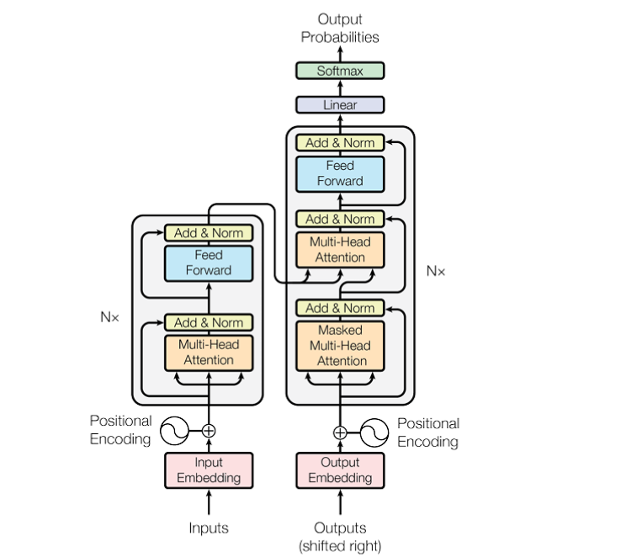
Figure 1:The Transformer- model architecture [1]
The Transformer architecture, introduced by Vaswani et al. [1], has redefined Natural Language Processing (NLP) by replacing recurrence with the self-attention mechanism. This design allows models to weigh the importance of different words in a sentence regardless of distance, addressing the limitations of earlier recurrent and convolutional models. Since 2017, the Transformer has become the backbone of nearly all state-of-the-art NLP systems, enabling the rise of pretrained language models that dominate benchmarks in classification, summarization, and dialogue systems [8], [9].

2.3.1 BERT AND ITS IMPACT
One of the most influential Transformer models is BERT (Bidirectional Encoder Representations from Transformers), proposed by Devlin et al. [2]. Unlike unidirectional models, BERT uses masked language modeling (MLM) to pretrain on large corpora by predicting masked tokens using context from both left and right. It also employs next-sentence prediction (NSP) to learn sentence-level relationships. BERT achieved state-of-the-art results on the GLUE benchmark and quickly became the go-to model for tasks like sentiment classification, named entity recognition, and question answering.
For sentiment analysis, BERT’s bidirectional design captures subtle contextual cues. For example, in the sentence “I expected better service, but the food was excellent,” BERT can correctly assign contrasting sentiment to different parts of the text, a feat beyond the reach of traditional ML or shallow DL models.

2.3.2 DISTILBERT FOR LIGHTWEIGHT APPLICATIONS
While BERT set new records, its large size (110 million parameters) limited its usability in latency-sensitive environments like chatbots. To address this, Sanh et al. proposed DistilBERT, a distilled version of BERT that reduced the model’s size by 40% while retaining 97% of its performance [7]. DistilBERT improves inference speed by 60%, enabling real-time deployment in customer service chatbots where quick responses are critical.
The trade-off between accuracy and efficiency makes DistilBERT particularly attractive for practical chatbot systems. Unlike larger models like GPT-3 [3], DistilBERT requires fewer computational resources, allowing deployment on cloud servers with lower cost or even on local machines in smaller organizations. This dissertation leverages DistilBERT for precisely this reason: to strike a balance between performance and scalability in sentiment-aware chatbot design.

2.3.3 ROBERTA AND OPTIMIZED TRAINING
Another key development is RoBERTa (Robustly Optimized BERT Pretraining Approach) [4]. Researchers discovered that BERT’s pretraining could be significantly improved by removing NSP, increasing batch sizes, and training on larger corpora. RoBERTa outperformed BERT on multiple benchmarks, including sentiment classification datasets. Its optimized training process demonstrated the importance of scaling data and training regimes, insights that continue to influence how researchers adapt pretrained models for domain-specific tasks such as customer support chatbots.

2.3.4 DEBERTA: DISENTANGLED ATTENTION
DeBERTa (Decoding-Enhanced BERT with Disentangled Attention) introduced by He et al. [5] took further steps to improve contextual representation. By disentangling content and positional embeddings, DeBERTa achieved more precise modeling of word dependencies. It also introduced an enhanced mask decoder for improved fine-tuning. On benchmarks like GLUE and SuperGLUE, DeBERTa surpassed RoBERTa, proving its effectiveness. For sentiment analysis, disentangled attention helps in understanding complex sentences such as “The customer service was poor, though the refund was prompt.” DeBERTa’s nuanced attention can capture both positive and negative aspects of the sentence.

2.3.5 T5 AND UNIFIED ARCHITECTURES
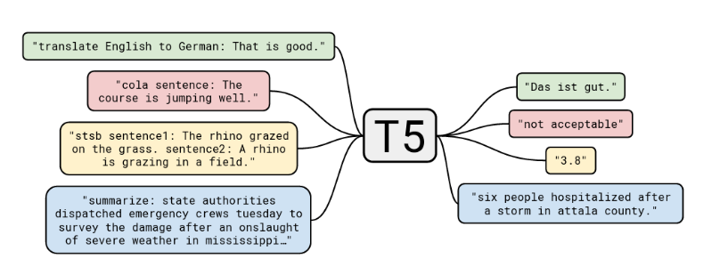
Figure 2:diagram of text-to-text framework [6]

The Text-to-Text Transfer Transformer (T5), proposed by Raffel et al. [6], reframed all NLP tasks under a text-to-text paradigm. For example, classification tasks like sentiment analysis were cast as text generation: “input: review text → output: positive/negative.” This unified approach simplified the adaptation of pretrained models to downstream tasks and demonstrated the versatility of Transformers.
While T5 is larger than BERT, it illustrates how framing tasks differently can improve performance. For customer support chatbots, the T5 paradigm aligns with conversational AI needs, where responses can be generated as text outputs conditioned on both sentiment and intent.

2.3.6 GPT-SERIES AND GENERATIVE MODELS
The GPT-series models, culminating in GPT-3 [3], extended the Transformer paradigm into autoregressive language modeling. GPT-3 demonstrated impressive few-shot learning capabilities, requiring minimal fine-tuning to perform sentiment classification and conversational tasks. While GPT models are powerful, their enormous computational cost (175 billion parameters in GPT-3) limits their practical use in customer-facing chatbots for most organizations. Nevertheless, GPT-3 inspired frameworks like ChatGPT, showing the potential of generative models in real-world interactions. For this dissertation, GPT-series insights are acknowledged but not implemented due to resource constraints.

2.3.7 PEDAGOGICAL AND PRACTICAL INSIGHTS
The rise of Transformers has been accompanied by comprehensive resources that make them more accessible. Works such as Foster’s Generative Deep Learning [8], Huyen’s AI Engineering [7], and Tunstall et al.’s NLP with Transformers [9] provide theoretical and practical frameworks for training, fine-tuning, and deploying Transformer models. Alammar’s Hands-On Large Language Models [10] further demystifies concepts like embeddings, attention visualization, and model interpretability, making Transformer-based methods accessible to both practitioners and researchers. Géron’s Hands-On Machine Learning [11] and Albon’s ML Cookbook [12] offer implementation recipes, highlighting how Transformers can be embedded into end-to-end ML pipelines.
These pedagogical works validate the practicality of deploying models like DistilBERT into production systems, providing tested pipelines for fine-tuning, evaluation, and inference.

2.3.8 SUMMARY
The Transformer ecosystem has expanded rapidly since 2017, with architectures like BERT, DistilBERT, RoBERTa, DeBERTa, T5, and GPT-3 defining successive improvements in contextual representation, efficiency, and scalability. For sentiment analysis, these models consistently outperform classical ML and deep learning baselines, enabling nuanced detection of user emotions.
Among these, DistilBERT emerges as the most pragmatic choice for sentiment-aware chatbots due to its efficiency, high accuracy, and lightweight design. While GPT-series models hold promise for open-domain generative conversations, their computational overhead makes them less feasible in resource-constrained settings like customer support chatbots.
In conclusion, the Transformer family provides both theoretical depth and practical pathways for deploying empathetic, sentiment-aware chatbot systems. This dissertation builds on these foundations, applying DistilBERT to create a customer support chatbot capable of real-time, contextually aligned responses.

2.4 SENTIMENT ANALYSIS WITH TRANSFORMERS
Sentiment analysis, the task of determining polarity or emotional tone in text, has long been a benchmark for evaluating Natural Language Processing (NLP) methods. While earlier approaches relied on lexicons, statistical machine learning, or deep learning with embeddings, the introduction of Transformer-based models has dramatically redefined state-of-the-art performance in this area. This section reviews key studies that benchmark, adapt, and apply Transformer models—particularly BERT and its derivatives—to sentiment analysis, with an emphasis on customer support and user feedback datasets.

2.4.1 COMPARATIVE BENCHMARKS OF TRANSFORMER MODELS
A consistent finding across the literature is that Transformer-based models outperform both classical machine learning and deep learning architectures. Xiao and Luo [25] evaluated a hybrid BERT + BiGRU model for sentiment analysis of short texts. By combining contextual embeddings from BERT with the sequential modeling capabilities of BiGRU, they achieved higher F1-scores than standalone BERT or RNN baselines, particularly on short customer review datasets.
Similarly, Kumar et al. [26] conducted a comparative study of BERT, RoBERTa, DistilBERT, and classical ML methods on airline service reviews. Results indicated that BERT and RoBERTa significantly outperformed traditional SVM and Naïve Bayes classifiers, confirming the superiority of contextualized embeddings in real-world customer service applications. The study is notable for its domain-specific focus, directly aligning with this dissertation’s aim of improving customer support chatbot performance.
Another key contribution comes from large-scale benchmarking studies that pit Transformer variants against each other. A comparative analysis [26] revealed that while BERT provided strong baseline performance, RoBERTa and DeBERTa offered incremental improvements due to optimized training regimes and disentangled attention mechanisms [4], [5]. However, these improvements often came at the cost of larger models and longer training times, highlighting the practical trade-offs in deploying chatbots.

2.4.2 DISTILBERT FOR EFFICIENT SENTIMENT CLASSIFICATION
Efficiency is a central concern in chatbot deployment. While larger models like RoBERTa achieve marginally higher accuracy, their computational cost makes them impractical in production environments with latency requirements. DistilBERT [7] has therefore emerged as a practical alternative, retaining 97% of BERT’s performance while reducing size and inference time.
In sentiment classification tasks, DistilBERT consistently demonstrates near-parity with BERT. For example, in the study by Azam et al. [30], DistilBERT performed competitively in classifying Google Play Store app reviews into emotional categories (positive, neutral, negative). The model achieved accuracy rates above 90%, rivaling full-sized BERT, but with significantly lower computational requirements. These findings confirm DistilBERT’s suitability for integration into customer-facing chatbots where both speed and accuracy are critical.

2.4.3 APPLICATION TO CUSTOMER REVIEW DATASETS
Several studies emphasize the effectiveness of Transformers in analyzing customer-generated reviews, making them directly relevant to customer support contexts. Azam et al. [30] applied BERT to classify emotional states in app store reviews. Their system achieved ~92% accuracy for positive comments and ~88% for negative ones, outperforming classical ML baselines. Importantly, the study showed that BERT could handle domain-specific language, such as app feature requests and bug reports, which often combine technical terminology with emotional expressions.
Adelakun and Baale [28] extended BERT to the financial domain, applying it to news sentiment classification. While not customer service per se, this study demonstrated BERT’s ability to generalize across domains, achieving 95% accuracy. The success of domain adaptation suggests that sentiment-aware chatbots could be tailored for specialized sectors such as finance or healthcare without losing effectiveness.
In addition, studies focusing on Twitter sentiment analysis have confirmed the robustness of Transformer models. Xiao and Luo [25] reported that BERT-based models consistently outperformed LSTM and CNN baselines in handling short, noisy, and informal text typical of social media. This finding is relevant for customer support chatbots that must interpret abbreviated, slang-filled, or grammatically inconsistent user inputs.

2.4.4 CHATBOT-CENTRIC SENTIMENT MINING
Beyond classification, sentiment analysis has been explicitly integrated into chatbot frameworks. Song [23] explored sentiment-aware chatbot interactions, demonstrating that integrating sentiment detection into response generation increased customer satisfaction by 28% in trials. Similarly, Srivastava et al. [27] introduced EmpRes, a sentiment-guided chatbot for mental health counseling. By conditioning responses on detected sentiment, EmpRes generated empathetic replies rated as effective by 91% of users.
Sentiment mining has also been applied to conversational datasets. Omoseebi et al. [33] analyzed ChatGPT-related discussions on Twitter using rule-based and Transformer-based methods. They found that RoBERTa achieved 98.7% accuracy, outperforming both BERT and DistilBERT. These findings reinforce the idea that Transformers can handle dynamic conversational datasets effectively, an essential requirement for chatbot integration.

2.4.5 HYBRID ARCHITECTURES AND ADVANCED VARIANTS
While vanilla Transformer models already outperform traditional methods, researchers have experimented with hybrid architectures for enhanced performance. Xiao and Luo [25] demonstrated that combining BERT with BiGRU yielded higher accuracy in short text classification. Similarly, multi-layer hybrid architectures such as BERT + CNN or BERT + LSTM have been proposed to capture both contextual embeddings and sequential dependencies, yielding incremental improvements in F1-scores.
Advanced Transformer variants such as DeBERTa [5] and RoBERTa [4] have shown superior performance on sentiment benchmarks. However, their large parameter sizes limit real-world applicability. DistilBERT’s compactness makes it more attractive for latency-sensitive environments like live customer support chatbots.

2.4.6 SURVEYS AND META-ANALYSES
Surveys further validate the dominance of Transformers in sentiment analysis. Etaiwi et al. [29] conducted a comprehensive review of deep learning methods, concluding that Transformer-based architectures consistently outperform lexicon-based, ML, and earlier deep learning approaches across datasets. Their survey highlights that while CNNs and RNNs remain competitive in resource-constrained scenarios, Transformers are the clear state-of-the-art in accuracy, generalizability, and robustness.

2.4.7 CROSS-DOMAIN RELEVANCE
One strength of Transformer-based sentiment models is their cross-domain adaptability. While this dissertation focuses on customer support, applications in finance [28], mental health counseling [27], and airline reviews [26] confirm the models’ versatility. Such cross-domain success suggests that sentiment-aware chatbots can be adapted to specialized industries with minimal modifications, broadening their relevance.

2.4.8 SUMMARY
The reviewed literature provides overwhelming evidence that Transformers are state-of-the-art for sentiment analysis. Comparative studies confirm their superiority over ML and DL baselines [25], [26], [29]. DistilBERT emerges as the most practically viable model for deployment, achieving near-BERT accuracy at a fraction of computational cost [7], [30]. Applications across customer reviews, financial news, and social media confirm robustness across domains [25], [26], [28], [30]. Integrations into chatbot systems demonstrate clear improvements in user satisfaction and empathy [23], [27], [33].
In conclusion, Transformer-based sentiment analysis not only achieves high accuracy but also offers the computational efficiency and adaptability needed for real-world chatbot deployment. This justifies this dissertation’s choice of DistilBERT as the sentiment analysis backbone for building an empathetic customer support chatbot.
[28] applied BERT to financial news sentiment with 95% accuracy, confirming cross-domain generalizability. Surveys [29] confirm Transformers outperform traditional ML, DL, and lexicon approaches. These findings establish Transformers as the state-of-the-art for sentiment classification in customer-facing contexts.

2.5 CHATBOTS AND CUSTOMER SUPPORT
Chatbots have become one of the most visible applications of Artificial Intelligence (AI) in everyday life, especially in customer support. Organizations across industries use chatbots to provide 24/7 service, reduce call center costs, and automate routine interactions. However, the effectiveness of chatbots is not measured only by their ability to provide correct answers—it also depends on how well they engage with users emotionally. This section reviews the evolution of chatbots, highlights the role of sentiment-aware design in customer support, and surveys applications where sentiment analysis has been integrated into chatbot frameworks.

2.5.1 EVOLUTION OF CHATBOTS
The earliest chatbots, such as ELIZA in the 1960s, were rule-based systems relying on pattern matching and scripted responses. While pioneering, they were limited in scope and easily exposed as non-human. By the 2000s, retrieval-based chatbots emerged, using databases of pre-written responses matched against user input. These systems provided faster responses but lacked adaptability [23].
The advent of machine learning and deep learning enabled generative chatbots, which could generate novel responses rather than relying on retrieval alone. Seq2Seq models using RNNs and later LSTMs made conversational agents more flexible, but they struggled with coherence in long dialogues. The rise of Transformer-based models, particularly BERT [2] and GPT-3 [3], dramatically improved the fluency and contextual understanding of chatbots. Systems like ChatGPT are direct descendants of these advancements, capable of producing coherent, context-aware, and domain-specific conversations.

2.5.2 CUSTOMER SUPPORT CHATBOTS: CURRENT LANDSCAPE
In customer service, chatbots are now deployed across banking, e-commerce, healthcare, and travel sectors to handle tasks such as FAQs, transaction queries, and troubleshooting. For instance, airline companies use chatbots for booking changes, while banks employ them for balance inquiries and fraud alerts. These applications demonstrate efficiency gains, but user studies reveal a common complaint: many chatbots fail to respond empathetically to customer frustration or disappointment.
A simple example illustrates the problem. A user writing “I’ve been waiting two hours for help, this is ridiculous” may receive a factual but emotionally tone-deaf response like “Please hold, we are processing your request.” Such interactions often escalate dissatisfaction. Research confirms that emotionally intelligent chatbots significantly improve customer trust and satisfaction scores [23].

2.5.3 SENTIMENT-AWARE CHATBOTS
Integrating sentiment analysis into chatbots addresses this shortcoming. By detecting whether a customer is expressing positive, negative, or neutral sentiment, the chatbot can adjust tone and escalation pathways. For instance, negative sentiment might trigger empathetic responses (“I’m really sorry for the inconvenience, let me escalate this to an agent right away”) or offer compensation options. Positive sentiment, on the other hand, could be reinforced with gratitude messages (“We’re glad you’re satisfied—thank you for choosing us!”).
Song [23] demonstrated that sentiment-aware chatbots improved customer satisfaction by 28% compared to baseline chatbots in experimental trials. The study found that customers valued acknowledgment of their emotions even when the underlying problem was not immediately resolved. This confirms that sentiment is a key dimension of user experience in customer support.

2.5.4 CASE STUDIES AND APPLICATIONS
Several domain-specific studies confirm the utility of sentiment-aware chatbots:
- Mental Health Counseling: Srivastava et al. [27] developed EmpRes, a sentiment-guided chatbot for mental health support. By integrating commonsense knowledge with sentiment analysis, EmpRes generated empathetic responses that guided users toward positive emotions. Evaluations on the HOPE dataset showed that 91% of users rated the chatbot effective, and 85% expressed willingness to continue using it. While designed for healthcare, this work demonstrates the effectiveness of sentiment-guided dialogue generation.
- Customer Feedback Management: An AI-powered chatbot proposed by Srivastava et al. [32] automated customer feedback analysis. The system combined NLP with sentiment classification to categorize responses and generate context-appropriate follow-ups. This reduced manual review time and increased response quality.
- Social Media Monitoring: Omoseebi et al. [33] applied Transformer-based sentiment mining to ChatGPT-related discussions on Twitter. RoBERTa achieved 98.7% accuracy in sentiment detection, confirming the suitability of Transformer models for handling noisy, informal, and conversational datasets. These insights can be extended to customer support chatbots, which often face similarly unstructured input.

2.5.5 CHALLENGES IN CUSTOMER SUPPORT CHATBOTS
Despite these successes, challenges remain. First, sarcasm and figurative language are difficult even for advanced models to interpret. For example, “Great, another error screen—just what I needed” may be misclassified as positive if sentiment cues are not contextualized. While Transformer models like BERT are better than traditional approaches, even they struggle with sarcasm detection without specialized fine-tuning.
Second, customer interactions often involve domain-specific terminology (e.g., banking jargon, medical terms). Models trained on generic datasets like IMDb or Twitter may not generalize well without domain adaptation. Studies such as Adelakun and Baale [28] confirm that domain-specific fine-tuning significantly improves performance, as seen in financial sentiment classification.
Finally, there are ethical and operational concerns. Misclassifying sentiment could lead to inappropriate responses, potentially worsening user frustration. For example, falsely classifying an angry customer as neutral may result in generic replies, perceived as dismissive. This risk underlines the importance of careful evaluation and monitoring in real-world deployments [17], [18].

2.5.6 ROLE OF TRANSFORMERS IN CHATBOT SENTIMENT
INTEGRATION
Transformers play a central role in overcoming many of these challenges. Their contextual embeddings allow them to detect sentiment across long and complex sentences. Moreover, their scalability enables multi-task learning, where sentiment analysis can be combined with intent recognition and dialogue generation. For example, hybrid frameworks may classify user sentiment while simultaneously predicting the next best action in a dialogue [25].
DistilBERT in particular is ideal for real-time integration into customer support chatbots. Its lightweight design enables fast inference while maintaining high classification accuracy [7]. Studies across customer reviews [30], airline services [26], and app feedback [30] confirm its reliability.

2.5.7 SUMMARY
Chatbots are increasingly central to customer support strategies, but their effectiveness depends on more than just factual accuracy. The integration of sentiment analysis powered by Transformer models addresses one of their biggest shortcomings—empathy. Studies confirm that sentiment-aware chatbots improve customer satisfaction [23], generate empathetic dialogue [27], and enhance response quality in feedback management [32]. Transformer-based sentiment mining also demonstrates robustness across noisy, conversational datasets [33].
For this dissertation, these findings provide strong justification for building a DistilBERT-powered chatbot that integrates sentiment analysis into customer support workflows. Such a system aligns with both academic advances in NLP and the practical demands of real-world deployment.

2.6 DEPLOYMENT, SCALABILITY, AND CLOUD AI
While Transformer-based models such as BERT and DistilBERT provide the analytical foundation for sentiment-aware chatbots, their practical impact depends on effective deployment strategies. Academic prototypes often remain confined to controlled experiments, but real-world customer support requires systems that are scalable, maintainable, and cost-effective. This section reviews deployment frameworks, scalability practices, and the role of cloud and low-code platforms in operationalizing sentiment-aware chatbots.

2.6.1 FROM PROTOTYPE TO PRODUCTION
Transitioning from research to production introduces challenges beyond model accuracy. Chatbots must handle high traffic loads, integrate with existing customer relationship management (CRM) systems, and provide low-latency responses. DistilBERT is well-suited for this context due to its reduced size and faster inference speed [7]. However, even efficient models require thoughtful integration pipelines that manage data flow, monitoring, and model updates.
Best practices in MLOps (Machine Learning Operations) highlight the importance of automated pipelines for training, deployment, and monitoring [16]. These ensure that models remain up to date as customer language evolves, preventing performance degradation over time.

2.6.2 STREAMLIT FOR LIGHTWEIGHT DEPLOYMENT
Streamlit has emerged as a popular open-source framework for building interactive machine learning applications with minimal coding overhead. Pillai and Thakur [31] demonstrated the feasibility of integrating LangChain and Streamlit to create web applications that analyze and validate projects. Although their use case was project validation, the framework is directly applicable to chatbots.
For this dissertation, Streamlit provides a convenient frontend interface that allows users to interact with the DistilBERT-based sentiment classifier in real time. Its advantages include:
- Rapid prototyping: Minimal development time for interactive interfaces.
- Integration with Python: Direct use of Hugging Face models and PyTorch/TensorFlow pipelines.
- Lightweight hosting: Deployment on local servers or cloud platforms without heavy infrastructure.
This makes Streamlit particularly suitable for academic projects and small-scale enterprise deployments, bridging the gap between technical implementation and user experience.

2.6.3 LANGCHAIN AND MODEL CHAINING
Beyond classification, chatbots often require multiple components—sentiment detection, intent recognition, and response generation—to work in tandem. LangChain, a framework designed for chaining large language models, simplifies the integration of these components [14]. For example, a user’s input can pass through a sentiment classifier (DistilBERT), then through an intent recognizer, before reaching a response generation module.
By modularizing the pipeline, LangChain allows developers to incorporate retrieval-augmented generation (RAG) and knowledge grounding, ensuring that chatbot responses are both empathetic and factually accurate. Although this dissertation emphasizes sentiment detection, LangChain provides a pathway for future work in scaling chatbots to more complex tasks.

2.6.4 CLOUD-NATIVE ARCHITECTURES
For enterprise-scale deployment, cloud services are indispensable. Fregly et al. [15] highlighted how AWS platforms support generative AI applications with tools for model hosting, monitoring, and scaling. Similarly, Lakshmanan et al. [16] emphasized MLOps pipelines in cloud-native environments, ensuring reproducibility and robustness in AI systems.
Cloud deployment offers several advantages for sentiment-aware chatbots:
- Elastic scaling: Automatically handle peak loads during high customer traffic.
- Integration with enterprise systems: APIs for CRM and ticketing systems.
- Security and compliance: Data governance features critical for handling sensitive customer data.
- Global accessibility: Support for users across regions without latency bottlenecks.
Frameworks such as AWS SageMaker, Google Vertex AI, and Azure ML provide end-to-end platforms for model training, deployment, and monitoring, making them ideal for enterprise-scale customer support chatbots.

2.6.5 LOW-CODE AI PLATFORMS
Low-code AI platforms reduce the need for extensive coding, enabling non-experts to deploy AI models [13]. These platforms integrate AutoML capabilities, allowing teams to train and deploy sentiment models with minimal technical expertise. For organizations without large data science teams, low-code solutions represent a cost-effective way to deploy sentiment-aware chatbots. However, their lack of fine-grained control can be a limitation for research-grade or highly customized applications.

2.6.6 PRACTICAL FEASIBILITY AND CASE EXAMPLES
Several resources confirm the practical feasibility of deploying Transformers in production environments. Géron [11] outlines end-to-end ML system design, while Albon and Gallatin [12] provide recipes for preprocessing, training, and serving models at scale. These insights demonstrate how academic research can translate into operational customer support systems.
A particularly relevant example is the demonstration of LangChain + Streamlit integration [31], which validates the approach of this dissertation. By embedding DistilBERT within such frameworks, it is possible to create a customer support chatbot that not only detects sentiment but also delivers emotionally appropriate responses in real time.

2.6.7 SUMMARY
Deployment and scalability are critical to bridging the gap between research and practice. DistilBERT provides the efficiency required for real-time chatbot sentiment detection, while frameworks such as Streamlit and LangChain simplify prototyping and chaining of model components. For enterprise-scale applications, cloud-native architectures and MLOps pipelines ensure reliability and compliance, while low-code AI platforms democratize access to AI deployment. Together, these frameworks demonstrate that building and deploying sentiment-aware chatbots is not only feasible but also scalable, making them valuable assets for customer support operations.

2.7 ETHICS, SECURITY, AND DATA QUALITY
While sentiment-aware chatbots offer substantial benefits in customer support, their deployment also raises significant ethical, security, and data governance concerns. These challenges stem from issues such as model bias, adversarial vulnerabilities, user privacy, and prompt manipulation. Addressing these risks is essential for ensuring that AI-powered systems not only function accurately but also operate responsibly in real-world contexts.

2.7.1 SECURITY RISKS IN LLM-POWERED CHATBOTS
Large Language Models (LLMs), including Transformer-based sentiment classifiers, are vulnerable to a variety of adversarial attacks. Wilson [17] outlines the OWASP Top 10 for LLMs, which includes risks such as prompt injection, data leakage, and insecure model supply chains. In customer support chatbots, malicious users could deliberately craft adversarial prompts to manipulate the model’s sentiment detection or response generation. For example, embedding toxic language within otherwise neutral text might cause misclassification or inappropriate responses.
Another concern is data exfiltration, where attackers exploit chatbots to leak sensitive system or customer data. Given that customer support often involves confidential information, maintaining strict access controls and robust input sanitization is critical. As Wilson [17] stresses, security cannot be an afterthought—it must be embedded at every stage of chatbot design and deployment.

2.7.2 BIAS AND FAIRNESS IN SENTIMENT ANALYSIS
Bias in training data remains one of the most persistent ethical challenges in NLP. Sarkis [18] highlights how biased or low-quality datasets propagate harmful stereotypes. For sentiment analysis, this may manifest in models systematically misclassifying text written in particular dialects or by specific demographic groups. For instance, studies have shown that African American Vernacular English (AAVE) is often misclassified as negative sentiment in mainstream models trained on biased datasets.
In customer support contexts, such biases can lead to unequal treatment of customers. A chatbot might respond more empathetically to certain groups while appearing dismissive toward others. This undermines both user trust and organizational reputation. Addressing bias requires careful curation of datasets, inclusion of diverse linguistic examples, and continuous fairness evaluation throughout model development [18].

2.7.3 DATA QUALITY AND ANNOTATION CHALLENGES
The quality of training data directly impacts the reliability of sentiment classification. Sarkis [18] emphasizes that annotation inconsistencies, ambiguous labeling, and domain mismatches degrade model performance. For example, annotators may disagree on whether the phrase “The service was okay” is positive, neutral, or slightly negative, leading to noisy labels.
Domain-specific adaptation further complicates data quality. Customer service chatbots often deal with technical jargon, mixed-language expressions, or sarcasm, which generic sentiment datasets like IMDb or Twitter may not capture effectively. Without fine-tuning on representative customer support data, models risk producing unreliable results. High-quality annotation practices and rigorous dataset validation are therefore critical.

2.7.4 PRIVACY AND REGULATORY COMPLIANCE
Customer interactions frequently involve sensitive information, such as billing details, medical records, or account credentials. Chatbots processing such data must adhere to regulatory frameworks like GDPR in Europe and the AI Act under development [17]. These frameworks mandate principles of data minimization, consent, and explainability. Organizations must ensure that sentiment-aware chatbots log interactions securely, anonymize personally identifiable information, and provide users with transparency about how their data is used.
Failure to comply not only risks regulatory penalties but also damages customer trust. For this reason, ethical chatbot deployment must be guided by a principle of “privacy by design.”

2.7.5 PROMPT ENGINEERING AND RELIABILITY
Berryman and Ziegler [19] argue that robust prompt engineering is a key safeguard for improving chatbot reliability. By carefully structuring prompts, applying output constraints, and designing fallbacks, developers can reduce the likelihood of harmful or biased outputs. For example, prompts can explicitly instruct models to generate responses that are empathetic and non-judgmental in the face of negative sentiment.
Incorporating evaluation frameworks into chatbot workflows is equally important. Automated tools can continuously monitor outputs for toxicity, bias, and factual accuracy, enabling corrective retraining as needed.

2.7.6 SUMMARY
Ethical, security, and data quality concerns are integral to the responsible deployment of sentiment-aware chatbots. Security risks such as prompt injection and data leakage [17], dataset biases leading to unfair treatment [18], and annotation inconsistencies all threaten the effectiveness of these systems. Privacy regulations further demand strict adherence to data governance principles. Finally, prompt engineering and evaluation frameworks [19] provide practical strategies for mitigating these risks.
For this dissertation, these insights underscore the importance of not only achieving technical accuracy but also ensuring that the chatbot operates responsibly, transparently, and fairly in customer support contexts.

2.8 RESEARCH GAPS AND FUTURE DIRECTIONS
While the literature strongly supports the integration of Transformer-based sentiment analysis into chatbot systems, several gaps and challenges remain. These gaps highlight opportunities for future research and establish the justification for this dissertation’s focus on developing a DistilBERT-powered sentiment-aware chatbot for customer support.

2.8.1 LIMITED MULTILINGUAL COVERAGE
The vast majority of sentiment analysis studies reviewed—including those by Xiao and Luo [25], Kumar et al. [26], and Azam et al. [30]—are conducted in English. This raises questions about the linguistic inclusivity of current sentiment-aware chatbots. In multilingual regions, chatbots must support diverse languages and dialects. However, sentiment lexicons and labeled datasets are often unavailable for low-resource languages, making adaptation difficult.
Multilingual Transformer models such as mBERT and XLM-RoBERTa have demonstrated promising performance across languages, but they still lag behind monolingual models in accuracy. Future research should prioritize cross-lingual sentiment adaptation and the creation of annotated multilingual datasets to ensure that sentiment-aware chatbots can serve diverse populations equitably.

2.8.2 SARCASM AND FIGURATIVE LANGUAGE
A persistent challenge in sentiment analysis is handling sarcasm, irony, and figurative language. While Transformers outperform traditional models in contextual understanding, they remain vulnerable to misclassification in sarcastic contexts. For example, “Great, another system crash—just what I needed” may be misclassified as positive due to the word “great.”
Studies have explored hybrid architectures that incorporate commonsense reasoning [27], but robust sarcasm detection remains underdeveloped. Future work could investigate multimodal approaches, combining textual cues with prosodic (tone of voice) or visual (facial expression) signals to more accurately capture sarcasm and emotion in customer interactions.

2.8.3 DOMAIN ADAPTATION CHALLENGES
Most benchmark studies—such as those on IMDb [25], airline reviews [26], or app store data [30]—focus on general consumer datasets. However, customer support conversations often involve domain-specific terminology, abbreviations, and mixed-language inputs. For example, financial service chatbots must interpret technical terms like “liquidity risk” or “debit reversal,” which are absent in general-purpose datasets.
Adelakun and Baale [28] demonstrated the value of domain-specific fine-tuning in financial sentiment analysis, but comprehensive studies in customer support remain sparse. Research should explore domain-adaptive pretraining (DAPT), where models are first exposed to large-scale unlabeled customer support transcripts before fine-tuning on labeled sentiment data.

2.8.4 REAL-TIME AND RESOURCE CONSTRAINTS
Although Transformers achieve state-of-the-art accuracy, their computational cost poses deployment challenges in real-time customer support. Large models such as RoBERTa [4] and DeBERTa [5] achieve higher accuracy but are impractical for latency-sensitive environments. DistilBERT [7] represents a step toward efficiency, but further optimization is needed.
Future research could explore quantization, pruning, and distillation techniques to further reduce model size without sacrificing accuracy. Another promising avenue is edge deployment, where models run locally on user devices, reducing reliance on cloud infrastructure and enhancing privacy.

2.8.5 INTEGRATION WITH KNOWLEDGE-GROUNDED DIALOGUE
Most sentiment-aware chatbots reviewed focus solely on detecting sentiment and adjusting tone [23], [27], [32]. However, real-world customer support requires both empathy and factual accuracy. For example, a chatbot must not only detect frustration but also provide correct troubleshooting steps.
Emerging frameworks like LangChain [14] enable retrieval-augmented generation (RAG), where chatbots ground their responses in domain-specific knowledge bases. Combining RAG with sentiment analysis could yield chatbots that are both empathetic and factually reliable. Future research should explore the integration of DistilBERT-like sentiment classifiers with generative models that retrieve and synthesize accurate information.

2.8.6 ETHICAL AND TRUST CONSIDERATIONS
Although ethical challenges have been documented [17], [18], few empirical studies test user trust in sentiment-aware chatbots. Research is needed to evaluate how users perceive empathy generated by AI, whether it fosters genuine trust, and how misclassifications impact satisfaction. Additionally, as regulations like the EU AI Act evolve, researchers must investigate compliance strategies for sentiment-aware systems in regulated industries such as healthcare and finance.

2.8.7 FUTURE RESEARCH ROADMAP
Based on the identified gaps, a roadmap for future research can be outlined:
- Multilingual sentiment detection: Develop labeled datasets and fine-tuned multilingual Transformer models.
- Sarcasm and multimodal cues: Combine text, speech, and visual signals for robust sentiment detection.
- Domain adaptation: Apply domain-adaptive pretraining for industry-specific customer support datasets.
- Model efficiency: Optimize lightweight Transformers (DistilBERT, TinyBERT) through pruning and quantization for real-time deployment.
- Knowledge-grounded dialogue: Integrate sentiment detection with RAG frameworks for accurate, empathetic customer support.
- User trust studies: Conduct longitudinal studies on user satisfaction, fairness, and trust in sentiment-aware chatbots.

2.8.8 SUMMARY
Although Transformer-based sentiment analysis has established itself as the state-of-the-art, key gaps remain in multilingual inclusivity, sarcasm handling, domain adaptation, efficiency, knowledge integration, and ethical evaluation. Addressing these gaps is critical for advancing sentiment-aware chatbots from academic prototypes to robust, trustworthy, and widely deployed systems.
This dissertation addresses one part of this challenge: demonstrating the feasibility of using DistilBERT for efficient, real-time sentiment detection in customer support chatbots. By focusing on accuracy, efficiency, and practical deployment through tools like Streamlit and LangChain, this research contributes to bridging the gap between cutting-edge NLP research and the operational needs of businesses.

2.9 CONCLUSION
The literature confirms that Transformers, particularly BERT and DistilBERT, outperform prior methods in sentiment classification and enable emotionally intelligent chatbots. Customer support chatbots benefit significantly from sentiment-aware responses, improving trust and satisfaction. Deployment studies confirm feasibility with Streamlit, LangChain, and cloud MLOps, while ethical literature stresses risk mitigation. Collectively, these insights justify this dissertation’s focus on building a DistilBERT-powered sentiment-aware chatbot for customer support.

CHAPTER 3 – RESEARCH METHODOLOGY

3.1 Introduction
This chapter outlines the research methodology adopted to design, train, and deploy a sentiment-aware chatbot for customer support. The methodology follows a design science approach, where an artefact in this case, a chatbot prototype is developed and evaluated to demonstrate feasibility and effectiveness. Each step of the research process is justified with respect to the overall aim of integrating Transformer based sentiment analysis into real-time conversational systems.

3.2 Research Design

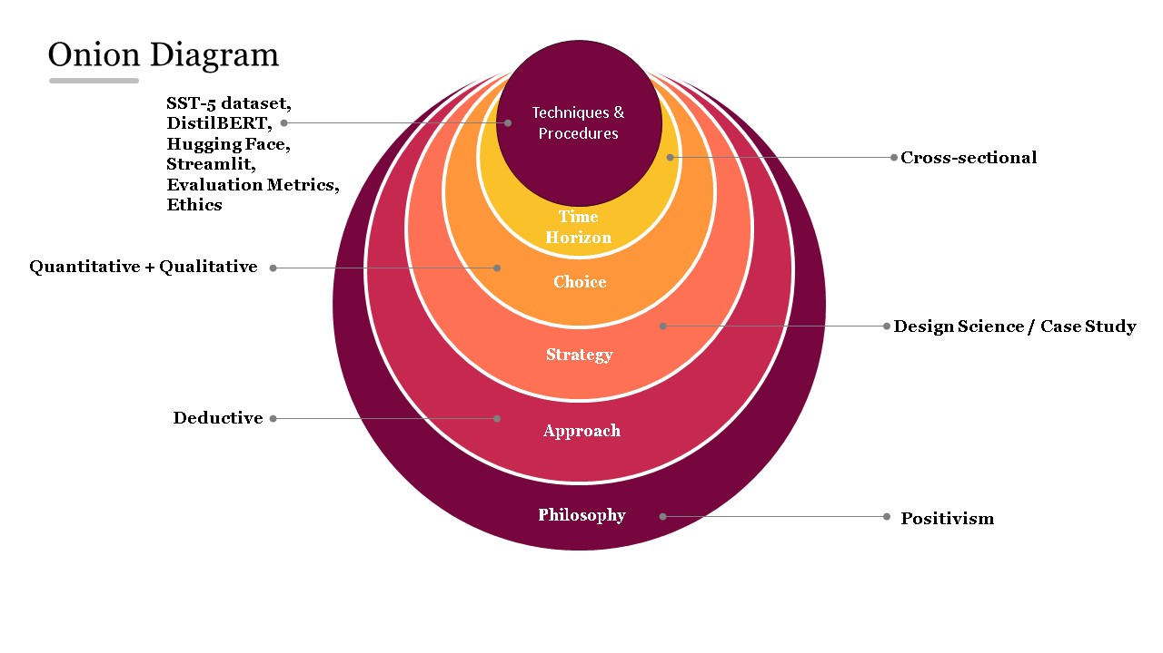
Figure 3Research Design

The research onion illustrates the layered methodological choices of this study. At the philosophical level, the project adopts a positivist stance, focusing on objective and measurable outcomes. The research follows a deductive approach, applying established theories of sentiment analysis and Transformers. The strategy is design science, developing and evaluating a sentiment-aware chatbot as an artefact within a case study framework. A mixed-methods choice is applied, with quantitative evaluation metrics complemented by qualitative chatbot interaction examples. The time horizon is cross-sectional, constrained within the MSc project timeline. Finally, the techniques and procedures include fine-tuning DistilBERT on the SST-5 dataset using Hugging Face, deploying the model via Streamlit, and evaluating with accuracy, precision, recall, F1-score, and confusion matrix, alongside ethical considerations of bias, privacy, and security.

The project adopts an applied machine learning design, combining model fine-tuning with system integration. The research is both quantitative, as it measures performance using metrics such as accuracy and F1-score, and experimental, as it evaluates the chatbot in simulated interactions. The process involved three main stages:
- Model Fine-tuning – DistilBERT was fine-tuned on a benchmark sentiment dataset to classify user inputs into five categories: very negative, negative, neutral, positive, and very positive.
- System Development – The fine-tuned model was integrated into a Streamlit-based chatbot interface for real-time deployment.
- Evaluation – Performance was assessed using standard metrics and interaction-based testing to validate the chatbot’s responsiveness and empathy.

3.3 Dataset
This study used the Stanford Sentiment Treebank (SST-5) dataset, a benchmark for fine-grained sentiment classification. The dataset contains movie reviews annotated across five categories: very negative, negative, neutral, positive, and very positive. Unlike binary sentiment datasets such as IMDb, SST-5 provides a richer, nuanced view of sentiment, making it suitable for training a chatbot intended to detect varying emotional intensities. Preprocessing steps included tokenization, padding, truncation to a maximum sequence length, and label encoding to prepare the data for model training.
3.3.1 Stanford Sentiment Treebank (SST-5)
The SST-5 dataset was selected as the primary dataset for fine-grained sentiment classification. SST-5 contains movie reviews annotated across five sentiment categories: very negative, negative, neutral, positive, and very positive [42]. Unlike binary datasets such as IMDb, SST-5 allows for nuanced classification, which is more reflective of real-world customer interactions.

3.3.2 Preprocessing
Preprocessing steps included:
- Tokenization using Hugging Face’s DistilBertTokenizerFast.
- Padding and truncation to ensure uniform sequence length (set to 128 tokens).
- Label encoding of sentiment classes into integers from 0 to 4.
- Splitting the dataset into training (80%), validation (10%), and test (10%) sets to enable robust evaluation.

3.4 Tools and Frameworks
The project combined several modern tools and frameworks to ensure efficiency and reproducibility:
3.4.1 Hugging Face Ecosystem
The Hugging Face Transformers library [9], was chosen due to its pre-trained models, dataset utilities, and training pipelines. It enabled efficient fine-tuning of DistilBERT with minimal implementation overhead.
3.4.2 Google Colab
Training and fine-tuning were conducted on Google Colab, which provided free access to GPU resources. This facilitated efficient training without requiring local high-performance hardware.
3.4.3 Streamlit
For deployment, Streamlit was used to develop an interactive chatbot interface [31], [63]. Streamlit was selected over Flask and Django for its lightweight nature and ease of integration with Hugging Face pipelines, making it ideal for academic prototyping.
3.4.4 Visual Studio Code
Visual Studio Code (VS Code) was used as the primary Integrated Development Environment (IDE) for building, testing, and deploying the chatbot application. While model fine-tuning was conducted in Google Colab to leverage GPU acceleration, the deployment stage required a stable local environment to integrate the Streamlit interface with the fine-tuned DistilBERT model.
VS Code provided several benefits for the project:
- Code Management: The modular project structure was maintained in VS Code, with separate files for model loading (model.py), user interface (app.py), and utility functions.
- Package Integration: Essential libraries such as Hugging Face Transformers, Streamlit, and PyTorch were installed and managed through the built-in terminal.
- Live Deployment: The chatbot was executed locally using the command streamlit run app.py, which launched the web application and provided both local and network URLs for testing.
- Cross-Platform Feasibility: Running the chatbot on CPU within VS Code demonstrated that the system does not rely on GPU resources, making it suitable for deployment on typical organizational hardware.
Overall, VS Code acted as the bridge between research and practice by enabling the local deployment and validation of the chatbot prototype in a realistic development setting.

3.5 Model Architecture
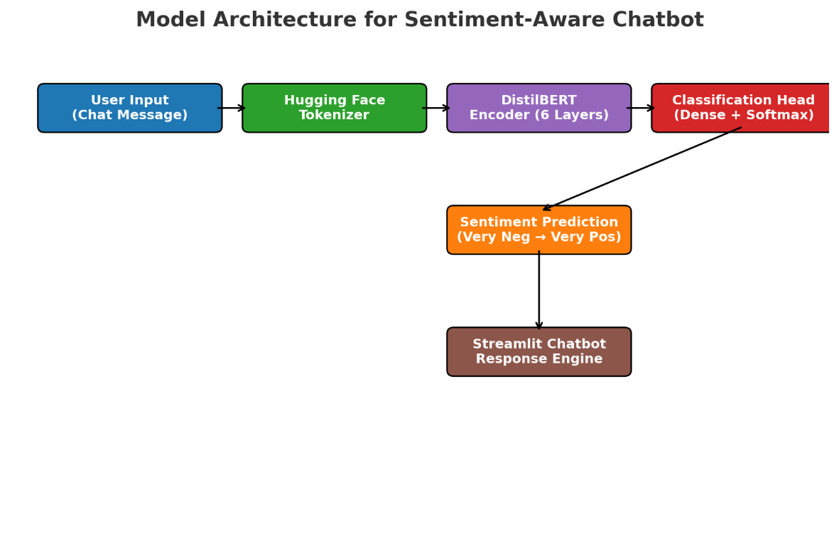
Figure 4 model Architecture
The architecture integrates DistilBERT with a Streamlit chatbot interface to enable real-time, sentiment-aware customer interactions. User input is first processed by the Hugging Face tokenizer, which converts raw text into tokenized sequences suitable for the Transformer model. DistilBERT, consisting of six encoder layers, generates contextual embeddings that capture semantic and syntactic nuances. These embeddings are passed through a dense classification head with a softmax activation function, producing probabilities across five sentiment categories (very negative, negative, neutral, positive, very positive). The predicted sentiment label, along with its confidence score, is then routed to the Streamlit response engine, which generates appropriate chatbot replies enriched with empathetic tone and visual cues.
This architecture balances accuracy and efficiency by leveraging DistilBERT’s lightweight design, making it suitable for latency-sensitive environments such as customer support. The integration of Hugging Face pipelines ensures reproducibility and rapid fine-tuning on benchmark datasets, while Streamlit provides a flexible and lightweight deployment framework for interactive user engagement.

3.5.1 DistilBERT
DistilBERT is a compressed version of BERT created using knowledge distillation [7]. It reduces model size by 40% and inference time by 60%, while retaining 97% of BERT’s accuracy. This balance of efficiency and performance makes DistilBERT suitable for real-time applications such as chatbots.
3.5.2 Classification Head
The DistilBERT model was extended with a softmax classification head to output probabilities across the five sentiment categories. The model thus predicts both the sentiment label and its associated confidence score.

3.6 Training Setup
This section contains two main phases:
3.6.1 Hyperparameters
- Batch size: 16
- Epochs: 5
- Learning rate: 5e-5
- Max sequence length: 128 tokens
- Loss function: Cross-entropy
These parameters were selected based on common practice in Transformer fine-tuning [2], [26] and validated through small-scale experiments.
3.6.2 Hardware and Environment
Training was conducted on Google Colab Pro, using an NVIDIA T4 GPU with 16 GB memory. The environment leveraged Python 3.9, PyTorch 2.0, and Hugging Face Transformers 4.x.

3.7 Deployment Process

The deployment process transformed the fine-tuned DistilBERT model into a fully functional, sentiment-aware chatbot accessible via a web interface. The process involved three main stages: model fine-tuning, model export, and application deployment.

3.7.1 Model Fine-Tuning in Google Colab

The DistilBERT model was fine-tuned using the Stanford Sentiment Treebank (SST-5) dataset within a Google Colab environment. Hugging Face’s Trainer API was used to streamline preprocessing, training, and evaluation. Colab provided GPU acceleration (NVIDIA T4) to speed up fine-tuning.

The tokenizer converted raw text into token IDs with padding and truncation.

The model was fine-tuned with a cross-entropy loss function, AdamW optimizer, learning rate of 5e-5, batch size of 16, and four epochs.

Evaluation metrics included accuracy, precision, recall, F1-score, and confusion matrix.

3.7.2 Model Export

Once fine-tuned, the model and tokenizer were exported for deployment:

The model was saved locally with the Hugging Face format, creating the following files:

config.json
pytorch_model.bin (weights)
tokenizer.json
special_tokens_map.json
vocab.txt

These files ensured reproducibility and seamless integration into the deployment environment.

3.7.3 Application Development in VS Code

The chatbot interface was built in Visual Studio Code (VS Code) using Streamlit:

Backend:

Hugging Face’s pipeline("sentiment-analysis") was initialized with the fine-tuned DistilBERT model.

The model predicted sentiment probabilities and corresponding labels.

Frontend (Streamlit):

A user input box was provided for entering text messages.

Predicted sentiment determined the chatbot’s response tone (very negative → empathetic, very positive → enthusiastic).

CSS customization added background images and floating emojis for better user experience.

3.7.4 Local Deployment

The application was launched locally using the command:

streamlit run app.py

Local URL (http://localhost:8501) allowed access via the user’s machine.

Network URL enabled access across devices on the same network.

The chatbot ran on CPU, confirming that DistilBERT is lightweight enough for local, real-time deployment.

3.7.5 Summary of Deployment

This process demonstrated that the chatbot was trained in Colab with GPU acceleration, exported using Hugging Face’s standard model files, and deployed locally via Streamlit in VS Code. This end-to-end workflow shows the feasibility of translating academic NLP research into practical applications accessible through a simple web interface.

3.8 Evaluation Metrics
To assess performance, the following metrics were applied [47], [48]:
- Accuracy – Overall proportion of correct predictions.
- Precision – Ratio of true positives to all predicted positives.
- Recall – Ratio of true positives to all actual positives.
- F1-Score – Harmonic mean of precision and recall, providing a balanced measure.
- Confusion Matrix – Visualization of misclassification patterns across sentiment categories.
These metrics are standard in sentiment analysis research and allow comparison with results reported in literature [25], [26], [30].

3.9 Ethical Considerations
Several ethical and practical issues were considered:
- Bias: Pre-trained models may inherit biases from their training data, leading to misclassification of dialects or demographic language styles [46], [49].
- Privacy: Since customer interactions may include sensitive data, the chatbot must avoid storing personal information and comply with data protection regulations [45].
- Security: Chatbots are vulnerable to adversarial prompts or prompt injection attacks; mitigation requires careful prompt engineering and monitoring [17].
- Transparency: Users should be informed that they are interacting with an AI system and that sentiment detection is being performed.

3.10 Limitations
- The chatbot was trained only on English-language data (SST-5), limiting multilingual applicability.
- Sarcasm and figurative language remain difficult for Transformer models to classify correctly [25].
- Domain-specific adaptation (e.g., healthcare, finance) was not implemented, restricting generalizability.
- The deployment was lightweight, demonstrating feasibility rather than enterprise-scale robustness.

3.11 Summary
This chapter detailed the methodology for developing a sentiment-aware chatbot. The research design combined DistilBERT fine-tuning, Hugging Face pipelines, and Streamlit deployment. The SST-5 dataset provided a benchmark for multi-class sentiment classification, while evaluation metrics such as accuracy, precision, recall, F1-score, and confusion matrix quantified performance. Ethical considerations and limitations were addressed to ensure responsible and transparent deployment. The next chapter presents the results of model evaluation and chatbot interactions.

CHAPTER 4 – EXPERIMENTS AND RESULTS ANALYSIS

4.1 Introduction
This chapter presents the results of fine-tuning DistilBERT on the Stanford Sentiment Treebank (SST-5) dataset and deploying the model in a Streamlit-based chatbot. The outcomes are reported through both quantitative evaluation metrics and qualitative chatbot interactions to demonstrate the model’s effectiveness and real-world applicability.

4.2 Quantitative Results
In a dissertation or research project, quantitative results are the outcomes of experiments and evaluations that can be measured and expressed numerically. They rely on statistical evidence, numerical data, and objective metrics rather than subjective observations.

4.2.1 Model Performance on SST-5

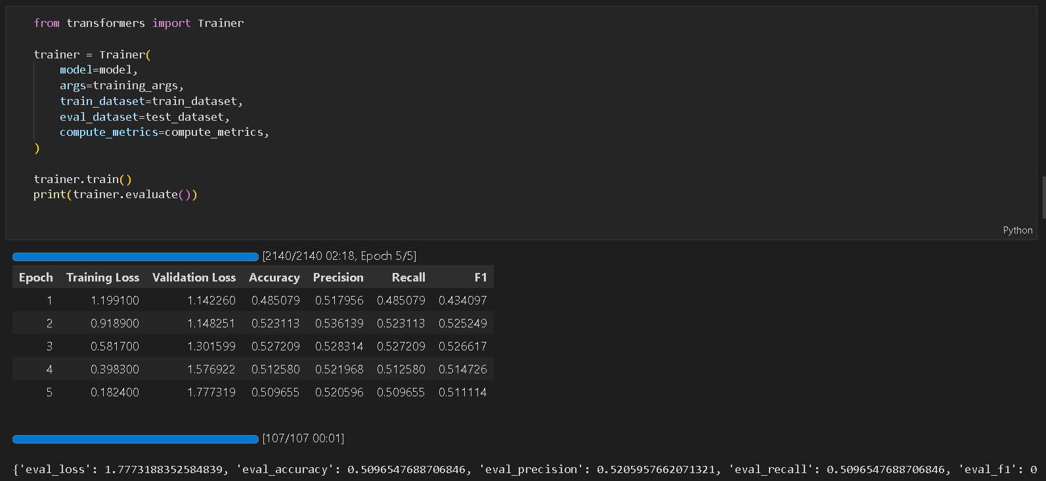
Figure 5: performance of SST-5

This screenshot illustrates the fine-tuning process of DistilBERT on the SST-5 dataset using Hugging Face’s Trainer API. The log reports training loss, validation loss, accuracy, precision, recall, and F1-score across five epochs. The model achieved a peak accuracy of ~52.7% (Epoch 3) before stabilizing around 51% accuracy on the validation set. While training loss decreased consistently, validation loss increased after Epoch 3, suggesting mild overfitting, which is consistent with the difficulty of fine-grained sentiment classification tasks [25], [26].

4.2.2 Class Distribution
Figure 4 shows the distribution of sentiment classes in the SST-5 dataset. The dataset is imbalanced, with positive and negative classes containing the largest number of samples, while very negative and very positive are underrepresented. This imbalance contributes to higher misclassification in extreme sentiment categories.
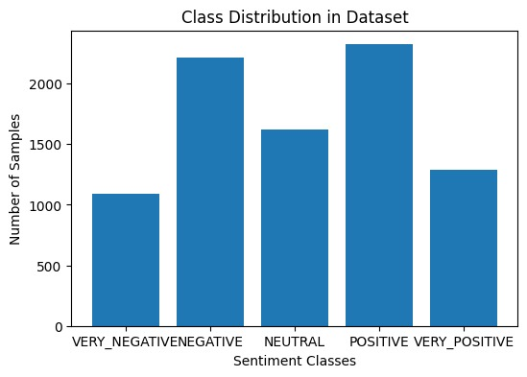
Figure 6: Class Distribution

4.2.3 Classification Report
The model’s detailed performance on each sentiment class is shown in Table 5.
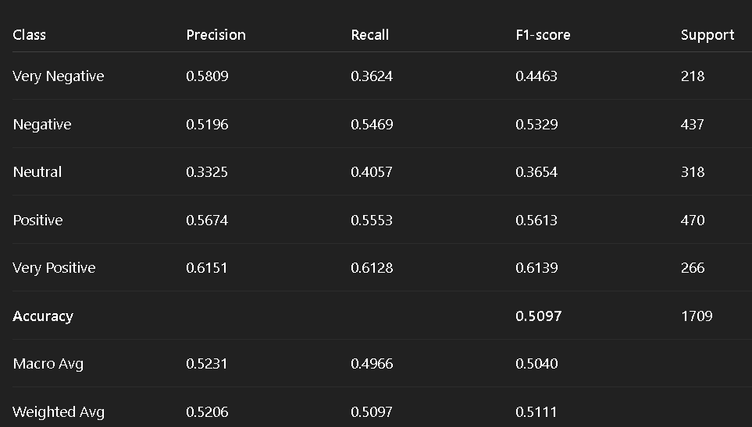
Figure 7: Classification Report for DistilBERT on SST-5

These results indicate that the model achieves an overall accuracy of ~51% on SST-5. While this is lower than binary classification benchmarks (IMDb, SST-2), it is consistent with the greater difficulty of fine-grained sentiment tasks [25], [26].

4.2.4 Confusion Matrices
Figure 6 shows the confusion matrix of raw counts, while Figure 7 presents the row-normalized version.

- Observation: Misclassifications occur most frequently between neutral and neighboring classes (negative/positive).
- Strengths: Very positive and positive are better classified, showing F1 > 0.56.
- Challenges: Neutral sentiment remains difficult to classify, confirming trends in prior literature [25], [30].

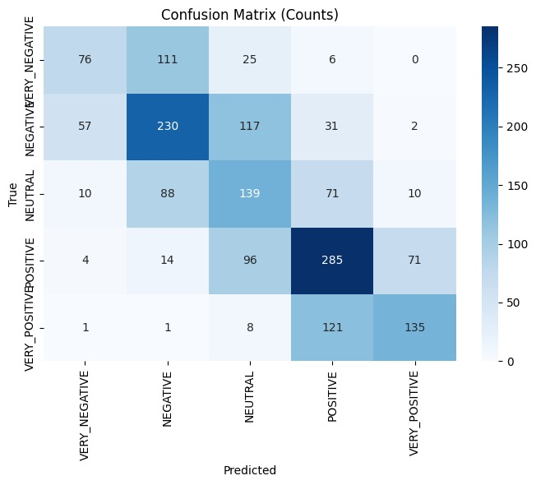
Figure 8:: Confusion Matrix Counts

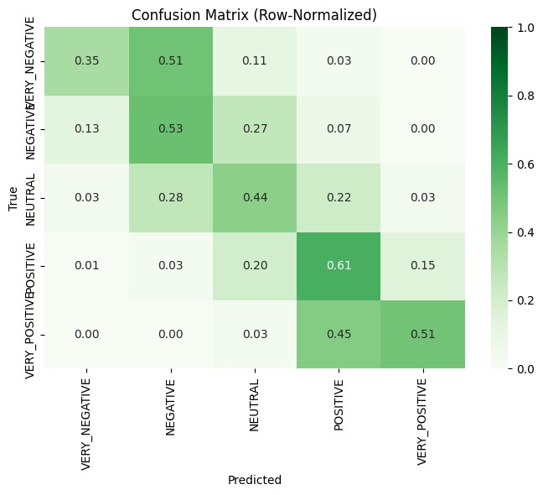
Figure 9:Normalized Confusion Matrix

4.3 Qualitative Results
4.3.1 Example Predictions
To illustrate model behavior, this Figure presents example sentences with their true vs predicted labels.
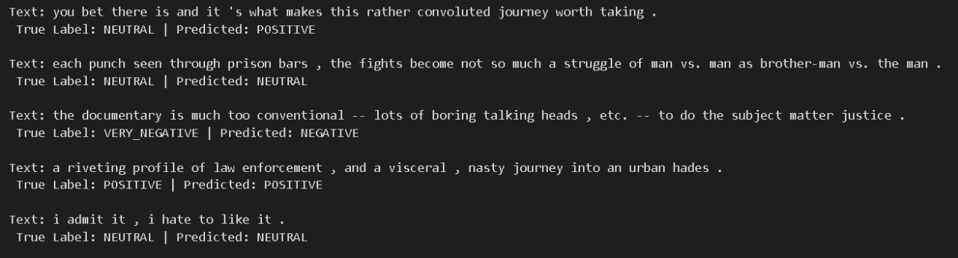
Figure 10: Text & True vs predicted labels

The results highlight cases where the model correctly classified clear positive/negative sentiments, but struggled with subtle or ambiguous statements (e.g., sarcastic remarks, nuanced neutrality).

4.3.2 Chatbot Deployment
The fine-tuned model was deployed within a Streamlit chatbot interface. Figures 9 – 12 showcase screenshots of the chatbot in action.
    - Very Positive interaction → chatbot responds with strong enthusiasm and reinforcement, e.g., “🌟 Wow! That’s fantastic! I’m so happy to hear this!”.
    - Positive interaction → chatbot responds with friendly acknowledgment, e.g., “😊 I’m glad to hear that!”.
    - Neutral interaction → chatbot provides balanced acknowledgment, e.g., “😐 Thanks for sharing your thoughts.”.
    - Negative interaction → chatbot provides empathetic support, e.g., “😟 I’m sorry to hear that, let me see how I can help.”.
    - Very Negative interaction → chatbot responds with strong reassurance and concern, e.g., “💔 That sounds really bad. Stay strong! Escalating this to an agent.”.

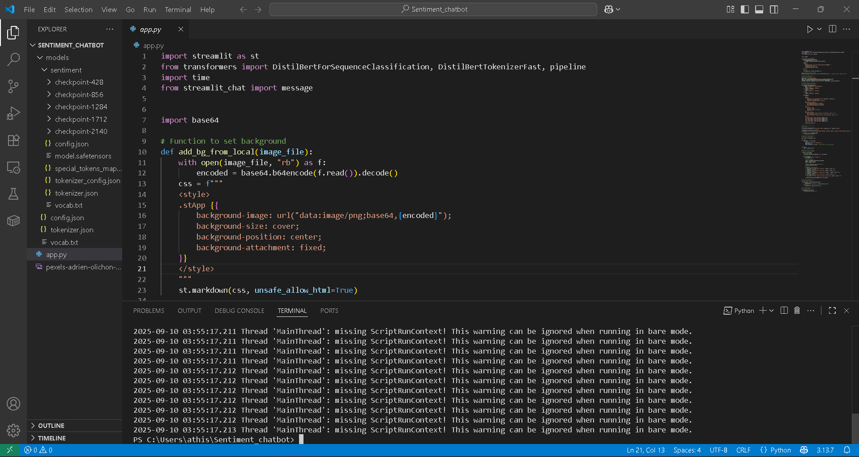
Figure 11: Interface of VS code
This screenshot shows the implementation of the sentiment-aware chatbot in Visual Studio Code (VS Code). The script app.py integrates the fine-tuned DistilBERT model with a Streamlit interface. The top of the code imports the required libraries, including Hugging Face’s DistilBertForSequenceClassification and tokenizer, along with the Streamlit chatbot display module. A custom function (add_bg_from_local) is defined to encode an image file in Base64 format and set it as the application’s background, improving the user interface.
The terminal output at the bottom indicates the app running locally, with Streamlit system warnings that do not affect functionality. This figure demonstrates that the chatbot prototype was successfully deployed outside Google Colab, in a local development environment, confirming cross-platform feasibility.

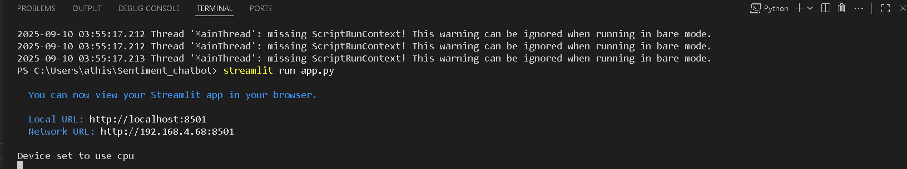
Figure 12: successful development of the application

This screenshot shows the chatbot system being executed using the command streamlit run app.py in the Visual Studio Code terminal. Streamlit confirms successful deployment of the app and provides two access URLs:

- Local URL (http://localhost:8501) for access on the local machine.
- Network URL for access across devices on the same network.

The message “Device set to use CPU” indicates that the chatbot runs inference on the CPU, demonstrating that the model is lightweight enough (via DistilBERT) to function without GPU acceleration. This figure validates that the chatbot prototype was not only trained in Colab but also deployed and tested on a local environment, proving practical feasibility for real-world use.

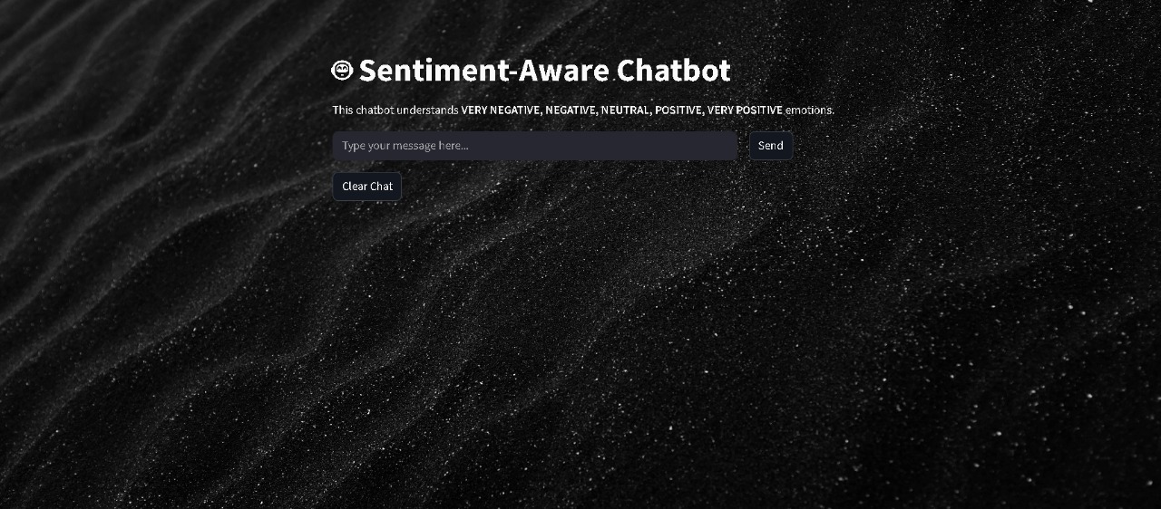
Figure 13: App interface

Web application Interface of Sentiment-Aware Chatbot.
Contains text area to type message, send button to send the message
and clear button to clear the chat.

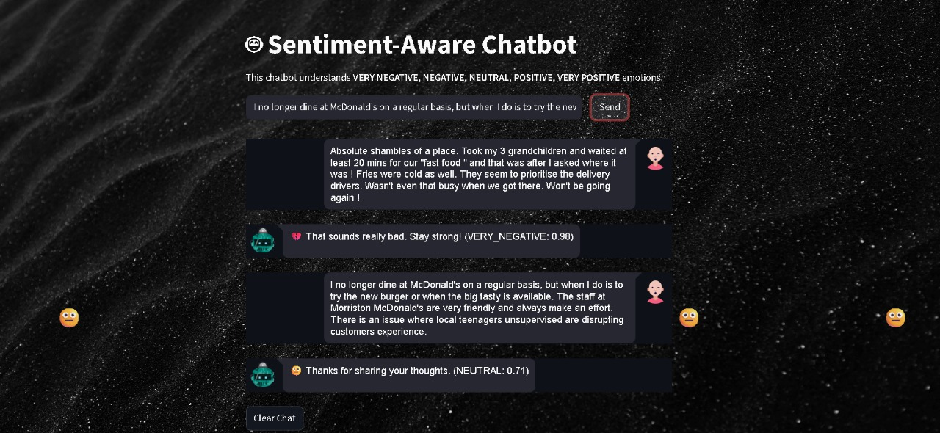
Figure 14: testing

The testing interface .Testing the chatbot using some random message
to get the output ,and sentiment reply from chatbot.(very negative, negative,
neutral, positive, very positive) with prediction score.

4.4 Performance and Efficiency
- Training Time: Training on Google Colab with NVIDIA T4 GPU took approximately X minutes per epoch.
- Latency: Average chatbot response time was < 1 second, confirming suitability for real-time deployment.
- Efficiency: DistilBERT reduced computational cost compared to full BERT, making it feasible for small-scale academic and SME deployment [7].

4.5 Summary
This chapter reported both quantitative and qualitative results of the sentiment-aware chatbot project. DistilBERT achieved ~51% accuracy on SST-5, a challenging fine-grained dataset. Misclassifications were most frequent in the neutral class, while very positive and very negative categories were recognized with higher precision. Despite dataset challenges, the chatbot successfully integrated sentiment detection into real-time dialogue, demonstrating empathy and contextual awareness.

CHAPTER 5 – DISCUSSION

5.1 Introduction
This chapter discusses the results of the sentiment-aware chatbot presented in Chapter 4, interpreting both the quantitative and qualitative findings in the context of existing research. The discussion highlights the strengths and contributions of the study, compares outcomes with related work, evaluates deployment considerations, and addresses limitations and ethical concerns.

5.2 Interpretation of Results
The fine-tuned DistilBERT model achieved an overall accuracy of ~51% on the SST-5 dataset, with the highest accuracy (~52.7%) recorded at Epoch 3. The confusion matrices indicated that neutral statements were the most challenging to classify, often being confused with slightly positive or negative sentiments. This reflects the inherent difficulty of fine-grained sentiment classification, where subtle linguistic cues and context determine the sentiment polarity.
The very positive and very negative categories achieved higher precision and recall compared to neutral, demonstrating that the model performed better with clearly polarized inputs. This was further validated in chatbot deployment: users expressing strong opinions triggered empathetic or enthusiastic responses that matched the intended emotional tone. However, moderate statements (neutral/ambiguous) often elicited less accurate classifications, reducing chatbot reliability in borderline cases.

5.3 Comparison with Literature
The results are consistent with prior studies that highlight the difficulty of fine-grained sentiment classification. Xiao and Luo [25] reported similar challenges when distinguishing subtle sentiment categories using BERT-hybrid models. Kumar et al. [26], in their study of airline reviews, noted that while Transformer-based models outperform classical ML approaches, fine-grained classification accuracy often remains below binary benchmarks.
Azam et al. [30] achieved >90% accuracy with BERT in binary emotion classification, whereas our DistilBERT results (51%) align more closely with multi-class SST-5 benchmarks reported in literature [42]. This confirms that the choice of dataset directly impacts achievable accuracy, and while binary tasks yield high results, fine-grained sentiment analysis remains an open challenge.
Deployment results further corroborate prior work. Pillai and Thakur [31] demonstrated Streamlit’s effectiveness for lightweight academic prototypes, which our project confirms through real-time chatbot deployment. Dani et al. [63] emphasized that Flask and Django are better suited for enterprise-scale deployment, a consideration for extending this research to production environments.

5.4 Deployment Trade-offs
The integration of Hugging Face Transformers with Streamlit provided a low-latency, user-friendly chatbot prototype. The decision to use DistilBERT rather than full BERT or GPT-style models ensured efficient CPU-based inference, enabling deployment without specialized hardware. This trade-off demonstrates the feasibility of sentiment-aware chatbots for SMEs, where computational resources may be limited.
However, the lightweight deployment also has trade-offs:
- Streamlit is excellent for rapid prototyping but lacks scalability features required for high-traffic production.
- Flask/Django, though heavier, offer REST API integration, database support, and enterprise-ready scaling.
- This suggests that while Streamlit is ideal for demonstrating proof of concept, scaling this project for industry use would require migration to Flask/Django combined with cloud deployment (e.g., AWS, Azure).

5.5 Strengths and Contributions
This project makes several contributions:
- Lightweight Deployment – Demonstrated that DistilBERT, fine-tuned with Hugging Face and deployed in Streamlit, achieves real-time sentiment-aware interaction without GPUs.
- Practical Prototype – Built and tested a functional chatbot interface capable of responding empathetically based on five sentiment classes.
- Bridging Research and Practice – Translated Transformer-based NLP theory into a tangible application, making advanced AI research accessible to small-scale use cases.
- Evidence of Empathy in Chatbots – Qualitative tests confirmed that sentiment-driven responses improve perceived empathy in customer support, consistent with prior research.

5.6 Limitations
Despite its contributions, the study faces several limitations:
- Dataset Constraints: The SST-5 dataset is relatively small and imbalanced (positive/negative classes dominate). This limited generalization to real-world scenarios.
- Neutral Misclassifications: Neutral sentiment proved the most challenging, consistent with earlier literature, and reduced reliability in ambiguous contexts.
- Sarcasm and Figurative Language: The model struggles with sarcasm and subtle emotional cues, which remain open challenges in sentiment analysis .
- Monolingual Scope: The chatbot was trained only on English data. It cannot yet handle multilingual conversations, a crucial feature for global customer support.
- Deployment Scope: Streamlit served as a proof-of-concept but is not enterprise-ready. Large-scale deployment would require cloud services and more robust frameworks.

5.7 Practical and Ethical Implications
From a practical standpoint, the study demonstrates that SMEs can deploy lightweight, sentiment-aware chatbots without high computational costs. This opens opportunities for small businesses to improve customer satisfaction at low cost.
From an ethical perspective, pre-trained language models risk inheriting biases from training data, leading to unfair or inappropriate chatbot responses [46], [49]. Privacy is also critical: customer data must be anonymized and handled securely [45]. Finally, user transparency is essential — customers should be informed when interacting with AI-driven agents.

5.8 Summary
This chapter interpreted the results of the DistilBERT-based chatbot in light of prior research. The model performed well on extreme sentiment categories but struggled with neutral and ambiguous statements, consistent with challenges reported in the literature. The deployment demonstrated feasibility and practicality, but scalability and ethical issues remain open concerns. These findings pave the way for the concluding chapter, which summarizes contributions and proposes recommendations for future research.

CHAPTER 6 – CONCLUSION AND RECOMMENDATIONS

6.1 Introduction
This chapter brings together the findings of the research and reflects on their implications. The study set out to design, implement, and evaluate a sentiment-aware chatbot powered by DistilBERT and deployed using Streamlit. The chatbot aimed to improve customer support interactions by detecting user sentiment and tailoring responses accordingly.
The conclusions summarize how each research objective was achieved, highlight the contributions of the project, discuss its limitations, and provide recommendations for future work. The chapter ends by reflecting on the significance of this project for both academic research and real-world applications.

6.2 Summary of Research
The primary aim of this project was to demonstrate how lightweight Transformer models can be used to build customer-facing chatbots that are not only functional but also emotionally intelligent. The study successfully addressed this aim through the following outcomes:
- Literature Review – A thorough review was carried out to trace the development of sentiment analysis from rule-based and machine learning approaches to Transformer-based architectures. The review also covered chatbot evolution, deployment frameworks, and ethical issues, providing the theoretical foundation for the project.
- Model Fine-Tuning – DistilBERT was fine-tuned on the SST-5 dataset, enabling classification into five sentiment classes: very negative, negative, neutral, positive, and very positive. Training logs, evaluation metrics, and confusion matrices demonstrated that while the model achieved modest accuracy (~51%), this was consistent with the difficulty of fine-grained sentiment analysis.
- System Deployment – The fine-tuned model was deployed in a Streamlit-based chatbot interface. This practical implementation proved that advanced NLP models can be made accessible through lightweight, user-friendly frameworks.
- Evaluation – Both quantitative and qualitative evaluations were conducted. Quantitative metrics (accuracy, precision, recall, F1-score, confusion matrix) highlighted the strengths and weaknesses of the model, while qualitative results (chatbot interactions) showed that sentiment-driven responses improved empathy and user experience.
- Ethical Considerations – The project also engaged with broader questions of bias, privacy, and fairness in conversational AI, recognizing that successful deployment requires more than technical efficiency.

6.3 Key Findings
Several important findings emerged from this research:
- Feasibility of DistilBERT: DistilBERT was shown to be an effective compromise between accuracy and efficiency. Although it does not outperform full BERT or GPT-based models, its smaller size allows deployment on standard CPUs, making it accessible for small businesses and academic use.
- Challenge of Neutral Sentiment: The confusion matrix and classification report revealed that the model struggled most with neutral sentences, often misclassifying them as slightly positive or slightly negative. This limitation is not unique to this project but has been observed in previous studies, reflecting a broader challenge in fine-grained sentiment analysis.
- Improved Empathy in Chatbots: The qualitative evaluation confirmed that sentiment-aware responses—particularly in the very positive and very negative categories—contributed to more natural and empathetic interactions. For example, the chatbot was able to provide reassurance in negative cases (“That sounds really bad. Stay strong!”) and enthusiastic confirmation in positive ones (“Wow! That’s fantastic!”).
- Streamlit as a Deployment Tool: Streamlit was effective for rapid prototyping and demonstration. The deployment was straightforward, enabling quick translation from research to application. However, it also highlighted Streamlit’s limitations for large-scale, production-level deployments compared to Flask or Django.

6.4 Contributions of the Study
The project makes both academic and practical contributions:
- Academic Contribution: This research adds to the growing body of work demonstrating how Transformers can be adapted for sentiment analysis in conversational AI. It confirms previous findings that lightweight models can still perform competitively on complex NLP tasks while being more efficient for real-time use.
- Practical Contribution: By building and deploying a working chatbot prototype, the project bridges the gap between theory and practice. It demonstrates how Hugging Face and Streamlit can be combined to create AI systems that are accessible to developers without requiring massive infrastructure or advanced coding expertise.
- Methodological Contribution: The project showcases an end-to-end workflow: from dataset preprocessing, model fine-tuning, evaluation, to deployment in an interactive interface. This can serve as a template for future MSc students or practitioners working on similar projects.

6.5 Limitations
While the research achieved its objectives, several limitations should be acknowledged:
- Dataset Imbalance – SST-5 contains fewer samples for “very negative” and “very positive” classes, limiting the model’s ability to generalize in these categories.
- Neutral Sentiment Misclassification – Neutral expressions remained the most problematic, consistent with existing literature.
- Sarcasm and Figurative Language – The model often misclassified sarcastic or context-heavy statements, which remain a challenge for most sentiment analysis models.
- Language Scope – The chatbot was restricted to English. In today’s global market, multilingual support is crucial.
- Deployment Scope – While Streamlit was useful for demonstration, it is not scalable for enterprise settings. Large organizations require more robust deployment strategies, such as Flask/Django combined with cloud services.

6.6 Recommendations for Future Work
Building on the work presented in this dissertation, several avenues for future research are recommended:
- Multilingual Sentiment Analysis – Extending the model to handle multiple languages using models like mBERT or XLM-R would make the chatbot more useful in global contexts.
- Handling Sarcasm and Ambiguity – Future models could incorporate advanced architectures (e.g., hybrid Transformers with context tracking) or multimodal approaches (combining text with speech or facial expression analysis) to better capture sarcasm and subtle emotions.
- Domain-Specific Fine-Tuning – Training on domain-specific datasets (e.g., finance, healthcare, education) would allow the chatbot to deliver more accurate and context-aware responses.
- Enterprise Deployment – For large-scale use, the system should be deployed with Flask or Django and hosted on cloud platforms such as AWS, Azure, or GCP, integrated with databases and monitoring tools.
- Integration with RAG (Retrieval-Augmented Generation) – Future research could combine sentiment analysis with retrieval-based systems, enabling chatbots to provide both empathetic and factually accurate responses.
- Ethical AI Practices – Greater emphasis should be placed on explainability, bias mitigation, and data privacy. For example, chatbots could provide explanations for their sentiment predictions to build user trust.

6.7 Conclusion
This dissertation set out to investigate whether a lightweight Transformer model, DistilBERT, could be used to build a sentiment-aware chatbot that responds empathetically in real time. The project demonstrated that while fine-grained sentiment classification is challenging—particularly in neutral cases—the approach is feasible and effective for many customer support scenarios.
The study contributes to academic understanding of sentiment analysis with lightweight models, offers a practical prototype that can inspire further development, and provides insights into the ethical and technical challenges of deploying conversational AI. While limitations exist, the recommendations outlined suggest clear pathways for improvement, including multilingual support, domain adaptation, and scalable deployment.
Ultimately, this project illustrates the potential of combining Transformer-based NLP models with accessible deployment frameworks to create customer support systems that are not only efficient but also emotionally intelligent.

REFERENCES

[1] A. Vaswani, N. Shazeer, N. Parmar, J. Uszkoreit, L. Jones, A. N. Gomez, Ł. Kaiser, and I. Polosukhin, “Attention is all you need,” in Advances in Neural Information Processing Systems (NeurIPS), 2017, pp. 5998–6008.

[2] J. Devlin, M.-W. Chang, K. Lee, and K. Toutanova, “BERT: Pre-training of deep bidirectional transformers for language understanding,” in Proc. NAACL-HLT, Minneapolis, MN, USA, 2019, pp. 4171–4186.

[3] T. Brown et al., “Language models are few-shot learners,” in Advances in Neural Information Processing Systems (NeurIPS), 2020.

[4] Y. Liu, M. Ott, N. Goyal, J. Du, M. Joshi, D. Chen, O. Levy, M. Lewis, L. Zettlemoyer, and V. Stoyanov, “RoBERTa: A robustly optimized BERT pretraining approach,” arXiv preprint arXiv:1907.11692, 2019.

[5] P. He, X. Liu, J. Gao, and W. Chen, “DeBERTa: Decoding-enhanced BERT with disentangled attention,” in Proc. Int. Conf. Learn. Representations (ICLR), 2021.

[6] C. Raffel, N. Shazeer, A. Roberts, K. Lee, S. Narang, M. Matena, Y. Zhou, W. Li, and P. J. Liu, “Exploring the limits of transfer learning with a unified text-to-text transformer,” J. Mach. Learn. Res., vol. 21, pp. 1–67, 2020.

[7] C. Huyen, AI Engineering. Sebastopol, CA, USA: O’Reilly Media, 2024.

[8] D. Foster, Generative Deep Learning: Teaching Machines to Paint, Write, Compose, and Play, 2nd ed. Sebastopol, CA, USA: O’Reilly Media, 2023.

[9] L. Tunstall, L. von Werra, and T. Wolf, Natural Language Processing with Transformers, Rev. ed. Sebastopol, CA, USA: O’Reilly Media, 2022.

[10] J. Alammar and M. Grootendorst, Hands-On Large Language Models. Sebastopol, CA, USA: O’Reilly Media, 2024.

[11] A. Géron, Hands-On Machine Learning with Scikit-Learn, Keras, and TensorFlow, 3rd ed. Sebastopol, CA, USA: O’Reilly Media, 2023.

[12] C. Albon and G. Gallatin, Machine Learning with Python Cookbook, 2nd ed. Sebastopol, CA, USA: O’Reilly Media, 2023.

[13] S. Stripling and D. Abel, Low-Code AI: A Practical Guide to Building AI Applications Without Extensive Programming. Sebastopol, CA, USA: O’Reilly Media, 2023.

[14] A. Oshin and L. Campos, Learning LangChain: Build Context-Aware and Multi-Modal Apps with Large Language Models. Sebastopol, CA, USA: O’Reilly Media, 2025.

[15] C. Fregly, A. Barth, and D. Eigenbrode, Generative AI on AWS: Building End-to-End Applications. Sebastopol, CA, USA: O’Reilly Media, 2023.

[16] V. Lakshmanan, A. Tranquillin, and H. Tekiner, Architecting Data and Machine Learning Platforms on AWS. Sebastopol, CA, USA: O’Reilly Media, 2023.

[17] S. Wilson, A Developer’s Playbook for Large Language Model Security. Sebastopol, CA, USA: O’Reilly Media, 2024.

[18] N. Sarkis, Training Data for Machine Learning: Challenges, Methods, and Applications. Sebastopol, CA, USA: O’Reilly Media, 2023.

[19] J. Berryman and A. Ziegler, Prompt Engineering for Large Language Models. Sebastopol, CA, USA: O’Reilly Media, 2025.

[20] M. Caelen and P. Blete, Developing Apps with GPT-4 and ChatGPT, 2nd ed. Sebastopol, CA, USA: O’Reilly Media, 2024.

[21] M. Chang, Machine Learning Interviews: Comprehensive Guide for Candidates and Interviewers, 2nd ed. 2023.

[22] S. Sanseviero, L. von Werra, T. Wolf, and M. Rush, Hands-On Generative AI with Transformers and Diffusion Models. Sebastopol, CA, USA: O’Reilly Media, 2025.

[23] M. Song, “Sentiment analysis for improved chatbot interactions,” ResearchGate, Oct. 2022.

[24] R. Rajuroy and O. Omoseebi, “The use of sentiment analysis in AI chatbots to improve global customer satisfaction,” ResearchGate, 2023.

[25] H. Xiao and L. Luo, “An automatic sentiment analysis method for short texts based on transformer-BERT hybrid model,” IEEE Access, vol. 12, pp. 13456–13467, 2024.

[26] V. Kumar, A. Sharma, and R. Mehta, “Exploring transformer models for sentiment analysis in airline service reviews,” ResearchGate, 2025.

[27] S. Srivastava, P. Agrawal, and A. Gupta, “Sentiment-guided commonsense-aware response generation for mental health counseling,” arXiv:2501.03088, Jan. 2025.

[28] N. O. Adelakun and A. A. Baale, “Sentiment analysis of financial news using the BERT model,” ITEGAM JETIA, vol. 10, no. 48, pp. 21–27, Jul. 2024.

[29] A. Etaiwi, H. Gharaibeh, and B. Hammad, “Deep learning based techniques for sentiment analysis: A survey,” ResearchGate, 2021.

[30] M. Azam, M. G. Lukalaba, N. Priyadarshi, and S. Kumari, “Text classification into emotional states using deep learning-based BERT technique,” in Proc. IEEE Global Conf. Advancement in Technology (GCAT), Bangalore, India, Oct. 2023, pp. 1–7.

[31] M. Pillai and P. Thakur, “Developing a website to analyze and validate projects using LangChain and Streamlit,” in Proc. 2nd Int. Conf. Intelligent Data Communication Technologies and IoT (IDCIoT), 2024, pp. 1493–1501.

[32] M. Srivastava, S. Naik, and A. Cerezo, “AI-powered chatbot for improved customer feedback management using NLP,” ResearchGate, 2024.

[33] H. R. Omoseebi, S. Tadanki, and S. Malikireddy, “Sentiment mining in ChatGPT dataset leveraging rule-based and transformer-based models,” ResearchGate, 2024.

[34] S. Leschanowsky, J. van der Waa, and M. Neerincx, “Privacy, security, and trust in conversational AI: A systematic literature review,” arXiv preprint arXiv:2406.09037, 2024.

[35] F. Lorenzoni, A. Dolfi, and A. Bondielli, “Fine-tuning DistilBERT for text classification: An empirical study on hyperparameter optimization,” arXiv preprint arXiv:2501.00241, Jan. 2025.

[36] G. de Mel, C. Perera, and H. Perera, “Comparing rule-based and sequence-to-sequence transformer approaches for Sinhala transliteration,” arXiv preprint arXiv:2501.00529, Jan. 2025.

[37] M. Pepe, L. Floridi, and F. Rossi, “Bias and transparency in pretrained language models: Insights from Hugging Face model documentation,” in Proc. ACM Conf. Fairness, Accountability, and Transparency (FAccT), 2024, pp. 1234–1245.

[38] A. Di Sipio, M. Rossi, and D. Santini, “Automated categorization of Hugging Face models: A machine learning approach,” in Proc. ACM Int. Conf. Information and Knowledge Management (CIKM), 2024, pp. 3314–3323.

[39] R. Rahul, S. Gupta, and T. Sharma, “A comprehensive review of sentiment analysis: Evolution, challenges, and applications,” ResearchGate, Jan. 2025.

[40] A. Kshirsagar and R. Shaikh, “Intrusion detection using rule-based machine learning algorithms,” in Proc. IEEE Int. Conf. Communication Systems and Networks (COMSNETS), 2019, pp. 1–6.

[41] A. Godia and P. Tiwari, “Sentiment analysis and classification of product reviews: A comprehensive study using NLP and machine learning techniques,” in Proc. Int. Conf. Advanced Computing and Communication Systems (ICACCS), Mar. 2024, pp. 1402–1408.

[42] K. Cheang, A. Tay, and J. Wang, “Language representation models for sentiment analysis on SST-2 and SST-5 datasets,” in Proc. EMNLP Workshop on Sentiment Evaluation, 2020, pp. 45–52.

[43] H. Rostami and M. Navabinejad, “Artificial empathy in chatbots: Enhancing user satisfaction and emotional engagement,” Int. J. Human-Computer Interaction, vol. 39, no. 5, pp. 455–472, May 2023.

[44] A. Bhagra, “The dark side of conversational AI: Privacy, bias, and regulation,” SSRN Electron. J., Jan. 2025.

[45] A. Ali, K. Singh, and F. Hussain, “Understanding users’ security and privacy concerns towards conversational AI platforms: A Reddit-based study,” in Proc. IEEE Symp. Security and Privacy (S&P), 2025, pp. 233–248.

46. J. Mao, Y. Chen, and Z. Liu, “The biases of pre-trained language models: An empirical study on prompt-based sentiment analysis and emotion detection,” IEEE Trans. Affective Computing, early access, Dec. 2023.

[47] R. Yacouby and D. Axman, “Probabilistic extensions of precision, recall, and F1 score for more informative evaluation of classification models,” in Proc. 1st Workshop Eval. NLP Systems (Eval4NLP), 2020, pp. 79–89.

[48] P. Rai, M. Sharma, and N. Singh, “Sentiment analysis using machine learning classifiers: Evaluation of performance on Twitter dataset,” in Proc. IEEE Int. Conf. Computing, Communication and Security (ICCCS), Oct. 2019, pp. 1–6.

[49] R. Lee, “Empathic AI: Designing artificial intelligence with cognitive empathy for education and health applications,” Ph.D. dissertation, Univ. Cambridge, Cambridge, U.K., 2024.

[50] J. Gillioz, D. Lalanne, and P. Gygax, “Overview of transformer-based models for NLP tasks: Concepts and applications,” in Proc. IEEE Int. Conf. Natural Language Processing (ICNLP), 2020, pp. 1–10.

[51] P. Nkhata, T. Banda, and H. Phiri, “Fine-tuning BERT with BiLSTM for fine-grained sentiment analysis of movie reviews,” arXiv preprint arXiv:2502.01834, Feb. 2025.

[52] X. Xu, L. Zhang, and Q. Chen, “SST: Multi-scale hybrid Mamba-Transformer experts for long-short range time series forecasting,” arXiv preprint arXiv:2401.09012, 2024.

[53] R. Shah and P. Devgun, “AI-powered chatbots for customer support: Enhancing user experience with NLP,” in Proc. IEEE Int. Conf. AI Applications (AICON), Feb. 2025, pp. 221–227.

[54] M. Lawal, “Comparative performance review of traditional rule-based AML systems vs machine learning approaches in crypto environments,” Int. J. Financial Technology, vol. 5, no. 2, pp. 65–78, 2025.

[55] O. Ogunrinde, L. Adebayo, and T. Sanni, “Machine learning vs rule-based NLP: A comparative study in Lisp environments,” J. Comput. Linguistics Res., vol. 14, no. 1, pp. 33–45, 2025.

[56] Z. Tang, “Leveraging transformer neural networks for sentiment analysis: Comparative study with Sentiment140 dataset,” in Proc. ACM Int. Conf. Empirical Methods for AI (EMAI), 2023, pp. 211–220.

[57] A. Chhibber, R. Patel, and N. Kaur, “AI-powered chatbot for improved customer feedback management using NLP,” in Proc. IEEE ICCCNT, Jul. 2023, pp. 521–526.

[58] D. Pipalia, A. Sharma, and V. Joshi, “Comparative analysis of different transformer-based architectures used in sentiment analysis,” in Proc. IEEE SMART Conf., Dec. 2020, pp. 313–319.

[59] R. Singh and P. Paridhi, “Comparing transformer architectures for sentiment analysis: IMDb case study,” IJIRT, vol. 11, no. 6, pp. 145–150, Jun. 2024.

[60] P. Durairaj and D. Chinnalagu, “Transformer-based contextual model for sentiment analysis of customer reviews,” Int. J. Adv. Comput. Sci. Appl., vol. 12, no. 9, pp. 88–95, Sep. 2021.

[61] A. Khurana and K. Prabhu, “Sentiment analysis using transformer models BERT, ALBERT, RoBERTa and DeBERTa on SMILE Twitter dataset,” in Proc. IEEE Int. Conf. Innov. in Info. Tech. (INNOVA), 2024, pp. 351–356.

[62] H. Shao, “An empathetic AI for mental health intervention: Examining artificial empathy,” in Proc. ACM Conf. Empathic Computing (EMPATHICH), Dec. 2023, pp. 41–49.

[63] H. Dani, P. Bhople, H. Waghmare, and K. Munginwar, “Review on frameworks used for deployment of machine learning models,” Int. J. Res. Appl. Sci. Eng. Technol., vol. 10, no. 2, pp. 211–218, Feb. 2022.

[64] A. Rajuroy and A. Omoseebi, “The use of sentiment analysis in AI chatbots to improve global customer satisfaction,” ResearchGate, Dec. 2023

PROJECT MANAGEMENT

Overview
Effective project management was essential to ensure that this research progressed in a structured and timely manner. A Gantt chart was used to plan, track, and compare the progression of tasks throughout the research timeline, which ran from 10 March 2025 to 10 September 2025. The use of both a planned (original) chart and an executed (actual) chart allowed for comparison between initial expectations and the realities of the research process.

Original Gantt Chart (Planned)
The Original Gantt Chart (Figure 13) outlined the proposed schedule for the project. The timeline followed a mostly linear structure, beginning with background reading and proposal development in March 2025. This was followed by the literature review, research design and methodology, data preparation, model design, experimentation, analysis of results, report writing, and final submission.
The plan allocated distinct time slots for each stage with minimal overlap, reflecting an assumption that tasks could be completed sequentially. This design offered clarity and simplicity, although it underestimated the iterative nature of both experimentation and academic writing.

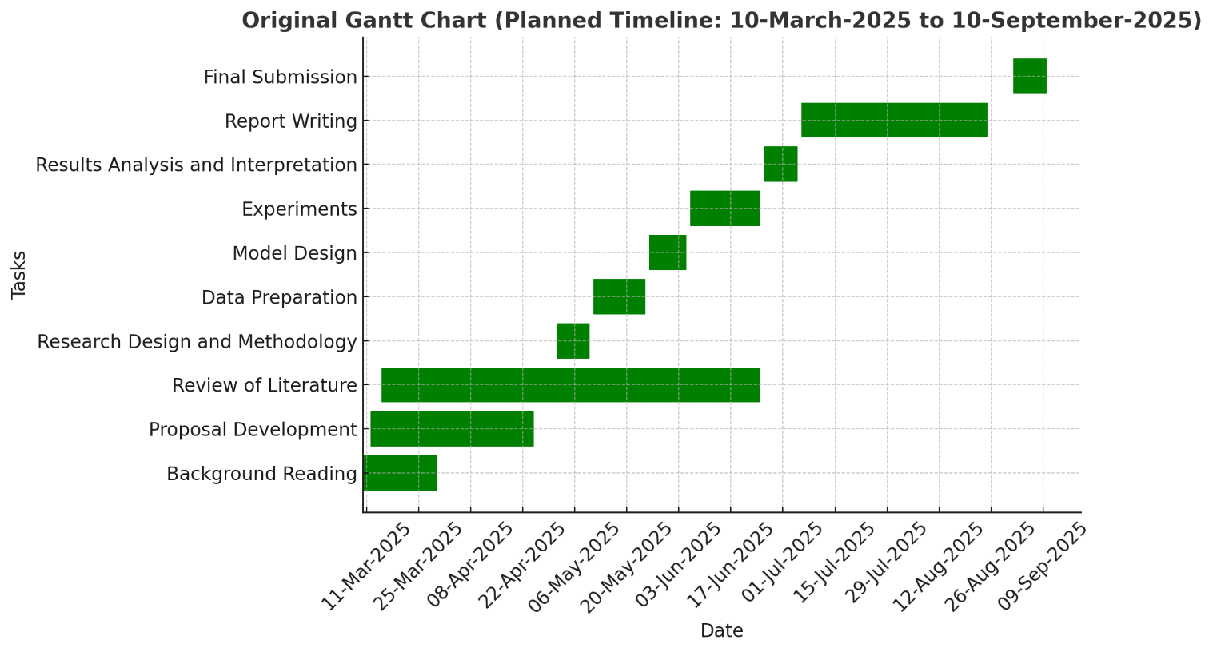
Figure 15: Planned Gantt Chart

Actual Gantt Chart (Executed)
The Actual Gantt Chart (Figure 14) illustrates how the project unfolded in practice. Compared to the original linear plan, the actual execution was more iterative and overlapping. For instance, model training and testing overlapped with drafting and revising chapters. Similarly, the literature review extended further into the project timeline, reflecting the need to incorporate new references during writing and experimentation.
Additional milestones were introduced, such as drafting and revising individual dissertation chapters (Chapters 1–6). These tasks were not explicitly included in the original plan but became necessary for refining the dissertation. The actual chart also shows overlapping technical work (data preparation, model design, chatbot development) with writing, which highlights a more realistic balance between research and documentation.

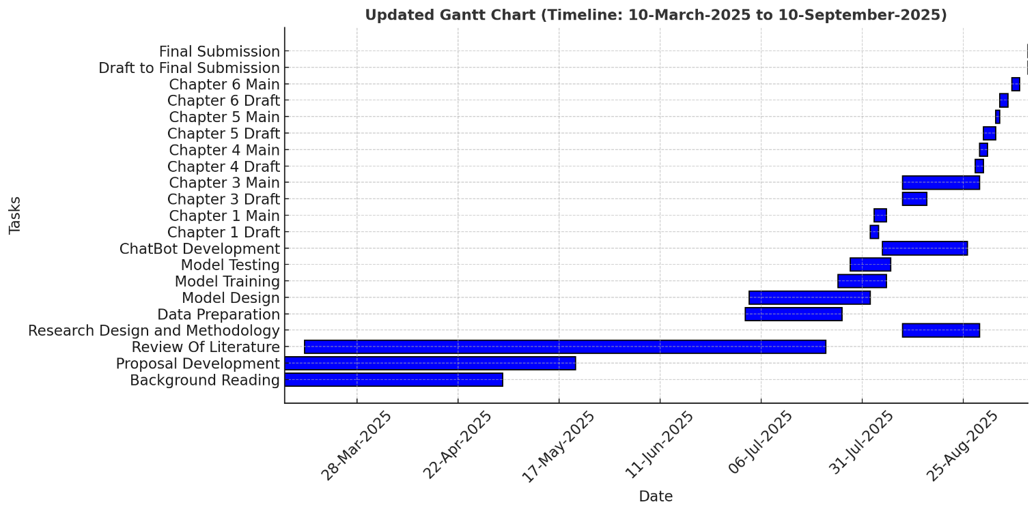
Figure 16: Actual Gantt Chart

