University of Wales Trinity Saint David

School of Engineering

Bicycle rear cassette sprocket
Peter Payne
P150305
06/03/2018
Materials and introduction
To manufacturing

Contents
Introduction 3
Production method research 3
Large Batch Production 3
CNC Milling 4
Overview 4
Advantages 4
Disadvantages 5
Sand casting 5
Overview 5
Advantages 5
Disadvantages 6
Blanking 6
Overview 6
Advantages 6
Disadvantages 6
Manufacturing method analysis 7
Requirement specification 7
Comparison of potential methods 7
Comparison results and decision for chosen manufacturing method 8
Materials research and analysis 9
Mechanical requirements 9
Comparison and results of mechanical properties 9
Analysis of Density and price in relation to mechanical properties 11
Results of price and density analysis 11
Conclusion 12
Table of Figures 13
Works Cited 14
Bibliography 16
Appendix 18

Introduction
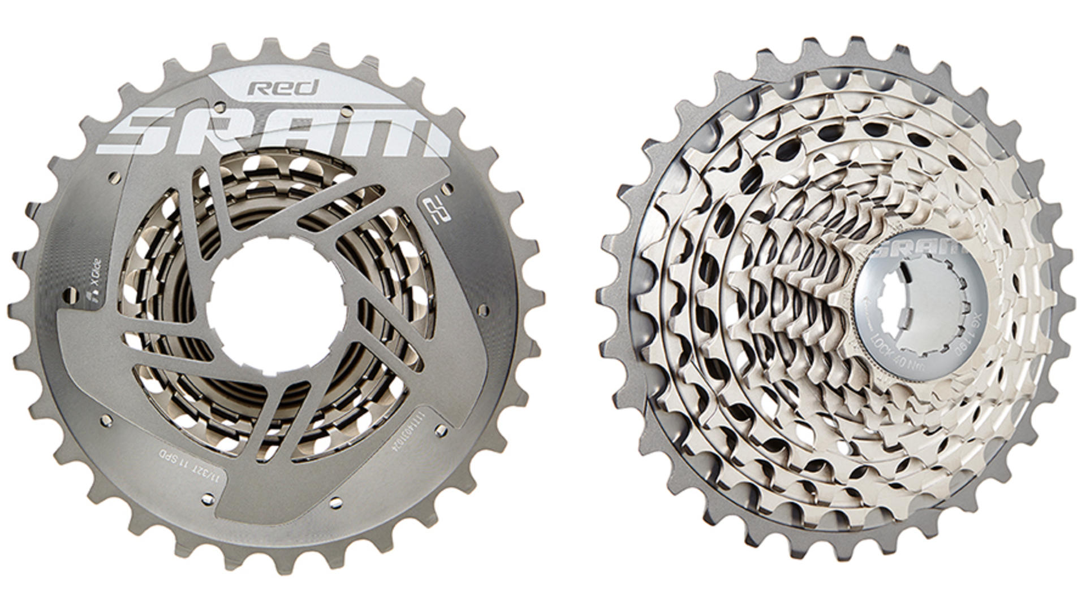
This report sets out to research and analyse potential production methods and suitable materials to produce a large batch of large cogs for a rear cassette used on a bicycle. The advantages and disadvantages of each production method will be outlined and discussed with the goal of choosing a manufacturing technique that is most suited to the application in question. Once the desired production method has been established, an appropriate material will be chosen according to whether its structural and mechanical properties are suitable for the required application. The chosen material also has to have the required properties to be machined using the selected production method.
Figure 1 front and back of a high end cassette (SRAM , 2014)

Production method research

Large Batch Production

Large batch production lies somewhere in the middle between individually produced products and full-scale continuous production. In order for production technique to be considered batch production, the entire amount of parts being produced within the single batch must have undergone the manufacturing process in question before being subject to the next stage in the production cycle. As an example, if a batch size of 100 rear cassette sprockets are manufactured using a two-step production process. All the 100 of the sprockets would need to complete the first process before any of them begin the second process.
(Graphic Products , 2018)

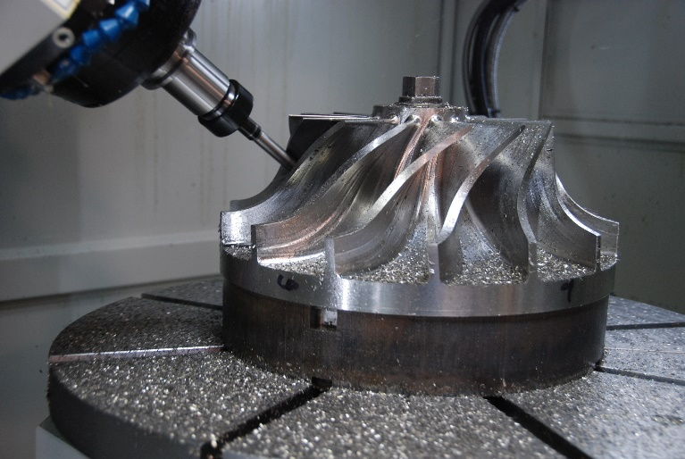
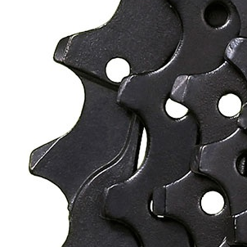
CNC Milling
Figure 2 5 axis CNC mill (imgur.com, n.d.)
Figure 3 Close up of rear cassette sprocket (Sun Race , 2018)

Overview
Computer numerical control is a type of computer aided manufacturing (CAM) process. CNC is a system that turns a once analogue production method such as lathing and milling into fully automated systems. The item being manufactured will be modelled on a computer using a CAD software package and then subsequently converted into data that the CNC machine can read. In essence milling is a combination of drilling and cutting where generally the cutting tool is spinning in a stationary position and the workpiece is manoeuvred around the cutting tool to produce the desired shape. CNC milling is the current industry stand for manufacturing bicycle Rear cassettes.
(Thomas Net , 2018)

Advantages
CNC milling is a highly accurate manufacturing method, it is able to achieve results to a tolerance of 0.02mm. This highly accurate nature lends itself perfectly to the complexities of sprocket design. CNC milling has the precision and dimensional accuracy to machine the intricate chamfers, holes and ridges found on rear cassette sprockets unlike alternative methods such as casting and forging. An example of this highly complex design can be seen in the image above. Due to its fully automated nature, CNC milling has the potential to work continuously at a very high rate of production which is ideal for large batch production. Only one person is needed to supervise a number of CNC machines at any one time. This reduction in human interaction can significantly reduce the risk of random error caused by human mistakes, thus improving the consistency and reliability of the process. The reduction in in workers needed to operate the machines will reduce production costs.
(custompart.net , 2018)

Disadvantages
The introduction of numerical control to machining processes such as milling clearly has brought along many benefits ranging from increased accuracy to higher production rates. However this advancement has not come without prominent drawbacks that need to be considered. For example, CNC milling is currently significantly more expensive than its analogue counterpart. Waste material it is also a concern with this process as in order to produce an intricate 3D component, the machine has to start with a block of material that is larger than the final product. This results in a substantial amount of material being lost throughout the manufacturing process.
(custompart.net , 2018)

Sand casting

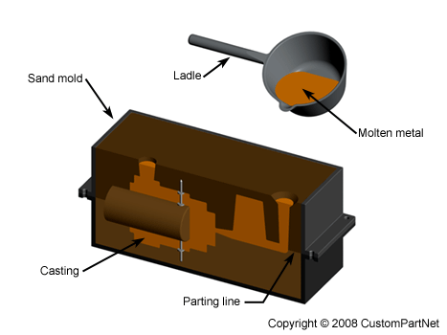
Overview
Figure 4sand casting diagram (custompart.net , 2008)
Sandcasting is a widely used and highly versatile casting methods, being compatible with nearly any alloy. The process involves a sand mould being made from an existing pattern of the desired product, the surfaces of the sand mould that will come into contact with the casting need to be lubricated to ensure successful removal of the casting. The chosen metal is melted in a furnace. Molten metal is then poured into the mould within a very short timescale to ensure that all of the material solidifies at the same rate. Once the metal has completely hardened and allowed to cool at a specific rate to prevent shrinkage and cracking, the sand mould is separated along the parting line freeing the finished casting.
(Reliance Foundry , 2017)

Advantages
There are a number of advantages to using sandcasting, one of which is the ability to produce complex shapes with a versatile size range. A large variety of materials are able to be sand casted which results in the ability to have numerous materials options for single product without the need for multiple production methods. Sandcasting has very low tooling and equipment costs due to the abundance of sand available at a low price. Any waste material has the potential to be salvaged, melted back down and re-casted.
(Customparts.not, 2018)

Disadvantages
Despite the numerous advantages of using sandcasting to produce rear cassette sprockets, there are a number of significant downsides that need to be analysed. Due to the mould being made out of sand, the surface finish and tolerance that is able to be achieved is of a poor standard compared to a process such as CNC milling. As a result of this additional machining may be required to achieve the desired quality for the finished product. Another disadvantage to using sandcasting, is its slow production rate and high labour costs. This is due to the fact that the sand mould has to be destroyed and re-created each time a casting is produced.
(custompart.net , 2008)

Blanking

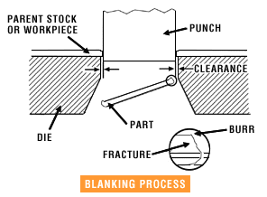
Overview
Figure 5 diagram of Blanking process (Advantage Fabricated Metals, 2009)
Blanking is a sheet-metal fabrication process, which essentially stamps out the desired part known as a blank from a larger workpiece in the form of a sheet of metal.
(Custompart.net, 2018) (360/GlobalSpec), 2006)

Advantages
There is really only one clear benefit of using blanking as a manufacturing process to produce sprockets. Due to its primitive simplicity, blanking can run at a very high work rate and different shaped punches can be swapped in and out quickly and easily. These attributes mean that blanking is the perfect process for large batch production.
(Custompart.net, 2018)

Disadvantages
Despite blanking’s rapidness, it is an incredibly inaccurate manufacturing process. The diagram above illustrates how the blanking process works. The punch stamps through the workpiece forcing the blank to shear across along the edges of the die. Depending on how large the clearance is between the punch and the die, the surface finish on the part produced can be littered with numerous burrs and fractures. This ragged and inconsistent finish will either render the sprocket structurally compromised thus unfit for purpose or being in much need of additional processing to produce a surface finish within tolerance.
(Advantage Fabricated Metals, 2009)

Manufacturing method analysis

Requirement specification

When comparing these free contrasting manufacturing methods, it is important to analyse them within the specific context of producing the large sprocket for the rear cassette of a bicycle. The application in question requires a number of manufacturing requirements that that will need to be met in order for a manufacturing method to be deemed appropriate for the task. These requirements consist of;
- The capability of working to a tolerance of at least 500th of a millimetre.
- To obtain a surface finish that is smooth and without burrs, fractures or inconsistencies.
- The ability to produce highly detailed and intricate designs without the need for additional processes.
- Being capable of a fast work rate that is both efficient and accurate.
- Minimal need for skilled worker operation.
- Being able to execute numerous manufacturing techniques within the same item of machinery.

Comparison of potential methods
 | CNC Milling | Sand Casting | Blanking
1 (Tolerance) | 10 | 6 | 4
2 (Surface Finish) | 9 | 5 | 3
3 (Produce Designs) | 10 | 10 | 2
4 (work Rate) | 7 | 2 | 10
5 (less Skilled Worker) | 9 | 4 | 10
6 (versatility) | 9 | 8 | 4
Total out of 60 | 54 | 35 | 33

The table above analyses and compares the three manufacturing methods being considered in this report. The score between one and 10, 10 being it highly satisfies or exceeds the requirements and one being in capable of meeting the requirement.

Comparison results and decision for chosen manufacturing method

The results of the table clearly show CNC milling as an outright winner over sandcasting and blank looking which receive comparable results.
Sandcasting, has a mixed results table. The process is capable of producing highly complex part as there are very few limitations on mould design. However it is let down by its inherent inability to adhere to tight dimensional and surface tolerances. As well as a very slow work rate.
Blanking’s results are highly split. The manufacturing method has an incredibly high work rate, with some blanking machines being capable of punching over 1000 blanks a minute. This process is also capable of being automated, with the workpiece being shifted across the die in sync with the machine’s punch. This automation reduces the amount of skilled workers needed to operate the machinery which would in turn reduce production costs. However blanking is unsuitable for the chosen application across all the other analysed requirements. It has a very poor surface finish and tolerance, is incapable of producing the complex design found on the surface of rear cassette sprockets and is limited to the single process that is punching.
In contrast to sandcasting and blanking, CNC milling more than satisfies all the requirements to successfully manufacture rear cassette sprockets. It is able to produce a part to an exceedingly high tolerance as well as achieving a high quality surface finish. Modern 5 axis CNC mills are easily able to achieve the highly complex curved ridges and chamfers found on the surface of high-end rear cassette sprockets. Because CNC mills are fully automated, they can produce finished parts at work rate far quicker than their analogue predecessors. As well as the increase production rate, CNC mills do not require skilled workers to be operated during a normal production cycle. However, in order to programme a CNC mill training is needed to learn how to use the required CAD and CAM software packages.
After taking into consideration the various advantages and disadvantages of these thee manufacturing methods. In terms of producing a large batch of large sprocket for the rear cassette bicycle, CNC milling is the most appropriate manufacturing method to use for the desired application.

Materials research and analysis

Mechanical requirements

When selecting the right material for a given application, there are a number of different factors that need to be taken into consideration. This section of the report details the research and analysis involved in selecting the most appropriate material to produce a large batch of large sprockets for a rear cassette using a CNC mill.
When analysing potential materials, it is important to firstly outline the mechanical properties that are most desirable for the application in question.
Mechanical properties that have been compared in this report are as follows;
- Young’s modulus
- shear modulus
- yield strength (elastic limit)
- tensile strength
- compressive strength

Comparison and results of mechanical properties

Using the software program CES Edupack 2015. A graph was produced Comparing tensile strength (MPa) against shear modulus (GPa). The Graph had results filter that only displayed materials that are capable of being milled.
Figure 6 CES EduPack Graph of tensile strength on Shear modulus (CES EduPack 2015 , 2015)
After analysing the results of the graph. Three potential materials were chosen to be analysed and compared in greater detail. The three materials that were chosen are stainless steel, high carbon steel and nickel based superalloy.
To further evaluate these chosen metals, their individual information pages found on CES Edupack 2015 were used to produce a table of values comparing each metals relevant mechanical properties.
The Data Found in the tables and Graphs below was sourced from (CES EduPack 2015 , 2015).
Mechanical properties  (GPa) | Materials
Higher is Better | Stainless Steel | High Carbon Steel | Nickel Based Superalloy
Young’s modulus | 210 (3rd) | 215 (2nd) | 245 (1st)
Shear modulus | 84 (2nd) | 84 (2nd) | 100 (1st)
Yield Strength (elastic Limit) | 1.0 (3rd) | 1.16 (2nd) | 1.9 (1st)
Tensile Strength | 2.24 (2nd) | 1.64 (3rd) | 2.4 (1st)
Compressive Strength | 1.0 (3rd) | 1.16 (2nd) | 1.9 (1st)
Collective Ranking (1st being the best) | 3rd | 2nd | 1st

The results table ranks the three potential materials from 1st to 3rd, 1st being the best (largest) value. The individual results for each material are combined to give an overall mechanical property ranking. Nickel based superalloy came out on top in every comparison. Therefore, on a purely mechanical basis nickel based superalloy is the most desirable out of the three materials. Closely followed by high carbon steel.
After comparing the mechanical properties of the three potential materials, the choice was narrowed down to just high carbon steel and nickel based superalloy. This was because the mechanical properties of stainless steel do not meet requirements to withstand the high levels stress and strain rear cassette sprockets are subject to during use.

Analysis of Density and price in relation to mechanical properties

When deciding on a material to use for a component of an item of sports equipment, both price and weight are factors that need to be considered very closely. For example, when choosing a material for a rear cassette sprocket. There is no point in using an incredibly strong material that will last a lifetime, if it weighs twice as much as a material that is only 10% weaker. Equally, a material may have all the desired mechanical properties as well as being very lightweight. However this peak performance may come at a high price. This is where it is important to choose a material that gives the best possible price to performance ratio
The table below compares the price per kilogram and the mass per metre cubed of high carbon steel and nickel based superalloy.

Results of price and density analysis
Other Properties | Materials
Lower is better | High Carbon Steel | Nickel Based Superalloy
Density (KG/m^3) | 7900 (1st) | 8650 (2nd)
Price (GBP/KG) | 0.36 (1st) | 14.4 (2nd)
Collective Ranking (1st being the best) | 1st | 2nd

The results of this table show that not only is high carbon steel lighter than nickel base superalloy, it is in fact exactly 40 times cheaper per kilogram. This dramatic difference in price far outweighs any mechanical benefit of using nickel base superalloy before even beginning to factor in the lower density of high carbon steel.
Despite the clearly superior mechanical properties of nickel base Superalloy, the extortionate price simply renders it unaffordable for the vast majority of both manufacturers and consumers.

Conclusion

In conclusion, high carbon steel strikes the perfect balance between high performance, with its well above average mechanical properties and incredibly low price compared to any of its nearest competitors.
High carbon steel it is by far the most appropriate of the materials analysed in this report to be used to manufacture a large batch of large rear cassette sprockets for a bicycle.

Table of Figures

Figure 1 front and back of a high end cassette (SRAM , 2014) 3
Figure 2 5 axis CNC mill (imgur.com, n.d.) 4
Figure 3 Close up of rear cassette sprocket (Sun Race , 2018) 4
Figure 4sand casting diagram (custompart.net , 2008) 5
Figure 5 diagram of Blanking process (Advantage Fabricated Metals, 2009) 6
Figure 6 CES EduPack Graph of tensile strength on Shear modulus (CES EduPack 2015 , 2015) 9
Figure 7 CES EduPack 2015 Stainless Steel (CES EduPack 2015, 2015) 18
Figure 8 CES EduPack 2015 High Carbon Steel (CES EduPack 2015, 2015) 19
Figure 9 CES EduPack 2015 Nickel Based Superalloy (CES EduPack 2015, 2015) 20

Works Cited

360/GlobalSpec), I. S. (., 2006. Chapter 6: Blanking and Piercing Operations. [Online]
Available at: https://www.globalspec.com/reference/63584/203279/chapter-6-blanking-and-piercing-operations
[Accessed 06 03 2018].
Advantage Fabricated Metals, 2009. Blanking. [Online]
Available at: http://www.advantagefabricatedmetals.com/blanking-process.html
[Accessed 06 03 2018].
CES EduPack 2015 , 2015. Graph of Tensile strength on Shear modulus. [Online]
[Accessed 06 03 2018].
CES EduPack 2015 , 2015. Mechanical Properties Data. [Online]
[Accessed 06 03 2018].
CES EduPack 2015, 2015. High Carbon Steel. [Online]
[Accessed 06 03 2018].
CES EduPack 2015, 2015. Nickel Based Superalloy. [Online]
[Accessed 06 03 2018].
CES EduPack 2015, 2015. Stainless Steel. [Online]
[Accessed 06 03 2018].
CNC.com, 2018. What is a CNC Mill and How Does it Work?. [Online]
Available at: http://www.cnc.com/what-is-a-cnc-mill-and-how-does-it-work/
[Accessed 06 feb 2018].
custompart.net , 2008. Sand Casting. [Online]
Available at: http://www.custompartnet.com/wu/images/sand-casting/sand-casting-mold.png
[Accessed 06 03 2018].
custompart.net , 2018. milling. [Online]
Available at: http://www.custompartnet.com/wu/milling
[Accessed 06 03 2018].
Custompart.net, 2018. Sheet Metal Cutting (Shearing). [Online]
Available at: http://www.custompartnet.com/wu/sheet-metal-shearing
[Accessed 06 03 2018].
Customparts.not, 2018. Sand Casting. [Online]
Available at: http://www.custompartnet.com/wu/SandCasting
[Accessed 06 03 2018].
Graphic Products , 2018. Batch Production. [Online]
Available at: https://www.graphicproducts.com/articles/batch-production/
[Accessed 06 03 2018].
imgur.com, n.d. [Online]
Available at: http://i.imgur.com/PDpV0f9.jpg
[Accessed 06 feb 2018].
Reliance Foundry , 2017. What is Sand Casting?. [Online]
Available at: http://www.reliance-foundry.com/castings/sand-casting#gref
[Accessed 06 03 2018].
Smelko, C., 2006. YouTube: The History of CNC. [Online]
Available at: https://www.youtube.com/watch?v=RJuIp6MP98I
[Accessed 06 03 2018].
SRAM , 2014. SRAM RED 22 WiFLi cassette offering expands.. [Online]
Available at: https://www.sram.com/stories/sram-red-22-wifli-cassette-offering-expands#sm.0000us75exbw9dkmpsh2dbt3j0lmx
[Accessed 06 03 2018].
Sun Race , 2018. CSRX0 RX 10-Speed Cassette. [Online]
Available at: http://www.sunrace.com/en/products/detail/csrx0
[Accessed 06 03 2018].
Thomas Net , 2018. More about CNC Milling. [Online]
Available at: https://www.thomasnet.com/about/cnc-milling-51276103.html
[Accessed 06 03 2018].

Bibliography

360/GlobalSpec), I. S. (., 2006. Chapter 6: Blanking and Piercing Operations. [Online]
Available at: https://www.globalspec.com/reference/63584/203279/chapter-6-blanking-and-piercing-operations
[Accessed 06 03 2018].
Advantage Fabricated Metals, 2009. Blanking. [Online]
Available at: http://www.advantagefabricatedmetals.com/blanking-process.html
[Accessed 06 03 2018].
CES EduPack 2015 , 2015. Graph of Tensile strength on Shear modulus. [Online]
[Accessed 06 03 2018].
CES EduPack 2015 , 2015. Mechanical Properties Data. [Online]
[Accessed 06 03 2018].
CES EduPack 2015, 2015. High Carbon Steel. [Online]
[Accessed 06 03 2018].
CES EduPack 2015, 2015. Nickel Based Superalloy. [Online]
[Accessed 06 03 2018].
CES EduPack 2015, 2015. Stainless Steel. [Online]
[Accessed 06 03 2018].
CNC.com, 2018. What is a CNC Mill and How Does it Work?. [Online]
Available at: http://www.cnc.com/what-is-a-cnc-mill-and-how-does-it-work/
[Accessed 06 feb 2018].
custompart.net , 2008. Sand Casting. [Online]
Available at: http://www.custompartnet.com/wu/images/sand-casting/sand-casting-mold.png
[Accessed 06 03 2018].
custompart.net , 2018. milling. [Online]
Available at: http://www.custompartnet.com/wu/milling
[Accessed 06 03 2018].
Custompart.net, 2018. Sheet Metal Cutting (Shearing). [Online]
Available at: http://www.custompartnet.com/wu/sheet-metal-shearing
[Accessed 06 03 2018].
Customparts.not, 2018. Sand Casting. [Online]
Available at: http://www.custompartnet.com/wu/SandCasting
[Accessed 06 03 2018].
Graphic Products , 2018. Batch Production. [Online]
Available at: https://www.graphicproducts.com/articles/batch-production/
[Accessed 06 03 2018].
imgur.com, n.d. [Online]
Available at: http://i.imgur.com/PDpV0f9.jpg
[Accessed 06 feb 2018].
Reliance Foundry , 2017. What is Sand Casting?. [Online]
Available at: http://www.reliance-foundry.com/castings/sand-casting#gref
[Accessed 06 03 2018].
Smelko, C., 2006. YouTube: The History of CNC. [Online]
Available at: https://www.youtube.com/watch?v=RJuIp6MP98I
[Accessed 06 03 2018].
SRAM , 2014. SRAM RED 22 WiFLi cassette offering expands.. [Online]
Available at: https://www.sram.com/stories/sram-red-22-wifli-cassette-offering-expands#sm.0000us75exbw9dkmpsh2dbt3j0lmx
[Accessed 06 03 2018].
Sun Race , 2018. CSRX0 RX 10-Speed Cassette. [Online]
Available at: http://www.sunrace.com/en/products/detail/csrx0
[Accessed 06 03 2018].
Thomas Net , 2018. More about CNC Milling. [Online]
Available at: https://www.thomasnet.com/about/cnc-milling-51276103.html
[Accessed 06 03 2018].

Appendix
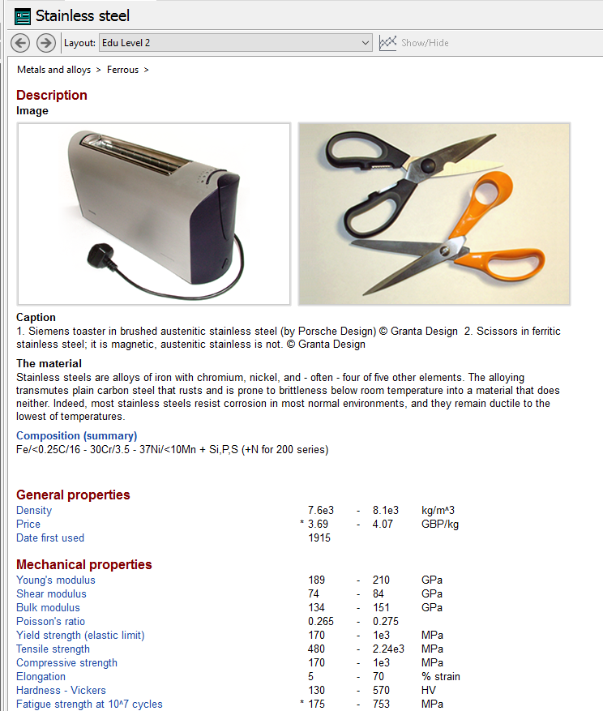
Figure 7 CES EduPack 2015 Stainless Steel (CES EduPack 2015, 2015)

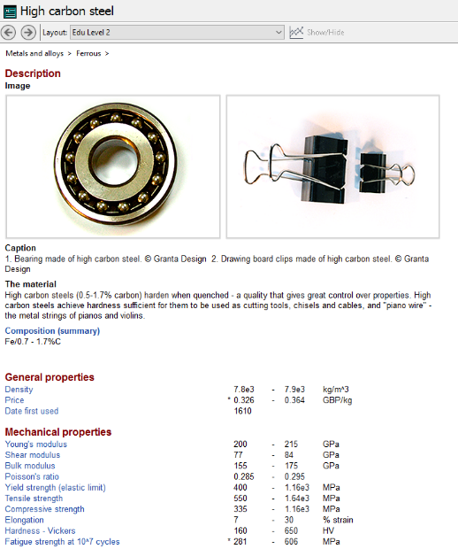
Figure 8 CES EduPack 2015 High Carbon Steel (CES EduPack 2015, 2015)

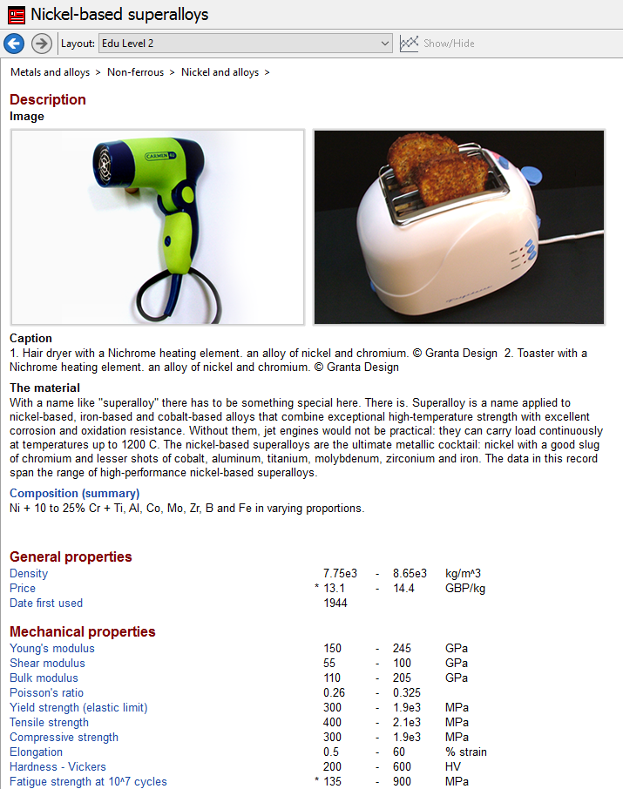
Figure 9 CES EduPack 2015 Nickel Based Superalloy (CES EduPack 2015, 2015)

