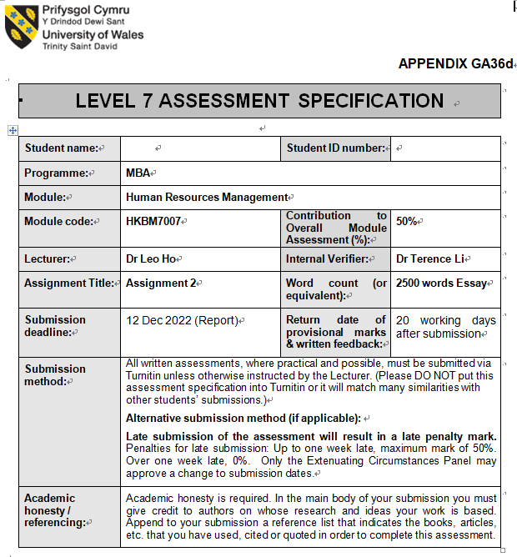



HRM - Employee relationship

Student Name: Kwok Chun Ho, Leo

Table of Contents
1. Introduction 3
2. Background of Sasa and Innisfree 3
3. Employee relationships, Key challenging issues related to international expansion 4
3.1 Power Distance 4
3.2 Uncertainty Avoidance 5
3.3 Individualism & Indulgence 5
3.4 Masculinity 6
3.5 Long Term Orientation 6
4. Analysis of the challenges 8
5. Recommendations for solution 10
5.1 Short term 11
5.2 Mid term 12
5.3 Long term 13
6. Conclusion 14
7. References 16

Introduction

Human resources professionals in any organization are responsible for many duties, including staff recruitment and retention, employee motivation, compensation and benefits packages that are competitive in the industry, and legal compliance, especially employee relationship. Humans are not machines, we cannot turn them into value by simply flipping a switch. Between colleagues, and supervisor, management. Employees must maintain healthy relationships for optimal performance. Five key dimensions of employee relations are employee communication, counseling, discipline, rights, involvement(Lance & Stephen, 1997, p. 39). Fortunately, HR experts have access to a wealth of tools and information that could assist them in addressing a wide range of HR-related challenges. This study compares and contrasts how well SASA Holdings and Innisfree Companies deal with HR issues.

Background of Sasa and Innisfree

Sa Sa International Holdings, a Hong Kong-based retail conglomerate focusing on cosmetics, personal care, skincare, fragrance, hair care, body care, and health and beauty supplements, sells over 700 distinct brands, including over 180 own brands and other exclusive international names. Kwok Siu-Ming founded the company in 1978. It was on the Hong Kong Stock Exchange's official list of firms as of 1997(Graban & Toussaint, 2018). The retail footprint of the business includes over 230 outlets in Hong Kong, Macau, Mainland China, and Malaysia.
Innisfree is a Korean cosmetics label sold by Amorepacific that began in 2000. Amorepacific opened the first retail outlet offering the Innisfree collection in 2005. Since 2007, the number of countries where you can purchase an Innisfree product has climbed to 100, including Korea, Hong Kong, China, Japan, Taiwan, Singapore, Malaysia, and Thailand. These stores may be found in nations such as Vietnam, Indonesia, the Philippines, India, the United States, Canada, Australia, and the United Arab Emirates.

Employee relationships, Key challenging issues related to international expansion

Figure 3.1: Analysis of countries with Hofstede
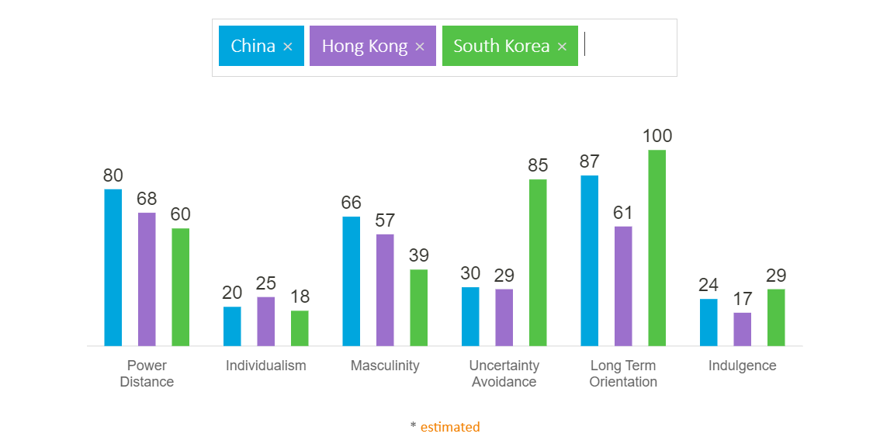 Source: (Hofstede Insights, 2022)

Power Distance

Inequality affects this axis. Institutions and organizations with a large "power gap" tolerate having little influence over their life. China's high PDI (80) suggests people accept inequality. Subordinate-superior interactions are usually hostile, and superiors might abuse their power. Authority and repercussions influence those who trust others' leadership and initiative. Hong Kong and South Korea are only slightly lower than China, so they don’t require employees and managers to be equal, and subordinates don’t think that superiors have the same rights as me or shouldn’t have privileges.

Uncertainty Avoidance

Uncertainty Avoidance evaluates a culture's fear of ambiguity and its beliefs and institutions to avoid it. Hong Kong scores close to China, but South Korea scores 85 on Uncertainty Avoidance. Pragmatism and adaptability are often required. We can know that South Korean companies manage employees through comprehensive quality management, and subordinate employees are very willing and willing to accept strict control and clear instructions from their superiors. Therefore, the human resources department in South Korea must pay special attention to this. The Chinese cannot accept it. To maintain good employee relations, it is necessary to formulate a set of more relaxed policies and guidelines. Otherwise, there will be a lot of resistance.

Individualism & Indulgence

This statistic measures communal dependence. Whether "I" or "We" define identity is the key. Individualist civilizations hold individuals completely responsible for themselves and their immediate families. Collectivist societies have "in groups" that protect members in return for allegiance. The three countries' scores are close. This is shown in a strong sense of loyalty to one's "group," which can include blood relatives or buddies of a certain age. In a collectivist society, loyalty is prized above all else and takes priority over established customs. In this civilization, connections are highly cherished, and members of all groups are expected to look out for one another. In collectivist cultures, transgression results in humiliation and loss of face, employer-employee interactions are moral (like a family bond), hiring and promotion choices consider the employee's in-group, and management is a social activity. Similarly, the people of the three countries are very similar in terms of self-indulgence. Therefore, it is relatively easy for the department of individualism and indulgence to expand from HRM to IHRM.

Masculinity

Are the values of masculine cultures favor competition and the pursuit of achievement? In Chinese society, most people think it is, but in Hong Kong, especially South Korea, it is more about advocating equality between men and women. Therefore, IHRMs in Hong Kong and South Korea must raise their spirits and pay more attention to the issue of dealing with male and female employees, because social and cultural differences will easily lead to inequality between men and women, discrimination, and even sexual harassment.

Long Term Orientation

Long-term orientation versus short-term orientation indicates a group's trade-off between long-term and short-term interests. In this respect, South Korea and China are relatively close, but there is a gap between Hong Kong and China. A country that is less focused on long-term direction. In terms of management, the performance evaluation cycle of superiors to subordinates is relatively short, and they are required to see results immediately. Therefore, HK's IHRM should not be too hasty in maintaining the relationship with Chinese employees, and focus too much on immediate results. It takes time to slowly cultivate a good communication culture and consultation, and give employees proper participation and rights before formulating discipline. A good employee relationship can improve the sense of belonging of the company's employees(Jeong & Carolina, 2012, p. 31), from paid human resources.
Table 3.1 HRM Challenges of expansion to China
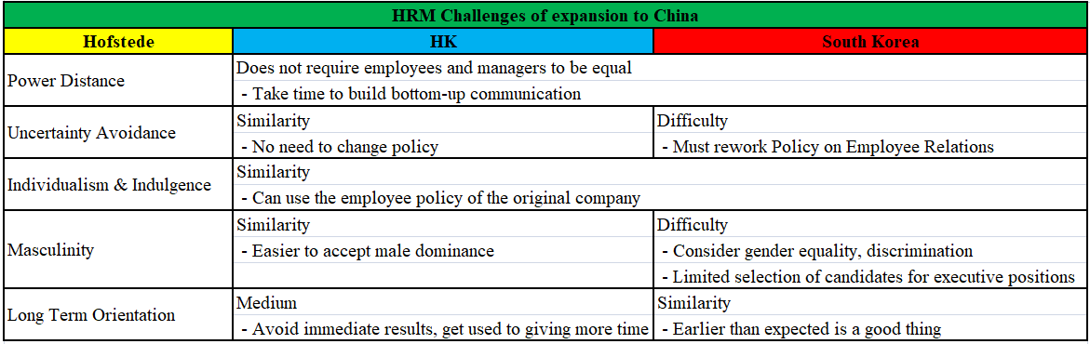
Source: Constructed by the Author

Analysis of the challenges

Employment discrimination based on protected characteristics is banned in many countries. People of a specific age, gender, sexual orientation, race, disability, or pregnancy may be protected against discrimination depending on the country. Measures to avoid harassment are also widely available(Beer, 2022). Many developed countries, including the Americas, Europe, South America, Asia and the Pacific, have anti-discrimination legislation.
Employee relations may be impacted by a broad variety of internal and external events, such as the growth of relationships, the alteration of expectations, the arrival of tough times, and the entrance or departure of new staff members. The economy's present status is an external element that may influence the dynamics at work. Workers may negotiate better working conditions with employers when the economy is well. New partnerships and age-related considerations affect workplace dynamics. Conflict and high expectations in interpersonal interactions are normal, although they often dissipate with time. Over time, these characteristics and the employer-employee relationship will change.
When the distance between the manager and the low-level employees is large to a certain extent, if the upper-level personnel cannot understand the truth from the bottom up, the two sides will go further and further in different directions. On the other hand, if the management fails to treat cultural differences correctly and seek consensus from each other's cultural backgrounds, the misunderstanding between the two parties will deepen, the contradictions will deepen, and the confrontation and conflict will become more intense. In the end, employees may express their dissatisfaction in the form of irrational revenge, which will eventually affect the working attitude and working atmosphere of employees.
Employee ties remain fractured and undeveloped due to the company's matrix structure, employees may experience stress if they fail to reach their own objectives, performance, or other expectations. Regular communication with workers and clear, explicit instructions may help the organization grow and solve this challenge.
To educate employees of business norms and alternatives, more two-way communication and employer-employee contact is needed. Well-informed employees are more likely to make good choices, stay motivated and productive, and feel like valued members of the company. Maintaining a good working relationship with staff may decrease disputes. Managers should welcome and motivate employees.
Participating in collective decision-making will drive employees to contribute individually. To achieve employee collaboration, employers must convince them that more engagement is necessary to meet business objectives. Management must treat workers fairly and respectfully. Employee prejudice must be avoided. Therefore, it's wise to actively solicit employee input.
An organization's success depends on a leader's popularity among workers. Leaders should use situational leadership to adapt to each event's demands rather than relying on one approach. They should create rapport with workers to make them feel secure and motivated to work hard.
Rewarding employees that go above and beyond will motivate them to work together. Employees shouldn't become comfortable. Task sharing, career advancement, enrichment, and employee empowerment should keep things fresh. Give them additional responsibilities and harder tasks to improve their performance. They should have best practices, cutting-edge technology training, safe working conditions, and a positive, supportive work environment(Parker, Sharon & Carolyn, 2001, p. 211).
Even with the best employee relations strategy in place, HR teams can find themselves in a challenging position when dealing with employee misconduct. Unfortunately, employee misconduct, such as violations of health and safety regulations and harassment, does occur from time to time. Therefore, the team needs to develop a plan to deal with these issues.

Recommendations for solution

Leadership-staff tensions intensified. This complicated and impersonalized business ties. Employee interactions are shared by corporate management. Industrial interactions are usually close. Industrial and service economies are separated. It discriminated against specific economic sectors (Turner, 2019). This led to "employment relations," where an employer pays an employee for services. Home-based employees have few legal rights (Hyman 1975, p. 232).
Innisfree said respect the diversity of employees around the world and help each other to realize themselves through work. We are committed to achieving the perfect harmony of inner and outer beauty, creating real beauty, helping everyone realize their dreams and live a beautiful and healthy life(Innisfree, 2022). Sasa sets out to develop women leaders in retail to promote equality, diversity and inclusion. Likewise, the health, safety and livelihoods of our employees have always been our priorities item. We are committed to providing a safe workplace for our employees (Sasa, 2021).

Short term

Management can express the recognition and appreciation of employees, when employees feel that they are not valued, they will start to look for outlets and opportunities outside. Therefore, executives need to express their concern for their subordinates in a timely manner and reasonably recognize their efforts(Joyce, 2007, p. 26). One way is to incorporate public recognition into your workplace. It is difficult to create a work environment in which everything is said and done, so executives need to be open to listen. Only in this way can we successfully establish the foundation of honesty and good communication. Management-employee connections influence firm success. Positive boss-employee relationships may boost workplace happiness, productivity, and cohesiveness(Maureen & Darren, 2012). Improving employee interactions helps you retain and hire top talent. Strong staff ties may increase company-wide communication. In a great environment, employees feel respected and free to speak. Management-worker communication makes leadership feedback easier. If you want your employees to have a good relationship with everyone, then don't favor anyone and be as fair and just as possible(Wendi, Jeffrey & Paul, 2007). It's all about an inclusive workplace
Also, we can provide extracurricular activities to improve employee well-being and workplace health. This could be as simple as a Happy Friday for drink, or even a paid gym or online yoga class. It can also improve office health at the same time.

Mid term

When we successfully complete the short-term goal to lay the foundation of employee relations, you can get your team to support the company's VMV, We can do this by regularly sharing our company's mission, vision, and values. The next step is to make everyone in the team clearly aware of the company's VMV and support it, so that both parties have the same goal and play an active role in order to practice and achieve common goals, thereby increasing the sense of belonging. Motivated employees who trust their superiors may work harder. Motivate workers. Employee-driven incentive and recognition(Dimitrios & Athanasios, 2014). "Buy-in" signifies business loyalty. Management-employee interactions boost company performance. Trust in senior management increases morale and collaboration. We suggest that the company can hold regular cross-departmental meetings, and during the meeting can share the different achievements of each department and the accumulative effect worthy of praise. Let all employees know that their contributions to the company will be known to everyone in the company, increase their sense of accomplishment, and motivate everyone to work towards better goals.
Celebrate your colleagues. Have a small weekend celebration of the little things that impact people all week. This can be as simple as sending an email reminding people to come up with their weekly “co-worker cheers,” which are then read or shared in front of the entire company at the end of the day, letting the pre-weekend compliments spread.
Understanding how their effort improves the organization helps workers flourish. Understanding their position in the company's goal may drive workers. Community-building activities may enhance employee morale and job satisfaction. Employee involvement on improving corporate operations frequently provides innovative, practical ideas that benefit everyone (Byrne, 2022). Communicating with employees shows you value their thoughts and generates fresh ideas. Respecting teammates' improvement suggestions demonstrates gratitude. Follow teammates' advice. If they created the approach, they may complete it.

Long term

Provide employees with access to decision makers, such as having breakfast or lunch with staff. This small gesture reassures them. Employees will think that executives genuinely care about them and will not be superior to others. Use the anonymous annual employee survey to find out what they think (Kim, 2002, p. 231), and the opinion collection box should be placed in a place that cannot be monitored by CCTV to protect employees.
We can also create a precedent for employee opinion surveys through the formation of labor unions, so that employees will feel more at ease to express their wishes and opinions, so as to obtain more honest information. Some companies use Alternative Dispute Resolution (ADR) to resolve policy issues, providing a bridge for employees to take issues directly to senior management for resolution.
Establishing a good employee relations culture requires the cooperation and participation of all levels of management, as well as investing resources in labor relations and training executives. Consider Aristotle's famous quote: "The whole is greater than the sum of its parts." Cohesive and engaged employees make the whole group more productive.

Table 5.2: Action plan’s Gantt Chart
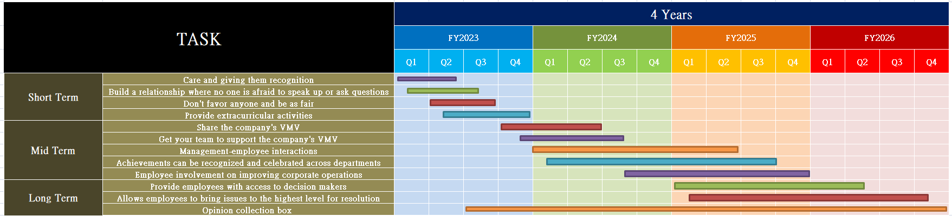
Source: Constructed by the Author

Conclusion

Facilitate employee comprehension of their job within the larger business and its relevance to the company's long-term aims. Team members may earn more from teamwork if they share the company's essential beliefs. To accommodate a diversity of learners' preferred modes of getting information, changes in expectations, regulations, and processes should be conveyed verbally and in writing. Email or team meetings may educate staff. Provide suitable information to your staff to establish a more effective working climate; people prefer companies who are straightforward and honest with them. Employees' views of the company and motivation increase when they're acknowledged. As a result, it's vital to think of innovative methods to convey thanks to your personnel. Honoring and recognizing workers for even minor accomplishments may have a huge impact on morale. Some individuals are spurred onward by the chance to shine in the spotlight. Appreciation may inspire job improvement. Implementing an Employee of the Month award is one approach to publicly honor a star worker while inspiring other employees to do better. Consider additional methods to reward great work performance for people who prefer not to be the focus of attention. When employees work together like family, a company becomes a relaxed and enjoyable place to work. If a person's mind is constantly clouded with unnecessary tension and stress, he tends to lose concentration and creativity. And as an added bonus, peer mentoring can enhance camaraderie among employees and have a positive impact on their engagement.

References

Beer, M. (2022). Human resource systems for sustainable companies. Sustainable Human Resource Management, 1-56. https://doi.org/10.1201/9781003339663-1
Byrne, Z. S. (2022). How do we improve employee engagement for competitive advantage? Understanding Employee Engagement, 143-158. https://doi.org/10.4324/9781003171133-10
Crosby, D. H. (2014). Improving employee retention in the public sector by increasing employee engagement. SSRN Electronic Journal. https://doi.org/10.2139/ssrn.2555709
Dimitrios, B. & Athanasios, K. (2014) “LEADERSHIP AND JOB SATISFACTION” European scientific journal, vol. 10, No 8. March,2014.
Graban, M., & Toussaint, J. (2018). Improving flow. Lean Hospitals, 199-226. https://doi.org/10.4324/9781315380827-9
Innisfree (2022) Respect Employees. Available at: https://www.innisfree.com/hk/zh/BrandPage.do?pageName=brand_value (Accessed: 4 December 2022).
Jeong, N. K. & Carolina, D. O. (2012) “Strategic Value of Employee Relationships”, International Journal of Strategic Communication, pp. 31-44.
DOI: 10.1080/1553118X.2011.634869
Joyce, K. F. (2007) “Leadership, Power, and Positive Relationships” Exploring Positive Relationships at Work, pp. 26.
Kim, S. (2002) “Participative Management and Job Satisfaction” Public administration review, pp. 231-241. DOI: 10.1111/0033-3352.00173
Lance, A. B. & Stephen, W. B. (1997) “Relationships among workplace” , journal of Retailing, pp. 39-61. DOI: 10.1016/S0022-4359(97)90014-2
Maureen, L. M. & Darren, F. W. (2012) “The Boss-Employee Relationship” Northeast Business & Economics Association (NBEA) 2012, Oct,2012.
Pincus, J. (2020). Employee engagement as motivation: Practitioner models. https://doi.org/10.31124/advance.13270571.v1
Pincus, J. (2020). Employee engagement as motivation: Practitioner models. https://doi.org/10.31124/advance.13270571.v1
Parker, Sharon, K. & Carolyn, M. (2001) “Designing a safer workplace” Journal of Occupational Health Psychology, Vol. 6(3) pp. 211-228.
Sasa Ltd. (2022) Annual report 2021. Available at: https://www1.hkexnews.hk/listedco/listconews/sehk/2022/0722/2022072200619.pdf (Assessed: 4 December 2022).
Turner, P. (2019). Measuring employee engagement. Employee Engagement in Contemporary Organizations, 193-222. https://doi.org/10.1007/978-3-030-36387-1_8
Wendi, J. E., Jeffrey, A. J. & Paul, M. M. (2007) “Be nice and fair or else” Journal of Management Development, 13th February.

