

UNIVERSITY OF WALES TRINITY SAINT DAVID
BSc Health and Social Care

MODULE: BMHP5014
Changemakers: Creativity and Value Creation

COMPONENT 2: WRITTEN ASSIGNMENT

EarlyHelp Navigator

An Innovative Digital Solution for Equitable Early Help Signposting
in UK Health and Social Care

Student Name [Sohail Akram]
Student Number [2328491]
Date [ 10.07.2026]
Name of Inctitute [Zarah Ahmad]

TABLE OF CONTENTS
POSTER 3
References 5
THE PITCH 7
Introduction 8
The Persistent Problem: Why Current Signposting Fails Families 8
EarlyHelp Navigator: A Practical and Inclusive Solution 8
Impact on Health, Wellbeing, and Social Outcomes 9
Alignment with Policy, Legislation, and Practice 10
Public Involvement and Co-Production 10
Conclusion: A Call for Action 11
References 12

POSTER

‘EarlyHelp Navigator: Bridging the Digital Divide in Early Help Access’
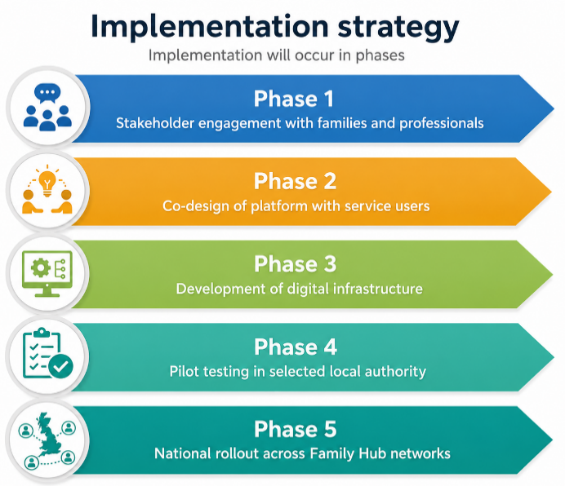
EarlyHelp Navigator: Bridging the Digital Divide in Early Help Access

- Many families continue to have difficulties accessing Early Help despite there being clear policy direction, as digital signposting is weak (Family Fund, 2026).
- Norfolk, Leeds and Nottinghamshire council websites have been reviewed and found to have inconsistent information on several pages, to have significant professional jargon such as “Level 2 and 3 needs” and to lack support for those with low literacy (Leeds City Council, 2025).
- This is exacerbated by digital exclusion, as 93% of low-income families with disabled children are impacted by the cost of digital exclusion. Challenges with language and health literacy further delay help-seeking (Chew et al., 2026).
The Issue/Gaps in Health & Social Care
Innovation Overview

- EarlyHelp Navigator is a co-designed responsive website and free mobile app that acts as one accessible 'front door' to Early Help services across UK local authorities.
- It provides easy-to-search-by-postcode functions with plain-language translation and inclusive design and self-referral. Professionals, on the other hand, utilise a hub and referral pathway.

v

- AI-assisted guidance (non-decision-making).
- Secure online referral forms
Automated translation tools.
- Service mapping by postcode.
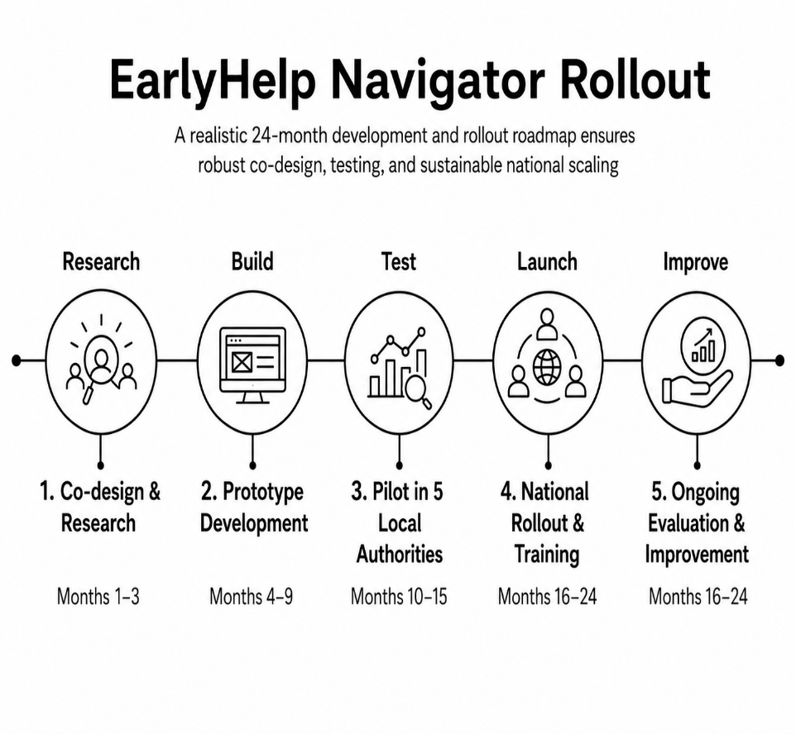
Dissemination Strategy
Development and Regulations

- Children Act 2004
- Working Together to Safeguard Children (DfE, 2023)
- Early Help System Guide
- UK GDPR and Data Protection Act 2018

- School and college awareness campaigns.
- Social media outreach
- Local authority websites and Family Hubs.
- Community organisation partnerships (Tam et al. 2024).
Target Audience & Impact

- Families with children needing early support
- SEND families requiring coordinated support
- Ethnic minority communities needing multilingual access.
It enhances health and wellbeing through earlier access to support, better child development, better mental health for parents and better family resilience. It promotes equality in line with the Equality Act (2010), which encourages prevention rather than intervention.

Timeline
Conclusion

Early Help Connect represents a modern, inclusive, and accessible approach to Early Help provision. It supports families earlier, improves clarity, and aligns with national safeguarding and prevention strategies.
Technology Integration

References

Chew, J., Frings, D., Reavey, P. and Allabyrne, C. (2026) ‘A systematic literature review of digital mental health interventions in providing support for children and their families’, Digital Health, 12, p. 20552076251406323. DOI: 10.1177/20552076251406323.
Data Protection Act 2018, c. 12. Available at: https://www.legislation.gov.uk/ukpga/2018/12/contents (Accessed: 18 June 2026).
Department for Education (2023a) Children’s social care data and digital strategy. London: Department for Education. Available at: https://www.gov.uk/government/publications/childrens-social-care-data-and-digital-strategy (Accessed: 18 June 2026).
Department for Education (2023b) Working together to safeguard children 2023: statutory guidance on multi-agency working to help, protect and promote the welfare of children. London: Department for Education. Available at: https://www.gov.uk/government/publications/working-together-to-safeguard-children—2 (Accessed: 18 June 2026).
Department for Levelling Up, Housing and Communities and Department for Education (2022) Early Help System Guide: a toolkit to assist local strategic partnerships responsible for their Early Help System. London: Department for Levelling Up, Housing and Communities/Department for Education. Available at: https://assets.publishing.service.gov.uk/government/uploads/system/uploads/attachment_data/file/1062596/Early_Help_System_Guide.pdf (Accessed: 18 June 2026).
Equality Act 2010, c. 15. Available at: https://www.legislation.gov.uk/ukpga/2010/15/contents (Accessed: 18 June 2026).
Family Fund (2026) Digitally Excluded 2026. York: Family Fund. Available at: https://www.familyfund.org.uk/impact/research/research-reports/digitally-excluded-2026/ (Accessed: 18 June 2026).
Leeds City Council (2025) One minute guide: Family Hubs and the Early Help front door team. Available at: https://www.leeds.gov.uk/one-minute-guides/family-hubs-and-early-help-front-door-team (Accessed: 18 June 2026).
Tam, M.T., Wu, J.M., Zhang, C.C., Pawliuk, C. and Robillard, JM. (2024) ‘A systematic review of the impacts of media mental health awareness campaigns on young people’, Health Promotion Practice, 25(5), pp. 907–920. DOI: 10.1177/15248399241232646.
UK General Data Protection Regulation (UK GDPR) (2016) Retained Regulation (EU) 2016/679. Available at: https://www.legislation.gov.uk/eur/2016/679 (Accessed: 6 July 2026).

THE PITCH

‘EarlyHelp Navigator- A Creative Digital Solution for Equitable Early Help Access’

Introduction
Building on the accompanying poster, this pitch explains why EarlyHelp Navigator is a necessary and realistic innovation for UK health and social care. It emphasises how the platform responds to the needs of structural barriers in digital access, how it supports the national policy, how it enhances outcomes for children and families and how it strengthens public engagement in the design of services.

The Persistent Problem: Why Current Signposting Fails Families
Early Help is widely acknowledged as the building blocks of effective children's services, providing support as early as it can be provided and before problems reach statutory proportions (DLUHC and DfE, 2022). But for many families, access to the pathway is inconsistent and challenging. Fragmented and inaccessible local systems: Of the three local authority websites reviewed, those of Norfolk, Leeds and Nottinghamshire all showed similar problems. The information was dispersed amongst multiple pages, technically complex and not easy for a non-technical user (Norfolk County Council, 2024). The data suggests that key services - Family Hubs, parenting support and referral routes were unclear and inconsistent (Leeds City Council, 2025)
Digital exclusion and inequality are problems that disproportionately impact vulnerable families. There are clear indications that 93% of low-income families where a child is disabled or seriously ill are digitally excluded or at risk of exclusion as a result of affordability, availability and lack of digital confidence (Family Fund, 2026; Nottinghamshire County Council, 2024). These challenges are compounded by language barriers and low health literacy. This means that families are not able to use early help, resulting in the deterioration of their needs, pressure on statutory services and greater cost to the service system in the long term (MacAlister, 2022). There is a lack of consistency in the use of the principle of “no wrong door” or “tell your story once” as set out in national guidance (Ofsted, 2023).

EarlyHelp Navigator: A Practical and Inclusive Solution
EarlyHelp Navigator provides a single, consistent digital front door for Early Help services across local authorities. It reduces fragmentation by offering one accessible platform that connects families to local support (Batool & Lopez, 2023).
The system combines several integrated tools:
- An AI chatbot that translates professional language into plain English
- Easy Read, multilingual, and audio-supported content
- A postcode-based Help Finder tool co-designed with families
- Direct self-referral pathways to local services
- Secure digital profiles enabling “tell your story once” functionality
- Human-centred design approach

The platform is based on lived experience. It focuses on families who are currently encountering the most challenges and incorporates co-production throughout the design, development, and governance process (Waid, Tomfohrde and Kutzler 2022). It shows a concern for 'social value' and fits with the learning outcomes for the modules related to innovation and the common good.

Impact on Health, Wellbeing, and Social Outcomes
Early help has a proven impact on children's development, and on parents' health and wellbeing, and can prevent a situation from going 'too far' to statutory care or crisis. (MacAlister, 2022). EarlyHelp Navigator makes it easier to navigate and understand service options to get help quickly (El-Hoss et al, 2023). The platform directly tackles inequality by reducing inequality in access to:
- Accessible design for low-literacy users
- Multilingual support for diverse communities
- Human-assisted digital navigation for those needing extra help
- These features ensure equitable access regardless of income, language, or digital ability.
- Benefits for professionals and services

For practitioners, this tool enhances the quality of referral and supports multi-agency communication. This helps to ensure more efficient and coordinated decision-making across services (Owens and Lloyd, 2023).
The platform also brings about broader social good by:
- Normalising early help-seeking behaviour
- Reducing long-term inequality
- Lowering costs through prevention rather than crisis intervention

Alignment with Policy, Legislation, and Practice
By encouraging the “tell your story once” approach to reduce the need for families to retell their story and promote accessible, coordinated services, EarlyHelp Navigator is a direct enabler of the Early Help System Guide. It is also consistent with “Working Together to Safeguard Children”, which emphasises the need for early identification of needs, timely intervention and effective multi-agency working to ensure better outcomes for children and families (Vasey et al. 2022). In addition, the platform needs to respond to some key legal and equality considerations such as providing equal access to services, ensuring the protection of personal data and the promotion of inclusive and child-centred practice within partner organisations (Qadir et al. 2023).

- Equality Act 2010 obligations for accessibility and inclusion
- Public Sector Equality Duty compliance
- Children Act 2004 principles on information sharing
- Integration with existing systems

Rather than replacing existing services, EarlyHelp Navigator enhances them. It supports Family Hubs, schools, health visiting teams, and social care by improving consistency, reducing duplication, and making information easier to access across agencies.

Public Involvement and Co-Production
Co-production with lived experience, such as Families, children, and young people with lived experience of Early Help are central to the platform’s development. Their input shapes language, design, functionality, and evaluation processes (Bennett et al. 2022). The role of the wider public: for example, public engagement is essential for long-term success. Early Help is not a niche service but a universal public good (Rijal 2023). Public involvement can include:
- Sharing lived experiences of accessing support
- Participating in testing and feedback sessions
- Joining parent and community advisory groups
- Advocating for local adoption of the platform
- Cultural and system change

Broader public engagement has a role in destigmatising help-seeking behaviour; encouraging both early intervention and it being viewed as normal, accessible and expected (Draganidis et al. 2024).

Conclusion: A Call for Action
EarlyHelp Navigator is a practical, evidence-based approach to the longstanding problems of access to Early Help. It tackles issues of digital exclusion, disjointed systems and communication difficulties, and is designed to meet the national policy and legal frameworks. The platform is geared toward families, but not for them. Technologies are in place, policy is supportive, and there is documented need. Commitment, investment and coordinated action are now needed. Supporting EarlyHelp Navigator will help to ensure that every family in the UK will be able to receive timely, appropriate support via an inclusive, equitable and truly accessible system.

References

Batool, A. and Lopez, A. (2023) 'Healthcare access and regional connectivity: bridging the gap', Journal of Regional Connectivity and Development, 1(2). Available at: https://journalofregionalconnectivityanddevelopment.com/index.php/2/article/view/27 (Accessed: 18 June 2026).
Bennett, V., Gill, C., Miller, P., Wood, A., Bennett, C., Ypag, N. and Singh, I. (2022) 'Co‐production to understand online help‐seeking for young people experiencing emotional abuse and neglect: Building capabilities, adapting research methodology and evaluating involvement and impact', Health Expectations, 25(6), pp. 3143–3163. Available at: https://onlinelibrary.wiley.com/doi/full/10.1111/hex.13622 (Accessed: 18 June 2026).
Department for Levelling Up, Housing and Communities and Department for Education (2022) Early Help System Guide: a toolkit to assist local strategic partnerships responsible for their Early Help System. London: DLUHC/DfE. Available at: https://assets.publishing.service.gov.uk/government/uploads/system/uploads/attachment_data/file/1062596/Early_Help_System_Guide.pdf (Accessed: 18 June 2026).
Draganidis, A., Fernando, A.N., West, M.L. and Sharp, G. (2024) 'Social media delivered mental health campaigns and public service announcements: A systematic literature review of public engagement and help-seeking behaviours', Social Science & Medicine, 359, 117231. Available at: https://www.sciencedirect.com/science/article/pii/S0277953624006841 (Accessed: 18 June 2026).
El‐Hoss, T., Thomas, F., Gradinger, F. and Hughes, S. (2023) 'The role of the voluntary, community and social enterprise sector in Early Help: Critical reflections from embedded social care research', Child & Family Social Work, 28(4), pp. 1150–1162. Available at: https://onlinelibrary.wiley.com/doi/full/10.1111/cfs.13034 (Accessed: 18 June 2026).
Family Fund (2026) Digitally Excluded 2026. York: Family Fund. Available at: https://www.familyfund.org.uk/impact/research/research-reports/digitally-excluded-2026/ (Accessed: 18 June 2026).
Leeds City Council (2025) One minute guide: Family Hubs and the Early Help front door team. Available at: https://www.leeds.gov.uk/one-minute-guides/family-hubs-and-early-help-front-door-team (Accessed: 18 June 2026).
MacAlister, J. (2022) The independent review of children’s social care. London: UK Government. Available at: https://www.thefosteringnetwork.org.uk/media/d45b44zp/the-independent-review-of-childrens-social-care-final-report.pdf (Accessed: 18 June 2026).
Norfolk County Council (2024) Early help for children and families. Available at: https://www.norfolk.gov.uk/article/40407/Early-help-for-children-and-families (Accessed: 18 June 2026).
Nottinghamshire County Council (2024) Early Help Unit. Available at: https://www.nottinghamshire.gov.uk/care/safeguarding/childrens-mash/services-available-for-non-safeguarding-concerns/early-help-unit (Accessed: 18 June 2026).
Ofsted (2023) The multi-agency response to children and families who need help. London: Ofsted. Available at: https://www.gov.uk/government/publications/the-multi-agency-response-to-children-and-families-who-need-help (Accessed: 18 June 2026).
Owens, R. and Lloyd, J. (2023) 'From behaviour-based to ecological: Multi-agency partnership responses to extra-familial harm', Journal of Social Work, 23(4), pp. 741–760. Available at: https://journals.sagepub.com/doi/full/10.1177/14680173231162553 (Accessed: 18 June 2026).
Qadir, N., Sahetya, S., Munshi, L., Summers, C., Abrams, D., Beitler, J., Bellani, G., Brower, RG., Burry, L., Chen, J.-T., Hodgson, C., Hough, C.L., Lamontagne, F., Law, A., Papazian, L., Pham, T., Rubin, E., Siuba, M., Telias, I., Patolia, S., Chaudhuri, D., Walkey, A., Rochwerg, B. and Fan, E. (2023) ‘An Update on Management of Adult Patients with Acute Respiratory Distress Syndrome: An Official American Thoracic Society Clinical Practice Guideline’, American Journal of Respiratory and Critical Care Medicine, 209(1), pp. 24–36. Available at: https://academic.oup.com/ajrccm/article/209/1/24/8427573 (Accessed: 6 July 2026).
Rijal, S. (2023) 'The importance of community involvement in public management planning and Decision-Making processes', Journal of Contemporary Administration and Management (ADMAN), 1(2), pp. 84–92. Available at: https://journal.literasisainsnusantara.com/index.php/adman/article/view/27 (Accessed: 18 June 2026).
Vasey, B., Nagendran, M., Campbell, B., Clifton, D.A., Collins, G.S., Denaxas, S., Denniston, A.K., Faes, L., Geerts, B., Ibrahim, M., Liu, X., Mateen, B.A., Mathur, P., McCradden, MD., Morgan, L., Ordish, J., Rogers, C., Saria, S., Ting, D.S.W., Watkinson, P., Weber, W., Wheatstone, P. and McCulloch, P. (2022) ‘Reporting guideline for the early stage clinical evaluation of decision support systems driven by artificial intelligence: DECIDE-AI’, BMJ, 377, art. no. e070904. Available at: https://www.bmj.com/content/377/bmj-2022-070904.short (Accessed: 6 July 2026).
Waid, J., Tomfohrde, O. and Kutzler, C. (2022) 'Promoting health and social equity through family navigation to prevention and early intervention services: a proof of concept study', BMC Public Health, 22(1), 1972. Available at: https://link.springer.com/article/10.1186/s12889-022-14320-4 (Accessed: 18 June 2026).

