Digital Marketing
SBUS5106
Georgina Buckland
1404838

Digital Marketing Campaign using Ad Words and Ad Sense for ‘Beach is Best’.
Introduction
For the purpose of this assignment, I will be focusing on a company by the name of Beach is Best. This company is yet to be officially launched, however I aim to create a digital marketing plan for the upcoming business. I will assess how Ad Word can be incorporated into Beach is Best’s digital marketing campaign, to benefit such a newly establishing company.
Client Overview
Client profile
Beach is Best is a company that is responsible for the creation and retailing of gifts and ornaments, sourced from materials found on Pembrokeshire’s local beaches. These materials ‘consist of items that people may have once considered to be litter or rubbish.’ (Buckland, 2018) The owner of Beach is Best is a newly established entrepreneur by the name of Samantha Buckland. After recognising a real potential for her own business, she left her job as a waitress to become a self-proclaimed, ‘ethical entrepreneur.’ (Buckland, 2018) Although Samantha has intentions to employ staff in the future, the business is currently operating as a sole trader. The Beach is Best workshop is situated in Haverfordwest in Pembrokeshire, however Samantha regularly travels to local coastal areas, such as Saundersfoot and Amroth in order to access the required materials to create her handmade gifts. By sourcing the materials purely of driftwood and rubbish found on her local beaches, Samantha is attempting to adhere to the sustainable development goals, particularly that of number 12; to, ‘ensure sustainable consumption and production patterns’. (Sustainable Development Goals, 2018)
I believe Google AdWords would create a good platform in which to showcase issues of sustainability that Beach is Best helps to tackle, to encourage people to get on board to become involved with the company and its motivations. This is vital for the success of Beach is Best’s digital marketing strategy. Here, there are clear connotations to Tim O’Reily’s theory whereby ‘users add value’. (O'Reily, 2016) From a time where the marketing mix consisted of product, price, promotion and place, ‘Digital channels have now fostered the need for a 5th P, Participation. Never before have brands been able to be this close to consumers and include them in all facets of the branding process. Brands embracing this opportunity will be rewarded with increased brand customer advocacy, loyalty and ultimately brand success.’ (Andrews, 2016) This indicates the opportunity Google Ad Words could provide Samantha. By both integrating customers into the digital strategy and providing a platform where establishment and access to a further reach is possible.
Market analysis
Although Beach is Best is still a company in formation, looking at their key competitors indicates a clear buyer persona for this industry. Another handmade gift company named ‘Etsy’ revealed that their typical customer is, ‘an adult woman, between 25 and 34 years old, and considered a member of the working or middle class. Though she doesn’t sell her own craft, she values handmade goods and enjoys the occasional craft fair.’ (Post, 2013) It seems appropriate to assume that for Beach is Best, the target customer would be someone with a clear concern for sustainability who is motivated in helping the environment. In this creative industry, it seems that Beach is Best’s key competition would come from that of ‘Just Nice’ and ‘The George’s’, which are both situated in Haverfordwest. Although Beach is Best may have a niche market through producing in such an ethical manner, it seems salient that Google Ad Word is used in their digital marketing strategy to stay competitive within the market.
Current Marketing
With Beach is Best not yet functioning as an official business, there is no current website in place. However, it would be beneficial for the company to have an online page in which people can visit through their mobile friendly devices to gather information about the company and purchase products. Having assessed some websites of this business’ competitors, ‘Just Nice’ provide a good website guideline for Beach is Best whereby all products are shown visually on one clear page. (Appendix 1). This is vital for Beach is Best’s Google Ad Word campaign. ‘Ultimately, you can’t just rely on AdWords to get you traffic, your landing pages need to be of a good quality and relevant to your ads, so you can’t neglect your SEO.’ (Radcliff, 2014)
As previously mentioned, Beach is Best will utilise Facebook as a digital marketing platform. Through this method, Samantha could easily use the Custom Audience Tool to create a Beach is Best group. This would act to target both her existing customers and those in the demographic, to generate discussion through her regular posts. Facebook uses a, ‘combination of real-time proxy metrics with both the reach and attention users give to a campaign to provide brands with maximum exposure.’ (Dudharejia, 2017) This indicates the way in which Facebook can be extremely successful in not only business promotion, but also the assistance of a business launch. Samantha also intends to create a company Instagram account which seems more fitting in promoting the visual representations of her work.
Proposed Ad Word Strategy
Where clear efforts have been made to promote Beach is Best, it seems the business’ reach would improve greatly through the use of Google Ad Word. With Samantha’s overall objective to be to both, ‘increase awareness of the upcoming business and create a relationship between Beach is Best and our potential customers’, (Buckland, 2018) it seems that these digital marketing tools are key to her success. In relation to Tim O’Reily’s Web 2.0 theory, these tools would build upon the company’s digital marketing options and act as a network. Where ‘the rules for business’ are different’, incorporating Ad Word into Beach is Best’s marketing strategy is perhaps crucial to success.
An art and craft company by the name of ‘The Works’ is an example company that successfully uses Google AdWords. (Appendix 2) By using this tool, The Works successfully promote individual products and have successfully generated £6120 in AdWords revenue over the space of 3 months. By selecting simple keywords and ensuring their adverts were both enticing and always had a call to action, this company could act as a guideline for Beach is Best. Although The Works are a much larger company, operating through their 317 stores across the UK, appendix 3 suggests that AdWords may be of increased importance to smaller companies like Beach is Best. The graph reveals that businesses with less employees are more likely to turn to Google AdWords to increase their opportunities.
Google Display Network
It seems apt to assume that for a new company that is yet to be established into the market, Google Ad Words would be advantageous to the first aspect of Samantha’s overall objective; ‘to increase awareness’. Arguably, unlike more well-known companies, the display aspect of Beach is Best’s campaign may prove more effective and of more use when becoming increasingly established. With limited awareness of Samantha’s startup company, perhaps it is arbitrary to expect people to search for Beach is Best in its early stages. However, by employing the display aspect of this tool, this new business would benefit from the viewers from more established companies’ websites. ‘The Google Display Network comprises both hundreds of large sites and hundreds of thousands of niche sites and will place your display ads against related content and audiences across thousands of sites.’ (Google, 2018)
Along with this increased reach that Beach is Best would access through Google Ads, the tool itself is extremely valuable to its users. The Google Display Ad Builder is a simplistic tool to allow businesses to create their own adverts quickly. This digital marketing tool would be salient to more established competition such as ‘Just Nice’ and ‘Etsy’ however, it would play perhaps a greater role in the digital marketing plan of a start-up company like Beach is Best. Samantha would be provided with quick and easy access to the creation of online adverts which could be put to use as soon as her business is up and running. As oppose to the search network, display has the ability to give a product context through the use of images. Evidence suggests that a banner ad would be most successful for Beach is Best due to the higher recall and direct response rates. If the company were to use a large banner, viewability would increase further. (Appendix 4) ‘The ads have become increasingly engaging, with options to add sitelinks and structured snippet extensions. Your ads can look better and more engaging than your organic listings.’ (Ahluwalia, 2017) Appendix 5 demonstrates a visual representation of possible display adverts for Beach is Best where key words are used to generate an emotional response and motivate custom. The fact that, ‘banner ads with positive emotional appeals have CTR higher than the banner ads with no emotional appeal’, (Radcliff, 2014) suggests that the Beach is Best adverts should incorporate their ethical actions into their display network to encourage this positive emotional appeal.
Google Search Network
Where similar companies have used the display tool for the effective promotion of their business, it seems Beach is Best is also in the position to benefit from the search feature of Ad Words. ‘Google AdWords is Google's advertising system in which advertisers bid on certain keywords in order for their clickable ads to appear in Google's search results’ (Radcliff, 2014) A possible drawback of this tool is that if your keywords are insufficient, the adverts may be of limited use. Appendix 6 lists some of the keywords associated with Beach is Best. When creating this list of key words and phrases, I ensured I used a sufficient sample of people to detect as many terms as possible. I then tried to incorporate these keywords into the advertisements for the company. This would work effectively in correspondence with the display network, whereby people have seen the large banner display adverts of Beach is Best and therefore with increased awareness, would be more inclined to search for the company itself.
One possible difficulty through using the Google Search Network is the advert limitations. ‘You are restricted by the amount of characters you’re allowed. There are two 30 character headlines and one larger 80-character description and a customisable display URL.’ (Google, 2018) For this reason, it is essential that Samantha uses attention grabbing headlines and effective key words to entice audiences to her site. Appendix 7 is a demonstration of possible adverts for Beach is Best, which may be efficacious in drawing the viewers’ attention. The bold choice of wording acts to catch the audience’s eye and draw them in. Where successful example companies like The Works always ensured they ended their advertisements with a call to action, Beach is Best should use this as a template for their adverts. By using the search and display networks successfully, Beach is Best would be both reaching their unaware potential customer base while ensuring that those who are conversant of the company have the ability to search at any time.
Google Search and Display
With Google Ad Words, ‘you can specify how much you’re willing to spend, and set your maximum cost per click for your keywords, and then you only pay for clicks.’ (Ahluwalia, 2017) By allowing each business the opportunity to set individual budgets, this tool would help Samantha maintain control of her spending. Although the company’s budget may have to be increased for busy periods between April and June, if Beach is Best used a standard budget of £7 per week, that would allow for effective promotion while still ensuring a realistic cost. Although Beach is Best could reduce this budget to a lower cost, it is vital that the company focusses on effective marketing to both access a wider reach of custom, but to also increase establishment, which is one of Samantha’s key goals.
For the purpose of Beach is Best’s digital marketing campaign, both search and display aspects of the Google Ad Words campaign should operate between the hours of 9am-5pm. These are the functioning hours of the business and this would allow Samantha to be contactable to those who may wish to get in touch. However, it seems sensible to extend these hours between 29th May and 2nd June as this summer half term would bring tourists to the UK which could be potential custom for Beach is Best. Also, search and display hours should increase between 10th June and 17th June as this is the lead up to Father’s Day which could increase customers purchasing gifts. For these periods, hours should extend from 9am to 7pm to allow for a further 2 hours of marketing. The campaign should allow adverts to be displayed and searched from Mondays to Fridays which would allow the company owner to be accessed if needed.
‘AdWords ads can be really helpful if you’re looking to drive traffic to your site quickly.’ (Ahluwalia, 2017) The mobile friendly factor of Google Ad Words allows the adverts to be accessed through multiple devices. Customers can use their laptops, phones, tablets and more to view Beach is Best’s adverts. Due to the sustainable and ethical motivations of the company, perhaps customers would be more willing to travel further due to their moral obligations. For this reason, I feel the campaign should be widespread and should reach the whole of Pembrokeshire and Carmarthenshire. The location of the adverts can be seen from appendix 8.
Google Ad Sense
Another opportunity for Beach is Best comes with Google AdSense. This is a tool that, ‘delivers Google AdWords ads to individuals' websites.’ (Andrews, 2016) Although this could be a potential consideration for Samantha’s company in the future, perhaps currently this should not be a key focus. Where Google AdWords offers increased exposure and an increased target reach, for such a newly forming company, until their online presence has fully emerged, AdSense may be currently of limited use. ‘If any site fails to attain traffic then it has no AdSense revenue.’ (Ahluwalia, 2017) With Samantha’s limited budget, she should concentrate on developing her brand awareness using the AdWords tool to ensure a regular revenue. However, after Samantha has achieved her goal to ‘become more established’, perhaps looking to AdSense would provide a valuable opportunity to generate an increased income.
Conclusion
Overall, it is clear to see that Google AdWords could be extremely valuable to Beach is Best. For an establishing business, this digital marketing tool would increase brand awareness and allow for a large target reach. When creating the display and search adverts, Samantha must ensure that the limited characters are used to their best potential to attract as much custom as possible. By allocating a set budget and timeframe, Samantha can maintain control of her advertisements and spending. However, I feel Beach is Best would profit greatly from an increased budget and timeframe throughout the busy periods that fall between April 24th and June 24th. Used appropriately, Google AdWords has the potential to enhance Beach is Best’s digital marketing campaign by integrating the company into Tim O’Reily’s Web 2.0 theory. Although for the business currently, AdSense seems somewhat restricted in use, it seems sensible for Beach is Best to consider the AdSense tool for future development of their digital marketing campaign.

References
Ahluwalia, L., 2017. Google AdWords: Pros and Cons. Hallam.
Andrews, J., 2016. The 5th P of Marketing: Participation. Linkedin .
Buckland, S., 2018. Beach is Best [Interview] (5 March 2018).
Dudharejia, M., 2017. 8 Reasons Facebook Will Beat All Other Digital Marketing Channels. Entrepreneur.
Google, 2018. Google Display Network. [Online]
Available at: https://support.google.com/partners/answer/2740585?hl=en-GB
[Accessed 29 April 2018].
Just Nice , 2018. Just Nice. [Online]
Available at: http://just-nice.co.uk/gifts.html
[Accessed 20 April 2018].
O'Reily, T., 2016. Web 2.0 [Interview] (March 2016).
Post, S., 2013. Who Buys Handmade?, s.l.: s.n.
Radcliff, C., 2014. What is Google Ad Words and How Does it Work?. [Online]
Available at: https://econsultancy.com/blog/65682-what-is-google-adwords-and-how-does-it-work
[Accessed 25 April 2018].
Sustainable Development Goals, 2018. Sustainable Development Goals. [Online]
Available at: https://sustainabledevelopment.un.org/?menu=1300
[Accessed 20 April 2018].

Appendix
Appendix 1
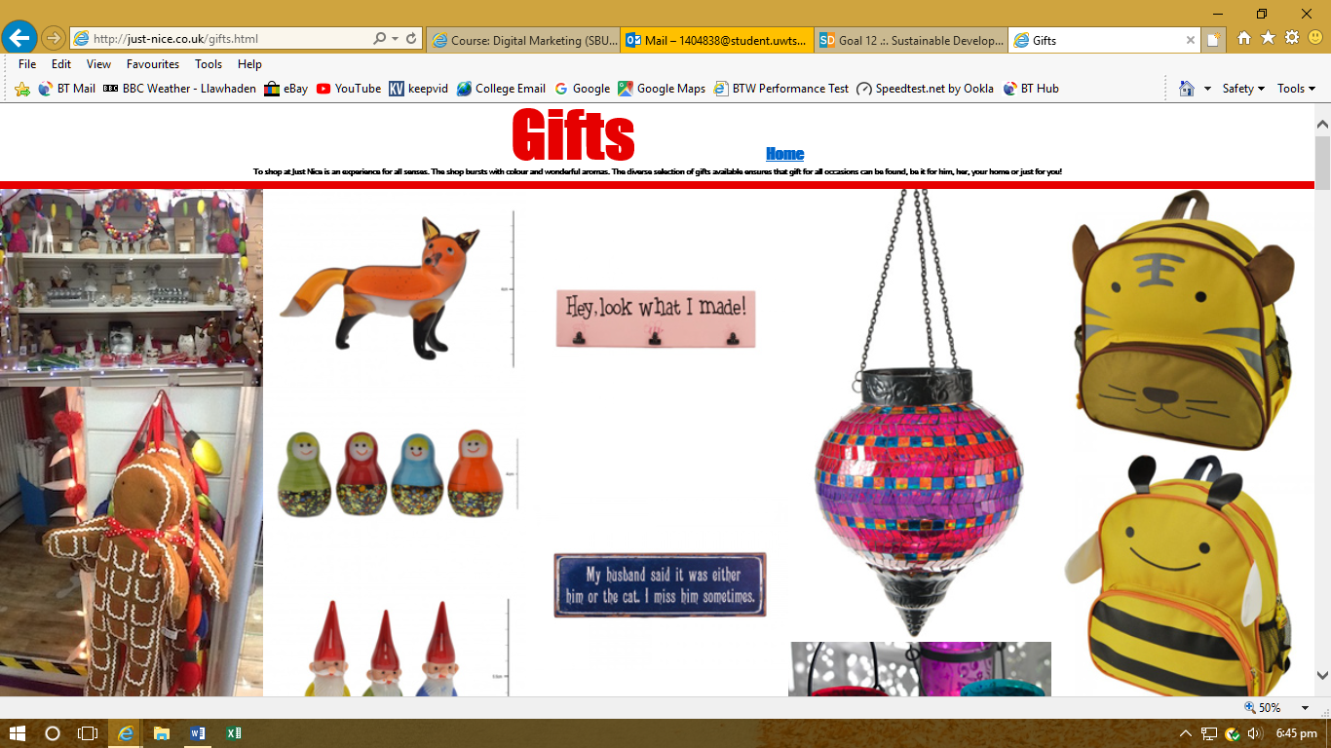
Just Nice’s website on the ‘gifts’ page. User friendly and clear visuals. (Just Nice , 2018)

Appendix 2
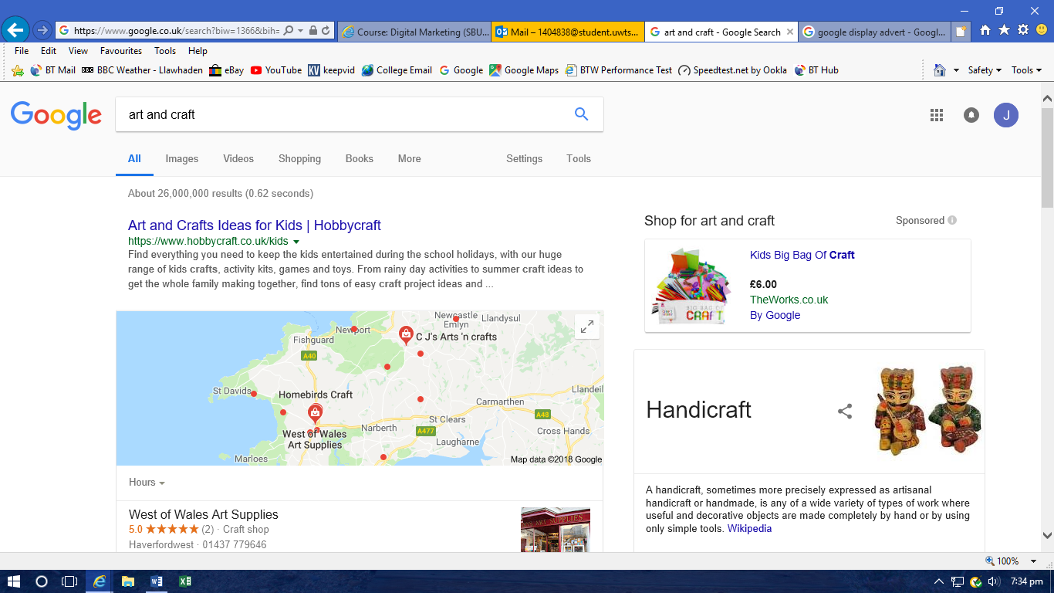
Example search ad by The Works using the key words, ‘art and craft’.
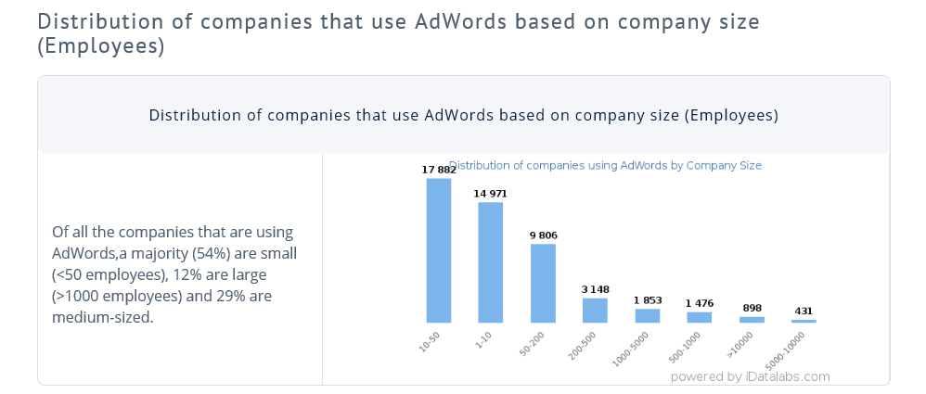
Appendix 3
The majority of businesses using Google AdWords are those with less employees.

Appendix 4
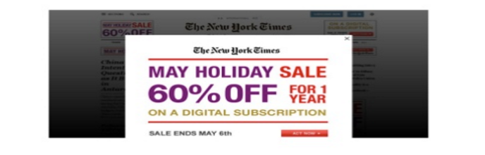
Large banner advert to increase viewability.

Appendix 5
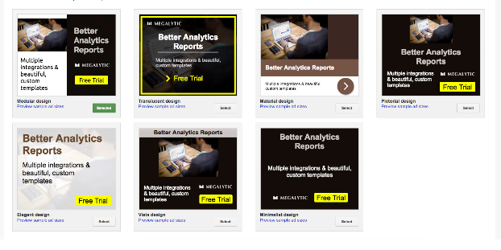
Following the templates that Google offers with an image of some of Samantha’s products, I would use this text for Beach is Best’s adverts:
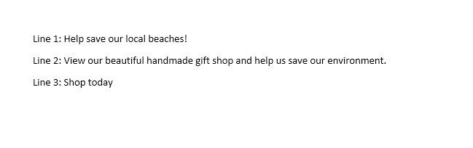

Appendix 6
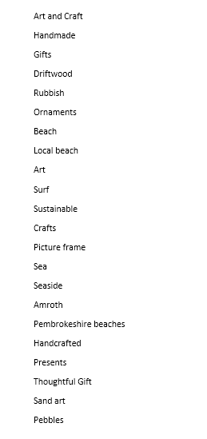
This is a list of some possible key words and phrases to search for Beach is Best.

Appendix 7
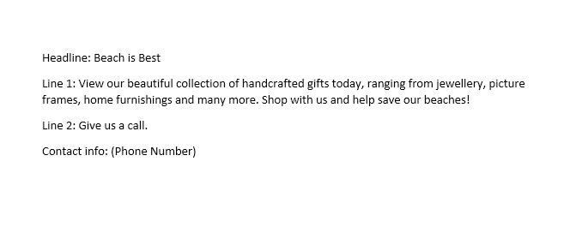

This would be the template for the search advert.
Appendix 8
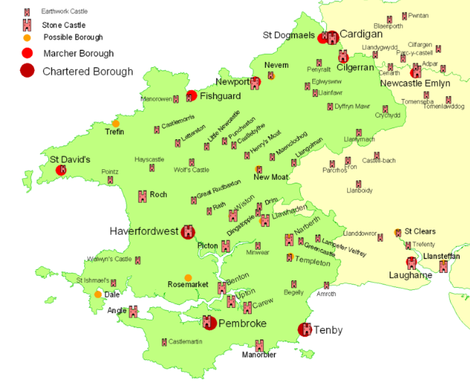
Shaded areas are the target locations.

