Was Celtic Britain completely Romanized during the 300-plus years of Roman occupation? From AD 47 to AD 410

Veni, vidi. Vici as Julius Caesar proclaimed. but he only came and saw and conquering was left to another emperor namely Claudius in AD 43. However, Caesar had made his mark and befriended certain of the Celtic tribes in the southeast of Britain, namely the Atrabates and the Trinovantes
Did Julius Ceasar ‘s influence make it easier for Claudius to establish a foothold on the mainland having won over the wealthy merchant class that had been established pre-Roman conquest? Where trade had been established within the Thames Estuary, in particular, it would have made an easy route for boats and larger ships to make a crossing. Roman goods .have been found at Baldock dating to c 100-50 BC. Similarly the findings at Welwyn Garden City, in a cremation burial ground, strongly suggest a connection with the Cetuvellauni with strong trade or diplomatic links to Rome. Late first century BC
Given that Roman influence in terms of culture and trade had been established in this corner of what is now England, it is evident that humans saw advantage and profit in dealing with whatever people and source that was available at the time to prosper and flourish.
However, the conquest of Britain in earnest and sustainable

However, the conquest of Britain in earnest and sustainable for the next two centuries began with the Claudian Invasion in AD 43. According to Guy de la Bedoyere, a great deal of the facts regarding the detail, which has been attributed to Tacitus have not survived. But an abridged synopsis of what might have occurred is recorded by Dio Cassidus some 160 years later.
No doubt there is some supposition that although the Invasion was an act of war and the self-belief in Rome and Claudius that it was easy pickings. There remained an element of altruism in the concept that Roman life and technology would lead to a better way of life and improved standard of living for the warring Celts, and morally justifiable. It is questionable whether their policy of enslavement could come under that particular umbrella. A map showing the Roman frontier in AD47 shows a line roughly from Lincoln In the north down to Exeter in the south and suggests all areas in between were now under Roman control.
Where the first landing took place in AD 43 is problematic and (GdlB) hints it could have been anywhere between what is now Fishbourne Harbour and Richborough and could have been in rapid succession or over several months and even years, and states that Archaeology will never be able to help determine where and how often Roman Legions landed or their equipment.
(GdlB)’s account of the early skirmish in the Medway and Thames area is confusing because he separates wrongly Britons from the Celts and this makes his analysis and accounts unintelligible

Caractacus is mentioned as being defeated and withdrawing to South Wales to drum up support amongst the various tribes there is no doubt to launch a counter-offensive.
Unfortunately for Caractucus (Cymraeg – Caradog ), he was betrayed by Cartimandua, Queen of the Brigantes after fleeing from a hard-fought battle in Wales where tribes rallied to his support but he was outflanked. It is correct in this instance to assume that the Brigantes were a supporter of Romanization as far as it went.
It is noted by surviving texts of Tacitus that Caradog was taken in chains to Rome and paraded as a vanquished hero of the Celts, and is allowed to survive as a result of his speech to the senate and pardoned by Claudius. There is much conjecture about the so-called speech, in particular, could Caradog speak Latin, and was there anybody able to interpret Brythonic? It is more likely that this was a classic case of propaganda to demonstrate to the Roman people how brave Caradog had been and how magnanimous Claudius and Rome could be to the vanquished, brave but ultimately no match for the Roman army and its centurions.
Roman influence was not very well supported in Wales and North Wales in particular, they feared the psychological influence of the Druids a secret sect that held power with all the tribes and organized resistance. Their stronghold was Anglesey. It became imperative in Roman tactical minds to crush the Druids and wipe them off the face of the earth, with their sacred groves destroyed in the process.
. The resistance was weak and the inevitable conclusion was a massacre of all, a complete ethnic cleansing. There was no account of any Druids or Druid supporters surviving.
However, a greater threat appeared to Roman rule in the shape of Boudica (Boudicea) Queen of the Iceni whose dead husband-Prasutagus, had made a pact of nonresistance with Nero to ensure the continuity of his dynasty
This arrangement was ignored and Boudica was flogged and her daughters raped and centurions aided by slaves marauded the Iceni kingdom and looted all and sundry.
The Iceni ( largely in present-day Norfolk. parts of Suffolk and Cambridgeshire ) had nothing to lose, and in AD 60 led by Boudica went on the rampage ( an estimated seventy thousand Romans were killed in the ensuing battles), and if the campaign had been successful would possibly have led to the withdrawal of the Romans. Some Historians regard Boudica as a mere figurehead and served as a purpose for Romans to extoll the virtues of valour and contrast the ineptitude of Nero.
Barry Cunliffe p381 notes how divided the Celts were from the prosperous and compliant southeast-with all the advantages of trade and Roman education implicit in their prosperity. With the rest of occupied Britain being a mishmash of military control with some attempt at basic Colonisation. ‘ But over much of Northern Britain and Wales, the Romanized style of civilian development characteristic of the southeast failed to take hold.’ The only exception is the small towns of Caerwent and Carmarthen. He further notes that ‘... it is particularly striking that west of Exeter the socio-economic system of the Celts continued unhindered is particularly striking that west of Exeter the socio-economic system of the Celts continued unhindered’
If we examine how widespread the Celtic/Brythonic language was during the third and fourth centuries it is noted Barry Cunliffe p384 ‘The discovery of a number of inscribed lead curse tablets in the spring of Sulis Minerva at Bath shows that personal names remained much in evidence into the third and fourth centuries AD. He further ascertains –‘ Away from the areas of intense Romanization, in the southwest peninsular- Wales, Scotland, and Ireland. Celtic would have remained the dominant language throughout.
How influential was the giant leap in the infrastructure of Roads, trade routes linked to this network, and buildings and garrisons which would begin to dominate the landscape and provide ready movement for soldiers and slave workers to achieve this end? What is reflected in archaeological evidence is enhanced by relics and grave goods which can be attributed to various gods, early pagans, and the Emperors who masterminded much of the work carried out?
A map of Watling Street overlaid on the 1911 Encyclopædia Britannica map of Roman Britain. Map by LlywelynII/Wikimedia Commons.

A map of Watling Street overlaid on the 1911 Encyclopædia Britannica map of Roman Britain. Map by LlywelynII/Wikimedia Commons.
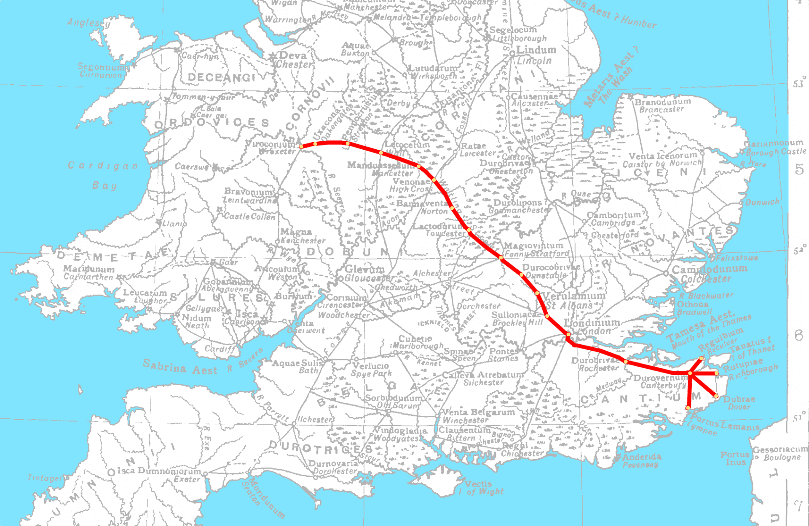
The above image is one of the earliest and most devloped roads that the Romans built progressing from the initial landing at Richborough through to Chester, no Roman name exists but it was known as Watling Street in later times and now most of the A5
Ermine Street ran from London to Lincoln and on to York
Another important route followed the current A2 as described in Wikipedia
The route of the current A2 follows a similar route to that of a Celtic ancient trackway. It was an important route for the Romans linking London with Canterbury and the three Channel ports of Rutupiae (now Richborough), Dubris (now Dover), and Portus Lemanis (in modern Lympne)

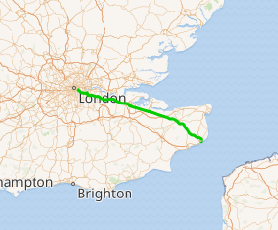

The Roads themselves were constructed in Layers enabling drainage and ditched on both sides.
With the roads came the development of towns and a taxation system that was incremental depending on the size of the land and its productivity.

Towns could only succeed with the cooperation of the local population and the civilization process was the result of a two-way cost-benefit analysis. A quid pro quo arrangement where everybody within the Romanized system benefit and although Tacitus comments that the local aristocracy had to be on board at the price of enslavement p132
Perhaps the next big question is how the Romans went about extracting the mineral wealth and producing the goods necessary for trade from pottery and household goods to more valuable artifacts such as jewellery and expensive tapestries and fashionable clothes for the elite Celts and Romans alike. If we recount Strabo’s words he believed that by the end of the first century BC the Celts had Romanized themselves without the need for an invasion. Stating that exports consisted of grain, cattle, hunting dogs, and slaves. gold, silver, and iron. The imports from Gaul consisted of ivory chains, necklaces, amber, glassware, and tin. P160
This meant that trade took place in that southeast corner of Britain and amongst a very limited upper tier of society and the grain exports were associated with abundant harvests, toiled by labourers of the lowest common denomination.
Mining of minerals such as lead and iron ore and smelting was carried out in isolated areas and it is suggested that small camps grew up to house the labour-intensive work with its associated labour force. Possibly slave labour because of the harsh conditions and zero life expectancy
Metalworking within Roman Britain has led to the most conspicuous remains within the field of archaeology and along with pottery has led to some spectacular finds. It is also noted p165 that a great deal of what has survived is discarded in some instances and buried as grave goods but incomplete. The custom of recycling was widespread among the craftsmen and artisans engaged in making jewellery such as rings and brooches, often of copper, bronze, and iron. Of course, weapons and armoury were in huge demand and required substantial workshops, one such fabrica was located at the ‘short-lived Flavian fortress of Inchtuthil’ where masses of iron nails were discovered buried to prevent them from falling into the hands of an advancing army.
In Snettisham (Norfolk) a hoard consisting of gemstones, gold, and silver rings silver and brass coins awaiting smelting into other artifacts
Bronze statuette of Mars – Fossdyke (Lincolnshire)
Bronze pan Ilam ( Staffordshire)
Such intricate and detailed work was no doubt the work of master craftsmen, perhaps not native to Britain but imported from the Continent for display and status to demonstrate the wealth of the owner. If we look at grave goods and imagine what the children of the time would have played within their homes or in the camps there is very little to survive and inevitably constitute objects such as swords and daggers made of wood. If we fast forward to modern-day toys, made of metal and cast die objects it would illustrate that children of today represent a valuable market that did not exist in Roman times. It would have been possible given the skills available then for miniature chariots of copper or bronze to be made as playthings but unfortunately for those children, it did not warrant the time or expense.
What legacy did the Romans leave within the realms of Food and Drink? Perhaps it is prudent to look at what the Celts already consumed. It is noted that they had domesticated cattle and drank milk, and they grew rudimentary crops of wheat, millet, barley, and legumes sufficient grain in fact to export to Gaul, in the years preceding the Roman occupation. It is also speculated that as a legacy of hunting and gathering they were familiar with a variety of hedgerow herbs such as wild lettuce, sheep sorrel, and edible berries. However, the transformation that followed the Roman occupation led to a variety of fruits and spices, only sampled perhaps in the southeast corner of Britain, during trading incursions during an earlier period, Sourcing information
introduced over 50 new kinds of food plants: fruits such as fig, grape, apple, pear, cherry, plum, damson, mulberry, date, and olive; vegetables such as cucumber and celery; nuts, seeds, and pulses such as lentil, pine nut, almond, walnut and sesame; and herbs and spices including coriander, dill, and fennel. Many of these were then successfully grown in Britain.

It is noted that evidence of what was consumed is not preserved but the vessels that the olive and wine were transported in have survived and are a common feature in archaeological digs. A ubiquitous term for largely imported goods is vessels referred to as amphorae. Interesting to note that none have been discovered in Wales, but concentrated in the southeast, demonstrating the early and recent import of wine, olives, and other products from within the Empire but outside Britain.
The diet of the Celtic tribes further west and north changed very little, except perhaps the addition of herbs and spices to enhance their single-pot cookery
A brief look at the places of abode, apart from early forts and camps, leads us to the classic Roman Villa, ranging in size from modest to the amazing fabulous villa discovered at Fishbourne which had a footprint larger than Buckingham palace and inevitably commensurate with wealth and prestige. Intricate designs using mosaic tiles were a feature of the villas and became more and more elaborate as local craftsmen were trained to carry out this remarkable decoration. P200
The villas seemed to follow a pattern of urbanization and distribution is recorded as –
There are recorded traces of about 1,200 villas in Britain, and all but about 50 of them are east of the River Severn and south of the River Humber. They are most thickly distributed south and east of a line drawn from the Wash to the mouth of the Severn

It is prudent and necessary to conclude what had changed for the better or the worse among the Celts, a mixed bag of tribes with a common Celtic speech pattern that made communication possible, especially where the Druids of Anglesey were concerned. They were masters at convincing tribes not to fight each other and concentrate on the perceived enemy of Rome. (unfortunately wiped out) However, looking closely at the stages of Roman occupation it can be seen that early trading influences with the continent especially Gaul had broken any homogenous perception of a united Celtic nation. The Romans were able to exploit this anomaly and make pacts with local Celtic chieftains to thwart any combined effort of resistance. This devious setup backfired on two occasions when Caractucus and Boudica mounted strong resistance to Roman treachery.
Rome and the Romans left Britain in 410 AD under a cloud of what might be called unfinished business, Called away to defend its eastern flank from marauding vandals sensing that Rome had expanded too far west to protect its core. They had demonstrated to the already wealthy Celts of the southeast that the Roman way of roads and administration and baths and sumptuous villas and law and order was preferable to what existed in the ‘(Wild West) of the Island. Unfortunately, despite nearly 400 years of endeavour they had to compromise on areas where their influence had proved unproductive, which constituted north of Hadrian and the Antonine walls, mountainous Wales, and Ireland where very little evidence exists of their presence except as trading partners with west wales.

Bibliography
British Museum
Barry Cunliffe The Ancient Celts edition 2 (Oxford University Press 2018
Guy de la Bedoyere Roman Britain: : A new History.( Published in the united kingdom, by Thames& Hudson Ltd 2014, reprint 2018)

www.roman-britain.co.uk-accessed 6/12/2022

www.english-heritage.org.uk

Enayat, M. (2014). Celtic and Roman food and feasting practices: A multiproxy study across Europe and Britain.

LlywelynII/Wikimedia Commons.org

www.britannica.com accessed 05/12/2022

Guy de la Bedoyere Roman Britain: p: A new History.( Published in the united kinggom, by Thames& Hudson Ltd 2014, reprint 2018) p20
Ibid .,P. 21
Ibid.,P21
Ibid P 21 ( British Museum)
Ibid P23
Ibid.. P26
Ibid P29
Ibid
Ibid
P36 (GdlB)
www.britannica.com accessed 05/12/2022
Barry Cunliffe The Ancient Celts edition 2 (Oxford University Press 2018)
Ibid
Internet access December 5th 2022
Internet access December 5th 2022
(GdlB)
Ibid
British Museum.
Ibd
Ibid
Enayat, M. (2014). Celtic and Roman food and feasting practices : A multiproxy study across Europe and Britain.
www.english-heritage.org.uk
(GdlB)
www.roman-britain.co.uk-accessed 6/12/2022

