

Research Proposal

ACFA 7004

Cybersecurity Threats Analysis and Responses in Government and Business

A Case Study, United Kingdom.

By
David Ntino (2225674)

April 2023

Table of Contents
List of Figures iv
List of Table v
Abstract vi
1. Introduction 1
1.2 Purpose of Study 2
1.3 Research Objectives 2
1.4 Context 2
1.5 Rationale 3
1.6 Depended Rationale and Independent Variables of experiment 3
1.7 Boundaries 3
2. Literature Review 4
2.1 Introduction 4
2.2 Cybersecurity 4
2.2.1 Overview of Cyber security and Attacks in Government 4
2.2.2 Cybersecurity Threats 5
2.2.3 Threat Actors 5
2.2.4 Importance of Cybersecurity 5
2.2.5 Different Cybersecurity Threats 5
2.2.6 Different cybersecurity attacks 6
2.3 Threat Actors and Their Motivation 7
2.4 Related Work 8
2.4.1 Cybersecurity for business organisation 8
2.4.2 Cybersecurity for Government Organisation 9
2.4.3 Statistics of Cybersecurity Breaches in United Kingdom 9
2.4.4 Average cost spent on security breaches in UK 10
2.4.5 Security checks performance percentage in UK 10
2.4.6 Percentage in Incident Management Process (IMP) in UK 11
2.4.7 Cybersecurity Attacks% vs Security Checks% 12
2.5 Brexit Impact on Cyber security of United Kingdom 13
2.5.1 Uk Government Efforts to Prevent Cyber Crime 14
3. Research Methodology 16
3.1 Introduction 16
3.2 Research Philosophy 16
3.3 Methodology 17
3.3.1 Quantitative Research 17
3.4 Research Strategy 18
3.5 Ethical Issues 19
3.6 Research methodology conclusion 19
4. Time Horizon 20
4.1 Gantt Chart 20
5. Results 22
5.1 Data Collection 22
5.2 Threat analysis chart 24
6. Evaluation 25
6.1 Incident Response 25
6.2 Cyber Incident Response Scheme 26
6.3 Penetration Test 26
6.3.1 Why is penetration testing important? 26
6.3.2 Types of Penetration Testing 26
6.3.3 Penetration Test Tools 27
6.3.4 Cybersecurity Maturity Model (CMM) 28
6.4 Evaluation Conclusion 29
7. Conclusion 30
8. Bibliography 31

List of Figures

Figure 1. 1 Snapshot of the breadcrumb trail [7] 11

Figure 2. 1 Threat Actors and their motivation [32] 14

Figure 3. 1 Cyber Security Breaches in the UK [12] 16

Figure 4. 1: Average Cost of Security Breaches [12] 16

Figure 5. 1: Security checks performed percentage [12] 17

Figure 6. 1: Incident management process [12] 18

Figure 7. 1: Comparison of Test vs Identified Attacks [12] 19

Figure 8. :1 Research philosophy in the ‘research onion [18] 22

Figure 9. 1: Types of research methodology [19] 24

Figure 10. 1: Gantt Chart 27

Figure 11. 1: Level of Attacks% in UK Business for 2020 29

Figure 12. 1: Level of Attacks% in UK Business for 2021 29

Figure 13. 1: Level of Attacks% in UK Business for 2022 30

Figure 14. 1: Threat analysis chart [13, 14 & 15] 30

Figure 15. 1: Incident response chart [15]. 31

List of Table

Table 1. 1: Survey Data for Cybersecurity Breaches in the UK [13,14 & 15] 28

Abstract

As the years go by, Information communication Technology has taken a different dimension. Almost all tasks are now done online. Another organisation has also adapted to the use of this technology. However, with this comes great risks and responsibilities. Cybersecurity has a big role to play in every organisation. Leaders, stakeholders, and all members have a responsibility to shape and align to the cyber security ethics of the organisation. As a growing problem associated with everything an organization does that is facilitated by the internet, cyber security is a multi-faceted program that must be addressed through proper cyber security governance.
Threats actor attack an organization’s information systems for different reasons, with different malicious attacks like a virus, worms, trojan-horse, spyware, social engineering, etc.
This study seeks to analyze different threats in government and business organisations, and how organisations can respond to these threats.
I will apply the qualitative approach and obtrusive method app in collecting and analyzing my data from different sources including [3, 4, 5, 6, and 7].
To respond to these threats, I will be adopting the NIST Cyber Security [1]Framework model and the Internal Organisation for Standardisation ISO 2700 model. The NIST model establishes and communicates an organisation's tolerance for risk and it accounts for the rapidly changing nature of cyber security threats. The ISO 2700 model is an international standard that outlines the best practices for information security management systems in organisations like governments and businesses.

1. Introduction

Currently, business and government organisations are relying on the availability of ICT tools to manage and regulate their daily tasks. These devices are controlled by a central system called servers. Most databases, financial records, policies, and all-important files are been d on the server. Without proper network security architecture, the organization is prone to attacks by threat actors. Recent cyber security reports [3] have indicated that threat actors now exploit vulnerabilities across networks and cloud environments, and have discovered new ways how to use identities and stolen credentials to bypass security defenses to achieve their goal, which is to lay hold on data. Reports, as observed by [3], shows that "62% of attacks comprise non-malware, hands-on-keyboard activity" This means that these threat actors have developed new approach and techniques for attacking systems without detection by legacy security solutions devices.
An organization must be able to identify risks in its system and be willing to pay the cost of acquiring the necessary devices and software to prevent these risks from occurring or be willing to bear the cost of losing private data.
Cyber threats can occur anytime, it is therefore imperative that organizations prepare measures to manage and respond to these risks, as soon as they occur. To guide against cyber security threats, government, and business organizations require proper awareness and deep understanding of recent cyber-attacks and how to respond to them accordingly.
According to S. Brown, “Insider threat from human behavior is one of the most difficult aspects of security to control [2]. Building a culture of cybersecurity within an organization guides employee behavior and increases cyber resilience” This means every security expert, threat analyst, network security engineer, and law enforcement officer can contribute to the cybersecurity risk of an organisation if the cybersecurity laws and guides are implemented
Threat actors carry out attacks once on a particular target and then reuse them on multiple targets, leaving each target to find, analyze and repel these threats. Not every organization [2]has enough resources to perform this level of tasks independently.

1.2 Purpose of Study

Discover different cyber security threats as premeditated and motivated attacks against government and business organisations. It will further analyze how these threats affect information, computer systems, computer programs, and databases, which leads to the loss of data and other resources. This research will also recommend more efficient and best practices on recent cybersecurity practices.

1.3 Research Objectives

The objectives of this research will cover the following
1. Research the history of cybersecurity, threats, and threats actors
2. Research different types of threat actors and their motivations
3. Investigate types of attacks and methods of attacks
4. Research the effects of cybersecurity attacks on government and businesses organisation.
5. Research and recommend the most recent and improved methods of cybersecurity practices and responses to attacks.

1.4 Context

Cyber threat actors attack businesses or organisations for personal gains, to the detriment of the organisation. These attacks could collapse an organisation or even lead to poor performance output amongst its competitors.
The following cases are some cyber security breaches and their effects on the organisation.
- In 2012, a Saudi threat actor OXOMAR released the details of over 400,000 credit cards online [7].
- In 2013, a former CIA employee for the US Government Edward Snowden leaked classified information from the NSA (National Security Agency) [7].
- In 2014, another malicious threat actor attacked Yahoo, tampering with the details of its 3 billion users. Yahoo was fined $35 million for failing to report the attack [7].
- Fast-forward to 2017 - 2020, a virus known as WannaCry ransomware infects over 230,000 computers in one day [7].
- In 2019, Multiple DDoS attacks forced New Zealand’s stock market to temporarily shut down [7].
- Multiple DDOS (Distributed Denial of Service) attacks forced New Zealand’s stock market to temporarily shut down [7].
- The average total cost of a breach in the public sector increased from $1.93 million to $2.07 million — a 7.25% increase between March 2021 and March 2022 — according to IBM [27].
- After Russia attacked Ukraine, several state-sponsored actors and activists showed their support for Ukraine by attacking Russia. Attacks against Russia increased by over 600% during the year, as the Russian government became the fifth most targeted public sector in 2022 [27].

1.5 Rationale

As more organisation increases their digital footprint, make use of MSP (Managed Service Providers, or permit their employees to use personal devices, the chances of experiencing cybersecurity breaches increases [5].

1.6 Depended Rationale and Independent Variables of the experiment
For this research, I won’t be using any special tools to analyze the threats. A survey data of cybersecurity breaches in the UK has been collected, and I will be using this data to conduct my research. No experiment will be required at this stage of the proposal.

1.7 Boundaries

This research work is focused on the UK government. The threat analysis will be centered on Cyber security breaches in UK businesses.

2. Literature Review

2.1 Introduction

This section of research will focus on the history of cybersecurity, different threats, and attacks in cybersecurity as recorded from 1972 to 2022. The author will investigate different threats, threat actors, and the motivation behind these attacks. The analysis will be carried out on different tools used in carrying out attacks and different organisations that are facing attacks and how these attacks have affected them.

2.2 Cybersecurity
Cybersecurity is the ability of an organisation to implement certain measures and practices to avoid risk of being attacked by cyber criminals or threat actors. Cybersecurity function is to protect organisations from unauthorized access to their network resources or data.

2.2.1 Overview of Cyber security and Attacks in Government
The term cybersecurity became known properly in 1972 [7] when a research project was carried out on ARPANET (The Advanced Research Projects Agency Network), an antecedent to the internet. ARPANET was a program used to develop protocols for remote computer networking.
A researcher named Bob Thomas [7] created a computer program called Creeper [7]. This program was able to move across the ARPANET’S network, leaving a trailing message that reads “‘I’m the creeper, catch me if you can”. However, the inventor of email Ray Tomlinson wrote a Creeper program that was able to chase and delete the Creeper program. Creeper became the first anti-virus software, but it was also known to be the first-ever computer worm since it was a self-replicating program.

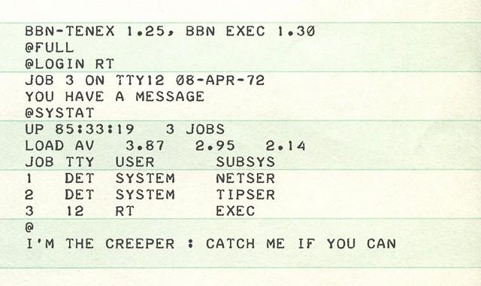

Figure 1. 1 Snapshot of the breadcrumb trail [7]

2.2.2 Cybersecurity Threats
Threats in cybersecurity refers to malicious actions that is performed by threat actors to disrupt, steal or damage data, computer networks or digital assets of an organisation.

2.2.3 Threat actors
Threat actors are persons that access an organisation resources or data without authorization, using some sophisticated tools to carry out their malicious acts, with intension to either profit from the stolen data.

2.2.4 Importance of Cybersecurity
The entire communication [10] architecture around the world relies mostly on the cyberspace and Internet. Any form of disruptions or attack on the network can possibly risk jobs, lives and properties. Cybersecurity becomes essential to protect the information flow in communication networks. For the safety of data and information of government, business and organisation, it is necessary to research and implement new security policies and practices.

2.2.5 Different Cybersecurity Threats
1. Ransomware: attackers take control of a user’s data and demand a payment ransom before restoring data. Ransomware is considered to be the most worrying threat currently. Attackers are gradually using sophisticated techniques to extract data from systems.
2. Malware: Malware includes worms, viruses, spyware and trojan horses. Malware are software that can harm a system.
3. Social engineering threats: Exploiting human error to have access to services or information
4. Threats against data: targeting different sources of data to gain unauthorized access to resources. 83% of data breaches involves human involvement. Attackers
5. Threat against availability of internet: threats aim at physical destruction of internet infrastructure which eventually leads to unavailability of internet.
6. Misinformation: Spreading of fake or false information.
7. Supply-chain attacks: attacks affecting the relationship between organisations and suppliers.

2.2.6 Different cybersecurity attacks
- Phishing attacks: This attack occurs when an attacker sends a replica of an email to a target with links resembling those from a trusted organization, like banks, tax agencies, etc.
- DDOS attack: Distributed Denial of service is an attack that disrupts flow of traffic of a particular network or server. This attack prevents authorized users from having access to resources on the network.
- Man in the Middle attack: This attack is often perpetrated by a former or current staff of an organization. Leaking information or data to an attacker for personal benefits.
Other attacks are: SQL injection attack, Trojan attack, Domain name server Spoofing, Business email compromise, Email account compromise, zero-day attack, Cross-site scripting (xss), Brute force attack, URL interpretation attack, Crypto-jacking, IOT based attack, Drive by attack, Eavesdropping, etc.
According to the World Economic Forum survey, cyberattacks are ranked as the 5th most important global risk. The study emphasizes how cyberattacks on businesses and governments could possibly harm society and destabilize economies (World Economic Forum, 2019).
Based on a survey [9] conducted by Tanium, a cybersecurity firm, it was discovered that most government agencies and businesses are at risk of cyber-attacks as a result of lack of perceptibility into their networks. This survey indicates that organisations must implement a proactive approach to threat intelligence to prevent attacks.
According to [8] the authors outline major cybersecurity threats and vulnerabilities faced by small medium and large-sized business enterprises. This article suggests strategies and solutions to mitigate those risks. The authors further suggest that SMEs should adopt a comprehensive and proactive approach toward cybersecurity in other to mitigate cyber risks effectively.
Some cybersecurity solutions as provided by [9] indicate that each level of security is characterized by a unique level of complexity, beginning from the basic cybersecurity tools, used for the dentification or authentication process, down to more complex protection tools.
1. Level 0 (Prerequisites)
2. Level 1 (Security management and maintenance)
3. Level 2 (Fault management and maintenance (risk and threats management)
4. Level 3 (Network management and maintenance)

2.3 Threat Actors and Their Motivation

- Insider Attacker: This threat actor exists within the targeted organisation or network, and is most difficult to identify or prevent. The attacker can be an employee, consultant, or board member of the organisation. This threat often occurs due to privilege abuse and is mostly motivated as a result of discontentment [32].

- Nation-State Threat Actors: These actors operate at a national level, their targets are mostly intelligence networks of big organisations like the nuclear industry, financial and technology institutions, the Military, etc. These attackers are mostly politically motivated [32].
Other threat actors are Cybercriminals, Hacktivists, Terrorist Groups, and Thrill-seekers.
Figure 2.1 is a summary of other threat actors and their motivation
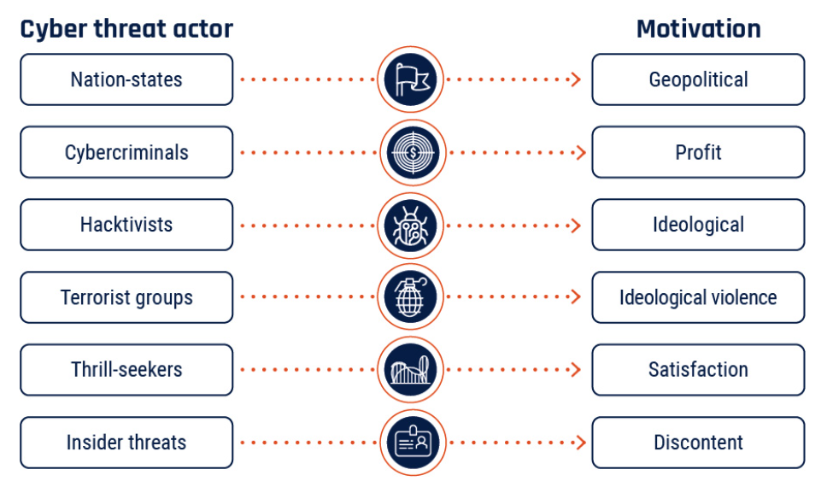
Figure 2. 1 Threat Actors and their motivation [32].

2.4 Related Work

2.4.1 Cybersecurity for business organisation

In 2008, manipulated credit-card readers were discovered in a UK supermarket [10]. These readers were wireless devices that were installed by attackers to steal data once a day and then go into a stealth mode to avoid detection by security tools.
A pottery firm was targeted by cyber attackers last year in the UK, for extortion. The attackers encrypted their important files including payroll files of employees and requested for 79 Bitcoins as payment, before decrypting the files. Luckily for the company, they had a back-up server data which was not affected by the attacks [11]. The IT and network security team of this firm was efficient and were able to set up a new server to save their data, this was able to save the company more, instead of paying for the ransom, before getting back their data.

2.4.2 Cybersecurity for Government organisation

There’s been numerous recorded attacks targeted at the European government over the last decades. In December, 2015, there was a cyber-attack in Ukraine, on multiple electricity distribution centers, causing power outages in most part of Ukraine, affecting over 225,000 users [11].

2.4.3 Statistics of Cyber security breaches in United Kingdom

According to a survey conducted by the Cyber Security Breaches Survey (CSBS) UK, in 2017 and 2018 [12], “overall, 45% of micro businesses detected cyber breaches in 2017 and 42% in 2018, 66% of medium business identified cyber-attacks in 2017 and 64% in 2019 while 68% of large businesses identified security breaches in 2017 and 72% in 2018”. These statistics indicates that both micro and medium businesses have detected less security breaches in 2018 than 2017, whereas, there seems to be an increase in detection of cyber security breaches in 2018 [12].
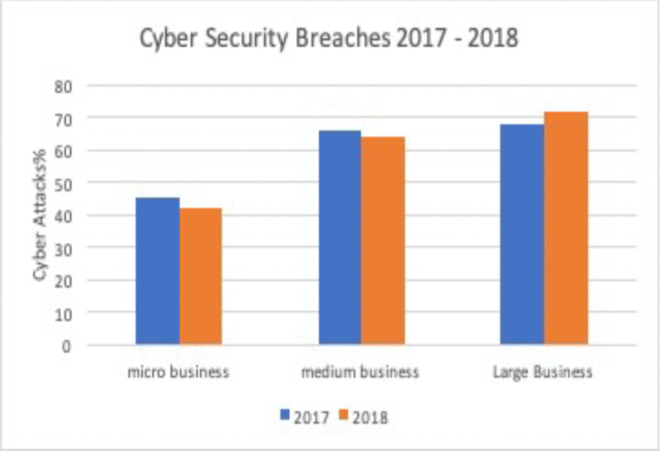

Figure 3. 1 Cyber Security Breaches in the UK [12]

2.4.4 Average cost spent on security breaches in UK

According to figure 3 above, it indicates that the overall average cost spent on security breaches decreased for micro businesses and increased for medium and large businesses [12].
The chart below shows the Average cost of Security Breaches in UK

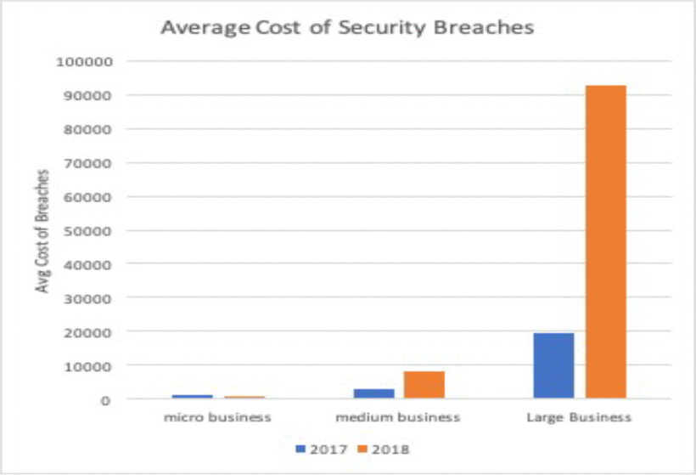

Figure 4. 1 Average Cost of Breaches [12]

2.4.5 Security checks performance percentage in UK

The security checks performance record in UK [12] shows that some organisations were vigilant in the fight against cyber-attacks and were able to carry out risk assessment or audits, and health checks to identify cybersecurity risks. According to CSBS [12], 57% of micro companies carried out some risk assessment tests in 2017 and 55% in 2018. The 7% of medium size organisation carried similar tests in 2017 and 79% in 2018. 86% of large size organisation also carried out same risks assessment in 2017 and 89% in 2018. The report indicates that the micro businesses or organisations mostly didn’t think that they possibly going to face cyber-attacks due to their small size, hence the low record of risk assessment in 2018, the medium and large organisations recorded high increase in cyber security awareness and risk assessment.

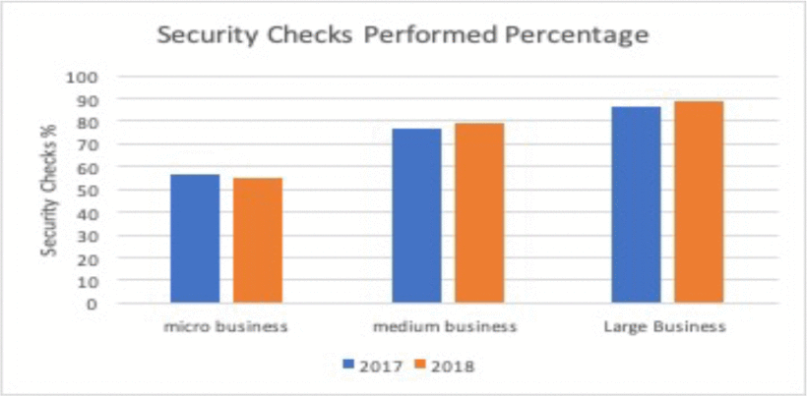
Figure 5. 1 Security checks performed percentage [12]

2.4.6 Percentage in Incident Management Process (IMP) in UK

Every company that faces cyber-attacks must devise means of surviving after the attack. This why the Incident Management Process (IMP) is very important for organisations. The IMP can be helpful to the IT staff of the company, in navigating through the aftermath of cyber-attacks and provide possible means of preventing further of attacks from happening in the future. From the table below, as provided in [12], 73% of micro business and organisation had such IMPs in place in 2017 and only about 12% in 2018. 24% of medium and 45% of large organisations were able to put IMPs in place in 2017, while in 2018 19% medium and 46% large size organisations put some IMPs in place. This report further proofs that there was less awareness about IMPs for the micro businesses and a significant amount of awareness was observed on both medium and large size companies.

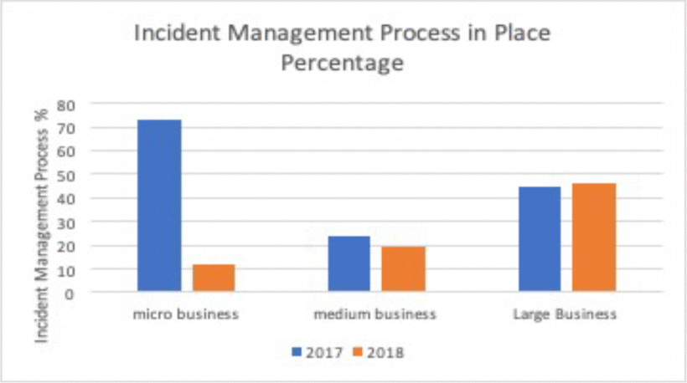

Figure 6. 1 Incident management process [12]

2.4.7 Cybersecurity Attacks% vs Security Checks%

From the Fig-5, the CSBS data analysis indicates that micro organisations were able to reduce cyber-attacks% to a certain level even though the number of companies who performed security checks was reduced. The medium size organisations or businesses were also able to reduce percentage in cyber-attacks by increasing security checks in 2018, as copared to 2017. However, the large organisations were able to reduce cyber breaches in 2017, but the number of organisation which carried security checks was increased. Regardless of the increment in the number of companies that performed security checks in 2018, the number of cyber-attacks also increased. This shows that large organisations are more prone to cyber-attacks, and there is need to place more strong security checks in place to avoid these security breaches [12.
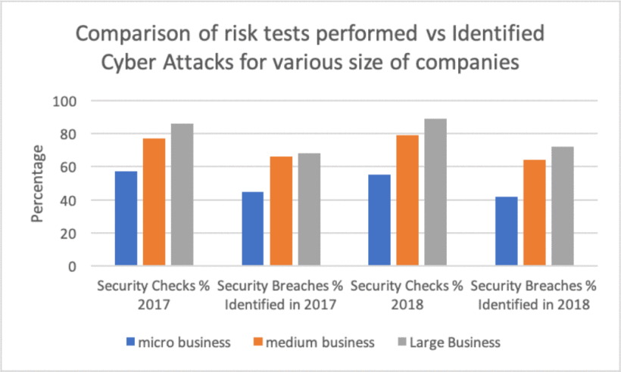
Figure 7. 1 Comparison of Test vs Identified Attacks [12]

2.5 Brexit impact on Cyber security of United Kingdom

Due the exit of the UK government from the European Union, at 23:00 GMT on 31 January 2020 (00:00 1 February 2020 CET). The UK is the only sovereign country to have left the EU, after been a member since 1 January 1973. Leaving the EU means the UK governemnt is now responsible for managing security breaches in the entire federation of the United Kingdom, and provide security policies that will guide against any form of security threats.

“If the UK government could understand the road ahead then it could plan and prepare for the future better. But if they could not, then the UK would struggle to develop policies and strategies which would guide our actions and provide benefits not only to UK citizens but to our Allies as well” [13]
In 2019, it was noted that there was shortages of cyber security skills in the UK, this was noted in a parliamentary committee as there questioned the lack of cyber security leadership in the heart of the UK government [13]. Furthermore, the National Audit Office’s February assessment of the National Cyber Security Programme finds that the UK government is unlikely to deliver on most of its stated strategic outcomes by 2021.

2.5.1 Uk Government Efforts to Prevent Cyber Crime

Before Brexit from the EU, the UK government have put inplace some security measures to prevent security breaches, some these efforts, although not fully implemented was able to regulated how data was used and protected. Some of these regulations are:

2.5.1.1 Data Policies and Law

They UK cyber law and policy developed in 1989, [12] was set up to combat syber security, this law is centred on four Act:
1990 - Computer Misue Act
1998 - Data Protection Act
2003 - Communications Act
2003 - Privacy and Electronic Communications (EC Directive) Regulations.

Other UK data regulation acts implemented in 10th and 25th May 2018 respectively are:
Network and Information Security Directive (NISD) 2016/1148
General Data protection Regulation 2016/679 (GDPR) [11]

2.5.1.2 National Cyber Security Centre

The NCSC is responsible for supporting organisations either government or privately owned organisations during he occurrence of cyber security breaches or attacks, in the UK [24]. The National Cyber Security Centre (NCSC) was set up to publish a “Self Help for Cyber Essentials” to help organisations take necessary steps in preventing cyber-attacks.
They provide an effective incident response to curb or minimise breaches from causing harm to the UK economy. Part of their tasks is to develop recovery plans and make recommendations on how to prevent similar attacks in the future [25] .

Every business organisation must register undter the NCSC, to keep their system safe from cyber attacks.

Although this jornal [12] has been able to point out different agency put in place by the UK government to tackle cyber crimes and breaches, it has not proposed a workable model on how these agencies will work towards regualting cyber breaches in the UK .

According to the 2022 Cyber laws updated to boost UK’s resilence against online attacks, “Outsourced IT providers will be brought into the scope of cyber regulations to strengthen UK supply chains” [14]

This updated law will boost security standards [14] and increase reporting of serious cyber incidents, in order to reduce the risk of attacks causing disruption. This law will protect essential everyday services like water, energy, and transport, from cyber attackers. The UK government further confirms that the National and Information Systems (NIS) Regulations will be strengthened to protect essential and digital services against increasingly frequent and sophisticated cyber-attacks, both now and in the nearest future [14].

3. Research Methodology

3.1 Introduction
For this chapter, I will outline the different stages necessary to formulate an effective methodological process, which includes the research philosophies, approaches, and strategies. This chapter will also cover aspects of ethical issues, time horizons, methods of collecting data, and a summary of the methodology.

3.2 Research Philosophy
Research philosophy is associated with the assumption, knowledge, and nature of the study [16]. It has to do with the specific way of developing knowledge. It refers to the basis on which a research is focused on, the importance of the research, and the strengths and weakness involved in conducting the research. Pragmatism, positivism, Realism, and interpretivism are different philosophical worldviews.
I am adopting a positivist approach in conducting my research because I am working with a highly structured and large sample of data from a large-size organisation [16].
The diagram below further explains more about the different reearch philosophies.
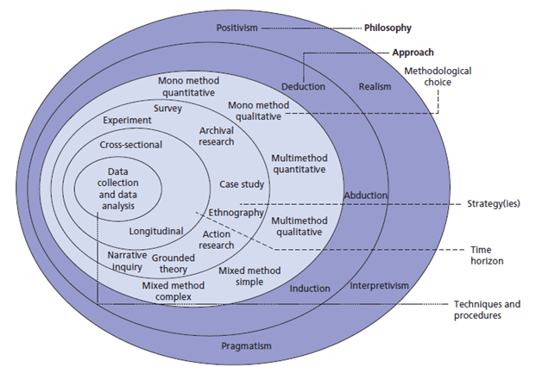

Figure 8. 1 Research philosophy in the ‘research onion [18]

3.3 Methodology

Research methodologies are techniques or strategies used to portray research effectively. It is concerned with the systematic study to ensure appropriate results that meet the aims and objectives of the study. These techniques ensure that the data gathered is valuable and reliable, and researchers employ a variety of research methods [19].

These methods are grouped into different categories, they include:
- The General Category: This category has two groups; Qualitative and Quantitative
- Nature of the study: (Descriptive and Analytical Research)
- Purpose of study: (Applied and Fundamental Research)
- Research Design: (Exploratory and Conclusive Research)
- Data Type: (Primary and Secondary Research)

For this research, I will be adopting the Quantitative Methodology.

3.3.1 Quantitative Research
This type of research deals with numerical data. The ability to quantify a certain amount of data or a specific phenomenon. "It focuses on gathering and analyzing numerical data and can be used to find averages and patterns or to predict outcomes" [19]. Quantitative research draws a conclusion based on facts, tables, and graphs.
Advantages of using quantitative research: It allows a thorough analysis of the research findings, allows the researcher to work with larger sample sizes, and also broader conclusions can be drawn about your target audience [19].

The diagram below further illustrate the connection between different research methodology.

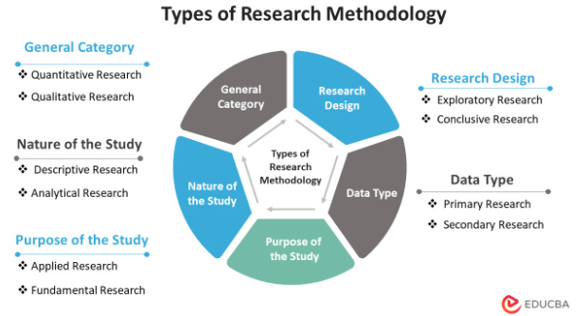
Figure 9. 1 Types of research methodology [19]

3.4 Research Strategy
Research Strategy is one of the important aspects of research methodology. It sets the direction of research and also includes the process in which research is carried out. Research strategy must be selected based on the amount of available resources, time, the objectives of the research, the philosophical foundations of the researcher, and the scope of existing knowledge about the studied area [20].

The different types of research strategies are; Surveys, Experiments, Action research, Case study, Grounded theory, Ethnography, and Cross-sectional studies [21]. My choice of research strategy is a Survey. A Survey strategy is often used when a researcher intends to obtain data that will guide research groups. This method helps to generate data from a large amount of data, either from a group of people or survey data from an organization [21].

3.5 Ethical Issues

Research Ethics is very important for human rights and dignity, scientific integrity, and collaboration between science and society. It checks to ensure participation in studies is voluntary and safe for research purposes. Defying the research ethics can reduce the credibility of the research [23].
My source of data collection is very credible because it is directly from the UK Data Service [22]. UWTSD is legally registered on the UK Data Service portal, so as a student, I was able to registered and request for data, to support my research, even though I couldn’t make use of all the data due to it’s ambiquity.
However, because of the limited time, I had to fall back to the statistical survey data of cybersecurity breaches [13, 14, and 2023], between 2020 to 2023.

3.6 Research methodology conclusion

Every country's goal is to minimise the impact of cybersecurity breaches and improve its resilience to cyber threats and incidents. It is not possible to completely eliminate cyber threats from an organis ation because as technology keeps evolving, cyber attackers also evolve in their attacking skills.
For this research, I am adopting a case study methodology. The case study is focusing on the cyber security breaches in the UK, between 2020 and 2022.

4. Time Horizon

Time horizon refers to the number of points in time a researcher plans to collect his/her data. There are two points for collecting data;
Cross-sectional and Longitudinal time horizon .

A cross-sectional time horizon is used when data is collected at one point in time while a longitudinal time horizon is used when studying changes and progressions over time [29].

4.1 Gantt Chart

A Gantt chart is a roadmap tool for managing projects that illustrates work completed over a time period in relation to the time allocated for the work. It helps teams maintain a coherent project strategy despite the insistent nature of the development process. Gantt chart can include the start and end dates of tasks, dependencies between tasks, milestones, assignees, etc.

A Gantt Chart is often used to assist in time management. The unique structure of Gantt charts is that they plot each part of the project and activities have direct relationships with each other [30].

Below is a Gantt chart designed for this research.

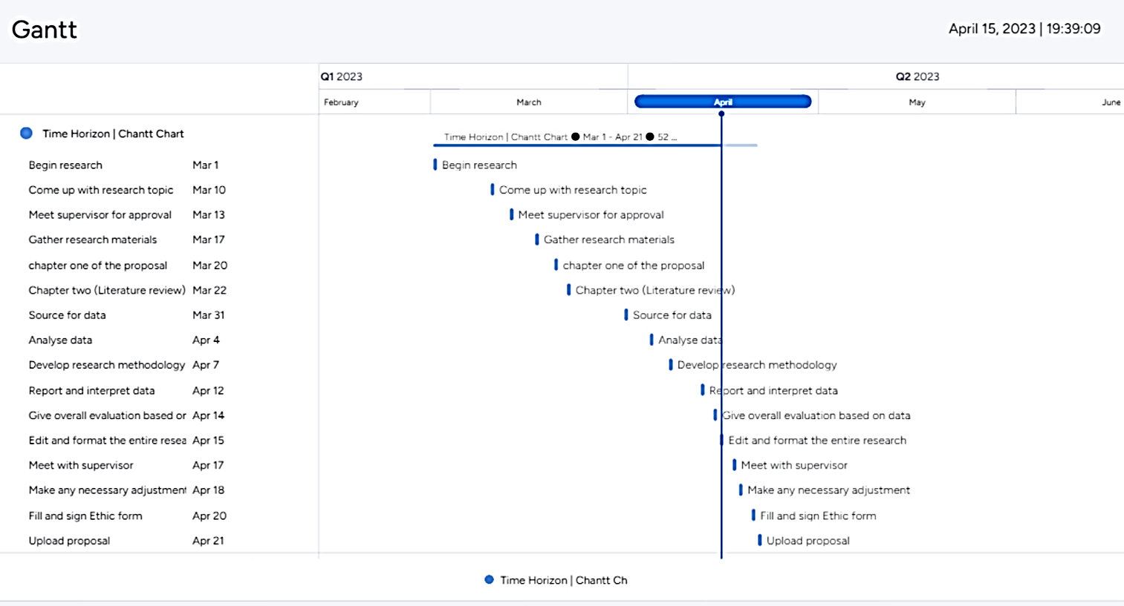

Figure 10. 1 Gantt Chart

5. Results

5.1 Data Collection

I am adopting a quantity research appproach in gathering my data, for this proposal [22]. Due the limited time, I was able to collect suvey data of Cyber Security Breaches from 2020 to 2022 [13, 14,& 15] from the UK government Official Statistics website.

The table below is survey data % of cyber security breaches in UK Businesses (Small, Medium and Large-size), both private and public owned institutions and organisation, excluding charities.

UK Cyber Threats Breaches % Survey | 2020 | 2021 | 2022
Phishing attacks | 86% | 83% | 83%
Other impersonating organisation in emails or online | 26% | 27% | 27%
Viruses, spyware, or malware (excluding ransomware) | 16% | 9% | 12%
Denial of service attacks | 0% | 8% | 10%
Hacking or attempted hacking of online bank accounts | 9% | 8% | 8%
Takeover of organisations or users’ accounts | 0% | 7% | 8%
Ransomware | 8% | 7% | 4%
Unauthorized accessing of files or networks by outsiders | 6% | 2% | 2%
Unauthorized listening to video conferences or instant messages | 0% | 2% | 1%
Unauthorized accessing of files or networks by staff | 5% | 1% | 2%
Any other breaches or attacks | 5% | 5% | 3%

Table 1. 1: Survey Data for Cybersecurity Breaches in the UK [13,14 & 15]
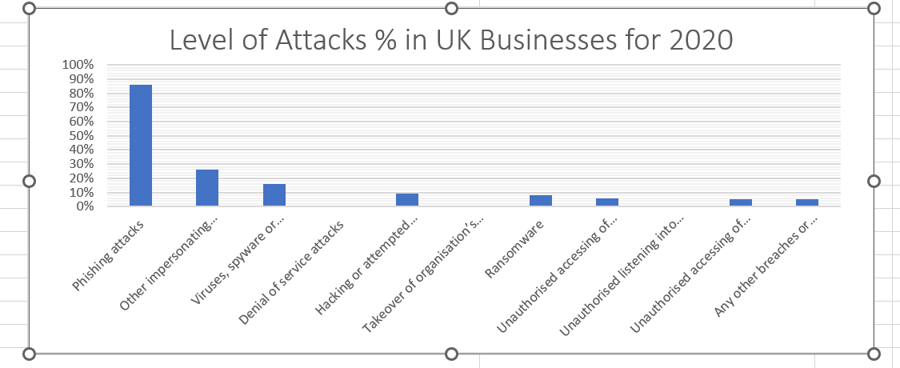
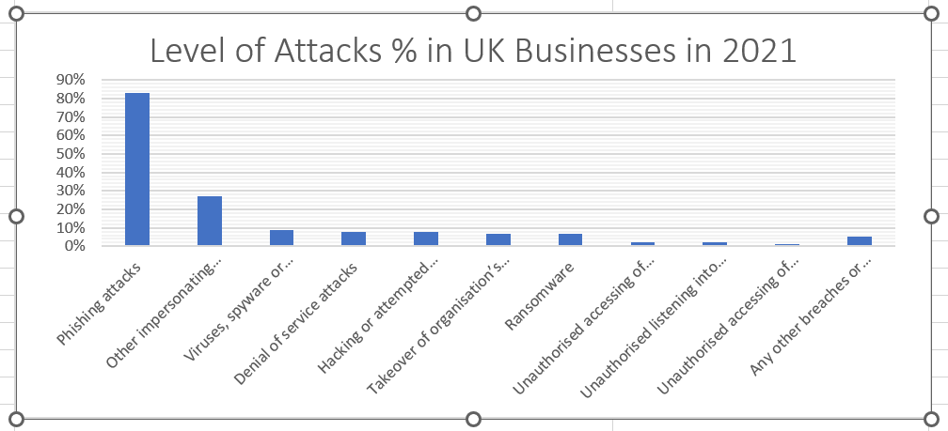
The charts below indicates flow of threats and breaches on UK business, from 2020 to 2023. Some threats indicates consistent high % recurrence than others.

Figure 11. 1 Level of Attacks% in UK Business for 2020
Figure 12. 1 Level of Attacks% in UK Business for 2021

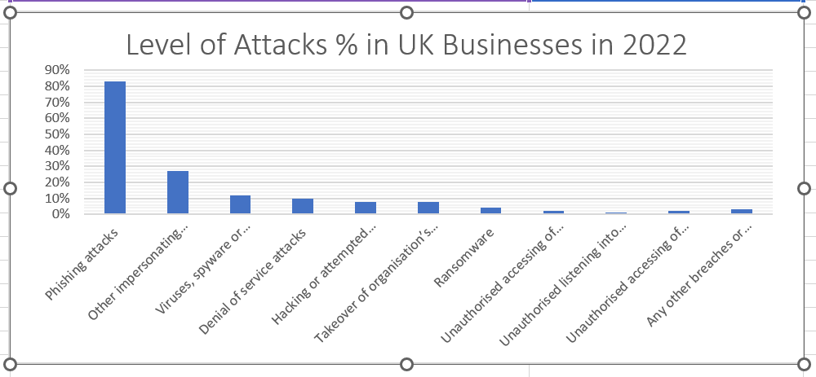
Figure 13. 1 Level of Attacks% in UK Business for 2022

5.2 Threat analysis chart

The chart below contains threats analysis based on the survey data received from [3, 4, & 5]
From the chart [fig 10] we observe the types of breaches and attacks that organisations report to be facing, among those that have been identified in the three years. The most frequent by far is phishing – staff receiving fraudulent emails or being directed to fraudulent websites. This is followed, to a much lesser extent, by impersonation others impersonating organisations in emails or online and then viruses or other malware [5].
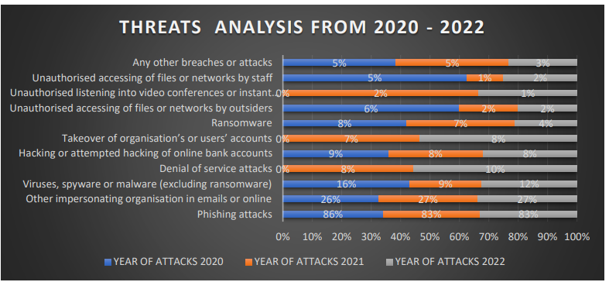

Figure 14. 1: Threat analysis chart [13, 14 & 15]

6. Evaluation

From the survey in [15] most of the disruptive attacks or breaches faced by organization for the past 3 years indicates that not much has been done in responding to these attacks.

6.1 Incident Response

The incident response survey data from [fig 8], shows the approaches organisations have taken so far in their response to a cyber security incident. Most organisations (93% of businesses and 89% of charities) do report having some sort of formalised incident response process, however, most of these organisations with response approaches are medium, and large-size organisations [15].

"Approaches to incident response among these organisation are reasonably comprehensive [5]. Two-thirds of businesses (67%) and charities (65%) say they take at least five of the listed actions in the chart when they experience a cyber security incident. This rises to 90% of medium-sized businesses and 93% of large businesses".
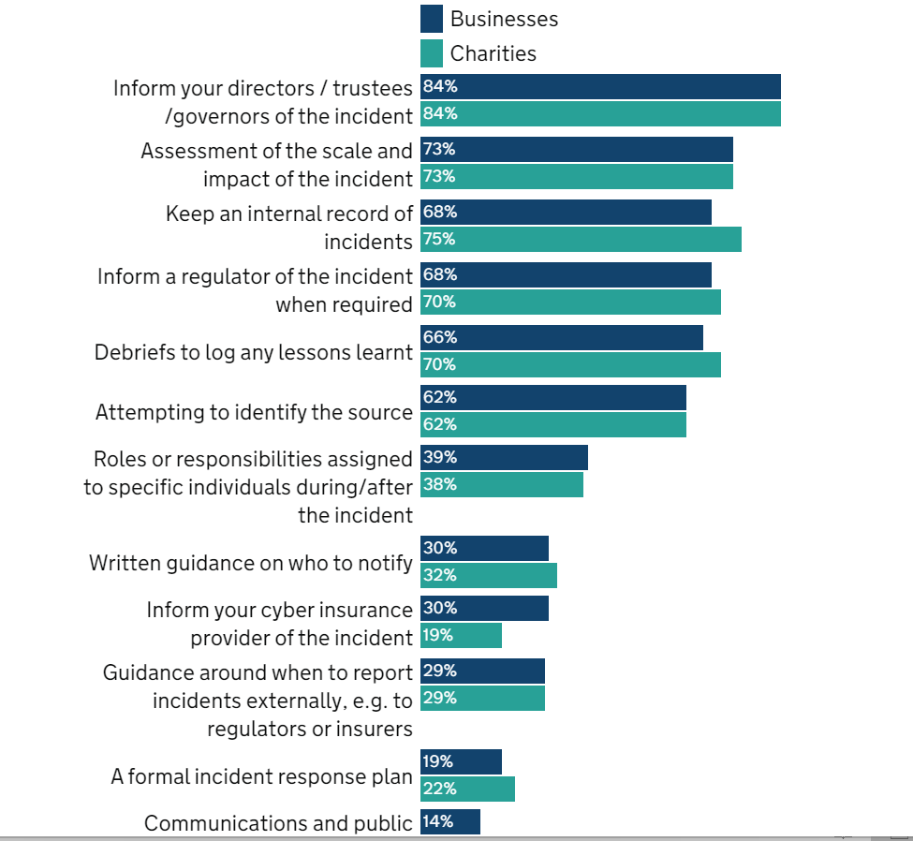

Figure 15. 1 Incident response chart [15].

6.2 Cyber Incident Response Scheme

The Cyber Incident Response (CIR) Level 1 scheme provides their customers assurance that the members of the scheme will meet the NCSC’s standard for high quality incident response [23]. The CIR standard are designed to support organisations that are typically at risk of sophisticated and bespoke cyber attacks, for example, those who are part of the UK central government, Critical National Infrastructure, or who operate in a regulated sector and/or in more than one country [23]. The NCSC helps to reduce risks to the UK government by securing public and private sector networks against cyber attacks [23].

6.3 Penetration Test
Penetration Testing is a cyber security approach for gaining assurance in the security of an IT system with the aim to breach a part or the entire system's security, using similar tools and techniques as a threat actor might [26].

6.3.1 Why is penetration testing important?
Experienced penetration testers can easily detect security issues that your network security or IT team may not notice.
The aim of a penetration test approach is to use the findings of a pen test report to improve an organisation's internal risk or vulnerability assessment and management process [26]

6.3.2 Types of Penetration Testing
There are different testing that can be conducted, to achieve a particular result.
1. White testing: This type of testing is conducted when an organisation wants to test its internal risk or vulnerability assessment level and management controls, by identifying vulnerabilities in security software and misconfigurations of security hardware equipment. This test is often conducted by an external tester who is not a part of the organisation, but all information about the organisation is given to the tester [26].

2. Blackbox testing: This type of testing is conducted when an organisation wants to check or identify other secret ways to access an organisation's internal assets. No information is provided or shared with the tester [26].

Other penetration testing are Vulnerability identification or niche software, Scenario driven testing at identifying vulnerabilities, and Scenario driven testing of detection and response capability [26] .

6.3.3 Penetration Test Tools
There are different penetration tools for finding and removing vulnerabilities in a system, the following are some of the tools available [29]:

1. Nmap means stands for Network Mapper: The Nmap tool is used to conduct pen tests for web applications and it also users to scan their networks. This tool can also be used to configure the network's IPs, Port ranges, and Protocols.

2. Wireshark: This tool is used to sniff network packets, and also for conducting a deep inspection on hundreds of protocols.
3. Metasploit: This tool is often used by certified ethical hackers to identify weaknesses in a system and also seek to exploit the system further.

4. Nessus: Nessus is a vulnerability scanner that can quickly identify and fix vulnerabilities in a system, including malware, missing patches, and software flaws. This tool can perform both credential and non-credentialed scans.

5. Nikto: This is an open-source vulnerability scanner that tests web applications for potential breaches or threats. It can perform in-depth tests that can neutralize over 7000 malicious applications and files.

6. Kali Linux: Kali Linux is the most used advanced tool for conducting effective pen testing. It is mostly used for ethical hacking. This tool comes with several pre-installed tools like Wireshark, Nmap, Metaspoilt, and Aircracking tool.

Other penetration testing tools are OpenVas, OpenScap, SQLmap, and Aircracking [29].

6.3.4 Cybersecurity Maturity Model (CMM)

A cybersecurity maturity model is a system or an approach that can be used to evaluate the digital capabilities of an orgainsation against threats and vulnerabilities. CMM is a standard security framework that can protect nenetworkesources against cyberattacks. It allows an organisation to measure its system's strengths and weaknesses, so as to identify the best strategies for protection.

To obtain the best out of the cybersecurity model, the organisation must first identify the current condition of their network, by conducting a risk assessment, the feedback from this assessment will be used to set better security goals [31].

6.3.4.1 Types of Cybersecurity Maturity Models

There are lots of CMM, but for this research, I will discuss the models that are relevant to this topic.

1. National Institute of Standards and Technology (NIST) CMM
The NIST is an organisation that oversees innovations mainly in Science and Technology, with proven measurable and repeatable standards.
This model provides a set of tested principles and guidelines that can be implemented to enhance cybersecurity [31].

2. Cybersecurity Capability Maturity Model (CCMM)
The CCMM is a systematised framework that can be used to measure and enhance cybersecurity defenses. Because of its deep-rootedness in operations technology and Information technology, it has become one of the most adopted and respected models. This framework has proven to be very effective if properly implemented [31].

3. ISO 27001 CMM
ISO 27001 is a product of the International Organisation for Standardization (ISO), which helps to protect the digital environment with effective practices. It is a well-known framework for Information Security Management Systems because it protects the privacy of the organisation and its customers [31].

4. Cybersecurity Maturity Model Certification (CMMC)
This model consists of different security standards for securing digital assets. This model was set up by the US Department of Defence (DOD), and it is a mandatory requirement for every defense contractor operating in the US [31].

6.3.4.1 Steps to Implementing a Cybersecurity Maturity Model [31]

- Assess your current Security status
- Choose a Suitable Maturity Model
- Customise the Maturity Model
- Track your Progress
- Maintain Latest Security Standards
- Gain Security Insights
- Save Costs
- Complete Visibility

6.4 Evaluation Conclusion

From the literature review down to the research methodology, It is been established a lot of organisations are facing cyber attacks due to up-to-date standards and techniques in protecting their digital assets, the above evaluation if well implemented, can prevent cyber breaches and attacks.

7. Conclusion
Between 2020 to 2023, there have been several cases of cybersecurity breaches in UK business organisations. This research has highlighted the origin of cybersecurity, the impact of cybersecurity, different threats, and attacks, different reported cases of cyber breaches, and how it has affected these organisations.
This study has reviewed different methodologies and has adopted the general methodology which comprises quantitative and qualitative methodology.
For the data collection, the quantitative methodology was the best fit for collecting and analyzing the data, because of the size of the data.
From the results of the data, I was to develop a chart with different threats and the rate at which these threats affect the organisation. Based on these results, different recommendations have been made. Aside from adopting the NCSC Penetration testing has proven to be the best response to cybersecurity breaches.

8. Bibliography

[1] K. Benacci, “CrowdStrike: We Stop Breaches,” crowdstrike.com, Jan. 6AD. https://go.crowdstrike.com/ (accessed Mar. 14AD).
[2] D. Kennedy, “DBIR Report 2022 - Master’s Guide,” Verizon Business, 2022. https://www.verizon.com/business/resources/reports/dbir/2022/master-guide/ (accessed Mar. 16, 2023).
[3] J. Clay, “A Quarter of Global Organizations Were Hit by Seven or More Cyber Attacks in The Last Year,” Trend Micro | Newsroom, Nov. 17, 2022. https://newsroom.trendmicro.com/2020-12-02-A-Quarter-of-Global-Organizations-Were-Hit-by-Seven-or-More-Cyber-Attacks-in-The-Last-Year (accessed Mar. 16, 2023).
[4] J. Clay, “Cyber Risk Index 1H’22 Snapshot,” Trend Micro, Nov. 17, 2022. https://www.trendmicro.com/en_gb/research/22/k/cyber-risk-index-1h-22-snapshot.html (accessed Mar. 16AD).
[5] “The Biggest cyber attacks of 2023 | BCS,” www.bcs.org, Nov. 3AD. https://www.bcs.org/articles-opinion-and-research/the-biggest-cyber-attacks-of-2023/ (accessed Mar. 16, 2023).
[6] K. Benacc, “2023 CrowdStrike Global Threat Report Reveals Sophisticated Adversaries Re-exploiting and Re-weaponizing Patched Vulnerabilities and Moving Beyond Ransomware,” Businesswire, Feb. 28, 2023. https://www.businesswire.com/news/home/20230228005546/en/2023-CrowdStrike-Global-Threat-Report-Reveals-Sophisticated-Adversaries-Re-exploiting-and-Re-weaponizing-Patched-Vulnerabilities-and-Moving-Beyond-Ransomware (accessed Mar. 16, 2023).
[7] Chadd, Katie. “The History of Cybercrime and Cybersecurity, 1940-2020.” Cybercrime Magazine, 30 Nov. 2020, cybersecurityventures.com/the-history-of-cybercrime-and-cybersecurity-1940-2020/.
[8] “Cyber Security Breaches Survey 2018: Preparations for the New Data Protection Act.” GOV.UK, 2018, www.gov.uk/government/statistics/cyber-security-breaches-survey-2018-preparations-for-the-new-data-protection-act. Accessed 10 Apr. 2023.
[9] Lopez MP, Julia. “Cyber Laws Updated to Boost UK’s Resilience against Online Attacks.” GOV.UK, 30 Nov. 2022, www.gov.uk/government/news/cyber-laws-updated-to-boost-uks-resilience-against-online-attacks. Accessed 10 Apr. 2023.
[10] Rhee, Eugene. “Security Threats and Countermeasures on the Internet of Things.” International Journal of Internet Technology and Secured Transactions, vol. 12, no. 4, 2022, p. 353, https://doi.org/10.1504/ijitst.2022.124472. Accessed 6 Aug. 2022.
[11] Saleem, Muntaha. “Brexit Impact on Cyber Security of United Kingdom.” 2019 International Conference on Cyber Security and Protection of Digital Services (Cyber Security), June 2019, https://doi.org/10.1109/cybersecpods.2019.8885271.
[12] Stevens, Tim, and Kevin O’Brien. “Brexit and Cyber Security.” The RUSI Journal, vol. 164, no. 3, 16 Apr. 2019, pp. 22–30, https://doi.org/10.1080/03071847.2019.1643256

[13] “Cyber Security Breaches Survey 2021.” GOV.UK, 14 Mar. 2021, www.gov.uk/government/statistics/cyber-security-breaches-survey-2021/cyber-security-breaches-survey-2021#chapter-5-incidence-and-impact-of-breaches-or-attacks.
[14] “Cyber Security Breaches Survey 2020.” GOV.UK, 26 Mar. 2020, www.gov.uk/government/statistics/cyber-security-breaches-survey-2020/cyber-security-breaches-survey-2020#chapter-5-incidence-and-impact-of-breaches-or-attacks.
[15] GOV.UK. “Cyber Security Breaches Survey 2022.” GOV.UK, 30 Mar. 2022, www.gov.uk/government/statistics/cyber-security-breaches-survey-2022/cyber-security-breaches-survey-2022.
[16] Dudovskiy, John. “Research Philosophy - Research Methodology.” Business Research Methodology, Business Research Methodology, 2022, research-methodology.net/research-philosophy/.
[18] Tsung, E.W.K. (2016) “The Philosophy of Management Research” Routledge
[19] Pedamkar, Priya. “Types of Research Methodology | Top 10 Types Types of Research.” EDUCBA, 19 Jan. 2021, www.educba.com/types-of-research-methodology/.
[20] Wedawatta G., Ingirige B., Amaratunga D. (2011), Case study as a research strategy: Investigating extreme weather resilience of construction SMEs in the UK, the University of Salford, Manchester, s. 3-4
[21] S. N. Hesse-Biber and P. Leavy, The Practice of Qualitative Research. SAGE Publications, 2010. Available: https://books.google.pl/books?hl=en&lr=&id=FVjcZk7mCFwC&oi=fnd&pg=PR1&dq=Research+strategy&ots=6uSwvhieba&sig=5lbCZjsQdaL7zOnmWkKvMjQlFKA&redir_esc=y#v=onepage&q=survey&f=false
[22] “UK Data Service › Studies,” beta.ukdataservice.ac.uk. https://beta.ukdataservice.ac.uk/datacatalogue/studies/?Search=cyber+security+breaches+survey# (accessed Apr. 13, 2023).
[23] P. Bhandari, “Ethical Considerations in Research | Types & Examples,” Scribbr, May 07, 2022. https://www.scribbr.co.uk/research-methods/ethical-considerations/

[24] National Cyber Security Centre, “About Cyber Essentials,” www.ncsc.gov.uk, 2021. https://www.ncsc.gov.uk/cyberessentials/overview
[25] NCSC, “About the NCSC,” Ncsc.gov.uk, 2019. https://www.ncsc.gov.uk/section/about-ncsc/what-we-do
[26] National Cyber Security Centre, “Penetration Testing,” Ncsc.gov.uk, Jan. 10, 2022. https://www.ncsc.gov.uk/guidance/penetration-testing

[27] A. Venkat, “Cyberattacks against governments jumped 95% in last half of 2022, CloudSek says,” CSO Online, Jan. 04, 2023. https://www.csoonline.com/article/3684668/cyberattacks-against-governments-jumped-95-in-last-half-of-2022-cloudsek-says.html
[28] “10 Best Penetration Testing Tools in 2023,” Testsigma Blog, Jan. 20, 2023. https://testsigma.com/blog/penetration-testing-tools/#What_is_Penetration_Testing (accessed Apr. 16, 2023).
[29] Atlassian, “Gantt Charts,” Atlassian. https://www.atlassian.com/agile/project-management/gantt-chart#:~:text=What%20is%20a%20Gantt%20chart
[30] D. Phair and K. Warren, “Saunders’ Research Onion: Explained Simply,” Grad Coach, Jan. 2021. https://gradcoach.com/saunders-research-onion/
[31] C. Odogwu, “What Is a Cybersecurity Maturity Model and How Does It Work?,” MUO, Feb. 11, 2023. https://www.makeuseof.com/what-is-cybersecurity-maturity-model/ (accessed Apr. 17, 2023).
[32] C. C. for C. Security, “An introduction to the cyber threat environment,” Canadian Centre for Cyber Security, Oct. 28, 2022. https://www.cyber.gc.ca/en/guidance/introduction-cyber-threat-environment (accessed Apr. 20, 2023).

