MBA Dissertation
Can Blue and Green Infrastructure Assets be used as drivers for economic regeneration in South West Wales?

1/31/2024
University of Wales Trinity Saint David
Julie Hannam 1915867

Module BMMB7003D


DECLARATION

This work has not previously been accepted in substance for any degree and is not being concurrently submitted in candidature for any degree.

Signed: Julie Hannam (candidate)
Date: 31/01/2024

STATEMENT 1
This work is the result of my own investigations, except where otherwise stated. Where correction services have been used, the extent and nature of the correction is clearly marked in a footnote(s).

Other sources are acknowledged by footnotes giving explicit references. A bibliography is appended.

Signed: Julie Hannam (candidate)
Date: 31/01/2024

STATEMENT 2
I hereby give consent for my work, if accepted, to be available for photocopying and for inter-library loan, and for the title and summary to be made available to outside organisations.
Signed: Julie Hannam (candidate)
Date: 31/01/2024
Acknowledgements
I would like to thank my family for their continuing support throughout the process of completing this dissertation.
I would also wish to thank my dissertation supervisor, Dr. Roisin Mullins for her guidance and encouragement, especially in the early stages that helped provide the focus and momentum to kickstart my research and ensure that I stayed on the right track.
I owe thanks to the interview participants and the valuable insight into regeneration in South West Wales that they kindly provided.

Abstract
The academic focus of this dissertation is the usefulness or otherwise of taking a blue green infrastructure approach to regional economic development and regeneration, specifically in the areas of Entrepreneurship, digital transformation and strategic management. This will look at the theories of Culture and Innovation. The provision within South West Wales as it currently stands and how it could be built upon. Examples of good practice from the USA and UK will be examined.
A series of semi-structured interviews conducted with a range of interested and sector relevant participants. Recommendations and suggestions to roll out the key aspects of GI regeneration based on good practice and opportunities.

Table of Contents
Student Declaration | 1
Acknowledgements | 2
Abstract | 3
Table of Contents | 4
List of Figures | 5
Abbreviations | 6
1.Introduction | 7
2.Literature Review | 13
3.Research Methodology | 22
4.Discussion and Findings | 28
5. Conclusions and Recommendations | 50
Bibliography and References | 52
Appendix | 54

Figures
Figure 1 A conceptual model of factors that contribute to community well-being and quality of life. | 9
Figure 2 The Settlement Health Map | 15
Figure 3 Economic and Social Evaluation of the Outdoor Sector in Wales | 20
Figure 4 Saunders Research onion | 22

Abbreviations
AONB | ………………………………………………… | Area of Outstanding Natural Beauty
CANARI | ………………………………………………… | Caribbean
ERDF | ………………………………………………. | European Regional Development Fund
GI | ………………………………………………. | Green Infrastructure
NRW | ………………………………………………. | Natural Resources Wales
SBCR | ………………………………………………. | Swansea Bay City Region
WG | ………………………………………………. | Welsh Government
SWOT | ………………………………………………... | Strength /Weakness /Opportunity /Threat
PESTLE | ………………………………………………… | Political
SUPs | ………………………………………………. | Stand Up Paddleboards
UN | ………………………………………………… | United Nations
WEFO | …………………………………………………. | Welsh European Funding Office
VRP | ………………………………………………… | Valleys Regional Park

- Introduction
Setting the scene
South West Wales is an area of mixed economies and infrastructure, from the industrial landscape of Port Talbot at the eastern edge of the area, to the rural landscape of coastal Pembrokeshire in the west, with a mixture of post-industrial urban, peri-urban, rural and coastal infrastructure in between. There have been many attempts to implement sustainable long-term regeneration in this area, indeed the Beven Foundation carried out a 40-year review of regeneration attempts in the Afan Valley (Bevan Foundation 2012) The geographical area chosen for this research covers the area included in the Swansea Bay City Region (There are other similar initiatives within Wales e.g. Cardiff City Region).

The area selected for focus within this dissertation includes areas already recognised for the quality of the Green and Blue Infrastructure to be found, namely Gower Peninsula Area of Outstanding Natural Beauty (AONB) to the west of Swansea city and Pembrokeshire Coast National Park in the west of the region. These two areas have become hubs for Tourism focused industry, alongside traditional farming.

Background to research topic
In a previous position the researcher worked for an ERDF (European Regional Development Fund) project that looked at utilizing natural and historical assets as drivers for regeneration within the former coalfield valleys of South Wales as part of a tri-partnership project in Wales, Belgium and France. In Wales this work looked at the early stages of developing a Regional Park within the South Wales Valleys - Valleys Regional Park. A Regional Park should not be confused with a National Park such as Exmoor National Park, and can be categorised as follows; “A regional park is much bigger and more diverse than a country park or a park in a town but smaller than a national park. It's a large area with multiple landowners and uses including farming, recreation, work and housing.” (National Trust 2023) This is a designation that affords some protection without the restrictions that exist within a National Park designated area. There is a network of Regional Parks across Europe that are often seen as an opportunity to assist in the regeneration of an area and provide focus for opportunities to utilize the blue and green resources found within an area.
South West Wales is an area that has suffered significant economic decline following the closure of several heavy industry facilities and the general UK move away from traditional manufacturing industries. It is however rich in blue and green resources which could be harnessed to bring a new sustainable prosperous future to the region.

A sustainable region needs to achieve a balance between the needs of the community, the environment and the economy in order to deliver a durable and attractive quality of life that can be maintained long-term, ensuring lasting regeneration that is generational. This will help to escape the short-term and often public funded projects that have characterised the post-industrial attempts over the past 40 years or so in this region (Bevan Foundation 2013)
A reason for this was the attitudinal approach to social, economic and environmental regeneration and management that existed primarily in independent silos of thought and action until the start of the 21st Century (van Kamp et al 2003). The model above is an example of the changing approach, although change can progress at a glacial rate or so it would appear when governmental and large business interests get involved.

What is Blue / Green Infrastructure?
Green Growth was formally recognised in 2012 at the Rio+20 Summit (but has been used since 2009).The World Bank characterises Green Growth as;
“Growth that is efficient in its use of natural resources, clean in that it minimises pollution and environmental impacts, and resilient in that it accounts for natural hazards and the role of environmental management and natural capital in preventing physical disasters. And this growth needs to be inclusive.”
(“Explaining green and blue growth” Kumunda Simpson, The Interpreter)
Their definition of Blue Growth is as follows ;
“Blue growth refers to a broad array of conservation concerns and economic interests related to the world’s oceans and the resources contained in them.”
(ibid Simpson)
This being said, many organisations and economic development programmes expand this term to include rivers, lakes and all watercourses and sources of water.
“Governments and businesses around the world have adopted the idea of ecosystem services and sustainability thinking into their practices and policies. Businesses increasingly regard climate mitigation, conservation, and sustainability as potential engines for innovative, economic development and growth. The European Union has devoted considerable resources to implementing a blue growth approach to maritime policy.”
(ibid Simpson)
There has been some adoption of this type of approach of nations and regions moving towards a green economy, such as in the Caribbean -The Caribbean Natural Resources Institute (CANARI) summarises its overall aims for a green economy as;
“A green economy … aims for … equitable distribution of economic benefits and effective management of ecological resources; it is economically viable and resilient, self-directed, self-reliant and pro-poor.”
(Commonwealth Peoples Forum May 2016)
As such there is increasingly an understanding that the economy, the environment and communities are interconnected in such a way that there is significant evidence that an approach to economic development that takes into account these connections and overlaps is one that is more likely to become sustainable in the long term as illustrated in the diagram below
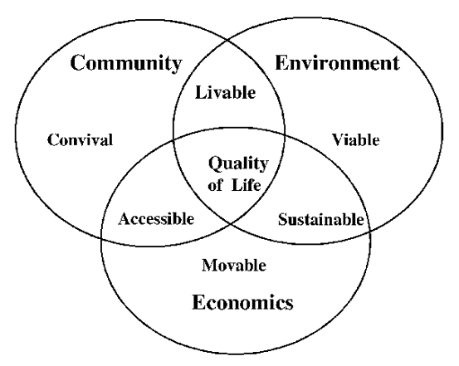

Figure 1 A conceptual model of factors that contribute to community well-being and quality of life.
Source: https://www.semanticscholar.org/paper/Urban-environmental-quality-and-human-well-being-a-Kamp-Leidelmeijer/12e6693ec007d7c9856af6bcc8012d397e9b843b/figure/0
Community – In order to attract and retain residents who feel that they have a good quality of life it is important that they feel a sense of welcome and neighbourliness. They need to want to feel that the area isn’t run down and has amenities and that they can have a sense of pride with regards to their community - that it is liveable, that you want to be there, which crosses into the environmental requirements.
Environment – Of all of the elements this needs most of all to be viable, in that it’s not damaged or polluted by past or current industry or economic practices. This is notable in South West Wales in former coal mining, copper or iron smelting facilities and the devastation that is still being remedied today. The Afan Forest Park in the Afan valley is one example, North Dock, Llanelli is a second and The Copper Quarter in Swansea is a third. These are working examples of how GI can be a driver for economic growth and a basis for this research (initial projects could be scaled up and joined together to boost the region as a whole). This needs to be implemented and managed in a sustainable manner, which brings in the third wheel that is a key component in raising and maintaining a good quality of life, the economy.
Economy – At a local and regional level this needs to be sustainable to offer security of employment, which enables communities to grow and the local environment to be protected. They need to be accessible to communities to provide a workforce and for the communities to earn money that can be spent locally (a start of a circular economy). The economy needs to be movable to withstand any shocks and turns in the larger economic climate.
Blue and Green Infrastructure is often combined nowadays into simply Green Infrastructure (GI), and the most straightforward description can be found in
“Green Infrastructure (GI) is a network of multi-functional green and blue spaces and other natural features, urban and rural, which is capable of delivering a wide range of environmental, economic, health and wellbeing benefits for nature, climate, local and wider communities and prosperity “. (National Planning Policy Framework, 2021). (Natural England – 2023)
In the field of economic regeneration and development there has been, since the turn of the 21st century a willingness to look beyond the traditional models of regeneration that were the focus of the 19th and 20th centuries in both the developed and developing world economies. These have often been heavy industry or civil service driven – Steel works in Port Talbot, DVLA in Swansea, S4C and Natural Resources Wales hubs in Carmarthen and Oil and Gas in Pembrokeshire.
As a result, there has been a shift in focus to include the opportunities presented by both the blue and green infrastructure that is arguably, alongside the population itself two of the most valuable resources that South West Wales has in its arsenal for sustainable, long term economic regeneration.
Aims
How can the utilization of a region’s blue and green assets become the drivers for long term economic regeneration?
Objectives
- Conduct a literature review of blue green economic development that highlight best practice and possible pitfalls of this approach and what work has been carried out to date with regards to transitioning to a blue green economy in South West Wales.
- Conduct a series of semi-structured interviews with key stakeholders to identify the blue and green resources within the region of South West Wales, current economic activity in this field and potential programme in the future.
- Produce a series of recommendations that could be adopted by key stakeholders to drive economic regeneration within South West Wales over the coming decade and beyond.
In order to complete this there will be a focus on the following research questions;
Research questions
- What are the blue and green resources within the region of South West Wales?
- How have other regions both nationally and internationally succeeded in making the most economically of their blue and green assets?
- What economic activity is currently linked to the blue and green resources of this region?
- What sustainable economic activity can be developed in this region utilizing blue and green resources?

Key elements to address
In order to address the aim, objectives and research questions outlined above this dissertation will look to address the following three elements;
- Look at what Green Infrastructure resources that could be either utilized (already exist), could be expanded to improve their impact or could be installed / developed (new).
- What are the barriers to greater use of a Green Infrastructure approach within economic and social regeneration programmes?
- What would be needed – both carrots and sticks – in order for a Green Infrastructure approach to become mainstream in South West Wales?
Issues to consider when examining GI branded developments
Greenwashing – whereby organisations, Local Authorities and others rebrand existing projects and works as Green in order to achieve accreditation, raise their profile or otherwise use the premise of GI development without the full implementation or adoption of the concept in practice.
This can in turn hide or mask potentially harmful products or processes within the built environment. A development may claim that it is working in partnership with the existing GI by using green roofs or living walls, however it is not disclosing the environmental impact of its building materials and the processes used to produce or install them (University College of Estate Management 2023).
GI as part of a transformational process of renewal and redevelopment – addressing the impact of industrial development and making a sustainable change that embraces both economic viability alongside GI considerations – flood mitigation within urban planning process, using GI to help in terms of urban cooling and warming (season dependant).
In order for a GI approach to regeneration that delivers a lasting economic improvement to an area it is important that is part of a holistic approach to regeneration – as has been seen globally in areas such Detroit, Malmo, Chicago that are discussed in the Literature Review chapter.
There is a role to play in all of this by planning officials in the encouragement of including Green walls / roofs and so forth in new-builds and building redevelopment.
Throughout this focus on GI driving sustainable regeneration there has to be checks and balances to ensure that the focus on GI hasn’t led to gentrification rather than regeneration? (Ian Mell 2022)
Underpinning any recommendations, reports or otherwise that this dissertation or other research makes with regards to employing GI as a driver for economic growth there is a need political buy-in to enable this approach to be successful (Ian Mell 2022)

Chapter 2 Literature Review
Introduction
In this chapter existing literature, reports, websites and so forth will be analysed to answer the principal objectives of this dissertation as outlined in the Introduction chapter above, namely;
- Identify the blue and green resources within the region of South West Wales
- How have other regions both nationally and internationally succeeded in making the most economically of their blue and green assets?
- What economic activity is currently linked to the blue and green resources of this region?
- What sustainable economic activity can be developed in this region utilizing blue and green resources?
In addition, this chapter will look at the various recognised frameworks and standards that have been agreed at differing levels of agreement and how these have impacted upon the ability to drive through sustainable use of GI within the field of regeneration at all levels. These will also contribute towards the analysis carried out to produce a PESTLE and SWOT analysis in chapter 5 of this dissertation.
Blue and Green resources in South West Wales
South West Wales is an area that, although has a lower-than-average tree cover – an average of 15% that falls as low as 7.5% in some urban areas such as Port Talbot (NRW South West Wales Regional Statement 2024). There is additional evidence that whilst living in an economically deprived community can reduce your life expectancy by around 16 (female) to 21 years (male), living near green spaces can help to combat this regardless of your economic class (NRW ibid).
There exists in the region a significant contrast between the areas with substantial GI resources and those still blighted by post-industrial landscape scaring legacy. As the premise of this dissertation supposes one of the remaining assets of this sometimes-forgotten region of Wales is the existing and potential GI infrastructure in the form of coastal access, green spaces, woodlands and upland areas.
In South West Wales when considering the economic potential that GI offers it is equally behoving of researchers, officers, and planners to bear in mind that whilst access to services and transport maybe relatively straightforward in the predominantly urban areas to the East of the region, once you step into rural communities this is no longer the case. Simply travelling to access services can take many times longer and the geographical landscape that attracts so many works against developments that seek to improve economic activity and quality of life. This is clearly set out in the Fabian Society Policy Report (Cooper and Wood (ed) 2022) “Green and Pleasant Land” where it is estimated that coastal communities on the whole lag behind in economic development to urban areas with a higher percentage of jobs that are lower paid, often seasonal and with little room for progression. In Wales as a whole there has been some attempts at rectifying this, for example the Welsh Government, in March 2022 launched a support fund of £227 million over 3 years for rural communities. In contrast to many previous schemes the framework underpinning the funds looks to support the rural economy and simultaneously the natural environment (Cooper and Wood (ed) ibid)
The Active Travel Bill has encouraged a significant increase in the provision of green routes, including cycle routes and safe walking routes to encourage people to exercise the option of increasing the number of journeys taken either on foot or by cycle. These have been supported by local health boards as an important contributor towards a healthier community that will require fewer medical interventions and long-term prescriptions for local communities (NRW South West Wales Regional Statement 2024). There is some evidence that promotion and upgrading of these routes encourage greater use from both the local community and visitors, but there is work to do with Public Service Boards (PSBs) to ensure joined up working and greater connectivity.
These all help to contribute towards a high-quality outdoor activity provision that is beneficial to local communities, an attraction to encourage movement into the area, and visitors attracted by the range on offer (ibid 2024). Visit Wales’s own research suggests that across Wales including the South West region it is the outdoor activity provision that brings visitors here rather than elsewhere in the UK. In addition to the GI as it stands – beaches, woods, mountains and so forth there is the important sector of managed GI that affords the opportunity to participate in specific activities. These range from world-class Mountain Bike trails at Glyncorrwg in the Afan Valley (NPT LDP 2011 – 2026 pub. 2013) and Brechfa Forest, Carmarthenshire (Discover Carmarthenshire 2022) to surfing in Gower and Pembrokeshire, coasteering in the Pembrokeshire Coastal Park, sailing along the coastal region and fishing in a range of lakes, rivers and sea settings (NRW ibid).

What does success look like in other regions (UK and Global)
Over the course of the last twenty years or so there has been an increasing awareness amongst town planners, regeneration departments and governments at all levels, especially in the developed West that economic prosperity, quality of life improvements and the natural environment are all inexplicably interconnected as reported in the “Landscape and Planning” journal that suggested the need had arisen to develop a new framework for assessing urban environmental quality and human well-being. (Van Kamp et al 2003). This approach has been further supported by such global agreements as the Davos Declaration (2018) on the concept of quality building processes to promote and increase the quality of life of communities (initially across Europe, but expanded to include signatories across the globe).

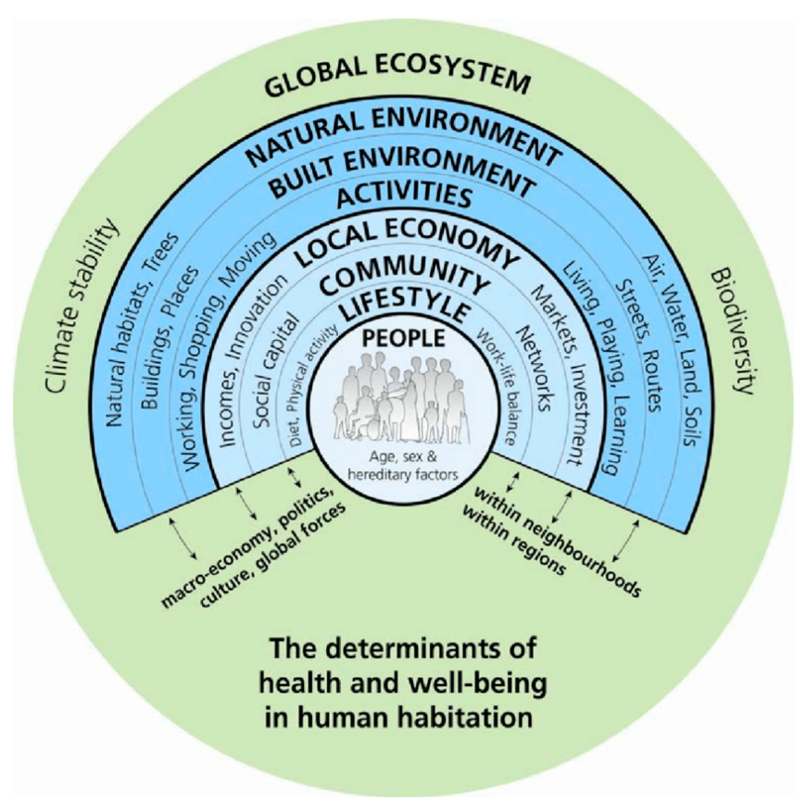
Figure 2. The Settlement Health Map. Source: Barton & Grant, 2006
This figure shows the interconnectedness of people, places and the environment and the research presented in this chapter and via the semi-structured interviews in Chapter 4 assist in presenting the case for a GI approach to economic development in South West Wales. The place in which people reside and the communities to be found there are often the primary determiners for the individuals’ outcome in later life and their ability to contribute to the society in which they live. A prosperous community attracts further investment, provides support networks and creates a circular economy that increases the flow of money and the ability for local and national governments to collect increased rates of taxation that then in turn fund higher quality services. (Barton & Grant 2006).
Whilst a GI rich community can support and encourage growth at a local level it can also afford protection from the global forces that can quickly extinguish facilities and services in more deprived communities. During the COVID-19 Pandemic more prosperous communities found a higher proportion of residents that moved to a “Working from Home” rather than an outward commute lifestyle that enabled them to maintain their income levels and continue to enjoy the same, if not higher standards of living. In more deprived communities, by contrast many residents lost their jobs in hospitality, zero-hours contracts and trades. (NRW 2024). These communities saw an increase in poor health, mental health issues, financial concerns and are still trying to recover to
Examples of successful uses of GI as drivers of economic regeneration around the world are summarised below
The USA;
In the USA there have been a series of schemes and projects across the country that has looked at restoring and revitalising previously industrially polluted or brownfield sites for community and economic benefit, especially in the management of rain water and flood areas (United States Environmental Protection Agency report 2014).
Detroit has employed the use of Green Infrastructure to create cost-effective water management schemes across the city that have turned derelict land to productive use and become an integral part of the city’s storm-water management.
Detroit has suffered from severe economic decline following the demise of the car industry and associated businesses in the city. In an effort to promote regeneration and community cohesion the EPA has awarded Detroit $1 million Shoreline Cities Infrastructure Grant via the EPA’s Great Lakes Restoration Initiative in 2014. The funding focused on significant GI projects in the Near East Side of the city such as converting empty brownfield sites into urban greenspaces that included meadows, woodland and orchards. This scheme alone helped to alleviate the pressure on the storm drains by roughly 100,000 gallons during heavy rainstorms. The funding from the EPA has been matched by two local foundations to help it come to full fruition. It is proposed that in future this project is scaled up and rolled out as a successful example of regeneration and repurpose of vacant land.
Detroit, via its Detroit Blight Task Force was looking to demolish approximately 80,000 unsalvageable homes over the course of 5 years (from 2014) and worked with the EPA, local organisations and communities to work out how to manage this is the most environmentally beneficial method. They covered every aspect from the demolition process, removal, re-use and recycling of building materials on the sites, to economic development and job opportunities arising from the scheme and how communications about the scheme would be managed. Additionally, there was engagement with the local community to look at selecting from a range of low-maintenance plans for the treatment of 10 separate vacant lots. These were selected to stabilize the soil, and look attractive while expanding the tree canopy in the area and helping with water management. The options presented ranged from low-growth prairie grass; tree planting; a rye grass and wildflower mix or a perennial wildflower mix. (EPA ibid).

UK
Research in the UK by Forestry Research (2010) and others have shown that there is an undoubtable economic benefit from developing and increasing Green Infrastructure provision across the UK.
Mersey Forest – This project was initially supported by objective 1 funding and analysis of the impact determined that over the 50-year lifespan of the project each £1 spend generated £2.30 of increased GVA (Forestry Research 2010).
Scotland – The Glasgow Green Renewal Project was able to initiate a sizable house building programme of between 500- 750 new homes. The economic benefit to the area was an increase in land value, which rose from £100,000 per Hectare to £300,000 per Hectare and resulted increasing council tax revenue by 47% (Benefits of Green Infrastructure, Forestry Research 2010 – data from GEN Consulting 2006).
The key economic benefits of increasing GI in UK settings have been assessed as follows;
- Significantly lower rates of asthma are found in children that live near street trees, reducing cost to the NHS and increasing school attendance.
- Sustainable Urban Drainage Systems (SUDs) help to reduce the risk of flooding and manage the flow of storm water through a local environment.
- GI can be used to reduce Urban Heat retention – open green spaces and areas with a number of trees help reduce the temperature via offering shade, evapotranspiration and latent heat transfer.
- If an area has more green space in an urban context, then it brings an increased level of inward investment – houses next to trees or parks always hold a higher value than those with little or no GI nearby.
(Forest Research 2010)
See Appendix 1 for a matrix regarding the economic value of different tree planting to the economy.
What GI currently exists in South West Wales that contributes towards sustainable economic growth?
South West Wales as a region is an area that has an abundant of existing Green (and Blue) infrastructure that is economically beneficial to the region and does contribute currently to the regional economy. The GI within South West Wales is considered to be one of its greatest assets currently contributing towards the quality of life that is on offer (South West Wales Regional Economic Development plan 2022), and one of the major factors that can drive forwards the economy of the region. The lasting legacy of the regional industrial heritage includes pockets of above average poor health and there has been significant research regarding the role that the use of GI to encourage outdoor exercise can have in reducing this trend (NRW 2024).
If the region can improve the health of its residents, then there will be a greater pool of potentially economically active adults to draw from. This will result in growing the talent for emerging sectors such as renewable energy connectivity rather than importing employees that may have a short-term view of the region and are less likely to participate in the longer term sustainable economic growth of the region.
The coast:
The coast is an important asset that supports economic development and is a resource for residents and visitors alike that can be utilized to improve health outcomes (NRW 2024)
The coastal areas contain 40 areas that are currently designated for bathing which are rated as follows; 33 – “excellent”, 6 – “Good” and 1 – “sufficient” (NRW 2024).
The Coastal area also contains a portion of the South West Coast Path stretching from Port Talbot in the East to Fishguard and the northern edge of Pembrokeshire in the west. There are several sections that are fully accessible to all users, such as Aberavon Seafront, Swansea Bay from the Marina to Mumbles head and the Millennium Coast Path at Llanelli (Welsh Government 2024).
Each of the 4 counties have significant seaside towns that draw tourists and visitor alike, driving the economy of the region.
Aberavon – wide beach, restaurant and café. The area is popular with walkers, families and water sports enthusiasts. It lies in front of an area of deprivation in the Sandfields Estate (originally built to house workers in the nearby Steel Works).
Mumbles – at the far end of Swansea Bay this, in contrast to Aberavon is one of the most prosperous areas of Swansea., which is reflected in the IMD
Gower Peninsula – several small coastal villages
North Dock in Llanelli – transformed a former industrial site into a vibrant outdoor area with a coast path, a facility for outdoor swimming and kayaking that regularly holds Triathlons and other competitions.
Tenby - a traditional seaside resort that has benefited from an increase in domestic and international visitors.
Pembrokeshire Coast Park, a range of beaches, walking routes and small islands including Skomer (a wildlife haven).
Blue Lagoon at Abereiddi which has played host to Red Bull’s Cliff Diving Series on several occasions
(Welsh Government 2024 – Visit Wales information guides).
The Active Travel (Wales) Act has leveraged funding and support to increase the number of green routes and cycle trails in the area.
Woodlands, hills and mountains;
The level of tree cover in South West Wales, and indeed Wales as a whole is below the UK average (38%) and falls as low as 7.5% in Port Talbot. There are maps showing the tree coverage and also the coverage of ancient woodland in South and Mid Wales in appendix 2 (Welsh Government 2018).
South West Wales has pockets of forest and small woodlands across the region, managed by NRW, landowners and community groups for a variety of reasons, be it recreation (Walking and riding trails and mountain biking), woodland-based industries such as timber or firewood production or landscape management- water or soil (Hall et al 2022).
In terms of expanding the tree cover in Wales the general public’s perception of tree planting can often be seen as confused and somewhat contradictory (Hall et al 2022), as whilst the general principle of planting more trees and the benefits of this are widely promoted and understood the reality of tree planting schemes is not always received in the same light. Indeed, often those who most strongly agree with the expansion of tree provision – say the National Forest scheme in Wales – do not agree with the types of trees planted. They may choose non-native for their gardens, which Local Authorities will not see as in keeping with their plans for increasing the tree canopy and increasing biodiversity in the green spaces that they manage.
Outdoor activity provision and tourism
This is a key economic sector in South West Wales and is the one with the greatest opportunity to make the most from an expansion in the GI provision and drive the sector to became an even more important part of the make up of the economy in this region. If this expansion is afforded political support, then it can bring enormous rewards. Below is a chart (Figure??) that was completed by Miller et al on behalf of the Welsh Government, although it talks about the Welsh economy as a whole it is included here as a visual understanding of what a co-ordinated and supported sector Outdoor Activity Provision is to this area. It is now possible to study Outdoor Education at both undergraduate and post-graduate level at University of Wales, Trinity Saint David on the Carmarthen campus as the recognition of the sector as more than just people playing outdoors grows. Outdoor activity provision and education is also recognised within the South West Wales Regional Economic Delivery Plan 2021 as Mission 3 (of 3) – Growing and sustaining the South Wales “Experience” Offer.
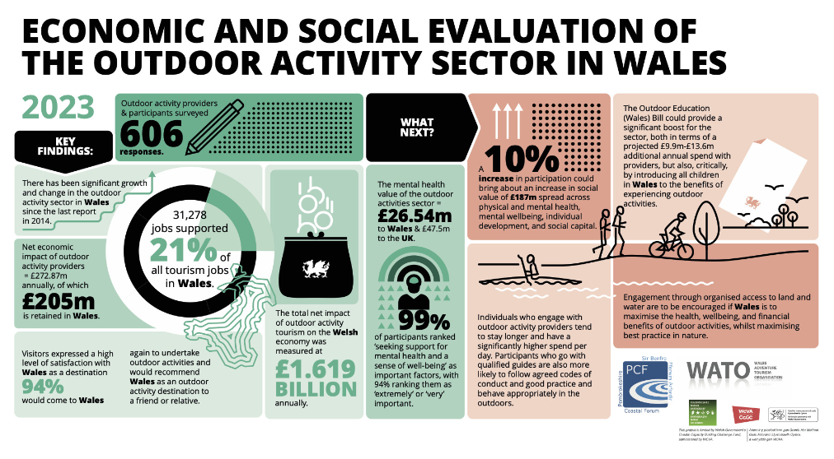
Figure3 Source: “Economic and Social Evaluation of The Outdoor Activity Sector in Wales” Miller et al (2023).

Political impetus - Following the passing of the Well-being of Future Generations Act in 2015, which contains 7 key goals to cover all aspects of wellbeing – Wellbeing Goals if you wish – there is now a requirement for all public bodies to consider these in all aspects of strategic planning going forward. This then includes any partnership working within South West Wales and so the goals feature increasingly in research and plans that, of course include the expansion of GI provision in this area. The seven goals are; Prosperous, resilient, equal, healthy, cohesive, globally responsible with a vibrant culture and Welsh language. This then leads to the underpinning principle of a Wales (or region therein) that is “Prosperous, Green and Equal” (South West Wales Regional Economic Delivery Plan 2021).
What could be developed and what are the pitfalls of this approach as identified by existing developments (UK and Globally).
As has been illustrated above there is enormous potential to build upon the current provision in Wales and to embed a GI approach into the economic developments proposed by the Swansea Bay City Region Misson 3 – Growing and sustaining the South West Wales “Experience” offer.
In all elements of GI focused regeneration, it is necessary to be aware of bias towards a GI approach above all, and equally the risk of organisations, developers and public bodies engaging in “Greenwashing” in order to attract funding and planning permission to continue doing business as usual. Greenwashing is a term adapted from the idea of “Whitewashing” to hide corruption and poor business practices.
Greenwashing has been around in many forms since the 1960s and the beginning of the boom in marketing activity, however it has gained pace in recent years as survey after survey shows that consumers are willing to pay a premium for “Green” products and services (McKinsey survey reported in University College of Estate Management 2023). There has also been a risk of Greenwashing being employed as increasingly there is a push from Governments via legislation and guidelines to include environmentally friendly and carbon neutral practices in all aspects of business. This has been discovered to be particularly rife in the building industry (UCoEM ibid).
An invaluable use of GI in regeneration is in multi-layer mapping exercises. This was used extensively by the Forestry Commission (now part of NRW) to identify which parts of the Crown Estate hold the greatest potential to deliver the highest level of community and economic benefit (Valleys Regional Park – A Green Infrastructure Framework for the Regeneration of the Afan and Llynfi Valleys 2013)

As this dissertation poses the overall question of whether GI assets could be used as economic drivers for sustainable regeneration in South West Wales it is valuable to look at the impact that regeneration can have on communities to highlight a qualitive approach to gaining community buy-in which can also have strong memorable outcomes by which to measure an initial baseline that progress can periodically be measured against (O’Hara 2018). The development assets identified in O’Hara’s theory of economic development are; education, health, environmental quality and leisure, social and cultural services. In Wales these can also be measured against the 7 Goals of the Future Well-being Act

Chapter 3 Research Methodology
Introduction
In this chapter the research methodology used to conduct the research presented within this dissertation will be examined and the reasoning behind the choices made will be explained. The choices have been directed by the area of research undertaken and the method of collecting primary evidence that is most appropriate in this specific instance.
The research methodology, ethical considerations and research bias will be examined in order to clearly identify the most appropriate methodology to employ to complete this piece of research. The researcher has read through the University of Wales Trinity Saint David ethical research handbook and completed the ethics form, and discussed the appropriate research approach to consider with the dissertation supervisor appointed to this piece of work (Dr Rosin Mullins).
The methodology as outlined below will endeavour to highlight that the approach taken is the most appropriate for the topic rather than the topic being shoehorned into the methodology most preferred by the researcher.
The process as outlined below is guided by the framework provided by Saunders Research Onion (Saunders et al 2019) as illustrated in Figure 4 below. This chapter will additionally provide information regarding the ethical considerations and the data collection methods utilised in this dissertation.
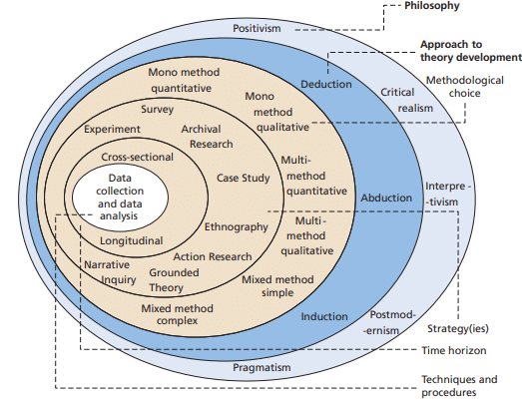
Figure 4
Saunders Research Onion (Saunders et al 2019 p104)
Rational
When considering economic regeneration and long-term sustainable development there has been an increasing awareness of the potential value of including Blue / Green Infrastructure into local, regional and national plans and strategies. This was however hindered by the absence of a clear and concise description – was its rural economies, National Parks, Rivers, Mountains, woods and sea?
The academic focus will be the usefulness or otherwise of taking a blue green infrastructure approach to regional economic development and regeneration, specifically in the areas of Entrepreneurship, digital transformation and strategic management. This will look at the theories of Culture and Innovation.
Research Design
The design for this piece of work has been carefully considered using Saunders Research onion as illustrated above in figure??? (Saunders et al 2019)
Research method
This dissertation takes the induction method that seeks to look at the evidence available, then conduct primary research using semi-structured interviews with participants that are involved or impacted by both Regeneration initiatives in South West Wales and Green Infrastructure developments. As a multi-method approach (Travers 2006) these two activities will then be analysed and interpreted to discover any commonality that produce patterns (Ryan 2018). The patterns will then be carefully scrutinised to draw out themes of commonality that will form the basis of the analysis and recommendations presented in chapters 4 and 5 of this dissertation (Travers 2006).
The primary research will take a qualitative approach using semi-structured interviews to pull out common themes within the area of development and regeneration using blue green infrastructure assets. The majority of the primary research will be gathered via 6-10 semi-structured in-depth interviews with a range of people working in relevant fields such as Natural Resources Wales, Welsh Government, Local Authorities, National Park Authorities, relevant third sector organisations, business forums etc. etc. The people interview will be chosen to reflect a wide as possible range of interests, experience and knowledge within the area of blue green infrastructure asset development. The selection of those to be invited to participate in the research interviews will be made via the principal researcher’s network of contacts, suggestions from these contacts and those identified following internet research into current activity in this field in South West Wales.
The questions that will form the basis for these interviews will be generated from the Literature Review research that will be completed prior to these interviews taking place. These may be amended as subsequent interviews take place to take account of emerging themes from the initial / previous interviews.
This will be supported by secondary research gained from academic sources, government reports, ONS and so forth as applicable.
Data Collection, sampling and size
As outlined above the primary data to be collected via semi-structured interviews with 6-10 participants. These will be recorded and transcribe by the principal researcher to ensure accuracy and complete capture of information and data provided.
Data analysis techniques
The data collected from the interviews will be analysed to discover principal themes. There will also be a SWOT and PESTLE analysis undertaken of both the primary data collected from the semi-structured interviews and the information gathered within the Literature Review in Chapter 2 above.
These activities will go to support the discussions, analysis, recommendations and conclusions that will form the latter part of this dissertation.
Supporting philosophy for research method
It is important to be clear regarding the “Why” of the chosen research method as well as the “What” type of research is being undertaking. While this may appear daunting at first it helps to clarify the process for the researcher and avoid a haphazard approach to the work being undertaken. (O’Gorman and MacIntosh 2015)
This dissertation takes the Postmodern qualitative philosophy approach to research in that the nature of the topic under consideration – Can Blue and Green infrastructure act as drivers for economic regeneration in South West Wales- cannot be determined by a single “Correct” answer, rather it is an amalgamation of many differing viewpoints and experiences that share commonalities (Travers 2006).
When employing qualitive research methods it is important to be mindful that our unconscious bias comes into play and that when selecting participants, they are not chosen merely because there is an understanding that they reinforce the view of the researcher (Denzin 2009)
There are some qualifiers that should be considered when looking at qualitive research and the way that it is then applied to recommendations that could potentially inform public policy such as ensuring that we reflect upon our unconscious bias and beliefs that may inform the information gathered and the interpretation that we place on it as suggested by Hammersley (2005) in Denzin (2009).
Ethical considerations
The UWTSD ethics form PG2 has been completed and will inform the approach and research activity undertaken by the principal researcher of this dissertation.
Risks to participants;
Location of semi-structured research interviews - Via Teams / Zoom between Researchers home and interviewees place of work (office, home etc. as applicable). Interviewees place of work. Neutral location as agreed by Researcher and Interviewee (that allows for privacy in terms of recording interviews, but not put either the participant or researcher at risk e.g. a public space NOT a home address or isolated location).
Devices used to record interviews to ensure accuracy of information - A mobile phone may be used to record face to face / WhatsApp interviews or Teams / Zoom recorded interviews via laptop if conducted virtually.
Accidental transfer of personal data - All participants to complete participation consent form outlining how information and any data gathered will be used within the research and stored.
Ensure that all information used from the interview is fully anonymous and that participants know that they are able to withdraw their consent for participation at any time.
Confidence of participants to engage following Covid-19 pandemic - All participants will be offered a range of methods in which to participate to enable them to choose which they feel most comfortable with e.g. Face to face, via Teams / Zoom / WhatsApp.
Risk to researcher;
The scope of the research will be minimised to what is feasible within the parameters of the dissertation (time) - The semi-structured interviews will be informed by the literature review conducted previously to them taking place. These will inform the general themes and topic areas to be discussed ensuring that there is a fairly tight focus.
Risk to University:
Data Protection issues - All participants will be required to complete a participation form that will include information regarding the collection and storage of any data or personal information acquired during the interviews. The researcher will ensure that this contains all of the relevant and most up to date information available to them.
Professional reputation - The principal researcher will maintain a professional attitude at all times while conducting the research interviews.
The principal researcher will ensure that the research does not contain any false information or any that is plagiarised from other sources.
Use of information and data
Feedback to participants - I will give a verbal summary of the information that they have provided at the end of the Semi-structured interview to be followed by a written summary within a week. I will also remind them that they can withdraw from the research at any point until completion of the dissertation.
All participants will be provided with contact details – email and mobile phone number in case they have and follow up questions, concerns or comments.
Informed consent - All participants in the semi-structured interviews will receive a consent form by email to be completed and returned to the principal researcher before any interviews commence. The consent form will clearly explain how the data and information they provide will be used and stored adhering to GDPR / DPA 2018 regulations. There will also be a recording of verbal / audio consent at the beginning of the semi-structured interviews.
Confidentiality / anonymity - All participants will be given a participation number and will not be referenced by name. Organisations or public bodies may be mentioned as appropriate but without reference to a participation number and permission will be collected for this within the participation consent form completed before any interviews take place.
All information including the participant number allocation will be stored on a USB memory stick that has password protected access. This USB memory stick will not be used or accessed by anyone other than the principal researcher.
Use of personal data - Audio and or visual data of interview participants will be collected to provide a record of the semi-formal interviews conducted as part of the primary research.
All participants will be requested to complete a consent form to show that they are willing and able to provide consent to the interviews and the ways in which the data gathered will be used within the research dissertation.
Contact information such as names, physical addresses (work) and emails will be used to communicate with the participants (both potential and agreed depending upon the stage of the research process).
Who will have access to data generated by the research - The Principal Researcher
Supervisor
Potentially – Second marker and external examiner
Who will control the data – The principal researcher
Data storage arrangements - All data will be encrypted and kept in password protected USB stick which will not be shared. Any USB sticks used to store or transfer data will be password protected, and will be reformatted at the end of the project in order to destroy the data. The data will be stored until the completion of the project and then deleted.

Chapter 4 Discussion and Findings
Alongside the secondary research conducted and presented in the Literature Review chapter primary research was also carried out via a series of semi-structured interviews. The reasoning behind this approach for this particular piece of research has been explored in the Research methodology chapter.
The interviews were conducted with 10 individuals from a range of sectors and organisations that are either based in South West Wales, have a considerable knowledge of economic development in this geographical area or a significant portion of their work in conducted in this regional area.
The interviewees were as follows;
Ref. No. | Interviewee organisation or industry sector as appropriate | Role
1. | Local Authority – South West Wales | Planning Officer
2. | Local Authority – South West Wales | Regeneration Programme Manager
3. | Natural Resources Wales | Water Management Officer
4. | Natural Resources Wales | Sustainable Forest Management Team member
5. | Private Landowner | Farmer
6. | Small business owner – Tourism and Leisure sector | Owner – Public House & Holiday accommodation
7. | Economic Development Consultant | Independent – worked at local, regional, national and trans-national level
8. | Private developer | Develop sites across South West Wales for various uses
9. | Outdoor Activity Provider | Business owner and instructor in outdoor activities in South West Wales
10 | Welsh Government | Community and Woodlands officer

Semi-structured questions and responses
*throughout the interviews it was clearly explained that Green Infrastructure or GI included Blue Infrastructure for the purposes of this research and if required what the term GI means in terms of the research being undertaken here.
- What do you understand the term Green Infrastructure or GI to mean in relation to economic regeneration?
Interviewee Number | Key comments from responses given | Theme
1 | GI refers to the elements of a site that have to be taken into account when developing it or worked into a planning design such as flood mitigation, street trees and so forth.  It’s a term that is increasingly cropping up in planning directives.  Have seen it used to create multi-layer maps to guide Local Development plans. | Q1 -C
2 | Using existing environmental or water-based assets to encourage and maximise regeneration schemes.  It crops up in Governmental initiatives and papers.  Given the area in which we are it makes sense to value these assets as they can tick many boxes at the same time.  Heard of GI being used to help with pollution and local warming and cooling – winter and summer. | Q1 - C
3 | Green and Blue infrastructure that are considered to alleviate problems and issues across an entire landscape or eco-system.  GI has an important role in the sustainable regeneration of an area, especially South West Wales. | Q1 – C
4 | In NRW it is a core understanding that underpins all the work that we do.  GI and regeneration go hand in hand these days unlike 15 years ago. | Q1 – C
5 | It appears in the new forms about grants and things.  The assets that I have are now all GI rather than fields, rivers and woodland. | Q1 – B
6 | Not known* Would this be a new way of joining things up?  Tourists stay in our Holiday lets, tourists and local eat and drink in our pub.  If the environment and its assets are maximised then there could be more tourists and more people could be attracted to live in this area all year round which would help our businesses especially in the winter.  This would bring more money into the local area and everyone would benefit. | Q1 – A
7 | GI is something that has greatly increased its profile within regeneration circles in recent years.  Now seen as one of the most important drivers for economic regeneration.  Examples of GI and regeneration are initiatives in Detroit USA, Malmo, Sweden. | Q1 – C
8 | Have heard it mentioned more and more often.  Something to do with looking at keeping environmental things  Possibly connected to Net Zero targets | Q1 – B
9 | Linked to core activity and fundamental to work  Have heard it at industry related working groups, especially post-COVID and in relation to industry sector sustainability. | Q1 - B
10 | Absolutely underpins all the work that I do  GI is a key asset, alongside people in South West Wales and absolutely a driver for economic growth in this region | Q1 - C

Emerging themes from Q1 – level of understanding of the concept of GI and its role within regeneration initiatives in South West Wales
(Each respondent’s answer will apply to one theme only in this question and therefore represent 10% in terms of understanding the concept of GI within a regeneration setting.
- Low level of understanding 10% -
- Medium level of understanding 30%
- High Level of understanding 60%
It is clear from these figures that GI as a concept is being increasingly recognised as a vital cog in the regeneration wheel within Wales and beyond within the relevant sectors, stemming from the agreements made at the Rio 2012 Summit and the formal use of the term “Green Infrastructure”.
Outside of the key governmental organisations the understanding becomes more fragmented – the term is recognisable but not fully understood. It is within this group that there is the opportunity to develop a broader understanding of the potential that GI affords the economic development and sustainability of South West Wales. There is a danger currently that GI risks being seen as a fad, or a tick box topic that private landowners and developers will pay lip service towards. This group could be the key to GI assets becoming a foundation to future economic regeneration in South West Wales (and indeed across the whole of Wales), at long last moving towards a process that is sustainable for the environment, whilst delivering long-term secure economic growth and prosperity. The aims of the Swansea Bay City Regional Economic Delivery Plan include Mission 3 – Growing and sustaining the South West Wales “Experience” offer. (2022)

- Have you ever considered GI within your work to date?
[Follow up question as relevant – A. If you have, what examples are you able to share?
B. If not are there any key reasons why not?]
Interviewee number | Key comments from responses  Follow up question A or B | Emerging Theme
1 | Often consider GI within work. The Davos Declaration of 2018 is increasingly used in relation to considerations for new builds and so on. This looks at the quality and quality of life that buildings help to create.  A – planning discussions with new developments to encourage the use of looking at using GI that may exist – working with it rather than against.  Looking at commercial buildings to include GI aspects such as green walls or roofs to reduce energy use and help combat local pollution issues.  Discussions on water management issues and mitigation within housing developments by including planning for water meadows, managed run-off and landscaping.  Work with Welsh Water to manage water run-off to reduce overwhelming the drainage systems around significant building projects.  At first stage discussions include suggestions for GI management and inclusion where appropriate.  Encourage a Green Infrastructure approach to help lower carbon footprint of projects above a certain scale. | Q2 – A GI approach underpinning developments going forward.  Q2 – B Contribute towards achieving Net Zero  Q2 – C Reto-fit – reuse and renew rather than replace.
2 | Depends upon the project and if it is physical or action focused. Also depends upon our role within the project and the amount of leverage we can bring.  A – A major regeneration theme in this area and the Swansea Bay City Region is tourism related to the outdoors and the environment and so it is one of the main assets that we have.  Our involvement in the Welsh Coastal path is major success in terms of using GI to drive regeneration. There has been a significant increase in visitors to the area not only in the traditional summer and autumn months but all year. The number of overnight stays has increased, which in turns has resulted in a rise in spending in related areas such as tourist accommodation, restaurants and food outlets. There has additionally been an increase in the number of tourists visiting attractions along the route of the Welsh Coast path, with data gathered by Visit Wales supporting this. | Q2 – A GI approach underpinning development going forward
3 | GI is a staple part of my work in water management.  A – Flood defence work has at its core the concept of protecting land, travel infrastructure, home and businesses. Whilst we are seeing increasing levels of storms and rising water levels globally there is, of course an impact at a regional level. We work with a range of partners to promote and develop schemes that manage and mitigate potential flood risks. We have found some of the best schemes are those with dual use that can almost appear to have flood defence as an after-thought. These are the schemes that serve a community as an asset rather than a necessary but commercially void. Examples of these are upland river management schemes in areas where Mountain Bike routes have been established. The management of upland water reduces the risk of damaging flooding all along the route of the river between the source and the sea. This also applies to GI assets such as reservoirs that are increasingly being used as regeneration drivers with active use by visitors and locals. They have many cross-sector benefits from financial to health and we are keen to promote this. | Q2 – A A GI approach underpinning development going forward.
4 | Yes, it is part of the underpinning aspects of my work  A-It is used as part of a multilayered mapping process to determine which woodlands would be the most valuable to develop and deliver multiple results. This helps to direct the work within the sustainable forest management team.  A successful use of the forests within Wales as we have by necessity moved away from using the timber produced as a crop to an asset to be managed. The most successful GI scheme has been the development of Mountain Bike Trails in the Afan Forest Park and around Carmarthen. From this there has been the development of further walking trails that can be used by a range of visitors with differing access needs. The push to see the forests as an asset also contributed towards the creation of an East to West Wales Bridlepath where we as NRW (and previously Forestry), worked with local authorities and other landowners to connect existing bridleways and promote it. | Q2 – D mapping potential
5 | See it within the management of my land, especially when I am involved with governmental or local authority schemes.  A – for me it can be a re-branding of what I’ve always done. Now I look to think about the wider Green Infrastructure impacts rather than what would be the easiest and quickest way to get what I need achieved.  Son is more interested in these schemes and is the one to push it on our land. | Q2 – A GI approach underpinning development going forward  Q2 -E rebranding existing work approach plus more
6 | I have seen it mentioned when consultation events have happened with outside agencies.  B - Not directly used it, can see how it would benefit my businesses at a secondary level in attracting more visitors and people to move to the area I’m based in. As other industries have shut or moved the spending power in the local area has dropped.  I don’t know how I could use GI directly, but I could get involved with community GI projects I suppose. | Q2 – F Community participation
7 | Over the past 10 – 15 years it has increasingly become the focus of the work that I undertake.  A – In South West Wales I have worked on projects that have looked at the feasibility of utilising bodies of water for commercial use (recreation), promoting outside exercise for well-being alongside health (a healthy population is more likely to be employed and pay taxes, spend locally – circular economy) and a regional project that examined the concept of using GI as the most viable asset to bring generational regeneration to an area of long-term deprivation. | Q2 – A GI approach underpinning development going forward.  Q2 – G Helps to promote a holistic approach to development.
8 | Consideration of GI has really only been as a result of suggestions but planners or partners if they have a focus.  B – I probably don’t know enough about it to have it as a main focus in what I do. There are not enough incentives for me at the moment, but I can see it becoming a part of the standard practice of property development in the future as part of planning guidance. | Q2 – H promoted by partners
9 | My entire business is based on GI really.  A – I use local rivers to take clients kayaking, on Stand-Up Paddleboards (SUPs) and bouldering.  I use the hills and mountains near my base to take out hikers, mountain bike tours and climbing.  I use the seas to take clients surfing, sea-kayaking, on SUPs, coasteering.  I use canals for kayaking and SUPs. | Q2 – A GI approach underpinning development going forward.
10 | My role is focused on joining GI and communities together for mutual benefit in a sustainable manner.  A – Within my work I have been a partner and the background driver to ensure that Woodlands are a positive force within the assets held by Welsh Government (WG).  An example of where GI or woodlands in my case have been used to deliver the key targets of my work have been working with local partners to ensure the long-term benefits are delivered in a sustainable manner to promote the value of our GI within Wales. Such schemes include the Valleys Regional Park (VRP), Coed Lleol (Small Woods) schemes and the National Forest. | Q2 – A GI approach underpinning development going forward.  Q2 – G helps to promote a holistic approach to development.

70% of respondents have considered a GI approach in their day-to-day work and 30% have considered GI specifically as a response to a drive towards Net Zero. The rest of the respondents have a sector or interest specific response that illustrates the range of uses for employing a GI influenced attituded to many differing sectors in this area.

- Do you feel that a GI focus could be a useful approach to sustainable economic development specifically in South Wales?
Interviewee Number | Key comments from responses | Emerging Themes
1 | It could be useful as one aspect and could help bring redundant buildings back into use.  The region has a mixed environment and an official endorsement of a GI approach needs to come from Welsh Government to carry any significant weight.  In the current climate it may help to spur on development. | Q3 – A Political Involvement
2 | A focus on GI can help to alleviate the effects of climate change and contribute towards Net Zero targets. Looking at the Well-Being of Future Generations Act and its targets a GI approach has a valid role to play here.  GI is vital in the way that physical developments are planned, constructed and maintained. There is the opportunity is using low carbon materials and incorporate aspects such as solar panels, water collection and re-use mechanisms, green walls and roofs, and ground-source heating where applicable to lower running costs, carbon footprints and increase sustainable practices.  The nature of the region of South West Wales means that our GI is one of the most valuable resources that we have next to the people, and it would be remiss not to make the most of this. | Q3 – B Strategic targets  Q3 – C Sustainable building process  Q3 – D GI as a valuable resource
3 | One of the most valuable assets that Wales as a whole and this area specifically has is its Green (and Blue) Infrastructure and so going forward it has to be one of the most important drivers for economic growth.  Hopefully the realisation that climate change and all that accompanies that means that we as a society move away from the past behaviour of imposing our economic requirements on the environment and instead work with it in a mutually beneficial relationship or we may find ourselves at the mercy of it. | Q3 – D GI as a valuable resource  Q3 – E Develop a mutually beneficial relationship between GI and Economic development.
4 | The woodlands of South West Wales are only one aspect of the GI to be found here and I don’t see how there can be sustainable economic growth without using GI as one of the principal economic drivers.  Using our woodland – based industries will also help to meet Net Zero targets and the Future Well-being ones as well as creating and encouraging employment opportunities. | Q3 – D GI as a valuable resource  Q3 – B Meet strategic targets  Q3 – F Employment opportunities
5 | It could be very useful in South West Wales to drive economic growth as long as it is implements in a practical and common-sense manner.  Food production security is as important as reaching Net Zero by 2050 or whenever it is, especially with what’s happening in mainland Europe at the moment. The war in Ukraine is impacting the ability to economically grow food and the political decisions in places like Germany and the Netherlands is making the situation worse. | Q3 – D GI as a valuable resource  Q3 – G Need to avoid focusing on political targets at the expense of food security.
6 | From what we’ve talked about so far it is one of the most important assets in this area. GI is the driver for my businesses as without it the would be no visitors to rent my holiday lets or visit my pub. People also wouldn’t want to live or move to the area if it looked poorly maintained. | Q3 – D GI as a valuable resource
7 | I think that a GI approach is the only sustainable option for South West Wales, or anywhere for that matter.  The holistic approach has the opportunity to deliver on so many fronts and possibly is the only viable option for long term sustainable economic growth here that will also meet the targets of the well-being act, Net Zero and the Environment Act (2018) | Q3 – D GI as a valuable resource  Q3 – B Deliver on strategic targets
8 | I think that it has to be, not least with the renewable energy developments that are happening in Pembrokeshire, the wind farms and in Swansea Bay, if that gets off the ground.  Gone are the old heavy industrial developments I think and a new approach is needed to regenerate this corner of Wales if there is to be good jobs that help drive the economy from within. | Q3 – D GI as a valuable resource  Q3 – H Green energy production  Q3 – F High quality jobs
9 | Focusing on GI has helped me to create a business that employs several people and pays my bills. We are still recovering from Covid, but the increase in holiday makers during the summers of 2020 / 2021 acted as a showcase for this area, encouraging visitors and inward movement as well.  Across the outdoor activity sector there is an increasing confidence that we will no longer be seen as the least important sector of the local economy – at a regional level if not a Welsh Government level. We now have an outdoor charter that helps to govern how we operate in National Park areas that helps to add validity to what we do (not just overgrown kids). | Q3 – D GI as a valuable resource  Q3 – F Confidence in the future  Q3 – A Political interference
10 | Within Welsh Government GI is seen as an important driver for sustainable economic growth and obviously within the woodlands and community section this is fundamental to our work.  There is a strategic target towards growing and sustaining the South West Wales “Experience” offer as Mission 3 of the Swansea Bay City Region development deal. | Q3 – D GI as a valuable resource.  Q3 – B Deliver on strategic Targets.

The majority of participants (90%) feel that GI is a valuable resource in terms of sustainable economic regeneration, with only the planning officer not including it in their response. This may be due to the way the question is phrased and so draws out unconscious bias to appear in a positive light to the interviewer as it is the focus of the research topic. The other themes that emerged were only mentioned by only a few participants and may then be sector specific, such as green energy production from the Welsh /Government officer and enabling the meeting of strategic targets by the planning officer, the economic development consultant and the Welsh Government Officer.
- What do you consider to be the most valuable uses of a GI approach to economic regeneration?
Interviewee Number | Key comments from responses given | Emerging Themes
1 | It is valuable for my work in terms of promoting a holistic approach to considering the built environment as contributing towards promoting a high quality of life and a more prosperous economy.  Additionally, it promotes an attitude whereby the environmental aspects of planning mean something and hopefully we are beginning to see plans being submitted that contain viable infrastructure that will work to mitigate against flood risk, promote natural warming and cooling (through landscaping, trees etc.) and look to reduce pollution. | Q4 - AHolistic approach to work  Change of attitudes
2 | We would need to promote and explain the concept of GI beyond “officials” and de-mystify the whole process.  If we could get communities, especially in areas considered to be run-down to get involved at least at the consultation level it would increase the sense of ownership “A Sense of Place” as it’s been called in the past. In communities that feel connected to the Green Infrastructure around them there is a significant level of a sense ownership and protectionism towards the GI, which helps to maintain and promote positive developments. An example is Briton Ferry, a community between Neath and Port Talbot. It contains one of the most deprived wards in the county, a site for the Travelling Community and a largely wooded hillside. Voting apathy is rife, yet any suggestion of development in the woods draws a large and vocal audience.  As a driver for small businesses, political interference notwithstanding GI has enormous transformational power in South West Wales to drive long term sustainable growth. If the value of GI could be fully recognised then a focus on this as an intrinsically key element of all regeneration work, with a long-term outlook has the change to change the post – industrial economic landscape across South West Wales.  The Swansea Bay City Region and its South West Wales Regional Economic Delivery plan is an ambitious start that will hopefully not be curtailed by political interference as has happened previously. | Ownership and protection  Political interference
3 | GI has a great potential to help to mitigate the effects of climate change across the region if really incorporated into economic development, planning, tourism infrastructure and more. Avoid the temptation to Greenwash to attract funding.  If those involved in developments at all levels can embrace a GI lens and understand how it can aid sustainable development that is economically beneficial to all this area would be able to offer a long-term future to current residents, businesses of all sizes and sectors within the local and regional economy.  Water is fundamental to life and well-being and the management of all types of water can help to increase the quality of life.  Blue (and Green) infrastructure needs to be considered in everything as it impacts positively and negatively on all activity – building on flood plains, water-based recreation, water flow management upstream, pollution levels and heat management. | Climate change mitigation  Greenwashing  Sustainable economic development  Increased quality of life  Underpin all activity
4 | GI is really valuable as a mapping tool that helps direct investment and visually show the benefits that could be reaped from taking a GI approach to asset management.  Within the Forestry estate in South West Wales and indeed Wales as a whole it is the approach that we have taken for many years now, moving away from seeing woodlands as a cash crop that needs to be managed in a strict growing cycle with a little bit of recreation grudgingly tagged on. If anything, it is now reversed and the cross-sector value of woodlands has seen the number of partners that we work with increase ten-fold.  The woodland-based industries that we support are now more sustainable and helps to contribute towards employment opportunities in a long-term environmentally conscious sector. By taking a GI approach these industries help to promote a sustainable energy sector within Wales and beyond.  The Woodlands for Wales strategy help to deliver on the relevant targets and principles that underpin both the Well Being Act and the Environment Act  We do need to have political support and funding to help to promote the benefits of using a GI approach to woodlands and the wider environment. This means providing carrots as well as sticks to promote the value of Green Infrastructure. South West Wales is a core part of the Green and Pleasant land that Wales likes to present as to the wider world, hopefully political support will help this to continue to be so. | Help direct investment  Multi-sector working and benefit mapping  Woodland- based employment  Deliver Strategic Goals  Political support
5 | It can be a useful mapping tool, that can be used to provide information needed to apply for grants look at the potential uses of different parcels of land.  It’s useful to have a single term or brand as a standard term if it cuts down an all the jargon that governmental bodies use in their forms and guidance.  There needs to be more promotion of the benefits if the Welsh Government and its relevant agencies are looking to embed this approach in economic development. | Q4 – J Direct investment  Q4 – D Political Interference
6 | It can be good for promoting a whole package approach to an area – all the assets, as for us the idea of using all the green bits like woodland walks, mountain biking on trails and the landscape to encourage more people to visit here and live here. We are seeing some people move here after Covid and it’s the green bits that have attracted them here instead of say a town or city centre – people want space now. | Q4 – holistic working
7 | GI is one of the most powerful drivers for economic regeneration we have now. It crosses so many sectors and therefore the delivery possibilities are endless.  It is an approach that I have been actively promoting in my work for many years and have sought out different projects that have employed a GI approach to economic regeneration.  There have been significant projects that have been able to revive the economic fortunes of post-industrial regions by adopting a long-term sustainable Green Infrastructure approach along with political support - at times as the approach of last resort especially in the USA and France. | Q4 – A Holistic working / K Multisector working  Q4 – G sustainable economic development
8 | I am interested to see how valuable it will become in the future or if it will be a tick box exercise to ensure that planning permission is granted.  From what I have heard about it so far there is potential for a GI approach to have positive benefits for developments, but it does need to ensure that it is still cost effective for it to be widely adopted as a standard practice within development projects – want to have rather than nice to have. | Q4 – F Greenwashing
9 | Green Infrastructure is paramount to my business and sector. I have seen how the promotion of a sustainable, low carbon business has attracted more clients.  Everyone these days are looking to increase the time they spend outdoors after covid and when they do, they also think more about the environment and how it is managed. I find that clients ask me about how the places we use are managed.  Am a member of relevant industry sector groups in South West Wales that looks at how we operate and how we can incorporate key strategic drivers into our work. These are the South Wales Outdoors Activity Providers (SWOAP) and Wales Adventure Tourism Organisation (WATO), which looks at how the sector operates specifically within the National Park areas (Pembroke Coastal Park in South West Wales). | Q4 – L Net Zero / Low Carbon  Q4 – K Sector co-ordination to promote GI
10 | GI is the underpinning ethos to the work that I do and passionately believe that an interconnected approach that this involves is that best way to revitalise the communities bordering woodlands that have been ravaged and then abandoned by the industrial past of South Wales.  There is also a fantastic opportunity to reconnect communities of all types to the environment via their local woodlands at first and then expand this view to all aspects of Green and Blue infrastructure. Increasingly schools are looking at concepts such as GI regeneration when they examine Climate Change and Net Zero, and so there is a generation growing up and entering the workforce that see GI as one of the most valuable resources available. This will impact developments in coming years across all sectors and industries. | Q4 – I underpinning work  Q4 – A holistic Approach and Q4 – C – ownership and protection

There were a wide range of answers to this question, with the most common being the promotion of a holistic approach, if possible, but with reservations regarding the level of political interference.
- What barriers do you believe there are or you have personally experienced in relation to using a GI focused approach within your work?
Interviewee Number | Key comments from responses given | Emerging Themes
1 | Attitudes of those involved in the planning process – resistant to change like most people.  This plays out also in relation to those in management – is this just a passing fad? There can sometimes be a lack of understanding which then requires “Managing Up” to ensure the correct information is getting through.  Political pressure to include processes or focus can result in resentment from officials and developers. | Q5 – A Attitudes of those impacted  Q5 – B support of management  Q5 – C Political pressure
2 | We need support from senior management to be able to promote this way of working, especially as we are looking to move beyond working in silos. This can be the most difficult aspect of my work – people are worried about possible cuts in funding and jobs and so can be reluctant to share ideas and develop joint projects in case they get sidelined. There needs to be a commitment to shared goals and outcomes.  Some partners still don’t fully understand what GI means and how it could possibly relate to their work – job creation, tackling health inequalities and meeting strategic “hard” targets (as opposed to “soft” less measurable ones).  A lack of focus from local politicians can impede progress and even stop projects getting off the ground. | Q5 – B Support of management  Q5 – A Attitudes  Q5 – C Political Pressure
3 | There needs to be financial support to go along with the rhetoric and strategy writing. We can’t deliver initiatives with good will alone.  A change in political focus or support is a major barrier – there’s lots of support when a community is flooding or a major river is polluted, but this doesn’t always translate into financial support to tackle these issues.  There is another issue and that is about communicating the importance of water management and the level of impact poor management can have e.g. building on flood plains without clear mitigation plans. People seem to forget that water can break rocks. Landowners and the general public need to have a campaign to raise awareness. | Q5 – D Financial support  Q5 – C Political support  Q5 – A Raised awareness and knowledge.
4 | We need the support of partners to make projects work – landowners, community agencies, third sector partners and politicians (local and governmental)  Money is always an issue with what we are trying to deliver – funding is often short -term and highly targeted which prevents anyone trying new ways of working and achieving innovation in the sector.  Political ambitions are high and not always matched on the ground. We need to be aware not to over-promise and under-deliver or we risk losing public support. | Q5 – E Multi-agency working needed  Q5 – D Financial Support  Q5 – C Political pressure
5 | Red tape is always a barrier to achieving what we want, that and so many forms that need completing. I understand accountability but at times it feels excessive.  Initiatives can feel like they are just some politicians pet projects and in a few months the goal posts will change so what’s the point?  There is a lack of long-term thinking and planning that seems to be a reflection of the political election cycle and funding driven employment that means the people I talk to about schemes get moved on or their job ends and I have to start again with a new person. This slows work down and sometimes schemes have stopped midway as new people have a different focus or instructions. | Q5 – F Red Tape  Q5 – C Political Pressure  Q5 – C Political Pressure
6 | It can be difficult to get support for things that we want to do that we think meets the targets that we see such as bringing old farm back into use as holiday lets.  There are conflicting messages from the Welsh government – on one hand tourism and hospitality helps to support local economies and foster community spirit and small businesses, yet on the other hand we are given arbitrary changes in regulations with little notice that threaten our continued viability. One thing is the increase in the number of nights holiday lets are booked for. This isn’t always possible depending on the area that you are in. Our main audience is mountain bikers and walkers, which is rarely a 12-month market. We know of some people that have left their properties empty as it’s more cost effective, which means less visitors, visitor spend in the local area and reason to maintain the local area eventually. | Q5 – D Financial support  Q5 – C Political Pressure
7 | Sometimes it can be difficult to get people to buy-in to projects and ideas that are suggested as they don’t fully understand the concept of GI or are resistant to new ways of working.  Political support can be short-lived. This can result in schemes stalling or not delivering as they are cut short. Unfortunately, it can be as simple as a change of person in a political post who wants a clean slate so that their only their name is associated with schemes.  We’ve all experience the glut of projects that seem to happen when an election, at whatever level is coming up and conversely there is a drought of funding and new starts mid-term. You would almost think funding was being held back to create some sort of “War Chest” come election time. | Q5 – A Lack of understanding / attitudes  Q5 – Political Pressures  (Election cycle restrictions)
8 | There can be a lack of clear guidance from planning authorities and local government officers that result in delays to projects getting off the ground.  The interpretation of guidance can also come down purely to which officer you get assigned – what passes on one project can be refused on the next even in a similar area within the same county.  As with everything funding plays a part – sometimes elements are included in schemes just because they will leverage more funding from Local Authority projects which in term helps support other aspects of funding. It can be anything from the addition of trees in a housing development or flood prevention landscaping in an edge of town development. This is opposed to being able to include elements that we choose, such as working with the landscape and local materials if there is an additional cost. | Q5 – F Red Tape - Lack of clear guidance in planning  Personal interpretation / lack of clear guidance  Q5 – Financial support - Funding restrictions and conditions
9 | Lack of understanding of what GI means and the interconnectedness of everything - buildings, land, water, people and their actions. Putting something down a drain can pollute land, rivers and seas miles away from the source.  We need to be mindful of the materials that we use, the lifespan and eventual disposal method and this can affect resources that we provide. Unfortunately, the outdoor activity industry is currently very heavily swayed to the use of plastics and we try to be mindful of our carbon footprint while still being able to operate our business at a profit. Post Covid we have had to focus on income generation to get us back on an even keel and so at the moment environmentally friendly products and initiatives are nice to have but not necessarily the top priority.  As we get more demand for carbon neutral activities and products, we will be able to justify the expense – as a service sector we are customer driven. | Q5 – A – Attitudes / Impact of our activity and that of others  Q5 – D Financial support / Ideal world vs cost benefit  Q5 – G Customer needs
10 | A major barrier can be getting communities to understand the benefits of the GI around them, especially in those areas that have seen the most deprivation post-industrialisation. There have been information campaigns, but there will always be those who are unwilling or unable to understand what we are trying to do. I remember an admin worker on a project who complained that the woods were pretty to look at but worthless otherwise – she couldn’t physically see the benefits directly in terms of more jobs in the woods or logging operations and didn’t make the link between woodlands for health schemes and local people being able to return to work.  Political support is always something that we need to be mindful of and work to maintain.  People working in this sector can be their own worst enemy in believing what they do is for the greater good and forgetting to take people along with them – be they community members, management or politicians. | Q5 – A Attitudes / Misunderstanding the value and Impact of GI  Q5 – C Political pressure  Q5 – A Attitudes / Miscommunication by practitioners.

The vast majority of respondents felt or had experienced the same types of barriers surrounding GI developments;
Political pressures and interference – 70%
Negative or obstructive attitudes – 60%
Financial support (lack of) – 50%
Also sector specific was the amount of “red tape” that seems to be involved with anything “Environmental” – 30%
There was a hope overall that there would be a few carrots dangled along with the usual governmental and regulatory sticks.
Utilizing the GI assets of an area can result in negative unintended consequences for local people whereby the core identity is altered beyond recognition. The increasing development of community owned tourism begins to show the renewed pride in their area post-industry, whilst maintaining the key infrastructure that marks its importance in the fabric of the area. (Llewellyn et al 2017).

SWOT Analysis – The potential to use Green Infrastructure as a driver for economic growth in South West Wales
Strengths  - A great many rural and peri-urban areas already exist – an expectation of Green Infrastructure.  - A tradition of Street Trees, parks, common land etc. etc.  - Increasing awareness amongst younger generations regarding the benefit of GI in terms of helping to combat pollution, increase urban cooling / warmth as required.  - Community champions – tradition of community action galvanised by risk to GI.  - Financial benefits to communities and professional bodies from implementing GI focused regeneration. | Weaknesses  - Lack of long-term thinking in terms by Welsh Government, Local Authorities, Developers and others – a history of “Quick-fix” solutions to regeneration.  - Over- consulted / over-promised communities that have been consistently under-delivered to.  - Lack of understanding regarding the concept of Green Infrastructure and a resistance to change or embrace new ideas.  - Financial costs – perceived or actual
Opportunities  - Re-development of old industrial areas.  - Economic and health benefits can be used as “Carrots” to drive the GI approach to development as being the norm.  - Sustainable development that helps contribute towards Net Zero targets.  - Undertake further research to provide relevant case studies / examples to inspire and engage “Why not us?”  - Use of GI to help warm and cool local homes.  - Change of focus | Threats  - Political apathy – no support  - Short-term gain vs long-term benefits.  - Those involved in economic regeneration or planning or NRW being resistant to engage or embrace new ways of working.  - Community buy-in  - Cost – perceived or real / installation and maintenance.  - Unable to sell the concept of GI to investors at all levels.

PESTLE Analysis
A PESTLE analysis is used to examine the macro (external) environment in relation to a business, strategy or large-scale undertaking. It is a useful framework to apply in relation to this research and the analysis of the central question underpinning this dissertation – Can Blue and Green assets be used as drivers for economic regeneration in South West Wales?
There are regulations, legal limitations and geographical realities that cannot be altered at this time and need to be considered in any recommendations this research makes. Likewise, there are aspects that can underpin and undeniably support and encourage this approach to sustainable regeneration specifically in South West Wales.

Political
There needs to be the political will to see through and support both long-and-short-term projects that they may not personally see to fruition. Politicians need to steer clear of political point scoring in relation to the election cycle.
There is a role to play for the political classes to spread a positive message surrounding GI regeneration and help to take communities along with the process, offering support and reassurances, especially in deprived communities.
Economic
The impact of doing nothing is too great to ignore, even if only due to doing nothing is no longer an option in the most deprived communities.
There is clear evidence of the multi-sector benefits from implementing a GI approach to regeneration that can be replicated in South West Wales.
Social
The social and community benefits from promoting a GI approach to community development and regeneration include multiple health benefits, a reduction in anti-social behaviour and a move towards happy, healthy and prosperous communities.
Technological
Interconnectivity and new energy provision technological advances are an enormous opportunity to the sustainable economic regeneration of South West Wales. It is embedded in the South West Wales Economic Delivery Plan (2021).

Legal
There is significant legislation in place in Wales to support and encourage a GI approach to economic regeneration, such as;
The Future Well-being Act
The Active Travel (Wales) Act
The Environment (Wales) Act
The Davos Declaration – in relation to planning
Environmental
A GI approach underpins a commitment to protecting and enhancing the environmental assets of the region without sacrificing economic progress.

Chapter 5 Conclusions and Recommendations
This chapter will draw conclusions from the research presented so far in this dissertation, especially the secondary research in chapter 2 – Literature Review and chapter 4 – Discussion and Findings, based on the aims and objectives outlined in the introduction to this piece of work and the principal research questions that formed the basis of the interviews conducted.
The research aims and objectives have been:
Aims
How can the utilization of a region’s blue and green assets become the drivers for long term economic regeneration?
Objectives
- Conduct a literature review of blue green economic development that highlight best practice and possible pitfalls of this approach and what work has been carried out to date with regards to transitioning to a blue green economy in South West Wales.
- Conduct a series of semi-structured interviews with key stakeholders to identify the blue and green resources within the region of South West Wales, current economic activity in this field and potential programme in the future.
- Produce a series of recommendations that could be adopted by key stakeholders to drive economic regeneration within South West Wales over the coming decade and beyond.
Conclusions:
There is a body of evidence that supports the use of GI as a driver for economic regeneration in South West Wales. The schemes that have been successful in the UK and elsewhere have all enjoyed political and financial support, which is echoed by the interviews conducted who worried that without wholesale political support that the GI schemes would not fully deliver on their aims.
There are concerns that there may be too much red tape and political posturing to achieve lasting regeneration in this part of Wales. The concept of Green Infrastructure and its benefits to communities and businesses alike need to be clearly communicated to bring all sectors along and secure a business buy-in. Likewise, there is a cynicism amongst all sectors that others will attempt to “Greenwash” their work to secure funding and deliver their targets above the possible best alternative options.
Overall there appears to be an interest and a commitment to explore the potential that GI has to deliver in South West Wales.

Future Recommendations:
*Look for comparable examples, including those considered “Blue Sky” ideas. Take the best of what has been tried in a way that could work across South West Wales.
*How could the GI approach to economic regeneration be normalised to combat apathy, fear of change etc. etc. (from SWOT and PESTLE).
*Look at how the GI approach could add value to projects and initiatives as well as cost savings, alongside which budgets could best be used (Westminster, Welsh Government, Local Authority, Private business).
* Expand the scope of the research conducted within this dissertation to a broader range of sectors and to be accessible to a larger audience.
* Develop a Good Practice framework that can be utilized by a range of audiences to encourage a GI approach to development and regeneration.
*Produce a report on what has actually been achieved to date using the GI approach – a series of case studies that cover all levels of regeneration from small scale community projects (such as the Caerau Community Garden scheme utilizing SUDS) to large scale regional projects.

Bibliography and references
Hall, C., Cook, M., Boyd, F., O’Brien, L. & Spencer, K., 2022. Public perspectives of treescape creation, expansion, management and maintenance. Forest Research, Alice Holt.
John Paul II. (2000). Jubilee Of University Professors: Address Of John Paul II to University Professors of All Nations. http://www.vatican.va/holy_father/john_paul_ii/speeches/documents/ hf_jp-ii_spe_20000909_jubilteachers_en.html (accessed 10 /01/2024)
Neath Port Talbot Local Development Plan 2011 – 2026 Economy and Employment Topic Paper (August 2013).
Ros-García, J.M. The Study of Quality of Life as a Guide to Urban Regeneration Analysis of Estepona’s New City Hall as a Sustainable Model. Buildings 2022, 12, 1699. https://doi.org/10.3390/ buildings2101699 (accessed 08 /07/2023)
Valleys Regional Park – A Green Infrastructure Framework for the Regeneration of the Afan and Llynfi Valleys 2013
https://naturalresources.wales/guidance-and-advice/environmental-topics/woodlands-and-forests/how-we-manage-the-welsh-government-woodland-estate/?lang=en (accessed 23 /01/2024)
https://gov.wales/sites/default/files/publications/2018-12/181203-valleys-regional-park-prospectus.pdf accessed 18/03/2022
^{Van} Kamp I, Leidelmijer K, Marsman G, de Hollander A, Urban environmental quality and human well-being: Towards a conceptual framework and demarcation of concepts; a literature study Landscape and Urban Planning Volume 65, Issues 1–2, 15 September 2003, Pages 5-18
Source: https://www.semanticscholar.org/paper/Urban-environmental-quality-and-human-well-being-a-Kamp-Leidelmeijer/12e6693ec007d7c9856af6bcc8012d397e9b843b/figure/0 (30/06/2022)
https://www.lowyinstitute.org/the-interpreter/explaining-green-and-blue-growth (30/06/2022)
https://commonwealthfoundation.com/wp-content/uploads/2017/01/Commonwealth-Insights-Small-states-and-the-green-and-blue-economy.pdf (30/06/2022)
https://www.mdpi.com/2075-5309/12/10/1699 (24/01/2024)
https://www.ucem.ac.uk/whats-happening/articles/what-is-greenwashing-and-how-does-it-impact-the-built-environment/#:~:text=Greenwashing%20is%20where%20an%20organisation,their%20impact%20on%20the%20environment. (24/01/2024)
https://www.researchgate.net/publication/349083776_Developing_and_Publishing_Strong_Empirical_Research_in_Sustainability_Management-Addressing_the_Intersection_of_Theory_Method_and_Empirical_Field/download?_tp=eyJjb250ZXh0Ijp7ImZpcnN0UGFnZSI6Il9kaXJlY3QiLCJwYWdlIjoiX2RpcmVjdCJ9fQ (accessed 24/01/2024)
https://orca.cardiff.ac.uk/id/eprint/57345/1/VRP_FinalInterimReport2013.pdf
(accessed 24 /01/2024)
https://www.swanseabaycitydeal.wales/projects/homes-as-power-stations/ (accessed 24/01/2024)
https://www.nationaltrust.org.uk/visit/worcestershire-herefordshire/clent-hills/8-hills (accessed 24/01/2024)
https://oro.open.ac.uk/49591/
https://www.researchgate.net/profile/Ria-Farhan/publication/338139743_Understanding_Postmodernism_Philosophy_and_Culture_of_Postmodern/links/5e01cc28a6fdcc28373a8dd8/Understanding-Postmodernism-Philosophy-and-Culture-of-Postmodern.pdf?_sg%5B0%5D=started_experiment_milestone&origin=journalDetail (accessed 23 /01/2024)
Travers, M. (2006). Postmodernism and qualitative research. Qualitative Research, 6(2), 267-273. https://doi.org/10.1177/1468794106065242
https://www.researchgate.net/profile/Abdulazim-Nelaati/publication/303812364_POSTMODERNISM_THEORY/links/5754f8f008ae17e65ecccfbf/POSTMODERNISM-THEORY.pdf
Woodlands for Wales Strategy via https://www.gov.wales/sites/default/files/publications/2018-06/woodlands-for-wales-strategy_0.pdf (accessed 10 /10/2023)
https://www.pembrokeshirecoastalforum.org.uk/wp-content/uploads/2023/07/Economic-and-Social-Evaluation-of-the-Outdoor-Activity-Sector-in-Wales_English.pdf (accessed 09/10/2023)
https://www.npt.gov.uk/pdf/ldp_deposit_economy_employment_topic_paper_august_2013.pdf (accessed 12/ 06 / 2023)
https://naturalresources.wales/about-us/what-we-do/strategies-and-plans/area-statements/south-west-wales-area-statement/reducing-health-inequalities/?lang=en (accessed 26 / 01/2024)
https://www.oxfordshire.gov.uk/sites/default/files/file/countryside/GreenInfrastructurefulltext.pdf (accessed 08 / 01/2024)
https://cdn.forestresearch.gov.uk/2022/02/urgp_benefits_of_green_infrastructure.pdf (accessed 08/ 01/2024)
https://designatedsites.naturalengland.org.uk/GreenInfrastructure/Home.aspx#:~:text=Green%20Infrastructure%20(GI)%20is%20a,and%20wider%20communities%20and%20prosperity.( Accessed 10 /01/2024)
https://www.swansea.gov.uk/regionaleconomicdeliveryplan?lang=en

APPENDIX

Appendix 1
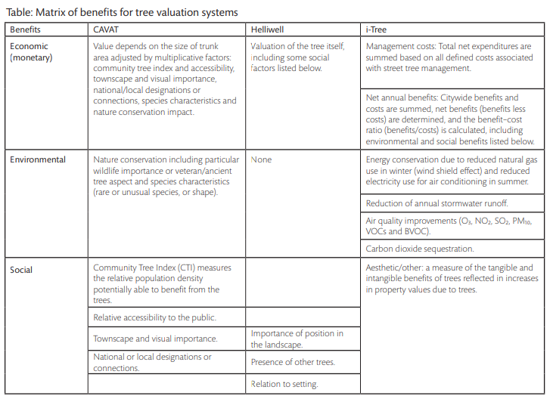
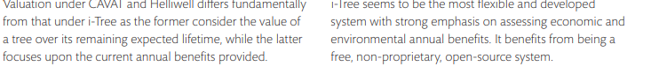
Social and Economic research Group. Forest research (Forestry Commission) 2008

Appendix 2
Woodland Cover in Wales
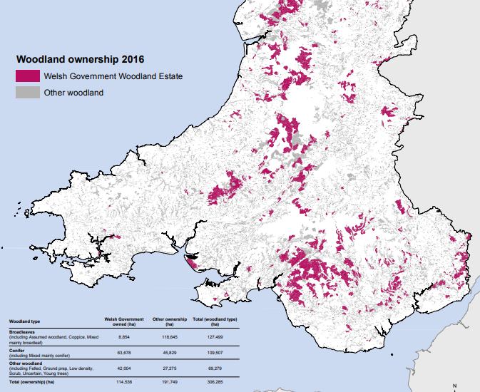

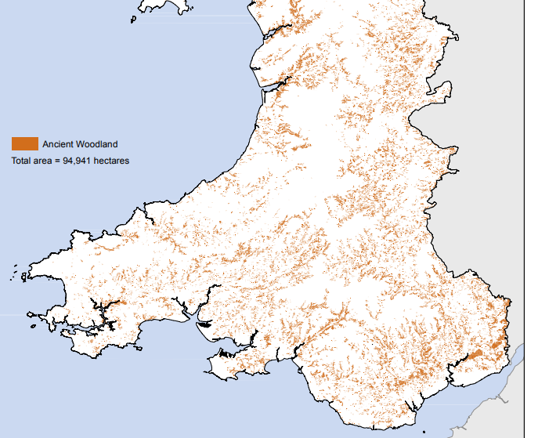
Woodland cover in Wales
Source; Woodlands for Wales Strategy 2018 (Welsh Government)
©Crown Copyright

