Module Code: BMIH5005
Module Name: Personnel Resourcing and Development
Lecturer’s name:Scott James
Student name in full: Ivascu Ana
Student ID:2239390

Assessment Component 1- Essay
“Discuss how the evolution of HRM facilitates the strategic development
of an international hotel brand through workforce planning, recruitment and selection.

The evolution of HRM plays a very important role in the process of driving the strategic development of an international brand through strategic planning, recruitment and also the selection process. This study discusses how Premier Inn, a well-known hotel brand in the UK, can effectively manage its planning, workforce, selection and recruitment process through the evolution of its Human resource management. Premier Inn is mainly a well-established hotel brand in the UK providing some budget-friendly accommodation in addition to the consistent service quality. Premier holds a very strong position in the UK market. In 2022 teh Premier Inn captured about 11.2 % of the market share and their revenue for the year ending of 2023 was about £ 967.9 million. This study discusses the evolution of Premier Inn discussing its transition from various traditional operational management to a proper strategic focus. This particular form of evolution is very important for the alignment of the workforce with the organizational objectives. This assignment also discusses the strategic HRM of Premier Inn giving importance to its transition from traditional operating management to a proper strategic focus

The evolution of the Human Resources Management (HRM) within the Premier Inn shows a proper strategic shift from traditional operational practices to a well-defined holistic approach which is particularly aligned with organizational goals as well as the market dynamics (Grefe et al., 2021). In personnel planning, Premier Inn has transitioned from reactive staffing to proactive skills management, focusing on figuring out current and future information desires to satisfy evolving customer demands and marketplace traits. This evolution encompasses studying employee demographics, assessing ability gaps, and implementing succession making plans to groom internal abilities for leadership roles, making sure continuity and strategic alignment. Additionally, Premier Inn's recruitment techniques have advanced to encompass enterprise branding, focused sourcing, and digital structures for skills acquisition. These techniques aim to attract top skills globally, beautify variety and inclusion, and construct a culturally capable frame of people critical for serving diverse client bases in global markets. Rigorous choice strategies in addition make certain that recruited humans not simplest very own the necessary capabilities but additionally align with Premier Inn's values and customer-centric ethos, contributing to provider excellence and purchaser pride. (Francois et al., 2021)This data-driven approach also includes that of the two-employee performance as well as the process of engagement, with data analytics informing training as well as the particular development programs, performance evaluations, and also the actual process of recognition initiatives, fostering a proper culture of continuous improvement as well as the employee satisfaction.

The strategic role of Human Resources (HR) functions within a proper Premier Inn includes that of the proper approach aimed at the process of driving organizational success, fostering employee engagement, and also properly ensuring strategic alignment with that of the various forms of business objectives(Farooqi al., 2021). Workforce planning emerges as a cornerstone of Premier Inn's HR method, with a focus on aligning the personnel composition with evolving corporation needs and marketplace dynamics. This entails analyzing the body of workers' demographics, assessing talent gaps, and imposing succession planning to nurture inner expertise for control roles, making sure organizational continuity and strategic agility. Furthermore, Premier Inn's recruitment and choice techniques are strategically designed to draw top understanding globally, leveraging organization branding, centered sourcing, and digital systems to build a numerous and culturally functional team of workers. (Ahmed et al., 2021). Premier Inn's market leadership in addition to this is also strengthened by its data-driven insights, therefore enabling agile decision-making, market segmentation, as well as the targeted customer engagement strategies.

The strategic role of the Human Resources (HR) functions often significantly impacts strategic planning as well as the recruitment process within Premier Inn, therefore including the workforce planning, recruitment strategies, talent management, as well as the proper strategic alignment to drive organizational success. Strategic planning in HR consists of aligning the staff composition with evolving industrial business enterprise wishes and market dynamics, making sure that Premier Inn has the proper abilities in the area to gather its strategic goals (Elude et al., 2021). This includes studying staff demographics, assessing talent gaps, and enforcing succession making plans to nurture internal capabilities for management roles, fostering organizational continuity and strategic agility. HR's strategic making plans efforts additionally focus on forecasting destiny expertise desires, watching for enterprise tendencies, and developing strategies to attract, maintain, and expand top expertise. (Khatri, et al., 2021). This particular form of the strategic approach to recruitment not only can properly enhances the quality of hires but also has the potential to properly contributes to Premier Inn's employer brand, attracting that of the top talent who has the potential to properly align with the company's values, culture, as well as the customer-centric ethos.

The strategic HR planning process within the context of the Premier Inn involves a proper form of meticulous approach in the process of forecasting labor demand as well as the process of supply, crucial for the purpose of maintaining optimal workforce levels which can be properly aligned with business objectives as well as the market dynamics’ (Pereira et al., 2021). Premier Inn conducts a meticulous evaluation of internal and outside elements which have an effect on frame of people call for, together with company boom projections, seasonal tendencies, technological improvements, and market dynamics. This evaluation enables in projecting destiny talent wishes as it need to be.The HR team collaborates closely with business employer leaders and department heads to acquire insights on present day personnel abilties, destiny information necessities, talent gaps, and capacity turnover expenses. Leveraging ancient statistics, marketplace research, and agency benchmarks, Premier Inn develops cutting-edge forecasting fashions to assume future hard work needs successfully.
.

Within the actual Premier Inn, there are some strategic HR planning processes that actually revolve around goal setting as well as proper strategic planning, which is very much essential for aligning the workforce with that of the organizational objectives as well as that of driving sustained business growth. The method begins with a complete analysis of Premier Inn's strategic dreams, mission, and vision, ensuring HR initiatives are right away aligned with the enterprise's overarching approach. HR collaborates intently with senior managers to apprehend enterprise priorities, market dynamics, competitive panorama, and growing industry inclinations, shaping HR dreams and techniques because of this (Faruk et al., 2021). Premier Inn aligns its HR techniques with the organization's strategic desires, assignment, and vision. This alignment guarantees that HR initiatives right now contribute to the corporation's overarching approach.HR collaborates closely with senior manipulate to recognize organisation priorities, market dynamics, aggressive panorama, and rising agency tendencies. This collaboration shapes HR desires and techniques therefore.Goal installing HR involves defining clear, measurable, and actionable dreams associated with personnel planning, recruitment, talent control, employee engagement, diversity and inclusion, standard performance control, and control improvement.These goals are knowledgeable by way of statistics-pushed insights, industry benchmarks, nice practices, and stakeholder comments, ensuring strategic alignment and relevance to Premier Inn's commercial enterprise priorities.

In Premier Inn, the different form of strategies strategic HR planning process also properly extends to that of the program implementation as well as proper evaluation which is very much crucial for translating HR strategies into the different form of actionable initiatives as well as the process of assessing their impact on organizational performance. Program implementation includes executing HR projects related to the frame of workers making plans, recruitment, abilities control, worker engagement, range and inclusion, performance manipulation, control improvement, and trade management (Josh et al., 2021). Premier Inn's HR team collaborates with several stakeholders to roll out applications efficiently, ensuring alignment with strategic desires, resource allocation, timeline manipulation, and verbal exchange strategies.HR collaborates with severa stakeholders to roll out these applications efficaciously, making sure resource allocation, timeline manipulate, and effective communique techniques.For instance, staff planning programs may moreover consist of abilities acquisition techniques, succession planning frameworks, and frame of employees analytics systems to optimize frame of people composition and assist Premier Inn's increase goals. Recruitment programs interest on attracting pinnacle talent through branding campaigns, cantered sourcing, and streamlined selection processes, enhancing(Getinge et al., 2021) Premier Inn's capabilities pool and competitive benefit.Talent control programs embody training and improvement tasks, overall performance manage systems, reputation packages, and career development pathways to nurture key information, force engagement, and promote performance excellence.Employee engagement packages prioritize developing a pleasant art work way of life, selling work-lifestyles stability, and enhancing conversation channels to boost morale, motivation, and productiveness. Performance management programs involve setting clear performance expectations, providing regular feedback, as well s properly implementing performance appraisal systems in order to properly drive continuous improvement and also proper form of accountability.

Premier Inn's recruitment stages as well as the proper selection process are very much integral components of its strategic HR planning, which is properly designed tin order to properly attract top talent as well as properly support business unit development, and also properly drive some form of organizational success. The recruitment system in Premier Inn typically follows numerous key tiers, each contributing to the overall aim of identifying, attracting, and choosing the first-class applicants for numerous roles within the organization. These ranges can be seen through the recruitment of a Front Office Manager function, showcasing how Premier Inn strategically helps business unit improvement through HR planning, recruitment, and choice.

Premier Inn exemplifies how strategic HR planning, recruitment, and preference approaches make contributions to employer unit development. For example, in aligning HR making plans with commercial enterprise targets, Premier Inn conducts thorough frame of people analyses to perceive expertise gaps and destiny expertise wishes, facilitating the development of commercial business enterprise devices via making sure the proper talents is in place to power growth and meet evolving marketplace needs(Гуменюк et al., 2021). In phrases of recruitment), Premier Inn strategically draws pinnacle information thru focused sourcing, leveraging its brand reputation and profession improvement opportunities to lure applicants who align with the business enterprise's values and strategic desires. This recruitment strategy now not handiest bolsters the commercial enterprise unit's skills but also strengthens Premier Inn's average marketplace competitiveness.

Job Analysis and Planning: The technique starts off evolving with a detailed mission analysis to recognize the characteristic necessities, duties, competencies, and qualifications desired for the Front Office Manager function. Premier Inn's HR team collaborates with the hiring supervisor and commercial organization unit leaders to define the activity description, outlining key capabilities, enjoy stages, and performance expectations essential for success inside the function. This strategic alignment guarantees that the recruitment manner is customized to meet the particular wishes of the commercial employer unit and assist its improvement desires.
Candidate Sourcing and Attraction: Premier Inn employs numerous techniques to attract a diverse pool of certified applicants for the Front Office Manager function (Grefe et al., 2020). This consists of leveraging online process portals, professional networking systems, industry-unique establishments, and social media channels to reach potential applicants. Additionally, Premier Inn utilizes its organization branding initiatives, highlighting its values, manner of life, career increase possibilities, and worker benefits to draw pinnacle skills who resonate with the enterprise's ethos and imaginative and prescient).

Interviews and Selection: Shortlisted candidates are invited to take part in comprehensive interviews, which includes panel interviews with key stakeholders which consist of branch heads, senior managers, and HR representatives. These interviews investigate applicants' technical abilities, management skills, hassle-solving capabilities, conversation abilities, and alignment with Premier Inn's values and strategic desires. Behavioral interviews also can be completed to delve deeper into candidates' past reports, selection-making procedures, and capacity to address hard situations applicable to the Front Office Manager feature. Through mounted interview tactics and evaluation standards (Alease al., 2021), Premier Inn guarantees that the very last choice displays a strategic healthful with the economic agency unit's development desires, contributing to its boom, performance, and overall performance excellence.
Onboarding and Integration: Upon preference, Premier Inn permits a strong onboarding and integration technique for the newly hired Front Office Manager. This includes complete orientation periods, activity education, introductions to key stakeholders, and clean expectations placed regarding roles, responsibilities, and typical performance desires. By the process of properly investing in the different form of effective onboarding practices, Premier Inn has the potential to properly accelerates the integration of the new form of new talent into the business unit therefore helping to properly fostering productivity, engagement, as well as proper alignment with that of the strategic priorities from the outset

Therefore, it can be concluded that the Premier Inn's strategic Human Resources (HR) planning plays a very vital role at the time of the business unit development as well as the organizational success. Through a meticulous team of workers making plans, recruitment stages, preference approaches, and talent control strategies, Premier Inn aligns its HR projects with strategic goals, ensuring a skilled and inspired group of workers that contributes to organization growth. The evolution of HRM within Premier Inn displays a shift towards proactive talent management, facts-driven preference-making, and a client-centric technique, vital for keeping an aggressive component within the hospitality industry. By strategically setting goals, imposing packages, and evaluating results, Premier Inn's HR talents strengthen non-prevent development, worker engagement, and customer delight, positioning the corporation as an organization of preference and a pacesetter within the dynamic hospitality quarter

Implementing different work modes in the hotel and hospitality sector becomes important for companies to foster employee engagement as well as adapting changing trends and also enhance services to meet customers’ requirements (Rabiul and Yean, 2021). Flexible work schedules, remote working, contractual working, job sharing, task-based working, developing hybrid working models and more alternate ways provide opportunities for companies in this sector to obtain overall development accordingly.
Premier Inn Limited is the largest British hotel chain corporation that works with the collaboration of Whitebread Plc in the United Kingdom. This hospitality chain company manages its business activities throughout the country with more than 900 hotels in various regions, totalling over 72,000 rooms (Premierinn, 2023). It is found that the hospitality company expands its service areas mainly in large cities, airport areas and different suburban locations to attract customers from different genres. According to estimates from The Guardian, Premier Inn successfully expectations by reporting £375 million in pre-tax profits in 2021 and 2022. Additionally, it is also identified that through expanded market operations, the company earned £58 million in 2022 which is 34% more than the total earnings of 2020 (Theguardian, 2023).
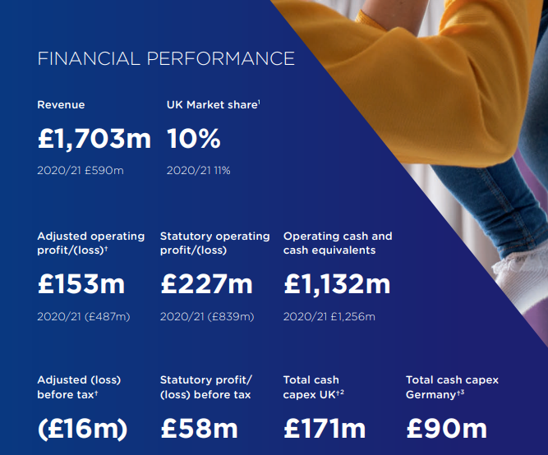
Annual Report of Premier Inn, 2022
(Source: Annualreports, 2022)
Based on the research work of Ntounis et al. (2022), it is identified that in the post-pandemic situation, companies in the global hospitality sector face different HRM issues that directly affect their employee management policies. Employee retention, changed management policies, increasing the popularity of hybrid working modes, touchless services and more factors become troublesome for contemporary hospitality companies. The Brexit and the global pandemic create economic issues for the entire hospitality sector in this current time. This project will analyse different socio-economic factors that affect the company’s growth and successful operations in the competitive environment. It can be mentioned that socioeconomic factors might impact HR management and employee monitoring in different work modes including office work arrangement, hybrid modes and others. This study will also analyse industrial trends at the current time and the emergence of different work modes in the hospitality sector in the last five years.

According to the research work of Thomas et al. (2021), it is identified that evaluating and identifying socio-economic factors becomes crucial for detecting whether it will be beneficial to enter a targeted market and finding out the best alternate strategies for enhancing ongoing operation tactics in the competitive environment.
Factors | Influences | Effects
Political | The UK has a stable political environment that makes it possible to expand the market successfully. The UK government has already taken advantage of several beneficial opportunities for the tourism and hospitality industry, including free market development, hassle-free promotions, tax rebates, term loans and strategic development to strengthen its position (Thomas et al. 2021). The country maintains diplomatic connections with other countries, providing chances for hospitality companies to attract foreign customers. | Opportunity
Economic | During the global pandemic, the UK economy faced multiple challenges including a drop in per capita income with a deterioration of the public’s buying limits. Thankfully, the country’s economic position and efficiency are stable now with the proper expansion of GDP by 2.7444 trillion US dollars (World Bank, 2023). It is also found that the rate of inflation has increased to 1.94% points which indicates the developing market experiences of the country after the troublesome pandemic and Brexit situations. This situation suggests that UK citizens are now able to increase their buying limits for pricey hospitality services. | Opportunity
Social | Within a given marketplace, social features have a big impact on organisational growth. After the situation of the global pandemic, citizens of the UK market are trying to overcome socio-economic issues by involving in the country’s economic plans. On the other hand, it is also identified that the UK has a large number of educated population which helps the company to get a skilled workforce. Premier Inn, a well-known hotel brand, uses social media marketing initiatives to reach potential customers. However, the labour cost of this market is comparatively higher due to the high literacy rate. | Moderate
Technological | Digital marketing is widely identified as the most efficient and long-lasting marketing strategy for companies that enable an organisation to contact a huge number of viewers seamlessly. It has been shown that over 90% of people in the UK are technologically advanced and utilise a variety of applications in their regular lives. This stage of technological advancement helps companies in creating modern, ethical and sustainable marketing practices. | Opportunity
Legal | Premier Inn is legally required to take into account several governmental regulatory laws as a hotel and hospitality business. These regulatory requirements cover a variety of topics including maintaining fair employment practices, tracking visitor records, and maintaining order. Due to rigorous standards of legal factors, companies face challenges in some specific areas in the UK market. | Threat
Environmental | Premier Inn generates industrial waste each day from its various locations, both connected to tourism and residential use. The government targets to minimise the overall wastage generation by 33% by 2025 (Casañ et al. 2021). The corporation needs to adhere to stringent environmental requirements to meet regulatory targets. | Threat

Financial Trends: Based on the research work of Clark et al. (2021), it is identified that the significant contribution that the travel and tourism sector makes to the national economy of the UK. In the same study, it is also identified that before the pandemic time, the tourism sector helped the domestic budget by £234.5 billion. Despite the significant decline in 2020, the criterion showed a positive trend in 2021, even though £131.5 billion was twice before the pandemic time. The national tourist agency aims that the UK tourism industry will be valued at £257 billion by 2025.
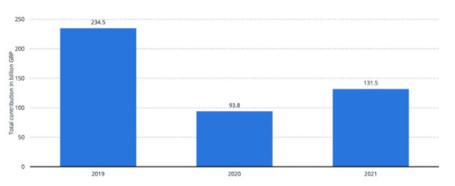
Total contribution of travel and tourism to GDP in the UK in 2019 and 2022
(Source: Statista, 2023)
Retention and Turnover Rate Trends: According to the research work of Statista, it is identified that the turnover rate of the UK tourism sector is very high and it is also identified that nearly 37.6% of employees in this sector leave their jobs each year (Statista, 2023). From the research work of the UK's famous hospitality management organisation Hospitalitynet, it is found that in 2023, after the pandemic turbulence, the employment rates in the hospitality sector in the UK have increased. 46% of hospitality jobs are increased. However, due to complex market situations, 42% of newly joined employees leave their jobs within 90 days (Hospitalitynet, 2023). Currently, the government and individual companies are taking serious steps to minimise the employee turnover rate in this industry by increasing various job opportunities.
Globalisation and Digitalisation: Due to the world's growing interconnectedness, the overall rates of international tourism have increased. Based on the study by Kim (2020), it is found that as more visitors travel across the globe for multiple purposes, the tourism sector has gained from this trend. Different UK-based tourism companies provide multiple offers to individuals which increases the trends of globalisation in the tourism industry. On the other side, due to the development of technologies, many companies take direct support from digital technologies to reach potential customers including social media accounts, internet booking platforms and others.

- Flexible Schedules: Due to constant pressures on employee retention rates, companies in the UK hospitality sector are forced to adopt the flexible work schedule strategy and it has become a popular trend in this industry in the last 5 years. Employers in the hospitality industry are implementing more flexible scheduling policies to meet the needs of balancing work-life for their employees (Chung et al. 2021). Along with permanent employment, companies in this sector also focus on part-time, freelancing and seasonal work modes to make employees’ work schedules flexible.
- Remote Working: Although remote working was not familiar to the hospitality industry in the past decade, it became popular after the COVID scenario. Today, most companies allow remote working to some administrative, marketing, finance and business planning employees which was totally not popular in this sector for five years.
- Gig Economy Platforms: Based on the findings of Montgomery and Baglioni (2021), it is identified that the concept of Gig Economy Platforms has become popular in the last five years. Like other sectors, the hospitality industry has witnessed the growth of platforms in the Gig economy that link independent contractors or freelancers with temporary work openings. It is found that these platforms serve both individuals seeking favourable and flexible work arrangements by providing opportunities for workers to select their locations and shifts.
The hospitality industry focuses on improving employee performance to develop the quality of guest service and increase communication with potential customers by providing innovative solutions in different work modes. Different renowned hotel brands have focused on improving the efficiency of employees in different work modes including hybrid and remote work in the post-COVID-19 situation. According to Kaushik (2020), in the hospitality sector of the UK, 88% of organisations introduced new methods of employee performance management in hybrid and remote environments. For example, As per the report of Marriott (2020), Marriott has introduced a new digital platform ‘My Marriott Hospitality’ to manage employees in remote and hybrid working harming to control their performance across 8000 global hotel chains. The platform has encouraged around 50% of its managers to improve their virtual performance to improve communication and provide real-time feedback to improve the efficiency of workers (Marriott, 2020).
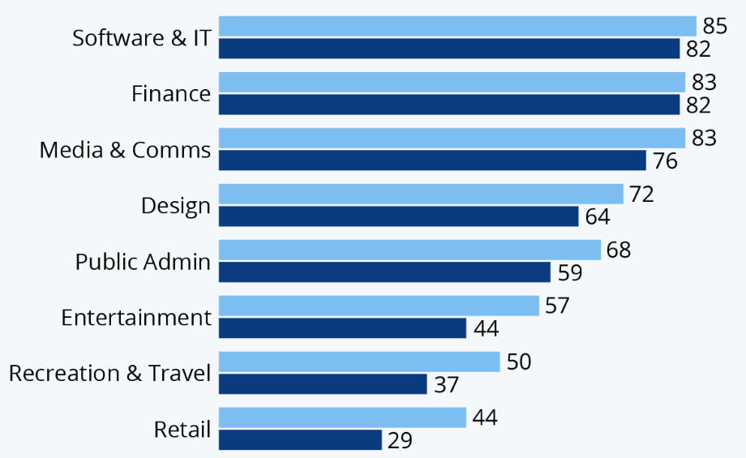
Figure: Infographic: Which Industries Are Best Geared Towards Remote Working?
(Source: Statista, 2020)
On the other hand, as reported by Radisson (2024), the Radisson Hotel Group has developed the ‘Radisson People Pulse’ program to monitor the performance of over 94,000 employees in more than 1100 hotels across the world. This program shows that 20% of employees improve their performance with proper coaching which helps to increase employee engagement by 12% in the hybrid work mode. According to Premier Inn (2024), Another example from the UK hospitality industry is Premier Inn which adopted Microsoft Viva to improve the performance of 47,000 as it introduced a 65% Hybrid work mode to maintain flexibility in the organisation. These digital solutions help to integrate collaboration and productivity of employees in different work notes to improve the reputation of Hotel brands in the competitive market.

From the study, it can be concluded that during the pandemic time, activities of the hospitality sector were totally paused. In current days, overcoming former financial loss becomes challenging. On the other hand, the buying limits of customers are affected by the pandemic scenario. It can be also inferred from the study that due to the changes in the industrial sector, being a large company, Premier Inn also considered different market-wise situations in their activities to develop effective employee engagement strategies that can be supported by socio-economic changes in the external market.

After completing the study, it can be recommended that the company consider the social and technological development of the market and establish effective plans to enhance business operations. By considering digital marketing, and utilisation of automation in customer services and promotions, the company might get socio-economic opportunities because customers in this current situation focus on digital support programs.
It can be also mentioned the company to consider hybrid working models with flexibility for employees. So that they can enjoy their working time and engage in work both from the office and remote locations accordingly. Implementing gig economy platforms will be also beneficial for the company to increase employee engagement rates in changed socio-economic scenarios.
Upskilling along with career progress will be also beneficial for Premier Inn to enhance the working level of employees to face multiple industrial changes. Moreover, it can be also recommended to the firm that it needs to focus on employees’ skill gaps and overcome their lacks through proper training programs.

Reference List
Annualreports, 2022, ‘Annual Report’, available at: https://www.annualreports.com/Company/whitbread-plc accessed on: 25-04-2024
Casañ, M. J., Alier, M., and Llorens, A. 2021. A collaborative learning activity to analyze the sustainability of an innovation using PESTLE. Sustainability, 13(16), 8756.
Chung, H., Birkett, H., Forbes, S. and Seo, H., 2021. Covid-19, flexible working, and implications for gender equality in the United Kingdom. Gender & Society, 35(2), pp.218-232.
Clark, J., Mauck, N. and Pruitt, S.W., 2021. The financial impact of COVID-19: Evidence from an event study of global hospitality firms. Research in International Business and Finance, 58, p.101452.
Hospitalitynet, 2023, ‘Employee Turnover Trends’, available at: https://www.hospitalitynet.org/opinion/4117334 Accessed on: 25-04-2024
Kim, Y.R., 2020. The impact of spatial clustering on the labour productivity of the UK tourism and hospitality industry (Doctoral dissertation, University of Surrey).
Montgomery, T. and Baglioni, S., 2021. Defining the gig economy: platform capitalism and the reinvention of precarious work. International Journal of Sociology and Social Policy, 41(9/10), pp.1012-1025.
Ntounis, N., Parker, C., Skinner, H., Steadman, C. and Warnaby, G., 2022. Tourism and Hospitality industry resilience during the Covid-19 pandemic: Evidence from England. Current Issues in Tourism, 25(1), pp.46-59.
Premierinn, 2023, ‘International Development’, available at: https://www.premierinn.com/gb/en/business/international-development accessed on: 25-04-2024
Rabiul, M.K. and Yean, T.F., 2021. Leadership styles, motivating language, and work engagement: An empirical investigation of the hotel industry. International Journal of Hospitality Management, 92, p.102712.
Statista, 2023, ‘Total contribution of travel and tourism to GDP in the United Kingdom (UK) in 2019 and 2022’ available at: https://www.statista.com/statistics/598093/travel-and-tourism-gdp-total-contribution-united-kingdom-uk/ Accessed on: 25-04-2024
Theguardian, 2023, ‘Premier Inn owner surpasses pre-Covid profits as travellers seek deals’, available at: https://www.theguardian.com/business/2023/apr/25/premier-inn-whitbread accessed on: 25-04-2024
Thomas, P. J. M., Sandwell, P., Williamson, S. J., and Harper, P. W. (2021). A PESTLE analysis of solar home systems in refugee camps in Rwanda. Renewable and Sustainable Energy Reviews, 143, 110872.
World Bank, 2023. GDP and inflation of the UK. Available at: https://data.worldbank.org/indicator/NY.GDP.DEFL.KD.ZG?locations=GB Accessed on: 25-04-2024.
Kaushik, M., 2020. Post COVID-19 World-A Paradigm Shift at Workplace. Test Eng. Manag, 83, pp.1-13.
Marriott, 2020. Marriott International Introduces New Content On Digital Platform For Meetings & Events. Available at: https://news.marriott.com/news/2020/08/11/marriott-international-introduces-new-content-on-digital-platform-for-meetings-events (Accessed: 25 April 2024).
Radisson, 2024. ‘Radisson People Pulse’: A new initiative. Available at: https://www.radissonhotels.com/en-us/corporate/media/press-releases/revenue-management-innovation (Accessed: 25 April 2024).
Premier Inn, 2024. .Premier Inn adopts addressing technology what3words. Available at: https://www.premierinn.com/gb/en/news/2019/what3words.html (Accessed: 25 April 2024).
Statista, 2020. Infographic: Which Industries Are Best Geared Towards Remote Working? Available at: https://www.statista.com/chart/21732/attitudes-towards-remote-working-on-an-individual-and-industry-level/ (Accessed: 25 April 2024).
Sarwar, H., Ishaq, M.I. and Franzoni, S., 2024. Influence of HRM on CSR and performance of upscale hotels in developed and developing countries. Environment, Development and Sustainability, 26(1), pp.335-357.
Grefe, G. and Payrate-Guillard, D. eds., 2020. Shapes of Tourism Employment: HRM in the Worlds of Hotels and Air Transport. John Wiley & Sons.
Francois Kouklakis, A.S., Adams, K. and Oyedeji, A., 2020. The contribution of human resource development managers to organizational branding in the hotel industry in India and South East Asia (ISEA): a dynamic capabilities perspective. Employee Relations: The International Journal, 43(1), pp.131-153.
Bergs, Y. and Lube, X., 2020. International human resource management in the hospitality industry. The Routledge Companion to International Hospitality Management, pp.279-295.
Costa, N., Oliveira, C.M. and Oliveira, I., 2021. The role and relevance of human resource management and its practices in the Portuguese hotel industry. Tourism and hospitality management, 27(2), pp.407-427.
Farooq, R., Zhang, Z., Talwar, S. and Dhir, A., 2022. Do green human resource management and self-efficacy facilitate green creativity? A study of luxury hotels and resorts. Journal of Sustainable Tourism, 30(4), pp.824-845.
Ahmed, Z., Khosa, M., Rehman, S.U. and Omar FAQ era, A.F., 2023. Towards sustainable development in the manufacturing industry: does green human resource management facilitate green creative behavior? A serial mediation models. Journal of Manufacturing Technology Management, 34(8), pp.1425-1447.
Elude, O., Akinbode, J., Ogunleye, O.I., Bakare, A. and Ogunrinde, R., 2023. Digitalization of Human Resources Management Practices in Nigeria's Hospitality Industry. In Strategic Human Resource Management in the Hospitality Industry: A Digitalized Economic Paradigm (pp. 79-96). IGI Global.
Kaushal, N., Kaurav, R.P.S., Sivathanu, B. and Kaushik, N., 2023. Artificial intelligence and HRM: identifying future research Agenda using systematic literature review and bibliometric analysis. Management Review Quarterly, 73(2), pp.455-493.
Khatri, N., 2021. Evolving uses of artificial intelligence in human resource management in emerging economies in the global South: some preliminary evidence. Management Research Review, 44(7), pp.970-990.
Pereira-Moliner, J., Molina-Azurin, J.F., Tari, J.J., López-Gamero, M.D. and Perturbs-Ortega, E.M., 2021. How do dynamic capabilities explain hotel performance?. International Journal of Hospitality Management, 98, p.103023.
Farrukh, M., Raza, A., Ansari, N.Y. and Bhutta, U.S., 2022. A bibliometric reflection on the history of green human resource management research. Management Research Review, 45(6), pp.781-800.
Joshi, A., Kataria, A., Rastogi, M., Buetel, N.J., Ahmad, S. and Yusoff, Y.M., 2023. Green human resource management in the context of organizational sustainability: A systematic review and research agenda. Journal of Cleaner Production, p.139713.
Choudhary, P. and Datta, A., 2024. Bibliometric analysis and systematic review of green human resource management and hospitality employees' green creativity. The TQM Journal, 36(2), pp.546-571.
Getinge, D.E., Oladapo, J.O., Elfie, O.A., Jairo, E. and Ezeafulukwe, C., 2024. Strategic HRM in the logistics and shipping sector: Challenges and opportunities.
Гуменюк, В., Казюка, Н., Маланюк, Т., Вівсюк, І. and Бетлей, А., 2022. International hotel and tourism business: anti-crisis management aspects. Financial and credit activity problems of theory and practice, 1(42), pp.493-501.
Already, M., Bujdosó, Z., Kabil, M., Akaak, A., Benkó, K.F., Setianingtyas, W.P. and Dávid, L.D., 2022. Green human resources management in the hotel industry: A systematic review. Sustainability, 15(1), p.99.
Ahmed, U., Umrani, W.A., Yousaf, A., Siddiqui, M.A. and Pahi, M.H., 2021. Developing faithful stewardship for the environment through green HRM. International Journal of Contemporary Hospitality Management, 33(10), pp.3115-3133.
Seal, P.P. and Gupta, P., 2024. Artificial Intelligence in Human Resource Management in Hotels: A Qualitative Approach. In Utilizing Smart Technology and AI in Hybrid Tourism and Hospitality (pp. 277-290). IGI Global.
Tanveer, M.I., Yusliza, M.Y. and Fawehinmi, O., 2024. Green HRM and hospitality industry: challenges and barriers in adopting environmentally friendly practices. Journal of Hospitality and Tourism Insights, 7(1), pp.121-141.
Qadri, S.U., Bilal, M.A., Li, M., Ma, Z., Qadri, S., Ye, C. and Rauf, F., 2022. Work environment as a moderator linking green human resources management strategies with turnover intention of millennials: a study of Malaysian hotel industry. Sustainability, 14(12), p.7401.
Murillo-Ramos, L., Huertas-Valdivia, I. and García-Muiña, F.E., 2023. Exploring the cornerstones of green, sustainable and socially responsible human resource management. International Journal of Manpower, 44(3), pp.524-542.
Shah, P., Singh Dubey, R., Rai, S., Renwick, D.W. and Misra, S., 2024. Green human resource management: A comprehensive investigation using bibliometric analysis. Corporate Social Responsibility and Environmental Management, 31(1), pp.31-53.

