EFFECTIVE TEAMWORK AND COMMUNICATION
Executive Summary
The report contained discussions about teamwork and communication. It has shown how excellent communication helps to build a successful and productive team. Three particular models of communication have been explained here which has been implemented by the researcher of this report in the workplace. Next part of this report has explained the relationship between effective communication and teamwork. Every discussion of this report is associated with the findings of the researcher which have been obtained through implantation of the theories in the workplace.

Table of Contents
INTRODUCTION: 4
THEORIES OF COMMUNICATION 5
Berlo’s SMCR Model of Communication: 5
Osgood Schramm Model of Communication: 7
Social Identity Theory: 9
RELATIONSHIP BETWEEN COMMUNICATION AND EFFECTIVE TEAMWORK: 10
CONCLUSION: 11
Reference List 13

INTRODUCTION:
Teamwork means collaborative efforts of a group to achieve organisational goals and objectives. When team members work together to achieve common aims and interest and each member of the team serves with dignity and faith, that's called active teamwork. However, to maintain this effective teamwork, transparency and a positive environment in the team should come out on top and sustain transparency and positivity in the team, communication has a big role to play. Being an attentive listener and paying attention to body language makes communication effective and strong communication. Team leaders and team members have to perform excellent communication skills continuously in the job to extract the best outcome from the people (Lacerenza et al., 2018). Active communication skills build trust and bonding in team members which is necessary for effective teamwork.

Various types of communication skills are there like non-verbal communication, verbal communication and body language. Every member of the team should adopt these different kinds of communication skills to enhance the productivity and overall performance and development of the team. A good team leader must have the qualities of clarity, decisiveness, problem-solving ability and integrity. To perform the role properly with all these qualities he/she must be excellent in all types of communications (Mandala, 2018). Good communication reduces conflicts in the team and improves employee engagement. With the help of effective communication, team leaders express ideas and provide the exact perception of goals and success. It also helps team leaders to motivate and inspire the employees and make the team members understand what is expected from them. Good communication is also required to assure stakeholders or to convince possible investors.

This report will provide a clear outlook on the influence of affective and strong communication on teamwork and an overview of the connection between teamwork and communication.

THEORIES OF COMMUNICATION
Various theories will be discussed below.

Berlo’s SMCR Model of Communication:
Berlo's SMCR model is the simplest form of the linear communication process. As per Berlo's theory, four basic components are there as the basic of communication which are Receiver, Message, Sender and Channel. These four components are affected by different factors.
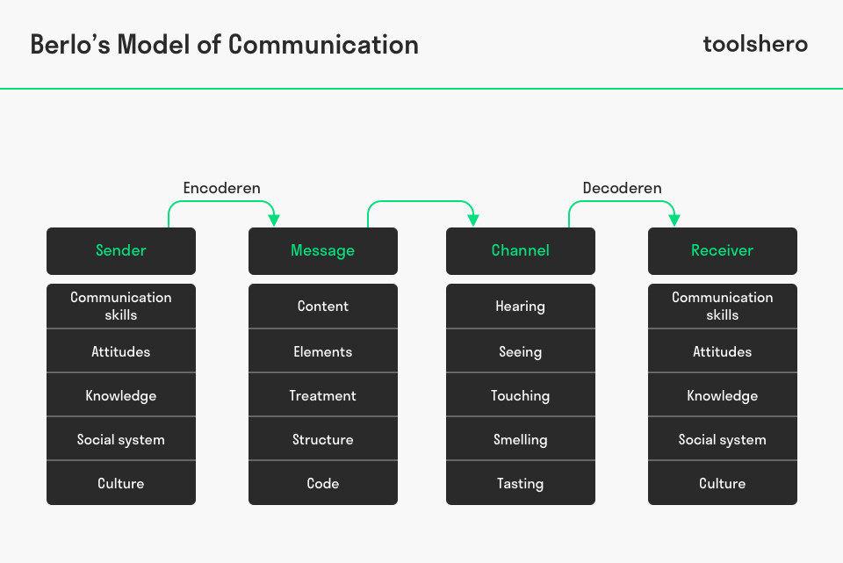
Fig 1: Berlo’s Model
(Source: https://www.toolshero.com/communication-skills/berlos-smcr-model-of-communication/)

Sender: Sender is the source i.e. start of the process. Message is constructed and encoded by sender. Then receiver receive the message. Sources can be affected by below mentioned factors.
- Skills - Includes speaking, reading, listening etc.
- Knowledge - Having a depth of knowledge about the subject of the message makes the communication stronger.
- Attitude - Meaning and outcome of the message depend on the attitude towards the subject, audience and receiver (Sutanto, 2016).
Also, differences in culture and social systems can interpret the message differently.

Message: Message is collection of information. Sender must send message to the recipient. There are various forms of messages like speech, text, audio and so on. Message can be affected by below mentioned attributes.
- Topic - Subject of the message
- Elements - Gestures or (non)verbal signs of the message.
- Treatment - How the message is sent.
- Structure - The way of structuring the message.
- Code - the form of the message i.e. text, video, audio, language, music, gesture etc (Sutanto, 2016).

Channel: Channel means the medium used in the communication and the medium must be capable to recognise by the human sensor system i.e.
- Hearing
- Seeing
- Smelling
- Touching
- Tasting

Receiver: Receiver means the person who at the end of a linear communication process receives and decodes the content. Berlo's model says, the thinking pattern of the sender and receiver must be in the same line (Sutanto, 2016). So, both the sender and receiver are affected by the same factors.

Disruptions: In reality, it is not a hazard free process. Below mentioned factors disturb the process in practice.
- Distortion - It is rare to find the actual motive is encoded by the sender in the message. It has also been found that after interpretation the message has lost part of its primary intention (Petersons and Khalimzoda, 2016).
- Noise - Noise disrupts the communication process and make the receiver unable or partially unable to interpret the messages. Example, background noise in a phone call.

Findings -
A researcher has developed Berlo's communication model in the workplace and gained knowledge about the effect of linear communication to the team (Petersons and Khalimzoda, 2016). It allows the team members to understand the subject knowledge properly and make them understand that with a proper attitude and body language transparency in communication systems can be maintained.

Osgood Schramm Model:
The Osgood Schramm model refers to a circular model of communication which explains exchange of informative subject which is received by recipient and send by source. According to this model, the sender and receiver can be the same person. Sender encodes the message and sends it to the same person or different person. Recipients receive and decode the message, interpret it and again encode it to send it to a new person.

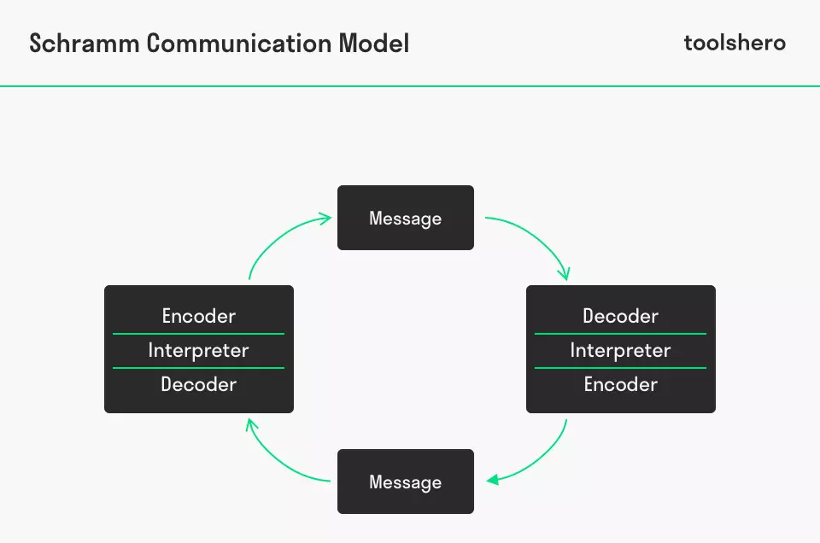
Fig 2: Schramm model
(Source: https://www.toolshero.com/communication-skills/schramm-communication-model/)

This contains three elements which are sender, message and receiver.
- Sender: The source of this process is the sender. Messages sent by the sender have to be informative, accurate and relevant. The message has to be encoded to properly receive by the recipient (John et al., 2019). It should be a simple and clear message. The way of encoding is affected by cultural background, skill, knowledge, experience and attitude of the sender.
- Recipient: Recipient means the individuals or the group of individuals who receives the messages. The recipient needs to decode the message. The decoding ability of a recipient depends on a few factors such as subject knowledge, trust on the source, cultural background, experience, attitude and skills.
- Message: Message is nothing else but information which is communicated to encoder from the source. It may contain verbal content (example - email, text messages, phone calls etc.) or non - verbal content (example - physical contact, eye contact, gesture, body language etc.)(John et al., 2019). Communication would be called effective communication when the recipient accurately interprets the message and provides proper feedback to the sender.

Findings -
At the workplace, the researcher has implanted the Schramm communication model. Researcher divides the role of components to three employees and confirms the accurate outcome of the process (John et al., 2019). While implementing this model researcher has gained lots of positivity in the workplace and felt that with the proper communication system actual thought can be delivered to others.

Social Identity Theory:
Social identity theory is about how people perceive themselves in a group they are attached to. This theory evaluates the intergroup behaviour in the light of reliability, status and authenticity. The major hypothesis of this theory is that the individuals in a group tend to attain and maintain a positive self-recognition i.e. social identity. Individuals of different interpersonal behaviour are established by their social identity.

Social identity theory narrates a few strategies. The decision to choose a specific strategy depends on permeability and status hierarchy. These strategies are intended for the group members who are currently stays in low status and has the intention to gain the supreme status.

- Individual mobility - According to this strategy, individual mobility strategies are often chosen by people when the chances to change the status is comparatively more. (Trepte and Loy, 2017). They put extra efforts to achieve interpersonal goals rather than group objectives.
- Social Competition – This theory is selected when the group member’s status is unstable. According to this strategy, people always want to gain positive identity recognition and to achieve that competition is done within the group.
- Social creativity - When the status of the group members is stable and boundaries are laid then individuals may engage in creative social behaviours (Scheepers and Ellemers, 2019). It can be executed by a comparison between the behaviour pattern of groups and individuals.

Findings -
The researcher implemented the Social Identity Theory in the workplace and find this theory more effective and significant. Besides the accurate content and appropriate interpretation, this theory helps to build strong team bonding (Scheepers and Ellemers, 2019). Direct competition enhances individual performance as well as team performance. Interacting socially also develops the confidence and self-esteem of team members.

RELATIONSHIP BETWEEN COMMUNICATION AND EFFECTIVE TEAMWORK:
Troubles and complications created by poor communication in the organisation cannot be realised until the business and a lower-level employee suffers. Massive and better communication is the key factor for effective teamwork. Poor communication negatively affects the information about project and job knowledge of the team member. Due to lack of knowledge employees would try to avoid the job which results in less productivity. Lack of communication increases misunderstanding among team members which negatively affect the desired goal of the organisation (Marlow et al., 2017). If team leaders are not proactively addressing the issues in the team then inaccurate information starts spreading in the organisation. It gives rise to bad interpersonal relationships. Misinterpretation occurs when team members don't feel connected to each other. Effective communication from every end of the organisational hierarchy can solve this issue. Regarding the current changes of the organisation team members need to be updated. The information must be shared with every team to adjust in the present scenario about any suitable change occurring in the organisation to maintain the position in the market. Due to unhealthy communication team members miss deadlines, appointments with clients and these made the superior as well as clients unhappy. In turn, dissatisfied clients will not continue their business with the organisation which cost the organisation huge loss.
Team members from different backgrounds can be tied up through good and healthy communication to attain the organisational goal. Team leaders here play a significant role to bring the team together. They need to clearly describe the job description to the team members and need to list out the priorities for every member. Brainstorming sessions, sessions for direct feedback, team meetings, planning sessions can be arranged to provide the teammates more detailed input of assigned tasks, set expectations and responsibilities (Valor-Segura et al., 2019). Face-to-face interaction with the teammates who are falling behind in the race can boost their morale high. The practise of active listening skills and wise use of email and texting apps with coworkers and clients resolve many queries and doubt automatically. Management needs to pool information directly to prevent any fatal consequences. It is the responsibility of management to set a transparent path of communication from the lower level to the upper level which helps to resolve any issue at the shoot.

Findings -
After adopting and diligently practising good communication in the workplace, the researcher finds teamwork and team bonding more effective. Good relationships and trust can be maintained among coworkers and every team member looks more confident and well-performed than earlier. According to the researcher, through effective communication, the decision-making quality of team management has also been improved in a needed time (Schmutz et al., 2019). People seem to be more interactive and open-minded in providing job-related feedback. So, for an organisation to
thrive, concrete and effective communication system and firm interpersonal relationship among every member of the organisation must be in focus.

CONCLUSION:
This report has assessed the concept of teamwork and its relationship with the effective communication system of the organisation. Strong communication is very much required in the world of technology and teamwork. it is the basic tool for management to perform basic functions like planning, leading, controlling etc. A comfortable work environment produces more effective outcomes. It is the responsibility of team leaders to maintain the workplace environment healthy through proper communication at each level of the organisation. Proper communication is not all about just sending a message to a group of people. It's about the assurance that the message has been interpreted and understood by the target audience properly. There must be mutual understanding in communication i.e. two-way traffic flow of information. Mutual understanding can be achieved when the recipient precisely hears the message of what the sender intended to convey and provides feedback to the sender about the conception. It is crystal clear in today's scenario that to be an exceptionally effective organisation, the mindset of the employee must be understood.

Reference List
Journals
John, P., Brooks, B. and Schriever, U., 2019. Speech acts in professional maritime discourse: A pragmatic risk analysis of bridge team communication directives and commissives in full-mission simulation. Journal of Pragmatics, 140, pp.12-21.
Lacerenza, C.N., Marlow, S.L., Tannenbaum, S.I. and Salas, E., 2018. Team development interventions: Evidence-based approaches for improving teamwork. American Psychologist, 73(4), p.517.
Mandala, H., 2018. Divergent Principles of Politeness in Verbal and Non-Verbal Directive Speech Act. International research journal of engineering, IT & scientific research, 4(2), pp.41-51.
Marlow, S.L., Lacerenza, C.N. and Salas, E., 2017. Communication in virtual teams: A conceptual framework and research agenda. Human Resource Management Review, 27(4), pp.575-589.
Petersons, A. and Khalimzoda, I., 2016, May. Communication Models and Common Basis for Multicultural Communication in Latvia. In Proceedings of the International Scientific Conference. Volume IV (Vol. 423, p. 433).
Scheepers, D. and Ellemers, N., 2019. Social identity theory. In Social Psychology in Action (pp. 129-143). Springer, Cham.
Schmutz, J.B., Meier, L.L. and Manser, T., 2019. How effective is teamwork? The relationship between teamwork and performance in healthcare teams: a systematic review and meta-analysis. BMJ open, 9(9), p.e028280.
Sutanto, S.M., 2016. The Use of Facebook Fanpage as Promotional Media for the Novel Book fans by using the Model of SMCR Berlo.
Trepte, S. and Loy, L.S., 2017. Social Identity Theory and Self‐Categorization Theory. The international encyclopedia of media effects, pp.1-13.
Valor-Segura, I., Navarro-Carrillo, G., Extremera, N., Fernández, L.M.L., García-Guiu, C., Bravo, M.I.R. and Moreno, A.R., 2019. Predicting Job Satisfaction in Military Organizations: Unpacking the Relationship between Emotional Intelligence, Teamwork Communication, and Job Attitudes in Spanish Military Cadets.

