  Component One:  What are the key skills required when working in the housekeeping team? 750 words (+/- 10%)  Contribution to Overall Module Assessment: 25% | Student No: | 2211131
 | Module Title: | Hotel Placement – Operating Hotel Facilities
 | Module Code: | BMIH4006
 | Lecturer: | Lisa Knight BA (Hons)
Working alongside colleagues in my recent placement, in hotel operations as a room attendant I gained had the chance to see it from a different perspective the demands of the essential skills needed to excel in this career if working in hospitality. My experience in Premier Inn allowed me to observe and understand the various tasks and responsibilities undertaken by housekeeping team colleagues. In this journal, I will highlight the key skills I identified as needed for working in the housekeeping department. I had the opportunity to actively engage in housekeeping duties during the placement and observe the tasks and responsibilities performed by the team in the department by paying attention to the skills they utilise to excel in their roles.

The fundamental skills recognised was attention to details Housekeeping professionals must meticulously clean and maintain the cleanliness and hygiene standards of various areas, public spaces, and back of house areas. Paying close attention to even the smallest details ensures that no aspect of cleanliness is overlooked.
For instance, as highlighted by Rutherford and O'Fallon (2006), the meticulous attention to detail exhibited by housekeeping staff in luxury hotels significantly influences guest satisfaction. A spotless room neatly arranged amenities, and properly folded towels contribute to an exceptional guest experience.
Time management skills are vital for housekeeping professionals who must efficiently complete tasks within specified timelines. They often have to adhere to strict schedules to accommodate guest check-ins, check-outs, and cleaning routines. Soltani and Wilkinson (2010) emphasise the significance of time management skills in the hospitality industry, efficiently managing time allows housekeeping staff to maintain high standards of cleanliness while ensuring rooms and public areas are prepared promptly for incoming guests.
Effective communication was a key skill that enhances collaboration among my colleagues in the housekeeping, or other departments, such restaurant, reception and maintenance. Clear and concise communication ensures smooth operations and the timely completion of tasks.
Nimri et all., (2020) highlight the importance of effective communication in the hospitality industry, emphasising the need for housekeeping professionals to communicate with colleagues to coordinate room turnover and address guest requests promptly. Strong communication skills also facilitate the reporting of maintenance issues or guest concerns, enabling swift resolution. Working in the housekeeping department noticed that it requires physical fitness and endurance as professionals engage in physically activities such as mattress turning heavy lifting quick room cleaning, equipment movement.
Alcalde-González et all (2021) underscore the physical demands of housekeeping work. They suggest that regular exercise and proper ergonomics training can contribute to the well-being of housekeeping staff and minimise the risk of musculoskeletal disorders.
I noticed how housekeeping department often faces unexpected challenges and changes, necessitating adaptability. I had to be flexible and capable of adjusting my priorities and approaches to accommodate evolving situations and guest needs.
Sanon's (2013) study emphasises the importance of adaptability in the hospitality industry, particularly in housekeeping. Housekeeping professionals need to be responsive to last-minute requests, changes in occupancy, and unforeseen events to maintain guest satisfaction and uphold cleanliness standards.

My placement experience in the housekeeping department allowed me to witness the significance of the identified key skills. I recognised the critical role played by attention to detail in ensuring exceptional guest experiences. Time management skills enabled me to complete tasks efficiently, meeting tight deadlines. Effective communication fostered collaboration and facilitated prompt issue resolution. The physical demands of the job highlighted the importance of maintaining physical fitness. By prioritising a welcoming manner, promptly responding to guest requests, anticipating their needs, and demonstrating empathy in problem-solving, I contributed to providing excellent customer service. These experiences reinforced the understanding that customer service is not limited to front-of-house roles but extends to every interaction within the hospitality industry. As I reflect on my placement, I appreciate the valuable lessons I learned and how they will shape my future approach to customer service in the housekeeping profession.

Overall, my placement experience provided insights into the housekeeping department's requirements and the key skills necessary to thrive in this role. It enhanced my understanding of the industry and develop my skills further more while setting a strong foundation for my future career in hospitality.

Word Count | 699

Component Two:
Contribution to Overall Module Assessment: 25%
In this scenario – You have just been promoted to team leader for a floor within the hotel. A guest complains that on their arrival, their room had not been properly cleaned. Create an action plan and answer the following questions.

Problem | Why did it happen? | What are you going to do? | How will you prevent this from happening in the future? | What measures would you introduce to improve team effectiveness?
Lack of communication | Been a breakdown interdepartmental communication leading to the room being mistakenly marked as cleaned when it was not | Establish clear communication protocols between the front desk and housekeeping department to avoid misunderstandings or errors | Implement a system for double-checking room statuses to ensure accurate information exchange | To prevent a breakdown in communication between the front desk and housekeeping department, I will suggest the hotel to establish clear communication protocols, implement double-checking systems for room statuses, and utilise digital tools for real-time information exchange.
Shortage of staff | Insufficient staffing levels have led to time constraints and rushed cleaning, resulting in certain areas of the room being overlooked or not cleaned thoroughly | Assess the staffing requirements and, if necessary, work with management to address any staffing shortages | Consider hiring additional staff, redistributing workloads, or adjusting scheduling to ensure sufficient time for thorough cleaning | Consider options such as hiring additional staff, redistributing workloads, or adjusting scheduling to allocate sufficient time for cleaning tasks
Room been maintained and not checked | The room have had maintenance issues with a malfunctioning plumbing, which delayed or prevented housekeeping from accessing the room for cleaning. | Develop contingency plans and procedures to handle unexpected events without compromising the quality of cleaning services | Provide additional training to housekeeping staff on adapting to changing circumstances while still prioritising cleanliness and guest satisfaction | Training staff to adapt to changing circumstances while maintaining cleanliness and guest satisfaction and ensure efficient communication between the maintenance and housekeeping departments to minimise delays in accessing rooms for cleaning.
Fire alarm evacuation | Fire alarm have diverted the attention of the housekeeping staff from completing the cleaning of the room and forget to return and carried on with the next | Establish a clear action on how to prevent this happening | By implementing a list of tasks to follow like where to leave the trolley to know where to start the job on return | Create a systematic approach for staff to return to the jobs without disturbing the route such as leaving the trolley in the room, only placing the chemicals back on the trolley if the room is done
Equipment malfunction | The housekeeping staff may have encountered equipment malfunctions as one of the cleaning solution dispenser not working correctly, resulting in incomplete mirror cleaning. | Ensure that all cleaning equipment is regularly inspected, maintained, and promptly repaired or replaced when necessary | Conduct training sessions for the housekeeping staff on proper equipment usage and troubleshooting techniques | Keeping a broken equipment sheet and ensure the equipment is labelled and not used until is up to be fixed to avoid faulty equipment usage

Component Three:
Contribution to Overall Module Assessment: 50%
Your task is to create and prepare a presentation following the detailed scenario provided below.

As the floor housekeeping manager and given the recent guest complaints you need to put together a basic training presentation for your colleagues within the housekeeping team to get the best out of them, ensure that brand standard is being achieved and that Health and Safety procedures are also being followed.

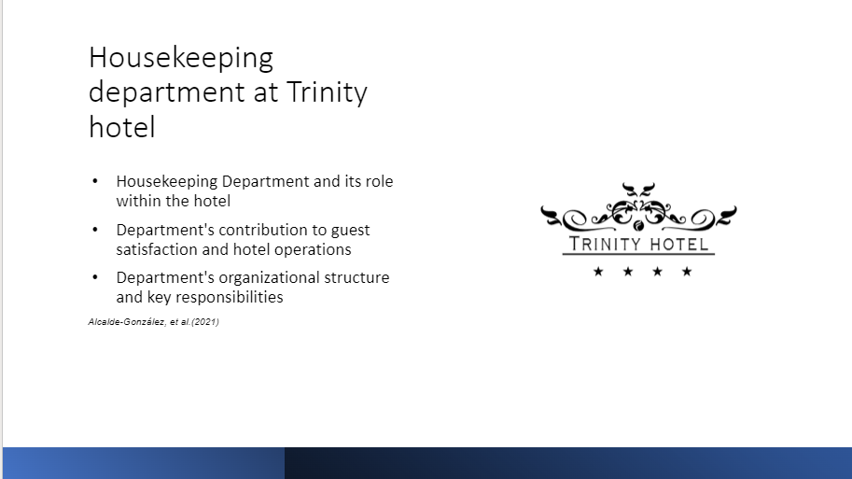
Training Notes: Housekeeping department

Housekeeping department is responsible for maintaining cleanliness, orderliness, and esthetical appeal throughout the hotel, ensuring a pleasant and comfortable experience for guests.

In terms of guest satisfaction, the Housekeeping Department's impact is to deliver to expectation. Guests expect clean and well-maintained rooms, which is our responsibility to meet and exceed these expectations.
These areas serve as the first impression for guests, and their cleanliness greatly influences guests' perception of the hotel. By keeping these areas well-maintained, the department contributes to creating a positive and welcoming atmosphere.

At our hotel team members of the Housekeeping Department in Trinity hotel reports to Housekeeping Manager who oversees the department's operations. This individual is responsible for managing the housekeeping team, coordinating daily tasks, and ensuring compliance with cleanliness and safety standards. The department is further divided into teams or shifts, with supervisors or team leaders overseeing specific areas or floors (Alcalde-González, et al., 2021).
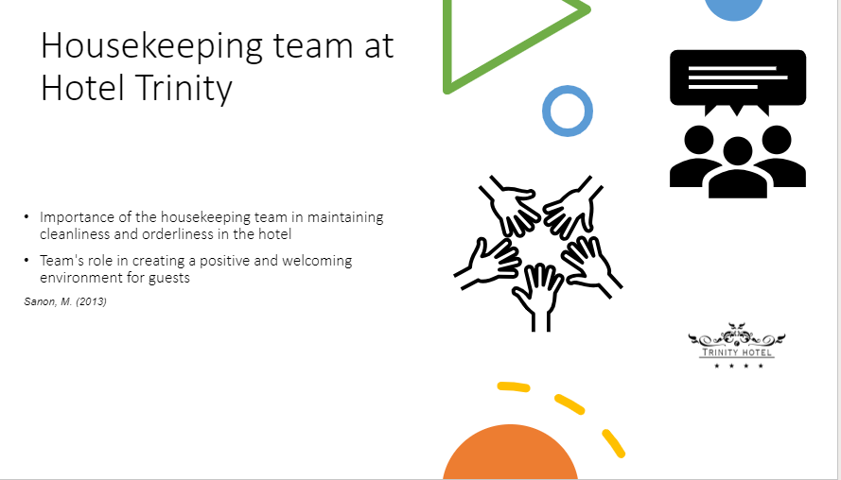
Training Notes: Housekeeping team

Your dedication and hard work are shown through our bookings and guests reviews here at Trinity hotel.

One of the key responsibilities of the Housekeeping Team is to ensure that guest rooms are impeccably clean and well-maintained. You create a clean and inviting space for our guests to relax and unwind.

Your diligent work in keeping these areas tidy and presentable sets a positive tone for their entire stay. Your attention to detail in these spaces creates a welcoming atmosphere and makes our guests feel valued and cared for.

In addition to cleanliness, the housekeeping team plays a significant role in ensuring the orderliness of the hotel. Your efforts in managing linens, supplies, and amenities contribute to the smooth operations of our establishment. By efficiently handling inventory and ensuring an adequate supply, you support the seamless functioning of our hotel and enable other departments to provide exceptional service (Sanon, M. 2013).

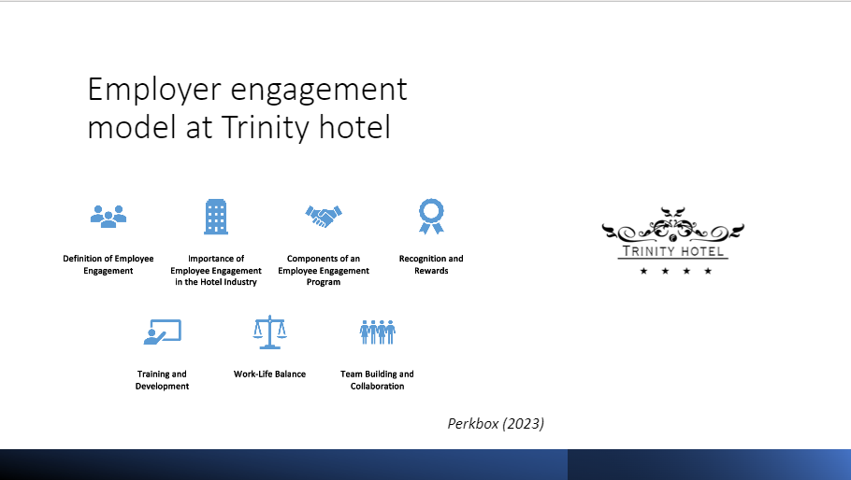
Training Notes: Employee engagement

We know our Employees dedication at Trinity hotel is shown trough they engagement to day to day activities engagement to the emotional commitment and dedication, that the team have towards the guests, hotel, and its goals.

The willingness of our staff it is encompasses the level of enthusiasm, motivation, and passion employees bring to their roles. At Hotel Trinity we work together to the satisfaction is of our guests, where employee engagement plays a crucial role in creating exceptional guest experiences and driving the success of the business.

In order to reward our dedicated team, we have implemented a reward program (Prekbox, 2023).

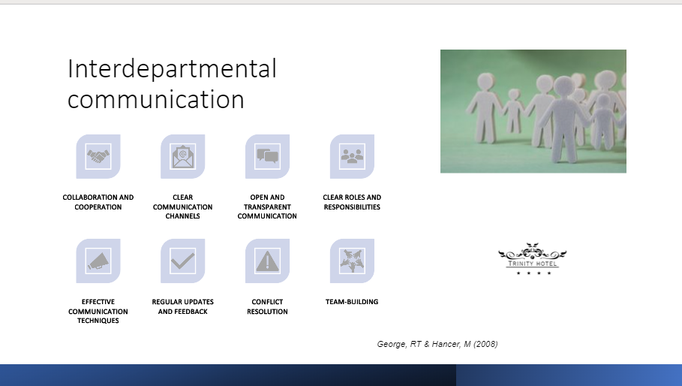
Training Notes: Interdepartmental communication

Effective interdepartmental communication is crucial for collaboration and cooperation within Trinity hotel. It involves clear and efficient exchange of information, ideas, and resources between departments.

Key factors for successful interdepartmental communication include establishing clear communication channels, promoting open and transparent communication, defining clear roles and responsibilities, utilising effective communication techniques, providing regular updates and feedback, resolving conflicts, and engaging in team-building activities.

When departments communicate effectively, it fosters a harmonious work environment, promotes problem-solving and decision-making, and contributes to the overall success of the Trinity hotel (George, RT & Hancer, M. 2008).
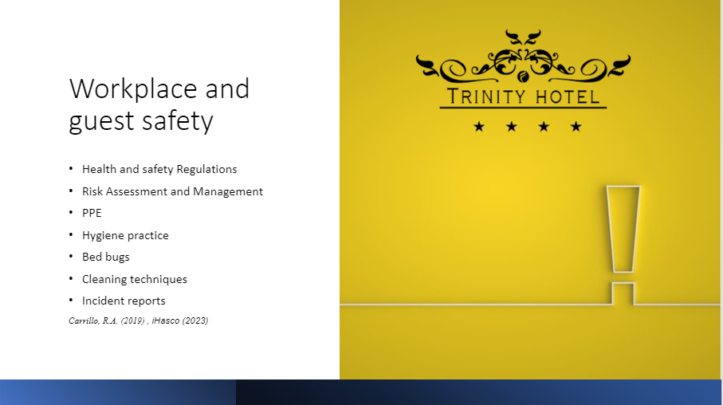
Training Notes: Workplace and guest safety

Workplace and guest safety in the Trinity hotel is ensured through adherence to health and safety regulations, conducting risk assessments, providing personal protective equipment (PPE), maintaining hygiene practices, addressing bed bug concerns, implementing effective cleaning techniques, and having a robust incident reporting system.

These measures aim to create a safe and secure environment for employees and guests, prevent accidents and infections, and protect the reputation of the hotel. Prioritising safety enhances guest satisfaction and contributes to the overall success of the establishment (Carrillo.R.A. 2019), (iHasco 2023).

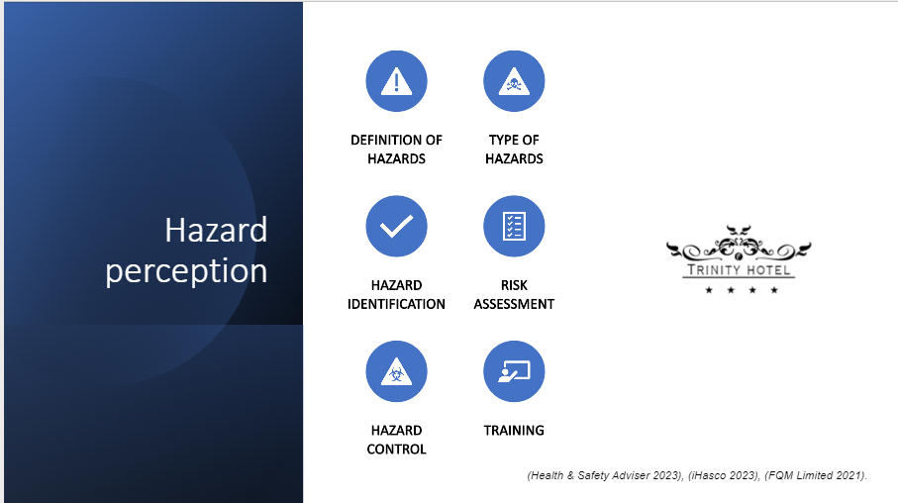
Training Notes: Hazard perception

Hazard perception in Trinity hotel involves the identification and assessment of potential hazards to ensure the safety of employees and guests.
Type of Hazazards:
- Physical
- Chemical
- Biological
- Ergonomic

Hazard perception requires conducting thorough hazard identification, assessing risks associated with the hazards, implementing appropriate hazard controls, and providing necessary training to employees.

By effectively perceiving and managing hazards, Trinity hotel can create a safer environment, reduce the risk of accidents, and protect the well-being of their workforce and guests (Health & Safety Adviser 2023), (iHasco 2023), (FQM Limited 2021).
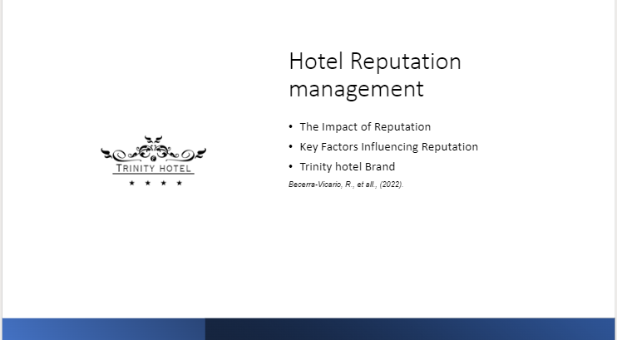
Training Notes: Hotel reputation management

Trinity Hotel reputation management is critical for the success of the hotel, as it directly impacts its ability to attract guests and generate our hotel. Factors such as service quality, guest satisfaction, online reviews and ratings, brand image, employee engagement, crisis management, and social responsibility influence a hotel's reputation.

By ensuring excellent service, addressing guest concerns, maintaining a strong brand identity, engaging and empowering employees, handling crises effectively, and demonstrating social responsibility, hotels can cultivate a positive reputation. This, in turn, leads to increased bookings, higher occupancy rates, and long-term success in the competitive hotel industry.

Brand awareness is another important factor in hotel reputation management. It refers to the level of familiarity and recognition that guests and potential guests have with a hotel's brand. Strong brand awareness helps hotels stand out in a crowded marketplace, build credibility, and attract a loyal customer base (Becerra-Vicario, R. et all., 2022).
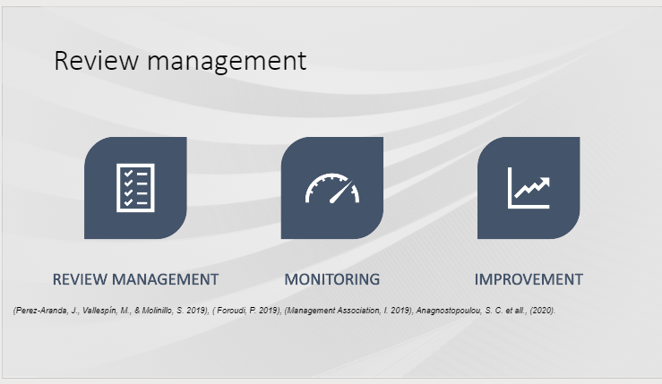
Training Notes: Review management

Review management is a crucial aspect of Trinity hotel reputation management. It involves monitoring and analysing guest reviews and feedback and implementing strategies for continuous improvement.

By actively listening to guest opinions and addressing their concerns, hotels can enhance the guest experience and demonstrate their commitment to guest satisfaction. Responding to reviews promptly and professionally, analysing patterns and trends, implementing staff training, conducting quality control measures, and promoting positive reviews are key components of effective review management.

By actively managing reviews, Trinity hotel can maintain a positive reputation, increase guest satisfaction, and attract more guests (Perez-Aranda, J., Vallespín, M., & Molinillo, S. 2019), (Foroudi, P. 2019), (Management Association, I. 2019), (Anagnostopoulou, S. C. et all., (2020).
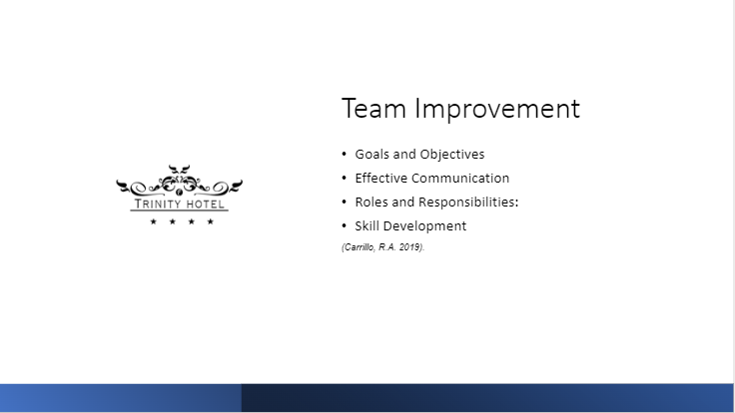
Training Notes: Improve the team.

At Trinity hotel the housekeeping team improvement is crucial for the success and productivity of a team. It involves setting clear goals and objectives, promoting effective communication, defining roles and responsibilities, and facilitating skill development.

By establishing clear goals, team members can work together towards a shared vision. Effective communication fosters trust and collaboration, while defining roles and responsibilities minimises confusion and conflicts. Skill development ensures that team members enhance their capabilities and contribute to the overall effectiveness of the team. By focusing on team improvement, organizations can create a positive work environment, enhance collaboration, and achieve their goals more effectively (Carrillo, R.A. 2019).

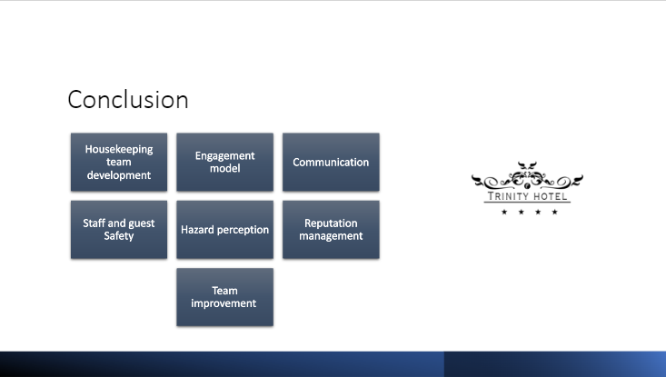
Training Notes: Conclusion

In conclusion, the development of the housekeeping team is crucial for the success of Trinity Hotel. Implementing an engagement model that encourages team members to actively participate and contribute to the team's goals and objectives is essential.

Effective communication plays a vital role in ensuring smooth coordination and collaboration within the team. Both staff and guest safety should be prioritised through adherence to health and safety regulations, hazard perception, and risk management practices. Reputation is key in maintaining the hotel, and continuous efforts should be made to enhance the hotel's reputation through guest satisfaction and effective review management.

Team improvement should be an ongoing process, focusing on goals, effective communication, skill development, and fostering a positive work environment. By prioritising these aspects, the housekeeping team can contribute significantly to the success and reputation of Trinity Hotel.

References

Alcalde-González, et al. (2021) No Clean Rooms, No Hotel Business: Subversion Tactics in Las Kellys’ Struggle for Dignity in Hotel Housekeeping. Annals of Tourism Research, vol. 91, Nov. 2021, p. 103315, Available on: https://doi.org/10.1016/j.annals.2021.103315 (Accessed on 9 June 2023).
Ambardar, A. & Raheja, K. (2017) Occupational Safety and Health of Hotel Housekeeping Employees: A Comparative Study. International Journal of Hospitality and Tourism Systems, vol. 10, no. 2, pp. 22-31. Accessed on: https://www.proquest.com/docview/1922311233?accountid=130472&parentSessionId=IY2n0%2FXKsM7%2BE0N88SXUPsp7afGIAhvVpRBrwwzuhsI%3D&pq-origsite=primo (Available on 9 June 2023).
Anagnostopoulou, S. C., Buhalis, D., Kountouri, I. L., Manousakis, E. G., & Tsekrekos, A. E. (2020) The impact of online reputation on hotel profitability. International Journal of Contemporary Hospitality Management, 32(1), 20-39. Accessed on: https://doi.org/10.1108/IJCHM-03-2019-0247 (Accessed on 9 June 2023).
Anthonisz, A. (2014) Assessing the future of housekeeping operations in Dubai's five-star hotel industry - room for innovation. Worldwide Hospitality and Tourism Themes, vol. 6, no. 4, pp. 352-361. Accessed on: Assessing the future of housekeeping operations in Dubai's five-star hotel industry - room for innovation? - ProQuest (Available on: 9 June 2023).
Becerra-Vicario, R., et all., (2022) Examining the effects of hotel reputation in the relationship between environmental performance and hotel financial performance. Journal of Hospitality and Tourism Management, [online] 53, pp.10–20. Accessed on: https://doi.org/10.1016/j.jhtm.2022.08.012 (Accessed on 9 June 2023).
Carrillo, R.A. (2019) The Relationship Factor in Safety Leadership. Abingdon, Oxon; New York, NY : Routledge, 2019.: Routledge. Available on: https://doi.org/10.4324/9780429057694 (Accessed on 9 June 2023).
Foroudi, P. (2019) Influence of brand signature, brand awareness, brand attitude, brand reputation on hotel industry’s brand performance. International Journal of Hospitality Management, 76(A), pp.271–285. Accessed on: https://doi.org/10.1016/j.ijhm.2018.05.016 (Accessed on 09 June 2023).
FQM Limited (2021) Introduction to COSHH. [online] www.youtube.com. Available on: https://youtu.be/HF8gP6-dPok (Accessed on 9 June 2023).
George, RT & Hancer, M (2008) ‘Housekeeping Managers and the Administration of Housekeeping Service’, International Journal of Hospitality & Tourism Administration, vol. 9, no. 4, pp. 365–383, Accessed on: https://search-ebscohost-com.ezproxy.uwtsd.ac.uk/login.aspx?direct=true&db=hjh&AN=36074002&site=ehost-live (Available on 9 June 2023).
Health & Safety Adviser (2023) Fire Protection Toolkit | Health & Safety Checklists | FREE DOWNLOAD. [online] Available on: https://www.safety-adviser.co.uk/lead/ed/fire-protection-toolkit/?affiliate=SEM_AGO_HSA_BNG_AGO_Fire_X-EM&msclkid=ac84cba2d41113e10f42af21b234eaab (Accessed on 9 June 2023).
iHasco (2023) Online Health & Safety Training for Hospitality. [online] Available on: https://www.ihasco.co.uk/courses/channel/hospitality/type/health-safety-training?utm_source=SearchEngineBing&utm_medium=Paid&utm_campaign=DSA&utm_keyword=ihasco%20co&msclkid=0fbc04e696ed178ba10d6065f02cc79c (Accessed on 9 June 2023).
Jones, P & Siag, A (2009) ‘A re-examination of the factors that influence productivity in hotels: A study of the housekeeping function’. Tourism & Hospitality Research, vol. 9, no. 3, pp. 224–234, Accessed on: https://search-ebscohost-com.ezproxy.uwtsd.ac.uk/login.aspx?direct=true&db=hjh&AN=42223574&site=ehost-live (Accessed on 9 June 2023).
Jones, TJA, & Jones (2007) Professional Management of Housekeeping Operations. John Wiley & Sons, Inc., Hoboken. Available on: ProQuest Ebook Central. https://ebookcentral.proquest.com/lib/trinity/detail.action?pq-origsite=primo&docID=315165 (Accessed on 9 June 2023).
Management Association, I. (Ed.). (2019) Brand Culture and Identity: Concepts, Methodologies, Tools, and Applications. IGI Global. Accessed on: https://doi-org.ezproxy.uwtsd.ac.uk/10.4018/978-1-5225-7116-2 (Accessed on 9 June 2023).
Nimri, R, Kensbock, S, Bailey, J, Jennings, G & Patiar, A (2020) ‘Realizing dignity in housekeeping work: Evidence of five-star hotels’. Journal of Human Resources in Hospitality & Tourism, vol. 19, no. 3, pp. 368–387, Accessed on: https://search-ebscohost-com.ezproxy.uwtsd.ac.uk/login.aspx?direct=true&db=hjh&AN=144473056&site=ehost-live (Accessed on 9 June 2023).
Perez-Aranda, J., Vallespín, M., & Molinillo, S. (2019) Hotel’s online reputation management: Benefits perceived by managers. International Journal of Contemporary Hospitality Management, 31(2), 615-632. Accessed on: https://doi.org/10.1108/IJCHM-07-2017-0460 (Accessed on 9 June 2023).
Prekbox (2023) How to set up an effective employee recognition program in 4 steps. [Online] Available on: How to Set Up an Employee Recognition Program | Perkbox Accessed on 11th June 2023).
Roy C Wood (2013) Key Concepts in Hospitality Management. London: SAGE Publications Ltd (SAGE Key Concepts Series). Available on: https://search-ebscohost-com.ezproxy.uwtsd.ac.uk/login.aspx?direct=true&db=nlebk&AN=1641824&site=ehost-live (Accessed: 9 June 2023).
Rutherford, DG, O'Fallon, MJ, & Rutherford, DG (2006) Hotel Management and Operations John Wiley & Sons, Incorporated, New York. Available on: ProQuest Ebook Central. https://ebookcentral.proquest.com/lib/trinity/detail.action?pq-origsite=primo&docID=257559# (Accessed on: 9 June 2023).
Sanon, M. (2013) “Hotel Housekeeping Work Influences on Hypertension Management” American Journal of Industrial Medicine, vol. 56, no. 12, 17 June 2013, pp. 1402–1413, Available on: https://doi.org/10.1002/ajim.22209 (Accessed on 9 June 2023).
Sharma, S. & Kaushik, T. (2021) "Aesthetically clean to clinically clean – A study on new housekeeping practices in Delhi hotels beyond COVID-19 pandemic" Worldwide Hospitality and Tourism Themes, vol. 13, no. 5, pp. 646-659. Available on: https://www.proquest.com/docview/2580315753?accountid=130472&parentSessionId=SLaHxPy3EqtQJAc%2B9EcEIkfKqvXc2QfKnFmvnRyYjhE%3D&pq-origsite=primo (Accessed: 9 June 2023).
Soltani, E., and A. Wilkinson. (2010) “What Is Happening to Flexible Workers in the Supply Chain Partnerships between Hotel Housekeeping Departments and Their Partner Employment Agencies” International Journal of Hospitality Management, vol. 29, no. 1, Mar. 2010, pp. 108–119, Available on: https://www-sciencedirect-com.ezproxy.uwtsd.ac.uk/science/article/pii/S0278431909000875 (Accessed on 9 June 2023).
Vane-Ing Tian, A. C. B. Tse. (2022) Understanding Chinese Hospitality Industry Employee Satisfaction and Marketing Performance from a Confucian Perspective. Journal of Quality Assurance in Hospitality & Tourism 0:0, pages 1-12. Available on: Citations: Job Satisfaction and Gender: A Global Comparison of Job Satisfaction in the Hospitality Industry (uwtsd.ac.uk) (Accessed on 9 June 2023).

