Student Name: Eden Davies
Student Number: 2405506
Programme of Study: Illustration BA
Module: Research in Practice
Word Count: 2,408
Tutor Name: Delyth Lloyd-Evans
Three Key Words: Dementia, Picture Books, Watercolours

This proposal will explore these three key words: Dementia, Picture Books, and Watercolours. I aim to explore the way dementia is presented within children’s picture books and how they may help younger audiences come to terms with what it is and what it means. They will help me gain a better understanding of the level of awareness around dementia and what ways picture books present difficult topics. Through this proposal, I will hope to develop my understanding of the different ways issues are presented within children’s picture books and learn how the illustrators and authors create the educational element while keeping them interesting for children. I also want to explore how watercolours can create meaning within the illustrations to help inform my practice in the third year.
Dementia
“There are currently estimated to be 982,00 people with dementia in the UK” (www.alzheimers.org.uk, 2024). With a lot of people living with dementia not having a diagnosis (www.alzheimers.org.uk, 2024). Not only does dementia affect the people who are living with it, but it also affects their families who have to figure out how to make their lives more comfortable while dealing with not being remembered by their loved one. “It is worth considering how difficult it must be for anyone who is affected by changes of this kind” (Kitwood ,1997, p.15). Dementia is a very difficult concept to understand especially for children, meaning that the books that are meant to educate them and to help them grasp what is happening have to be made with a lot of care and consideration for the child. One stand out book that delves into the issue of a child having to navigate her grandmother having dementia in a very thoughtful and delicate way is Forget Me Not (Nancy Van Laan and Graegin, 2014). The way they present dementia and an aging grandparent is in a “non threatening and easy for a child to understand way” (Maryanne H, 2015). Van Lann is not afraid of explaining this very difficult and confusing topic to children, “though the illustrations depict the child as quite young, her narration is rather adult” (Maryanne H, 2015).

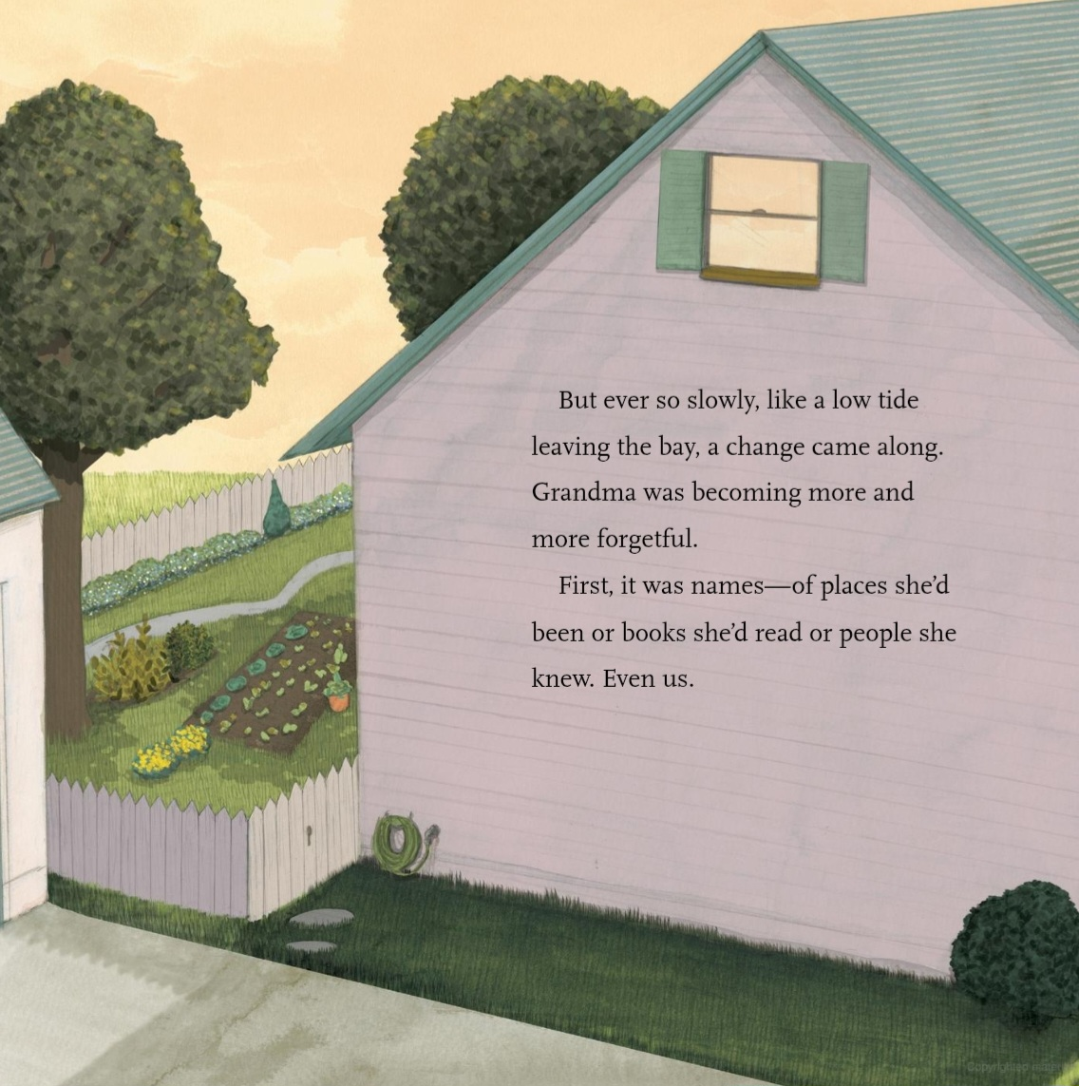
Fig 1: Forget Me Not (Nancy Van Laan and Graegin, 2014)
The way that the narrative describes her grandmothers changes is very poetic, which makes it a less scary concept for a child. The narrative stays on Julia and her relationship with her grandmother which makes the book “a powerful, clear-eyed meditation on one girls loving but painful relationship with a beloved aging relative” (Gross, 2014). The soft illustrations also create a more calm and safe environment within the book, this makes the message of the book less threating and scary for a younger audience. Within the book the focus is around memories and Julia’s Grandmothers decline and loss of memory and Graegin’s Illustrations of family portraits implements this theme into the book without it having to say it directly, “ frequent images of family photographs on the walls help draw attention to the importance of memories” (Gross, 2014). Van Lann’s approach to this difficult subject is very personal and touching when looking at the impact of Alzheimer’s on the whole family (Tasha, 2014). Van Lann uses Julia to show children that although it can start like a game that over time the more the grandparent will forget the more it will be upsetting, however “despite the grandmothers decline, the light remains bright in the illustrations and the family stays close knit in a visual way” (Tasha, 2014). This shows the young readers that despite how isolating it may feel to be forgotten by a loved on that the family doesn’t have to grow apart, they will still be the grandparent you remember just in a slightly different way. This is also shown by the fact that “Julia has to find a way to continue to connect with her grandmother even though she cant remember her” (Tasha, 2014). This encourages the readers to not give up on the person suffering with dementia and instead gets them thinking of other ways to interact with them and spend time with them, in ways that is beneficial to both people. Throughout the book the grandmothers humanity is kept, she doesn’t become a shell of her former self despite her diagnosis of dementia, “Graegin’s illustrations show the changes in the grandmother but also maintain a sweetness that never leaves” (Tasha, 2014). This delicate approach to this topic is something that not all people with dementia are giving the courtesy of after they start declining and losing their memories, “is it that they were no longer deemed to be persons, and thus not worthy of consideration” (Kitwood, 1997 p.13).

Picture Books
Picture books are very helpful within children’s development and learning, “picture books hold a special pride place in the learning literacy, and lives of young children” (Crawford, Lacina and Roberts, 2024). Picture books can be presented in many different ways to teach children in an interesting way that keeps the child engaged, “picture books frequently resist linear readings, instead focusing on the process of reading and the pleasure of the moment as the reader encounters a text” (O’Sullivan, 2008, p.48). The more a picture book doesn’t treat a child as less intelligent the more a child can learn the information they are given, “through their experiences with challenging and complex picture books with metafictive devices, children will grow in their abilities as readers” (Pantaleo, 2014, p.228). Postmodern picture books are seen as very effective when it comes to children’s learning because it treats children with the respect and understanding that they aren’t unintelligent and don’t need to be told all the information. “The most effective examples create some tension between the information included in the words and pictures; so that they collaborate rather than simply repeat” (Nikolajeva and Scott, 2006, p.259). Postmodern picture books use that tension to create deeper meanings within the book and also to keep them playful and fun for the children. These types of picture books have been used as a vehicle for education because they allow the children reading to form their own thoughts and feelings around the situations in the book, they allow the children to learn instead of repeating the text within the illustrations. “We will be father ahead if we treat children not as different sorts of beings incapable of mature thought but as beginners at mature thought who need and are capable to acquire experience of it” (Nodelman, 1990, p.282). Although allowing children to come up with their own interpretations is a good skill for them to learn sometimes the books are to lose and allow them to ignore the actual story that is in the illustrations.
If we encourage children to misuse wordless books in their attempts to find stories in them by ignoring details the pictures actually do show, then these books will indeed be the threat to literacy that some commentators believe them to be (Nodelman, 1990, p.190-191)
Postmodern picture books allow children to come up with their own conclusion from the information that is presented to them while also keeping the story concise and easy for children to pick up on so that they don’t lose the message. One postmodern picture book that allows the audience to reach their own deductions through the presentation of the illustrations and the hidden details is ‘Voices in the Park’ by Anthony Browne. “Numerous illustrations in the book can be ‘read’ and interpreted in multiple ways” (Pantaleo, 2004, p.225). Browne’s use of different narrative voices is very effective in keeping the story interesting and showing children about how different people can view the same day and shows off the personality of each of the character, “Browne reveals much about the four narrators through their type-front, vocabulary and syntax, and the intensity of color and quality of line in their illustrations” (Pantaleo, 2004, p.219).

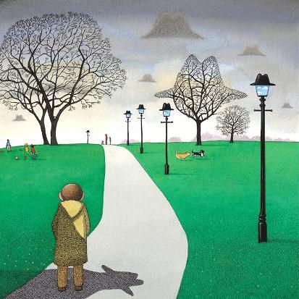
Fig 2: Voices in the Park (Browne, 1998)
Using the illustrations as a vessel to tell a more rounded story is one of the postmodern techniques Browne uses the most, especially when showing how overbearing the mother is to her child, “picture books have always required readers to fill in the gaps” (Iser, 1978, p.227). Showing and not telling is a big thing within this book because the child’s mother is never said to be controlling however she is perceived as controlling through the illustrations, “she dominates her son, and through a recurring image off the shape of her hat her presence is felt throughout three of the four sequences” (Doonan, 1999, p.10).

Watercolours
“Each painting medium seems to interact with colour in unique ways offering distinct possibilities and limitations that artists can exploit to express their vision” (Yuan and Chu, 2024, p.19). Watercolours are a very delicate medium which can create a lot more unique effects compared to other painting techniques, “the fluid nature of watercolours enables a level of spontaneity and unpredictability in the artwork” (Yuan and Chu, 2024, p.20). Watercolours allow an artist to be either very soft or bold when it comes to presenting colours because of how watercolours layer, this can shape meaning within a piece. “Light colours are active, while deep colours likely to be passive” (Birren , 2025, p.141). How active colours are within a piece can change how it is interpreted and can change how people feel about the piece, “color may cause things to happen in the human brain even though they may not be clearly perceived” (Birren , 2025, p.119). Watercolour illustrations can be very dynamic and abstract when creating meaning allowing an audience to come up with their own interpretations. Sally Cataldo’s work is a great example of this, “because she doesn’t spell everything out for us, we are free to use our imagination” (King, 2008). Cataldo uses watercolours in a very bold way highlighting the colours she is using, she has a very abstract style. “Drips and splatters abound, and the form and definition may become lost or obscured” (King, 2008), her use of watercolours allows the medium to be in control and she works with it in a more collaborative way rather than trying to control it.

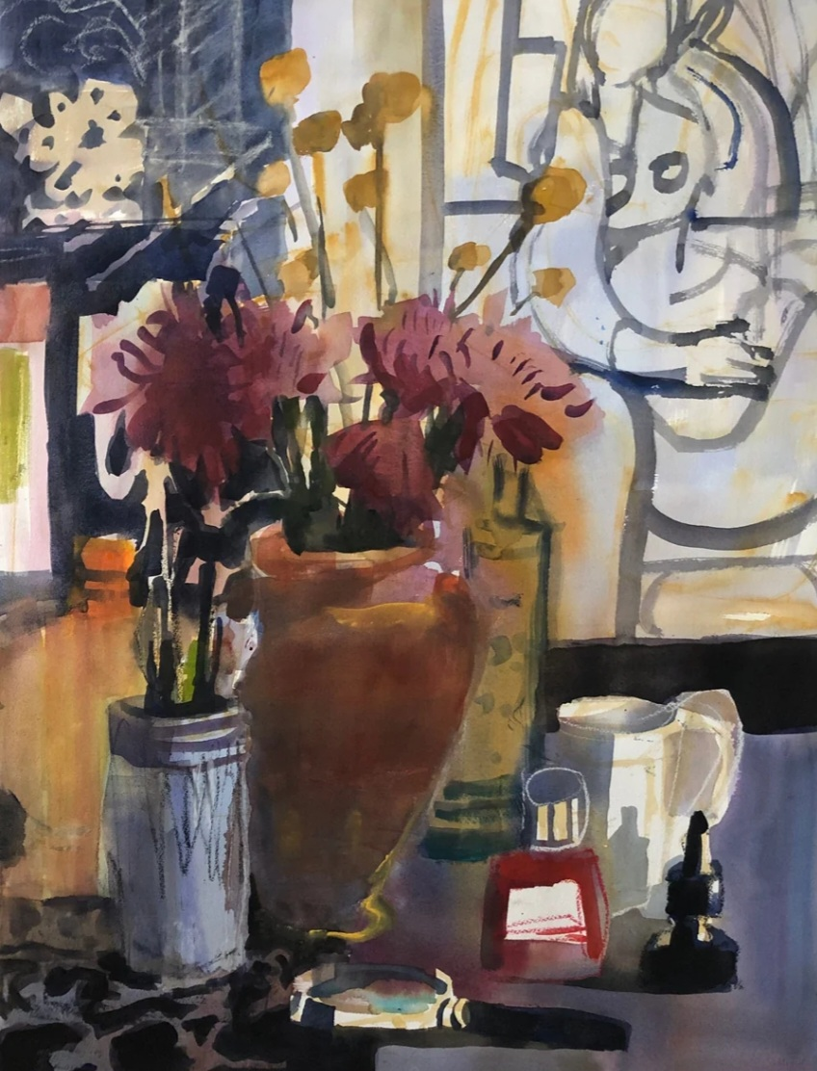
Fig 3: The Studio, watercolour on paper 32”x39.5” – Sally Cotaldo
Cotaldo’s work has a lot of contrast and the ways she uses watercolours makes them look like acrylic , her strong lines and very deep colours does not stay trapped within the delicate view people have around watercolours. Her work is meant to be interpreted in many different ways by her audience, she invites the audience to connect with her work and read between the line (The Highlight Gallery, 2022). Her expressions are meant to be explored by a viewer and questioned “her goal is to create a simple, poetic, visual language in her art” (The Highlight Gallery, 2022). Not all of her pieces are bold watercolours like ‘The studio’, however they all share the same visual language, where she does not try to completely control the medium and embraces any drips and splatters that come with working with watercolours. Cataldo uses a lot of expressive marks when working with watercolours to shape the meaning within the work, she is able to create an air of mystery drawing the viewers in, “mystery is also commonly associated with darkness, and Cataldo is a master at achieving luscious, glowing darks with her watercolours” (King, 2008).

The research into the keywords: Dementia, Picture books, and watercolours, has helped me expand my prior knowledge and helped me chose what direction I want my writing and practice to go in next year. From my research I found some very effective ways to display the difficult topic while not making the topic of dementia a scary thing for children. I don’t want to create a narrative that children should be afraid of this happening to their grandparents, I want to help break down the taboo around dementia.
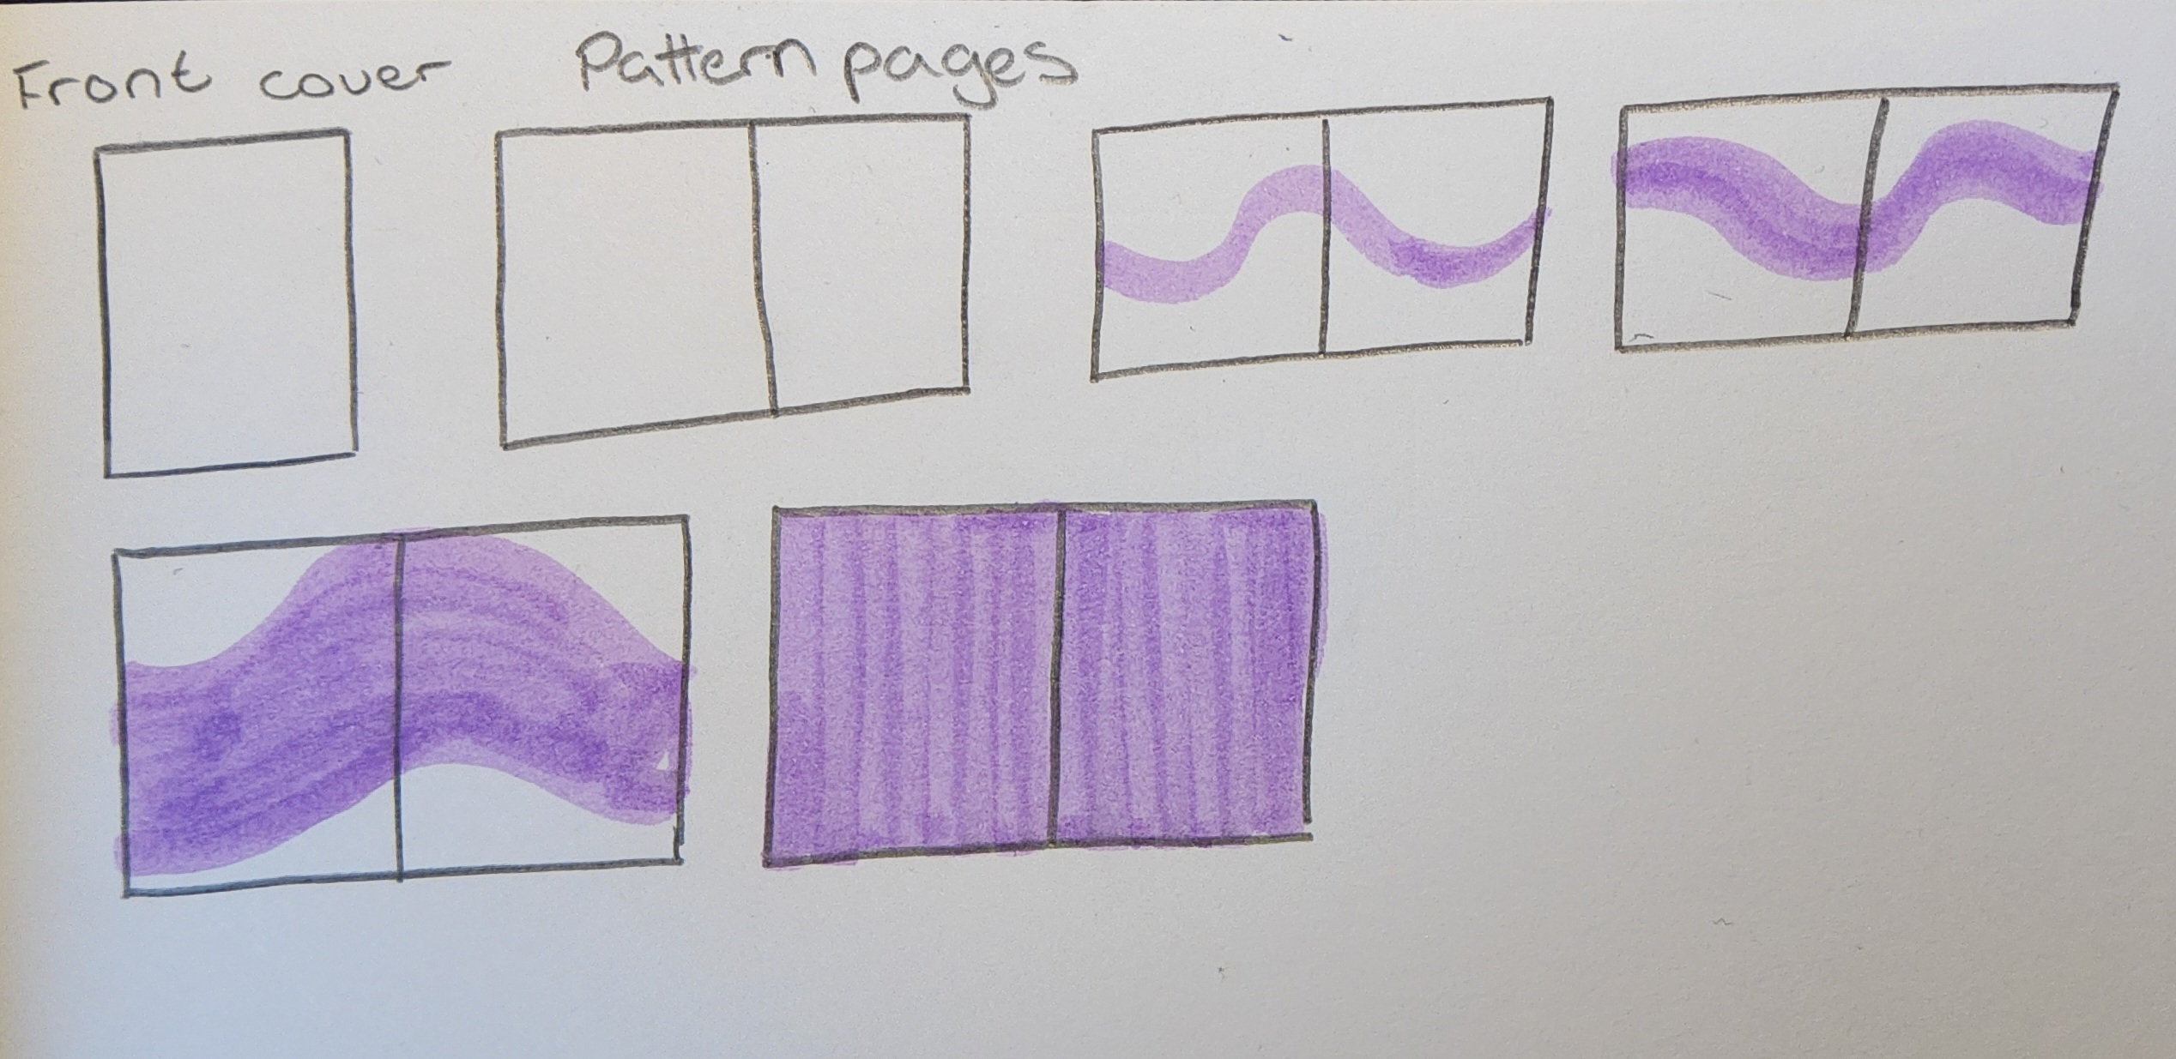
This proposal has informed my passion for spreading awareness around dementia while keeping a level of humanity and sweetness. For my practice I will be illustrating pages for a picture book based around dementia. The book is aimed at older children so that I can implement postmodern techniques within the book which would allow the children reading to find their own meanings and process their own feelings about the topic using the book as help. This will also help them create more of a personal connection with the book and find comfort if they have a grandparent that suffers with dementia. I will be using watercolours to illustrate the book because I want a delicate and inviting feel to come from the illustrations. The colour scheme will connote nostalgia without sadness, I will be using pastel colours and have traces of purple through the pages. The purple will slowly take over the pages to show how dementia slowly takes over the person, I want this detail to be very subtle so that the readers may not notice in the first read through. For the book I will create a front cover and pattern pages and four double-page spreads.
I am heavily inspired by how Van Lann discussed the issue within her book because she presented the issue and explained with a lot of care and consideration for both the family that is affected and the person who has dementia. My practice will dive into how both the child feels and how the grandparent feels by adding in a dual narrative, I don’t want the main focus to be on how the family is affected by this devastating news. I want the focus to be on how the person suffering has to navigate the changes and how difficult it would be to try make sense of what is happening within their own brain. I have found that a lot of media spreading awareness on dementia takes away the focus from the person affected, ignoring how difficult it is for them and instead puts all of the focus onto how bad it is for the family and the people caring for them. I hope to create an educational book that helps dismantle the taboo around dementia and show children that although dementia is an upsetting topic that their grandparent is still themselves just slightly different and changed. This is why I’m proposing the question ‘ The Taboo around Dementia: How illustrated books can help children come to terms with the changes of their loved ones.

