

A Study on Gamification in Higher Education via Moodle Learning Management System

By

Chisom Vanessa Nwankwo
(2227183)

Supervisor: Dr Nik Whitehead
Second Marker: Dr Seena Joseph

Project submitted as part of the requirements for the award of
MSc Data Science and Analytics

March 2024

DECLARATION

I, Chisom Vanessa Nwankwo declare that I am the sole author of this Project; that all references cited have been consulted; that I have conducted all work of which this is a record, and that the finished work lies within the prescribed word limits.

This work has not previously been accepted as part of any other degree submission.

Signed: C.V.N

Date: 7th March 2024

FORM OF CONSENT

I Chisom Vanessa Nwankwo hereby consent that my Project, submitted in candidature for the M.Sc. Data Science and Analytics, if successful, may be made available for inter-library loan or photocopying (subject to the law of copyright), and the title and abstract may be made available to outside organisations.

Signed C.V.N

Date 7TH March 2024

DEDICATION
This project is dedicated first and foremost to God, the giver of life, for the strength and wisdom to complete it. Secondly, I would like to thank my mother, who has always supported me in all my endeavours and is one of the strongest people I have ever met. Finally, I thank myself, the author and finisher of this project, for not giving up on the way. Congratulations.

ACKNOWLEDGEMENTS
The successful completion of this project is attributed to my project supervisor, who guided me throughout the project, and Lee Cobley, who set up the Microsoft Azure virtual machine used to run the Moodle server. I would also like to acknowledge Dr Terry Walcott, as one of his lectures greatly inspired this project. I thank my family and friends, especially the council of elders, for their support throughout this project. I want to thank myself, the author of this project, for working hard this time; thank you very much. May God continue to bless us all.

ABSTRACT
The primary objective of this study is to explore the impact of gamification elements and strategies within the Moodle Learning Management System (LMS) on enhancing student engagement and learning outcomes in higher education. The research used a comprehensive mixed-methods approach to develop and implement a gamified Moodle platform and collect participant feedback. This platform served as the primary material for the study, incorporating various game mechanics and elements to enrich the learning experience. The subjects of the study included a group of participants who had completed primary education, providing their perspectives on the effectiveness of gamification in higher educational settings.
Data was collected through a questionnaire, and a comprehensive analysis was conducted. This data analysis employed quantitative and qualitative methods to extract meaningful insights and measure the impact of gamification on student engagement and academic performance.
The study's major findings reveal significant positive effects of gamification on student motivation and engagement levels. Participants reported an enhanced learning experience, increased motivation, and a deeper understanding of the course content. The deliverables of the study include a set of best practices for implementing gamification in Moodle, along with recommendations for educators looking to adopt similar strategies in their courses.
Conclusively, the study affirms the potential of gamification and game-based learning as practical strategies to improve educational outcomes in higher education. The findings suggest that when implemented thoughtfully, gamification can lead to a more engaging, motivating, and enriching learning environment, ultimately contributing to better academic performance and student satisfaction.

TABLE OF CONTENTS

TABLE OF TABLES

TABLE OF FIGURES

CHAPTER 1: INTRODUCTION

1.1 Background Information
The term ‘education’ has been defined in several ways, with the general idea remaining the same. The dictionary [1] defines education as the process of acquiring knowledge through teaching or learning. Adesemowo and Sotonade [2] define education as a life-long process of learning and skill development through acquiring knowledge or discipline of the mind. Less formal definitions could be drawn from the quotes of Oprah Winfrey [3], who said, “Education is the key to unlocking the world, a passport to freedom”, and Nelson Mandela [4], “Education is the most powerful weapon you can utilise to transform the world”.
It is a known fact that education is essential to success as it helps develop crucial life skills, which include reading, writing, independent learning, social skills, etc. It is also believed that attending school and attaining several degrees aligns a person on the path to success. While attending classes can have positive results, this belief holds only ideally and not realistically. Education is supposed to teach facts while training the mind to think, but the traditional teaching methods defeat the latter purpose of ‘training the mind to think’. Nowadays, students are fed a lot of information without the means to utilise this information. The instructors carry on teaching, but learning does not occur. The conventional techniques teach what to think instead of the ‘how’ or ‘why’. Frankly, the average student is not interested, as their main goal is to complete that level of education regardless of whether a subject or topic was learned. The current education system focuses on the conformity of students, where every student learns the same thing at the same pace. Cramming rather than studying to pass an exam is prevalent in schools because too much information is delivered but cannot be understood and applied, defeating the primary purpose of examinations. This system results in students who are less passionate about learning and look to others instead of themselves for knowledge.
The pedagogical methods currently in place involve taking notes, reading lengthy textbooks, and attending lectures delivered in the same format on the same day and time every week over the semester, which could be mentally draining. Some time ago, theorists Albert Einstein and Plato talked about the adverse effects coercion and compulsion had on students and how they prevented any form of learning. This could be viewed as a thing of the past due to the significant changes brought about by technological advancements. However, the reality is that the problem persists year after year. In more recent times, Sasha et al. [5] and Elon Musk [6], founder and CEO of multiple innovative companies, stated that the education system needs improvement. They emphasised the importance of thinking ‘outside the box’ and the value of purpose-driven programs and curricula in the education system.
It is puzzling that digital devices are banned or severely restricted in some schools, but in the real world, they are used to accomplish almost everything. Notably, it could distract the learner, defeating the purpose of being in the class, especially if the student is doing something else, for instance, texting instead of paying attention. From one perspective, the focus should be taken away from the student, and the question could be asked, ‘Why is the student not able to pay attention to the lecture?’. A simple answer can also be provided, ‘It is not engaging’. Another way to phrase the question would be, ‘If the lectures were engaging, purpose-driven, and offering intrinsic values to the learner, why would they be texting in the classroom? We can also picture a scenario in which a lecturer explains a complex topic using elements and characters of a popular game or movie. Indeed, at the end of the lecture, it would be easier for them to remember part, if not all, of what was taught.
Learning itself is enjoyable and occurs in different forms and environments. Humans are curious by nature. When coercion and control in education are removed and replaced with engaging elements, the result is intrinsically motivated, excited, and passionate students willing to do their best and do more than the bare minimum to achieve excellent grades. A way to accomplish this is by using games and game elements in classroom lectures. Research has also proven that there is an increasing number of game enthusiasts. In 2022, statistics recorded 3.03 billion gamers worldwide [7]. Elements of games have been introduced at the basic levels of education, and they achieve their purpose. Hence, more effort should be put into developing these elements in a specialised and advanced manner to be used at further and higher levels.
Games in education refer to gamification and game-based learning (GBL). These terms are similar, but they do not mean the same thing. The general idea behind both is the same, i.e., transferring the positive features of a game into a mundane process or activity. Hence the term ‘gamifying’. Gamification in learning involves introducing game elements in learning activities, while game-based learning uses actual games. The positive features of games that make them fun and engaging to users are the reasons for their application in education. Recently, the ‘Metaverse’ has become buzz due to its ability to incorporate elements such as AI, big data, games, and extended reality (virtual reality, augmented and mixed reality) to immerse students in their curriculum fully. It provides a more comprehensive and immersive platform than regular gaming software applications. Within the Metaverse, students can take advantage of a real-time 3D-enhanced perception of the physical world. This visualisation technology overcomes the limitations of relying heavily on texts in teaching. Using these immersive technologies in an educational context is based on the need to pique students’ curiosity, arouse interest in education, engage and encourage them to have fun, achieve more ambitious goals and identify their passions.
Another advantage of games in education is that they promote learning from failures. It removes the fear of failure that the current teaching method instils in students. In gaming, it is common for gamers to lose or fail, if not once but repeatedly and continue playing to win while learning from their mistakes. The game-based education approach also appeals to different types of learners and encourages personalised learning. This learning approach does not imply eradicating teachers and lecturers; they operate together. An instructor must guide students using game-based learning applications to maximise learning. The best part is that these software applications can be tailored to function on different platforms (laptops, tablets, mobile phones and even cyberspace) in various environments while meeting the learning objectives and providing immediate feedback. It also promotes visualisation, play and autonomy, which are vital in any form of learning.

1.2 Problem Statement
The education system needs to change from fundamental to higher levels. The traditional pedagogical methods (methods of teaching) in place in the education system need to be updated [13]. The advent of technology has changed how things work in different fields, even in certain areas of education, but the teaching method is finding it difficult to adapt. The conventional teaching methods involving lectures, taking notes, and reading textbooks are not appealing to twenty-first-century students. As a result, many students are not engaging with these methods. It also has been known to affect student satisfaction with school. This can lead to low academic performance as students do not feel motivated enough to be creative in their work. The focus, instead, is attaining a passing grade by whatever means, regardless of whether learning took place. Gamified education focuses on personalised learning and immersing students in the course content. The use of games and game elements in classrooms has become more popular over the years. However, the importance of ‘fun’ and ‘play’ in universities is still severely underrated. The misconception remains that learning is only achieved in formal and serious environments utterly devoid of humour. Hence, there is a need for more research in this field to disseminate information on the importance of gamification in universities to understand incorporation principles in the education system better.

1.3 Aim of the Study
The study aims to demonstrate gamification capabilities at higher education levels using the free and open-source learning management system known as Moodle, commonly used by higher education providers/universities, and collect data on the learning experiences of users of the platform. The information gathered was analysed to gain insights into its effectiveness in education.

1.4 Objectives of the Study
- Review existing literature on gamification and game-based learning in education.
- Review existing literature on gamification in Moodle learning management systems.
- Develop a prototype Moodle platform to demonstrate gamification and collect user experience data.
- Analyse the data collected.
- Present the findings.

1.5 Scope of the Project
The scope of the study will be narrowed down to focus on gamification via Moodle Learning Management System and the analysis of data based on users’ experience instead of an actual Game-based application software. The development part of the project involves gamifying a level 6 (undergraduate) course on Usability Engineering delivered via the Moodle platform. This study will demonstrate this gamification with Moodle Learning Management System and provide insights on its effectiveness or ineffectiveness. It should be noted that the essence of this study is not to propose eliminating paper and pens in classrooms but rather to limit the over-reliance on reading and writing lengthy texts to study or understand a lecture, which could be mentally stressful and tiring.

1.6 Report Structure
This report is organised in the following manner: Chapter One introduces gamification and its place in education. The chapter also contains the aim and objectives of the study, including the problem to be solved. Chapter Two provides a literature review of gamification, its previous applications in education, its advantages, and previously discovered challenges in implementation. Chapter Three explains the tools and methods to achieve the study's objectives. It describes the processes for developing and hosting the Moodle server and the research methodology for obtaining participant data. Chapter Four explains the gathered data in detail, with data visualisations. Chapter Five summarises the collected data and makes inferences based on the information obtained through the data visualisations. Chapter Six concludes the study with recommendations and suggestions for future works on gamification in higher education. Chapter Seven discusses the information discovered while conducting this research, which was based on the activities of the study participants.

Chapter 2: Literature Review

2.1 Overview of Education
Learning, defined by [14], is a process which develops a modification in stimulus-response relations due to continuous interaction with the environment through sensory perception. Learning is also a process of actively acquiring new knowledge. Learners begin their educational journey with knowledge and skills previously acquired that can influence their perceptions of the environment [15], which affects how they remember and interpret new information. This process also involves critical thinking and problem-solving during activities that enable learners to think and build on prior knowledge [16], [17], [18]. This means that learning involves learning something somewhere and at a particular time. Education is one of the ways through which learning is achieved, and it could be formal or informal. Formal education occurs in a formal setting such as a school. It involves attending lectures, and usually, a trained instructor is present. Informal education occurs in less formal and social environments, i.e., through interaction with peers or relatives. However, this study focuses on formal education at the university level.
Several years ago, information was passed from one person and generation to another through speech due to the absence of a reliable information carrier, which caused distortions as information was being spread. Later, the invention of paper allowed learning through texts as it was more reliable than word of mouth [19]. Due to technological developments like digital devices capable of conveying information in real-time, the interest in acquiring simply textual information is gradually diminishing. In higher education, the pedagogical methods still in use involve taking notes, reading lots of text, and reproducing these texts in assignments or exams. The conclusion is that learning has taken place. This method, which has promoted the acquisition of abstract knowledge, causes students to feel disconnected from what they are learning. It causes disengagement from what is being taught. Therefore, students resort to cramming to get higher grades. After exams, whatever was read becomes forgotten, contrary to the aim of education. This disengagement from the lectures also leads to low grades and high dropout rates of students. Admittedly, several other factors could contribute to the lack of interest in education and the high dropout of students, such as issues with work-life balance, which causes anxiety and distress in students. The fear of failure and perceived inability to attain high grades also cause high levels of stress, leading to avoidance behaviours and procrastination. As there exists a connection between academic success and the engagement of students [20], [21], which is also related to play, institutions must endeavour to allow for creativity and innovation in their curriculum and pedagogy to assist each student’s growth and development. The gamification and use of games in education can be implemented as a positive psychological strategy to foster students’ engagement and retention.

2.2 Gamification and Games-based Education
Several technologies have been developed and will continue to evolve as technology improves to aid areas of human endeavour. In education, research has contributed to the body of knowledge concerned with modifying the pedagogical methods, i.e., the way lecture contents are delivered and taught to students. Gamification and Game-based learning fall under these technologies. They have also been extended to using the Metaverse and Extended Reality in education.
Games are organised forms of play that use a medium such as a digital device, cards, boards, etc. It allows people to learn through experimentation from their victories and failures [8]. Psychologists Jean Piaget in 1962 and Lev Vygotsky [9] in 1978 talked about the importance of play in education. Before then, Plato [10] proposed that play had an important role in education. In his words, “Play is the first step on a ladder towards true knowledge”. Also, the theory of education proposed by John Comenius [11] in the 17th century viewed games (Ludus) as the ideal form of learning. The researcher Coonradt [24], in his book, ‘Game of Work, How to Enjoy Work as Much as Play’, applied gamification in the business domain to motivate the workforce. This study mentions the importance of feedback for positive reinforcement to enable players’ improvement. More recently, studies by Costello and Lambert [22] indicate that gamification can ease anxiety, isolation, and retention of learners. The survey by Costello in [23] also highlights the importance of extrinsic motivation through rewards, points and badges and intrinsic motivation derived through a sense of achievement or accomplishment by completing a level and progressing to the next. These tools can be harnessed to increase student engagement by using progress bars to provide feedback and allow them to reflect on their understanding of a subject [22]. Gamification elements can also enable students to identify peers who can mentor or guide them by looking at their leaderboards and badges, thereby creating a supportive network [23].
The word ‘Gamification’ was invented by Nick Pelling in 2002 [12], but it did not get much recognition until the year 2010. It involves using extrinsic motivational elements in games like leaderboards, badges, points, etc., to engage and motivate students. Game-based learning takes a more active approach and involves utilising a game application, i.e., learning through playing games. These methods promote critical thinking and collaboration and enhance students’ problem-solving skills. In 1973, Jean Piaget introduced GBL as an approach to teaching at the university level [10]. A few years after gamification became widespread, in 2014 [25], it was deemed pointless as the information being circulated revolved around its failure. A source stemmed from the hotel Marriott’s inability to gamify its training and recruitment process. According to [25], the business tried to gamify its process without fully understanding the principle of gamification or gamifying a process. Marriott failed to engage their audience, which was one of the reasons for its failure.
Since then, game-based learning and gamification have become increasingly popular due to their power to engage, motivate, and enhance students’ learning. Researchers have studied the usefulness and impact of games and have observed that if designed well, they could allow opportunities for communication, collaboration, problem-solving, hypothesis generation, reflective thinking, etc. [13]. Nowadays, where many students have access to the internet and digital devices, they are comfortable learning in a gaming environment; unlike the textbook approach, students are left to develop novel ways to apply their knowledge in solving problems.
Gamification, which uses elements like points or scores, badges, leaderboards, feedback and progress bars, and storytelling, are vital components that make games engaging. To create personalised teaching experiences with gamification, it is essential to understand the four types of gamers that the researcher Richard Bartle identified in order to develop educational material that would best enhance learning. They include the ‘achievers’, who are more interested in the points and scores aspect of games, as these types of gamers are very competitive; The ‘socialisers’, who are more interested in collaborative games and interacting with new people; The ‘explorers’, who play games out of curiosity to explore the game environment, and are less concerned about other players; The ‘killers’ who are very competitive and try to win by making others lose [26]. These player types are not mutually exclusive, as a gamer could be a socialiser, an achiever, or all four. The Achievers are more into games that can earn them a bragging right; Explorers are fans of simulation games; Socialisers delight in interactive games that do not require competition, while Killers could be said to be more interested in action or very competitive games.
The use of virtual, augmented, mixed and augmented reality has gained recognition recently and has become a buzz today. These terms have been generalised to the ‘metaverse’ incorporating one or more elements [19]. [27], [28] define the Metaverse as a 3-D world in which activities are conducted through avatars representing humans in the real world. The real world and the Metaverse exist independently, with actors in both environments interacting. It has been applied in several areas, such as business, entertainment and even education. This technology in education is in the form of educational games where each student uses visualisation technology to learn. It aims to immerse students actively and fully in the lecture content, contrary to the system, which relies heavily on textual contents [29], [19] and has many unsolved limitations, such as low participation and engagement of students, limited availability of time and lots of abstract information. Research conducted by [30] explains the importance of active and playful learning achievable within the Metaverse. With the aid of these environments, lecturers can organise personalised activities, communicate effectively with students, and track their progress in time. It also allows for collaboration between students through their avatars. [19] reveals that the Metaverse in education can aid personalised learning through content customisation to foster play while learning. This personalisation aims to provide tailored experiences to each student and cater to their individuality by adapting to the learner’s interests [31], [32], [33]. Institutions must ensure that the games are designed appropriately to enable students to learn more effectively, as improper design principles can potentially impair learning. Some universities like Stanford University and Case Western Reserve University have begun implementation in their classrooms [19].

2.3 Previous Research on Gamification in Education
The table in Figure 2.1 gives a brief review of existing research work carried out on game-based learning and gamification in education.
Educational Applications | Results | Paper
FoldIt | Students could appreciate the complex nature of protein folding and the scientific processes employed in solving the structure of proteins. | [35]
Kahoot | The study showed that it minimised distractions, enhanced students’ engagement, and improved classroom dynamics. | [36]
Variant: Limits | This calculus game-based application was used to encourage students’ engagement, participation, and improved understanding of mathematical concepts. | [37]
Classcraft | Classcraft had a positive impact on students’ engagement and academic performance. | [38]
Roblox | It allowed for autonomy and collaboration to foster the learning experience. | [39]
Socrative | The study concluded that Socrative was easy and fun to use. It also aided the active participation of students. | [40]
Duolingo | The students were excited and motivated students to learn | [41]
Minecraft | Increased student engagement and competencies in a range of fields. | [42]
PaGAmO | The research on PaGAmO as a GBL tool showed that it offered extrinsic and intrinsic benefits to learners, especially when combined with traditional teaching. | [43]
Table 2.1: Review of gamified/GBL applications implemented in education.

2.4 Gamification in Moodle Learning Management System
Learning Management Systems (LMS) are online learning platforms with built-in capabilities to facilitate course delivery and support collaboration. The facilities provided by these systems allow course materials upload, viewing or downloading of these course materials and assessment of students through quizzes. Moodle, an open-source learning platform that is an acronym for Modular Object-Oriented Dynamic Learning Environment, has emerged as a leading learning management system (LMS) that supports online learning and teaching. It provides educators and learners with a robust, secure, and integrated system to create tailored learning environments [51]. The COVID-19 pandemic accelerated the adoption of online learning platforms, with Moodle being at the forefront of this transition. The reason for its effectiveness includes its flexibility in supporting diverse educational requirements and its role in facilitating the transition to online learning during the pandemic.
In recent years, despite the return to physical work environments after the pandemic, learning management systems have remained largely in use. Moodle’s success remains before and after the pandemic, signifying its importance in education. As Moodle is here to stay, research is continuously being carried out to modify the platform’s services and better engage students via gamification.
Dimitrov and Kovatcheva [52] present a comprehensive study on the practical application of Moodle's gamification toolbox in an online course. Their research highlights the positive impact of gamification on student motivation, engagement, and success rates. By comparing a gamified version of a course to its traditional counterpart, they provide empirical evidence supporting the efficacy of gamification in Moodle to reduce attrition and improve learning outcomes.
Landebila, Saputra, and Razilu [53] explore the development of Moodle-based e-learning media by incorporating gamification concepts into the curriculum. Their study, conducted within the context of Visual Communication Design education, demonstrates the feasibility and effectiveness of gamified e-learning media in enhancing student learning experiences. The research underscores the importance of aligning gamification strategies with educational objectives to maximise their benefits.
Viamonte and Figueiredo's [54] work on gamification with Moodle in higher education offers insights into the potential of gamified learning to address challenges related to student motivation and engagement. Their experience with first-year students in a mathematical unit suggests that gamification can contribute to lower dropout rates and higher student satisfaction. However, they caution that further research is needed to draw definitive conclusions.
A study evaluating the user experience of a gamification-based Moodle LMS [55] also provides valuable data on the system's usability from the perspective of computer science students. The findings indicate that gender and prior LMS experience do not significantly influence the perceived usability of gamified Moodle environments, suggesting the broad applicability of gamification features across diverse learner demographics.

2.5 Advantages of Gamification and Game-based Learning in Education.
The application of game elements in education has garnered significant attention for its potential to enhance learning experiences. Some of the advantages highlighted by [48], [49] include:
                - Cognitive Development: Gamification aids in cognitive development. It stimulates brain activity, leading to improved information processing and retention. Games designed for cognitive enhancement, often called "brain games," have gained popularity for their effectiveness in this area.
                - Physical Development: In some instances, gamification also contributes to physical development. Interactive games that involve physical activity can be as effective as traditional exercise, benefiting people who prefer video games over physical activities.
                - Increased Engagement: Gamification increases engagement levels in classrooms. Studies have shown that a game-like atmosphere in educational settings boosts student productivity and involvement in learning activities.
                - Accessibility in Learning: Gamification has been used effectively to teach students with diverse needs, including those diagnosed with autism and ADHD, by helping with attention regulation. This approach has proven successful in delivering age-appropriate content in an engaging manner.
                - Retention Improvement: Gamified learning enhances knowledge retention. Research indicates that it can increase retention rates by approximately 40%, making it a powerful tool in educational settings.
                - Real-World Application: Gamification in education connects learning to real-world problems and applications. It creates a risk-free environment where students can apply their knowledge and skills, preparing them for real-life situations.
                - Instant Feedback and Reinforcement: Game-based learning provides immediate feedback, allowing for quick correction of mistakes and reinforcement of correct answers. This immediate response system helps students understand their progress and areas for improvement.
                - Fostering a Love for Learning: Gamification can make learning an engaging and almost addictive experience. Game mechanics like rewards and competition trigger dopamine release in the brain, making the learning process more enjoyable and motivating.

2.6 Challenges in Implementation
Some of the challenges in its implementation in education include:
- Balancing Entertainment and Education: Ensuring the game is engaging and educational can be challenging. There is a risk of the game being too entertaining, which might distract from the learning objectives.
- Design Complexity: Creating games that are both fun and educational requires a deep understanding of game design and pedagogy. This complexity can be a barrier for educators and developers who may not have expertise in both areas.
- Accessibility and Inclusivity: Making sure that game-based learning apps are accessible to all students, including those with disabilities, can be challenging. Additionally, the games need to be inclusive and culturally sensitive.
- Technological Limitations: Limited access to technology among students, especially in underprivileged areas, can hinder the implementation of game-based learning. Moreover, technical issues with the game or platform can disrupt learning [50], [34].
- Assessment and Feedback: Integrating effective assessment and feedback mechanisms within the game to track and support student learning can be complex. It's crucial to ensure that the feedback is timely and constructive.
- Cost and Resource Constraints: Developing high-quality educational games can be expensive and resource intensive. Schools and educators may face budgetary constraints in acquiring or developing these tools.
- Teacher Training and Support: Teachers need adequate training and support to effectively integrate games into their teaching. Without proper training, the potential of these tools may not be fully realised.
- Student Motivation and Engagement: Keeping students motivated and engaged with the game over time can be challenging. There's a risk of students losing interest if the game does not evolve or doesn't align with their interests and learning needs.

Chapter 3: DEVELOPMENT METHODOLOGY
This chapter presents the tools and methods for installing and configuring the gamified online learning platform. It discusses the installation and configuration of the Moodle server, which can be run using the ‘Start Moodle’ function available in the extracted folder. The ‘Stop Moodle’ function cleans up the running processes and stops the server.
The processes involved in the development of the Moodle Platform are as follows:

3.1 Installation of the Moodle server
The Moodle installer package, version 4.3.3+ for Windows, was downloaded on a Microsoft Azure virtual machine. This virtual machine used a Windows x64 architecture, Standard E2s v3 (2 vcpus, 16 GiB memory), and the Moodle installer package files were extracted to set up the Moodle server. The package is built using XAMPP version 8.2.4-0 Portable (x64), which includes Apache web server, MySQL database, and PHP. Additionally, it comes with local_adminer installed​​, and it is compatible with Windows Vista and later versions [56]. For Mac OS X environments, it is built with MAMP 6.8, incorporating Apache 2.2.34, PHP 8.1.13, and MySQL 5.7.39, and is compatible with macOS 10.10+ on Intel x64, as well as Apple M1/M2 platforms [57]​. Previous XAMPP installations may result in conflicts while running the Moodle server as a required port, which could be used by another service and, therefore, unavailable. The reconfiguration of ports or uninstallation of previous XAMPP installations can eliminate these conflicts. An essential file for its successful set-up is the VCRUNTIME140.dll file, which will cause an error message and prevent the server from running if absent. It comes as a part of the Microsoft Visual C++ 2015 Redistributable package and is required by PHP versions that were compiled with Visual Studio 2015. Therefore, it can be obtained simply by downloading and installing the Microsoft Visual C++ 2015-2022 redistributable package. The web server must be running to access the Moodle website.
3.2 Configuration of the Moodle server
The server configuration comes after the extraction of files and successful installation of the Moodle server. Due to the nature of the project, there was a need to reconfigure the server files to allow the website to be accessible to the participants via the Internet. The network security group's configuration, firewall, and testing of the network connection were used to solve network connectivity issues between the server and Azure virtual machine.
The activities taken to make the website available on the internet are as follows:
- The ‘$CFG->wwwroot = 'http://localhost';’ parameter in the config.php file contained in the moodle folder, which allows the server to be run only locally on the machine, was changed to match the public IP address of my virtual machine. That is, $ CFG -> wwwroot =' http://ip.address.of.virtual.machine'. This public IP address enables the website to be reachable by anyone on the internet with the URL.
- The Azure Network Security Group (NSG) was configured to allow inbound traffic on HTTP (port 80) and HTTPS (port 443), as the machine used SSL.
This was done by adding inbound security rules to allow traffic on both ports. The source was set to ‘Any’, the destination to ‘Any’, and the service was configured as HTTP for port 80 and HTTPS for port 443.
- The Windows Firewall on the virtual machine was also configured to allow inbound traffic on HTTP (port 80) and HTTPS (port 443).
- The network connection to the IP address of the virtual machine on ports 80 and 443 was tested via Windows PowerShell using the commands:
Test-NetConnection ‘IP address of virtual machine’ -Port 80
Test-NetConnection ‘IP address of virtual machine’ -Port 443
Where ‘IP address of virtual machine’ refers to the public IP address of the Microsoft Azure virtual machine.
When these commands are run, PowerShell attempts to establish a TCP connection to the specified IP address on the specified port. It then provides output that includes:
- Whether the connection was successful or not.
- Round-trip latency in milliseconds (if the connection is successful).
- Detailed TCP and ICMP (ping) statistics, if available.
Simply put, one or both tests should output “TcpTestSucceeded: True”.
Where the website or service only uses HTTP and is accessible via the standard port 80, there's no requirement to set up port 443. Port 443 is the default port used for HTTPS traffic, which is encrypted using a security certificate (SSL/TLS certificate). It is highly recommended, however, to use HTTPS for enhanced security, especially when the site handles sensitive data or personal information. HTTPS encrypts the data transmitted between the client and the server, protecting it from eavesdropping and tampering.
- Setting up a cron job to run via the PHP command line interface (CLI), which is recommended by Moodle to be run every minute.
In the context of Moodle, cron refers to a script that needs to be run regularly in the background to perform various maintenance tasks essential for the site's smooth operation. These tasks include sending email notifications, updating RSS feeds, processing queued tasks, generating reports, and more.
Running the cron job every minute ensures that tasks are performed promptly. This is particularly important for time-sensitive operations like sending forum post notifications, assignment reminders, or quiz deadlines. Spreading these tasks out in smaller, more frequent intervals helps manage the server load instead of executing many tasks all at once, which can lead to performance spikes as the site grows in users, content, and the number of background tasks. Also, frequent execution reduces the impact of any single cron job failure. If a cron job fails to run or complete at one interval, it will be attempted again in the next minute, thus ensuring that system tasks are reliably executed.
To run the cron job, a scheduled task was set up. This new task triggers the cron.php script located in the moodle directory, to run at the desired frequency. The trigger for the task was set to run "daily", and then the "Repeat task every" option was set to 1 minute for a duration of "1 day". This process mimics the every-minute execution of a Unix-like cron job. The action should be to start a program, which would be the PHP executable ‘php.exe’ contained in the php folder, with the argument pointing to the cron.php script (e.g., C:\path\to\php\php.exe -f C:\path\to\moodle\admin\cli\cron.php).
- The post_max_size and upload_max_filesize parameters contained in the php.ini file were changed from 32M (megabytes) to 250M to allow larger files greater than 32M (megabytes) to be imported into the website, such as the course materials. This activity is not required but was important in setting up the courses on the website.
- Outgoing confirmation email was set up for Moodle using Gmail to allow automated confirmation emails to be sent to participants when they register through email on the Moodle site to complete their registration.
To set this up, the values in the ‘outgoing mail configuration’ page in the site administrator settings were set as follows:
SMTP hosts: smtp.gmail.com:587
SMTP security: TLS
SMTP Auth Type: LOGIN
SMTP username: ‘my Gmail address’
SMTP password: ‘chosen password for the Moodle site’. Here, an app password was generated for Moodle using a Google account created solely for this project [58].

3.3 Gamification Elements
The study achieved gamification mainly through Moodle plugins, downloaded from Moodle’s official website, moodle.org. The plugins H5P, Game, Level Up XP, Stash, and associated dependencies, such as stash availability, shortcodes and tiny stash, were downloaded and installed for Moodle version 4.3.3+ via the plugin settings available to site administrators and added in each course page as either blocks in block drawer or as part of the course content. The free images used on the Moodle website were downloaded from websites such as Freepix, Pexels, and Pixabay. The Academi theme plugin was downloaded and installed as the theme for the website, and the primary colours, secondary colours, and fonts were customised.
For this project, each participant was enrolled in four courses based on L6 Usability Engineering topics: Prototyping, Human-Computer Interaction, Virtual and Augmented reality, and Human Factors, with the first three being gamified. Human Factor, the non-gamified course, was created to demonstrate non-gamification currently in the education system (it was developed based on the current format of lecture materials delivered on the university’s Moodle platform). Avatars were also incorporated into the platform. Links to websites such as Cartoonify and Bitmoji, which allow for easy creation of avatars, were also provided to users as an option to create avatars to be uploaded as their profile pictures. This is because the plugin for avatars discovered, i.e., Webcam Snapshot, does not allow for much customisation. There is no current release for Moodle 4.3.3+ at the time of this project. Ideally, each course's content will be set to be completed weekly, with the course materials and games for each week being different. Then, at the end of each week, incentives, for example, grades, will be awarded to students at the top of the Level Up XP leaderboard who have also gained all the necessary stash items in their inventory.
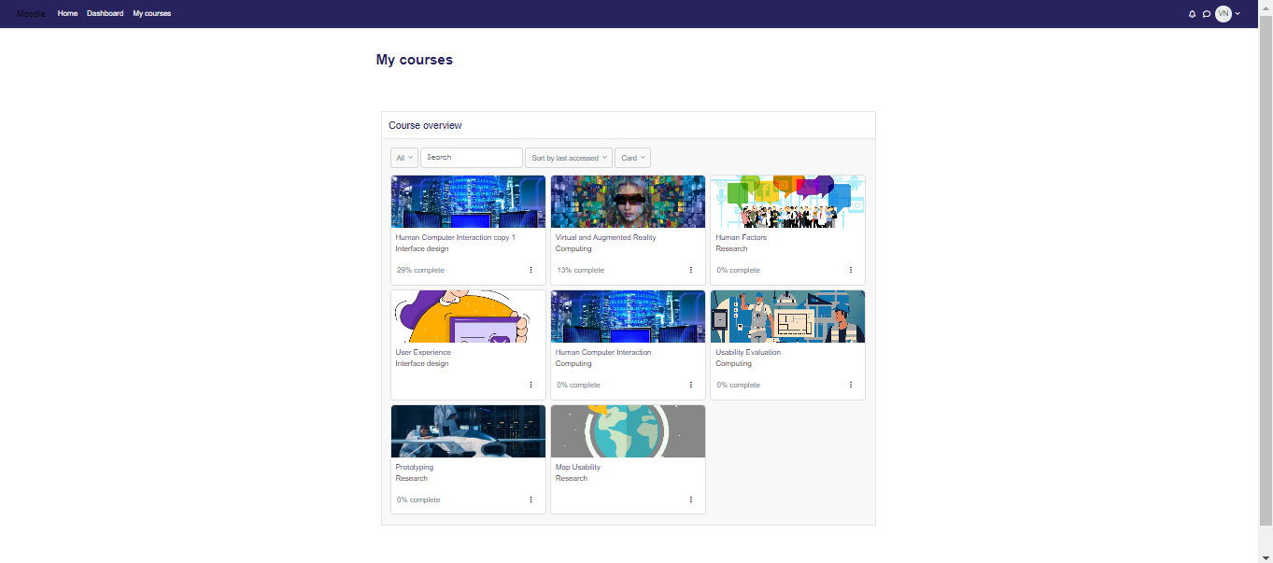
Figure 3.1: Participants’ courses page.
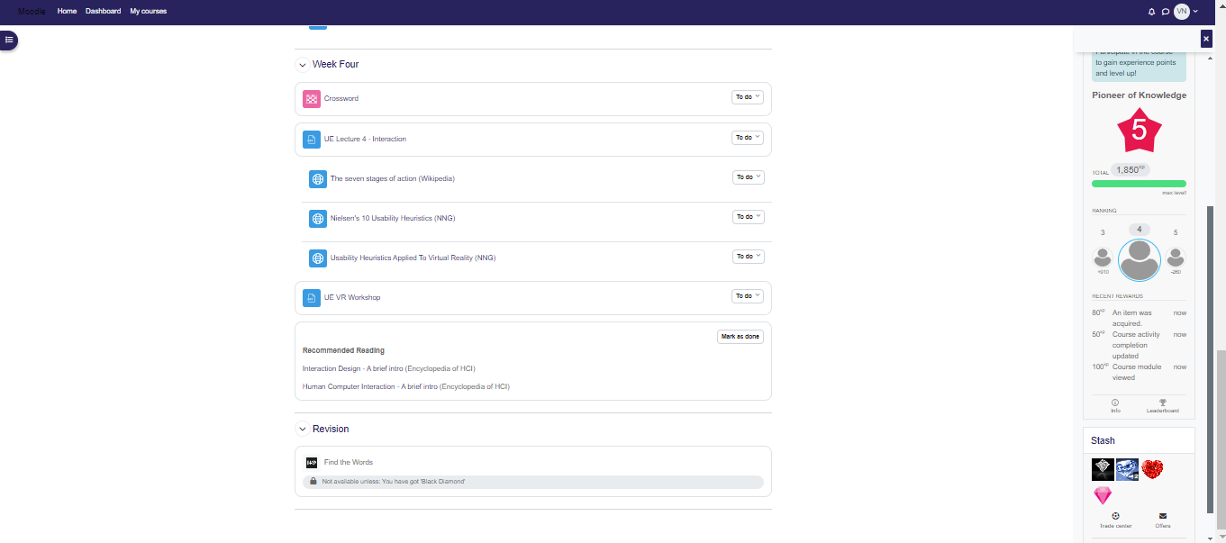
Figure 3.2: Example of a course’s main page

3.3.1 Level Up XP plugin
After the plugin is successfully installed, the Level Up XP block appears in the block drawer on the right side of the screen (bottom right for mobile phone screens and top right for desktop screens). Configuring this block involves setting up the information for each level, how leaderboard information will be displayed, the number of levels to be attained in the course, and the number of points for each course activity.
This plugin was utilised to introduce leaderboards and promote healthy competition, which can increase students’ engagement. The idea behind this plugin is that points are awarded for user activities on each course page. For example, in the course ‘Human-Computer Interaction’, five levels are set from Level 1 – Novice to Level 5 – Pioneer of Knowledge. Also, 100 points are earned when a participant views course material, such as a file or submits a quiz attempt. Points are not taken away or awarded in the event of any deletion activity. In this course, earning 120 points moves a participant from Level 1 to Level 2 – Seasoned Investigator. The final level to be attained is Level 5 – Pioneer of Knowledge, which requires 742 XP points and above. The scoring system was simplified due to the nature of the project.
For anonymity in the project, the leaderboard page is set to show ‘Someone else’ for other participants. Still, the participant currently logged in can view his position on the leaderboard page within the course. Figure 3.3 shows the message that pops up when the user has earned a certain number of points and moves to the next level. Figure 3.4 shows the leaderboard page for the Human-Computer Interaction course.

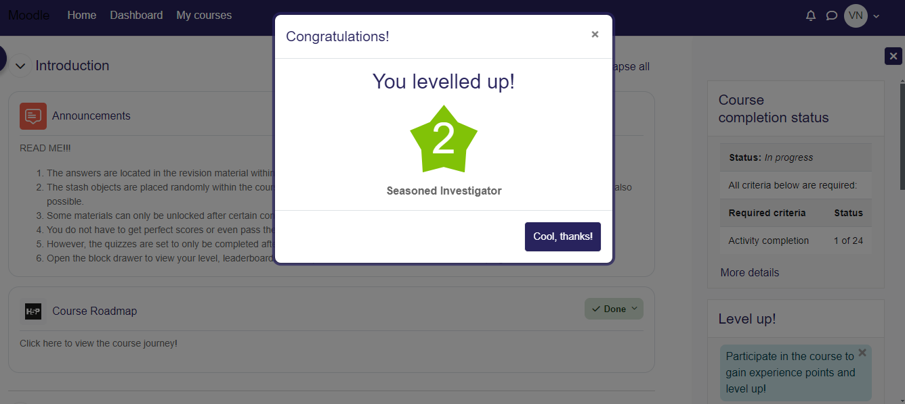
Figure 3.3: Levelling Up
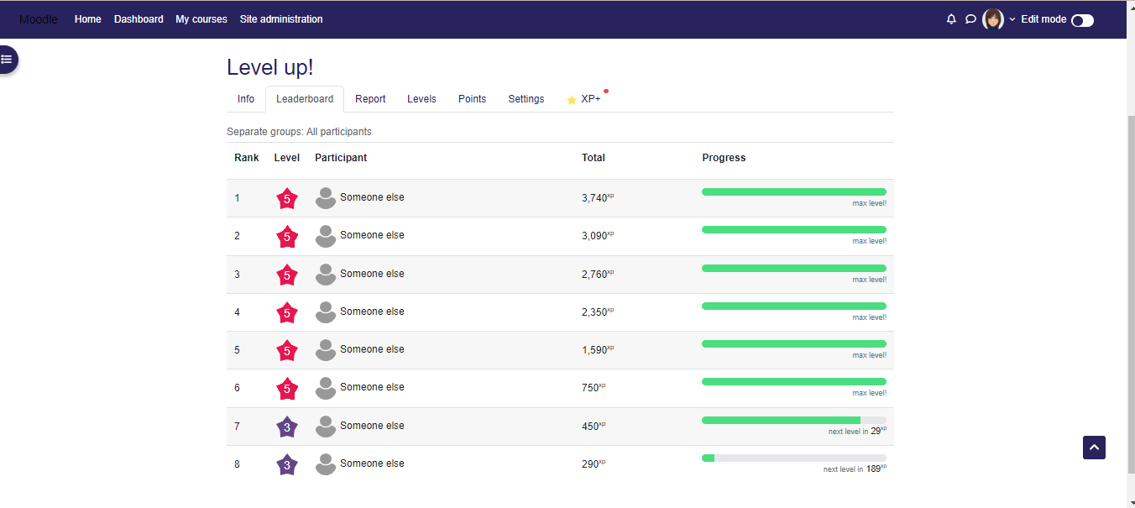
Figure 3.4: Level Up XP leaderboard

3.3.2 Stash plugin
The stash plugin was used to incorporate exploration into the platform. Students might not visit the Moodle site unless it is necessary. Hence, incorporating this plugin is to give them a reason to engage with Moodle. The Stash block also exists as a block in the block drawer and allows participants to view a collection of items they have picked up throughout the course page. The stash items are images of objects set up as ‘drops’ embedded in various course materials. The stash availability and tiny stash plugins are not required for the Stash plugin to work. However, these plugins add more functionality, like trading stash items and restriction of course materials based on stash inventory. The stash items can be created and placed as drops within the text editors for course activities, such as the activity description text editor, with the aid of the treasure chest icon.
The stash items were placed randomly in several course materials, with some recurring at intervals to encourage engagement with the course materials. To facilitate searching for the stash items, the gamified quizzes were restricted/locked only to be accessible upon gaining specific stash item(s). The stash plugin also allows for the trading of stash items, which is ideal in a classroom where students must work in groups to share ideas and access resources. However, this study did not introduce it as the participants need not know each other’s identity. Figure 3.5 shows the stash inventory on the right side of the image.
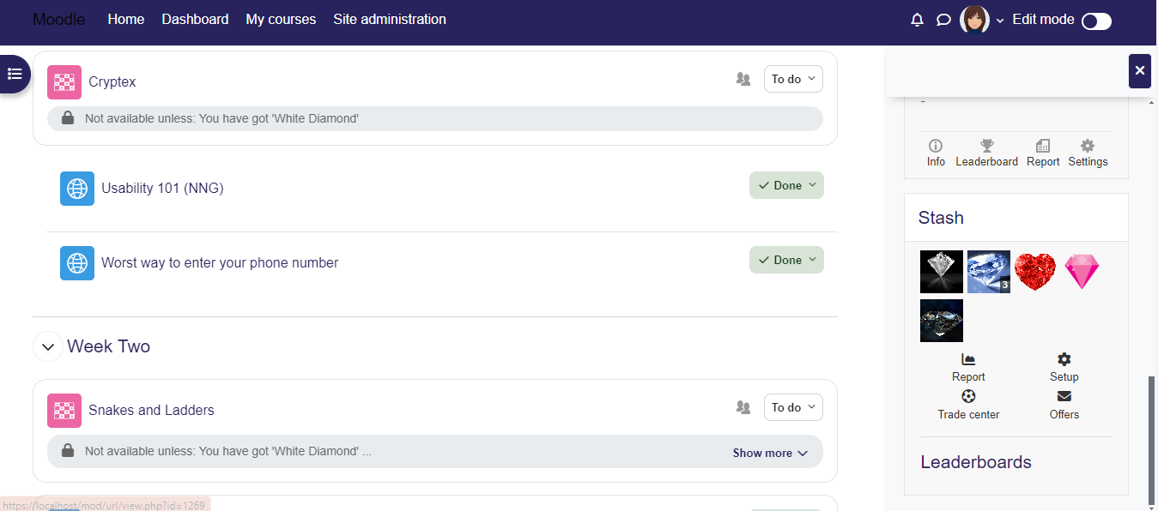
Figure 3.5: Stash Inventory

3.3.3 Game plugin
The Game plugin is one of the plugins in the gamification set on Moodle’s official website. This plugin consists of games that use quizzes, glossaries, and questions to offer interactive and gamified activities. This project used Millionaire, Cryptex, Hangman, Crossword and, Snakes and Ladders which are included in this plugin. For this study, the questions for the games were set based on lecture content for the week and setting up these games involved using Moodle’s question bank. The game plugin was installed to introduce learning with games and encourage learning from failures by allowing multiple game attempts while providing the correct answer to the failed question after each attempt.
The Millionaire game uses multiple-choice questions. The questions were created in Moodle’s multiple-choice questions or Aiken question format, shown in Figure 3.6, and imported as test files into the question bank for each course where the game was being used. The game is shown in Figure 3.7. It is ideal in a learning environment with multiple students as there are options to either phone someone for assistance, ask the audience or take out two incorrect answers.
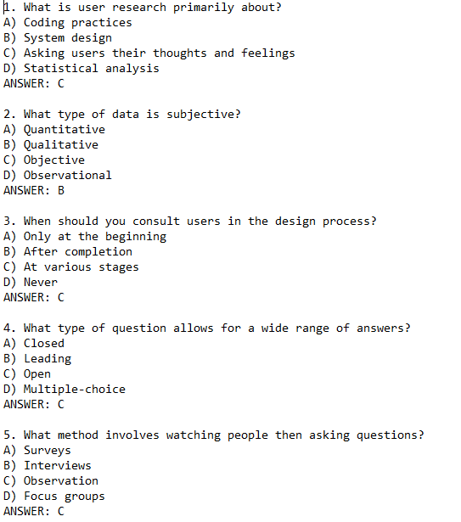
Figure 3.6: Aiken Format
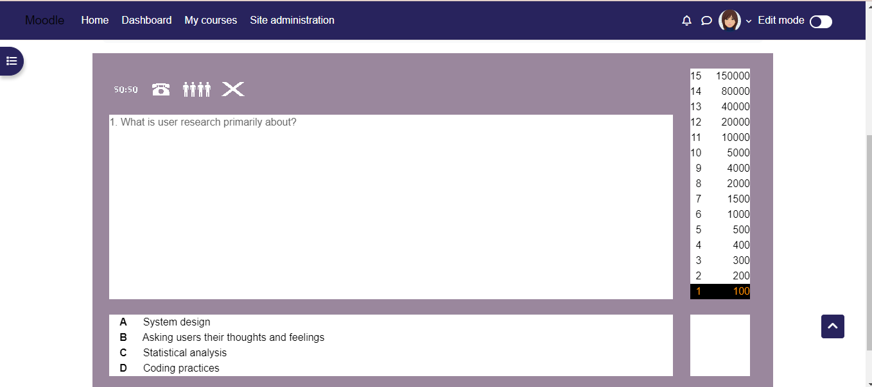
Figure 3.6: Millionaire

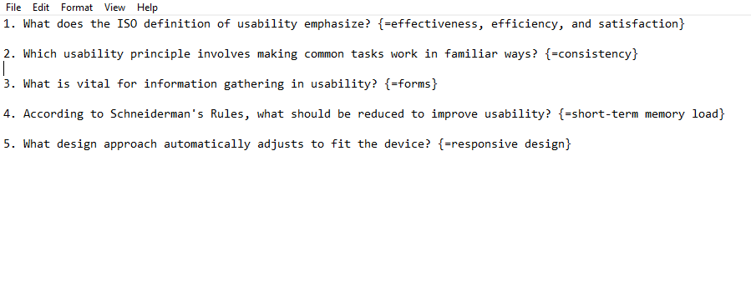
Figure 3.7: GIFT format

The Snakes and Ladders, Cryptex, Hangman, and Crossword games used short answer questions. The questions were created in Moodle’s short answer questions or GIFT format, shown in Figure 3.7, and imported as text files into the question bank for each course where the games were being used. The Snakes and Ladders game, shown in Figure 3.8, is played by inserting the answer in the answer box and afterwards clicking ‘Grade Answers’. The little red star in the game moves depending on the answer selected. This means that if the right answer is selected, the star moves based on the number on the die. When the wrong answer is selected, the star remains in place. In the case of Cryptex, depicted in Figure 3.9, the answers are contained in the grid and mixed with a bunch of other irrelevant letters. To answer a question, the user can search for the answer in the grid and type that answer in the answer box. The Hangman game, in Figure 3.10, involves selecting the letters that make up the answers to the questions. The correct selection of a letter that is repeated in the answer brings up that letter in all its correct positions. The Crossword game is based on a regular crossword. Each answer has specific spaces for its characters in the crossword, with hints on whether the answers should go across or down in the crossword box. This is shown in Figure 3.11.

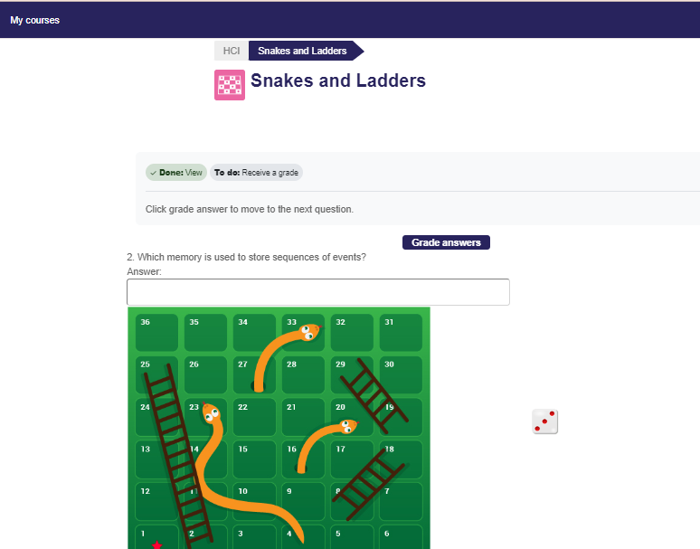
Figure 3.8: Snakes and Ladders

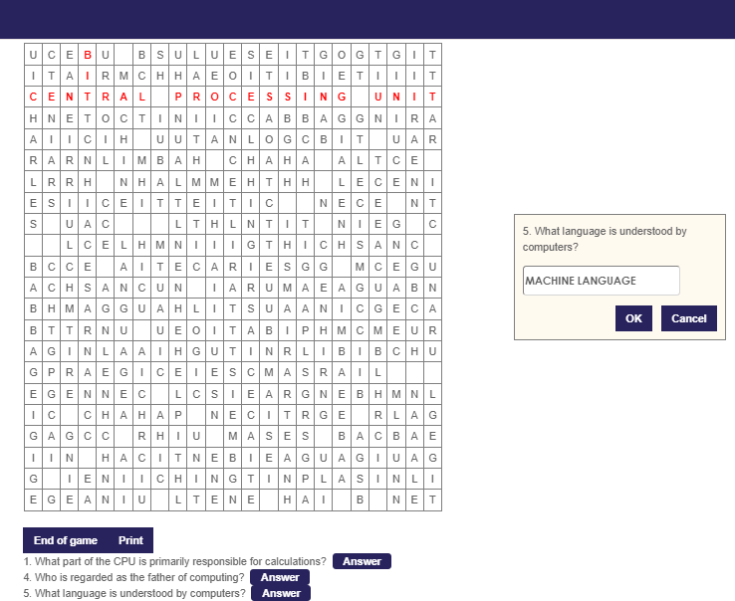
Figure 3.9: Cryptex

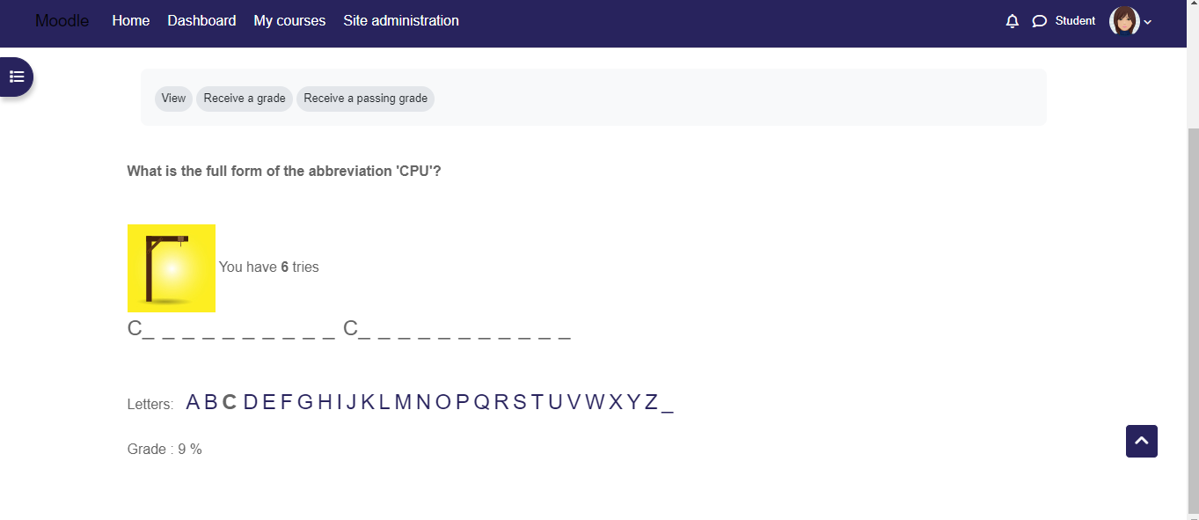
Figure 3.10: Hangman

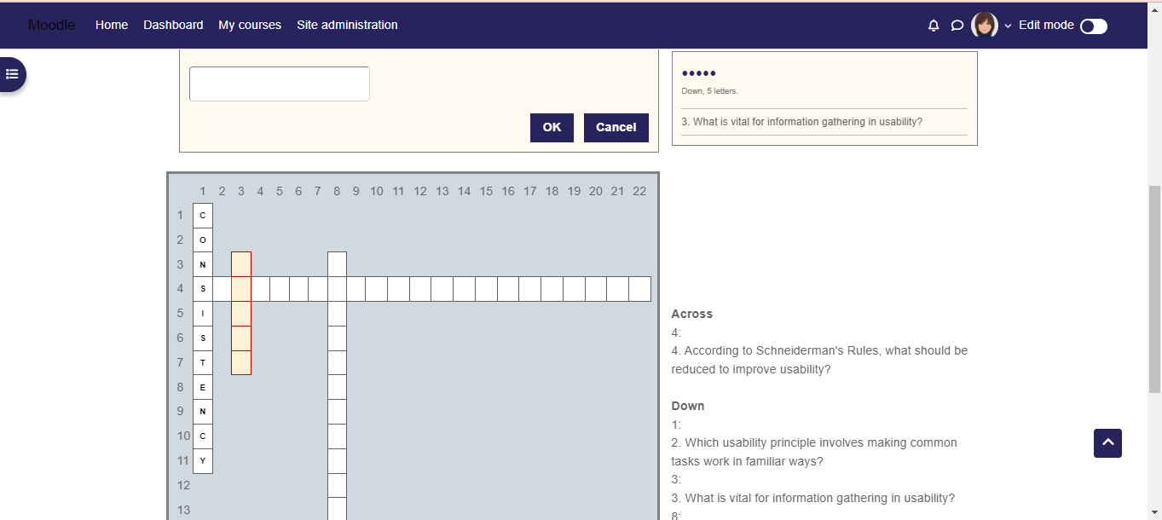
Figure 3.11: Crossword

3.3.4 H5P plugin
The H5P contents used in this project include Picture with hotspots, Multiple-choice questions (with images), Dialog cards, and Find the words. The ‘Picture with hotspots’ shown in Figure 3.12 was used to display the course syllabus interactively. As the name implies, this content is a picture with clickable icons. When an icon on the page is clicked, the syllabus information is displayed to the user. The background image chosen for this were pictures of maps. The idea behind this was that the syllabus information would be displayed as a journey, with each week’s topic/activity as a destination and the final destination being the final topic or course completion.
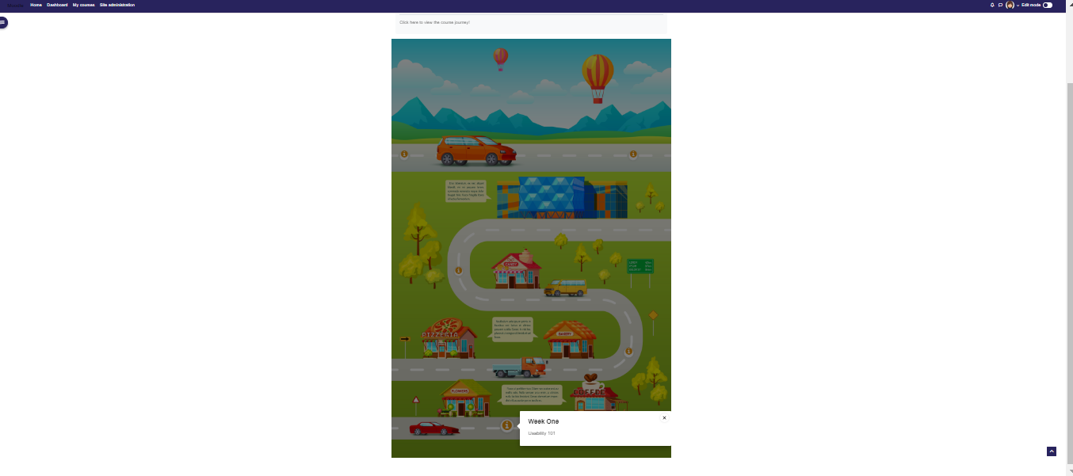
Figure 3.12: Course Roadmap (Picture with hotspots)
The ‘Dialog cards’, Find the words, and Multiple-choice questions (with images) shown in Figure 3.13, Figure 3.14 and Figure 3.15 were incorporated as revision materials, one for each gamified course, and were put in place to provide participants with the answers to some of the game questions. The H5P Dialog Cards are similar to study flashcards. ‘Find the words’ is a word search activity that allows users to find and select words in a grid, and ‘Multiple-choice questions’ use animations as the narrators of the multiple-choice questions. While the Game plugin activities are graded, the H5P activities are not. These activities were set to present questions to students and provide the answers immediately.
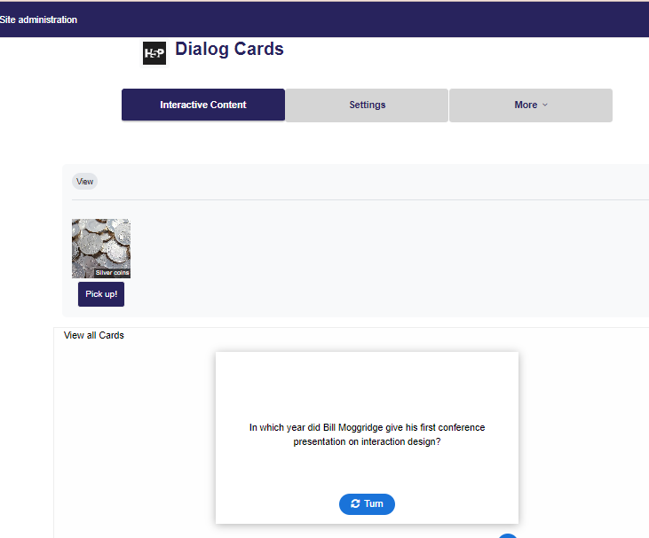
Figure 3.13: Dialog Cards
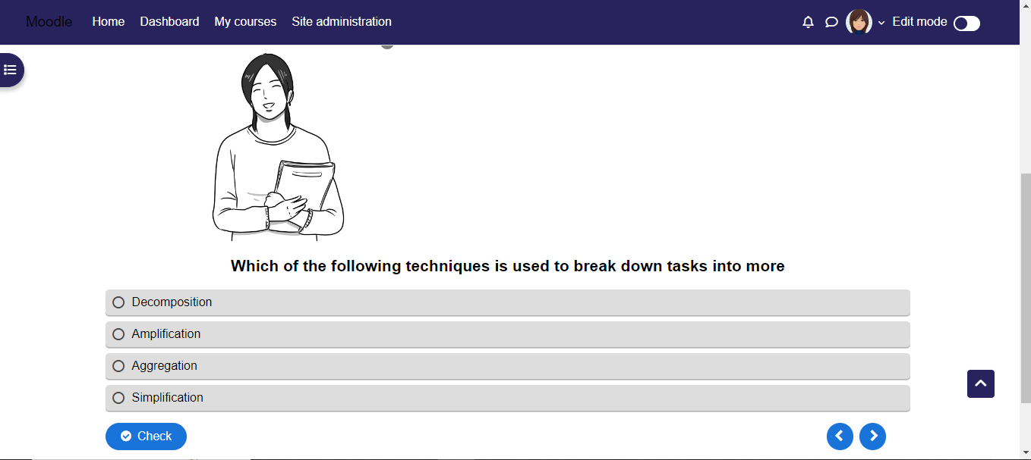
Figure 3.14: H5P Multiple Choice Questions

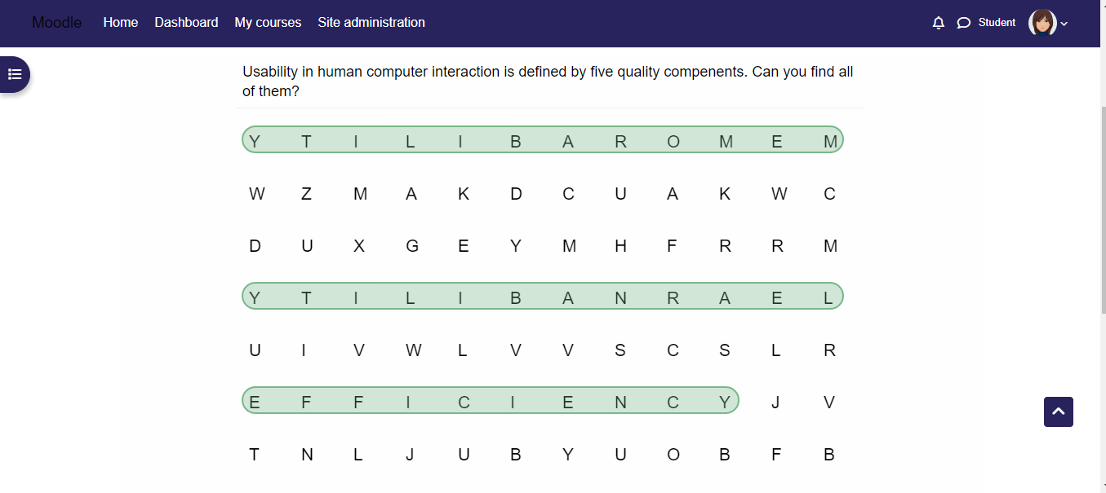
Figure 3.15: H5P Find the words

Chapter 4: RESEARCH METHODOLOGY

4.1 Participants and Data Collection
The study was conducted with thirty participants between 18 and 50 who completed primary education. Among these participants, thirteen are female, fifteen are male, and two prefer not to say. Eighteen of them are between the ages 18 to 24, seven of them fall in the age range 25 to 34, one person is between 35-44 and four people are aged 45 to 50. Regarding their current level or highest level of education attained, fifteen answered ‘bachelor’s degree’, twelve answered master’s degree, two answered ‘college degree’, and one answered doctorate degree.
Data was collected from the study participants using Microsoft Forms in the form of a questionnaire. The questions are contained in APPENDIX A. The form includes the researcher's details and the study's title. Quantitative and Qualitative data were also collected from participants to gain insights into their experience with gamification and the Moodle platform.

4.2 Ethical Issues
The study ensures the anonymity of participants by solely focusing on the participants’ experience with the platform. The names and contact information of participants were not collected via questionnaire; hence, the data collected cannot be tied to individuals. However, during registration on the Moodle site, the participants had to provide personal information such as their names (real or not), email addresses, city, country of residence, etc. This information, which the participants freely provided, was erased upon project completion. The participants were also made aware of the terms and requirements of the study before participation. Those given access to the website and whose responses were recorded filled out the questionnaire agreeing to the consent statements contained in APPENDIX D. An ethics form was also completed and submitted to comply with the guidelines for research projects.

CHAPTER 5: Data Analysis
The data obtained from the 30 study participants was organised and analysed using Microsoft Forms, Microsoft Excel spreadsheet, and R Studio for analysis in R programming language. Initially, with the questionnaire, the study tries to determine:
              - Contrary to the information gained from the literature review, gamified learning does not improve student engagement and is not potentially effective in higher education.
              - Similar to the information obtained from the literature review, gamified learning improves student engagement and is potentially effective in higher education.

5.1 Primary Data Pre-processing
The data collated using a Microsoft Forms questionnaire was imported into Microsoft Excel for primary data cleaning. Primary pre-processing activities were as follows:
- Removing unnecessary columns: Columns such as id, start time, completion time, and email (anonymous) that were unnecessary to the analysis were removed.
- Renaming Columns: When the data was imported into Excel, the questions were retained as column names, so they needed to be renamed to more concise and suitable column names. This activity, when carried out in R Studio, resulted in more complications. Therefore, the column names were simply changed in Excel.
- Merging Columns: The questions below were presented to participants to better understand each participant’s perspective on gamification and the gamified courses. The answers were then merged into a column called ‘opinion_on_gamification’.
- Did the project meet your initial expectation(s) on gamification? Explain
- What is your overall opinion on the gamified courses?
- Were you more likely to revisit gamified course content than non-gamified content?
- If yes, why?
- Identifying themes: The main point was selected verbatim to replace the information provided for columns with qualitative data, such as opinion_on_gamification’, reason_best_elements, etc. When multiple themes were conveyed, these themes were separated with ‘|’. For Instance, where the participant said, ‘They (gamification elements) make it easier to understand taught concepts and make learning less cumbersome’, the theme was set as ‘effective’. Also, in areas where the participants responded ‘good’ without further explanation, the theme ‘good’ was chosen without making assumptions about what they considered good.
This was also done to provide answers to their challenges, suggestions, and modifications.

5.2 Secondary Data Pre-processing
After cleaning and organising data in Microsoft Excel, the data was read into an R dataframe using R Studio.
- Reading the file into a dataframe: The read_excel() function, which takes the Excel file path and sheet as arguments, was used to convert the file to a dataframe called ‘data_df’.
- Splitting best_elements column: The best_elements column contains the gamification elements selected by participants as the most motivating or enjoyable. This question allowed for the selection of multiple items; therefore, it was split into individual columns. Binary values 0,1 were used to indicate a selection or non-selection of the elements. In the R code, the presence or absence of each element is determined using grepl to search for the element within the best_elements string, and ifelse, to assign a 1 or 0 based on the search result.
- Conversion to factor datatype: Categorical values for columns such as age_group, gender, education_level_attained, rate_level_up_xp, satisfaction_elements_used, etc., were converted to factor datatype using the mutate() and factor() functions, for future manipulation and analysis.

5.3 Analysis
The data analysis involved descriptive, correlation, and thematic tasks to delineate existing relationships and patterns supported by data visualisation techniques.

5.3.1 Demographic Impact Analysis
a. Age group and Gender
The plot in Figure 4.1 depicts the distribution of each gender across the various age groups. There are more participants (16 people) between ages 18 and 24, balanced between males and females. It shows that more young people are represented in the study. Within the age group 25-34, there are five more male than female participants. The diagram also shows that while there are slightly more male participants, more older females than males aged between 35 and 50 participated in the study. The few people who withheld their genders also fall within the age group 18 to 24.
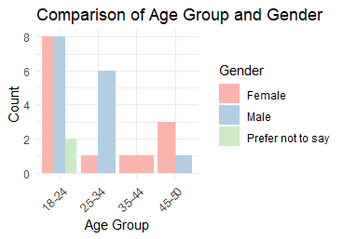
Figure 4.1: Age Group vs Gender
- Education levels
Figure 4.2 shows the distribution of participants by education level attained. This means that those who chose college have completed or are in college, those who chose a bachelor’s degree are currently pursuing it or have earned it, etc. The graph shows that more people in this study have completed their undergraduate degree or are currently pursuing it, meaning they have completed education at the foundation level. Figure 4.3 compares age groups and fields and gives more information about the participants. Many of them have a college degree or bachelor’s degree or are in pursuit of either one of them and are between the ages of 18 and 24. This could mean that these participants are recent graduates or early career professionals. Here, participants over 34 are either pursuing their second degree or are currently multiple degree holders. However, the diagram also shows that the study does not really represent those who chose college or a doctorate as their current or highest level of education.
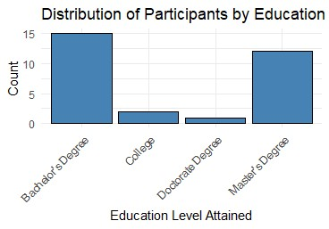
Figure 4.2: Education level of participants

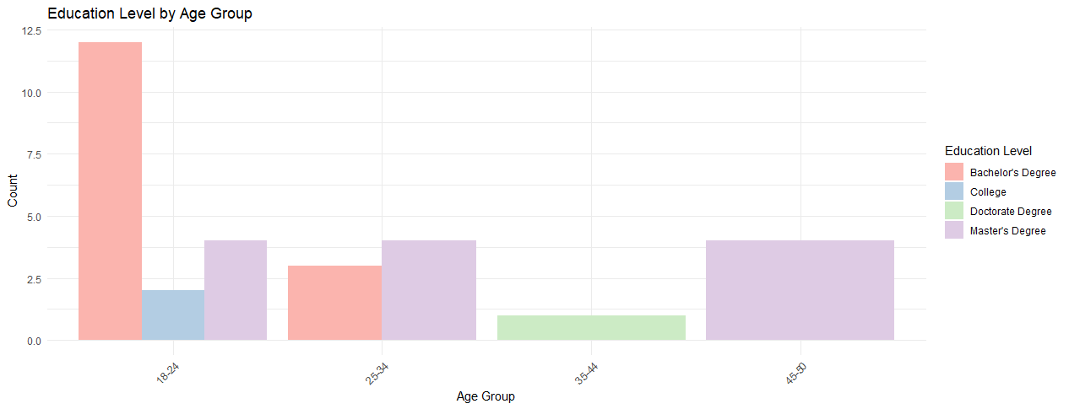
Figure 4.3: Education level and age group
c. Fields of Study or Major
Figure 4.3 shows the distribution of the participants across their various fields. The image shows that the participants are predominantly in the IT and computing field, for example, cybersecurity, data analytics, etc., with 6 of them in the Computer Science field, 4 in the Data Science field, and the others spread across other fields. This means that the study does not represent the opinions of people from different fields.

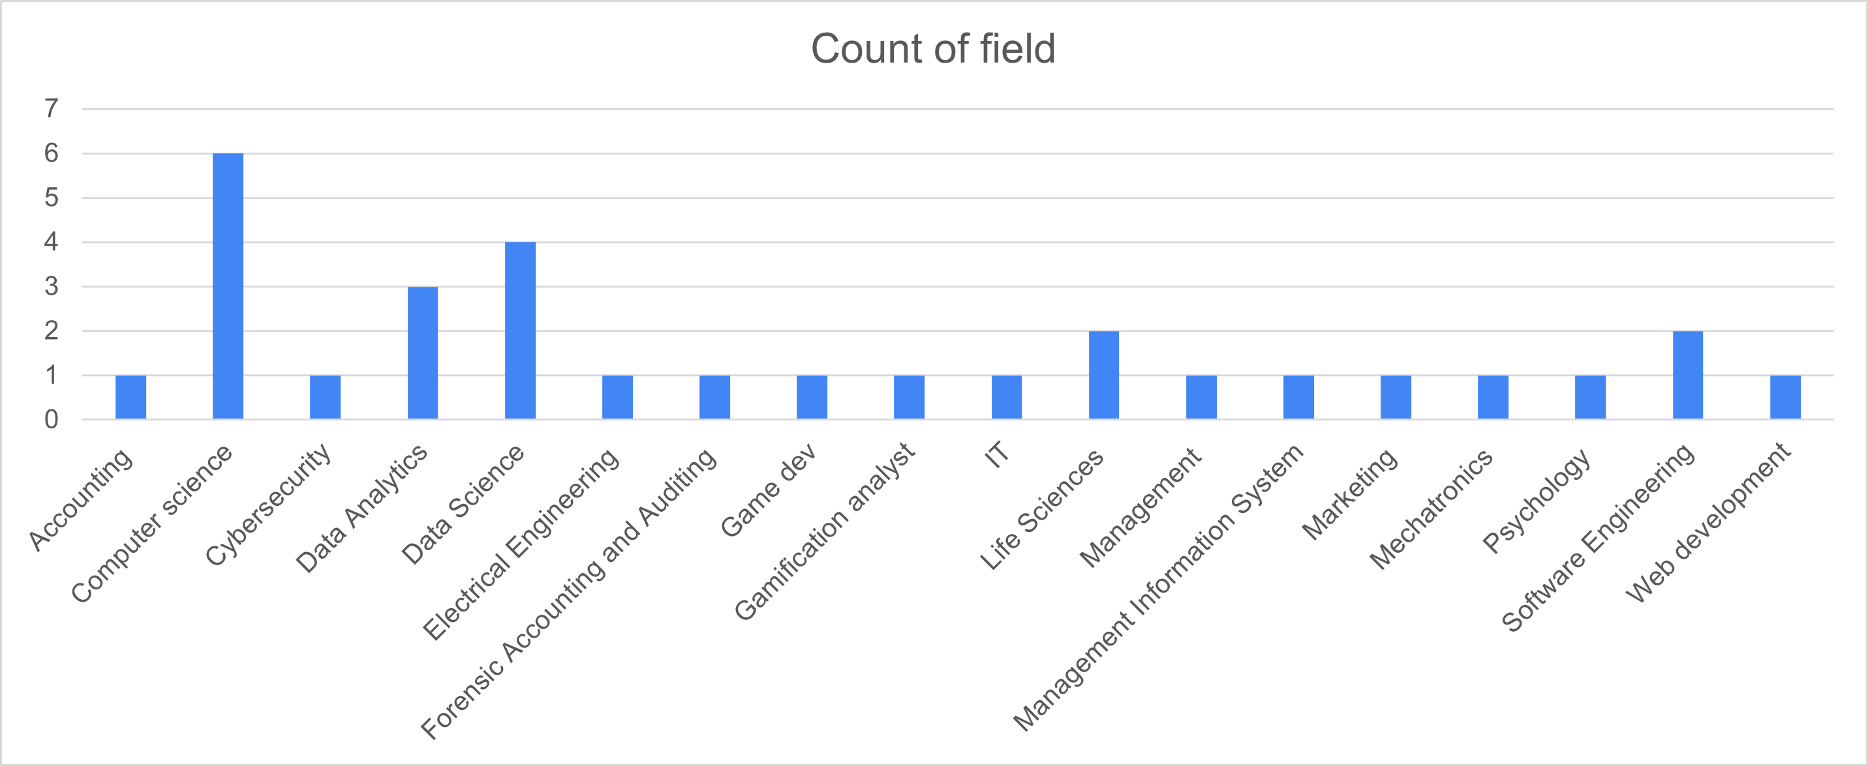
Figure 4.4: Field of study or major

Relationships Analysis
              - Prior knowledge of gamification versus Perspective of learning with games
The graph in Figure 4.4 compares the relationship between prior knowledge of gamification and the participants’ perspective on learning with games before participation. This analysis determines their views on gamified learning before participation in the study. It shows that most were previously aware of the term and its meaning and felt it was moderately to highly effective. Among the people without prior knowledge, only one felt it was highly effective, and another one thought it was not effective at all before participation. Also, among those without prior knowledge, there was a tie between the people who felt it was slightly ineffective, those who were neutral about its effectiveness, and those who felt it was moderately effective. It can be gathered from this graph that prior knowledge of gamification most likely influenced their perspective on its effectiveness.
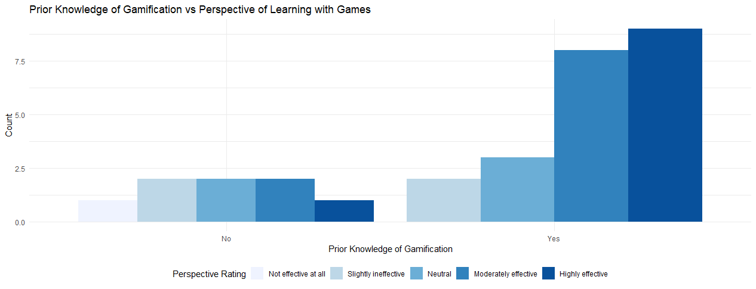
Figure 4.5: Prior Knowledge vs Effectiveness

              - Perspective on learning with games and Improved understanding
The study also compared the participants’ perspectives on learning with games before participating in the project with their perspectives on the ability of gamification to improve understanding during the project. This analysis is to determine the changes in their perspective of gamified learning. As shown in Figure 4.6, it was discovered that most people felt that the gamified elements helped them understand the course materials better, including those who previously felt it was slightly ineffective and those who were neutral about its effectiveness. After partaking in the study, only one person who, prior to the study, felt it was not effective at all maintained their opinion on its effectiveness. This means that the gamified elements impacted the majority of participants and did indeed improve their understanding, of course, the materials. This discovery also supports the theory that awareness and exposure to gamification in education can influence people’s opinions on its effectiveness.
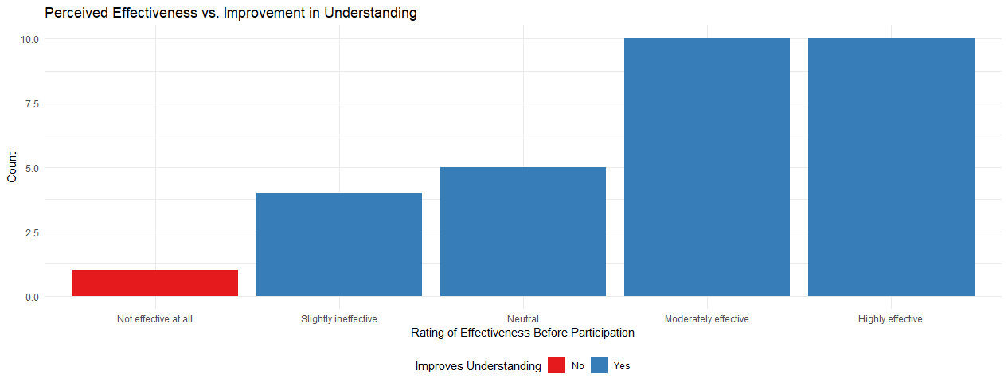
Figure 4.6: Perceived Effectiveness vs Improved Understanding
- Engagement levels and Improved understanding
Figure 4.7 shows the relationship between participants' engagement levels and their improved understanding of the course materials. It illustrates some association between these factors. While there is no evidence suggesting that the improved understanding of participants was due to increasing engagement levels, the plot shows that the gamification elements not only improved understanding but also contributed to increased engagement levels, as 27 participants found it more engaging than non-gamified course content (a combination of ‘more engaging’, and ‘much more engaging’). Here, only one person found the gamified courses less engaging than non-gamified courses. The person found the non-gamified content more engaging at engagement level 1.
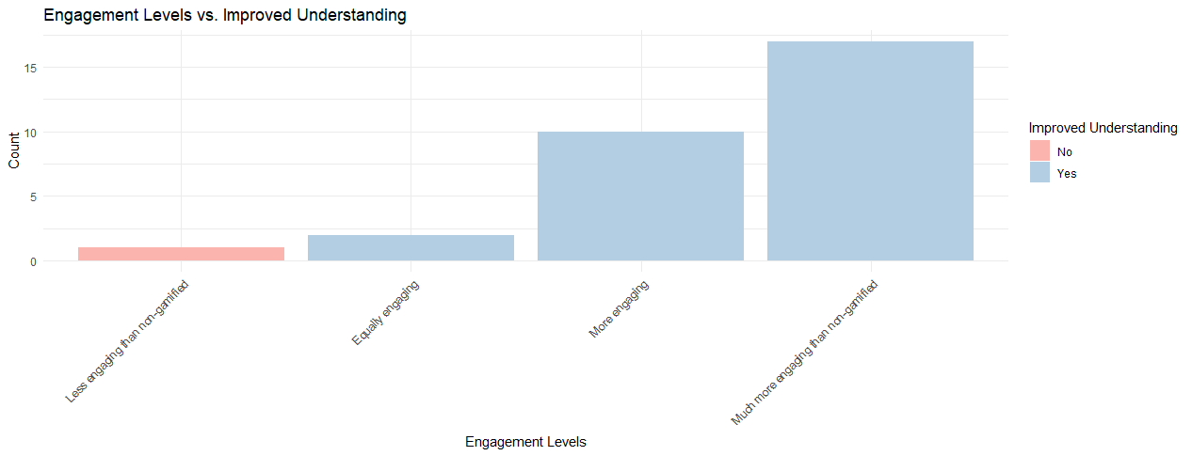
Figure 4.7: Engagement Levels vs Improved Understanding
- Engagement Levels and Gender
Figure 4.8 is a graph showing the comparison between the gender and engagement levels of participants. This analysis determines if a particular gender engages with gamification more than the other. Only one participant who withheld their gender information considered the non-gamified course more engaging (engagement level 1). The graph also shows that there were slightly more males than females, with engagement levels at 4 and 5, a ratio of 14:12. This means that engagement levels between both genders were relatively balanced, noting the fact that the number of males in this study was also slightly more than the females. No one gender found it more engaging than the other.

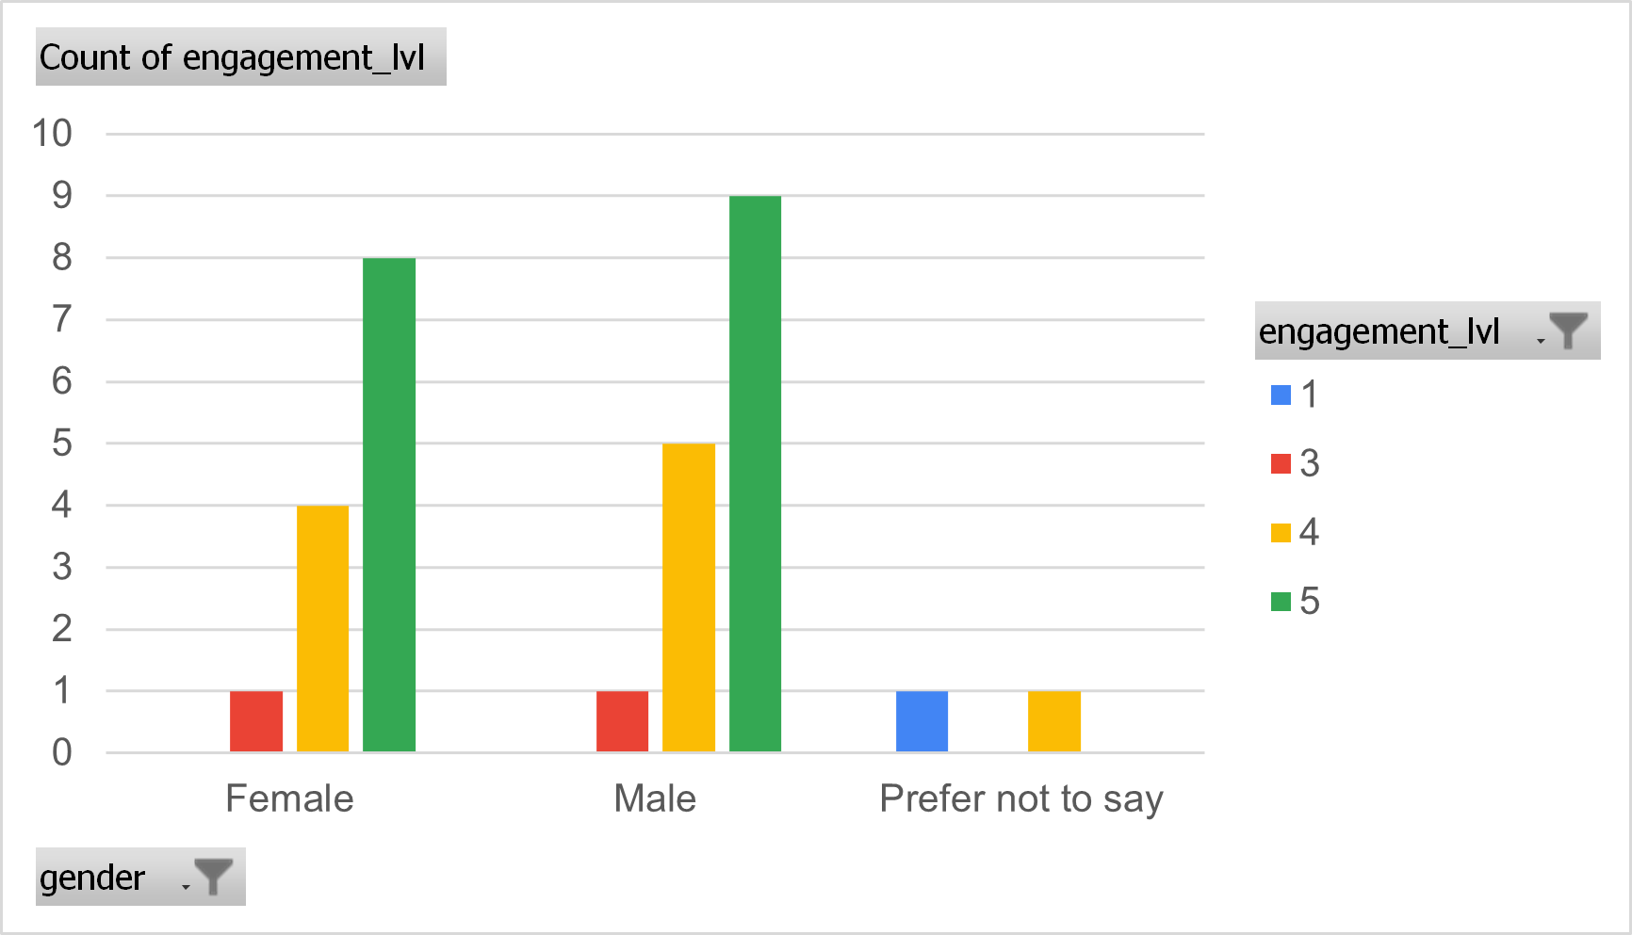
Figure 4.8: Gender vs Engagement levels
- Age Group and Engagement Levels
It is not unusual to assume that different age groups will respond to gamified learning differently, hence the diagram in Figure 4.9. Firstly, it is worth noting the data imbalance between the age groups. Secondly, the chart shows that most participants aged 18-24 found the gamified courses more engaging than non-gamified courses. Of the eighteen, 11 found it ‘much more engaging’, five found it just ‘more engaging’, one found it less engaging, and another found it equally engaging. The study reveals that older people between 25 and 50 responded well to the gamified courses. Out of the 12 of them, 11 found it engaging and much more engaging. None of the participants here, aged 25 to 50, considered the non-gamified course more engaging.
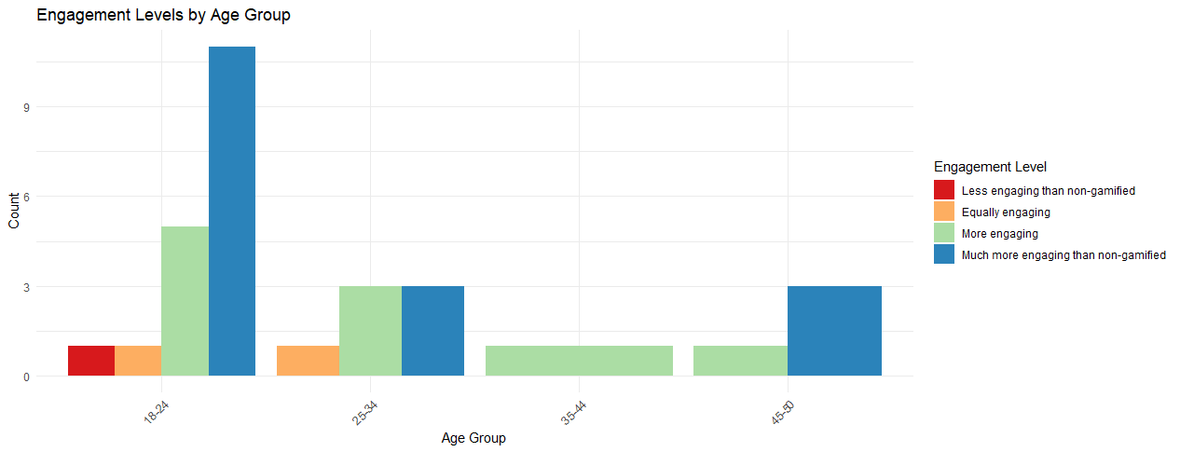
Figure 4.10: Age Group vs Engagement Levels

Elements Effectiveness Analysis
              - Best elements
The best elements graph in Figure 4.11 depicts the elements chosen as most enjoyable or motivating by the study participants. This question allowed participants to select multiple gamification elements. 19 out of the 30 participants selected the Level Up XP as the most enjoyable or motivating. This was followed by stash items and avatars, with 15 selections for each. The Cryptex is seen to be the least selected gamification element.
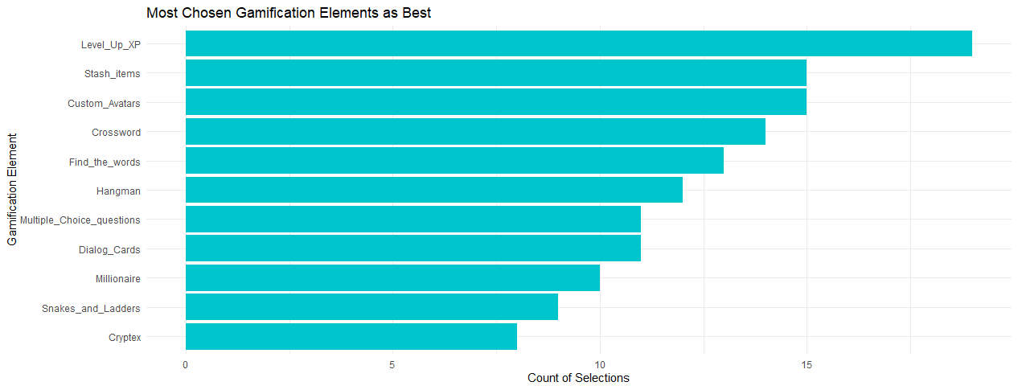
Figure 4.11: Most motivating/Enjoyable gamification elements

              - Connections between best elements and demographics of participants
Figure 4.12 depicts each gamification element, age group and gender of participants who made the selection. This analysis is to determine how demographic factors influenced the participants’ choices. More females generally selected each element for the age group 18 to 24 than males. They also made many selections for the elements used, which suggests they engaged with many of the elements.
The Level Up XP, which had the highest selection, was balanced between the male and female participants in this age group alone. Participants in other age groups did not select this element as much. For participants aged 25 to 34, the Crossword was the most popular choice, although by males. Only one female participant in this age group selected the Level Up XP. The single participant within the age group selected the Stash element. For the age group 45 to 50, the elements ‘Find the words’, ‘Multiple choice questions’, and avatars were their most selected element, also by makes. However, this graph cannot give suggestive or conclusive information due to data imbalance. As depicted in Figure 4.15, the simplified version of Figure 4.14, excluding the Level Up XP, the stash, avatars and H5P find the words, were commonly selected by females. The stash, avatars, and crossword were more selected among the male participants, excluding the Level Up XP.
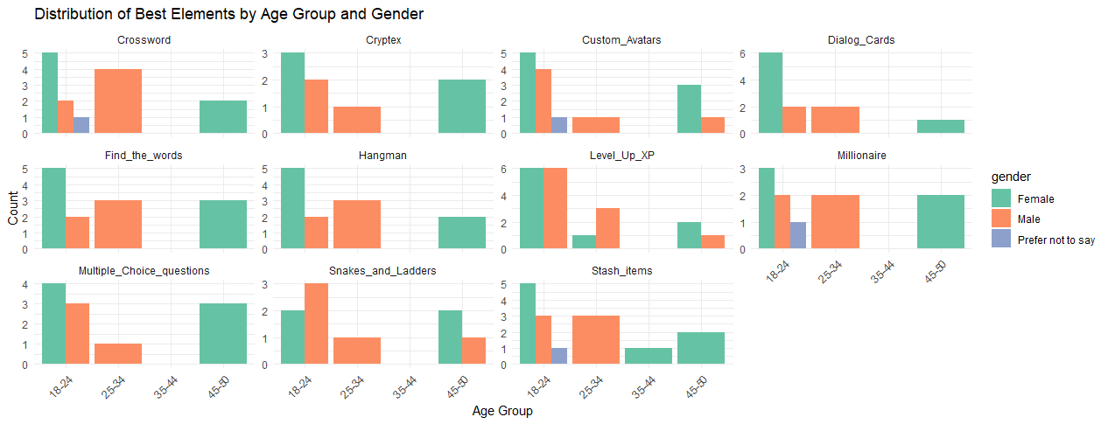
Figure 4.12: Best elements vs age group and gender

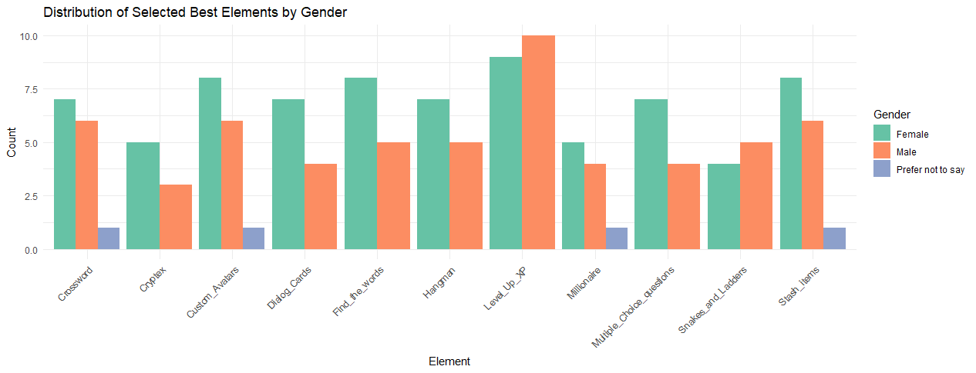
Figure 4.13: Best Elements vs Gender

              - Frequency of themes
Figures 4.14 and 4.15 are graphs showing the themes in the participants’ responses regarding questions on their opinion on gamification and the reason for their best element. The expectation was that they would state the reason(s) for each selected element. Since that was not the case, their answers were generalised. The most frequent themes in their opinion on gamification were ‘effective’, ‘engaging’, ‘fun’, and ‘interactive’, with over 26 comments. The most frequent themes in their reasons for selected elements were ‘interesting’, ‘fun’, ‘good’, and ‘engaging’ with 18 comments. From these data, it can be deduced that the gamification elements were fun, engaging, effective and interesting for the study participants. It clearly shows very few comments related to low satisfaction or interest.

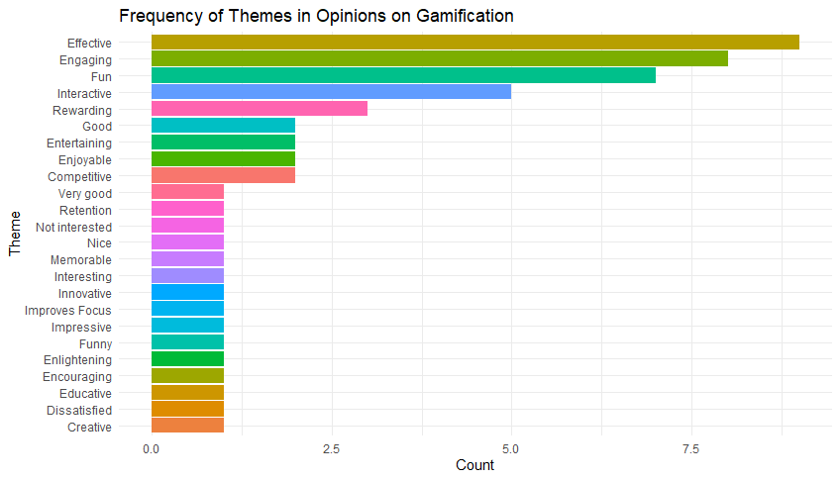
Figure 4.14: Opinion on gamification

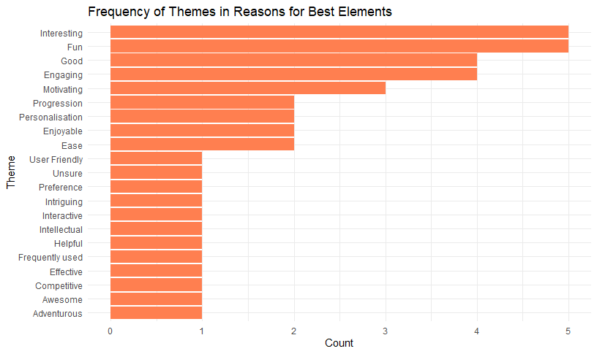
Figure 4.15: Reason for selected elements

5.3.4 Satisfaction and Improvement Analysis
a. Satisfaction Level
The graph in Figure 4.16 shows the participants' overall satisfaction with the gamification elements used in this project. Many of them had a positive experience overall. Twenty-eight participants answered ‘satisfactory’ and ‘very satisfactory’, which shows that they were satisfied with the gamification elements. Two participants, however, found the elements very unsatisfactory.
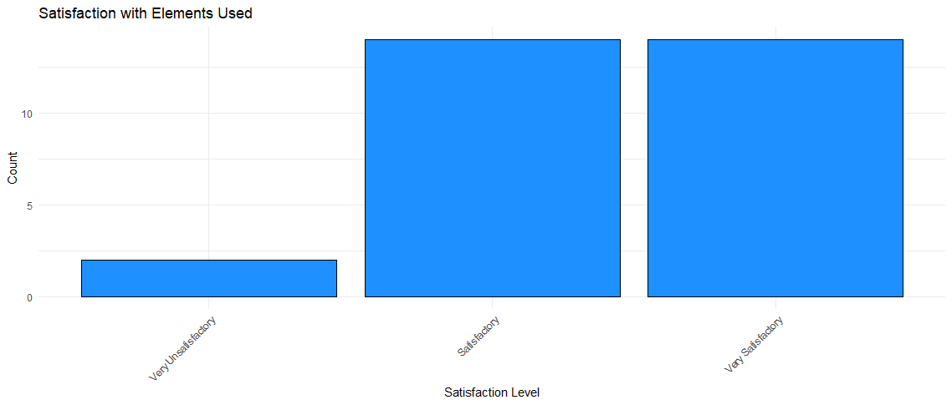
Figure 4.16: Satisfaction with gamification

- Previous experience with gamification and challenges encountered.
The diagram in Figure 4.17 compares participants' previous experience with online learning platforms to the challenges they had using the Moodle platform. This is to determine whether the challenges faced could result from inexperience with learning management systems and online learning platforms. The graph provided contrary results. The graph shows that challenges were encountered only by people with a moderate to comprehensive understanding of online learning platforms. This means that the previous experiences of certain participants allowed them to spot usability issues that others could not spot. The graph also depicts that most participants recorded ‘none’, which means they had no challenges with the platform. Where ‘the games’ were listed as a challenge, based on their responses, the participants had little to no understanding of how to play the gamified quizzes or use the games in general. For participants who recorded ‘Navigation’ as a challenge, they had difficulties navigating the Moodle site and identifying the gamification elements. The information that can be obtained from this graph is that while there were few challenges with the platform, more information on the navigation of the Moodle site and an explanation of the gamification elements would have been necessary.
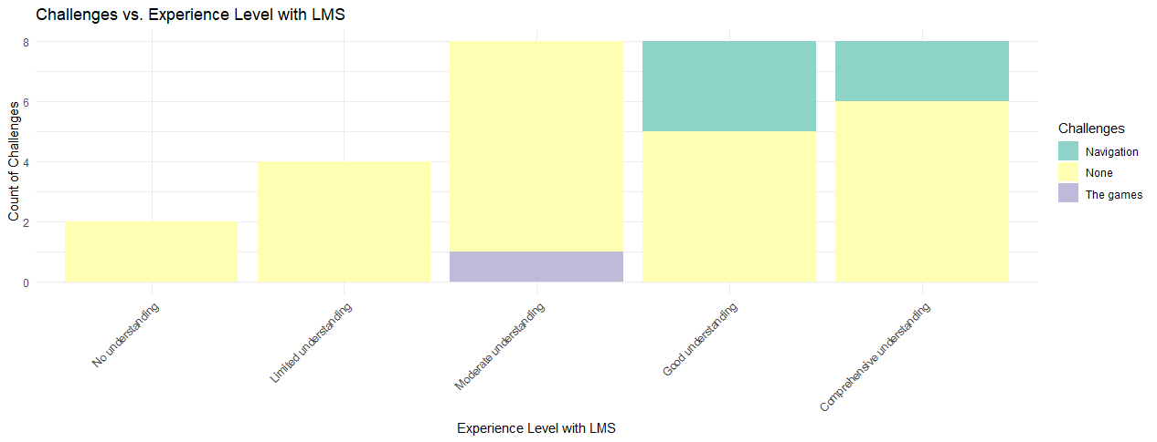
Figure 4.17: Challenges vs Experience with LMSs

- Suggestions for Improvement/Modification
The suggestions by 40% of the participants include more explanation of the games, easier navigation, better user interface and design, inbuilt functionality for avatars, more learning games, speech-to-text functionality, and optional participation in leaderboards. Other participants (59%) answered ‘No’, ‘None’, etc., while 1% answered ‘Unsure’. For elements to be removed or modified, Snakes and Ladders and Cryptex were suggested to be removed by 2 participants (one for each element) because they found it confusing. The Snakes and Ladders, alongside Cryptex, were also the least selected elements as the most enjoyable or motivating. Therefore, in utilising these games, the instructor will have to provide more detailed guidance on these two compared to the other elements.

Chapter 6: RESULTS AND DISCUSSION
Although conducted with a limited number of participants, this study produced results that indicate that most participants were engaged and felt that the gamification elements improved understanding. This indicates the potential usefulness of gamification in education due to the number of positive experiences recorded, referring to themes like fun, engaging, effective, interesting, etc. The gamification elements, Level Up XP, Stash and Custom Avatars, which both males and females frequently selected, are the most successful elements in the study. Similar to previous studies, the study also indicates that prior experience with online learning platforms does not significantly impact the usability of gamified Moodle platforms. On the other hand, prior knowledge/awareness of gamification can influence its perceived effectiveness.
Since understanding participants' demographics is useful information when researching capabilities for personalised learning, the distribution of participants’ fields, age groups and genders were compared with their selected best elements. As the participants were predominantly in the information technology and computing field, comparing fields with engagement levels did not provide much information. The data does not provide much information about how people from other fields, such as social sciences or engineering, will respond to gamified learning, but it did show that people in this field might connect with gamification. Many participants, both male and female, were seen to have connected with gamification, especially the participants aged between 18 and 24, due to their high engagement levels. This suggests that gamification with Level Up XP, Stash and Avatars could be effective with this population, presumably undergraduate students or early career professionals.
This study does not focus on the application of knowledge; it, however, touches on the matter of student engagement and retention. It also acknowledges the need for careful planning, design, implementation and explanation when integrating game elements and game-based apps into the learning process.

Chapter 6: Conclusion and Recommendations

6.1 Conclusion
The investigation confirms that integrating gamification and game-based learning within Moodle LMS can elevate student engagement and comprehension in higher education contexts. The data, derived from a group of participants, underscores the potential of gamified learning to create more interactive and rewarding educational environments. The study results also highlight the importance of implementing a variety of gamification approaches to accommodate different learning styles and preferences. Implementation strategies include using online learning platforms like Moodle, which can be downloaded and installed free of charge, as described in this project. Extensive technical training is also not required for this implementation method. Developing a gamified or game-based software application is another method of implementation, but it is more resource intensive. Finally, the results derived from this research will contribute to existing literature on gamification and its benefits in learning environments.

6.2 Recommendations
The theme to look out for when carrying out similar research is the effectiveness of gamification. Gamification in higher education must achieve learning objectives to be considered successful; otherwise, it is solely for entertainment. That is why it was important to keep the Moodle website as professional as possible by refraining from designs or colours that could make it look childish. Another useful data analysis is comparing participants’ demographics with engagement levels like age, field, and gender with a larger population to determine what demographic factors of individuals may affect its effectiveness.

6.3. Suggestions for Future Works
Future studies should expand on these findings by exploring the impact of various gamification elements on a broader demographic, ensuring diversity and inclusion of participants. More research should be conducted with a larger number of diverse participants across ages, fields, genders, disabilities, etc., to optimise educational methodologies further and produce conclusive evidence. Gamification elements might not work the same way for everyone in a learning environment, as illustrated in this study. Therefore, more in-depth study should be carried out to understand the reason for each participant's selection of their best elements, as it is essential for gamification in education to be successful. Also, as the virtual machine hosting the Moodle server had a time limit, the participants' activities could not be observed naturally. This factor should be considered when conducting similar research works. Many of the participants who had positive experiences were young people in the IT and computing field. They could serve as a starting point for further research or implementation. The Level Up and Stash plugins, as well as avatars, which are the three most successful gamification elements in this study, could also be utilised. This information can be used to optimise and tailor gamification elements to foster personalised learning.

Chapter 7: Reflection
Conducting this research was very tasking but rewarding. As I had little to no understanding of setting up a website and conducting detailed research, most of the activities required frequent iterations. During the project, the activities participants engaged with were monitored, such as their stash inventory and position on the leaderboard. Moodle’s activity completion was also used to achieve this. During the study, some participants inquired about the identities of the participants who scored higher than them in the leaderboards because they were curious about their performance. As this information could not be revealed, they inquired about activities that could put them at the top of the leaderboard even when there were no rewards involved. This means that these participants were intrinsically motivated. They wanted to do better not because of external rewards but rather their own sense of accomplishment. This involved revealing information about quizzes that could give them higher points. Many people engaged with this Level Up XP feature, contributing to its success. Their activities also revealed that while the participants were given a form containing instructions about the project for review, and the instructions were also placed on each course's main page on the website, many participants ignored them because they were not interested in ‘reading’. Hence, verbal communication of the requirements of the project and the use of the elements was important.
At the beginning of the study, I was interested in a complete reformation of the education system with gamification. Then I realised that people could have been engaged simply because it was new. Later, it could be overused to the point that it becomes less effective and engaging. This disengagement could arise due to boredom that all humans are subject to, and then we are back where we started. The results made me realise that while people engaged with the games, they still did not open the lecture materials. Many of them did not want to read but preferred to quickly look up the answers online. However, this is also a form of learning, as they might be able to remember the questions due to their reason for looking up the questions online. That is, playing a game. This is a form of tricking the brain to learn. Organising the lecture content in an attractive way on each course’s main page could help with this issue. For it to be effective, I feel it is necessary to use it periodically as a tool to increase engagement levels. Introducing new gamified activities once or twice a week can be more beneficial than having them every day.

References
[1] Cambridge Dictionary, “education,” @CambridgeWords, Mar. 29, 2023. https://dictionary.cambridge.org/dictionary/english/education (accessed Apr. 04, 2023).
[2] P. O. Adesemowo and Olufunmilayo Abosede TUMININU Sotonade, “Basic of Education: The Meaning and Scope of Education,” ResearchGate, Jul. 07, 2022. https://www.researchgate.net/publication/361813544_BASIC_OF_EDUCATION_THE_MEANING_AND_SCOPE_OF_EDUCATION (accessed Apr. 04, 2023).
[3] “A quote by Oprah Winfrey,” Goodreads.com, 2023. https://www.goodreads.com/quotes/70547-education-is-the-key-to-unlocking-the-world-a-passport (accessed Apr. 24, 2023).
[4] “‘Education is the most powerful weapon which you can use to change the world.’ -Nelson Mandela,” Toano, 2020. https://wjccschools.org/tms/2020/02/24/education-is-the-most-powerful-weapon-which-you-can-use-to-change-the-world-nelson-mandela/ (accessed Apr. 24, 2023).
[5] S. A. Barab, M. Gresalfi, A. Arici, and A. Ingram-Goble, “Transformative play: games as 21 st century curriculum,” ResearchGate, Jun. 29, 2010. https://www.researchgate.net/publication/262241123_Transformative_play_games_as_21_st_century_curriculum (accessed Apr. 25, 2023).
[6] Z. Mejia, “Elon Musk: This simple question can help fix what’s wrong with the U.S. education system,” CNBC, Jul. 20, 2017. https://www.cnbc.com/2017/07/20/elon-musk-this-question-can-help-fix-the-u-s-education-system.html (accessed Apr. 24, 2023).
[7] “Global video game users 2027 | Statista,” Statista, 2022. https://www.statista.com/statistics/748044/number-video-gamers-world/ (accessed Apr. 23, 2023).
[8] “Kids are here to play - the importance of games | Cambridge English,” Cambridgeenglish.org, 2023. https://www.cambridgeenglish.org/learning-english/parents-and-children/your-childs-interests/kids-are-here-to-play-the-importance-of-games/#:~:text=Research%20has%20shown%20that%20games,build%20new%20confidence%20and%20skills. (accessed Apr. 24, 2023).
[9] J. L. Plass, B. D. Homer, and C. K. Kinzer, “Foundations of Game-Based Learning,” Educational Psychologist, vol. 50, no. 4, pp. 258–283, Oct. 2015, doi: https://doi.org/10.1080/00461520.2015.1122533.
[10] A. Hellerstedt and P. Mozelius, “Game-based learning - a long history,” ResearchGate, Jun. 27, 2019. https://www.researchgate.net/publication/336460471_Game-based_learning_-_a_long_history (accessed Apr. 24, 2023).
[11] “Game-Based Learning (GBL): The Oldest Tool of Education | Talkingtown,” Talkingtown.co, 2022.https://talkingtown.co/game-based-learning-gbl-the-oldest-tool-of-education/#:~:text=Finally%2C%20in%20the%2020th,Jean%20Piaget%20and%20Lev%20Vygotsky.&text=India%20has%20a%20rich%20history,as%20teaching%20and%20recreational%20tools. (accessed Apr. 04, 2023).
[12] B. Kim, “Chapter 1. The Popularity of Gamification in the Mobile and Social Era,” Library technology reports, 2015. https://www.semanticscholar.org/paper/Chapter-1.-The-Popularity-of-Gamification-in-the-Kim/266d9f99e88ef04505715d2ae7d06e305f09e5f4 (accessed Apr. 25, 2023).
[13] M. Mavromihales, V. Holmes, and R. Racasan, “Game-based learning in mechanical engineering education: Case study of games-based learning application in computer aided design assembly,” International Journal of Mechanical Engineering Education, vol. 47, no. 2, pp. 156–179, Mar. 2018, doi: https://doi.org/10.1177/0306419018762571.
[14] S. J. Lachman, “Learning is a Process: Toward an Improved Definition of Learning,” The Journal of Psychology, vol. 131, no. 5, pp. 477–480, Sep. 1997, doi: https://doi.org/10.1080/00223989709603535.
[15] Bransford, J. D., Brown, A. L., & Cocking, R. R. (2000). “How People Learn Brain, Mind, Experience, and School”. Washington DC National Academy Press. - References – Scientific Research Publishing, Scirp.org, 2016. https://www.scirp.org/(S(i43dyn45teexjx455qlt3d2q))/reference/ReferencesPapers.aspx?ReferenceID=1750614 (accessed Apr. 25, 2023).
[16] E. Wenger, “Communities of Practice and Social Learning Systems,” Organization, vol. 7, no. 2, pp. 225–246, May 2000, doi: https://doi.org/10.1177/135050840072002.
[17] D. C. Edelson, “Learning-for-use: A framework for the design of technology-supported inquiry activities,” Journal of Research in Science Teaching, vol. 38, no. 3, pp. 355–385, Mar. 2001, doi: https://doi.org/10.1002/1098-2736(200103)38:3%3C355::aid-tea1010%3E3.0.co;2-m.
[18] M. Sharples, J. Taylor, and G. Vavoula, “A Theory of Learning for the Mobile Age,” Medienbildung in neuen Kulturräumen, pp. 87–99, 2010, doi: https://doi.org/10.1007/978-3-531-92133-4_6.
[19] H. Lin, S. Wan, W. Gan, J. Chen, and H.-C. Chao, “Metaverse in Education: Vision, Opportunities, and Challenges,” arXiv.org, 2022. https://arxiv.org/abs/2211.14951 (accessed Apr. 22, 2023).
[20] E. R. Kahu and K. Nelson, “Student engagement in the educational interface: understanding the mechanisms of student success,” Higher Education Research & Development, vol. 37, no. 1, pp. 58–71, Jul. 2018, doi: https://doi.org/10.1080/07294360.2017.1344197.
[21] M. Vaez and L. Laflamme, “Experienced stress, psychological symptoms, self-rated health and academic achievement: a longitudinal study of Swedish university students,” Social Behavior and Personality: An International Journal, vol. 36, no. 2, pp. 183–196, Mar. 2008, Accessed: Apr. 25, 2023. [Online]. Available: https://go.gale.com/ps/i.do?p=AONE&u=googlescholar&id=GALE|A188213838&v=2.1&it=r&sid=googleScholar&asid=59d85f74
[22] R. Costello and M. Lambert, “Motivational Influences for Higher Education (HE) Students,” International Journal of Online Pedagogy and Course Design, vol. 9, no. 1, pp. 38–50, Jan. 2019, doi: https://doi.org/10.4018/ijopcd.2019010103.
[23] R. Costello, "Learning Theories Within Gamification," in Gamification Strategies for Retention, Motivation, and Engagement in Higher Education: Emerging Research and Opportunities, Hershey, PA: IGI Global, 2020, ch. 1. [Online]. Available: https://doi.org/10.4018/978-1-7998-2079-6.ch001
[24] C. A. Coonradt, The Game of Work. GibbsSmith.ORM, 2007. Accessed: Apr. 25, 2023. [Online]. Available: https://www.perlego.com/book/2449665/the-game-of-work-how-to-enjoy-work-as-much-as-play-pdf
[25] G. Christians, “The Origins and Future of Gamification,” Scholar Commons, 2018. https://scholarcommons.sc.edu/senior_theses/254/ (accessed Apr. 22, 2023).
[26] R. Bartle, “Hearts, clubs, diamonds, spades: Players who suit MUDs,” 2014. Available: http://www.arise.mae.usp.br/wp-content/uploads/2018/03/Bartle-player-types.pdf
[27] J. Huggett, “Virtually Real or Really Virtual: Towards a Heritage Metaverse,” Studies in Digital Heritage, vol. 4, no. 1, pp. 1–15, Jun. 2020, doi: https://doi.org/10.14434/sdh.v4i1.26218.
[28] Stylianos Mystakidis, “Metaverse,” ResearchGate, Feb. 10, 2022. https://www.researchgate.net/publication/358497370_Metaverse (accessed Apr. 25, 2023).
[29] N. Friesen, “The Lecture and the Textbook - Education in the Age of New Media,” ResearchGate, Dec. 12, 2017. https://www.researchgate.net/publication/321497056_The_Lecture_and_the_Textbook_-_Education_in_the_Age_of_New_Media (accessed Apr. 25, 2023).
[30] K. Hirsh-Pasek et al., “A whole new world: Education meets the metaverse Policy brief,” 2022. Available: https://www.brookings.edu/wp-content/uploads/2022/02/A-whole-new-world_Education-meets-the-metaverse-FINAL-021422.pdf
[31] R. Costello, “Supporting Doctoral Students through the Personalisation of a Graduate Virtual Research Environment.,” International Journal of Adult Vocational Education and Technology, vol. 7, no. 4, pp. 54–71, 2016, Accessed: Apr. 25, 2023. [Online]. Available: https://eric.ed.gov/?id=EJ1155642
[32] R. Costello, “End User Perspective of e-Learning using LMS-Like Systems,” International journal of people-oriented programming, vol. 6, no. 1, pp. 19–49, Jan. 2017, doi: https://doi.org/10.4018/ijpop.2017010102.
[33] C.-M. Chen, H. Liu, and H.-B. Huang, “Effects of a mobile game-based English vocabulary learning app on learners’ perceptions and learning performance: A case study of Taiwanese EFL learners,” ReCALL, vol. 31, no. 2, pp. 170–188, Apr. 2019, doi: https://doi.org/10.1017/s0958344018000228.
[34] “Benefits and Challenges of Using Educational Games,” Digital Games for Minority Student Engagement, pp. 1–15, 2019, doi: https://doi.org/10.4018/978-1-5225-3398-6.ch001.
[35] R. R. Achterman, “Minds at Play: Using an Online Protein Folding Game, FoldIt, To Support Student Learning about Protein Folding, Structure, and the Scientific Process †,” Journal of Microbiology & Biology Education, vol. 20, no. 3, Oct. 2019, doi: https://doi.org/10.1128/jmbe.v20i3.1797.
[36] S. A. Licorish, H. E. Owen, B. Daniel, and J. L. George, “Students’ perception of Kahoot!’s influence on teaching and learning,” Research and Practice in Technology Enhanced Learning, vol. 13, no. 1, Jul. 2018, doi: https://doi.org/10.1186/s41039-018-0078-8.
[37] “Game-Based Course Design: A new Approach for Effective Online Teaching,” Proceedings of the 12th European Conference on Game Based Learning, Oct. 2019, doi: https://doi.org/10.34190/gbl.19.201.
[38] I. Rivera-Trigueros and M. del M. Sánchez-Pérez, “Classcraft as a Resource to Implement Gamification in English-Medium Instruction,” Teacher Training for English-Medium Instruction in Higher Education, pp. 356–371, 2020, doi: https://doi.org/10.4018/978-1-7998-2318-6.ch017.
[39] H. Lin, S. Wan, W. Gan, J. Chen, and H.-C. Chao, “Metaverse in Education: Vision, Opportunities, and Challenges,” arXiv.org, 2022. https://arxiv.org/abs/2211.14951 (accessed Apr. 22, 2023).
[40] S. Pryke, “The use of Socrative in university social science teaching,” Learning and Teaching, vol. 13, no. 1, pp. 67–86, Mar. 2020, doi: https://doi.org/10.3167/latiss.2020.130105.
[41] A. Jaelani and Dilla Rachmadanti Sutari, “Students’ Perception of Using Duolingo Application as a Media in Learning Vocabulary,” Bogor English Student And Teacher (BEST) Conference, vol. 2, pp. 40–47, 2020, Accessed: Apr. 25, 2023. [Online]. Available: http://pkm.uika-bogor.ac.id/index.php/best/article/view/797
[42] Thierry Karsenti and Julien Bugmann, “Transforming education with Minecraft? Results of an exploratory study conducted with 118...,” ResearchGate, 2017. https://www.researchgate.net/publication/317588279_Transforming_education_with_Minecraft_Results_of_an_exploratory_study_conducted_with_118_elementary-school_students (accessed Apr. 24, 2023).
[43] S. Y. Cheung and K. Y. Ng, “Application of the Educational Game to Enhance Student Learning,” Frontiers in Education, vol. 6, Mar. 2021, doi: https://doi.org/10.3389/feduc.2021.623793.
[48] Smithsonian Science Education Center, "5 Benefits of Gamification," 2023. [Online]. Available: https://ssec.si.edu/stemvisions-blog/5-benefits-gamification. [Accessed: Dec. 17, 2023].
[49] Software Advice, "5 Benefits of Gamification in Education," 2022. [Online]. Available: https://www.softwareadvice.com/resources/benefits-of-gamification-in-education/. [Accessed: Dec. 17, 2023].
[50] N. King, “Pedagogy in Games: Exploring the Intersection of Learning Theories and Game Theories,” Medium, Aug. 25, 2023. https://nicoking.medium.com/pedagogy-in-games-exploring-the-intersection-of-learning-theories-and-game-theories-25c21dfb0bf5 (accessed Dec. 18, 2023).

[51] T. Dogaru, N. Götze, D. Rotelli, Y. Berendsohn, A. Merceron, and P. Sauer, “Task Definition in Big Sets of Heterogeneously Structured Moodle LMS Courses,” vol. 2023, p. 313, Accessed: Feb. 20, 2024. [Online]. Available: https://dl.gi.de/server/api/core/bitstreams/665db20b-39dd-46e7-812c-923dc5dabc3f/content
[52] K. Dimitrov and E. Kovatcheva, “Moodle’s Modern Gamification Toolbox: A Practical Application,” Serdica Journal of Computing, vol. 17, no. 1, pp. 55–77, Jul. 2023, doi: https://doi.org/10.55630/sjc.2023.17.55-77.
[53] J. Landebila, H. N. Saputra, and Z. Razilu, “Moodle-Based E-learning Development by Implementing Gamification Concept,” Edunesia : Jurnal Ilmiah Pendidikan, vol. 5, no. 1, pp. 56–69, 2024, doi: https://doi.org/10.51276/edu.v5i1.532.
[54] Ana Júlia Viamonte and Isabel Perdigão Figueiredo, “Gamification with Moodle in higher education,” Hal.science, vol. TWG26, no. 15, Feb. 2019, doi: https://hal.science/hal-02410444.
[55] J. Ahmed, F. NAQVI, and A. Naz, “Evaluating the User Experience of a Gamification-Based Moodle LMS,” ResearchGate, vol. 4, no. 1, pp. 248–260, Mar. 2023, doi: http://dx.doi.org/10.47205/jdss.2023(4-I)23.
[56] “Complete install packages for Windows - MoodleDocs,” Moodle.org, 2015. https://docs.moodle.org/403/en/Complete_install_packages_for_Windows (accessed Mar. 03, 2024).
[57] “Installation Package for macOS - MoodleDocs,” Moodle.org, 2023. https://docs.moodle.org/403/en/Installation_Package_for_macOS (accessed Mar. 03, 2024).
[58] “Gmail with Moodle for ... | Moodle Wiki,” Moodlewiki.com, 2024. https://www.moodlewiki.com/books/administration/page/gmail-with-moodle-for-outgoing-email-%28smtp%29 (accessed Mar. 04, 2024).

APPENDICES
The questionnaire, participants’ responses, and R code have been uploaded as files for submission using the link ‘Project Files’.
Appendix A: Questionnaire
Appendix B: R code
Appendix C: Responses
Appendix D: Ethics Form

THINGS TO DO FOR PROJECT REPORT
Edit gamification elements' story*
edit analysis story*
read entire report and use grammarly
Turnitin and references
Page number, table of contents, table of figures and tables
Acknowledgement, Dedication, Reflection*
Appendices (questionnaire and code).*
Explain why you didn’t use Kendall’s test, fisher’s exact test and chi-square test.

