Assessment 2
Marketing Fundamentals
Analysis and Evaluation

Name: Ana-Maria Ciobanu
Student ID :2123843
Module code :LCBB4004
Lecturer: Afzal Munna
Contents
Introduction 3
Process of Marketing and The Role of The Marketing Mix 3
External analysis of Unilever 5
PESTLE analysis of Unilever 5
Porter’s five forces of Unilever 8
Internal analysis of Unilever 10
SWOT 10
Market segmentation, targeting & positioning of Unilever 11
Marketing mix of Unilever 12
Impact of COVID-19 on Unilever 14
Conclusion 15
References……………………………………………………………………………………..15

Introduction
Marketing methods are used to advertise a company's goods and services in order to get customers to make purchases(Marinescu,2016). A company's brand value and sales volume may be improved via the use of marketing. Some of the most significant responsibilities of the marketing department are market research, segmentation, market selection, and corporate promotion. Correctly implemented marketing processes and techniques may boost productivity and long-term viability for a business. Many companies utilise marketing tactics including investigative branding, cause branding, connection marketing, and constraint marketing to increase their brand's value, product sales, productivity, and long-term sustainability. Taking into account Covid-19's possible influence on Unilever's performance and profitability, a marketing manager will conduct an internal and external review of the firm. This report includes PESTLE and SWOT assessments of Unilever in order to conclude the investigation. Also included is a Porter's Five Forces study of Unilever.

Process of Marketing and The Role of The Marketing Mix
To keep customers coming back, firms utilise marketing to guarantee that their products provide and represent the value necessary to satisfy customers (Marinescu,2016). In order to deliver on the product's promise, multiple stages must be completed in the marketing process. Developing relationships with key stakeholders Most importantly, promote the product's advantages to convince customers that it is the one they should choose.
Mission Statement
Each company or product has an overarching aim that must be articulated in its mission statement, which is part of the marketing process(Marinescu,2016). What the company wants consumers to think about the value of its goods is included in this section. It also outlines the ideal picture that customers should connect with the business. This is at the heart of the whole marketing process.

Market Research
Every marketing strategy has to be based on thorough market research(Marinescu,2016). The consumer's mind may be accurately seen via good market research. Customers' needs are always taken into consideration while designing a good product, whether or not they realise it. The goal of market research is to learn as much as possible about the target market before a product is introduced to it. A large portion of the data consists of recognising customer needs that have not yet been met or are not being provided at the proper pricing point. Then it's time to do some research on the competition and see how they're positioning themselves in the marketplace. A study of the strength of suppliers and customers would be part of more comprehensive market research. A product that is well-positioned in the market, delivers the proper message, and fulfils the right needs must be created by the marketing team based on this information.
Setting Objectives
One way to keep a marketing plan on track is to set objectives and strive to achieve them(Marinescu,2016). There is no use in having a plan if you don't know how far you've come. There may be several goals depending on the marketing approach. If the product is a service, one of the objectives can be to increase the average amount of time a customer spends using the service in order to encourage them to renew their subscription. A floor mop is an example of an item that has a simple purpose of lowering costs and increasing sales, as well as occupying more shelf space. Marketing plans are based on a set of objectives, which define their success and progress.
Strategy
To answer the "how" issue of the operation, the strategy explains the "what" and "why" of its operation (Marinescu,2016). In order to achieve their aims, managers utilise the strategy as a detailed and tactical playbook. This made it much simpler to monitor sales and other metrics for Dell computers to establish a "Just in time" inventory system in which everything was transported immediately from suppliers to production facilities and distributed out to customers. Dell computers now sells all of its goods online. Selling computers online and using data to reduce running costs is a strategy.
Implementation
Logistics and human resources are the primary focus of implementation. It is important to define how the strategy will be supported, how many people will be involved, how things will be managed, and so on after the plan has been created (Marinescu,2016). Even though we know we need to construct a smooth and faultless operating system, the question of what we would need to do it remains. In what ways will we design and develop the software that will analyse data, figure out how many parts we need to buy, and then manage the production? To put it another way, how big is the workforce, how long will it take to construct, how much money will it cost, and so on.
Control
To determine whether or whether the organization's aims, or in certain cases, its purpose, were achieved after execution, it is necessary to conduct an evaluation. Since there is no assessment, there is no advancement(Marinescu,2016). Control also entails looking into the root reason of any deviations from the plan and making changes as a result of what is discovered.

External analysis of Unilever

PESTLE analysis of Unilever
Unilever's position in the global consumer goods market is due to the company's ability to manage external factors in its remote or macro-environment(Ullah, 2021). This PESTEL/PESTLE analysis identifies such exogenous factors. To better understand how their organisations are affected by their surroundings, managers may use the PESTEL/PESTLE Analysis model as a guide. As a worldwide company, Unilever is subject to a wide range of external factors. However, the firm must put profits ahead of everything else. By adopting strategies that address the most critical obstacles and capitalise on the most significant possibilities outlined in this research, Unilever may enhance its business performance."
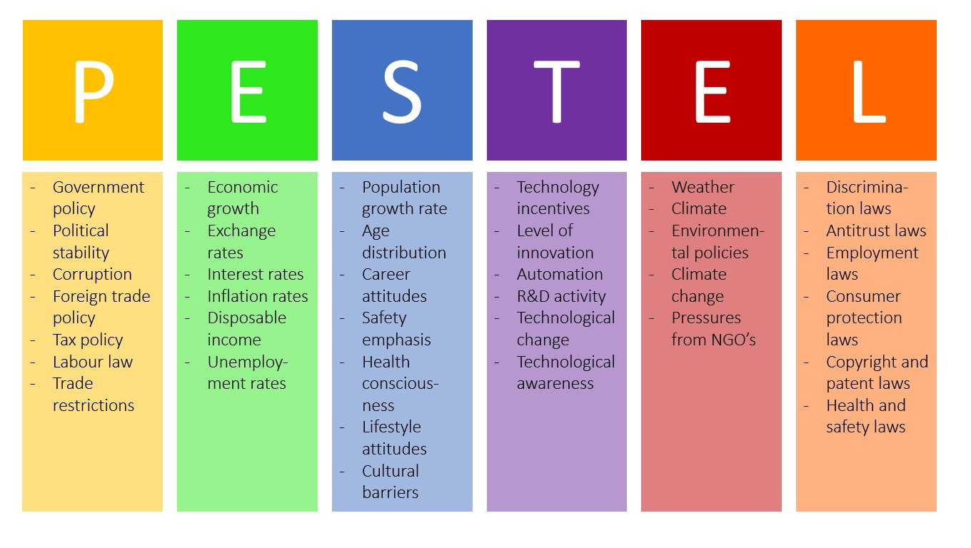
Figure 1 PESTLE(Ullah, 2021)
Political aspects
How well Unilever performs is influenced by the current political situation. A company's long-term or macro-environment is affected by governments, according to PESTEL/PESTLE study. These areas provide Unilever a lot of space for growth since most nations are stable. Because of the country's political stability, the execution of a company's plan may be more effective in the United States. Political difficulties in the European Union might pose a danger to Unilever's European consumer products activities(Ullah, 2021).
Economic aspects
As the global economy changes, so does Unilever's bottom line. Businesses and the economy as a whole are examined in this portion of PESTEL/PESTLE research. Increasing incomes in emerging countries provide more sales opportunities for Unilever. This external component, which is the presence of several manufacturing facilities across developing countries, might, however, provide an issue in terms of rising prices(Birahim,2020).

Social aspects
Both the near and distant macroenvironment of Unilever and its economic performance are impacted by current social trends and concerns. This part of the PESTEL/PESTLE research takes into account the market's socially influenced behaviour. One way Unilever may broaden its client base is by creating goods that cater to the rising demand for healthier alternatives. In addition, as environmentalist sentiment grows, so does the opportunity for the company to earn new clients by improving its environmental impact(Birahim,2020).
Technological aspects
Unilever's consumer goods division depends on pre-existing technological solutions. This part of the PESTEL/PESTLE research examines how changes in technology impact businesses and the macroenvironment as a whole. Unilever has an opportunity to increase operational efficiency as a result of the rise of business automation. As an example, new business processing technology could improve supply chain and distribution efficiency(Birahim,2020).
Legal aspects
Unilever must abide by rules if it wants to expand its consumer products sector. Legal systems are examined in this phase of the PESTEL/PESTLE research project. It is possible that Unilever's business ethics and environmental requirements might work together to enhance its business image. In order for the firm to expand, international patent restrictions need to be modified. New patent constraints in underdeveloped nations, for example, help Unilever reduce patent-related challenges in the faraway or macro-environment(Birahim,2020).
Environmental aspects
In the long run, or macro-environment, environmental patterns and circumstances have an impact on Unilever. Natural environment and related themes are examined in this section of the PESTEL/PESTLE test. In order to entice environmentally responsible clients, Unilever might take advantage of the increased interest in company environmentalism by strengthening its environmental initiatives and programmes. To compete effectively in the consumer goods market, the company may desire to improve its environmental practises. These programmes must be appropriately implemented across Unilever's CSR strategy if it is to be successful(Birahim,2020).

Porter’s five forces of Unilever
Unilever is exposed to a wide variety of external factors as a result of the scope of its activity in the global consumer goods industry. However, as the results of this Five Forces analysis reveal, these outside impacts produce changes in the strength of the five forces that influence the company. The following are the five elements that have an effect on Unilever at varying intensities(Ibidunni,2013).
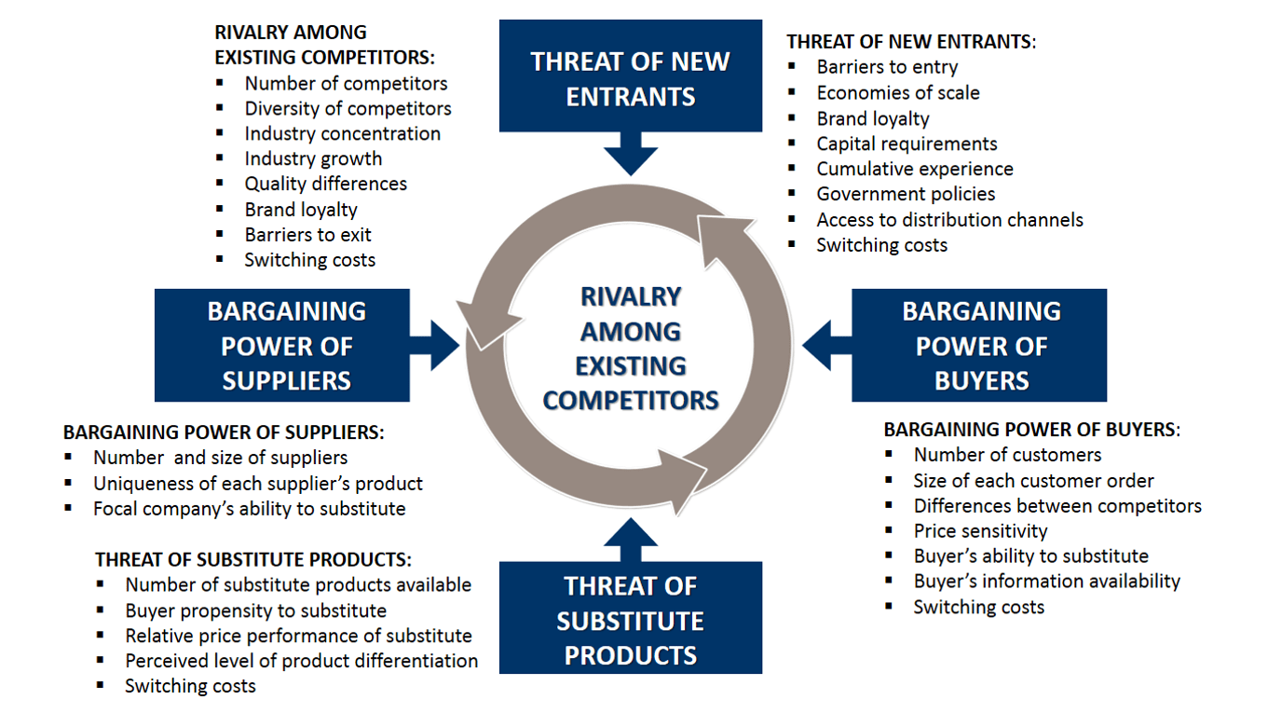
Figure 2 Porter's five forces(Ibidunni,2013).
Competitive Rivalry
There is a lot of competition in Unilever's sector. This section of the Five Forces model focuses on factors outside of a company's control. There are a lot of firms that make things for the general public. Unilever is greatly impacted by this external factor. Competition is rising as a result of the aggressiveness of these firms. Because of its low switching costs, Unilever is able to compete. Switching companies is simple for customers. Competition is shown to be a high-priority component in Unilever's industrial environment by this section of Unilever's Five Forces research(Ibidunni,2013).
Bargaining Power of Unilever’s Customers/Buyers.
Unilever's products have a direct impact on the corporation and the industry as a whole. The influence of customers on a company's performance is taken into account by the Five Forces study. Customers may easily switch from Unilever to another brand due to the cheap switching costs. It gives buyers more leverage in the negotiation process because of this external impact. Customers may easily move from Unilever to another supplier thanks to high-quality information on consumer items. Consumers may be able to make more informed decisions by comparing products on the internet. Unilever's profitability is unaffected by little acquisitions. To a greater extent than the third industry-specific component, low switching costs and high information quality prevail over all others(Ibidunni,2013).
Bargaining Power of Unilever’s Suppliers.
A company's suppliers have a direct effect on its supply chain. Supplier impact is examined in this Five Forces component. Although Unilever relies on large suppliers like paper and energy businesses, the average supplier is smaller and less well-known. The consumer products industry is feeling the effects of this external problem. Unilever, for example, is influenced by a small number of suppliers. Providers' impact is also limited by the limited availability of overall supply. Changes in the production level of any supplier have an impact on the raw material availability for Unilever. Other businesses have been affected. According to Unilever's Five Forces analysis, supplier bargaining power is a significant but moderate component in the consumer goods industry(Ibidunni,2013).
Threat of Substitutes.
It is possible that Unilever's sales and consumer products industry would be weakened by substitutes. The analysis of the Five Forces takes replacement into account. Unilever's products are simple to replace because of low switching costs. Corporations and the consumer goods industry are both impacted by this problem on the outside. The overall impact of replacement is weakened when a low number of substitutes are readily available. Buying Close-Up toothpaste from Unilever is a lot less work than making your own organic dentifrice. When compared to ready-to-use consumer goods, most replacements are of inferior quality and cost little(Ibidunni,2013).
Threat of New Entrants.
Unilever interacts with both old and young competitors in the consumer products market. Five Forces study focuses on how new enterprises affect competition. Because of the low switching costs, newcomers may pose a threat to Unilever. Customers may readily try out new items from new companies. Construction of a Unilever-like brand is a pricey operation. External factors reduce the threat of a newcomer entering the company(Ibidunni,2013).

Internal analysis of Unilever

SWOT
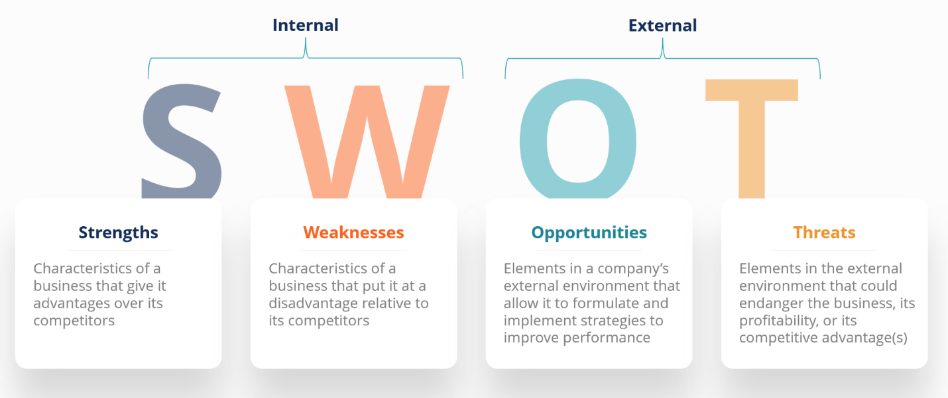
Figure 3 SWOT(Ibidunni,2013).
Strengths of Unilever
- Large-scale commercial deals are one of Unilever's greatest assets. Competitive pricing may be established with the use of large-scale economics(Farahin,2018).
- With more than a century of experience, Unilever is well-positioned to benefit from a wide variety of acquisitions and mergers with other businesses(Farahin,2018).

Weaknesses of Unilever
- Comparatively, Unilever's business diversification is limited despite its wide range of consumer products offerings.
- Due to Unilever's distribution systems, the company does not have direct contact with its customers, which immediately impacts the buyer.
Threats from Unilever
- Unilever's performance may suffer if it does not focus on its deficiencies, which are a business danger.
- As a result of product copying, Unilever's biggest difficulty is that other local businesses simply mimic its goods and shops pose a danger by selling their own brand.
Opportunities at Unilever
- External factors include the potential for growth in the global consumer goods industry.
- In order to expand the market for its goods, Unilever sells the profits it makes from the sale of its products in other markets.

Market segmentation, targeting & positioning of Unilever
There is only one remedy for each and every one of my customers. As a result, the company's financial status might be severely affected. segmentation may be described as the practise of creating distinct groups of customers based on shared qualities or behaviours(Andaleeb,2016). Numerous criteria for market segmentation allow a business to split its market into homogeneous groups of consumers and customers. Further discussion on each of these topics will follow.
- To do population studies, the word "demography," which meaning "demographics," was coined. People may be categorised based on their age, gender, and other factors, such as their family structure, as well. Because people's preferences and needs evolve with age, some firms focus on certain demographics by selling items such as baby diapers, children's toys, teen clothing, and so on and so forth(Andaleeb,2016).
- The technique of segmenting a market into smaller, more manageable portions is known as geo-segmentation. Marketers use geographic segmentation to narrow their focus on certain demographics. Different things are available in the West End and East End of London because of the different degrees of affluence in both locations.
- Based on stated business aims, Unilever divides its product lines into several segments. As a result, Unilever's customers come from a wide range of demographics and socioeconomic backgrounds. Unilever uses both 'local person marketing' and'segment marketing' as part of its strategy.
- Unilever's goods are aimed towards people of all ages, and this is reflected in their design. Almost everyone has some kind of Unilever product.
- According to Unilever's head of home and personal care, "Vitality" will stay at the core of all brand positionings. When it comes to brand positioning, Unilever's president of home and personal care says, "Vitality" will always be a key component.

Marketing mix of Unilever
The marketing mix of Unilever analyses product and market differences throughout the globe. Using the four Ps of marketing to capture a specific market, a business demonstrates how it intends to maximise its profits(Hasan,2015). The product and the place are at the centre of Unilever's marketing strategy. The success of a company depends on its ability to effectively market and price its products. Maintaining a marketing that addresses global competition and other challenges is essential for Unilever.
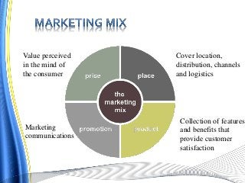
Figure 4 Marketing mix(Hasan,2015)
Product
Due to Unilever's continued expansion in the consumer goods industry, company presently offers over 400 distinct product lines. As a whole, the product mix comprises the outputs specified in this part of the marketing mix. In the following areas, Unilever carries a wide variety of products:
- Foods and drinks (Hasan,2015).
- Care at Home.
- Keeping one's self clean.
Place
It is clear from Unilever's global operations that the business has great clout when it comes to consumer goods. This section of the marketing mix defines the places where the organisation does business with its customers or potential customers. The following outlets are where Unilever's products are sold:
- Consumers (primary) (Hasan,2015).
- Stores.
Promotion
Unilever is forced to market its products due to the intense rivalry in the global consumer goods business. Customers' needs and preferences are the focus of this part of the marketing mix. The following are Unilever's most important promotional tactics, as listed by importance:
- Promoting (primary).
- Publicity and advertising for business
- Selling to one person at a time.
- Direct-to-consumer marketing.
Price
Unilever maintains a wide range of price options due to the variety of its products. Prices and pricing techniques are determined by this marketing mix component. In general, Unilever's consumer goods division employs the following pricing strategies:
- Strategy for Premium Pricing That Is Market-Oriented
- The Best Way to Price Product Bundles

Impact of COVID-19 on Unilever
Despite the fact that the global coronavirus epidemic is impacting every industry, food and household products are mostly unaffected(Aditi,2021). Additionally, C&T and non-alcohol beverages have been severely impacted. However, Unilever's variety will allow it to weather the storm and rebound quicker than its competitors. In the face of the global economic crisis, Unilever's wide range of products and markets will provide a strong foundation for the company. As a result of the COVID-19 pandemic, several of Unilever's key donor countries have been devastated. While C&T and non-alcoholic enterprises will feel the brunt of COVID-19's effect, home goods and food firms will benefit. For Unilever's cosmetics and toiletries group, haircare and personal hygiene will take a particularly heavy toll. For the duration of the coronavirus pandemic, Unilever Plc said that it will defend its workers against pay cutbacks caused by market interruptions or an inability to perform their duties. Small and medium-sized suppliers will get financial help as part of a €500 million (US$543.25 million) rescue plan provided by Unilever.

Conclusion
Firms must implement their marketing strategy with accuracy and efficacy in order to enhance the possibility of a new customer becoming a long-term one. A well-executed marketing plan may have a positive impact on a company's efficiency and profitability. When it comes to marketing, a broad variety of skills and expertise is needed to stay up with the ever-changing sector. Detailed research of Unilever's marketing strategies, including a broad variety of internal and external analytical techniques as well as the company's influence on the Covid-19 was conducted in order to give a clear picture.

References
Grădinaru, C., Toma, S.G. and Marinescu, P., 2016. Marketing mix in services. Ovidius” University Annals.
Ullah, N., 2021. A Comparative Analysis between Unilever and Johnson & Johnsons.
Birahim, S.A., 2020. Internal and external factors of Nestle and comparison with Unilever.
Dirisu, J.I., Iyiola, O. and Ibidunni, O.S., 2013. Product differentiation: A tool of competitive advantage and optimal organizational performance (A study of Unilever Nigeria PLC). European Scientific Journal, 9(34).
Khodori, M. and Farahin, N., 2018. The Internal Factors and External Factors that Affected the Liquidity Risk on Hindustan Unilever Ltd, Mumbai, India. Mumbai, India (May 21, 2018).
Andaleeb, S.S., 2016. Market segmentation, targeting, and positioning. In Strategic Marketing Management in Asia. Emerald Group Publishing Limited.
Hasan, M.M., 2015. Marketing Analysis of Unilever. Total Quality Management, 11(1), pp.13-24.
Pandey, R., Massand, A., Mulya, V.T., Sin, L.G., Naresh, V.P., Zamara, F.B., Kee, D.M.H., Zamri, S.K.B., Azmi, N.A.S.B., Hamdan, N.N.B.M. and Aditi, A., 2021. The Impacts of Covid-19 on Unilever. Journal of the Community Development in Asia (JCDA)

