Skills for the Workplace
Module Assignment Submission

Module No: | BMSK4003
Module Title: | Digital skills and research methods
Student Number: | 1911020
Student Name: | Lucy Jayne Morgan

Introduction
The author is Lucy Morgan, she is twenty-seven years old. The author is currently studying skills for the workplace at the University of Trinity Saint David. Furthet to completing this qualification, the author would like to complete her BA Honours degree in business management. The focus of part one of this assignment is to demonstrate and evaluate how modern technology has affected the world of business.

Management synopsis
In part one of this assignment, the author researched various modern technologies in the workplace and discovered the plus and delta points of each technology. Lucy then conducted a SWOT analysis on social media within the workplace, to help her conclude. She then produced a primary data survey, put them into a graph, analysed the data to find patterns and anomalies. She conducted the mean, median, dispersion and mode from the data.
In part two of this assignment the author demonstrated the ability to evaluate the appropriate use of social media and its applications in the workplace. She then created three social media pages, then explained the positives and negatives of the social media sites. Furthermore, Lucy researched and discussed personal safety and professional security online in depth leading to a conclusion.

Part one
Modern technology in the world of business is everchanging, therefore it is important we understand how this affects business in a positive and negative way. Technology in the workplace is key and without it you can’t envision an office. According to Deyan (2019) his statistics show there are 2.7 billion smartphone users around the world in 2019, increasing to 2.87 billion by 2020.These statistics display a large amount of the population use a smartphone worldwide and according to the statistics it will continue to grow. There are many benefits of using a smartphone, one is you do not need to buy several electrical devices for separate functions. For example, to take a photograph or send an email, your smartphone is several devices in one. This could be cost effective for businesses and employees, enabling them to use one device instead of using several devices separately. A smartphone is a convenient mobile device that you can bring anywhere, at any time. A smartphone also offers flexibility to your daily work life, enabling you to work remotely. Additionally, smartphones are changing how people communicate and form relationships Duck and McMahan (2016). By using a smartphone appropriately to communicate with colleagues during or after work, it can help build up relationships and increase productivity within the workplace. Furthermore, smartphone digital systems provide you with data access, storage, banking applications to track payments, profits and important documents at any given time. Although there are many advantages, Claremont Graduate University (2013) argues that using a smartphone in the workplace can have negative factors that need to be taken into consideration. Using a smartphone at work or for work purposes can distract colleagues, disrupt workflow, lower productivity, bring personal issues into the workplace and separate people from reality according to Claremont Graduate University (2013). An Additional negative to using a smartphone in the workplace is work-life balance. Being available out of work hours may affect an employee or employer’s personal life, when receiving calls, emails or text messages regarding work at unsociable hours. Therefore, this could affect a person’s mental health and well-being. From research, the author found that cyber bullying can occur in the workplace and can have an adverse impact on employees. In male dominated workplaces such as manufacturing, or the building industry it has been found to have an increased risk of workplace bullying but the occurrence of cyberbullying in this sector is unknown (Privitera and Campbell, 2009). According to Kowalski et al. (2018) studies, 20% of 3,698 partakers had been a victim of cyberbullying victimization. Compared to 7.5% of partakers had been a victim to traditional bullying, with 30% of partakers said they had been bullied while at work. From research the statistics show a high level of cyberbullying is occurring within the workplace, employers must work together with employees to eliminate any problems.

In the 21st century there are a wide range of technologies being used in the workplace daily. Firstly, the author has researched the positives and negatives of using self-service checkouts within the workplace and how it has changed for the retailer and customer. Many shoppers around the world use self-serve checkouts, when shopping at their local supermarket or retail store. The benefits for the retailer are, to reduce expenses and to enhance the customers experience when shopping in store. Although retailers believe that self-serve checkouts would enhance the customers experience, increase efficiency, devotion and fulfilment. Additionally, the benefits for customers are convenience and speed according to Orel and Kara (2014). Although Turner and Sszymkowiak (2019) disagrees that self-serve checkout systems increase efficiency because they are not always the quicker option due to technical issues, lack of staff assistance and the impersonal overcrowded areas. Even though there are various positives, some customers deliberately avoid the self-service checkouts for many reasons. The author discovered some negative points were delays when buying products that require age verification, bagging items can take longer, and items will not scan properly. Retailers provide self-serve checkouts in stores instead of traditional checkouts resulting in job cuts jobs for the local people. There are valid arguments for pros and cons of using self-service checkouts, but the modern technology will not be going anywhere anytime soon. Therefore, the author concludes that the best way for companies to appeal to all customers of all ages and abilities, there should be a balance of self-service checkouts and traditional checkouts in stores.
Industrial businesses use robots for many reasons, when using robots in the workplace there are many advantages for companies. Robots do not get distracted or need to take breaks; they are consistent and work quicker, unlike humans. Robots are programmed to deliver perfection when producing products, therefore this can reduce overheads for the company. Robots are often used for dangerous tasks that humans are unable to do, consequently robots improve workplace safety. There are various drawbacks when using industrial robots, the initial cost to invest in the technology can be excessive and may take several years to make the money back, on what was paid for the equipment. Whereas robots are fantastic for performing several tasks, they require expertise and training to set up the complicated equipment. This could be an inconvenience, time consuming and costly for a company. Furthermore, robots can be limited on the type of tasks they can perform, they can breakdown or malfunction which can cause extra financial costs for the company (Granta, 2016). The author concludes that industrial businesses robots are vital for dangerous tasks humans cannot do, if you have the money to invest in them.
Storing your data is essential in the modern workplace, online cloud storage is among one of the cheapest and easiest ways for businesses to store their data. The advantages of using cloud-based storage is that you can access your data anywhere, at any time. Being able to access data remotely your employees can easily access their colleagues work, this can help the workplace run efficiently. Additionally, the cloud uses encryption technology ensuring high security to keep your data safe. Cloud based storage caters for everyone, you only pay for the storage you need. The cloud can be used to keep external copies of your data, should your local storage on premise be corrupted or lost, cloud backups can be used to recover the data. In the modern world of computing users we are generally required to accept the fundamental premise of trust according to Kaufman (2009) The negatives of cloud-based storage is, you require internet to store or view your data, this can be an issue if you need to access your data and have no Wi-Fi or signal. Security and privacy could be a problem when using a third-party company to store your data, therefore it is important to use a trusted company. When using cloud storage, it could be difficult to migrate to another cloud provider. If you wanted to switch provider, this could easily be overcome by researching the provider in depth before signing up. There are various modern workplace technologies that have evolved over the years, online banking has become widely popular with employees and employers that use online banking daily. The benefits to online banking are saving paper, easy access to your account at any time, convenience, transaction speed, being able to pay employees quicker and paying for a service quicker at no extra cost. The delta points to online banking are security and identity theft concerns, technology and service interruptions, lack of personal banker relationship and your banking information may be put at risk.
Social media is widely used for personal and business use around the world, to help people keep in touch, interact, and share information. A study by The London School of Economics and Political Science, in June 2017 the world’s population was 7.5 billion with 2.89 billion people actively using social media. Results from this study show nearly one third of the population in 2017 were actively using social media. Using social media in the workplace has many benefits, enhancing the communication and collaboration of employees and employee satisfaction by reducing the social isolation Bennett (2010). In the world of business several social media companies are used within most workplaces. According to Law (2019) the top 5 social media sites used for business are Facebook, YouTube, WhatsApp, Messenger and Instagram. Facebook is the largest social media site in the world with a third of the world’s population using the site and 65 million business pages. YouTube has an impressive 2 billion users, WhatsApp has 1.6 billion active users, Messenger with 1.3 billion active users and Instagram with 1 billion active users. Marketing your business through social media is a fantastic way to attract potential customers. Customer care is a vital to running your business successfully and social media helps customers access you directly. You can interact with customers anytime, anywhere and resolve issues quickly. Customers can read or write reviews on social media pages, recommend businesses on their personal page or local groups and check inn to your business premises. When customers use these tools on social media positively it creates a good image for your brand and markets your business effectively at no extra cost. This is ideal for small businesses who have little or no budget for marketing. A wide range of businesses and employees use social media in the workplace but there are certain circumstances where social media is not allowed. For example: In a children’s care home there are vulnerable children who are protected by social services therefore no social media is to be used at any time. If social media is used in these circumstances it could cause detrimental harm to the children.
Even though social media can be constructive for businesses, it can also have a negative impact on your business. Customers can write unfair reviews or comments on social media business pages, which could potentially jeopardise a business. Employers public reputation is vital to represent a good brand to the customer. Employees who are frustrated or annoyed at work may use their personal social media to voice their opinion on the situation (Price, 2018). Moreover, employees who are connected to their company through social media could post racist, extremist, offensive or political photographs and posts on their social media page. This could affect a business or organisation greatly, with detrimental effects. This could be avoided, by putting a restriction in place with a workplace policy or contract of employment. Furthermore, bullying and harassment within the workplace can occur using social media. Therefore, it is important employers should state that bullying and harassment will not be tolerated. Employers have a duty of care to employees and must act if this occurs within the workplace.
The author has conducted a SWOT analysis (Appendix A) on the strengths, weaknesses, opportunities and threats; to help her conclude on whether social media in the workplace is good or a bad. From her results the author agrees there are many positives to social media in the workplace, especially for marketing purposes. The author concludes that the negatives can outweigh the positives, for example an employee who posts negative things on their personal social media account could cause detrimental damage to a business, which could be irreversible. Therefore, allowing employees to use social media in the workplace for their own personal use could result in financial loss for the company, due to the employees wasting paid time on social media.
Part 1 section 2.
In this part of the assignment the author conducted a qualitive survey, from primary data about smartphones in the workplace. The survey had thirty-four responses (Appendix C), however the author was hoping to get more responses on her survey to analyse the data more accurately. From the authors results she calculated the overall mean of people who answered yes to all questions is 64.7 and the overall mean of people who answered no is 35.2. The mode of people who answered yes is 62.5 and the mod of people who answered no is 37.5. The median of people who answered yes is 64 and the median of people who answered no is 36.3. From her survey results the author was able to analyse that thirty-three people out of the thirty-four responses owned a smartphone. The author was surprised that 60.61% of people use their smartphone within work hours and 24.4% have a smart phone provided by their employer.
The author researched online for a secondary source of data, she applied the C.R.A.A.P test on all questions then analysed the data to find patterns and anomalies. The C.R.A.A.P test stands for Currency, Relevance, Authority, Accuracy and Purpose. The author is using the C.R.A.A.P test to decide whether the source is credible. From secondary data, the author conducted a bar graph of smartphone ownership, mobile phone ownership and people who do not own a mobile phone in advanced economies around the world (Appendix D). From the results, South Korea had the highest percentage who reported owning a smartphone at 95% compared to Greece with the lowest percentage of 59% owning a smartphone. Russia was the highest percentage of people who own a mobile phone with 34% and the lowest was Canada with 9%. From the results the increase of technology to date has not been the same, either across countries or within them Silver (2019). The median of people who own a smartphone is 76, mobile phone is 33 and people who do not own a phone is 17. The mean of people who own a smartphone in advanced economies is 74.6, mobile phone 17.7 and who do not own a phone 7.1. The range of people who own a smartphone is 36, mobile phone is 29 and who do not own a mobile phone is 25. From the authors results she calculated multiple modes of people who own a smartphone is 59, 81 and 66. The mode of people who own a mobile phone is 13 and 19, lastly the mode for people who do not own a mobile phone is 2 and 6.

Part two section 1.
In part two of the assignment the author will be demonstrating the ability to evaluate the appropriate use of social media to improve workplace efficacy and employability support by criteria leading to an evaluation. The author has conducted research of primary data on what social media platforms are used in her place of work. Lucy uses Instagram, Facebook, Twitter and Messenger in her place of work for several reasons. She advertises her candle business on Facebook and Instagram daily to help grow her following, resulting in more sales for her business. Lucy also uses Facebook for her cleaning business to book inn client’s, to post before and after photographs and customers can leave reviews on her page. She uses WhatsApp to communicate with her regular customers and clients. The author has created three types of social media network pages after research, that will benefit her business in numerous ways. Firstly, she made a LinkedIn account (http://linkedin.com/in/the-luxe-wax-co-luxury-home-fragrance-b27785199 ) to maintain her professional brand, advertise jobs for her business and to communicate with other business owners. When creating a LinkedIn account, it is vital to represent you or your business professionally. The author decided to upload her company logo to her LinkedIn, so customers get a good first impression. For a personal account upload a photograph of yourself looking smart and presentable, to show professionalism (Appendix B). When creating your personal LinkedIn page appear well rounded, show your creativity, list your hobbies and qualifications but do not oversell yourself. This will help you stand out from the crowd when applying for jobs through the social media site. If you are creating a page for business purposes keep your page clean, presentable and professional because a company’s online image is important. Personally, the author feels that a LinkedIn account is beneficial for people who are looking for work or to grow your business, because there are so many opportunities.
Secondly, she created a Facebook business page (https://www.facebook.com/theluxewaxcompany) with an appropriate profile photo to ensure her business looks professional and appealing to the customer. The benefits of creating a Facebook business page are to communicate with customers at any time or anywhere. Facebook is the largest social media platform in the world it is used by nearly 500 million individuals throughout the world Miller (2011). Facebook business provides flexibility to the customer and the business, which is essential in her line of work. Customers can write reviews on your business page on the overall service they received. This can be a positive for business owners who ensure high standards. Although this could be a negative for a business if a customer leaves an unfair review, since it is difficult to remove the review after a customer has submitted it. The author is also able to post photographs of products, conduct online polls to engage with customers and advertise her business on Facebook to gain more custom. There is an extensive range of prospects when using Facebook for business therefore the author feels it is essential for businesses to set up a page to help their business grow. A negative to having Facebook business is work life balance. Customers or employees can message you at any time which can be distracting when you are having a family day out and your phone is constantly notifying you with work. This could be prevented by turning off notifications for the app when it is out of work hours.
Lastly, the author made a business Instagram account (https://instagram.com/theluxewax.co) for her business because she feels that Instagram is an ever-growing platform for business users. There are numerous opportunities when using Instagram for business, you can send out products to influencers for them to advertise your business and hashtags can increase your visibility. Using the right influencers can help your business gain custom and grow your page following. There can be negatives to marketing your business through influencers because studies have shown if you choose an influencer that follows very few accounts him-/herself, this can cause a negative impact on the influencer’s likability. Also, if you are working with influencers that have a high following this may not be the finest marketing choice, as this can decrease the brands distinctiveness and consequently brand attitudes (Veirman et al, 2017). Subsequently, it may not be suitable for small businesses because they have a small marketing budget, or the influencer may not want to market a small business with a small following. Other positives to Instagram are posting stories or live streaming that can help build rapport with customers. You can demonstrate how your products are made live for customers to watch. Hash tagging are key phrases to summarize what your post is saying, it is a free way of increasing your visibility and if used correctly can be very effective. Instagram gives opportunities to learn from other businesses, discovering how they post to engage with their customers. Instagram can be fantastic for business, but there are negatives to using the social media site. It has a negative effect on young people’s mental health. It can negatively impact body image and sleep, increases bullying leading to anxiety, depression and loneliness according to Firestone (No date). When making the Instagram account the author found the process straight forward even though it took her some time to get used to all the features the social media site provides.

Part two section two.
Security and ethics in the workplace are vital for employees and employers. Employers can monitor the workplace for various reasons in various ways, but employees are permitted to some privacy while at work. Employers by law must inform all employees about monitoring and the reason to why they are monitoring them. Therefore, it is essential for employers to have written policies and procedures in place and all information collected should always be stored securely. Employers must comply with the data Protection Act 1998, if they do not comply it could lead to sanctions and bad publicity for the company. Employers use CCTV cameras to prevent theft, violence, to safeguard staff, protect business interests and for health and safety. When CCTV cameras are in the workplace, they must be visible and contain details of why the cameras are there. An employer can monitor employee communications by reading email, phone and internet use without asking for the employees’ consent, but the employer must have a valid purpose for monitoring employees. for example: to maintain the standards of the communication systems or quality control to comply with the law of The Telecommunications regulations 2000.
Personal online safety and security is so important and knowing how protect yourself while browsing the internet in the modern world is vital. When online shopping or job-hunting companies can collect and use your data. Companies have a responsibility to protect your data, but it is best to be safe and check the company’s privacy policy. Companies use your data for marketing purposes and build up your profile to target you with related products or services. There are many threats compromising your personal data when using the internet, always research online retailers before visiting a website to make sure they are legitimate. Pay for goods with PayPal or a credit card, this will give you extra protection and scammers are less likely to get hold of your bank details. Under section 75 of the Consumer Credit Act, paying by credit card will give you added protection on purchases over £100. Be wise when creating passwords for personal and professional accounts, this will make your accounts harder to hack. Look after your computer, tablet or phone by updating your software regularly. Installing anti-virus protection on your computer is key to protect you from viruses and threats. Antivirus software protects the computer from incoming threats, destroys, and warns you of possible threats to the system. When using public Wi-Fi in your local coffee shop or favourite restaurant be aware that the Wi-Fi is often unsecure. Never log on to public Wi-fi to use your online banking or anything that requires your personal information.
Professional online safety and security is vital in running your business efficiently and effectively. While personal and professional security share the same core principles, there are several things you can put in place to protect your business. Two factor authentications can be used to add an additional layer of security to accounts or transactions. Data loss can be devastating for businesses, it is imperative to back up your data with a memory stick, portable hard drive or through a cloud-based system (FSB, 2018). The author agrees with this statement, but if a business is handling personal data you must always keep the portable hard drive or memory stick stored securely. When creating passwords for your business accounts it is important to use password complexity as it provides you with essential protection from financial fraud and identity theft.

Appendix C

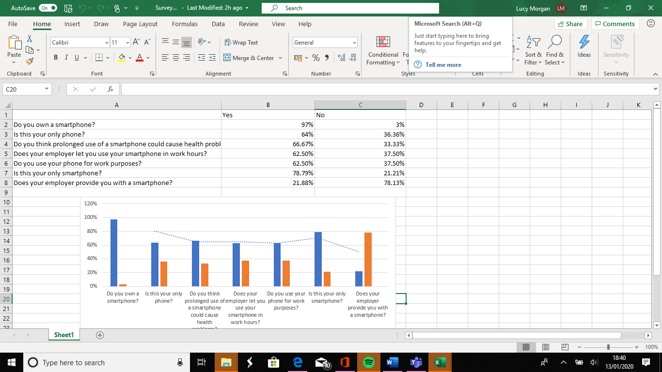

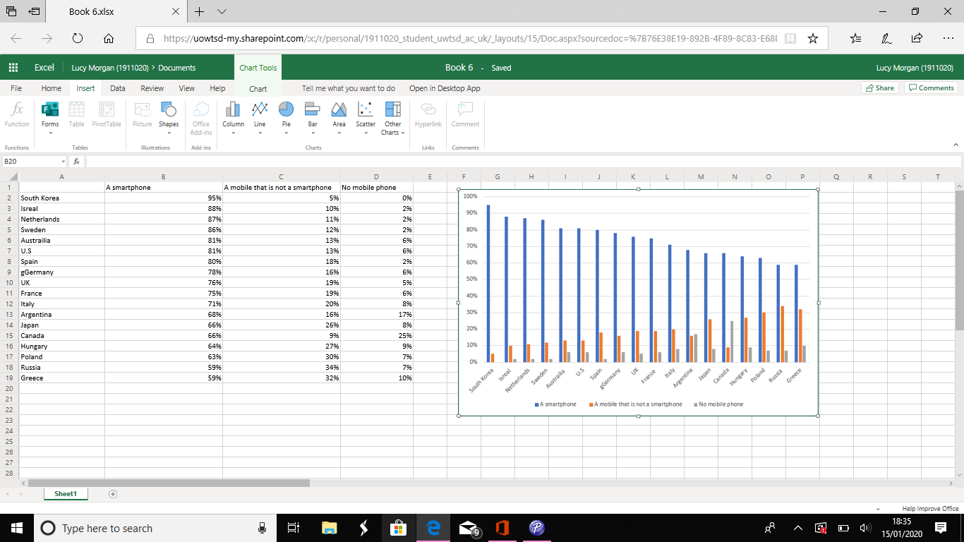
Appendix D

Appendix A
Strengths  - Communicate with employees/colleagues.  - Communicate with clients/customers.  - Marketing your business in a positive way.  - Can help mental well-being. | Weaknesses  - Bullying or harassment within the workplace.  - An employee posting racist, discriminating comments on social media which can have an negative impact on the business.  - Allowing employees to use social media within the workplace for personal use could result in a financial loss to the company.
Threats  - Hackers  - Security issues  - Privacy issues  - Employees losing jobs | Opportunities  - Job opportunities  - Advertising  - Business growth  - Increased profit

References
Bennett, et al. (2010) ‘Workplace impact of social networking’, Property Management, Volume 28, pp. 138-148. Issue 3, [On-line]. Available at: Hhttps://doi.org/10.1108/02637471011051282
[Accessed 16th of December 2019].

Business phone systems. ( No date ) ‘Advantages and disadvantages of mobile phones in business’.
https://wwww.nibusinessinfo.co.uk/content/advantages-and-disadvantages-mobile-phones-business
[Accessed 26th of December 2019].

Deyan, G. (2019) ‘61+ Revealing Smartphone Statistics for 2019’
Hhttps://techjury.net/stats-about/smartphone-usage#gref
[Accessed 14th of December 2019].

Duck, S. and McMahan, D. T. (2016) ‘In Communication in Everyday Life.’ Third Edition. Thousand Oaks: SAGE. Ch. 13, pp. 248-273
[Accessed 17th of December 2019].

Firestone, L. (No date) ‘Which is the worst for your mental health: Instagram, Facebook or YouTube’. Anxiety, depression, self-development, self-esteem, students.
https://www.psychalive.org/worst-mental-health-instagram-facebook-youtube/
[Accessed 15th of January 2020].

Granta,. (2016) ‘Advantages and Disadvantages of Industrial Robots’.
https:/www.granta-automation.co.uk/news/advantages-and-disadvantages-of-industrial-robots/
[Accessed 27th of December 2019].

Kaufman, L. (2009) ‘Data security in the world of cloud computing’.
IEEE Security & Privacy Volume 7. Issue 4. Pp.61-64
Available online at: https://ieeexplore.ieee.org/abstract/document/5189563 [Accessed 10th of January 2020].

Kowalski et al. (2018) ‘Bullying and cyberbullying in adulthood and the workplace’, The journal of social psychology. Volume 158, Issue 1, pp.64, [On-line]
Available online: https://doi.org/10.1080/00224545.2017.1302402
[Accessed 31st of December 2019].

Law, T. (2019) ‘The top 15 Western social media sites to consider for your business’.
www.oberlo.co.uk/blog/social-media-sites/amp
[Accessed 26th of December 2019].

London School of Economics and Political Science. (2017) ‘Social Media Platforms and Demographics’.
https://info.Ise.ac.uk/staff/divisions/communications-division/digital-communications-team/assets/documents/guides/A-Guide-To-Social-Media-Platforms-and-Demographics.pdf
[Accessed 14th of December 2019].

Miller, D. (2011) ‘ Tales from Facebook’.
https://scholar.google.com/scholar?hl=en&as_sdt=0%2C5&q=Facebook+btnG=#d=gs_qabs&u=%23p%3DXc97u04M4aMJ
[Accessed 10th of January 2020].

Orel, F. and Kara, A. (2014) ‘Supermarket self-checkout service quality, customer satisfaction, and loyalty, Empirical evidence from an emerging market’,
Journal of retailing and consumer services, Volume 21, Issue 2, pp.118-129. [On-line]. Available at:
https://www.sciencedirect.com/science/article/abs/pii/S0969698913000829
[Accessed 27th of December 2019].

Pitichat, T. (2013) ‘Smartphones in the workplace: Changing organizational behaviour, transforming the future’, Claremont Graduate University, Volume 3, Issue 1. [On-line]. Available at: https://scholarship.claremont.edu/lux/vol3/iss1/13/
[Accessed 17th of December 2019].

Price, A. (2018) ‘Social media problems: how to avoid these five issues in the workplace’.
https://smallbusiness.co.uk/five-problems-in-the-workplace-and-how-to-avoid-them-2506561/
[Accessed 26th of December 2019].

Privitera, C. and Campbell, M. (2009) ‘Cyberbullying: The New Face Of Workplace Bullying?’, Cyberpsychology & behaviour, Volume 12, Issue 4. [On-line] Available at:
https://doi.org/10.1089/cpb.2009.0025
[Accessed 31st of December 2019].

Silver, L. (2019) ‘Smartphone ownership is growing rapidly around the world, but not always equally’.
https://www.pewresearch.org/global/2019/02/05/smartphone-ownership-is-growing-rapidly-around-the-world-but-not-alway-equally/
[Accessed 5th of January 2020].

Turner, J. and Szymkowiak, A. (2019) ‘An analysis into early customer experiences of self-service checkouts: Lessons for improved usability’.
Volume 11. Issue 1. Pages 36-50.
Available online at: https://rke.abertay.ac.uk/ws/portafiles/portal/15805304/Szymkowiak_AnAnalysisIntoEarly_Published_2019.
[Accessed 10th of January 2020].

Vierman, M. et al. (2017) ‘Marketing through Instagram influencers: the impact of number of followers and product divergence on brand attitude’. P798-828
Available online: https://doi.org/10.1080/02650487.2017.1348035
[Accessed 7th of January 2019].

