New Building Dwelling: Technical Report with Drawings
Assignment Two
Caitlyn Moore
2024
Contents
Introduction – 2
Site Details - 3
How the frame will be kept out of the foundations - 3
How do we keep timber away from water? 3
What are the benefits of having the services on the inside? 3
Penetrations (screwing/drilling). 4
Definition of off-site construction – 4
There are four main types of offsite construction: 4
How will the design meet the current building regulations for a domestic new build? 5
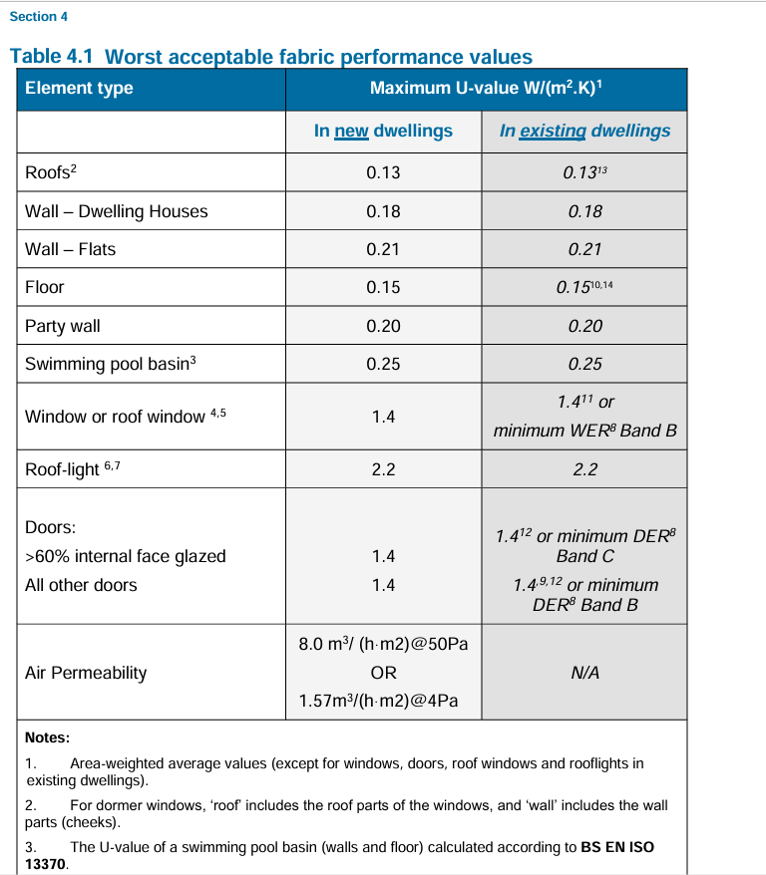 6
Thermal Insulation & U-Values – 7
Ground floor construction – 7
Different Type of Substructure 7
Comparison of Brick & Blockwork against Twin Panel Timber – 8
Why Twin Timber Panel Frame was Chosen over Brick & Blockwork – 11
Part 2: 11
Illustrations – 11
Conclusion – 13
References 14

Introduction –
Throughout this report the design and construction process for a new build two storey detached domestic building will be identified with detailed explanations and annotated sketches will be provided to build an image of the proposed building for the client. The previous proposed construction will also be compared against the final construction method to assess the advantages and disadvantages of both. Off site construction methods will also be discussed to see how they could possibly be implemented into the design of the project.
The proposed design of is for a two-storey new build with a garage at ground level. The frame will be a 300mm thick twin frame panel with insulation etc. The external face of the house will finished with brick slip clad at the lower level and the upper levels will have a render finish.

Site Details -
The proposed site is based on reclaimed land which has previously been used as agricultural land. The proposed land is going to be used to build a single two storey detached domestic building.

How the frame will be kept out of the foundations -
The timber panels which create the skin of the building will be fixed upon solid concrete blocks in accordance with the NHBC standards to stop the frame from sicking into the foundation. The blocks specified within the NHBC documents are BS EN 771 with a minimum crushing strength of 7.3n/mm2. These blocks will also need to be grouted and a galvanised steel fixing will also be used to securely fix the frame to the blocks, the steel must be galvanised to provide protection against fire. (NHBC, 2024)

How do we keep timber away from water?
To stop the frame from gaining moisture which could lead to damp/rot the cavity within the wall should be ventilated to reduce the risk. In accordance with the NHBC guidelines a vapour control plasterboard with DPC wrapped will be fixed to the warm side of the insulation and frame. The guidelines also state that a timber frame should have a moisture content of less than 20% so running some moisture checks throughout the construction phase for moisture buildup will be required to ensure that the 20% tolerance is kept to a minimum. If the frame was to exceed the 20% tolerance, then it would need to be left to dry out before it is enclosed. (NHBC Standards, 2024) (NHBC, 2024)

What are the benefits of having the services on the inside?
Having the services on the inside has a better aesthetic appearance ensuring that all pipes/wires are built within the framework and are not visible but are also accessible for the future for maintenance and checks.
Hiding services within the walls can also improve the energy efficiency of the building by limiting the level of heat loss/gain through penetrations within the envelope of the building. Hiding the services can also reduce noise transmissions such as plumbing services etc.
Services that will travel through the walls and floors within this building will be energy distribution systems, gas supply, fire safety, heating and ventilation systems, lighting, water distribution, and drainage systems. These are the services required that should be fitted in every building to comply with current regulations.

Penetrations (screwing/drilling).
Penetrations through the timber panel will be limited to what’s required for MEP holes. They will need to limit because of the acoustic levels which need to be met within the whole building not to allow sound to pass out. Another reason is because of the risk of dampness coming through the holes if they are not sealed fully.

Definition of off-site construction –
The term ‘off-site construction’ which is also known as ‘prefabrication’ is a fairly new method of construction which involves the manufacture of structures/materials in a factory rather than on site. This process saves onsite time as materials are tailored to the site and delivered ready to be installed. This is a less labour-intensive system which will be used more commonly moving into the future compared to traditional methods of construction. (Munmulla T, 2023)

There are four main types of offsite construction:

Volumetric:
Volumetric construction is a well-developed process that provides three dimensional units that are assembled and fitted within a factory. After they are assembled within a factory, they are delivered to site to be fixed in place to create the building. This particular method of construction is mainly used for houses; however, the house will be limited to the arrangement design as little to no changes can be made to the panels. The use of volumetric systems is becoming more popular in the UK using timber panels.
A volumetric system could be incorporated within this build by having the twin frame panels assembled within a factory and delivered to site ready to be fixed in place. (Mike Riley and Alison Cotgrave , 2018)

Panelised Construction:
Panelised Construction is a method of premanufactured flat panels that are assembled to create a building once delivered to site, the most common materials used to manufacture this type of system as timber and lightweight steel. Panelised systems can be created using a number of different types of panels which can either be load bearing or non-load bearing, this depends on the function of the structure as a whole. The panels can be manufactured as an open panel or closed panel which can have the insulation fixed on the inside, there are a number of different options when considering panelised construction.
Panelised construction could be used for the frame for this project as it would save on site time if a structural insulated panel (SIP) was chosen due to the insulation already being installed within the closed panel. (Mike Riley and Alison Cotgrave , 2018)

Sub- assembly and components:
This type of construction is becoming more popular as components such as trusses etc can be incorporated within the design off site and by doing this it saves on site labour, project duration time and provide another layer of reassurance that the components are correctly fixed. This system is more commonly used for commercial buildings rather than low-rise domestic houses.

Hybrid System:
Hybrid systems are a type of construction that aim to be more economical through reducing low carbon footprint. Hybrid systems are more cost effective in the long run when compared to traditional methods of construction with higher levels of carbon footprint.
This system could be implemented into the design by sourcing the twin frame panels from a local supplier to reduce C02 emissions. (Sarah Moore, 2023)

How will the design meet the current building regulations for a domestic new build?
Current building regulations will be followed throughout the design process to ensure that the building complies with each approved document relating to the build to ensure that the finished product is habitable and safe, failure to comply will lead to the building being altered or even taken down.
Building Regulations Part L Conservation of fuel and power for Dwellings states that U-Values should be assessed using methods and conventions set out in the Building Establishment BR 443 and that they should be assessed for the whole element of the frame. Calculations are to be found in accordance with British Standards (BS). (Welsh Government, 2022)
The performance for new dwellings must be demonstrated to ensure that the values set have been met and they must be entered into the Standard Assessment Procedure in order to demonstrate compliance with regulation 6B. (Welsh Government, 2022)

4.10:
4.10 of part L of the Building Regulations states that the insulation within the building fabric should be continuous with no gaps to reduce the risk of heat loss which can create damp and condensation. The building regulation states that the guidance to follow is within the Appendix F. (Welsh Government, 2022)

4.11:
4.11states that the building should be constructed so that there is a limited amount of thermal bridging. Thermal bridging occurs when the heat is higher in a certain part of a building compared to another area. Causes of thermal bridging could be because of breaks in insulation or reduced insulation. To comply Appendix G guidance should be followed.

4.13:
4.13 Airtightness the minimum standard or air permeability is stated in the table inserted above. It is important that unwanted heat loss is kept to a minimum through complying with the guidance provided in Appendix H.

Section 4: Limiting Heat Losses and Gains from Building Services
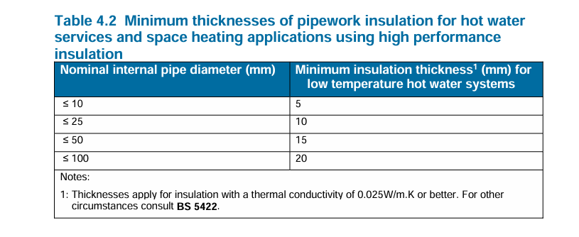
Sates that all hot water pipes should be insulated and the level of heat loss should not go above the levels stated in BS 5422, the table inserted above provides an example of the heat losses.

Thermal Insulation & U-Values –
U-values are a measurement of transmission of heat through an area of a building fabric and are measured in W/m2k (watts per square meter kelvin), this method is used to calculate the heat transfer and loss through a building fabric. In accordance with Building Regulation L there are now set maximum values that must be achieved, and domestic builds fall within this requirement. The values that must be achieved are: (Gavin Taylor , 2024)
External walls: 0.18 W/m2K.
Floors: 0.13 W/m2K
Roofs: 0.13 W/m2K
Windows & Doors: 1.4 W/m2K

Ground floor construction –
The ground floor construction of this new build house will be sat upon a reinforced concrete raft foundation with a damp proof membrane which will sit beneath an insulation layer, on top of the insulation there will be a layer of screed with underfloor heating sitting within which will be covered with the floor chosen finish.

Different Type of Substructure
The importance of analysing substructure to identify the type of soils is important to ensure that the load of the building can be distributed into the foundation and into the ground evenly across the site. For this project a raft foundation has been chosen to ensure that the weight of the frame will be suitably supported with the correct stability to ensure that there is little to no movement within the frame.

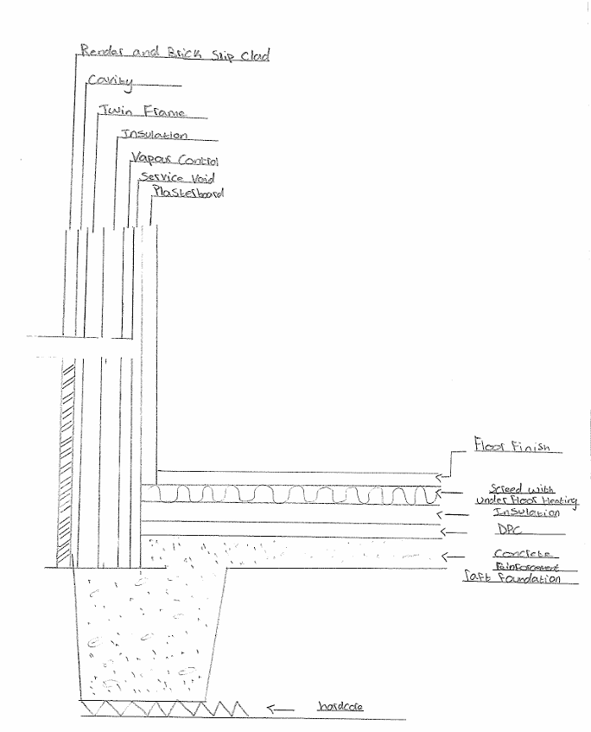

Comparison of Brick & Blockwork against Twin Panel Timber –

Twin Panel Timber -
Timber is becoming a material which is used more commonly as a modern method of construction compared to traditional brick and blockwork, this is because timber can be made offsite in a factory and delivered ready to be installed it is generally a more economical/efficient material to use. However, it has its cons just like other materials.

Twin Panel Timber Advantages – (Isabel Barros, 2018)
- Recyclable material.
- Renewable material as long as the material is maintained.
- Quick build time
- Construction waste is reduced

Twin Panel Timber Disadvantages –
- Specialist companies required to complete the process.
- Regular maintenance is required.
- The risk of damp/moisture build up and rot is likely to happen if the building isn’t maintained/constructed correctly.
- Sound transmission through timber frames has a lower resistance, this can be solved with insulation.
- Low resistance to fire. (N/A, 2024)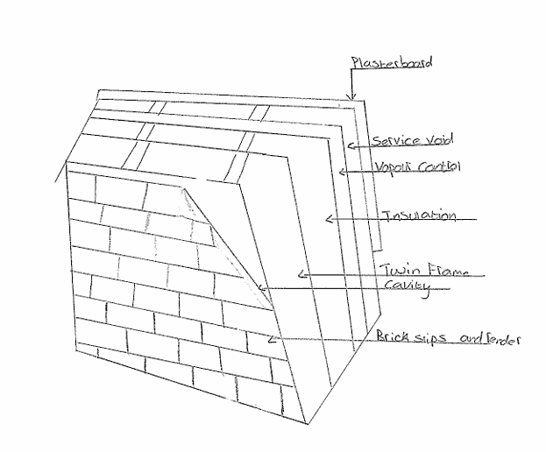

Brick & Blockwork –
Brick and blockwork is a traditional method of construction which is still commonly used. This method of construction involves creating a inner face of blockwork which the separates the insulation from the outer face of brickwork. Once the walls are constructed they are then held together using walls ties. Brick and blockwork is also a much for time consuming method as time will be needed to set the bricks out and collect mortar, it is also vital that a skilled/experienced company is used to complete the job to have a professional finish. (Build It, 2024)

Brick & Blockwork Advantages –
- Great flexibility which means if there was a need to change the layout you can, but with timber frames this is not achievable as it is a factory made product.
- Acoustic insulation is very good because of the density of both of the skins with an additional barrier of insulation within the cavity.
- fire resistance levels are good as brick and blockwork can withstand extreme heat.

Brick & Blockwork Disadvantages –
- in comparison to timber frame the build time for brick and blockwork is a lot longer because of the level of skill and concentration needed to ensure the bricks are level etc.
- brick and blockwork also pass a greater level of weight into the foundations.
- There is a likelihood that the walls could crack due to settlement etc.
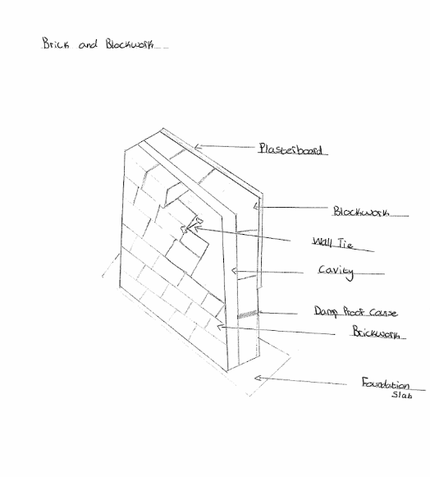

Why Twin Timber Panel Frame was Chosen over Brick & Blockwork –
The choice of twin frame panels was a better suited frame for this project build because it is a cost-effective system that has high energy efficiency ratings due to the insulation factors that will be built into the frame. Twin frames are also economically for efficient compared to traditional brick and block work which also makes it a renewable material if maintained correctly, the frame will also be light weight to suit the foundation of the building. Twin frames are also a lot more cost efficient to build when compared to brick and block work with less labour costs. The thermal performance within a twin frame is also more efficient when compared to traditional brick and block, another reason why a twin panel frame was a better option for the project is because of the condition of the ground was more suited to have a lighter material sat upon it.

Part 2:

Illustrations –

Raised Tie Roof Detail -
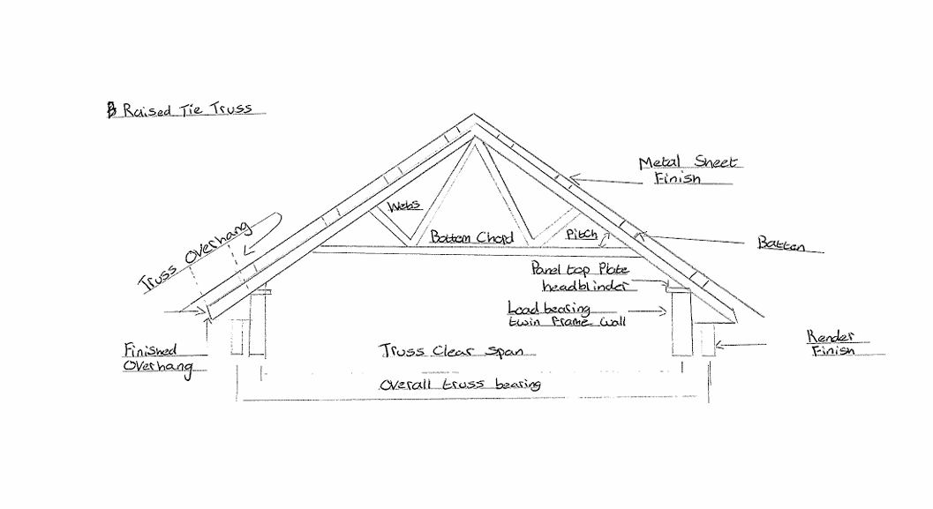

Window Section & Plan Detail-
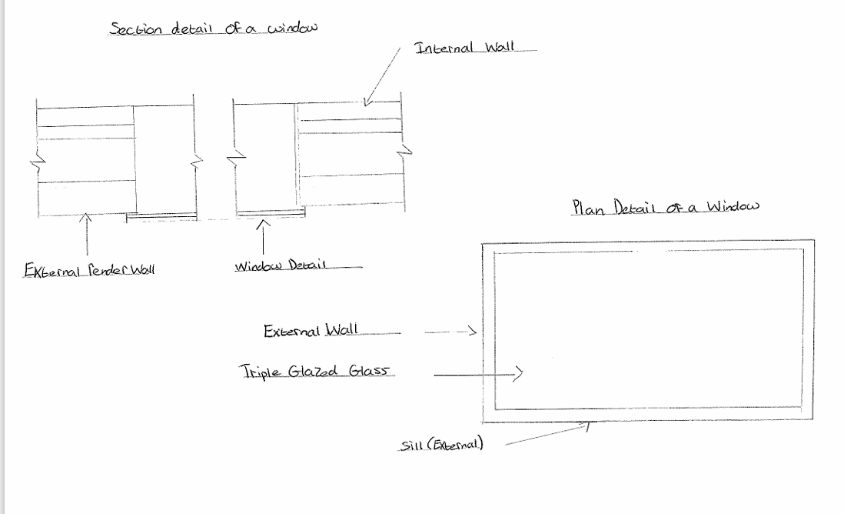

Conclusion –
To conclude, this report provides an understanding to the client through the use of descriptive language and sketches of how their proposed house construction is intended to be designed and built. Moving forward the use of timbered panel systems will become more of a common method of construction compared to traditional brick and block systems due to the benefits that timber can provide such as more efficient time scales, less costs, easier to build and so on. The construction of the project interblends well to create an efficient building that is compliant with the current regulations to ensure that human comfort levels are maintained to be habitable.

References
Build It, 2024. Building a Brick Home. [Online]
Available at: Brick and Block Construction - Help to Build (buildhelp.co.uk)
[Accessed April 2024].
Gavin Taylor , 2024. Week 08 Assessment Review and U-values pages 36-37. s.l.:Gavin Taylor.
Isabel Barros, 2018. Advantages and Disadavatages of Timber Frame Construction. [Online]
Available at: Advantages and Disadvantages of Timber Frame Construction - Isabel Barros Architects - Blog
[Accessed April 2024].
Mike Riley and Alison Cotgrave , 2018. Construction Technology 1. In: M. R. &. A. C, ed. House Construction. s.l.:Palgrave , pp. 63-65.
Munmulla T, 2023. Suitability of Modular Technology for House Construction. In: Y. Ding, ed. Suitability of Modular Technology for House Construction in Sri Lanka: A Survey and a Case Study. s.l.:s.n., pp. 1-3.
N/A, 2024. UK Construction Blog. [Online]
Available at: Understanding the Disadvantages of Timber Frame Houses: A Comprehensive Guide - UK Construction Blog
[Accessed April 2024].
NHBC Standards, 2024. 6.10.16 Moisture Control. [Online]
Available at: 6.2.10 Protection from moisture NHBC Standards 2023 (nhbc-standards.co.uk)
[Accessed April 2024].
NHBC, 2024. 6.10.18 Air and Vapour Control Layers. [Online]
Available at: 6.2.12 Vapour control layers NHBC Standards 2023 (nhbc-standards.co.uk)
[Accessed April 2024].
NHBC, 2024. NHBC Technical Standards. [Online]
Available at: 6.2.5 Fixing the frame NHBC Standards 2023 (nhbc-standards.co.uk)
[Accessed April 2024].
Sarah Moore, 2023. Hybrid Construction: What Can it Offer?. [Online]
Available at: https://www.azobuild.com/article.aspx?ArticleID=8430#:~:text=Hybrid%20construction%20is%20a%20building%20concept%20that%20utilizes,construction%20project%E2%80%99s%20sustainability%20and%20reducing%20its%20carbon%20footprint.
[Accessed 15 April 2024].
Welsh Government, 2022. Building Regulations Part L. [Online]
Available at: https://www.gov.wales/building-regulations-guidance-part-l-conservation-fuel-and-power
[Accessed April 2024].

