
Module Code and Title:
LCMB7026 International Marketing: Principles and Practice

Assignment Title:
International Marketing Report: Mercedes-Benz in the UK and Germany
Lecturer: Tushara Balendran

Student Name: Md Rony Sheak
Student ID: 2434287

Words: 5575

Date of Submission: 24 April 2026

Table of Contents
List of Figures 5
Introduction 6
Overview of Home and Host Country 7
Germany 7
United Kingdom 7
Mission of Mercedes-Benz 7
Vision of Mercedes-Benz 7
PESTLE Analysis of the Macro Environment 8
Political Factors 8
Economic Factors 9
Social Factors 9
Technological Factors 10
Legal Factors 10
Environmental Factors 10
Differences and Similarities of the PESTEL MODEL 11
Hofstede Cultural Dimension Model 12
Power Distance 12
Collectivism vs. Individualism 13
Masculinity vs Femininity 13
Uncertainty Avoidance 13
Long-Term Orientation 14
Indulgence vs Restraint 14
Advantages of the Hofstede Model 15
Disadvantages of the Hofstede Model 15
Segmentation, Targeting, and Positioning (STP) 16
Segmentation Strategy 16
Targeting Strategy 17
Positioning Strategy 17
Similarities and differences of STP 18
Marketing Mix (7Ps) Comparison 18
Product 19
Price 20
Place 20
Promotion 21
People 21
Process 21
Physical Evidence 21
Similarities and differences after 7Ps 22
Brand Directional Development Strategy (Ansoff Matrix) 23
Market Penetration 23
Product Development 24
Market Development 24
Diversification 24
Ethical Issues 25
Recommendations 25
Recommendations for Mercedes-Benz in the United Kingdom 25
1. Grow Affordable Luxury EV 25
2. Enhance Digital Retail and Online Sales Experience 26
3. Enhance Sustainability and Carbon Neutral Positioning 26
Recommendations for Mercedes-Benz in Germany 26
1. Enhance Leadership in Innovative Automotive 26
2. Grow Premium Luxury and Performance EV 26
3. Support Sustainable Manufacturing and Circular Economy 26
Section 2: Kolb’s Learning Cycle 27
1. Concrete Experience 27
2. Reflective Observation 28
3. Abstract Conceptualisation 28
4. Active Experimentation 29
Conclusion 30
References 31

List of Figures
Figure 1: PESTLE Analysis (Gini and Agala, 2023) 8
Figure 2: Hofstede Cultural Dimension Model (Arif et al., 2025) 12
Figure 3: STP Analysis (Waliya et al., 2023) 16
Figure 4: Mercedes-Benz Position (Ding et al., 2023) 17
Figure 5: Marketing Mix (7Ps) (Molamohamadi and Talaei, 2022) 19
Figure 6: Mercedes-Benz in the UK and Germany (Kim et al., 2022) 20
Figure 7: Websites of both countries (Khan et al., 2023) 22
Figure 8: Ansoff Matrix (Rifki and Kirana, 2024) 23
Figure 9: Kolb’s Learning Cycle (Rifki and Kirana, 2024) 27

Introduction
Through international marketing, global firms are able to develop their business operations in more than one country while adjusting their strategies to suit various economic, cultural, and regulatory conditions. Companies should examine the macro-environment, consumer behaviour and competition forces before moving or reinforcing their presence in foreign markets. This report compares the international marketing of Mercedes-Benz in the United Kingdom and Germany (Herasymenko, 2023). The report discusses macro-environmental factors, which rely on the PESTEL framework, and cultural differences based on the Cultural Dimensions model of Hofstede. It also analyses the marketing mix (7Ps) of the company in the two markets and contrasts the Segmentation, Targeting and Positioning (STP) decisions of the company. The strategy of directional development of the brand according to the Ansoff Matrix is also analysed in the report, and the ethical marketing issues are discussed. Lastly, the suggestions are made to improve the international marketing of the company in future.

Overview of Home and Host Country

Germany
Mercedes-Benz has its home country in Germany and is generally known as a major automotive engineering and manufacturing company in the world. Germany boasts of a well-developed motor industry and has some of the world's most powerful brands like BMW and Audi. The German market appreciates engineering, innovation and performance of high quality (Younis and Elbanna, 2022). Reliability and technological advancement are common concerns that consumers use to shop for cars.

United Kingdom
The United Kingdom is a significant foreign market for Mercedes-Benz. The UK automotive industry is highly competitive and developed. The British consumers are very demanding of high-quality cars, especially in urban regions and among high-income professionals (Rifki and Kirana, 2024). Nevertheless, consumer buying behaviour in the UK market is more affected by the environmental policies, fuel costs, and the transition to electric vehicles.

Mission of Mercedes-Benz
The mission of Mercedes-Benz is to produce high-quality, innovative and technologically advanced cars that will give them high performance, safety and comfort. The company expects to surpass customer expectations through engineering excellence, luxury design and continuous innovation and ensure good customer relationships and long term value generation in the global automotive industry.

Vision of Mercedes-Benz
Mercedes-Benz has a vision to make a breakthrough in the next generation of driving by becoming a world leader in sustainable, electric, and autonomous driving technologies. The company dreams of a carbon-neutral transportation world, luxury, and innovation, to shape the future of the automotive industry with a digital transformation and environmentally friendly solutions.

PESTLE Analysis of the Macro Environment
PESTEL analysis is a strategic instrument to review the macro-environment external factors that impact on an organization. It analyzes six major factors namely Political, Economic, Social, Technological, Environmental and Legal factors (Gini and Agala, 2023). This framework assists business in recognizing the opportunities and threats, learning about the market conditions, and making sound decisions by examining how the external forces impact the business operations, performance, and strategic planning over a long period in a dynamic business environment.
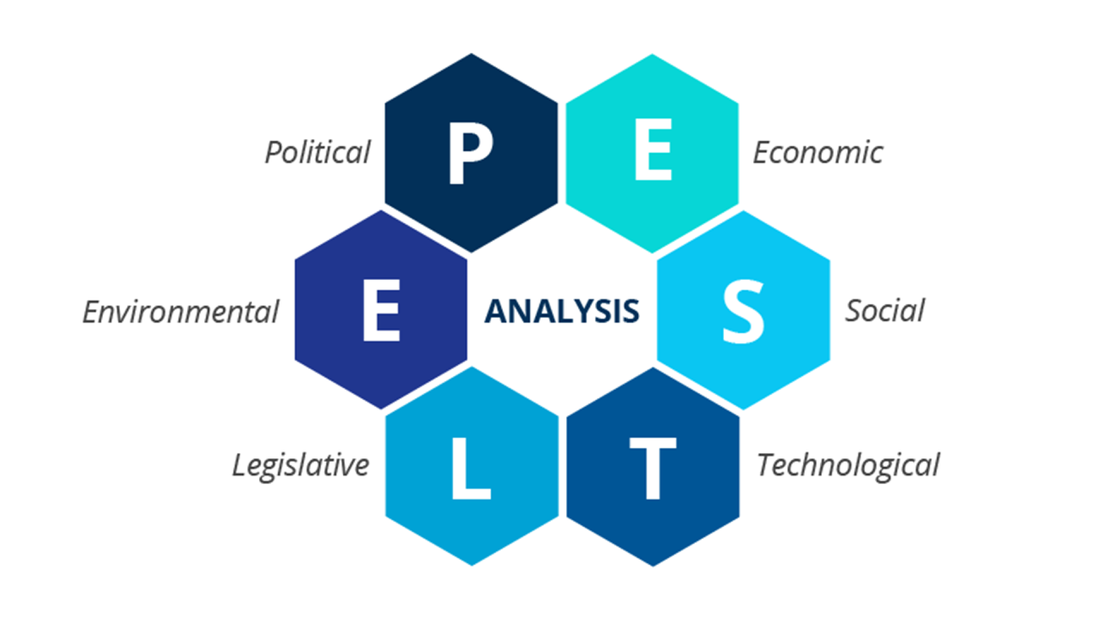
Figure 1: PESTLE Analysis (Gini and Agala, 2023)

Political Factors
Political stability is mostly favourable in both Germany and the United Kingdom in regards to the development of the automotive industry. Germany enjoys a good relations with government like subsidies on electric cars and making policies favourable to sustainable mobility, which favours Mercedes-Benz. This provides a very favourable climate in innovation and long term investment. The political conditions in the UK are also favourable to innovation as they are very stable and conducive to innovation. Nevertheless, there are some negative challenges associated with trade conditions and importing, especially supply chain management and expenses, post Brexit. In general, politics in both countries is favourable, albeit a little more favourable in Germany, given that the country has a better industrial policy alignment.

Economic Factors
Demand for luxury cars is greatly affected by economic conditions. The economy of Germany is robust and has a GDP of about $4.5 trillion and a high level of employment, hence very favourable to sales of premium cars. Unchanging purchasing power helps in the steady demand of luxury brands such as Mercedes-Benz. By early 2026, Mercedes-Benz retains a good premium position with 2024 statistics recording a 9.1% share of the new car market in Germany and robust, level sales, with new models in the UK starting as low as around £30,000 in compacts to over £100,000 in luxury EVs. On the other hand, the UK boasts a GDP of approximately $3.3 trillion, and GNP is $3.2 trillion, which also reflects well in the luxury car market segment, as it is usually favourable. However, the inflation and economic uncertainty put negative pressure on consumer spending.

Social Factors
Both the UK and Germany have mostly favourable social and demographic factors. Quality, reliability and safety of engineering are the key factors of the consumers in Germany, which in many ways could support the brand positioning of Mercedes-Benz. The growing environmental consciousness also favours the demand of electric and hybrid cars, which means that there is a positive change to sustainable solutions to cars. The consumer behaviour in the UK is influenced by the changing mobility patterns, the environmental concerns and the urban lifestyles. Electric vehicle growth is favourable as younger consumers are more interested in sustainable transportation. Nevertheless, a lack of interest in the conventional model of owning cars by certain urban communities might be marginally negative. Generally, both markets have social trends that are favourable to innovation and sustainability.

Technological Factors
In both countries, technological factors are very favourable. Automobile engineering and advanced technology in Germany is a world leader and would be a good basis of research and development. Mercedes-Benz enjoys the advantages of the well-developed infrastructure and ongoing technological advances in terms of autonomous driving and electric mobility. The United Kingdom also has good technological capacities especially in the field of digital systems and automotive engineering. Both markets demand sophisticated functionality like connectivity, navigation and driver assistance technologies. Such expectations provide a favourable innovation climate but heighten the level of competition as well, which can be a little bit difficult to keep up with technological leadership.

Legal Factors
Legal aspects in both the UK and Germany are mostly hostile in terms of rigidity, but are pro-sustainability and trust in the long-term. In Germany, there are strict regulations of automotive safety and emissions, which guarantee high standards of manufacturing. This will raise the cost of compliance in the case of Mercedes-Benz, but it will boost brand credibility and consumer confidence. On the same note, the United Kingdom has stringent laws that cover vehicle safety, emissions and environmental conservation. These laws are not conducive to the cost and complexity of operation but favourable to innovation and sustainable practices. In general, legal factors pose both a challenge and an opportunity to the company.

Environmental Factors
The environmental factors are becoming more important and mostly favourable to innovation but difficult to operate. The incentives provided by the government in Germany are pro-electric vehicle and low-emission transport systems, which is a good opportunity to develop automotive in a sustainable manner. The environmental consciousness in the United Kingdom is increasing quickly, and the government policies are geared towards decreasing petrol and diesel vehicles in the future. This opens a good prospective market to the growth of the electric vehicle of Mercedes-Benz under its EQ brand. But stringent environmental policies and switching expenses may be disadvantageous in the short-run. Overall, the long-run strategic development is driven by environmental factors.

Differences and Similarities of the PESTEL MODEL
The PESTEL environment analysis of Germany and the United Kingdom indicate similarities and differences that influence the activities of Mercedes-Benz. Both nations have secure political conditions and effective legal frameworks, especially in terms of vehicle safety and environmental standards, which promote the development of electric mobility. Both markets are conducive to the luxury car demand economically, but Germany has a better purchasing power, whereas the UK is susceptible to uncertainties linked to inflation (Ding et al., 2023). The consumers in the two countries are becoming more concerned about the environment socially, though the German consumers focus more on the quality of engineering and UK consumers focus on lifestyle and sustainability. Both countries are technologically advanced, with Germany being the leader in automotive engineering and research and development, however, in terms of the environment, stricter regulations are present in both markets, but the UK has a quicker change in policy to transition to phasing out petrol and diesel cars and accelerate electric vehicles.

Hofstede Cultural Dimension Model
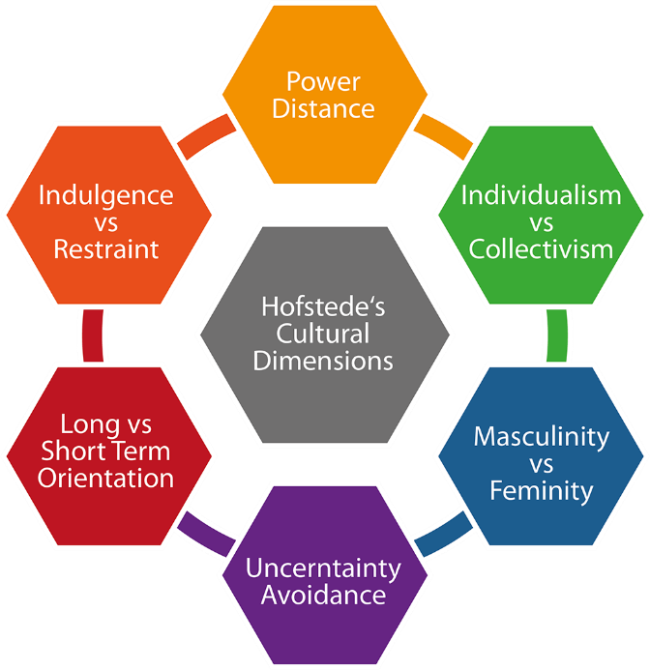
Figure 2: Hofstede Cultural Dimension Model (Arif et al., 2025)

Power Distance
Power distance is the level of acceptance of unequal power distribution of the less powerful members of society. Power distance in Germany is not that high, implying that organisations and societies are inclined to focus on equality and open dialogue between the management and employees. Consumers would require brands to be transparent and professional in communication (Yeganeh, 2025). In the case of Mercedes-Benz, this cultural attribute underlines the marketing approaches that focus on technical skills, product openness, and engineering superiority as opposed to the status quo. In like manner, the power distance in the United Kingdom is also very low. British consumers tend to choose friendly brands that can communicate in a friendly and straightforward manner. Nevertheless, there is still the value of prestige brands, particularly in the luxury automobile industry.

Collectivism vs. Individualism
Individualism is when individuals focus more on personal interests and self-reliance as opposed to group interests. Both the United Kingdom and Germany are very individualistic, and that is, consumers prefer individuality, self-expression, and independent decision-making. Consumers in the German automotive market will take a long time to make purchases by researching the technical features and performance of vehicles and comparing them (Rochmadika and Parantika, 2023). United Kingdom is not an exception as it is rated highly in terms of individualism, where consumers tend to consider ownership of car as a means of personal identity and lifestyle. The British customers can give high values to the design of their vehicles, brand image, and status. In the case of Mercedes-Benz, the cultural aspect would support the marketing strategies which emphasise luxury design, comfort and status.

Masculinity vs Femininity
Masculinity dimension is the degree to which societies value achievement, competitiveness, and success over collaboration and quality of life. Germany is taken to be a relatively masculine society where success, productivity and performance are noted to be highly appreciated. This cultural orientation promotes the demand of automobile that is engineering excellent, performing, and is reliable in the automotive industry. Mercedes-Benz fits in this cultural expectation by enhancing innovation, technological dominance and automotive design of high performance (Waliya et al., 2023). There are moderately masculine cultural features in the United Kingdom, as well, but lifestyle balance and comfort are focused upon slightly. The consumers in Britain might value both the performance and the luxury in the picking of premium cars.

Uncertainty Avoidance
Uncertainty avoidance refers to how much individuals are not comfortable with uncertainty and risk. Germany has a relatively high uncertainty avoidance as compared to a number of other countries. German consumers tend to be safe in their choice of products, have extensive technical knowledge, and prefer high-quality products guaranteed before decision-making (Yulia, 2025). Unlike that, the United Kingdom is less uncertain avoidance, which implies that consumers are mostly more receptive to innovations and new technologies. In the case of Mercedes-Benz, it opens up the possibilities to implement new technologies in its cars and luxury vehicles that can attract potential clients who want to use up-to-date and technological means of transport.

Long-Term Orientation
Long-term orientation is the extent to which societies focus on the future, perseverance and long-term rewards. Germany also has a comparatively good score in the long-term orientation, that is, the consumers usually think about durability, reliability and long-term worth during the buying of vehicles. Before making decisions, German buyers can be very thorough when considering the cost of maintenance, fuel efficiency and technological reliability. This mentality is advantageous to Mercedes-Benz since its cars are mostly linked with quality, durability and good resale value in the long run (Ding et al., 2023). The United Kingdom is more balanced in terms of both short and long-term orientation. British consumers might be interested in the short-term and long-term benefits of buying cars. Fancy, looks, and brand status can be used to shape buying behaviour as well as dependability and performance.

Indulgence vs Restraint
Indulgence dimension is the measure of how societies give people a chance to indulge in leisure activities and personal satisfaction. Generally, the United Kingdom reflects a higher degree of indulgence than that of Germany. The lifestyle experiences, comfort and enjoyments are a priority element of the purchasing choices of British consumers. Luxury cars can thus be considered not only as a means of transport but also as a source of individual achievement and pleasure. The lifestyle, comfort and aspirational brand images are common in the Mercedes-Benz advertisements across the UK (Gini et al., 2023). Germany is more likely to exhibit somewhat less expressive cultural attributes, in which pragmatism and functionality can be more beneficial in the decision-making by the consumer. German customers can focus on the vehicle performance, efficiency, and technical excellence instead of luxury experiences. Mercedes-Benz responds to these expectations by indicating the engineering innovation and the quality of performance in the German marketing strategies.

Advantages of the Hofstede Model
The model aids international marketers in comprehending the effects of cultural variations on consumer behaviour, consumer decisions to make, and their preferences in communication. In the case of an international company like Mercedes-Benz, the model of Hofstede can be used to inform marketing strategies since it can help to identify the role of cultural values in defining the expectations of customers in various markets (Chatterjee et al., 2022). The framework enables businesses to determine the similarities and differences between countries, which facilitates the formulation of viable international marketing strategies.

Disadvantages of the Hofstede Model
Although useful, the model provided by Hofstede has several shortcomings as well. The structure is founded on past information and might not be a complete reflection of contemporary globalised societies, where cultural values are ever-changing. What has been eroded is the cultural boundary between nations due to the expansions of globalisation, technological advancement and international communication. Furthermore, the model presupposes that national cultures are quite homogeneous, which can ignore regional variations, sub-cultures, and demographic diversity within countries (Molamohamadi and Talaei, 2022).

Segmentation, Targeting, and Positioning (STP)
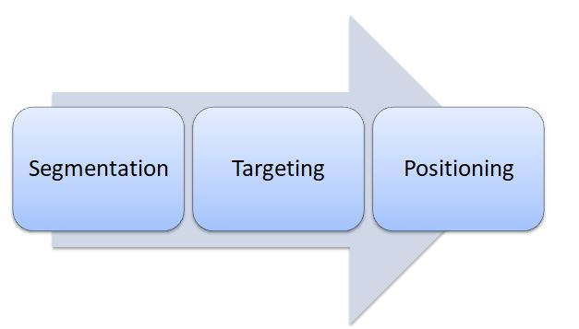
Figure 3: STP Analysis (Waliya et al., 2023)

Segmentation Strategy
Mercedes-Benz employs an integrated approach to segmentation, which is a blend of demographic, psychographic and behavioural variables in Germany and the United Kingdom. In terms of demographics, the company mainly focuses on high-income-earning professionals, entrepreneurs, corporate leaders and wealthy people with the purchasing power to acquire luxury cars (Ma et al., 2024). Such consumers are generally upper-middle or high-income and often want to have vehicles that are able to demonstrate their social and professional position. Psychographically, Mercedes-Benz targets those customers who believe in prestige, innovation, luxury and high performance on the road. On the behavioural front, the brand focuses on the customers who value high technology, safety elements, and high-quality driving experiences.

Targeting Strategy
Mercedes-Benz has implemented an intensive targeting approach which targets the consumer of premium and luxury automobiles in Germany and the United Kingdom. The brand aims at those customers who want high-quality cars with advanced engineering, high level of comfort and innovative technology. Businesspersons, business executives and successful entrepreneurs are some of the main target markets since they tend to appreciate prestige and performance in choosing cars (Martin-de et al., 2023). Affluent young consumers have also become a key target consumer, especially in sporty and compact luxury vehicles like the A-Class and CLA models. Applying to several luxury customer segments, Mercedes-Benz is very strong in its brand presence in various car luxury segments and is able to retain its exclusive brand image.

Positioning Strategy
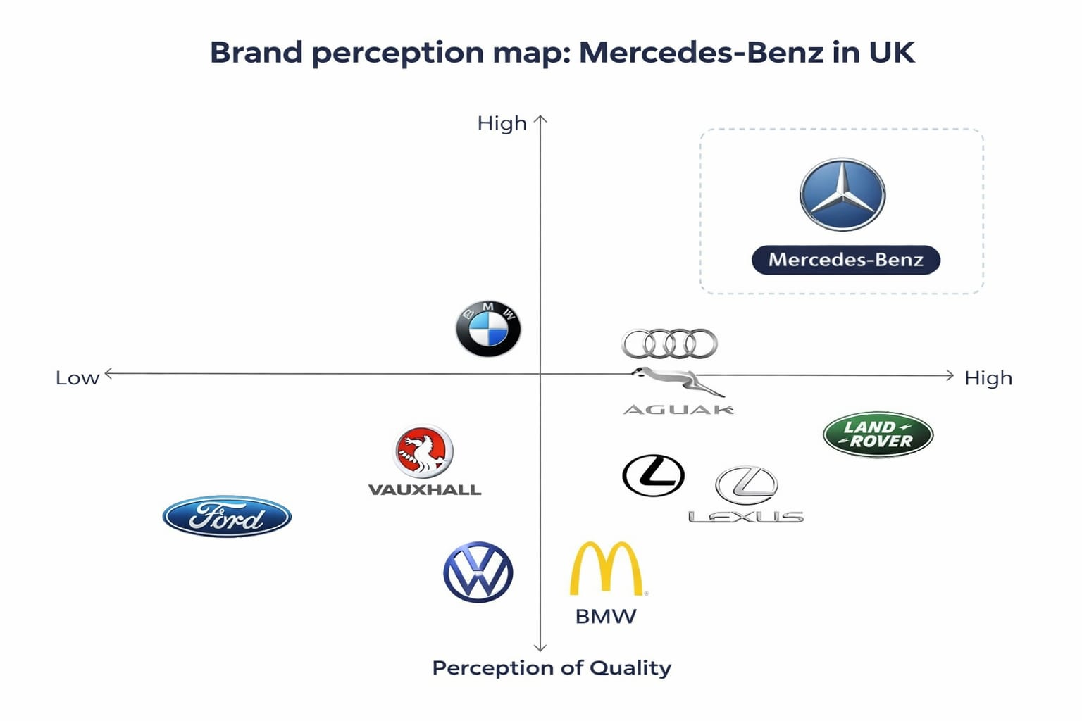
Figure 4: Mercedes-Benz Position (Ding et al., 2023)
Considering positioning, Mercedes-Benz positions itself as a luxury automobile brand in the world, which is linked to prestige, innovation, and a high standard of engineering. The brand focuses on the aspects of comfort, high level of technology, and sophisticated design to make a distinction among others in the premium car segment. This positioning strategy aims to strengthen the long history of the brand of excellence and reliability in the world automotive sector (Jadil et al., 2023). In comparison to the leading rivals like BMW and Audi, Mercedes-Benz is overemphasised on luxury comfort, sleek design, and the stylish approach in automobile technology. Whereas BMW tends to focus on sporty cars with a focus on performance, and Audi puts much focus on technological advancement, Mercedes-Benz integrates luxury, safety, and engineering precision.

Similarities and differences of STP
STP (Segmentation, Targeting, Positioning) is a marketing model that is employed to recognize and reach out to particular customer segments. The three elements are similar in the sense that they are interconnected and are geared towards enhancing marketing (Gini and Agala, 2023). Segmentation separates the market into groups in terms of characteristics, selecting the most desirable segments, and positioning a certain image in the mind of the customers so that it can be more aligned to the products and needs of the consumers.
Their dissimilarities are in their different roles in the process. Segmentation is analytical; it is aimed at identifying groups of customers whereas targeting uses selective approach where it selects the most profitable segments. Positioning is strategic, as it is the way of how a brand is perceived as compared to its competitors (Molamohamadi and Talaei, 2022). They both help businesses to create targeted marketing plans, enhance competitiveness, and create value to the appropriate audience.

Marketing Mix (7Ps) Comparison
It demonstrates the extent to which a company extends its coverage of various issues including product lines, pricing strategies, distribution channels and promotional tools. Marketing mix width is the difference or diversity of marketing activities and aspects that a company employs in each of the elements of marketing mix (7ps) (Chatterjee et al., 2022). To illustrate, a firm that has extensive coverage in its marketing mix can have various product lines, application of different pricing strategies, both online and offline strategy, and different promotional strategies.
The degree of detail, intensity and specialisation of individual component of the marketing mix is known as marketing mix depth. It is the extent to which a company would go in developing every aspect like the provision of a variety of options in a product range or a highly tailored promotional effort (Arif et al., 2025). An example of a deep product strategy is the availability of many versions, features and customisation of a single product range. Likewise, deep promotion can be related to personalised marketing campaigns and advanced digital targeting.
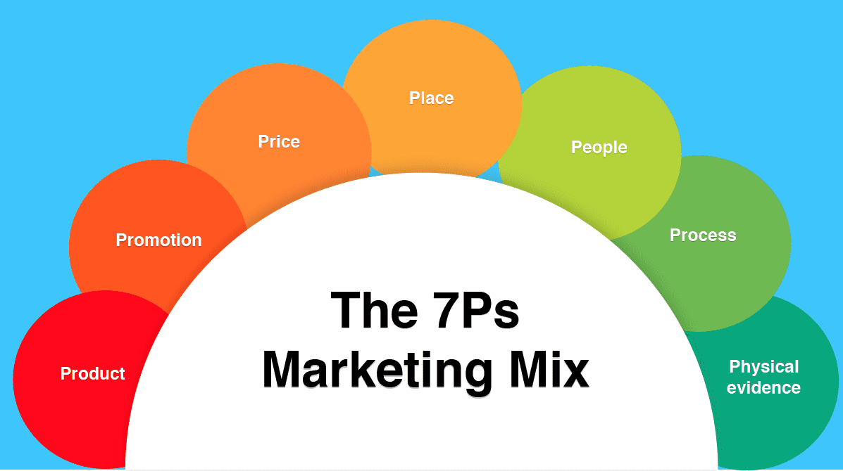
Figure 5: Marketing Mix (7Ps) (Molamohamadi and Talaei, 2022)

Product
Mercedes-Benz has a wide range of luxury cars, such as sedans, SUVs, sports cars, and electric cars. The product strategy in Germany is keen on engineering accuracy, high-level safety measures, and technology. German consumers are generally concerned with longevity, performance and advanced engineering (Arif et al., 2025). In the UK, the company emphasises the elegant design, comfort, and green technologies, including hybrid and electric cars. With these product differentiation strategies, Mercedes-Benz can satisfy the diverse customer expectations without losing its global luxury brand.

Price
Mercedes-Benz uses a premium pricing strategy in Germany and the United Kingdom, as it is a luxury car brand. The cars command a higher price than most of its competitors because of its advanced engineering, innovative technology and high quality of the build. German customers tend to perceive greater prices with engineering and durability. Pricing also depicts brand prestige and luxury in the UK market (Dana et al., 2022). The brand does not change its premium pricing; however, financing and leasing plans and promotions make Mercedes-Benz cars more affordable to high-income customers.

Place
Mercedes-Benz distributes its cars in authorised dealerships, online and certified showrooms. The brand has a good network of dealerships in Germany and is in proximity to manufacturing plants. Large showrooms are often visited by customers who have an opportunity to experience vehicles (Chatterjee et al., 2022). In the UK, dealerships and direct channel distributions are very significant; however, online configuration tools and digital channels are gaining widespread popularity.
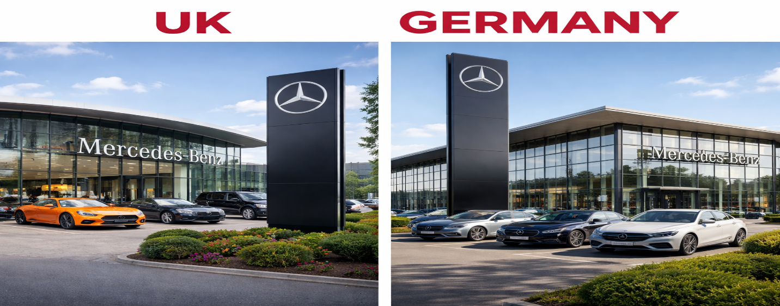
Figure 6: Mercedes-Benz in the UK and Germany (Kim et al., 2022)

Promotion
Integrated Marketing Communications (IMC) is a technique that keeps all the marketing communication tools, advertising, PR, online marketing, and sales promotion, in a regular state of coordination to communicate a clear, unified, and persuasive message to the target audience in all of the media. Mercedes-Benz promotes using its luxury, innovation, and engineering excellence. The advertising campaigns usually embody the history of the brand, high-level safety, and innovative technologies. The common promotional practices in Germany revolve around the engineering performance and product performance (Eichhorn et al., 2024). In the United Kingdom, the marketing campaigns can be based on lifestyle, design sophistication and prestige.

People
The customers are also a key component in the provision of a premium experience that is linked to Mercedes-Benz. There is intensive training of sales representatives and dealership staff to give customers professional and personalised services (Ayub et al., 2022). The employees in both the United Kingdom and Germany have a high level of expectation in regard to products and customer communication skills. The fact that they can describe technical specifics and offer customers the opportunity to choose the right vehicles contributes greatly to the purchasing experience.

Process
The process element describes the systems and procedures that are applied in an efficient delivery of products and services. Mercedes-Benz has high-quality production systems, quality regulations and control and effective supply chain management (Ding et al., 2023). In Germany and the United Kingdom, the customers enjoy efficient shopping processes, online configuration of vehicles and quality services after-sales. Maintenance service, warranty service and customer service systems make sure that the buyers experience high quality and constant service during the ownership experience.

Physical Evidence
Physical evidence constitutes the hard aspects that support the luxury brand image of Mercedes-Benz. The brand has a sophisticated image, which is created by premium showroom spaces, sophisticated interior design, and premium promotional materials. In Germany and the United Kingdom, the dealerships have modern design, display of luxury, and even customer lounges (Waliya et al., 2023). Also, the quality of design of the cars, interiors and development of the dashboards used in the Mercedes-Benz cars, can be taken as their physical testimony to the luxury, innovativeness and excellent craftsmanship offered by the brand.
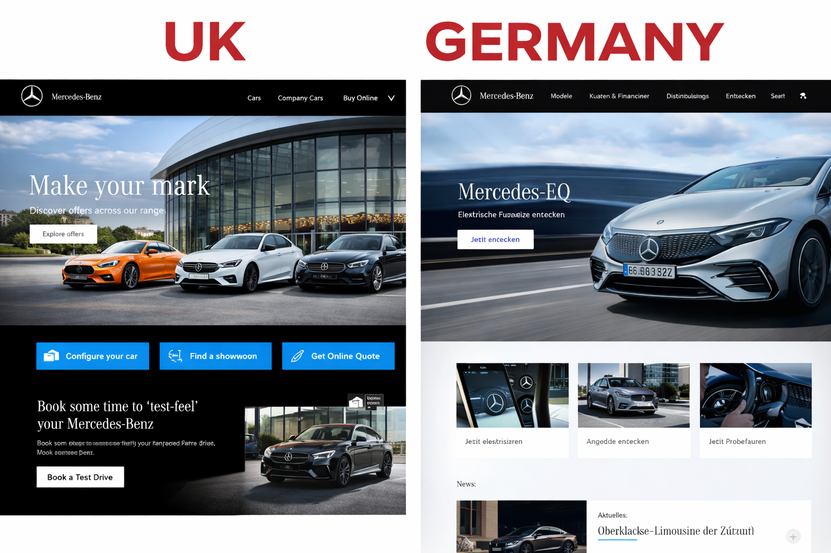
Figure 7: Websites of both countries (Khan et al., 2023)

Similarities and differences after 7Ps
The UK and Germany are highly similar in terms of the 7Ps marketing mix of Mercedes-Benz because the brand is positioned globally as a luxury brand. Mercedes-Benz focuses on a premium price, high-quality products and high focus on innovation, safety and customer service in both markets. Online configuration tools, dealerships, and after-sales support are also a common strategy to achieve digital transformation, which guarantees a smooth customer experience (Dana et al., 2022). Nonetheless, there are major variations in the marketing priorities and consumer expectations. Germany focuses on a technical consumer base by emphasising engineering excellence, durability, and performance, whereas the UK focuses on lifestyle appeal, elegant design and sustainability. The approaches towards promotion also vary, as in Germany, the emphasis is put on technical excellence, whereas in the UK, the emphasis is placed on the prestige and modern classifications of luxury.

Brand Directional Development Strategy (Ansoff Matrix)
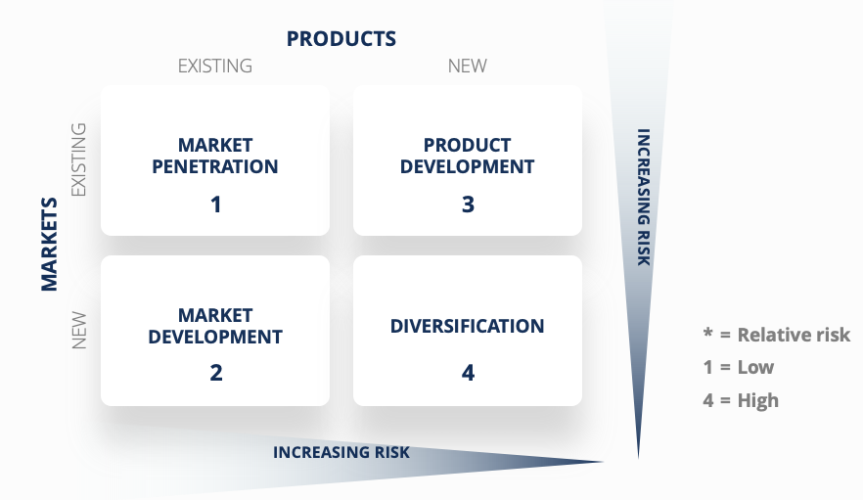
Figure 8: Ansoff Matrix (Rifki and Kirana, 2024)

Market Penetration
Mercedes-Benz in the United Kingdom aims to penetrate the market by enhancing its position in the current luxury automobile market. The company enhances the brand presence by using specific advertising platforms, auto shows, and online advertising. The increase in market share is also due to expanding the number of dealership connections and enhancing the customer services (Rifki and Kirana, 2024).

Product Development
In the UK market, product development is one of the main growth strategies of Mercedes-Benz. The company is also constantly launching new vehicle models integrated with new technologies, enhanced safety, and greener solutions. Specifically, the emergence of electric and hybrid cars has been a strategic priority since the environmental issues are growing, and the governmental policies are becoming more demanding (Tuominen et al., 2023).

Market Development
Market development implies penetrating into new customer segments and geographical locations in the United Kingdom. Mercedes-Benz will focus on younger high-income buyers, urban professionals, and those who are interested in high-quality vehicles, but with the latest technology and are ecologically friendly. The firm also experiments with new distribution channels, such as online vehicle sales platforms and digital tools for interacting with customers (Kim et al., 2022). Mercedes-Benz can enhance brand awareness and get more customers in the UK luxury automobile market by increasing its market coverage and modifying its marketing approach to various consumer groups.

Diversification
Diversification is the approach whereby companies bring new services or products to new markets. Mercedes-Benz has started to go beyond the conventional car-making business through investing in novel mobility solutions and digital technologies. These are mobility services, connected vehicle technologies and self-driving research. These efforts enable the company to experiment in the new business opportunities in the future transportation ecosystem (Herasymenko, 2023).

Ethical Issues
Ethics is a significant factor in the world automotive industry, especially to luxury brands like Mercedes-Benz. The ethical marketing practices entail responsible manufacturing procedures, clear communication with the consumers and compliance to the environmental and safety standards. Mercedes-Benz has been paying more attention to the sustainability issue through investing in greener technologies and developing its electric vehicle range (Huang et al., 2024). The company has made a move to minimise carbon emission through schemes like the EQ electric vehicle range and help the world move towards sustainable mobility.
In spite of these measures, there have been cases of ethical issues in the broader automotive sector in terms of vehicle emission and effect on the environment (Yulia, 2025). In the case of Mercedes-Benz, the only way to resolve these issues is to constantly invest in clean technologies, ethical treatment of supply chains, and responsible corporate governance. The company can increase consumer confidence through the reinforcement of sustainability efforts and the presence of openness in its communication with stakeholders to enhance the likelihood of guaranteeing the company as a responsible global luxury automobile brand.

Recommendations

Recommendations for Mercedes-Benz in the United Kingdom

1. Grow Affordable Luxury EV
Mercedes-Benz UK can offer more middle-range electric and hybrid models to enable more people to access premium mobility. The UK market structure is highly competitive, and the demand of affordable EVs is growing as people have to pay more, and the government provides incentives. The increased production of entry-level luxury EVs will enhance the market penetration and appeal to younger professionals.

2. Enhance Digital Retail and Online Sales Experience
The company ought to also work to enhance its online car buying platform in the UK and enable customers to complete the customisation of their vehicles, finance them and buy them online. The UK consumers are opting more and more towards online research and online buying.

3. Enhance Sustainability and Carbon Neutral Positioning
Mercedes-Benz UK needs to take its sustainability communications a step further by encouraging carbon-neutral production and environmentally friendly supply chain. Customers in the UK are very conscious of the environment and marketing campaigns that are aligned in net-zero will enhance brand reputation. .

Recommendations for Mercedes-Benz in Germany

1. Enhance Leadership in Innovative Automotive
Germany is the domestic market, and it is time to demonstrate the most innovative technologies of Mercedes-Benz: autonomous driving, artificial intelligence-based systems, and the new generations of EV. The investment in innovative cutting-edge R&D will support its reputation as a worldwide leader in innovation and a high level of domestic brand loyalty.

2. Grow Premium Luxury and Performance EV
Mercedes-Benz Germany is encouraged to develop its premium and performance EVs line, aiming at consumers with high income and corporate fleets. German market people appreciate engineering quality and thus improving high-performance electric vehicles will strengthen the luxury and technological quality of the brand.

3. Support Sustainable Manufacturing and Circular Economy
The company ought to also incorporate the concept of sustainable production in the German plants such as the use of more recycled materials and energy-efficient production process. Germany possesses high-level environmental standards and societal demands, which make sustainability one of the main criteria in preserving brand loyalty and adhering to regulations.

Section 2: Kolb’s Learning Cycle
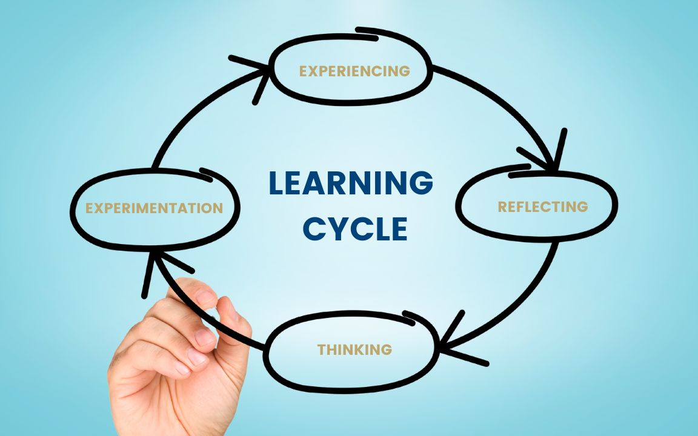
Figure 9: Kolb’s Learning Cycle (Rifki and Kirana, 2024)

1. Concrete Experience
This assignment was aimed at the analysis of the International marketing of Mercedes-Benz in United Kingdom and Germany. The assignment involved the use of a number of theoretical approaches, among them being PESTLE analysis, the Cultural Dimensions model created by Hofstede, Segmentation, Targeting and Positioning (STP) model, marketing mix of 7Ps and the Ansoff Matrix. In the process, I did a lot of research through academic journal, industry reports and other credible online sources to learn about the global automotive industry and how Mercedes-Benz has strategized itself.
The experience was to compare two mature markets with well established automotive markets with varying cultural, economic and regulatory features. I organized the report based on the requirements of academic guidelines and made sure that each section of the paper covered certain requirements of analysis. The project on a globally recognised luxury brand has enabled me to relate the knowledge gained in theory to actual business practices. This practical academic experience equipped me with more knowledge on the operations of multinational firms in various international markets.

2. Reflective Observation
In doing this assignment, I was able to contemplate my learning experience and the pitfalls I had to navigate. To begin with, I struggled to combine various theoretical frameworks into one and unified analysis. The various models needed a unique approach and integration of both models was only achieved through proper planning and organisation. I also realized that it was not possible to learn about the differences between UK and Germany only by having the basic knowledge; one had to think critically and compare and contrast the two countries in detail.
Nevertheless, with the development of my practice, I felt freer to use these frameworks and connect them. I noted that the structured models were very helpful in enhancing the clear and depth of my analysis. Another thing that came to my attention was that I was able to interpret information and relate theory to practice over the course of the assignment. Considering my performance, I can admit that I was quite good at descriptive writing, but I could have included more critical analysis and discussion of some parts.

3. Abstract Conceptualisation
This assignment enabled me to acquire new theoretical ideas in international marketing and strategic management. Among the essential ideas I have learned better is the necessity of standardisation of the world and localisation at the same time. Mercedes-Benz has a stable brand image of a luxury, innovative, and engineering excellence globally, yet it modifies its approaches according to the conditions on the local markets. To illustrate, in the UK, environmental issues drive the marketing of electric vehicles whereas in Germany it is the focus on precision and performance in engineering.

I also had a more insight into the impact of cultural dimensions on consumer behaviour. The model by Hofstede assisted me in examining how such aspects of purchasing behaviour as the levels of uncertainty avoidance and individualism influence the process. Also, the use of Ansoff Matrix allowed me to learn about the various growth strategies, such as market penetration and product development. These theoretical observations have enhanced my skills to analyse business strategies both in the theoretical and practical context.

4. Active Experimentation
With the help of this learning experience, I will use my enhanced analytical and research skills in the future academic and professional activities. I will work on merging various theoretical constructs more efficiently and making sure that my analysis will incorporate both a descriptive and a critical component. I also will engage a broader variety of scholarly sources to uphold my points and enhance the validity of my work.
When working on any task in future, I will begin my research on time to give myself time to critically assess and refine. I will also be doing practice in using international marketing theories to various industries and case studies to enhance my knowledge. In addition, I would like to develop my academic writing abilities by increasing the level of clarity, coherence, and logicality. Through these enhancements, I will be in a better position to assess complex business environments and be useful in real-life strategic decision making environments.

Conclusion
To sum it up, the international marketing of Mercedes-Benz in Germany and the United Kingdom has been analysed in this report. The results have shown that the company is able to preserve a good global luxury brand image and yet adjust its strategies to address the local market conditions and consumer expectations. PESTLE framework, Hofstede model, STP and the 7ps marketing mix are important frameworks that bring out the impact of cultural, economic, and environmental aspects on business decisions. Although there are similarities between the two markets, consumer behaviour and sustainability expectations vary necessitating strategic changes. Altogether, the orientation towards innovation, quality, and sustainability can guarantee the further competitiveness of Mercedes-Benz and its long-term success in the automotive market.

References
Arif, N.F., Rahman, F.H. and Setyani, A., 2025. Tourism in Supporting Indonesia's Creative Industry: Ansoff Matrix Approach. In RSF Conference Series: Business, Management and Social Sciences (Vol. 5, No. 2, p. 415). Research Synergy Foundation.
Ayub, Y., Mehmood, A., Ren, J. and Lee, C.K., 2022. Sustainable recycling of poultry litter to value-added products in developing countries of South Asia. Journal of Cleaner Production, 357, p.132029.
Chatterjee, S., Chaudhuri, R. and Vrontis, D., 2022. Knowledge sharing in international markets for product and process innovation: moderating role of firm's absorptive capacity. International Marketing Review, 39(3), pp.706-733.
Dana, L.P., Salamzadeh, A., Mortazavi, S. and Hadizadeh, M., 2022. Investigating the impact of international markets and new digital technologies on business innovation in emerging markets. Sustainability, 14(2), p.983.
Ding, Z., Wang, X. and Zou, P.X., 2023. Barriers and countermeasures of construction and demolition waste recycling enterprises under circular economy. Journal of Cleaner Production, 420, p.138235.
Eichhorn, T., Schaller, L., Hamunen, K. and Runge, T., 2024. Exploring macro-environmental factors influencing adoption of result-based and collective agri-environmental measures: a PESTLE approach based on stakeholder statements.
Gini, K.B. and Agala, H.O., 2023. The Impact of Macro-Environmental Factors on Business Performance. International Journal of Research and Innovation in Social Science, 7(11), pp.1837-1843.
Herasymenko, A., 2023. The Impact of the Macroeconomic Environment on Bank Lending to Industrial Enterprises: the Case of Ukraine. Economics and Education, 8(3), pp.18-23.
Huang, Z., Li, K., Xu, Z., Yin, R., Yang, Z., Mei, W. and Bing, S., 2024. STP-Model: A semi-supervised framework with self-supervised learning capabilities for downhole fault diagnosis in sucker rod pumping systems. Engineering Applications of Artificial Intelligence, 135, p.108802.
Jadil, Y., Jeyaraj, A., Dwivedi, Y.K., Rana, N.P. and Sarker, P., 2023. A meta-analysis of the factors associated with s-commerce intention: Hofstede's cultural dimensions as moderators. Internet Research, 33(6), pp.2013-2057.
Khan, U.U., Ali, Y., Petrillo, A. and De Felice, F., 2023. Macro-environmental factors and their impact on startups from the perspective of developing countries. International Journal of Sustainable Engineering, 16(1), pp.166-183.
Kim, T., Kim, D., Kwon, J. and Gim, G., 2022, July. An Empirical Study on the Economic Factors Affecting on the Export of Defense Industry Using Hofstede’s Culture Dimension Theory. In International Conference on Software Engineering, Artificial Intelligence, Networking and Parallel/Distributed Computing (pp. 107-120). Cham: Springer International Publishing.
Ma, C., Zhang, P., Zhang, H., Liu, Z., Song, F., He, Y. and Zhang, G., 2024. STP: Self-supervised transfer learning based on transformer for noninvasive blood pressure estimation using photoplethysmography. Expert Systems with Applications, 249, p.123809.
Martin-de Castro, G., Gonzalez-Masip, J.J. and Fernández-Menéndez, J., 2023. The role of corporate environmental commitment and STP on technological talent recruitment in service firms. Knowledge Management Research & Practice, 21(2), pp.412-425.
Molamohamadi, Z. and Talaei, M., 2022. Analysis of a proper strategy for solar energy deployment in Iran using SWOT matrix.
Orientani, R. and Akbara, A.Z., 2025. Analysis Of The 7P Marketing Mix At Panorama Hejo, Sentul. EKOMBIS REVIEW: Jurnal Ilmiah Ekonomi dan Bisnis, 13(3), pp.2095-2104.
Pandey, U.K., Thakur, S., Chaturvedi, R. and Joshi, B., 2024. AI-Enabled Segmentation Targeting and Positioning (STP) in the Service Industry. In Integrating AI-Driven Technologies Into Service Marketing (pp. 65-86). IGI Global Scientific Publishing.
Rifki, M.B. and Kirana, D.H., 2024. Market Expansion Strategy for Sweet Potato Export Products Using the Ansoff Matrix (Case Study of CV SNR Bumi Indonesia). International Journal of Management and Business Economics, 2(3), pp.59-63.
Rochmadika, H. and Parantika, A., 2023. Strategi Bauran Pemasaran 7P Menggunakan Pendekatan Analisis SWOT dalam Upaya Meningkatkan Daya Saing Mangata Coffee & Eatery. Media Wisata, 21(1), pp.164-177.
Tuominen, S., Reijonen, H., Nagy, G., Buratti, A. and Laukkanen, T., 2023. Customer-centric strategy driving innovativeness and business growth in international markets. International marketing review, 40(3), pp.479-496.
Waliya, I., Choiriyah, C. and Fadilla, F., 2023. Analisis Penerapan Bauran Pemasaran 7P (Marketing Mix) Pada Penjualan Produk Dalam Meningkatkan Pendapatan Di Khadijah Galery Palembang. EKOMAN: Jurnal Ekonomi, Bisnis dan Manajemen, 1(2), pp.131-142.
Yeganeh, H., 2025. Hofstede, GLOBE, Schwartz and Inglehart’s cultural dimensions: a critical examination and assessment. European Business Review, 37(6), pp.1073-1090.
Younis, H. and Elbanna, S., 2022. How do SMEs decide on international market entry? An empirical examination in the Middle East. Journal of International Management, 28(1), p.100902.
Yulia, S., 2025. Analisis Manajemen Strategi dan Pengembangan Olshop Siti Munira dengan Pendekatan Ansoff Matrix. PENG: Jurnal Ekonomi dan Manajemen, 2(2), pp.1833-1843.

