
APPENDIX GA36d – LEVEL 7 ASSESSMENT
Master of Business Administration

Marketing Environment Analysis of Rio Tinto Group’s Transition Towards a Lower-Carbon Business Model
Module | Marketing Management (LCMB7024)
Assessment | Assessment Component 1: Marketing Environment Analysis
Lecturer | Taonga Kaonga Sobere-Snithers (Birmingham)
Student name | Rani Ravat
Student ID | 2605880
Submission date | 22 October 2026
Final word count | 2476
Submission format: single Microsoft Word document

Table of Contents
1. Introduction 3
2. Task 1: Marketing Environment Analysis 3
2.1 Environment actor: climate, resource and decarbonisation pressure 3
2.2 Technological actor 5
2.3 Political actor 6
3. Task 2: Strategic Growth and Competitive Positioning 7
3.1 Ansoff assessment 7
3.2 Recommended strategy: product development 9
4. Task 3: Managerial and Professional Reflection 10
5. Conclusion 11
Reference List 12

1. Introduction
The chosen organization for this report is Rio Tinto Group – a significant metals and mining company operating in iron ore, aluminium, copper and lithium, and making changes in its portfolio due to the energy transition (Rio Tinto, 2024a). The company reported gross Scope 1 and 2 emissions of 30.7 Mt CO2e in 2024 and set the goal to decrease net Scope 1 and 2 emissions by 50% from the 2018 baseline until 2030 and achieve net zero by 2050 (Rio Tinto, 2024a). It gives the ground for the examination of the effect of environmental, technological and political pressures on marketing decisions. The report examines three actors among the external environment, with particular focus on the Environment actor, using the Ansoff Matrix to give recommendations on growth.

2. Task 1: Marketing Environment Analysis

2.1 Environment actor: climate, resource and decarbonisation pressure
Environment is the most important influence on the company because the industry causes environmental impacts, but its products are becoming essential for a low-carbon economy. According to IPCC (2022), industry could become net zero through energy efficiency, circular material flows, electrification, hydrogen and other low-emission technologies, yet there is a need in innovations and development. Therefore, Rio Tinto has to face a dual pressure: to reduce the environmental impact of its products and increase their supply.
The scale of the problem can be seen from Rio Tinto’s emissions in 2024. Scope 1 and 2 emissions decreased from 35.7 Mt CO2e in 2018 to 30.7 Mt CO2e in 2024, which is 14%. About 78% of the Group’s electricity consumption comes from renewables in 2024, and about two-thirds of its emissions are connected with the Aluminium business because aluminum production is very electricity intensive (Rio Tinto, 2024a). On the whole, the trend is positive, but the emissions remain huge. Rio Tinto also experiences Scope 3 pressure from its downstream customers, which means that its marketing claims cannot be based only on lower emissions.
The general industry situation puts additional pressure on the company. The International Aluminium Institute (2021) suggests that demand for aluminium for primary metal production could increase by 40% by 2050, but the sector has to reduce its emissions by 80% from the pathway. The World Bank (2020) states that a clean-energy transition will increase demand for minerals and metals, which makes responsible extraction and production even more important. Therefore, Rio Tinto has to prove that the increase in supply of minerals is not associated with unnecessary environmental damage.
To respond, Rio Tinto uses technology and renewables. The company’s AP60 project of 2023 is the investment of C$1.1 billion, which will add approximately 160,000 tonnes of annual low-carbon aluminium production. Rio Tinto claims that its AP60 technology together with hydropower in Quebec could produce about one-seventh of the greenhouse gases per tonne of aluminium compared to the industry average (Rio Tinto, 2023a). In 2024, Rio Tinto agreed to purchase 80% of the electricity from 1.4 GW Bungaban wind project for its Gladstone operations over 25 years (Rio Tinto, 2024b). The company tries to apply its environmental strategy in product and marketing strategy.
It is vital to note the difference between decarbonisation and green positioning. Block, Sharma and Benz (2024) found that stakeholders’ pressure could lead to the growth of decarbonisation; however, companies could react with substantial changes or symbolic ones. Therefore, Rio Tinto will have to demonstrate measurable results, carbon data and clear boundaries. As far as Aluminium Stewardship Initiative (2023) expects formal greenhouse gas reduction plan, clear pathway and environmental responsibility in the entire value chain, marketing has to promote the proof, not just the sustainability talk. It could include independently assured carbon intensity, recycled content, renewable electricity and lifecycle evidence.
Thus, the environmental pressure is both a threat and an opportunity for the company. First, it is the threat because of high capital costs, technology risk, increased expectations and potential reputational damage in case of claims being not credible. Second, it is the opportunity to differentiate its metals as the low-carbon ones. According to Mishra and Yadav (2021), proactive environmental strategy can help with achieving the competitive advantage through environmental capabilities. Rio Tinto has to use its capability as marketing advantage, but only where environmental performance can be proven and compared on consistent measures.
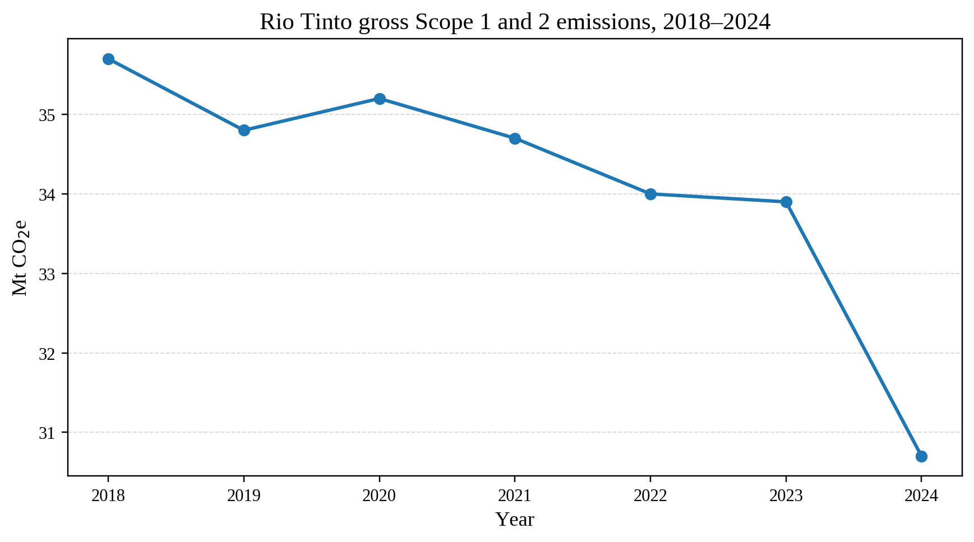
Figure 1: Rio Tinto gross Scope 1 and 2 emissions, 2018–2024.
Source: Rio Tinto (2024a).

2.2 Technological actor
Technological capability is important for Rio Tinto’s journey to lower carbon intensity because of the need to reduce emissions without lowering production at a low cost. An increase in low-carbon aluminium through the expansion of AP60 in Quebec will lead to the production of 160,000 tonnes per year of aluminium through technology using hydropower (Rio Tinto, 2023a). This can position process innovation as an aspect of the product in addition to being an internal aspect for the organisation. Technical performance is thus related to marketing.
The link between operations and the acquisition of new electricity through renewable sources can be seen in the recent 2024 decision by the company to acquire 80% of 1.4 GW Bungaban wind project for Gladstone operations for 25 years (Rio Tinto, 2024b). Long-term contracts such as the one above can help address energy needs for aluminium production. Looking into the future, minerals outlook shows that materials needed for clean energy will be increasingly in demand putting pressure on manufacturers to responsibly scale up their supplies (IEA, 2025). However, large projects need money, robust infrastructure, and efficient delivery. Projects can also enhance energy security.
Technology does not assure sustainable commercial advantage. Production claims need clear boundaries due to varying carbon intensity dependent on electricity type, material input, processing stage, and lifecycle approach. Rio Tinto should provide comparable data on how it determines the figures, give details on what is included in the carbon calculation and apply independent verification where possible. It should also give information on recycling processes, efficiency of production and clean energy use without describing planned projects as achievements. Organisational ambidexterity research shows that innovation adds competitive value where innovation is linked to organisational readiness and strategy (Ed-Dafali et al., 2023). This would make its technology story clearer and more credible to buyers.

2.3 Political actor
Rio Tinto’s working environment is subject to influences from politics by way of climate policy, industrial strategy and trade policies. The Critical Raw Materials Act of the European Union sets out a legal framework to enhance secure and sustainable access to critical raw materials (European Parliament and Council, 2024). Together with policies for clean energy, policy measures can lead to an increased demand for sustainable minerals along with higher standards in terms of resilience, transparency and environmental performance. Thus, political decisions impact the places in which the firm is investing and its market narratives in relation to the energy transition.
On the one hand, there are new opportunities created by such political influences. On the other hand, there are risks associated with potential shifts in government priorities, permits and trade policies. The International Energy Agency (2025) emphasizes the importance of mineral supply chains while the World Bank (2020) associates clean energy transition with increasing mineral demand. Rio Tinto needs to be aware of policy trends in relevant markets and convert those trends into the information on provenance, resilience of supply chains and emissions. Market communications should not imply that policy support means certain performance or demand from customers. Instead, the firm needs to demonstrate evidence of compliance, investments and environmental performance. This can reduce reputational risk and strengthen credibility across regulatory settings.
Table 1: External actor analysis
Actor | Key pressure | Evidence | Marketing implication
Environment | Emissions reduction, climate risk, resource efficiency | Rio Tinto’s 30.7 Mt Scope 1 and 2 emissions in 2024; aluminium accounts for about two-thirds of operational emissions (Rio Tinto, 2024a). | Sell verified lower-carbon products and communicate measurable environmental value (IAI, 2021).
Technological | Low-carbon technology, innovation and process efficiency | AP60 expansion and wind power purchase (Rio Tinto, 2023a, 2024b). | Promote verified technology and efficiency benefits to buyers.
Political | Policy, minerals security and climate targets shape investment | EU Critical Raw Materials Act and minerals outlook shape priorities (European Parliament and Council, 2024; IEA, 2025). | Align market claims with clear policy, traceability and supply-resilience requirements.

3. Task 2: Strategic Growth and Competitive Positioning

3.1 Ansoff assessment
Ansoff Matrix is important because Rio Tinto can either develop the present products and markets or enter new products and markets. According to Kotler et al., (2024), growth strategy involves making decisions on products and markets. In this situation, the best decision should be in line with the organization's strengths and pressures outlined in Task 1.
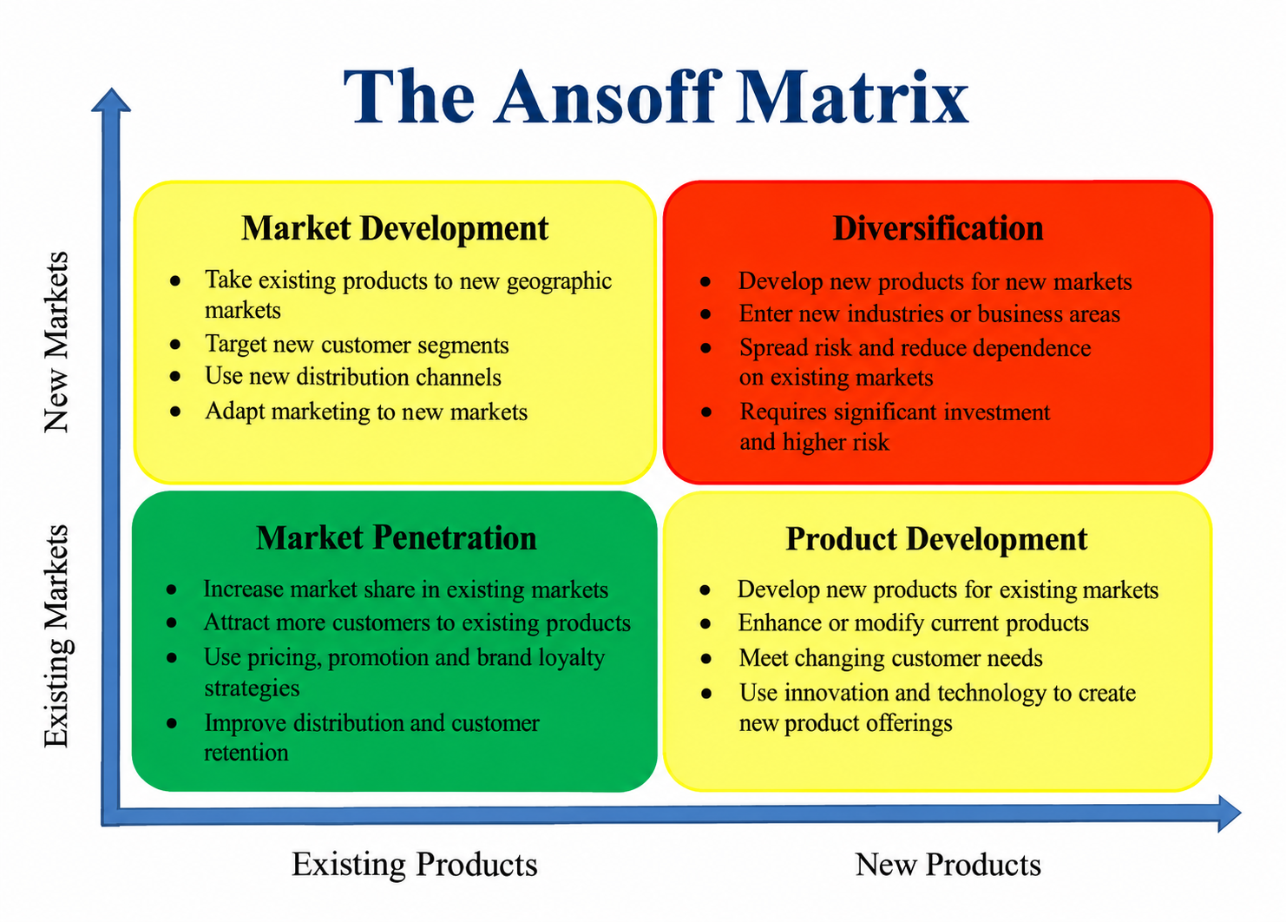
Figure 2: Ansoff Matrix for Rio Tinto’s lower-carbon transition.
Source: author’s application of the Ansoff framework using Kotler, Armstrong and Balasubramanian (2024).
An assessment indicates that market penetration involves less risk but is not likely to offer sufficient strategic differentiation. Diversification, which involves entering entirely new markets with new products, is a strategy with higher growth prospects but one that involves high risks. Market development is ideal when existing low-carbon products can be sold in new geographical markets, but differences in regulation and infrastructure can be significant. Product development is the best option as it is supported by existing customers, skills, supply chain and brand name.
Table 2: Ansoff option assessment for Rio Tinto
Strategy | Fit with external pressures | Risk | Recommendation
Market penetration | Medium | Low | Support existing customers but not the main growth route
Market development | High | Medium | Selectively expand into regions where renewable power and demand are strong
Product development | Very high | Medium | Primary strategy: create and scale differentiated low-carbon metal products
Diversification | Medium | High | Limited pilots only until capabilities and demand are proven

3.2 Recommended strategy: product development
Rio Tinto should use a product development approach with a portfolio of validated low-carbon aluminium and other transition metals for its current B2B customers. In particular, it should launch a standardized offer of “Rio Tinto Verified Low-Carbon Metals” that will include carbon intensity information, energy sources used, recycled metal content if available, and information about its validation and chain of custody data. The product should be aimed at customers that need that kind of data for their climate reporting. This would be an extension of Rio Tinto low-carbon aluminium projects, strong customer relations and supply chain partnerships (Rio Tinto, 2021; Rio Tinto, 2022; Rio Tinto, 2023b, 2023c).
Secondly, Rio Tinto should co-develop products with customers. Ford shows how lithium, copper and low-carbon aluminium can help with a transition (Rio Tinto, 2022). Rio Tinto can do that through multiyear contracts with customers from automotive, grid, packaging and construction industries, exchanging the data about the product development process and life cycle for customer climate reporting. Marketing in this case would move from one-way communication to value creation. Willingness to pay is uncertain, as green preference is not able to bring premium, and value for money is important (Dangelico, 2021; Morone et al., 2021). Green innovation requires specific internal skills as well (Al-Swidi et al., 2022; Tran, 2024).
Third, Rio Tinto should pursue selective market development. The 2025 assessment of a potential renewable-powered aluminium project in India shows how Rio Tinto can expand low-carbon production to a growth market rather than limit itself with current facilities (Rio Tinto, 2025a). Market development should, however, be based on established product standards and availability of renewable power.
Porters Generic Strategy - Competitive Positioning
This strategy can provide competitive advantage through differentiation, not just through pricing. Proactive environmental capabilities can help achieve differentiation and cost advantages (Mishra and Yadav, 2021), while B2B green marketing can enhance green competitive advantage when financial and environmental objectives are balanced (Eyadat, Almuhana and Al-Bataineh, 2024). In case of Rio Tinto, the key advantage is likely to be a combination of low-carbon production, reliable supply, traceability, technical quality and co-development with key customers.
According to IEA (2025), there will be a significant increase in demand for copper and lithium in connection with electrification. Also, the European Union's 2024 Critical Raw Materials Regulation includes bauxite/alumina/aluminium, copper and lithium among strategic or critical raw materials (IEA, 2025; European Parliament and Council, 2024). Thus, product development can combine environmental value and structural market growth.
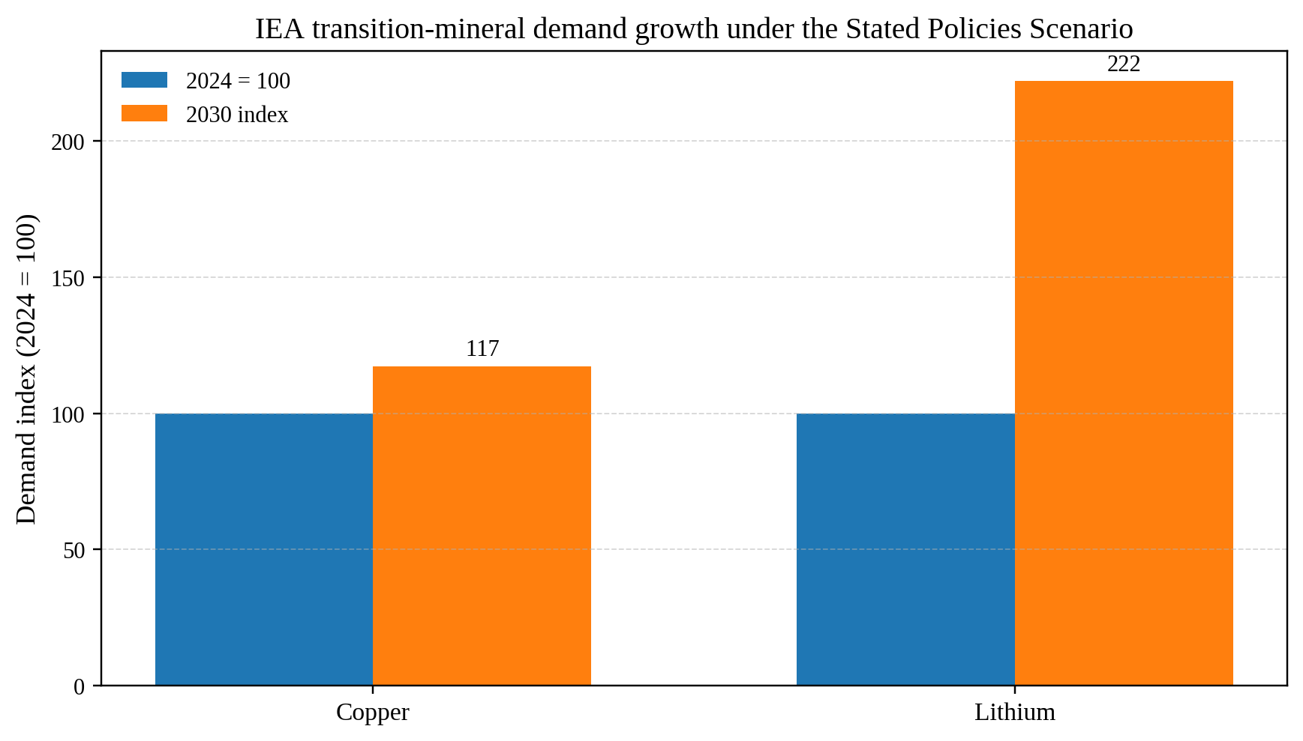
Figure 3: IEA transition-mineral demand growth under the Stated Policies Scenario, indexed to 2024.
Source: IEA (2025).

4. Task 3: Managerial and Professional Reflection
In terms of senior leadership, I chose Rio Tinto because this firm shows a good and visible relationship between environmental pressure, the need for change and expectations of customers and potential for growth. In addition, there are measurable targets for emissions and visible investments into low-carbon aluminium, renewable power and transition materials. So, the analysis has better evidence than a company without public data.
The Environment, Technological, and Political actors were included since they affect the strategic choices. Environmental pressure necessitates changes to be seen; technological capacity will allow lower-carbon production, efficiencies, and measurement of carbon emissions. Lastly, political priorities will determine investments, permits, security of supplies and market access. Overall, those actors prove that sustainability is a strategic topic rather than a separate CSR activity. Product Development strategy is the optimal one for the company, since Rio Tinto has everything to enhance its competitive product value. It seems to be a more conservative strategy than diversification; however, its financial feasibility and customer demand should be tested.
The weakness of the analysis is the fact that all evidence is secondary. The information provided in company reports may not be completely objective. Competitor carbon intensity data, including EcoLum by Alcoa, may include various assumptions (Alcoa, 2024). Customers' demand may vary between industries and countries, and therefore evidence obtained from the green products research cannot be used in case of industrial metals. To give the final recommendation, a consultant would need the following data to be obtained: customer willingness to pay, contract pipeline, lifecycle assessment of products, competitors' carbon intensity with consistent methodology, renewable electricity cost per project, technology readiness data, and aluminium, copper and lithium price sensitivity. These gaps limit reliable like-for-like comparisons across firms and markets over time.
Another limitation is that Ansoff is a good framework for growth analysis but it is not enough to test feasibility of implementation. The management should combine the matrix with financial modeling, scenarios, risks assessment, and customer interviews before large-scale investment. The recommendation should be seen as strategic guidance, not the completed investment case. The reflection is needed here because the decision-making at Level 7 is judgment under uncertainty.

5. Conclusion
Rio Tinto is under increasing pressure for the commercialization of lower carbon content metals from an environmental, technological and political perspective. The Growth Strategy of the Product Development type still applies as it utilizes current strengths while providing differentiated and measureable value to the customers. Success of Rio Tinto will depend upon the results of the emissions intensity, value proposition marketing, co-development with the customers, proper capital management and communication of technology and policy risks.

Reference List
Alcoa (2024) Alcoa 2024 Sustainability Report. Available at: https://www.alcoa.com/sustainability/pdf/2024-Sustainability-Report.pdf (Accessed: 7 October 2026).
Al-Swidi, A.K., Al-Hakimi, M.A., Gelaidan, H.M. and Al-Temimi, S.K.A.J. (2022) ‘How does consumer pressure affect green innovation of manufacturing SMEs in the presence of green human resource management and green values? A moderated mediation analysis’, Business Ethics, the Environment & Responsibility, 31(4), pp. 1157–1173. Available at: https://doi.org/10.1111/beer.12459.
Aluminium Stewardship Initiative (2023) ASI Performance Standard V3.1. Available at: https://aluminium-stewardship.org/wp-content/uploads/2023/04/ASI-Performance-Standard-V3.1-April-2023.pdf (Accessed: 7 October 2026).
Block, J.H., Sharma, P. and Benz, L. (2024) ‘Stakeholder pressures and decarbonization strategies in Mittelstand firms’, Journal of Business Ethics, 193, pp. 511–533. Available at: https://doi.org/10.1007/s10551-023-05576-w.
Dangelico, R.M. (2021) ‘Which are the determinants of green purchase behaviour? A study of Italian consumers’, Business Strategy and the Environment, 30(5), pp. 2600–2620. Available at: https://doi.org/10.1002/bse.2766.
Ed-Dafali, S., Al-Azad, M.S., Mohiuddin, M. and Reza, M.N.H. (2023) ‘Strategic orientations, organizational ambidexterity, and sustainable competitive advantage: Mediating role of industry 4.0 readiness in emerging markets’, Journal of Cleaner Production, 401, 136765. Available at: https://doi.org/10.1016/j.jclepro.2023.136765.
Eyadat, A.A., Almuhana, M. and Al-Bataineh, T. (2024) ‘The role of green marketing strategies for a competitive edge: A case study about analysis of leading green companies in Jordan’, Business Strategy & Development, 7(3), e70000. Available at: https://doi.org/10.1002/bsd2.70000.
European Parliament and Council (2024) Regulation (EU) 2024/1252 establishing a framework for ensuring a secure and sustainable supply of critical raw materials. Available at: https://eur-lex.europa.eu/eli/reg/2024/1252/oj (Accessed: 7 October 2026).
International Aluminium Institute (2021) Aluminium Sector Greenhouse Gas Pathways to 2050. Available at: https://international-aluminium.org/resources/aluminium-sector-greenhouse-gas-pathways-to-2050-2021/ (Accessed: 7 October 2026).
International Energy Agency (IEA) (2025) Global Critical Minerals Outlook 2025. Paris: IEA. Available at: https://www.iea.org/reports/global-critical-minerals-outlook-2025.
IPCC (2022) Climate Change 2022: Mitigation of Climate Change. Contribution of Working Group III to the Sixth Assessment Report. Cambridge: Cambridge University Press. Available at: https://www.ipcc.ch/report/ar6/wg3/ (Accessed: 7 October 2026).
Kotler, P., Armstrong, G. and Balasubramanian, S. (2024) Principles of Marketing. 19th edn. Harlow: Pearson. Available at: https://www.pearson.com/en-us/subject-catalog/p/principles-of-marketing/P200000009859/9780137991839.
Mishra, P. and Yadav, M. (2021) ‘Environmental capabilities, proactive environmental strategy and competitive advantage: A natural-resource-based view of firms operating in India’, Journal of Cleaner Production, 291, 125249. Available at: https://doi.org/10.1016/j.jclepro.2020.125249.
Morone, P., Caferra, R., D’Adamo, I., Falcone, P.M., Imbert, E. and Morone, A. (2021) ‘Consumer willingness to pay for bio-based products: Do certifications matter?’, International Journal of Production Economics, 240, 108248. Available at: https://doi.org/10.1016/j.ijpe.2021.108248.
Rio Tinto (2021) Rio Tinto partners with Schneider Electric to drive decarbonisation through circular and sustainable market ecosystem. 23 June. Available at: https://www.riotinto.com/news/releases/2021/rio-tinto-partners-with-schneider-electric-to-drive-decarbonisation-through-circular-and-sustainable-market-ecosystem (Accessed: 7 October 2026).
Rio Tinto (2022) Rio Tinto and Ford sign MOU for battery and low carbon materials supply to support net-zero future. 21 July. Available at: https://www.riotinto.com/news/releases/2022/ford-rio-tinto-sign-mou-for-battery-and-low-carbon-materials-supply-to-support-net-zero-future (Accessed: 7 October 2026).
Rio Tinto (2023a) Rio Tinto to expand its AP60 low-carbon aluminium smelter in Quebec. 12 June. Available at: https://www.riotinto.com/news/releases/2023/rio-tinto-to-expand-its-ap60-low-carbon-aluminium-smelter-in-quebec (Accessed: 7 October 2026).
Rio Tinto (2023b) Rio Tinto and Prysmian partner on sustainable supply of materials for the energy transition. 30 October. Available at: https://www.riotinto.com/en/news/releases/2023/rio-tinto-and-prysmian-partner-on-sustainable-supply-of-materials-for-the-energy-transition (Accessed: 7 October 2026).
Rio Tinto (2023c) Rio Tinto and Marubeni partner to create stronger and more responsible Aluminium supply chains. 16 February. Available at: https://www.riotinto.com/news/releases/2023/rio-tinto-and-marubeni-partner-to-create-stronger-and-more-responsible-aluminium-supply-chains (Accessed: 7 October 2026).
Rio Tinto (2024a) Annual Report 2024. Available at: https://www.riotinto.com/-/media/content/documents/invest/reports/annual-reports/2024-annual-report.pdf (Accessed: 7 October 2026).
Rio Tinto (2024b) Rio Tinto signs Australia’s biggest renewable power deal as it works to repower its Gladstone operations. 21 February. Available at: https://www.riotinto.com/en/news/releases/2024/rio-tinto-signs-australias-biggest-renewable-power-deal-as-it-works-to-repower-its-gladstone-operations (Accessed: 7 October 2026).
Rio Tinto (2025a) Rio Tinto and AMG Metals & Materials to assess low-carbon aluminium project in India. 17 April. Available at: https://www.riotinto.com/en/news/releases/2025/rio-tinto-and-amg-metals--materials-to-assess-low-carbon-aluminium-project-in-india (Accessed: 7 October 2026).
Tran, N.K.H. (2024) ‘Customer pressure and creating green innovation: The role of green thinking and green creativity’, Sustainable Futures, 7, 100177. Available at: https://doi.org/10.1016/j.sftr.2024.100177.
World Bank (2020) Minerals for Climate Action: The Mineral Intensity of the Clean Energy Transition. Washington, DC: World Bank. Available at: https://www.worldbank.org/en/news/press-release/2020/05/11/mineral-production-to-soar-as-demand-for-clean-energy-increases (Accessed: 7 October 2026).

