


Network Management (NM)

Case study

Faculty of Applied Design and Engineering
School of Applied Computing
Mount Pleasant Campus
Swansea
SA1 6ED

- INTRODUCTION AND OBJECTIVES
This case study is based on figure 1 below. It is a poorly network design that is being implemented by a medium size business. The network persons who are responsible to manage this network are quite inexperience.
For this semester you will be working in groups of three to analyse the network diagram and make recommendations to improve it. You will need to apply your understanding and knowledge from what you have learnt throughout this module and other relevant modules from the computer networks course. You will also need to conduct researches to aid in your analysis and evaluations. Relevant sources such as text books, library databases, and/or the Internet can be used.
At the end of the tasks each group will be required to give a presentation to the class and upload the PowerPoint slide to a shared space in one drive of Office 365. All students will be given access to this space. Note these upload PowerPoint will serve as solutions to the case study and should consider as content to aid with exam preparation.

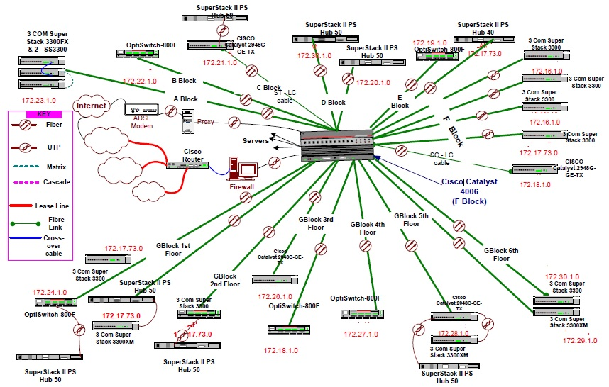
WAN
WAN
WAN
Figure 1

Task 1:
- Assign yourselves in groups of three
- Make a list of all the problems you can identify in figure 1
- assign yourself the following roles:
- Network Manager
- Network Administrator
- Administrator and Planner
- State what your job function/responsibility will be for the role you are assign to. Research your function to ensure you know and understand the capability of the role.
- Wrap up task 1 by starting your PowerPoint presentation

End of task 1

Task 2:
- Rebuild/design the current network infrastructure
- All problems and weaknesses identified in task one must be address and explain all measures taken to correct them.
- The improvement of the network infrastructure should incorporate VOIP; A PBX server be part of a server farm.
- What SNMP system will you recommend to manage and examine network traffic? Give reasons for your choice.
- Wrap up task 2 by putting your PowerPoint presentation together

End of task 2

Task 3:

- Each group give a 15 minutes presentation plus 5 minutes for questions

End of task 3

