Student Name: Robert Constantin Dan | 2507758
ACCA4023
Lecturer Name: Sadhana Jha
Deadline: 19/07/2026
HTML & CSS WEB DEVELOPMENT

University of Wales Trinity Saint David
Contents
Introduction 0
Requirements 1
Purpose: 1
Subject matter 1
Intended audience 1
Implementation 2
Screenshots of the Webpages 2
Validation 4
HTML Validation 4
CSS Validation 5
Evaluation 6
Part A 6
Website usability- 6
Website accessibility: 6
Search engine optimisation 7
Part B 7
Usefulness (Usability and Utility) 7
Search Engine Optimisation (SEO) 7
Accessibility: 8
Part C 8
Conclusion 8
References: 10
Appendix 11

Figure 1 – Home Page 3
Figure 2 – London Page 3
Figure 3 – Birmingham Page 4
Figure 4 - Manchester Page 4
Figure 5 – HTML Validation 5
Figure 6 – CSS Validation 6

Table 1 – Websites Comparison 9

Introduction

This report explains how I planned, designed, built, and evaluated my website, “Discover UK Cities”. The website was created using HTML and CSS and provides information about three UK cities: London, Birmingham, and Manchester.
The report describes the purpose of the website, the intended audience and the features included on each page. It also explains how the website was implemented, including the design choices, navigation and layout. The report contains the results of HTML and CSS validation, an evaluation of the website in terms of usability, accessibility and search engine optimisation (SEO), and a comparison with two existing websites[1].
The aim of this report is to show the development process and demonstrate how web design principles were used to create a simple and informative website.

Requirements

Purpose:

The purpose of this website is to provide visitors with useful and interesting information about three of the most well-known cities in the United Kingdom: London, Birmingham and Manchester. I wanted to create a website that is easy to navigate and suitable for people who would like to learn more about these cities before visiting them or simply to increase their knowledge. The website was also created to demonstrate my understanding of HTML and CSS by building a multi-page website that follows good web design practices.

Subject matter

The website focuses on tourism and general information about the cities of London, Birmingham and Manchester. Each city has its own dedicated page containing a brief introduction, popular tourist attractions, traditional food, cultural information and interesting facts. The homepage provides a summary of each city and allows users to navigate easily to the individual pages through the navigation menu. The website also includes images and a consistent colour scheme to make the content more attractive and engaging.

Intended audience

The website is intended for a wide range of users, including students, tourists and anyone interested in learning more about cities in the United Kingdom. It is designed for people who want quick and simple information without having to read large amounts of text. I also considered users with different devices by creating a responsive layout so the website can be viewed on computers and mobile devices. The simple navigation and clear structure make it suitable for all users.

Implementation

Screenshots of the Webpages

The implementation stage involved creating a four-page website using HTML and CSS. The website was designed with the same layout on every page to keep it simple and easy to use. Each page has the same navigation menu, header and footer, so users can move easily between the homepage and the city pages[2].
The homepage introduces the purpose of the website and provides a short overview of London, Birmingham and Manchester. Each city has its own page containing information about popular attractions, traditional food, culture and interesting facts. Relevant images were included to make the pages more visually attractive and to help users understand each city's main features.
To improve the look of the website, I created an external CSS stylesheet that controls the colours, fonts, spacing, navigation bar, buttons and page layout. Using one stylesheet keeps the design consistent across all pages and makes it easier to update the website.
The screenshots below show the completed webpages and demonstrate the final appearance of the website after implementation.

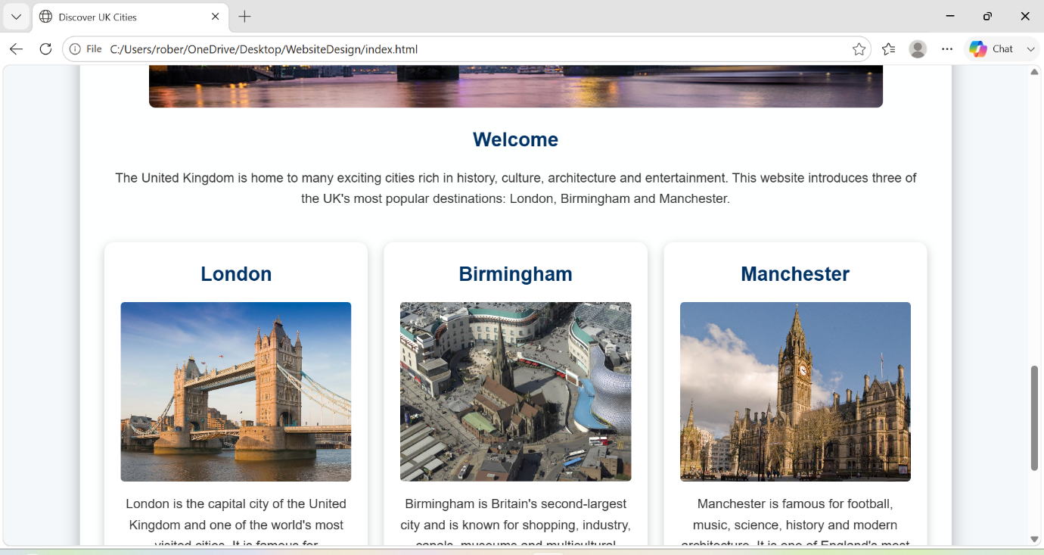
Figure 1 – Home Page

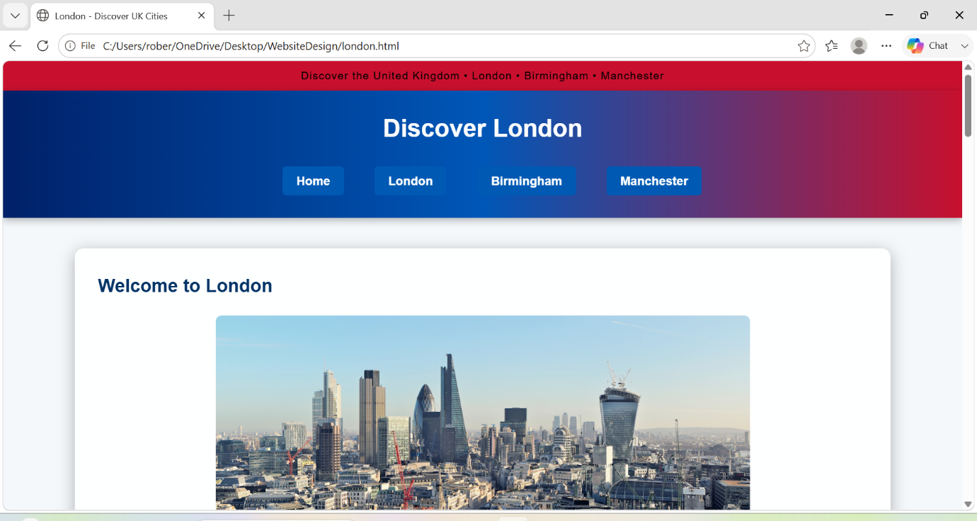
Figure 2 – London Page

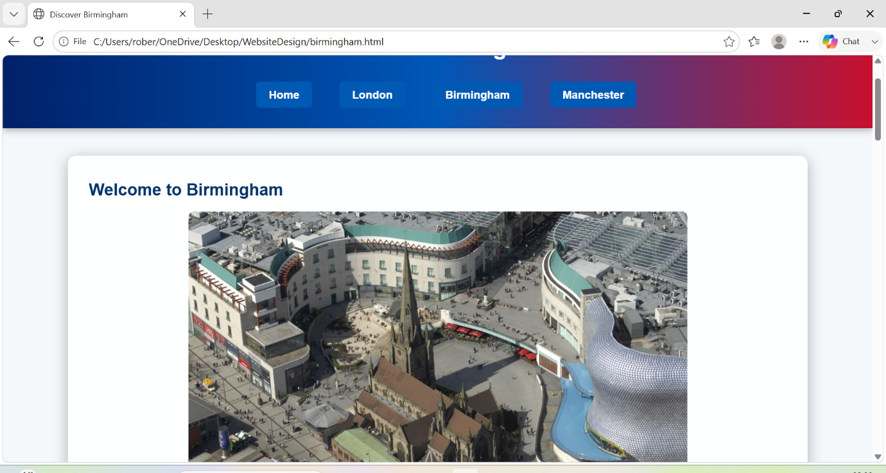
Figure 3 – Birmingham Page

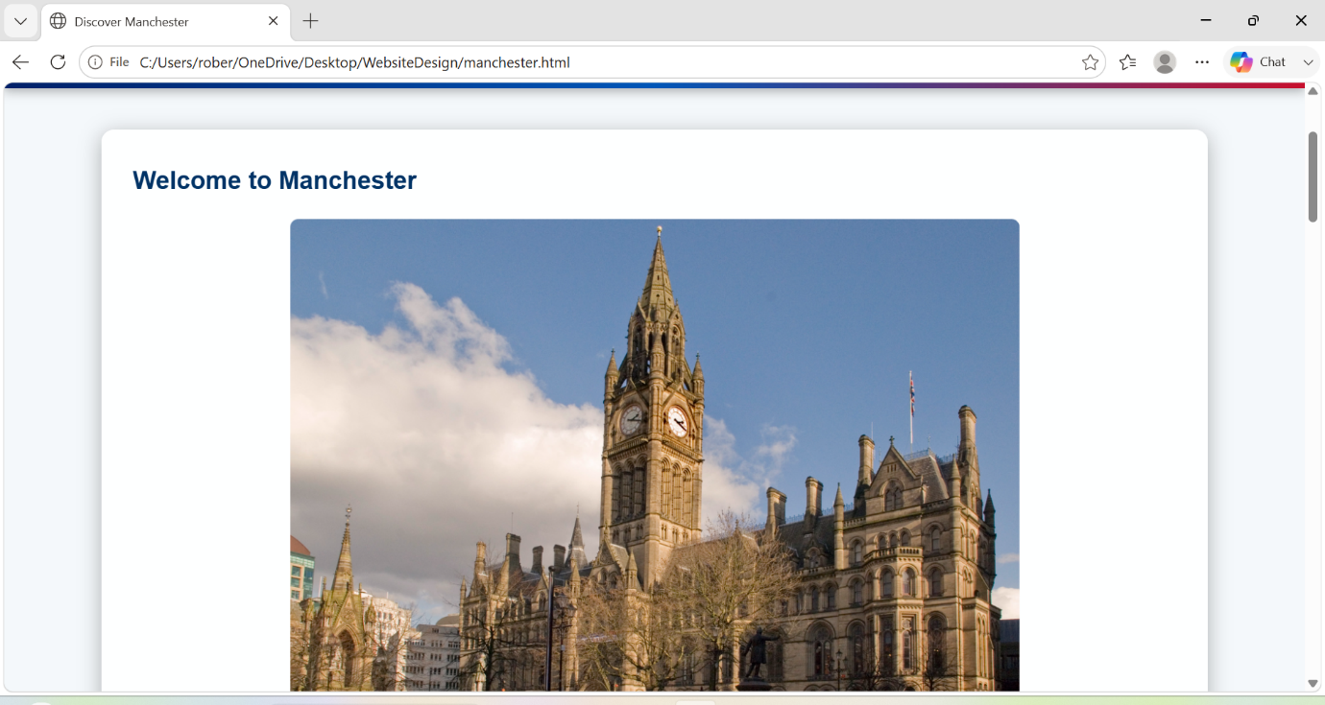
Figure 4 - Manchester Page

Validation

HTML Validation

After completing the homepage, I used the W3C HTML Validator to check that the code followed HTML standards. The validation process found one warning but no critical errors that prevented the webpage from working correctly.
The warning indicated that one of the “section” elements did not contain a heading. This happened because I used a “section” element to group the city cards on the homepage without adding a heading. To improve the structure of the page, I added a suitable heading to the section. After making this improvement, I rechecked the page to ensure the HTML followed recommended web standards.
The validation process helped me find small improvements that made the HTML clearer and easier for browsers and assistive technologies to read.

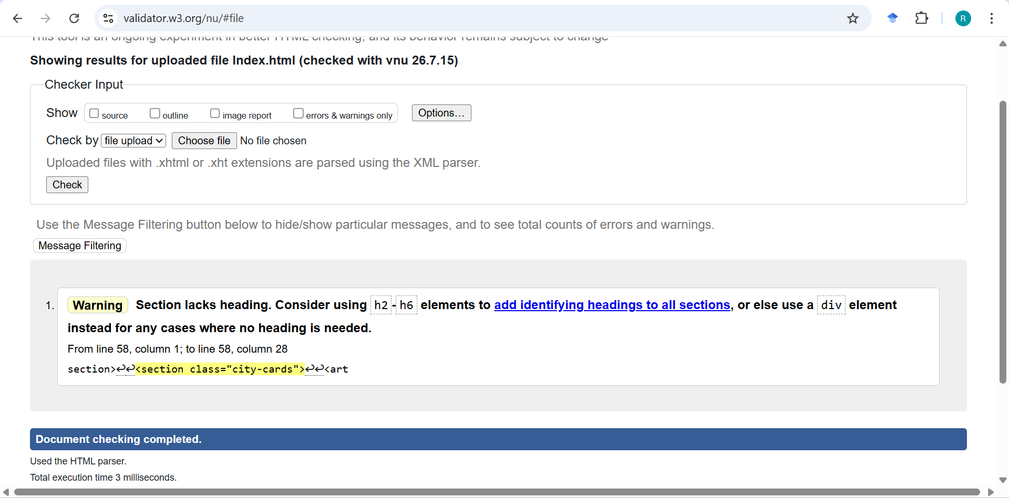
Figure 5 – HTML Validation

CSS Validation

After completing the stylesheet, I used the W3C CSS Validator to check that my CSS code followed the correct standards and contained no syntax errors.
The validation showed that the stylesheet has no errors and meets CSS standards. This gave me confidence that the CSS is correct and will work consistently across different web browsers. It also helped improve the quality and reliability of the website by ensuring the styling follows recognised web standards.

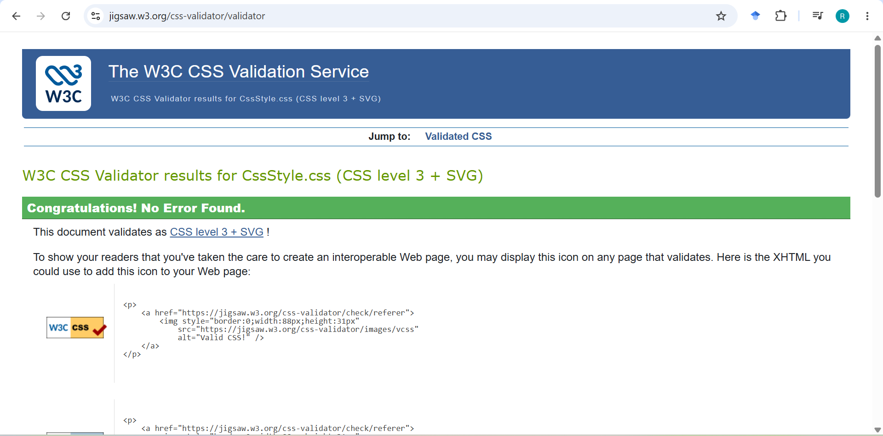
Figure 6 – CSS Validation

Evaluation

Part A

Website usability-

Website usability is how easy it is for people to use and move around a website. A good website should have a clear structure, simple navigation and easy-to-read content. This helps users find what they need quickly without getting confused.
When designing my website, I focused on keeping the layout simple and consistent across all four pages. Every page contains the same navigation bar, making it easy for users to move between the homepage and the city pages. I also used headings, images and short paragraphs to organise the information and improve readability. The buttons and navigation links are clearly visible, helping users find their way around the website[3].

Website accessibility:

Website accessibility means designing a website so that it can be used by as many people as possible, including people with disabilities. Accessible websites use clear text, appropriate colours, descriptive headings and alternative text for images so that screen readers can describe the content.
To improve accessibility, I used semantic HTML elements such as <header>, <nav>, <main>, <section> and <footer>. Every image includes alternative text describing what it shows, allowing screen readers to provide meaningful information to visually impaired users[4]. I also selected colours with good contrast between the background and text, making the content easier to read.

Search engine optimisation

Search Engine Optimisation (SEO) is the process of improving a website so that search engines such as Google can understand its content more easily[5]. Good SEO helps a website appear higher in search results, increasing the number of visitors.
My website follows several basic SEO practices. Each page has a unique title, meaningful headings and descriptive text related to the cities being presented. Images include alternative text, which improves accessibility and helps search engines understand the image content. The website also uses simple navigation and clean HTML code, making it easier for search engines to scan and index the pages.

Part B

Usefulness (Usability and Utility)

The website it successfully provides useful information about London, Birmingham and Manchester while maintaining a consistent design throughout all pages. The navigation menu makes it easy to move between pages, and the external CSS stylesheet creates a professional appearance using blue, white and red colours inspired by the United Kingdom[6].
Its simple layout makes it suitable for users of different ages and levels of computer experience. The use of images and short sections of text makes the information easy to understand without overwhelming the visitor.

Search Engine Optimisation (SEO)

The website follows many SEO principles that improve its visibility on search engines. Each page has a descriptive title, structured headings and relevant content about UK cities. Images include descriptive alternative text, and the navigation menu allows search engines to scan the website efficiently[5]. These features help improve usability and search engine indexing.

Accessibility:

Accessibility was considered throughout the development process. I used HTML elements to organise the content correctly and included alternative text for all images. The navigation menu is consistent across every page, allowing users to move around the website easily[7]. The colour scheme provides good contrast between the background and text, making the content easier to read for most users.

Part C

Table 1 – Websites Comparison
Area | VisitBritain | Lonely Planet
Weblink of the Website | https://www.visitbritain.com | https://www.lonelyplanet.com
Usability | Very easy to navigate with clear menus and categories. | Easy to navigate with detailed travel guides and search features.
Accessibility | Good colour contrast, clear headings and accessible navigation. | Good accessibility with readable fonts and structured content.
SEO | Strong use of keywords, descriptive page titles and structured content. | Excellent SEO with detailed travel articles and optimised page structure.
Mobile Friendliness | Fully responsive and works well on smartphones and tablets. | Fully responsive with an adaptive layout for mobile devices.
Conclusion | Easy to use with clear information and good accessibility. | Well-organised and provides detailed travel guides.

Conclusion
Creating this website helped me develop my skills in HTML and CSS while learning about website design, usability, accessibility and SEO. Throughout the project, I learned how to create multiple linked webpages using a consistent layout and an external stylesheet.
I also learned the importance of validating HTML and CSS to identify small issues and improve the quality of my code. The project has increased my confidence in designing websites and applying good web development practices.
I believe the website meets its original objectives by providing clear and useful information about London, Birmingham and Manchester in a simple, attractive and easy-to-use format.

References:

[1] N. R. Ayni, A. Saputra, Z. Nurrahman, D. Meiliani, R. Rafeinal and D. Fernandes, "Perancangan Game Catur Sederhana Berbasis Web Menggunakan HTML, CSS, dan JavaScript," vol. 1, no. 1, pp.21–30, 2026,
[2] J. Robbins, Learning web design: A beginner's guide to HTML, CSS, JavaScript, and web graphics, " O'Reilly Media, Inc.", 2012.
[3] J. Tidwell, Designing interfaces: Patterns for effective interaction design, " O'Reilly Media, Inc.", 2010.
[4] F. Filipe, I. M. Pires and A. J. Gouveia, "Why web accessibility is important for your institution," vol. 219, pp.20–27, 2023,
[5] J. L. Ledford, Search engine optimization bible, John Wiley & Sons, 2015.
[6] P. A. F. Michalichem, L. T. Pereira and K. R. da Hora Rodrigues, "A gamified solution to promote positive habits in children and adolescents with Intellectual Disabilities," vol. 16, no. 1, pp.833–849, 2025,
[7] U. Singh, J. Divya Venkatesh, A. Muraleedharan, K. S. Saluja, A. JH and P. Biswas, "Accessibility analysis of educational websites using WCAG 2.0," vol. 5, no. 3, pp.1–28, 2024,

Appendix

The appendix contains screenshots of the HTML and CSS source code used to create the website. These screenshots provide evidence of the development work completed during the project and demonstrate the structure of the webpages and the external stylesheet.

Index.html:

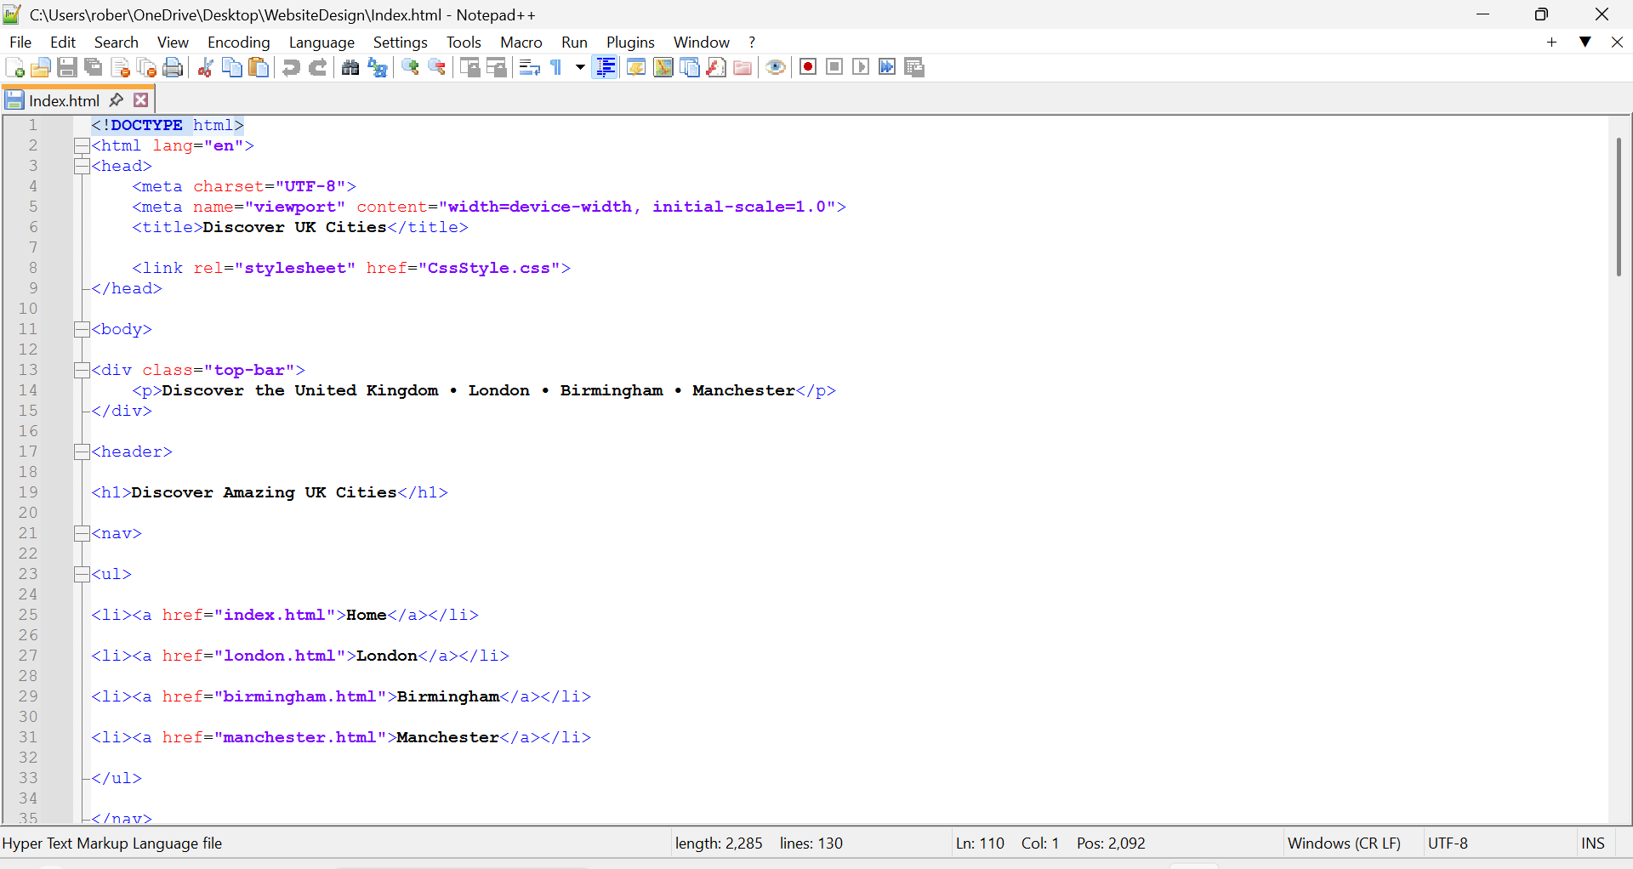

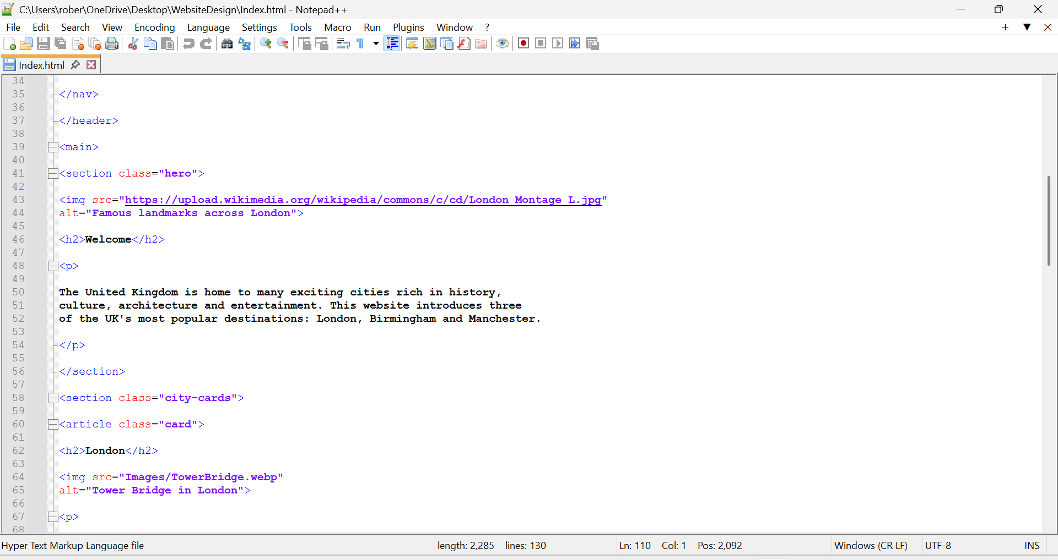
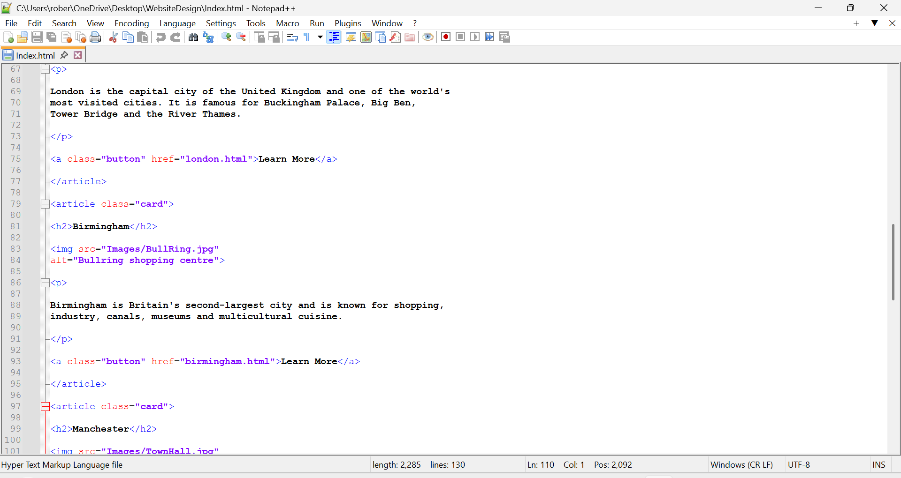

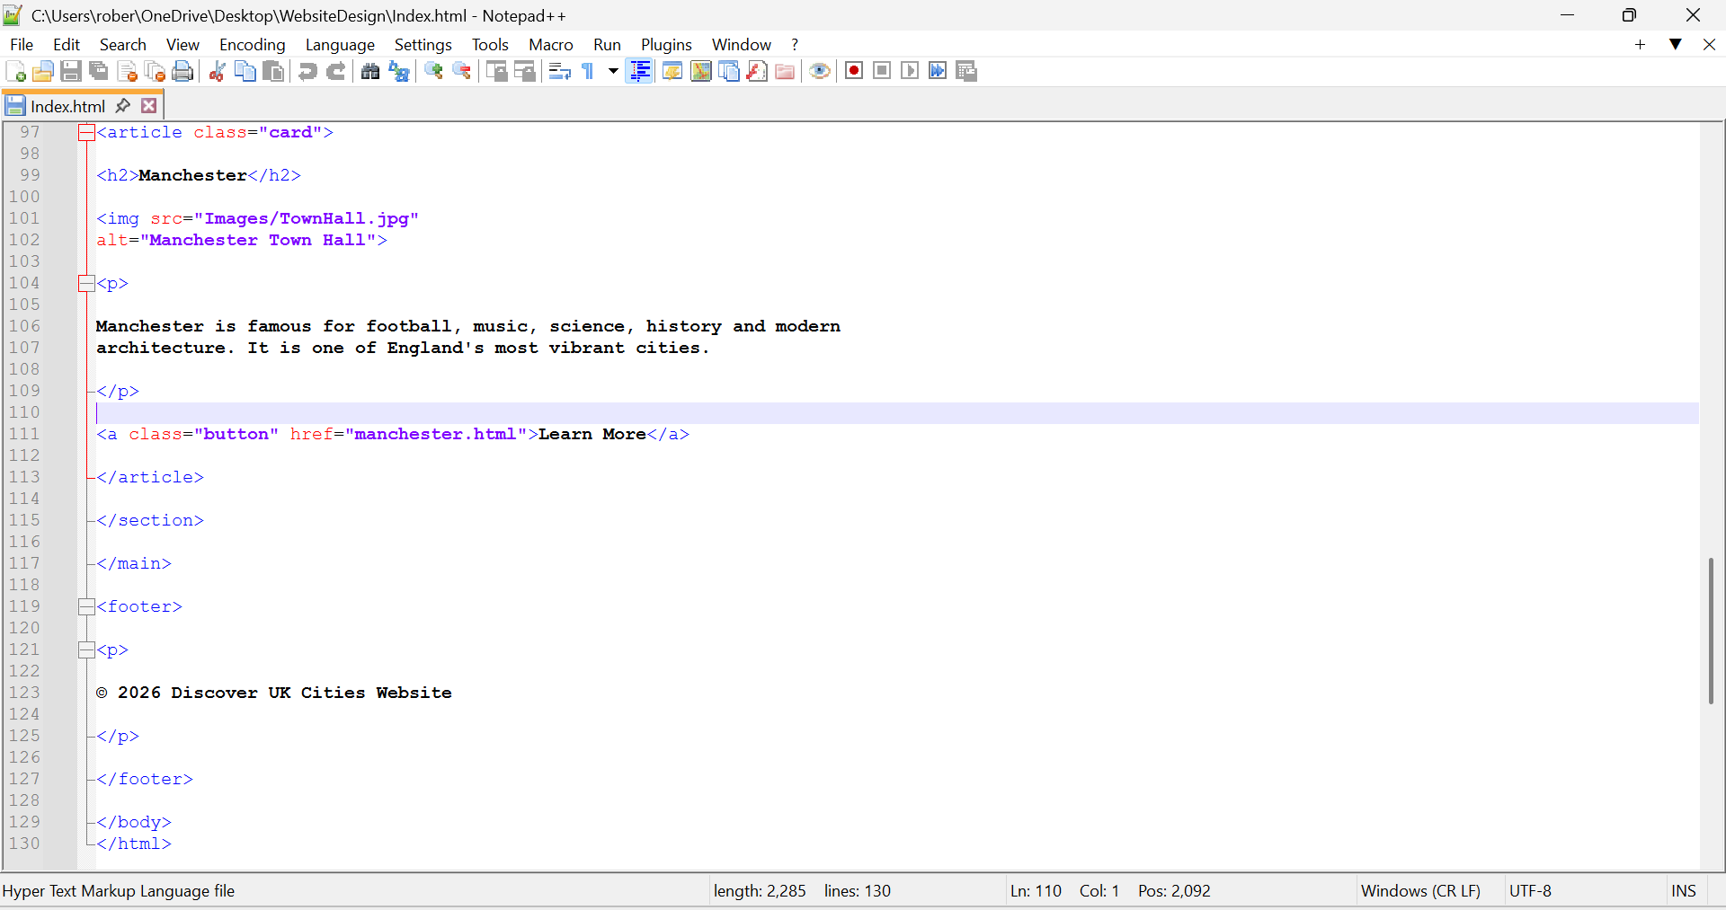

London.html:

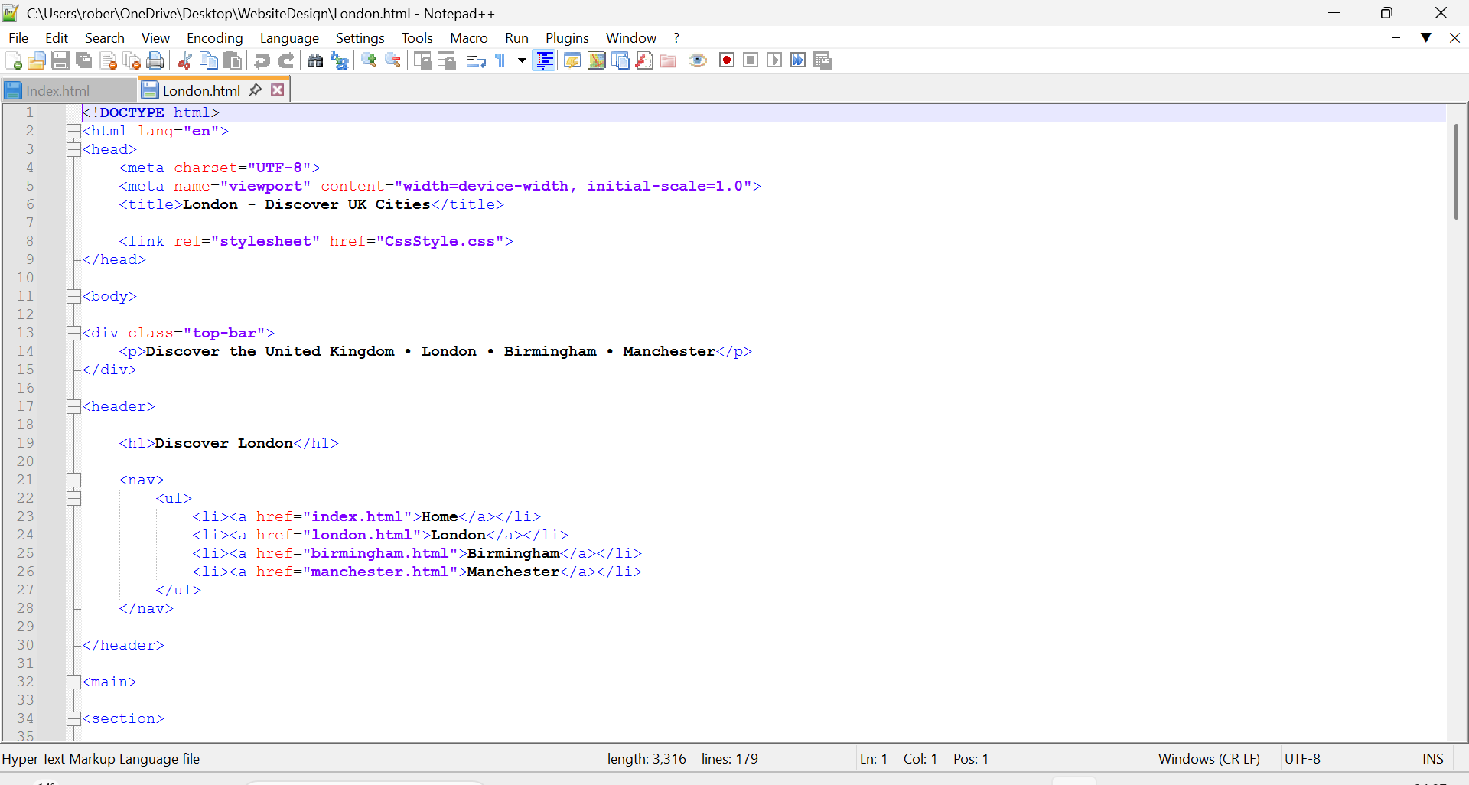

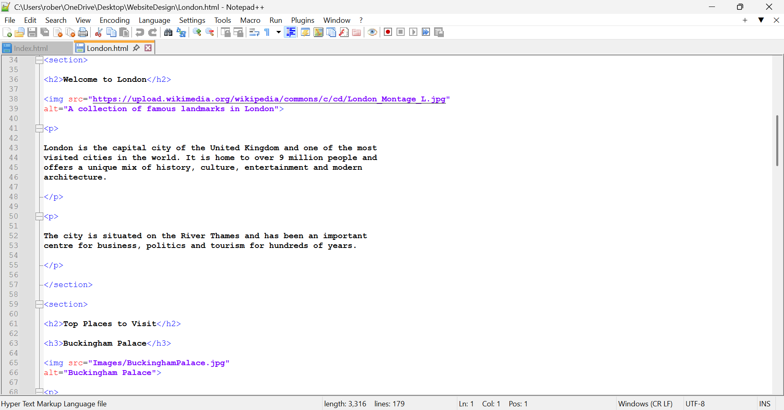

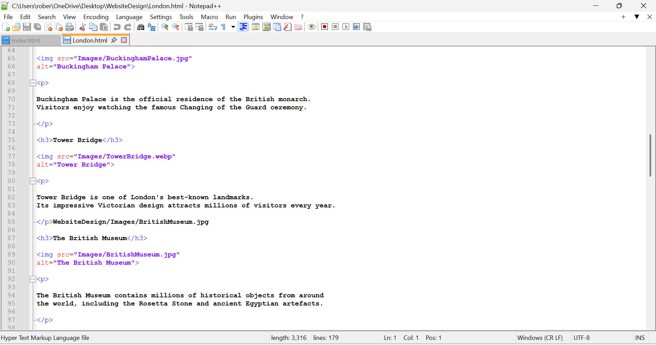

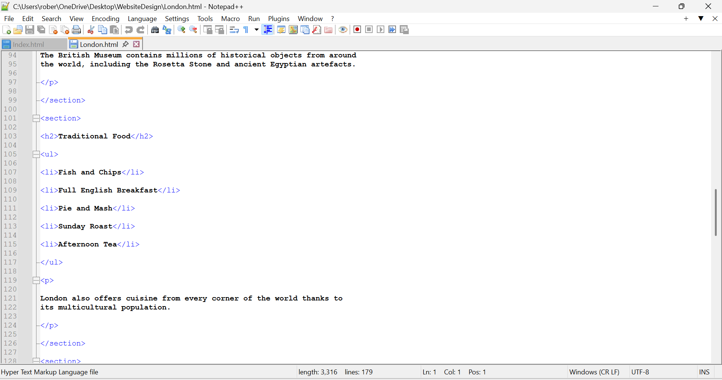

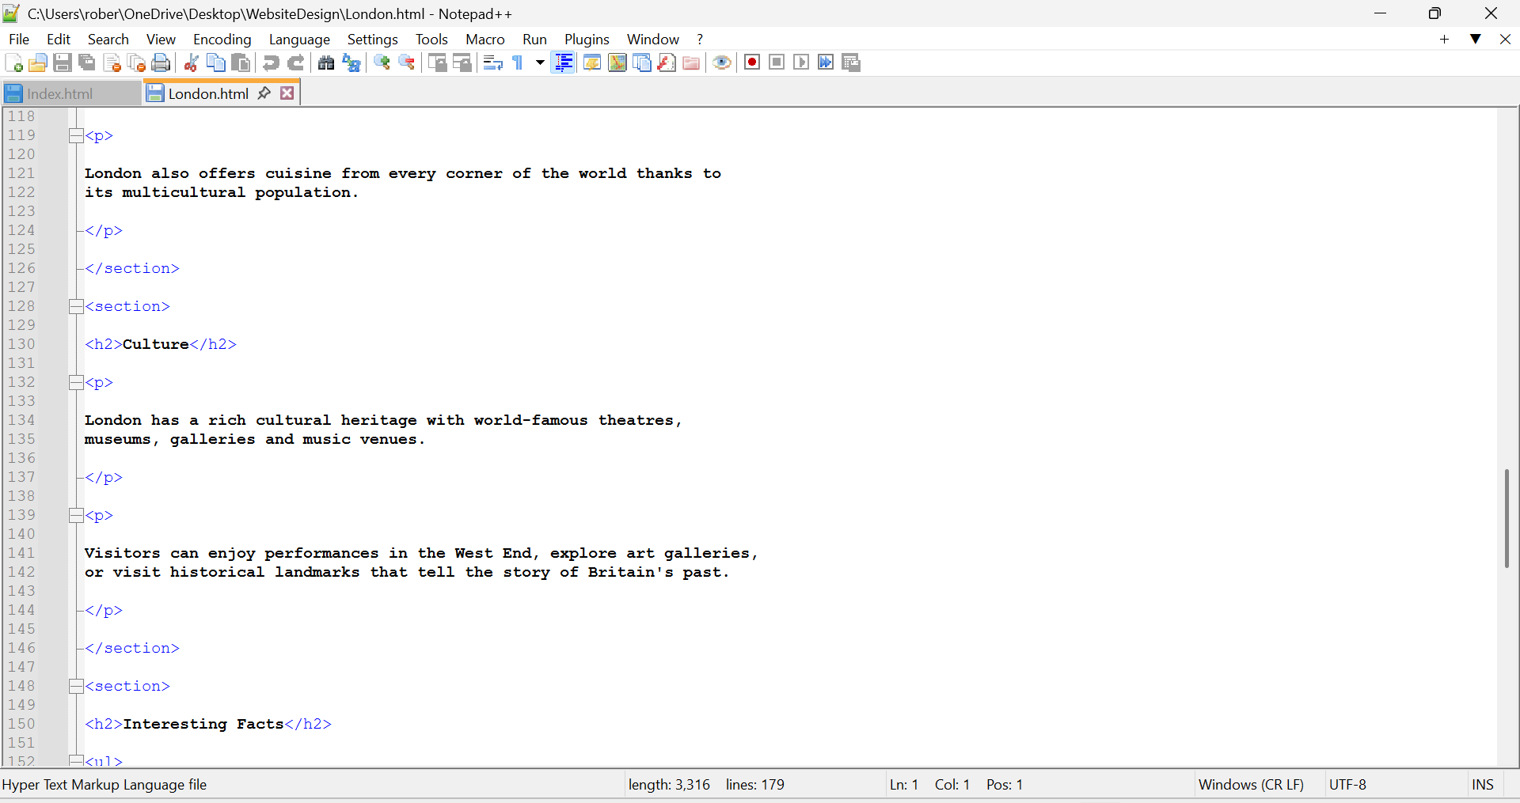

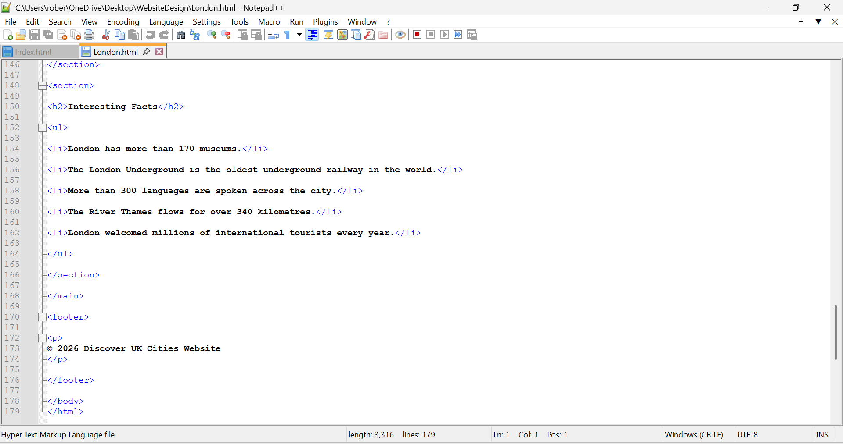

Birmingham.html:

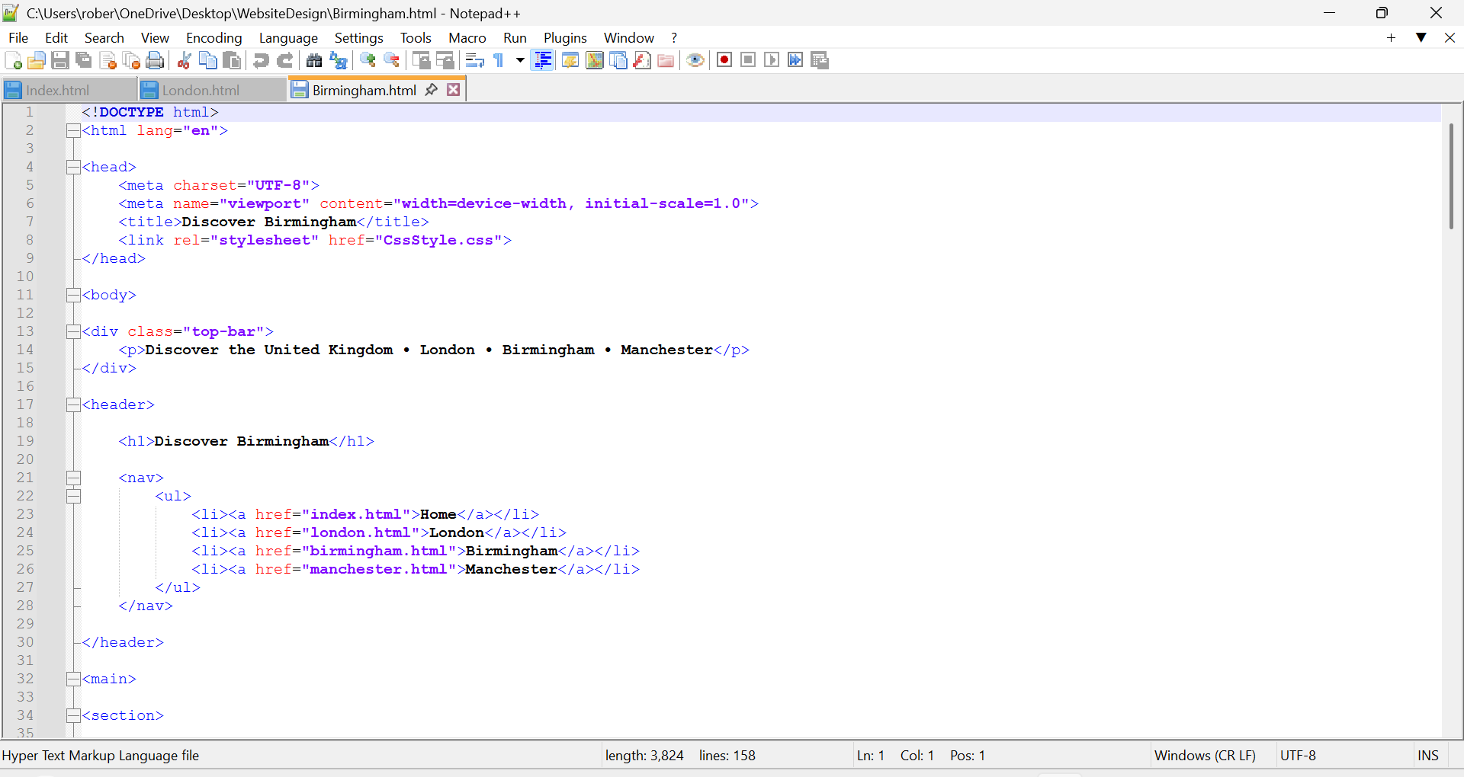

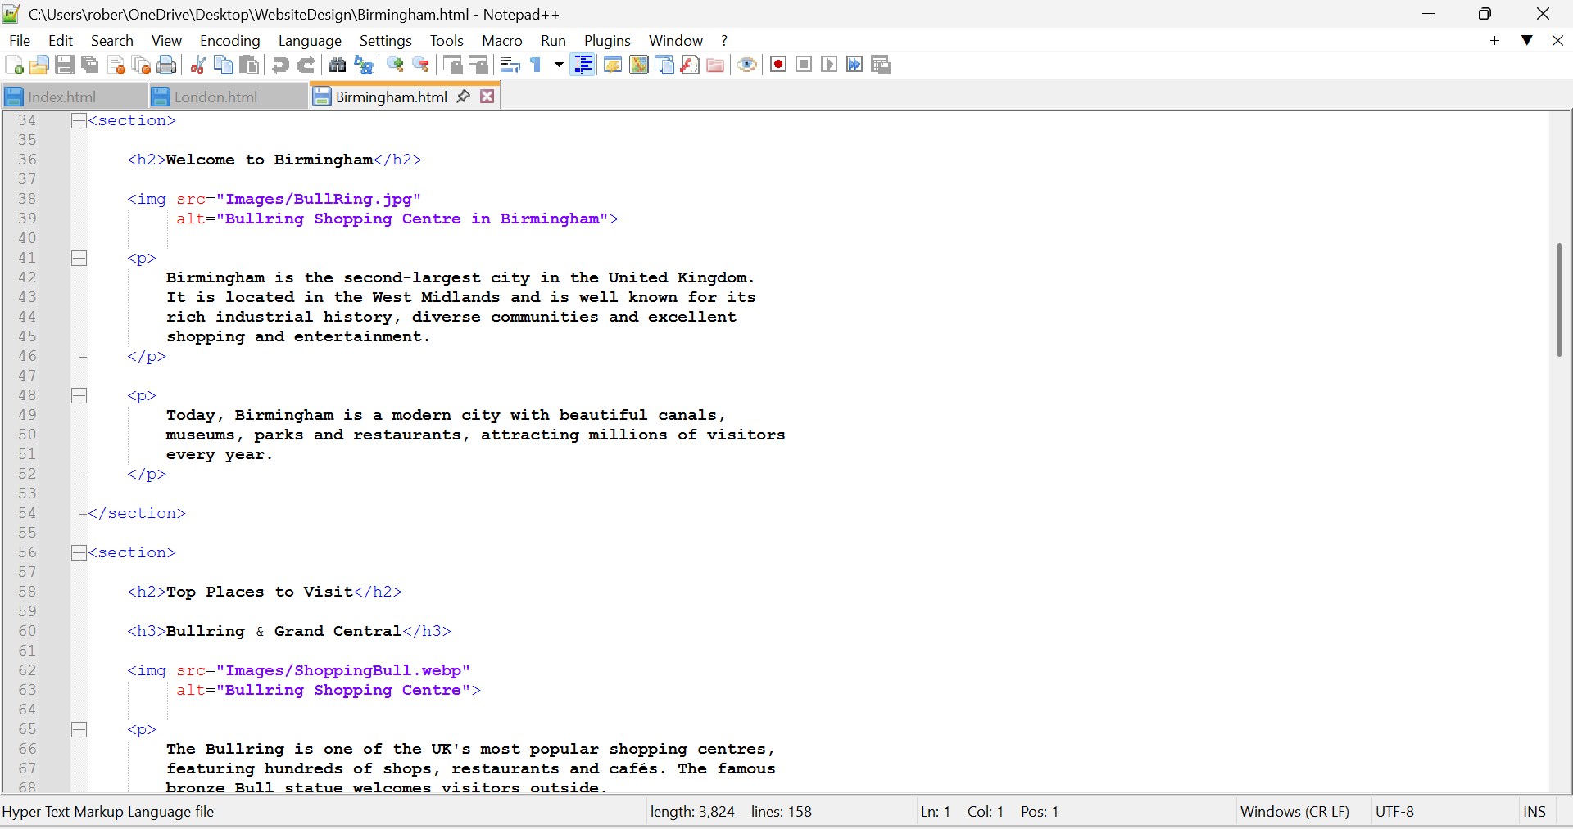

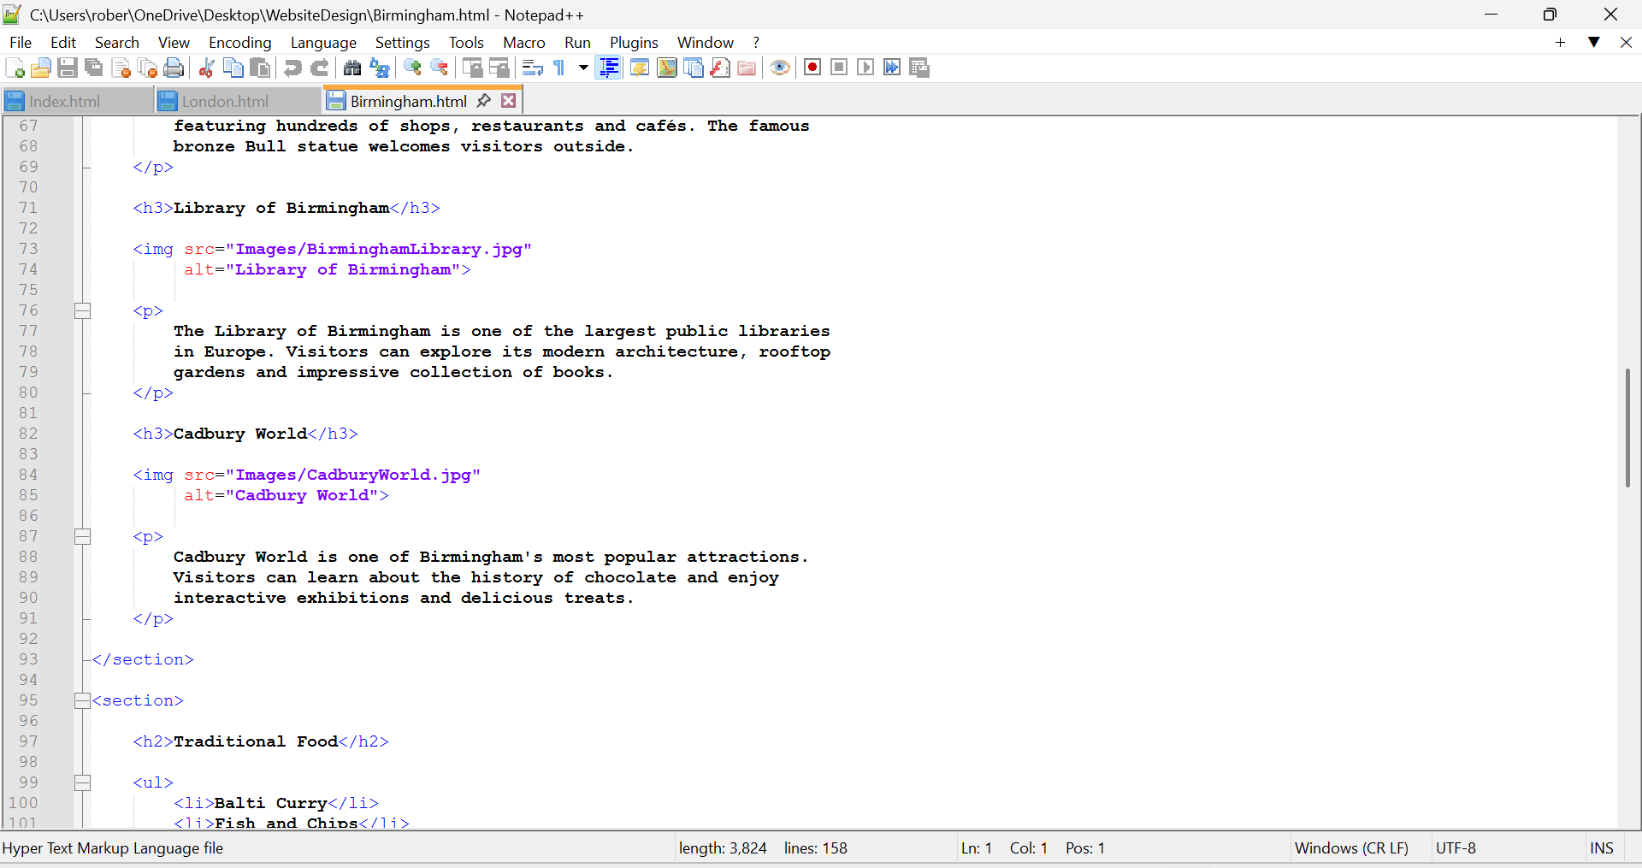

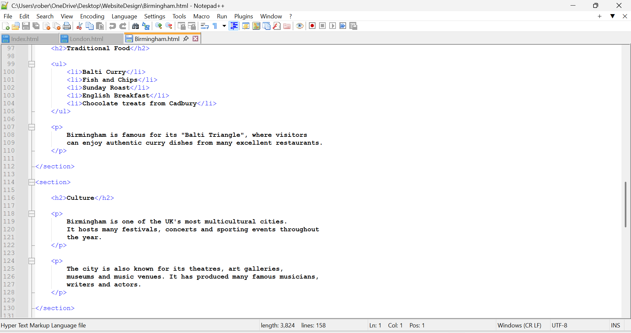

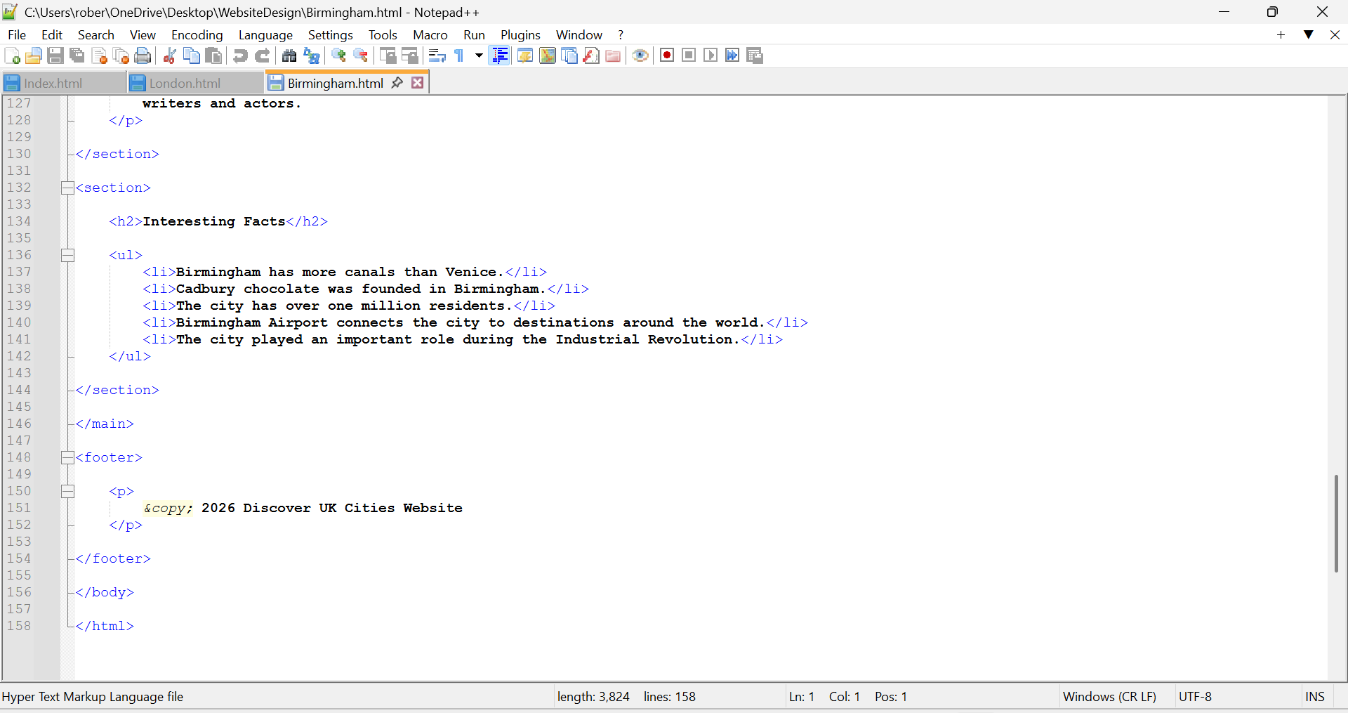

Manchester.html:

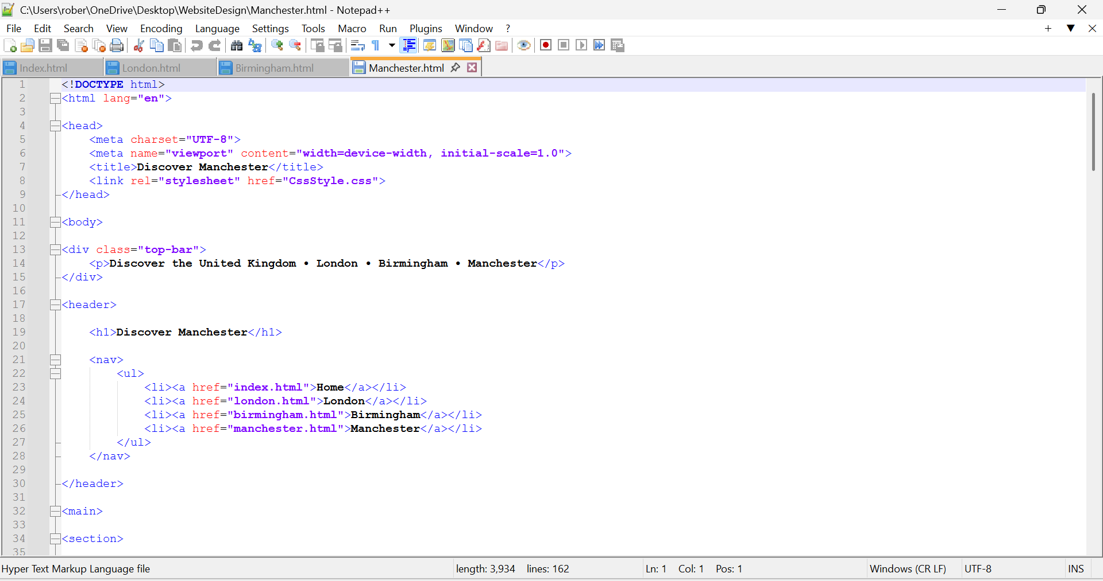

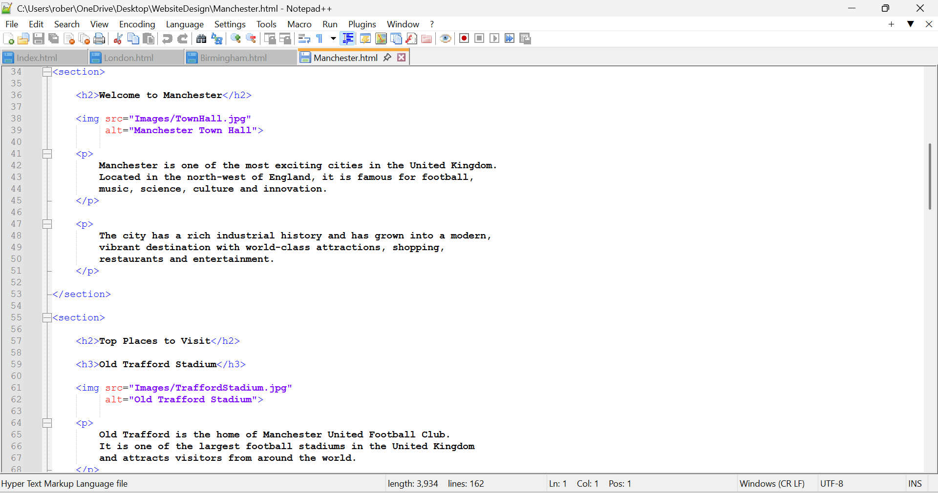

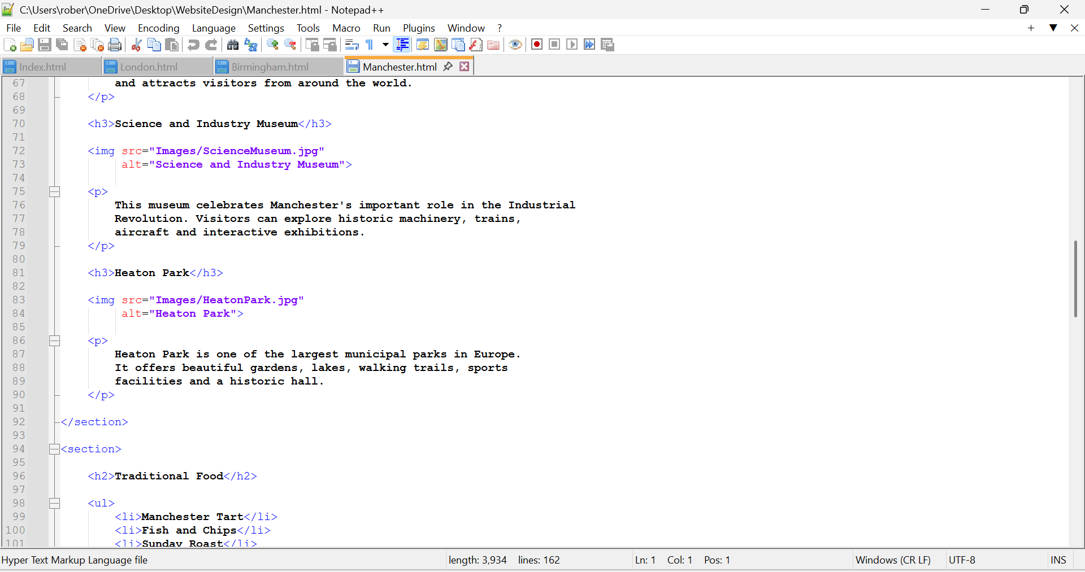

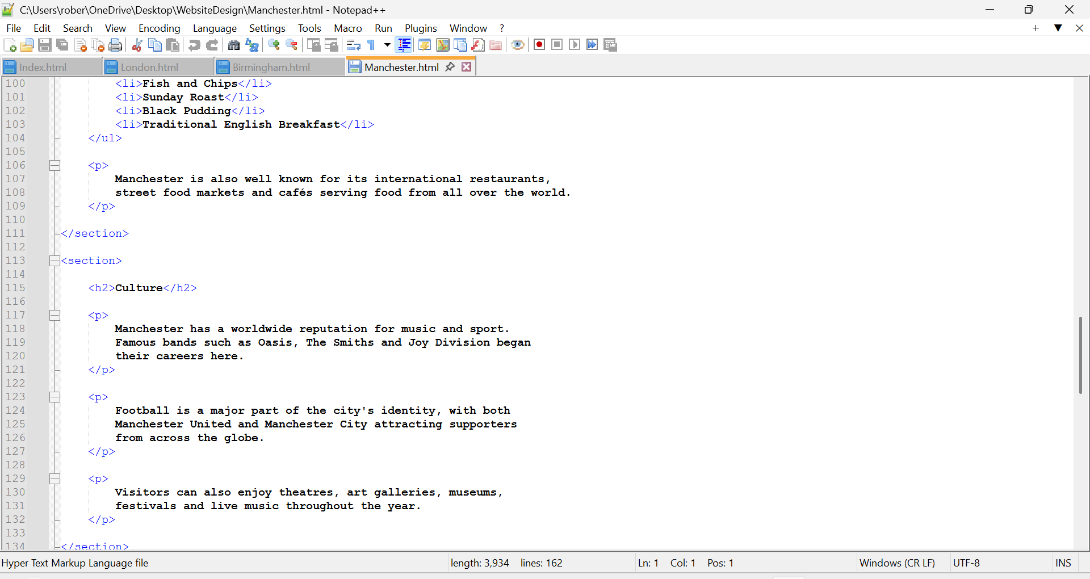

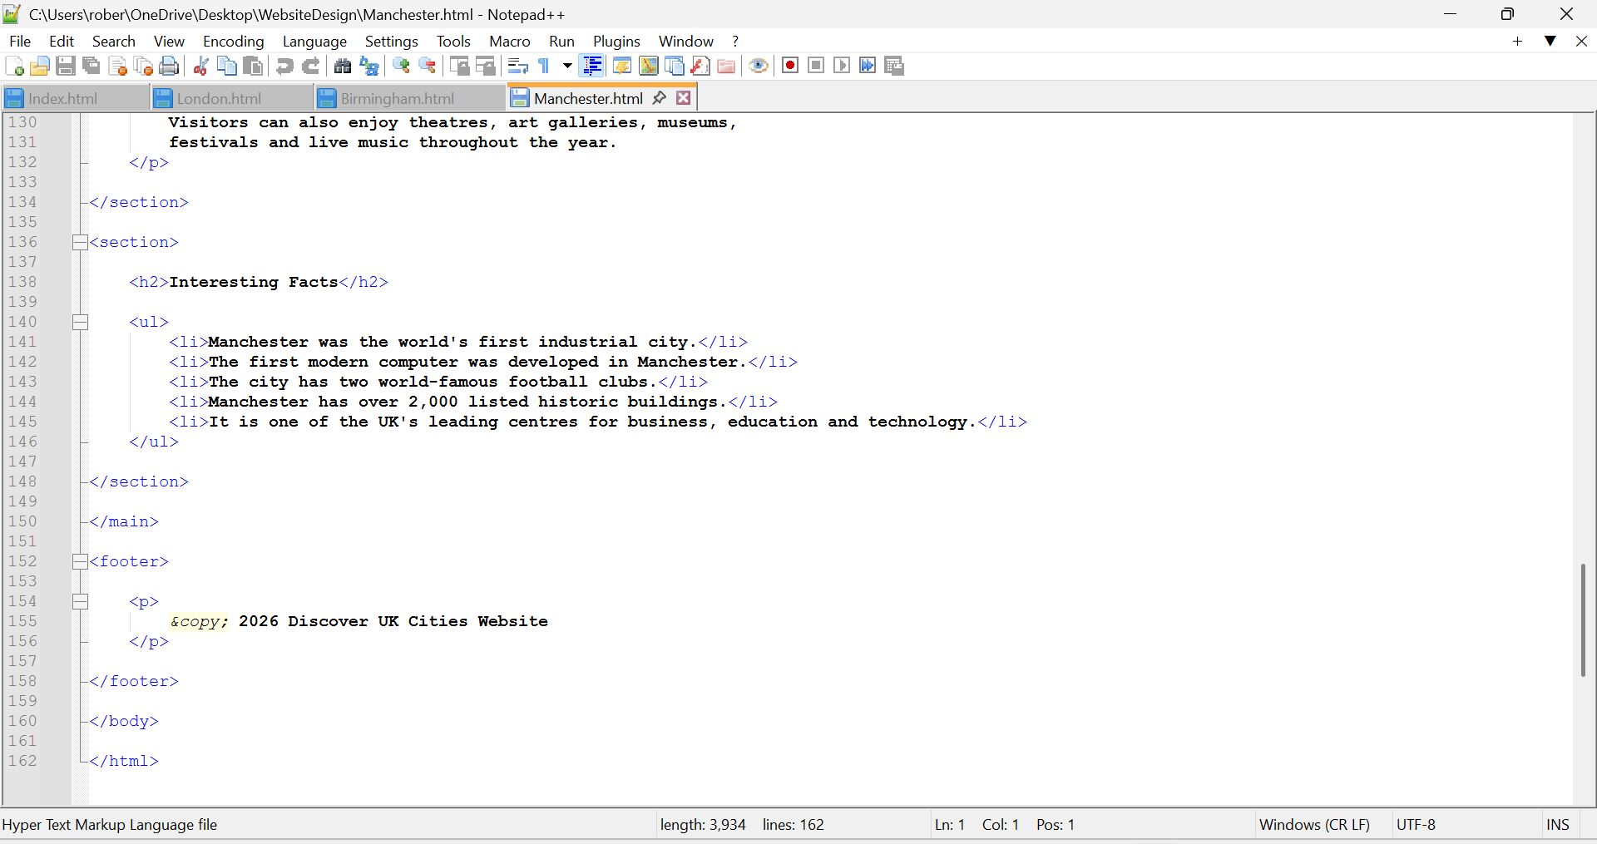

Style.css:



