Target 1 | To ensure all references are accurate and follow the Harvard referencing protocols, for example, reference direct quotations accurately and ensure every single document or author mentioned is followed by a reference.
Target 2 | To ensure you support your views throughout with reference to literature. Before each assignment, use the module reading list (found within the Module Handbook) to guide and broaden your choice of literature.

A critical analysis and evaluation of the observation research tool; ‘Leuven Scale’. Amelia-Grace Hughes
Cycle 1: Researching the Learning: what, how and why am I teaching?
To conduct my observation, I have chosen Video 3. This shows three individuals in the Foundation Phase engaging in the role-play area of the classroom. The research question is as follows: To what extent does the role-play environment provide opportunities for pupil involvement and learning? I chose this as I thought that the role-play area would provide an interesting environment for the children to actively engage with each other in an informal setting. The area was set up as a travel agents centred around ‘Japan’, as this had been the class topic for the term. The environment allows the children to use their imagination and to explore ‘freedom’ and ‘fantasy’ (Attfield & Wood, 2013). The area encourages ‘self-expression’, (Attfield & Wood, 2013), through the characterisation of different roles. The individuals each had a specific role, which was transferable and showed understanding of the real world. Each individual engaged with skills such as leadership and communication. The environment also supports literacy and oracy.
Foundation Phase teaching and learning is successful when a number of variable factors, multiple strategies and a range of learning environments are utilised. The Welsh Government stresses that Foundation Phase learning is built on ‘prior experiences’, in an environment which responds to individuals’ ‘needs and interests’. It could be argued that the motivation to learn very much depends on the effect that the ‘stimulus’ has on the individual. Included within the ‘Learning and Teaching Pedagogy’, published by the Welsh Government, is a case study entitled ‘I love trains’, which is taken from a child’s school report. It shows the progression of some aspects of holistic development from nursery to year one, and clearly shows the child’s continued fascination for trains. It could be argued that the case study shows that high interest in a stimulus has a positive effect on involvement. It is recorded within the case study that the child chooses to spend their ‘golden-hour’ free time exploring trains which shows continuity of interest.
Similarly, on Professional Teaching Experience One, child R showed a continuous interest in Maths and Numeracy. This was particularly highlighted to me during a group session I undertook on subtraction. Child R’s interest in the subject was clearly shown through the engagement level shown, which was significantly higher than that of other students. Child R was interested and concentrated, therefore involvement and engagement were high. Also, the child’s well-being and sense of achievement was noticeable. It has been suggested that expressions such as ‘smiling’ and ‘laughing’ are signs of well-being and engagement (Laevers, 2005), and that an involved and engaged child is ‘absorbed’ in the activity. On PTE1 child R was deeply concentrated in the activity, the child was ‘absorbed’ (Laevers, 2005), both mentally and physically, was sat up right and engaged in the learning. This lesson was a form of direct teaching, which for child R was clearly beneficial.
However, it has been argued that a ‘suitable balance’ is required in conjunction with ‘experiential learning’ (ESTYN, 2017). An ESTYN report suggests that schools are overly dependent on formal and direct teaching and that this could be having adverse effects on progression in areas such as literacy and numeracy. The report also suggests that independent work is overmuch scaffolded due to the overuse of resources, such as writing frames, limiting creative inquiry. In my observation the individuals had the opportunity to write with or without the use of worksheets and writing frames. This choice was interesting to observe and showed that the role-play area is a ‘decision-making experience’ (Cohen, Manion & Morrison, 2007).
The Foundation Phase is home to many key learning environments, from outdoor areas to quiet book nooks. Each has a role to play in enabling good teaching and learning, and the role-play area is an example of this. It has been considered that the role-play area is one of the most beneficial learning environments within a classroom, when executed correctly. The book ‘Research Methods in Education’ supports this notion; stating that the environment provides a ‘heightened interest and excitement in learning’ (Cohen, Manion & Morrison, 2007). The idea that the environment is informal and child-led suggests creative inquiry is increased. It could also be regarded as an area where the classroom meets the ‘real world’ (Cohen, Manion & Morrison, 2007), and helps to bridge the experience to understand job roles within the individuals’ own community, linking with the Knowledge and Understanding of the World, and Personal and Social Development, Well-being and Cultural Diversity Areas of Learning, set out in the Foundation Phase Framework, (Welsh Government, 2015).
Research in education can be undertaken in a number of ways to gather qualitative and quantitative data, (NSW, 2019). One tool used is observation. Like all forms of researching, observation has many strengths, however, it also has limitations.
Observation can be used broadly to undertake research in many contexts, it is a flexible research tool and therefore suggesting it can be used in a number of settings, in and outside of academia, (NSW, 2019). Observation can be carried out via digital technology, causing low impact on the classroom atmosphere. It has been suggested that observation connects well with other research tools, perhaps beginning or ending a research project, and provides a good link from previous research undertaken, (NSW, 2019). However, some believe that observing one specific area or one particular question may result in oblivion of other outcomes in the classroom. To limit this, some suggest that more than one observer would be beneficial, (NSW, 2019).
Another limitation associated with observation is ‘confounding bias’, when exposure of interest is shown, particularly with children, it often has an effect of the performance and behaviour of the individuals involved, (Boyko, 2013). This change in behaviour is known as ‘The Hawthorne Effect’:
‘The Hawthorne Effect is the tendency, particularly in social experiments, for people to modify their behaviour because they know they are being studied, and so to distort (usually unwittingly) the research findings’, (Payne, G. & Payne, J. 2004).
To minimise limitations, it is crucial to plan before undertaking research. Before conducting my observation, I created an observation schedule. Prior to observation I could ensure my research question would be answered and some limitations may be overcome. A blank copy of my observation schedule can be found in the appendix, at the end of this document. As shown, I composed subsequent minor questions to enhance my original question. My approach has been adapted from the Leuven Scale.
The Leuven Scale is a tool to measure well-being and involvement, and like other observation methods, it has strengths and limitations. I found it to be a useful tool when conducting my observation. Like observation, as an overarching research method, the Leuven Scale is an adaptable tool which is ‘suitable for different settings’ (OECD, 2004). A report published by OECD supports the idea that it is a responsive tool suitable for multiple contexts involving anyone from ‘babies to adults’, (OECD, 2004). This indicates that The Leuven Scale is suitable for different types of people. The report suggests there is no differentiation between a child with Special Educational Needs, a baby or adult. This is supporting of the Ethical Guidelines published by BERA in 2018.
When carrying out any research, particularly in education, there are always ethical implications to consider. Ethical considerations are an important feature in planning and undertaking research, they exist to protect oneself as the researcher and your participants. Ethical considerations are ‘associated with morals’ (Ramrathan, Le Grange, Higgs, 2017), and help protect individuals and institutions involved. BERA’s ethical guidelines highlight which aspects of research may be ethically problematic.
There are many ethical boundaries associated with research, there are also many ways in which one can overcome them. Informed and voluntary consent is required from each individual involved in the research before commencement begins. Your participants have a right to remain anonymous and care must be taken in terms of ‘privacy and data storage’, (BERA, 2018). There are many other aspects of the research which your participants are required to know, it is your responsibility to understand this and to be aware of the duty of care which you behold. Children with Special Educational Needs must be adhered to as they may find it more challenging to understand what is required of them and ‘why their participation is required’ (Ramrathan, Le Grange, Higgs, 2017), in order to make an informed decision to consent, or whether assent can be granted. ‘Ethics in Educational Research’ suggests that children are particularly susceptible to ‘exploitation’ (Ramrathan, Le Grange, Higgs, 2017), therefore it is imperative that every participant is clear on what is required of them, and they are fully aware that they have a right to withdraw, ‘for any or no reason’ (BERA, 2018), if they wish. Particularly where children or vulnerable adults are involved it is paramount that attention is directed at the well-being of the individuals. The Leuven Scale could be used in this situation, as, if well-being is extremely low or low, where the individual is clearly showing ‘signs of discomfort’ (Laevers, 2005), it may be necessary to ethically consider whether it is in the individual’s best interests to continue, as you have a duty of care, (BERA, 2018).
A researcher’s responsibility is to their participants, institution, any sponsors, or external companies involved, and the schools or settings involved. Particularity where schools are involved it is vital that the school’s own privacy policy is adhered to. It could be argued that accountability should always be at the forefront of the researchers’ mind where there is risk of harm to the participants. ‘Harm from participation’ must be clearly noted when participants give consent to partake, and transparency is given ‘avoiding non-disclosure’, (BERA, 2018). Where participants may be subject to harm it is crucial to ‘minimise and manage’, this by risk assessing and minimising hazards, (BERA, 2018).
Honesty to participants is required, methods to increase participation levels such as incentives must be used carefully in order not to ‘impinge on the free decision to participate’ (BERA, 2018). Consent is a voluntary and free decision, impingement of this does not correlate to national or institutional guidelines, or codes of practice. When undertaking research in education one represents educational researchers as a body, and therefore it is most appropriate to ensure integrity of this is upheld.
At all times when conducting research, one must ensure to be an ethical researcher. Not only for self-integrity but for the reputation of your institution and your responsibility to those involved in your research. To do this codes of practice must be met and where necessary research should be approved by an ethics committee, (BERA, 2018).
Overall, I believe that my observation went well and although improvements could be made, it does help to answer the research question. However, I think it is important to consider that I carried out my observation on a small group of learners, therefore it may not be overly reliable. I was able to answer the research question to an extent, however, further research may be necessary in order to produce a variety of results. An observation before or after the activity may have been beneficial as this would show the impact that the role-play activity had on involvement in comparison with other learning environments. More of a concentration on the learner’s well-being may also have strengthened the findings. It is clear to see from my observation schedule (see appendix b.), although all three children showed moderate to high levels of involvement, not all individuals were showing signs of happiness and well-being throughout the observation. Pupil C in particular showed more levels of disengagement than the others. Some suggest that the well-being and happiness of a learner depends on whether they feel comfortable with the activity and whether they possess ‘a sense of mastery’, (De Haan, 2006). Further observations would be beneficial to see where pupil C feels more comfortable and where the pupils’ engagement and well-being is higher or lower.
As specified in the introduction, I conducted my observation on Video 3, my research question was: To what extent does the role-play environment provide opportunities for pupil involvement and learning? Overall, I feel that my observation went well and, given the current circumstances, produced findings which contributed to answering the research question. I believe more research is required in order to gain a superior outcome, which hopefully, in the future, will be possible. Going forward I would like to look at the impact of the role-play environment again, and in my own practice I will view it with a greater respect and will put more of an emphasis on its contribution to holistic development.
In the future I would like to research the effect that music and movement have on learning and involvement. I have chosen this as it is an area which highly interests me and is ‘specific and focussed’, (Walker & Solvason, 2014). On PTE1, as a form of classroom management, I played calming music to my class. This seemed to have a positive impact on concentration and behaviour, particularly following physical activity. This is something which I would like to explore further.

Appendix
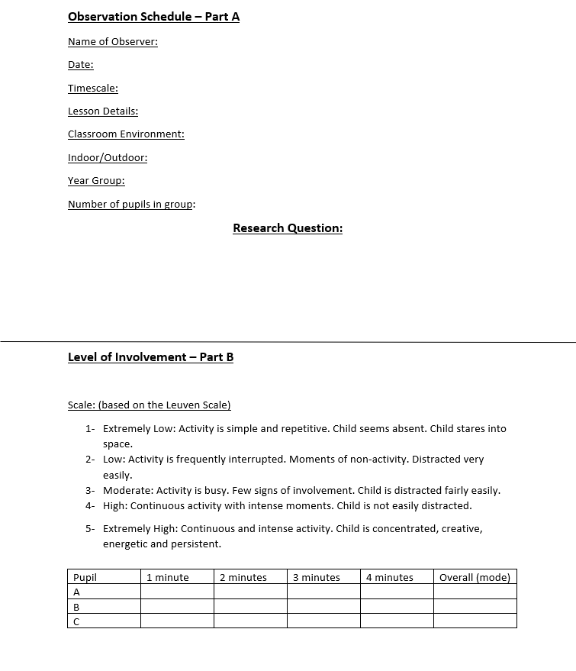
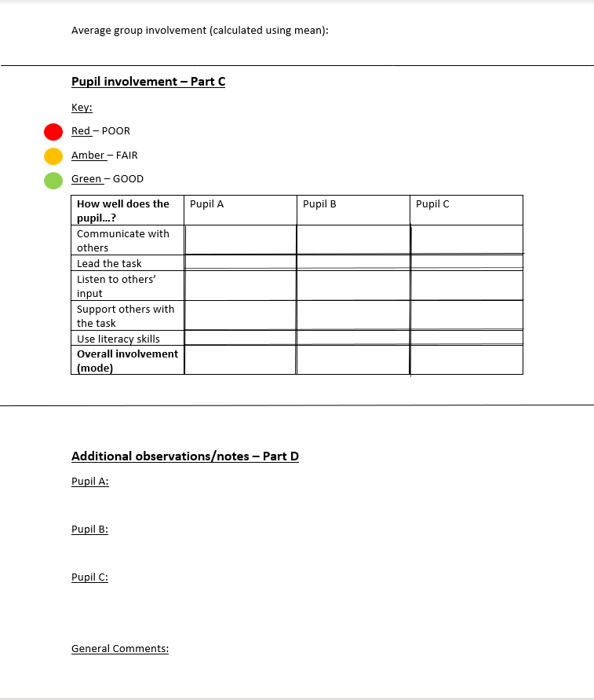


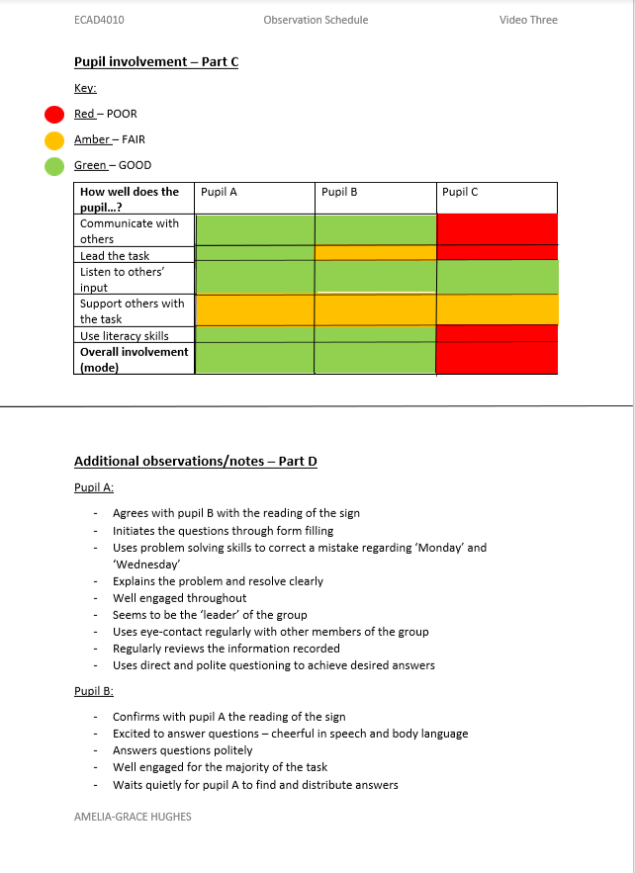



Reference List

- Attfield, J. & Wood, E. (2013) Play, learning and the early childhood curriculum. 3rd Ed. London: SAGE Publications.
- BERA. (2018) Ethical Guidelines for educational research. Available at: https://www.bera.ac.uk/researchers-resources/publications/ethicalguidelines-for-educational-research-2018 (Accessed: 10th May 2020)
- Boyko, E. J. (2013) Observational research: Opportunities and limitations. Available at: https://www.ncbi.nlm.nih.gov/pmc/articles/PMC3818421/ (Accessed: 12th May 2020)
- Cohen, L. & Manion, L. & Morrison, K. (2007) Research methods in education. 6th Ed. New York: Routledge.
- De Haan, M. (2006) Children and happiness. Available at: https://www.open.edu/openlearn/body-mind/childhood-youth/childhood-and-youth-studies/childhood/children-and-happiness (Accessed: 13th May 2020)
- ESTYN (2017) Active and experiential learning. Available at: https://moodle.uwtsd.ac.uk/pluginfile.php/366015/mod_resource/content/2/Estyn%20Active%20and%20experiential%20learning_E_Accessible_1.pdf (Accessed: 10th May 2020)
- Higgs, P. & Le Grange, L. & Ramrathan, L. (2017) Education studies for initial teacher development. 1st Ed. Cape Town: Juta.
- Laevers, F. (2005) Well-being and involvement in care settings. A process-orientated self-evaluation instrument. Leuven University: Kind & Gezin.
- NSW (2019) Observation: A Guide for use in evaluation. Available at: https://education.nsw.gov.au/teaching-and-learning/professional-learning/evaluation-resource-hub/collecting-data/observation (Accessed: 12th May 2020)
- OECD. (2004) Starting strong, curricula and pedagogies in Early Childhood Education and . care. Five curriculum outlines. Paris: OECD.
- Payne, G. & Payne, J. (2004) The Hawthorne Effect. London: SAGE Publications.
- Solvason, C. & Walker, R. (2014) Success with your Early Years Research Project. 1st Ed. London: SAGE Publications.
- Welsh Assembly Government (2015) Curriculum for Wales: Foundation Phase Framework. Available at: https://hwb.gov.wales/storage/d5d8e39c-b534-40cb-a3f5-7e2e126d8077/foundation-phase-framework.pdf (Accessed: 9th May 2020)
- Welsh Assembly Government (2008) Learning and teaching pedagogy. Available at: https://hwb.gov.wales/storage/8f0b360f-f1f6-4bec-b11a-df88168007f9/learning-and-teaching-pedagogy.pdf (Accessed 10th May 2020)

