Marketing Report

Chelsea Renshaw 2516848
Niche Marketing and social media (BMTP4014)
Chris Wilkin
March 20th, 2026
Word count: 1397

I acknowledge that the use of ChatGPT www.chatgpt.com on November 20, 2025, to help find researchers backing up my assignment. I use the prompts:

- Can you find me 15 academic recourses linked with niche marketing and social media.
- How do I reference an appendix.

Introduction

This marketing report explores how Swansea Arena can take its “House Party” event to the next level transforming it into a standout live music celebration that audiences genuinely get excited about. Created to mark the anniversary of the Arena’s opening, House Party is more than just an event; it is an opportunity to celebrate the venue, bring people together, and create a memorable experience that people will talk about long after the night ends.

Blending the energy of a live music event with the fun, social atmosphere of a house party, this event has a unique position within Swansea’s nightlife scene. While many venues focus on repetitive club nights, House Party offers something different: a large-scale, high-energy experience that feels special, limited, and worth showing up for. As Pine and Gilmore (1999) suggest, modern consumers are increasingly drawn towards experiences rather than just services, making this type of event especially valuable.

The aim of this report is to explore how Swansea Arena can grow House Party into a flagship annual event by finding the right audience, analysing competition, and developing creative yet strategic marketing ideas. Frameworks such as the SOSTAC Model (Smith, 2021), the Marketing Mix (4Ps) (Booms and Bitner, 1981), and the Ansoff Matrix (Ansoff, 1957) will guide the plan.

Situation Analysis

A 5C’s analysis model is used to evaluate the current marketing environment.

Company

The arena benefits from a sturdy reputation as a modern live entertainment venue, offering high-quality facilities and a central location. However, brand recognition outside South Wales is still limited. A SWOT analysis (Appendix A) highlights these internal strengths and weaknesses (Kotler and Keller, 2016).

STRENGTHS | WEAKNESSES
- Modern, high-capacity venue  - Strong event portfolio  - Central Swansea location | - Limited national brand awareness  - Heavy reliance on digital marketing  - Smaller scale compared to other uk arena’s
OPPORTUNITIES | THREATS
- Growth in live experiences  - Tourism and regional visitors  - Influencer marketing | - Cost-of-living crisis  - Fierce competition  - Changing entertainment habits
(Appendix A)

Customers

The primary target audience is 18–35-year-olds, including students and young professionals. This group is highly experience-driven, valuing social interaction and memorable events (Solomon, 2020).

Psychographically, they are influenced by FOMO (fear of missing out) and are highly active on social media platforms. Generational marketing highlights the importance of targeting Gen Z and Millennials, who prioritise experiences over material goods (Baines, Fill and Rosengren, 2017).

SimilarWeb analysis shows that traffic to the Swansea Arena website is primarily driven by direct and social channels, with limited organic search visibility. This suggests a reliance on existing brand awareness rather than new audience acquisition. Opportunities exist to improve Search engine optimisation (SEO), increase referral traffic, and enhance digital marketing strategies to attract new audiences.
(SimilarWeb, 2026).

Competitors

Competition includes regional arenas, festivals, and nightlife events offering similar live music experiences. Using Bowman’s Strategy Clock (Appendix B) and perceptual mapping (Appendix C), competitors can be analysed based on price and perceived value (Baines, Fill and Rosengren, 2017). The House Party event can differentiate itself through its unique celebratory theme and community focus.

(Appendix B)

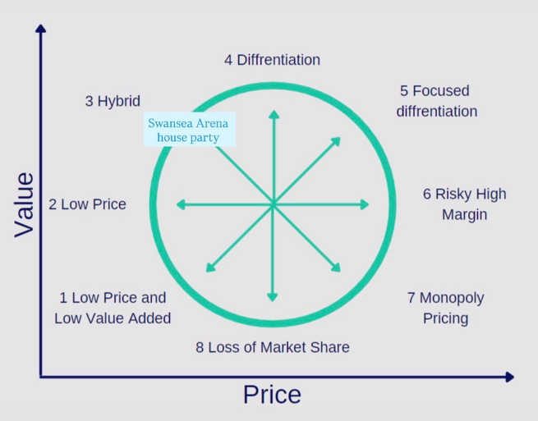

This hybrid position and supports competitive advantage by balancing affordability with experiential value, which is particularly important when targeting younger experienced-driven consumers.
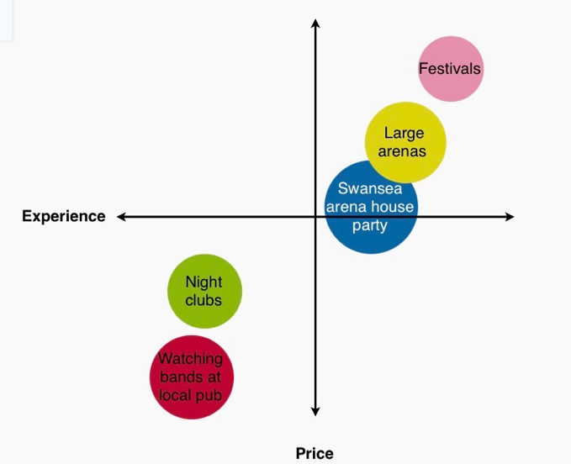
The house party event provides fair value, strong experience, and competitive pricing.

This perpetual map shows where house party sits amongst competitors when measuring with experience and price (low to high).

Collaborators
(Appendix C)

Key collaborators include artists, ticketing platforms, influencers, and local businesses. Importantly, the arena supports grassroots music initiatives, contributing to the sustainability of local live music venues, which strengthens its role within the creative industry (Music Venue Trust, 2024).

Climate

A PESTLE analysis highlights key external factors. Economic pressures such as the cost-of-living crisis may affect spending, while social trends show increased demand for live experiences (Mintel, 2024). Technological advancements in digital marketing and social media also create new opportunities for audience engagement (Chaffey and Ellis-Chadwick, 2019).

Objectives
Using SMART goals (Doran, 1981), Swansea Arena’s House Party should aim to:
- Increase ticket sales by 25%, within 6 months
- Boost social media engagement by 30% within a 3-month campaign targeting 18–35-year-olds
- Increase repeat attendance by 20%
- Strengthen its identity as a must-attend live music event increasing brand awareness and audience reach within the live entertainment sector (kotler and Keller, 2016).

Strategy

The marketing strategy is guided by Ansoff’s Matrix, with a primary focus on market penetration and a secondary focus on market development (Ansoff, 1957).

The marketing mix (4Ps) provides further structure (Kotler and Keller, 2016):

Product

The House Party event is marketed as a high-energy, immersive experience that combines live music with a strong social atmosphere. In addition, the event supports grassroots music initiatives, contributing to the sustainability of local venues, which enhances its value proposition and appeals to socially conscious consumers (UK Music, 2024).

Price

A tiered pricing strategy will be implemented, including early-bird offers and group discounts. This aligns with yield management principles, allowing pricing to adapt based on demand (Yeoman, 2013).

Place

Tickets are distributed through online platforms, including the arena’s official website and ticketing partners. Improving mobile accessibility and user experience can enhance conversion rates (Chaffey and Ellis-Chadwick, 2019).

Promotion

Promotion will focus on digital channels, including social media, influencer marketing, and email campaigns. Customer Relationships Management (CRM) systems will allow personalised communication and improved customer relationships (Chaffey, 2023).

Tactics

The campaign will follow the RACE framework: Reach, Act, Convert, Engage (Chaffey, 2022).

Reach

Digital advertising through Instagram, TikTok, and Google Ads will increase visibility. Influencer marketing will target younger audiences, leveraging social media trends (Statista, 2025). SEO improvements will also increase organic traffic (SimilarWeb, 2026).

Act

User engagement will be encouraged through interactive content such as polls, countdowns, and behind-the-scenes videos. Email marketing will provide exclusive content and early ticket access (Chaffey and Ellis-Chadwick, 2019).

Convert

Conversion strategies include limited-time offers, early-bird pricing, and urgency messaging. Social proof through reviews and platforms such as
Trip Advisor will enhance credibility and influence purchasing decisions (Statista, 2025).

Engage

Post-purchase engagement will include personalised emails and user-generated content campaigns. Encouraging attendees to share their experiences online will increase brand exposure and support future events (Chaffey, 2022).

Improving Digital Presence

Current digital marketing focuses primarily on event announcements. However, improvements can be made by increasing interactivity, enhancing video content, and collaborating with influencers. SimilarWeb data suggests opportunities to improve referral and organic traffic (SimilarWeb, 2026).

Highlighting the event’s support for grassroots music within promotional campaigns can further strengthen emotional engagement and brand authenticity (Music Venue Trust, 2024).

Action

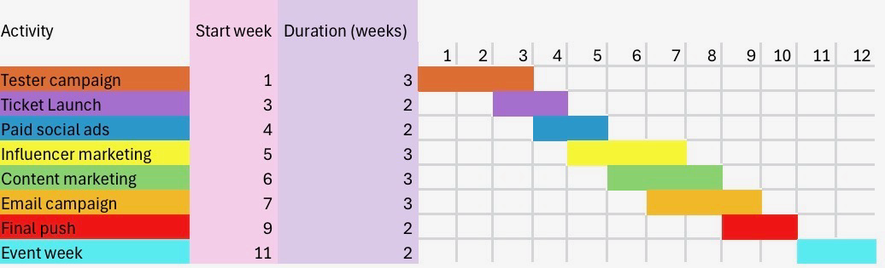
The campaign will run over a three-month period, using social media, influencer marketing, email campaigns, and paid advertising. A Gantt chart (Appendix D) outlines key campaign stages, including promotional launches and ticket sales phases.

(Appendix D)
Action Plan
To bring the event to life:
- Launch promotion weeks in advance
- Use teaser content to build excitement
- Work with student ambassadors
- Create a clear, fun theme for each event

These actions are informed by audience behaviour and digital insights, ensuring marketing efforts are delivered effectively (Chaffey and Ellis-Chadwick, 2019).

Control

The campaign will be evaluated using key performance indicators (KPIs), including ticket sales, social media engagement, website traffic, and conversion rates (Kotler and Keller, 2016).

Digital tools such as Google Analytics and social media insights will track performance in real time. Email marketing metrics, including open and click-through rates, will also be analysed (Chaffey, 2022).

Monitoring these KPIs will allow for continuous optimisation of marketing strategies, ensuring alignment with campaign objectives and maximising return on investment (ROI).

Success can be measured through:
- Ticket sales
- Social media engagement
- Customer feedback
- Repeat attendance
This reflects the control stage of the SOSTAC Model (Smith, 2021).

Growth Opportunities (Ansoff Matrix)

Using the Ansoff Matrix:
- Market Penetration: Build local awareness
- Product Development: Introduce new themes
- Market Development: Expand audience
- Diversification: Create spin-off events

Conclusion

In conclusion, the House Party event at Swansea Arena has strong potential to grow within the competitive live entertainment market. By applying strategic frameworks and using digital marketing, the event can increase attendance and engagement.

The integration of grassroots music support enhances the event’s value proposition and strengthens its connection with audiences. Future campaigns should continue to focus on innovation, audience insights, and digital engagement to ensure long-term success (UK Music, 2024).

Reference list

Allen, A. (2020). The 7Ps of The Marketing Mix. [online] Oxford College of Marketing. Available at: https://blog.oxfordcollegeofmarketing.com/2020/10/08/understanding-the-7ps-of-the-marketing-mix/.

Ansoff, H.I. (1957). A Model for Diversification. Management Science, [online] 4(4), pp.392–414. Available at: https://www.jstor.org/stable/2627461.

Baines, P., Fill, C. and Rosengren, S. (2022). Marketing. Oxford University Press.

Chaffey (2022) (n.d.). DIGITAL MARKETING. [online] Available at: https://sinhvien.dinhtienminh.net/wp-content/uploads/2025/01/Dave-Chaffey-Fiona-Ellis-Chadwick-Digital-Marketing-2022-Pearson.pdf.

Chaffey, D. (2023). SOSTAC Marketing Planning Model Guide. [online] Smart Insights. Available at: https://www.smartinsights.com/digital-marketing-strategy/sostac-model/.

Chaffey, D. and Ellis-Chadwick, F. (2019). Digital Marketing Strategy and Implementation. Pearson Education. - References - Scientific Research Publishing. [online] www.scirp.org. Available at: https://www.scirp.org/reference/referencespapers?referenceid=3413574.

Doran (1981) (2017). LibGuides: Self-Direction and Planning: SMART Goals. [online] Derby.ac.uk. Available at: https://libguides.derby.ac.uk/develop-at-derby/self-direction-and-planning/SMART-goals.

Kotler, P. and Keller, K.L. (2016). Marketing Management. 15th ed. Boston: Pearson.

Mintel (2024). Mintel announces Global Consumer Trends for 2024 | Mintel. [online] www.mintel.com. Available at: https://www.mintel.com/press-centre/mintel-announces-global-consumer-trends-for-2024/.

Music Venue Trust (2025). Music Venue Trust Launch 2024 Annual Report. [online] Music Venue Trust. Available at: https://www.musicvenuetrust.com/2025/01/music-venue-trust-launch-2024-annual-report/.

Pine, J. and Gilmore, J.H. (2013). The Experience economy: past, Present and
Future. [online] ResearchGate. Available at: https://www.researchgate.net/publication/260917972_The_experience_economy_past_present_and_future.

Soloman(2020) (2020). Solomon, M. R. (2020). Consumer behaviour: Buying, having, and being. Pearson.[online] Sciepub.com. Available at: https://www.sciepub.com/reference/465748.

Statista. (2020). Statista - The Statistics Portal. [online] Available at: https://www.statista.com/?srsltid=AfmBOorrbAgmVU5maekXKFHUr3n3C2Yx_N7b-qBIKHFDThca41UrcAfH [Accessed 20 Mar. 2026].

Yeoman (2013) (2025). APA PsycNet. [online] Apa.org. Available at: https://psycnet.apa.org/record/2013-36284-001.

