Report on Personal career development plan
Tsvetelina Viktoria Tsvetanova
SN1907859

PROFESSIONAL CAREER DEVELOPMENT
BMSW4005
Malani Guanaratnam
University of Wales Trinity Saint David
London
2/9/2020

Table of contents

Introduction 2

Career development 2

Personal Development Plan 3

SWOT 6

PEST 6

Conclusion 7

References 8

Appendix 9

1
Introduction
This report is a reflection on my personal career development. The first part will be focused on my previous experiences by using reflective writing.
I will analyze my goals and achievements so far. What kind of techniques I tend to apply, what went wrong and why, and what kind of lesson I have learned.
Reflective writing, according to the University of Cambridge and the article “Study skills” (2020) is about an experience. Looking towards the past event, we must provide the expectations, approach and what were the difficulties in the implementation process. Next is the evaluation of the result and the lesson that I learned. What could be done differently. Evaluate the knowledge and how it will be useful in the future.
To do more effective the reflective thinking I will use the Gibbs’ reflective cycle. What the conclusion is and what the next steps are. Subsequently, I will present the current situation and how I will handle it.
The next step is the creation of PDP. I plan the PDP and follow exactly the steps. Because of the unexpected occurrence of the pandemic of Corona virus some of the points has been changed. At this point the most suitable tool is SWOT analysis. It will help to discover, investigate and forecast the future threats and how to avoid them.
The last part is the demonstration of the implementation prosses of the plan. For the purpose of implementing the tasks I mention above, I will apply relevant tools and techniques to approve my contentions. Citations will be used in order to support the whole theory.
Career development
My career starts years ago in Mediterranean country without experience and shortcoming training. I did not have any academic skills. There was lack of employability skills as well. During the working proses I started discovering and adopting some essential skills for my profession. I was monitoring my supervisors, leaders and colleagues closely. I used to study their actions in every type of situation and how they used to manage the coming up issues in daily basis. The knowledge came to me easy and fast. I learn effectively in very short time. I was a good listener and even if the information was not useful at the moment, I tried to keep it just in case that I needed it in the future. Learning on a daily basis my agility increased. I started to help and train new workers in our team. My communication with costumers and colleagues was improving constantly. I have learned that is useful to practice seeing things through the others’ eyes. To try understanding people even if their theories were not relevant to the situation. I developed my creative thinking. After years I was already experienced. I tried to manage difficult situations. I was able to take decisions and solve conflicts. My critical and analytical thinking were already

2
at a very good level. But still there was something missing. There was still a gap. Something that I was not able to recognize and address it. Now I know that it was the lack of education and academic skills. I have learned all the employability soft skills in practice without knowing that there is a whole study and theory behind this. According to Cleeve (2018), academic skills are important for students because they are making them capable and effective. He continues summarizing that those skills are transferable and efficient therefore for the guaranteed success in any workplace.
After many years of hard working and sacrifices I realized that my career is a dead end and if I want to develop it and go further, I must do some changes. Then I decided to make the big step. I moved to the UK. I started studying. Simultaneously, I chose the field that I wanted to grow in. At this point self-motivation was very important. Childs (2020) targets very impressively some points for successful self-motivation even in times with difficulties. As he says the most powerful is the right attitude. The start must be simple. Avoid the negative actions and people and get as more knowledge you can. The knowledge gives you confidence and power. Draw a lesson even from the bad events and stop giving too much thought. Start acting.
I realized that is time for analytical and reflective thinking if I want to go on and build successful career. Reflection is the reaction on one action. As I mention above, I will apply the Gibbs’ reflective model. According to Rumson (2018) this cycle is inspired in some parts from Kolb’s learning cycle. It is suitable to situations and events from the past and helps to understand the event, learn and plan the next steps effectively. Sample of the Gibbs’ model is included in the appendix of this report. This model consists of 6 elements. Description, feelings, evaluation, analysis, conclusion and action plan. The aim of this model is to understand and evaluate the situation.
I already described the start of my career and how my feelings lead me to take the decision to leave my country. The time for the evaluation has come. In my career so far, I have learned many things, I had a lot of experience. Things went wrong at some point because of lack of academic knowledge. Analyzing the facts, the idea was generated. And the conclusion was that I have to get an education and academic knowledge and skills to be able to achieve further my goals and aims. The action plan arises effortlessly as a result of my willingness for change and further development of my career and skills.

Personal Development Plan
When I arrived in the UK, I start working in the hospitality area. I started from low position. At the same time, I started my studies in the university. In a few months I got a better position and subsequently I got a higher position in the same organization.

3

The business provides high quality services to it guests. The brand standards are very specific. Many of the customers choose this brand because of the standards and they are loyal. Most of them have membership and wherever they travel globally, they can use this membership in each property of the chain. Our organization has mission and vision. The mission is to make our guests feel like home. The vision is to make them loyal. To make guests loyal, the organization must keep the brand standards at a very high level. For that reason, the business has a BSA (Brand Standard Audit) department. Auditors check all properties of the chain globally and evaluate the level of services and compliance of the standards.
Last year, our property got the first position in London and 12th globally. The management team was very satisfied of the job we have done. It was great honor for us. After all this hard work and great effort, we did great.
There was still some gaps and deficiencies. I was able to see the problems and I come up with solutions for them. But I did not have the position and the authority to make decisions and take action. I was so dedicated and loyal to the organization. I enjoyed my job and accomplished my duties with enthusiasm. That lead me to the decision to go to the next level. I decided to go for the position of brand standard auditor. Creation of personal development plan is essential at this point. Lu (2015) points out that our PDP is our life guide. It helps you to have the control and leading your career in right direction.
To implement the creation of PDP I must have in mind what is important to me, what I want to achieve, what my strengths and weaknesses are and what I need to do to improve further.
- Address my goals
The most important thing in my life is my family. So, I would like to spend as much time is possible time with my loved ones.
Second, is my education. For this purpose, I must continue studying.
As a result of my studies achieving growth in my profession.
- Prioritize
Developing my career.
Get more knowledge.
Use the skills I have already (transferable skills) and develop new essential skills.
Go further by taking cross training for BSA skills, knowledge end techniques.
- Deadline

4

One year from now completing the first part of the cross training. Ending successfully
the academic year and planning the next one. Achieve position of leader in my
workplace.
Two years from now completing the next part of the cross training. Finishing the university.
Apply for a position of junior BSA.
- Facing my strengths
I must be completely sure of my strengths and be confidence when apply them. Our talents are our weapons because nothing and no one can take them from us. There is only one possibility, to developed them.
- Identify opportunities and threats
Threats for my career are my bad habits. I must work more effectively on them. Some of them are bad time management, thinking in the box, not enough flexibility, not enough confidence.
Opportunity for me could be a new training in my workplace, seminars and lectures on my field. I must achieve every single chance to develop my knowledge and experience.
- Develop new skills
Identify the essential skills that I need to go forward. For the implementation of my plan I must learn and develop problem solving, decision making, analytical thinking, communication, collaboration and other employability and academic skills. Address the right way to learn and develop them.
- Going on in actions
Apply for the next available cross training. Recharge for relevant seminars and monitoring them. Apply for the leader position.
- Ask for support
To implement my goals the most suitable support could be from supervisor, team leader and the HR of the business.
- Evaluation of my progress

5

The best motivation to stay focused on the PDP are the achievements so far. If something is not going well, I should change strategy or improve my skills.
Reflecting on this report so far, I already have covered the SMART tool. According to Eby (2019) SMART tool is George T. Dorian’s idea and it was published for first time at 1981. She claims that using SMART helps the chance to achieve our goals.
To be successful, the implementation prosses of the PDP is necessary and essential to apply strategy by using tools, which helps to forecast and avoid failure. For this purpose, are more relevant Force Field Analysis, SWOT and PEST. I will use the SWOT and PEST.
SWOT has some similarities with Force Field Analysis and has the mission to point on our strengths, weaknesses, opportunities and threats. According to Grant (2020) this is a framework usually presented on square. This technique has the mission to identify our skills and values, our potential lack of skills, the upcoming opportunities and possible upcoming threats. Analytic table for my personal development plan is attached in the Appendix.
The last think to do is to consider the outside factors effecting somehow my career development. Facing them and have on mind how they may affect my plan, I will be able to have better understanding of the final result. Mustafov (2020) points out in his article that PEST analysis has many types, depending on the factors that we need to investigate.
- Political factors
There are not any political factors which could affect negative my PDP. Political environment, stability or any new regulation from the government is not able to affect this plan.
- Economic factors
There is only one economic factor that could affect this plan. Cutting down my student credit. As a result of that I will have difficulties to go further with my studies. In that case I must work more hours an it will be more difficult to manage my timetable.
- Social factors
Public expectations from the hospitality changes with time. That means the brand standards changes and the quality of the services as well. There will be new rules and

6

politic. So, I must be ready to follow the new trends.
- Technological factors
Considering the fact that the technology is part of our life on a daily basis from personal and professional aspect I must update my knowledge and skills regularly.

Conclusion
This report has the goal to expose the importance and value of the personal development plan. As I present the whole planning and processing of the implementation, tools were presented as well. The lesson drawn from this paper is that if I want to have a successful career, I must follow specific steps and support my decisions and act with tools and techniques. There is not a chance of failure in case that I use each of them in the right place and time. Learning new skills and getting knowledge on a daily basis is essential. Developing and Focusing on my strengths is very important as well. It will make me more confident and lead me to the successful implementation of my personal development plan.

7

References

Childs, C. 2020. Lifehack. 2020. 8 Steps To Continuous Self Motivation Even During The Difficult Times. [online] Available at: <https://www.lifehack.org/articles/featured/8-steps-to-continuous-self-motivation.html> [Accessed 3 September 2020].
Cleeve, R. 2020.5 Academic Skills To Prepare Your Students For Higher Education. [online] Resources for English Language Learners and Teachers | Pearson English. Available at: <https://www.english.com/blog/academic-skills-for-higher-education/> [Accessed 3 September 2020]. Eby, K. 2020. Smartsheet. 2020. The Essential Guide To Writing SMART Goals. [online] Available at: <https://www.smartsheet.com/blog/essential-guide-writing-smart-goals> [Accessed 3 September 2020]
.Grant, M. 2020. Investopedia. 2020. How SWOT (Strength, Weakness, Opportunity, And Threat) Analysis Works. [online] Available at: <https://www.investopedia.com/terms/s/swot.asp> [Accessed 3 September Lu, E.2020. Lu, E., 2020. How To Create A Personal Development Plan | Mind Of A Winner. [online] Mindofwinner.com. Available at: <http://www.mindofwinner.com/create-personal-development-plan> [Accessed 3 September 2020].].
Mutafov, S. 2020. Medium. 2020. Business Principles In Personal Life: #4 PEST Analysis. [online] Available at: <https://medium.com/globalized-ltd/business-principles-in-personal-life-4-pest-analysis-620a5608c0bb> [Accessed 3 September 2020].
Rumson, R. 2020. Eln.io. 2020. Graham Gibbs Reflective Cycle Model 1988. [online] Available at: <https://www.eln.io/blog/gibbs-reflective-cycle-model-1988> [Accessed 3 September 2020
University of Cambridge 2020. Libguides.cam.ac.uk. 2020. Libguides: Reflective Practice Toolkit: Models Of Reflection. [online] Available at: <https://libguides.cam.ac.uk/reflectivepracticetoolkit/models> [Accessed 3 September 2020].

8

Appendix
Norbert Nemes Questions
Q1. Why do you apply for this position?
Q2. What experiences do you have in the hospitality ?
Q3. How good you are as a team player, communication, interpersonal skills……?
Q4. How good you are as team leader?
Q5.Why do you think you are the right candidate for the position?

Tsvetelina Viktoria Tsvetanova Questions
Q1. Why do you want to work for the Chopard brand?
Q2. What are your skills for the applied vacancy?
Q3. How would you deal with a difficult customer?
Q4. What makes you suitable for this job?
Q5. Where do you see yourself in the next 5 years with our company?

Reflective journal

Week 1

Discussion and introduction to the subject of the module.
Viewing statistics on UK employment for 2019 and National qualification framework.
How to develop our professional and personal vision.
Studying the SMART tool.
Studying Gibbs’ reflective cycle.
Analyzing the meaning of reflective thinking and writing.
In class exercise.

9
Week 2
Career planning. Why is a PDP useful? What is PDP?
Learning styles.
Honey and Mumford learning styles. Kolb learning stile. Vak learning stile.
How we can apply the Honey and Mumford learning styles?

Week 3
Assignment guideline. Description of the tasks.
Task 1 Role play
Task 2 Report
Creating personal SWOT analysis.
Studding SMART objectives further.

Week 4
Introduction to the recruitment and selection.
Recruitment guide. Studying carrier progression report of Black and Minority.
HR basics rules.
Week 5
Job interviews.
Typical questions and more relevant answers.
Analyzing and studying the meaning of the questions and responses.
Demonstrating of proper interview. How to prepare?
What is Johari window and how to use it?
Considering career options.

Week 6
Employment legislation
Preparation for the task 1Role play. Conversation on task 2.

10
Week 7
What kind of challenges graduates are facing? Professionalism.
Study the employee lows and duties.
Employee rights according to the HR basics.
Health and safety low.
Dress code.
Rights and obligations on workplace.
Practicing the role play.

Week 8
Job search. The importance of the CV. How to create successful CV and cover letter. The meaning of the good preparation of the interview. Top questions and how to prepare the answers.
Expectations of the different type of roles and positions.
Preparation for the role play.

Week 9
Role play.

Week 10
Role play.
Revision of the tasks on the report. Supporting information and feedbacks from the lecturer.
Reviewing the subject and the aims of the task 2.

11

Gibb’s Reflective Cycle


The University of Edinburgh. 2020. Gibbs' Reflective Cycle. [online] Available at:<https://www.ed.ac.uk/reflection/reflectors-toolkit/reflecting-on-experience/gibbs-reflective-cycle> [Accessed 3 September 2020].

12
SWOT Analysis
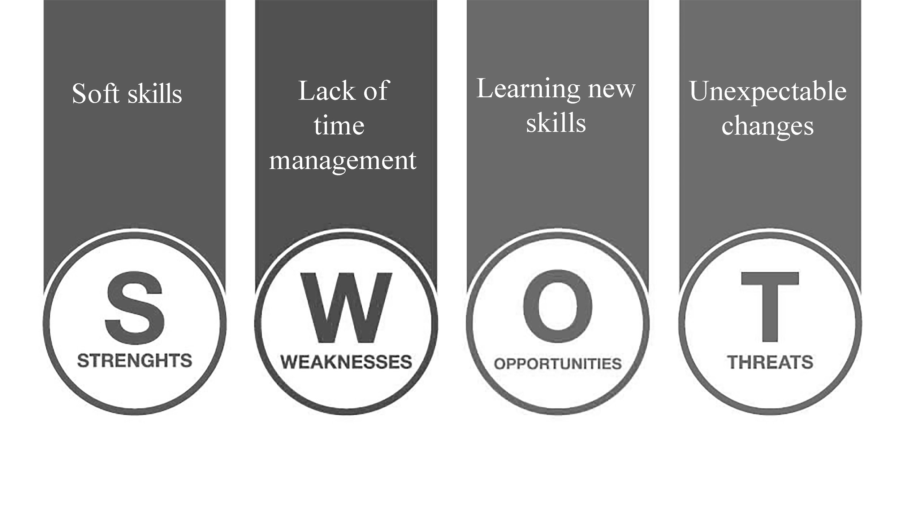Created by T. Tsvetanova.

13

