Name: Beniamin Avram
Student Number: 2131588
Module code and title: Academic and employability skills
Lecturer name: Doreen Nyaa Amudam
Assignment title: Task 3 – Reflective report

Introduction

The reflective report is defined as a piece of writing that analyses a past event from the present with the aim of analysing the experience, the meaning of the experience and the lessons that can be learned from it. The following report aims to examine the experience of writing the report and the experience of working as a group by using a model of reflection and incorporating the feedback from peers into a personal development plan. Learning how to correctly write a reflective report helps with analysing and concluding the reading, making better connections between the text and the world, learning more and acquiring new information, identifying interests and writing subjectively (John, 2022). Reflection in learning is extremely important, giving the students the opportunity to develop critical thinking skills and develop independence but also identify gaps in their learning. For students, it is important to self-assess and self-reflect, and it helps them evaluate their own work, track their process of learning, identify strengths and weaknesses in their knowledge, set realistic learning goals, reflect on their processes and style of learning, improving performance based on the feedback received (Norwood, 2022).

Gibb’s reflective circle

In order to analyse the experience of writing the report and working in a group, the Gibb’s reflective cycle created by Professor Graham Gibbs will be used. The model was created in 1988 in the book “Learning by Doing”, and it follows five steps, the description of the event or the experience in detail, the feelings experienced, the evaluation of the experience, the conclusion drawn after the experience and the action that need to be taken when dealing with similar situations in the future (Mind Tools, 2020). In order to use the cycle to reflect on my experience of writing the report all the steps will be followed such as the description which is writing the academic report for the 10th of July, the report’s theme being motivation in the workplace and it was one of the first reports to do for university; the feelings that it brought was a little insecure about the task but confident that with a lot of work and information it can be done, relieve after the report was handed it, and a little nervous for receiving the feedback from the lecturer; the evaluation from my point of view was a positive one, with the information that I looked for being easy to find and easy to write, the only thing that I could have done better is to start earlier to work on the report, but I am now waiting for the grade and the feedback from the lecturer; the conclusion is that it was a positive experience and I learned more about myself and how to prepare for future assignments; the actions that I will take in the future include starting earlier, reading more on the subject and drawing up ideas, and looking always for credible, reliant and current sources. For the group work, the experience was similar to the description which is working as part of a group to deliver a presentation in class; the feelings involved were a little fear and anxiousness about the public speaking but happy to have a team to work with and support each other to deliver the presentation; the evaluation of the colleagues and lecturers was a positive one people noticing that it was one of the best presentations, and in my opinion, the teamwork was very good, but I need to improve on my presentation and public speaking skills; the conclusion is that it was a good presentation with a good feedback, but each of us still has certain skills that need to be developed; the action taken for future group works include developing my presentation skills and meeting more often offline.

Feedback from peers

The feedback from peers received after the group presentation is very important, and it is extremely useful if it is complete and correct. Many employers and managers use this type of feedback in order to adopt new knowledge, identify errors and mistakes, keep people on track, enabling growth in their careers while also gaining skills such as critical thinking, collaboration, creativity and problem solving (Kritik, 2022). Also, developing the peer feedback culture in the workplace has a number of benefits such as team building and better collaboration, having more sources of feedback rather than only direct managers, a reduced bias, employee engagement, removes the fear factor, improves self-evaluation and development and gives people a new perspective (Engagedly, 2020). As seen from the images below, my group was happy with our work as a group and the delivery of the presentation, the only skill they identified I needed to improve was public speaking. By analysing my own performance, I would also like to improve my communication skills, leadership skills and time management skills.

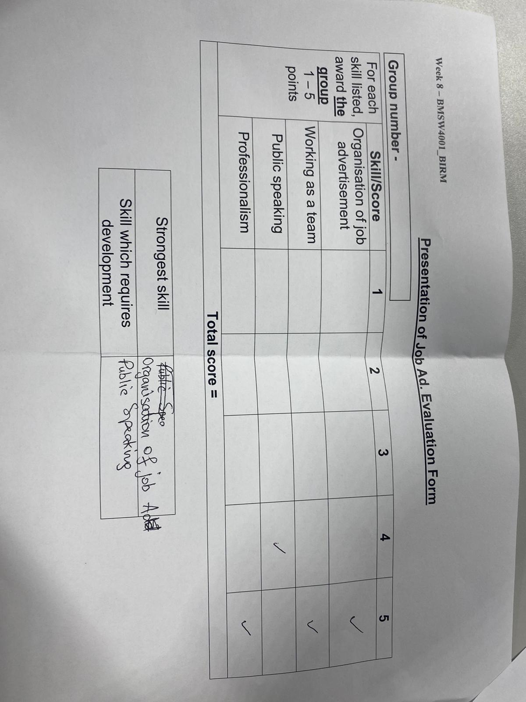
Image 1 – First feedback from peers
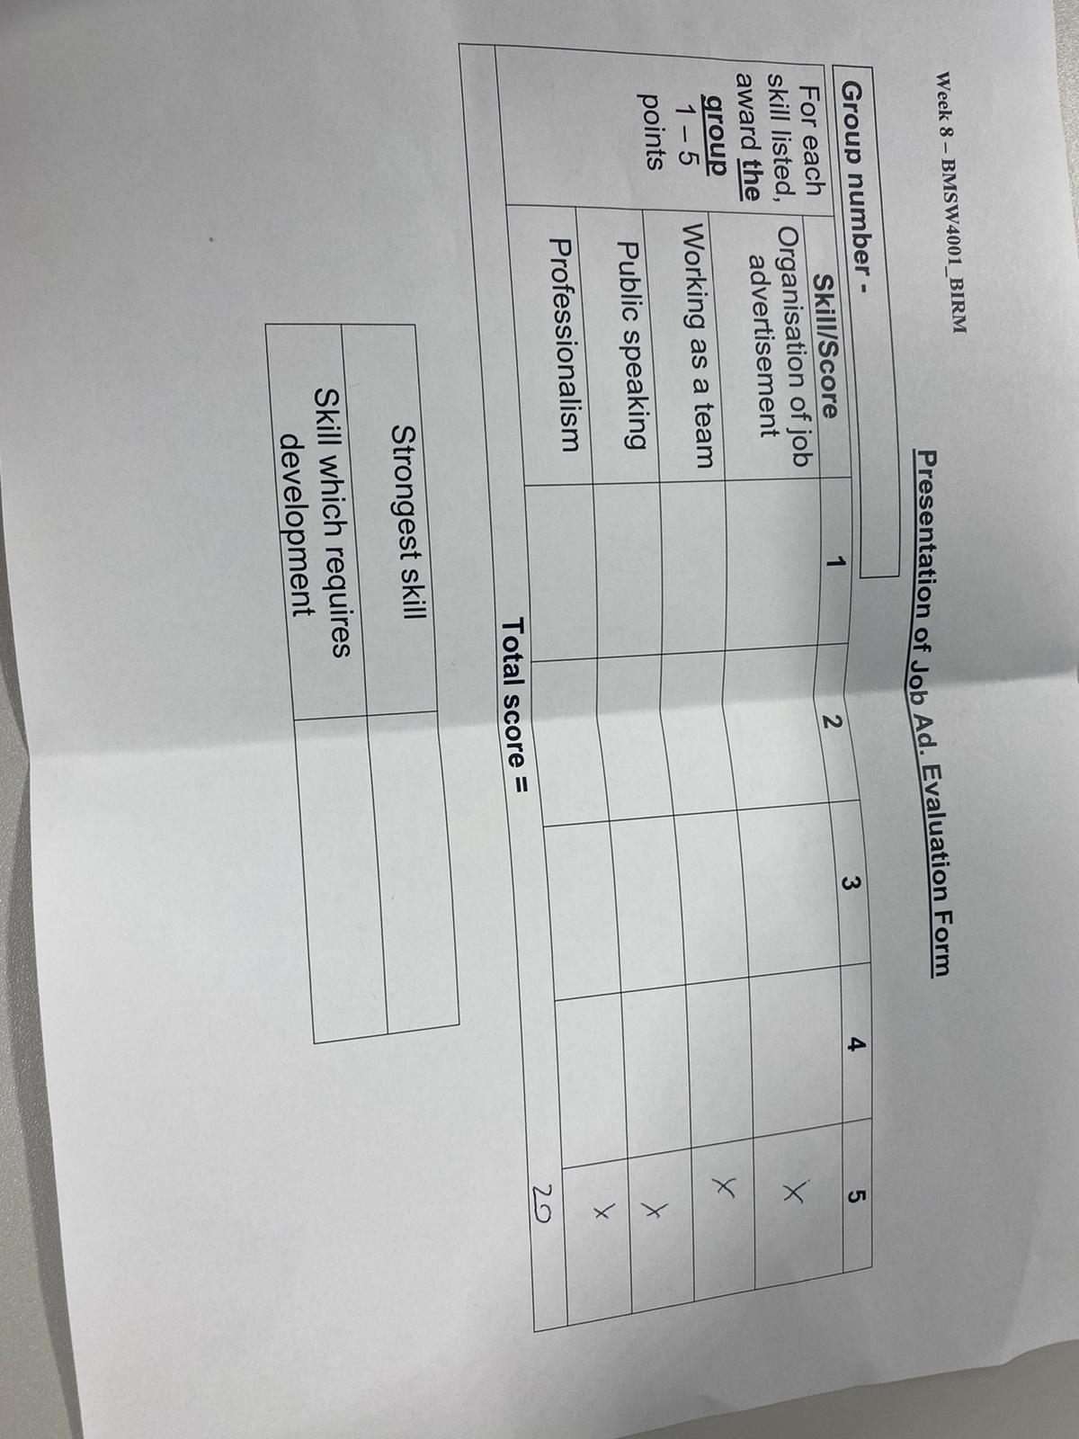
Image 2 – Second feedback from peers

Personal development plan

By analysing our experience of working as a group and the feedback received from peers, I identified that I have some skills that require my attention and dedication, so I will create a personal development plan in order to create goals to develop these skills in a timely manner. A PDP is usually an action plan where an individual identifies individual goals they want to achieve, strengths and weaknesses, areas that need to be improved and developed, what needs to be done in order to achieve these goals and anything that can distract a person from achieving the goal (Putter, 2021). Rosser (2022) identifies that there are a big number of benefits to developing a personal development plan, such as giving a person clarity about their goals and benchmarks, empowering a person to achieve the goals they set, becoming more resilient because of setting up long term goals, becoming more confident and inspiring, becoming a master in setting goals, increasing self-esteem, developing better relationships in the personal and professional environment, becoming more motivated to achieve the goals, creating a work-life balance, getting more knowledge and skills, and overall having a happiness and contentment feeling.

Target goal | Things to do | Support | Target date
Develop public speaking skills | Deliver more presentations at the university, in the workplace or between friends (in English). Also, try to volunteer for events that require giving presentations or working with people from different backgrounds in order to communicate more with different people. | University events, online events, career fairs, and other events happening around the city. | September 2024
Develop communication skills | By participating in the same events and developing public speaking will also help communication skills, but also developing language skills and writing skills through academic reading and writing and being more involved in the events happening around me both in my professional and personal life. | Family and friends, lecturers, and colleagues.  Academic information and tools, online resources, and events. | September 2024
Develop leadership skills | Taking the lead when doing a group work at the university. Organising more activities with friends and family.  Taking the initiative, coming up with new ideas and presenting them at work. | Online resources.  Support from family, friends and colleagues. | January 2023
Develop time management skills | Creating more personal development plans such as this one, creating lists with bullet points, organising my time and writing down the things I need to do within time frames to make sure I respect them and do them in the required time. | A notebook or an app on the phone.  Online resources.  Patience and involvement. | January 2022

Conclusion

In conclusion, all the tools used during the time spent in the university are helpful for developing a successful career, while developing skills is extremely important, especially when there are big market gaps and the students who are prepared with more than just a CV have a high chance of getting a job in the industry immediately after finishing the courses. By using theories and models such as Gibb’s reflective cycle, a person can analyse and reflect on their experiences in order to react in a better way the next time it happens. Another important tool is feedback, not only from superiors but also from colleagues. It has been proven that people who openly accept feedback have more chances of actually improving and developing the lacking skills and growing in their careers.

References

Engagedly (2020) The importance of peer feedback at the workplace, available at: https://engagedly.com/the-importance-of-peer-feedback-at-workplace/ (Accessed on: the 25th of July 2022)

John, S. (2022) Reflective essay: ultimate guide to write a successful paper easily, available at: https://essaypro.com/blog/reflective-essay (Accessed on: the 15th of July 2022)

Kritik (2022) Value of peer feedback beyond your classroom, available at: https://www.kritik.io/resources/value-of-peer-feedback-beyond-the-classroom (Accessed on: the 25th of July 2022)

Mind tools (2020) Gibb’s reflective cycle, available at: https://www.mindtools.com/pages/article/reflective-cycle.htm (Accessed on: the 15th of July 2022)

Norwood, A. (2022) What does self-assessment and self-reflection bring to the learning journey, available at: https://schoolbox.com.au/blog/what-does-self-assessment-and-self-reflection-bring-to-the-learning-journey/ (Accessed at: the 25th of July 2022)

Putter, M. (2021) What is a personal development plan? Available at: https://cpdonline.co.uk/knowledge-base/business/what-are-personal-development-plans/ (Accessed on: the 25th of July 2022)

Rosser, J. (2022) 11 benefits of personal development and creating a plan, available at: https://www.success-stream.co.uk/11-benefits-personal-development-and-plan/ (Accessed on: the 25th of July 2022)

