University of Wales Trinity Saint David
School of Engineering
Motorsport Engineering BEng

Materials Testing and Sustainability in Composites for Motorsport & Automotive Industries Automotive
Materials and Sustainability (ACHA6012)

Priveshnan Soemani Segaran
2204879
May 2024
Word count: 3243 (After Relevant Exclusion)

Table of Contents
1. Introduction 3
2. Composite Materials in Motorsport and Automotive Applications 4
3. Materials and Usage 6
3.1 Aluminium 6
3.2 Non-Woven Carbon Fibre with Bio Resin 7
3.3 Woven Kevlar with Bio Resin 8
3.4 Woven Flax with Bio Resin 9
3.5 Woven Carbon Fibre with Resin 10
3.6 Non-Woven Flax with Bio Resin 11
3.7 Non-Woven Hemp with Bio Resin 12
3.8 Woven Flax with Bio Resin 13
3.9 Woven Carbon Fibre with Bio Resin 14
4. Methodology 15
5. Results & Analysis 19
6. Sustainability Analysis 24
7. Recommendation 26
8. Conclusion 27
9. References 28

Introduction
Composite materials are now the engineering cornerstone of the automotive, motorsport, and motorcycle industries, offering exceptional strength-to-weight characteristics, design flexibility, and good performance under adverse conditions. The materials utilised and assessed in this assignment are Aluminium, Carbon Fibre, Kevlar, Flax, and Hemp. With the automotive industry striving for better and more efficient fuel economy, road handling and speed the use of these materials increased tremendously. These composites allow for weight reduction without sacrifice of structural properties and are particularly suitable for high-performance application such as chassis components, aerodynamic components, and crash structures.
With increasing global emphasis on environmental responsibility, the sustainability of composite materials has become a very pressing issue. Traditional composites often rely on energy-intensive manufacturing processes and petroleum-based resins. These processes pose a serious challenge in terms of recyclability and end-of-life disposal. Government and motorsport governing body regulations, along with the changing expectations of citizens, have begun to push the industry to highly reconsidered its past transgressions towards the traditional composites and adopted a more efficient development plan with environmental impact as a factor in materials selection and design decisions.
This assignment examines the mechanical behaviour and environmental performance of various composite materials that have been traditionally applied in the automotive or motorsport sectors. The collected results will lead to recommendations for more sustainable material strategies in performance engineering applications.

Composite Materials in Motorsport and Automotive Applications
Composites are the combination of two or more very different materials, usually a matrix material is combined with a reinforcing material to form a composite with optimized properties. These materials are designed to deliver superior mechanical properties such as high strength-to-weight ratios, corrosion resistance and excellent fatigue performance qualities that are essential for performance-focused vehicles. Composites were first used in automotive in 1947 by Japan to reduce weight thus decreasing fuel consumption (Khan, 2024). Carbon fibre reinforced polymers CFRPs are the most widely used materials within elite competitions such as Formula 1. A Formula 1 car contain up to 85% of its volume in composites, mainly CFRP, while only representing around 20% of its total weight. (Racecar-engineering, 2019).
Aramid fibres such as Kevlar are used in impact zones of motorsport vehicles, such as underfloor panels, wheel arches, and impact components. Kevlar offers satisfactory energy absorption and abrasion resistance, making it a suitable addition alongside carbon fibre due to its stiffness and brittleness. Hybrid composites of both carbon and aramid fibres are being used more and more to obtain a balance between lightweight stiffness and damage tolerance. These materials are widely used in structural parts like monocoque chassis, aerodynamic bodywork panels, suspension links, and crash structure. (Knaufautomotive, 2022).
Across the wider automotive industry, composite adoption is becoming more prevalent as vehicles strive to achieve fuel efficiency requirements and the push towards electrification. Weight loss is at the forefront since a 10% loss in car weight can lead directly to 6–8% improved fuel economy. To achieve this, manufacturers increasingly use glass fibre reinforced polymers (GFRPs), CFRPs, and hybrid composites to produce parts like hoods, roofs, interior parts, and door panels. They induce mass reduction but maintain structural integrity and sensitivity to crash. (FinancialTimes, 2019).
More recently, there has been a concerted effort to create natural fibre composites such as flax and hemp as sustainable alternatives. They are renewable, biodegradable, and can be paired with bio-based resins to create low-impact composite structures. While natural fibres generally have poorer mechanical performance compared to synthetic fibres, environmental benefits of natural fibres render them suitable for use in non-structural automotive applications such as interior trim and panels. These developments are in alignment with governments' and industry associations' sustainability guidelines and the automotive sector's shift to circular economy strategies (Tech-Fab, 2023).
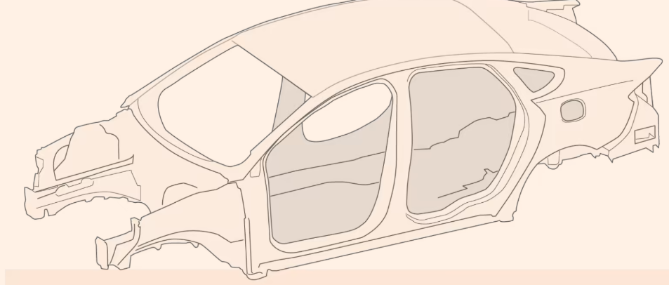
Figure 1: Application of the Materials on the (Body) (FinancialTimes, 2019)

Figure 2: Application of the Materials on the (Interior) (FinancialTimes, 2019)

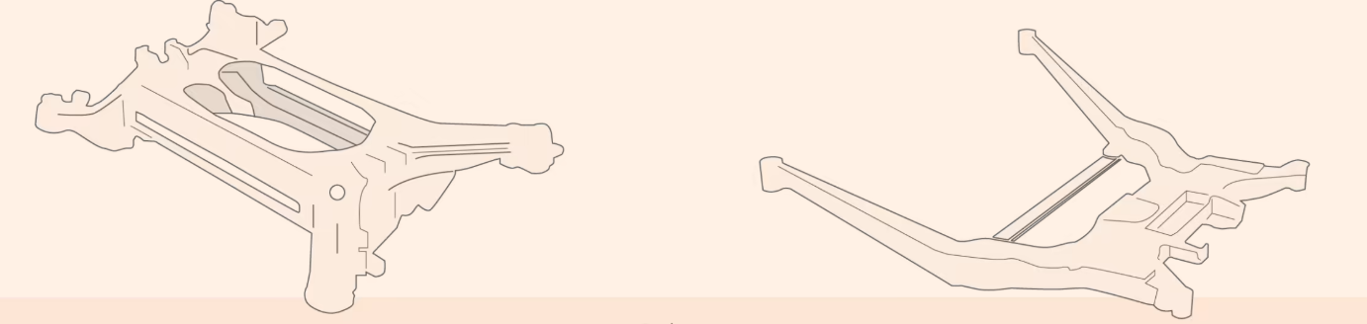
Figure 3: Application of the Materials on the (Chassis) (FinancialTimes, 2019)

Materials and Usage

Aluminium
Aluminium is widely used in motorsport and automotive engineering due to its favourable strength-to-weight ratio, corrosion resistance, and recyclability. In motorsport, it’s commonly used in subframes, suspension components, and heat exchangers. In the automotive industry, it is found in chassis panels, wheels, engine blocks, and body structures. Aluminium can be recycled indefinitely with only 5% of the original energy required to produce it from raw materials, giving it one of the lowest lifecycle environmental footprints among structural metals (Simmal, 2023).
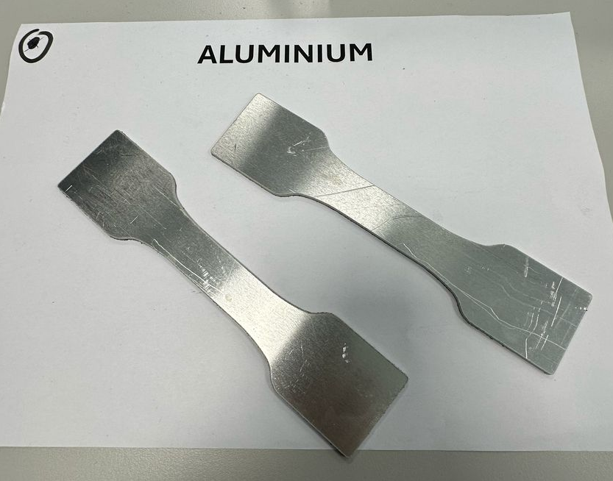

Figure 4: Aluminium Sample

Non-Woven Carbon Fibre with Bio Resin
Non-woven carbon fibre with bio resin is a versatile, sustainable composite choice ideal for internal reinforcement, mould backing, and lightweight panels where isotropic strength and ease of manufacturing are important. It provides the fundamental advantages of carbon composites having low weight and high stiffness at a lower cost and with improved sustainability. In motorsport, they are typically located in secondary structural components or internal layers in laminated panels, especially where ultra-high mechanical performance is not critical. Non-woven carbon fibre in the automotive sector contributes towards reduced material cost, lightweighting goals while addressing environmental concerns, allowing manufacturers to reduce the carbon footprint of virgin carbon fibre production. (Plasticstoday, 2016).
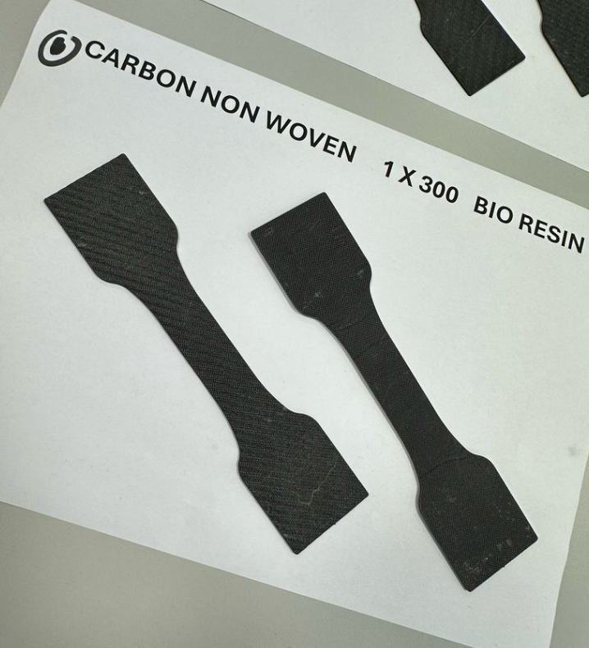

Figure 5: Non-Woven Carbon Fibre with Bio Resin Sample

Woven Kevlar with Bio Resin
Kevlar is widely used in motorsport because of its high resistance to impact and energy absorption. This aramid fibre is commonly introduced into composite lay-ups in areas that are exposed to stone chips, debris, and crash damage. For example, undertrays, wheel arch liners, and side skirts. In motorsport classes like rallying, where components are subjected to impacts and harsh conditions regularly, Kevlar composites are enforced to provide structural integrity and safety for vehicles. The advantages of Kevlar are its comparatively high tensile strength and great fatigue resistance. When used with bio resin, the environmental footprint is reduced while maintaining energy absorption capabilities. Although Kevlar itself is not biodegradable, the hybrid use with bio resin reduces the total petrochemical content of the composite and supports greener material systems (Dupont, 2025).
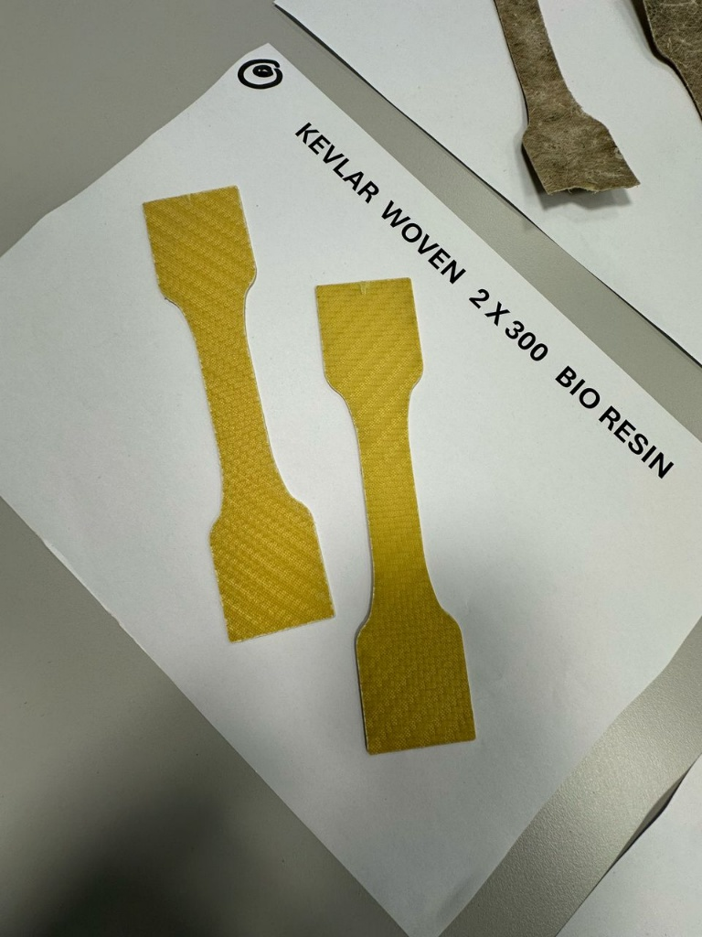

Figure 6: Woven Kevlar with Bio Resin Sample

Woven Flax with Bio Resin
The IB2 bio-based epoxy infusion resin is a significant breakthrough in sustainable composite manufacturing. Particularly formulated to use with natural fibre reinforcements such as flax. Woven flax fibres used with a bio-resin system offer a sustainable alternative with excellent vibration dampening and biodegradability. This application is appropriate for green material initiatives in motorsport and automotive sectors. In motorsport, it is increasingly being applied in prototype vehicles, interior trim, and bodywork parts where environmental credentials are becoming more important. In mass car production, the IB2 resin enables life cycle analysis and environmental certification through reducing embedded carbon emissions. The high infusion capacity, low viscosity, and mechanical properties of the resin make it a suitable option for structural and semi-structural components, with performance and reduced environmental impact (Jeccomposites, 2024).
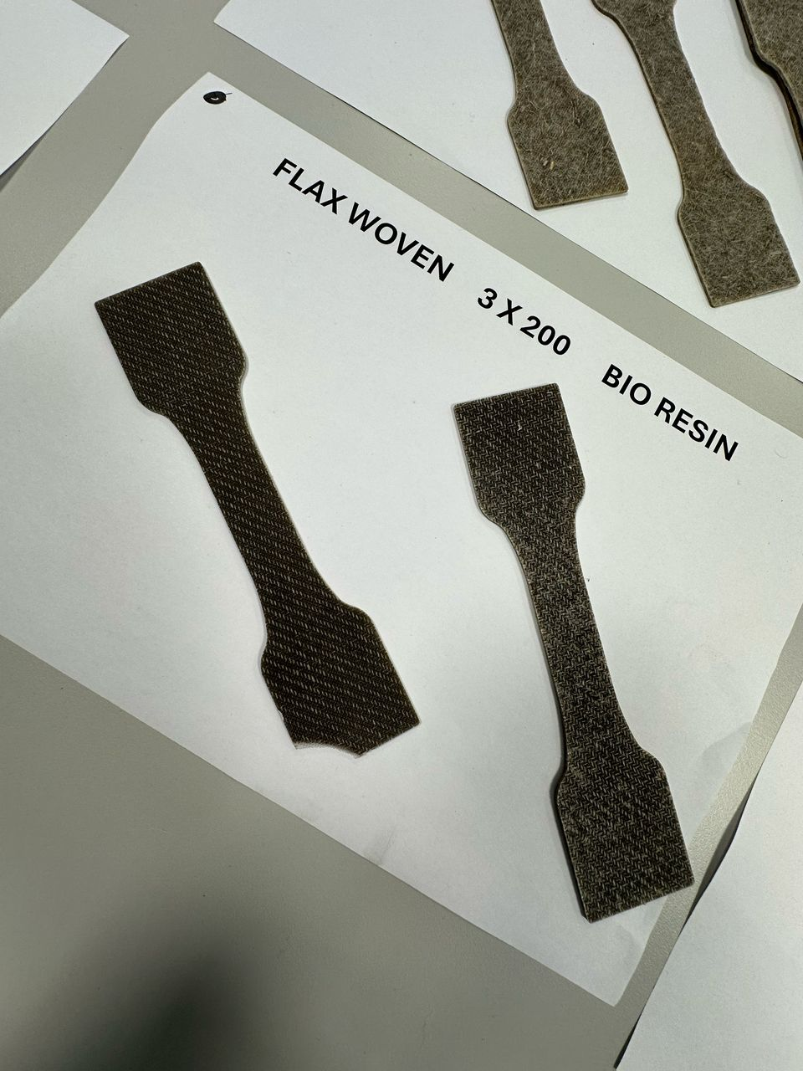

Figure 7: Woven Flax with Bio Resin Sample

Woven Carbon Fibre with Resin
Woven carbon fibre with traditional epoxy resin remains the gold standard for performance applications in motorsport. It is widely used in advanced composite fabrication where mechanical integrity is considered most important. In motorsport, it is extensively used in Formula 1 for monocoque chassis, crash structures, and aero elements due to its ultra-high stiffness and tensile strength. In supercars and racing-derived road vehicles, it is used in body panels and structural components. (Innovationintextiles, 2023).
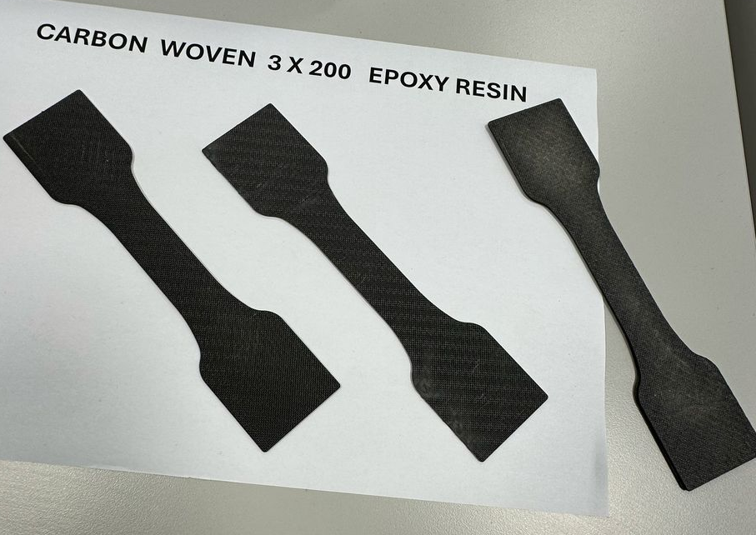

Figure 8: Woven Carbon Fibre with Resin Sample

Non-Woven Flax with Bio Resin
Non-woven flax are being adopted more and more as green alternatives to synthetic reinforcement in motorsport and the automotive industry. The non-woven flax are lightweight, biodegradable and are compatible with a variety of different resin systems including epoxies and bio-resins. Flax composites are used in non-safety-critical components such as interior panels, dashboards and aerodynamic covers in motorsport. In the automotive industry, non-woven flax find application in interior trims, door panels, and noise damping layers due to their sound absorption characteristics and lower environmental footprint. (Textileworld, 2024).
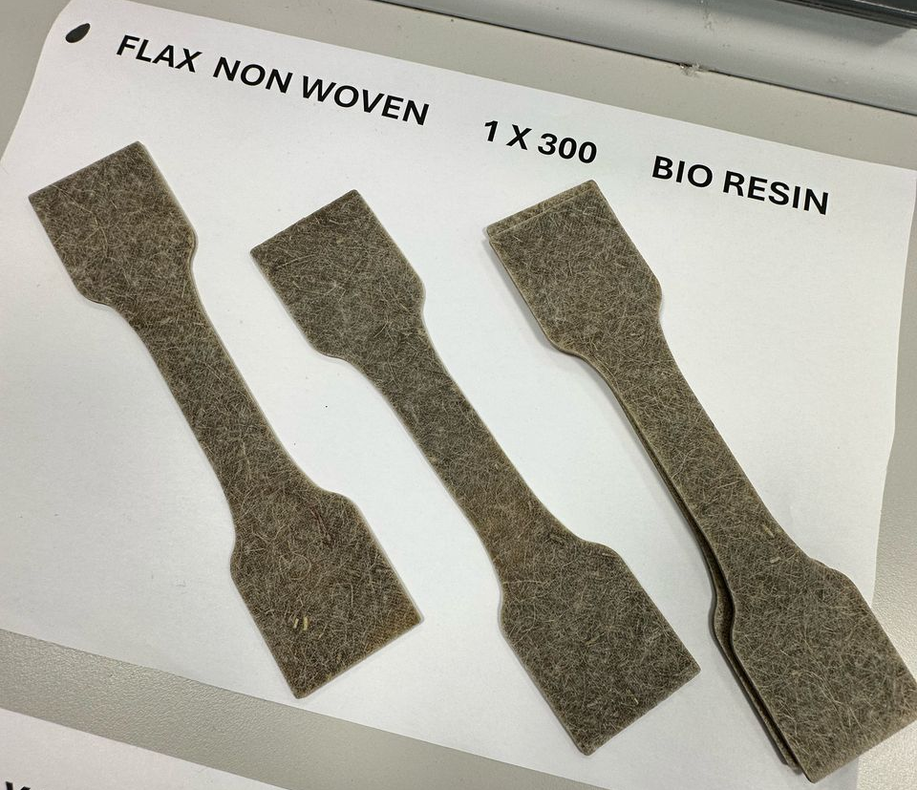

Figure 9: Non-Woven Flax with Bio Resin Sample

Non-Woven Hemp with Bio Resin
Non-woven hemp are yet another natural fibre alternative with potential for use in sustainable composites. Like flax, hemp is a biodegradable and renewable source of reinforcement but with slightly different mechanical characteristics. Hemp fibre composites have been found to exhibit dimensional stability, vibration damping, and stiffness improvement compared to certain other natural fibres. For motorsport, hemp is at the early stage of adoption but is being developed for use in interior structures, energy-absorbing parts, and bodywork with minimal aerodynamic impact. For production automotive use, hemp mats are used in door cards, headliners, parcel shelves, and trunk liners, where weight and cost reduction are critical. In addition, hemp has a quick growth cycle and requires very limited pesticide, which contributes to its sustainability appeal (Textileworld, 2024).
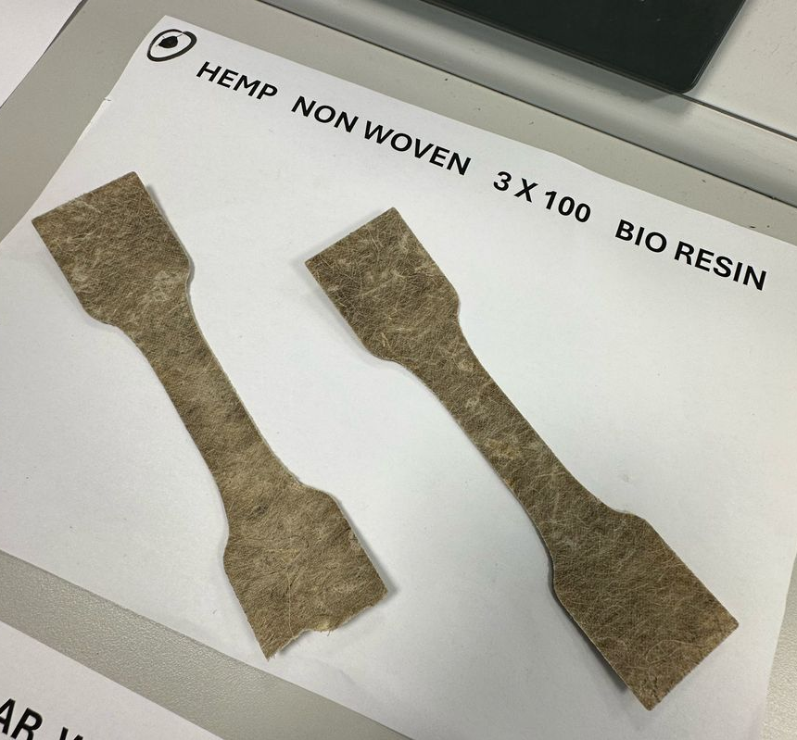

Figure 10: Non-Woven Hemp with Bio Resin Sample

Woven Flax with Bio Resin
Woven flax provides greater formability and mechanical performance than non-woven flax and can be an excellent material for semi-structural applications. Its woven architecture possesses better in-plane stiffness and strength, which is beneficial in the case of making curved, visible, or moderately loaded parts. In motorsports, woven flax cloth is explored for interior shells, visual body panels and aerodynamic pieces for electric and hybrid concept cars. In automotive manufacturing, it can be found in dashboards, structural trim and visible environment-themed components. Notable values that are shown by the woven flax are low weight, high fatigue life. When blended with bio-resin, it produces a high-performance, low-impact composite suitable for modern lightweighting and sustainability requirements. Additionally, their natural fibre origin allows for carbon sequestration during growth and reduced end-of-life impact (Heartland, 2023).
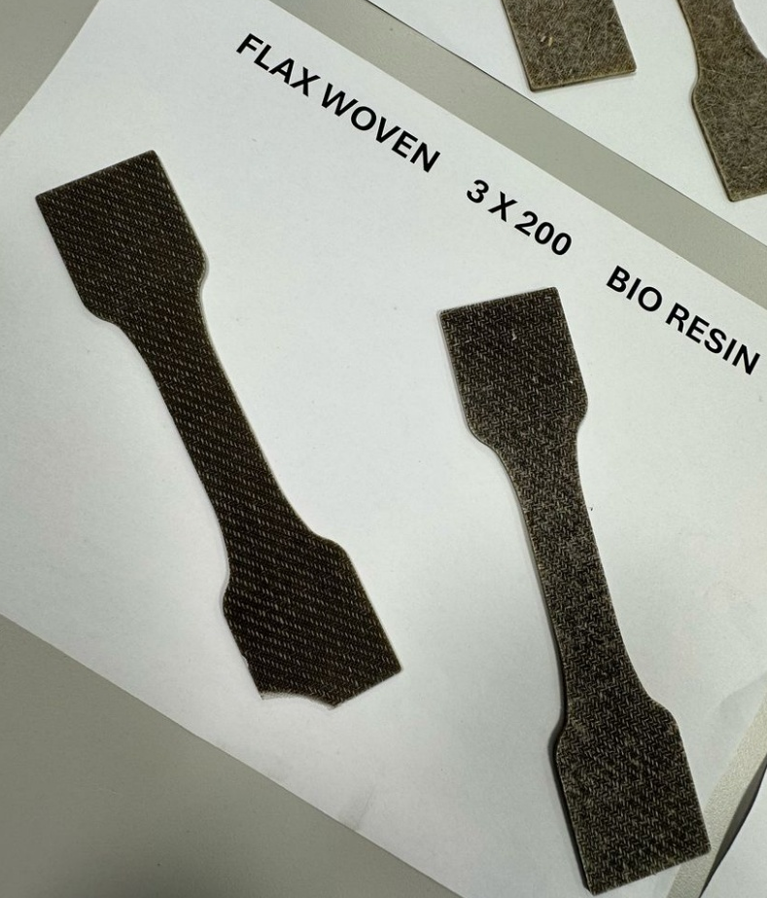

Figure 11: Woven Flax with Bio Resin Sample

Woven Carbon Fibre with Bio Resin
Woven carbon fibre combined with a bio-based epoxy resin provides an optimal balance of high mechanical performance and reduced environmental impact. The bio-resin incorporates 31% renewable plant-based content without compromising tensile or flexural strength. This pairing is becoming more common in motorsport prototype vehicles and sustainable concept cars. It allows for substantial weight savings while reducing reliance on petroleum-based materials.
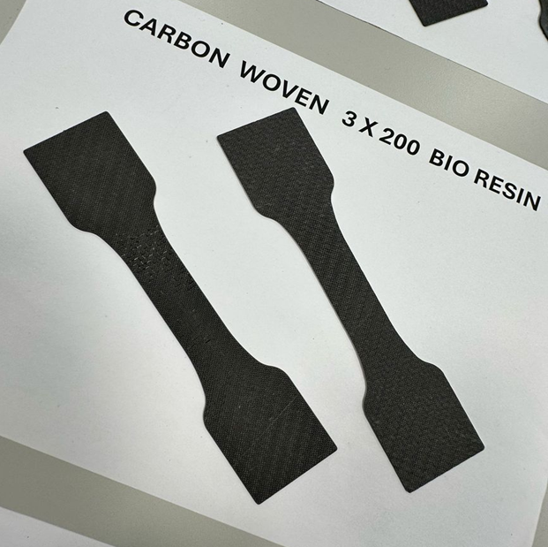
Figure 12: Woven Carbon Fibre with Bio Resin Sample

Methodology
The experimental methodology for this investigation was designed to evaluate the mechanical performance of a range of composite materials both synthetic and natural, with a focus on tensile strength. All testing was carried out in Science Lab IQ007 using the Denison Universal Tensile and Compression Testing Machine under the supervision of the lab technician. Before we begun the experiment, the lab technician provided us with the appropriate personal protective equipment (PPE) which were safety goggles. The safety goggles were worn at all times to protect against potential fragment projection during specimen failure. Additionally, a safe distance was kept from the tensile testing apparatus while it was in use to reduce the possibility of accidents. Next, the lab technician demonstration how to operate the machine. While doing so, the lab technician also discussed the Health & Safety guidelines. The primary aim was to obtain consistent tensile load data, from which stress and strain could be derived enabling comparative analysis of performance characteristics across various material types used in motorsport and automotive engineering. A mesh gripping tab was incorporated into each specimen to ensure a reliable interface with the jaws of the test machine. Two tensile tests were conducted per group per material, and the results were collated from all seven groups providing a sample size of fourteen data sets per material.
The test specimens included Aluminium as the baseline, Woven Carbon Fibre with Bio Resin, Woven Carbon Fibre with traditional epoxy resin, Woven Flax Fibre with Bio Resin, Woven Kevlar with Bio Resin, Non-woven Carbon Fibre with Bio Resin, Non-woven Flax with Bio Resin and Non-woven Hemp with Bio Resin. The twill-woven samples were fabricated using three layers of 200 g/m² carbon or flax, or two layers of 300 g/m² Kevlar twill, with each layer oriented at 45° to simulate quasi-isotropic layups commonly used in structural panels. Non-woven samples consisted of one layer of 300 g/m² flax or carbon fibre mats, and three layers of 100 g/m² hemp mats, also placed at 45° angles to represent realistic manufacturing orientations and mechanical anisotropy.
Prior to each test, the cross-sectional area of each sample was precisely measured using vernier callipers, as accurate area data was essential for calculating engineering stress. The test samples were then placed into the machine. The machine was then programmed to the correct load value and the test was conducted. The load-time data collected from the Denison machine was exported as .CSV files. As the machine’s strain and elongation values were not valid for composite materials, only raw load data was used, alongside manually measured dimensions, to calculate stress. Observational notes and pictures were taken during the test to record failure modes such as fibre pull-out, delamination, or brittle fracture, which were particularly useful for qualitative comparisons.
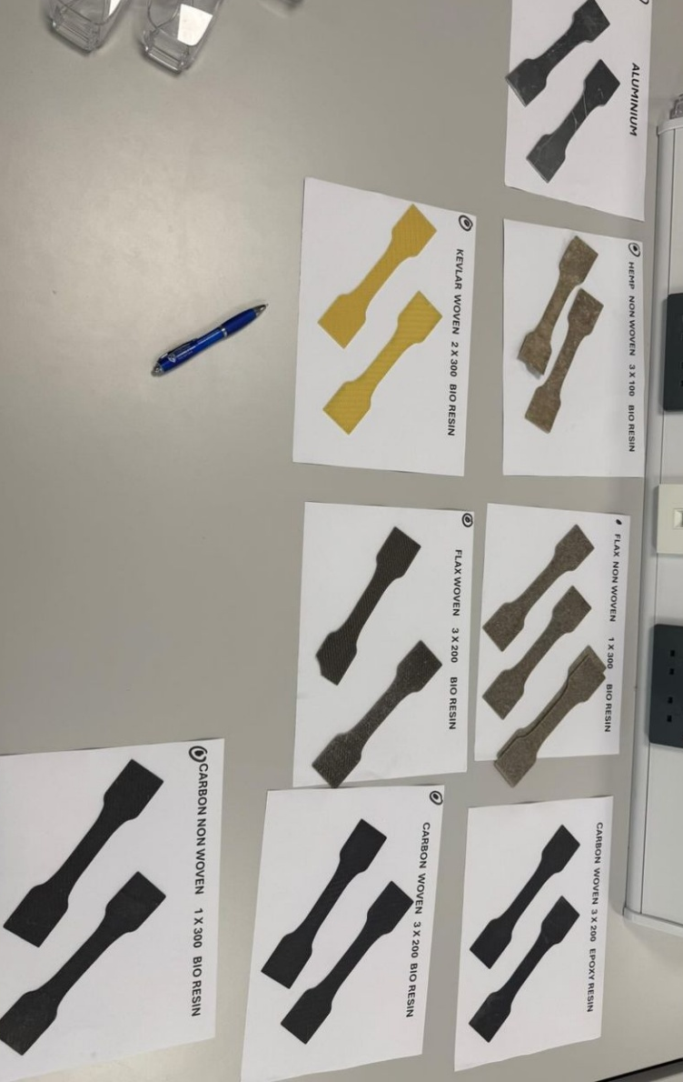

Figure 13: All Samples Before Testing

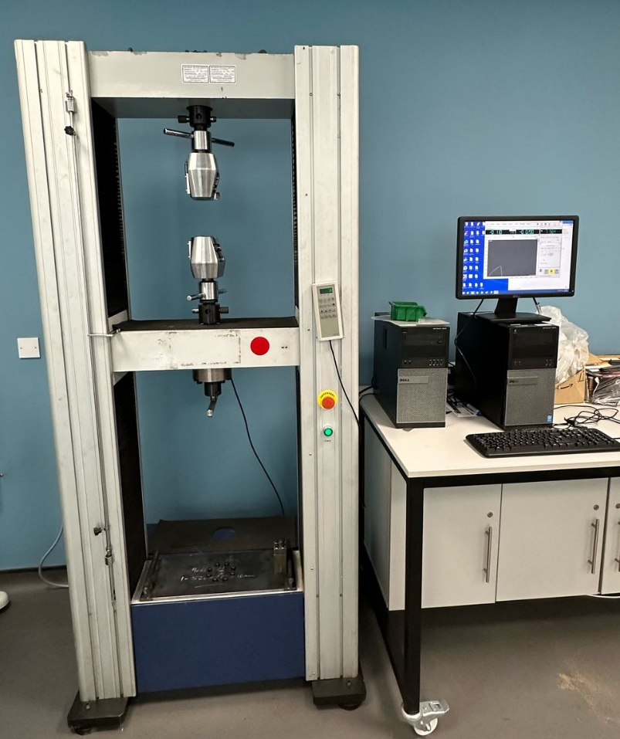

Figure 14: Denison Universal Tensile and Compression Testing Machine
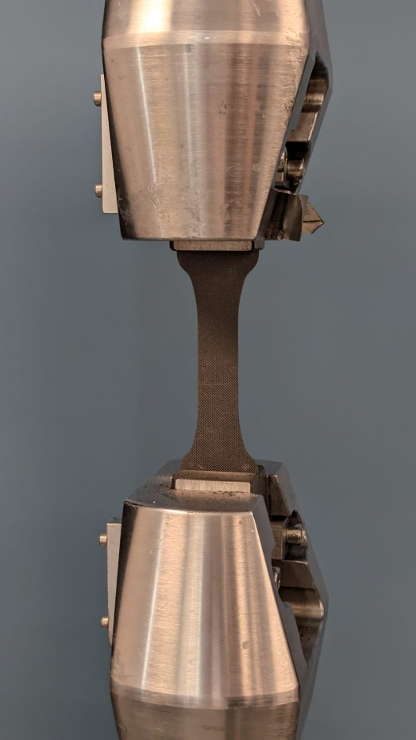

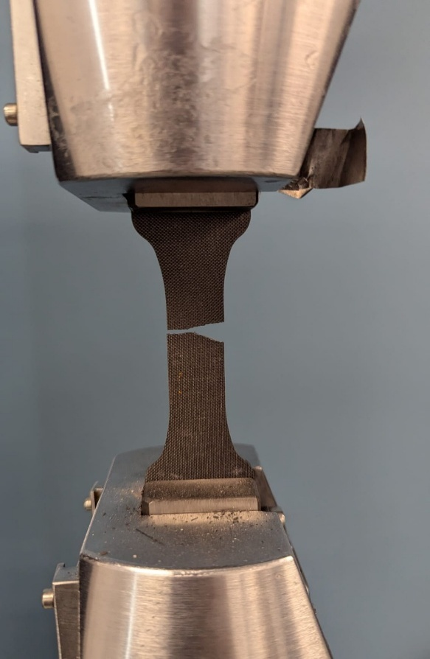
Figure 15: Sample Placed in Machine Prior to Testing

Figure 16: Sample After Testing
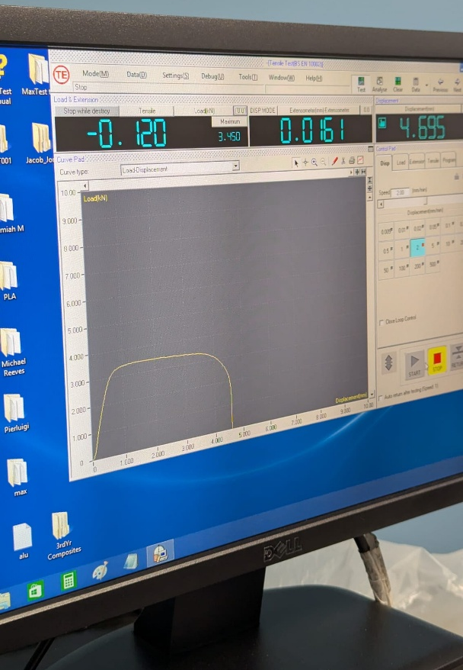

Figure 17: Data Being Recorded
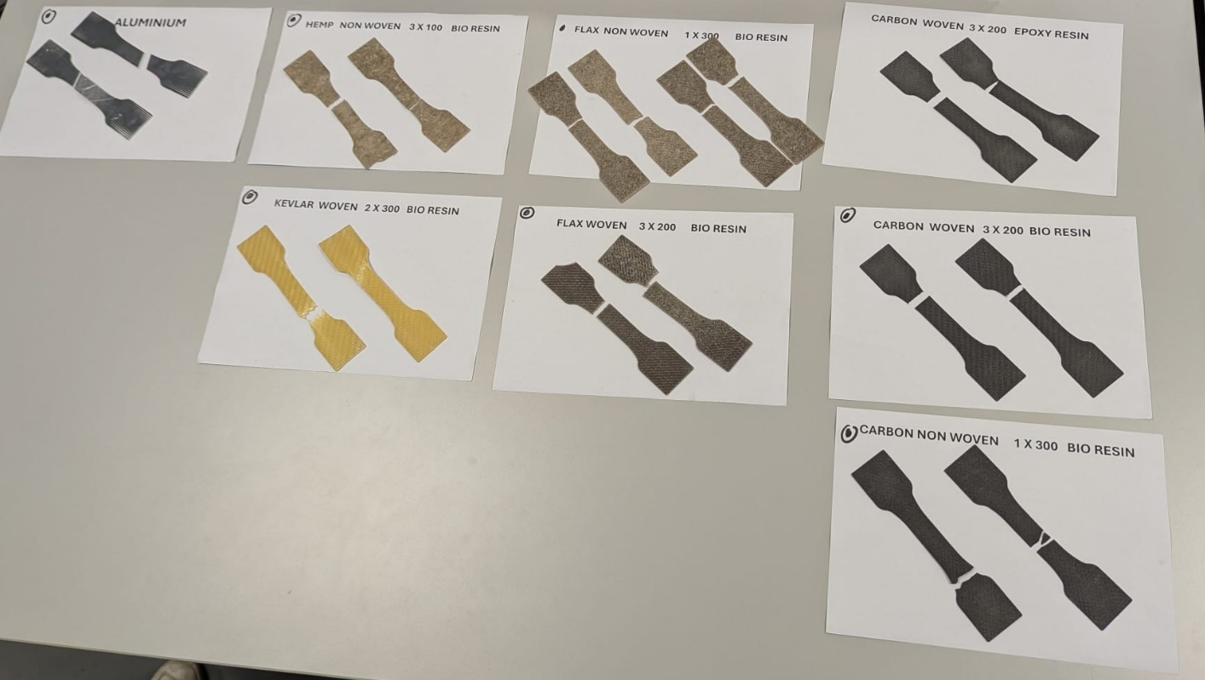
Figure 18: Samples after All Testing has been Completed

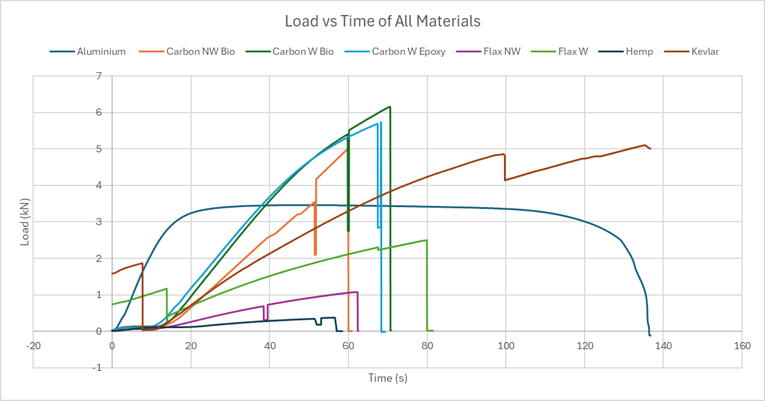
Results & Analysis

Figure 19: Load vs Time Graph

Figure 19 illustrates the tensile loading behaviour of eight different materials. Among all samples, the woven carbon fibre with epoxy resin achieved the highest peak load of approximately 6.2 kN, exhibiting a steep linear rise followed by a sudden drop, characteristic of brittle failure. A closely comparable result was observed in woven carbon fibre with bio resin, which peaked at 5.7 kN and failed at a similar time indicating that bio-based resins can serve as a viable, more sustainable substitute without significant compromise in mechanical strength. Kevlar with bio resin demonstrated a distinctly different response, with a slower load buildup and prolonged resistance up to 138 seconds, reflecting its high toughness and impact resistance. Unlike carbon composites, Kevlar failed gradually, suggesting ductile behaviour ideal for safety-critical components like undertrays or wheel arch protection. The non-woven recycled carbon fibre with bio resin also performed well, peaking at 5.0 kN. Aluminium displayed a rounded peak at 3.4 kN and plateaued before slowly declining, which indicates plastic deformation before final failure. Among the natural fibres, woven flax with bio resin achieved a moderate peak of 2.5 kN, proving its usefulness in semi-structural or interior automotive components where sustainability is valued. By contrast, non-woven flax and non-woven hemp composites reached much lower peak loads of 1.1 kN and 0.4 kN respectively.

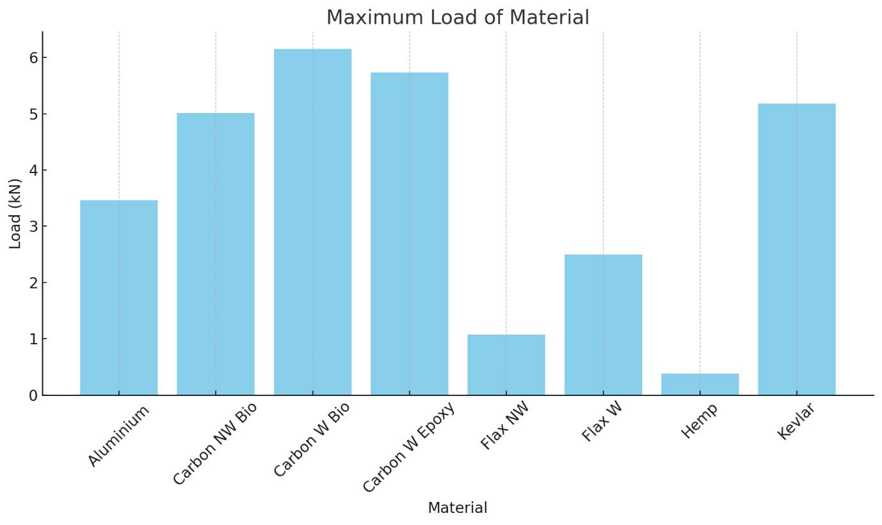
Figure 20: Maximum Load Graph

Figure 20 highlights the tensile performance of eight tested materials. Woven carbon fibre with bio resin recorded the highest peak load of 6.2 kN, slightly outperforming the traditional epoxy version of 5.7 kN, showing that bio resins can offer comparable strength. Kevlar with bio resin followed closely at 5.2 kN, demonstrating strong load resistance and likely superior toughness. Non-woven carbon fibre with bio resin also performed well at 5.0 kN, confirming its potential in sustainable, semi-structural applications. Aluminium reached a moderate peak of 3.5 kN, offering durability but lacking the weight advantage of composites. Among natural fibres, woven flax with bio resin performed best at 2.5 kN, while non-woven flax and hemp showed lower strength of 1.1 kN and 0.3 kN, making them suitable for interior or low-stress components.

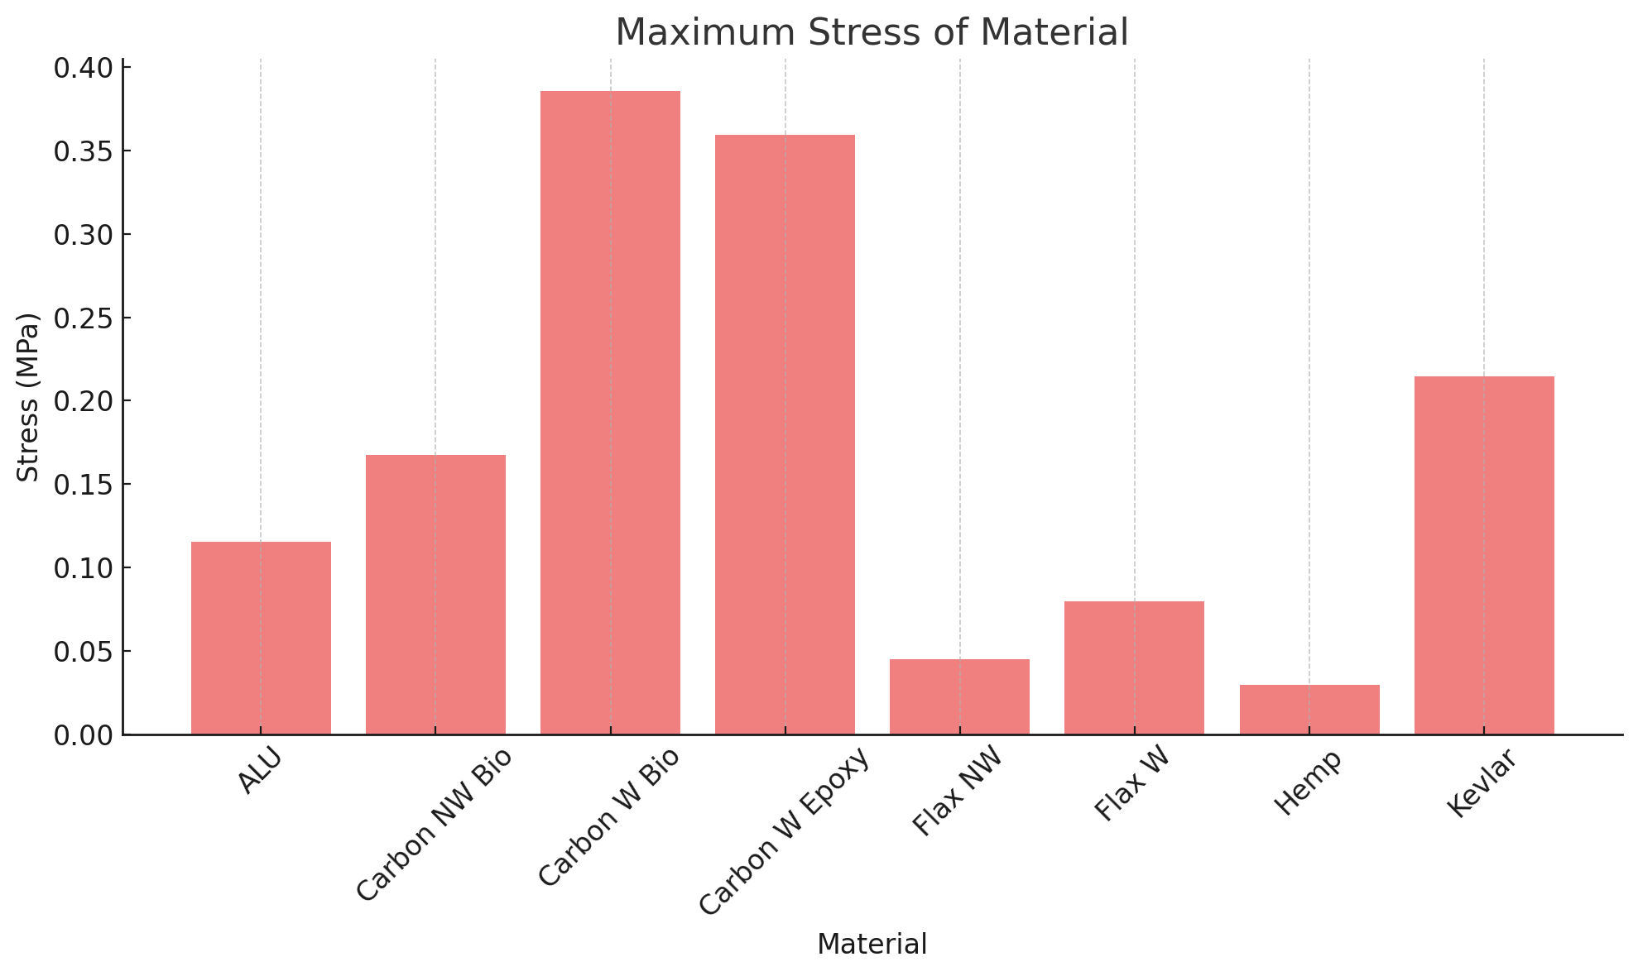
Figure 21: Maximum Stress Graph

Figure 21 highlights the peak stress each material withstood before failure. Woven carbon fibre with bio resin achieved the highest maximum stress of 0.39 MPa, slightly outperforming the epoxy-bound version at 0.36 MPa, demonstrating that bio-based resins can rival traditional systems in structural performance. Kevlar with bio resin followed with a strong result of 0.21 MPa, reflecting its high tensile strength and toughness, ideal for components exposed to impact and abrasion. Non-woven carbon fibre with bio resin also performed well at 0.17 MPa, reinforcing the viability of recycled fibres in semi-structural applications when paired with a sustainable matrix. Aluminium reached a moderate stress level of 0.12 MPa, consistent with its known ductility and predictable failure behaviour. Among natural fibres, woven flax with bio resin showed superior performance of 0.08 MPa compared to its non-woven counterpart at 0.04 MPa, confirming that fibre alignment plays a critical role in stress resistance. Hemp, the lowest performer with 0.03 MPa, is better suited for non-structural uses such as interior panelling or insulation.
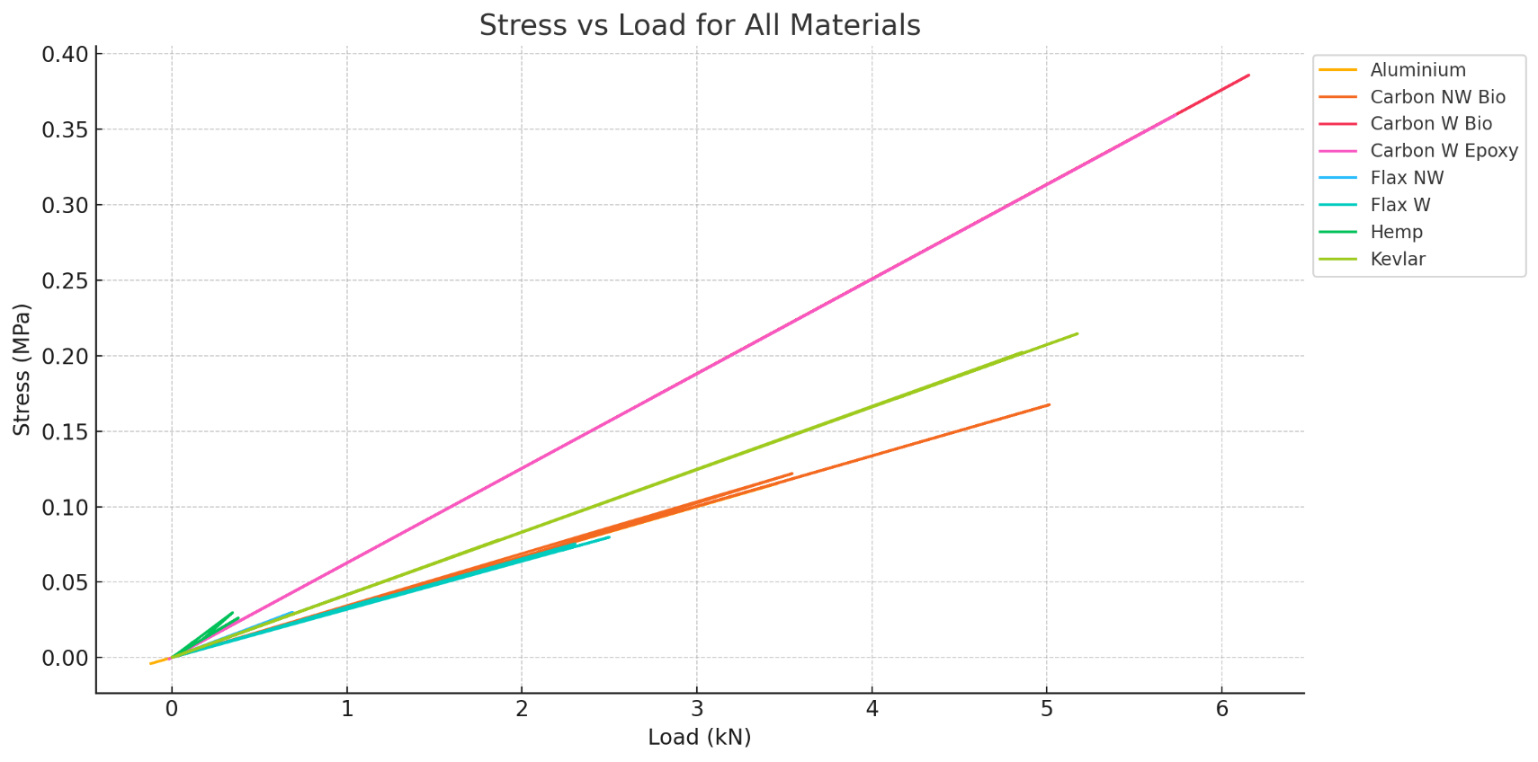
Figure 22: Stress vs Load Graph

Figure 22 shows the material efficiency of each sample under tensile loading. Woven carbon fibre with epoxy resin showed the highest stress with 0.38 MPa, confirming its exceptional strength and stiffness, ideal for high-performance structural applications in motorsport followed closely by its bio-resin counterpart at 0.36 MPa, confirming that bio resins can match traditional systems in performance-critical applications. Kevlar reached 0.21 MPa at 5.0 kN offering a balance of strength and ductility, while non-woven carbon fibre with 0.17 MPa showed solid performance despite reduced fibre alignment. Aluminium displayed moderate stress of 0.12 MPa, offering predictable failure but lacking the stiffness of composites. Among natural fibres, woven flax with 0.08 MPa benefiting from better fibre alignment outperformed non-woven flax at 0.04 MPa and hemp at 0.03 MPa, underscoring the impact of fibre orientation on strength. Overall, all the graphs above shows that woven composites deliver superior stiffness, while natural fibres are best suited for low-load, sustainable applications.

 | Calculated from Manufacturer Data
 | UTS (Mpa) |  |  | % Diff
Composites | Ul | Ll | Experimental Average (Mpa) | Ul | Ll
Aluminium |  |  | 125
Non-Woven Carbon Bio Resin | 330 | 290 | 209 | -37% | -28%
Woven Carbon Bio Resin | 2094 | 134 | 365 | -83% | 173%
Woven Carbon Epoxy | 2096 | 142 | 392 | -81% | 176%
Woven Flax Bio | 62 | 58 | 85 | 37% | 46%
Non-Woven Flax Bio | 44 | 33 | 44 | 1% | 34%
Hemp Bio | 108 | 46 | 27 | -75% | -42%
Kevlar Bio | 1534 | 133 | 301 | -80% | 126%
Table 1: Comparison Table of Manufacturer Data vs Experimental Data

Table 1 compares theoretical UTS values with experimental results for various composites. Most materials, particularly woven carbon (bio and epoxy) and Kevlar bio, showed significant underperformance in testing, with differences exceeding -80%, likely due to manufacturing imperfections or fibre alignment issues. Interestingly, woven flax bio exceeded its expected UTS by 37%, while non-woven flax bio closely matched predictions. These results suggest that while high-performance composites may not reach theoretical strengths without precision manufacturing, natural fibre composites can perform consistently and even outperform expectations in controlled settings.

Sustainability Analysis
The environmental sustainability of composite materials depends on their full lifecycle impact, from raw material extraction to end-of-life disposal. This analysis evaluates the sustainability of the tested materials.
Traditional composites such as carbon fibre with epoxy resin offer excellent performance but come with high environmental costs. Carbon fibre production is energy-intensive, relying on fossil-fuel-based precursors like polyacrylonitrile (PAN), with significant CO₂ emissions during the graphitization process (Sharma, 2022). Epoxy resins are also derived from petroleum and are non-biodegradable. In contrast, bio-based resins such as the IB2 used in this study incorporate renewable feedstocks like glycerol, reducing dependence on fossil fuels and lowering embodied carbon (Krzak, 2024). Similarly, natural fibres such as flax and hemp are grown with relatively low agricultural input, offering lower energy and water usage compared to synthetic fibres. The manufacturing processes also influence sustainability. Natural fibre composites can be processed at lower temperatures, reducing energy consumption. Moreover, non-woven formats, while mechanically weaker, are easier to process and more compatible with high throughput moulding techniques, making them viable for mass production with reduced emissions (Sewport, 2025).
End-of-life management remains a significant challenge for composite materials. However, new efforts shown promise. In this context, the use of recycled carbon fibre paired with bio resins, as tested in this study, presents a step toward circular material use. Natural fibres like flax and hemp offer better biodegradability and lower toxicity during disposal. Combining these fibres with bio-based, partially degradable resins improves the sustainability profile, although full composability or separation at end-of-life is still under development (Beigbeder, 2019).
Increasingly stringent environmental policies across the automotive and motorsport sectors are driving material innovation. The European Green Deal, EU End-of-Life Vehicle Directive, and FIA Environmental Accreditation Programme all emphasize reduced lifecycle emissions, improved recyclability, and the adoption of renewable materials (EuropeanCommission, 2024). Motorsport series such as Formula E and newer electric motorcycle competitions are placing emphasis on carbon-neutral operations. Adopting sustainable composites can significantly reduce the carbon footprint of vehicles, especially when applied to non-safety-critical components like fairings, undertrays, dashboards, and internal panels. For example, replacing traditional glass or carbon composites in these areas with woven flax or hemp fibre and bio-resin combinations offers a measurable reduction in embodied carbon. Lightweight natural fibres also contribute indirectly to emissions reduction by lowering vehicle mass and improving fuel efficiency or electric range. Finally, using recycled carbon fibre supports waste reduction from aerospace and motorsport industries. Additionally, as recycling and resin reformulation technologies mature, these materials could enable closed-loop systems, aligning motorsport and automotive production with circular economy principles (Halliwel, 2006).

Recommendation
Based on the experimental results and sustainability analysis, woven carbon fibre with bio resin is best suited for high-performance applications such as body panels and crash structures, offering both strength and reduced environmental impact. Kevlar with bio resin is ideal for impact-prone components such as in underbody protection or wheel arches due to its toughness. For interior and semi-structural parts, woven flax with bio resin provides a sustainable alternative with adequate mechanical properties, while non-woven flax and hemp are best suited for low-load applications such as acoustic insulation, dashboards, or boot linings, where biodegradability and cost-effectiveness are more important than strength (Dupont, 2025) (Innovationintextiles, 2023).
Despite the clear advantages, composite materials are faced with serious challenges that limit widespread application. The high cost of production, particularly for carbon fibre, discourages large-scale application in price-sensitive markets. Recycling of composite materials remains complex and underdeveloped, especially for thermoset-based systems. Production processes such as resin infusion, autoclaving, and compression moulding also require specialized equipment and longer production times, which result in scalability issues. (Compositesworld, 2024).
To further enhance sustainability, manufacturers should integrate bio-based resins and recycled fibres in non-critical components, particularly in motorsport and low-volume automotive. Bio-based resin systems should be adopted wherever feasible, as they offer a clear path to reducing dependency on fossil fuels without drastically compromising mechanical properties (Compositesuk, 2025).
Future research should focus on developing recyclable thermoplastic composites that retain structural performance while enabling true end-of-life recovery. Improving bio-resin curing efficiency could improve their efficiency for large-scale production. Exploring hybrid natural-synthetic layups will enable both sustainable fibre content and high-performance reinforcements in critical areas. Advancements in resin-fibre separation and broader lifecycle assessments will also support more sustainable composite use across the industry. Finally, hybrid architectures are also opening new possibilities for sustainable yet high-performance solutions (Compositesworld, 2024).

Conclusion
This study has demonstrated the critical role that composite materials play in advancing both performance and sustainability within the motorsport and automotive industries. Through mechanical testing, it was found that woven carbon fibre with bio resin achieved the highest strength-to-weight performance, closely rivalling traditional epoxy systems, thus validating its potential as a sustainable alternative for high-stress applications. The sustainability analysis reinforced that traditional composite, while mechanically superior, carry a high environmental cost throughout their lifecycle. In contrast, bio-based resins and natural fibres offer reductions in embodied energy, emissions and end-of-life impact. These materials align with the increasing regulatory and environmental pressures facing the transportation sector, including goals set by the EU Green Deal and FIA sustainability initiatives. In conclusion, the integration of sustainable composites particularly those using bio-resins and renewable or recycled fibres can significantly reduce the environmental footprint of vehicles without severely compromising performance.

References
Beigbeder, J., 2019. How to manage biocomposites wastes end of life? A life cycle assessment approach (LCA) focused on polypropylene (PP)/wood flour and polylactic acid (PLA)/flax fibres biocomposites. Waste Management, 83(1), pp. 184-193.
Compositesuk, 2025. Materials with Bio/Recycled Content. [Online]
Available at: https://compositesuk.co.uk/industry-support/environmental/materials-with-bio-recycled-content/
[Accessed 29 April 2025].
Compositesworld, 2024. Composites end markets: Automotive. [Online]
Available at: https://www.compositesworld.com/articles/composites-end-markets-automotive-%282024%29
[Accessed 5 April 2025].
Dupont, 2025. Kevlar® for automotive component reinforcements. [Online]
Available at: https://www.dupont.ca/en/knowledge/automotive-industry.html#:~:text=Kevlar%C2%AE%20brand%20fibers%20also,results%20in%20improved%20fuel%20efficiency.
[Accessed 10 April 2025].
EuropeanCommission, 2024. The European Green Deal. [Online]
Available at: https://commission.europa.eu/strategy-and-policy/priorities-2019-2024/european-green-deal_en
[Accessed 30 April 2025].
FinancialTimes, 2019. How to lightweight a car — in charts. [Online]
Available at: https://www.ft.com/content/77353112-65bf-11e9-b809-6f0d2f5705f6
[Accessed 5 April 2025].
Halliwel, D. S., 2006. End of LIfe Options for Composite Waste Recycle, Reuse or Dispose. [Online]
Available at: chrome-extension://efaidnbmnnnibpcajpcglclefindmkaj/https://compositesuk.co.uk/wp-content/uploads/2021/12/End-of-Life-Options.pdf
[Accessed 24 April 2025].
Heartland, 2023. The Benefits of Hemp Fiber Reinforced Polypropylene Composites for the Auto Industry. [Online]
Available at: https://heartland.io/sustainability-news/the-benefits-of-hemp-reinforced-polypropylene-for-automotive/#:~:text=Whereas%20most%20plastic%20fillers%20in,the%20toxic%20fillers%20it%20replaces).
[Accessed 10 April 2025].
Innovationintextiles, 2023. Automotive gains for European Flax. [Online]
Available at: https://www.innovationintextiles.com/automotive-gains-for-european-flax/
[Accessed 10 April 2025].
Jeccomposites, 2024. Flax fibre revolution: sustainable composites enter automotive production with the Volvo EX30. [Online]
Available at: https://www.jeccomposites.com/news/by-jec/flax-fibre-revolution-sustainable-composites-enter-automotive-production-with-the-volvo-ex30/#:~:text=Derived%20from%20renewable%20European%2Dgrown,for%20interiors%20(Figure%202).
[Accessed 10 April 2025].
Khan, F., 2024. Advances of composite materials in automobile applications – A review. Journal of Engineering Research, 1(1), p. 23.
Knaufautomotive, 2022. Carbon fiber, Kevlar, graphene – modern materials used in the automotive industry. [Online]
Available at: https://knaufautomotive.com/carbon-fiber-kevlar-graphene-modern-materials-used-in-the-automotive-industry/
[Accessed 2 April 2025].
Krzak, A., 2024. Analyzing the environmental performance of epoxy compositions for cryogenic use: A comparative LCA study. Science of The Total Environment, 957(17), p. 7.
Plasticstoday, 2016. Recycled carbon fiber nonwoven mats deliver cost-effective solutions for auto lightweighting. [Online]
Available at: https://www.plasticstoday.com/automotive-mobility/recycled-carbon-fiber-nonwoven-mats-deliver-cost-effective-solutions-for-auto-lightweighting
[Accessed 10 April 2025].
Racecar-engineering, 2019. How are composites used in motorsport. [Online]
Available at: https://www.racecar-engineering.com/tech-explained/how-are-composites-used-in-motorsport/
[Accessed 5 April 2025].
Sewport, 2025. What is Hemp Fabric: Properties, How its Made and Where. [Online]
Available at: https://sewport.com/fabrics-directory/hemp-fabric
[Accessed 2 May 2025].
Sharma, H., 2022. An Overview on Carbon Fiber-Reinforced Epoxy Composites: Effect of Graphene Oxide Incorporation on Composites Performance. [Online]
Available at: https://pmc.ncbi.nlm.nih.gov/articles/PMC9032017/
[Accessed 24 April 2025].
Simmal, 2023. Benefits of Aluminium Fabrication in Automotive Engineering. [Online]
Available at: https://simmal.com/benefits-of-aluminium-fabrication-in-automotive-engineering/
[Accessed 10 April 2025].
Tech-Fab, 2023. Composites in the automotive industry. [Online]
Available at: https://tech-fab-europe.eu/composites-in-the-automotive-industry/
[Accessed 5 April 2025].
Textileworld, 2024. Flax Fiber, A Serious Production Option For Automotive And Mobility. [Online]
Available at: https://www.textileworld.com/textile-world/fiber-world/2024/05/flax-fiber-a-serious-production-option-for-automotive-and-mobility/
[Accessed 10 April 2025].

