Contents
Introduction 2
Interface Design Research 2
What is Usability Engineering 2
Human-Computer Interaction (HCI) 2
Stages of Usability Engineering 2
Design Principles and Guidelines 2
Target User Group 3
User Requirements 3
HTA Diagram 4
Overview 4
Human Factors 10
Paper Prototype Design 11
User Feedback Questionnaire 30
Design Evaluation 31
Software Prototype 32
Choice of software 32
Prototypes 32
Overall Evaluation 54
Conclusion 54
Bibliography 54

Word count: 3297 without references, table of contents and bibliography

Introduction
An interface for a blood testing kiosk will be developed. This will be used within health clinics to test for STD’s, pregnancy, and blood chemical levels. The interface should deliver the results of each test in a clearly, offering an email or printed report should have a clear understanding of test prices and selection. This report will look at interface design theories and user requirements for a testing kiosk, including protypes and a cognitive walkthrough. Design evaluation will occur through user testing with a conclusion judging overall success.

Interface Design Research

What is Usability Engineering
According to the Nielsen Norman Group, usability is defined as the attribute that assesses how easy interfaces are to use [1]. Usability engineering is the development of user-friendly interfaces. Many theories regarding usability exist, however usability is often defined through five factors. These are Learnability (how easily new users can use the interface), efficiency (how quickly tasks can be performed), memorability (how memorable is the interface), errors (how do users recover), and satisfaction (how appealing is the design). [1]

Human-Computer Interaction (HCI)
Many believe that usability engineering comes from Human Computer Interaction (HCI). HCI is a field that focuses on how individuals interact with technology and designs that facilitate user interactions. This is often achieved by simplifying user inputs and providing informative outputs. Initial HCI research focused on making interactions more human and focused on usability. [2] Overtime portable devices and smartphones became popular, causing HCI research to shift toward portability and touch screen interactions. [2] The blood kiosk will make use of HCI through a touch screen, with interfaces designed with this in mind.

Stages of Usability Engineering
The usability engineering lifecycle begins with requirement analysis. [3] This develops requirements to be included within interfaces and will be completed through Hierarchal task analysis. This is beneficial as it provides a clear scope for each interface. The next stage involves design using paper prototypes. [3] These influence the testing stage through a paper walkthrough and are beneficial as it allows interfaces to be developed and improved based on user feedback. A software prototype will be developed, filling the development stage. This is beneficial as it includes feedback from the previous stages and can be used in the final stage of installation. [3] This stage installs the finalised interfaces and will be completed to form a final evaluation. This is beneficial as it allows the projects successes to be assessed and for lessons to be learnt and applied in future designs. [3]

Design Principles and Guidelines
Within usability engineering four design theories exist. These were produced by Dix [4], Shneiderman [5], Nielsen [6] and Norman [7]. Whilst Dix offers broad guidelines, the other researchers offer specific guidance. Each has advantages and disadvantages, with Dix offering the broadest structure but lacking detail. Whilst Nielsen’s heuristics offer the most comprehensive approach but do not add significant detail. Normans Principles are robust but lack scope, leaving some areas of usability unmentioned. Whilst Shneiderman offers the most succinct rules that fit many scenarios but need to be adapted for specific interfaces.
Shneiderman focuses on eight rules [5]. The first being consistency, each of the four researchers include this in their guidelines. Consistency means interfaces following the same theme and layout, with inputs becoming familiar and easier to use. Shneiderman’s [5] second rule involves shortcuts for frequent users; similar to Nielsen’s flexibility and efficiency heuristic [6], for interfaces that can be used quickly by power users whilst linking to Dix’s advice on flexibility [4]. Shneiderman’s third of rule of informative feedback is mentioned in Nielsen’s visibility of system status and Normans visibility principle [7]. Suggesting users should be informed about the system state. Shneiderman’s seventh rule of internal locus control gives users control of program flow; linking to Nielsen’s user control heuristic, arguing users should have freedom to control each interface.
Shneiderman’s eighth [5] rule is the reduction of memory load; users should not have to remember anything when using an interface. This rule can be linked to Normans first principle of using knowledge from the real world, using icons to create intuitive interfaces. This links to Nielsen’s recognition principle [6]. Save icons as floppy disks is a common example. Dix touches on this in his predictability principle [4], believing users should be know what the interface will do based on their previous experience, linking to his familiarity principle.
The easy reversal of actions is Shneiderman’s’ sixth rule [5] and allows users to change their inputs without restarting, useful if they have made a mistake. Normans sixth principle of designing for errors [7] can be compared to Shneiderman’s fifth principle which argues for simple error handling.
Differences can however be observed between these guidelines. Whilst Nielsen advocates for help and documentation as well as minimalism [6], both Norman and Shneiderman fail to mention these topics. Norman comments on the power of constraints [7] whilst Nielsen and Shneiderman don’t consider them. Shneiderman [5] specifically mentions reducing working memory load, the other researchers fail to consider working memory and instead advocate for visual perception and familiarity. Dix differs by specifically mentioning robustness and goal-directed behaviour [4], which is a form of user guidance not mentioned by other researchers.

Target User Group

User Requirements
- Be able to select specific tests, knowing their costs.
- Receive results in a simple, convenient format.
- Colours should be accessible to the visually impaired/colour blind.
- Intuitive, easy to use and follow.
- Should provide visual feedback, keeping users involved in each process.

HTA Diagram

Overview
HTA | Explanation
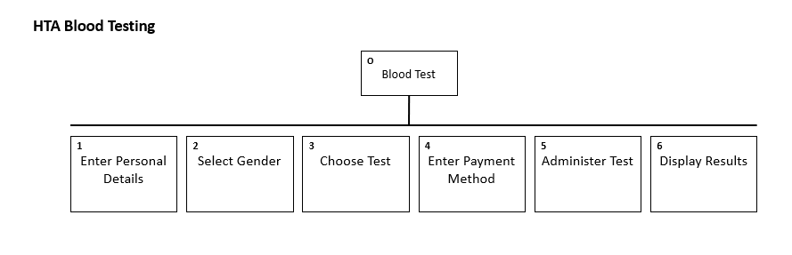 | Overview shows each step of the kiosk. Users must first enter their details and select a gender. They will choose a test and pay for it. The test will be conducted, and their results generated.
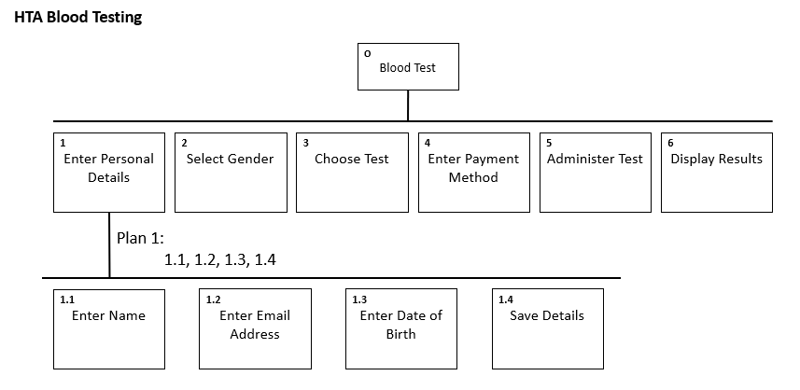 | Users will enter their name and email address, to be included in their results; date of birth is required. Their details are saved for later use.
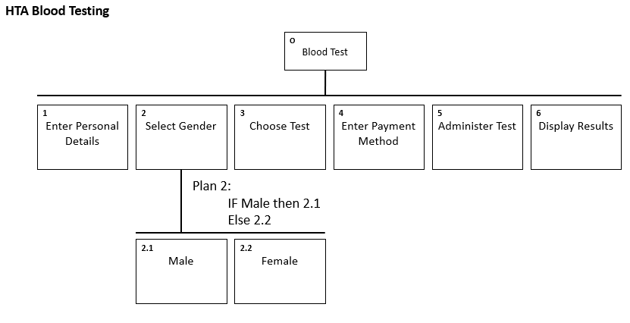 | Users select a gender to be used in the next screen. Only females are offered a pregnancy test, males have it hidden.
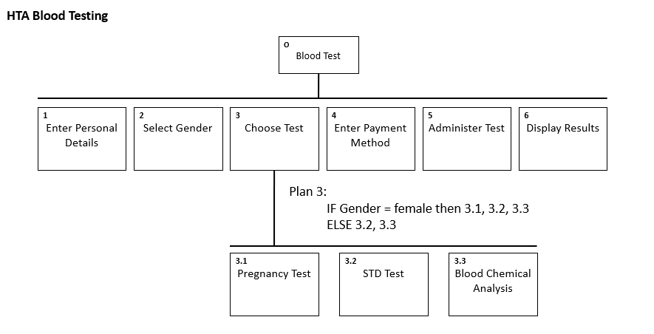 | If the person is female then show pregnancy tests as an option, else only show STD and Blood chemical analysis. Users will select a test with the price being displayed before moving onto the next screen.
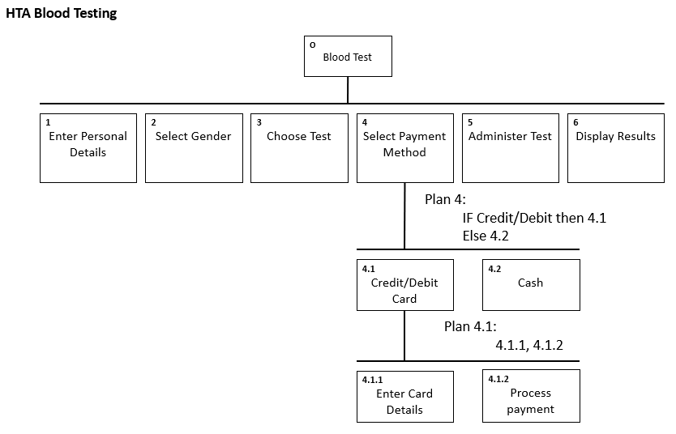 | In this screen users select a payment method. Users then complete the transaction, with it being processed before the test can begin.  Users must pay up-front for the test.
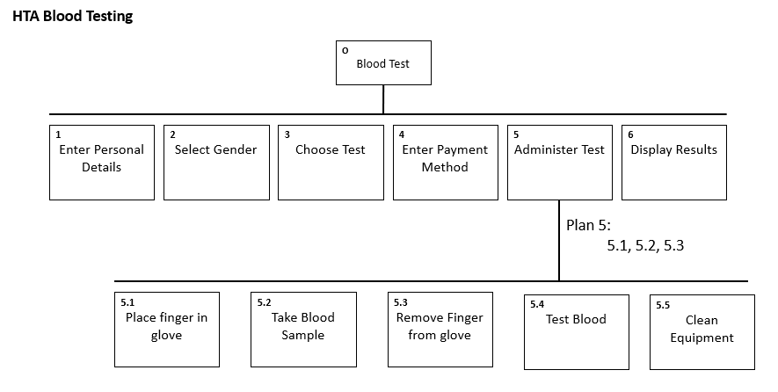 | Users should be directed throughout testing. First, they put the glove on, and a blood sample is taken, before removing their hand as testing occurs. Equipment is cleaned to ensure it is sanitized before future use.
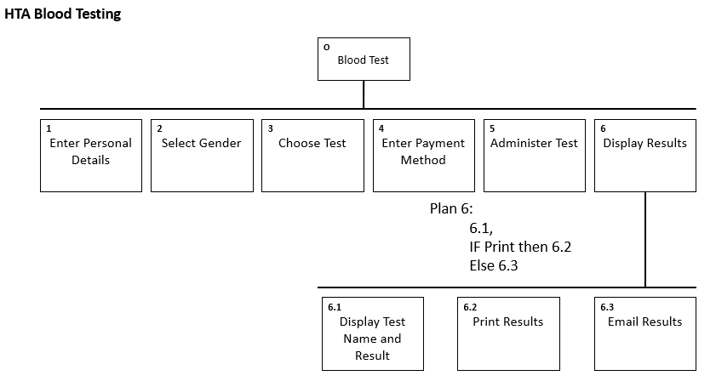 | User test results are shown with the option of printing or emailing their results. Users are able to select both if they wish.

Human Factors
Human factors influence the way humans interact with technology. This includes visual perceptions, cognitive systems, motor skills and memory. These were termed the “Model Human Processor” by Card, Moran & Newell. Under this model, perception stores visual and auditory images in working memory. (mentioned in Shneiderman’s principle on short-term memory load) This influences how users interact with an interface through motor processing. Cognitive processing draws on both working and long-term memory, users remember how to interact with an interface and can complete their desired tasks.
Perceptual processing is how users select and derive meaning from information in their environment. This often relates to visual perceptions and makes use of colour and images to draw attention to specific parts of an interface. Cognition focuses on building information models in users’ minds. They remember (links to memory) how they have previously interacted with interfaces. Common examples are icons, where the save button is a floppy disk; cognition causes users to intuitively know the purpose of this button without additional guidance. This type of cognition is referred to as experiential cognition by Donald Norman and influences user behaviour in interfaces when users remember the location of buttons and features, making the interface easier for frequent users. Using an interface for the first time can require reflective cognition as user must think and make decisions to use an interface. Over time, frequent usage builds long term memory, however infrequent usage will lead to working memory. Henkel suggest images are better for activating memories, linking to Nielsen’s recognition heuristic in interface design.

Paper Prototype Design
Interface Name | Interface | Discussion
Splash Screen | 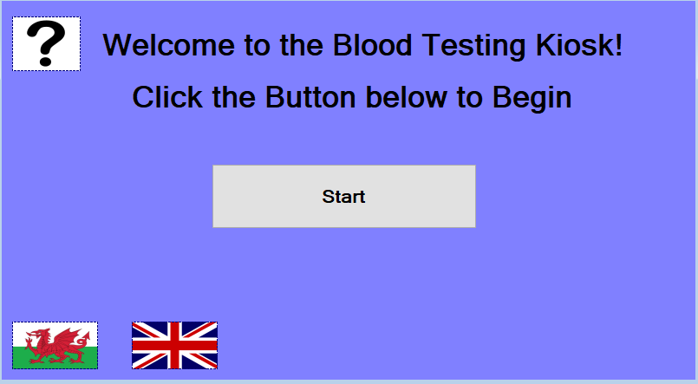 | Background colour is the same in each interface for consistency, using Shneiderman’s first rule. Users choose what to do next, offering them the locus of control with Shneiderman’s seventh rule and to Norman, Nielsen, and Dix’s rules on user control
Patient Details | 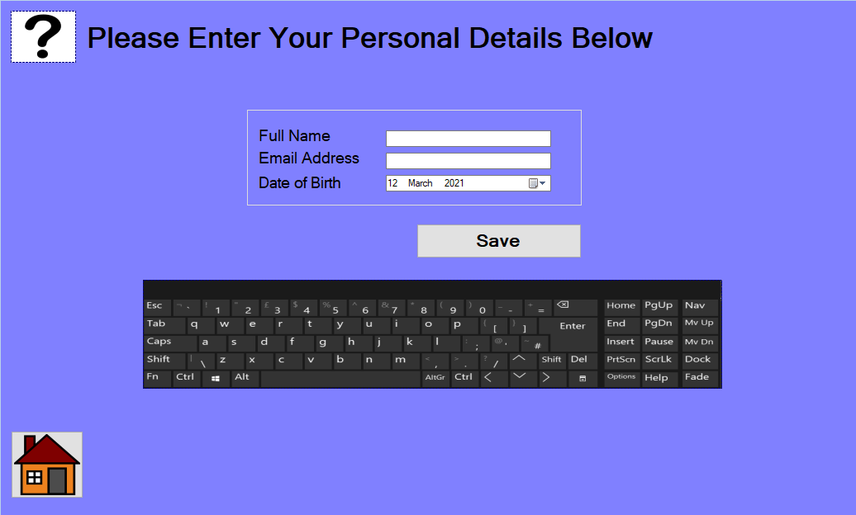 | User can return home with the home icon, offering easy reversal of actions according to Shneiderman’s sixth rule. Date picker used to prevent errors, meeting Shneiderman’s 5th rule. The help icon meets Nielsen’s rule on help and documentation.
Patient Details Error Screen |  | Back button used to enable Shneiderman’s rule of action reversal, arrow used instead of text to meet Nielsen’s recognition heuristic.  Each error interface follows the same template, meeting the consistency rules put forward by each usability researcher.
Gender Selection | 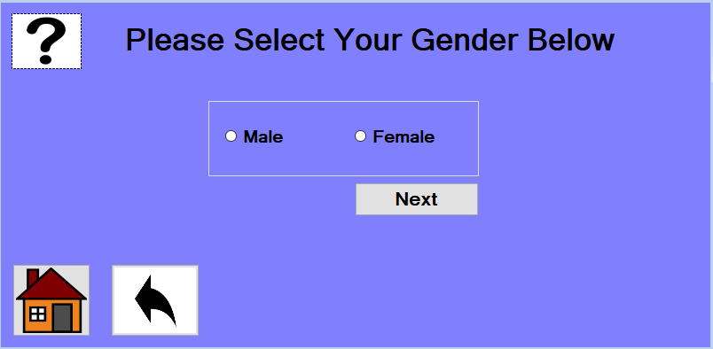 | Home and back buttons fulfilling Shneiderman’s rule of action reversal, in the same location and same images used; meeting consistency rules by each researcher
Gender Error Screen |  | Error screens meeting each researcher’s consistency rules
Test Selection Menu | 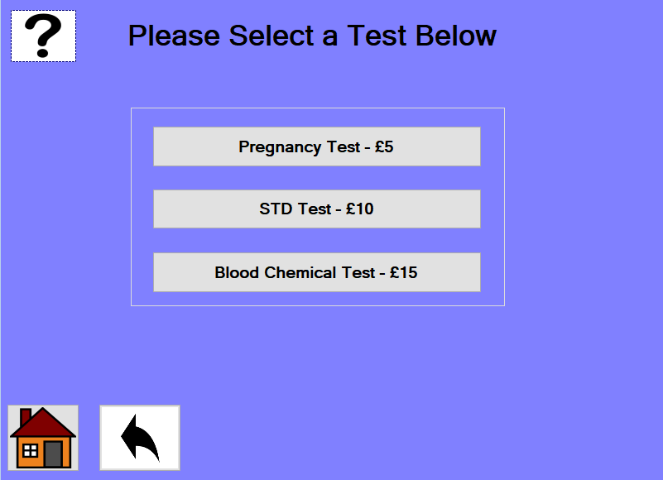 | Home and back buttons continue to meet both rule 1 & 6 of Shneiderman. Whilst navigation buttons meet rule 7.
Test Selection Error Screen |  | Continued consistency with a clear explanation of error meeting Shneiderman’s rule of dialogue closure and of informative feedback.
Payment Method Menu | 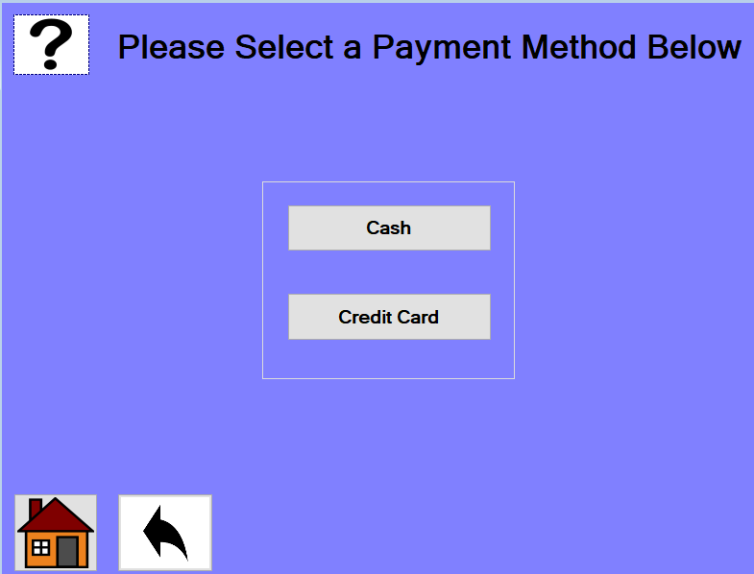 | Home and back buttons remain consistent, users have two payment options, giving users the locus of control. Meeting user flexibility rules of Nielsen.
Payment method error |  | Error message gives informative feedback, back button providing easy reversal of actions.
Cash selection | 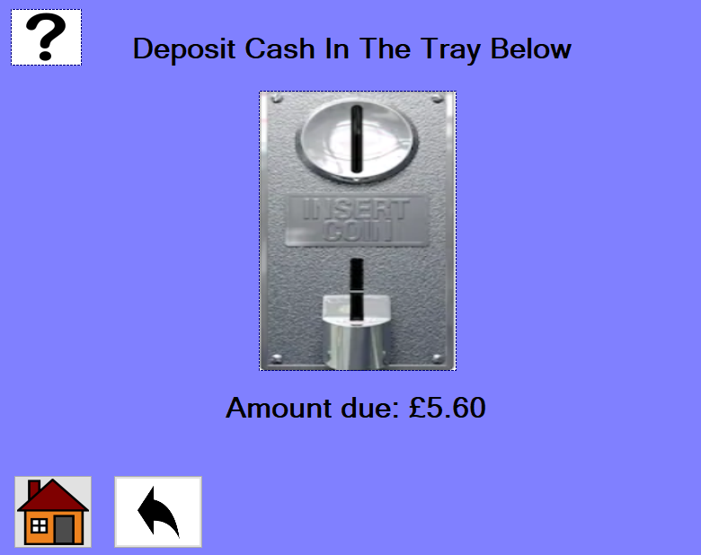 | Coin slot image is used, reducing short-term memory load according to Shneiderman’s 8th rule as well as Normans Visibility rule. Nielsen’s real-world rule is met.
Cash selection error screen |  | Error offers informative feedback and easy reversal of actions; meeting Shneiderman’s third and sixth rules
Credit Card Selection | 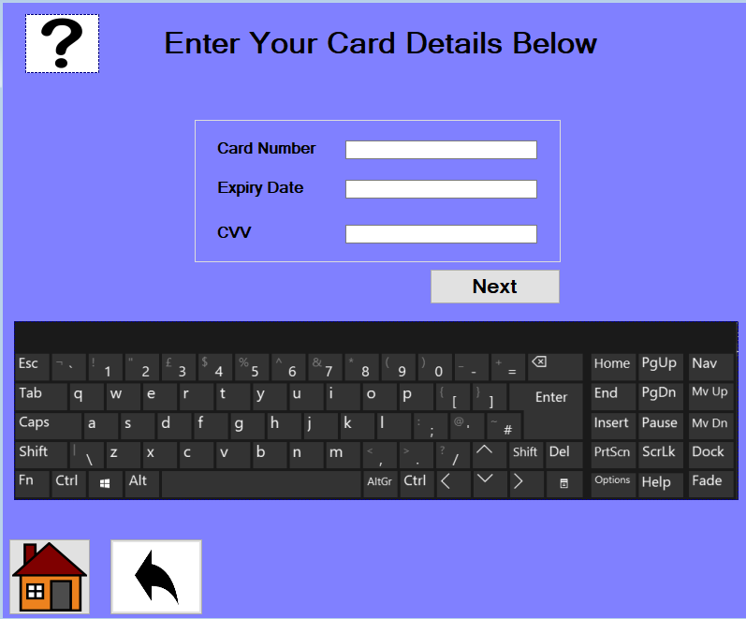 | On-screen keyboard is consistent with other data entry, meeting Shneiderman’s first rule.
Credit Card error screen |  | Error is consistent with other messages and offers informative feedback, meeting Shneiderman’s consistency and feedback rules.
Test Administration start | 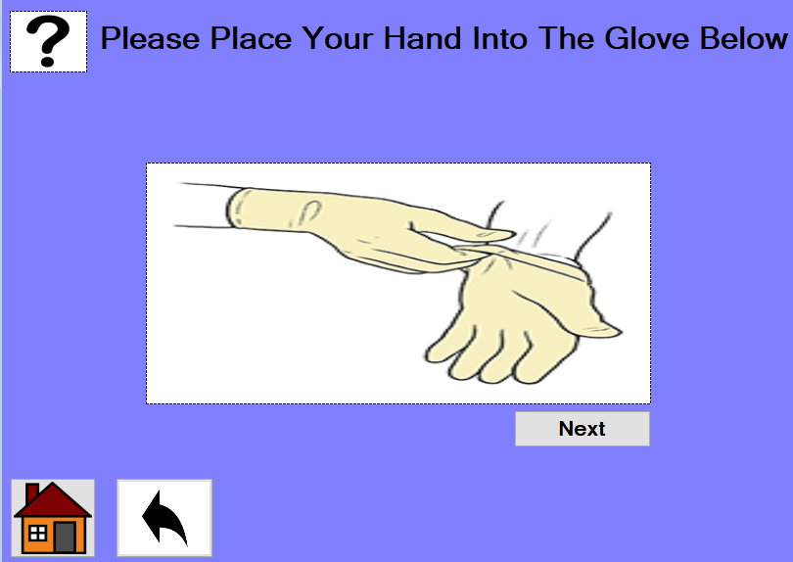 | Image used is clear, guides users and meets and meet Shneiderman’s eight rule of reducing short term memory load
Test Start Error |  | Error message is consistent and offers easy reversal back to the previous interface, meets Shneiderman’s rules.
Testing and Cleaning Screen | 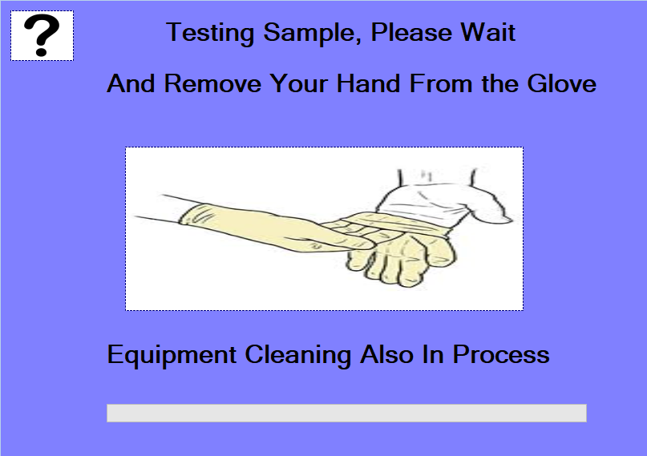 | The progress bar on this page offers closure to users in updates of system status, meeting system status rule of Nielsen and system state visibility of Norman. The text offers informative feedback whilst the guidance image reduces short-term memory load, meeting more of Shneiderman’s rules.
Testing Error screen |  | Error message remains consistent, offers informative feedback and meets many of Shneiderman’s rules
Result Screen | 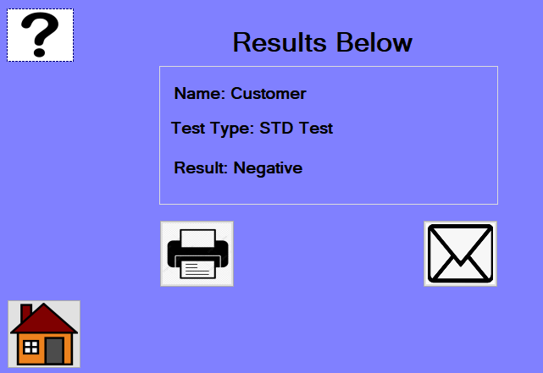 | Results screen is clear, informative and gives users the locus of control by letting them choose to print or email their results or navigate home. Meets many of Shneiderman’s rules
Results error screen |  | Error is consistent with previous messages, continues to meet Shneiderman’s rules

User feedback questionnaire
- On a scale of 1 to 5, how easy were the interfaces to use? (1 – Very difficult to use, 5 - Very easy to use)

1 2 3 4 5
- On a scale of 1 to 5, how intuitive did you find the designs? (1 – Not intuitive, 5 - Very intuitive)

1 2 3 4 5

- Did each error message provide appropriate feedback?

Yes No

- Was the colour scheme clear and appealing?

Yes No

- Did you encounter any issues when using the interfaces? If so, please write them below:
Missing a recommendations screen after receiving the results from the test, other than that all included screens displayed relevant and useful information and features.

- What would you improve about these interfaces?
Make more use of icons to show waiting, include waiting screens, potentially put the language selection on each screen, add an email entry screen for email results method.

Design Evaluation
(Link to cognitive walkthrough conducted by user: https://youtu.be/F6ad4JYdHMs)
Application was intuitive in the cognitive walkthrough. Each interface and button met Shneiderman’s’ first evaluation heuristic through colour and layout consistency. Users experienced no navigation issues; shortcuts met Shneiderman’s’ second heuristic whilst the back button met his sixth characteristic in easy reversal of actions. No data entry issues occurred, date selection is used for date of birth, meeting Shneiderman’s’ fifth heuristic on error prevention. Error messages appeared clear; users easily navigated out of the error message, meeting Schneiders informative feedback and dialog closure heuristics. Program flow was not clear because example errors were placed after each screen, this was an issue within the walkthrough but won’t impact the live kiosk as errors will only appear when a problem occurs.
In Question 5. Of the feedback questionnaire, users reported “all included screens displayed relevant and useful information and features”. This positive feedback highlights the use of Shneiderman’s informative feedback rule. The images used to guide users on payment and testing screens proved useful. However, audio feedback options would improve accessibility for the visually impaired. Users state a recommendations screen would be useful, offering guidance about their results. This feature could recommend a GP visit to those who test positive for further medical advice.
In question 6. it was suggested icons be used in waiting screens. This is relevant as users wait for their sample to be analysed. Presently a progress bar is used, this was not observed during the walkthrough as each screen was static and the bar didn’t fill. During ordinary running, the progress bar will be sufficient in indicating the state of the kiosk and provide visual feedback. Written indication is provided during cleaning, showing equipment as sterilised. Changing language on every screen was suggested, reducing the time to change language. Email entry during results was suggested, however users already enter their email with their personal details. Instead, users’ email will be added to their results, reminding which email was entered. This would meet Shneiderman’s usability characteristic by reducing short term memory load. The issues identified through this cognitive walkthrough are likely to be experienced by all users, they are severe usability problems that will be solved in the software prototype.
Another users interfaces were tested (walkthrough found here: https://www.youtube.com/watch?v=de8uoS5gtq8). From their walkthrough, visual perception was highlighted. The importance of appealing colour schemes was apparent to maintain user interest and direct attention to specific elements of the screen. This links to interfaces being intuitive and the colours used by the kiosk interfaces will be considered in the software prototype.

Software Prototype

Choice of software
Visual Studio was used to develop the software prototype. This is due to its feature rich, drag and drop interface builder. This means interfaces can be quickly developed and changed when necessary without significant time or resources. It is free to use, no additional costs are incurred. Its compatibility with the visual basic programming language and Windows 10 platform is advantageous as they allow the blood kiosk system to be programmed and built at the same time as the interfaces, removing compatibility issues.

Prototypes
Interface Name | Interface | Changes Made Since Design
Splash Screen | 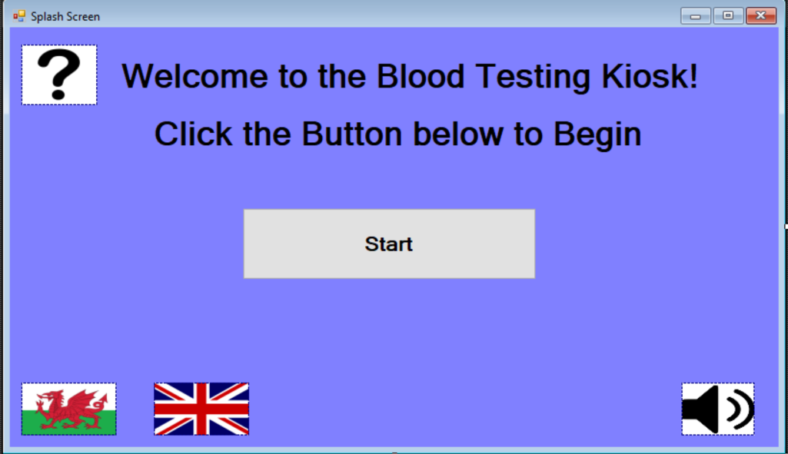 | Audio option has been added to the bottom right corner to read on-screen text, making the interface more accessible
Patient Details | 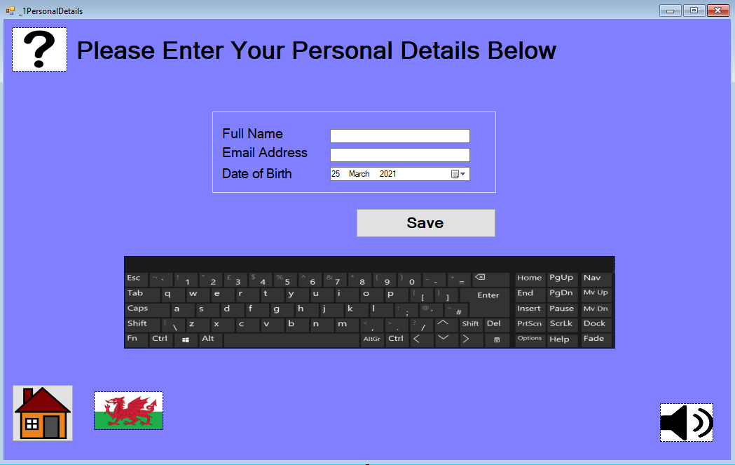 | Audio option added to corner, improving accessibility for the visually impaired.  Welsh language option included in bottom left corner based on feedback from the cognitive walkthrough
Patient Details Error Screen |  | Audio option added
Gender Selection | 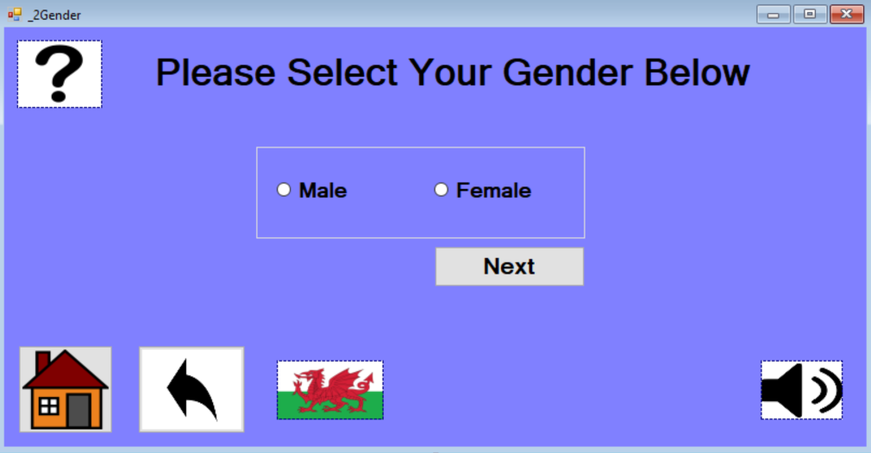 | Audio option added.  Welsh language option added, this will change to English language option when clicked, allowing users to switch between languages.
Gender Error Screen | 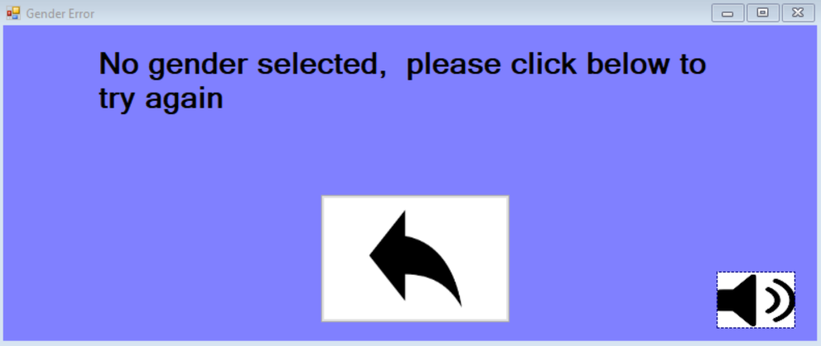 | Audio option added, error message simplified
Test Selection Menu | 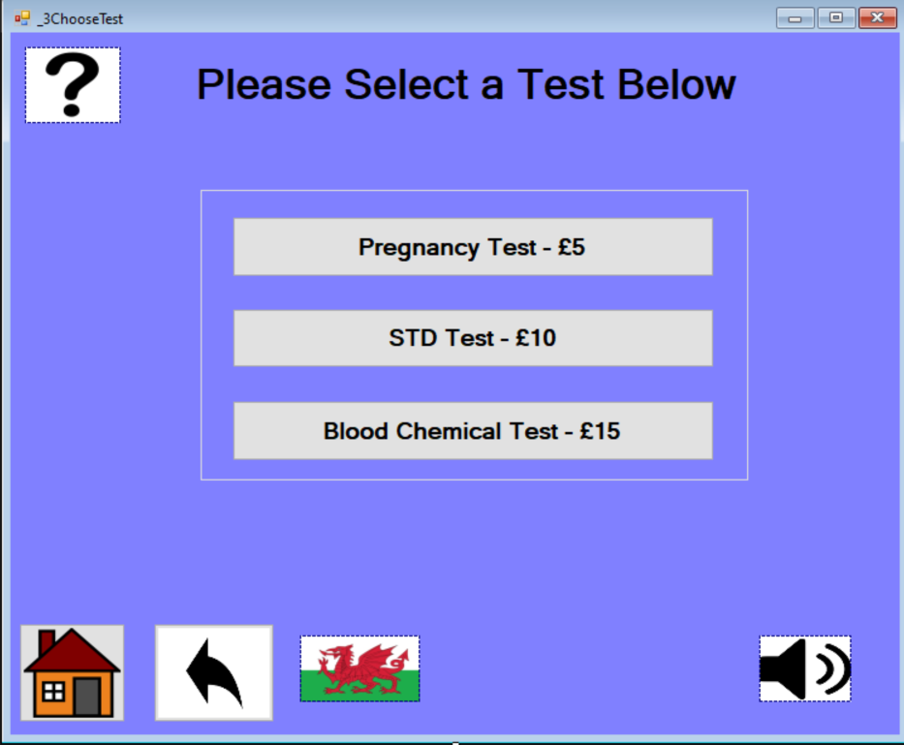 | Audio option added.  Welsh language button included changes to English language button on click.
Test Selection Error Screen | 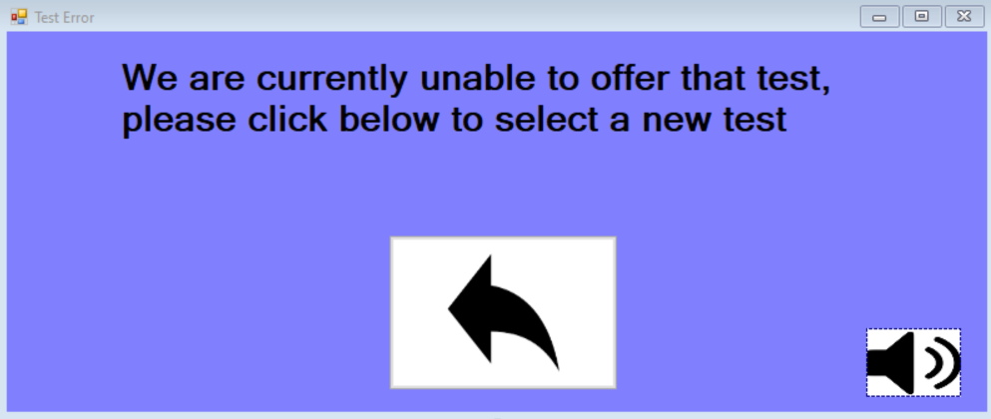 | Audio added, message simplified
Payment Method Menu | 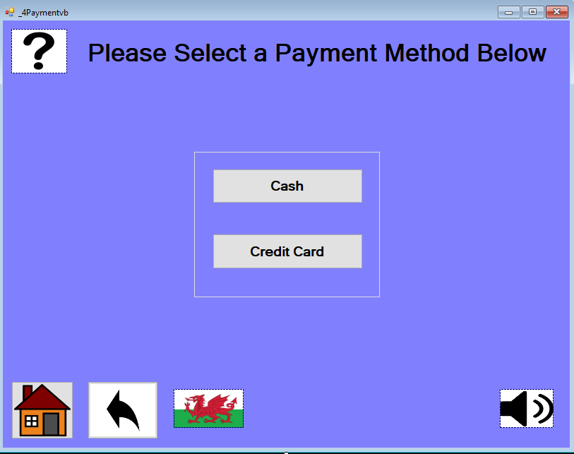 | Audio accessibility added along with welsh language option
Cash selection | 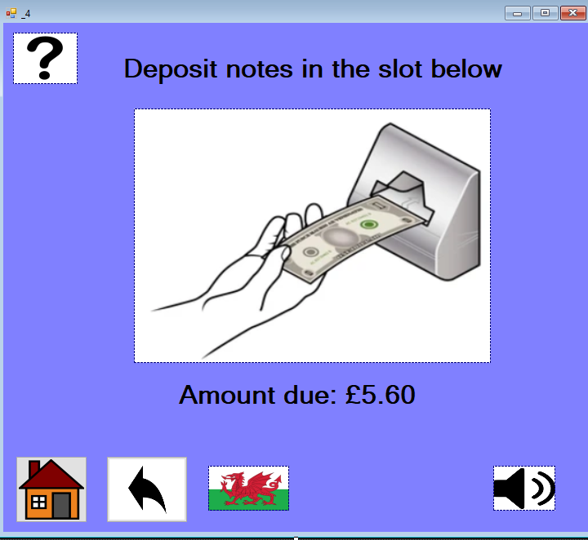 | Audio option added, welsh language option included.  Image changed to direct user to insert notes as the blood kiosk does not accept coins.
Cash selection error screen | 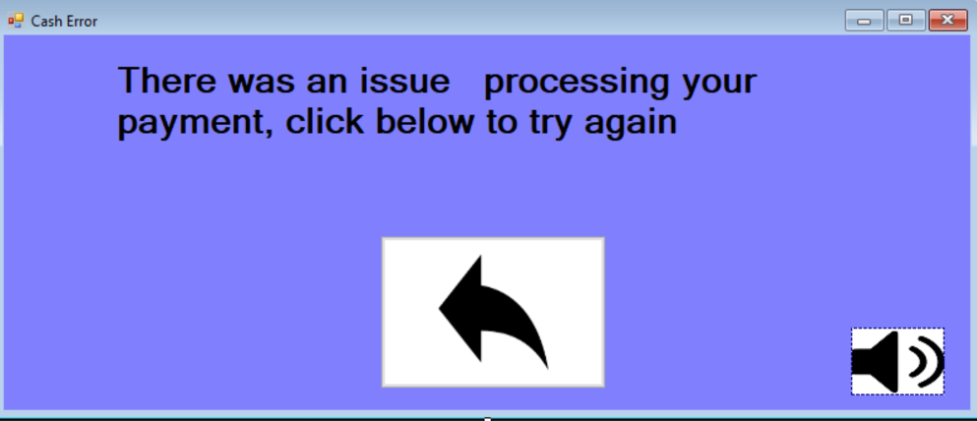 | Audio added, message simplified
Credit Card Selection | 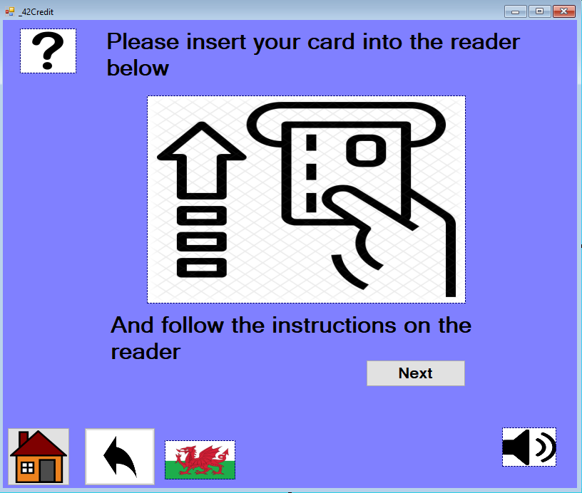 | Audio and welsh options added.  Image changed to guide users to the card reader. This is faster than entering details by hand and reduces the chance of card detail theft
Credit Card error screen | 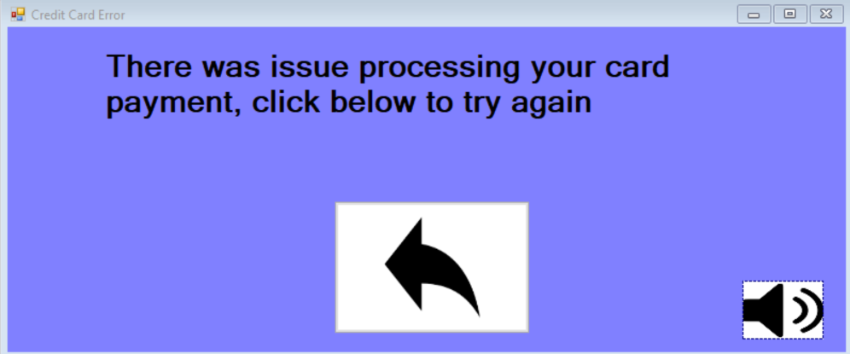 | Audio added, message simplified
Test Administration start | 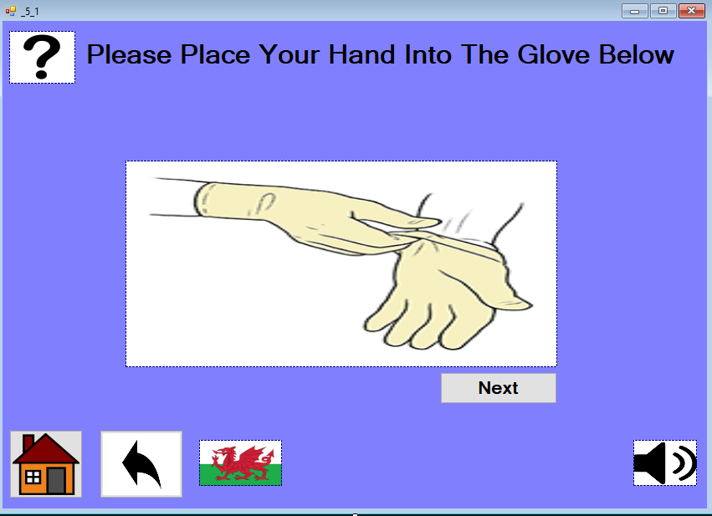 | Audio and welsh options added
Test Start Error | 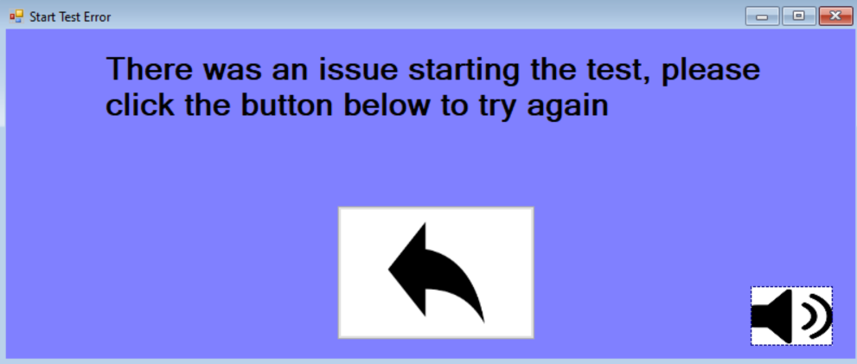 | Audio added, message simplified
Testing and Cleaning Screen | 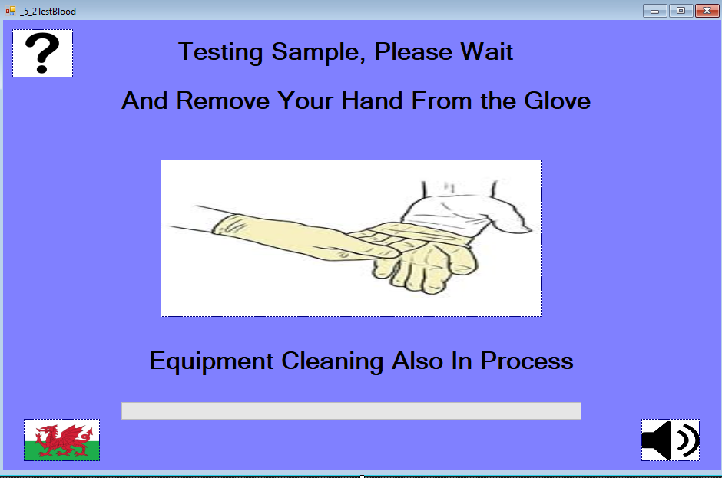 | Audio and welsh options added
Testing Error screen | 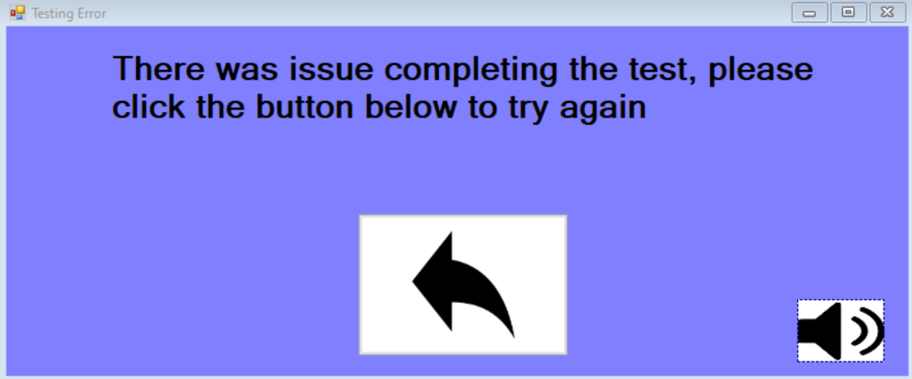 | Audio added, message simplified
Result Screen | 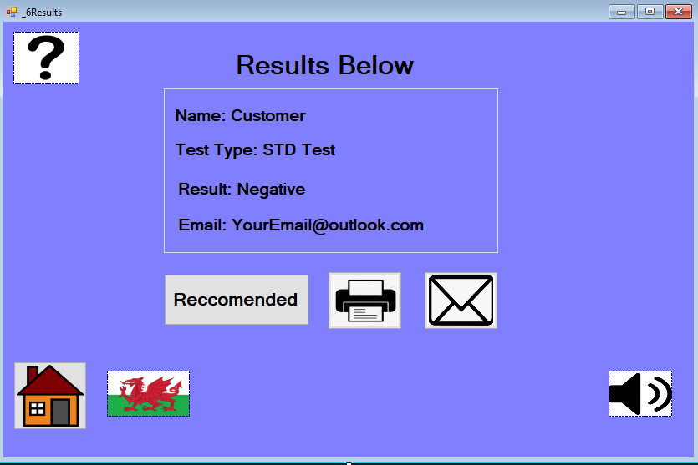 | Audio and welsh options added. Recommendation’s button added, links to recommendations screen.  User email has been added based on results of cognitive walkthrough, ensuring users remember which email they entered.
Results error screen |  | Audio added, message simplified
Reccomendations | 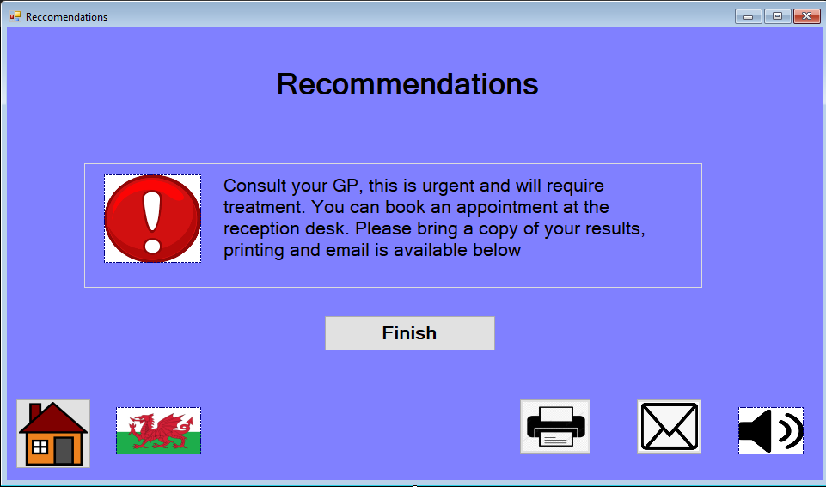 | This is a new screen, added based on feedback from the cognitive walkthrough. Users told to consult a GP when a test result is positive and encourages them to bring their results..
Printed Results | 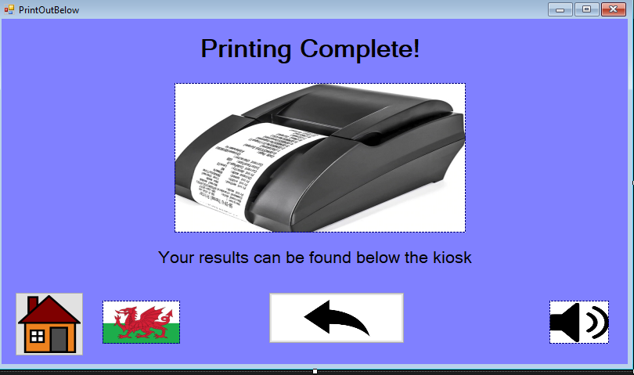 | This is a new screen based on feedback from the cognitive walkthrough. Users alerted when their results are printed and tells them where to collect them.
Print Error |  | Audio added, message simplified
Emailed Results | 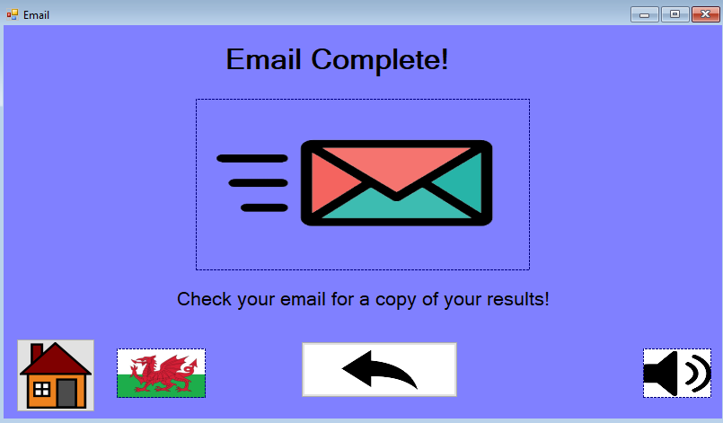 | This is a new screen based on feedback from the cognitive walkthrough. Users alerted when their results have been emailed and allows navigation to the results screen.
Email Error | 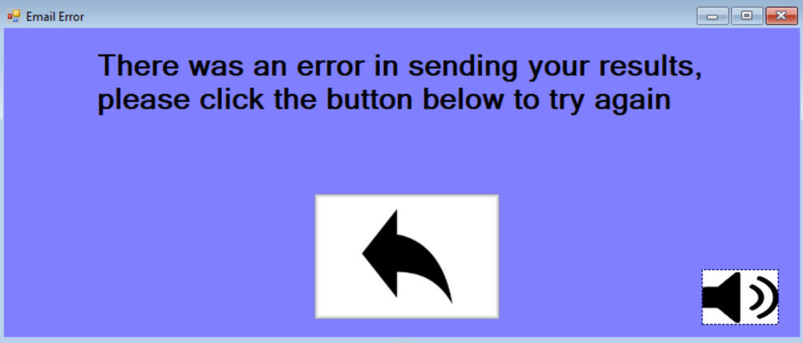 | Audio added, message simplified

Overall Evaluation
The investigation of user requirements was effective due to task analysis. Looking at each step of the blood testing process aided the whole design process by documenting what needed to occur and in what order. After analysing the task, I had a clear set of user requirements, ensuring no steps were missed. Developing an understanding of human factors played an integral role in the design stage by highlighting how users interact with the interface. This understanding was the reason for my use of images to reduce onscreen text and make interfaces intuitive. This understanding placed emphasis on working memory and reducing memory load, leading me to focus on visual perception and less on cognition. This means users do very little thinking when using interfaces. The cognitive walkthrough proved useful in gathering feedback in combination with the feedback questionnaire. The interfaces were found to be good at guiding users. However, more feedback needed to be given on the results screen. Following this feedback, I developed a recommendations screen and alerts to tell users printing and emailing had been successful. I acted on feedback to add language options to each screen along with audio options, this improved accessibility and showed genuine improvements over the initial paper designs. On reflection, I could have made each button and icon the same size, showing more uniformity and consistency in each screen. This may be difficult in some circumstances due to the changing layout of each screen, but it would better meet Shneiderman’s rule of consistency. I have discovered that some users may not have email access and therefore an option to skip the email section would be useful, I would make this change in the future. Doing so would implement the flexibility rules mentioned by both Nielsen and Dix.

Conclusion
Many different factors that influence how individuals interact with interfaces. The most prominent theories stem from the researchers Dix, Norma, Nielsen and Shneiderman. Whilst each has their own advantages and disadvantages, they are similar in many ways. Parts of each theory were applied to the interfaces of the blood kiosk; however, user feedback highlighted many issues. These issues were resolved in a software prototype however feedback from users should be sought to improve the functions of the kiosk in everyday operations.

Bibliography
[1] Nielsen, J., 2012. Usability 101: Introduction to Usability. [online] Nielsen Norman Group. Available at: <https://www.nngroup.com/articles/usability-101-introduction-to-usability/> [Accessed 15 March 2021].
[2] The Interaction Design Foundation. 2021. What is Human-Computer Interaction (HCI)?. [online] Available at: <https://www.interaction-design.org/literature/topics/human-computer-interaction> [Accessed 15 March 2021].
[3] Mayhew, D., 1999. The usability engineering lifecycle. CHI '99 extended abstracts on Human factors in computing systems - CHI '99,.
[4] Dix, A., Finlay, J., Abowd, G. and Beale, R., 2004. Human Computer Interaction. 3rd ed. Pearson, p. Chapter 7.
[5] Shneiderman, B., 2004. Designing for fun. Interactions, 11(5), pp.48-50.
[6] Nielsen, J., 2020. 10 Usability Heuristics for User Interface Design. [online] Nielsen Norman Group. Available at: <https://www.nngroup.com/articles/ten-usability-heuristics/> [Accessed 26 March 2021].
[7] Norman, D., 1983. Design principles for human-computer interfaces. Proceedings of the SIGCHI conference on Human Factors in Computing Systems - CHI '83,.

